**CHAPTER 4**

**THE ULS OF SHEAR AND BOND, ANCHORAGE AND DEVELOPMENT LENGTH**

**4.1 The ULS Design of Beams for Shear**

Beams are designed for flexure and then the influences of other actions on its capacity are assumed. The ULS of shear is characterized by either diagonal compression failure of concrete or failure of the web reinforcement due to diagonal tension.

When a beam is subjected to flexure and shear, the shear resistance in the absence of shear reinforcement is contributed by concrete compression zone, mechanical interlock of aggregate at the crack and dowel action of the longitudinal reinforcement. The contributions of the later two are difficult to quantify. Hence, the resistance to a diagonal tension is obtained as the sum of the resistance of the web reinforcement and the concrete section. In checking this resistance, the critical section for shear is assessed a distance d from the face of support.

**4.2 Design Criteria**

**(i) *Only nominal web reinforcement***

When the shear force in a section does not exceed the shear strength of the concrete vc, only nominal web reinforcement is provided.

*Vc =* *0.25 fctd K1 K2 bwd*

Where: k1 = 1+50ρ ≤ 2.0

k2 = 1.6 – d ≥ 1.0, d is effective depth in m. For members where more than 50%

of the bottom reinforcement is curtailed, k2 = 1.0.

*ρ = * ≤ *0.02* (*bw* = the minimum width of the web)

*As* = the area of the tensile reinforcement anchored beyond the intersection of

the steel and the line of possible 450 crack starting from the edge of the section.

When Vsd < Vc, the section is adequate and provide nominal web reinforcement specified by longitudinal spacing as:

1. All beams except joists of ribbed slabs, shall be provided with at least the minimum web reinforcement given by:

 

Where: *fyk* is in MPa

*Av* = Pair area of stirrups

*s* = Spacing in mm

*bw* = width of web

1. The maximum spacing *smax* between stirrups, in the longitudinal direction, shall be as given below.

smax = 0.5d ≤ 300mm if Vsd ≤ 

smax = 0.3d ≤ 200mm if Vsd > 

1. The transverse spacing of legs of stirrups shall not exceed d, or 800mm, which ever is the smaller.

**(ii) *Limiting value of ultimate shear stress***

In order to prevent diagonal compression failure in the concrete the shear resistance (*VRd*) of a section shall not be less than the applied shear force at d distance from face of support (Vsd).

Where, VRd = 0.25fcdbwd

When Vsd > VRd, the section size must be increased.

**(iii)** *Shear reinforcement*

When *VC <VD <VRd*, shear reinforcement need be provided.

 ; Av = pair area of reinforcement



When inclined bars are used,



Where: α = the angle of inclination from the horizontal.

**4.3. Bond, Anchorage and Development Length**

**Introduction**

In reinforced concrete members, flexural compressive forces are resisted by concrete and the flexural tensile forces by the reinforcement. For this process to exist, there must be a force transfer, or bond between the two materials. One of the basic assumptions in the analysis and design of reinforced concrete is that there is absolutely no slippage between concrete and reinforcing steel. Whenever there is rate of change of stress in reinforcing bar, there must be some interchange of stress or shear flow between the concrete and the reinforcement. The resistance to slippage is termed bond. And the intensity of this bonding force is termed bond stress.

Bond transfer is due to:

* Adhesion between the concrete and the reinforcing steels
* Frictional resistance and interlock between the bar deformations and the surrounding concrete.
* Mechanical anchorage effect of the ends of the bars ( hook or bend)

**Bond Stress Development**

Bond stress in reinforced concrete embers arise from two distinct situations:

* From anchorage of bars (anchorage bond)
* From the change of bar force along its length due to change in bending moment along the member (flexural bond).

**Bond**

In order for reinforced concrete to behave as intended, it is essential that bond forces be developed on the interface between concrete and steel, such as to prevent significant slip from occurring at that interface. If the bar is smooth enough to slip, the assumption that the strain in an embedded reinforcing bar is the same as that in the surrounding concrete, would not be valid. Consequently, the beam would be very little stronger than if it were built of plain concrete, without reinforcement.

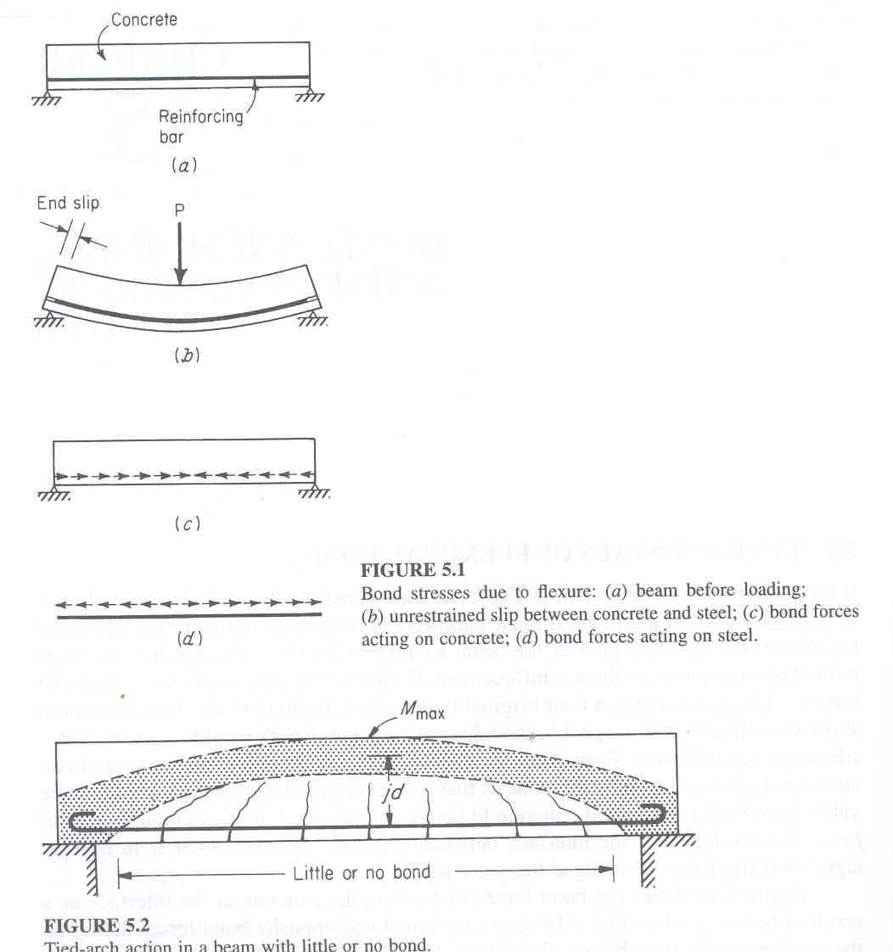

**Figure shows:-** Bond stresses due to flexure (a) beam before loading; (b) unrestrained slip between

concrete and steel; (c) bond forces acting on concrete; (d) bond forces acting on steel.

Formerly plain bars were used with provision of end anchorage in the form of hooks. Such beam forms a broken bond over the entire length between anchorages and acts as a tied arch (Fig. 4.3.2).



**Figure**  Tied arch action in a beam with little or no bond

To avoid development of wide cracks and dispense with special anchorage devices, deformed bars are now universally used. With such bars, the shoulders of the projecting ribs bear on the surrounding concrete and result in greatly increased bond strength.

**Bond Stress**

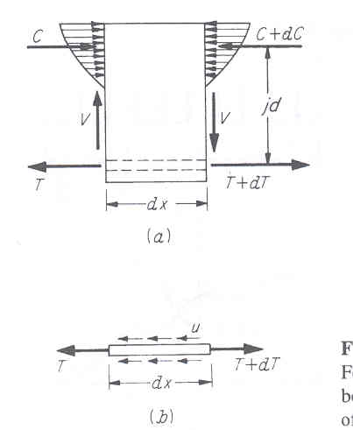Figure 6.2.1 shows forces in an isolated piece of a beam of length dx. The moment at one end will generally differ from that at the other end by a small amount dM.



**Figure shows:-** Forces and stresses acting on elemental length of beam: (a) Free body sketch of

reinforced concrete element; (b) Free body sketch of steel element.

Assuming that concrete does not resist any tension stresses, the change in bar force becomes,

 (*Z* – Moment arm)

As shown in figure 4.3.1b, this force is resisted by the bond at the contact surface between bar and concrete.

Summing horizontal forces,



Where: *u* = local average bond stress per unit of bar surface area.

 = sum of perimeters of all the bars.



Hence, the unit bond stress is proportional to the shear at a particular section, i.e., to the rate of change of bending moment. The above equation applies to the tension bars in a concrete zone that is assumed to be fully cracked. It does not apply to compression reinforcement, for which it can be shown that the flexural bond stresses are very low.

Actual distribution of flexural bond stress:

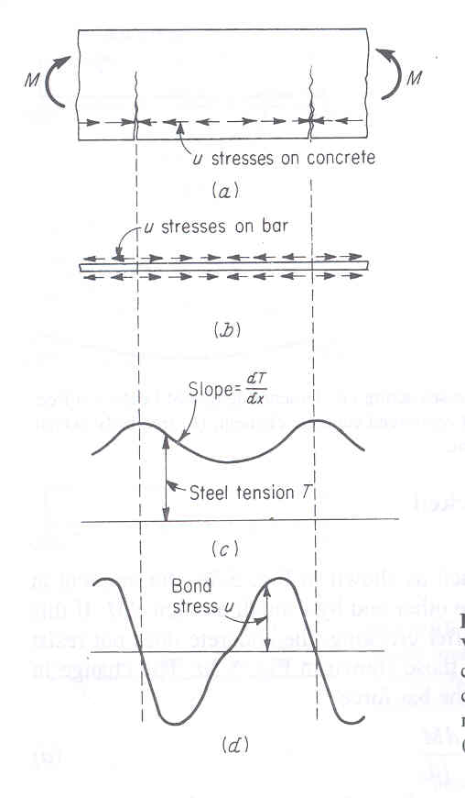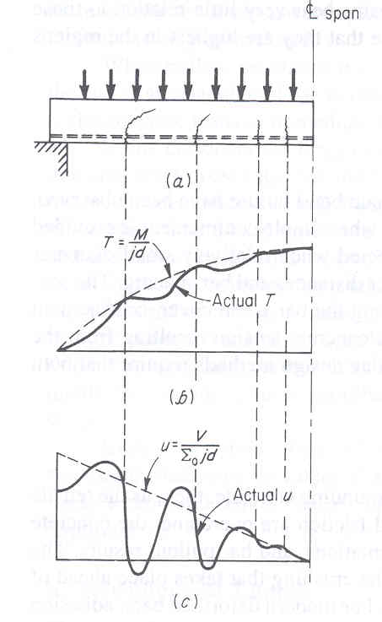

**Figure a** **Figure b**

**Figure a)** variation of steel force and bond stress in reinforced concrete member subjected to pure bending: (a) cracked concrete segment; (b) bond stresses acting on reinforcing bar; (c) variation of tensile force in steel; (d) variation of bond stress along steel.

**Figure b)** Effect of flexural cracks on bond stresses in beam (a) beam with flexural cracks; (c) variation of tensile force T in steel along span; (d) variation of bond stress u along span.

**Development Length**

Ultimate bond failures for bars in tension are of two types: the first is direct pullout of the bar, which occurs when ample confinement is provided by the surrounding concrete. The second type of failure is splitting of the concrete along the bar when cover, confinement or bar spacing is insufficient to resist the lateral concrete tension resulting from the wedging effect of the bar deformations. The latter if more common than the former

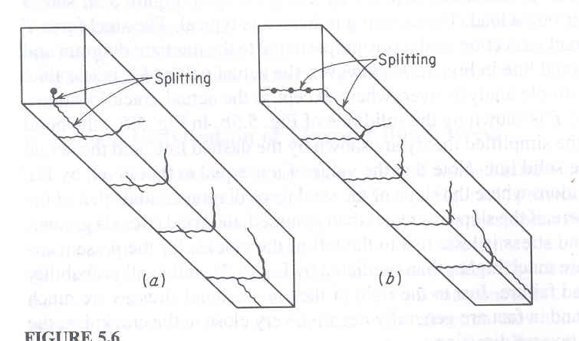

**Figure** Splitting of concrete along reinforcement

The development length is defined as that length of embedment necessary to develop the full tensile strength of the bar, controlled by either pullout or splitting. Referring to figure 4.3.7, the moment, and hence the tensile stress, is evidentially maximum at point ***a*** and zero at supports. The total tension force ***Abfs*** must be transferred from the bar to the concrete in the distance ***l*** by bond stress on the surface.

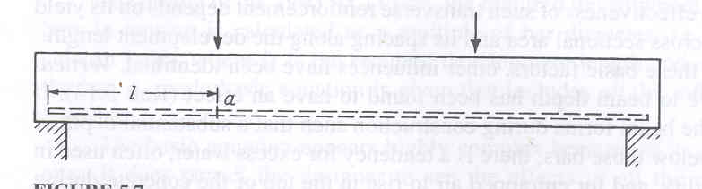

**Figure** Development length

The safety against bond failure is that the length of the bar, from any point of given steel stress (***fs*** or at most ***fy***) to its nearby free end must be at least equal to its development length.

The basic anchorage length, ***lb***, is the straight length of bar required to anchor the force ***Asfyd***. For a bar of diameter-φ, this force must equal the shear force developed between the bar surface and the surrounding concrete:



Where, *fyd* = design bond strength.

The required anchorage length ***lb,net*** depends on the type of anchorage and on the stress in the reinforcement and can be calculated as:



Where, *As,cal* = theoretical area of reinforcement required by the design.

*As,ef* = area of reinforcement actually provided.

 = 1.0 for straight bar anchorage in tension or compression.

0.7 for anchorage in tension with standard hooks.

For bars in tension, *lb,min* = *0.3lb* ≥ *10φ* or ≥ *200mm*

For bars in compression, *lb,min* = *0.6lb* ≥ *10φ* or ≥ *200*

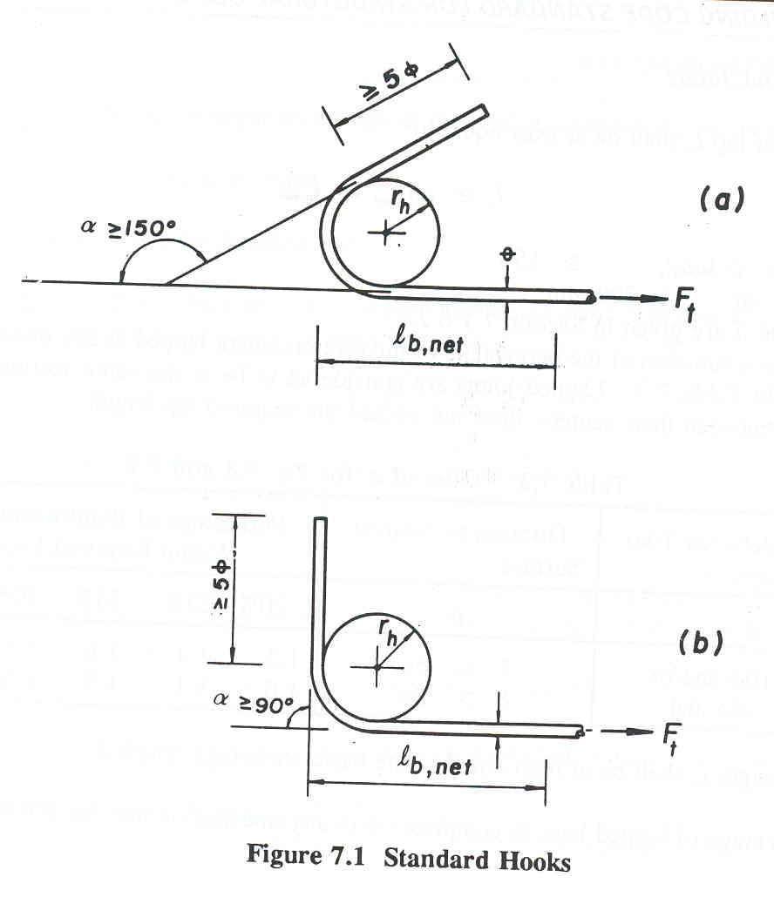

**Figure 4.3.8** Standard Hooks

Reinforcement shall extend beyond the point at which it is no longer required to resist tension for a length given by:

1. *lb*
2. *lb,net* ≥ *d* provided that in this case, the continuing bars are capable of resisting twice the applied moment at the section.

**Bar Cut off and Bend points**

It is a common practice either to cut off bars where they are no longer required to resist stress or in case of continuous beams, to bend up bottom steel so that it provides tensile reinforcement at the top of the beam over the support.

Bending stresses, concrete dimensions, and longitudinal bar areas are calculated based on critical moments along the length. These critical moment sections are generally at the face of the supports (negative bending) and near the middle of the span (positive bending).

The steel requirement on the other hand, is easily varied in accordance with requirements for flexure, and it is common practice either to cut of bars where they are no longer needed to resist stress or, some times in the case of continuous beams, to bend up the bottom steel (usuallky at 45o) so that it provides tensile reinforcement at the top of the beam over the supports.

The tensile force to be resisted by the reinforcement at any cross section is T = Asfs = M/z where M is the value of bending moment at that section and z is the internal lever arm of the resisting moment. The lever arm z varies only with in narrow limits and is never less than the value at the maximum moment section. Consequently, the tensile force can be taken with good accuracy directly proportional to the bending moment. Since it is desirable to design so that the steel every where in the beam is as nearly fully stressed as possible, it follows that the required steel area is very nearly proportional to the bending moment.

To illustrate, the moment diagram for a uniformly loaded simple span beam shown in Fig. 5.4 can be used as a steel requirement diagram. At the maximum section, 100 percent of the steel is theoretically required (0 percent can be discontinued or bent), while at the supports, 0 percent of the steel is theoretically required (100 percent can be discontinued or bent). The percentage of bars that could be discontinued elsewhere along the span is obtainable directly from the moment diagram, drawn to scale.

To determine cutoff or bend points for continues beams, negative and positive moment envelops are drawn (see fig. 5.3b). The location of the points at which 50% of the bottom and top steel may theoretically be discontinued are shown

Actually, in no case should the tensile steel be discontinued exactly at the theoretically cutoff points. It is necessary that the calculated stress in the steel at each section be developed by adequate embedment length or end anchorage, or a combination of the two. For the usual case, with no special end anchorage, this means that the full development length ld must be provided beyond critical sections at which peak stress exists in the bars. These critical sections are located at points of maximum moment and at points where adjacent terminated reinforcement is no longer needed to resist bending.

To determine bend points, or bar cutting points, the moment diagram resulting from loading for maximum span moment and maximum support moment is shown below.

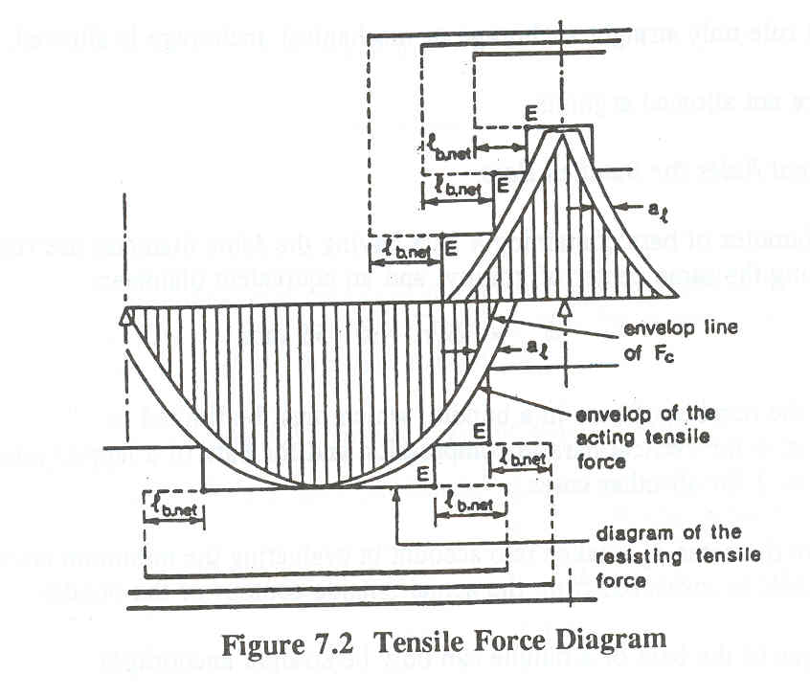

**Figure** tensile force diagram

Recognizing the various uncertainties, for bars with no special end anchorage the full development length *lb,net* [*d* or 12φ] whichever is larger, must be provided beyond the peak stress location. The critical section may be the point of max moment or a point where adjacent terminated reinforcement is no longer needed to resist bending.

**Bending of Bars**

1. the minimum diameter to which a bar is bent shall be such as to avoid crushing or splitting of concrete inside the bend of the bar, and to avoid bending cracks in the bar
2. For bars or wires, the minimum diameter of the mandrel used should be not less than the values given in the following Table.

Table 5.1 Minimum diameter of bend

|  |  |  |
| --- | --- | --- |
| Bar size | Main reinforcement | Stirrups and ties |
| Ø ≤ 16  16 < Ø ≤ 25  25 < Ø ≤ 32  Ø > 32 | 5Ø  6Ø  8Ø  10Ø | 4Ø  6Ø  -  - |

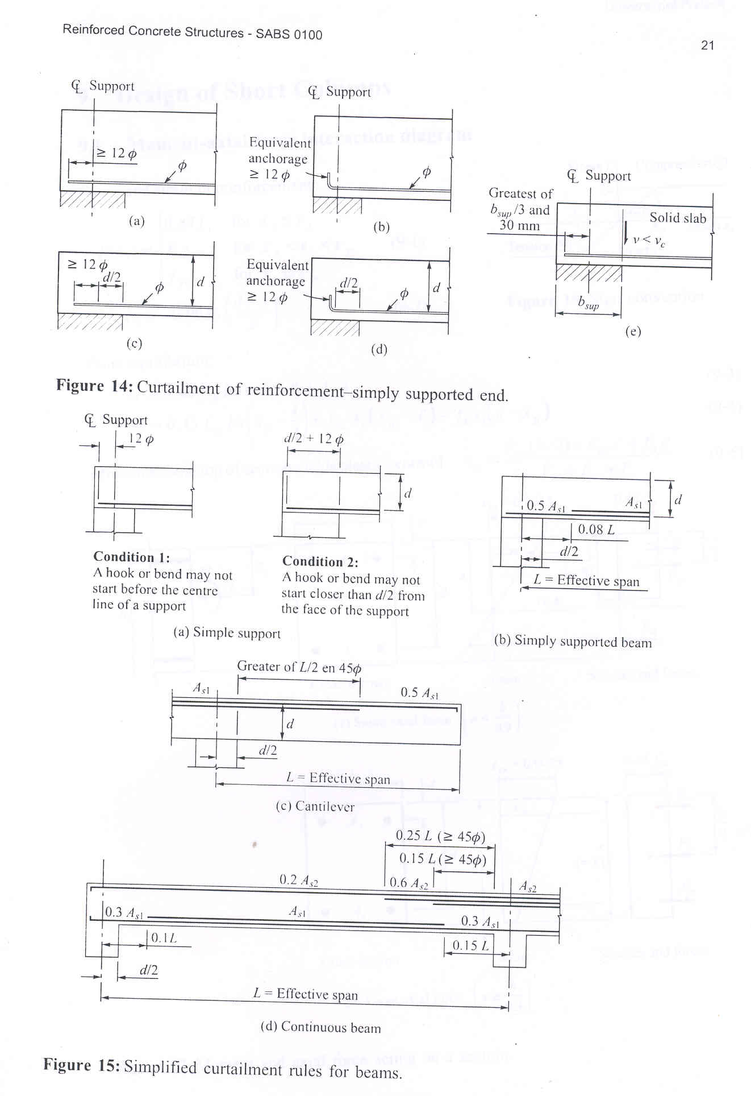In the absence of explicit calculation, the sketch shown may serve this purpose.

**4.3.5 Bar splices**

Reinforcing bars are as by fabrication limited in length, say 12 m. Thus it is normal to splice bars in the field. To do this, one has to notice the following regarding splicing.

* Splicing of bars must be avoided at points of max-moment.
* Bars which are spliced should be staggered.
* Splices are made simply by lapping the bars a sufficient distance to transfer stress

by bond from one bar to the other.

* The required length of lap for tension is approximately *1.3lb* and that for compression is *lb*.