AMBO University Woliso Campus
School of Technology & Informatics
Department of Computer Science
Assignment for Computer Graphics prepared for 3rd year CS (R) and 4th year extension CS Students for second Semester.

- Compare and contrast CRT, LCD, LED, Plasma panel display technology based on the following criteria
- Cost, Weight, Size
- Power consumption
- Spatial & Color resolution
- Peak brightness, Black, contrast
- Typically, the refreshing rate for CRT is 60 – 80 times per second (Hz). What will happen if refreshing is too slow or too fast?
- Select one hidden surface removal technique and explain its basic characteristics using examples?
- Suppose we have three surfaces in a scene that all project to the same region of the image. The projected positions in the image are illustrated by the figure below.

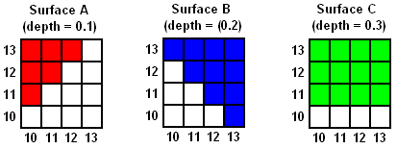

All pixels in surface A will be drawn in red, all pixels in surface B in blue, and all pixels in surface C in green. The normalised depths of each surface are shown in the figure. Assuming that the surfaces are drawn in the order C, A B, explain how the depth-buffering algorithm would produce the correct occlusions.

- Consider the arrangement of surfaces shown in the figures (a) and (b) below. For each, explain how the depth-sorting algorithm would order these surfaces for scan-conversion.

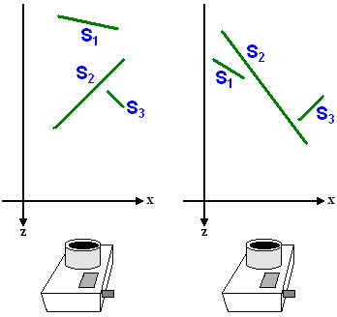
(a) (b)

- Write the application modelling in computer graphics.
- Discuss the difference between DDA and Bresenham's line drawing algorithm.

What does it mean by RGB, CMY and HSV color model? and explain how they are operating.

Note:
- This assignment should be including introduction, body and final conclusion for each and every question.
- After you finish, send on this “abdisalechisa@gmail.com “email address
- Phone number: 0923607747

