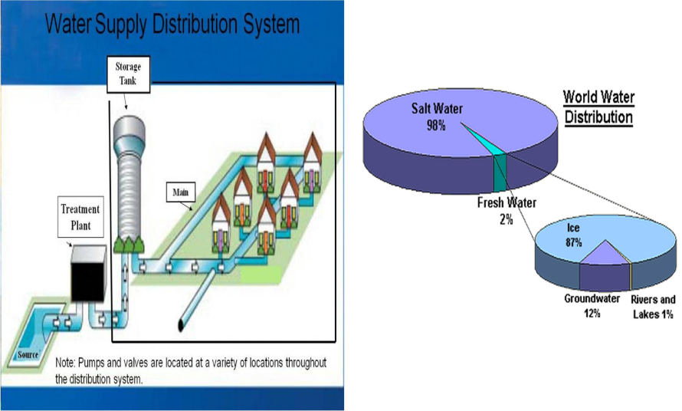

CHAPTER FOUR
4.0 COLLECTION AND DISTRIBUTION OF WATER
4.1 Intakes.
It is a well type masonry structure whose function is to provide still water,free from floating matter for water supply schemes.
The term conveyance indicate transfer of water from source to purification plant and from treatment plant to consumers.
An intake consists of:
•The opening and strainer through which the water enters, and •The conduit conveying the water, usually by gravity, to a well.
The following must be considered in designing and locating intakes:
It should be provide purer water so that its treatment may be less exhaustive.
The location with respect to sources of pollution.
heavy water current should not strike the intake directly.
The occurrence of floating materials such as ice and vegetation.
Site should be well connected by good type of road.
- Intake should be located on the upstream side of the town. Etc…

Types of Intakes

There are different types of intakes, such as reservoir intakes, river intakes, Lake Intake and canal intake
Reservoir Intakes for Impounding.
They are developed when the dam and weir are constructed across the river.
They Constructed on the side of the dam of the reservoir, because depth of water along the dam maximum and water remain available at the intake during driest season.
Fluctuations of water level which may be expected in reservoirs, it advisable to have ports at various heights.
The ports may be closed by sluice gates or by gate valves on short lengths of pipe.

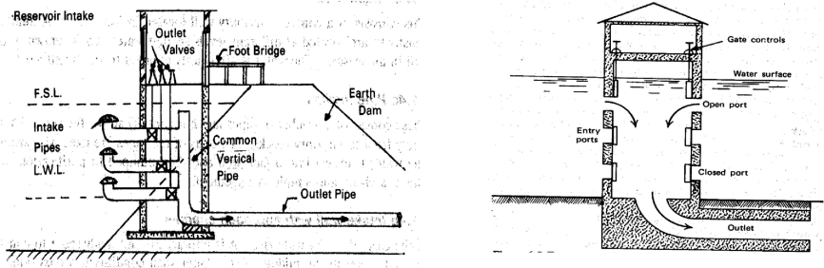
River Intakes
River intakes are especially likely to need screens to exclude large floating matter which might injure pumps.
It is always located on the upstream of the town.
Sometimes an approach channel is provided may have to be constructed on the upstream side of the intake.
River intake is located inside the river so as to get adequate supply in all seasons.
Water is drawn from the upstream side of the river, where it is comparatively of better quality.
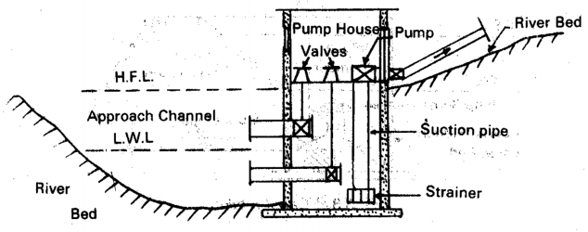Fig.4.2 River in take
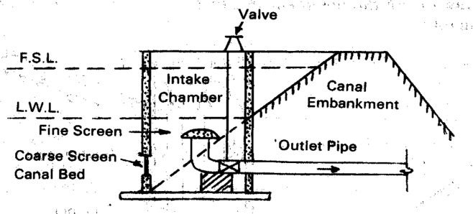Canal Intakes
This consists of a concrete well in the canal. An inlet pipe laid in the canal bed leads in to the well.
As the full supply level in the canal is, fairly constant, inlets at different depths are not necessary.
The inlet end of the pipe is provided with an enlarged bell mouth, to which is fixed a hemispherical fine screen which prevents floating materials from entering the intake pipe.
Also, there is a coarse screen provided so that big floating particles are excluded. The water from the out let of the intake pipe is led to a sump well or supply.
Fig. 4.3 Canal Intake

4.2 Methods of Distribution
Water is distributed to consumers in several different ways. These methods are:

Gravity Distribution
Distribution by means of pumps with storage (Pumping + Gravity )
Use of Pumps with out storage ( Direct Pumping)
Gravity Distribution.
Pumping is not required however purification unit is situated on hill itself, then the water may have to be pumped.
Purified water flows to the distribution system without pumping. This system is the most reliable and economical method of water distribution. 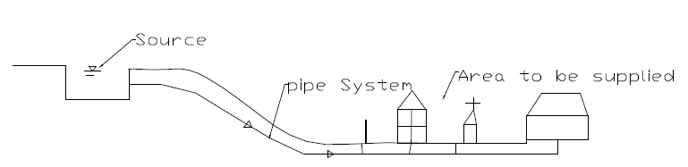
Distribution by means of pumps with out storage.
In this system purified water is directly pumped into the distributing mains for obtaining the required pressure.
The most undesirable system ,because power failure mean complete interruption in the water supply.
Also the consumption varies from time to time.
Double pump is required …… 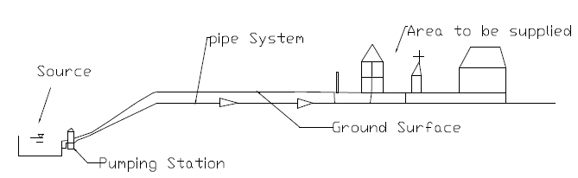
Use of Pumps with storage.
It is the combination of both gravity and pump method.
In the system the excess water is pumped during low consumption is stored in elevated tank . Pumping run not at varying speed but at constant speed, thus reduce the wear of the pump.
The method more reliable and economical.
Stored water in elevated tank also fulfill water requirement for sometimes during breakdown of pump and fire fighting. 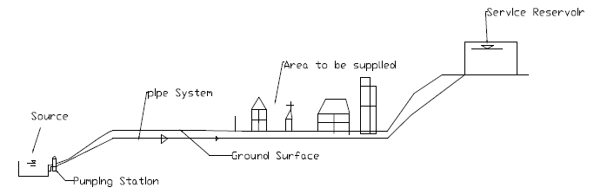
4.3 Service Reservoirs (Function and Capacity)
A service reservoir has four main functions:
Generally, there are two types of service reservoirs: 1.Surface reservoir (Ground Reservoir or Non-elevated) 2.Elevated reservoir (Over head Tank)
Functions
1. To balance the fluctuating demand from the distribution system.
2. Provide a supply during a failure or shutdown of treatment plant, pumps or trunk main leading to the reservoir.
3. To give a suitable pressure for the distribution system and reduce pressure fluctuations.
4. To provide a reserve of water to meet fire and other emergency demands.
Types of Service Reservoirs

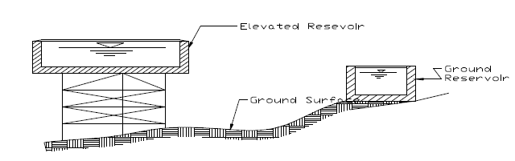

Accessories of Service Reservoirs
The service reservoirs are to be provided with the following accessories: 1.Inlet Pipe: For the entry of water
2.Ladder cleaning | : To reach the top of the reservoir and then to the bottom of the reservoir, for inspection and
3.Lightening Conductor: In case of elevated reservoirs for the passage of lightening 4.Manholes: For providing entry to the inside of reservoir for inspection and cleaning 5.Outlet pipe: For the exit of water
6.Outflow Pipe: For the exit of water above full supply level 7.Vent pipes: For free circulation of air
8.Washout pipe: For removing water after cleaning of the reservoir
9.Water level indicator: To know the level of water inside the tank from outside. 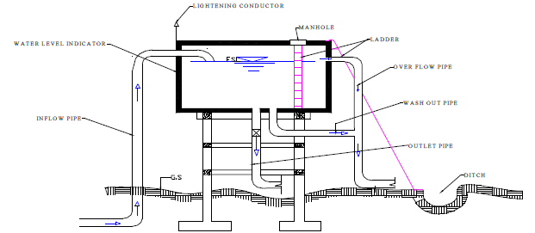

4.4 Pipes Used in the Water Distribution System
Pipe Materials
For use in transmission and distribution systems, pipe materials must have the following characteristics:
Adequate tensile strength and bending strength to withstand external loads.
High bursting strength to withstand internal water pressure
- Resistance to both internal and external corrosion.

The types of pipes used for distributing water include:
Cast iron pipe Steel pipe Concrete pipe Plastic pipe Asbestos cement pipe Copper pipe Lead pipe

A pipe material is selected based on various conditions:
Durability and period of life. Quality of water to be conveyed. Initial cost and maintenance cost.
Internal pressure in the pipe as well as external stresses due to overlying soil, traffic and impact load.

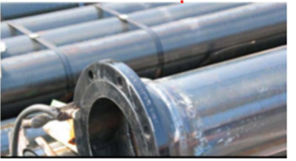
Asbestos cement pipes
Advantages
The inside surface of pipe is smooth The joining of pipes is very good and flexible The pipes are ant-corrosive and cheap in cost Light in weight to handle and transport
Disadvantage
The pipes are brittle The pipes are not durable
The pipes can be used only for very low pressure

Cast iron pipes
Advantages
The cost is moderate
The pipes are easily joined The pipes are not subjected to corrosion The pipes are strong and durable Service connections can be made easily
Disadvantage
The breakage of this pipe is large
Carrying capacity decreases with increase in life The pipes become heavy and uneconomical when their sizes increase (especially beyond 1200mm)
Cement Concrete Pipes
Advantages
The inside surfaces of the pipes can be made smooth The maintenance cost is very low
Under normal conditions the pipes are durable The pipes can be cast in place(in site)
Pipes can resist normal traffic loads when placed below roads There is no danger of rusting.
Disadvantage
If no reinforcement is provided they cannot resist high pressure The pipes are and difficult to transport
The pipes are likely to crack during transport and handling The repair of these pipes are difficult
These pipes are affected by acids, alkaline, and salty waters These pipes are likely to cause leakage due to porosit
Galvanized Iron Pipes
The pipes are cheap
Can be easily affected by acidic or alkaline water Short useful life
Advantages
Light in weight and easy to handle and transport Easy to join
Disadvantage
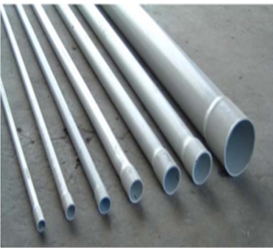Plastic Pipes
The pipes are cheap
The coefficient of expansion for plastics is high, the pipes are less resistant to heat
Advantages
The pipes are flexible and possess low hydraulic resistance (less friction)
They are free from corrosion
The pipes are light in weight and it is easy to bend, join and install them
The pipes up to certain sizes are available in coils and therefore it becomes easy to transport
Disadvantage
Some types of plastics may impart taste to the water
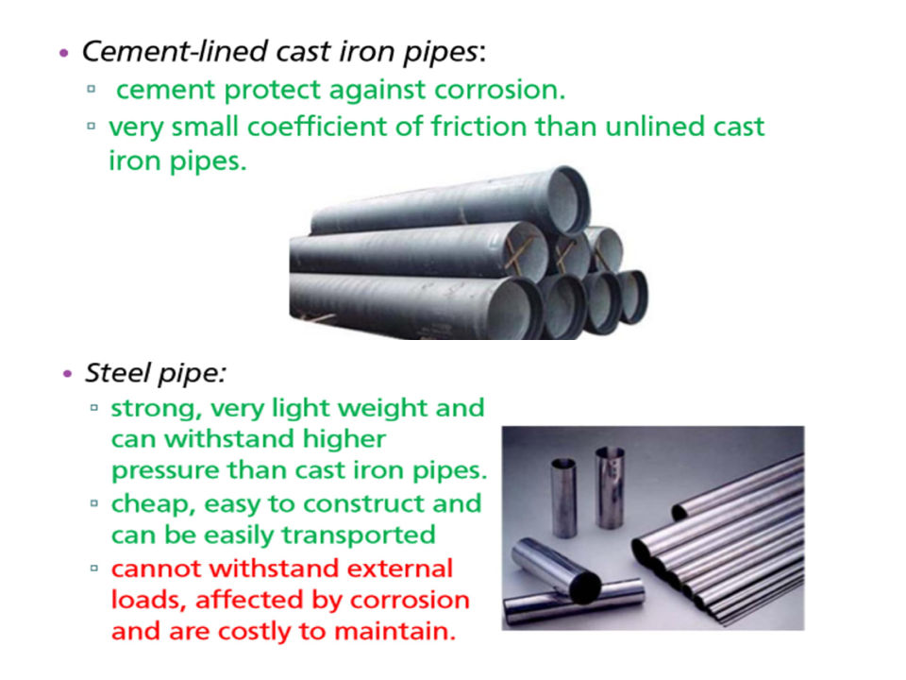
Design of distribution systems
Design flow: Max (Peak hour demand or maximum day demand + Fire demand)
Minimum main sizes: generally:150mm (6 in); high value districts: 200mm (8 in); major streets: 305mm (12 in); domestic flows only: 100mm (4 in); small communities: 50-75 mm
Velocity: typical values – minimum = 0.6 - 1 m/s; maximum = 2.5 m/s
Pressure: typical minimum value is 140 kPa (14 m) and maximum not to exceed 410 kPa (42 m).
