CHAPTER SIX
6.0 WATER QUALITY AND POLLUTION
Absolutely pure water is never found in nature and contains number of impurities in varying amounts. The rainwater which is originally pure also absorbs various gases, dust and other impurities while falling. This water when moves on the ground further carries salt, organic and inorganic impurities. So this water before supplying to the public should be treated and purified for the safety of public health, economy and protection of various industrial processes, it is most essential for the water work engineer to thoroughly check, analyze and do the treatment of the raw water obtained the sources, before its distribution. The water supplied to the public should be strictly according to the standards laid down from time to time.
3.1 Water Quality Characteristics
For the purpose of classification, the impurities present in water may be divided into the following three categories.
3.1.1 Physical Characteristics
Physical characteristics include:

- Turbidity
- Color
- Taste and odor
- Temperature, and
- Foam.

1. Turbidity
Turbidity is caused due to presence of suspended and colloidal solids. The suspended solids may be dead algae or other organisms. It is generally silt, clay rock fragments and metal oxides from soil.
The amount and character of turbidity will depend upon:
- The type of soil over which the water has run and
- The velocity of the water
When the water becomes quite, the heavier and larger suspended particles settle quickly, while the lighter and more finely divided ones settle very slowly. Very finely divided clay may require months of complete quiescence for settlement. Ground waters are normally clear because, slow movement through the soil has filtered out the turbidity. Lake waters are clearer than stream waters, and streams in dry weather are clearer than streams in flood because of the smaller velocity and because dry-weather flow is mainly ground water seepage.
Low inorganic turbidity (silt and clay) may result in a relatively high organic turbidity (color). The explanation of this is that low inorganic turbidity permits sunlight to penetrate freely into the water and stimulates a heavier growth of algae, and further, that organics tend to be absorbed upon soil fractions suspended in water.
Turbidity is a measure of resistance of water to the passage of light through it. Turbidity is expressed as NTU (Nephelometric Turbidity Units) or PPM (parts per million) or Milligrams per liter (mg/l).
Turbidity is measured by:
1) Turbidity rod or Tape
2) Jacksons Turbidimeter
3) Bali’s Turbidimeter
The sample to be tested is poured into a test tube and placed in the meter and a unit of turbidity is read directly on the scale by a needle or by digital display.
Drinking water should not have turbidity more than 10 NTU. This test is useful in determining the detention time in settling for raw water and to dosage of coagulants required to remove turbidity. Sedimentation with or without chemical coagulation and filtration are used remove it.
2. Color
Color is caused by materials in solution or colloidal conditions and should be distinguished from turbidity, which may cause an apparent (not true) color.
True color is caused by dyes derived from decomposing vegetation. Colored water is not only undesirable because of consumer objections to its appearance but also it may discolor clothing and adversely affect industrial processes.
Before testing the color of water, total suspended solids should be removed by centrifugal force in a special apparatus. The color produced by one milligram of platinum in a liter of water has been fixed as the unit of color. The permissible color for domestic water is 20ppm on platinum cobalt scale.
3. Temperature
Temperature increase may affect the portability of water, and temperature above 150c is objectionable to drinking water. The temperature of surface waters governs to a large extent the biological species present and thereof activity. Temperature has an effect on most chemical reactions that occur in natural water systems.
It also has pronounced effect on the solubility of gases in water.
4. Foam
Foam form various industrial waste contributions and detergents is primarily objectionable from the aesthetic standpoint.
5. Tastes and Odor
The terms taste and odor are themselves definitive of this parameter. Because the sensations of taste and smell are closely related and often confused, a wide variety of tastes and odors may be attributed to water by consumers. Substances that produce an odor in water will almost in variably impart a taste as well. The converse is not true, as there are many mineral substances that produce taste but no odor.
Many substances with which water comes into contact in nature or during human use may import perceptible taste and odor. These include minerals, metals, and salts from the soil, and products from biological reactions, and constituents of wastewater. Inorganic substances are more likely to produce tastes unaccompanied by odor. Alkaline material imports a bitter taste to water, while metallic salts may give salty or bitter taste.

Organic material, on the other hand, is likely to produce both taste and odor. a multitude of organic chemicals may cause taste & odor problems in water with petroleum-based products being prime offenders. Biological decomposition of organics may also result in taste-and odor producing liquids and gases in water. Principal among these are the reduced products of sulfur that impart a rotten egg taste and odor. Also certain species of algae secrete an oily substance that may result in both taste and odor.
Consumers find taste and odor aesthetically displeasing for obvious reasons. Because water is thought of as tasteless and odorless, the consumer associates taste and odor with contamination and may prefer to use a tasteless, odorless water that might actually pose more of a health threat.
3.1.2 Chemical Characteristics
1. Total Solids
Total solids include the solids in suspension colloidal and in dissolved form. The quantity of suspended solids is determined by filtering the sample of water through fine filter, drying and weighing. The quantity of dissolved and colloidal solids is determined by evaporating the filtered water obtained from the suspended solid test and weighing the residue.
The total solids in a water sample can be directly determined by evaporating the filtered water obtained from the suspended solid test and weighing the residue. The total solids in a water sample can be directly determined by evaporating the water and weighing the residue of the residue of total solids is fused in a muffle furnace the organic solids will decompose where as only inorganic solids will remain. By weighing we can determine the inorganic solids and deducting it from the total solids, we can calculate organic solids.
2. Alkalinity
It is defined as the quantity of ions in water that will react to neutralize hydrogen ions. Alkalinity is thus the measure of the ability of water to neutralize acids. By far the most constituents of alkalinity in natural waters are carbonate (CO3 ²⁻ ), bicarbonate (HCO3 ⁻) and hydroxide (OH-). These compounds result from the dissolution of mineral substances in the soil atmosphere.
Effects:
i) Non pleasant taste
ii) Reaction between alkaline constituent and cation (positive ion) produces precipitation in pipe.
3. PH
PH is a measure of the concentration of free hydrogen ion in water. It expresses the moral concentration of the hydrogen ion as its negative logarithm. Water and other chemicals in solution therein, will ionize to a greater or lesser degree. Pure water is only weakly ionized.
The ionization reaction of water may be written:
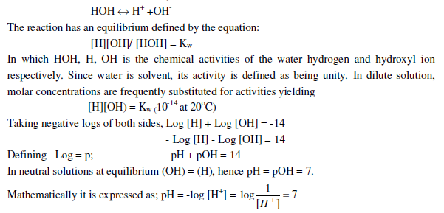
Increasing acidity leads to higher values of (H), thus to lower values of pH. Low pH is associated with high acidity, high pH with caustic alkalinity. pH is important in the control of a number of water treatment and waste treatment processes and in control of corrosion. It may be readily measured potentially by use of a pH meter.
4. Dissolved Oxygen (DO)
Dissolved oxygen is present in variable quantities in water. Its content in surface waters is dependent upon the amount and character of the unstable organic matter in the water. Clean surface waters are normally saturated with DO.
The amount of oxygen that water can hold is small and affected by the temperature. The higher the temperature, the smaller will be the DO. Gases are less soluble in warmer water.
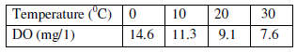
Oxygen saturated waters have pleasant taste and waters lacking in DO have an insipid tastes.
Drinking water is thus aerated if necessary to ensure maximum DO. The presence of oxygen in the water in dissolved form keeps it fresh and sparkling. But more quantity of oxygen causes corrosion to the pipes material.
Observing a heated pot of water, one can observe that bubbles form on the walls of the pot prior to reaching the boiling point. These cannot be filled with only water vapor because liquid water will not begin to vaporize until it has reached its boiling point. One can surmise that this gas is oxygen, or at least a mixture of gases from the air, because bubbles of this sort form in water from virtually every source: what other gas mixture besides air is in constant contact with water? When these bubbles form, they eventually grow to a sufficient size to leave the surface of the pot and escape to the air: the dissolved gas in the liquid has decreased. This seems to support the hypothesis that dissolved oxygen will decrease when temperature is increased.
5. Oxygen Demand
Organic compounds are generally unstable be oxidized biologically or chemically to stable, relatively inner end produce such as CO2, H2O & NO3. Indicators used for estimation of the oxygen demanding substance in water are Biological Oxygen Demand (BOD), Chemical
Oxygen Demand (COD), Total Oxygen Demand (TOD) and Total Organic Carbon (TOC).
An indication of the organic content of water can be by measuring the amount of oxygen required for stabilization.
BOD is the quality of oxygen required for the biochemical oxidation of the decomposable matter at specified temperature within specified time. (20ºC and 5 day)
It depends on temperature and time t.
6. Nitrogen
The forms most important to water quality engineering include;
- Organic – nitrogen: in the form of proton, amino acids and urea.
- Ammonia – nitrogen: nitrogen as ammonium salts. E.g. (NH4). CO3
- Nitrate- nitrogen: an intimidate oxidation stage. Not normally present in large quantity.
- Nitrate- nitrogen: final oxidation product of nitrogen.
- Gaseous nitrogen (N2)
The presence of nitrogen compounds in surface waters usually indicate pollution excessive amount of ammonia and organic nitrogen may result from recent sewage discharges or runoff contamination by relatively fresh pollution. Therefore, water containing high org-N & ammonia –N levels are considered to be potentially dangerous. While waters in which most of nitrogen is in nitrate from are considered to somewhat stabilized to constitute prior pollution.
7. Hardness
Hardness is caused by the sum of the alkali earth elements present in water although the major constituents are usually calcium and magnesium. These materials in water react with soap, causing precipitation which as scum or curd on the water surface. Until enough soap has been dissolved to react with all these material s, no lather can be formed. Water that behaves like this is said to be ‘hard ‘. The hardness compounds are temporary and permanent:
1. Temporary hardness (carbonate hardness)
- Calcium bicarbonate (Ca (HCO3) 2)
- Magnesium bicarbonate (Mg (HCO3) 2)
2. Permanent hardness’ (non- carbonate hardness)
- Calcium sulfate (CaSO4)
- Magnesium chloride (MgSO4)
- Calcium chloride (CaCl2)
- Magnesium chloride (Mg Cl2)

The most usual compounds causing alkalinity, calcium and magnesium bicarbonate, happen also to cause the temporally hardness. Hence, when the alkalinity and hardness are equal, all the hardness is temporary. If the total hardness is greater than the alkalinity, then the excess hardness represents permanent hardness. On the other hand, if the total hardness is less than the alkalinity, the difference indicates the presence of sodium bicarbonate, which adds to the alkalinity but doesn’t increase the hardness.
A generally accepted classification of hardness is as follows:
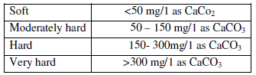
Generally a hardness of 100 to 150 mg/liter is desirable. Excess of hardness leads to the following effects:
1. Large soap consumption in washing and bathing
2. Fabrics when washed become rough and strained with precipitates.
3. Hard water is not fit for industrial use like textiles, paper making, dye and ice cream manufactures.
4. The precipitates clog the pores on the skin and make the skin rough
5. Precipitates can choke pipe lines and values
6. It forms scales in the boilers tubes and reduces their efficiency
7. Very hard water is not palatable
When softening is practices when hardness exceeds 300mg/lit. Water hardness more than
600mg/lit have to rejected for drinking purpose.
Methods of removal of hardness

1. Boiling
2. Lime addition
3. Lime soda process
4. Caustic soda process
5. Zeolite process

Methods 1 and 2 are suitable for removal of temporary hardness and 3 to 5 for both temporary and permanent hardness.

Boiling
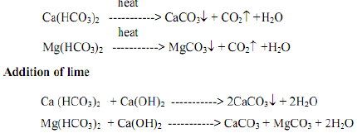
Lime soda process
In this method, the lime and is sodium carbonate or soda as have used to remove permanent hardness from water. The chemical reactions involved in this process are as follows
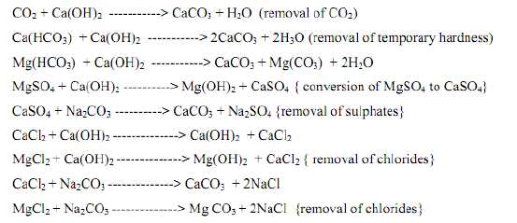
Zeolite process
This is also known as the base-exchange or Ion exchange process. The hardness may be completely removed by this process.
Zeolites are compounds (silicates of aluminum and sodium) which replace sodium Ions with calcium and magnesium Ions when hard water is passes through a bed of zeolites. The zeolite can be regenerated by passing a concentrated solution of sodium chloride through the bed. The chemical reactions involved are:
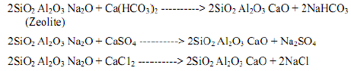

8. Chloride
The natural waters near the mines and sea dissolve sodium chloride and also presence of chlorides may be due to mixing of saline water and sewage in the water. Excess of chlorides is dangerous and unfit for use. The chlorides can be reduced by diluting the water. Chloride may demonstrate an adverse physiological effect when present in concentration greater than 250mg/l and with people who are acclimated. However, a local population that is acclimated to the chloride content may not exhibit adverse effect from excessive chloride concentration. Because of high chloride content of urine, chlorides have sometimes been used as an indication of pollution.
9. Fluoride
It is generally associated with a few types of sedimentary or igneous rocks; fluoride is seldom found in surface waters and appears in ground water in only few geographical regions. Fluoride is toxic to humans and other animals in large quantities, while small concentrations can beneficial.
Concentrations of approximately 1.0mg/1 in drinking water help to prevent dental cavities in children. During formation of permanent teeth, fluoride combines chemically with tooth enamel, resulting in harder, stronger teeth that are more resistant to decay. Fluoride is often added to drinking water supplies if quantities for good dental formation are not naturally present.
Excessive intakes of fluoride can result in discoloration of teeth. Noticeable discoloration, called mottling, is relatively common when fluoride concentrations in drinking water exceed 2.0mg/1, but is rare when concentration is less that 1.5mg/1.
Adult tooth are not affected by fluoride, although both the benefits and liabilities of fluoride during teeth formation years carry over into adulthood. Excessive concentrations of greater than 5mg/1 in drinking water can also result in bone fluorisis and other skeletal abnormalities.
10. Metals and other chemical substances
Water contains various minerals or metal substances such as iron, manganese, copper, lead, barium, cadmium, selenium, fluoride, arsenic etc.
The concentration of iron and manganese should not allow more than 0.3ppm. Excess will cause discoloration of clothes during washing and incrustation in water mains due to deposition of ferric hydroxide and manganese oxide. Lead and barium are very toxic, low p.p.m of these are allowed. Arsenic, Selenium are poisonous, therefore they must be removed totally.
Human beings are affected by presence of high quantity of copper in the water.
3.1.3 Biological Characteristics
A feature of most natural water is that they contain a wide variety of micro – organisms forming a balance ecological system. The types and numbers of the various groups of micro – organisms present are related to water quality and other environmental factors.
Microbiological indicators of water quality or pollution are therefore of particular concern because of their relationships s to human and animal health. Water polluted by pathogenic micro- organisms may penetrate into private and or public water supplies either before or after treatment.
- Bacterium
Many are found in water. Some bacteria are indicator of pollution but are harmless; other few in number are pathogenic. Bacterial-born diseases include: typhoid fever, cholera, and bacterial dysentery:
2. Viruses
These are group of infectious which are smaller than ordinary bacteria and that require susceptible host cells for multiplication and activity. Viral-borne diseases include infectious hepatitis and poliomyelitis.
3. Algae
These are small, Chlorophyll bearing generally one–celled plants of varying shapes and sizes which live in water. When present in large numbers they may cause turbidity in water and an apparent color. They cause trouble in water works by undue clogging of filters, but their most troublesome characteristics in the taste and odor that they may cause
4 protozoa
They are the lowest and simplest forms of animal life. Protozoa–borne diseases include giardiasis and amebic dysentery.
3.3. Examination of Water Quality
Examination of water is made to help informing an opinion of the suitability of a water supply for public and other uses.

1. Sampling
Necessary to obtain a representation sample in a quantity sufficient for analysis complete preservation of sample is practically impossible; however, freezing or adding suitable preservatives may slow down changes in composition. Plastic, glass or metal sample containers are able introduce contamination to sample. Normally plastics are used for chemical analysis (except for oil & grease) and glass for bacteriological analysis.
2. Standard Tests
i. Titration (volumetric) method
Using burettes, pipits, and other volumetric glass ware, standard solutions are prepared using analytical and distilled water.
The recommended determinations to be made by titration method are: Chloride (Cl⁻), carbonates (CO3²⁻), bicarbonates (HCO3), DO, BOD, COD, calcium (Ca++), magnesium (Mg++), bromide (Br), hydroxide (OH-), sulfide(S⁻), sulfite (SO3²), acidity, alkalinity etc.
ii. Colorimetric method (using color as the basis)
Is the measuring amount of color produced by mixing with reagents at fixed wavelength (using Spectro photometer) or comparison with colored standards or discs (comparator).
The recommended determinations made by colorimetric method are: color, turbidity, iron
(Fe++), manganese (Mn++), chlorine (Cl2), flurried (F-), nitrate (NO3⁻), nitrite (NO2), phosphate (PO4-), ammonia (NH4+), arsenic, phenols, etc.
iii. Gravimetric method (using weight as the basis)
Using weight of insoluble precipitates or evaporated residues in glassware or metal and accurate analytical balance
The recommended determinations made by gravimetric methods are: sulfate (SO4), Oil and grease, TDS, TSS, TS, etc.
iv. Electrical method
Is using probes to measure electrical potential in mill volts against standard cell voltage.
The recommended determinations made by electrical methods are: pH, Fluoride (F-), DO, nitrate (NO3), etc.
v. Flame spectra (emission & absorption) method
At fixed wave length characteristics to ions being determined measuring intensity of emission or absorption of light produced by ions exited in flame or heated sources.
The recommended determinations made by flame spectra methods are: sodium (Na+), potassium (K+), lithium (Li+), etc.
3.4. Water Quality Standards
Public water supplies are obliged to provide a supply of wholesome water which is suitable and safe for drinking purposes.
Potable water is water which is satisfactory for drinking, culinary and domestic purposes.
Water quality standards may be set regional, national, or international bodies. Guidelines for drinking water quality have established by the World Health Organization (WHO) as shown in table below.
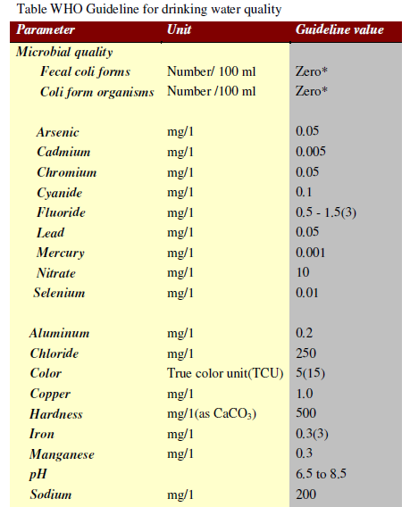
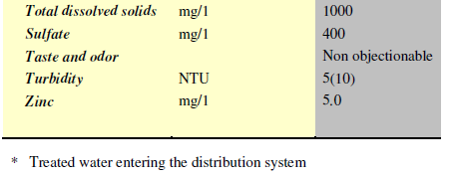
3.5. Sources of Water Pollution
Following are the main sources of water pollution.
1. Domestic Sewage
If domestic sewage is not properly after it is produced or if the effluent received at the end of sewage treatment is not of adequate standard, there are chances of water pollution.
The indiscriminate way of handing domestic sewage may lead to the pollution of underground sources of water supply such, as wells. Similarly if sewage or partly treated sewage is directly discharged into surface waters such as rivers, the waters of such rivers get contained.
2. Industrial Wastes
If industrial wastes are thrown into water bodies without proper treatments, they are likely to pollute the watercourses. The industrial wastes may carry harmful substances such as grease, oil, explosives, highly odorous substances, etc.
3. Catchment Area
Depending upon the characteristics of catchment area, water passing such area will be accordingly contained. The advances made in agricultural activities and extensive use of fertilizers and insecticides are main factors, which may cause serious pollution of surface waters.
4. Distribution System
The water is delivered to the consumers through a distribution of pipes which are laid underground. If there are cracks in pipes or if joints are leaky, the following water gets contaminated by the surrounding substances around the pipes.
5. Oily Wastes
The discharge of oily wastes from ships and tankers using oil as fuel may lead to pollution.

6. Radioactive Wastes
The discharge of radioactive wastes from industries dealing with radioactive substance may seriously pollute the waters. It may be noted that radioactive substances may not have color, odour, turbidity or taste. They can only be detected by and measured by the use of special precise instruments.
7. Travel of Water
Depending upon the properties of ground through which water travels to reach the source of water supply; it is charged with the impurities. For instance, ground water passing through peaty land possesses brown color.

