2.6.2 Determination of Pipe Sizes
The size of the pipe is determined by considering the discharge through the pipe and permissible velocity of the flow in the pipe.
Q = A*V
Where, Q = discharge (m3/s)
V = permissible velocity (0.6 to 1.50m/s)
A = Cross sectional area of pipe (m2)
The size of the pipe used in the water distribution system can be determined by one of the following formulas:
- Darcy –Weisbach formula;
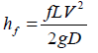
- Hazen-Williams formula;
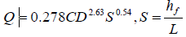
- Manning’s Formula;
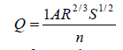
* The most common pipe flow formula used in design and evaluation of a water distribution system is the Hazen-Williams’ formula.
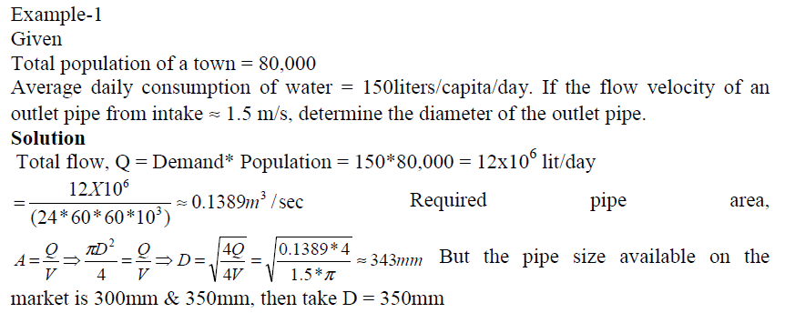

Example 2
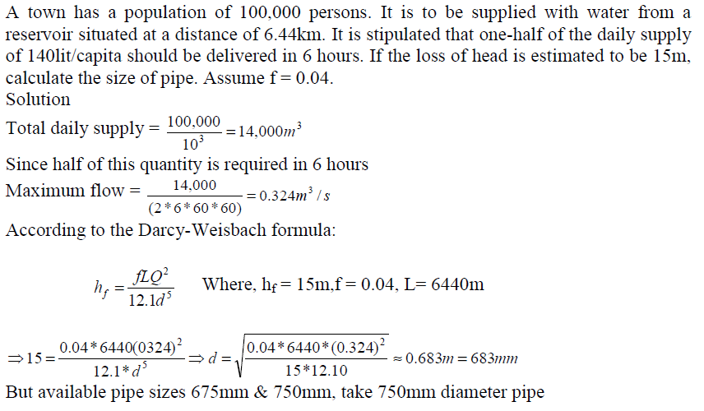

b) What size of pipe line (L = 1000m) should be used to supply 100l/s so that the head loss does not exceed 10m. Use both the three formula, C= 100, n = 0.013, f = 0.035, find also the velocity.
2.6.3 Energy Losses in Pipes
Energy loss (head loss) in pipes can be found by one of the following formulas:
- Darcy-Weisbach formula
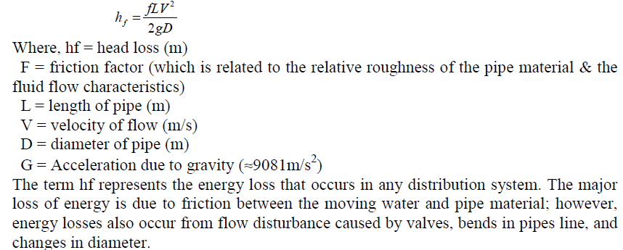

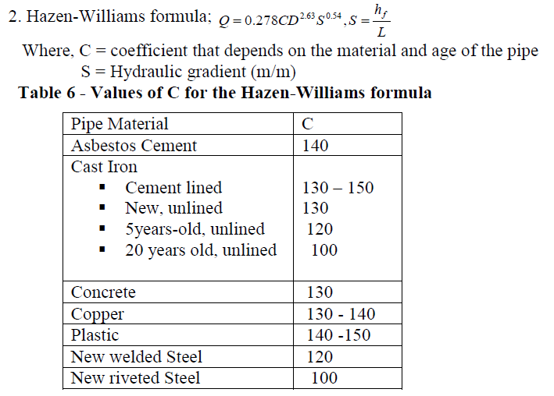
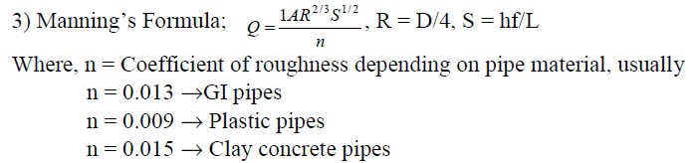

2.6.4 Pipe Appurtenances Valves.
Used to isolate and drain pipe line sections for test, inspection, cleaning and repair
i.) Gate valves. Are installed in every main and sub-main to isolate a portion of the network system during a repair.
i) Check-valves (Non-Return valves). Are generally used to prevent reversal of flow when a pump is shot down
ii) Air-Relief Valves. In long pipes lines air will accumulate in the high points (summits) of the line and may interfere with the flow. It is necessary, therefore, to place air relief valves at those points where trouble is expected.
iii) Pressure regulating valves. These valves automatically reduce pressure on the d/s side to any desired magnitude and are used on lines entering low areas of a city, without such reductions pressures would be too high.
iv) Sluice Gates. Are vertically sliding valves which are used to open or close openings in to walls.
a. Fire hydrants. It is used on mains to provide a connection for fire hazards to fire fighting
b. Water meters. In most cities, the water furnished to a consumer is measured, and the consumer charged accordingly to the amount of water consumed.

Assignment
- Write the purpose of service reservoirs.
- Compare and contrast services reservoir with elevated reservoirs.
- Isn’t determination of distribution Pipe size is depend on Either demand of customers per day or amount of water from a source?

