Ambo University Woliso Campus
School of Technology and Informatics
Department of Civil Engineering

HYDRAULLIC STRUCTURES I
LECTURE NOTE

Kamel Jambo

Woliso

May 2020

Course outline
Course Objective
This course provides a broad understanding of the basic principles of hydraulic structures. The emphasis is on design and analysis of different types of dams and spillways. Computer applications included.

Course Content
6. Spillways, Energy Dissipators,
Intake and Outlet works
- Types
- Design
7. Stable channel Design
and Stream diversion
- Definition
- Forces acting on
- Combination of loads on
- Types and Causes of failure
- Design Principle
- Principal and Shear stresses
- Elementary profile of
- Stress intensities
- Stability analysis
- Merits and Demerits of
1. Introduction
- Types of dams
- Characteristics of dams
- Reservoir planning
- Hydrology and geology Investigation
- Topography, Geology, Sociology
- Resource
- Budget Inventory
- Feasibility
2. Foundation of dams
- Gravity Dam

- Arch and Buttress Dams
5. Embankment Dams

Reference Books:
- P. Novak, Hydraulic Structures
- S. R. Sahasrabudhe, Irrigation Engineeering and Hydraulic Structures
- S. K. Garg Irrigation Engineering and Hydraulic Structures
- V. T. Chow, Open Channel Hydraulics
- USBR, Design of Small Dams

Instructor
Kamel J. (Ato).
E-mailkemaljambo1 @gmail.com
Tel.+251- 941717386(Mob.)

Contents

1.Introduction
  - General
  - Types of dams
  - Characteristics of dams
  - Reservoir Planning
  - Hydrology and geology
  - Environmental, Social, Economical and Political investigation
  - Location criteria for dam and spillway site
  - Dam site investigation
  - Data collection
  - Site Requirement
  - Stages in Project Planning and Implementation
- Foundations of Dams and their Treatment
  - General
  - Rock foundation
    - General
    - Foundation treatment
    - Measures against leakage
    - Drainage
    - Stability of Dams and Strength of Rock Foundation
  - Earth foundation
    - General
    - Gravel and sand foundation
    - Estimation of seepage amount
    - Piping
    - Uplift pressure and control of seepage
    - Theories of Seepage Flow
    - Uplift pressure and seepage under masonry structures on pervious foundations 2.3.8 Silt and clay foundation
- Concrete Gravity Dam
  - General
  - Forces acting on gravity dams
    - Water pressure
    - Wight of Structure
    - Earth and silt pressure
    - Wind pressure
    - Wave pressure and wave height
    - Earthquake forces
  - Load combination for Design
  - Reaction of the foundation
  - Rules Governing the Design of Gravity Dams
  - Theoretical versus practical section of a dam
  - Design procedure of gravity dams
    - Design methods
    - Multiple step method of determining profile of gravity dam
    - Single Step Method
  - Gravity dam Construction, Quality control and the Future
    - The Construction Process
    - Quality Control
    - The Future
- Concrete Arch and Concrete Buttress dams
  - Concrete Arch Dam
    - Constant radius arch dam
    - Constant Angle Arch dam
    - Variable radius arch dam
    - Loads on arch dam
    - Methods of design of massive arch dams
    - The thin cylinder theory
    - Design procedure for variable radius arch dam
    - Elastic arch theory (Arch dam analysis)
  - Buttress dams
    - Classification of buttress dams
    - Advantages and Disadvantages of Buttress Dams
    - Forces on buttress dams
    - Design Principle for Buttress Dams
- Embankment Dam
  - Introduction
  - Key elements and appurtenances of Embankment dam
    - Foundation
    - Core or membrane
    - Shell
    - Height of dam
    - Top Width
    - Appurtenances
  - Types of Embankment dam
  - Causes of Failure of Embankment dams
  - Design features
  - Seepage analysis
  - Determination of Phreatic Lines
  - Stability analysis
    - Stability of side slopes of earth dam
    - Stability of earth dam against horizontal shear developed at the base of the dam
  - Foundation analysis
  - Internal drainage system
- Spillways
  - General
  - Types of Spillway
    - Free overfall (straight drop) spillway
    - Ogee (overflow) spillway
    - Side channel spillway
    - Siphon spillway
    - Chute spillway
    - Shaft spillway
  - Spillway Crest Gates
  - Spillway design
    - Background
    - Stilling Basin
References

Introduction

General
Hydraulic Structures are engineering constructions designed and mechanically fit for managing and utilizing water resources to the best advantage of the human being and environment.
Dam is a barrier across flowing water that obstructs, directs or retards the flow, often creating a Reservoir.
Reservoir is an artificial lake created by flooding land behind a dam. Some of the world's largest lakes are reservoirs.
Spillway is a section of a dam designed to pass water from the upstream side of a dam to the downstream side. Many spillways have gates designed to control the flow through the spillway.
Flood is an overflow or an expanse of water submerging land.
Dams differ from all other major civil engineering structures in a number of important regards:
- Every dam, large or small, is quite unique; foundation geology, material characteristics, catchment flood /hydrology etc. are each site-specific.
- Dams are required to function at or close to their design loading for extended periods.
- Dams do not have a structural lifespan; they may, however, have a notional life for accounting purposes, or a functional lifespan dictated by reservoir sedimentation.
- The overwhelming majority of dams are of earth fill, constructed from a range of natural soils; these are the least consistent of construction materials.
- Dam engineering draws together a range of disciplines, e.g. Structural and fluid mechanics, geology and geo technique, flood hydrology and hydraulics, to a quite unique degree.
- The engineering of dams is critically dependent upon the application of informed engineering judgment.
Hence the dam engineer is required to synthesize design solutions which, without compromise on safety, represent the optimal balance between technical, economic and environmental considerations.

Types of dams
Dike is a stone or earthen wall constructed as a defense or as a boundary.
The best known form of dyke is a construction built along the edge of a body of water to prevent it from flooding onto adjacent lowland.
Levee is a natural or artificial structure, usually earthen, which parallels the course of a river. It functions to prevent flooding of the adjoining countryside. However it also confines the flow of the river resulting in higher and faster water flow.
Weir is a small overflow type (designed to be overtopped) dam commonly used to raise the level of a small river or stream. Water flows over the top of a weir, although some weirs have sluice gates which release water at a level below the top of the weir.
Check dam is a small dam designed to reduce flow velocity and control soil erosion
Diversion dam is a type of dam that diverts all or a portion of the flow of a river from its natural course
Masonry dam is a type of dam constructed with masonry. It is made watertight by pointing the joints with cement. A plaster of cement is also applied. The interior could be either in coursed masonry or rubble masonry.

Dams may be classified according to
- Material of construction,
- structure,
- intended purpose or height;

Hence, no classification is exclusive.
- Classification according to material of construction
- Timber dams
- Steel dams
- Concrete dams
- Earth dams
- Rockfill dams
- Combined dams

Classification according to design criteria

Hydraulic design Stability consideration
Non-overflow dams Gravity dams Overflow dams Non-gravity dams
Composite dams Classification according to Purpose
Storage dams Stage control dams Barrier dams Flood control Diversion Levees and dykes
Water supply Navigation Coffer dams
Detention storage

Classification according to height (H) H ≤ 30m low dam
30 ≤ H ≤ 100m medium
H ≥ 30m high dam
When the size of the dam has been determined, the type of dam envisaged requires certain geological and topographical conditions which, for the main types of dams, may be stated as follows.
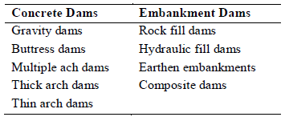

Characteristics of dams
Coffer dam is a temporary structure constructed of any material like timber, steel, concrete, rock or earth. It is built to enclose certain work site or to divert the flow to enable construction activity in the main river channel. After the main structure is built (bridge, barrage or dam) either the coffer dam is dismantled or it becomes part6 of the structure if the design so provides.
Gravity Dams
Stability is secured by making it of such a size and shape that it will resist overturning, sliding and crushing at the toe. to prevent tension at the upstream face and excessive compression at the downstream face, the dam cross section is usually designed so that the resultant falls within the middle third at all elevations of the cross section
Good impervious foundations are essential
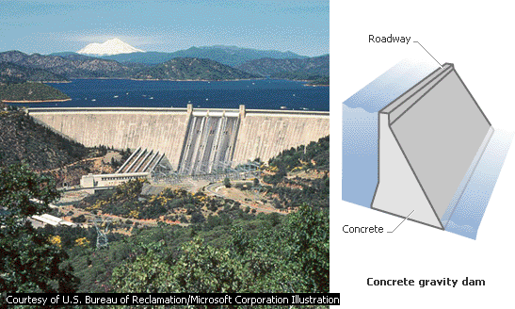
Inspires more confidence in the layman than any other type; it has mass that lends an atmosphere of permanence, stability, and safety

Figure 1-1 Example of concrete Gravity dam

The dam will not overturn provided the resultant force falls within the base.
Gravity dams are classified as "solid" or "hollow." The solid form is the more widely used of the two, though the hollow dam is frequently more economical to construct. Gravity dams can also be classified as "overflow" (spillway) and "non-overflow."
Buttress Dams
    - The buttress dam is suitable where the rock is capable of bearing pressures of 2 - 3 MPa.
    - Buttress dams require between one thirds and half of the concrete required for a gravity section, hence making it more economical for dams over 14m.
    - Additional skilled labor is required to create the formwork.
    - Threat of deterioration of concrete from the impounded water is more likely than from a thick gravity section.
    - There is also an elimination of a good deal of uplift pressure, the pressure resulting from the water in the reservoir and possibly of water from the hillside rocks gaining access through or under any grout curtain and exerting upwards underneath the mass concrete dam.
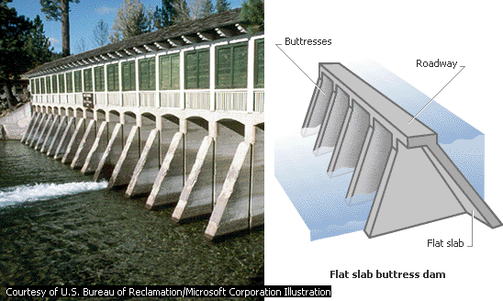

Lake Tahoe Dam impounds the Truckee River in northern California. Like all flat slab buttress dams, it has a flat slab upstream face supported by a series of buttresses on the downstream side. Lake Tahoe Dam measures 5.5 m tall and 33 m long. It was completed in 1913 to raise the water level in Lake Tahoe, a natural lake, to provide additional water for crop irrigation.
Figure 1-2 Profile of buttress dam

Arch dam
    - Stability is obtained by a combination of arch and gravity action
    - Utilizes the strength of an arch to resist loads placed upon it by 'arch action'
    - The foundations and abutments must be competent not only to support the dead weight of the dam on the foundation but also the forces that are directed into the abutments because of arch action in response to the forces acting on the dam.
    - The strength of the rock mass at the abutments and immediately down valley of the dam must be unquestionable and its modulus of elasticity must be high enough to ensure deformation under thrust from the arch is not so great as to induce excessive stresses in the arch

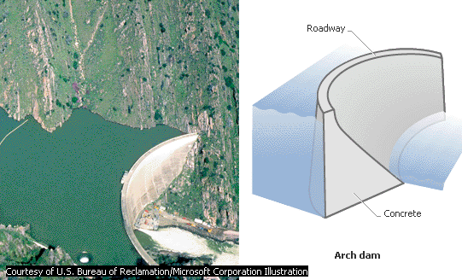

Monticello Dam impounds Putah Creek west of Sacramento, California. The solid concrete structure stands 93 m tall. The dam’s arched upstream face transfers some of the pressure from its reservoir, Lake Berryessa, onto the walls of the canyon. This design enables an arch dam to be much less massive than an equivalent gravity dam, which relies solely on the force of its weight to hold back the water in a reservoir. While Monticello Dam measures 30 m at its base, an equivalent gravity dam might be more than five times as thick at the base.
Figure 1-3 Sample of Arch dams

Rockfill dams
    - Can be built where the following conditions exist -
    - Uncertain or variable foundation which is unreliable for sustaining the pressure necessary for any form of concrete dam.
    - Suitable rock in the vicinity which is hard and will stand up to variations of weather.
    - An adequate amount of clay in the region which may be inserted in the dam either as a vertical core or as a sloping core.
    - Accessibility of the site and the width of the valley is suitable for the manipulation of heavy earth-moving machinery, caterpillar scrapers, sheepfoot rollers and large bulldozers.
Hydraulic Fill Dams
Hydraulic fill dams are suitable in valleys of soft material and are constructed by pumping soft material duly consolidated up to moderated heights up to 30m.
A hydraulic fill is an embankment or other fill in which the materials are deposited in place by a flowing stream of water, with the deposition being selective. Gravity, coupled with velocity control, is used to effect the selected deposition of the material.

Earthen Embankment dams
Near the site there must be clay to fill the trench and embanking material capable of standing safely, without slipping, to hold up a clay core.
An advantage of earthen embankments is that troubles due to the deterioration of the structure by peaty waters of low pH do not arise.

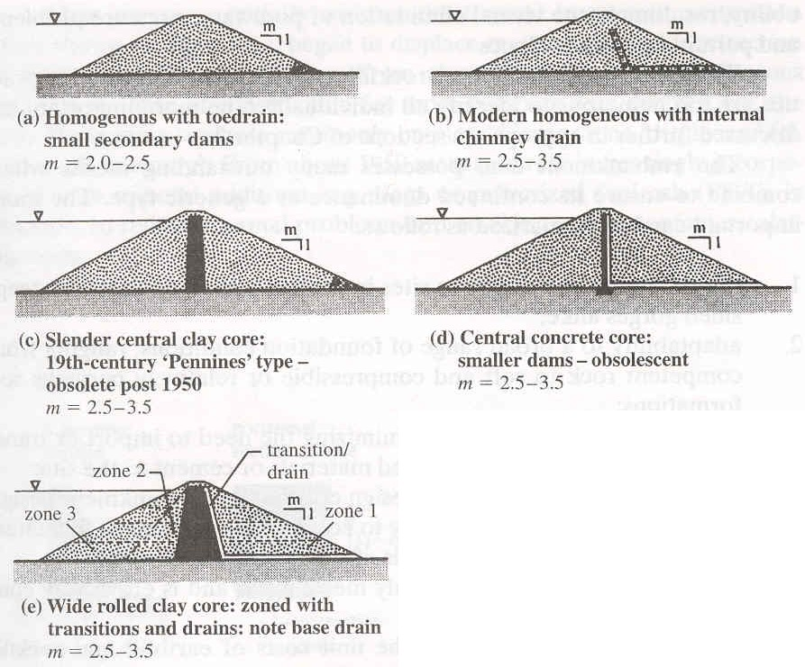

Figure 1-4 Typical profiles of Earth dam

Rock-fill dams
are embankments of loose rock with either a watertight upstream face of concrete slabs or timber or a watertight core
Where suitable rock is at hand, a minimum of transportation of materials can be realized with this type of Resist damage from earthquakes quite well.
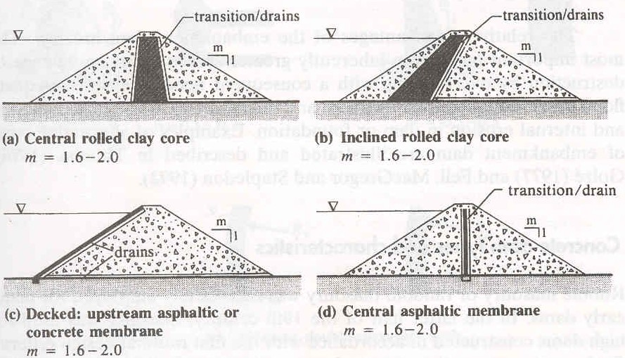
Figure 1-5 Typical profile of Rock fill dams
Composite Dams
Not only can different types of dam can be built in the same valley, but the same dam can be of different types owing to the varying geological and topographical features of the dam site.
Many buttress dams also join up with gravity mass concrete dams at their haunches at the sides of the valley, and again at the centre have a mass concrete gravity dam to form a suitable overflow or spillway.
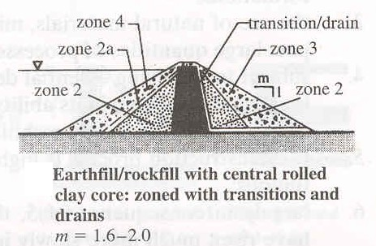

Figure 1-6 Profile of Composite dam

Reservoir Planning
The absence of natural storage of adequate capacities necessitates construction of some artificial storage works. Development of natural storages may also be included in this category sometimes (Cherecherea weir at Lake Tana). In rainy season there is excess flow down the valley in a river. An impounding

reservoir can be constructed in the valley to store this excess water which will meet the demand in dry periods.
Storage works may be designed and constructed to serve single or multipurpose. The various purposes for which storage works are required are mentioned below
- Irrigation
- Hydro-electric power generation,
- control of destructive floods
- Low water regulation for navigation
- Domestic and industrial water supply
- Recreation
- Preservation and breeding of useful aquatic life, etc.
Before any dam is built, certain hydrological information is necessary regarding river discharge, rate and character of siltation, and the location and duration of flooding. A critical concern in rivers is the magnitude and duration of discharge with respect to time. Feasibility studies are necessary in assessing the water budget for future industrial operations. Relevant studies involve meteorological monitoring, hydrological measurements, reservoir capacity, safe yield, and flood frequency. Questions that need to be confronted during dam site investigation include the depth at which adequate foundation materials exist, the strength of the rocks and soils, and the likelihood of water leakage.
By analysis of storage data, availability of water is ascertained before any project is contemplated. The next step in reservoir planning is to fix the reservoir capacity. The reservoir has to provide sufficient storage for various purposes, namely
- Dead storage to contain silt deposition,
- Storage to account for evaporation loss
- Live storage to meet the downstream demands for irrigation domestic or industrial supply, power generation, etc.
- Storage to act as flood protection.
The basis of fixing storage capacity for dead storage and evaporation loss depends upon the amount of incoming sediment and the annual evaporation loss respectively. Requirement for flood protection depends on the intensity and volume of flood flow. The live storage capacity of a reservoir depends on the demand for various purposes. It can be arrived at by plotting the mass curves of demand and inflow of accumulated flow or rainfall plotted against time. The capacity of the reservoir is fixed in such a way as to take care of the demands during the minimum flow period in the driest year on record. In some cases it is necessary to cover a period of successive dry years to consider storing of sufficient water to meet the demand during periods of prolonged drought.

Hydrology and geology
The hydrological and geological or geotechnical characteristics of catchment and site are the principal determinants establishing the technical suitability of a reservoir site. The hydrology of the catchment indicates the available quantity and quality of water to be stored in the reservoir. The geology of the site is one of the important aspects to be investigated for a dam to take decision about selection and location of the reservoir and the type, and size the dam. More discussion will be made in the following sections about the hydrology and geology considerations for dam design.

Ambo University Woliso Campus Hydraulic Structures I

Reservoirs capacity determination partially procedure.
To select ten consecutive years which relatively show dry periods, plot the annual average flow for the entire data.
1999
1994
1989
1984
Year
1979
1974
1969
250

200

150

100

50

0
1964
Average annual flow
Flow (m³/s)

Figure 1-7 Annual average flow
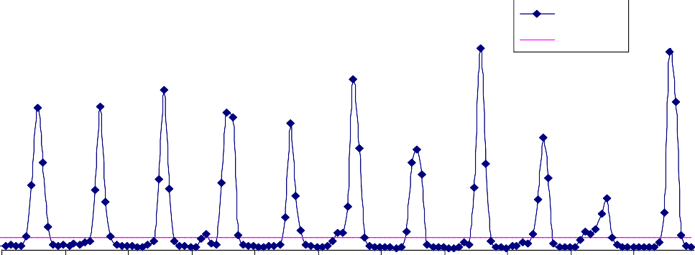From the plot it can be seen that the flow record from 1978-1988 can be taken as a critical period and be used for further analysis and determination of reservoir capacity.
Jan-78 Jan-79 Jan-80 Jan-81 Jan-82 Jan-83 Jan-84 Jan-85 Jan-86 Jan-87 Jan-88
Tim e
flow
demand
800
700
600
500
400
300
200
100
0
10 years flow hydrograph
Flow (m3/s)

Figure 1-8 Critical dry period hydrograph from data series
The 10 year flow hydrograph indicates a dry period to be used in the mass curve analysis. This dry period is from January 1986 to January 1989. For this specific period the mass curve is plotted as shown below.
To know the capacity of the reservoir needed to meet the demand, the reservoir can be considered as full or empty at the beginning. Assuming that the reservoir is full at the beginning, move the demand line in a way that it forms tangent line that do not intersect the inflow mass curve of the previous period. The point at which the tangent line crosses the inflow mass curve is where the reservoir fills again. If the line never intersects the curve this means that the reservoir will never be full within the time frame considered.

May 20 9

Volume (Mill M³)

Ambo University Woliso Campus Hydraulic Structures I

Figure 1-9 Mass Curve diagram for reservoir capacity
Dec-88
Jun-88
Dec-87
Jun-87
Time (months)
Dec-86
Jun-86
0
Jan-86
1000
2000
3000
4000
5000
Inflow
Demand_1 Tang 2 Dem_2 Tang 3 Dem_3
8000

7000

6000
9000
Mass curve

May 20 10

Environmental, Social, Economical and Political investigation
The environmental, economic and other socio-political issues associated with reservoir development must in all instances be acknowledged at the outset and fully addressed thereafter. This is especially important in the case of the larger high-profile projects and all other, large or lesser, sited in environmentally or politically sensitive locations.
Environmental impacts and other socio-political considerations can extend across a diverse spectrum of issues. Socio-political considerations may range from population displacement, with consequent economic impacts, to the preservation of cultural or heritage sites; from the consequences of sedimentation and/or of changing flood regimes to altered patterns of disease.
It is necessary to examine the complex relationships between human society and its surrounding environment, paying particular attention to issues relating to the local and regional environment, especially the use and misuse of water resources and the policies governing resource use.
Various types of surveys based on functional and technical requirements should be carried out for selecting a site for the dam and reservoir. Functional suitability of a site is governed by the balance between its natural physical characteristics and the purpose of the reservoir. Catchment hydrology, available head and storage volume etc. must be matched to operational parameters set by the nature and scale of the project served. Technical acceptability is dictated by the presence of a satisfactory site for a dam, the availability of materials suitable for dam construction, and by the integrity of the reservoir basin with respect to leakage. To these must be added an assessment of the anticipated environmental consequences of construction and operation of the dam.

Location criteria for dam and spillway site
While selecting a site for a dam the following points should be taken into consideration
- The dam should be as near as possible to the area to be served, hence conveyance cost and water losses will be minimized.
- Foundation area should be impervious and should be able to support the weight of the dam.
- The topography of the dam and reservoir sites should permit maximum storage of water at minimum cost.
- Materials of construction should be available in sufficient quantity and good quality at a reasonable distance.
- The value of property and land which will be submerged by the reservoir has to be as small as possible.
- The cost of relocating roads, buildings etc. should be as small as possible
- The cost of stream diversion and dewatering the site should be as small as possible
- Transportation facilities and accessibility of the site
- Availability of suitable sites for construction equipment and camps
- The safety of the structure.
While selecting a site for spillway the following points should be taken into consideration
- The spillway must be a part of the dam itself (not for embankment dams) or it may be located at a separate site,
- The location depends on the foundation and the topography of the area. Good rock foundation is always desirable and the topography should permit easy diversion of the flood waters passing over the spillway, back into the original stream channel.

Dam site investigation
The items of investigation required mainly for a dam structure are listed below:
- General planning and preparation of location maps: before undertaking actual investigation it is necessary to prepare location maps indicating
  - likely dam and spillway site,
  - proposed relocation of approach roads,
  - quarry sites for construction material,
  - stream gauging stations,
  - proposed camp site,
  - existing utilities like lines of communication, transmission lines, rail/road communication,
  - Other important features.
- Hydrologic investigation:
  - collection and analysis of stream flow and precipitation records,
  - assessment of available yield, estimation of flood peaks,
  - determination of spillway capacity and
  - Ground water studies.
- Topographic survey:
  - Detailed survey for the dam site covering sufficient area on the u/s and d/s as well as above the likely height of the dam on both the banks,
  - Detailed survey for areas proposed for constructing spillway, diversion tunnels, outlets, power houses etc
  - Preparation of detailed maps to various scales based on the data collected.
- Surface geologic investigation:
  - identification of boundary and nature of deposits and overburden;
  - the characteristic, structure, strike of rock beds;
  - Shape and magnitude of folds and fault zones.
- Subsurface or foundation exploration:
  - sinking open pits,
  - drilling holes,
  - driving shafts and drifts,
  - Geophysical prospecting using latest techniques.
- Seismic surveys.
- Construction material survey:
  - location and estimate of quantities of available construction material,
  - estimates need to be supported by laboratory tests to determine suitability of various materials for construction of dam and other structures.

Data collection
The collection of relevant data is the first state in the formulation of a project.
- Physical data General plan
  - obtain a general plan of the catchment and project area
  - carryout limited surveys to include additional information in this plan
  - the plan must include the dam site, spillway site, irrigable area, catchment area of the stream, locality to be supplied with potable water (if any) map scale may vary from 1:1000 – 1:10,1000
  - features to be included in the map

    - contour at 0.5 – 1.5m interval
    - location of existing works, if any, affected by the proposed development,
    - Proposed relocation of roads, railways, transmission lines, etc.
    - Additional transportation facilities such as access roads, cableways, etc. required for the execution of the project.
    - Location of stream gauging station, water sampling and meteorological stations, if any, in the area.
Larger plans for dam and spillway sites
    - This should be in the scale of 1:500 – 1:1000 with contours as small as possible
    - The plans should show the following
      - Over-banks
      - Location of elevation of all features such as buildings, roads, etc.
      - Location and number of test pits and boreholes
- hydrologic data
  - data needed:
  - Monthly flow, momentary peak flow of a stream at or near the dam site
  - Annual sediment load
  - If available, the following information is necessary
- Maximum observed flood level in the system
- Report on damage caused by flooding
- Data for estimating water demand
  - # of people to be served
  - approximate maximum and minimum daily water demand
  - irrigation water requirement
  - Other water requirements (industries, livestock, etc.)
- Meteorological Data
  - Average monthly temperature
  - Average monthly rainfall
  - Maximum recorded storm intensities
  - Annual rate of evaporation
- Geologic Data: geological map of the entire catchment area.
  - Dam and Spillway sites
  - Geologic map is essential
  - Subsurface investigation should be carried out by an experienced geologist
- geologic sections of selected dam site
- quality of the overburden material if an earth dam is to be built
  - shearing strength of the overburden material and the dam material
  - permeability of the overburden material
  - quantity and quality of the overburden material for construction purposes
  - Presence, orientation and extent of joint planes, seams, caverns, and solution channel.
  - Strength of the rock (Hardness, etc.) if a concrete dam is to be built.
  - Reservoir site
  - Check the existence of cracks
  - Banks should be checked for possible zones of landslides
- Earthquake information on past seismic activity in the area should be obtained
- Agricultural data
  - For irrigation purposes, the following data are essential for determining of water requirement

  - The size of the area to be irrigated
  - Soil structure
  - Possible types of crops
  - Soil types
- Material type
  - Soil, sand and stone (for aggregate and riprap) are needed in good quality and sufficient quantity for dam construction. Therefore, possible quarry sites for these materials should be identified with in a reasonable distance from the construction site.
  - Selection of a suitable burrow area is influenced by
  - Thickness of top organic soil which has to be discarded
  - Content of organic matter in the rest of the soil
  - Quantity of oversize cobbles which could have to be removed from the soil
  - Rock for aggregate and riprap has to pass the standard tests of specific gravity absorption, abrasion soundness etc.
- Miscellaneous data
  - Erosion in the catchment area
  - Identify exception sources of erosion
  - Transport
  - Existing facilities and rates
  - Local labor
  - Availability and rates

Site Requirement
For the budget allocated and the data collected the site selected for the reservoir and dam need to be further evaluated for detail design. The detail design will of course necessitate additional data collection.

Stages in Project Planning and Implementation
Strategic Planning: Project Initiative

Field Reconnaissance Mapping, Surveys, Data collection

Feasibility study and report Technical resources, options, etc.

Phase 1 dam site evaluation: reservoir site evaluation

Confirmation of dam type
Phase 2 dam site investigations

Dam design
Construction foundation feedback

Figure 1-10 Stages in dam site appraisal and project development (P. Novak, 2001)

Foundations of Dams and their Treatment

General
Foundation is part of the area under and adjacent to a dam, i.e., bottom and abutments. A sound foundation
Must have sufficient strength to withstand crushing and to prevent sliding,
Must be tight enough to prevent excessive leakage and to reduce uplift as much as possible. Must not be damaged by overflow discharge and discharge from outlet works.
Foundations may be classified as: Rock foundations
Earth foundations
Foundations of coarse grained material (sand and gravel) Foundations of fine grained materials (silt and clay)

Rock foundation

General
In the strength and stability calculations rock foundations are considered to be homogeneous, continuous and isotropic but actually the rock as well as earth foundations are heterogeneous, anisotropic, consisting of rocks of different properties and are divided by various cracks, i.e. foundations are never continuous.
In general, rock foundations present no problem of bearing capacity and settlement even though the foundation mass has smaller strength and large deformability than its composing rock.
Defects of rock foundations:
- Presence of seams, fissures, cracks or faults that have usually resulted in erosive leakage, excessive loss of water and sliding.
- Presence of weathered zone (surface rock) or crushed zone that have usually resulted in separate foundation.

Foundation treatment
Treatment of foundation, if it is necessary, consists of grouting cracks and tectonic zones and infilling of weak portions with concrete, in strengthening broken-up parts using different connecting arrangements and structures.
Weathered portion (surface rock) has to be excavated and removed. Excavation has to be deep enough to give a firm ‘toe hold’ to the dam.
Consolidation of foundation:
Grouting is carried out to consolidate fissured or cracked foundations (consolidation grouting) by a grout that is prepared properly as a mixture of water and cement with admixtures of rock flour, bentonite, etc. Grouting is usually started with a mixture of cement and water in the proportion 1:5 and gradually thickened to 1:1.
Grouting hole: Depth =15 m
Spacing= 3 to 6 m on centers Grout pressure = 3.5 kg/cm² (=350 KPa)

Execution starts with holes drilled and grouted from 12 to 25 m apart; then, intermediate holes are drilled and grouted.
Allowable stress: Granite : 4.0 – 7.0 KPa Limestone : 2.5 – 5.5 KPa
Sandstone : 2.5 – 4.0 KPa

Measures against leakage
Leakage through rock foundations can be prevented by making grout curtain or trench filled with concrete.
Grout curtain: High pressure holes drilled relatively deep and near the u/s foundation of dam at close intervals and grouted under pressure (depth to be determined by water pressure test).
Depth: In hard rock = 30 – 40 % of dam height
In poor rock = as much as 70 % of dam height. Tentative spacing = 1.5m on centers
Grout Pressure = 0.25 Kg/cm² per meter depth below the surface
For small dams, one row of grouting holes may be sufficient. No grouting is required for detention dams. Hot asphalt is used for sealing openings of large size containing running water.

Trench filled with concrete: Preferable if it can be done economically. Treatment of faults, shear joints, etc.:
Optimum depth of back filling = 20% of dam height Estimation of optimum depth as per USBR recommendation,
d = 0.0066 bh – 1.5 for h ≤ 46 m
d = 0.3 bh + 1.5 for h ≥ 46 m
Where: d = depth of excavation of weak zone below ground surface at adjoining sound rock in m. h = height of dam above average foundation level general
b = width of wet zone
Preparation of rock and dam interface
The rock and dam interface must be prepared to obtain reliable interlocking and long contact length in the flow direction.
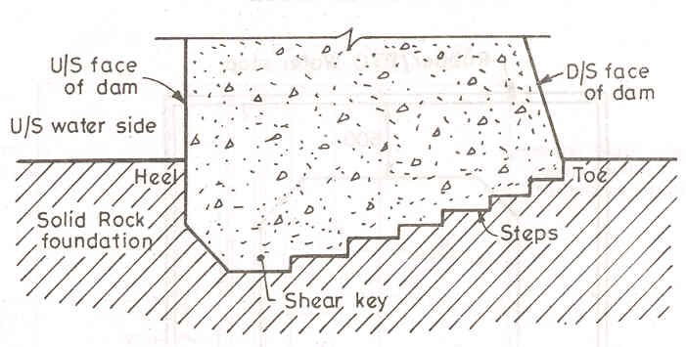
Figure 2-1 Profile of a typical interface

Drainage
Drainage is provided to relieve uplift pressure at base of dam. It is provided by a line of drilled holes d/s from the grout curtain. The holes are connected to drainage gallery to carry the seepage to the tail water.

The reduction in uplift pressure in a properly working drainage gallery can be estimated as,

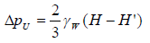
Where ΔP_{U} = reduction of pressure at the drainage
γ_{w} = unit weight of water
H = u/s water head
H’ = tail water head

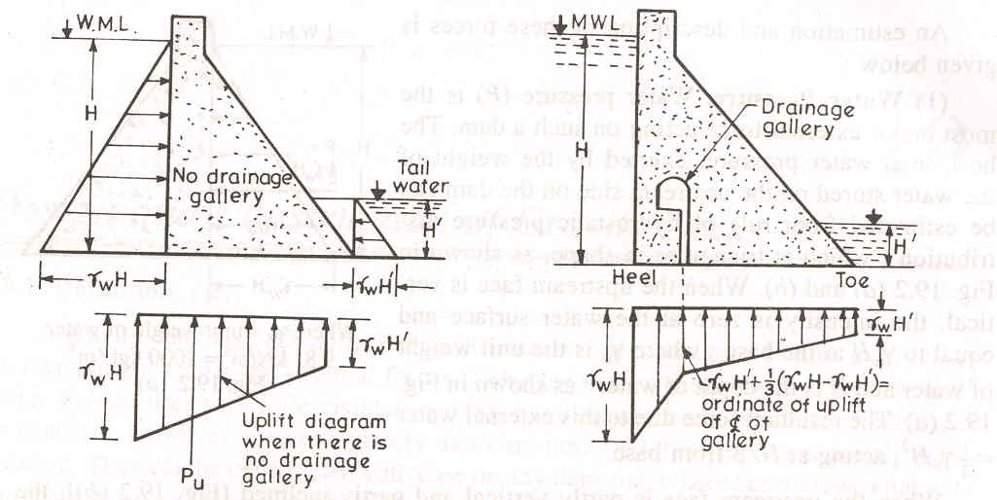
a. No drainage b. Drainage gallery is provided
Figure 2-2 Uplift pressure distribution with and without drainage gallery Net pressure available at the gallery becomes

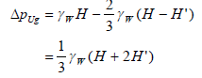

Stability of Dams and Strength of Rock Foundation
Loss of stability of dam and displacement thereof may occur due to:
      - sliding, when its contact with the foundation is disturbed or due to cracks in the foundation when inadmissible tensile and tangential stresses appear;
      - overturning, when its contact with the foundation is disturbed;
      - Destruction of rock mass of foundation under the action of stresses appearing in it.

Earth foundation

General
Earth foundation may be classified as:
Foundations of coarse-grained material (gravel and sand). Foundations of fine-grained material (silt and clay).

In preparation of earth foundations, the objectives are to prevent: crushing, sliding, excessive seepage under the dam, piping, and scouring by water flowing over the dam.
Because of the high cost of treatment of earth foundations, gravity dams on earth foundations are limited in height to 20m.

Gravel and sand foundation
Gravel and sand foundations are alluvial in origin. The following two basic seepage problems are encountered in using these foundations:
excessive loss of water large seepage force
Extent of treatment to reduce the effect of the aforementioned problems depends on: The purpose of the dam (seepage quantity is of little concern in a detention dam).
The necessity of the downstream release
Regardless of the quantity of seepage, adequate measures have to be provided to reduce the danger of piping.

Estimation of seepage amount
A rough estimation of the amount of seepage could be made using the Darcy’s equation Q = kiA
Where: Q = rate of seepage (m³/s)
k = Permeability (Hydraulic conductivity) of the foundation material (m/s). i = hydraulic gradient
= ΔH/ΔL ΔH = upstream and downstream sections head difference (m).
ΔL = length of seepage path (m)
A = gross area of foundation through which flow takes place (m²).
A better estimation of seepage quantity can be made by flow net analysis of the foundation. Using flow net technique,
q = k ΔH N_{f} / N_{p}
Where: q = seepage quantity per unit length (m³/s/m) N_{f} = number of flow channels
N_{p} = number of potential drops
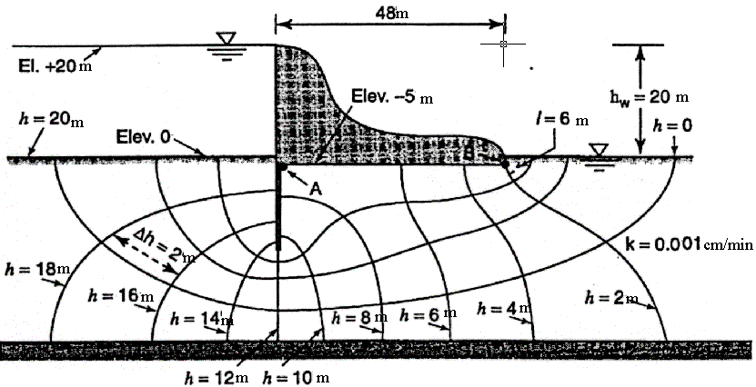
Example: For the ogee spillway with sheetpiling cutoff shown below:
- Compute the seepage in m³/min.; and
- Calculate the uplift force acting on the base of the dam.

To compute the seepage
Alternative I.
Δh = 2m, H = 20m
k = 0.00001m/min [Hydraulic conductivity of pervious foundation]
L = 48m [bottom length of the spillway]
I = Δh/Δl = 2/6 = 0.33
q = KIA [Darcy’s Equation]
= 0.00001 m/min * 0.33 * 24 m²/m
= 8.0 x 10⁻⁵ m³/min Per meter length of structure
Alternative II
H = 20m [head difference of head and tail water level]
N_{f} = 4 [number of Flow channels]
N_{d} = 10 [number of Equipotential lines]
q = kH N f
N d

q = kH N f
N d
= 0.00001m / min* 20 * 4
10

= 8.0 *10−5 m3 / min/ m length

Uplift force on the dam
At point A h1 ≈ 7.5m
At point B h2 = 2m

Uplift Pressure

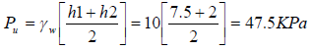

Uplift force F_{u} = P_{u} x A = 47.5 * 48 = 2280.0 kN per meter length of the structure.

Piping
Seepage forces
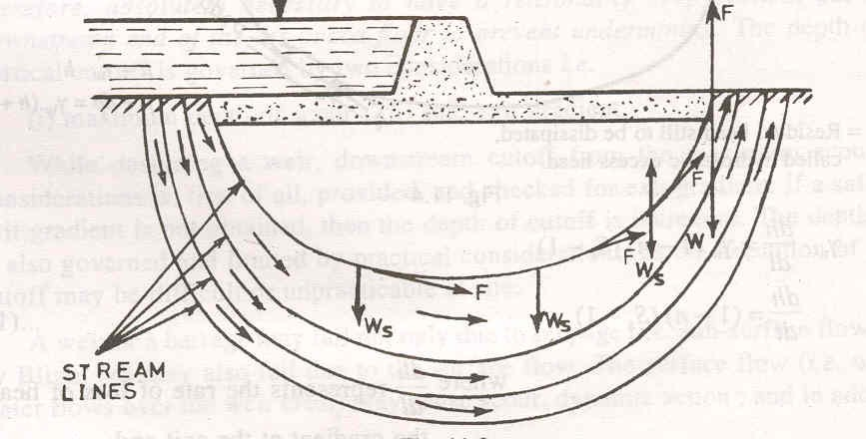
Seepage forces are developed as a result of friction between the seeping water and the walls of the particles.
Figure 2-3 Seepage below a dam in pervious foundation.
Considering Figure 2-3, at the upstream side F increases Ws and tends to hold the soil particles in position. At the downstream side F decreases Ws and tends to lift the soil particles. If F >Ws, the soil particles would be floated out and thus erosion progresses backwards along the flow lines until a “Pipe” is formed resulting in loss of large quantities of water and soil particles and ultimate collapse of the foundation.
Piping is the movement of materials from the foundation caused by the velocity of the seeping water as it comes out from the soil below the dam. The danger of piping exists at any point when the pressure of seeping water is greater than the weight of the soil above that point.
hf
dw
de
A

Figure 2-4 Illustration of seepage.
Consider the illustrative diagram of seepage shown in Figure 2-4. Upward pressure force at A

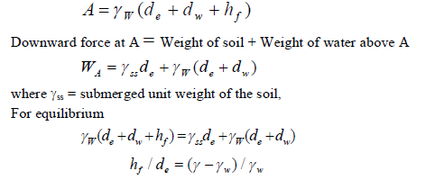h_{f}/d_{e} = i_{a} (actual friction gradient) (γ-γ_{w})/ γ_{w} = i_{c} (critical gradient)
The factor of safety against piping is computed as
S_{f} = i_{c}/i_{a}
A value of S_{f} ≥ 4 is usually considered in design.

Uplift pressure and control of seepage
Seepage quantity can be reduced by the following methods:
      - Using soil of low permeability for the body of the dam
      - Placing core in earth structure and cut-off in the foundation
      - Increasing the seepage path by employing upstream blanket
Cut-off is a core of impermeable material placed in the foundation. It may be of impervious soil (clay) in a cut-off trench; masonry (usually concrete); sheet piling (limited to foundations of silt, sand and fine aggregate), and grout curtain.
Cut-off penetrating up to the impervious layer is called complete cut-off. When properly constructed, it reduces seepage to a negligible amount.

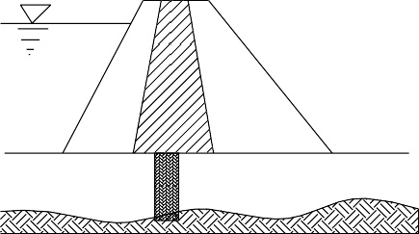
Complete Cutoff

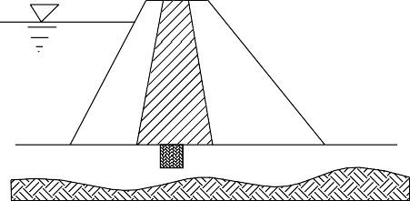
Partial Cutoff

Figure 2-5 Complete and partial Cut-off
Cut-off penetrating only part of the pervious foundation is called partial cut-off. Its action is similar to an obstruction in a pipe. The flow across it is reduced because of the loss of head due to the obstruction. Cut-off extending through 50 % of the distance to the impervious stratum will reduce the seepage by only 25 %. An 80 % cut-off reduces the seepage to 50 %. Thus, partial cut- off is less effective in reducing seepage. However, it reduces danger of seepage along a line of contact of foundation and dam particularly when there is a differential settlement. It is effective in intercepting horizontal cracks and seams in rock foundation.
An adequate width of cut-off for a small dam may be determined by W = h – d
Where: W = bottom width of cut-off trench
h = reservoir head above ground surface, and
d = depth of cut-off trench excavation below ground surface.
Upstream blanket
It is a layer of impervious soil placed on the foundation upstream from the structure. For earth dams it extends to the impervious core. It increases the length of the seepage path and thus reduces hydraulic gradient and quantity of seepage.

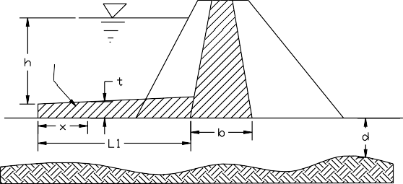
Upstream Blanket

Figure 2-6 Upstream Blanket.
Length of blanket: the length of blanket L₁ required to reduce seepage to a required quantity can be determined from flow net analysis.
L₁ = (khd – PQ)b / (PQ)
Where: L₁ = length of upstream blanket
k = mean horizontal permeability coefficient of the pervious stratum h = gross head on impervious upstream blanket
d = depth of pervious stratum
P = fraction to which Q is desired to be reduced by means of the blanket.
Thickness of blanket at a distance x from the upstream toe of blanket, the thickness t can be computed as:
t = (k₂/k₁)(L₁/d)x
Where t = thickness of blanket at the point under consideration
X = distance from the point under consideration to upstream toe of the blanket k₁ = average permeability of stratum
k₂ = permeability of blanket
L₁ = length of blanket from upstream toe to impervious section, and d = depth of pervious stratum
For normal conditions:
t = 1.5 – 3.0 meters L₁ = 10h
In case of fine sand or silty foundation; L₁ = 15h

Upstream apron
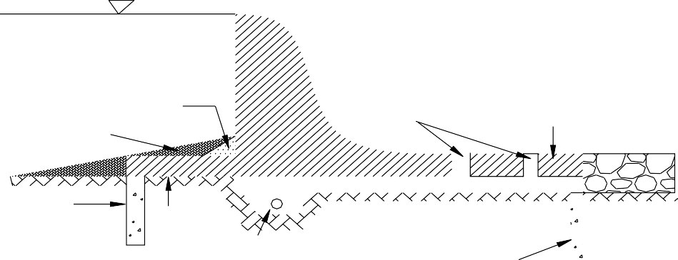It can be of RC or impervious earth blanket. Differential settlement may crack the junction between apron and dam. A filter layer with clay blanket helps to remedy this danger.

B lanket

Filter

D rain Holes

D/s apron

U/s cutoff

U/s apron

Trench Drain

Figure 2-7 Aprons, Cut-offs, drains and blankets.

D /s cutoff

Downstream apron: It helps to increase the path of seepage, but its primary purpose is to balance the uplift pressure.
Downstream cut-off: A short downstream cut-off helps to keep the point of flow concentration (i.e. high gradient) well within the soil mass where it is protected by the weight of the soil above.
D/s apron
Flow Concentration Bl

Flow Concentration

U/s cutoff

Figure 2-8 Regions of flow concentration.
Internal drainage (horizontal drainage layers and filters): It is effective in controlling excess pressure and exit gradients. It serves to short circuit the seepage. Various arrangements are possible
Trench drain

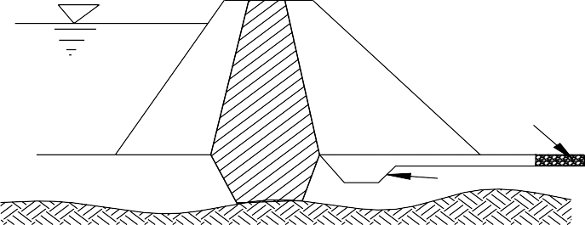
B l a n k e t d r a i n

T r e n c h d r a i n

Figure 2-9 Trench and Blanket drains
Toe drain: it is used when the downstream shell is so pervious that it forms a drain.

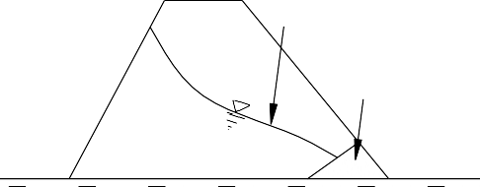 Lowered line of seepage

Toe drain

Figure 2-10 Toe drain.
Relief wells: These are holes or wells employed in masonry structures downstream from the cut-off and in the downstream apron where uplift is likely to cause a blow out. They serve to concentrate the seepage and reduce internal pressure.
Internal drain and relief wells have the disadvantage of increasing seepage quantity. They all need protective filters, thus, permitting the free drainage of water but preventing the movement of soil particles.

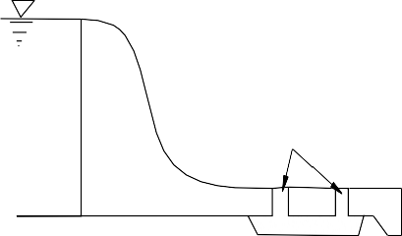
Relief wells
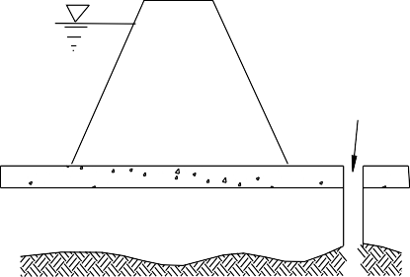
Relief well

Figure 2-11 Relief Wells and Relief holes.
    - Theories of Seepage Flow
Whenever a hydraulic structure is founded on a pervious foundation, it is subjected to seepage of water beneath the structure, in addition to all other forces to which it will be subjected when founded on an impervious rock foundation. The concepts of failure of hydraulic structures due to subsurface flow were introduced by Bligh, on the basis of experiments and the research work conducted after the failure of Khanki weir, which was designed on experience and intution without rational theory.

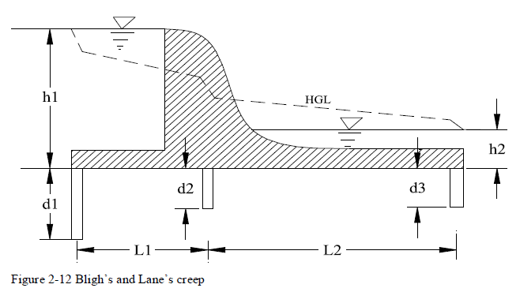

Bligh’s creep theory
The seeping water follows the outline of the contact surface of the structure and foundation soil. The length of the path traversed is the creep length [L]. The loss of head is assumed to be proportional to the creep length

Referring to Figure 2-12:
The total head loss between upstream and downstream [H_{L}] = h₁- h₂ Creep Length [L] = 2d₁ + L₁ + 2d₂ + L₂ + 2d₃
Head loss per unit length of hydraulic gradient = H_{L} /L
Safety against piping is ensured by providing sufficient creep length,
L = CH_{L} Where: C – Bligh’s coefficient for the soil
C = L/H_{L} C is reciprocal of the hydraulic gradient. The HGL represents the residual uplift water head at each point.
h’ = h + t
Uplift pressure = γ_{w}h’ Downward pressure =
    - Uplift pressure and seepage under masonry structures on pervious foundations
For designing low concrete dams on pervious foundations, the weighted creep theory, as developed by Lane is suggested for safety against uplift pressure and piping. According to this theory, the flow will concentrate along the line of creep, i.e., along the line of contact of the dam and cut-offs with the foundation.
After testing the theory on more than 200 dams on pervious foundations, the following conditions were drawn
The weighted creep length of a cross-section of a dam is the sum of the vertical creep distances (steeper than 45⁰) plus 1/3 of the horizontal creep distance (less than 45⁰).
The weighted - creep ratio is the weighted-creep length divided by the effective head.
When filter drains and relief wells are not used, the full Lane’s weighted - creep ratio is to be used (case a). Where drains are properly provided (but no flow net analysis is made), use 80% of Lane’s weighted creep ratio (case b).
Where both drains and flow net analysis are used, use 70% of weighed-creep ratio (case c). Take minimum weighted-creep ratio (WCR) = 1.5
The pressure to be used in design may be estimated by assuming that the drop in pressure from headwater to tail water along the contact line of the dam and foundation is proportional to weighted-creep length
Table 2-1 Lane’s recommended WCR for different materials

Material | Case a Lane 100% | Case b Lane 80 % | Case c Lane 70%
Very fine sand and silt | 8.5 | 6.8 | 6
Fine sand | 7.0 | 5.6 | 4.9
Medium sand | 6.0 | 4.8 | 4.2
Coarse sand | 5.0 | 4.0 | 3.5
Fine gravel | 4.0 | 3.2 | 2.8
Medium gravel | 3.5 | 2.8 | 2.5
Coarse gravel (including Cobbles) | 3.0 | 2.4 | 2.1
Boulders with stone, cobbles, and gravel | 2.5 | 2.0 | 1.8
Soft clay | 3.0 | 2.4 | 2.1
Medium Clay | 2.0 | 1.6 | 1.5
Hard clay | 1.8 | 1.5 | 1.5
Very hard clay and hard pan | 1.6 | 1.5 | 1.5

Example
For the dam section shown below determine
      - the type of the foundation on which the dam section shown below may be judged safe;
      - 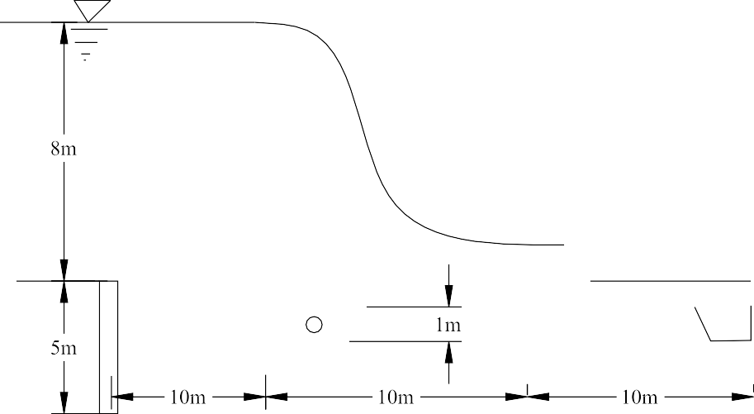the magnitude of the uplift force for the section A to B

Solution
Weighted creep length = 5 + 5 + 4*1 + (10 + 10 + 10)/3 = 24 m Net head on structure = Head water – Tail water = 8-1.6 = 6.4m
Weighted creep ratio = 24 / 6.4 = 3.75
According to Lane’s ratios, the dam (spillway) would be safe on clay or on medium gravel and coarse gravel. With properly provided drains and filters, it may be considered safe on fine gravel foundations [case b]
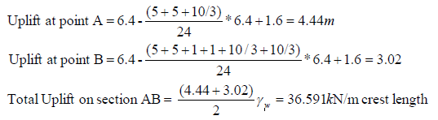

    - Silt and clay foundation
Such foundation materials are sufficiently impervious. Thus seepage is not a problem. The main challenge is bearing capacity.
Methods of foundation treatment are based on:
- Soil type
- Location of water table
- State of compactness of the soil
Methods of treatment
- For saturated fine-grained soils
  - Soil of low shearing strength is removed. This is practical for thin layers of soft soil overlying firm material if the cost of excavation and refill is less than the cost of special investigation and provision of flatter slopes of embankment.
  - Drainage is provided to the foundation to permit increase of strength during construction.
  - Flatter slopes for the embankment are used to reduce the magnitude of the average shearing stress along the potential surface of sliding. This is the most practical solution. For recommended slopes, refer to “Design of small dams, USBR” sec 129.
- For relatively dry foundations
For a given void ratio, an impervious soil has greater bearing capacity in the unsaturated condition than in the saturated condition. Hence dry silt and clay foundations are generally satisfactory for small dams.
Soils like loess (very loose wind deposited soils) exhibit sufficient strength at low water content. Such low density soils are subject to large settlements when saturated by reservoir and may result in failure of the dam by differential settlements that may cause rupture of the impervious portion or by considerable reduction in free board resulting in overtopping.
Treatment here depends on the compression characteristics of the soil.
If appreciable post construction settlements are not expected upon saturation, little foundation treatment is necessary.
Remove organic top soil Provide a key trench
Provide a toe drain so that the foundation at the downstream toe will not saturate
When appreciable post construction settlements upon saturation are expected, measures to minimize the settlements should be adopted.

Concrete Gravity Dam

General
Basically, gravity dams are solid concrete structures that maintain their stability against design loads from the geometric shape and the mass and strength of the concrete. Generally, they are constructed on a straight axis, but may be slightly curved or angled to accommodate the specific site conditions. Gravity dams typically consist of a non-overflow section(s) and an overflow section or spillway.

Forces acting on gravity dams
The structural integrity of a dam must be maintained across the range of circumstances or events likely to arise in service. The design is therefore determined through consideration of the corresponding spectrum of loading conditions. In all foreseeable circumstances the stability of the dam and foundation must be ensured, with stresses contained at acceptable levels and watertight integrity essentially unimpaired.

Where:
F_{WA}
F_{V}
F_{W}
F_{WA}
F_{H}
W
F'_{V}
Fs
Heel
F_{OD}

Toe
F'_{H}
H = Head water depth H’ = Tail Water depth
F_{WA} = Wave pressure force
F_{H} = Horizontal hydrostatic force F_{S} = Silt/sediment pressure force F_{EQ} = Earthquake/Seismic force F_{W} = Wind pressure force
F_{H}’ = Tail water hydrostatic force W = Weight of dam
F_{OD} = Internal pore water pressure
F_{U} = Uplift pressure force [base of dam] F_{V} = Weight of water above dam [u/s] F_{V}’ = Weight of water above dam [d/s]
F_{U}
Figure 3-1 Representation of typical loads acting on Gravity dam

Water pressure
Water pressure is the force exerted by the water stored in the reservoir on the upstream and the water depth at the tail of the dam.
- External water pressure load
External water pressure can be calculated by the law of hydrostatics according to which in a static mass of liquid the pressure intensity varies linearly with the depth of liquid and it acts normal to the surface in contact with the liquid. For the non-overflow section of the dam water pressure may be calculated as follows and for the overflow portion the loading will be discussed in section six of the course.
F_{H} = horizontal component of hydrostatic force, acting along a line 1/3 H above the base
= ½ γ_{w}H²
γ_{w} = Unit weight of water (=10 kN/m³)
Fv = Vertical component of hydrostatic pressure
= Weight of fluid mass vertically above the upstream face acting through the center of gravity of the mass.

- Internal water pressure (Uplift Pressure)
Internal water pressure is the force exerted by water penetrating through the pores, cracks and seams with in the body of the dam, at contact surface between the dam and its foundation, and with in the foundation. It acts vertically upward at any horizontal section of the dam as well as its foundation and hence it causes a reduction in the effective weight of the portion of the structure lying above this section.
The computation of internal pressure involves the consideration of two constituent elements, i.e,
  - Hydrostatic pressure of water at a point
  - The percentage C, area factor, of the area on which the hydrostatic pressure acts Both these elements are discussed below.
Hydrostatic pressure
In practice dams are usually provided with cut-off walls or grout curtains to reduce seepage and drain to relieve pressure downstream from the cutoff. Actually cutoff and grout curtains may not be perfectly tight and hence fail to dissipate the head (h₁ – h₂)
Usually a distribution like 1-2-3-4 is used with 3-4 a straight line as shown in Figure 3-3. Opinions about the value of uplift reduction factor, ζ (Zeta), are varied, the tendency is to take:
ζ = 0.85 (for normal loading cases)
ζ = 1.00 (for exceptional loading cases like earthquake)
γ_{ω}h2
γ_{ω}h1
γ_{ω}h2
When flow from u/s to d/s face is allowed With u/s effective cutoff
γ_{ω}h1
γ_{ω}h2
γ_{ω}h2
γ_{ω}h1
With d/s effective cutoff With an intermediate cutoff

Figure 3-2 Uplift pressure distribution for perfectly tight cutoff walls.

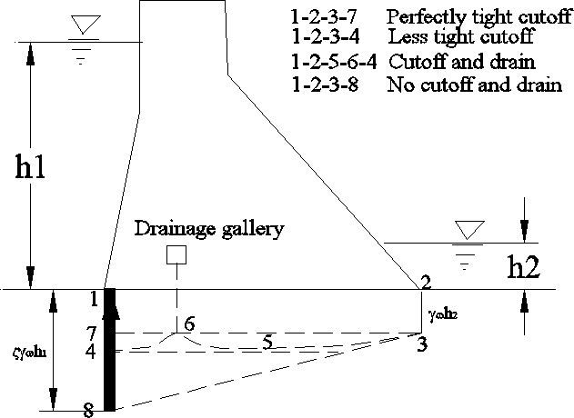

Figure 3-3. Uplift pressure distribution for less tight cutoff.
Uplift area factor, C
The value of area factor for concrete has been determined experimentally by several investigators. However, for the foundation rock the value of area factor is not determinable experimentally and hence the same has been estimated on the basis of theoretical considerations.
Some of the earliest investigators recommended, for both concrete and rock, a value of area factor ranging from one third to two-thirds of the area to be considered as effective area over which the uplift pressure acts. However, Harza, Terzaghi and Lelivakey have indicated that, for both concrete and rock, the value of area factor is nearly equal to unity.
Table 3-1Values suggested for uplift area factor are

Value of C | Suggested by
0.25 to 0.40 | Henry
1.00 | Maurice Levy
0.95 to 1.00 | Terzaghi
As such the present practice followed in the design of dams is that the uplift pressure is assumed to act over 100 percent of the area with in the body of the dam as well as its foundation. Hence, under all conditions, the value C = 1.00 is recommended.

Wight of Structure
For a gravity dam the weight of the structure is the main stabilizing force, and hence the construction material should be as heavy as possible.
Structure self weight is accounted for in terms of the resultant, W, which acts through the centroid (center of gravity) of the cress-sectional area. The weight of the structure per unit length is
W = γc * A
Where:γc is the unit weight of concrete
A is the cross-sectional area of the structure
The unit weight of concrete may be assumed to be 24 kN/m³ in the absence specific data from laboratory test trials. For final designs the specific weights shall be based on actual test data. Where crest gates and other ancillary structures or equipments of significant weigh are present they must also be accounted for in determining the weight of the structure.
It is essential to make sure that the actual specific weight obtained for the construction material is more than or at least equal to that assumed in the design.

Earth and silt pressure
The gradual accumulation of significant deposits of fine sediment, notably silt, against the face of the dam generates a resultant horizontal force, F_{s}. The magnitude of this force in additional to water load, F_{WH}, is a function of the sediment depth, h_{s}, the submerged unit weight, γ_{ss,} and the active pressure coefficient, K_{a,} and is determined according to Rankine’s formula.
Fs = ½ K_{a}γ_{ss} h_{s}² Where Ka = (1-sinφ) / (1+sinφ)
φ = angle of internal friction of material.

Wind pressure
When the dam is full, wind will act only on the downstream face, thus contributing to stability. When the dam is empty, wind can act on the upstream face, but the pressure is small compared to the hydraulic pressure of the water. Hence for gravity dams wind is not considered. For buttress dams, wind load on the exposed buttresses has to be considered.

Wave pressure and wave height
Wave exerts pressure on the upstream face. This pressure force, F_{wv} depends on fetch (extent of the water surface on which the water blows) and wind velocity. It is of relatively small magnitude and, by its nature, random and local in its influence. An empirical allowance for wave load may be made by adjusting the static reservoir level used in determining F_{WV.} According to Molitor the following formula could be used to determine the rise in water level, h_{w}
vf

hw = 0.763 + 0.032
− 0.271 f 1 / 4
for f < 32km

hw = 0.032 vf
h
2
for f ≥ 32km

Fwz
= 2.0γw w

where: h_{w} in meters
v wind velocity in km/hr and
f fetch in km

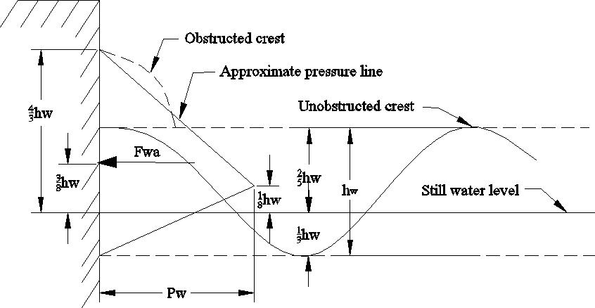
Figure 3-4 Wave configuration and wave pressure on a gravity dam For high dams the wave pressure is small compared to other forces.
The point of application of F_{wv} can be taken as 3/8hw from the still water level.
The wave rides up higher on inclined dam faces as compared to the vertical one.

Earthquake forces
Dynamic loads generated by seismic disturbances must be considered in the design of all major dams situated in recognized seismic “high risk” regions. The possibility of seismic activity should also be considered for dams located outside those regions, particularly where sites in close proximity to potentially active geological fault complexes.
Seismic activity is associated with complex oscillating patterns of accelerations and ground motions, which generated transient dynamic loads due to the inertia of the dam and the retained body of water. For design purposes both should be considered operative in the sense least favorable to stability of the dam. Horizontal accelerations are therefore assumed to operate normal to the axis of the dam. Under reservoir full conditions the most adverse seismic loading will then occur when a ground shock is associated with:
      - horizontal foundation acceleration operating upstream, and
      - vertical foundation acceleration operating downward

Reservoire full

Reservoir empty

Earthquake Direction

Direction of vibraion

Figure 3-5 Direction of ground acceleration and the respective horizontal earthquake force on gravity dam
As a result of 1, inertia effects will generate an additional hydrodynamic water load acting downstream, plus a further inertia load attributable to the mass of the dam and also acting in a downstream sense. Foundation acceleration downwards, 2 above, will effectively reduce the mass of the structure. The more important recurring seismic shock waves have a frequency in the range 1-10Hz. Seismic loads consequently oscillate very rapidly and are transient in their effect. The strength of seismic event can be characterized by its magnitude and its intensity.
Ground motions associated with earthquakes can be characterized in terms of acceleration, velocity or displacement. Only peak ground acceleration, pga, generally expresses as a portion of gravitational acceleration, g, is considered in this course. It has been suggested that in general seismic events with a high pga of short duration are less destructive than seismic events of lower pga and greater duration.
The natural frequency of vibration, f_{n}, for a triangular gravity profile of height H (m) and base thickness B(m) constructed in concrete with an effective modulus of elasticity E=14GPa can be approximated as
f_{n} = 600 B/H² (Hz)
For a dam of H = 500m and B = 375m, f_{n} = 0.9 Hz. But the most important recurring seismic shock waves are in the order of magnitude of 1-10Hz. Hence resonance (the frequency of vibration of the structure and earthquake are equal) of an entire dam is unlikely and is not a series concern in design. But vulnerable portion of the dam should be detailed.

There are two methods to determine the seismic load on a dam
Pseudostaic (equivalent static load) method: inertia forces are calculated based on the acceleration maxima selected for design and considered as equivalent to additional static loads. This method generally is conservative and is applied to small and less vulnerable dams.
The acceleration intensities are expressed by acceleration coefficients α_{h} (Horizontal) and
α_{v}(vertical) each representing the ratio of peak ground acceleration. Horizontal and vertical accelerations are not equal, the former being of greater intensity (α_{h} = (1.5 – 2.0α_{v}).
Based on the vertical and horizontal acceleration, the inertial force will be Horizontal force = ±α_{h} * (static mass)
Vertical force = ±α_{v} * (static mass)
Three loading cases can be used for the assessment of seismic load combination:
- Peak horizontal ground acceleration with zero vertical ground acceleration
- Peak vertical ground acceleration with zero horizontal acceleration
- Appropriate combination of both (eg. Peak of the horizontal and 40-50% of the vertical)
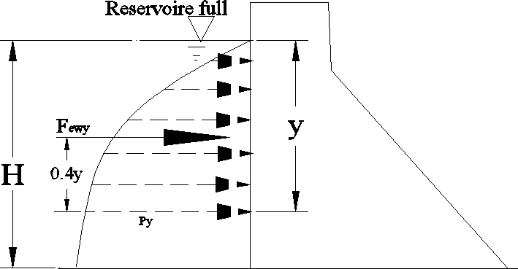
Inertia forces
- Mass of dam
Horizontal F_{eqh} = ±α_{h}W Vertical F_{eqv} = ±α_{v}W
- Water body
As analyzed by Westerguard(1993)

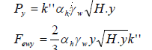

where k” = earthquake factor for the water body

k"=
0.816

Where: T = period of earthquake
1 − 7.75⎜
⎛ H
⎞2
⎝ 1000T ⎠
⎟
γ_{w} = in tone/m³ H, y in meters
The force acts at 0.4y from the dam joint being considered. For inclined upstream face of dam
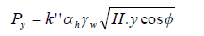
where φ is the angle the face makes with the vertical.
The resultant vertical hydrodynamic load, F_{ewv}, effective above an upstream face batter or flare may be accounted for by application of the appropriate seismic coefficient to vertical water load. It is considered to act through the centroid of the area.
F_{ewv} = ±α_{v} F_{v}
Uplift load is normally assumed to be unaltered by seismic shock.
Dynamic analysis: the dam is idealized as a two dimensional plane-strain or plane-stress finite element system, the reservoir being regarded as a continuum. The foundation zone is generally idealized as a finite element system equivalent to a visco-elastic half space. The complexities of such an approach are evident, and take it outside the scope of this course.

Load combination for Design
The design of a gravity dam is based on the most adverse combination of the loads/forces acting on it, which includes only those loads having a reasonable probability of simultaneous occurrence. The combination of transient loads such as those due to maximum flood and earthquake are not considered because the probability of occurrence of each of these phenomena is quite low and hence the probability of their simultaneous occurrence is almost negligible. Thus for the design of gravity dams according to Indian Standard is specified as the following load combination:
- Load combination A (construction condition or empty reservoir condition): Dam completed but no water in the reservoir and no tail water.
- Load combination B (Normal operating condition): Full reservoir elevation (or top of gates at crest), normal dry weather tail water, normal uplift, ice and uplift (if applicable)
- Load combination C (Flood Discharge condition): Reservoir at maximum flood pool elevation, all gates open, tail water at flood elevation, normal uplift, and silt (if applicable)
- Load combination D - Combination A, with earthquake.
- Load combination E - Combination A, with earthquake but no ice
- Load Combination F - Combination C, but with extreme uplift (drain inoperative)
- Load Combination G - Combination E, but with extreme uplift (drain inoperative)

Reaction of the foundation
The foundation should provide the required reaction to the resultant force for the dam to be stable.
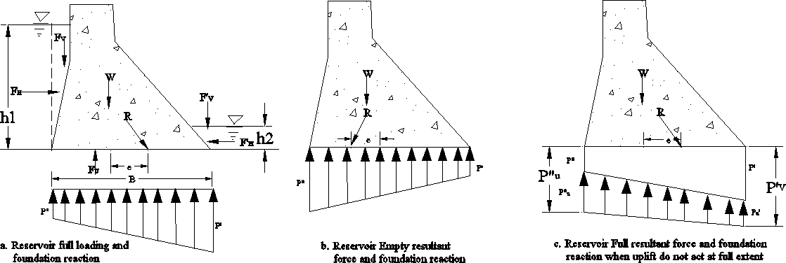

Figure 3-6 Foundation reaction for reservoir full and empty loading

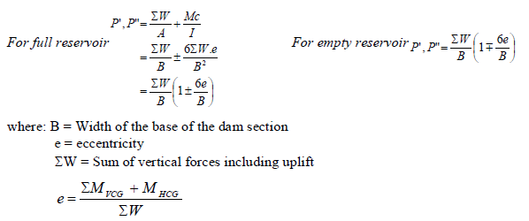

Requirements for stability
A masonry of plain concrete dam must be free from tensile stress, i.e. neither P’ nor P” shall be negative, or
e ≤ B/6 (law of the middle third)
To limit compressive stress with in the dam body use: P’, P” if uplift always acts to the fullest extent. P’_{v} , P”_{v} if uplift does not act always.
Horizontal forces must be resisted both by shear and friction in the dam joint or in the foundation.

Rules Governing the Design of Gravity Dams
The following are basic assumptions that should be considered relative to the design of important masonry/concrete dams.
- The rock that constitutes the foundation and abutments at the site is strong enough to carry the forces imposed by the dam with stresses well below the elastic limit at all places along the contact planes.
- The bearing power of the geologic structure along the foundation and abutments is great enough to carry the total loads imposed by the dam without rock movements of detrimental magnitude.
- The rock formations are homogeneous and uniformly elastic in all directions, so that their deformations may be predicted satisfactorily by calculations based on the theory of elasticity, by laboratory measurements on models constructed of elastic materials, or by combinations of both methods.
- The flow of the foundation rock under the sustained loads that result from the construction of the dam and the filling of the reservoir may be adequately allowed for by using a somewhat lower modulus of elasticity than would otherwise be adopted for use in the technical analyses.
- The base of the dam is thoroughly keyed into the rock formations along the foundations and abutments.
- Construction operations are conducted so as to secure a satisfactory bond between the concrete and rock materials at all areas of contact along the foundation and abutments.
- The concrete in the dam is homogeneous in all parts of the structure.
- The concrete is uniformly elastic in all parts of the structure; so that deformations due to applied loads may be calculated by formulae derived on the basis of the theory of elasticity or may be estimated from laboratory measurements on models constructed of elastic materials.
- Effects of flow of concrete may be adequately allowed for by using a somewhat lower modulus of elasticity under sustained loads than would otherwise be adopted for use in technical analyses.
- Contractions joints are properly grouted under adequate pressures, or open slots are properly filled with concrete, so that the dam may be considered to act as a monolith.
- Sufficient drains are installed in the dam to reduce such uplift pressures as may develop along areas of contact between the concrete and rock materials.
- Effects of increases in horizontal pressures caused by silt contents of flood waters usually may be ignored in designing high storage dams, but may require consideration in designing relatively low diversion structures.

- Uplift forces adequate for analyzing conditions at the base of the dam are adequate for analyzing conditions at horizontal concrete cross sections above the base.
- Internal stresses caused by natural shrinkage and by artificial cooling operations may be adequately controlled by proper spacing of contraction joints.
- Internal stresses caused by increases in concrete temperature after grouting are beneficial.
- Maximum pressures used in contraction joint grouting operations should be limited to such values as may be shown to the safe by appropriate stress analyses.
- No section of the Ethiopia may be assumed to be entirely free from the occurrence of earthquake shocks.
- Assumptions of maximum earthquake accelerations equal to one tenth of gravity are adequate for the design of important masonry dams without including additional allowances for resonance effects.
- Vertical as well as horizontal accelerations should be considered, especially in designing gravity dams.
- During the occurrence of temporary abnormal loads, such as those produced by earthquake shocks, some increases in stress magnitudes and some encroachments on usual factors of safety are permissible.
- Effects of foundation and abutment deformations should be included in the technical analyses.
- In monolithic straight gravity dams, some proportions of the loads may be carried by twist action and beam action at locations along the sloping abutments, as well as by the more usually considered gravity action.
- Detrimental effects of twist and beam action in straight gravity dams, such as cracking caused by the development of tension stresses, may be prevented by suitable construction procedure.
- In monolithic curved gravity and arch dams, some proportions of the loads may be carried by tangential shear and twist effects, as well as by the more usually considered arch and cantilever actions.
- The distribution of loads in masonry dams may be determined by bringing the calculated deflections of the different systems of load transference into agreement at all conjugate points in the structure.
The aforementioned assumptions are rephrased as rule/guideline for design of concrete gravity dam as described below:
Rule1: Location of the resultant: No tension in any joint of the dam under all loading conditions (i.e. for full and empty reservoir). Thus, resultant of all forces (including uplift) must intersect the joint within the middle third.
Rule2a: Resistance to sliding when shear is neglected: the tangent of the angle between the vertical and the resultant (including uplift) above horizontal plane shall be less than the allowable coefficient of frictional force ‘f’. If empirical values are taken, factor of safety, S_{f} = 2.
Table 3-2 Some values of Coefficient of friction f
Surface f
Masonry on masonry or masonry on good rock or concrete on concrete 0.75
Concrete or masonry on gravel 0.50
Concrete or masonry on sand 0.40
Concrete or masonry on clay 0.30
However, the value of f for specific cases should be obtained by test

For foundation on earth,
ΣP = tanӨ = f
ΣW S f
S_{f} is taken as 3

Rule 2b: Resistance to sliding when shear is considered

θ
R
The total friction resistance to sliding on any joint plus the ultimate shearing strength of the joint, must exceed the total horizontal force above the joint by a safe margin, i.e.

ΣP ≤
fΣW + r.S n .A S sf

Where: S_{n} – ultimate shearing strength of material S_{sf} = shear friction factor of safety
A = cross sectional area of joints
r = ratio of average to maximum shearing strength Recommended values S_{sf} = 5, r = 0.5
rS_{sf} = 200 to 500t/m²
While analyzing resistance to sliding, first compute tanφ and if tanφ > f apply Rule 2b. In that case, S_{sf} should equal or exceed the allowable value.
Rule 3: Governing compressive stresses: P’_{v}, or P”_{v} (maximum vertical stresses) are not the maximum stresses in the structure. The maximum stresses occur at the end joints, or inclined planes, normal to the face of the dam.
Maximum stress for downstream face, reservoir full:
P ' = P ' (1 + tan 2 Ф ')
i v
Maximum stress for upstream face, reservoir full
P" = P" (1 + tan 2 Ф " )
i v

The inclined compressive stresses in the dam and foundation shall not exceed the allowable values.
Ultimate stress, σ’_{c} = 14 to 31 MPa (after 28 days curing) Working stress σ_{c} = σ’_{c}/6
For foundation materials some indications for allowable stress are: Limestone -------------200 to 350 t/m3
Granite -------------250 to 300t/m3
Rule 4: Governing internal tension: The dam shall be designed and constructed in such a manner as to avoid or adequately provide for tension on interior planes, inclined, vertical or horizontal.
Rule 5: Margin of safety: all assumptions of forces acting on the dam shall be unquestionably on the safe side, all unit stresses adopted in design should provide an ample margin of safety against rupture and the shear-factors shall be considered.
Rule 6: Detail of design and methods of construction: all details shall support and confirm to the assumptions used in design; masonry should be of quality suited to the stresses adapted, protection against overflowing water shall be ample.

Theoretical versus practical section of a dam
Considering only the two major forces acting on the dam, i.e. the weight of the dam and the hydrostatic water pressure, the required section of the dam for its stability will be a triangle of base width,
B = H
s
Where: H = depth of water
s = specific gravity of concrete
For this section, the resultant will pass through the upper middle third point of the base when reservoir is empty and through the lower middle third point when the reservoir is full.
Practical section:
- The pointed crest of the theoretical dam is unstable to resist shock due to floating objects.
- There is need for a free board
- There is also need for top width for a roadway For practical section
- Crest of the dam shall be a certain thickness depending on the height of the dam. For non- overflow dams, most economical crest width ≈ 14 % of the height (10 – 15 %) is normal.
- Free board is provided and usually 3-4% of the dam height is used as a maximum height of the free board.

Design procedure of gravity dams

Design methods
The various methods used for the design of concrete gravity dams are as follows:
      - Stability analysis method
        - Gravity method.
        - Trial load twist method

          - Joints keyed but not grouted
          - Joints keyed and grouted
        - Experimental method
          - Direct method
          - Indirect method
        - Slab analogy method
        - Lattice analogy method
        - Finite element method
      - Zoned (multiple-step) method of determining profile of dam
      - Single step method
Two procedures of design will be discussed in this course: – multiple-step method and single-step method.

Multiple step method of determining profile of gravity dam
This method deals with designing the dam joint by joint (block by block) beginning at the top and making each joint confirm to all gravity dam design requirements. The procedure results in a dam with polygonal face that may be smoothened up for appearance with no appreciable change in stability or economy. The multiple-step method is almost always used for the final design of dams with a height that does not encroach greatly on Zone V.
Zoning of high non-overflow dams
A high gravity dam may be divided into seven zones according to design and stability requirements. The characteristics and limits of these zones are described below.
Zone I: is a rectangular section from the top of the dam to the water surface. The resultant force passes through the mid-point of the base.
Zone II: is also a rectangular section and extends to a depth where the resultant in the reservoir full condition reaches the outer middle third point of the base.
Zone III: upstream face of the dam is vertical but the downstream face is gradually inclined so that the resultant in the reservoir full condition has exactly at the outer middle third point of the base. This zone extends to a depth where the resultant in the reservoir empty condition reaches the inner middle third point of the base.
Zone IV: in this zone both the upstream and downstream faces are inclined so that the resultant both in the reservoir full and empty conditions lie at the middle third point. The zone extends to a point where maximum permissible compressive stress is reached at the toe of the dam.
Zone V: the slope of the downstream face is further increased to keep the principal stresses within permissible limits. Resultant in the reservoir full condition is kept well within the middle third section. The resultant in the reservoir empty condition follows the upper middle third section. This zone extends to a depth where the stress at the heel of the section reaches the permissible limits in the reservoir empty case.
Zone VI: the slope of the upstream face is rapidly increased so as to keep the principal stress at the heel with in the permissible limits in the reservoir empty condition. The inclination of the downstream face should also be adjusted so that the principal stress at the toe does not exceed the maximum allowable stress. The resultants in both reservoir empty and full conditions lie within the middle third section. This zone extends to a point where the slope of the downstream face reaches 1:1. This normally happens when the dam is 80 to 90 meters high.
Zone VII: in this zone the inclination of both upstream and downstream faces increase with the height of the dam. Consequently, at some plane the value of (1 + tan²Ф) may become so great

that the principal stress at the downstream face may exceed the allowable limit. If one reaches this zone during design, it is better to avoid it and start again with a fresh design with increased crest width and/or better quality concrete.
Zoning of overflow dams (Spillways)
Zone I: the resultant in the reservoir full condition is outside the middle third point both horizontal and vertical forces are existing. End of zone I is at a depth where resultant intersects downstream middle third point. Upstream face needs reinforcement to take tension.
Zone Ia: this is the zone below zone1. The end of zone Ia is established by the plane where only friction is sufficient to resist sliding.
Zone II: similar to zone II of non overflow dam with the only difference that the downstream face is inclined in overflow dams. The rest of the zones are similar to those of non-overflow dams.

Single Step Method
This method considers the whole dam as a single block. It is used for final design of very high dams that extend well beyond zone V. it can also be used with an accuracy of 2 to 4% on the safe side; for preliminary designs to obtain the area of the maximum section of the dam.
The dam designed by single step method has a straight downstream face. When extended it intersects upstream face at the headwater surface.
Consider the sketch given:
L = 10-15% of h₁
H₁₀ = 2L (when earthquake is considered)
= 3L (when earthquake is not considered) H₆ = 1.33L
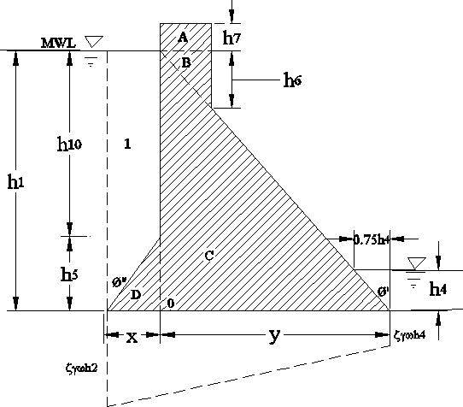
When designing (analyzing) a dam in the single step method, the dam is considered as a single block; and dam dimensions are determined in such a way that rules of Zone IV are satisfied.

Figure 3-7 Gravity dam section relationship in single step method of design

Comparison of Single step and Multiple step design of gravity dam
- Dams of smaller height can be designed economically by Multiple step method
- High dams beyond zone IV are designed by Single step method so that convex curvature of downstream face and excessive flat slope of upstream face are avoided
- It may be economical to increase the concrete strength through the use of more expensive material, so that even a high dam designed by dividing it into only four zones, thus eliminating zone V and VI
Design Example:
Design a non-overflow concrete gravity dam by the multiple-step method using the following data.

Item | Value | Item | Value
H_{max} (depth of headwater | 60 m | f- Friction coeffnt. | 0.75
h_{e} ( spillway crest to MWL) | 3 m | s_{a} | 560 kPa
Tail water | None | ssf | 5
γ_{c} | 24 kN/m³ | ζ | 0.5
γ_{w} | 10 kN/m³ | C | 1
Minimum Top width | 7.5 m | σc’ | 30 MPa
Earthquake and silt press | Ignore | F – Fetch length | 6.4 km
 |  | V | 128 km/hr
Zone I
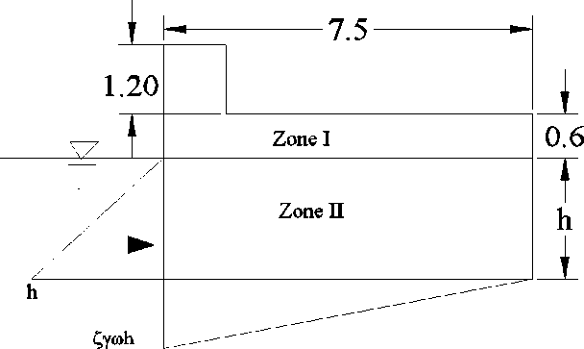
Determine the wave height by the empirical equations

hw = 0.763 + 0.032
vf
− 0.271f 1 / 4
; for f < 32km

hw = 0.763 + 0.032
= 1.25m
128 * 6.4 − 0.271* 6.41 / 4

Rise of water wave = 1.33h_{w} = 1.66 m; With an allowance of 0.14 m, free board = 1.8m
F_{wa} = 2.0γ_{w}h²_{w} = 2.0 * 10 * 1.25²
= 31.25 kN/m
Point of application = 3/8 *1.25 =0.47m above still water level.
Zone II
Taking moment about the outer middle third point of the base,

Line | Item | Description & dimension | Forces |  | Lever | Moment
 |  |  | Horizontal | Vertical
1 | W0 | Zone I: 0.6*7.5*24 |  | 108 | 1.25 | 135
2 | W1 | Zone II: 7.5 * h * 24 |  | 180h | 1.25 | 225h
3 | Wu | Uplift: 0.5*7.5*ζγ_{w} h |  | 18.75h | 2.5 | -46.9h
4 | F_{h} | Water Pressure | 5h² |  | h/3 | -1.67h³
5 | Fwa | Wave action | 31.25 |  | 0.47 + h | -(14.7+31.2h)
 |  | for h=
M = 135 + 225h + 46.9h – 1.67h³- (14.7 + 31.2h) = 0
By trial and error, h = 9.75m. Calculating actual values as follows for further check:

Line | Item | Description & dimension | Forces |  | Lever | Moment
 |  |  | Horizontal | Vertical
1 | W0 | Zone I: 0.6*7.5*24 |  | 108 | 1.25 | 135
2 | W1 | Zone II: 7.5 * h * 24 |  | 1755 | 1.25 | 2193.75
3 | Wu | Uplift: 0.5Bζγ_{w} h |  | -182.813 | 2.5 | -457.03
4 | Fh | Water Pressure | -475.31 |  | 3.25 | -1544.76
5 | Fwa | Wave action | -31.25 |  | 10.22 | -319.38
 |  | For h=9.75m | -506.56 | 1680.188 |  | 7.58
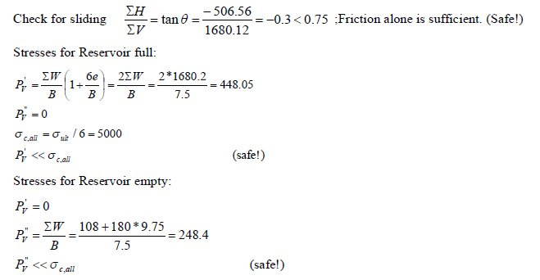

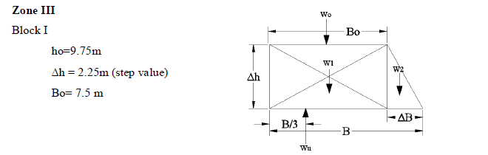

Line | Item | Description & dimension | Forces |  | Lever | Moment
 |  |  | Horizontal | Vertical
1 | W0 | Zone I & II: (0.6+9.75)*7.5*24 |  | 1863 | 3.75 | 6986.25
Trial I ΔB_{d} =0.9 B = 8.4 B/3 = 2B/3=
2 | W1 | Zone III: 7.5 *Δh * 24 |  | 405 | 3.75 | 1518.75
3 | W2 | 0.5*0.9*2.25*24 |  | 24.3 | 7.8 | 189.54
Reservoir Empty |  |  |  | 2292.3 | [3.79] | 8694.54
4 | Wu | Uplift: 0.5Bζγ_{w} h |  | -252 | 2.8 | -705.6
5 | Fh | Water Pressure | 720 |  | 4 | 2880
6 | Fwa | Wave action | 31.25 |  | 12.47 | 389.69
Reservoir Full |  |  | 751.25 | 2040.3 | [5.52] | 11258.63
Trial II ΔB_{d} =0.84 B = 8.34 B/3 = 2B/3 =
3 | W2 | 0.5*0.84*2.25*24 |  | 22.68 | 7.78 | 176.45
 |  | Reservoir empty |  | 2290.68 | [3.79] | 8681.45
4 | Wu | Uplift: 0.5*Bζγ_{w} h |  | -250.2 | 2.78 | -695.56
5 | Fh | Water Pressure | 720 |  | 4 | 2880
Reservoir Full |  |  | 751.25 | 2040.48 | [5.52] | 11255.58

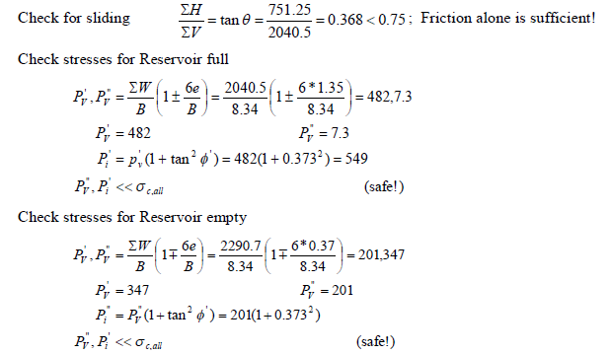

Check for sliding

l
Continue with the design block by block until you arrive at the required dam height or the limit of Zone III, whichever comes first.

Zone IV
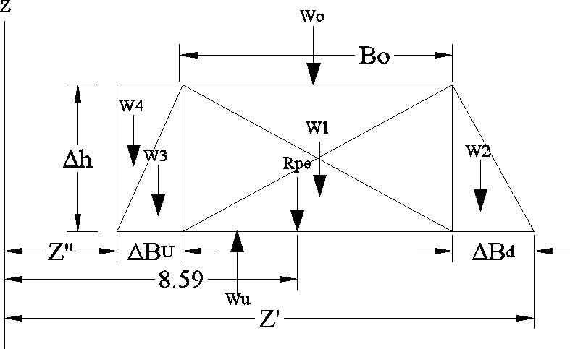
Block I
ho = 23m
Δh = 4m h = 27m
Bo = 14.57m

Line | Item | Description & dimension | Forces |  | Lever | Moment
 |  |  | Horizontal | Vertical
1 | W0 | concreter above h = 23m |  | 5230 | 7.88 | 41212.4
2 | W1 | 4*14.57*24 |  | 1398.72 | 10.29 | 14392.83
 | Trial I | ΔB _{d} = 3.0
3 | W2 | 0.5*3*4.0*24 |  | 144 | 18.57 | 2674.08
4 |  | Total Partial empty |  | 6772.72 | 8.61 | 58279.31
 |  | Estimation |  | Z' | 20.57
 |  | 2B/3=Z' - 8.6 = 20.57 - 8.6 = | 11.98 | B= | 17.97
 |  | ΔBu =B - (Bo + ΔBd) = | 0.4 | Z'' = | 2.6
 |  | Z''+B/3 = | 8.59 | Z''+2B/3 = | 14.58
5 | W3 | 0.5*0.4*4*24 |  | 19.2 | 2.87 | 55.1
6 |  | Reservoir Empty |  | 6791.92 | 8.59 | 58334.41
7 | W4 | Water column 0.4*25*10 |  | 100 | 2.8 | 280
8 | Wu | Uplift: 0.5Bζγ_{w} h |  | -1212.98 | 8.59 | -10419.5
9 | Fh | Water Pressure | 3645 |  | 9 | 32805
10 | Fwa | Wave action | 31.25 |  | 27.47 | 858.44
 |  | Reservoir Full | 3676.25 | 5678.945 | 14.41 | 81858.39
 | Trial II | ΔB_{d} =2.8
11 | W2 | 2.8*4*24*0.5 |  | 134.4 | 18.3 | 2459.97
12 |  | Total Partial empty |  | 6763.12 | 8.59 | 58065.2
 |  | Estimation |  | Z' | 20.37
 |  | 2B/3=Z' - 8.59 = 20.37 - 8.59= | 11.78 | B= | 17.67
 |  | ΔBu =B - (Bo + ΔBd) = | 0.3 | Z'' = | 2.7
 |  | Z''+B/3 = | 8.59 | Z''+2B/3 = | 14.48
13 | W3 | 0.5*0.3*4*24 |  | 14.4 | 2.9 | 41.76
14 |  | Reservoir Empty |  | 6777.52 | 8.59 | 58106.96
15 | W4 | Water column 0.3*25*10 |  | 75 | 2.85 | 213.75
16 | Wu | Uplift: 0.5Bζγ_{w} h |  | -1192.73 | 8.59 | -10245.5
17 |  | Reservoir Full | 3676.25 | 5659.79 | 14.44 | 81738.64

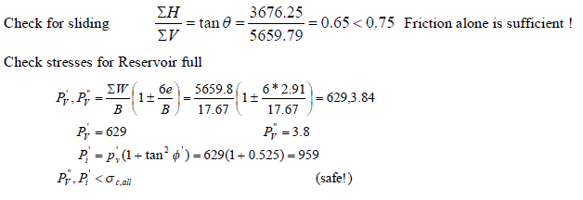
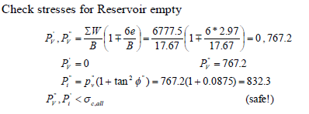

Block II
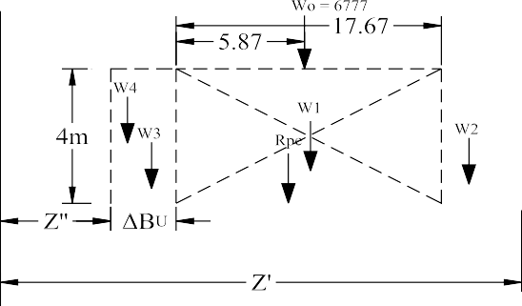ho = 27m
Δh = 4m h = 31m
Bo = 17.67 m

Line | Item | Description & dimension | Forces |  |  | Lever | Moment
 |  |  | Horizontal |  | Vertical
1 | W0 | concreter above h = 27m |  |  | 6777 | 8.87 | 60111.99
2 | W1 | 4*17.67*24 |  |  | 1696.32 | 11.83 | 20075.95
 | Trial I | ΔB_{d} = 3.1
3 | W2 | 3.1* *24 |  |  | 148.8 | 21.70 | 3229.46
4 |  | Total Partial empty |  |  | 8622.12 | 9.67 | 83417.4
 |  | Estimation  2B/3=Z' - 8.61 = 23.77 - 8.61=  ΔBu =B - (Bo + ΔBd) =  Z''+B/3 = | 14.1  0.38  9.67 | Z' = | 23.77  B = Z'' =  Z''+2B/3 = | 21.15  2.62  16.72
5 | W3 | 0.5*0.38*4*24 |  |  | 18.24 | 2.87 | 52.35
6 |  | Reservoir Empty |  |  | 8640.36 | 9.66 | 83469.75
7 | W4 | Water column 0.38*25*10 |  |  | 110.2 | 2.81 | 309.662
7 | Wu | Uplift: 0.5*B*0.5h*10 |  |  | -1639.13 | 9.67 | -15850.3
8 | Fh | Water Pressure | 4805 |  |  | 10.33 | 49651.67
9 | Fwa | Wave action | 31.25 |  |  | 31.47 | 983.44
 |  | Reservoir Full | 4836.25 |  | 7111.435 | 16.67 | 118564.2
The resultant for both reservoir empty and reservoir full case passes with in the middle third of the base. Furthermore, from the line of action of the resultant it can easily be deduced that the section is economical.

Check for friction Resistance
tanӨ = ΣH
ΣW
= 4836 = 0.68 < 0.75 = f ; Friction alone is sufficient!
7111

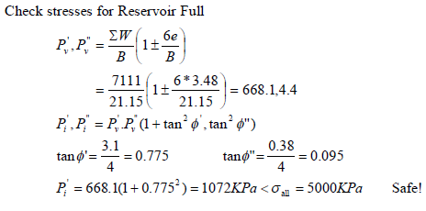

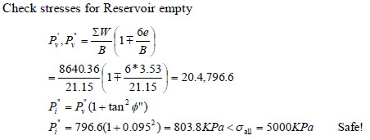
Continue with the design block by block until you arrive at the required dam height or the limit of zone IV, whichever comes first. If the dam height could not be obtained in Zone IV, continue the design block by block in the remaining zones by fulfilling the design rules.
Example:
Design a non-overflow gravity dam by the Single-step method using the following data.
Item | Value | Item | Value
H_{max} (depth of headwater) | 45 m | f (friction factor) | 0.75
h_{e} ( spillway crest to MWL) | 3 m | s_{a} (Shear strength) | 4.5 MPa
Tail water | None | s_{sf} (Shear safety factor) | 5
Top width | 7.5 | ζ (Uplift factor) | 0.5
γ_{c} (concrete Specific unit weight) | 22 MPa | C (uplift area factor) | 1
γ_{w}(water specific unit weight) | 10 MPa | ο ’ (concrete ultimate strength)  c | 30 MPa
Earthquake | small | F (Fetch length) | 5 km
silt pressure | Ignore | V (Wind Velocity) | 128 km/hr
Solution
Determine the wave height by the empirical equations

hw = 0.763 + 0.032
hw = 0.763 + 0.032
= 1.17 m
− 0.271 f 1 / 4
128 * 5 − 0.271* 5.01/ 4
vf
for f
< 32km

Rise of water wave = 1.33h_{w}
= 1.56 m;
With an allowance of 0.14 m, free board = 1.70m F_{wv} = 2.0γ_{w}h²_{w}
= 2.0 * 10 * 1.17²
= 27.40 kN/m
Point of application = 3/8 x 1.17 =0.44m above still water level.

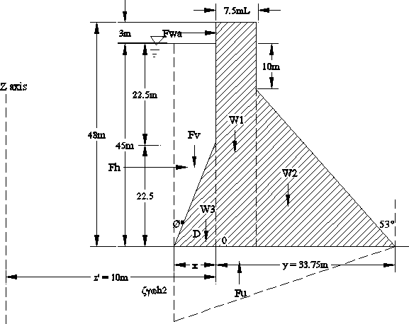

Line | Item | Description & dimension | Forces |  |  | Lever | Moment | Remark
 |  |  | Horizontal |  | Vertical
1 | W1 | 7.5*46.7*22 |  |  | 7705.5 | 13.75 | 105950.6
2 | W2 | 0.5*35*26.25*22 |  |  | 10106.25 | 26.25 | 265289.1
 |  | Total Partial empty |  |  | 17811.75 | 20.84 | 371239.7
Trial I |  | Estimation of x |  | Z'= | 43.75
 |  | 2B/3=Z' - 20.84 = 22.91 |  |  | B= | 34.37
 |  | x = 0.75 |  |  | Z'' = | 9.25
 |  | Z''+B/3 = 20.71 |  |  | Z''+2B/3 = | 32.16
3 | W3 | 0.5*22.5*0.8*22 |  |  | 185.625 | 9.75 | 1809.84
 |  | Reservoir Empty |  |  | 17997.38 | [20.73] | 373049.5 | Ok!
4 | Fv | Water column 0.3*25*10 |  |  | 253.125 | 9.63 | 2437.594
5 | Fu | Uplift: 0.5*B*0.5h*10 |  |  | -3866.63 | 20.71 | -80077.8
6 | Fh | Water Pressure | 10125 |  |  | 15 | 151875
7 | Fwa | Wave action | 27.4 |  |  | 45.44 | 1245.06
 |  | Reservoir Full | 10152.4 |  | 14383.88 | [31.18] | 448529.4 | Ok!

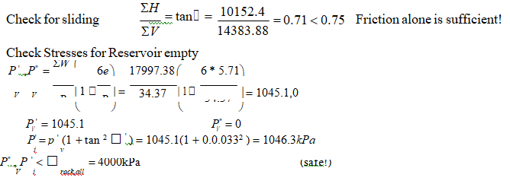
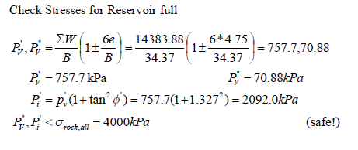
Exercise:
- Prepare a flow chart for a computer program which could be developed to design gravity dams by the multiple step method considering all the possible forces on the dam. The flowchart should clearly show the main program and sub programs.
- The non-overflow dam previously designed by the multiple step method is to be constructed in a seismic area. Redesign the dam taking earth factor αh = 0.10, period of earth quake vibration T = 0.4sec and a top width B = 12m. Dam height, H, is 40m
- Design the dam of the previous example of multiple-step design method by the single-step method and compare the section obtained with the section of the multiple-step method
- Foundation level is at 66m below the max water level
- Allowable stress of foundation rock is 2Mpa
- Design a non-overflow gravity dam by the Single-step method using the following data. (Consider earthquake and silt pressure)

Item | Value | Item | Value
H_{max} (depth of headwater) | 45 m | f (friction factor) | 0.75
h_{e} ( spillway crest to MWL) | 3 m | s_{a} (Shear strength) | 4.5 MPa
Tail water | None | s_{sf} (Shear safety factor) | 5
Top width | 7.5 | ζ (Uplift factor) | 0.5
Hs (depth of silt-water mixture) | 4 m | C (uplift area factor) | 1
Ss(Specific gravity of silt) | 1.5 | ο ’ (concrete ultimate strength)  c | 30 MPa
γ_{ss}(for horizontal silt water pressure) | 14 kN/m² | F (Fetch length) | 5 km
α (earthquake factor) | 0.12 | V (Wind Velocity) | 128 km/hr
T (period of EQ vibration) | 0.80 sec | γ_{c} (concrete Specific unit weight) | 22 MPa
 |  | γ_{w}(water specific unit weight) | 10 MPa

Gravity dam Construction, Quality control and the Future

The Construction Process
Dry construction area: Before construction can begin on any dam, the water in the streambed must be diverted or stopped from flowing through the site. As in the case of fill dams, a coffer-dam (a temporary structure to impound the water) must be built or the water must be diverted into another channel or area down-stream from the dam site. For large projects, this construction may be done several seasons before building of the dam begins. The flow of water is closed off at the very last moment.
Foundation: The foundation area for any concrete dam must be immaculate before the first concrete for the dam is placed. As for fill dams, this is a detailed process of excavating, cleaning, and repairing the rock throughout the foundation "footprint" and on both

abutments (the sides of the canyon that form the ends of the dam). Sites immediately downstream of the dam for any power-plant, stilling basin, or other structure must also be prepared.
At some sites, extensive work may be required. If the rock in the foundation or abutments is prone to fracturing because of the load imposed by the dam and its reservoir, earthquake activity, or the properties of the rock, it may be necessary to install extensive systems of rock bolts or anchor bolts that are grouted into the rock through potential fracture zones. On the abutments above the dam, systems of rock bolts and netting may be required to keep large rock fragments from falling onto the dam. Instruments to monitor groundwater levels, joint movement, potential seepage, slope movements, and seismic activity are installed beginning during the early stages of foundation preparation through completion of the dam.
A cutoff wall may be excavated deep into rock or holes may be drilled in the foundation for the installation of reinforcing steel, called rebars, that extend up into the dam and will be tied to the steel inside the first lifts of the dam. The idea is to build a reservoir that, like a bowl, is equally sound around its perimeter. The water is deepest and heaviest at the dam (when the reservoir is near capacity) so the dam and its foundation cannot be a weak point in that perimeter.
Formwork and concrete casting: Forms made of wood or steel are constructed along the edges of each section of the dam. Rebar is placed inside the forms and tied to any adjacent rebar that was previously installed. The concrete is then poured or pumped in. The height of each lift of concrete is typically only 1.5-3 m and the length and width of each dam section to be poured as a unit is only about 15 m. Construction continues in this way as the dam is raised section by section and lift by lift. Some major dams are built in sections called blocks with keys or inter-locks that link adjacent blocks as well as structural steel connections.
The process is much like constructing a building except that the dam has far less internal space; surprisingly, however, major concrete dams have observation galleries at various levels so the condition of the inside of the dam can be observed for seepage and movement. Inlet and outlet tunnels or other structures also pass through concrete dams, making them very different from fill dams that have as few structures penetrating the mass of the dam as possible.
Early dam performance: As soon as a significant portion of the dam is built, the process of filling the reservoir may begin. This is done in a highly controlled manner to evaluate the stresses on the dam and observe its early performance. A temporary emergency spillway is constructed if dam building takes more than one construction season; lengthy construction is usually done in phases called stages, but each stage is fully complete in itself and is an operational dam. The upstream cofferdam may be left in place as a temporary precaution, but it is not usually designed to hold more than minimal stream flows and rainfall and will be dismantled as soon as practical. Depending on design, some dams are not filled until construction is essentially complete.
Appurtenances: The other structures that make the dam operational are added as soon as the elevation of their location is reached as the dam rises. The final components are erosion protection on the upstream (water) side of the dam (and sometimes downstream at the bases of outlet structures), instruments along the crest (top) of the dam, and roads, side- walks, streetlights, and retaining walls. A major dam like Hoover Dam has a full-fledged roadway along its crest; small dams will have maintenance roads that allow single-file access of vehicles only.

Away from the dam itself, the powerhouse, instrument buildings, and even homes for resident operators of the dam are also finished. Initial tests of all the facilities of the dam are performed.
Completion: The final details of constructions are wrapped up as the dam is put into service. The beginning of the dam's working life was also carefully scheduled as a design item, so that water is available in the reservoir as soon as the supply system is ready to pump and pipe it downstream, for example. A program of operations, routine maintenance, rehabilitation, safety checks, instrument monitoring, and detailed observation will continue and is mandated by law as long as the dam exists.

Quality Control
There is no dam construction without intensive quality control. The process of building alone involves heavy equipment and dangerous conditions for construction workers as well as the public. The population living downstream of the dam has to be protected over the structure itself; the professionals who design and construct these projects should absolutely be committed to safety, and they are monitored by local, regional, and federal agencies.

The Future
The future of concrete dams is the subject of much debate. Each year, over 100,000 lives are lost in floods, and flood control is a major reason for building dams, as well as protecting estuaries against flooding tides and improving navigation. Lives are also benefited by dams because they provide water supplies for irrigating fields and for drinking water, and hydroelectric power is a non-polluting source of electricity. Reservoirs are also enjoyed for recreation, tourism, and fisheries.
However, dams are also damaging to the environment. They can change ecosystems, drown forests and wildlife (including endangered species), change water quality and sedimentation patterns, cause loss of agricultural lands and fertile soil, regulate river flows, spread disease (by creating large reservoirs that are home to disease-bearing insects), and perhaps even affect climate. There are also adverse social effects because human populations are displaced and not satisfactorily resettled.
For years before the start of construction in 1994 of the Three Gorges Dam in China, environmentalists the world over organized protests to try to stop this huge project. They have not succeeded, but controversy over this project is representative of the arguments all proposed dams will face in the future. The balance between meeting human needs for water, power, and flood control and protecting the environment from human eradication or encroachment must be carefully weighed.

Concrete Arch and Concrete Buttress dams

Concrete Arch Dam
Concrete arch dam is a concrete dam with a considerable upstream curvature, structurally resisting the imposed loads by arch and cantilever action. Arch dam transmits the major portion of the water load to the abutments or valley sides rather than to the floor of the valley, hence, large horizontal reactions are required by the abutments.
Arch dams are restricted to relatively narrow valley sections with strong abutments. They are structurally more efficient than the gravity or buttress counterparts, greatly reducing the volume of concrete required.
The structural interaction between the loaded arch dam and its supporting abutments is extremely complex and is beyond the scope of this course.
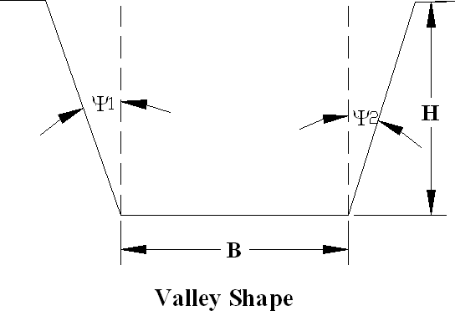
Valleys suited to arch dams are narrow gorges. The ratio of crest length to dam height is recommended not to exceed five. To determine the site suitability for an arch dam the following equation of canyon shape factor (CSF) is proposed:

CSF = B + H (secΨ 1 + secΨ ₂)
H

Usual values of CSF are from 2 to 5. The lower the CSF value the thinner the section. Table 4-1 Classification of valley shapes based on CSF value
Valley type | Bottom width B | ψ₁ | ψ₂ | CSF
U shaped | < H | < 15⁰ | < 15⁰ | < 3.1
Narrow V shaped | 0 | < 35⁰ | < 35⁰ | < 2.4
Wide V-shaped | 0 | > 35⁰ | > 35⁰ | > 2.4
Composite U-V shaped | < 2H | > 15⁰ | > 15⁰ | ≅ 4.1
Wide and flat shapes | > 2H | ψ₁ | ψ₂ | > 4.1
Unclassified | Highly irregular valley shape

Arch dams may be grouped into two main divisions: Massive arch dams and multiple arch dams.
Massive arch dam:- the whole span of the dam is covered by a single curved wall usually vertical or nearly so.
Multiple arch dam:- series of arches cover the whole span of the dam, usually inclined and supported on piers or buttresses. These are usually considered as a type of buttress dam and will be described later.
Massive arch dams in turn are divided into the following types:
- Constant radius arch dams,
- Constant angle arch dams
- Variable radius arch dams
- Double curvature or Cupola arch dams
- Arch gravity dams

Constant radius arch dam
Constant radius is the simplest geometric profile combining a vertical upstream face of constant extrados (outside curved surface of the arch dam) radius with a uniform radial downstream slope. Though the constant radius arch dam is not the most economical profile in volume, it is simple to analyze and construct. Besides, this profile is suitable to relatively symmetrical “U” shaped valley. For a site with variable span length “V” shaped valleys a constant radius can have the correct central angle only at one elevation. Therefore, smallest masonry volume for the whole dam is obtained by increasing the top angle to get the best average angle. Usually a maximum of 150º is used for the top arch.
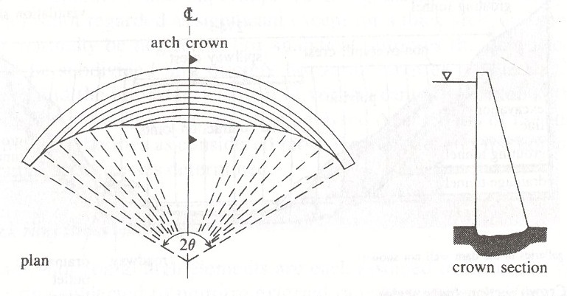
Figure 4-1 Constant Radius Arch dam

Constant Angle Arch dam
Central angle 2θ of different arches has the same magnitude from top to bottom. In practice 2θ = 100⁰ to 150⁰ is used. It uses about 70% concrete as compared to constant radius arch dam.

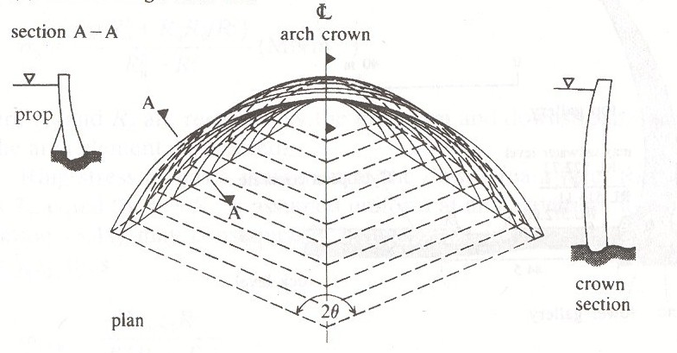
Figure 4-2. constant angle arch dam.

Variable radius arch dam
It is a compromise between constant radius and constant angle arch dams, i.e., neither the radius nor the angle is constant. The radii of the extrados and intrados surfaces vary from the top to bottom, usually maximum at the top and minimum at the base. The central angle of the different

arches is not constant; it usually ranges from 80⁰ to 150⁰. The central angle for the top arch is made as wide as possible. The dam is suitable for V and U-V shaped valleys.
The radius is varied to cut the face at the required contour interval so that there is no overhang. Masonry volume consumed is about 82% of that for constant radius arch dam of the same height.
[include figure]

Loads on arch dam
The forces acting on arch dam are the same as that of gravity dams. Uplift forces are less important (not significant). Internal stresses caused by temperature changes and yielding of abutments are very important. Foundation stresses are generally small.

Methods of design of massive arch dams.
  - thin cylinder theory
  - elastic theory
  - trial load method (discussion beyond the scope of this course)

The thin cylinder theory
It is envisaged that the weight of concrete and water in the dam is carried directly to the foundation. The horizontal water load is carried entirely by arch action. The theory assumes that the arch is simply supported at the abutments and that the stresses are approximately the same as in thin cylinder of equal outside radius r_{o}.

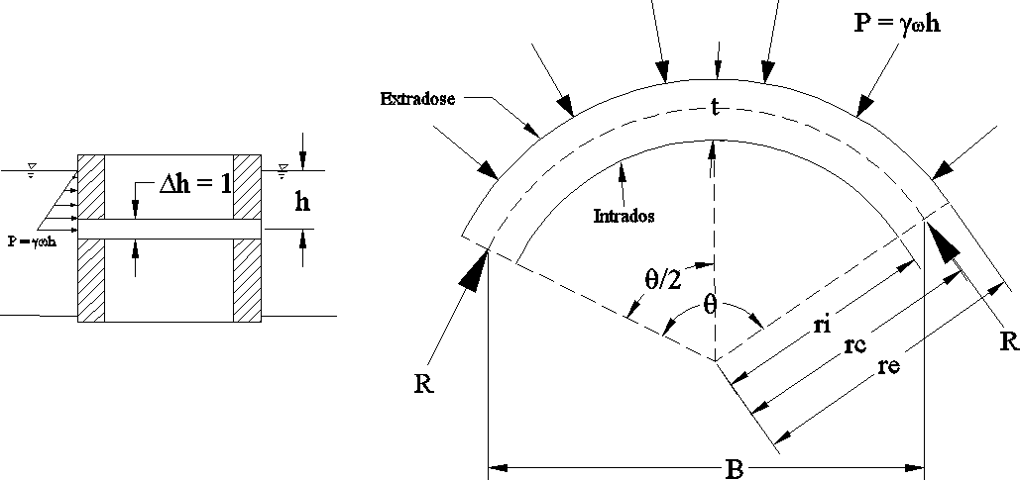
Figure 4-3 thin cylinder model of an Arch dam
Summing forces parallel to the stream axis

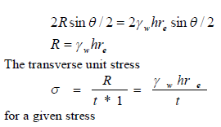

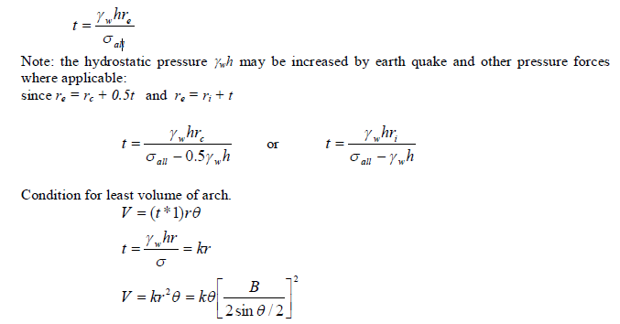

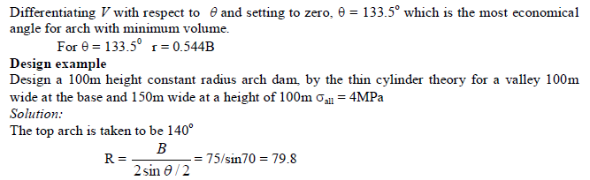

Take r = 80m

The extrados radius r_{e} of all arches is kept as 80m. Calculations are shown in table below:
h | B | r_{e} | P | t | r_{i} | ❑
0 | 150 | 80 | 0 | 0 | 80 | 139.27
10 | 145 | 80 | 100 | 2 | 78 | 129.98
20 | 140 | 80 | 200 | 4 | 76 | 122.09
30 | 135 | 80 | 300 | 6 | 74 | 115.08
40 | 130 | 80 | 400 | 8 | 72 | 108.68
50 | 125 | 80 | 500 | 10 | 70 | 102.75
60 | 120 | 80 | 600 | 12 | 68 | 97.18
70 | 115 | 80 | 700 | 14 | 66 | 91.90
80 | 110 | 80 | 800 | 16 | 64 | 86.87
90 | 105 | 80 | 900 | 18 | 62 | 82.03
100 | 100 | 80 | 1000 | 20 | 60 | 77.36
Note: Provide a nominal thickness of 1.5 m when necessary.

Procedure to layout a constant radius arch dam:
- Draw excavated rock contours,
- Draw the center line and locate the arch center O,
- Draw the extrados and intrados curves for the top arc
- Starting at the point of intersection of the center line and the extrados curve, lay off the arch thickness t at successive contour intervals toward the point of intersection of the center line and intrados curve of the last arch,
- With center at O, draw arcs through these points to the respective contours,
- Draw the x-section on the center line. It may also be drawn before the plan. Example:
Design a 100m high constant angle arch dam by thin cylinder theory for a valley 40m wide at the base and 240m wide at a height of 100m. Take σ_{all} = 5MPa.
Solution
Taking θ = 133.44⁰
r_{i} = 0.544B
t = ℽw hri
σall − ℽw h
r_{e} = r_{i} + t
h | B | r_{i} | P | P*r_{i} | σ_{all} –p | t | r_{e}
0 | 240 | 130.56 | 0 | 0 | 5000 | 0 | 130.56
10 | 220 | 119.68 | 100 | 11968 | 4900 | 2.44 | 122.12
20 | 200 | 108.80 | 200 | 21760 | 4800 | 4.53 | 113.33
30 | 180 | 97.92 | 300 | 29376 | 4700 | 6.25 | 104.17
40 | 160 | 87.04 | 400 | 34816 | 4600 | 7.57 | 94.61
50 | 140 | 76.16 | 500 | 38080 | 4500 | 8.46 | 84.62
60 | 120 | 65.28 | 600 | 39168 | 4400 | 8.90 | 74.18
70 | 100 | 54.40 | 700 | 38080 | 4300 | 8.86 | 63.26
80 | 80 | 43.52 | 800 | 34816 | 4200 | 8.29 | 51.81
90 | 60 | 32.64 | 900 | 29376 | 4100 | 7.16 | 39.80
100 | 40 | 21.76 | 1000 | 21760 | 4000 | 5.44 | 27.20

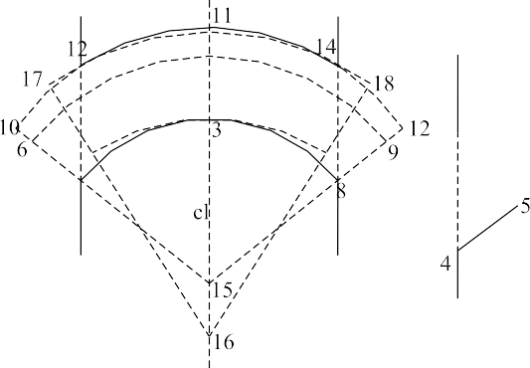Design procedure for variable radius arch dam

Figure 4-4. Overhang of arches
Design is begun at the top, θ for the top arch being as wide as possible. 1-2-3-4-5-1: top arch
6-7-3-8-9: the constant angle design for the next contour interval. Thickening the arch to 10-11- 12, overhang can be eliminated. If the arch 6-7-3-8-9-6 fulfills the equation
t = ℽ w hre ,
σ all

10-7-3-8-12 is thicker than necessary. Hence, lengthening the radius on arch 16-17-18 is found by trial which just avoids overhang and fulfills the requirement of the above equation. The dimensions of successive arches, proceeding downward, are determined in the same manner.

Elastic arch theory (Arch dam analysis)
The theory assumes complete transfer of load by arch action only. Horizontal arch rings are assumed fixed to the abutments, but acting independently of neighboring rings. Effect of temperature variation on arch stress is considered. This method can be used for preliminary design to determine the adequacy of the section designed by the thin cylinder theory.
Modified Cain’s Equations are used for calculating forces and moments at the crown and at abutments.

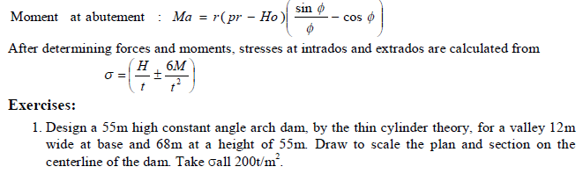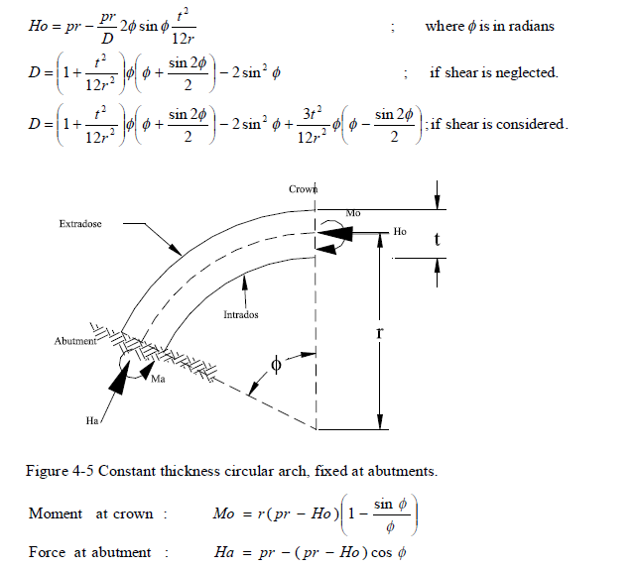

- Determine the stresses at the intrados and extrados of the crown and abutment for the constant angle arch dam of the previous example at h = 40m

Buttress dams
Buttress dams consist of a slopping u/s membrane which transmits the water load to the axis of the dam. The principal structural elements of a buttress dam are the water supporting u/s deck and the buttresses that in turn support the deck. The buttresses are carefully spaced, triangular walls proportionate to transmit the water load and the weight of the structure to the foundation.
Buttress dams are adaptable to both overflow and non-overflow conditions. In overflow dams a downstream deck is provided to guide the flowing stream.

Figure 4-6 Typical section and plan view of a buttress dam

Classification of buttress dams
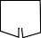Buttress dams can be classified according to the water supporting membrane utilized in the body of the structure. The main types are shown in Figure 4-7 below and there are other types emerged from the flat deck types with modification in the buttress configuration.

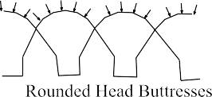
Figure 4-7 Types of Buttress Dam
    - Advantages and Disadvantages of Buttress Dams Advantages of buttress dams
- - less concrete is used compared to a gravity dam of the same height,
  - Increased surface area to volume ration

  - Better heat dissipation
  - Increased speed of construction
- More safety against overturning and sliding because of the larger vertical component of hydrostatic force exerted on the dam (highly inclined u/s face)
- More equal distribution of stresses of foundation.
- Less massive than gravity dam hence may be used on weak foundation not suitable for gravity dam
- Decreased uplift pressure ( if no spread footing, joining the buttresses is used)
Disadvantages of Buttress dam
- needs reinforcement and expensive shuttering
- needs more skilled labor
- slabs and columns are highly stressed; danger of deterioration of concrete of the u/s deck
- more susceptible to damage by sabotage

Usually, β = 40⁰ – 60⁰ To increase stability
α = 70⁰ – 80⁰
To provide for adequate Buttress width B = (1.2 to 1.5)h

Forces on buttress dams
Essentially buttress dams are subjected to the same forces as gravity dams. Uplift forces may be insignificant as in the case of arch dams. Wind load on buttress faces may be considerable when high velocity winds blow diagonally from the downstream side, hence struts (beams) are usually provided.

Design Principle for Buttress Dams
The stability analysis for buttresses is done in a similar fashion as for a gravity dam. However, the design element is not taken to be a slice of unit thickness as in gravity dams, but the full panel is considered. In addition to satisfying the stability criteria the buttresses are designed to conform to the design rules for structural concrete members.
The buttress width is determined by considering the buttress to be a vertical cantilever beam. The width has to be sufficient to avoid tension at the upstream face when fully loaded and also to avoid excessive compression at the downstream face. In order to determine the thickness of the buttress required to prevent buckling they are considered to be bearing walls instead of beams. The minimum allowable thickness is same as that for columns. The unsupported length is generally reduced by providing struts at intermediate points.

Simple slab (Ambersen type) buttress dams
The slab is simply supported and the joint between the slab and buttresses is filled with asphalt putty or any flexible compound.
The slab is designed by assuming that it consists of a series of parallel beams acting independent of one another and simply supported on the buttresses.

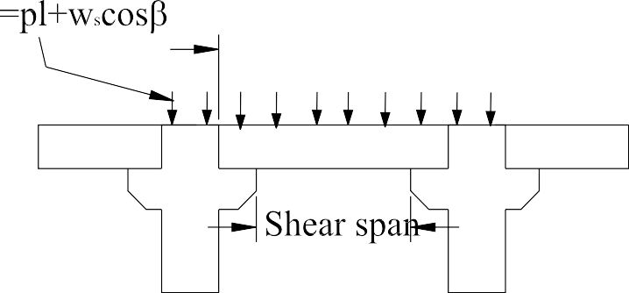
Figure 4-8 Modeling of simply supported Buttress dam
Spacing of the buttress is governed by:
- length of the dam
- pressure of spread footing or a continuous floor slab
- presence of spillway over the dam
- slope of the upstream water supporting membrane(slab)
- Unusual foundation or side hill condition.
For high dams greater spacing may be economical. Wider spacing may entail increased thickness and reinforcement of slabs. The spacing that will give the most economical balance of concrete steel and formwork area is determined by the total cost of the items.
Mean height | Economical buttress spacing (distance b/n CL)
15 to 30 | 4.5 to 6.0
30 to 45 | 9.0 to 12.0
Above 45 | 12.0 to 12

The buttress is designed as a system of columns each carrying the load by column action to the foundation. These columns are proportioned to develop a uniform compressive stress and curved to avoid any serious eccentricity on any horizontal or normal plane when the water and concrete loads are resolved.

Embankment Dam

Introduction
Embankment dam is a water impounding structure constructed from fragmental natural materials excavated or obtained close to the dam site. The natural fill materials are placed and compacted without the addition of any binding agent, using high capacity mechanical plant. They rely on their weight to resist the flow of water, just like concrete gravity dams.
Embankment dam derive its strength from position, internal friction and mutual attraction of particles. Relative to concrete dams, embankment dams offer more flexibility; and hence can deform slightly to conform to deflection of the foundation without failure.
Broadly, depending upon the material used during construction, embankment dams are classified in to two:
- Earth fill Embankments: if compacted soils, i.e. clays/silts & sands, account for over 50% of the placed volume of material
- Rock fill Embankment: if compacted rock particles larger than a man can easily lift,
i.e. coarse grained frictional material, accounts for over 50% of the placed volume of materials.

Embankment dam possesses many outstanding merits which could be summarized as follows:
- Suitability of the type to different site conditions such as wide valleys, steep sided gorges, etc.
- Adaptability to a broad range of foundation condition such as rock and pervious soil formation,
- use of natural materials,
- Extreme flexibility to accommodate different fill materials,
- Highly mechanized and effectively continuous construction process,
- Appreciable accommodation of settlement-deformation without risk of serious cracking and possible failure.

The relative disadvantages of the embankment dam are
- Inherently susceptible to damage or destruction by overtopping
- Necessity of separate spillway structure
- Vulnerability to concealed leakage and internal erosion in dam or foundation

Key elements and appurtenances of Embankment dam
Every embankment dam consists of three basic components plus a number of appurtenances which enable the basic components to function efficiently shown in Figure 5-1.

Foundation:
The foundation of embankment dam could either be earth or rock material. The foundation provides support resisting both vertical and horizontal loads. It may also resist seepage beneath the embankment

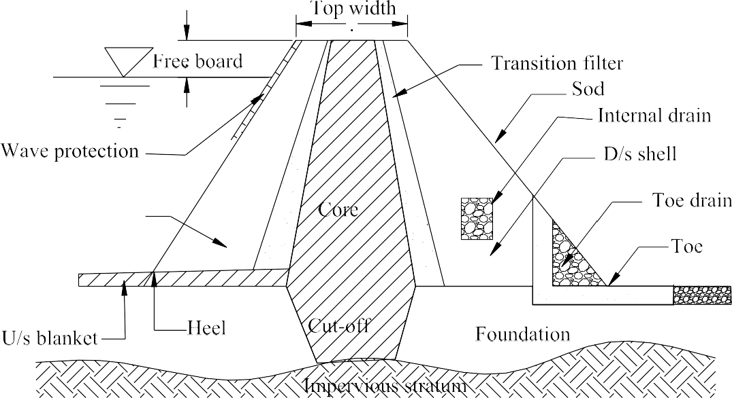

Figure 5-1 Basic components and appurtenances of Embankment dam

Core or membrane
The primary purpose of the core or membrane is to hold back free water. Depending on the structural requirements of the dam, the core may be placed at the center or upstream from the center, or on the upstream face (in the case of certain rock fill dams)
When the foundation is incapable of resisting under seepage the core is extended down into the foundation to impervious layer. Such an extension of the core is termed cut-off.
Core material:
Earth, concrete or masonry, steel sheeting, etc. are used as core material. Lack of flexibility of concrete and masonry make them undesirable. An earth core (when suitable material is available) is usually cheaper and more water tight than any other type. Suitability of earth core depends on the character of the available soil.
Table 5-1: Permeability of different soil types

Permeability coefficient | Typical soil | Value as core
2 – 0.002 | Sand | Considerable leakage
0.002 – 0.0002 | Silty clay | Usable with good control if some  leakage is tolerable
0.0002 – 0.000006 | Silts | Little leakage if well compacted
≤ 0.000006 | Silty clay, clay | Impervious

A core should not be composed of silt which tends to swell upon saturation. To avoid swelling tendencies, the elasticity index should not exceed 30.
Typical requirements for core compaction are
90 – 97% of standard proctor maximum, or 87 – 95% of modified proctor maximum.
Water content: - as high as possible consistent with the above requirements.
Core thickness: - to control erosion and provide good compaction a minimum core thickness in meters is given by

b = 6 + 0.1Δh (clay)
b = 6 + 0.3Δh (silt) Where: Δh = head difference at that point;
b = core width at that point.

    - Shell
The purpose of shell is to provide structural support for the core and to distribute the loads over the foundation. The shell also acts as foundation for most of the appurtenances. Sometimes the core and shell of a dam are constructed of the same material (homogenous dam).
Shell (embankment) materials
Availability and strength are the requirements for selection.
Strength: - the strength for the upstream side should be that at the inundated condition. The same strength should be used for the downstream face which is below the maximum phreatic line.
Permeability: - high permeability is desirable from the standpoint of pressure buildup during construction and stability during sudden drawdown.
Typical compaction requirements:
95 – 100% of standard proctor maximum; 92 – 97% of modified proctor maximum.
Slopes: - shell slopes are based on stability analysis. When the stability is insufficient, improvements are possible by adopting
- Flatter slopes;
- Increasing strength through high density;
- Treatment for weak foundation;
- Drainage of the foundation and embankment.
Table 5-2: Tentative slopes of shoulder for different embankment materials

Soil type | Upstream | Downstream
Gravel, sandy gravel with core | 2.5H : 1V | 2.0H : 1V
Clean sand with core | 3.0H : 1V | 2.5H : 1V
Low density silt, micaceous silt | 3.5H : 1V | 3.0H : 1V
Low plasticity clay | 3.0H : 1V | 2.5H : 1V

Composite slopes: - are used for large dams. They can be found in two ways: a series of straight slopes or a constant slope with berms.

Figure 5-2 composite slopes for shell of embankment dam

A berm is a level surface on the slope that can serve the following purposes
  - Increases slope stability by increasing dam width;
  - Breaks the continuous downstream slope to reduce surface erosion
  - Provides level surface for maintenance operations, roads, etc.
Berm is also used at the bottom of a zone of riprap to provide supporting shoulder.

Height of dam:
Required height of an embankment dam is the vertical distance from the foundation to the water surface in the reservoir, when the spillway is discharging at design capacity, plus a free board allowance.
Free Board = maximum wave run-up height + allowance for settlement + allowance for splash
Maximum wave run-up height = 4h_{w}/3
Where: h_{w} = effective wave height (with expectancy of 1%) Table 5-3: Wave run-up to maximum wave height ratio on slopes
Slope | Ratio of run-up to maximum wave height
 | Smooth Surface | Riprap surface
1.5H : 1V | 2.5 | 1.6
1H : 1V | 2.0 | 1.3

Maximum vertical height of run-up = Expected wave height * appropriate factor from Table 5-3 Settlement allowance: the following may be used as guide.
For foundation: 1% of height of dam
For embankment: 1-2% of height of embankment Splash allowance could be taken 0.30 – 0.50m.

Top Width:
- Should be sufficient to keep the phreatic line with in the dam when the reservoir is full
- Should be sufficient to withstand wave action and earthquake shock
- Has to satisfy secondary requirements such as minimum roadway width.

Appurtenances
Transition filter: - it is provided between core and shell to prevent migration of the core material into the pores of the shell material. It is particularly needed between clay cores and rock and gravel shells.
The objective of transition filter is to carry away seepage that has passed through the core and cut-off and to prevent stratum of the upper part of the downstream shell.
Toe drain: - it helps to prevent sloughing of the downstream face as a result of rain water or seepage saturation. In small dams, the toe drain serves also as internal drain. In large dams with pervious foundation, the toe drain and the internal drain are sometimes combined. Drains need protective filter (inverted filter) to prevent clogging of the drain.
Riprap: - required to cover the upstream/downstream face.
Normally riprap extended from above the maximum water level to just below the minimum.
Sod: - required on the downstream face to prevent rain wash.
For economic reasons, the material available at the particular site has to be employed as much as possible for the construction of the earth dam and the quantity of imported material should be minimized.
Internal drains: - they are essential in large dams where the d/s shell is not so pervious.

Types of Embankment dam
The materials available locally control the size and configuration of the dam. Many small embankment dams are built entirely of a single type of material such as stream alluvium, weathered bedrock, or glacial till. These are homogeneous dams, constructed more or less of uniform natural material as shown in Figure 5-3.
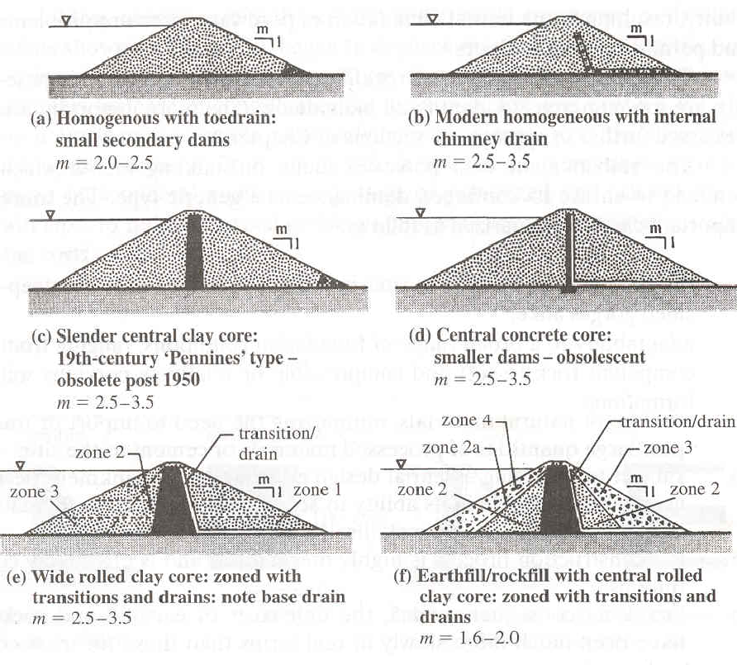
Figure 5-3 Principal variants of earth fill embankment dams (Values of m are examples)
The central core earth fill profile, shown in Figure 5-3 (c) and (d), is the most common for larger embankments dams. Larger embankment dams are also zoned and constructed of a variety of materials Figure 5-3 (f), either extracted from different local sources or prepared by mechanical or hydraulic separation of source material into fractions with different properties.
An important element in a zoned dam is an impermeable blanket or core which usually consists of clayey materials obtained locally. In locations where naturally impermeable materials are unavailable the dams are built of rock or earth-rock aggregates as shown in Figure 5-4, and the impermeable layers of reinforced concrete, asphalt concrete, or riveted sheet steel are placed on the upstream face of the dam.

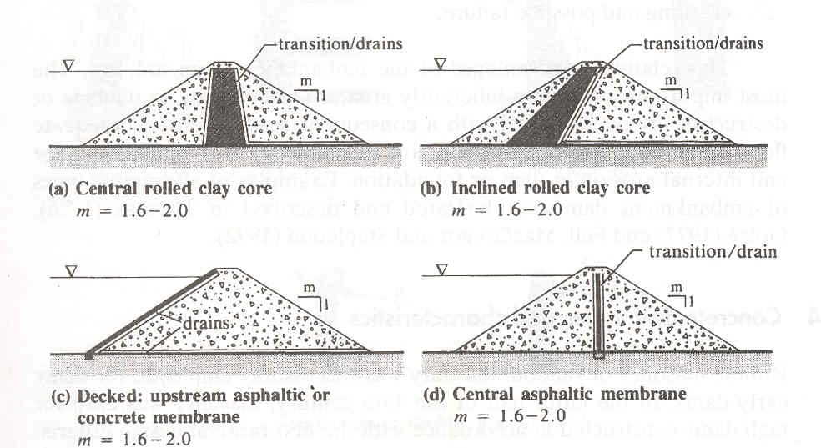
Figure 5-4 Principal variants of rock fill embankments dams (values of m are examples)
Selection of the optimum type of embankments for a specific location is determined largely by the nature and availability of different fill materials in sufficient quantity.
The primary loads acting on an embankment do not differ in principle from those applicable to gravity dams. There are, however, the conceptual differences there referred to with regard to the water load which is exerted inside the upstream shoulder fill. Self weight load, similarly a distributed internal body load, is significant with respect to stability and internal stress for the embankment and for a compressible soil foundation.
Because of such differences, embankments dam analysis is less formalized and is carried out quite differently from concrete dam analysis.

Causes of Failure of Embankment dams
Embankment dams, like any other engineering structure, may fail due to improper design, faulty constructions, lack of maintenance, etc. Generally, causes of failure are grouped into three classes: Hydraulic failure, Seepage failure and Structural failure.
Hydraulic failures: About 40% of earth dam failures have been attributed to these causes due to;
- Overtopping. Occurs when the design flood is less than the coming flood. Spillway and outlet capacity must be sufficient to prevent overtopping. Freeboard should also be sufficient to prevent overtopping by wave action.
- Erosion of upstream faces. Wind waves of water developed due to wind near the top water try to notch-out the soil from u/s face and may even sometimes cause the slip of the u/s slope.(upstream slope pitching or rip rap should be applied.)
- Erosion of downstream face by gully formation. Heavy rains falling directly over d/s face and the erosive action of the moving water may lead to the formation of gullies on the d/s face, ultimately leading to the dam failure.
- Cracking due to frost action. Frost in the upper portion of dam may cause heaving of soil with dangerous seepage. Consequently failure. Provide an additional free board allowance up to a maximum of say 1.5m may be provided.

Seepage failure: controlled seepage or limited uniform seepage is inevitable in all embankments and it does not produce any harm. However, uncontrolled or concentrated seepage through the dam or the foundation may lead to piping* or sloughing† and the subsequent failure of the dam.

  - The progressive erosion and subsequent removal of soil grains from within the body of the dam or the foundation of the dam
† The progressive removal of soil from the wet d/s face.

Structural failure: about 25% of the dam failures have been attributed to structural failures. Structural failures are generally caused by shear failures, causing slides.

Causes of failure as categorized based on time of occurrence During construction
    - Unstable slop
    - Heavy rainfall that washes the d/s face
    - Weak foundation After construction
    - Failure of u/s face due to sudden drawdown
    - Failure of d/s when the reservoir is full
    - Overtopping
    - Seepage failure.

Design features
Some of the more important features that should be considered in the design of embankment dams are:
- Zoning of shoulder-fills: the permeability of successive zones should increase toward the outer slopes, materials with a high degree of inherent stability being used to enclose and support the less stable impervious core and filter.
- Spillway location: geotechnical and hydraulic design considerations require that to minimize the risk of damage to the dam under flood conditions the spillway and discharge channel are kept clear of the embankment.
- Freeboard: is the difference between maximum reservoir level and minimum crest level of the dam. The provision necessary for long-term settlement within the overall minimum freeboard is determined by the height of dam and the depth of compressible foundation at any section.
The overall minimum freeboard from spillway sill to dam crest should be at least 1.5m on the smallest reservoir embankment, and it will be very much greater for larger embankments and/or reservoir.
The minimum height of freeboard for wave action is, generally, 1.5h_{w}

hw = 0.032
hw = 0.032
v.F + 0.763 − 0.2714 F
v.F
For F < 32km
For F > 32km

Where; v is wind velocity (km/hr)
F is fetch or straight length of water expansion in km
  - Foundation seepage control: seepage flows and pressure within the foundation are controlled by cut-offs and by drainage. Cut-offs is impervious barriers which function as extensions of the embankments core into foundation. The cut-offs are generally two types:
    - Fully penetrating cut-off: penetrate to impervious strata
    - Partially penetrating cut-off: terminate where the head loss across the cut-off is sufficient to effect the required degree of control

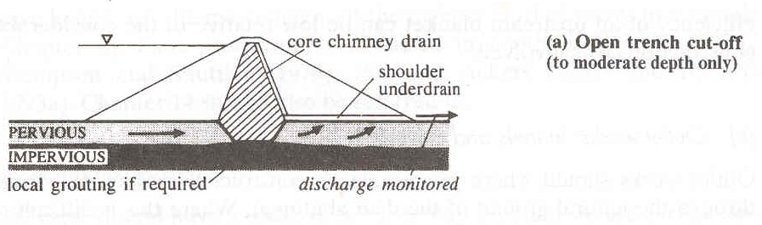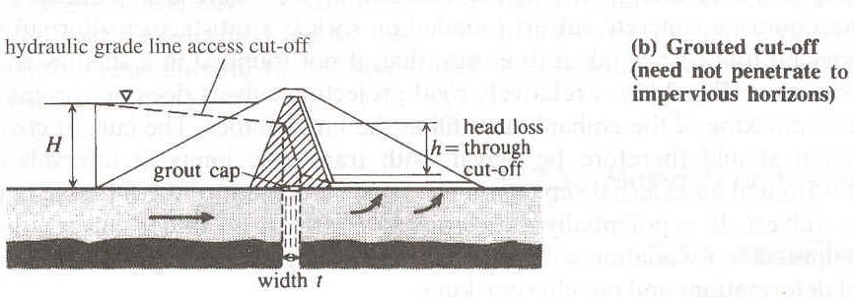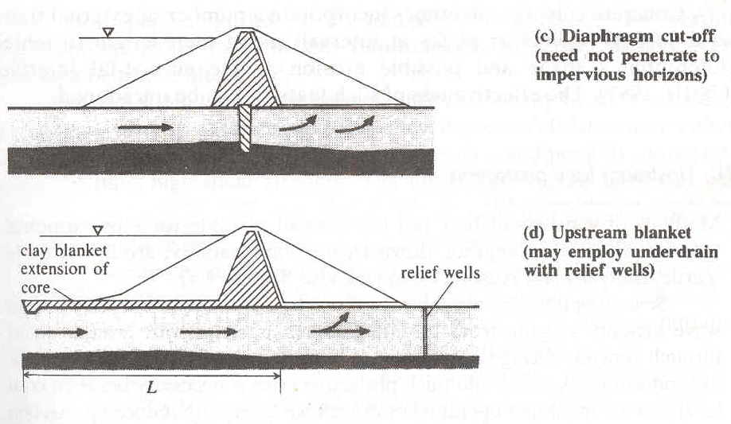
Figure 5-5 Cut-offs and control of under seepage

  - Outlet works (tunnels and culverts): outlet works should where practicable be constructed as a tunnel driven through the natural ground of the dam abutments. Where this is difficult or uneconomical a concrete culvert founded on rock is a satisfactory alternative.
  - Upstream face protection: several options are available for protection of the upstream face against wave erosion, ranging from traditional stone pitching with grouted joints through concrete facing slabs to the use of concrete block work, rock armoring and riprap.
  - Embankments crest: the top width of larger earthen dam should be sufficient to keep the seepage line well within the dam, when reservoir is full. The crest should have a width of not less than 5m, and should carry a surfaced and well-drained access road. The top width
(W) of the earth dam can be selected as per the following recommendation:

W = H + 3 5
, For very low dams 4.1

W = 0.55 + 0.2H
H
1
, For dams lower than 30m 4.2

W = 1.65(H + 1.5)$\frac{1}{3}$
Where: H is the height of the dam.

Seepage analysis
, For dams higher than 30m 4.3

Seepage occurs through the body of all earthen dams and also through their pervious foundation. The phreatic surface of the seepage regime, i.e. line within the dam section below which there is positive hydrostatic pressures in the dam, must be kept well clear of the downstream face to avoid high pore water pressures which may promote slope instability.
The amount of seepage can be easily computed from the flow net, which consists of two sets of curves, known as ‘Equipotential line’ and ‘stream lines’, mutually perpendicular to each other. For homogeneous embankments dam, discharge per unit width (q) of the dam passing through a flow net is described as:
q = kH N f
N d
Where: H is the head differential.
N_{f} is number of stream lines.
N_{d} id number of Equipotential lines.

Determination of Phreatic Lines
It is absolutely essential to determine the position of the phreatic line, as its position will enable to determine the following:
- The divide line between the dry (or moist) and submerged soil.
- The top stream line and hence, helps us in drawing the flow net.
- To ensure that the phreatic line doesn’t cut the downstream face of the dam, which is extremely necessary for preventing softening of the dam.

  - Homogeneous dam section with horizontal filter
It has been found that the seepage line is pushed down by the filter and it is very nearly parabolic except near its junction with u/s face. Since the u/s face of the dam (i.e. GB in Figure 5-6) becomes an equipotential line when fully covered with water, the seepage line shall be perpendicular to the face near its junction point B.
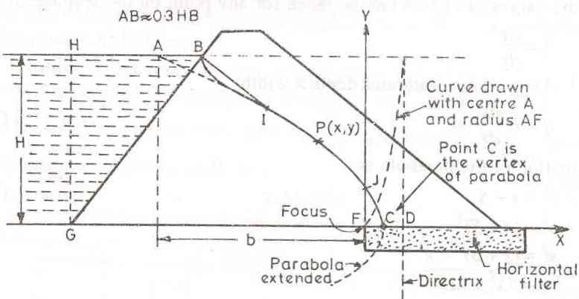
Figure 5-6 Seepage through homogenous dam section with horizontal filter

Equation of the base parabola
Let a base parabola with focus at F is drawn and produced so as to intersect the water surface at a point A as shown in Figure 1-1.Taking the focus (F) as the origin, equation of the parabola p(x, y) can be written as
= x + FD
x 2 + y 2

Where; FD is the distance of the focus from the directrix, called focal distance and is represented by S.

Hence the equation of the parabola of the seepage line becomes:
= x + S
x 2 + y 2

Location of A is approximately 0.33HB horizontal distance upstream from point B according to Cassagrande. Where, H is the projection of the point G on the water surface.

If the horizontal distance between the already determined point A and the focus (F) is taken as say b, then (b, H) represents the coordinates of the point A on the parabola. And hence;
= b + S
b2 + H 2
S = − b
b 2 + H 2
The center point (C) of FD will then be the vertex of the parabola. When x = 0, y= S. Hence the vertical ordinate FJ at F will be equal to S. Knowing the points A, C, and J and working out a few more points from the equation, the parabola can be easily drawn and corrected for the curve BI, so as to get the seepage line BIJC. The amount of seepage can also be calculated easily from the equation of the seepage line as derived below.

Darcy’s law is defined as, q = KiA. When steady conditions have reached, the discharge crossing any vertical plane across the dam section (unit width) will be the same. Hence, the value i and A can be taken for any point on the seepage line

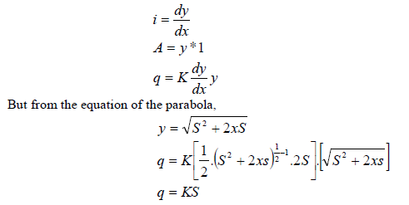

Example:
An earth dam made of a homogeneous material has a horizontal filter and other parameters as shown in the figure. Determine the phreatic line and the seepage quantity through the body of the dam.

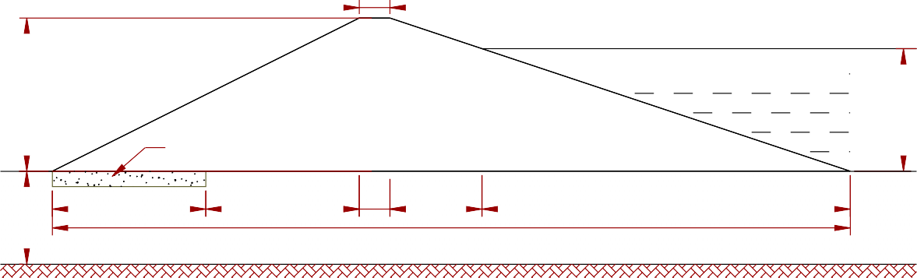
5
A
25

Horizontal Filter
F
Ø = 25° c = 24 kN/sq.m
γdry = 18.0 kN/cu.m
20
γsub = 12.0 kN/cu.m k = 5*10^-6 m/sec

25
25
5
15
60

130
8
Ø = 12°
c = 54 kN/sq.m

Figure 5-7 Section of a homogenous earth dam

γdry = 18.3 kN/cu.m
γsub = 18.3 kN/cu.m

For the origin of the Cartesian co-ordinate system at the face of the filter (point F), the equation of the parabola of the seepage line can be expressed as:

x 2 + y 2 = x + S
At point A, x = 65m, and y = 20m. Inserting into the parabola equation, S = 3.07m. Working out a few more points from the equation, the parabola can be easily drawn and corrected for the curve at the upstream face of the dam, so as to get the seepage line.

x | -1.51 | 0 | 10 | 15 | 25 | 30 | 40 | 45 | 55 | 65
y2 | 0 | 9.06 | 69.26 | 99.36 | 159.56 | 189.66 | 249.86 | 279.96 | 340.16 | 400.36
y | 0 | 3.01 | 8.32 | 9.97 | 12.63 | 13.77 | 15.81 | 16.73 | 18.44 | 20.01

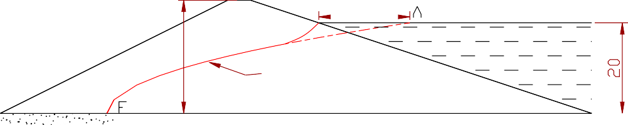
20

Phreatic line
25

 | 25 | 5 | 15 | 60
25
130

The amount of seepage flow is Q = kS
= 5 * 10⁻⁶ * 3.07
= 15.35 * 10⁻⁶m³/sec per meter width of dam

B. Homogeneous dam section without horizontal filter
The focus (F) of the parabola will be the lowest point of the downstream slope as shown in Figure 5-8. The base parabola BIJC will cut the downstream slope at J and extend beyond the dam toe up to the point C i.e. the vertex of the parabola.
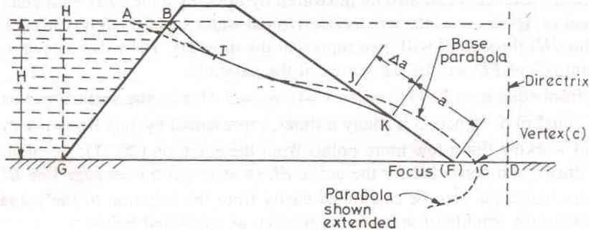
Figure 5-8 Homogeneous dam section without filter
The seepage line will, however, emerge out at K, meeting the downstream face tangentially there. The portion KF is known as discharge face and always saturated. The correction JK (say ∆a) by which the parabola is to be shifted downward can be determined as follows:
α‡ in degrees | Δa  a + Δa
30º | 0.36
60º | 0.32
90º | 0.26
120º | 0.18
135º | 0.14
150º | 0.10
180º | 0.0

α is the angle which the discharge face makes with the horizontal. a and ∆a can be connected by the general equation;

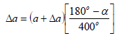

Example
An earth dam made of a homogeneous material has the coefficient of permeability K= 5*10⁻⁴ cm/ sec and the other parameters are as shown in the Figure 5-9. Determine the phreatic line and the seepage quantity through the body of the dam.
RL = 200.0m

H = 19.5m
RL = 197.5m

3:1

RL = 178.0m

2:1

66m
4.5m
44m

Figure 5-9 Body of homogeneous earth dam

Stability analysis
Three considerations govern the design of an earth embankment.
- Side slopes must be stable;
- Dimensions must be sufficient to control seepage;
- Base width must be long enough to distribute weight of dam over sufficient area to prevent overstress in the foundation.
An earthen embankment usually fails because of the sliding of a large soil mass along a curved surface.

Stability of side slopes of earth dam
Forms of side slope failure:
Toe failure: - most likely to occur when the slopes are relatively steep or when the soil below the toe of the slope is strong.
Base failure: - occurs when the slopes are flat or when the soil below the toe is relatively weak.
Face or slope failure: - occurs only when there is a relatively weak zone in the upper part of the slope or when there is a very strong stratum above the toe level.
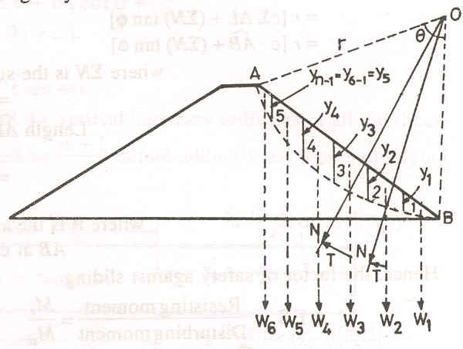
The method used for examining the stability of slopes of earthen embankments is called the Swedish Slip Circle Method or the Slices Method. It assumes the condition of plane strain with failure along a cylindrical arc. The location of the centre of the possible failure arc is assumed. The earth mass is divided into a number of vertical segments called slices as shown in Figure 5-10, O is the center and r is the radius of the possible failure.
Figure 5-10 Possible slip surface in Earth fill dam
The side slopes of earth dam will be stable if the soil mass is not dislodged from the slopes. However, the soil mass in an earthen dam is subjected to forces which tend to cause movement or sliding of the soil mass. These forces are known as actuating, driving or disturbing forces which mainly consists of gravity forces. The movement or sliding of the soil mass in an earthen dam is resisted by the resisting or stability forces which are provided mainly by the shearing strength of the soil.
The stability of the side slope of an earthen dam is thus analyzed by assuming a surface slippage within the soil mass and by determining the resisting and the disturbing forces acting on this surface and the moments of these forces about the center of rotation, and then factor of safety against sliding is calculated.

The forces acting on the slices are:
  - The self weight W of the slice acting vertically downward through the center of gravity.
  - The cohesive forces acting tangentially opposite to the direction of probable slippage
  - The soil reaction across the arc. When the soil mass is about to slide, the soil reaction will act at an angle ф (the angle of internal friction of the soil) to the normal i.e. radial direction
  - The soil reaction on the two vertical sides of the slice exercised by the adjacent slices on the right and left respectively.
  - Pore pressures at the base of the arc, and left and right side of the slice.
Usually it is assumed that the soil reactions on the two vertical sides of the slice cancel each other and so also the pore pressures on the two sides balance each other
The disturbing force is the component of weight of slice in tangential direction i.e.,
T = W sin σ ,
Where: α is the angle which the slope makes with the horizontal.
The total disturbing forces will be summation of disturbing forces for all slices;
∑T = T1 + T2 + T3 + ....
The total disturbing moments over the sliding surface will be equal to
M d = ∑Ti ri = r ∑Ti
The magnitude of shear strength developed in each slice will depend upon the normal components of that slice. Its magnitude will be:
= cΔL + N tanΦ
Where; c is the unit cohesion of the soil
∆L is curved length of the slice Ф is the angle of internal friction N is equal to Wcosα
The total resisting force will be summation of resisting forces for all slices;
= ∑cΔL + ∑ N tanΦ
= c∑ΔL + (∑ N )tanΦ
The total resisting moment over the entire sliding surface will be equal to
M r = r(c∑ΔL + (∑ N )tanΦ)
Hence the factor of safety against sliding

FS = M r
M d
= c∑ΔL + tan Φ∑ N
∑T

For determining the stability of the proposed side slope of an earth dam it is necessary to find the least factor of safety which may occur on any of the possible surfaces of slippage or slip circles. Slip circle which yields the least factor of safety is the most critical and hence it is known as critical surface slippage or critical slip circle. For locating the critical surface of slippage, it is necessary to try several different surfaces of slippage as one trial gives the value of factor of safety for that arc only.

For preliminary analysis 4 to 5 slices may be sufficient; however, 10 to 15 slices are considered in general. It is not necessary for the analysis to make all the slices of equal width, but for the sake of convenience it is customary to have slices of equal width.
In order to reduce the number of trials, Fellenius has suggested a method of drawing a line, representing the locus of the critical slip circle. The determination of this line PQ is shown in Figure 5-11. The point P is obtained with the help of directional angles α₁ and α₂ as shown in
Table 5-4

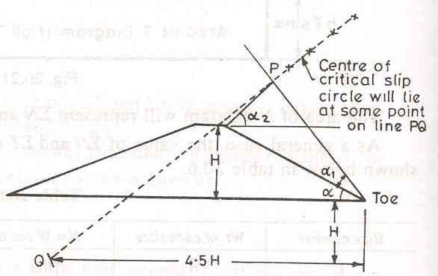
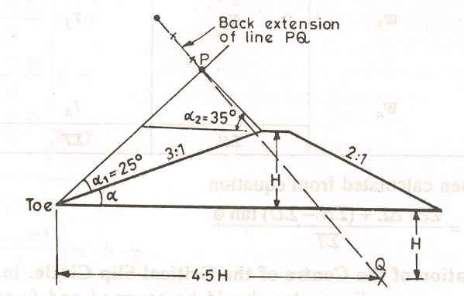
    - downstream slope b. upstream slope Figure 5-11 locus of critical circle

Table 5-4 Slope and respective directional angle

Slope | Directional angles
 | α₁ in degrees | α₂ in degrees
1:1 | 27.5 | 37
2:1 | 25 | 35
3:1 | 25 | 35
4:1 | 25 | 35
5:1 | 25 | 35

Design parameters to be employed in stability analysis may be summarized as follows:
- Stability of downstream slope during steady seepage (reservoir full)
The most critical condition for the d/s slope occurs when the reservoir is full and the seepage is taking place at full rate.
The seepage water below the phreatic line exerts a pore pressure on the soil mass which lies below the phreatic line, see Figure 5-12.
b

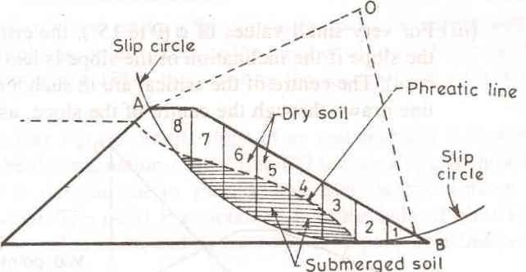Phreatic line
V41
α₄
h₄
V42
N₄
W₄ τ₄

Figure 5-12 stability of downstream slope during steady seepage

Consider slice number 4 in Figure 5-12, the weight of the slice is defined as;
W4 = ℽdry *V41 + ℽ sat *V42
α₄ read from the scaled drawing of the earth fill dam. And tangential component of W₄ is defined as, which is shear stress developed at failure plane,
T4 = W4 sin α 4
The pore pressure for slice 4 is represented by the piezometric head h₄. Hence pore water pressure is
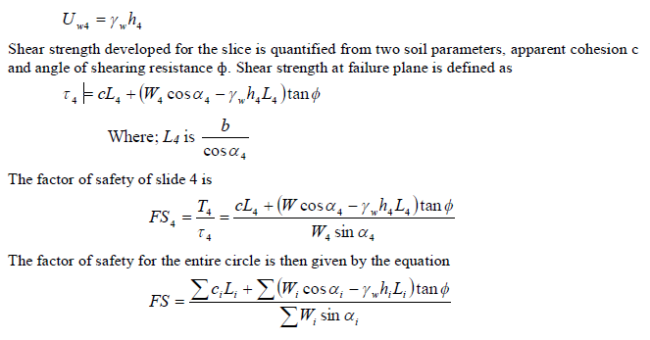

- Stability of Upstream Slope during sudden drawdown
For the u/s slope, the critical condition can occur, when the reservoir is suddenly emptied. In such case, the water level within the soil will remain as it was when the soil pores were full of water. The weight of this water within the soil now tends to slide the u/s slope along a circular arc.
The tangential components of the saturated soil lying over the arc will create a disturbing force; while the normal component minus the pore pressure shall supply the shear strength of the soil.
Table 5-5: General format of computation

Slice# | W | T | N | U | l | Ul | N’=N-ul | tanΦ | N’tanΦ | Cl | N’tanΦ+cl
1
…
n
Σ T Σ (N’tanΦ+cl)

The factor of safety is finally obtained from the equation

FS =
∑ci Li
- ∑ N ' tan Φ
∑T '

Where: N’ represents normal components on submerged density
T’ represents tangential components on saturated unit weight of the soil

Stability of earth dam against horizontal shear developed at the base of the dam
Approximate method for checking the stability of u/s and d/s slopes under steady seepage from consideration of horizontal shear at base
      - Stability of u/s slope during sudden drawdown
It is based on the simple principle that a horizontal shear force P_{u} is exerted by the saturated soil. The resistance to this force R_{u} is provided by the shear resistance developed at the base of the soil mass, contained within the u/s triangular shoulder GMN of Fig.
Considering unit length of the dam, the horizontal force Pu is

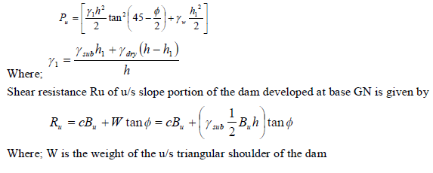

The factor of safety against can be easily calculated, using
FS = Ru
Pu
It should be more than 1.5.
      - Stability of d/s slope under steady seepage
It is based on the consideration of horizontal shear at base under the d/s slope of the dam. The horizontal shear force Pd is given by, referring Fig;

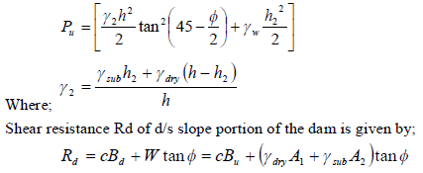

The downstream profile RTS of the downstream slope portion of the dam has an area A1 and of dry soil above seepage line and the area of submerged soil say A2 below the seepage line.
The entire weight W may be calculated on the basis of submerged soil as it will be on a still safer side.
In that case,
W = ℽ sub Bd h
The factor of safety against shear can be easily determined as;
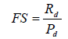

Foundation analysis
Foundation stress in earth dams are not usually critical except when the foundation material consists of unconsolidated clay or silt with low shearing strength.
Consider a dam on homogeneous, unconsolidated earth foundation of thickness t

Figure 5-13 Homogenous embankment dam with pervious foundation of thickness t
The downward force exerted on the foundation at the center of the dam tends to squeeze the foundation material from under the dam. But shear stress develops in the foundation resisting this action. Assuming the foundation loading to vary as indicated above, Leo Jugenson suggested the following maximum stresses:
If t > L, τ_{max}= 0.256γ_{f} H_{s} ; Where γ_{f} = specific weight of fill usually t < L
If t < L/10, τ_{max} = γ_{f} H_{s} t/L Shear strength = S_{s} = c + σ tanΦ
The factor of safety against overstress is FS = S_{s}/ τ_{max}
A minimum value of FS = 1.5 is recommended.
Example:
Design the embankment dam shown in Figure 5-7 used as an example for analysis of seepage flow. Detail all the necessary procedures and important consideration in the process.
Design Solution
The stability design process starts by determining the phreatic line profile which is done before. The critical slippage circle is then drawn by following the suggestion made by Fellinus. Here a single slippage circle is considered for illustration and four slices were considered for both upstream and downstream slope failure. The geometric information’s were then determined as shown below.

25

Fig. Sample of failure circle, slices and related measurments of the earth dam section Geometric properties of slices
5

A1 A1
A2
A2
Phreatic line
A3
A4
A3
A4
25 25 5
15
130
60
12.5
13.8
20
 | Upstream |  |  |  | Downstream
Slice | Area(m²) | α (deg) | h_{w} (m) | L (m) | Area (m²) | α (deg) | L (m)
A1 | 25.97 | 32 | 0 | 14.5 | 68.58 | 40 | 18
A2 | 111.68 | 24 | 6.1 | 22 | 111.48 | 28 | 15.4
A3 | 120.83 | 15 | 6.2 | 20.7 | 96.1 | 17 | 14.2
A4 | 55.52 | 4 | 3.6 | 20.1 | 40.11 | 7 | 13.7
Area in relation with phreatic line.

Area (m²) | Dam | U/s shoulder | D/s shoulder
Under seepage line (saturated) | 1102.08 | 838.1 | 221
Dry portion | 584.92 | 99.4 | 404
Total | 1687 | 937.5 | 625
To assess the overall stability of the dam considering 1m length,

Item | Dam |  | U/s shoulder |  | D/s shoulder
 | Area(m²) | Weight(kN) | Area(m²) | Weight(kN) | Area(m²) | Weight(kN)
Under seepage line | 1102.08 | 13224.96 | 838.1 | 10057.2 | 221 | 2652
Dry portion | 584.92 | 10528.56 | 99.4 | 1789.2 | 404 | 7272
Total | 1687 | 23753.52 | 937.5 | 11846.4 | 625 | 9924

The stability design then proceeds by first considering the entire embankment and its interaction with the foundation.
Shear resistance of the dam at the base(R) R = C + W tanΦ
Where: C = total cohesive resistance of the soil at the base
= c*B*1 = 24 * 130 * 1
= 3120 kN
Wtanφ = 23753 * tan25⁰
= 11076 kN
R = 3120 + 11076
= 14196 kN
Horizontal force due to hydrostatic pressure of water P = ½ γ_{w} h² = ½ * 10 * 20²

= 2000kN
Factor of safety against failure due to horizontal shear at the base
FS = R/P = 7.1 > 1.5 Safe!

Check stresses in the foundation
t = 8m < L/10 = 130/10 =13,

Hence,

τ_{max}= γ_{f} H_{s} t/L
= 18.3 * 20* 8/130
= 22.52kN/m²

Shear strength = S_{s} = c + σ tanΦ
= c + W/L tanφ
= 54 + 23754/130 * tan 12⁰
= 92.8 kN/m² The factor of safety against overstress is
FS = S_{s}/ τ_{max} = 92.8/22.52 = 4.12 > 1.5 Safe!

Stability of u/s and d/s slopes against sliding shear.
Upstream slope (under sudden drawdown):
Considering unit length of the dam, the horizontal force P_{u} is

ℽ₁ =ℽsub h1 + ℽdry (h − h1 )
h
= 12 *13.8 + 18(25 − 13.8)
25
= 14.7
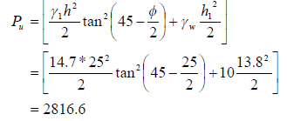
Shear resistance R_{u} of upstream slope portion of the dam developed at base GN is given by,
Ru = cBu + W tanΦ = 54 * 75 + 11846.4 * 0.47 = 9574.1
Where; W is the weight of the upstream triangular shoulder of the dam.

The factor of safety against shear can be easily calculated,

FS = Ru
Pu
= 9574.1 = 3.4 > 1.5
2816.6
Safe!

It has been known that the maximum intensity of shear stress occurs at a distance 0.6B_{u} (where B_{u} is the base length of the upstream shoulder) from the heel and is equal to 1.4 times the average shear intensity.
Hence, maximum shear stress induced (τ_{max}) = 1.4(P_{u}/B_{u})
= 1.4 (2816.6/75)
= 52.6
The unit shear resistance developed at the same point is
τ_{f} = c + 0.6hγ_{sub}tanφ

= 24 + 0.6 * 25 * 12 * tan 25⁰
= 107.9
FS at the point of maximum shear should be greater than unity.
FS = τ_{f} / τ_{max} = 107.9 / 52.6 = 2.0 > 1 Safe!

For the downstream shoulder, similarly,
ℽ = 12 *12.5 + 18(25 − 12.5) = 15
1 25

⎡15 * 252 2 ⎛
25 ⎞
12.52 ⎤

Pu = ⎢
⎣ 2
tan
⎜ 45 −
⎝
⎟ + 10
2 ⎠
⎥ = 2683.7
2 ⎦

Ru = cBu + W tanΦ = 54 * 60 + 9924 * 0.47 = 7904.3

FS = Ru
Pu
= 7904.3 = 2.9 > 1.5
2683.7

Safe!

Maximum shear stress induced (τ_{max}) = 1.4(P_{u}/B_{d})
= 1.4 (2683.7/50)
= 75.1
The unit shear resistance developed at the same point is
τ_{f} = c + 0.6hγ_{sub}tanφ
= 24 + 0.6 * 25 * 12 * tan 25⁰
= 107.9
FS at the point of maximum shear should be greater than unity.
FS = τ_{f} / τ_{max} = 107.9 / 75.1 = 1.44 > 1 Safe!

Ambo University Woliso Campus Hydraulic Structures I

Analysis of upstream and downstream slopes by Swedish Circle method: Upstream slope
Slice | Area | α | W | T | N | U | L | UL | N’=N-ul | tanΦ | N’tanΦ | Cl | N’tanΦ+cl
A1 | 25.97 | 32 | 467.46 | 247.72 | 396.43 | 0 | 14.5 | 0 | 396.43 | 0.47 | 186.32 | 348 | 534.32
A2 | 111.68 | 24 | 1340.16 | 545.09 | 1224.3 | 61 | 22 | 1342 | -117.7 | 0.47 | -55.32 | 528 | 472.68
A3 | 120.83 | 15 | 1449.96 | 375.28 | 1400.55 | 62 | 20.7 | 1283.4 | 117.15 | 0.47 | 55.06 | 496.8 | 551.861
A4 | 55.52 | 4 | 666.24 | 46.47 | 664.62 | 36 | 20.1 | 723.6 | -58.98 | 0.47 | -27.72 | 482.4 | 454.68
Σ T 1214.56 Σ (N’tanΦ+cl) 2013.54

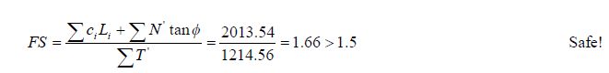

Downstream slope

Slice | Area | α | W | T | N | l | N’=N-ul | tanΦ | N’tanΦ | Cl | N’tanΦ+cl
A1 | 68.58 | 40 | 1234.44 | 793.48 | 945.64 | 18 | 945.64 | 0.47 | 444.45 | 432 | 876.45
A2 | 111.48 | 28 | 2006.64 | 942.06 | 1771.76 | 15.4 | 1771.76 | 0.47 | 832.73 | 369.6 | 1202.33
A3 | 96.1 | 17 | 1729.8 | 505.74 | 1654.22 | 14.2 | 1654.22 | 0.47 | 777.48 | 340.8 | 1118.28
A4 | 40.11 | 7 | 721.98 | 87.99 | 716.6 | 13.7 | 716.6 | 0.47 | 336.8 | 328.8 | 665.6
2329.27 Σ (N’tanΦ+cl) 3862.66

FS = 3862.66 = 1.66 > 1.5
2329.27
Safe!

Internal drainage system
General
Purpose of drainage:
    - To reduce the pore pressure thereby increasing the stability of the dam
    - To prevent piping so that soil particles are not carried away from the embankment. A drainage system consists of two components.
      - the protective filter
      - the conduit which collects and disposes of the seepage. Protective filter: - serves to allow free drainage and to prevent erosion. It is provided between
Riprap and embankment Core and embankment
Embankment and drains
Experiments by Terzaghi, Bertram and others have shown that a filter need only hold the coarse 15% of the grain size. These coarse particles D₈₅ and over, will collect over the filter opening bridging over it and trapping finer particles.
Size of filter holes, D_{f} ≤ D₈₅ ( of the soil being filtered) From tests, the following criteria are established.
D₁₅ (filter) ≤ 4 to 5 D₈₅ (soil); to satisfy prevention of migration of soil particles. D₁₅ (filter) ≥ 4 to 5 D₁₅ (soil); for free drainage.
Filter gradation curve should be smooth and parallel to the soil being filtered. When the soil is gap graded recompute and re-plot the grain size distribution using only the fraction finer than the break as representing the entire soil; apply the filter criteria to this distribution
Filter thickness:
Thin filter is desirable to minimize flow resistance. Practical considerations, however, put minimum sizes as shown in Table 5-6.
Table 5-6: Representative mean filter thickness

Filter | Thickness for given head, cm
 | 0 – 25 m | 25 – 50 m | 50 – 100 m
Fine sand | 15 | 30 | 45
Coarse sand | 25.5 | 45 | 60
Gravel | 30 | 60 | 75
For every fine grained soil a multiple layered filter is necessary. Each successive layer is designed to fit the D₁₅ and D₈₅ of the finer layer it must filter. The last layer must fit the openings of the drain conduit which carries the water away.

Example:
Determine the size of the bed material for the embankment dam with the grain size shown below.

Grain size | Riprap | Dam
D15 | 70 mm | 0.3 mm
D85 | 130 mm | 2.0 mm

Drain Conduit:
Function: to collect water from the filter and carry it away with as little head as possible. Quantity of Flow: Estimated from the seepage analysis. A factor of safety of 5 is not uncommon. Simplest conduit: uniform coarse fragmental material (coarse sand, gravel, crushed rock, etc.)
A properly designed filter must surround the drain. For high discharges or when suitable crushed rock is not available, pipe conduits wig perforated and flexible joints are employed.
Types of drain
Trench drain:
Trench drain is used for intercepting seepage through homogeneous foundations and those containing horizontal pervious strata or seams

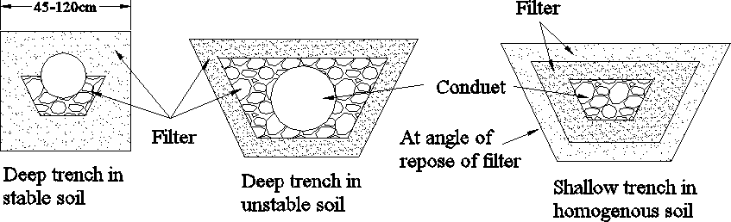
Figure 5-14 Trench Drain
Mound drain: used when the need for embankement drainage exceeds that of the foundation.
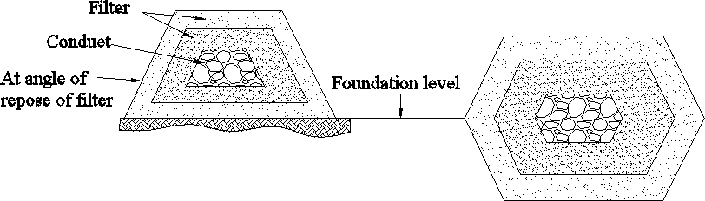

Figure 5-15 Mound drain
Position- when there is cut-off, the drain is placed immediately downstream from the cut-off to relieve any pressure build up.
When there is no cut-off, the position depends on the seepage analysis of dam and foundation. Upstream location
Increases stability at the cost of increased seepage and cost of conduit.
Minimum distance from downstream toe to provide substantial increase in stability is 1/3 of the base width. Maximum distance is 2/3 of base width, from downstream toe.
Blanket drain:
This is horizontal drain placed on top of foundation.
To intercept water from vertical fissures in the foundation; To lower the seepage line in the embankment
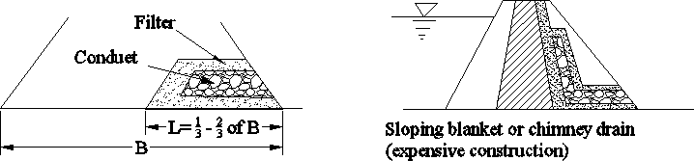
Figure 5-16 Blanket drain

Riprap:
Riprap is required on the upstream slope and the downstream slope below the tail water level. An estimation of the required weight of rock pieces required for riprap is given by Hudson as
W ≥ (H2 ρst tan α) / (3.2Δ2)
Where: the factor 3.2 is for smooth quarry stone
ρst = density of rock
α = angle of slope Δ = (ρst – ρw)/ ρw
ρw = density of water Types of riprap
Dumped riprap: consists of angular broken rock dumped from truck and spread.
Hand-placed riprap: consists of more or less prismatic stone placed on end to form rough pavements.
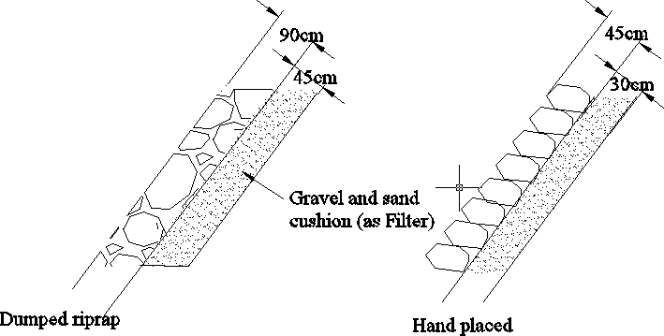
Figure 5-17 Types of riprap

Spillways

General
Spillway is the most important component of the dam which serves to release excess flood from a reservoir efficiently and safely. It is the most expensive of all the appurtenances structure. Its capacity is determined from the hydrological studies over the drainage area.
Spillway components include;
    - Entrance channel: to minimize head loss and to obtain uniform distribution of flow over the spillway crest
    - Control structure: to regulate and control the outflow. It may consist of a sill, weir, orifice, tube, or pipe.
    - Discharge channel: to convey the discharge from the control structure to the terminal structure/stream bed. The conveyance structure may be the downstream face of a concrete dam, an open channel excavated along the ground surface, a closed cut-and- cover conduit placed through or under a dam, or a tunnel excavated through an abutment.
    - Terminal structure: to dissipate excess energy of the flow in order to avoid scouring of the stream bed
    - Outlet channel: to safely convey the flow from the terminal structure to the river channel.
Types of spillway taking the hydraulic as criteria are broadly
- Controlled (Gated) spillway: a spillway having a certain means to control the outflow from the reservoir.
- Uncontrolled (Ungated) spillway: is a spillway, the crest of which permits water to escape automatically, as the water level in the reservoir rises above the crest.
Taking the most prominent feature as criteria, spillway types are
- Free overfall (straight drop) spillway
- Ogee (overflow) spillway
- Side channel spillway
- Siphon spillway
- Chute (open channel or trough) spillway
- Drop inlet (shaft or morning glory) spillway

Types of Spillway

Free overfall (straight drop) spillway
A free overfall spillway has a low height narrow crested weir as control structure and a vertical or nearly vertical downstream face. The overflowing water may be discharged as in the case of a sharp crested weir or it may be supported along the narrow section of the crest. However, in either case the water flowing over the crest of this spillway drops as a free jet clearly away from the downstream face of the spillway. Occasionally the crest of free overfall spillway is extended in the form of an overhanging lip to direct small discharges away from the downstream face of the overfall section. The underside of the nappe is ventilated sufficiently to prevent pulsating fluctuating jet.
If no artificial protection is provided on the downstream side of the overflow section, the falling jet usually cause the scouring of the streambed and will form a deep plunge pool. To protect the stream bed from scouring, an artificial pond may be created by constructing a low auxiliary dam downstream of the main structure or by excavating a basin which is then provided with a concrete

apron. However, if tailwater depths are sufficient, a hydraulic jump will form when the jet falls freely from the crest, in which case a sufficiently long flat apron may be provided. In addition, floor blocks and an end sill may be provided in this case to help in the establishment of the jump and thus reduce the downstream scour.
The free overfall spillway is used:
      - most commonly for low earth dams (or earthen bunds),
      - for thin arch dams,
      - or other dams having nearly vertical downstream face and would permit free fall of water, and
      - where, in general, the hydraulic drops from head pool to tailwater are not in excess of about 6m.
However, free overfall spillways are not suitable for high drops on yielding foundations, because the apron will be subjected to large impact forces at the point of impingement. The impact force causes vibrations which may crack or displace the apron and may result in failure by piping or undermining.

Ogee (overflow) spillway
The ogee spillway has a control weir which is ogee or S-shaped in profile. The profile is derived from the lower envelop of the overall nappe flowing over a high vertical rectangular notch with an approach velocity V_{o}≈ 0 and a fully aerated space beneath the nappe (P = P_{o}).
The following crest profile has been found to give good agreement with the prototype measurement by U.S. Waterways Experimental Station (WES). Such shapes are known as WES Standard Spillway Shapes as shown in Fig 6-1.

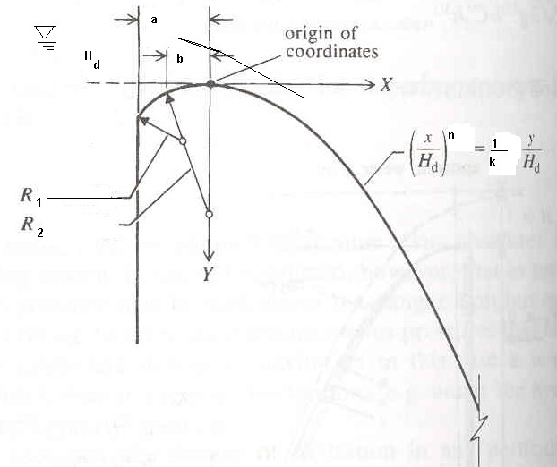
Fig 6-1 WES Standard Spillway Shapes
Table 6-1 Values of a, b, R₁, R₂,K and n for different U/S slope

U/S slope | a/H_{d} | b/H_{d} | R₁/H_{d} | R₂/H_{d} | K | n
0H:3V | 0.175 | 0.282 | 0.50 | 0.20 | -0.5 | 1.85
1H:3V | 0.139 | 0.237 | 0.68 | 0.21 | -0.516 | 1.836
2H:3V | 0.115 | 0.214 | 0.48 | 0.27 | -0.515 | 1.81
3H:3V | 0 | 0.199 | 0.45 | ∞ | -0.534 | 1.776
The spillway discharge is given by:

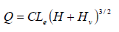

Where: Q- discharge
v

C- Coefficient which depends on u/s and d/s flow condition (1.65-2.5)
L_{e}- effective crest length
H- head on the crest
H_{v}- approach velocity head
Where crest priers and abutments are shaped to cause side contractions of the overflow, the
effective length, L_{e}, will be less than the net length of the crest. The effect of the end contraction may be taken into account by reducing the crest length as follows:
L = L' − 2(NK + K )(H + H )
e
p
V
a
Where: L’- net length of the crest
N- Number of piers
K_{p}- piers contraction coefficient
K_{a}- abutment contraction coefficient
The pier contraction coefficient, K_{p}, is affected by the shape and location of the pier nose, the thickness of the pier, the head in relation to the design head, and the approach velocity. The average pier contraction coefficient may be assumed as follows:
Pier condition K_{p}
Square nosed pier with corners rounded on a radius equal to about 0.1 of the pier 0.02 thickness
Rounded nosed piers 0.01
Pointed nose piers 0

The abutment contraction coefficient is affected by the shape of the abutment, the angle between the upstream approach wall and the axis of flow, and the head in relation to the design head, and the approach velocity. The average abutment contraction coefficient may be assumed as follows:
Abutment condition Ka
Square abutments with head wall at 90º to direction of flow 0.20
Rounded abutments with head wall at 90º to the direction flow 0.10
Rounded abutments with head wall placed at not more than 45º to the direction of 0
flow

Side channel spillway
Side channel spillways (Fig 6-2) are mainly used when it is not possible or advisable to use a direct overfall spillway as, e.g., at earth and rock fill dams.
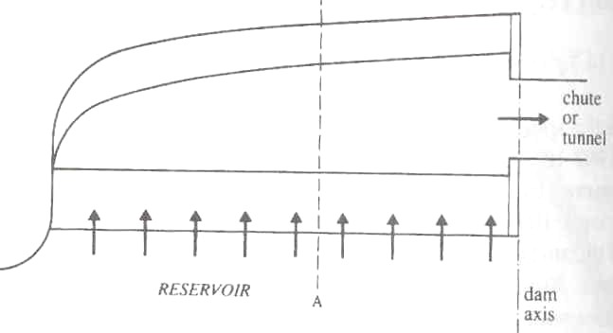
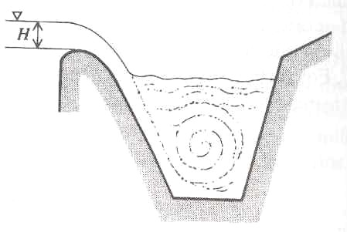
(a) (b)
Fig 6-2 Side channel spillway: (a)Plan (b) section A-A, side view

They are placed on the side of the dam and have a spillway proper, the flume (channel) downstream of the spillway, followed by the chute or tunnel. The spillway proper is usually designed as a normal overfall spillway. The depth, width, and bed slope of the flume must be designed in such a way that even the maximum flood discharge passes with a free overfall over the entire horizontal spillway crest, so that the reservoir level is not influenced by the flow in the channel. The width of the flume may therefore increases in the direction of the flow. From the energy dissipation point of view, the deeper the channel and the steeper the side facing the spillway, the better; on the other hand , this shape is in most cases more expensive to construct than a shallow wide channel with a gently sloping side.

Siphon spillway
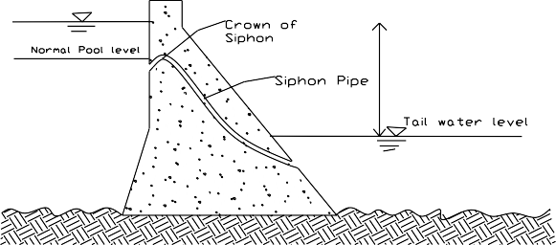Siphon spillways (Fig 6-3) are closed conduits in the form of an inverted U with an inlet, short upper leg, throat (control section), lower leg, and outlet.
Fig 6-3 siphon pipe installed within the gravity dam
For very low flows a siphon spillway operates as a weir; as the flow increases, the upstream water level rises, the velocity in the siphon increases, and the flow in the lower leg begins to exhaust air from the top of the siphon until this primes and begins to flow full as a pipe, with the discharge given by
Q = C A(2gH )1/ 2
d
Where: A is the (throat) cross-section of the siphon, H is the difference between the upstream water level and siphon outlet or downstream water level if the outlet is submerged and

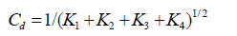

Where: K1, K2, K3, and K4 are head loss coefficients for the entry, bend, exit, and friction losses in the siphon.

Chute spillway
A chute spillway is a steep channel conveying the discharge from a low overfall, side channel, or special shape spillway over the valley side into the river downstream.
For earthen and rock fill dams, a separate spillway is generally constructed in a flank or a saddle, away from the main valley. Sometimes, even for gravity dams, a separate spillway is required because of the narrowness of the main valley. In all such circumstances, a separate spillway like chute could be provided.
A chute spillway essentially consists of a steeply sloping open channel, placed along a dam abutment or through a flank or a saddle. It leads the water from the reservoir to the downstream channel below.

The entire channel spillway can hence be divided into the following parts:
- Entrance channel
- Control structure (Low Ogee weir)
- Chute channel or discharge carrier
- Energy dissipation arrangements at the bottom in the form of the stilling basin

Shaft spillway
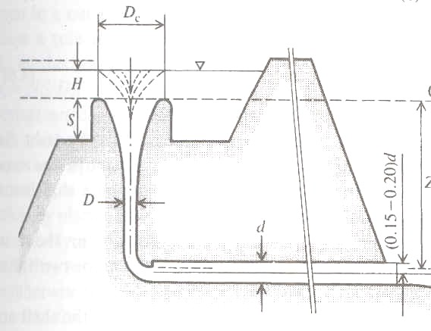A shaft (‘morning glory’) spillway consists of a funnel-shaped spillway, usually circular in plan, a vertical (sometimes sloping) shaft, a bend, and a tunnel terminating in an outflow as shown in Fig 6-4.
Fig 6-4 Shaft spillway
The shape of the shaft spillway is derived in a similar manner to the overfall spillway from the shape of the nappe flowing over a sharp-edged circular weir. Clearly, in this case the shape for atmospheric pressure on the spillway is a function of H_{s}/D_{s}, where H_{s} is the head above the notch crest of the diameter D_{s}. For ratios Hs/D_{s} < 0.225 the spillway is free-flowing and for H_{s}/D_{s} > 0.5 the overflow is completely drowned. For the free overfall the discharge is given by

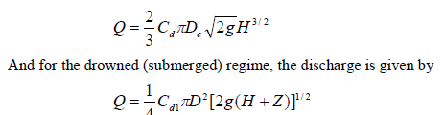

Where: D is the shaft diameter, D_{c} is the crest diameter (D_{c}<D_{s}), H is the head of the reservoir level above the crest (H<H_{s}), Z is the height of the crest above the outflow from the shaft bend, C_{d} and C_{d1} are discharge coefficients.

Spillway Crest Gates
Various types of gates have been evolved to control the flow of water over the spillway when the reservoir is full. The common types of gates are:
- Flashboards
  - Temporary
  - permanent
- Stop logs & needles
- Rectangular lift gates
- Radial (Tainter) gates
- drum gates
- Rolling (roller) gate
- Tilting (Flap) gate
Flash boards, Stop logs and needle are the simplest and oldest types of movable gates used for small heads. The rest are used for major works.
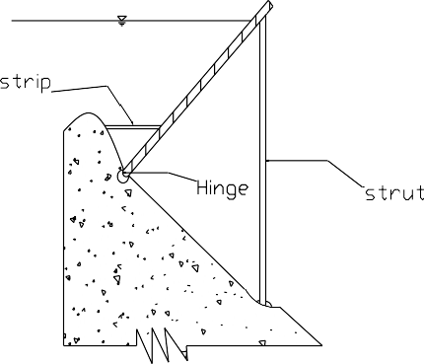
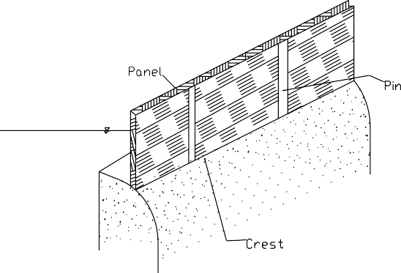Flashboards: A temporary arrangement of flash boards for heads of 1.20 to 1.50m consists of individual wooden panels supported by vertical pins that are expected to carry a certain predetermined head of water and bend and fail when that head is exceeded (Fig 5.5(b)). A permanent arrangement may be a hinged flash board made up of panels which can be raised or lowered from an overhead cable way without damage to it (Fig 5.5(a)). The panels are supported by wooden struts.
(a) (b)
Fig 6-5 Flashboards
Flash boards have the advantage that an unobstructed crest is provided when they and their supports are removed. However, they have the following disadvantages.
- They present a hazard if not removed in time to pass floods, especially where the reservoir is small and the stream is subject flash boards
- They require the attendance of operator or crew to remove them, unless they are designed to fail automatically
- If they are designed to fail when the water reaches certain stages their operation is uncertain, and when they fail they release sudden and undesirable large outflows
- Ordinarily they cannot be restored to position while the flow is passing over the crest
- If the spillway function frequently, the repeated replacement of flashboards may be costly

Stop logs: they are timber planks spanning horizontally between vertical grooves in adjacent piers (Fig 5.6). They are built up one on another, a vertical bulkhead formed from the crest of the spillway to the headwater level. The timber planks may vary in size from short , which can be handled by one man to sizes limited by the span and the capacity of a power which to raise them. These gates are used for small installation.
Stop logs must be removed before the floods occur, or they must be arranged so that they can remove while being overtopped.

Fig 6-6 Stop logs
Needles are timber planks set on end side by side to close an opening (Fig 5.7). They are supported from top by a runway (bridge), from which they are handled, and at the bottom they are resting in a key way on the spillway crest. Needles are difficult to place in swift waters of considerable depth, but they are easier to remove than stop logs. The arrangement may present a hazard to the safety of the dam if the stop logs are not removed in time to pass floods, especially where the reservoir is small and the stream is subject to flash floods.
Fig 6-7 Needles
Rectangular lift gate: it is a simple timber or steel gate on the crest of a dam which span horizontally between the guide grooves in the supporting piers. The guides may be placed either vertically or inclined slightly downstream. The gate is raised or lowered by a host mounted on a bridge overhead. It consists of a framework to which a skin plate is attached, normally on the upstream face. The high friction on the guides limits its size since a relatively large hoisting capacity is required to operate the gate. Sliding friction is reduced by means of rollers. Depending on the method of providing the rollers, lift gates are classified into fixed wheel gates and Stone gates.
Fixed wheel gate: In this type the roller are mounted on the downstream face of the gate. Axle friction as well as roller friction exists in this case.
Stone gate: In this type a train of roller is placed between the side walls of grooves on the piers and the downstream face of the gate (Fig 6.8). The train of rollers is neither attached to the gate nor the side walls of the grooves. It is supported in the space in between the two by means of chain which passes over a pulley. One end of the chain is attached to the counter weight and the other to the gate.

An advantage of the arrangement is that the frictional forces are nearly eliminated except at a negligible amount of roller friction.
Forces to be considered in a lift gate are hydrostatic force on the gate, the hoisting force, the weight of the gate and the roller friction.

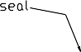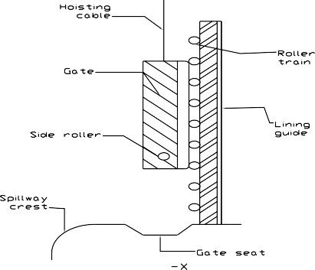

Fig 6-8 Stoney gate
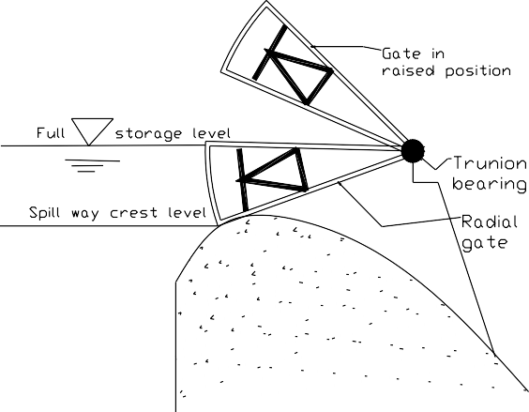Radial (Tainter) gate: It is a steel frame work with a circular (cylindrical) segmental plate for its face which is attached to supporting bearings by radial arms. It rotates about its center of curvature. All the hydrostatic forces are radial, i.e., pass through the center of curvature (trunion bearing) of the gate.
Fig 6-9 Radial gate
The housing load consists of the weight of the gate, the friction between the side seals and piers and the frictional resistance at the pins. The gate is often counter weighted to partially counter balance the effect of its weight, which further reduces the capacity of the hoist. The small hoisting effort needed to operate the gate makes hand operation practical on small installation which otherwise might require power. The small hoisting forces involved also make the radial gate more adaptable to operation by relatively simple automatic control apparatus.
Sizes of radial gates vary from 1 to 10m in height and 2 to 20m in length.
Rolling (Roller) gate: it is a steel cylinder spanning between spillway crest piers. It is opened by rolling up an inclined toothed rack on the piers. A cylindrical segment is commonly attached to the lower limbs of the roller to give greater height of the gate.
Fig 6-10 Rolling gate
Drum gate: this is an acute circular sector in cross-section, formed by skin plates attached to internal bracing. It is hinged at the center of curvature which may be either upstream or downstream. In the lowered portion, it fits in the shape of the crest.
Its crest is lowered automatically by rising headwater. The plates are so proportioned the headwater in the recess supports the movable structure against the headwater pressure above the sill at low water. When the water surfaces rises, the head water pressure becomes relatively grate on the upper skin and the crest is depressed. As the water level falls to the low water level, the crest returns to that level.
Drum gate is not adapted to small dams because of the large recess required.
Tilting (Flap) gate: It consists of a flat frame hinged at the lower edge. The upper edge can be moved with the help of chains or rods about the lower hinge to pass the flood over the crest of the gate. It is normally suitable for small sizes of openings.
Weight of gate:
W = KLm H n
Where L – gate opening (ft)
H- depth of water against the gate (ft) K, m, n - constants
Type of gate | m | n | Range of K | Mean K
Rectangular lift | 1.5 | 1.75 | 0.80-2.00 | 1.2
Radial | 1.9 | 1.35 | 0.85-1.45 | 1.16
Rolling | 1.5 | 1.67 | 2.40-3.40 | 2.85
Drum | 1.33 | 1.33 | 26.00-35.00 | 31.00

Spillway design

Background
A multi-purpose medium dam is planned to be constructed on the selected location. The dam is intended to serve for irrigation, power generation and control of flood which has been destroying property worth millions of birr whenever it occurs.
The overall construction of the project and its future implementation is well accepted by the society living in the surrounding and the catchment. The socioeconomic importance of the structure is deeply understood by the people and the cooperation of them is granted before hand by the assessment done for this particular purpose. This is done because there were structures built with huge amount of investment and couldn’t be functional just because of the community unawareness.
A site, which is ideal for the construction of any type of dam, is obtained in a narrow gorge. Then the contour map of the site is properly prepared and the different spillway options are considered. A preliminary cost analysis is done for the various types.
The preference of each option is justified based on the site and social condition prevailed in the surrounding and the fund available for the construction of the dam
The pertinent dimensions of the dam are decided considering different parameters and conditions. For instance the dam height is selected based on the following conditions.
  - The fetch of the dam upstream will be prone to flooding and nearby villages will be submerged if the specified height is exceeded.
  - The amount of storage obtained at this elevation is comparable with the demand projected.
  - The budget allocated for the project could not go beyond this limit.
  - The available spilling options function optimally in the elevation already selected.
Therefore, after the appropriate dam height and site is selected the type of dam needs to be decided upon. For the ogee spillway a gravity dam is proposed along the dam. For the rest cases of spillways an earth dam can be constructed for it is quite easy to obtain construction material from queries around the dam. These make the earth dam much economical as compared to the former.
Much of the design procedure is based on the USBR Design of Small Dams and on the experimental results of the Waterways Experiment Station. Various tables and charts were used from these references.

Generally, the description of dam site and the available data:
Elevation m.a.s.l

Bottom of the dam | 1390.0
Top of the dam crest | 1428.0
Ogee spillway crest | 1420.0
Ogee spillway design water level | 1425.0
Chute spillway design water level | 1425.0
Normal reservoir water level  Dam and spillway | 1419.0
Type: Gravity for the case of ogee spillway and arch or Earth and rock fill (Zoned) with side channel, siphon spillway or chute spillway.
Length of dam 96.0 m
Design discharge (1000 years return period) 1410 m3/s Height of dam 35.0 m
Mean annual temperature 250C
Vapour pressure of water 3.595kpa
Alternative I
Free overflow ogee spillway.
For the free overflow ogee a sound rock foundation is assumed to exist for the construction of the gravity dam and a ski jump is found to be satisfactory at the toe of the ogee for the dissipation of energy. From the topography it is observed that there is no need for the construction of an approach channel.
Design data
Design discharge (Q) = 1410 m3/s River bed elevation = 1390 m
The design head is 6m, but a negative pressure head of 1.0 m is assumed to develop in the crest of the spillway for economic reasons and the workmanship is assumed to be good enough not to create rough surface for this negative head to result in cavitations problem. The vapor pressure of water for the spillway site is 3.595m
Therefore, from the negative pressure head (h_{u}) specified the corresponding design head (h_{des}) is h_{u} = h(1-h/h_{des})
-1. = 6(1- 6/h_{des})
h_{des} = 5.14 m P/h = 6
This value (P/h = 6) hence the effect of approach velocity is too small and can be neglected. But a case where the dam is filled by sediment is considered and P is decreased. Therefore P is assumed to be 2m.
P/h = 2/6
= 0.333
The respective value of C_{o} (coefficient of discharge) from chart is C_{o} = 2.175
q_{o} = C_{o}H^{1.5}
= 2.175 * 6 ^{1.5}
= 32 m³/s/m v_{o} = q/(P + h)
= 32/(2+6)
= 4 m/sec

Velocity head (h_{a})
h_{a} = v_{o}²/2*g
= 16/19.62
= 0.81 m
adding 10% of h_{a} for entrance and other losses h_{a} = 0.9 m
Therefore, H_{e} = 6.9 m
Correction for the coefficient of discharge P/H_{e} = 0.29
C_{o} = 2.18 hence, no appreciable change from the previous value.

For an upstream slope of 2:3 C_{i}/C_{o} = 1.026

Submergence effect is not considered here because the downstream apron is much below the crest level for any submergence to occur for the design discharge. For similar reason the correction for downstream apron is not carried out.
Therefore, the final corrected value of the coefficient of discharge for the ogee is C = 2.18 *1.026
= 2.23
From the discharge equation by Polini Q = CL’He1.5
1410 = 2.23 *L’* 6.91.5 L’ = 35.00m

For the provision of round nosed piers (k_{p} = 0.01) at every 8m interval along the ogee Number of piers required = 4
Pier thickness is 2m
Rounded abutments with headwalls at 90⁰ to the direction of flow are used (k_{a} = 0.1) the effective length of the crest will then be

L= L’ + 2(nkp + ka)H
= 35.0 +2(4*0.01 +0.1) * 6.9
= 36.93 ≈ 37.0m

Adding the pier width the total width of the crest will be B = 37.0 + 8
= 45.0 m
The profile of the nape is determined based on the charts available on USBR design of small dams. H_{a}/H_{e} = 0.9/6.9
= 0.13
For an upstream slope of 1:1 crest position

X_{c}/H_{e} = 0.195 X_{c} = 1.35m
Y_{c}/H_{e} = 0.07 Y_{c} = 0.49m
Profile upstream of the crest R₁/H_{e} = 0.465
R₁ = 3.21m R₂/H_{e} = 0.367 R₂ = 2.53m

Downstream of the crest
Y/H_{e} = -k(X./H_{e})^{n}
Values of the constants are found (from charts on USBR) to be K = 0.52
n = 1.763

y = -0.119 x^{1.763}
Tabulating values for the above equation,
The point of tangency in the downstream for a slope of m= 0.6 The value of a is obtained from table (a = 1.80)

Y_{T} = -H_{e}K(mkn)^{n/(1-a)}
= -9.4m
The coordinate values obtained so far for the ogee nape profile are tabulated and plotted as follows.
Table 1.1 Computation of ogee profile.
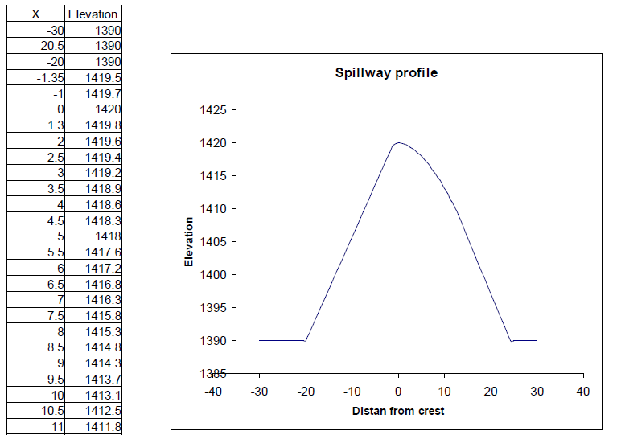
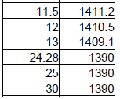
Alternative II
Siphon spillway
Siphon spillway is a bit complicated to construct and the low elevation difference between the upstream and downstream water level makes it unsuitable for most dams..
For this particular case a site is selected which is suitable for its construction and a tail water elevation necessary for the proper functioning of the spillway is maintained by taking advantage of the topography and building an additional structure.

Design procedure
Siphon cross section at the throat width (b) 5m
Depth (a) 4m
Normal water surface elevation is the crest elevation 1420m design head is as used in the case of the ogee 6m
P_{v} = 3.595m
The minimum and maximum pressures at the crest elevation

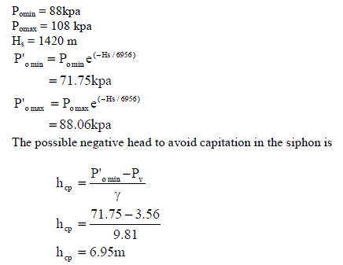

Hence the design head for the siphon discharge is taken to be 6.9m for a concrete hood the roughness coefficient (ε) is taken to be 1.5 the total length of the hood is assumed to be 25m
The hydraulic diameter (D) will be
D = 4A/P
= (4*20)/18
= 4.44 m
ε/D = 0.00034
From Moody’s chart for the corresponding value of ε/D, the friction factor(f) for a rough flow behavior (since the Reynolds number is supposed to be very large),
f = 0.0145
Now siphon coefficient (μ) will be determined

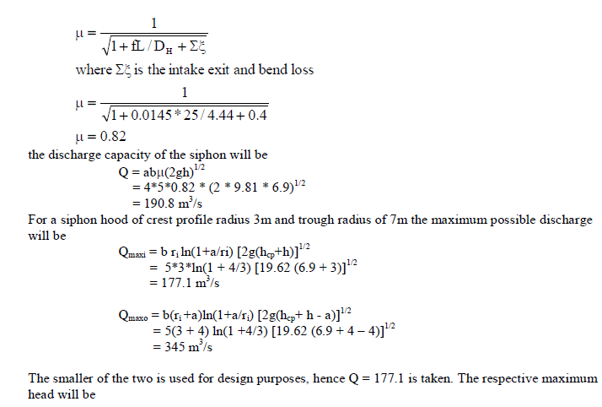

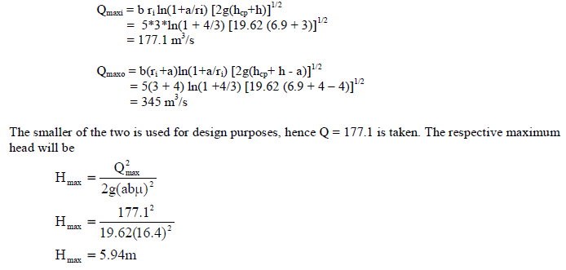

Hence, the head to be used for the design of the siphon is 5.94m.
Alternative III
Side channel spillway
The topography of the dam site reveals that there is a possibility to construct a side channel spillway. An iterative approach is followed to determine the water surface profile as well as the critical section. The bed slope is the optimum slope obtained after a minimum adjustment is carried out.
Available data
Length | 70.00
Design head | 6.00
Discharge per length | 20.14
Side slope m | 0.50
Bottom width | 10.00
Manning’s n | 0.02
Alpha | 1.00
Bed slope | 0.30
Crest elevation | 1420.00
Critical profile for the given channel condition is simulated for fictions flow depth to be used in obtaining the actual profile through interpolation
Table 3.1. A Critical flow depth computation.
Y | A | T | D/2 | V_{c} | Q_{c} | P | R_{c}
1.00 | 10.50 | 11.00 | 0.48 | 3.07 | 32.24 | 12.24 | 0.86
1.50 | 16.13 | 11.50 | 0.70 | 3.71 | 59.82 | 13.35 | 1.21
3.00 | 34.50 | 13.00 | 1.33 | 5.11 | 176.30 | 16.71 | 2.06
4.00 | 48.00 | 14.00 | 1.71 | 5.79 | 277.92 | 18.94 | 2.53
5.00 | 62.50 | 15.00 | 2.08 | 6.39 | 399.38 | 21.18 | 2.95
6.00 | 78.00 | 16.00 | 2.44 | 6.92 | 539.76 | 23.42 | 3.33
7.00 | 94.50 | 17.00 | 2.78 | 7.39 | 698.36 | 25.65 | 3.68
8.00 | 112.00 | 18.00 | 3.11 | 7.81 | 874.72 | 27.89 | 4.02
9.00 | 130.50 | 19.00 | 3.43 | 8.20 | 1070.10 | 30.12 | 4.33
10.00 | 150.00 | 20.00 | 3.75 | 8.58 | 1287.00 | 32.36 | 4.64
11.00 | 170.50 | 21.00 | 4.06 | 8.93 | 1522.57 | 34.60 | 4.93
12.00 | 192.00 | 22.00 | 4.36 | 9.25 | 1776.00 | 36.83 | 5.21
13.00 | 214.50 | 23.00 | 4.66 | 9.56 | 2050.62 | 39.07 | 5.49
14.00 | 238.00 | 24.00 | 4.96 | 9.86 | 2346.68 | 41.30 | 5.76
15.00 | 262.50 | 25.00 | 5.25 | 10.15 | 2664.38 | 43.54 | 6.03
16.00 | 288.00 | 26.00 | 5.54 | 10.43 | 3003.84 | 45.78 | 6.29
17.00 | 314.50 | 27.00 | 5.82 | 10.69 | 3362.01 | 48.01 | 6.55
18.00 | 342.00 | 28.00 | 6.11 | 10.95 | 3744.90 | 50.25 | 6.81
19.00 | 370.50 | 29.00 | 6.39 | 11.20 | 4149.60 | 52.49 | 7.06
20.00 | 400.00 | 30.00 | 6.67 | 11.44 | 4576.00 | 54.72 | 7.31
21.00 | 430.50 | 31.00 | 6.94 | 11.67 | 5023.94 | 56.96 | 7.56

The critical water surface profile with respect to the critical bed is calculated in Table 2 then the critical depth is transferred to the actual bed slope. An arbitrary elevation (1470 m) is selected and the water surface profile at critical flow is plotted in fig 1.The lowest point of tangency of the actual channel bed with the critical bed profile is taken as the control section. The actual flow profile is then determined by going upstream and downstream from the critical section for subcritical and supercritical flow conditions respectively as shown in Table 3.1

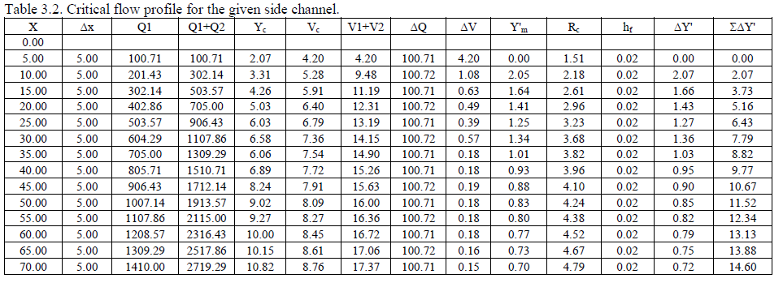
Table 3.3. Flow profile computation.
X | Δ x | Z_{o} | Δy | Z | Y | A | Q | V | Q1+Q2 | V1+V2 | ΔQ | ΔV | ΔY_{m}' | R | h_{f} | ΔY'
subcritical flow profile
30.00 | 0.00 | 1411.00 |  | 1418.36 | 7.36 | 100.68 | 604.29 | 6.00
25.00 | 5.00 | 1412.50 | 0.86 | 1419.22 | 6.72 | 89.78 | 503.57 | 5.61 | 1107.86 | 11.61 | 100.72 | 0.39 | 0.86 | 3.59 | 0.010 | 0.87
20.00 | 5.00 | 1414.00 | 0.99 | 1420.21 | 6.21 | 81.38 | 402.86 | 4.95 | 906.43 | 10.56 | 100.71 | 0.66 | 0.99 | 3.41 | 0.009 | 1.00
15.00 | 5.00 | 1415.50 | 0.99 | 1421.20 | 5.70 | 73.25 | 302.14 | 4.12 | 705.00 | 9.07 | 100.72 | 0.83 | 0.98 | 3.22 | 0.006 | 0.99
10.00 | 5.00 | 1417.00 | 0.90 | 1422.10 | 5.10 | 64.00 | 201.43 | 3.15 | 503.57 | 7.27 | 100.71 | 0.97 | 0.90 | 2.99 | 0.004 | 0.90
5.00 | 5.00 | 1418.50 | 0.76 | 1422.86 | 4.36 | 53.10 | 100.71 | 1.90 | 302.14 | 5.05 | 100.72 | 1.25 | 0.76 | 2.69 | 0.002 | 0.76
0.00 | 5.00 | 1420.00 | 0.37 | 1423.23 | 3.23 | 37.52 | 0.00 | 0.00 | 100.71 | 1.90 | 100.71 | 1.90 | 0.37 | 2.18 | 0.000 | 0.37
Super critical flow
30.00 | 0.00 | 1411.00 |  | 1418.36 | 7.36 | 100.68 | 604.29 | 6.00
35.00 | 5.00 | 1409.50 | 0.59 | 1417.77 | 8.27 | 116.90 | 705.00 | 6.03 | 1309.29 | 12.03 | 100.71 | 0.03 | 0.59 | 4.10 | 0.010 | 0.60
40.00 | 5.00 | 1408.00 | 0.35 | 1417.42 | 9.42 | 138.57 | 805.71 | 5.81 | 1510.71 | 11.85 | 100.71 | -0.22 | 0.35 | 4.46 | 0.008 | 0.35
45.00 | 5.00 | 1406.50 | 0.22 | 1417.20 | 10.70 | 164.25 | 906.43 | 5.52 | 1712.14 | 11.33 | 100.71 | -0.30 | 0.21 | 4.84 | 0.007 | 0.22
50.00 | 5.00 | 1405.00 | 0.15 | 1417.05 | 12.05 | 193.10 | 1007.14 | 5.22 | 1913.57 | 10.73 | 100.71 | -0.30 | 0.14 | 5.23 | 0.005 | 0.15
55.00 | 5.00 | 1403.50 | 0.10 | 1416.95 | 13.45 | 224.95 | 1107.86 | 4.92 | 2115.00 | 10.14 | 100.71 | -0.29 | 0.10 | 5.61 | 0.004 | 0.10
60.00 | 5.00 | 1402.00 | 0.08 | 1416.87 | 14.87 | 259.26 | 1208.57 | 4.66 | 2316.43 | 9.59 | 100.71 | -0.26 | 0.08 | 5.99 | 0.004 | 0.08
65.00 | 5.00 | 1400.50 | 0.06 | 1416.81 | 16.31 | 296.11 | 1309.29 | 4.42 | 2517.86 | 9.08 | 100.71 | -0.24 | 0.06 | 6.37 | 0.003 | 0.06
70.00 | 5.00 | 1399.00 | 0.00 | 1416.81 | 17.81 | 336.70 | 1410.00 | 4.19 | 2719.29 | 8.61 | 100.71 | -0.23 | 0.04 | 6.76 | 0.002 | 0.04
Table 3. 4. Flow profile for
X | Drop from EGL | Cr. water level | Bed level | Cr. Bed profile | Actual profile
0.00 | 1470.00 | 1420.00 | 1420.00 | 1470.00 | 1423.23
5.00 | 1470.00 | 1420.57 | 1418.50 | 1467.93 | 1422.86
10.00 | 1467.93 | 1420.31 | 1417.00 | 1464.62 | 1422.10
15.00 | 1466.27 | 1419.76 | 1415.50 | 1462.01 | 1421.20
20.00 | 1464.84 | 1419.03 | 1414.00 | 1459.81 | 1420.21
25.00 | 1463.57 | 1418.53 | 1412.50 | 1457.54 | 1419.22
30.00 | 1462.21 | 1417.58 | 1411.00 | 1455.63 | 1417.58
35.00 | 1461.18 | 1415.56 | 1409.50 | 1455.12 | 1417.77
40.00 | 1460.23 | 1414.89 | 1408.00 | 1453.34 | 1417.42
45.00 | 1459.33 | 1414.74 | 1406.50 | 1451.09 | 1417.20
50.00 | 1458.48 | 1414.02 | 1405.00 | 1449.46 | 1417.05
55.00 | 1457.66 | 1412.77 | 1403.50 | 1448.39 | 1416.95
60.00 | 1456.87 | 1412.00 | 1402.00 | 1446.87 | 1416.87
65.00 | 1456.12 | 1410.65 | 1400.50 | 1445.97 | 1416.81
70.00 | 1455.40 | 1409.82 | 1399.00 | 1444.58 | 1416.81

1470.00

1460.00
EGL drop
Cr.wat. Surf. Prof Bed elev
Cr.bed prof.
Actual flow profile

1450.00

1440.00
Elevation (m.a.s.l)

1430.00

Control section

1420.00

1410.00

1400.00

1390.00
0.00 10.00 20.00 30.00 40.00 50.00 60.00 70.00 80.00
Distance along the channel(m )

Fig. 1. Com putation of flow profile for side channel

Alternative IV Chute spillway
For the design of the chute spillway three components are considered
- Design of the approach channel.
- Design of the control structure.
- Design of the chute channel. Spillway crest length is optimized to be 40m.
Round nosed piers of 2m thickness will be used to at every 9m along the spillway.
An approach channel of side slopes 1:1 is suggested to be used to guide the channel to the control structure.
The height of the control ogee is 6m.
Elevation of bottom of the control structure is 1414m. Approach channel
For the design of the approach channel first the head over the control structure/ogee/ need to be determined. From the equation of discharge
Q = CLeHe3/2
Assume the value of the discharge coefficient C = 2.13. The design head hdes is equal to the total head. 1410 = 2.13 * 32 *h^{1.5}
h = 7.54
Upstream water surface level = crest elevation + h
= 1420 + 7.54
= 1427.54
bed level of the ogee = 1414m water depth upstream of ogee = 13.54 m channel width is = 40m
area of the channel = (40 + 13.54) * 13.54
= 724.9 m2
wetted perimeter P = 40 + 2*1.414* 13.54
= 78.3
hydraulic radius R = A/P
= 9.26 m
v = Q/A
= 1.94
ha = v2/ 2g 0.1923
Correction for the coefficient of discharge
P/H_{e} = 0.78
C_{o} = 2.128
For an upstream slope of 1:1 C_{i}/C_{o} = 1.004

To remove any submergence effect at the downstream apron position h_{d}+d/H_{e} = 1.777 > 1.7
and to maintain supercritical flow h_{d}/H_{e} = 1.34

Therefore, the final corrected value of the coefficient of discharge for the ogee is C = 2.128 *1.004
= 2.13

Design of crest profile
P/H_{e} = 0.78
h_{d}/H_{e} = 0.025
The upstream profile of the crest is, therefore, obtained by interpolating for ha/He = 0.025 Table 4.1 coordinates of upstream profile for low ogee weir
X/He | Ha/He |  |  | x | Elevation
 | 0 | 0.08 | 0.12
0 | 0 | 0 | 0 | 0.00 | 1220.00
-0.02 | 0.0004 | 0.0004 | 0.0004 | -0.15 | 1420.00
-0.06 | 0.0036 | 0.0035 | 0.0035 | -0.46 | 1420.00
-0.1 | 0.0103 | 0.01 | 0.0099 | -0.77 | 1419.99
-0.12 | 0.015 | 0.015 | 0.0147 | -0.93 | 1419.99
-0.14 | 0.0207 | 0.0208 | 0.0149 | -1.08 | 1419.98
-0.15 | 0.0239 | 0.0235 | 0.0231 | -1.16 | 1419.98
-0.16 | 0.0275 | 0.027 | 0.0265 | -1.24 | 1419.97
-0.175 | 0.0333 | 0.0328 | 0.0325 | -1.35 | 1419.97
-0.19 | 0.0399 | 0.0395 | 0.039 | -1.47 | 1419.96
-0.195 | 0.0424 | 0.042 |  | -1.51 | 1419.96
-0.2 | 0.045 |  |  | -1.54 | 1419.96

The optimum position of the downstream apron is taken as 1414.0m because it is sufficient to maintain critical flow and avoid submergence effects. From the specific energy at the upstream and downstream of the control structure the depth of flow at the toe of the ogee is obtained
U/s E = 6.0 + 7.54 + 0.19
= 13.73m
velocity at the d/s
= q/d
d/s E = d + (q/d)²/2g
equating and solving by trial and error the water depth is 2.3m
For the downstream profile of the ogee the equation obtained from table is Y = -0.115x^{1.75}
And the values are calculated for the elevation range of 1420m and 1414m as shown in the following table.

Table 4.2 Downstream profile of ogee
x | Elevation
0 | 1420.00
0.50 | 1419.97
1.00 | 1419.89
2.00 | 1419.61
3.00 | 1419.21
4.00 | 1418.70
5.00 | 1418.08
6.00 | 1417.35
7.00 | 1416.54
8.00 | 1415.62
9.00 | 1414.00

Design of the chute.
Critical depth y_{c} = (q²/g)^{1/3}
= 5.02m

The critical depth is much higher than the calculated depth, hence the flow is supercritical. The chute channel should now be given a milder slop for a little distance from toe, keeping the flow in supercritical condition.
Critical velocity = q/y_{c} = 7.02 From Manning’s equation

V = 1/n R^{2/3}s^{1/2}
Inserting the values and calculating for slope S=0.001
Hence a slope of 1/400 is provided in 40m distance from the toe of the spillway. The bed level at the end of this slope is 1414-0.1 = 1413.9m.
For the reverse curve at the toe a concave curve of radius 2He is provided.

For the remaining reaches of the channel a slope is given based on the prevailing topography formation of white water and keeping the flow supercritical. The calculation is shown in the following table.

Ambo University Woliso Campus Hydraulic Structures I

Table 4.3 Calculation of water depth on chute channel.

S.N | Distance from start | Length (L) | Drop in bed(Y_{m}) | Bed level (Z_{o}) | Depth (d) | Velocity (v) | vel head (h_{a}) | Sp. energy (E) | Z_{o} +E | Area (A) | R | h_{f} | Act TEL | Froud no
Slop 1:6
1 | 0 |  |  | 1413.90 | 2.36 | 14.94 | 11.37 | 13.73 | 1427.63 | 23.60 | 1.60 |  |  | 3.10
2 | 20 | 20 | 3.32 | 1410.58 | 2.06 | 17.11 | 14.92 | 16.98 | 1427.56 | 20.60 | 1.46 | 1.28 | 1426.35 | 3.81
 | 40 | 20 | 3.32 | 1407.26 | 1.85 | 19.05 | 18.50 | 20.35 | 1427.61 | 18.50 | 1.35 | 1.76 | 1425.81 | 4.47
Slop 1:3
3 | 60 | 20 | 6.66 | 1400.60 | 1.66 | 21.23 | 22.98 | 24.64 | 1425.24 | 16.60 | 1.25 | 2.43 | 1425.19 | 5.26
 | 80 | 20 | 6.66 | 1393.94 | 1.54 | 22.89 | 26.70 | 28.24 | 1422.18 | 15.40 | 1.18 | 3.04 | 1422.20 | 5.89
Slop 1:2
4 | 100 | 20 | 10 | 1383.94 | 1.39 | 25.36 | 32.78 | 34.17 | 1418.11 | 13.90 | 1.09 | 4.15 | 1418.03 | 6.87
 | 120 | 20 | 10 | 1373.94 | 1.30 | 27.22 | 37.76 | 39.06 | 1413.00 | 12.95 | 1.03 | 5.15 | 1412.96 | 7.64

Convex curves joining the different slopes were then designed as follows.
  - joining slope 1:400 and 1:6
  - joining 1:6and 1:3
  - joining slope 1:3 and 1:2 The design is based on the equation

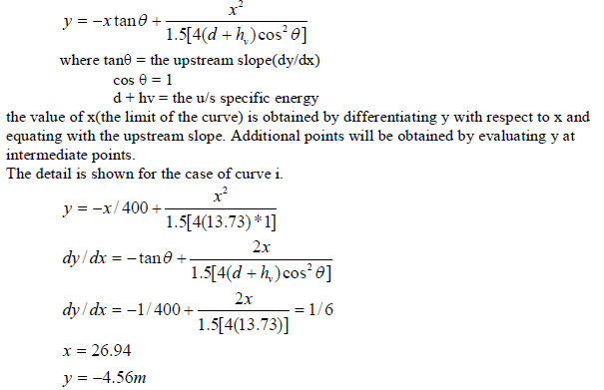

Table 4.4. Curve terminal points
curves | u/s slope | d/s sloe | u/s E | x | Y
1 | 0.0025 | 0.166 | 13.73 | 0.00 | 0.00
 |  |  |  | 5.00 | -0.85
 |  |  |  | 10.00 | -1.69
 |  |  |  | 15.00 | -2.54
 |  |  |  | 20.00 | -3.38
 |  |  |  | 25.00 | -4.23
 |  |  |  | 26.94 | -4.56
2 | 0.17 | 0.333 | 18.50 | 0.00 | 0.00
 |  |  |  | 5.00 | -1.67
 |  |  |  | 10.00 | -3.33
 |  |  |  | 15.00 | -5.00
 |  |  |  | 20.00 | -6.67
 |  |  |  | 25.00 | -8.33
 |  |  |  | 30.00 | -10.00
 |  |  |  | 36.93 | -12.31
3 | 0.333 | 0.5 | 28.24 | 0 | 0.00
 |  |  |  | 8 | -4.00
 |  |  |  | 16 | -7.99
 |  |  |  | 24 | -11.99
 |  |  |  | 32 | -15.99
 |  |  |  | 40 | -19.99
 |  |  |  | 48 | -23.98
 |  |  |  | 56.60 | -28.28
1430

1420

1410

1400
Elevation (m)

1390

1380

1370

-50 0 50 100 150 200
Distance from the ogee crest(m)

Stilling Basin
Profile of the chute spillway

A stilling basin is a channel structure of mild slope, placed at the outlet of a spillway, chute or other high velocity flow channel, whose purpose is to confine all or part of the hydraulic jump or other energy reducing action and dissipate some of the high kinetic energy of the flow. It is a structure which is necessary to prevent bed scour and undermining of the structure in situation where high velocity flow is discharged into the downstream channel.
Usually flow entering a stilling basin is at super critical velocity. The stilling basin on the mild slope supports only sub critical flow. The transition from super critical to sub critical flow takes place in the form of a hydraulic jump.

The stilling basin is designed to insure that the jump occurs always at such a location that the flow velocities entering the erodible downstream channel are incapable of causing harmful scour.
The design of a particular stilling basin will depend on the magnitude and other characteristics of the flow to be handled, and particularly the Froud number of the approaching flow. Consider the simplest and most common stilling basin, a horizontal rectangular channel as shown in Fig 5-11,
Hydraulic jump equation:
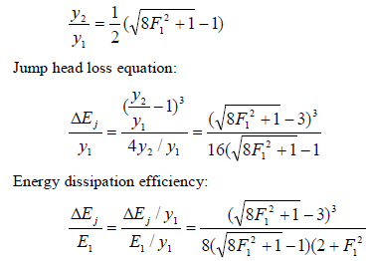
Jump Height
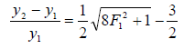

The length of jump is a very important factor in stilling basin design. It can be obtained from the curve by USBR.
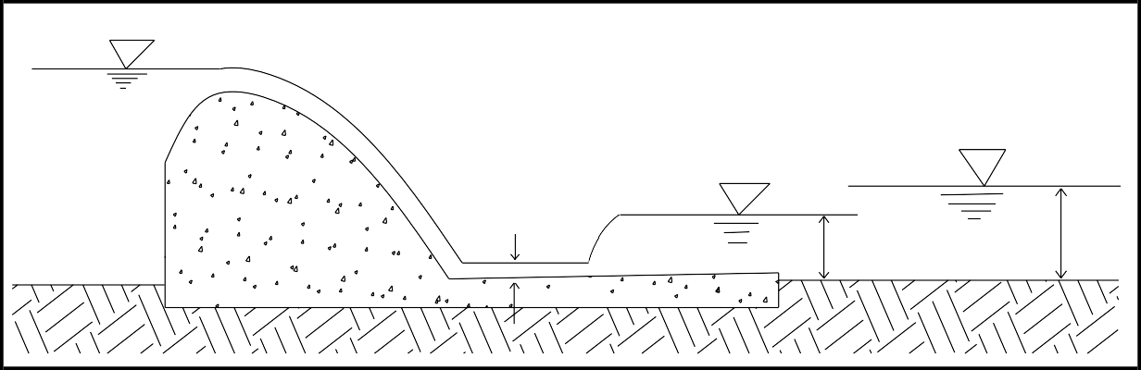The longitudinal position of the jump on the apron must be such that the upstream and downstream depth satisfies the jump equation. For more precise jump location a trial-and-error procedure using the flow profiles is necessary.
Fig 6-11 Simple Stilling basin

Hence, for a given discharge intensity and given height of spillway, Y₁ is fixed and the thus Y₂ is also fixed. But the availability of a depth equal to Y₂ in the channel on the d/s cannot be guaranteed as it depends upon the tail water level, which depends upon the hydraulic dimensions and slope of the river channel below. For different discharges, the tail water depth is found by actual gauge discharge observations and by hydraulic computation.

References:
  - M.M. Grishin, Hydraulic Structures, vol. 1, Mir Publishers, 1987, Moscow.
  - P.N. Moodi, Irrigation Water Resources and Water Power Engineering, Standard Book House, 1995, New Delhi.
  - S.K.Garg, Irrigation Engineering and Hydraulic Structures,
  - Design of Small Dams. U.S. Bureau of Reclamation. 4th Ed.
  - Prof. Bollrich ,G Manual on Functional Hydraulic Structures for Dams,.

Symbol |  | Name
Capital | Small
A | α | Alpha
Β | β | Beta
Γ | γ | Gamma
Δ | δ | Delta
Ε | ε | Epsilon
Z | ζ | Zeta
H | η | Eta
Θ | θ | Theta
I | ι | Iota
K | κ | Kappa
Λ | λ | Lambda
M | μ | Mu
N | ν | Nu
Ξ | ξ | Xi
O | ο | Omicron
Π | π | Pi
Ρ | ρ | Rho
Σ | σ | Sigma
T | τ | Tau
Y | υ | Upsilon
Φ | φ | Phi
X | χ | Chi
Ψ | ψ | Psi
Ω | ω | Omega

