Auwc department of civil engineering

CHAPTER TWO

2.0 METHODS OF FORECASTING POPULATION
Design of water supply and sanitation scheme is based on the projected population of a particular city, estimated for the design period. Any underestimated value will make system inadequate for the purpose intended; similarly overestimated value will make it costly. Changes in the population of the city over the years occur, and the system should be designed taking into account of the population at the end of the design period.
Factors affecting changes in population are: increase due to births decrease due to deaths increase/ decrease due to migration increase due to annexation.
The present and past population record for the city can be obtained from the census population records. After collecting these population figures, the population at the end of design period is predicted using various methods as suitable for that city considering the growth pattern followed by the city.
2.1 ARITHMETICAL INCREASE METHOD
This method is suitable for large and old city with considerable development. If it is used for small, average or comparatively new cities, it will give lower population estimate than actual value. In this method the average increase in population per decade is calculated from the past census reports. This increase is added to the present population to find out the population
of the next decade. Thus, it is assumed that the population is increasing at constant rate. Hence, dP/dt = C i.e., rate of change of population with respect to time is constant.
Therefore, Population after nth decade will be Pn= P + n.C  Where, Pn is the population after ‘n’ decades and ‘P’ is present population. | (1)

Example: 1
Predict the population for the year 2021, 2031, and 2041 from the following population data.
Year | 1961 | 1971 | 1981 | 1991 | 2001 | 2011
Population | 8,58,545 | 10,15,672 | 12,01,553 | 16,91,538 | 20,77,820 | 25,85,862

Year | Population | Increment
1961 | 858545 | -
1971 | 1015672 | 157127
1981 | 1201553 | 185881
1991 | 1691538 | 489985
2001 | 2077820 | 386282
2011 | 2585862 | 508042
Average increment = 345463 Population forecast for year 2021 is, P2021= 2585862 + 345463 x 1 = 2931325
Similarly, | P2031= 2585862 + 345463 x 2 = 3276788 P2041= 2585862 + 345463 x 3 = 3622251

2.2 | GEOMETRICAL INCREASE METHOD  (OR GEOMETRICAL PROGRESSION METHOD)
In this method the percentage increase in population from decade to decade is assumed to remain constant. Geometric mean increase is used to find out the future increment in population. Since this method gives higher values and hence should be applied for a new industrial town at the beginning of development for only few decades. The population at the end of nth decade ‘Pn’ can be estimated as:
Pn= P (1+ IG/100)n  Where, IG= geometric mean (%) | (2)
P = Present population N = no. of decades.

Example: 2
Considering data given in example 1 predict the population for the year 2021, 2031, and 2041 using geometrical progression method.
Solution
Year | Population | Increment | Geometrical increase Rate of growth
1961 | 858545 | -
1971 | 1015672 | 157127 | (157127/858545) = 0.18
1981 | 1201553 | 185881 | (185881/1015672) = 0.18
1991 | 1691538 | 489985 | (489985/1201553) = 0.40
2001 | 2077820 | 386282 | (386282/1691538) = 0.23
2011 | 2585862 | 508042 | (508042/2077820) = 0.24
Geometric mean IG= (0.18 x 0.18 x 0.40 x 0.23 x 0.24) 1/5 = 0.235 i.e., 23.5%
Population in year 2021 is, P2021= 2585862 x (1+ 0.235)1 = 3193540
Similarly for year 2031 and 2041 can be calculated by, P2031= 2585862 x (1+ 0.235)2 = 3944021 P2041= 2585862 x (1+ 0.235)3 = 4870866
2.3 INCREMENTAL INCREASE METHOD
This method is modification of arithmetical increase method and it is suitable for an average size town under normal condition where the growth rate is found to be in increasing order. While adopting this method the increase in increment is considered for calculating future population. The incremental increase is determined for each decade from the past population and the average value is added to the present population along with the average rate of increase.
Hence, population after nth decade is Pn= P+ n.X + {n (n+1)/2}.Y Where, Pn= Population after nth decade | (3)
X = Average increase Y = Incremental increase
Example: 3
Considering data given in example 1 predict the population for the year 2021, 2031, and 2041 using incremental increase method.
Solution
Year | Population | Increase (X) | Incremental increase (Y)
1961 | 858545 | - | -
1971 | 1015672 | 157127 | -
1981 | 1201553 | 185881 | +28754
1991 | 1691538 | 489985 | +304104
2001 | 2077820 | 386282 | -103703
2011 | 2585862 | 508042 | +121760
 | Total | 1727317 | 350915
 | Average | 345463 | 87729
Population in year 2021 is, P2021= 2585862 + (345463 x 1) + {(1 (1+1))/2} x 87729 = 3019054
For year 2031 P2031 = 2585862 + (345463 x 2) + {(2 (2+1)/2)} x 87729 = 3539975
P2041 = 2585862 + (345463 x 3) + {(3 (3+1)/2)} x 87729 = 4148625
2.4 GRAPHICAL METHOD
In this method, the populations of last few decades are correctly plotted to a suitable scale on graph (Figure 2.1). The population curve is smoothly extended for getting future population. This extension should be done carefully and it requires proper experience and judgment. The best way of applying this method is to extend the curve by comparing with population curve of some other similar cities having the similar growth condition.

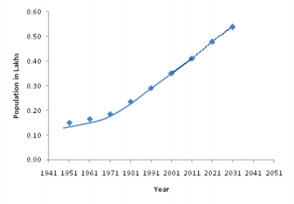Figure 2.1 Graphical method of population forecasting
2.5 COMPARATIVE GRAPHICAL METHOD
In this method the census populations of cities already developed under similar conditions are plotted. The curve of past population of the city under consideration is plotted on the same graph. The curve is extended carefully by comparing with the population curve of some similar cities having the similar condition of growth. The advantage of this method is that the future population can be predicted from the present population even in the absence of some of the past census report. The use of this method is explained by a suitable example given below.
Example: 4
The populations of a new city X given for decades 1970, 1980, 1990 and 2000 were 32,000; 38,000; 43,000 and 50,000, respectively. The cities A, B, C and D were developed in similar conditions as that of city X. It is required to estimate the population of the city X in the years 2010 and 2020. The population of cities A, B, C and D of different decades were given below:
(i) | City A: 50,000; 62,000; 72,000 and 87,000 in 1960, 1972, 1980 and 1990, respectively.  City B: 50,000; 58,000; 69,000 and 76,000 in 1962, 1970, 1981 and 1988, respectively.  City C: 50,000; 56,500; 64,000 and 70,000 in 1964, 1970, 1980 and 1988, respectively.
(ii)
(iii)

2020
2010
2000
1990
1980
1970
(iv) | City D: 50,000; 54,000; 58,000 and 62,000 in 1961, 1973, 1982 and 1989, respectively.
Population curves for the cities A, B, C, D and X are plotted (Figure 2.2). Then an average mean curve is also plotted by dotted line as shown in the figure. The population curve X is extended beyond 50,000 matching with the dotted mean curve. From the curve, the populations obtained for city X are 58,000 and 68,000 in year 2010 and 2020. 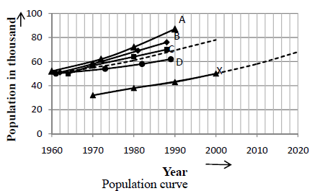
Figure 2.2 Comparative graph method
2.6 MASTER PLAN METHOD
The big and metropolitan cities are generally not developed in haphazard manner, but are planned and regulated by local bodies according to master plan. The master plan is prepared for next 25 to 30 years for the city. According to the master plan the city is divided into various zones such as residence, commerce and industry. The population densities are fixed for various zones in the master plan. From this population density total water demand and wastewater generation for that zone can be worked out. By this method it is very easy to access precisely the design population.
2.7 LOGISTIC CURVE METHOD
This method is used when the growth rate of population due to births, deaths and migrations takes place under normal situation and it is not subjected to any extraordinary changes like epidemic, war, earth quake or any natural disaster, etc., and the population follows the growth
curve characteristics of living things within limited space and economic opportunity. If the population of a city is plotted with respect to time, the curve so obtained under normal condition looks like S-shaped curve and is known as logistic curve (Figure 2.3).
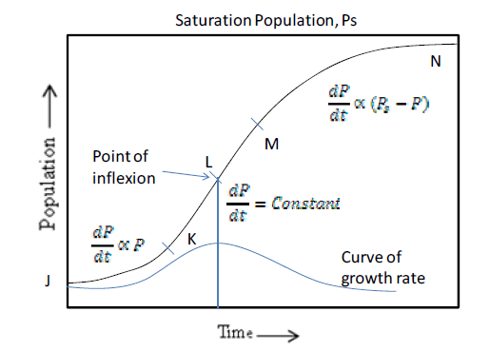
Figure 2.3 Logistic curve for population growth
In Figure 2.3, the curve shows an early growth JK at an increasing rate i.e. geometric growth
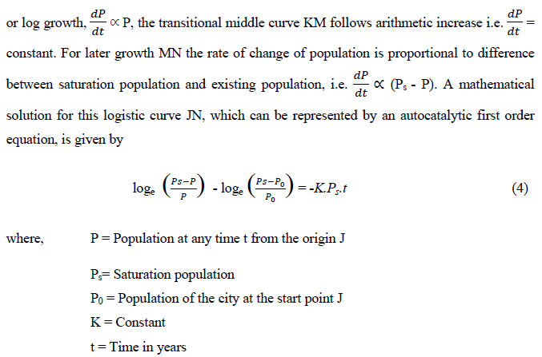
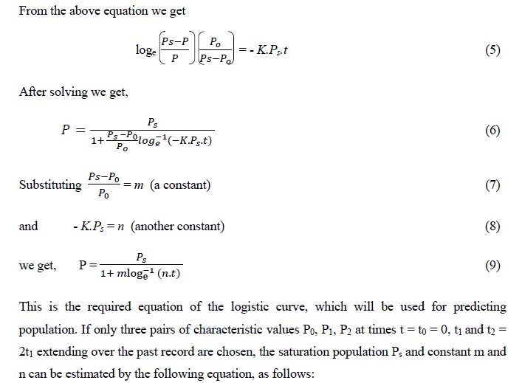 This is the required equation of the logistic curve, which will be used for predicting population. If only three pairs of characteristic values P0, P1, P2 at times t = t0 = 0, t1and t2 = 2t1 extending over the past record are chosen, the saturation population Ps and constant m and n can be estimated by the following equation, as follows:
Example: 5
The population of a city in three consecutive years i.e. 1991, 2001 and 2011 is 80,000; 250,000 and 480,000, respectively. Determine (a) The saturation population, (b) The equation of logistic curve, (c) The expected population in 2021.

Solution
It is given that
P0 = 80,000 t0 = 0
P1= 250,000 t1 = 10 years
P2 = 480,000 t2 = 20 years
The saturation population can be calculated by using equation 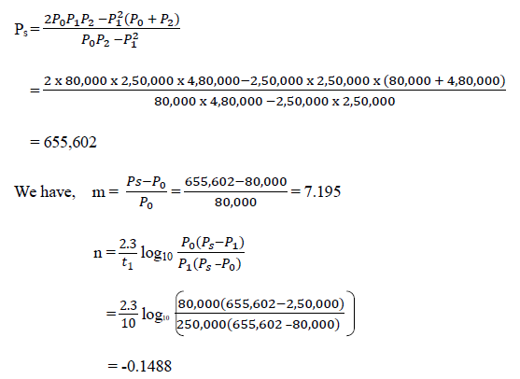 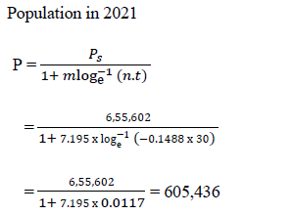
Assignment
1. Which methods of population forecasting is mostly used for our country, support your answer by writing the reason.
2. The population data for a town is given below. Find out the population in the year 2021, 2031 and 2041 by (a) arithmetical (b) geometric (c) incremental increase methods.
Year | 1971 | 1981 1991 2001 2011
Population 84,000 1, 15,000 |  |  | 1, 60,000 | 2, 05,000 2, 50,000
3. In three consecutive decades the population of a town is 40,000; 100,000 and 130,000. Determine: (a) Saturation population; (b) Equation for logistic curve; (c) Expected population in next decade.

