CHAPTER THREE
3.0 WATER SOURCES
3.1 Sources of Water Supply
The origin of all water is rainfall. Water can be collected as it falls as rain before it reaches the ground; or as surface water when it flows over the ground; or is pooled in lakes or ponds; or as ground water when it percolates in to the ground and flows or collects as groundwater; from the sea/ocean in to which it finally flows.
All the sources of water can be broadly divided into:
1. Surfaces sources and
2. Sub surface sources

3.1.1 Surfaces Sources
The surface sources further divided into
i. Streams and rivers
ii. Ponds and Lakes
iii. Impounding reservoirs etc.
- Streams and Rivers
Rivers and streams are the main source of surface source of water. In summer the quality of river water is better than monsoon because in rainy season the run-off water also carries with clay, sand, silt etc which make the water turbid. So, river and stream water require special treatments. Some rivers are perennial and have water throughout the year and therefore they don’t require any arrangements to hold the water. But some rivers dry up wholly or partially in summer. So they require special arrangements to meet the water demand during hot weather. Mostly all the cities are situated near the rivers discharge their used water of sewage in the rivers; therefore much care should be taken while drawing water from the river.

In mountains at some places natural basins are formed with impervious bed by springs and streams are known as “lakes”. The quantity of water in the natural ponds and lakes depends upon the basin’s capacity, catchment area, annual rainfall, porosity of ground etc. Lakes and ponds situated at higher altitudes contain almost pure water which can be used without any treatment. But ponds formed due to construction of houses, road, and railways contains large amount of impurities and therefore cannot be used for water supply purposes.
iii. Impounding Reservoirs

In some rivers the flow becomes very small and cannot meet the requirements of hot weather. In such cases, the water can be stored by constructing weir or a dam across the river at such places where minimum area of land is submerged in the water and maximum quantity of water to be stored. In lakes and reservoirs, suspended impurities settle down in the bottom, but in their beds algae, weeds, vegetable and organic growth takes place which produce bad smell, taste and color in water. Therefore, this water should be used after purification. When water is stored for long time in reservoirs it should be aerated and chlorinated to kill the microscopic organisms which are born in water.
3.1.2 Subsurface Sources
These are further divided into

(i) Infiltration galleries
(ii) Infiltration wells
(iii) Springs
(iv) Well

i. Infiltration Galleries

A horizontal nearly horizontal tunnel which is constructed through water bearing strata for tapping underground water near rivers, lakes or streams are called “Infiltration galleries”. The yield from the galleries may be as much as 1.5 x 104 lit/day/meter length of infiltration gallery. For maximum yield the galleries may be placed at full depth of the aquifer. Infiltration galleries may be constructed with masonry or concrete with weep holes of 5cm x 10cm.
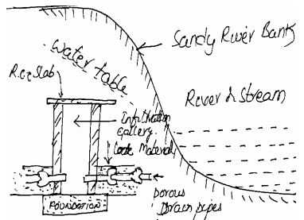
Fig 3.1 Infiltration Gallery
ii. Infiltration Wells

In order to obtain large quantity of water, the infiltration wells are sunk in series in the blanks of river. The wells are closed at top and open at bottom. They are constructed by brick masonry with open joints as shown in fig. 3.2
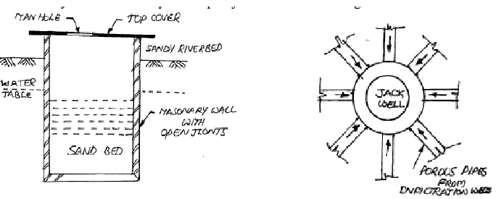
Fig 3.2 Infiltration Well Fig 3.3 Jack Well
For the purpose of inspection of well, the manholes are provided in the top cover. The water filtrates through the bottom of such wells and as it has to pass through sand bed, it gets purified to some extent. The infiltration wells in turn are connected by porous pipes to collecting sump called jack well and there water is pumped to purification plant for treatment (fig 3.3).
Iii. Springs
Sometimes ground water reappears at the ground surface in the form of springs. Springs generally supply small quantity of water and hence suitable for the hill towns. Some springs discharge hot water due to presence of sulphur and useful only for the curve of certain skin disease patients.
Types of springs:
- Gravity Springs: When the surface of the earth drops sharply the water bearing stratum is exposed to atmosphere and gravity springs are formed as shown in fig.3.4
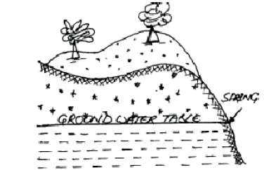
Fig 3.4 Gravity spring
- Surface Spring: This is formed when an impervious stratum which is supporting the ground water reservoir becomes out crops as shown in fig.3.5
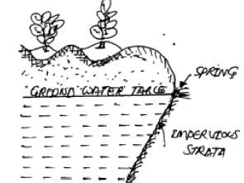
Fig 3.5Surface spring
- Artesian Spring: When the ground water rises through a fissure in the upper impervious stratum as shown in fig.3.6
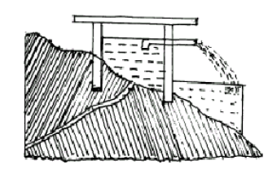
Fig 3.6 Artesian Spring
When the water-bearing stratum has too much hydraulic gradient and is closed between two imperious stratums, the formation of artesian spring from deep seated spring.
When the water-bearing stratum has too much hydraulic gradient and is closed between two imperious stratums, the formation of artesian spring from deep seated spring.
Fig 2.8 Artesian Spring
iv. Wells

A well is defined as an artificial hole or pit made in the ground for the purpose of tapping water.
The three factors which form the basis of theory of wells are
1. Geological conditions of the earth‟s surface
2. Porosity of various layers
3. Quantity of water, which is absorbed and stored in different layers

The following are different types of wells
1. Shallow wells
2. Deep wells
3. Tube wells
4. Artesian wells

1. Shallow Wells
Shallow wells are constructed in the uppermost layer of the earth‟s surface. The diameter of well varies from 2 to 6m and a maximum depth of 7m. Shallow wells may be lined or unlined from inside. Fig. 3.7 shows a shallow well with lining (staining). These wells are also called draw wells or gravity wells or open wells or drag wells or percolation wells.
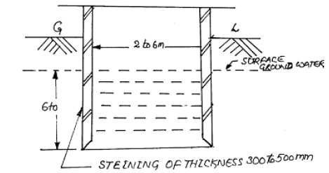
Fig 3.7 Shallow well
Quantity of water available from shallow wells is limited as their source of supply is uppermost layer of earth only and sometimes may even dry up in summer. Hence they are not suitable for public water supply schemes. The quantity of water obtained from shallow wells is better than the river water but requires purification. The shallow wells should be constructed away from septic tanks, soak pits etc because of the contamination of effluent.
The shallow wells are used as the source of water supply for small villages, undeveloped municipal towns, isolated buildings etc because of limited supply and bad quality of water.
2. Deep Wells

2. Deep Wells

The deep wells obtain their quota of water from an aquifer below the impervious layer as shown in fig 3.8. The theory of deep well is based on the travel of water from the outcrop to the site of deep well. The outcrop is the place where aquifer is exposed to the atmosphere. The rain water entered at outcrop and gets thoroughly purified when it reaches to the site of deep well. But it dissolves certain salts and therefore become hard.

In such cases, some treatment would be necessary to remove the hardness of water.
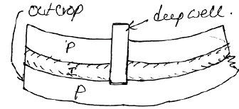
Fig 3.8 Deep Well
The depth of deep well should be decided in such a way that the location of out crop is not very near to the site of well. The water available at a pressure greater atmospheric pressure, therefore deep wells are also referred to as a pressure wells.
3.1.3 Intakes for Collecting Surface Water
The main function of the intakes works is to collect water from the surface source and then discharge water so collected, by means of pumps or directly to the treatment water.
Intakes are structures which essentially consist of opening, grating or strainer through which the raw water from river, canal or reservoir enters and carried to the sump well by means of conducts water from the sump well is pumped through the rising mains to the treatment plant.
The following points should be kept in mind while selecting a site for intake works.
1. Where the best quality of water available so that water is purified economically in less time.
2. At site there should not be heavy current of water, which may damage the intake structure.
3. The intake can draw sufficient quantity of water even in the worst condition, when the discharge of the source is minimum.
4. The site of the work should be easily approachable without any obstruction
5. The site should not be located in navigation channels
6. As per as possible the intake should be near the treatment plant so that conveyance cost is reduced from source to the water works
7. As per as possible the intake should not be located in the vicinity of the point of sewage disposal for avoiding the pollution of water.
8. At the site sufficient quantity should be available for the future expansion of the water-works.

3.2 Water Sources Selection Criteria
The choice of water supply to a town or city depends on the following:
1. Location: The sources of water should be as near as to the town as possible.
2. Quantity of water: the source of water should have sufficient quantity of water to meet up all the water demand throughout the design period.
3. Quality of water: The quality of water should be good which can be easily and cheaply treated.
4. Cost: The cost of the units of the water supply schemes should be minimum.

The selection of the source of supply is done on the above points and the source, which will give good quality, and quantity at least cost will be selected. This economic policy may lead to the selection of both surface and ground water sources to very big cities.
Surface water sources can be developed for drinking water but special care must be taken to ensure the quality of the water.
The choice of a method depends on many factors including the source and resources available and community preferences.
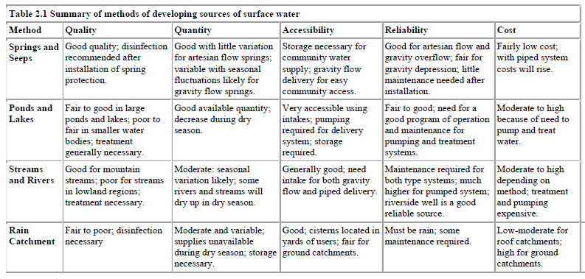

Assignment
- Which sources of water is mostly need for water supply? Why?
- Us an Engineer you are recommended to select the sources of water for woliso town, what criteria you proceeds’?
- Have you select nearly to the town or along the town?why?

