CHAPTER ONE
1.0 WATER DEMAND
In the design of any water works projects it is necessary to estimate the amount of water that is
required. This involves:
- the determination of people who will be served
- the per capita water consumption
- Analysis of the factors that may operate to affect consumption
It is usual to express water consumption in liters (gallons) per capita per day, obtaining their
Figure by dividing the total no of people in the city in to the total daily water consumption. For
Many purposes the average daily consumption is convenient. It is obtained by dividing the Population in to the total daily consumption averaged over one year. It must be realized, However, that using the total population may in some cases, result in serious in accuracy, since
A large proportion of the population may be solved by privately owned wells. A more accurate Figure would be the daily consumption per person served.
- WATER CONSUMPTION FOR VARIOUS PURPOSES
The water furnished to a city can be classified according to its ultimate use or end. The uses are:
Domestic: this includes water furnished to houses, hotels, etc, for sanitary, culinary, drinking, washing, batching, and other purposes. It varies according to the living Conditions of consumers, the range usually being considered as 75 to 380 liters per Capita per day, averaging 190 to 340 per capita. The domestic consumption may be expected to be about 50% of the total in the average city, but where the total Consumption in small, the proportion will be much greater.
Commercial and Industrial: water so classified is that furnished to industrial and commercial plants. Its importance will depend up on local conditions, such as the Existence of large industries and whether or not the industries patronize (utilize) the Public water works. Self-supplied industrial water requirements are estimated to be More than 200 percent of municipal water supply demand.
The quantity of water required for commercial and industrial use has been related to the floor
Area of buildings served. Symons proposes an average of 12.2 m³ / 1000 m² of floor area per day. In cities of over 25, 000 population commercial consumption may be expected to amount to about 15 percent of the total consumption.
Public Use water demand: Public Buildings, such as:
- City halls
- Jails
- Schools
- Flushing streets &
- Fire protection
Require much water for which, usually, the city is not paid. Such water amounts to 50 to 75 Liters per capita. The actual amount of water used for extinguishing fires does not figure greatly
In the average consumption, but very large fires will cause the rate of use to be higher for short
Periods.
Losses and Waste: This water is sometimes classified as “un accounted for”, although some
Of the loss and waste may be accounted for in the sense that its cause and amount are approximately known. Un-accounted for water is due to:
- meter and pump slippage
- Unauthorized water connections and
- Leaks in mains
It is apparent that the unaccounted for water, also waste by consumers, can be reduced by careful maintenance of the water system and by universal metering of all water services. In a system 100 percent metered and moderately well maintained the unaccounted for water, exclusive of pump slippage, will be about 10 percent. The total consumption will be the sum of the forecasting uses and the loss and waste. The probable division of this consumption is show in table below.
Table 1. Projected consumption of water for various purposes in the year 2000
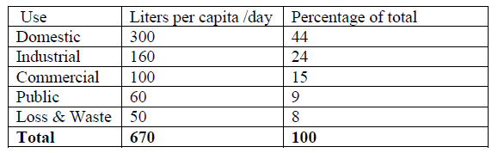

1.1 FACTORS AFFECTING CONSUMPTION
The average daily per capita water consumption varies. The variation depends up on a number of important factors. The more important of these factors will be separately treated below, but some can be briefly discussed here. The efficiency of the water works management will affect consumption by decreasing loss and waste. Leaks in water mains and services and unauthorized use of water can be to a minimum by surveyors. A water supply that is both safe and attractive in quality will be used to a great extent than one of poor quality. In this connection it should be recognized that improvement of the quality of water supply will probably be followed by an increase in consumption. Increasing the pressure will have a similar effect. Changing the rates changed for water has little effect up on consumption, at least in prosperous periods.
- Size of City: The effect of size of city is probably indirect. It is true that small per capita water consumption is to be expected in a small city, but this is usually due to the fact that there are only limited uses for water in small towns. On the other hand, the presence of an important water using industry may result in high consumption.
A small city is likely to have a relatively larger area that is inadequately served by both the water and sewer systems than a large city. Sewerage or its absence will have considerable effect. In the answered home, water consumption will rarely exceed 4lit/capita/day; while in the average skewered home, it will equal or exceed 300lit/capita/day. The extension of sewer may, therefore, necessitate additional water supply.
- Characteristics of the Population: Although the average domestic use of water may be expected to be about 300liters per capita per day, wide variations are found. These are largely dependent up on the economic status of the consumers and will differ greatly in various sections of a city.
In the high value residential districts of a city or in a suburban community with a similar population the water consumption per capita will be high. In apartment houses, which may be considered as representing the maximum the maximum domestic demand to be expected, the average consumption should be about 380 lit/capita. In area of moderate –or high value single residences even higher consumption may be expected, since to the ordinary domestic demand there will be added an amount for watering lawns. The slum districts of large cities will have lower per capita consumptions, perhaps 100 liters, but consumptions as low as 50 lit/capita have been reported.
The lowest figures of all will be found in low-value districts where sewerage is not available and where perhaps a single faucet serves one or several homes.
- Climatic Conditions: Where summers are hot and dry, much water will be used for watering lawns. Domestic use will be further increased by more bathing, while public use will be affected by use in parks and recreation fields for watering grass and for ornamental fountains. On the other hand, in cold weather water may be wasted at the faucets to prevent freezing of pipes, there by greatly increasing consumption. High temperatures may also lead to high water use for air conditioning.
- Metering: Every water works should have some means at the pumping plant of accurately measuring all the water that is delivered to the city, if the meters are of the recording type, valuable information regarding hourly rates of consumption will be available. If all services are metered the difference between the total amount pumped and the sum of service meter readings and any un-metered publicly used water will be the accounted for water.
Metering of services consists of placing a rescoring meter in the line leading from the water main to the building served. Consumers are then billed for the water that they used. The alternative to this method is charging by some form of flat rate, which is not related to the actual amount of water used or wasted. The advantages of metering are apparent. Pumping and treatment of water costs money, and wasting of water means a greater cost to be distributed among customers.
If services are unlettered, the careful consumers bear some of the burden imposed by the careless and wasteful. It is almost impossible to construct a good system of water charges unless they are based upon actual consumption of water. Lack of service meters has a definite effect upon water consumption in fact; the installation of meters may so reduce consumption that provision of more water may be indefinitely postponed. Comparison of figures in 22 Cites 90 to 100 present metered, with 13 cites, 20 present metered, showed that the former group had an average consumption of 366 liters; and the latter 824 liters. These were all cites having over 100,000 populations. Metering all service of a city should reduce consumption to about 50 percent of the consumption without meters. Although metering reduces water consumption, there is a tendency for consumption to increase gradually after all services are metered.

- Zoning: the Zoning is that feature of city planning which regulates the height and bulk of building and the uses top which they may be put a city plan , therefore , controls the character of districts and prevents ,directs or furless changes in then . The advantages of this degree of certainty in the solution of water disturbing and sewerage problems are important. in residential sections the density of population at maximum development will be known . a residential district of high or medium class will not become a slum or apartment house district.
Industrial districts will be set aside on the plan and not allowed to encroach upon residential areas. Commercial districts will be largely decentralized, and the main business district will grow in a planned direction. Water mains and sewer systems can then be planned only for actual needs and with some certainty that future changes in the character of districts will over tax ten.
1.1.1 Periods of Design and Water Consumption Data Required
The economic design period of a structure depends up on its, fire cost, ease of expansion, and likely hood of obsolescence in connection with design, the water consumption at the end of the period must be estimated .over design is not conservation since it may burden a relatively .over design is not conservation since it may burden a relatively small community with the cost of extravagant works designed for a far large population. Very appropriately design different segment of the water testament and distribution systems for differing periods using differing capacity criteria.
i. Development of Source: The design period will depend upon the source .for ground water, It is easy to drill additional wells, the design period will be short, perhaps 5 years. for surface waters requiring impoundments , the design period will be longer, perhaps as much as 50 years .
The design capacity of the source should be adequate to provide the maximum daily demand anticipated during the design period, but not necessarily up on a continuous basis.
ii. Pipe Line from Source. The design period is generally long since the life of pipe is long and the cost of material is only a portion of the const of constriction .25 year or more would not be UN usual. The design capacity of the pipe line should based up on average consumption of suitable velocities under all anticipated flow conditions
iii. Water treatment plant: The design period is commonly 10 to 15 years since expansion is generally simple it is considered in the initial design.
Most treatment units will be designed for average daily flow at the end of the design period since overloads do not result in major flow at the efficiency. Hydraulic design should be based up on max-anticipated flow.
iv. Pumping plant. The design period is generally 10 years since modification and expansion are easy it initially considered. Pump selection requires knowledge of max flow including fire demand, average flow, and minimum flow during the design period.
v. Amount of storage: The design period may be influenced by cost factors peculiar to the construction of storage vessels, which dictate minimum unit cost for tank of specific size. Design requires knowledge of average consumption, fire demand, maximum hours, maximum week, and maximum month as well as the capacity of the source and pipe lines from the source.
vi. Distribution system. The deign period is indefinite and the capacity of the system should be sized to accommodate the maximum anticipated development over factors affecting per capital flow should be considered. Maximum hourly flow including fine demand is the basis for design.
1.1.2. Variation in rate of consumption
The parfait daily water consumption figures discussed above have been based upon annual consumption. The annual average daily consumption, which useful, design tell the fuel story.
Climatic conditions, the working day, etc. tend to cause wide versions in water use.

Through the week Monday will usually have the highest consumption and Sunday the lowest. Some months will have an average daily consumption higher than the annual average .in most cites the peak month will be July or august. Especially hot, dry weathers will produce a week of maximum consumption, and certain days will place still greater demand upon the water system .peak demands also occur during the day, the hours of occurrence depends upon the characteristics start and a minimum about of A.m. A curve showing hourly variation in consumption for a limited area of city may show a characteristic shape.

It but there will be a fairly high consumption thorough the working day. The night flow, excluding industries using much water night, is a good indication of the magnitude of the loss and waste. The important of keeping completely record of water pupate of city for each day and fluctuations of demand throughout the day cannot be cover emphasized. So far as possible the information shield is obtained for specific areas.
1.2 QUANTITY OF WATER fOR DOMESTIC AND INDUSTRIAL USES
- Domestic water demand

It includes the quantity of water required in the houses for drinking, bathing, washing hands and face, flushing toilets, washing clothes, floors, utensils, etc.
In developed countries the domestic water demand may be as high as 350l/cap/day. In many cases water demands are fixed by governmental agencies. Water demand data provided by ministry of water resources of Ethiopia are given in tables below.
Table 2 Estimation of per capita demand for piped water in l/c/d (1997) for population of greater than 30,000(urban and rural)
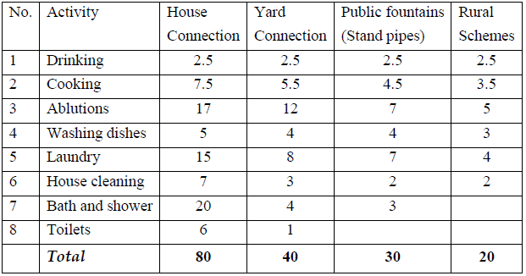
Table 3 Estimate of per capita demand for piped water in l/c/d (1997) for population of less than 30,000(for urban between 2500 and 30000).
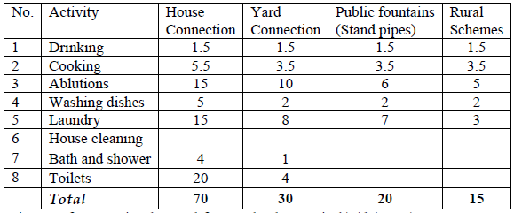

Table 4 Estimate of per capita demand for rural schemes in l/c/d (1997)
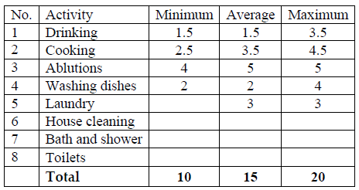

- Industrial Water Demand
The water requirements for this purpose depends up on the type and size of the industry (table
5)
Table 5 Typical values of water use for various industries
Industry Range of flow (*Gal/ ton Product)
-----------------------------------------------------------------------------------------------------
Cannery
Green beans 12000-17000
Peaches & pears 3600-4800
Other fruits & vegetables 960-8400
Chemical
Ammonia 24000-72000
Carbon dioxide 14400-21600
Lactose 144000-192000
Sulfur 1920-2400
Food and beverage
Beer 2400-3840
Bread 480-960
Meat packing 3600-4800
Milk products 2400-4800
Whisky 14400-19200
Pulp and paper
Pulp 60000-190000
Paper 29000-38000
Textile
Bleaching 48000-72000
Dyeing 7200-14400

• 1gal. = 3.7854 lit

1.3 FIREFIGHTING WATER DEMAND (FIRE DEMAND)
Fires generally break in thickly populated localities and in industrial area and cause serious damages of properties and sometime life of people are lost. Fire may take place sue to faulty electric wires by short circuiting, fire catching materials, explosions, bad iterations of criminal people or any other unforeseen happenings. If fires are not properly controlled and extinguish in minimum possible time, they lead to serious damages and may burn the cities.
In cities fire hydrants should be provided on the mains at a distance of 100 to 150m apart. Fire brigade men immediately connect these fire hydrants with their engines & start throwing water at very high rate on the fire.
Fire demand is treated as a function of population and some of the empirical formulae commonly used for calculating demand as follows:
a) John R.Freeman‘s formula:

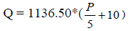
Where Q = Quantity of water required in 1/min.
P = population in thousands
b) Knuckling’s formula

Where Q = Quantity of water required in 1/min.
P = population in thousands

c) National Boarded of Fire Underwriter’s formula (widely used in USA)

Where Q = Quantity of water required in 1/min.
P = population in thousands

Example 1
Calculate the fire demand for a population of 100,000 by using formulae of Freeman, Knuckling and National Board of Fire Under writers.
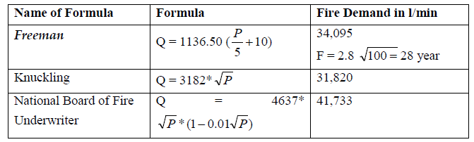
Although the actual amount of water in a year for firefighting is smaller than the rate of use, the Insurance Service Office (USA) uses the formula
Where Q = the required fire flow in gpm (lit/min/3.78)
C = a coefficient related to the type of construction which ranges from a max of 1.5 for wood frame to a minimum of 0.60 for fire resistive construction.
A = total floor area ft² (m²x10.76) excluding the basement of the building
The fire flow calculated from the formula is not to exceed 30,240 lit/min in general, nor 22,680 lit/min for one story construction .The minimum fire flow is not to be less than 1890 lit/min. Additional flow may be required to protect nearby buildings. The total for all purposes for a single fire is not to exceed 45,360 lit/min nor be less than 1990 lit/min.

Assignment
- Write the diffidence between water demand and supply?
- Isn’t the quantity of water demand during the holiday is the same with other demand condition? If no why?

