CHAPTER NINE
9.0 SOLID WASTE MANAGEMENT
9.2 INTRODUCTION TO SOLID WASTE MANAGEMENT
Solid waste is the unwanted or useless solid materials generated from combined residential, industrial and commercial activities in a given area. It may be categorized according to its origin (domestic, industrial, commercial, construction or institutional); according to its contents (organic material, glass, metal, plastic paper etc); or according to hazard potential (toxic, non-toxin, flammable, radioactive, infectious etc). Management of solid waste reduces or eliminates adverse impacts on the environment and human health and supports economic development and improved quality of life. A number of processes are involved in effectively managing waste for a municipality. These include monitoring, collection, transport, processing, recycling and disposal.
9.3 Reduce, Reuse, Recycle
Methods of waste reduction, waste reuse and recycling are the preferred options when managing waste. There are many environmental benefits that can be derived from the use of these methods. They reduce or prevent green house gas emissions, reduce the release of pollutants, conserve resources, save energy and reduce the demand for waste treatment technology and landfill space. Therefore it is advisable that these methods be adopted and incorporated as part of the waste management plan.
Waste reduction and reuse
Waste reduction and reuse of products are both methods of waste prevention. They eliminate the production of waste at the source of usual generation and reduce the demands for large scale treatment and disposal facilities. Methods of waste reduction include manufacturing products with less packaging, encouraging customers to bring their own reusable bags for packaging, encouraging the public to choose reusable products such as cloth napkins and reusable plastic and glass containers, backyard composting and sharing and donating any unwanted items rather than discarding them.
All of the methods of waste prevention mentioned require public participation. In order to get the public onboard, training and educational programmers need to be undertaken to educate the public about their role in the process. Also the government may need to regulate the types and amount of packaging used by manufacturers and make the reuse of shopping bags mandatory.
Recycling
Recycling refers to the removal of items from the waste stream to be used as raw materials in the manufacture of new products. Thus from this definition recycling occurs in three phases: first the waste is sorted and recyclables collected the recyclables are used to create raw materials. These raw materials are then used in the production of new products. The sorting of recyclables may be done at the source (i.e. within the household or office) for selective collection by the municipality or to be dropped off by the waste producer at a recycling centers. The pre-sorting at the source requires public participation which may not be forthcoming if there are no benefits to be derived. Also a system of selective collection by the government can be costly. It would require more frequent circulation of trucks within a neighbor hood or the importation of more vehicles to facilitate the collection. Another option is to mix the recyclables with the general waste stream for collection and then sorting and recovery of the recyclable materials can be performed by the municipality at a suitable site. The sorting by the municipality has the advantage of eliminating the dependence on the public and ensuring that the recycling does occur. The disadvantage however, is that the value of the recyclable materials is reduced since being mixed in and compacted with other garbage can have adverse effects on the quality of the recyclable material.
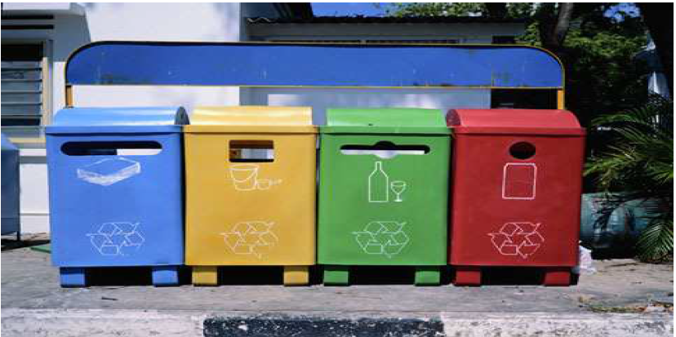
Figure7.1. Colour coded recycling bins for waste separation at the source of production

9.4 Waste Collection
Waste from our homes is generally collected by our local authorities through regular waste collection, or by special collections for recycling. Within hot climates such as that of the Caribbean the waste should be collected at least twice a week to control fly breeding, and the harboring of other pests in the community. Other factors to consider when deciding on frequency of collection are the odours caused by decomposition and the accumulated quantities. Descriptions of the main types of collection systems are given in the table below.
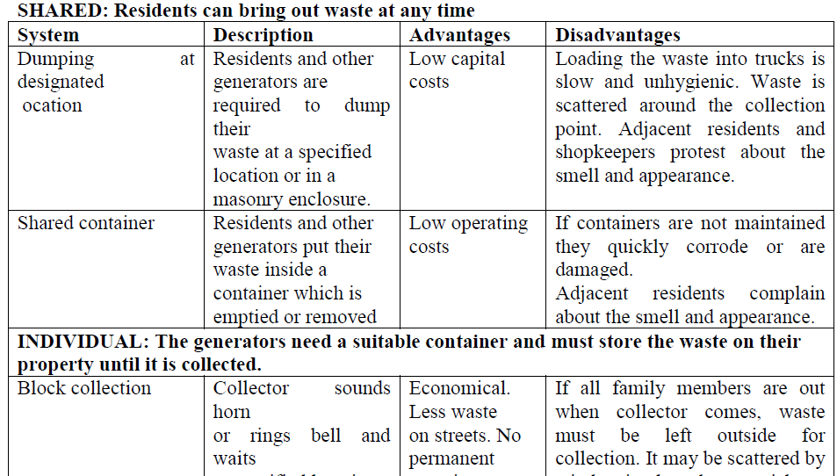
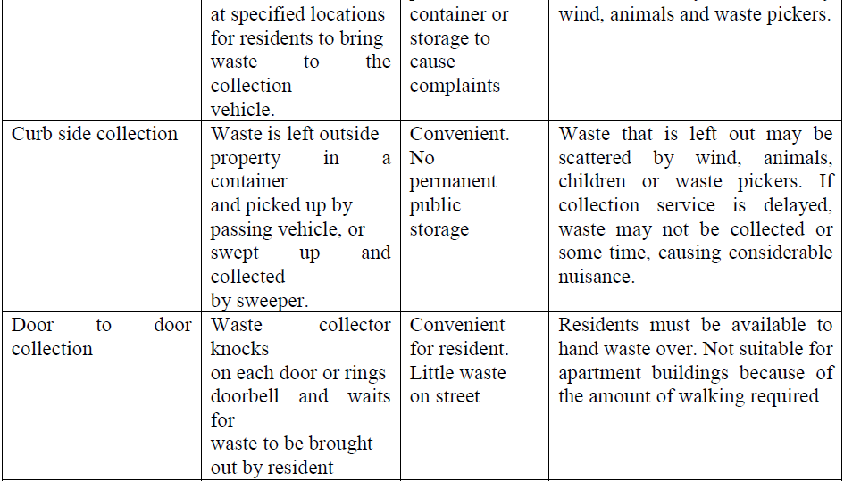
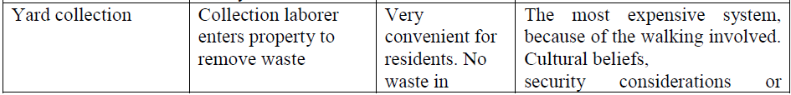
Table 7.1 Descriptions of the main collection systems.
9.5 Treatment & Disposal
Waste treatment techniques seek to transform the waste into a form that is more manageable, reduce the volume or reduce the toxicity of the waste thus making the waste easier to dispose of. Treatment methods are selected based on the composition, quantity, and form of the waste material. Some waste treatment methods being used today include subjecting the waste to extremely high temperatures, dumping on land or land filling and use of biological processes to treat the waste. It should be noted that treatment and disposal options are chosen as a last resort to the previously mentioned management strategies reducing, reusing and recycling of waste (figure 2).
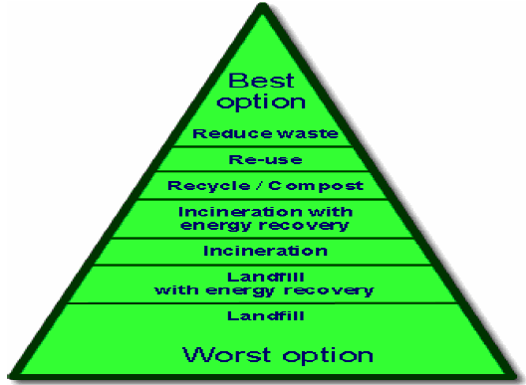
Figure7. 2. Solid waste management hierarchy
9.6 Thermal treatment
This refers to processes that involve the use of heat to treat waste. Listed below are descriptions of some commonly utilized thermal treatment processes.
Incineration
Incineration is the most common thermal treatment process. This is the combustion of waste in the presence of oxygen. After incineration, the wastes are converted to carbon dioxide, water vapour and ash. This method may be used as a means of recovering energy to be used in heating or the supply of electricity. In addition to supplying energy incineration technologies have the advantage of reducing the volume of the waste, rendering it harmless, reducing transportation costs and reducing the production of the green house gas methane.

