CHAPTER FIVE
5.0 INTRODUCTION TO WATER TRETMENT
Water available in various sources contains various types of impurities and cannot be directly used by the public for various purposes, before removing the impurities. Therefore, removing these impurities up to certain extent so that it may not be harmful to the public health is necessary. The process of removing the impurities from water is called water treatment and the treated water is called wholesome water.
The degree and methods of treatment depend upon nature of the source, quality of the source and purpose for which the water is supplied.
The surface sources generally contains large amount of impurities therefore they requires sedimentation, filtration and chlorination as treatment. If the water contains algae or other microorganisms, pre-chlorination has to be done. Tastes and odours, dissolved gases like CO2, H2S are removed by aeration. During the flood season, the turbidity of the surface water may be high and flocculation may become necessary to remove turbidity.
Groundwater which is usually clear may require only disinfection and chemical treatment for the removal of pathogens, iron removal, softening etc. Sometimes ground water contains dissolved gases like hydrogen sulphide (H2S) carbon dioxide (CO2), which gives very bad odour and requires its removal by aeration.
5.1 PRELIMINARY TREATMENT
5.1.1 Pre treatment
High turbidity water which may occur particularly during the rainy season requires pretreatment in the form of sedimentation, storage or roughing filtration to reduce much of the suspended solids. This is an advantage otherwise a very large amount of chemicals may have to be employed for chemical coagulation which can be expensive. Pretreatment provides cheaper treatment. Slow Sand Filters require raw water turbidity below 30NTU. High turbidity waters require pre-treatment before slow sand filtration.
There is, however, a form treatment known as dynamic filtraation (although it is not very popular) which involves diverting a relatively large volume of water out of which a small percentage (10%) settles through the slow sand filter while the remaining is used to wash off the solids deposited on the sand top as the water moves horizontally via the sand bed.
- Types of preliminary treatment

- _ Intakes
- _ Screens
- _ Plain sedimentation
- _ Storage
- _ Roughing filter
- _ Infiltration galleries
- _ Silt trap

- Intakes
Proper design of the intake structure is one way of achieving preliminary treatment. The intakes should be located in such a way that rolling debris at the bottom is prevented from entering via the intake. Bar Screens are provided to screen out larger size floating and suspended materials. Sometimes two filters are provided successively for coarse and fine screening.
A floating intake ensures intake from the top and relatively clean layer. Multiple level intakes (low level intake in the dry season and to avoid algae at the top and high level intake in the wet season to avoid suspended solids at the bottom) are provided in lakes and reservoirs.
Types of intake

River
Chanel
Reservoir
Lake

Example 1 Design a bell mouth intake for a city of 80,000 persons drawing water from a channel which runs for 10hrs in a day with depth of 1.8m. Also calculate the head loss in intake conduit if the treatment plant is ½ km away .draw a net sketch of the canal intake assume average consumption per person =150l/d. Assume the velocity through the screen & the bell mouth to be less than 16cm/s & 32cm/s respectively.
- Screens
Screening of water which is one form of pre-treatment is done by passing the water through closely spaced bars, gratings or perforated plates. Screening does not change the chemical or bacteriological quality of the water. It serves to retain the coarse material and suspended matter that are larger than the screen openings.
Purposes: -
(i) Removal of floating and suspended matter which clogs pipes, damages pumps, etc.
(ii) Clarification by removal of suspended matter to lighten the load on subsequent treatment processes. Bar screen spacing is typically between 0.5 and 5cm. Angle of inclination of bars is 60- 75⁰ if screening are very small and 30-45⁰ if larger amount is retained over the screen bar. Velocity of flow should be low towards the screen bar (0.1-0.2m/sec). it may be increased to 0.3-0.5 after the screen to prevent settling there. Between the openings the velocity should be restricted to up to 0.7m/sec to avoid forcing through the suspended solids. If regular cleaning is done an allowance for loss of heads of up to 0.1 to 0.2m is made. However to allow for delay and mechanical failures a loss of head allowance between 0.5 to 1.0m is made.
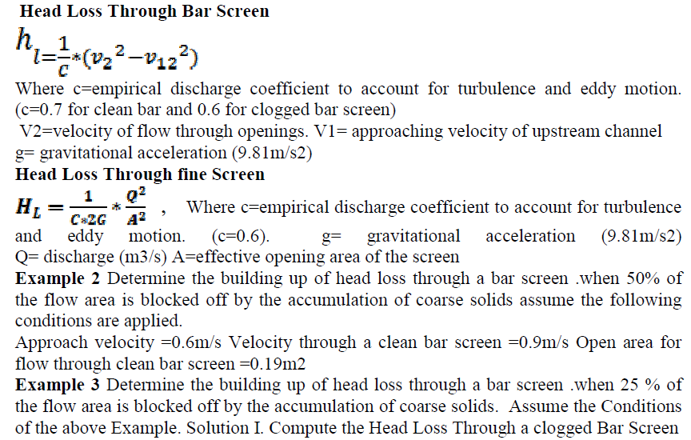
5.1.2. Plain Sedimentation
Plain sedimentation is a form of pre-treatment that provides a low velocity of flow through a tank preferably excavated in the ground. The purpose is to settle some solids because of this low velocity by gravity sedimentation. Plain sedimentation is favorable in a tropical climate due to the high load of suspended solids to be settled as a result of erosion by tropical high intensity rains, and also, because of the high temperature in the tropics and the associated low viscosity water in the sedimentation tank that provides less viscous resistance for the settlement of solids.
Since plain sedimentation offers limited detention period for the water its effectiveness is restricted in that sense. Significant reduction in solids is obtained for high turbidity waters, and, the feasibility of reducing the turbidity below 30 NTU - if the tank is provided as a pre-treatment unit for a slow sand filter -must be tested through a settling column test. The settlement of solids is dependent on the nature of the suspension. The table below shows the typical values used in practice for the parameters listed.
Table 7: Design parameter for plain sedimentation
The tank may be rectangular, or, to minimize the need for thicker walls trapezoidal shape (which also facilitates settlement to the bottom) tank can be used. Baffle walls are provided at the inlet to dissipate the kinetic energy of the incoming water and provide quiescent settlement. Less importantly though, they are also provided at the outlet to prevent turbulence in the outlet zone.
For trapezoidal channels a thin Ferro-cement wall lining may be adequate. For waters laden with algae the outlet weir are arranged behind a deflecting baffle. At least two settling baffles are provided each designed for 3/4 of the design flow so that during cleaning of one of the tanks, the other takes the full load and will be overloaded by 33% only. It is possible though to design both tanks to handle the full flow without being overloaded. This is, however, an over design as cleaning is needed for a short while and usually after a long period of operation. Manual cleaning can be done. Fixed nozzles and fire hoses can be used to help with cleaning.

The table below indicates the turbidity removal to be anticipated with respect to varying raw water quality and provided with different detention times (Experiment done in Iraq.)
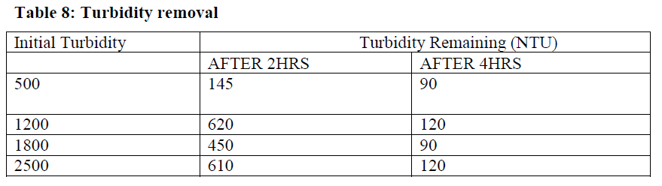

Tube Settlers
Inclined plates or tubes are fixed in the tank and water is left to pass through this tubes/plates. The surface area of settlement increases and hence the efficiency of settlement. Tube settlers are employed for upgrading the performance of existing tanks and for reducing the size of new tanks. Best angle of inclination is 40⁰.
5.1.3. Storage
Storage is very effective for high turbidity water. The detention time is greater than for plain sedimentation tanks. For extremely turbid waters annual average turbidity > 1000NTU storage provides the best pre-treatment. Advantages:
- Natural sedimentation
- Attenuation of sudden water quality fluctuation.
- Reduction in the number of pathogenic bacteria
- Improved reliability of supply
- Excessively turbid water can be diverted away.
The storage can be in the form of ponds or lagoons which are natural or excavated in the ground or in the form of man-made earth dams. Capacity should make allowance for seepage and evaporation. The bottom of the pond should be covered with clay or other impermeable material. In order to minimize pollution from outside, access to outsiders should be restricted. Fences can be provided with vegetation (bush). This also acts as a wind breaker. Example of treatment with Ponds (England)
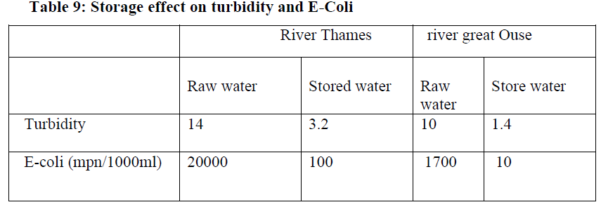
The above table shows how storage can be effective in reducing turbidity and suspended solids significantly. The costs of providing storage can be very high, however. Depths of ponds can be as high as 15m.
5.1.4. Roughing Filtration
Roughing filtration allows a deep penetration of the filter layer and holds a large silt storage capacity.
Diameters:
Rapid sand 0.4 - 0.7mm
Slow sand filters 0.15-0.35mm
Roughing filters >2.0mm diam.
Rate of filtration is variable depending on the nature of the media, turbidity of the incoming water, etc. Roughing filters if designed well, can serve as effective pretreatment units prior to slow sand filtration for water with raw water turbidity of 20 to 150 NTU. For high turbidity Waters, it may be difficult to clarify to below 30NTU without sedimentation or other pre-treatment such as storage.
Apart from horizontal and vertical roughing filters, there is a form of roughing filtration known as up-flow down flow filtration that involves an up flow roughing filter together with chemical coagulation and flocculation followed by a down flow rapid filtration. This arrangement can result in reduction of cost almost by 50% compared with the conventional designs involving coagulation, sedimentation and filtration. Roughing filters are capable of reducing turbidity to as low as 5NTU from a raw water turbidity of 150NTU.
Bacterial removal is between 60 and 90% without using any disinfectant. The following reasons are given to advocate the use of roughing filters in developing countries:
a. In some of these regions the use of flocculent seems to be a very delicate matter due to inadequate handling of flocculation installations or inadequate supply. Roughing filters do not require the addition of chemicals to reduce solids to the extent necessary for slow sand filters downstream.
b. They ensure long filter runs owing to their excellent solid storage capacity. Filter runs can be extended to periods close to one year for raw water with periodically high solids load, especially when long horizontal filter layers are applied. They do not require a very high construction (sometimes simple ditches as done in some refugee camps in Sudan can be adequate.)
c. They do not require high skills to build them. The filters can be filled with local materials screened on site.
d. Because of low head no substantial head is required. The energy requirement is therefore reduced. The water is beneath the gravel top hence contamination by man, animal, micro- organisms and algae growths are avoided largely.
The efficiency of solids removal in roughing filters depends on the character (chemical, electrostatic, etc.) of the particles to be removed, the fluid property (dissolved matters such as Pumice and Ca++, etc.), the process related characters such as the media size, flow rate, head, layer thickness, layer configuration, filtration rate, etc.

5.2 Coagulation (Coagulation Aided with Sedimentation)
The hydraulic settling values of small size particles in water are very small and therefore, they require longer time to settle in plain sedimentation tanks. For example, a slit particle of size 0.05mm will require about 11hrs to settle down through a depth of 3m and clay particle of size 0.002mm will require about 4 day‟s time to settle the same height of 3m at normal temperature of about 25ºc. Moreover, water may be containing colloidal impurities which are even finer than 0.0001mm and which also carry electrical charge on them. Due to electrical charge they remain continuously in motion and never settle down by gravity in water. Therefore, when water is turbid due to presence of such fine size and colloidal impurities, plain sedimentation is of no use.
For dealing water with such impurities a chemical process was evolved. This process removes all these impurities within reasonable period of 2 – 3hrs. This chemical process is called coagulation and the chemical used in the process is called coagulant. The objective of coagulation is to unit several colloidal particles together to form bigger sized settable flocs which may settle down in the tank.
The principle of coagulation can be explained from the following two conditions:
1. Floc formation
When coagulants (chemicals) are dissolved in water and thoroughly mixed with it, they produce a think gelatinous precipitate. This precipitate is known as floc and this floc has got the property of arresting suspended impurities in water during downward travel towards the bottom of tank. The gelatinous precipitate has therefore, the property of removing fine and colloidal particles quickly.
2. Electric charges
Most particles dissolved in water have a negative charge, so they tend to repel each other. As a result, they stay dispersed and dissolved or colloidal in the water.
The purpose of most coagulant chemicals is to neutralize the negative charges on the turbidity particles to prevent those particles from repelling each other. The amount of coagulant which should be added to the water will depend on the zeta potential, a measurement of the magnitude of electrical charge surrounding the colloidal particles. You can think of the zeta potential as the amount of repulsive force which keeps the particles in the water. If the zeta potential is large, then more coagulants will be needed.
Coagulants tend to be positively charged. Due to their positive charge, they are attracted to the negative particles in the water, as shown below.
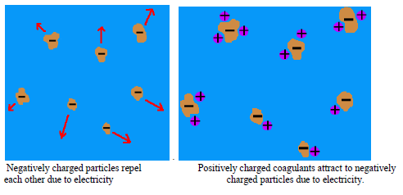
The combination of positive and negative charge results in a neutral. As a result, the particles no longer repel each other.
The next force which will affect the particles is known as van der Waal's forces. Van der Waal's forces refer to the tendency of particles in nature to attract each other weakly if they have no charge.
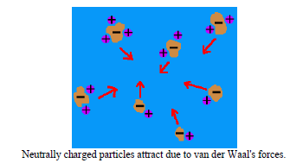
Once the particles in water are not repelling each other, van der Waal's forces make the particles drift toward each other and join together into a group. When enough particles have joined together, they become floc and will settle out of the water.
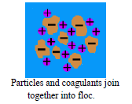
Factors Affecting Coagulation

1. Type of coagulant
2. Dose of coagulant
3. Characteristic of water
1. Type and quantity of suspended matter
2. Temperature of water
3. pH of water
4. Time and method of mixing

Common Coagulants
Coagulant chemicals come in two main types - primary coagulants and coagulant aids. Primary coagulants neutralize the electrical charges of particles in the water which causes the particles to clump together. Coagulant aids add density to slow-settling flocs and add toughness to the flocs so that they will not break up during the mixing and settling processes.
In water treatment plants, the following are the coagulants most commonly used:
i. Aluminum sulfate [Al 2(SO4) 3.18H2O].

It is also called Alum. It is the most widely used chemical coagulant in water purification work. Alum reacts with water only in the presence of alkalinity. If natural alkalinity is not present, lime may be added to develop alkalinity. It reacts with alkaline water to form aluminum hydroxide (floc), calcium sulphate and carbon dioxide. Due to the formation of calcium sulphate, hardness and corrosiveness of water is slightly increased.
Chemical Reaction Taking Place
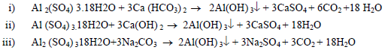
The chemical is found to be most effective between pH ranges of 6.5 to 8.5. Its dose may vary from 5 to 30mg/lit, for normal water usually dose being 14 mg/l. actually, dose of coagulant depends on various factors such as turbidity, color, taste, pH value, temperature etc.
Due to the following reason, Alum is the most widely used chemical coagulant.
1. It is very cheap
2. It removes taste and color in addition to turbidity
3. It is very efficient
4. Flocs formed are more stable and heavy
5. It is not harmful to health
6. It is simple in working, doesn’t require skilled supervision for dosing

ii. Sodium aluminates (Na2Al2O4)
In the process of coagulation, it can remove carbonate and non-carbonate hardness. It reacts with calcium and magnesium salts to form flocculent aluminates of these elements.
Chemical reactions:
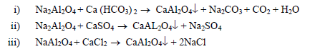
The pH should be within the range of 6 and 8.5.
iii. Chlorinated Copperas
Combination of Ferric sulphate and Ferric chloride
When solution of Ferrous Sulphate is mixed with chlorine, both Ferric sulphate and Ferric chloride are produced.
6FeSO4.7H2O + 3Cl2 2Fe3 (SO4)2 + 2FeCl3 + 42H2O
Ferric sulphate and Ferric chloride each is an effective floc and so also their combination.
Both Ferric sulphate and Ferric chloride can be used independently with lime as a coagulant
If alkalinity is insufficient, lime is added.
Chemical reaction taking place
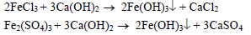
Ferric chloride effective pH range 3.5 – 6.5 or above 8.5 and Ferric sulphate is effective with pH range of 4 – 7 or above 9.
iv. Polyelectrolytes

They are special types of polymers. They may be anionic, cationic, and non-ionic depending upon the charge they carry. Out of these only cationic polyelectrolytes can be used independently.
Example 3:
Find out the quantity of alum required to treat 18million liters of water per day. The dosage of alum is 14mg/lit. Also work out the amount of CO2 released per liter of treated water.
Feeding of coagulant
In order to feed chemicals to the water regularly and accurately, some type of feeding equipment must be used.
Coagulants may be put in raw water either in powder form or in solution form.
- Dry-feed Type
Dry powder of coagulant is filled in the conical hopper. The hoppers are fitted with agitating plates which prevent the chemical from being stabilized. Agitating plates are used to prevent arching of chemicals.

2. Wet feeding type
First, solution of required strength of coagulant is prepared. The solution is filled in the tank and allowed to mix in the mixing channel in required proportion to the quantity of water. It can be easily controlled with automatic devices.
Mixing devices
The process of floc formation greatly depends upon the effective mixing (rapid mixing) of coagulant with the raw water.
Rapid mixing of the mixture of coagulant and raw water is used to:
- Disperse chemicals uniformly throughout the mixing basin
- Allow adequate contact between the coagulant and particles
- Formation of microflocs

The mixing is done by mixing device.
1. Hydraulic jump - flume with considerable slope is developed
2. Pump method - centrifugal pump is used to raise raw water
3. Compressed air method – compressed air is diffused from bottom of the mixing tank
4. Mixing channels
5. Mixing basin with baffle wall
6. Mechanical mixing basins

5.3 Filtration
The effluent obtained after coagulation does not satisfy the drinking water standard and is not safe. So it requires further treatments. Filtration is one of the water purification process in which water is allowed to pass through a porous medium to remove remaining flocs or suspended solids from the previous treatment processes.
Filtration process assist significantly by reducing the load on the disinfections process, increasing disinfection efficiency.
Theory of Filtration
Filtration consists of passing water through a thick layer of sand. During the passage of water through sand, the following effects take place.
i) Suspended matter and colloidal matter are removed
ii) Chemical characteristic of water get changed

iii) Number of bacteria considerably reduced.
These phenomena can be explained on the basis of the following mechanisms of filtration.
1. Mechanical straining – Mechanical straining of suspended particles in the sand pores.
2. Sedimentation and Adsorption
- The interstices between the sand grains act as sedimentation basins in which the suspended particles smaller than the voids in the filter-bed settle upon the sides of the sand grains.
- The particles stick on the grains because of the physical attraction between the two particles of matter and the presence of the gelatinous coating formed on the sand grains by the previously deposited bacteria and colloidal matter.
3. Electrolytic action

Due to the friction between medium and suspended solids, certain amount of dissolved and suspended matter is ionized. Suspended matter in water is ionized, carries charge of one polarity and the particles of sand in filter which are also ionized, possess electrical charges of opposite polarity. These neutralize each other; change the chemical character of water.
4. Biological Action

The growth and life process of the living cells, biological metabolism. The surface layer gets coated with a film in which the bacterial activities are the highest and which feed on the organic impurities. The bacteria convert organic impurities by a complex biochemical action into simple, harmless compounds – purification of water.

5.4 Disinfection
The process of killing harmful bacteria from water and making it safe to the consumers is said to be disinfection. The materials which are used for disinfection of water are called the disinfectants.
Requirements of Good Disinfectant
1) Destroy bacteria/pathogens within a practicable period of time, over an expected range of water temperature.
2) Effective at variable compositions, concentration and conditions of water treated.
3) Neither toxic to humans and domestic animals nor unpalatable or otherwise objectionable in required concentration.
4) Not change water properties
5) Have residual in a sufficient concentration to provide protection against recontamination
6) Can be determined easily, quickly, and preferably automatically.
7) Dispensable at reasonable cost
8) Safe and easy to store, transport, handle and supply
9) Not form toxic by-products due to their reactions with any naturally occurring materials in water.

Methods of Disinfection
The disinfection of water can be done by one of the following methods:
a) Boiling of water
b) Ultra–Violate rays
c) Iodine and bromine
d) Ozone O3
e) Excess lime
f) Potassium permanganate [KMnO4]
g) Chlorine

The most common method of disinfection is the use of chlorine i.e. chlorination. The various chlorine compounds which are available in the market and used as disinfectants are:
1. Calcium hypo chlorite [Ca (OCl) 2] – power from
2. Sodium hypo chlorite [NaOCl] –liquid from
3. Free chlorine Cl2- Gaseous form

Chlorination Chemistry
When chlorine is added to water, a variety of chemical processes take place. The chlorine reacts with compounds in the water and with the water itself. Some of the results of these reactions (known as the chlorine residual) are able to kill microorganisms in the water. In the following sections, we will show the chemical reactions which occur when chlorine is added to water.

Chlorine Demand
When chlorine enters water, it immediately begins to react with compounds found in the water. The chlorine will react with organic compounds and form trihalomethanes. It will also react with reducing agents such as hydrogen sulfide, ferrous ions, manganous ions, and nitrite ions.
Let's consider one example, in which chlorine reacts with hydrogen sulfide in water. Two different reactions can occur:
Hydrogen Sulfide + Chlorine + Oxygen Ion Elemental Sulfur + Water + Chloride Ions
H2S + Cl2 + O2- S + H2O + 2Cl-
Hydrogen Sulfide + Chlorine + Water Sulfuric Acid + Hydrochloric Acid
H2S + 4Cl2 + 4H2O H2SO4 + 8HCl
In the first reaction, hydrogen sulfide reacts with chlorine and oxygen to create elemental sulfur, water, and chloride ions. The elemental sulfur precipitates out of the water and can cause odor problems. In the second reaction, hydrogen sulfide reacts with chlorine and water to create sulfuric acid and hydrochloric acid.
Each of these reactions uses up the chlorine in the water, producing chloride ions or hydrochloric acid which have no disinfecting properties. The total amount of chlorine which is used up in reactions with compounds in the water is known as the chlorine demand. A sufficient quantity of chlorine must be added to the water so that, after the chlorine demand is met, there is still some chlorine left to kill microorganisms in the water.

Reactions of Chlorine Gas with Water
At the same time that chlorine is being used up by compounds in the water, some of the chlorine reacts with the water itself. The reaction depends on the type of chlorine added to the water as well as on the pH of the water itself.
Chlorine gas is compressed into a liquid and stored in metal cylinders. The gas is difficult to handle since it is toxic, heavy, corrosive, and an irritant. At high concentrations, chlorine gas can even be fatal.
When chlorine gas enters the water, the following reaction occurs:
Chlorine + Water Hypochlorous Acid + Hydrochloric Acid
Cl2 + H2O HOCl + HCl
The chlorine reacts with water and breaks down into hypochlorous acid and hydrochloric acid. Hypochlorous acid may further break down, depending on pH:
Hypochlorous Acid ↔ Hydrogen Ion + Hypochlorite Ion
HOCl ↔ H+ + OCl-
The concentration of hypochlorous acid and hypochlorite ions in chlorinated water will depend on the water's pH. A higher pH facilitates the formation of more hypochlorite ions and results

in less hypochlorous acid in the water. This is an important reaction to understand because hypochlorous acid is the most effective form of free chlorine residual, meaning that it is chlorine available to kill microorganisms in the water. Hypochlorite ions are much less efficient disinfectants. So disinfection is more efficient at a low pH (with large quantities of hypochlorous acid in the water) than at a high pH (with large quantities of hypochlorite ions in the water.)
Hypochlorites
Instead of using chlorine gas, some plants apply chlorine to water as a hypochlorite, also known as a bleach. Hypochlorites are less pure than chlorine gas, which means that they are also less dangerous. However, they have the major disadvantage that they decompose in strength over time while in storage. Temperature, light, and physical energy can all break down hypochlorites before they are able to react with pathogens in water.
There are three types of hypochlorites - sodium hypochlorite, calcium hypochlorite, and commercial bleach:
Hypochlorites and bleaches work in the same general manner as chlorine gas. They react with water and form the disinfectant hypochlorous acid. The reactions of sodium hypochlorite and calcium hypochlorite with water are shown below:
Calcium hypochlorite + Water Hypochlorous Acid + Calcium Hydroxide
Ca(OCl)2 + 2H2O 2HOCl + Ca(OH)2
Sodium hypochlorite + Water Hypochlorous Acid + Sodium Hydroxide
NaOCl + H2O HOCl + NaOH
Chloramines
Some plants use chloramines rather than hypochlorous acid to disinfect the water. To produce chloramines, first chlorine gas or hypochlorite is added to the water to produce hypochlorous acid.
Then ammonia is added to the water to react with the hypochlorous acid and produce a chloramine. Three types of chloramines can be formed in water - monochloramine, dichloramine, and trichloramine. Monochloramine is formed from the reaction of hypochlorous acid with ammonia:
Ammonia + Hypochlorous Acid Monochloramine + Water
NH3 + HOCl NH2Cl + H2O
Monochloramine may then react with more hypochlorous acid to form a dichloramine:
Monochloramine + Hypochlorous Acid Dichloramine + Water
NH2Cl + HOCl NHCl2 + H2O
Finally, the dichloramine may react with hypochlorous acid to form a trichloramine:
Dichloramine + Hypochlorous Acid Trichloramine + Water
NHCl2 + HOCl NCl3 + H2O
The number of these reactions which will take place in any given situation depends on the pH of the water. In most cases, both monochloramines and dichloramines are formed. Monochloramines and dichloramines can both be used as a disinfecting agent, called combined chlorine residual because the chlorine is combined with nitrogen. This is in contrast to the free chlorine residual of hypochlorous acid which is used in other types of chlorination.
Chloramines are weaker than chlorine, but are more stable, so they are often used as the disinfectant in the distribution lines of water treatment systems. Despite their stability, chloramines can be broken down by bacteria, heat, and light. Chloramines are effective at killing bacteria and will also kill some protozoans, but they are very ineffective at killing viruses.

Dosage of Chlorine
(A) Plain Chlorination
Plain chlorination is the process of addition of chlorine only when the surface water with no other treatment is required. The water of lakes and springs is pure and can be used after plain chlorination. A rate of 0.8mg/lit/hour at 15N/cm2 pressure is the normal dosage so as to maintain in residual chlorine of 0.2 mg/lit.
(B) Super Chlorination
Super chlorination is defined as administration of a dose considerably in excess of that necessary for the adequate bacterial purification of water.
About 10 to 15 mg/lit is applied with a contact time of 10 to 30 minutes under the circumstances such as during epidemic breakout water is to be dechlorinated before supply to the distribution system.
(C) Brake Point Chlorination
The graph below shows what happens when chlorine (either chlorine gas or a hypochlorite) is added to water. First (between points 1 and 2), the water reacts with reducing compounds in the water, such as hydrogen sulfide. These compounds use up the chlorine, producing no chlorine residual.
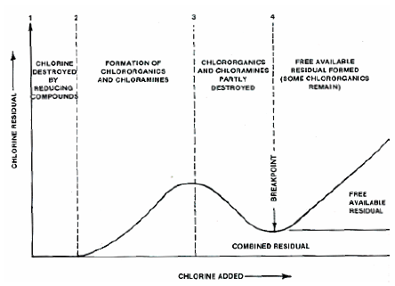

Fig 13 Break point chlorination
Next, between points 2 and 3, the chlorine reacts with organics and ammonia which is naturally found in the water. Some combined chlorine residual is formed - chloramines. Note that if chloramines were to be used as the disinfecting agent, more ammonia would be added to the water to react with the chlorine. The process would be stopped at point 3.
In contrast, if hypochlorous acid is to be used as the chlorine residual, then chlorine will be added past point 3. Between points 3 and 4, the chlorine will break down most of the chloramines in the water, actually lowering the chlorine residual.
Finally, the water reaches the breakpoint, shown at point 4.
The breakpoint is the point at which the chlorine demand has been totally satisfied - the chlorine has reacted with all reducing agents, organics, and ammonia in the water. When more chlorine is added past the breakpoint, the chlorine reacts with water and forms hypochlorous acid in direct proportion to the amount of chlorine added. This process, known as breakpoint chlorination, is the most common form of chlorination, in which enough chlorine is added to the water to bring it past the breakpoint and to create some free chlorine residual.
(D) De-chlorination
Removal of excess chlorine resulting from super chlorination in part or completely is called „De-chlorination‟. Excess chlorine in water gives pungent smell and corrodes the pipe lines. Hence excess chlorine is to be removed before supply.
Physical methods like aeration, heating and absorption on charcoal may be adopted. Chemical methods like sulphur dioxide (SO2), Sodium Bi-sulphate (NaHSO3), Sodium Thiosulphate (Na2S2O8) are used.
Points of Chlorination
Chlorine applied at various stages of treatment and distribution accordingly they are known as pre, post and re-chlorination.
a) Pre-Chlorination
Chlorine applied prior to the sedimentation and filtration process is known as Pre-chlorination. This is practiced when the water is heavily polluted and to remove taste, odour, colour and growth of algae on treatment units. Pre-chlorination improves coagulation and post chlorination dosage may be reduced.
b) Post Chlorination
When the chlorine is added in the water after all the treatment is known as Post-chlorination. After chlorination water is sent for distribution to the consumers.
c) Re-Chlorination
In long distribution systems, chlorine residual may fall tendering the water unsafe. Application of excess chlorine to compensate for this may lead to unpleasant smell to consumers at the points nearer to treatment point in such cases chlorine is applied again that is re-chlorinated at intermediate points generally at service reservoirs and booster pumping stations.

5.5 MISCELLANEOUS WATER TREATMENT
5.5.1 Removal of Taste and Odor Problem
The sense of odour is closely related to that of taste. In fact it is normally correct to suggest that most 'tastes' in water are really a sensation of smell. There are only four sensation of taste (1) sour, sweet, salty and bitter-all other sensations are of odour although not necessarily noticed until the water is in the mouth (2). some tastes in water are unrelated to odour and these include the brackishness associated with relatively high concentrations of salts such as sodium chloride or magnesium sulphate. Iron and manganese in water often produce an astringent taste.
Chalk derived waters are frequently described as possessing a 'sharpness' _ possibly due to Co2 or bicarbonate _while surface waters deficient in dissolved oxygen are often 'flat' to the taste.
Consumers identify and accept water as being pure as a result of its lack of colour, its clarity and its lack of taste and odour. Hence it is not only necessary that water is pure but that it also appears to be pure. some substances, such as many inorganic salts do not create sensations of odour or taste until present in a concentration of several hundreds or even thousands of mg/1. Others such as commercial grade parathion (0.003 mg/1) and sodium fluoride (2,4 mg/1) become noticeable at much lower concentrations. People also vary in their sensitivity to odour and taste and some people are perhaps as much as eleven times as sensitive as others. In addition many causes of odour and taste in water possess additive, synergistic or antagonistic effect, so that the mixing of two sources of water, each possessing only a limited odour can result in combined water with a pronounced odour problem.
Conversely, mixing odoriferous water can produce a non-offensive supply.
5.5.1.1. Causes of Odor and Taste
Concentrations of inorganic salts (brackishness)
- Hydrogen sulphide
- Contact with painted surfaces
- Industrial discharges _ pesticides, phenols etc
- Metabolites of actinomycete, algae etc
- Dead and decaying organic material including sewage and algae
- Chlorination
Some of these may be prevented by various means while others must be cured. Hydrogen
sulphide is commonly found in ground waters from deep wells.
Formation of H2s on other water supplies should be prevented by maintaining the water always in an aerobic condition. Chlorination should be carefully controlled to prevent excessive odor and taste in the treated water.

5.5.1.2. Prevention of odours and tastes from microorganisms
Bacteria - Some bacteria reduce sulphate to sulphide (H2S) and these are controlled by aeration and chlorination. Actinomycete (mold-like bacteria) - grow frequently in mains as a slime on the inside of the pipes. They may be controlled by treating reservoirs with copper sulphate or by ensuring there is residual chlorine throughout the mains, or by biological control employing Bacillus cereus to reduce the obnoxious metabolites produced.

Iron bacteria _ grow in water containing appreciable concentrations of iron and in which the dose is limited. They produce objectionable odours and tastes as well as leading to the precipitation of iron. The remedies are removal of iron, chlorination or dosing with copper sulphate.
Plankton (algae, protozoa) _ these either produce taste or odour as a result of normal metabolic activity or as a result of death and decay. Growth may be controlled by limiting nutrients, desertification of reservoir, mechanical removal of plants, and chemical control.
In addition the levels of water containing the troublesome microorganisms may be avoided by varying the level of the water intake. Chemical control is nearly invariably by the addition of small quantities of copper sulphate.

5.5.1.3. Recommended method to remove test and odour problem
1. Aeration this is of limited value, particularly with the only slightly volatile odors resulting from the decomposition of vegetation. However, concentrations of odoriferous metabolites emanating from living microorganisms can be decreased, thus reducing the amount of activated carbon required at a later stage.
2. Chlorine Marginal chlorination is not sufficient to remove odoriferous compounds and also may add a noticeable smell of chlorine. In the presence of phenols a pronounced smell of chlorinated phenols will become apparent. Super chlorination with more than a breakpoint dosage will destroy most malodorous compounds. Ammonia/chlorine treatment can be useful in preventing chlorophenolic, odours.
3. Ozone usually deals effectively with odors that are only accentuated by
chlorine.Modest doses of 1 to 2 mg/1 will completely destroy phenols at any likely PH value. Ozone reduces H2s odors and tastes and also the odors from decaying vegetable matter. Algae must be removed prior to the addition of ozone. Partial breakdown by the addition of zone of previously non-biodegradable organic material can result in the production of soluble substrate to encourage growth of obnoxious microorganisms in the distribution system.
4. Hydrogen peroxide~ this is occasionally used for odor control. It works by releasing 'nascent' oxygen but is generally too costly.
5. Chlorine Dioxide Cl02 is particularly effective at removing phenolic odors from water.
It does not react with ammonia and hence its treatment strength is not dissipated. It is most effective when mixed with an excess of chlorine.
6. Potassium Permanganate It is one of the most effective chemical reagents for odour taste control. It is normally applied as a solution and as such is easy to control. In the USA it is widely used and is most effective between PH8.o and PH8.3 (3).
The benzene rings of both phenol and aniline are broken by permanganate. Although it is about three times as costly as activated Carbon it has been claimed to be up to five times as effective.
7. Activated Carbon relies on its large surface area and physical adsorption for its effect and tends to remove larger, rather than smaller organic molecules and non-polar rather than polar compounds. It is used either as powdered activated carbon or as granular activated carbon.
Powdered activated carbon is a fine black powder which is formed into slurry before use and applied either to the raw water, or the mixing basin, on the settling basin or directly before the filters. It is not recoverable. A normal dose might be 2.0 mg/1 to clarified water although it has been applied at rates up to 125 mg/1 to raw water (4).
Granular activated carbon consists of relatively large grains and is held in filter towers through which the water is continually passed. Periodically the carbon beds are cleaned by back washing and when approaching exhaustion the carbon is regenerated in a furnace in carefully regulated oxidizing conditions at about 800oc. At low levels of taste and odour powdered activated carbon is suggested as being more economic than the granular variety but the reverse is true once higher dosages are required (5). the PH of the water to which the carbon is added is of importance, as the adsorptive properties appear to be about four times as great at PH5 to PH6 than between PH9 and PH10.
Chlorine is effectively mremoved by activated carbon treatment and hence post-chlorination is necessary.
5.5..2. Removal of Hydrogen sulphide
The permissible concentration of H2S in water, which are required for domestic purpose, is 0.5 mg/1 of H2S and it is offensive when its concentration greater than 1.0 mg/1. The
odours are less noticeable as the PH rises due to the formation of alkaline sulphides (s" & Hs'), although these sulphides add appreciably to the chlorine demand of the water.
Hydrogen sulphide is removed by aeration and chlorination. Aerators are normally of the natural- draft cascade-type but aeration has only a limited effect and it is necessary to establish a cost balance between aeration and chlorination. Removal by chlorination is highly effective but as much as 10 kg of chlorine may be required to remove 1.0 kg of hydrogen sulphide.
Threshold odour Number
The T.O.N is the number of times a sample must be diluted with odor-free water so that the odor is the least definitely perceptible (1). Since there is little consistency in sensitivity of at least five persons, and preferably of ten, is employed.
The sample is progressively diluted with odor-free water which is normally obtained by passing tap-water through a column of activated carbon. Most tap-waters are suitable for this purpose so long as they do not contain unusual salt concentrations and do not vary appreciably from a normal PH. All glassware used must be clean and odor-free, having been washed with a non-odorous soap, rinsed with an acid cleaning solution and finally rinsed with odor-free water. The testers must be free from colds, be non-smoking, should not use cosmetics, perfumes or shaving lotions and should not have recently eaten a small. All extraneous odors such as from fresh paint must be excluded.
5.5.3. Removal of Iron and Manganese
Before assuming that iron has come from the other source one should check that it is not coming from corroding steel well screens or pipes.
Iron and manganese can be dissolved from sandy soils, laterite, shale, sandstone and other rocks by acid water which contains no dissolved oxygen. (Such water may have _ or have had _ an organic content. Decomposition consumes the oxygen and produces carbon dioxide, which is acidic.) The iron is usually in the form of ferrous bicarbonate and the manganese in the form of manganese oxide or bicarbonate.
These forms are soluble. If the water is now exposed to air so that oxygen can enter into solution and carbon dioxide leaves, the ferrous from is oxidized to ferric, and the manganese to manganese. These latter forms are insoluble and so visible precipitates are formed.
Therefore iron bearing water may be clear when pumped up from a well, but may, on standing, turn brown and turbid. (For this reason samples of groundwater should be analyzed before they have a chance to lose carbon dioxide and gain oxygen). The formation of a precipitate may take longer with manganese, or when the metals are combined in organic compounds. Sometimes the evidence of a manganese problem in a distribution system may take years to appear because the reactions are slow until catalyzed by deposits.
Iron and manganese problems most commonly occur with groundwater, but may also appear in water drawn from the bottom of a stratified reservoir or in acid peat waters. Manganese may occur in significant quantities in river water, sometimes coming from acid mine drainage.
5.5.3.1. Causes of Iron and Manganese
These metals in potable water can cause
a) Colour in the water
b) Staining of plumbing fixtures and clothing (Fe -brown. Mn - black)
c) Astringent, metallic or medicinal taste in the water
d) Growth of iron bacteria (mainly crenothrix and Leptohrix) which feed on iron when the dissolved oxygen content is low and form slimes which clog well screens and pipes and water meters.
They also produce tastes and odors in the water. Manganese bacteria may produce long black streamers of slime which emerge from consumers' taps. When the water contains sulphate, sulphate reducing bacteria may work together to produce black deposits of iron sulphate and H2S in dead ends. e) Brown stains on cooked vegetables and discoloured etc.

Assignment

1. List out the requirements of good disinfectant.
2. What do you understand by break point chlorination?

