CHAPTER TWO

THEORY OF THE FIRM
Chapter objectives: After reading this chapter you must be able to;
- Know managerial theory of the firm
- Know principal – agent theory of the firm
- Pursuit solution to moral hazards
- Know transaction cost theory of the firm
2.1. The Neoclassical Theory of the firm
It is also called Microeconomic theory of the firm. According to neo classical vision, the firm is abstraction, an idealized form of business, whose existence is solely explained by the purely economic motive of generating a profit (i.e. the firm is taken here as purely profit maximizing economic agent). Behavior of a firm in pursuit of profit maximization can be analyzed in terms of:
  - the quantities of inputs it utilizes
  - production techniques it employs
  - the quantity of outputs it produces, and
  - the prices it charges
The firm’s legal or organizational characteristics are insignificant. The only objective guiding its operation is the desire to maximize profit /minimize costs) when MR=MC.
Criticism of neoclassical theory of the firm
1. Firms may not aim at profit maximization by equating MR and MC; instead the right price might be based on recovering full cost (including a conventional allowance for profit).
2. Imperfect information, and thus uncertainty, is not taken as a relevant factor in this theory since the firm operates in a timeless environment.
3. The organizational complexity of firms may impede the application of the profit maximization principle.
4. The motivation and decision-making of individuals are more fundamental than that of the organizations which they form.
- So as to overcome such drawbacks of the neoclassical theory of the firm, the modern theory of the firm is developed as discussed in the following section.

2.2. Modern theories of the Firm
2.2.1. Managerial Theory of Firm
Throwing some light into the neoclassical theory, the managerial theory emphasized the complex nature of the modern corporate firm. Firms are owned and controlled in a variety of ways. A firm must raise money to finance itself, decide how its business is to be managed, and distribute its revenues to those who have contributed to its activity. According to Berle and Means, the influence of shareholders in the decision making process of large firms has diminished from the turn of 20th century. This left much of the decision making to the manger whose objectives could be different from those of the owners of the firm. If, in terms of its influence on managers’ salaries, size of firm’s profitability, then growth could be a more important objective of firms than profit.
Other reasons why the hired managers may be more preoccupied by sales or revenue maximization than by profit maximizing include the following.
- If sales fail to rise, it indicates reduced market share and then it leads to increased vulnerability to the actions of competitors.
- The firms’ sales are considered as an indicator of companies’ performance.
- Financial markets and distributors are responsive to rising sales.
Baumol attempts to reconcile the behavioral conflict between profit maximization and the maximization of the firm’s sales (i.e. its total revenue). Baumol assumes that the firm maximizes sales revenue subject to a minimum profit constraint.
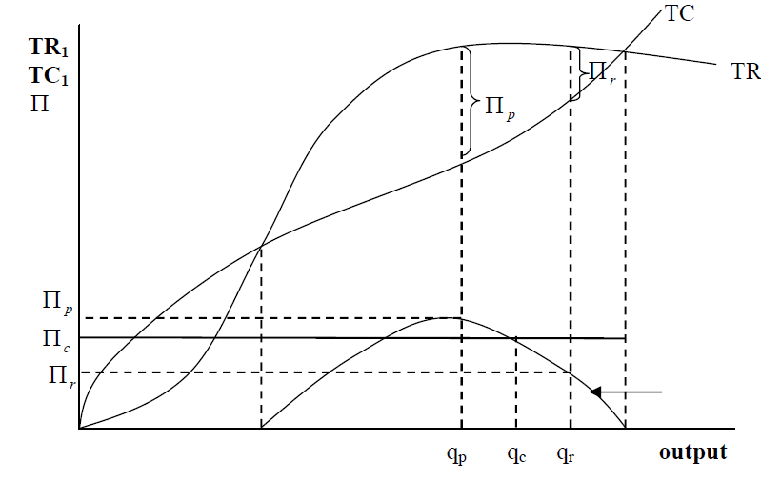
Figure 2.1. Revenue Maximization :depicts the firm’s Total sales Revenue (TR), Total Cost (TC) and Total Profits ().
From the figure 2.1, q^{p} is profit maximizing output, q^{r} is revenue maximizing output and q^{c} revenue maximizing output subject to a minimize profit constraint, П_{c}.
The revenue maximizing level of output is the level at which the marginal revenue is zero (and the elasticity of demand is unity). The output q^{c} is that which is produced by the revenue maximizing firm when constrained by a minimum profit П_{c}. The difference between the maximum possible level of profit and minimum constrained profit (i.e. between П_{p} and П_{c)} is called sacrificeable. In the view of Baumol, these profits will be voluntarily given up by the firm in order to increase sales revenues.
If the sacrificed profits are too apparent, they would tend to attract other firms acting in the same market, and would tend to create the ultimate threat of takeovers. This is why the sacrifice will be done quietly and only in way which do not look life sacrificing.
In any event, the profit-maximizing output will generally be less than the revenue maximizing output. The profit-constrained revenue-maximizing output may be greater than or less than the revenue-maximizing output. If q_{c} < q_{r,} then the firm will produce q_{c.} If q_{c} > q_{r}, then the firm will produce q_{r}. That is, the profit-constrained revenue- maximizing output may be greater than or less than the revenue maximizing output.
The managerial theory of the firm was further developed by a number of writers, in particular by Marris. Marris formalized the hypothesis that managerial control would lead to growth as an objective, showing that shareholders were a less important constraint on such firms than financial markets. Marris model is dynamic in the sense that it incorporates growth. Like Baumol’s model, Marris model assumes that mangers will act to maximize their utilities rather than profits, but in contrast to Baumol, it assumes that this will be achieved through growth rather than sales.
The Three major principles around which general managerial theory came to be articulated during 1960s are as follows.
1. In a firm, the ownership (by shareholders) is distinct from control (exercised by managers)
2. Because of this separation, it is possible to conceive of a divergence of interests of owners and controlling managers.
3. Firms operate in an environment that affords them an area of discretion in their behavior.
2.2.2. The principal-Agent Theory
At its simplest, principal - agent theory examines situations in which there are two main actors, a principal who is usually the owner of an asset, and the agent who makes decisions which affect the value of that asset, on behalf of the principal. As applied to the firm, the theory often identifies the owner of the firm as principal and the manager as agent, but the principal could also be a manager, and an employee nominated by the manager to represent him in some aspect of the business could be the agent. In this case the asset, which the agent’s decisions could enhance or diminish, is the manager’s reputation.
To explain the relationship between the principal-agent (or agency) theory, we turn to Williamson’s theory. There are two main such approaches or branches; monopoly which views contracts as a means of obtaining or increasing monopoly power; and efficiency which views contracts as a means of economizing. Among the major concerns of principal agent theory is the relationship between ownership and control. In this respect it can be seen to have emerged from the managerial theory tradition. Principal-agent theory can be seen as a new industrial economics version of sub-set of managerial theory.
Principal-agent theory sees the firm as does neoclassical theory as a legal entity with a production function, contracting with outsiders (including suppliers and customers) and insiders (including owners and managers). There is information asymmetry between principals and agents but unlike in transaction cost theory (which usually assumed bounded rationality) there is often assumed to be unbounded rationality. Unbounded rationality refers to the ability of those designing the contract to take all possible, relevant, future events into consideration. The principal many know various things not known to the agent (in relation, for example, to the prospects of the firm), and vice versa (the agent may have a lower commitment to the firm than he needs the principal to believe).
The major difference between principal-agent and transaction cost theories is that the former (principal-agent theory) focuses on the contract, the later (transaction cost theory) on the transaction. The problem for principal-agent theory is how to formulate a contract such that the shareholders (the principal) will have their interests advanced by the manger (the agent). In fact, the manager’s interests may diverge from those of the shareholders. Or, is there any class of reward for the manager (the agent) such as that can yield Pareto efficient solution for any pair utility functions both for the agent and the principal. Pareto efficient means making one party better off without making the other party worse off.
Where the objectives of the agent are different from those of the principal, and the principal cannot easily tell to what extent the agent is acting self interestedly in ways diverging from the principal’s interests, and then the problem of moral hazard arises. The problem originated in the insurance industry, will change their behavior, resulting in large claims on the insurance company than would have been made if they had continued to behave as they did before they had insurance. If must, in addition be difficult to determine whether this behavior has conformed to the terms of the contract. This arises particularly where the agent is a member of a team. Principal agent theorists have attempted, by specifying conditions such as that the manager’s salary be equal to the expected value of his or her managerial product, to design contracts on the basis of which there will be an incentive for the manager to act in the interests of shareholders. However, the importance of the team element in managerial jobs discredits the notion of a managers’ marginal product.
In the context of relations between principals and agents, refers to the possibility that, once there is a contract, the agent may behave differently from how he or she would have behaved had he or she not had the contract.
There are a number of ways to control moral hazard. Rather than attempting to circulate the value of each manager’s marginal product, managers could each be paid a salary plus a bonus based on the performance of the company. Other example to solve employment contract problems include the development of efficient ways of monitoring the performance of individual managers (or management teams), providing incentive contracts which reward agents only on the basis of results, bonding (where the agent makes a promise to pay the principal a sum of money if inappropriate behavior by the agent is detected) and mandatory retirement payments. It should be emphasized that to the extent that managers want to keep their jobs, the free markets (for corpora rate control, managerial labor and the firms’ products) can control moral hazard.
The most obvious solution to the problems of conflict of interest between the principal and agent is for the principal to become his or her own agent. Where there is team production, and the existence of a monitor can reduce shirking by enough to pay his or her own salary, then it may be appropriate for that monitor to be the owner of firm. If he or she is not the owner then there should be a need to monitor the monitor, to ensure that he or she does not shirk.
2.2.3. The Transaction Cost Theory
Rights of ownership (or property rights) to a good or service must be able to be established before a market for that good or service can exist. Transaction costs are those incurred in enforcing property rights, locating trading partners, and actually carrying out the transaction. If property rights over a good cannot be established, then transaction cost theory is inappropriate.
According to Coase, it is due to the existence of transaction costs that firms exist. If it is through the market mechanism that prices determine how factors of production are to be combined to produce what goods, for what markets, then why are organizations necessary? An esteemed affiliate! Can you please think of why? It is where transactions between individuals would be too difficult, inefficient or expensive an organization is needed. If an organization could coordinate transactions at a lower cost than if they were market transactions, then firms emerge to do this coordination. This is because an organization could coordinate transactions at a lower cost than market transactions.
It is in this way firms emerge to do the coordination and obviate these transitions by internalizing them. By doing this transactions can be internalized. In general, if the costs of making an exchange are greater than the gains which that exchange would bring that exchange would not take place and the greater production that would flow from specialization would not be realized.
Apart from reducing transaction costs, firms obtain additional benefits by internalizing transactions. The internalization of transactions enables the exploitation of economics of scale or economies of scope. The extent to which economies of scale can be exploited determines the size of a firm. Under what circumstances will transaction costs be lower when internalized than when left to be negotiated in an external market?
To answer this question Williamson identified bounded rationality, opportunism and asset specificity. Bounded rationality refers to the imperfect ability to solve complex problems. This takes place when there is imperfect ability to process the available information, and/or when the information itself is imperfect (i.e. there is uncertainty), both in relation to the present and future events.
Opportunism relates to how people will respond to conflicts, given the existence of bounded rationality. They will behave opportunistically if they act in their self interests by, for example, finding loopholes in contracts. If there was unbounded rationality, the potential opportunistic behavior would be known, and avoided.
Asset specificity refers to assets, involving non-trivial investment, that are specific to particular transactions (e.g. skills in an employer-employee contract). Asset specificity refers either to physical or human elements in the transaction. Market contracting gives way to bilateral contracting, which in turn is supplanted by unified contracting internal governance, as asset specificity is deepened.
If there was no opportunism, there would be no need for internalization. Without opportunism, the transaction would take place within the market rather than within a hierarchy market. But, bounded rationality is a precondition for opportunism. So, opportunism and bounded rationality are likely to give rise to internalization. This, however, is still only part of explanation for why and where internal governance will be preferable to market governance.

2.3. The Growth of the Firm
Growth is an important dimension of a firm whether it is small or a large one. Maximization of growth may be the goal of the firm or an instrument to achieve some other goal like maximization of profit or sales or managerial utility, etc.
Most of the large firms that we see around were small when they were established. In the course of time they grew continuously and attained their present status. Why do firms grow to such an extent? Why do firms grow at all? Is it a natural process? Are there market forces which compel a firm to grow over time?

To give answers for these questions, it is better to examine the desirability of growth at macro level. Every country irrespective of its political ideology, pattern of economy and size aspires for rapid economic growth. To bring growth in the country, it is necessary to create the production capacity. This production capacity can be increased via the establishment of new factories owned by new entrepreneurs or by expanding the existing factories in an industry. When new firms join an industry it implies an increase in competition among the sellers. The market power of individual sellers decreases with an increase in competition (i.e. number of sellers) in the industry.
This eventually leads to a situation when every firm losses its market power completely as we find in perfect competition. The existing firms will expand themselves and block the entry of new firms in order to maintain or increase their market power for greater profits in future provided there are no institutional restrictions for this. Hence, it is a natural inducement which the market provides to the existing firms for growth. Through growth, the firm will be able to enlarge its size. The larger the firms, the more perfect the control it assumes over its environment and the higher the efficiency with which it plans its overall activities. A growing firm may be able to increase its market share in the industry. It may acquire more market power which will have effects on earnings of the firms. Introduction of new products, new production processes and organizational techniques as parts of the growth strategy of the firm will enhance the competitive power of the firm as a result of which it will be able to withstand or survive in the creative destruction.
In a corporate economy where there is a separation between ownership and management, firms will be having growth as a major objective since this suit the managers. This is because managers want more pay, perks and subordinates, etc which accrue to them when the firm grows larger and larger. While maximizing their own ability, the managers have to take the interest of the shareholders of the company into account. For this, they use a minimum profit constraint or stock market value constraint. If this is overlooked by them, and if profit or value of the firm in the stock market declines, the firm will be having a threat of being taken over by the other firms. In this case the job security of the managers will be in danger. If we accept this proposition then the firm has to grow as it will be the sole objective of the firm in the market.
This theory of growth of the firm has been contributed by Downie, Penrose & Marris.
2.3.1. The life cycle of Firm
What is life cycle of the firm? The theme of the theory is that growth is a natural process. A firm is created, grows, matures and finally dies out like any biological species. This is captured by the product-life cycle or the Sigmoid Curve / S-Curve/. There is short hierarchy in the organizational structure of a young firm.Young firms allow management economies. It is easier to handle and transmit information concerning the company’s product or idea at the early stage of a firm.
There is high communication in the firm, which implies prompt and flexible decision- making. As a result of such managerial attributes and hence competence, firm’s growth rate accelerates the objective of management and shareholders coincides profit raises Managerial diseconomies of older firms arise Growth slows. The Life – Cycle Theory can be depicted by the following diagram.
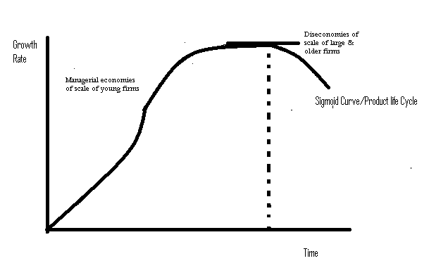
2.3.2. Downie’s Theory
According to Downie, alternative forms of market structure and conventions govern business behavior. This means rules of the game affect the dispersion of efficiency between firms and the rate of technical progress. For him in an industry, there will be dispersion of efficiency across the firms, i.e. some firms having greater efficiency than the industry average and some lower than this.
The source of variation in efficiency (measured in terms of unit costs) across the firms is their technical processes. This means that those firms having access to technologically superior processes and /or products are taken to be more efficient than the firms which do not have such facility. The technological superiority of a firm is established as a result of its past innovations which are patented or kept secret by it, and the accumulated skill or experience gained by the firm in its activities.
Given the competitive environment and assuming that the firms pursue the growth maximization objective, the process of growth of the firm’s model starts with the postulation of the steady encroachment on the market share of the less efficient firms by the more efficient firms. The efficient firms having advantageous access of the means of growth will be able to encroach on the market shares of the less efficient firms more or less rapidly.
The means of the growth are capacity of production and customers. To expand capacity, finance is needed which may be raised either internally or externally. In both the situations, the access to finance depends on the rate of profit. The efficient firms are assumed to have high rate of profit. Thus, they will be able to raise finance for capacity expansion. This means that the rate of growth of capacity expansion has a positive relationship with the rate of profit.
On customer side, an efficient firm having better technique or efficient production may be able to sustain a price reduction for its product and thus attract new customers which affect the markets for the less efficient firms adversely. The attraction of new customers or expansion of market by the efficient firm through its price reduction strategy will be feasible up to certain limit. This is possible as long as it is operating on the elastic zone of its demand curve, beyond which further reduction in price for expanding the market may lead to a reduction in the rate of profit for the firm. This implies an inverse relationship between the rate of customer expansion and the rate of profit for the firm.
There are now two opposing trends in the growth process of the firm. The capacity side of the growth varies positively with the rate of profit and the market side i.e. the rate of customer expansion varies inversely with the rate of profit. These two opposite trends will set the upper limit on the rate of growth of the firm. At that limiting point, the rate of profit and the product price of the firm are such as to enable capacity and market of the firm to grow at the same rate.
In figure 3.1, the optimum situation for the rate of growth of the firm would be at point G where capacity and the market growth curves intersect.
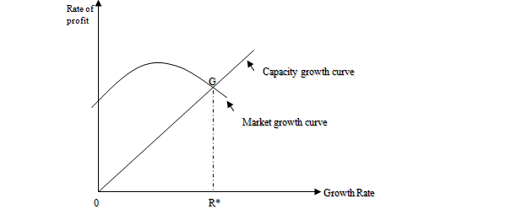
Figure 3.1 Optimum Growth Rate of the Firm (Downie’s Equilibrium point)
2.3.3.Penrose’s Theory
According to Penrose, the goal of the firm should be to increase total long run profits. To achieve this objective, the firm continues to make investment as long as it gets positive return from that. It takes the advantages of the productive opportunities for expansion which it thinks profitable.
Penrose considers the firm as a pool of productive resources organized within an administrative framework. The set of activities which the firm is aware of and able to undertake at a profit, defines its productive opportunity. The firm will continue to grow if allowed by its productive opportunity but there will be some restraints which will limit the productive opportunity and hence growth of the firm. The concept of the productive opportunity is conceived as the basic elements in the theory of the growth of the firm by Penrose.
Every individual firm is supposed to have a unique productive opportunity which makes the firm unique itself. To explain this point, Penrose defined productive resources as a bundle of potential services rather than merely the physical quantities. The physical amount of a resource may be same but its use or service may be different in different firms. Service implies a function or an activity.
How does growth process proceed? The process of growth is not automatic in the Penrosian framework. It is a deliberate and conscious choice of the management. If the managerial services are adequate, the firm can sustain higher rate of expansion, otherwise not. It is possible to expand the managerial services by the recruitment of the new managerial resources. The existing managerial resources of the firm would not be increased significantly by such recruitments immediately. Its rate of expansion is very much limited which will put a restraint on the expansion of the firm also. The managerial restraint limits the productive opportunity of the firm at any given time which in turn puts an upper limit to its growth.
There are other restraints on the growth of the firm as seen in practice, such as the financial and market restraints. Penrose, however, treated them as insignificant in limiting the growth rate of the firm. She emphasized solely on the managerial restraint for this.
In what direction will a firm grow? There are internal and external inducements and obstacles for expansion of the firm. The external inducements include changes in demand, technological innovations and other changes in market conditions. External obstacles include competition from rivals patent or other restrictions on the adoption of new technology, barriers to entry and market scarcity of input.
2.3.4. Mari’s Theory
A Coherent and integrated theory of the growth of the firm has been developed by Marris. His theory is applicable to a corporate firm owned by shareholders but controlled by mangers. Shareholders, being owners of the firm, are assumed to have the objective of maximizing the return on their investments in the firm. Managers of the firm, on the other hand, aspire to maximize their own interests which are taken care of by higher pay, perks, power, prestige, etc. All such things are postulated to be positively correlated with the growth of the firm in Marris model. It implies that mangers of the firm are assumed to have the rate of growth of the firm as their objective. The return on shareholders’ investment is realized in the form of dividend and capital gains through the life of the firm. Higher the expectation of the earnings by shareholders from a firm, greater will be its value in stock market and vice versa. Hence, the growth in market value of equity shares of a firm can be taken as a proxy variable to specify the profit maximization goal of its shareholders.
Consequently, he specified the rate of growth as the overall goal of the firm subject to a stock market valuation constraint. The constraint takes care of the objective of the firm’s shareholders. They have to be assured a minimum level of earnings (i.e. a minimum market value of the shares as a proxy for profits) on their investment; otherwise the job security of the managers will be in danger.
So, the stock market valuation constraint on growth of the firm is very important in Marris’s model. Thus, this constraint is called the security constraint since it provides security of profits to the shareholders and security of jobs to the managers of the firm. Financial constraint on growth of the firm will also be taken care of by it.
Marris growth of the firm can best be explained with the help of the following relationships.
1.The Steady-State Growth Condition. To simplify the analysis of the growth of the firm, Marris made the assumption of steady-state growth under which all characteristics of the firm such as assets, employment, sales, profits, etc grow at the same constant exponential rate over time. The implication of the steady-state growth is that supply and demand side of the firm grows overtime at the same rate. If this is not the same, there will be either ever growing spare capacity when supply grows at a faster rate than demand or ever growing excess demand when demand grows at faster rate than supply.
The supply side of the growth is represented by its assets base which includes:
i, physical assets comprising of fixed assets and stocks at a replacement value;
ii, financial assets at current market value including cash iii, goodwill mainly generated by market expenditure; and iv/ know-how as a result of R&D investment.
The demand side of the firm is difficult to be specified precisely as the product structure of the firm would be changing over time because of diversification process. For every new product, there will be a different capital output ratio as well as a different value added to sales ratio making the equality of growth of supply and growth of demand sides very much complex. However, under the assumption of steady state, such ratios are constant, so demand as measured by sales value grows at the same constant rate as gross assets.
2. The Growth-in-Demand Function: - The growth-of-demand is one side of the growth of a firm. If demand prospect for the existing and potential products of the firm is brighter then it will grow, otherwise not. If the demand for the product of a firm reaches to its saturation point, then the firm will be stagnant. To avoid this situation, Marris advocated diversification as the most effective way. Diversification is not only a competitive strategy in the market but an effective way to grow further as Penrose advocated. Marris specified the growth of demand function as g_{d}= f₁(d), where g_{d} is growth of demand and d is the rate of successful diversification. f₁ shows the functional relationship between g_{d} and d.
3. The Growth-of-Supply Function: - The growth-of-supply means an increase in the assets (fixed as well as current) of the firm. The growth rate of assets will be simply the ratio of new investment of capital employed. The new investment depends on the finance available. A firm can raise finance primarily through three sources: i, retained earnings, ii. barrowings including bonds and debentures, and iii. the issue of new equity shares.
For Simplicity let us consider the new investment finance only by retained earnings as follows.
I= rП, where I= new investment, r = retention ratio, and П is net profit. From this we get
g_{s} = = r = rP, Where g_{s} = growth – of – supply,
K= Capital Stock; and P= rate of return on capital =
In practice, a firm raises money for new investment from other sources also. The capacity of raising funds from external sources e.g. borrowings and equity capital of a firm depends on its long term return on capital. If expected rate of return is high, the potential shareholders will buy shares of the firm and creditors will provide money to it, otherwise not. From this assumption we derive the following growth – of – supply function as:G_{s}= _{P,} Where = amount of new investment financed per unit of profit earned. There will be some maximum upper limit for determined by the managers of the firm after taking into account the riskiness of different modes of financing. If retained earnings are increased, the dividend comes down which may affect the market price of the shares. If borrowings are increased further then the fixed interest charges of the firm will go up which may reduce the earnings of the firm.
4. The Cost-of-Expansion Function. In Marris model, it is the rate of successful diversification that determines the growth of demand of the firm. The rate of diversification depends on cost of expansion and, if cost of expansion grows fast, the profit rate on capital is likely to decline. Hence, the relationship between the rate of diversification and the rate of return on capital is defined as:
d= f₂ ().
The inverse of profit rate is a proxy for cost of expansion. That is
P=
Where m= = Profit margin, Q is the value of output, and V= capital-output ratio.
Substituting for P in the 1st equation, we get
d= f₂ = f₂ = f₂
This relationship shows the rate of diversification directly related to capital-output ratio and inversely to the profit margin.
Marris model can be summarized as follows:-
g_{d}= f₁ (d) - - - - - - - - - - - - - growth- in-demand function
g_{s} = p - - - - - - - - - - - - - - growth-of-supply function
d = f₂ ( = f₂ - - - the cost-of-expansion function
g_{d} = g_{s} - - - - - - - - - - - - - - - - equilibrium condition for growth and
g_{d}= f₃ ( - - - - - - - - - - - - Substituting the cost- of- expansion function in growth in demand function. Equation g_{d}= f₃ ( shows the growth of demand as an inverse function of the rate of return (p)

