CHAPTER FOUR
INDUSTRIAL LOCATION AND ANALYSIS

4.0. Chapter overview
Dear learners, now we are on the fourth chapter that deals with the Industrial location Analysis. Industrial location plays a vital role in the performance of a firm. In Ethiopia, since we are far behind in infrastructural matters than other developing countries, the place where an industry is located is one of the major determinants of its performance. In this chapter we are going to discuss about the need, importance and approaches of industrial location analysis in detail.
Objectives
After reading this chapter you must be able to understand;
- The meaning of industrial location analysis
- The importance of industrial location in the performance of a firm.
- The determinants of industrial location.
- The scientific approaches to industrial location.
4.1. Introduction
In setting up a factory a manufacturer has to take three interrelated decisions simultaneously:
- The scale of operation;
- The technique to be adopted, which involves the selection of the appropriate combination of the factors of production; and
- The location of the factory.
As you know very well the conventional theory of the firm provides the rules or norms for taking the first two types of decisions, but it ignores the third one completely. Now a days especially in developing countries like ours needs a separate branch of economics bordering with the discipline of geography, which is known as industrial Location or Location Analysis, deals with the elements of locational or spatial decision-making. In the coming discussion we will study this branch of economics in detail.
The task of decision-making about industrial location is not very simple. A manufacturer has to consider several technical, economic and institutional factors for this. Our first step in this chapter will be to identify such factors. Following this, we have to examine how individual firms react in locating their factories under different physical and economic circumstances. This implies a review of the theoretical approaches to industrial location analysis.
- Why Muger Cement Factory selected its location at its current location? Is it only because of the availability of raw material or some other factors?
4.2. Determinants of Industrial Location
Suppose a factory, with whose location analysis we are concerned, is a technical unit whose function is to convert a set of raw materials into some output with the help of men and machines, i.e., the factors of production. The raw materials and other inputs required by the factory for production will be rarely available at a place. The owners of the factory will have to procure them from different places which involve transportation and other procurement costs. Similarly, the output of the factory will be rarely sold at a single place. It has to be sent to different places which involve transportation and selling costs.
Given the spatial distribution of the inputs and outputs markets, the owners of the factory will have to take the decision about the place where the factory should be located.
All potential locations for the factory will not be equally economical. Only one of them is to be chosen which will be the most economical.
How to make the choice for this?
A large number of factors have to be considered simultaneously while taking the decisions of industrial location, such as
a) Technical,
b) Economic and Infrastructural Factors
c) Other factors
Which exert pull and pressure on location of the factory in varying magnitudes?
  - Technical Factors
These are the physical factors which are more or less geographical in nature related to soil, raw materials, people, climate, etc. The important factors in this category are:
- Availability of land.
- Nature and quality of raw materials from land, e.g. forest products, agricultural inputs, minerals, and semi-finished products from existing industries.
- Geographic situation of the factory site in relation to the transport facilities by rail, road, water and air.
- Quantity and quality of human resources.
- Energy resources.
- Availability of water for drinking and industrial uses.
- Waste disposal facilities.
- Climate
  - Economic and Infrastructural Factors
Input prices, taxes, markets, skills of labor forces, availability of adequate infra-structural facilities, finance, etc., constitute together the category of economic factors. The general list of factors for this would be as follows:
- Local markets.
- Situation in relation to export markets.
- Costs of land and buildings.
- Costs of infra-structural facilities such as transport charges, power tariffs, water-rates,etc.
- Salaries and wages in relation to skills.
- Local cost of living.
- Taxes and subsidies.
- Cost and availability of finance.
- Structure of existing industries.
- Industrial relations and trade union activities around the proposed location sites.
- Demographic factors such as age and sex composition of local population,
- Literacy, professional skills, etc.
- Local medical facilities.
- Housing facilities.
- Cultural facilities such as schools, clubs and other recreation
- Communication facilities.
C) Other Factors
All other miscellaneous location factors may be put in this category, viz;
1. Government policies towards location of new plants, and
2. Personal factors.
Most of the governments pursue the policies of rapid industrialization of their states. They provide several facilities for locating new plants in some places or regions. An entrepreneur has to evaluate the facilities given by the government very carefully before taking a decision on location of his factory.
Personal factors also play important role in location decision, a manufacturer may prefer to locate his factory at his birth place-disregarding all economic factors. Again may set up his factory close to a golf-club in order to keep up his interest of playing golf. Industrial location based on such personal factors will entirely be a matter of chance or which is called as historical accident.
Most of the factors, mentioned above are self-explanatory. In some industries firms are located near sources of major raw materials such as iron and steel, and pulp etc, while in other industries, they are located near markets. All factors together provide a spatial configuration which is to be analyzed very carefully for the optimum location of a factory. The choice of location will not be independent of the scale of production and the technique to be used for that. They are interrelated aspects which are to be decided together.
4.3. Approaches to Industrial Location Analysis
There are several theoretical and applied approaches for location analysis based on the above-mentioned factors. In order to understand the precise relevance of the various location factors and the interactions among themselves, let us examine the leading theoretical approaches to industrial location analysis. In this regard significant contributions were made by geographers and the economists; their approaches however were different.
The geographers, by and large, adopted intuitive conceptual base and case studies approach to arrive at some generalization about the industrial locational patterns.
The economists, on the other hand, followed a more formal, abstract or deductive approach for location analysis, an integration of these two diversified approaches led to develop some operational models for location studies.
4.3.1. The Geographical Contributions
The discipline geography examines the form of the earth, its physical features, natural and political divisions, climate, production, and population, etc. Industries appearing on the earth's source do make some changes in its physical features and production patterns. Recognizing this fact, the geographers considered industrial location as a part of their discipline and we are trying to present a brief review of a few selected works having some theoretical relevance, they are
  - The Central Place Theory
  - Renner's theory
  - Rawstron's Principle
4.3.1.1. The Central Place Theory
This was the first systematic geographical theory of location. It was developed by Walter Christaller mainly to determine the number, size, and distribution of town and. cities. Using certain simplified assumptions, Chris taller was able to demonstrate graphically the spatial arrangement between hinterland and central places, mainly service centers.
In simplest terms, his theory proposed that towns with lowest level of specialization would be equally spaced and surrounded by hexagonally shaped hinterlands. Although, empirical testing of this theory is doubtful yet it is regarded as valuable theoretical contribution in urban geography. It has relevance for location of a manufacturing industry in a special case where production tends to be centralized and the market is al really extended.
The major limitation of this theory is that it fails to encompass the development of belts of industrial concentration and the agglomerative tendencies which are common features of the modern industrial structures.
4.3.1.2. The Renner’s theory
Renner developed some general principles concerning industrial location. He classified industry into four categories viz;

- Extractive
- Reproductive
- Fabricative
- Facilitative

To undertake anyone of these, six ingredients are required raw material, market, labor and management, power, capital and transportation. Keeping in mind these ingredients, Renner postulated the law of location for fabricative (i.e. manufacturing) industry according to which any manufacturing industry tends to locate at a point which provides optimum access to its ingredients.
It will, therefore, locate near to:
- Raw Materials, if it uses perishable or highly condensable raw substances, or
- Market, where the processing adds fragility, perishability, weight, or bulk to the raw materials or where its products are subject to rapid changes in style, design, or technological character; or
- Power, where the mechanical energy costs of processing are the chief items in the total cost; or
- Labor, where its, wages to skilled workers are a large item in the total cost.
Apart from the above tendencies or laws, Renner gave a scheme for, industrial symbiosis. Three different types were mentioned for this:
(a) Disjunctive symbiosis where different industries having no organic i.e. economic or technical connections among themselves, gain advantages by existing together at a particular place;
(b) Conjunctive symbiosis where different industries with some organic connection among themselves (i.e. inter-connections) are located together; and
(c) Conindustrialization which is an advance stage of the conjunctive symbiosis leading thereby to a huge industrial belt of interconnected industries.
Renner's approach on industrial location is quite realistic as it tries to bring together the major determinants for that. However, he has not been able to go into deep in analyzing the effects of spatial cost variation and industrial symbiosis, i.e. agglomeration on industrial location. He merely describes the tendencies of industrial location based on these factors.

4.3.1.3. Rawstron’s Principle
Rawstron has developed his theory of industrial location in terms of three restrictions which impede the choice of location for a factory. The restrictions are the principles of location in his model. These are:
- Physical restriction,
- Economic restriction, and
- Technical restriction.
The physical restriction will be operative when some raw materials mainly natural resources are to be produced or procured at the proposed site for the plant.
The economic restriction embodies the concept of spatial margins to profitability. The cost of production, i.e. the sum of expenditure on labor, materials, land, marketing and capital, varies from place to place resulting in a spatial variation in profitability for a firm. Unlike most authors, Rawstron does not identify transport as a separate cost item but takes it as a factor for spatial variation in the cost of other items and hence of profitability. The sum of costs arising solely from the choice of location is defined as the location cost by Rawstron. It plays crucial role in locational decision making.
The technical restriction examines the effect of the level of technology on location. The decision on the choice of technique for production is one of the three interrelated decisions as we have mentioned earlier. Location decision is one of them. So Rawstron's emphasis on technical restriction as location is consistent with this. Location decisions will be important with stable technology. In the case of changing technology it may be difficult to link the choice of plant location with the choice of technology since the latter is uncertain. Generally, the effect of technological change is felt through some change in input requirement and hence on cost of production. Such change is taken into account by the second restriction in Rawstron's model. On the whole, Rawstron's contribution to the geographical studies on industrial location has been a pioneering one. The emphasis on cost-structure for industrial location makes his approach more important than the other geographical studies on the subject of industrial location based on minimum transport cost.
NB: The geographers, by and large, adopted intuitive conceptual base and case studies approach to arrive at some generalization about the industrial locational patterns
4.3.2. The Economic Theories of Industrial Location
Some of the pioneering works from some celebrated economists in the field of industrial location are discussed in this section, such as:
a) Weber's Theory
b) Tord Plander's theory of Market Area
c) Losch's Theory of Central Place
4.3.2.1. Weber’s Theory
Weber's main interest was to construct a general theory of location which could be applied to all industries at all times. In his theory he followed Launhardt's principle of industrial location based on minimum transport cost. For this he has taken into account the general factors of location which were relevant to all industries. The factors considered by him were divided into two groups;
Those influencing inter-regional location of industries (i.e. regional factors) and those influencing intra-regional location (i.e. agglomerating factors).He found three general factors which vary regionally;
- Raw material costs,
- Transport costs and
- Labor costs.
The fluctuations in raw material costs were however included within transport costs. The approach followed by Weber was to explain industrial location in terms of transport cost first and then to examine the effects of changes in labor cost and agglomerative factors on it. He made some simplifying assumptions for his analysis such as
- The locations of raw materials including fuel are fixed
- Situation and size of consuming canters are given; and
- There are several fixed labour supply centers; labor is immobile and unlimited in supply at fixed wage rate.
- The institutional factors like taxation, interest, insurance, etc., are insignificant locational factors.
- The economic culture and political system are treated to be uniform and stable across the locations.
- On the whole Weber assumed perfect competition for his model.
Weber started his analysis with the proposition that a manufacturing unit tends to locate at the place where cost of transportation is minimum, i.e. the location where the number of ton-miles of raw materials and finished product to be moved per ton of product would be minimum. Weber used the locational triangle of Launhardt to find the place of minimum transport cost. He assumed a simple spatial situation in which there is only one consumption Center(C) and two fixed supply centers (M₁ and M₂) for two most important raw materials
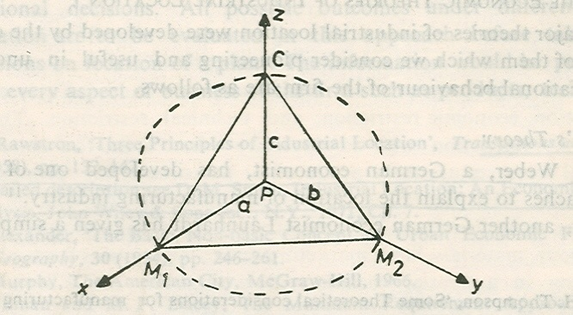
Fig.4.1The location Triangle
There may be other consumption points and raw material supply centers but Weber did not consider all of them together. According to him, the least cost point will be located within the triangle CM₁M₂ such as the one shown by P. The three corner points of the triangle will be pulling the location point (P) towards themselves. The position of the point will depend on the balance of the pulls exercised by them. If the pull of anyone corner is greater than the sum of the pulls of the other corners, production will be located at the point or corner of origin of the dominant force. The force exerted by each corner on production point is in the form of ton-mile weight to be moved from that point (M1 and M2) and to the point (C). Let x and y be the requirements of materials M1 and M2, in tons per ton of output and let one unit of output, i.e. finished product be transported from point P to C. The distances of the corner points from the production point (P) are unknown. Let them be a, b and c between P and M1, M2, and C points respectively.
The total ton-miles of transport per unit output would then be ax + by + c. This is to be minimized in order to find the position of point P, i.e. the location of production. The distances a, b and c and hence the point P are easy to be found by applying the theorem of parallelogram of forces in geometry.
An industry may be material-oriented or market-oriented from location point of view. Weber used the 'material index' for identifying such nature of the industry.
The material index (M I) is defined as:
MI= Weight of localized material / Weight of finished product
Industries displaying a high material index i.e., MI > 1 are attracted towards the sources of raw materials such as iron and steel industry,
Industries displaying a material index less than one i.e., MI < 1 are attracted towards the place of consumption.
The assumption of a uniform transportation rate, was relaxed by Weber by converting the weight to be transported into an ideal weight which is defined as a product (or a function) of actual weight and the rate of transportation cost, for a material or finished product. Let t₁, t₂ and t₃ be the transportation rates per ton-mile for material M₁, M₂ and finished product respectively, which is explained in the figure 4.1.The total transport cost per ton of finished product would be then equal to t₁ax + t₂by + t₃c. The location of production point (P) within the triangle CM₁M₂ can be determined now by minimizing this cost instead of the sum of ton-miles as mentioned earlier.
According to Weber an industry will choose a cheap labour site if the labour cost saving is greater than the increment in transport cost at this site above the minimum possible transport cost. Weber used the isodapanes to explain the effect of labor cost on the least-transport-cost location of a plant. An isodapane is the locus of the points having equal additional transport cost around the least-transport cost location. There will be several isodapanes forming rings around the location fill different levels of incremental transport cost as shown in Fig. 4.2. Let P₁be the least-transport-cost location and L1be a cheap labor site.
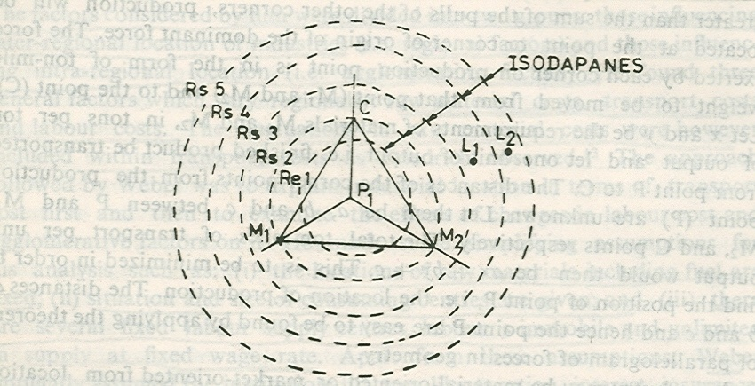
Figure 4.2 Isodapanes and equilibrium location with cheap source of labour
Further, let us presume that there will be a saving of labour cost by Birr. 4 if plant is located at L1 instead of at P1. Should the location be shifted from P1 to L1? For illustration, the isodapanes around P1 are drawn for incremental transport cost of Birr.1, Birr. 2, Birr. 3, Birr. 4 and Birr.5. Point L1 lies with in the isodapane of Birr. 4. It implies that it is economical to shift the location from P1 to L1. If labor source making a saving of Birr. 4 in cost of production lie outside the isodapane of Birr. 4, such as shown by L2, it would mean a loss in shifting the location from the least-transport-cost location P1 to the labour centre L2. In general, let d₁ and d₂ be the total ton-miles of transport services per ton of product at P1 and L1 sites respectively, and let W1 and W2 be the hourly wage rates at these two sites respectively,' h' is the number of man-hours required to produce one ton of product and 't' is the cost of transportation per ton-mile. The cost of production and transport at site P1 would be (tdl +W1h) and at site L1 it would be (td2 + W2h).
The cheap labor site (L1) would be chosen if(tdl +W1h) > (td2 + W2h)
Or(w1-w2) h > t (d2 - dl) i.e., saving in labour cost exceeds the increment in transportation cost. For every level of saving in labour cost there will be a critical isodapane within which the cheap labour cost site must lie for economic viability from location point of view.
To measure the importance of labour as a location factor, Weber used the average cost of labour per unit weight of product as an index. Greater the labour cost index more will be the industry's susceptibility to move from the least transport-cost site. As an improvement over the simple labour Cost index. Weber suggested to use the industry's coefficient of labor. This is defined as the labour cost per ton of location weight, where
Location weight = Weight of material and product/Weight product
= Material index (MI) + 1
A high coefficient of labour means a strong attraction to the cheap labour location.
Weber's analysis of industrial location is indeed a pioneering one. It has paved the way for development of programming models for industrial location. Many economists have used this analysis as the basic framework for their location theory and empirical works. Even then this theory is not free from criticisms.
4.3.2.2. The Market Area Theory of Tord Palander
Tord Palander started his market area theory of industrial location analysis by posing two different but interrelated questions.
- Given the price and location of materials and the situation of the market, where will production take place?
- Given the place of production, the competitive conditions, factory costs, and transportation rates, how does price affect the extent of the area in which a particular producer can sell his goods?
To demonstrate how the market boundary between firms can be determined, Palander took a simple case of two firms making the same product and selling that in a linear market, which is depicted in figure. 4.3, the firms are located at two different places, A and B, which are on a horizontal line which defines the market area of the firms. Let the prices charged by the firms at their locations be α and β respectively These are shown by the vertical distance AA' for firm A and BB' for firm B The consumers who are situated away from the location points of the firms will be paying higher prices for the product of the firms. The addition in price will be the transportation cost Let ta and tb be the average transport costs for the product per unit distance for the two firms respectively. The price for the product at a point other than location would be α + ta da for firm A and β+ tb db for firm B, da and db are the distances of the point from the location of firm A and firm B respectively. The transport cost is a function of distance for each firm. The gradients of total price paid by the consumer for the product are shown by the lines forming cones at points A' and B' for the two firms in Fig. 4.3.
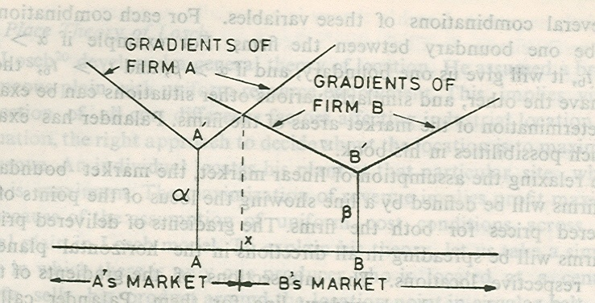
Figure 4.3 Determination of market boundary for two firms in a linear market
The gradients are linear because of fixed transport rates for the product over distance. Just above point X, the gradient lines of firm A and firm B intersect. This implies that consumers would be paying same price for the product of the firms. The point X defines the boundary between the market areas of the two firms.
Algebraically, at point X we have:
α + ta (AX) = β + tb (BX)
Since AX + XB =AB, i.e. the distance between the firm, we can therefore write
α + ta (AX) = β + tb (AB-AX) Or
AX = [(β - α)/ (ta+tb)] + [(tb)/ (ta+tb)]. AB
Example
Let α = Birr.100, β = Birr. 90, ta = ta = Birr. 2 and AB = 100 km.
So, AX = [(90 – 100) / (2+ 2)] + [2/ (2+2)] [100]
= -2.50 + 50
= 48.5 km.

Firm A can sell only up to 48.50 kilometers toward firm B. The rest of the distance between- them, i.e. 51.50 kilometers defines the market area of firm B. The determinants of market boundary or area for the firm are prices at the locations, transport rates, and the distance between the firms. Given the location of the firms and hence the distance between them, the boundary of their market areas will depend on the relative magnitudes of the location price (α and β) and the transport rates (ta and tb). There may be several combinations of these variables. For each combination there will be one boundary between the firms. For example if α > β and ta = tb, it will give us one boundary, and if α > β and ta > tb, then we will have the other, and similarly various other situations can be examined for determination of the market areas of the firms.
On relaxing the assumption of linear market, the market boundary for the firms will be defined by a line showing the locus of the points of equal delivered prices for both the firms.
The gradients of delivered prices for the firms will be spreading in all directions in the horizontal plane from their respective locations. The intersections of the gradients of the two firms will give the market boundary line for them. Palander calls such boundary line as 'isotante'. The shape and situation of the isotante depend on the relative magnitudes of location prices and transport rates for the firm.
The market area of a firm will be extended to greater distance if its factory price and transport cost are lower or decline. The size of market area will influence the profit of the firm. Given the production cost and the rate of profit per unit output, larger the market area more will be the total sales and hence total profits of the firm. The market area and hence sales and total profits of anyone firm will be influenced by the locational decisions and other actions of the competing firms.
Palander's analysis is not a mere extension of the Weber's work. He made valuable contribution to locational analysis by adding the market area dimension to it. He did not accept the agglomeration analysis of Weber but emphasized much on dynamic aspects of locational factors. NB: The economists followed a more formal, abstract or deductive approach for location analysis, an integration of these two diversified approaches led to develop some operational models for location studies
4.3.2.2. The Central Place Theory of Losch
The advocator of central place theory August Losch started his analysis on a broad homogeneous plain with uniform resource endowment. This rejects all cost difference factors affecting industrial location. In such situation, the right approach to decide about the location is to maximize total revenue. An individual locates his plant at that particular site, where revenue is maximum. The maximization of revenue implies profit maximization because of the assumption of uniform cost conditions across the locational plain in Losch model. To explain his theory, let us take a simple situation in which there is only one producer who is located at a central place. He sells his product around the location point in circular belt, the extent of which depends on the economies of scale accruing to the producer and the transportation, i.e. distribution cost of the product. The demand for the product falls with distance. The maximum extent of the market area for the producer is given by the distance when demand falls to zero because of high price for the product. This is shown by OF in Fig.4.4
.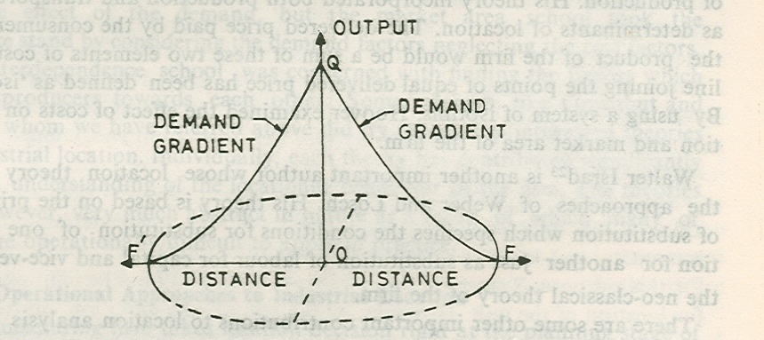
Fig. 4.4.Market area of firm (Losch Model)
The circle with OF as radius defines the market area for the producer. 0 is the location of the producer at which OQ is the demand for his product. The producer being only one in the market makes profits. This attracts other competitors in the industry. They put up their plants in the area. There is no restriction for that. The resources are available. The entry of new producers gradually reduces the market area of the existing firms. Their markets will not continue to be circular but somehow irregular in shape. However, when distribution of the firms in the plain is uniform the market area for each one of them will be hexagonal. The profits for each firm will be minimal at this stage. Each industry will have a system of hexagons of its own. The superimposition of hexagons of different industries produces a common production centre surrounded by the sub-centers of productions in orderly sequence. Losch's theory is a general spatial equilibrium theory, and it is not giving anything about the factors which determine the location of individual firms. The rejection of cost differences as locational factors is a major weakness of Losch's theory.

