CHAPTER TWO
SURFACE TRANSPORTATION

2.1. History of Surface Transportation

Despite the advent of air transportation, travel by land is still the major way to get from here to there. The various sectors of the surface travel industry-railroads, motor coaches, car rentals and mass transit-all play a vital role in the modern transportation.

The history of transportation is largely one of technological innovations. Advances in technology have allowed people to travel farther, explore more territory, and expand their influence over larger and larger areas. Even in ancient times, new tools such as foot coverings, skis, and snowshoes lengthened the distances that could be traveled. As new inventions and discoveries were applied to transportation problems, travel time decreased while the ability to move more and larger loads increased. Innovation continues today, and transportation researchers are working to find new ways to reduce costs and increase transportation efficiency.
The domestication of animals was the first great leap in transportation ability. However, the use of animals to pull vehicles or to carry riders had to await several important inventions. Oxen and horses were harnessed to vehicles by neck straps, which tended to choke them when they pulled heavy loads. Horse stirrups were in use in India and Asia by around 200 BC, allowing riders to maneuver their horses more effectively. Saddles were introduced in Europe around ad 200. Around AD 500, someone devised a padded collar that rested on the animal’s shoulders. The use of such a collar increased the amount of weight that the animal could comfortably pull. Finally, horseshoes, used to protect the hooves of a horse, were in widespread used by about AD 700.
The first major innovation in wheeled transport was the spoked wheel. By using a spoked wheel instead of one made of solid wood, faster and more maneuverable vehicles could be designed. Protruding copper nails placed in the wheel to provide greater traction were introduced around 2000 BC. Iron rims fastened to the edges of wheels were introduced in 700 BC. These rims increased the strength and durability of the wheels. The harnessing of multiple animals to a single vehicle began around 100 BC. These innovations all contributed to increasing the weight that a wheeled vehicle could carry. The wheel, when applied in wagons and carts, was the first transportation innovation to create the need for roads that could survive repeated use.
- Road Transport
Tracks were created as animals were domesticated. Horses, oxen and donkeys became an element in track-creation. With the growth of trade, tracks were often flattened or widened to accommodate animal traffic. Later, the travois, a frame used to drag loads, was developed. Animal-drawn wheeled vehicles probably developed in Sumer in the Ancient Middle East in the 4th or 5th millennium BC and spread to Europe and India in the 4th millennium BC and China in about 1200 BC. The Romans had a significant need for good roads to extend and maintain their empire and developed Roman roads. The early roads were built—usually by slaves—in Rome, India, Persia, and China were made of brick or stone. These ancient roads fell into disrepair during the middle Ages.
The modern history of road transport also involves the development of new vehicles such as new models of horse-drawn vehicles, bicycles, motor cars, motor trucks and vehicles.
- Rail Transport
The modern passenger train owes its beginnings to the work of James watt, a British inventor, and William Murdock, an engineer. Together they invented a three-wheel carriage propelled by a steam engine in early 1800s.
An English man, George Stephenson, is regarded as the originator of the modern railway system. Many of the early railway networks in South America, Asia, Africa, and India were built by British engineers.
Early trains were powered by steam engines however; the development of electric, diesel, and turbine engines in the 20th c brought an end to the smoke-spewing locomotive. Electric trains were quick-starting, quiet, and relatively efficient. Thomas Edison produced an electric locomotive in 1880 and by 1895; steam engines were being replaced by electric trains.
- Pipelines
Pipelines are a unique form of transportation used to move liquids, gases, or solid/liquid mixtures over great distances. Pipelines consist of two major components: pipes and pumping stations. A piston in a pump forces liquid out of the pump and into the pipe. A vacuum created by the departing liquid forces more liquid to enter the pump, and that liquid in turn is forced out as the liquid before it was. With pumping stations placed appropriately along a pipeline, liquid can be moved great distances.
Pipelines are commonly used to transport crude oil or petroleum. Oil pipelines have been constructed in all parts of the world, primarily in oil-producing regions such as the Middle East, the North Sea, Southern Russia, the South China Sea, Texas, Oklahoma, and Alaska. In 1999, there were approximately 248,000 km (154,000 mi) of pipelines for crude oil or petroleum products. Also in 1996, the latest year for which figures are available, there were 2,054,029 km (1,276,315 mi) of pipelines for natural gas in the United States. Pipelines are also used to transport solids suspended in liquids, such as coal slurry, which consists of powdered coal suspended in water.
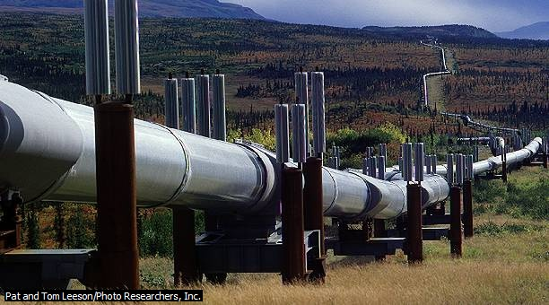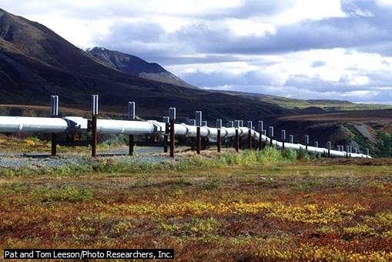
2.2. Classifications of Surface Transportation

Land transportation is the dominant form of transportation in the world. It can be of various types of forms. The most common forms of land transportation combined the wheel with electric or fuel-powered engines to move people and freight quickly and efficiently. Listed below are the three classifications of land transportation based on the motive power:

- Human-powered transportation, such as walking or bicycling, relies entirely on human muscle power for movement. Today, in many countries of the world, human-powered transportation remains the main form of transportation. In African cities, two-thirds of daily trips are made by walking. Even in automobile-dominated North American and European cities, walking and cycling are important modes of transportation. Special equipment, such as skis and snowshoes, has long been used to help people move over difficult terrain, such as snow-covered ground. Other inventions, such as the bicycle, make travel over flat terrain faster and more efficient. The Rover safety bicycle, one of the first practical bicycle designs, was invented around 1885 in Great Britain. Today, in Beijing, China, residents own over 8 million bicycles. In cities in Denmark, between 20 and 30 percent of daily trips are made on bicycles. In many Asian cities, bicycle-like vehicles called rickshaws carry between 10 and 20 percent of the freight moved daily. In Africa, the bicycle is the most common means of traveling intermediate distances.
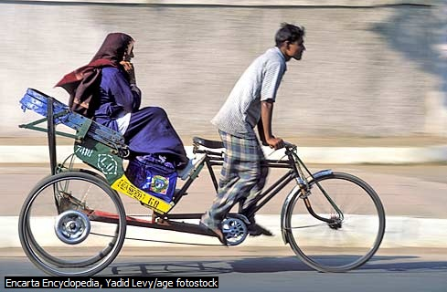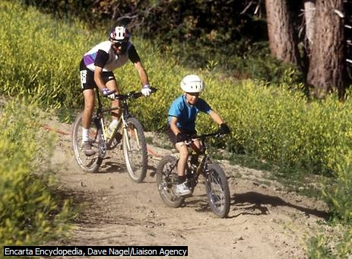

- Animal-powered transportation- People have used domestic animals for thousands of years to help transport goods over longer distances. Pack-animal caravans using domesticated donkeys originated as early as 3500 BC. Pack animals are still used today in many parts of the world, particularly in rugged or hilly terrain where motor vehicles cannot travel. Other pack animals include camels, mules, oxen, water buffalo, dogs, goats, elephants, reindeer, and horses. The horse, with its superior speed and range, has been a favorite animal for transportation use.
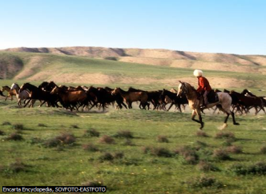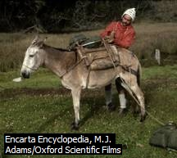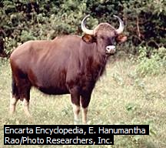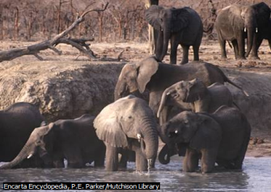
- Engine-powered transportation – these are machines or transport vehicles where engines rely to fuel, electric or any other energy sources like solar or batteries. This transport mode can be of various types which include:

  - Motorcycles and Tricycles – are some of the fastest mode of transportation today. These vehicles are economical in the sense that it can go beyond the limit of major roads or thoroughfares especially during heavy traffic congestion by taking alternative routes or smaller street roads to go to their destination.
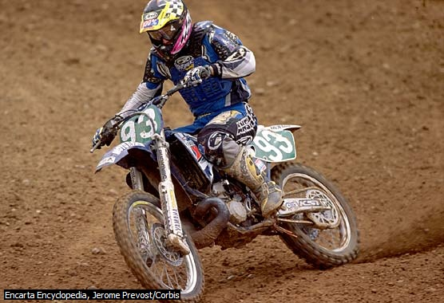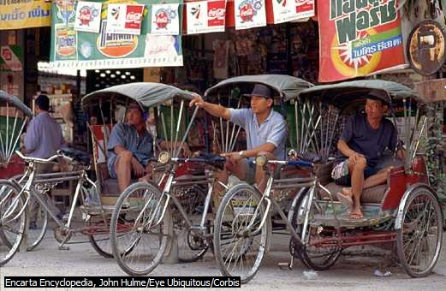

  - Buses - Bus service operates diesel or electric buses along defined routes and according to published schedules. Buses vary in size from minibuses, which can carry up to 20 passengers, up to multisection articulated buses, which have an extra passenger unit attached by means of a flexible joint. Articulated buses can carry as many as 130 passengers. Buses operate on both city streets and highways. Some streets and highways have special lanes reserved only for bus transit, thus increasing the speed and efficiency of bus travel. Trolley buses are electrically powered buses that use electricity from overhead wires mounted along city streets. The use of electric power reduces pollution, noise, and the need for refueling but also limits the routes a trolley bus can take.

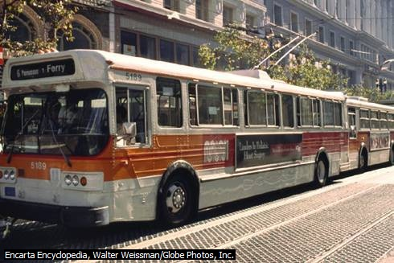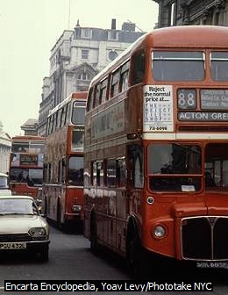

  - Para transit or other four-wheeled vehicles- Para transit includes taxicabs, jitneys, and dial-a-ride services. It provides short-distance transportation for small groups of passengers. A taxicab is an automobile operated by a driver and hired by users for an individual trip. Taxicabs have the highest out-of-pocket cost of all types of public transportation, but taxicab service is closest in convenience to the private automobile. Jitneys are privately owned large cars or vans that usually operate on fixed routes but without fixed schedules. Jitneys are a flexible means of public transportation, although they also tend to add to traffic congestion. Dial-a-ride services consist of minibuses or vans that are directed from a central dispatching office as the service is requested. The dispatcher plans the routes so that as many passengers as possible are served on a single trip. Dial-a-ride services are slower and less direct than taxicabs but generally are cheaper as well. Car rentals, on the other hand is a system where cars are rented by persons for a specified time under agreement. Big car rental companies of today include Avis, Dollar and Nissan.

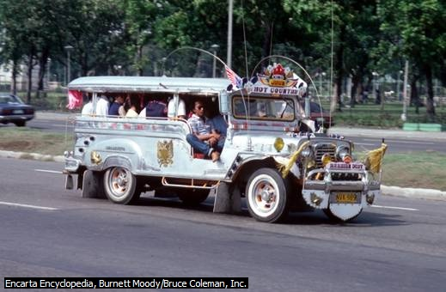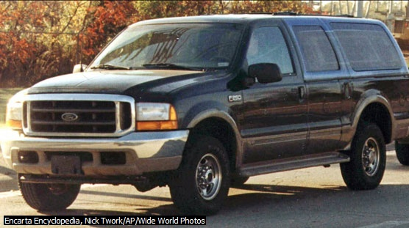

  - Trucks and vans – are mostly for freight service and carry it from short to far distances.
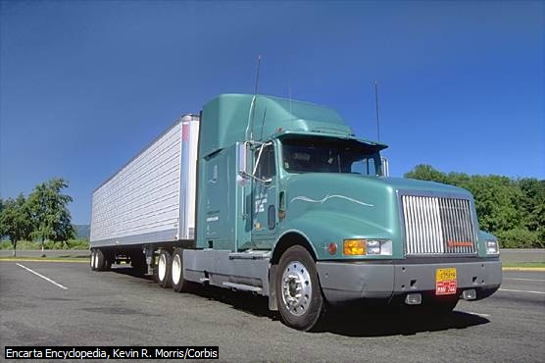

  - Trains – trains can be in the form of light-rail, heavy rail or automated rail systems for passengers and there are trains to carry only goods or cargoes.

    - Light-rail transit (can also be considered as streetcars) is an electric railway system that evolved from streetcar systems. Like streetcars, light-rail cars operate as single units or as short trains of two or three cars. Light rail is designed to use a variety of rights-of-way, providing more flexibility than the streetcar. In some cities, light-rail systems operate like streetcars in downtown areas but then move to reserved lanes of traffic to service outer neighborhoods. Light-rail systems may also operate in tunnels under congested areas or on elevated tracks mounted over city streets. Light rail is popular in Europe and is in use in several U.S. cities, including Portland, Oregon; San Diego, California; and Baltimore, Maryland. Light rail is a cheaper and more versatile alternative to older rail systems.

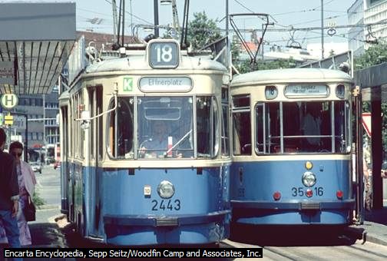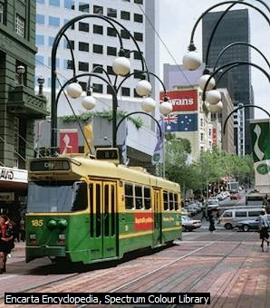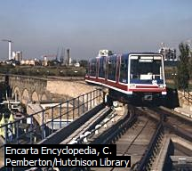

    - HEAVY-rail transit - Heavy-rail systems are also commonly referred to as rail rapid transit. Subways (often called metros outside of the United States) are common examples, although rail rapid-transit systems may also operate above ground, as parts of the New York City and Chicago, Illinois, subway systems do. Heavy-rail systems typically consist of large four-axle rail vehicles operating in trains of two to ten cars. Rail rapid-transit systems operate on tracks reserved solely for the rail cars, and so the trains are able to travel at high speeds. Some rail rapid-transit systems, such as BART (Bay Area Rapid Transit) in the San Francisco Bay area, are highly automated. Power for rail rapid-transit vehicles is usually supplied by an electrified third rail mounted alongside the train tracks. Some heavy-rail systems use rubber tires rather than steel wheels. These tires produce a quieter ride but create more friction, which reduces efficiency. A monorail is a special type of heavy-rail system that uses a single rail to support and guide the vehicles. A monorail that was built for the 1962 World’s Fair in Seattle, Washington, connects the downtown to the nearby fairgrounds and is still in use. Monorails have also been built for circular routes around airports or at amusement parks, such as Walt Disney World, but they have not been widely used for urban transportation.

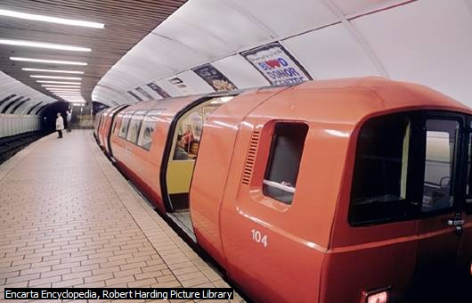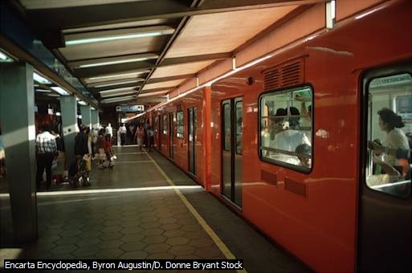
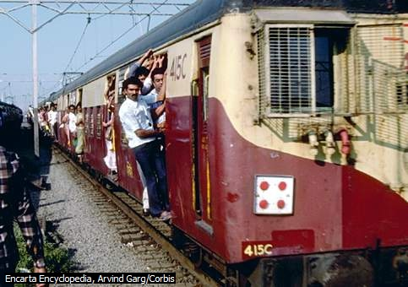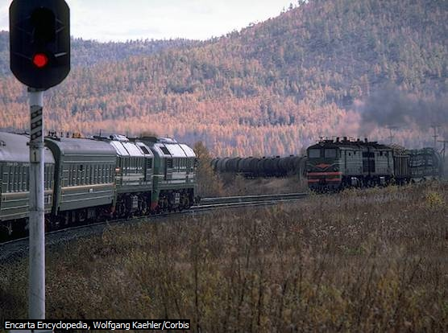

    - Automated Guided Transit - Automated guided transit systems, also known as people movers, are fully automated transit systems, which operate with no crew. These systems vary widely in design and are less common than bus and rail systems. Automated guided transit is a popular method at large airport for transporting passengers short distances between terminals. Some designs are essentially automated buses running on guided routes, while other systems run on rails. The vehicles may be operated individually or in small trains.

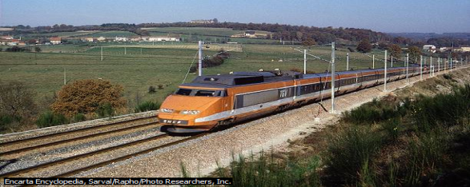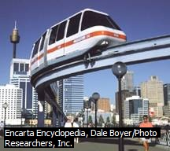

    - High-speed trains – like Maglev, short term for Magnetic Levitation Train, also maglev train, a high-speed ground transportation vehicle levitated above a track called a guideway and propelled by magnetic fields, in England, Germany, Japan and now in China. Magnetic levitation train technology can be used for urban travel at relatively low speeds (less than 100 km/h, or less than 62 mph). For example, a short-distance maglev shuttle operated for 11 years from 1984 to 1995 between the Birmingham, England, airport and the city train station. However, the greatest worldwide interest is in high-speed maglev systems. Train speeds of 552 km/h (343 mph) have been demonstrated by a full-size maglev vehicle in Japan, while in Germany a maglev train has run at 450 km/h (280 mph) and in China a maglev train has reached a peak speed of 432 km/h (268 mph).
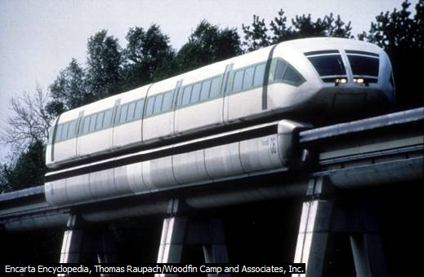

    - Luxury trains – are mostly used to cater tourists and provide some amenities and services typically not found in regular trains. Like restaurants, bar, lounge, rooms, casino and other recreation to give the tourist the luxuries and enjoyment of a travel from origin to the final destination.

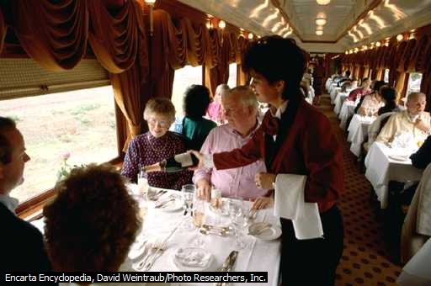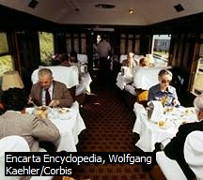

f. Freighter trains – are used to carry cargoes or goods mostly for far distances.
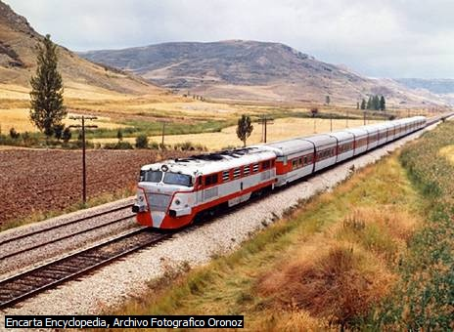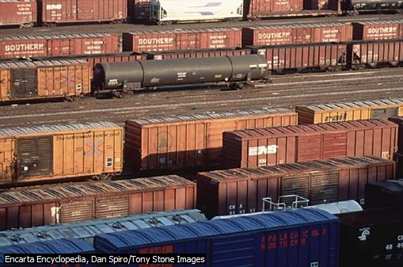

The famous railway transportations of the world:

The great trains of the world include:

1. Orient Express-London to Paris crosses the Swiss and Austrian Alps and concludes at Venice (Italy).It is often considered as “The Train of Kings, the king of Trains” is the most famous train in the world.
2. Trans-Siberian special-a leisurely 19 day voyage from Moscow to Mongolia
3. The Blue Train- provides a 24 hour luxurious trip from Cape Town to Pretoria, South Africa.
4. The palace of Wheels-India
5. The Royal Scotsman-/Scotland/, which menders through the Scottish highlands
6. The Bullet Train /Japan’s shinkansen/-Japan
7. France’s Train a’ Grande Vitesse /TGV/- France
8. Amtrak /American track/- one of the world’s modern train systems, America

Amtrak Accommodation

Accommodations on Amtrak trains vary considerably. In general, two types of accommodations are available:

- Coach accommodation
- Private accommodation
1. Coach accommodation-
It provides seating chair facilities. Seating in coach section is similar to that on an airplane or bus. Some trains have special coach sleeping accommodations called slumber coaches. These rooms provide a retractable bed and toilet facilities.

2. Private compartments-
It provides a sleeping facility in a coach. Private compartments on some trains are available in two configurations.

Roomette- is a single room for one traveler, with a retractable bed and toilet facilities. It is larger than slumber coach, which requires only a coach ticket.
Bedroom- bed room accommodations are available in six configuration, depending on the train:-
- Economy bed room- accommodates two adults, without private bathroom
- Standard Bed room- has two berths/ sleeping seat in a train/, a toilet and a washbasin(hand basin)
- Family Bed room- has three berths and seating for five with the beds retracted
- Deluxe Bed room-located on the upper level, with bathroom facilities
- Handicapped Bed room- rooms for disabled travellers have special facilities for wheel chair users
- Suite Bed room- consists of two adjoining rooms with flour beds

2.3. Service Characteristics of Surface Transportation

- Accessibility – any person can have the access of this mode at a place anytime they want to go to their destinations.

- Flexibility - Land vehicles can go to any place they want where other modes cannot penetrate compared with airplanes, trains and ships.

- Distribution networks – wide distribution or supply of goods and services from the provider to the final consumers.

- Speed – the speed of land transportation is slow to some extent compared with other modes in bringing people and goods to the destinations.

- Load and range of services offered – it can carry minimal volume of cargoes or load at a time; and services provided by the land transportation vehicles are usually basic and limited to some extent. Only few providers offer additional service to the public or tourists.

- Level of competition – high degree of competition among land transportation operators and providers.

- Cost – considered cheaper in overall cost compared to other modes.
2.4. Institutional Organizations Related to Surface Transportation

- Ethiopian Investment Agency (EIA) – the one in-charge for various activities and projects like in tourism and transportation. Investors need to comply with the existing policies promulgated for investment purpose.

- Ministry of Works and Urban Development through Ethiopian Roads Transport Authority (ERA) – for road projects and infrastructural development.

- Ministry of Transport and Communications – the body in-charge of the overall supervision and activities in the transportation and communication sectors. A special body under this is also in-charge for regulatory and franchising of transport units or for operations. Transportation Bureau Regional/Zonal Offices for the issuance of driver’s license and permits in every region.

- Ministry of Economic Development and Cooperation – for the local and national programs and activities, projects for economic development or based in the Millennium development goals.

- Ministry of Finance – the one-in-charge of providing the needed budget for any government projects, activities or infrastructural reforms like road construction, airports, terminals and other basic services either through the national budget or loan from other financial institutions.

- Ethiopian Customs Authority – the overall body in-charge in administering and enforcing tariffs and other related laws and to provide revenue for the country. The authority assesses and collects import duties and taxes, regulates carriers and merchandise entering or departing form Addis Ababa, detects and prevents smuggling and frauds and related issues.

- Ethio-Djibouti Railway Office – one of the premier modes of transportation in Ethiopia in transporting goods and people from Addis Ababa to Dire Dawa and then to the port of Djibouti. The Office is the controlling body for overall operations of the railway system.

