Ethiopian TVET-System



**IT SUPPORT SERVICE LEVEL II**

Based on May 2011 Occupational Standards

October, 2019

**Module Title: Administering Network Hardware and Peripheral**

**TTLM Code: ICT ITS2TTLM 1019v1**

**This module includes the following Learning Guides**

**LG18:- Confirm Requirements of Clients**

**LG Code: ICT ITS1 M06 LO1LG18**

**LG19: Obtain required peripheral**

**LG Code: ICT ITS1 M06LO2LG19**

**LG20: Connect hardware peripherals**

**LG Code: ICT ITS1 M06 LO3LG20**

**LG21: Install peripherals to a network**

**LG Code: ICT ITS1 M06LO4**

**LG22:- Configure peripheral service**

**LG Code: ICT ITS1 M06LO5LG22**

**LG23: Administer and support peripheral services**

**LG Code: ICT ITS1 M06LO6LG23**

**LG24: Maintain peripherals and fix common problems**

**LG Code: ICT ITS1 M06LO7LG24**

**LG25: Use and maximize operating system**

**LG Code: ICT ITS1 M06LO8LG25**

**LG26. Support input and output devices**

**LG Code: ICT ITS1 M06LO9LG26**

|  |  |
| --- | --- |
| **Instruction Sheet** | **LG18 – Confirm requirements of clients** |

This learning guide is developed to provide you the necessary information regarding the following content coverage and topics:-

* Identify and confirmclientperipherals***.***
* Document clientrequirements and peripherals***.***
* Verify clientrequirements.
* Ensure warranty and support services.

This guide will also assist you to attain the learning outcome stated in the cover page.

Specifically, upon completion of this Learning Guide, you will be able to –

* Identify and confirm client peripherals in accordance with organizational standards.
* Document the client requirements and peripherals in line with organizational standards and findings are reported to the appropriate person.
* Verify the client requirements with appropriate person in line with organizational standards and reporting procedures
* Ensure client support expectations are covered by vendor and support services.

**Learning instruction:**

1. Read the specific objectives of this Learning Guide.
2. Follow the instruction describe below 1
3. Read the information written in the information “sheet 1, sheet2,sheet3 and sheet4” , “in page 3.4.5.6.8.10 and 12 ” respectively
4. Accomplish the “self-check 1, self-check 2,self-check 3,self-check 4,” “in page 7,9,11,and 13”

Respectively

1. If you earned a satisfactory evaluation from the “self-check” proceed to “operation sheet 1” “in page 14 and 15”
2. Do the” LAB “Test in page “16”

\*Your teacher will evaluate your output either satisfactory or unsatisfactory. If unsatisfactory, your teacher shall advice you on additional work. But if satisfactory you can proceed to the next topic.

|  |  |
| --- | --- |
| **Information Sheet – 1** | **Identify and confirm client peripherals** |

# 

* 1. Identifying and conforming Client peripheral with organizational standard

# Overview of peripheral devices

Peripheral devices are the devices that are attached to the computer’s system unit. They can be divided into either:

* input
* output
* communication, or
* secondary storage devices
  + 1. Peripheral device
       1. Input Devices

In computing, an input device is a piece of computer hardware equipment used to provide data and control signals to an information processing system such as a computer or information appliance. Examples of input devices include keyboards, mouse, scanners, digital cameras, joysticks, and microphones.

* + - 1. Output Devices

An output device is any piece of computer hardware equipment which converts information into human-readable form. In brief, output unit is responsible for providing the output in user readable form. It can be text, graphics, tactile, audio, and video.

**Component of input device**

**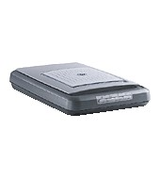Mouse**

A mouse is a [device](http://www.webopedia.com/TERM/M/device.html) that controls the movement of the [cursor](http://www.webopedia.com/TERM/M/cursor.html) on a screen.

**Scanners**

A scanner is a device that captures text or illustrations on paper and

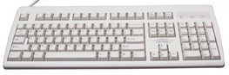converts the information into a form the computer can use.

**Keyboard**

a combination of a typewriter keyboard and numeric keypad,

a keyboard enables you to enter data into a computer.

**Web Cam**

Web cams are small cameras that plug into your computer which allow the user to share a moving image of themselves with others on other computers through the Internet.

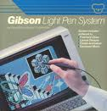

**Light Pen**

It is an input device that with utilize alight sensitive detector to select objects a display screen.

**Microphones**

Microphone is attach a computer by a cable that can transmit sounds and used to

gather sound information to the computer when the computer is a multimedia

system.

**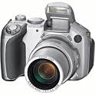Digital camera**

The digital camera takes a still photograph, stores it and then sends it as

digital input in to computer.

**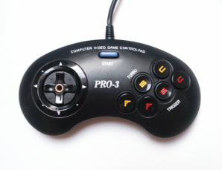Joy Stick**

Joystick is popular pointing device, used mostly for playing computer games.

**Bar Code**

The bar code is identifies the product to the supermarket’s computer and has

a description and the latest price of the product.

**Component of Output device**

Monitor (LED, LCD, and CRT):

The age of **CRT** (cathode ray tube) displays is over and **LCD** displays are already being replaced with **LED** screens. ... While **LCD monitors** use CCFL (cold cathode fluorescent lamps) for backlighting, the latter use light emits diodes. This is the prime **difference between** the two display technologies.

Printers (all types):- a printer is a peripheral device which makes a persistent representation of graphics or text on paper. While most output is human-readable, bar code printers are an example of an expanded use for printers.

Plotters: - A plotter is a printer that interprets commands from a computer to make line drawings on paper with one or more automated pens. Unlike a regular printer, the plotter can draw continuous point-to-point lines directly from vector graphics files or commands. ... As a rule, plotters are much more expensive than printers.

Projector: - A projector is an output device that can take images generated by a computer or Blu-ray player and reproduce them by projection onto a screen, wall, or another surface. ... Projectors can produce either still (slides) or moving images (videos). ... Today, most projectors use either an HDM

Speaker(s):- A loudspeaker is an electro acoustic transducer; a device which converts an electrical audio signal into a corresponding sound.

Head Phone: - Headphones traditionally refer to a pair of small loudspeaker drivers worn on or around the head over a user's ears. They are electro acoustic transducers, which convert an electrical signal to a corresponding sound.

* + 1. organizational standard

Organisations often have a set of standards which are required to be adhered to when it comes to purchasing equipment. Standards allow organisations to:

* Ensure that all equipment used within the organisation meets satisfactory levels of operation.
* Ensure that the equipment used is compatible with other equipment in use.
* Ensure that support staff is trained to service and maintain the equipment in use.
* Budget for and plan the timely upgrade of equipment.
  + - 1. Personal use of emails and internet access

The **Internet**, sometimes called simply "the Net," is a worldwide system of computer networks -- a network of networks in which users at any one computer can, if they have permission, get information from any other computer (and sometimes talk directly to users at other computers).

Email is one of the fundamental internet technologies, a tool used by nearly every person with an internet connection. It allows you to, at no cost; send a letter of unlimited length to one person – or many people at once. It arrives almost instantly, and they can reply straight away. Setting up your own email account will allow you to communicate with people you know in ways you never thought possible

Email is the modern way to send letters – you can send a message to the other side of the world and get a reply in minutes! Email is short for electronic mail. An email is a letter that is sent over a computer network instead of being sent through the post. You can attach documents and photos to emails, just like you can include a photo or a document with a letter.

Internet has been the most useful technology of the modern times which helps us not only in our daily lives, but also our personal and professional lives developments. The internet helps us achieve this in several different ways.

For the students and educational purposes the internet is widely used to gather information so as to do the research or add to the knowledge of various subjects. Even the business professionals and the professionals like doctors, access the internet to filter the necessary information for their use. The internet is therefore the largest encyclopedia for everyone, in all age categories. The internet has served to be more useful in maintaining contacts with friends and relatives who live abroad permanently.

* + - 1. **Content of emails**

As in the case of normal mail system, e-mail is also based upon the concept of a recipient address. The email address provides all of the information required to get a message to the recipient from anywhere in the world.

Consider the e-mail [ID.john@hotmail.com](mailto:ID.john@hotmail.com) In the above example john is the username of the person who will be sending/receiving the email. Hotmail is the mail server where the username john has been registered and com is the type of organization on the internet which is hosting the mail server.

**1.2.1.3 Downloading information and accessing particular websites**

Downloading is the process of copying a file (such as a game or utility) from one computer to another across the internet. When you download a game from our web site, it means you are copying it from the author or publisher’s web server to your own computer. This allows you to install and use the program on your own machine.

**1.2.1.4 Opening mail with attachments**

You can open an attachment from the Reading Pane or from an open message. In either case, double-click the attachment to open it. To open an attachment from the message list, right-click the message that has the attachment, click View Attachments, and then click the name of the attachment.

* + - 1. **Virus risk (MS windows OS and Mac OS only**)

Windows has the reputation of the most vulnerable operating system to malware. It is on the other hand, the most used desktop and laptop platform around the world.

You may have wondered why you always need to have an anti-virus on windows system but never on Linux or Mac OS systems. Although antivirus software is necessary for each platform, but Windows is most susceptible to attacks.

* + - 1. **Dispute resolution, document procedures and templates**

The **goal** of the **dispute resolution** process is to exchange and review information in order to determine whether revision or rescission is warranted of discipline, end of employment or other application of **policy**.

1.2.1.7 **Communication methods and financial control mechanisms**

Control techniques provide managers with the type and amount of information ... Organizational Communication · Improving Communications ... Financial statements provide management with information to monitor financial resources and activities. ... A budget, in reality, is both a planning tool and a control mechanism.

|  |  |
| --- | --- |
| **Self Check 1** | **Written Test** |

Name:\_\_\_\_\_\_\_\_\_\_\_\_\_\_\_\_\_\_\_\_ Date:\_\_\_\_\_\_\_\_\_\_\_\_\_\_\_\_\_

*Direction:*  Choose the best answer for the following question, if you have some clarifications – feel free to ask your teacher.

# A peripheral device is?

# A device attached to the computer’s system unit C. Hardware part of computer

# External part of a computer system D. All

# One of the following is input device?

# Monitor C. Scanner

# Printer D. Projector

1. **\_\_\_\_\_\_ is a** combination of a typewriter and numeric keypad?
2. Printer C. Webcam
3. Keyboard D. Mouse
4. Output device in computer is?
5. Printer C. Microphone
6. Light pen D. Digital camera
7. Internet is?
8. Is a worldwide system of computer networks
9. Is the modern way to send letters – you can send a message to the other side of the world
10. Is a combination of networks of network
11. A and C

***Note:* Satisfactory rating - 3 points Unsatisfactory - below 3 points**

|  |  |
| --- | --- |
| **Information Sheet – 2** | **Documenting client requirements and peripherals** |

1.2 **Documenting Client requirements, peripherals and reporting findings to appropriate person**

# Identify and clarify user/client requirements and document these in a requirements specification file according to organizational guidelines.

# Investigate and document a solution to the requirements. Document any additional requirements discovered in the investigation and provide advice and support on the

Steps to document requirements

1. Create a comprehensive explanation of what is needed for a product. ...
2. Interview various sources. ...
3. List system requirements or properties. ...
4. Identify any constraints for the project. ...
5. Consider any interface requirements. ...
6. Identify parameters like cost and scheduling. ...
7. Work up a development plan. ...
8. Insert visuals.

After analysis of the client’s requirements, you should fully document the client’s requirements and report them to your supervisor.

This document may take the forms, but would include the following:

* background information such as company details
* problems and issues that may have led to the client’s request
* questions asked during your meeting with the client and their answers to those questions, as well as a list of any essential criteria
* other options or possibilities of which the client may not have been aware
* Any information for the client that will help them understand what they’re getting into before you go ahead with the job (or project).

A covering memo should be attached, stating the purpose of your report and asking the supervisor for their acceptance of the report.

|  |  |
| --- | --- |
| **Self Check 2** | **Written Test** |

Name:\_\_\_\_\_\_\_\_\_\_\_\_\_\_\_\_\_\_\_\_ Date:\_\_\_\_\_\_\_\_\_\_\_\_\_\_\_\_\_

# *Direction:* Write TRUE If the Statement Is Correct, FALSE If It Is Incorrect, if you have some clarifications – feel free to ask your teacher.

# \_\_\_\_\_\_\_\_\_\_Requirements specification is file according to organizational guidelines.

# \_\_\_\_\_\_\_\_\_\_ Reporting is one of checking requirement analysis.

# \_\_\_\_\_\_\_\_\_\_ Each client need their specification on the organization.

# \_\_\_\_\_\_\_\_\_\_ Interview is one method of collecting information from clients.

# \_\_\_\_\_\_\_\_\_\_ a covering memo should not be attached, stating the purpose of your report and asking the supervisor.

***Note:* Satisfactory rating - 3 points Unsatisfactory - below 3 points.**

|  |  |
| --- | --- |
| **Information Sheet – 3** | **Verifying and reporting client requirement** |

* 1. **Verifying and reporting Client requirements**

Identifying the client means obtaining certain basic information about your client and any third party directing, instructing or who has the authority to direct or instruct your client such as a name and address. You must obtain this information whenever you are retained to provide legal services to a client unless an exemption applies.

Verifying the identity of a client means actually looking at an original identifying document from an independent source to ensure that your clients and any third parties are who they say they are. You are only required to verify the identity of your client and such third parties if you are involved in a funds transfer activity, that is, you engage in or instruct with respect to the payment, receipt or transfer of funds*.* You are not required to identify and/or verify the identity of your client and such third parties in all situations.

**Methods of verification**

Verification techniques can be classified into formal or informal, and static or dynamic. Four main verification methods are inspection, demonstration, testing, and analysis. Some of the popular verification techniques include desk checking, inspections, walkthroughs, and reviews.

|  |  |
| --- | --- |
| **Self Check 3** | **Written Test** |

Name:\_\_\_\_\_\_\_\_\_\_\_\_\_\_\_\_\_\_\_\_ Date:\_\_\_\_\_\_\_\_\_\_\_\_\_\_\_\_\_

# *Instruction:* Choose the best answer for the following question, if you have some clarifications – feel free to ask your teacher.

1. Verifying client support is
2. Obtaining certain basic information about your client
3. Any third party directing, instructing
4. Who has the authority to direct or instruct your client such as a name and address
5. All
6. How to verify the identity of client
7. Is looking at an original identifying document from an independent source to ensure that your clients
8. Obtaining certain basic information about your client
9. Any third party directing, instructing
10. All
11. You are only required to verify the identity of your client by
12. you engage in or instruct with respect
13. payment
14. receipt or transfer of funds
15. All
16. Verification techniques can be classified into
17. formal or informal
18. static or dynamic
19. demonstration
20. A & B
21. One of the following is main verification methods?
22. Inspection, demonstration, testing, and analysis.
23. static or dynamic
24. formal or informal
25. All

***Note:* Satisfactory rating - 3 points Unsatisfactory - below 3 points.**

|  |  |
| --- | --- |
| **Information Sheet – 4** | **Ensure client support expectation by vendor warranty** |

* 1. **Taking action to ensure client support expectation by vendor warranty and support services**

# Warranties and support

Before acquiring hardware peripheral devices, it is vital to assess what kind of warranties, service and support, prospective suppliers will provide.

## Warranties

A warranty is an agreed upon term which covers a computer or computer component. Generally, most computers have a 1 or 3 year warranty. This warranty may or may not cover the service, repair and replacement of computer parts.

An extended warranty is an available option provided by manufacturers or third-party companies that provides additional support and/or repair of a computer or other hardware devices beyond its standard warranty.

## Service and support

It is important to know what kind of support services are offered by the prospective supplier. There are many questions to consider such as:

* If a device requires repairs does it have to be sent back to the supplier (called ‘Return to base’) or will they provide on-site visits?
* What is the average response time if service is required?
* What kinds of maintenance and repair costs could be incurred during the duration of use of the device?
* Will the device require regular servicing? If so, how many services will be necessary over a one-year period?

|  |  |
| --- | --- |
| **Self Check 4** | **Written Test** |

Name:\_\_\_\_\_\_\_\_\_\_\_\_\_\_\_\_\_\_\_\_ Date:\_\_\_\_\_\_\_\_\_\_\_\_\_\_\_\_\_

# *Direction:* filling the appropriate answer for the following question in the specie provided, if you have some clarifications- feel free to ask your teacher.

# \_\_\_\_\_\_\_\_\_\_\_\_ is an agreed upon term which covers a computer or computer component.

# \_\_\_\_\_\_\_\_\_\_\_\_ is an available option provided by manufacturers or third-party companies that provides additional support.

# \_\_\_\_\_\_\_\_\_\_\_\_ a device requires repairs does it have to be sent back to the supplier.

# \_\_\_\_\_\_\_\_\_\_\_\_ Will the device requires regular servicing?

# 

***Note:* Satisfactory rating - 3 points Unsatisfactory - below 3 points.**

|  |  |
| --- | --- |
| **Operation Sheet – 1** | **Procedure of how to opining, downloading email attachment in internet** |

# To open email in internet follow the following instruction

**You’ll need:**

* a computer with internet connection
* an email that is set up and ready to send and receive emails.

**Follow these step-by-step instructions to open an attachment**

**Step 1:** Log in to your email account.

**Step 2:** Make sure you’re in your inbox.

**Step 3:** An email with an attachment will have a paperclip icon next to it to show that there’s something attached to the email you’ve received. Click on the icon.

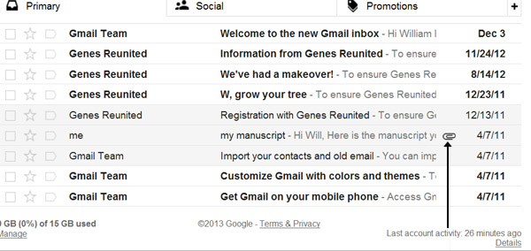

**Step 4:** The email will open up with the attachment shown at the bottom.

**Step 5:**Hover over the attachment to see the download options. In this instance, you can open the document as a 'Google Doc' or download it to your computer. We will click the **down arrow**to download it to our computer.



Another box will pop up asking if you want to ‘Open’, ‘Save’ or ‘Cancel’ the download. Click **Save**.

You may see a box similar to this.

Another box will pop up asking if you want to ‘Open’, ‘Save’ or ‘Cancel’ the download. Click **Save**.You may see a box similar to this:

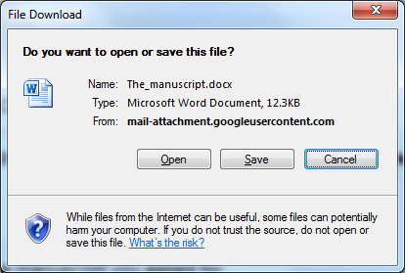

Or this:

Attachment options

**Step 6:** Find a place to save your document and download it to your computer. Once the document has been downloaded, you may be offered another dialogue box with further options: open the document itself by clicking **Open**; or open the folder to which the document has been saved by clicking **Open folder**.

Attachment options

**Step 7:** Click **Back to Inbox** to go back to your list of received emails. You’ll now be able to access through your Windows folders the attachment saved on your computer.

|  |  |
| --- | --- |
| **Lap Test** | **Practical Demonstration** |

Name: \_\_\_\_\_\_\_\_\_\_\_\_\_\_\_\_\_\_\_\_\_\_\_\_\_\_\_\_\_ Date: \_\_\_\_\_\_\_\_\_\_\_\_\_\_\_\_\_\_\_\_\_\_\_

Time started: \_\_\_\_\_\_\_\_\_\_\_\_\_\_\_\_\_\_\_\_\_\_\_\_ Time finished: \_\_\_\_\_\_\_\_\_\_\_\_\_\_\_\_

**Instructions:** You are required to perform the following individually with the presence of your teacher.

* *Your teacher will evaluate your output either satisfactory or unsatisfactory. If unsatisfactory, your teacher shall advice you on additional work. But if satisfactory, you can proceed to the next topic.*

Task 1. How to open a file from email?

Task 2. How to download attachable file an email?

|  |  |
| --- | --- |
| **Instruction sheet** | **LG19 – Obtain required peripheral** |

This learning guide is developed to provide you the necessary information regarding the following content coverage and topics:-

* Obtaining a peripheral
* Hardware inventories
* Checking contents
* Storing peripherals
* Storing consumables

This guide will also assist you to attain the learning outcome stated in the cover page.

Specifically, upon completion of this Learning Guide, you will be able to:-

* Peripherals are obtained under instruction from appropriate person.
* Peripherals are entered into equipment inventory according to organizational standards.
* Contents of delivered components and physical contents that match the packing list are validated and resolved discrepancies if necessary.
* Peripherals are stored according to vendor/manual guidelines.

**Learning instruction:**

1. Read the specific objectives of this Learning Guide.
2. Follow the instruction describe below
3. Read the information written in the information “sheet 1, sheet 2,sheet 3 and sheet 4” , “in page 3.4.5.6.8.10.11.13,14,15,16,and 17 ” respectively
4. Accomplish the “self-check 1, self-check 2,self-check 3,self-check 4,” “in page 7,12,14,and 18”

Respectively

\*Your teacher will evaluate your output either satisfactory or unsatisfactory. If unsatisfactory, your teacher shall advice you on additional work. But if satisfactory you can proceed to the next topic.

|  |  |
| --- | --- |
| **Information Sheet – 1** | **Obtaining a peripheral** |

# 

* 1. **Obtaining peripherals under instruction**

The first step in obtaining a peripheral device is to locate suppliers of that device. Then, there are factors you need to consider about the supplier and the devices on offer, such as support provided and purchase price. This will help you to compare and choose the most appropriate supplier and the exact model of the device according to client requirements. Finally, you are ready to place an **order** for your organisation or client to purchase the device.

## 

## Locating a supplier:- There are many ways to find a supplier of peripheral equipment. Some ways include:

### Searching the Internet

The Internet provides different methods for searching for suppliers. Using search engines such as *Google* or *Yahoo* can help you find a hardware supplier anywhere in the world. Suppliers will often have their own websites that can provide you with catalogues of available equipment. Other ways to investigate suppliers are to follow links from a website such as a manufacturer’s website, or to browse website directories that may be linked to search engine home pages.

### PC magazines

Computing magazines often contain a large section devoted to advertising current hardware suppliers.

### Newspapers

Major newspapers have computer/IT sections or classified advertisements which can be a source for finding suppliers.

### Brochures/advertising material

Many larger hardware suppliers use television, radio or leaflet deliveries to inform potential customers of their latest hardware.

### Telephone directory: - A telephone directory is useful if you need to find a hardware supplier located within your local area.

### Contacting the manufacturer directly

Manufacturers generally have their own websites. These may list major suppliers in your area. Emailing or telephoning the manufacturer may also be a way to find out names of local suppliers.

## 

## Choosing a supplier

With so many choices of suppliers available, how do you find the right one? There are a few factors to consider:

* **How long has the supplier been operating?** It is a good idea to find a supplier who will still be around for the lifetime of the hardware.
* **Does the supplier offer suitable support and training?** If the client will be requiring a lot of additional assistance, training could be a major contributing factor for choosing a particular supplier.
* **Does the supplier offer competitive pricing?** Considering the support and stability, it is also important to weigh up these factors in relation to price. For a client with a strict budget, price may be a big issue when determining where to purchase hardware.
* **Is the supplier a preferred supplier for your organisation?** Some organisations have arrangements that equipment must be purchased from suppliers who are considered to be the preferred provider for the organisation. Organisations create these agreements because customer loyalty offers substantial discounts, extended warranties and additional support.

## 

## Selecting a peripheral

Once you have selected suitable suppliers you need to contact each supplier. Information you should find out from the supplier includes:

* model and manufacturer names of peripherals that will satisfy the majority of your clients requirements (including system specifications, physical dimensions, support)
* price of each model
* Availability of each model.

You may find it helpful to keep a record of any details that you collect so you refer to this information quickly and easily.

## 

## Placing an order

Depending on the type of organisation you work for, placing an order for a hardware peripheral device could be done in a variety of ways. In a small organisation you may be responsible for ordering the device yourself. However, in a larger organisation there may be employees who are responsible for purchasing new equipment. You may need to fill out an **order form** that can be given to the purchasing department.

Before an order is submitted, it could also be necessary to obtain final approval from senior staff. Often an order form might require signatures from the manager or supervisor before it can be processed. A purchasing department might require **written quotes** from **three suppliers**, a **recommendation** and **justification** for the chosen supplier.

Make sure that you find out from your supervisor or manager what procedures you need to follow when placing an order within your organisation.

## 

## Sample order form

From

Date

|  |  |  |  |  |
| --- | --- | --- | --- | --- |
| Code | Quantity | Description | Price | Supplier: name and telephone |
|  |  |  |  |  |
|  |  |  |  |  |
|  |  |  |  |  |
|  |  |  |  |  |

|  |  |
| --- | --- |
| COST |  |
| GST |  |
| TOTAL |  |

Delivery point

Budget holder’s signature

**Please return to the Purchasing Department**

|  |  |
| --- | --- |
| **Self Check 1** | **Written Test** |

Name:\_\_\_\_\_\_\_\_\_\_\_\_\_\_\_\_\_\_\_\_ Date:\_\_\_\_\_\_\_\_\_\_\_\_\_\_\_\_\_

*Direction:*  Choose the best answer for the following question, if you have some clarifications – feel free to ask your teacher.

# The first step in obtaining a peripheral device is?

# Locate suppliers

# Placing an ordered

# Selecting

# All

# Which of the following is locating of supplier?

# Searching in internet

# News paper

# Contacting the manufacturing directly

# All

# Factor of considering choosing a supplier?

# Telephone directory

# Does the supplier offer suitable support and training

# Contacting the manufacturing directly

# Placing an ordered

# Information you should find out from the supplier is

# Selecting a peripheral

# Written quotes from three suppliers

# Model and manufacturer names of peripherals that will satisfy the majority of your clients requirements

# All

***Note:* Satisfactory rating - 3 points Unsatisfactory - below 3 points.**

|  |  |
| --- | --- |
| **Information Sheet – 2** | Entering peripherals into equipment inventory |

* 1. **Entering peripherals into equipment inventory**

**Hardware inventories**

The purpose of a hardware inventory (or registry) is to keep detailed information about all the hardware equipment within an organisation. Every piece of hardware, including each computer and peripheral device, should be recorded on the inventory. As well as providing an excellent quick reference guide to the organisation’s hardware, an inventory can be very useful for insurance, warranty and service purposes.

In order for an inventory to be a valuable source of information, it is vital that the information be maintained regularly. New devices need to be entered into the inventory as soon as they have been obtained.

There are a number of tools available to create hardware inventories. Databases and spreadsheets are often used to store the information. There are also software programs that you can purchase, designed specifically for recording hardware and software details.

Details that should be included within a hardware inventory include:

|  |  |
| --- | --- |
| * description of hardware device | * serial number |
| * manufacturer | * warranty or maintenance conditions |
| * supplier | * components |
| * model number | * location |
| * number and identity of authorised users | * purchase price |
|  | * date of purchase |

## Documenting peripherals used with each computer

If the peripheral is an essential part of the computer system (for example mouse, keyboard or monitor) it is logical to record information about the device within the documentation for the computer to which it is connected. Individual computer inventories will often contain detailed information about the computer’s related hardware and software. It may also be more practical to record information about the peripheral inside the computer’s record, if the device is also permanently connected to a computer (for example a printer or scanner).

### Hardware inventory (Example 1)

#### Details for Administration Computer

|  |  |  |  |
| --- | --- | --- | --- |
| Manufacturer: | Dell |  |  |
| Model: | OptiPlex GX280MT Minitower—Power | Monitor: | Dell UltraSharp™ 1905FP flat panel, |
| Operating System: | Windows XP | Printer: | HP LaserJet IID |
| Serial number: | 12345 | Keyboard: | Dell USB keyboard |
| RAM: | 128 Mb | Pointing device: | Dell USB 2-button optical mouse with scroll |
| Hard disk space: | 160 Gb |  |  |

### Individually documenting each peripheral device

# If the device is shared between several computers, it makes more sense to keep information about the peripheral as an individual entry in an inventory. Devices such as digital cameras, data projectors and USB drives would more likely to be used by many computers, thus it would make more sense to record their details separate to the computer details.

# Hardware inventory (Example 2)

# 2069_uf01

* + 1. **Workstations**: - is a special computer designed for technical or scientific applications, **workstations** offered higher performance than mainstream personal computers, especially with respect to CPU and graphics, memory capacity, and multitasking capability.
    2. **Server**

A **server** is a computer, a device or a program that is dedicated to managing **network** resources. There are a number of categories of **servers**, including print **servers**, file **servers**, **network servers** and database **servers**. In theory, whenever computers share resources with client machines they are considered **servers**.

* + 1. **Modems or other connectivity devices**

Broadband **Modems** Cellular **modems** are **a** type of digital **modem** that establishes internet **connectivity** between **a** mobile **device** and **a** cell phone **network**. The word **modem** is **a** mash up of the term modulation/demodulation, which is the technical term for the conversion between digital and analog signals.

* + 1. **Printers, hard drives, monitors**

A peripheral is a “device that is used to put information into or get information out of the computer.” Output, which provides output to the user from the computer (**monitors**, **printers**, etc.) Storage, which stores data processed by the computer (**hard drives**, flash **drives**, etc.)

* + 1. **Switches**

A network switch is networking hardware that connects devices on a computer network by using packet switching to receive, and forward data to the destination device. A network switch is a multiport network bridge that uses media access control addresses to forward data at the data link layer of the OSI model.

2.2.6 **Hubs**

A **hub**, also called a **network hub**, is a common connection point for devices in a **network**. **Hubs** are devices commonly used to connect segments of a LAN. The **hub** contains multiple ports. When a packet arrives at one port, it is copied to the other ports so that all segments of the LAN can see all packets.

* + 1. **Bridge**

A network bridge is a computer networking device that creates a single aggregate network from multiple communication networks or network segments. This function is called network bridging. Bridging is distinct from routing.

* + 1. **Router**

A **router** is a device that forwards data packets along **networks**. A **router** is connected to at least two **networks**, commonly two LANs or WANs or a LAN and its ISP's **network**. **Routers** are located at gateways, the places where two or more **networks** connect.

* + 1. **Firewall**

A **firewall** is a system designed to prevent unauthorized access to or from a private **network**. You can implement a **firewall** in either hardware or software form, or a combination of both. **Firewalls** prevent unauthorized internet users from accessing private networks connected to the internet, especially intranets.

|  |  |
| --- | --- |
| **Self Check 2** | **Written Test** |

# *Direction:* filling the appropriate answer for the following question in the specie provided, if you have some clarifications- feel free to ask your teacher.

# \_\_\_\_\_\_\_\_\_\_\_\_\_ is a device that forwards data packets along networks.

# \_\_\_\_\_\_\_\_\_\_\_\_\_ is a computer networking device that creates a single aggregate network from multiple communication networks or network segments.

# \_\_\_\_\_\_\_\_\_\_\_\_\_ is a common connection point for devices in a network.

# \_\_\_\_\_\_\_\_\_\_\_\_\_ is a system designed to prevent unauthorized access to or from a private network.

# \_\_\_\_\_\_\_\_\_\_\_\_\_ is a multiport network bridge that uses media access control addresses to forward data at the data link layer of the OSI model.

# \_\_\_\_\_\_\_\_\_\_\_\_\_ is a device that is used to put information into or get information out of the computer.

# \_\_\_\_\_\_\_\_\_\_\_\_\_ is a computer, a device or a program that is dedicated to managing network resources.

# \_\_\_\_\_\_\_\_\_\_\_\_\_ is a special computer designed for technical or scientific applications.

***Note:* Satisfactory rating - 3 points Unsatisfactory - below 3 points.**

|  |  |
| --- | --- |
| **Information Sheet – 3** | **Validating delivered component and physical content** |

2.3 **Validating delivered component and physical content**

# Checking contents

When **unpacking** any peripheral device, an organised and methodical approach needs to be taken. Randomly ripping open boxes and packaging without carefully identifying each component can potentially cause many problems later on.

Prepare a **suitable work area** before you begin unpacking. This should include a large sturdy flat area with no carpet so that small components will not be lost.

Before commencing to open any packaging, find the **manual** for the device. **Check instructions** for any precautions or specific unpacking procedures. Most manuals will also contain a section that tells you a list of included components. It is useful to create a **checklist** based on the component list. You will then be able to use the checklist to mark off the components when they have been identified.

Below is a sample checklist for a typical inkjet printer.

* printer
* cartridge
* power cable
* USB cable
* sample paper
* feeding device
* CD driver

# Be attentive when unpacking a peripheral device — handles the packaging and contents with care, as you do not want to damage your new device. Remove any packing material surrounding and also within the device. Some printers, for example, have soft foam and plastic pieces inside the device to ensure that parts are locked into the correct position. Make sure that you remove these pieces and foam before installation.

|  |  |
| --- | --- |
| **Self Check 3** | **Written Test** |

Name:\_\_\_\_\_\_\_\_\_\_\_\_\_\_\_\_\_\_\_\_ Date:\_\_\_\_\_\_\_\_\_\_\_\_\_\_\_\_\_

# *Direction:* Write TRUE If the Statement Is Correct, FALSE If It Is Incorrect, if you have some clarifications – feel free to ask your teacher.

# \_\_\_\_\_\_\_\_\_\_ Packaging without carefully identifying each component can potentially cause many problems later on.

# \_\_\_\_\_\_\_\_\_\_ Prepare a suitable work area before you begin unpacking.

# \_\_\_\_\_\_\_\_\_\_ to open a new packing device doesn’t need any manuals.

# \_\_\_\_\_\_\_\_\_\_ a power cable is one sample cheek of a printer device.

***Note:* Satisfactory rating - 3 points Unsatisfactory - below 3 points.**

|  |  |
| --- | --- |
| **Information Sheet – 4** | **Storing peripherals** |

* 1. **Storing peripherals**

# Storing peripherals

Peripheral devices need to be located in a suitable environment — otherwise there may be potential problems. It is a good idea to refer to the manufacturer’s manual to determine what guidelines should be followed. When storing peripherals it is important to:

* make sure equipment is kept in ideal working conditions
* adhere to current Occupational Health and Safety guidelines
* ensure the electrical safety of the device
* Consider security of the device.

## Keeping equipment in ideal working conditions

Each manufacturer will have their own recommendations on how to store their peripheral equipment. In order to guarantee that a peripheral will function correctly throughout its life it is important to follow guidelines that have been recommended by the manufacturer. Some common recommendations may include:

* **Keep equipment in the correct position**: - after unpacking, most devices will usually have a proper resting position. If a device is not kept in its natural position, there could be problems when trying to operate the device later on. For example, when a printer is stored in a vertical position, components such as the ink cartridges could leak or be dislodged.
* **Keep equipment away from weather, dust and other harmful material**: - When finding a storage location, consider what kind of elements the device may be subjected to. If, for example, you store a USB drive in a cabinet next to chalk, dust from the chalk could potentially damage the storage device’s USB connection.
* **Do not expose equipment to extreme temperatures and high humidity**: - Sudden changes in temperature can cause condensation in many peripheral devices. For instance, if a video camera is taken from a cold place to a warm place, condensation may form on the lens and internal parts.
* **Avoid storing the device in direct sunlight**: - Exposure to direct sunlight could damage many of the external components of a device as well as subject the device to high temperatures.
* **Do not expose equipment to water or moisture**: - If water gets inside many peripheral devices there is a risk of electric shock.

## 

## Adhering to OH&S guidelines

When positioning peripherals in their permanent locations it is important to take into account many OH&S considerations as follows.

### Positioning of the monitor

It is essential to position a monitor correctly to ensure it will suit the needs of the user. Tips include:

* Try to make sure that monitor is in a position away from the glare of sunlight.
* Check that the brightness and contrast controls of the screen have been adjusted to suit lighting conditions in the room.
* The top of the screen should be the same level as the user’s eye level.

### Positioning of the keyboard

A keyboard also needs to be positioned carefully to be of adequate comfort and safety for the user.

Some tips include:

* Position the keyboard directly in front of the monitor and at the same height as the mouse.
* The keyboard should allow the user’s forearms to be parallel to the floor.
* Allow space for the computer user to rest their wrists.

### Positioning of other equipment

Some general Occupational Health and safety guidelines to consider when positioning other peripheral equipment are:

* Make sure that you can reach the peripheral device and its components without having to strain your back.
* Place equipment such as scanners and printers at a suitable height so a user is easily able to reach paper trays, open scanner lids, etc.
* Make sure that equipment such as speakers is easily accessible if settings such as volume control need to be changed.

### Ensuring electrical safety

Some tips to ensure electrical safety are:

* Do not be tempted to add too many extension cables or double socket adapters to your existing electrical sockets.
* Never use damaged plugs or leads.
* If possible, ask an electrician to check the safety of your system.
* Position electrical leads where they will not cause tripping hazards to people.

## 

## Physical security of devices

# In many situations it is important to consider the physical security of the peripheral devices. Some devices, such as digital cameras, data projectors and USB drives, may not be permanently connected to a computer so it will be necessary to find a secure location to store the device. Make sure that these kinds of devices are secured in a lockable storage cupboard, cabinet or safe when not required. Some organizations install security devices onto desks to guarantee that computers are secure and will not be able to be taken from their position unless unlocked.

|  |  |
| --- | --- |
| **Self Check 4** | **Written Test** |

Name:\_\_\_\_\_\_\_\_\_\_\_\_\_\_\_\_\_\_\_\_ Date:\_\_\_\_\_\_\_\_\_\_\_\_\_\_\_\_\_

# Directions: Match column A with the correct answer on column B, write only the letter of answer on the blank provided at the right side of the test paper.

# Column “A” Column “B”

# \_\_\_\_\_\_ Peripheral devices A. Away from the glare of sunlight

## \_\_\_\_\_\_ Ideal working conditions B. Adequate the comfort and safety

### \_\_\_\_\_\_ Positioning of the monitor C. Digital cameras & USB derives

### \_\_\_\_\_\_ Positioning of the keyboard D. Locate in a suitable environment

## \_\_\_\_\_\_ Physical security of devices E. Dust and other harmful material

***Note:* Satisfactory rating - 3 points Unsatisfactory - below 3 points.**

|  |  |
| --- | --- |
| **Instruction sheet** | **LG20: Connect hardware peripherals** |

This learning guide is developed to provide you the necessary information regarding the following content coverage and topics:-

* Verifying installation time frame
* Removing old Peripherals
* Connecting new peripherals by taking into account operating systems
* Configuring computers to accept new peripherals based on business requirement
* Testing and confirming compatibility issues and hardware peripherals to meet client satisfaction

This guide will also assist you to attain the learning outcome stated in the cover page. Specifically, upon completion of this Learning Guide, you will be able to:-

* Timeframe for installation schedule is verified with the client requirement.
* Old peripherals are removed if they are being replaced with minimal disruption to clients, taking into account environmental considerations and OHS standards.
* New peripherals are connected with minimum disruption to clients, taking into account operating system procedures.
* The computer configured to accept the new peripherals based on business requirement
* Hardware peripherals are tested and confirmed to client satisfaction, pay particular attention to possible impact on other systems and make adjustments as required.

**Learning instruction:**

1. Read the specific objectives of this Learning Guide.
2. Follow the instruction describe below
3. Read the information written in the information “sheet 1, sheet 2,sheet 3 and sheet 4” , “in page 3,5,10 and 12 ” respectively
4. Accomplish the “self-check 1, self-check 2,self-check 3,self-check 4,” “in page 2,9,11and 14”

Respectively

\*Your teacher will evaluate your output either satisfactory or unsatisfactory. If unsatisfactory, your teacher shall advice you on additional work. But if satisfactory you can proceed to the next topic.

|  |  |
| --- | --- |
| **Information Sheet – 1** | **Verifying installation time frame** |

* 1. **Verifying installation time frame**

Approximately 6-8 weeks: - Once the installation date has been established, a highly skilled window installer can usually install 12-15 windows per day. Thus, the average window job takes approximately 6-8 weeks from start to finish from the date the contract is signed.

# 

|  |  |
| --- | --- |
| **Self Check 1** | **Written Test** |

Name:\_\_\_\_\_\_\_\_\_\_\_\_\_\_\_\_\_\_\_\_ Date:\_\_\_\_\_\_\_\_\_\_\_\_\_\_\_\_\_

# *Direction:* filling the appropriate answer for the following question in the specie provided, if you have some clarifications- feel free to ask your teacher.

# \_\_\_\_\_\_\_\_\_\_\_\_Once the installation date has been established, a highly skilled window installer can usually install 12-15 windows per day.

# The average window job takes approximately 6-8 weeks from \_\_\_\_\_\_\_\_\_\_\_\_\_\_

***Note:* Satisfactory rating - 3 points Unsatisfactory - below 3 points.**

|  |  |
| --- | --- |
| **Information Sheet – 2** | **Removing old peripherals** |

* 1. **Removing old Peripherals**

Almost every piece of hardware attached to your Windows computer will show up in Device Manager as an installed device. This includes [Graphics card](https://www.raymond.cc/blog/having-problems-with-video-card-stress-test-its-memory/)s, CPUs, USB devices, disk drives, network adapters and just about anything else. When the device is first connected to the computer, Windows will pick it up and either [installs the device driver](https://www.raymond.cc/blog/the-easiest-way-to-automatically-install-device-drivers-on-any-windows-xp-computer/) automatically or you install it yourself from CD or the internet.

After that, it’s not a problem while the device remains connected but can potentially become a problem [if you disconnect it](https://www.raymond.cc/blog/remount-ejected-or-safely-removed-usb-device-without-unplug-and-reinsert/). The driver that was installed when the new hardware was connected does not get uninstalled when the hardware is removed. Over time this can leave dozens of driver entries on the system for devices which have long since been removed. Some applications also do the same and install a software driver but don’t remove it when you [uninstall the software](https://www.raymond.cc/blog/monitor-software-installs-remove-leftovers-install-monitor/).

* + 1. Environmental considerations

The components that go into computers are exceptionally valuable to recycle, and are extremely toxic or dangerous to the environment if released or disposed of incorrectly.

Heavy metals used in batteries or circuits pollute groundwater and kill animals. Batteries are also readily flammable and are unsafe to go into mixed garbage. There is a large quantity of plastic used in most electronics, which will take decades to break down, and often this plastic is ABS. ABS is based on polystyrene, and as such it will break down into toxic particulate as it degrades.

You should do your best to make sure you buy equipment that will last as long as is feasible for you and your business. The environmental impact of the initial construction of electronic equipment can be quite high, so making your equipment last as long as is practical would go a long way towards making sure that you keep your footprint small. That being said, old computer equipment degrades in performance, and at some point there is a breakdown of the value proposition in continuing to service and use old equipment. In other words, there is a point where it makes more economic and ideological sense to dispose of your old equipment in a safe way, rather than keep using it. You should make the determination as to when that is, because only you really understand the personal costs to continued use.

3.2.2.1 **Disposal of packaging**

To make sure you dispose of old computers and hardware safely follows these steps.

1. Backup your data. Before you do anything, backup your hard drive so you don't lose any data.
2. Wipe your hard drive. Clearing data off our computer is no easy process.
3. Donate, resell, or recycle. You can't just throw your computer away.

A typical computer has many negative influences on the environment, anywhere from the manufacturing of computers to the distribution of computers. This has caused many questions and awareness among individuals who are concerned with the negative influences on the environment; which may cause hurdles for the new generations to come. There are various ways one should manufacture, buy, use and dispose computers so the negative impact on the environment can be reduced.

3.2.1.2 Disposal of redundant hardware

Used computer disposal means that there will be a need for the disposal of computer parts when equipment cannot be re-used. This raises issues within the WEEE directive and at Concept we feel that environmental legislation is a difficult, oft misunderstood topic that is subject to wide interpretations.

When **disposing** of an old PC, there is really only one way to securely erase the information on the **hard drive**: You must destroy the magnetic platter inside. Use a T7 screwdriver to remove as many screws as you can access. You'll probably be able to remove the main circuit board from the enclosure.

* + 1. **OHS standards**

Occupational Safety and Health Standards. Written by Bureau of Working Conditions Hits: 71973. The Occupational Safety and Health Standards were formulated in 1978 in compliance with the constitutional mandate to safeguard the worker's social and economic well-being as well as his physical safety and health.

Environmental and safety requirements. The operator or the application may not been in a clean and air-conditioned room. Power supplies may not be well regulated. There is no computer room environment. Equipment designated to be installed in the home will have to meet stringent standards regarding audio noise and radio frequency interference. They also need to meet relevant safety standards.

* + - 1. **Physical hazards**

A physical hazard is defined as "A factor within the environment that can harm the body without necessarily touching it. Vibration and noise are examples of physical hazards". Physical hazards include but aren't limited to electricity, radiation, pressure, noise, heights and vibration amongst many others.

* + - 1. **Chemical hazards**

A chemical hazard is simply the risks involved with using a chemical. So in the workplace chemical hazards can be; Health **hazards** - where workers and other personnel are exposed to **hazardous chemicals** through inhalation, absorption through the skin, or ingestion and swallowing.

* + - 1. **Ergonomics**

**Ergonomics** (from the Greek word ergon **meaning** work, and nomoi **meaning** natural laws), is the science of refining the design of products to optimize them for human use. ... Computers and related products, such as computer desks and chairs, are frequently the focus of **ergonomic** design.

**Ergonomics** is the science of designing the **workplace**, keeping in minds the capabilities and limitations of the worker. ... A systematic **ergonomics** improvement process removes risk factors that lead to musculoskeletal injuries and allows for improved human performance and productivity.

3.1.1.4 **Psychological factors**

**Physiological factors** are things related to your physical body that affect your thinking. For **example**, when your body's chemistry is off, due to unbalanced nutrition, dehydration, alcohol, etc., the neurotransmitters that control your thinking processes can be affected.

* + - 1. **Burglary**

The criminal offense of breaking and entering a building illegally for the purpose of committing a crime. **Burglary**, at Common **Law**, was the trespasser breaking and entering of the dwelling of another at night with intent to commit a felony therein. It is an offense against possession and habitation.

* + - 1. **Fire**

**Fire** is the product from a chemical reaction between oxygen in the atmosphere and some sort of fuel (wood or gasoline, for example). "The combustion or burning, in which substances combine chemically with oxygen from the air and typically give out bright light, heat, and smoke."

* + - 1. **Power accidents**

Nuclear **power** plants are complex systems operated by human beings who can and do make mistakes. As such, they are vulnerable to **accidents** and failures because of natural disasters such as flooding, earthquakes and extreme weather, fires, equipment failures, improper maintenance, and human errors.

|  |  |
| --- | --- |
| **Self Check 2** | **Written Test** |

Name:\_\_\_\_\_\_\_\_\_\_\_\_\_\_\_\_\_\_\_\_ Date:\_\_\_\_\_\_\_\_\_\_\_\_\_\_\_\_\_

*Direction:* filling the appropriate answer for the following question in the specie provided, if you have some clarifications- feel free to ask your teacher.

1. \_\_\_\_\_\_\_\_\_\_\_\_\_\_\_ is defined as A factor within the environment that can harm the body without necessarily touching it.
2. \_\_\_\_\_\_\_\_\_\_\_\_\_\_\_ are things related to your physical body that affect your thinking.
3. \_\_\_\_\_\_\_\_\_\_\_\_\_\_\_ is the product from a chemical reaction between oxygen in the atmosphere and some sort of fuel
4. \_\_\_\_\_\_\_\_\_\_\_\_\_\_ is the science of refining the design of products to optimize them for human use.
5. \_\_\_\_\_\_\_\_\_\_\_\_\_ Constitutional mandate to safeguard the worker's social and economic well-being as well as his physical safety and health.

***Note:* Satisfactory rating - 3 points Unsatisfactory - below 3 points.**

|  |  |
| --- | --- |
| **Information Sheet – 3** | **Connecting new peripherals by taking in to account operating system** |

* 1. **Connecting new peripherals by taking into account operating systems**.

**Install and configure computer peripheral devices**

The peripheral devices are those devices which are connected to the computer and it helps the computer function. These devices contain both the input devices, which are used to give command to the computer and the output devices, which help computer showing the result to the user.

The computer works with many peripheral devices so it's important to know that how much these devices can be installed in the computer and how can a persona configure them. Following are the devices which are used by the computer and the ways they can be configured;

## Hardware Minimum Requirements

Please keep the following hardware requirements in mind when selecting a laptop to use in the Business School. Systems purchased within the past two (2) years will typically be outfitted with the recommended features. Please confirm that your laptop meets these requirements. *Remember that if your laptop does not meet the minimum requirements, among other issues, you will not have access to ITG Support Specialists, who are key to getting your computer configured for the School's network and keeping it correctly configured when you encounter problems. Most critically, your laptop runs the risk of not supporting software that is required for your courses.*

**How to Check Computer Configuration**

Although most computer users are aware of the importance of basic PC components like the RAM and hard drive, other components -like the graphics and sound cards, network adapter and central processing unit - are also critical to a PC's operation. You need this information to troubleshoot or upgrade your computer and when downloading drivers. For the best performance, business owners should keep up-to-date with their computer equipment; to determine whether or not you should upgrade a workstation, review the PC's configuration in Windows.

In communications or **computer** systems, a **configuration** of a system refers to the arrangement of each of its functional units, according to their nature, number and chief characteristics. Often, **configuration** pertains to the choice of hardware, software, firmware, and documentation.

|  |  |
| --- | --- |
| **Self Check 3** | **Written Test** |

Name:\_\_\_\_\_\_\_\_\_\_\_\_\_\_\_\_\_\_\_\_ Date:\_\_\_\_\_\_\_\_\_\_\_\_\_\_\_\_\_

# *Direction:* Write TRUE If the Statement Is Correct, FALSE If It Is Incorrect, if you have some clarifications – feel free to ask your teacher.

# \_\_\_\_\_\_\_\_\_ Peripheral devices are those devices which are connected to the computer and it helps the computer function.

# \_\_\_\_\_\_\_\_\_ Computer works with many peripheral devices so it's important to know that how much these devices can be installed in the computer and how can a persona configure them.

# \_\_\_\_\_\_\_\_\_ most computer users are aware of the importance of basic PC components.

# \_\_\_\_\_\_\_\_\_ a configuration of a system refers to the arrangement of each of its functional units.

# .

***Note:* Satisfactory rating - 3 points Unsatisfactory - below 3 points.**

|  |  |
| --- | --- |
| **Information Sheet – 4** | **Testing and confirming compatibility issues and hardware peripherals to meet client satisfaction** |

* 1. **Testing and confirming compatibility issues and hardware peripherals to meet client satisfaction**

Compatibility testing is a type of software testing used to ensure compatibility of the system/application/website built with various other objects such as other web browsers, hardware platforms, users (in case if it's very specific type of requirement, such as a user who speaks and can read only a particular language).

Compatibility is nothing but the capability of existing or living together. In normal life, Oil is not compatible with water, but milk can be easily combined with water.

Compatibility Testing is a type of Software testing to check whether your software is capable of running on different hardware, operating systems, applications, network environments or [Mobile](https://www.guru99.com/mobile-testing.html) devices.

Let's look into compatibility testing types

* **Hardware**: It checks software to be compatible with different hardware configurations.
* **Operating Systems**: It checks your software to be compatible with different Operating Systems like Windows, Unix, Mac OS etc.
* **Software**: It checks your developed software to be compatible with other software. For example, MS Word application should be compatible with other software like MS Outlook, MS Excel, [VBA](https://www.guru99.com/vba-tutorial.html) etc.
* **Network:** Evaluation of performance of a system in a network with varying parameters such as Bandwidth, Operating speed, Capacity. It also checks application in different networks with all parameters mentioned earlier.
* **Browser**: It checks the compatibility of your website with different browsers like Firefox, Google Chrome, Internet Explorer etc.
* **Devices**: It checks compatibility of your software with different devices like USB port Devices, Printers and Scanners, Other media devices and Blue tooth.
* **Mobile**: Checking your software is compatible with mobile platforms like Android, iOS etc.
* **Versions of the software:**It is verifying your software application to be compatible with different versions of the software. For instance checking your Microsoft Word to be compatible with Windows 7, Windows 7 SP1, Windows 7 SP2, Windows 7 SP3.

|  |  |
| --- | --- |
| **Self Check 4** | **Written Test** |

Name:\_\_\_\_\_\_\_\_\_\_\_\_\_\_\_\_\_\_\_\_ Date:\_\_\_\_\_\_\_\_\_\_\_\_\_\_\_\_\_

*Direction:*  Choose the best answer for the following question, if you have some clarifications – feel free to ask your teacher.

1. Compatibility testing is
2. a type of software testing used to ensure compatibility of the system/application/website built with various
3. Evaluation of performance of a system in a network with varying parameters
4. It checks compatibility of your software with different devices
5. It checks software to be compatible with different hardware configurations.
6. Type of compatibility testing is
7. **Hardware C. Network**
8. **Browser D. All**
9. **\_\_\_\_ is** verifying your software application to be compatible with different versions of the software.
10. **Browser C. Software**
11. **Versions of the software D. All**
12. **\_\_\_\_** It checks your developed software to be compatible with other.
13. **Versions of the software C. Software**
14. **Browser D. Devices**

***Note:* Satisfactory rating - 3 points Unsatisfactory - below 3 points.**

|  |  |
| --- | --- |
| **Instruction sheet** | **LG21: Install peripherals to a network** |

This learning guide is developed to provide you the necessary information regarding the following content coverage and topics:-

* Planning location of peripherals to provide service to users
* Connecting peripherals to the network
* Connecting peripherals to computers using parallel, serial and other direct connection
* Testing Peripherals

This guide will also assist you to attain the learning outcome stated in the cover page. Specifically, upon completion of this Learning Guide, you will be able to:-

* Location of peripherals are planned to provide appropriate services to users and to take into consideration OHS standards.
* Peripherals are connected to network, using vendor-approved method and technology.
* Peripherals are connected to computers in the network
* Using parallel, serial or other direct connection methods appropriate for the job order.
* Peripherals are tested for correct operation based on client’s specifications.

**Learning instruction:**

1. Read the specific objectives of this Learning Guide.
2. Follow the instruction describe below
3. Read the information written in the information “sheet 1, sheet 2,sheet 3 and sheet 4” , “in page 3,4,6,7,9 and 11 ” respectively
4. Accomplish the “self-check 1, self-check 2,self-check 3,self-check 4,” “in page 5,8 and 10”

Respectively

\*Your teacher will evaluate your output either satisfactory or unsatisfactory. If unsatisfactory, your teacher shall advice you on additional work. But if satisfactory you can proceed to the next topic.

|  |  |
| --- | --- |
| **Information Sheet – 1** | **Planning location of peripherals to provide service to users** |

* 1. **Planning location of peripherals to provide service to users**

A **computer peripheral** is a device that is connected to a computer but is not part of the core computer architecture. The core elements of a computer are the central processing unit, power supply, motherboard and the computer case that contains those three components. Technically speaking, everything else is considered a peripheral device. However, this is a somewhat narrow view, since various other elements are required for a computer to actually function, such as a hard drive and random-access memory (or RAM).

Most people use the term peripheral more loosely to refer to a device external to the computer case. You connect the device to the computer to expand the functionality of the system. For example, consider a printer. Once the printer is connected to a computer, you can print out documents. Another way to look at peripheral devices is that they are dependent on the computer system. For example, most printers can't do much on their own, and they only become functional when connected to a computer system.

**Types of Peripheral Devices**

There are many different peripheral devices, but they fall into three general categories:

1. **Input devices**, such as a mouse and a keyboard
2. **Output devices**, such as a monitor and a printer
3. **Storage devices**, such as a hard drive or flash drive

Some devices fall into more than one category. Consider a CD-ROM drive; you can use it to read data or music (input), and you can use it to write data to a CD (output).

Peripheral devices can be **external** or **internal**. For example, a printer is an external device that you connect using a cable, while an optical disc drive is typically located inside the computer case. Internal peripheral devices are also referred to as integrated peripherals. When most people refer to peripherals, they typically mean external ones.

The concept of what exactly is 'peripheral' is therefore somewhat fluid. For a desktop computer, a keyboard and a monitor are considered peripherals - you can easily connect and disconnect them and replace them if needed. For a laptop computer, these components are built into the computer system and can't be easily removed.

How can you **connect peripheral devices** to a **computer**? One connects **Computer** Peripherals to **Computer** Systems through the I/O ports designed for that purpose, e.g. Universal Serial Bus (USB), PCI Express, SATA, SCSI, FireWire (IEEE 1394), Thunderbolt (interface), HDMI, etc.

|  |  |
| --- | --- |
| **Self Check 1** | **Written Test** |

Name: \_\_\_\_\_\_\_\_\_\_\_\_\_\_\_\_\_\_\_\_ Date: \_\_\_\_\_\_\_\_\_\_\_\_\_\_\_\_\_

*Direction:*  Choose the best answer for the following question, if you have some clarifications – feel free to ask your teacher.

# The core elements of a computer are

# Central processing unit C. Motherboard

# Power supply D. All

# Which elements are required for a computer to actually function?

1. Power supply  **C.** hard drive and random-access memory (or RAM).

# Motherboard D. keyboard

# The use of printer is

# Output of document from pc C. Inserting images in pc

# Input device D. All

# Types of peripheral device are

# Input C. Process

# Output D. All

# \_\_\_\_\_\_\_ is example of internal peripheral device

# Optical disc drive C. keyboard

# Printer D. Mouse

***Note:* Satisfactory rating - 3 points Unsatisfactory - below 3 points .**

|  |  |
| --- | --- |
| **Information Sheet – 2** | **Connecting peripherals to the network** |

* 1. **Connecting peripherals to the network**

Peripherals are devices physically connected to a computer or network that require ‘driver’ software to run them and to be configured to meet requirements of operating systems and network protocols. Single user peripherals can include: printers, scanners, speakers, external DVDs, CDs, game pads and joysticks, graphics tablets and pens, modems, UPS (uninterrupted power supply), removable hard disks and webcams, while printers, network attached storage devices (NAS), and LCD projectors are often accessed over networks.

* + 1. **Large and small LANs, WANs and VPNs**

A **virtual private network** (**VPN**) is programming that creates a safe and encrypted connection over a less secure network, such as the public internet. A **VPN works** by using the shared public infrastructure while maintaining privacy through security procedures and tunneling protocols.

A local-area network (**LAN**) is a computer network that spans a relatively **small** area. Most often, a **LAN** is confined to a single room, building or group of buildings; however, one **LAN** can be connected to other **LANs** over any distance via telephone lines and radio waves.

Many **WANs** are built for one particular organization and are private. Others, built by Internet service providers, provide connections from an organization's LAN to the Internet. **WANs** are often built using leased lines

* + 1. **The internet,**

A global computer network providing a variety of information and communication facilities, consisting of interconnected networks using standardized communication protocols.

The information used to get packets to their destinations is contained in routing tables kept by each router connected to the **Internet**. Routers are packet switches. A router is usually connected between networks to route packets between them. Each router knows about its sub-networks and which IP addresses they use.

The **Internet** is a global wide area network that connects computer systems across the world. It includes several high-bandwidth data lines that comprise the **Internet** "backbone." ... When you connect to the **Internet** using a public Wi-Fi signal, the Wi-Fi router is still connected to an ISP that provides **Internet** access.

**4.2.3 The use of PSTN for dial-up modems only**

Dial-up Internet access is a form of Internet access that uses the facilities of the public switched telephone network (PSTN) to establish a connection to an Internet service provider (ISP) by dialing a telephone number on a conventional telephone line. The user's computer or router uses an attached modem to encode and Because telephone access is widely available,

PSTN stands for Public Switched Telephone Network, or the traditional circuit-switched telephone network. This is the system that has been in general use since the late 1800s. ... The phones themselves are known by several names, such as PSTN, landlines, Plain Old Telephone Service (POTS), or fixed-line telephones.

4.2.4 **Private lines, data and voice**

**Private Line**

A Private Line service is a private data connection securely connecting two or more locations with high data speeds. A private line circuit is a closed network data transport service which does not traverse the public Internet and is inherently secure with no data encryption needed. Private Line services are available in higher bandwidth speeds such as T1, Ethernet private line, DS3 private line.

Private line service provides unparalleled quality of service (QoS) as it is not a shared service and follows the same direct private line network path every time. Private Line circuits are used by businesses to provide reliable, secure point to point data service for applications including credit card processing, file sharing, data backup, point to point VOIP, and video conferencing. Private Line services can also be configured to carry voice, video, Internet, and data services together over the same private line network connection.

|  |  |
| --- | --- |
| **Self Check 2** | **Written Test** |

Name:\_\_\_\_\_\_\_\_\_\_\_\_\_\_\_\_\_\_\_\_ Date:\_\_\_\_\_\_\_\_\_\_\_\_\_\_\_\_\_

*Direction:* filling the appropriate answer for the following question in the specie provided, if you have some clarifications- feel free to ask your teacher.

1. \_\_\_\_\_\_\_\_\_\_\_\_ are devices physically connected to a computer or network that require ‘driver’ software to run them and to be configured to meet requirements of operating systems and network protocols.
2. \_\_\_\_\_\_\_\_\_\_\_\_ is programming that creates a safe and encrypted connection over a less secure network, such as the public internet.
3. \_\_\_\_\_\_\_\_\_\_\_ is a computer network that spans a relatively **small area**.
4. \_\_\_\_\_\_\_\_\_\_\_\_ is a global wide area network that connects computer systems across the world.
5. \_\_\_\_\_\_\_\_\_\_\_\_ is a private data connection securely connecting two or more locations with high data speeds.

***Note:* Satisfactory rating - 3 points Unsatisfactory - below 3 points.**

|  |  |
| --- | --- |
| **Information Sheet – 3** | **Connecting peripherals to computer using parallel, serial and other direct connection** |

Bottom of Form

* 1. **Connecting peripherals to computers using parallel, serial and other direct connection**

How can you **connect peripheral devices** to a **computer**? One connects **Computer** Peripherals to **Computer** Systems through the I/O ports designed for that purpose, e.g. Universal Serial Bus (USB), PCI Express, SATA, SCSI, FireWire (IEEE 1394), Thunderbolt (interface), HDMI,

Some of your **peripherals will need** special software, which **you install** on your **computer** so that your operating system **will** be able to communicate with and send instructions to the **device**.

On PCs, the **parallel port** uses a 25-pin connector (type DB-25) and is used to **connect** printers, computers and other devices that need relatively high bandwidth. It is often called a Getronics **interface** after the company that designed the original standard for **parallel** communication between a computer and printer

**Parallel** busses, which are **used** by SCSI (small computer system interface) and ATA (advanced technology attachment) **ports**, have 16 or more **parallel** wires that are **used** to send bits simultaneously. They are much faster than **serial** busses for identical clock speeds.

A **peripheral** device **connects** to a **computer** system to add functionality. Examples are a mouse, keyboard, monitor, printer and scanner.

|  |  |
| --- | --- |
| **Self Check 3** | **Written Test** |

Name:\_\_\_\_\_\_\_\_\_\_\_\_\_\_\_\_\_\_\_\_ Date:\_\_\_\_\_\_\_\_\_\_\_\_\_\_\_\_\_

# *Direction:* Write TRUE If the Statement Is Correct, FALSE If It Is Incorrect, if you have some clarifications – feel free to ask your teacher.

1. \_\_\_\_\_\_\_\_\_ I/O ports are design for connecting external device to internal computer.
2. \_\_\_\_\_\_\_\_\_Some of your peripherals will need special software.
3. \_\_\_\_\_\_\_\_\_Parallel port uses a 27-pin connector.
4. \_\_\_\_\_\_\_\_\_ a peripheral device connects to a computer system to add functionality.

***Note:* Satisfactory rating - 3 points Unsatisfactory - below 3 points.**

|  |  |
| --- | --- |
| **Information Sheet – 4** | **Testing peripherals** |

* 1. **Testing Peripherals**

How do you test a network?

**Testing Your Computer Network**

1. Check the physical connections. Check that the Link light — the little red or green light next to the RJ-45 port — is lit on every computer. ...
2. Verify that you can log on. ...
3. Check the network configuration. ...
4. This command will spit out numerous lines of information. ...
5. Verify that the computers can ping each other.

|  |  |
| --- | --- |
| **Instruction sheet** | **LG22: Configure peripheral services** |

This learning guide is developed to provide you the necessary information regarding the following content coverage and topics: –

* Installing software to manage local and network-connected peripherals
* Using meaningful name for peripherals and control queues
* Configuring Security and access to make use of peripherals
* Configuring Workstation to allow applications
* Database programs, word processors, email programs, internet browsers, system browsers and spreadsheets

This guide will also assist you to attain the learning outcome stated in the cover page. Specifically, upon completion of this Learning Guide, you will be able to –

* Required software is installed to manage local and network-connected peripherals according to business.
* Requirement software peripherals according to business requirement.
* Meaningful names are used for peripherals and control queues.
* Security and access are configured to allow appropriate users to make use of peripherals.
* Workstation for peripherals is configured to allow applications to work with peripherals.

**Learning instruction:**

1. Read the specific objectives of this Learning Guide.
2. Follow the instruction describe below 1
3. Read the information written in the information “sheet 1, sheet 2,sheet 3 and sheet 4” , “in page 3.4.5.6.8.10 and 12 ” respectively
4. Accomplish the “self-check 1, self-check 2,self-check 3,self-check 4,” “in page 7,9,11,and 13”

Respectively

1. If you earned a satisfactory evaluation from the “self-check” proceed to “operation sheet 1” “in page 14 and 15”
2. Do the” LAB “Test in page “16”

\*Your teacher will evaluate your output either satisfactory or unsatisfactory. If unsatisfactory, your teacher shall advice you on additional work. But if satisfactory you can proceed to the next topic.

|  |  |
| --- | --- |
| **Information Sheet – 1** | **Installing software to manage networked peripherals** |

|  |
| --- |
|  |

**5.1 Installing software to manage local and network-connected peripherals**

System installation and configuration: - A configuration that allows an operating system or application to automatically download and install system updates.

**Network Management**

Network management is defined as the process of managing a network for fault and performance using various tools and technologies to keep up with the business requirements. The objective of network management is to achieve an error free network.

**Installation** or setup is the act of making the system or program ready for execution. Because the process varies for each program and each computer, programs (including operating systems) often come with an installer, a specialized program responsible for doing whatever is needed for their installation.

**Configuration** is an arrangement of functional units according to their nature, number, and chief characteristics. Often, configuration pertains to the choice of hardware, software, firmware, settings, and documentation. The configuration affects system function and performance.

|  |  |
| --- | --- |
| **Self Check 1** | **Written Test** |

Name: \_\_\_\_\_\_\_\_\_\_\_\_\_\_\_\_\_\_\_\_ Date: \_\_\_\_\_\_\_\_\_\_\_\_\_\_\_\_\_

*Direction:* filling the appropriate answer for the following question in the specie provided, if you have some clarifications- feel free to ask your teacher.

1. \_\_\_\_\_\_\_\_\_\_\_ that allows an operating system or application to automatically download and install system updates.
2. \_\_\_\_\_\_\_\_\_\_\_ is defined as the process of managing a network for fault and performance using various tools and technologies.
3. The objective of \_\_\_\_\_\_\_\_\_\_\_\_\_\_\_\_\_\_\_\_\_ is to achieve an error free network.
4. \_\_\_\_\_\_\_\_\_\_\_\_\_\_\_is the act of making the system or program ready for execution.
5. \_\_\_\_\_\_\_\_\_\_\_\_\_\_\_ is an arrangement of functional units according to their nature, number, and chief characteristics.

***Note:* Satisfactory rating - 3 points Unsatisfactory - below 3 points.**

|  |  |
| --- | --- |
| **Information Sheet – 2** | **Using meaningful name for peripherals and control queues** |

* 1. **Using meaningful name for peripherals and control queues**

A peripheral device is typically a device that is external to a computer and connected either wirelessly or via a cable, although some are internal to the digital system. A way of introducing students to peripheral devices is to start with a desktop computer with no other devices connected. Progressively add devices as the different user needs are introduced.

As you install and configure a printer you should keep to the network standards of the organisation, which should include naming conventions for peripherals and other devices.

Each organisation will have its own standards, but it is important that users can identify peripherals easily. There have been cases of users waiting by one printer for their report while it is being printed three floors away.

Naming conventions usually reflect the function of a peripheral, and in the case of a large office or global enterprise, the location. For example, the following may be used for a peripheral name of 15 characters:

**Table 1:** Peripheral naming convention using 15 characters

|  |  |  |  |  |
| --- | --- | --- | --- | --- |
| Characters | **1– 4** | **5–7** | **8–10** | **11–15** |
| Attributes reflected | City or town | Type of peripheral | Workplace location | Uniqueness of device, usually number sequence |

|  |  |
| --- | --- |
| **Self Check 4** | **Written Test** |

Name: \_\_\_\_\_\_\_\_\_\_\_\_\_\_\_\_\_\_\_\_ Date: \_\_\_\_\_\_\_\_\_\_\_\_\_\_\_\_\_

*Direction:* filling the appropriate answer for the following question in the specie provided, if you have some clarifications- feel free to ask your teach.

1. \_\_\_\_\_\_\_\_\_\_\_ is conversation of naming peripheral 1-4 character.
2. \_\_\_\_\_\_\_\_\_\_\_ is conversation of naming peripheral 5-7 character.
3. \_\_\_\_\_\_\_\_\_\_\_ is conversation of naming peripheral 8-10 character.
4. \_\_\_\_\_\_\_\_\_\_\_ is conversation of naming peripheral 11-15 character.

***Note:* Satisfactory rating - 3 points Unsatisfactory - below 3 points .**

|  |  |
| --- | --- |
| **Information Sheet – 3** | **Configuring Security and access to make use of peripherals** |

**5.3 Configuring Security and access to make use of peripherals**

**Network Connections**

After establishing the physical or wireless connections of the computers, you can electronically connect them, test or check that they can "see" each other. Microsoft Windows XP makes networking ridiculously easy. In fact, when writing these lessons, after physically connecting the computers to the router and turning everything on, the whole network had been built and there was no particularly necessary configuration to perform.

To virtually connect the network, Microsoft Windows 7 provides the Network Setup Wizard, which is a series of dialog boxes that can guide you in this process.

Making a peripheral available on the network does not necessarily mean that every single user should have access. Drives may be shared and then permissions allocated to users or groups. All other peripherals will normally provide some means of restricting access.

Setting security access and permissions can help keep peripherals in peak condition. For example, a high-speed laser printer of minimal quality may always print large label runs, or invoices for thousands of clients. A laser printer running at a slower speed but with high print quality may do letters and documents. This uses the advantages of both without placing undue stress on the slower machine. Setting security access and permissions can also ensure protection for confidential documents or activities.

Just how a peripheral is secured will depend upon the operating system used. Windows-based operating systems use the concept of sharing. Sharing a printer works in a similar way to sharing drives. The administrator can select a printer and designate the users that may access it, or set a level of access such as read only, read and execute, modify or full access. In most cases, network administrators enable user access by the following method:

1 Connect the peripheral and install the drivers.

2 Share the peripheral.

3 Allow access to certain users or groups of users.

4 Set the security level for each user or group of users. For example, this may be read only, or read and execute, or modify or full access.

5 On the client’s computer, allow access to the peripheral.

6 Install the drivers for the peripheral on the client’s computer.

|  |  |
| --- | --- |
| **Self Check 4** | **Written Test** |

Name: \_\_\_\_\_\_\_\_\_\_\_\_\_\_\_\_\_\_\_\_ Date: \_\_\_\_\_\_\_\_\_\_\_\_\_\_\_\_\_

# Instruction*:* Choose the best answer for the following question, if you have some clarifications – feel free to ask your teacher.

# Connection of networking is

# To sharing different resources C. sharing of document

# To sharing different files D. All

# Network administration is

# Controlling the overall activity of the computer

# Controlling the all networking

# Giving same permission for the user

# All

# The administrator can select a printer and designate the users that may access it

# Set a level of access such as read only

# Read and execute

# Modify or full access

# All

***Note:* Satisfactory rating - 3 points Unsatisfactory - below 3 points.**

|  |  |
| --- | --- |
| **Information Sheet – 4** | **Configuring Workstation to allow applications** |

5.4 **Configuring Workstation to allow applications**

Configuring workstation

* Perform appropriate steps to set up a basic workstation
  + Plug in cables
  + Power on computer
  + Follow initial operating system setup wizard
    - Localization settings
    - Screen resolution
    - Audio settings
  + Install security software
  + Configure peripherals (if applicable)
  + Uninstall unneeded software (if applicable)
  + Configure and verify Internet connection
  + Install additional software (if applicable)
  + Run software and security updates
  + Other user accounts (if applicable)
  + Basic cable management
* Given a scenario, use software management best practices
  + Install / uninstall
    - OS features
    - Applications
    - Drivers
  + Patching / updates for OS, drivers, applications and security software
    - Scheduling
    - Frequency
    - Automatic updates
  + Software version identification and compatibility
  + Licensing
    - Product keys
    - Single / multi-license

Configure keyboard, mouse, display, sound, etc.

* + Windows: Review [Microsoft: Working with Control Panel](http://windows.microsoft.com/en-us/windows7/working-with-control-panel). Use Control Panel applets to configure keyboard, mouse, display, sound, and other settings.

Create user accounts.

* + Windows: Review [Microsoft: Create a User Account](http://windows.microsoft.com/en-us/windows/create-user-account#create-user-account=windows-7) and [Microsoft: Change Use Account Types](http://windows.microsoft.com/en-us/windows/change-users-account-type#1TC=windows-7). Create a new administrator account and a new standard user account. Test the accounts and identify differences between the account types. Delete the accounts when you're finished.

|  |  |
| --- | --- |
| **Information Sheet – 5** | Database programs, word processors, email programs, internet browsers, system browsers and spreadsheets |

5.5 **Database programs, word processors, email programs, internet browsers, system browsers and spreadsheets**

A **database program** is the heart of a business information system and provides file creation, data entry, update, query and reporting functions. The traditional term for **database software** is "**database** management system"

A **word processor** is software or a device that allows users to create, edit, and print documents. It enables you to write text, store it electronically, display it on a screen, modify it by entering commands and characters from the keyboard, and print it. Of all **computer** applications, **word processing** is the most common.

**Top 10 Email Programs**

* Thunderbird. Thunderbird is a free email client brought to you by Mozilla. ...
* Gmail. Gmail is a browser-based email program provided to you by Google. ...
* Outlook. Outlook is a paid email client by Microsoft. ...
* Hotmail. Hotmail is Microsoft Network's (MSN) solution to free web-based email. ...
* Outlook Express. ...
* Eudora. ...
* Opera. ...
* Yahoo! Mail.

A web **browser**, or simply "**browser**," is an application used to access and view websites. Common web browsers include Microsoft **Internet** Explorer, Google Chrome, Mozilla Firefox, and Apple Safari. For **example**, Ajax enables a **browser** to dynamically update information on a webpage without the need to reload the page.

The **System Browser** is an effective tool for finding components that are not assigned to a **system**. The System Browser opens a separate window that displays a hierarchical list of all the components in each discipline in a project, either by **systems** or by zones

A **spreadsheet** or **worksheet** is a file made of rows and columns that help sort data, arrange data easily, and calculate numerical data. What makes a **spreadsheet** software program unique is its ability to calculate values using mathematical formulas and the data in cells.

|  |  |
| --- | --- |
| **Self Check 1** | **Written Test** |

Name: \_\_\_\_\_\_\_\_\_\_\_\_\_\_\_\_\_\_\_\_ Date: \_\_\_\_\_\_\_\_\_\_\_\_\_\_\_\_\_

*Direction:* filling the appropriate answer for the following question in the specie provided, if you have some clarifications- feel free to ask your teach.

# 1.\_\_\_\_\_\_\_\_ is the heart of a business information system and provides file creation, data entry, update, query and reporting functions.

# 2.\_\_\_\_\_\_\_\_\_ is software or a device that allows users to create, edit, and print documents.

# 3.\_\_\_\_\_\_\_\_\_ is a browser-based email program provided to you by Google.

# 4.\_\_\_\_\_\_\_\_\_ is an application used to access and view websites.

# 5.\_\_\_\_\_\_\_\_\_ is an effective tool for finding components that are not assigned to a system.

***Note:* Satisfactory rating - 3 points Unsatisfactory - below 3 point.**

|  |  |
| --- | --- |
| **Operation** sheet **– 4** | **Procedure of configuring Workstation** |

# Windows 7, as with many of the different operating systems available, has a number of different network functions which can be configured.

# How to configure advanced IPv4 parameters

**Advanced IPv4 Configuration**

Accessing the Network and Sharing Center can be done in two ways. The first way to access it is via the control panel. Select the Windows 7 Orb and then select the control panel option:

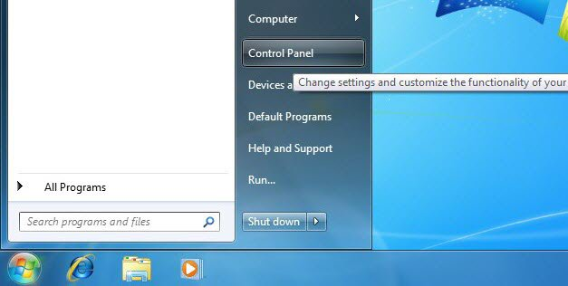

There are several views which are available for the control panel; by default the category view is used. When using the category view, the option that you need to select is called **View network status and Tasks**, as shown below. This will bring you to the Network and Sharing Center.

[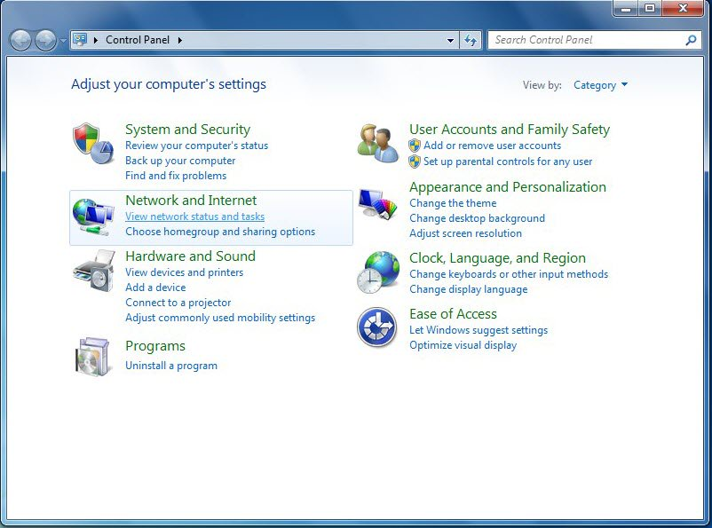](https://www.pluralsight.com/blog/wp-content/uploads/2010/07/02.jpg)

The second way to gain access to the Network and Sharing Center is through the network icon which is displayed in the system tray when a network interface has been enabled. When you right-click this icon the option to open the Network and Sharing Center is given.

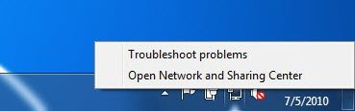

Once the Network and Sharing Center is open there is an option which allows the change of adapter settings which is shown in the upper left hand corner of the window.

[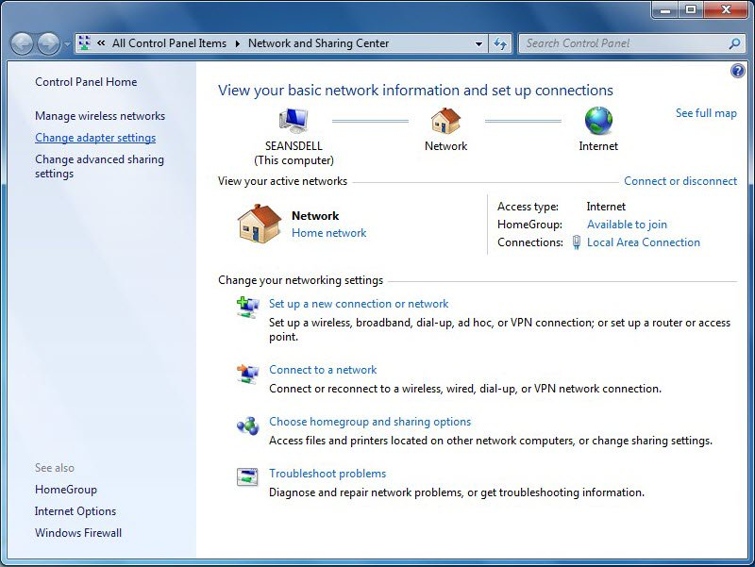](https://www.pluralsight.com/blog/wp-content/uploads/2010/07/04.jpg)

Once in the **Network Connections** window, you can select an interface (either wired or wireless) that you want to configure with a static IP address.

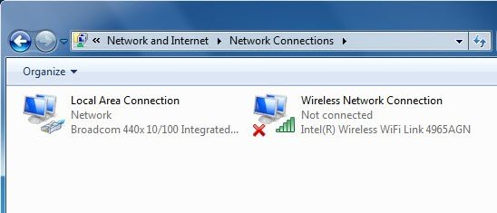

By right-clicking on the correct interface a sub-menu pups up; from this menu you can select the properties option.

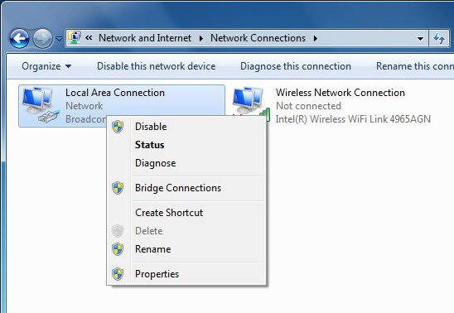

Once the properties option is selected the interface properties windows will be displayed. This screen gives the option to configure a number of different network parameters.

This section is focused on advanced IPv4 configuration parameters, to configure these settings select the IPv4 option. Once the IPv4 option is selected the properties button will be enabled, press on this properties button.

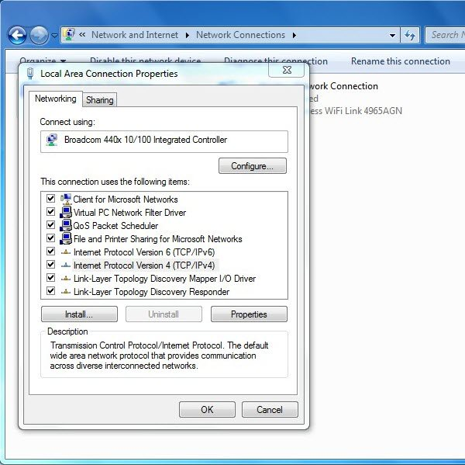

When the properties button is pressed the IPv4 properties window is shown.

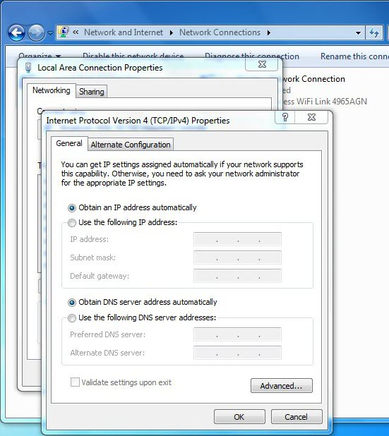

From the IPv4 properties screen you can choose to enter static IP or DNS entries, configure the use of multiple IP addresses on a single interface, configure the use of DNs suffixes, WINS servers and change the setting of NetBIOS over IP. All of these different tasks are shown below.

The following figure shows that a static IP address and DNS address (es) can be configured from the main screen. It is possible to statically configure DNS servers while also obtaining an IP address automatically but it is not possible to have DNS servers obtained automatically with a static IP address.

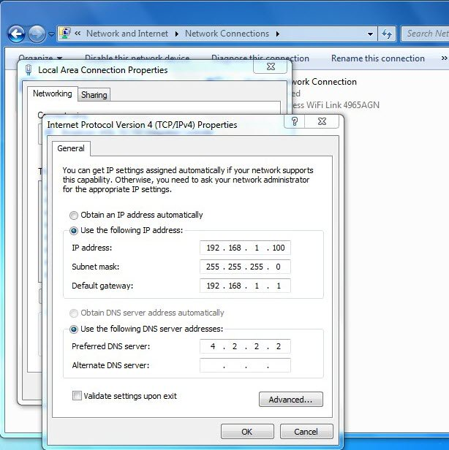

If more advanced configuration is required then the use of the advanced IPv4 settings is required. To gain access to these settings press the **advanced** button.

**IP Settings in Windows 7**

* The IP settings tab gives the option to add multiple IP addresses to the interface, (this is typically used when an IP address transition is happening from one IP network to another; this gives the ability to speak on both networks), multiple default gateways to the interface (keep in mind that each new network will require a matching gateway which is reachable from that network) and the configuration of a metric for the interface.
* The metric option is only used when more than one interface is used for connectivity. The interface with the lowest metric will get priority until the higher priority interface goes down or is disabled. All of these tasks are shown in the following figures:

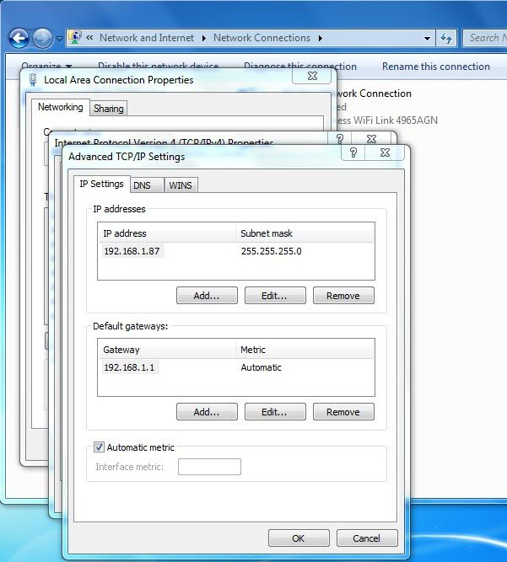

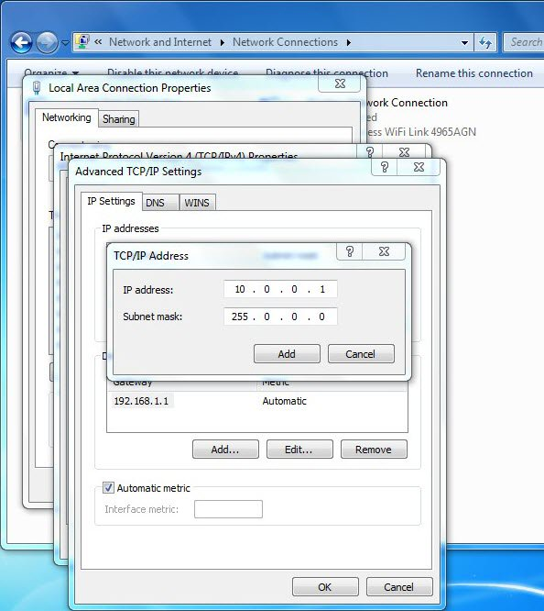

|  |  |
| --- | --- |
| **Operation Sheet – 2** | **Viewing the Connected Computers** |

|  |  |  |
| --- | --- | --- |
| |  | | --- | | **Practical Learning: Viewing the Connected Computers** | |  |  1. On one of the computers, click Start -> My Network Places. If you don't see that option in the right column of the Start menu, depending of your configuration, click Start -> Settings -> Network Connections. Then, under Other Places, click My Network Places. As an alternative, you can click Start -> Control Panel or Start -> Settings -> Control Panel. Under Other Places, click My Network Places. 2. Under Network Tasks, click View Workgroup Computers |

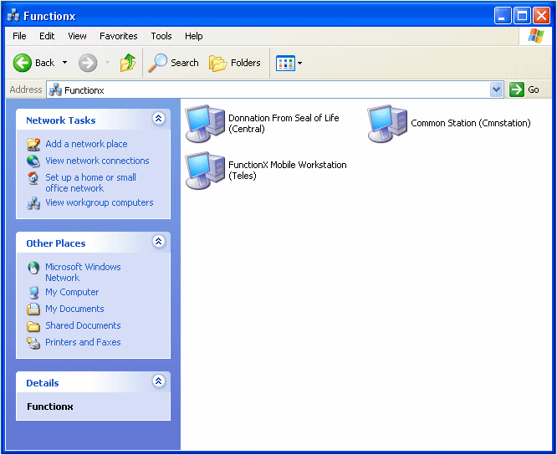

# 

|  |  |
| --- | --- |
| **Operation Sheet – 3** | **Creating a Computer Account** |

# Joining a Domain

**Creating a Computer Account**

After creating a domain, you can add client computers to it. In our examples, we will add workstations that run Microsoft Windows XP Professional. There are two actions to adding a client to a Microsoft Windows Server 2003 domain but only one is required.

Before physically or electronically adding a client to a domain, you can first create a computer account for it. To create a computer account, you have various alternatives:

* If using the Manage Your Server window, you can click Manage Users And Computers In Active Directory
* You can also click Start -> Administrative Tools -> Active Directory Users And Computers
* You can also click Start -> Control Panel -> Administrative Tools -> Active Directory Users And Computers

Any of these actions would open the Active Directory Users and Computers window. In the left frame, expand the name of the domain. Then you can right-click the name of the domain -> New -> Computer. This would open the New Object - Computer dialog box. In the Computer Name text box, enter the name of the computer. The operating systems before Windows 2000 don't use very long names. Therefore, when naming a computer, keep this in mind and give a name made of fewer than 15 characters. After naming the computer, click Next twice and click Finish.

Instead of right-clicking the name of the domain, in the Active Directory Users And Computers, you can expand the name of the domain, right-click the Computers node -> New -> Computer. As mentioned already, in the first page of the New Object - Computer wizard, you can type a name for the computer. Here is an example:

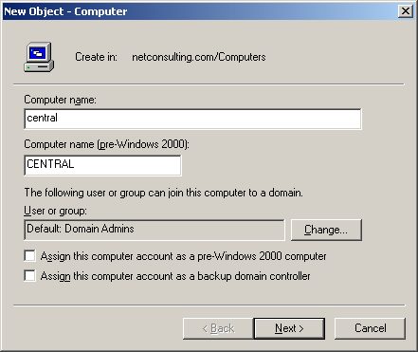

Then click Next, Next, and Finish.

|  |  |
| --- | --- |
| **Operation Sheet – 4** | **Joining a Domain** |

# Joining a Domain

After creating an account for a computer, you can add it to the domain. This is referred to as joining a domain. Normally, primarily creating an account for a computer is not required although it's a good idea. When joining a domain, if the computer you are adding doesn't have one already, an account would be created for it.

To join a domain using Microsoft Windows XP Professional:

1. First display the System Properties dialog box. To do this,

|  |
| --- |
| * + You can right-click My Computer and click Properties...   + You can display Control Panel and double-click System |

1. In the System Properties, click Computer Name
2. Click Change...
3. In the Computer Name text box, enter the desired name of the computer. If you had already created an account in the domain for this computer, type that name
4. In the Member Of section, click the Domain radio button
5. Click the Domain text box and enter the name of the domain

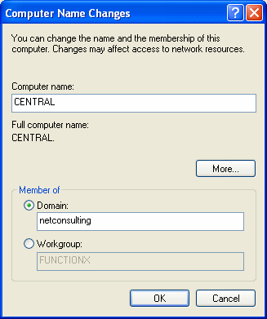

1. After specifying the name of the computer and the domain to join, click OK
2. You would then be asked to asked to provide a user name and a password for a user who has the permissions to join let a computer join a domain

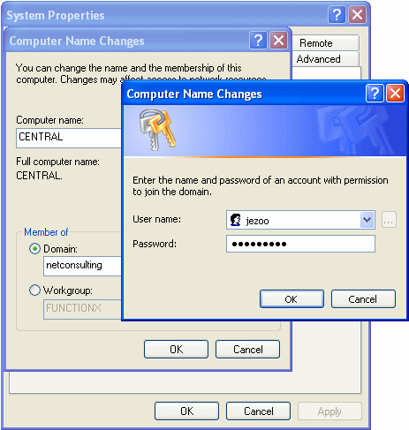

1. After entering a user and a password, click OK. If you have the right to add computers to the domain, you would receive a Welcome message and click OK:

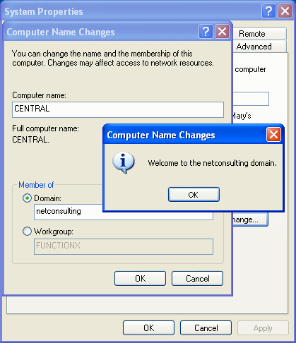

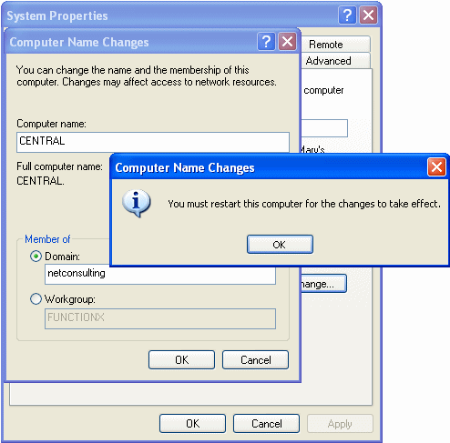

1. Once you click OK, you will be asked to restart the computer, which you should do. Therefore, in the System Properties dialog box, click OK.
2. When asked whether you want to restart the computer, click Yes.
3. After the computer has restarted, when it displays the Log On To Windows dialog box, click the arrow of the Log On To combo box and select the name of the domain.
4. If necessary, change the User Name in the top text box.  
   In the Password text box, enter the password associated with the user name
5. Click OK.

|  |  |
| --- | --- |
| **Operation Sheet – 5** | **Physical Connections** |

**Physical Connections**

**Wired Networking**

After installing the operating systems on the computers that will primarily participate in the network, you can "physically" connect the computers and the router. You can start connecting the pieces whether the computers are on or off.

**Practical Learning: Wiring the Network**

1. Shut down all computers and the router (if necessary)
2. Turn on one computer you will use to setup the router
3. You router should have come equipped with a piece of paper or a brochure of just a few pages that lists the instructions to follow to setup the router. One of the early instructions may ask you to insert the CD that came with the router, in the CD drive and wait for the instructions. Follow these instructions faithfully
4. After setting up and configuring the router, turn it off and turn off the computer you used to set it up (this step is optional)
5. Connect each of the other computers to the router using an RJ-45 cable for each connection:

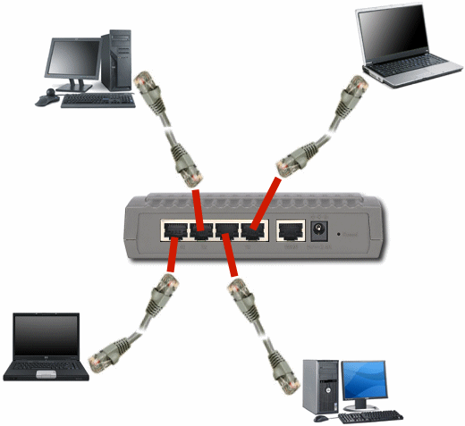

If you had turned off (some of) the machines, first turn on the router. Then, after a few seconds, turn on the computers. If you receive some messages indicating that a network was detected, fine. If not, don't worry, we will check the network later.

|  |  |
| --- | --- |
| **Operation Sheet – 6** | **Wireless Networking** |

**Wireless Networking**

If you plan to setup a wireless network using a wireless router, you will need to use one computer to set it up.

**Practical Learning: Wirelessly Connecting a Network**

1. Start the computer you will use to setup the router (you should turn the others off):

|  |
| --- |
| computer2 |

1. Most, if not all, wireless routers come with very easy to follow instructions. Most of them usually ask you to first insert the CD that accompanies the router, that is, before physically installing the router. Consult the documentation (usually just one or a few pieces of paper or a small brochure) and faithfully follow its CD's instructions. At one time, the instructions would indicate to you when to connect the computer and the wireless router. To do this, you will use a cable (usually supplied to you) to connect one end to the computer and another end to the router:

|  |
| --- |
| connect2 |

1. Because the steps to perform depend on the router (or the manufacturer), we will let you perform as described by their documentation
2. After installing and setting up the wireless router, turn it off and turn the computer off
3. If you didn't yet, install the wireless network card(s) on the other computer(s).  
   For any computer that doesn't have a wireless network card but has a wired network card, connect it to a port of the wireless router using an RJ-45 cable. The computers that have a network card will not need a physical connection to the wireless router:

|  |
| --- |
| connect3 |

1. Turn on the router. After a few seconds, turn on the computers one by one.  
   You may not need to check whether they work at this time or not. We will check this later

|  |  |
| --- | --- |
| **Lap Test** | **Practical Demonstration** |

Name: \_\_\_\_\_\_\_\_\_\_\_\_\_\_\_\_\_\_\_\_\_\_\_\_\_\_\_\_\_ Date: \_\_\_\_\_\_\_\_\_\_\_\_\_\_\_\_\_\_\_\_\_\_\_

Time started: \_\_\_\_\_\_\_\_\_\_\_\_\_\_\_\_\_\_\_\_\_\_\_\_ Time finished: \_\_\_\_\_\_\_\_\_\_\_\_\_\_\_\_

**Instructions:** You are required to perform the following individually with the presence of your teacher.

* *Your teacher will evaluate your output either satisfactory or unsatisfactory. If*

*unsatisfactory, your teacher shall advice you on additional work. But if satisfactory, you can proceed to the next topic.*

* + - 1. Configuring a small local area networking physical connection?
      2. Configuring a wireless connection?
      3. Installing network software?

|  |  |
| --- | --- |
| **Instruction sheet** | **LG23: Administer and support peripheral services** |

This learning guide is developed to provide you the necessary information regarding the following content coverage and topics:-

* Assigning Priority to control queues
* Configuring settings on network.
* Demonstrating methods to use peripherals services.

This guide will also assist you to attain the learning outcome stated in the cover page.

Specifically, upon completion of this Learning Guide, you will be able to:-

* Priority is assigned to control queues based on organizational requirement.
* Settings on the network are configured to create maintenance schedules, usage logs, and cost center.
* Usage statistics Methods are demonstrated to the user for using.
* Peripheral services from their application or workstation.

**Learning instruction:**

1. Read the specific objectives of this Learning Guide.
2. Follow the instruction describe below 1
3. Read the information written in the information “sheet 1, sheet 2 and sheet3 ” , “in page 3.5.6.7 and 8” respectively
4. Accomplish the “self-check 1, self-check 2,self-check 3” “in page 4,9,and 11”

Respectively

1. If you earned a satisfactory evaluation from the “self-check” proceed to “operation sheet 1and operation sheet 2” “in page 10, 16 and 17,32”
2. Do the” LAB “Test in page “33”

\*Your teacher will evaluate your output either satisfactory or unsatisfactory. If unsatisfactory, your teacher shall advice you on additional work. But if satisfactory you can proceed to the next topic.

|  |  |
| --- | --- |
| **Information Sheet – 1** | **Assigning priority to control queues** |

* 1. **Assigning Priority to control queues**

## Physical versus logical printers

The priority of printers is normally controlled by the operating system. To understand priorities, you first need to know the terms that operating systems use to distinguish between physical and logical printers (the latter refers to the software name). Some operating systems also use the concept of a **queue**. Software such as Windows uses the term **print device** when referring to the **physical printer**. The term **printer** is then used as the logical name that will be used to connect to a physical printer.

Very often, the same name may be used to describe a printer and a print device, since it is a one-to-one chain. However, it is possible to have multiple printer names refer to the same print device. This facility allows you to allocate priorities. You set up a single print device, but allocate two or more printers to it. Each printer then has a different priority. You then use the security and sharing features of each printer to only allow appropriate users or groups to access each one.

For example, if you have three printers called:

* Laser High
* Laser Normal
* Laser Low.

You set appropriate **priorities to each printer** that uses the same print device. For example, you can allow:

* Executives to access Laser High
* Managers to access Laser Normal, and
* Everyone can access Laser Low.

If an executive sends a print job to their printer it will take priority over any lower priority jobs in the queue.

|  |  |
| --- | --- |
| **Self Check 1** | **Written Test** |

|  |  |
| --- | --- |
| **Self cheek – 1** | **Written Test** |

Name:\_\_\_\_\_\_\_\_\_\_\_\_\_\_\_\_\_\_\_\_ Date:\_\_\_\_\_\_\_\_\_\_\_\_\_\_\_\_\_

# *Direction:* filling the appropriate answer for the following question in the specie provided, if you have some clarifications- feel free to ask your teacher.

1. The priority of printers is normally controlled by the \_\_\_\_\_\_\_\_\_\_\_\_\_\_\_\_\_\_\_\_\_\_.
2. Operating systems also use the concept of a **\_\_\_\_\_\_\_\_\_\_\_**.
3. There are three printer \_\_\_\_\_\_\_\_\_\_\_,\_\_\_\_\_\_\_\_\_\_\_\_\_\_\_ and \_\_\_\_\_\_\_\_\_\_\_\_

|  |  |
| --- | --- |
| **Information Sheet – 2** | **Configuring setting on network** |

* 1. **Configuring settings on network**

Network configuration is the process of setting a network's controls, flow and operation to support the network communication of an organization and/or network owner. This broad term incorporates multiple configuration and setup processes on network hardware, software and other supporting devices and components.

* + 1. **Create maintenance schedules**

Printers, in particular, have many moving parts subject to wear as well as consumables that run out. They require more maintenance than purely electronic or solid state components.

Device manuals normally specify maintenance schedules. Some maintenance is time-based and other forms are usage-based, such as with printer toner, the need to replace which is shown by a warning light on the printer, or in the case of a large network printer with management software, an automatic email may be sent to the administrator. Paper can be considered a time-based consumable because if packets of it are left open for more than a few weeks it can dry or be subject to moisture,

Humidity or dust. These changes alter the friction between each sheet and contribute to misfeeds and paper jams. It is important estimate replacement times for things such as toner and paper so to ensure stock and minimise user disruption. You do not want to overstock, as some consumables are expensive and subject to falling quality over time. Laser printer developers, for instance, usually have a limited working life.

### Reflection activity

1 List what you would expect to find in the maintenance schedule that services peripherals in your workplace, or in another workplace to which you have access.

2 Compare the actual workplace maintenance schedule with your own list.

3 Might you improve the workplace maintenance schedule?

# 6.2.2 Creating templates and forms

Templates and forms can make it easier to follow a maintenance schedule.by using templates, an organisation can lift the standard of documentation and it becomes easier to find information in documents. Templates can speed the process of creating new documents, as much work is already done.

Consistency of layout and design helps clients easily recognise where the document has originated. For example, the header may always have the page number and document name, with the section name of the document, the version number and date completed in the footer. The start of the document may contain the heading page, contents, author and introduction.

Templates are useful for enforcing consistency of style also and in some cases provide much of the text, which may then only require a small amount of editing. This is most common in specification documents, which may all contain similar information with only a small amount of information needing to be tailored for a specific job.

Many organisations store templates in a networked or shared area. The user opens the template, and then saves it as a normal document in their individual folder. As an example, a template for the LAN administrators of an IT department to record their maintenance schedules may include: dates; parts for maintenance; frequency of maintenance; whether an automatic or manual schedule; the date that the next maintenance is to be performed.

The information may be stored directly in a database to then view the maintenance history of a piece of hardware. Usually, a paper copy of the maintenance task is required with the signature of the technician who performed it, but an electronic signature is now possible also.

### Reflection activity

Consider a place where you have access to computers and peripheral equipment. It may be a learning place such as TAFE, or a workplace where you are employed or have access. Answer the following questions.

1 Are templates used in the organisation to create standard documents?

2 What are the benefits of using the templates for the organisation? Can you think of more templates that could be created for the organisation?

**Conducting maintenance**

Once you have maintenance schedule organised you then follow the instructions as the need for maintenance that arises. Most peripherals have detailed instruction books, including diagrams that show you how to perform routine maintenance tasks. Proper care of peripherals will improve their long-term functioning and reliability.

It is important to follow the instructions in the manuals, especially any health and safety warnings. You should also dispose of any spent consumables in accordance with the manufacturer’s recommendations. For example, you should wear gloves when changing any printer toner. When disposing of the empty cartridge, place it in the container it arrived in and either put it in the bin or organise a recycling company to collect it.

The care of computer equipment usually falls under three categories:

1. External components
2. Internal components
3. Software.

6.2.2 **Usage logs**

# Monitoring usage

Some organisations are keen to track the usage of peripherals, especially printers. For example, it can be done as part of an accounting procedure, to ensure sufficient capacity, or to keep track of consumable items.

Most printers allow a **report** to be produced, or the printer may have a **counter**. With many, the configuration report displays the number of pages printed. It also lists the number of pages printed at a higher fuser temperature (at which the toner is melted onto paper) if this mode has been selected.

### 

### Research activity

Consider a place where you have access to computers and peripheral equipment. It may be a learning place such as TAFE, or a workplace where you are employed or have access. Answer the following questions.

1 What software monitors usage of a peripheral you have access to?

2 What reports does that software produce and how are they used?

6.2.3 **Cost center usage statistics**

Use the transactions and for create change and display cost centre master data. A cost centre is created at the request of the party responsible for the cost centre. The cost centre is used **to** collect costs and is distinguished by area of responsibility or accounting method.

* 1. **Demonstrating methods to use peripherals services**

There are also devices that function as both input and output devices, such as: external hard drives. Media card readers.

**What are some examples of computer peripheral devices?**

* Keyboard
* mouse
* Touch screen.
* Pen tablet
* Joystick
* MIDI keyboard.
* Scanner.
* Digital camera.

|  |  |
| --- | --- |
| **Self Check 2** | **Written Test** |

Name: \_\_\_\_\_\_\_\_\_\_\_\_\_\_\_\_\_\_\_\_ Date: \_\_\_\_\_\_\_\_\_\_\_\_\_\_\_\_\_

# *Instruction:* Choose the best answer for the following question, if you have some clarifications – feel free to ask your teacher.

# Network configuration is a

# Process of setting a network's controls

# Adding peripheral device

# Controlling of operating

# All

# Multiple configuration of networking is

# Network hardware

# Software

# Supporting devices and components.

# All

# IT department to record their maintenance schedules may include

# Parts for maintenance C. Automatic or manual schedule

# Frequency of maintenance D. All

# One of the following is care of computer equipment usually falls under three categories

# Frequency of maintenance

1. Internal components and software
2. Network hardware
3. Supporting devices and components

***Note:* Satisfactory rating - 3 points Unsatisfactory - below 3 points.**

|  |  |
| --- | --- |
| **Operation Sheet – 1** | **Installation and connection** |

# Practical Learning: Installing the Server Operating System

1. If the computer doesn't have an operating system but it meets all the requirements and it can boot from the CD, start the computer. You may receive a message stating operating system missing or something like that. Open the CD drive, put the CD in the drive, and close it. Restart the computer. You should receive a message stating **Press Any Key To Boot From CD** (or something like that)
2. Press any key to start the installation.  
   If your computer already has an operating system, start it. Open the CD drive, put the CD in it, and close its door. If the operating system cannot be upgraded, a message box and display and let you know. Accept to perform a new installation and click Next
3. When the installation starts, it will display a blue screen with **Windows Setup** on top and some messages on the status bar (bottom of screen).  
   After a while, the screen will change and display a new title based on the version of operating system you are installing. For example, if you are installing Microsoft Windows Server 2003 Enterprise Edition, the title would display  
   **Windows Server 2003, Enterprise Edition Setup**  
   The body of the screen will present options to you. To continue the installation, press Enter
4. The next screen will show the Windows Licensing Agreement. Read it. Since it is long, to navigate up and down, you can press Page Up or Page Down. After reading it, if you accept the terms of the license, press F8. If you don't like what it says, press ESC and stop the installation.
5. The next screen asks you to select the partition you want to use to install the operating system:
   * If you have only one partition and it looks small, such as less than 8 GB, simply select it
   * If you have only one partition and that, regardless of its size, you want to use it wholly to install the OS, select it
   * If you have only one partition but it is large and you want to create various partitions, first make sure it is selected it. Then, press C to partition it. The next screen would ask how much space you want to use for the new partition. By default, it will propose the total space for it. To reduce it, first press Backspace a few times to delete the numbers, then type the desired number of megabytes, and press Enter. Press the down arrow key to select the **Unpartitioned Space** option and press C. Continue in the same way until you have created the desired partitions
   * If you have many partitions already, to specify which one will be used to hold the operating system, use the up and down arrow keys to select it
6. After selecting the partition you will use, press Enter to install the OS in it
7. The next screen will ask you to format the selected partition and specify the type of file system you want to use. Select the **Format The Partition Using The NTFS File System** option and press Enter
8. In the next screen, the partition will get formatted. This may take a few minutes.  
   Once the formatting is over, the installation will continue by copying files.  
   After a while, a wizard, titled Windows Setup, will come up. Its first page presents you with two options.  
   The first choice consists of changing the Regional and Language Options. The default options will be selected depending on your version of the CD. For example, if you bought the OS intended for a US use, the US English would be selected. If you want to change the language, click the Customize button. Another dialog box, titled Regional and Language Options, would come up with English (United States) selected. You can then click the arrow of its combo box to change the language. After making your selection, you can click OK. If you don't intend to change anything, you can click Cancel.  
   The second option consists of making changes to the way the keyboard will interpret text. Once again, if you are installing the OS intended for a US audience, the US English is selected by default. If you want to change it, click Details. This would open the Text Services and Input Languages dialog box. You can change the language by clicking the arrow of the combo box. After making the change, you can click OK. To ignore any change, you can click Cancel or press Esc.  
   After dealing with the Windows Setup dialog box, click Next
9. The next screen request that you enter your name or the name of the primary person who will be using the computer. You must type a name other than Administrator or Guest
10. The other text box, Organization, expects the name of the company. Make sure that you provide this information
11. After entering the name and the organization, click Next or press Enter
12. The next page of the wizard requests the Product Key, which you must enter
13. After typing the product key, click Next
14. The next page of the wizard shows the options available for licensing. You should accept the Per Server option and click Next
15. The next page of the wizard, expects you to type the computer name. It also suggests a default, based on the company name you would have entered previously as the Organization. You can accept the suggested name, which you can still change later on, or you can type a new name
16. We haven't mentioned "user accounts" yet but during installation, a user object is created and it is named Administrator. When setting up the operating system, you must give a password to this account. Obviously the password should not be too easy. Fortunately you can give it temporary password and change it later on as your network, skills, and concerned improve. You must enter the password in the Administrator Password text box and type it again in the Confirm Password text box. Make sure you remember this password because you will need it just after the installation
17. After specifying the password, click Next
18. The next page of the wizard allows you to set the date, the time, and the time zone that the server will use. Most of the time, the computer finds out the right date and the right time and it selects them. On the other hand, you should adjust the time zone if the default is not the right one. This page of the wizard also allows you the let the computer adjust its clock when daylight time is switched during the year. The option to change this is selected by default. If you don't want the computer to take care of that, you can remove the check mark on the check box.  
    After changing the options or making sure that they are right, click Next
19. After clicking next, the wizard is closed and the installation continues copying files.  
    After a few minutes, a new wizard, titled Windows Setup, comes up. This time, it will ask you to accept or change the network settings of the server. The first option allows you to let the installation take care of networking details. The second option allows you to manually set them.  
    Because we will review the details of this wizard in later lessons, accept the Typical Settings option and click Next
20. The next page of the wizard allows you to actually make this computer into a server.  
    Accept the first option not to "join" a domain.  
    The wizard suggests WORKGROUP as the name of the "domain". If you don't like that name, change it. If you can't come up with a domain, you can use the one we will use. For our lessons, our domain will be called Neptune. In this case, in the top text box, type **NEPTUNE**
21. After entering the name of the domain, click Next
22. After clicking Next, the wizard will start copying the files, again.  
    Once the installation has finished copying the files, the computer will start. When the computer comes back, you will be asked to log in.  
    Press Ctrl + Alt + Delete to log in
23. Accept the User Name as Administrator.  
    In the Password text box, type the password you entered during the installation
24. Click OK.  
    If you see a window titled Manage Your Server, congratulations: you have finished installed Microsoft Windows Server 2003
25. If the computer doesn't have an operating system but it meets all the requirements and it can boot from the CD, start the computer. You may receive a message stating operating system missing or something like that. Open the CD drive, put the CD in the drive, and close it. Restart the computer. You should receive a message stating **Press Any Key To Boot From CD** (or something like that)
26. Press any key to start the installation.  
    If your computer already has an operating system, start it. Open the CD drive, put the CD in it, and close its door. If the operating system cannot be upgraded, a message box and display and let you know. Accept to perform a new installation and click Next
27. When the installation starts, it will display a blue screen with **Windows Setup** on top and some messages on the status bar (bottom of screen).  
    After a while, the screen will change and display a new title based on the version of operating system you are installing. For example, if you are installing Microsoft Windows Server 2003 Enterprise Edition, the title would display  
    **Windows Server 2003, Enterprise Edition Setup**  
    The body of the screen will present options to you. To continue the installation, press Enter
28. The next screen will show the Windows Licensing Agreement. Read it. Since it is long, to navigate up and down, you can press Page Up or Page Down. After reading it, if you accept the terms of the license, press F8. If you don't like what it says, press ESC and stop the installation.
29. The next screen asks you to select the partition you want to use to install the operating system:
    * If you have only one partition and it looks small, such as less than 8 GB, simply select it
    * If you have only one partition and that, regardless of its size, you want to use it wholly to install the OS, select it
    * If you have only one partition but it is large and you want to create various partitions, first make sure it is selected it. Then, press C to partition it. The next screen would ask how much space you want to use for the new partition. By default, it will propose the total space for it. To reduce it, first press Backspace a few times to delete the numbers, then type the desired number of megabytes, and press Enter. Press the down arrow key to select the **Unpartitioned Space** option and press C. Continue in the same way until you have created the desired partitions
    * If you have many partitions already, to specify which one will be used to hold the operating system, use the up and down arrow keys to select it
30. After selecting the partition you will use, press Enter to install the OS in it
31. The next screen will ask you to format the selected partition and specify the type of file system you want to use. Select the **Format The Partition Using The NTFS File System** option and press Enter
32. In the next screen, the partition will get formatted. This may take a few minutes.  
    Once the formatting is over, the installation will continue by copying files.  
    After a while, a wizard, titled Windows Setup, will come up. Its first page presents you with two options.  
    The first choice consists of changing the Regional and Language Options. The default options will be selected depending on your version of the CD. For example, if you bought the OS intended for a US use, the US English would be selected. If you want to change the language, click the Customize button. Another dialog box, titled Regional and Language Options, would come up with English (United States) selected. You can then click the arrow of its combo box to change the language. After making your selection, you can click OK. If you don't intend to change anything, you can click Cancel.  
    The second option consists of making changes to the way the keyboard will interpret text. Once again, if you are installing the OS intended for a US audience, the US English is selected by default. If you want to change it, click Details. This would open the Text Services and Input Languages dialog box. You can change the language by clicking the arrow of the combo box. After making the change, you can click OK. To ignore any change, you can click Cancel or press Esc.  
    After dealing with the Windows Setup dialog box, click Next
33. The next screen request that you enter your name or the name of the primary person who will be using the computer. You must type a name other than Administrator or Guest
34. The other text box, Organization, expects the name of the company. Make sure that you provide this information
35. After entering the name and the organization, click Next or press Enter
36. The next page of the wizard requests the Product Key, which you must enter
37. After typing the product key, click Next
38. The next page of the wizard shows the options available for licensing. You should accept the Per Server option and click Next
39. The next page of the wizard, expects you to type the computer name. It also suggests a default, based on the company name you would have entered previously as the Organization. You can accept the suggested name, which you can still change later on, or you can type a new name
40. We haven't mentioned "user accounts" yet but during installation, a user object is created and it is named Administrator. When setting up the operating system, you must give a password to this account. Obviously the password should not be too easy. Fortunately you can give it temporary password and change it later on as your network, skills, and concerned improve. You must enter the password in the Administrator Password text box and type it again in the Confirm Password text box. Make sure you remember this password because you will need it just after the installation
41. After specifying the password, click Next
42. The next page of the wizard allows you to set the date, the time, and the time zone that the server will use. Most of the time, the computer finds out the right date and the right time and it selects them. On the other hand, you should adjust the time zone if the default is not the right one. This page of the wizard also allows you the let the computer adjust its clock when daylight time is switched during the year. The option to change this is selected by default. If you don't want the computer to take care of that, you can remove the check mark on the check box.  
    After changing the options or making sure that they are right, click Next
43. After clicking next, the wizard is closed and the installation continues copying files.  
    After a few minutes, a new wizard, titled Windows Setup, comes up. This time, it will ask you to accept or change the network settings of the server. The first option allows you to let the installation take care of networking details. The second option allows you to manually set them.  
    Because we will review the details of this wizard in later lessons, accept the Typical Settings option and click Next
44. The next page of the wizard allows you to actually make this computer into a server.  
    Accept the first option not to "join" a domain.  
    The wizard suggests WORKGROUP as the name of the "domain". If you don't like that name, change it. If you can't come up with a domain, you can use the one we will use. For our lessons, our domain will be called Neptune. In this case, in the top text box, type **NEPTUNE**
45. After entering the name of the domain, click Next
46. After clicking Next, the wizard will start copying the files, again.  
    Once the installation has finished copying the files, the computer will start. When the computer comes back, you will be asked to log in.  
    Press Ctrl + Alt + Delete to log in
47. Accept the User Name as Administrator.  
    In the Password text box, type the password you entered during the installation
48. Click OK.  
    If you see a window titled Manage Your Server, congratulations: you have finished installed Microsoft Windows Server 2003

|  |  |
| --- | --- |
| **Operation Sheet – 2** | **The Role of a Server** |

# The Role of a Server

# 

# After you have installed Microsoft Windows Server 2003 as we did above, it is primarily a regular computer. To use it as a server, you must properly transform. Fortunately, this is an easy process. When the computer comes up and displays the desktop, the first window you see, titled Manage Your Server, allows you define the "role" of the computer. A convenient link is available in the middle of the window.

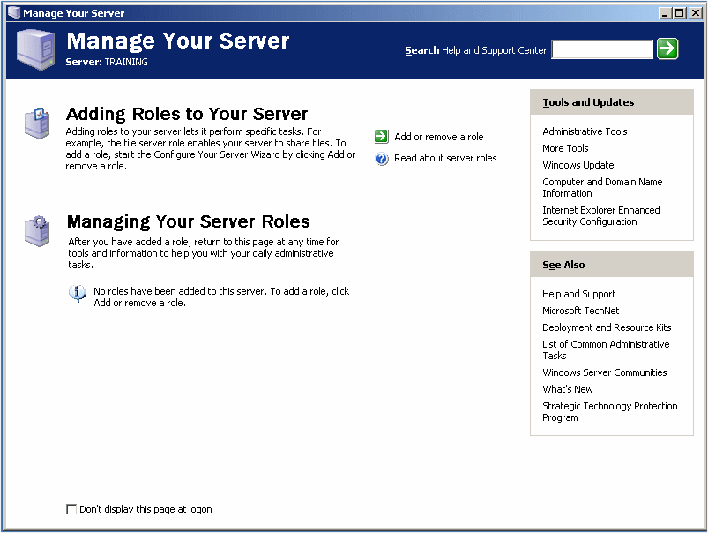

|  |
| --- |
| **Practical Learning: Configuring Active Directory** |
| 1. Read the text in the window and click Add Or Remove A Role 2. The first page of the wizard presents a summary of the actions you must have taken before continuing:   configure1  Read it and click Next 3. A dialog box will display briefly and then display a list of the roles you can assign to the server. In the list, click Domain Controller (Active Directory)   configure2 4. Click Next   configure3 5. Click Next to Run The Active Directory Installation Wizard 6. Another wizard, titled Active Directory Installation Wizard, comes up. Read its text and click Next   activedir1 7. In the second page of the wizard, read the text again, and click Next   activedir2 8. In the third page of the wizard, you must specify whether this is the first or an additional domain controller. As this is the first, accept the first radio button and click Next   activedir3 9. In the fourth page of the wizard, accept the first radio button and click Next   activedir4 10. In the fifth page, you must enter the name of the domain. The name should be followed by an Internet domain name (**.com**, **.net**, **.org**, **.us**, etc). If you have a domain in mind, type it. If you don't have a domain in mind, for our lessons, type **netconsulting.com**   activedir5 11. Click Next 12. In the next page of the wizard, a suggested NetBIOS name displays, intended for earlier versions of Windows":   activedir6   Accept it and click Next 13. The next page allows you to specify where the Active Directory information would be stored:   activedir7   Accept the default and click Next 14. The next page specifies where the domain's public files would be stored:   activedir8  Accept the default and click Next 15. After a few seconds, the next page allows you to install DNS. Read the options:   activedir9  Accept the suggested second radio button and click Next 16. The next page allows you to set the default permissions:   activedir10  Accept the suggested second radio button and click Next 17. The next page prompts you to create a password used to start the server in "Restore Mode". Enter a password in both text boxes:   activedir11 18. Click Next 19. The next page displays a summary of your selections:   activedir12  Read the text and click Next 20. The wizard will start creating and configuring Active Directory:   activedir13   After a while, if you don't have the Microsoft Windows Server 2003 CD in the drive, you may be be prompted to supply it:   activedir14  Do so After a few seconds, you may receive a message box informing you that your computer has a static IP address. Click OK When the dialog box comes up, simply click OK Another message box will come up. Click it and click OK. The wizard will continue copying files. After a few seconds, the last page of the wizard will display. Read its summary and click Finish   activedir15 21. You will be asked to restart the computer:   activedir16  If you have a CD in the CD drive, remove it and click Restart New 22. When the computer comes up, click the Options button and make sure that the name of the domain is selected in the Log On To text box. Make sure that Administrator is specified in the User Name text box. Enter your administrator's password 23. Click OK 24. After the computer displays the desktop, a dialog box titled Configure Your Server will let you know whether the installation of Active Directory was successful:   configure4  Click Finish | |  |

|  |  |
| --- | --- |
| **Lap Test** | **Practical Demonstration** |

Name: \_\_\_\_\_\_\_\_\_\_\_\_\_\_\_\_\_\_\_\_\_\_\_\_\_\_\_\_\_ Date: \_\_\_\_\_\_\_\_\_\_\_\_\_\_\_\_\_\_\_\_\_\_\_

Time started: \_\_\_\_\_\_\_\_\_\_\_\_\_\_\_\_\_\_\_\_\_\_\_\_ Time finished: \_\_\_\_\_\_\_\_\_\_\_\_\_\_\_\_

**Instructions:** You are required to perform the following individually with the presence of your teacher.

* *Your teacher will evaluate your output either satisfactory or unsatisfactory. If*

*unsatisfactory, your teacher shall advice you on additional work. But if satisfactory, you can proceed to the next topic.*

1. Installing network administration operating system?
2. Configuring network administration software in network?

|  |  |
| --- | --- |
| **Instruction sheet** | **LG24: Maintain peripherals and fix common problems** |

This learning guide is developed to provide you the necessary information regarding the following content coverage and topics –

* Establishing and following regular maintenance schedule
* Replacing consumables and components
* Fixing peripherals unfortunate accident and malfunction
* Monitoring peripheral usage and traffic
* Determining and rectifying failure of peripherals

This guide will also assist you to attain the learning outcome stated in the cover page.

Specifically, upon completion of this Learning Guide, you will be able to:-

* A regular maintenance schedule is established and followed as recommended by peripheral manufacturer.
* Consumables and components are replaced when required.
* Peripheral mishaps (unfortunate accident) and malfunctions are fixed based on procedure.
* Peripheral usage and traffic is monitored and recommend additional peripherals if needed.
* Failures of peripheral services or devices are determined and rectify as required.

**Learning instruction:**

1. Read the specific objectives of this Learning Guide.
2. Follow the instruction describe below 1
3. Read the information written in the information “sheet 1, sheet 2,sheet 3,sheet 4 and sheet 5” , “in page 3.4.6.7.8.10.11.13.14.16.17.and 18 ” respectively
4. Accomplish the “self-check 1, self-check 2,self-check 3,self-check 4,” “in page 5,9,15,and 17”

Respectively

1. If you earned a satisfactory evaluation from the “self-check” proceed to “operation sheet 1” “in page 14 and 15”
2. Do the” LAB “Test in page “19 and 20”

\*Your teacher will evaluate your output either satisfactory or unsatisfactory. If unsatisfactory, your teacher shall advice you on additional work. But if satisfactory you can proceed to the next topic.

|  |  |
| --- | --- |
| **Information Sheet – 1** | **Establishing and following regular maintenance schedule** |

* 1. **Establishing and following regular maintenance schedule**

# Maintenance schedules

Device manuals normally specify maintenance schedules. Some maintenance is **time**-based and other forms are **usage**-based, such as with printer toner, the need to replace which is shown by a warning light on the printer, or in the case of a large network printer with management software, an automatic email may be sent to the administrator. Paper can be considered a time-based consumable because if packets of it are left open for more than a few weeks it can dry or be subject to moisture, humidity or dust. These changes alter the friction between each sheet and contribute to misfeeds and paper jams. It is important estimate replacement times for things such as toner and paper so to ensure stock and minimise user disruption. You do not want to overstock, as some consumables are expensive and subject to falling quality over time. Laser printer developers, for instance, usually have a limited working life.

### Reflection activity

1 List what you would expect to find in the maintenance schedule that services peripherals in your workplace, or in another workplace to which you have access.

2 Compare the actual workplace maintenance schedule with your own list.

3 Might you improve the workplace maintenance schedule?

# Scheduling maintenance

Many organisations with a preventative maintenance program will have maintenance tasks organised on a schedule. The goal of a schedule is to ensure that regular maintenance occurs. Given the time pressures of working as an IT Support person, a schedule will assist you in organising your workload to ensure that the best possible service is provided to the client.

If a maintenance schedule does not exist, consider designing one. A schedule should simply include:

1 each preventative maintenance task that should be completed

2 how often the task should be repeated

3 an estimate of the time required to complete the task.

These tasks can then be allocated time in your schedule at the required intervals.

## Developing a preventative maintenance schedule

In developing a preventative maintenance schedule, it is important that as an IT Support person you are aware of the main aims of preventative maintenance. They are:

* To meet the needs of the business
* To extend the working life of equipment
* To reduce the amount of emergency downtime caused by faults that can be prevented
* To be practical
* To make the IT system more cost effective.

### Cost effectiveness

It is important that any preventative maintenance be cost effective. It is possible to spend significant amounts of time cleaning and testing devices such as keyboards and mice to extend their life. However, the replacement cost of those devices, including the cost of having an inventory of such items on hand, may mean that it is cheaper to purchase new devices rather than extend the life of the existing devices.

Every maintenance issue must be examined from a cost point of view.

|  |  |
| --- | --- |
| **Self Check 1** | **Written Test** |

Name: \_\_\_\_\_\_\_\_\_\_\_\_\_\_\_\_\_\_\_\_ Date: \_\_\_\_\_\_\_\_\_\_\_\_\_\_\_\_\_

*Direction:*  Choose the best answer for the following question, if you have some clarifications – feel free to ask your teacher.

# One of the following is a part of maintenance schedules

# Time-based C. Installation

# Software D. Device manager

# \_\_\_\_\_\_\_ is same preventative maintenance program will have maintenance tasks organized.

# A. workstation C. Configuration

# B. Preventative maintenance D. All

# 

# The goal of a schedule is to ensure that regular maintenance occurs is

# Given the time pressures of working as an IT Support person

# Assist you in organizing your workload

# Best possible service is provided to the client

# All

# To do maintenance schedule should simply include

# Each preventative maintenance task that should be completed

# How often the task should be repeated

# An estimate of the time required to complete the task

# All

***Note:* Satisfactory rating - 3 points Unsatisfactory - below 3 points.**

|  |  |
| --- | --- |
| **Information sheet – 2** | **Replace/Repair Components** |

* 1. **Replacing consumables and components**

Purchase and replacement of consumable parts (components, such as batteries and printer cartridges that have delectable life) is your responsibility. If Lenovo acquires or installs a consumable component at your request, you will be charged for the service.

### Replace/ Repair Components

### Replacing Computer Components

1. Power Supply.
2. Video Card.
3. Motherboard/CPU/RAM.
4. Hard Drives.
5. CD and DVD.
6. Sound Card.
7. Modems and Networks.

|  |
| --- |
| In earlier times, processor speed doubled approximately every 18 months, but this is not universally true anymore. So, should you keep the old computer until you either max out the hard drive or it starts making odd noises, or should you automatically upgrade every X number of years? The answer depends on a few factors: How intensively do you use your computer? Do you have a backup computer and excellent backup system in case your current computer fails catastrophically? Do you do processor-intensive computing such as using a speech recognition program to dictate into your translation memory program? All of these factors are important in your decision on when to get a new computer.  Regardless of how often you purchase a new computer, basic digital and physical hygiene can go a long way toward prolonging your machine’s life. Especially if you have pets, a thorough cleaning of the inside of your computer’s case (make sure to unplug it from all power sources first) can be a worthwhile (if horrifying!) step, as can deleting large/old files that you no longer need. Movies and music are big culprits on most of our computers, so it’s a good idea to go through and purge the ones that you don’t want.  If you are one of those translators who likes to get the longest possible life out of your computer, make sure that you have a backup computer (i.e. a laptop or a separate desktop that is in working order) in case your computer either literally or figuratively goes up in smoke. In addition, a reliable [computer backup system](http://thoughtsontranslation.com/2008/09/15/methods-for-backing-up-your-computer-data/) is critical regardless of how old your primary computer is.  When you decide that it’s time to replace your computer, it’s worth considering the option of assembling your own computer from parts. This option allows you to put your money into the features that are important to you; for example you might want a lot of processor speed but just adequate audio and video capabilities, or the other way around |

Expenditure on computer systems does not stop with the initial purchase of the hardware and software. Various computer supplies and consumables are needed to keep a computer system operating. These include:

* paper for printers, photocopiers and fax machines
* ink and toner for printers, photocopiers and fax machines
* lubrication oil for various machines with moving parts
* spare replacement parts for various items
* storage disks of various kinds, such as floppy disks, tapes and CDs
* cables of various kinds
* cleaning materials
* tools for maintenance purposes
  + 1. **Ink cartridges**

An ink cartridge or inkjet cartridge is a component of an inkjet printer that contains the ink that is deposited onto paper during printing. Each ink cartridge contains one or more ink reservoirs; certain producers also add electronic contacts and a chip that communicates with the printe.

* + 1. **Toner cartridges**

Toner cartridge: - A toner cartridge, also called laser toner, is the consumable component of a laser printer. Toner cartridges contain toner powder, a fine, dry mixture of plastic particles, carbon, and black or other coloring agents that make the actual image on the paper.

* + 1. **Ribbons**

In computer interface design, a ribbon is a graphical control element in the form of a set of toolbars placed on several tabs. The typical structure of a ribbon includes large, tabbed toolbars, filled with graphical buttons and other graphical control elements, grouped by functionality.

* + 1. **Compact Disk**

Compact disc is a digital optical disc data storage format that was co-developed by Philips and Sony and released in 1982. The format was originally developed to store and play only sound recordings but was later adapted for storage of data. [Usage](https://www.google.com/search?q=compact+disc+usage&sa=X&ved=2ahUKEwjo4IGY3YzlAhWpk4sKHVuDDC8Q6BMoADAaegQIDRAG): Audio and data storage [Capacity](https://www.google.com/search?q=compact+disc+capacity&sa=X&ved=2ahUKEwjo4IGY3YzlAhWpk4sKHVuDDC8Q6BMoADAbegQIDRAJ): Typically up to 700 MiB (up to 80 minutes audio).

|  |  |
| --- | --- |
| **Self Check 2** | **Written Test** |

*Direction:* filling the appropriate answer for the following question in the specie provided, if you have some clarifications- feel free to ask your teacher.

* 1. \_\_\_\_\_\_\_\_\_\_\_\_\_\_ is a component of an inkjet printer that contains the ink that is deposited onto paper during printing.
  2. \_\_\_\_\_\_\_\_\_\_\_\_\_\_ is the consumable component of a laser printer.
  3. \_\_\_\_\_\_\_\_\_\_\_\_\_\_ is a graphical control element in the form of a set of toolbars placed on several tabs.
  4. \_\_\_\_\_\_\_\_\_\_\_\_\_\_ is a digital optical disc data storage format that was co-developed by Philips and Sony.

***Note:* Satisfactory rating - 3 points Unsatisfactory - below 3 points.**

|  |  |
| --- | --- |
| **Information sheet 3** | **Fixing peripherals unfortunate accident and malfunction** |

* 1. **Fixing peripherals unfortunate accident and malfunction**

Speeding up a slow computer troubleshoot basic computer problems

1. Run fewer programs at the same time. Don't have too many programs running at the same time.
2. Restart your computer.
3. Remove viruses and malware.
4. Free up hard disk space.
5. Verify windows system files.
6. Uninstall unnecessary programs.
7. Adjust windows visual effects.
8. Run a disk scan.

## Peripheral Failure and Solutions

The first step is to always check the hardware. The cables may be damaged or the USB hub you’re using between your PC and the peripheral may not have power.

## #1: Problems with a port

If attached peripherals suddenly stop working, check the Device Manager to see if the port itself is to blame. A red exclamation mark (!) means there’s an error with the port.

Delete a device from the Device Manager and then reboot your computer. Once your PC is up and running again, install the device driver.

### #2: Problems with the port connectors

Especially with PS/2 ports, one or two of those holes could be clogged with dust, causing a loss in connection with the pins. The same thing could happen when the pins on the peripheral connector are damaged.

A USB port can get damaged, too, resulting in no power or connection. A solution would be to use another USB port.

### #3: USB standards don’t match

Newer USB devices may not run on old USB ports. Most of them would need a 3.0 cable for high-speed processing. If the USB port and device are incompatible, attached peripherals will not work.

### #4: Error with wireless keyboard or mouse

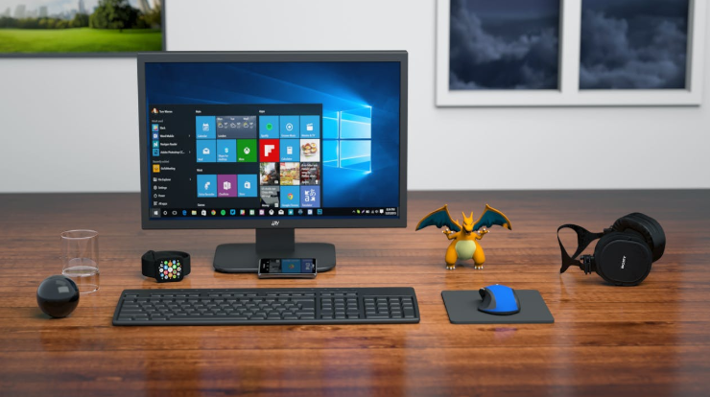

Wireless peripherals often rely on the IR or RF controller to work and communicate with a computer. If it doesn’t work the first time you use it, you could be using an old operating system. Most wireless PC peripherals need a newer OS Service Pack. So, if you’re still using Windows 95 OS or older, an upgrade will fix the problem.

If you’re using the current operating system and the wireless keyboard and mouse still don’t work, the problem may be an interference with the line of sight or a weak battery. Use the peripherals on other PCs to help identify the cause of error.

If the wireless device has a reset button, use it to reset the device and refresh the connection. It would also help if you unplug the USB wireless receiver and leave it off for about 10 seconds. This will help reestablish the wireless connection once you plug the receiver back into the port.

### #5: PS/2 keyboard and mouse not working

See that the device is plugged in the correct port. If the port and cable are color-coded, the keyboard cable should go into the purple-colored port and the mouse into the green-colored port.

Color coding can vary. Try to switch them up and see if doing so helps fix the problem. Follow the same process if the PS/2 connectors are identical in color and you need to identify which one is designated for the keyboard and the mouse.

If the cables are on the right parts and the peripherals still don’t work, try to use other devices. The keyboard or mouse may need replacement.

### #6: Blocked keys or sensors

Dirt blocking the keys or sensors prevents PC peripherals from responding to commands. Regardless of how much you click on a mouse or press a key, nothing will happen if contact is not established.

### #7: Input devices stop working after updates

Following an operating system or software update, one or two of your attached PC referrals may no longer work. There are several ways to restore a device’s functionality.

* **Switch USB ports**

Doing so will force your computer to recognize a device. A computer system usually recognizes a device based on their location or the specific USB port where the device was attached before any updates were made. If the system thinks nothing has changed, it will not reload drivers, resulting in peripherals not working. Thus, the need to switch USB ports.

* **Start in safe mode**

In some cases, a driver in the cache will not load properly after an update. The result is a broken mouse and keyboard … or so it might appear. With a bit of a system purge in safe mode, the boot will reload drivers and load them properly.

* **Reset the PRAM**

During a firmware update, the PRAM settings of your computer, which include peripheral devices, video settings, startup disk, and audio volumes, may be reconfigured. Reset the PRAM to fix the problem.

Reboot the system and then press and hold down the option-command-P-R keys at the same time. Wait for your computer to reset and chime a couple of times at reboot before you release the keys.

* **Power cycle the entire system**

Faulty settings may occur after an update. Remove a peripheral device from your computer and leave it off for a few minutes. For better results, shut down your computer as well and power cycle it. After 5 to 10 minutes, turn the computer back on and then plug the attached peripherals back in.

### #8: Mouse and keyboard stopped working when printer is turned on

* **Ensure efficient power**

This could happen when the USB ports for the keyboard and mouse receive too little power to work because the [printer](https://www.hellotech.com/blog/6-common-printer-problems/) is hogging all of it. Make sure not to connect the printer to a USB hub that is shared by the keyboard and mouse.

Another solution is to plug the devices into different USB ports. Attached peripherals can go at the back of the computer while the printer is plugged in at the front.

* **Fix interference**

Do your keyboard, mouse, and printer all use a wireless connection? They could be interfering with one another, even if one is using radio frequency while the other relies on Bluetooth.

To avoid conflict and establish different frequencies for different devices, switch off the keyboard and mouse. When you switch them back on, they will be forced to reconnect to your computer using a free frequency.

* **Check driver compatibility**

Conflicts between drivers could cause problems with different devices. Communication with your operating system will be effected and will result in devices not working properly. Open Device Manager and check that drivers for peripherals and the printers are updated.

Double click on a device and open the Properties windows. Under Driver tab, check if the option to Update Driver is available. This means a newer version of a driver is available.

* **Reinstall devices**

If you’ve done all the steps above and the problem persists, you may need to reinstall devices to resolve the issue.

1. Remove the PC-attached peripherals from Device Manager.
2. Any related software must be uninstalled from your computer.
3. Restart the system.
4. Switch on the printer and see that it is connected to your computer and working properly.
5. Reconnect the keyboard and mouse like you’re using them for the first time. This reinstalls the peripherals and ensures there are no conflicts.

|  |  |
| --- | --- |
| **Self Check 3** | **Written Test** |

*Direction:* filling the appropriate answer for the following question in the specie provided, if you have some clarifications- feel free to ask your teacher.

* 1. \_\_\_\_\_\_\_\_ is a connector of external device in computer based on colors.
  2. \_\_\_\_\_\_\_\_\_ is faulty settings may occur after an update.
  3. \_\_\_\_\_\_\_\_\_ interfering with one another, even if one is using radio frequency while the other relies on Bluetooth.
  4. \_\_\_\_\_\_\_\_\_\_ a driver in the cache will not load properly after an update.

***Note:* Satisfactory rating - 3 points Unsatisfactory - below 3 points.**

|  |  |
| --- | --- |
| **Information sheet 4** | **Monitoring peripheral usage and traffic** |

* 1. **Monitoring peripheral usage and traffic**

They can also provide warnings about network slowdowns, overloaded servers and other signs **of** trouble so **you** can address problems before they affect staff and patrons. Better understanding **of** long-term trends. Network monitoring tools also create graphs and reports about **network** performance over time.

**Network traffic monitoring** is the process of reviewing, analyzing and managing **network traffic** for any abnormality or process that can affect **network** performance, availability and/or security.

It is a network management process that uses various tools and techniques to study computer network-based communication/data/packet traffic.

|  |  |
| --- | --- |
| **Self Check 4** | **Written Test** |

*Direction:* filling the appropriate answer for the following question in the specie provided, if you have some clarifications- feel free to ask your teacher.

* 1. \_\_\_\_\_\_\_\_\_\_\_\_ is the process of reviewing, analyzing and managing network traffic for any abnormality or process that can affect network performance, availability and/or security.
  2. \_\_\_\_\_\_\_\_\_\_\_\_ that uses various tools and techniques to study computer network-based communication/data/packet traffic.

***Note:* Satisfactory rating - 3 points Unsatisfactory - below 3 points.**

|  |  |
| --- | --- |
| **Information Sheet 5** | **Determining and rectifying failure of peripherals** |

* 1. **Determining and rectifying failure of peripherals**

Troubleshooting is a form of problem solving, often applied to repair failed products or ... Determining the most likely cause is a process of elimination—eliminating potential causes of a problem. ... later renamed MaxServ), immediately show the top 10 solutions with the highest probability of fixing the underlying problem.

The most common **causes** of hard drive **failure**: Heat: The primary **cause** of hard drive **failures** is **hardware** overheating. ... Physical damage to your computer: Any type of physical force, such as bumping, jarring, or dropping your computer may lead to physical damage to the hard drive.

# [How to Fix Common Computer Network Issues](http://www.wikihow.com/Fix-Common-Computer-Network-Issues)

[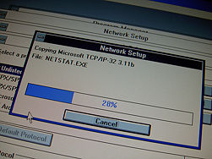](http://www.wikihow.com/Image:Internet-Networking-Web-Technology-Installation.jpg)

Are you experiencing problems with your computer network? Are these error messages appearing?:

* Unable to clear the DNS cache
* Unable to renew your IP address
* An operation was performed on something that is not a socket
* Unable to clear the ARP cache

If so, here are some potential solutions for Windows XP/Vista.

|  |  |
| --- | --- |
| **Operation Sheet – 1** | **How to fix common computer network issues** |

## Steps

1. **Check to make sure your computer is on and is connected to a network**.
2. **Be aware that Windows has a built in function to repair a network connection**. This function can give valuable information in the form of an error message if you know what you are looking for. Some common error messages given are:
   * Unable to clear the DNS cache
   * Unable to renew your IP address
   * Unable to clear the ARP cache
3. **Deal with a message that states "Unable to clear the DNS cache**." When you get the message “Unable to clear the DNS cache”, this usually means that the DNS client service has been disabled. Follow these steps as an administrator to re-enable it:
   1. Open the Services MMC plugin, located under Administrative Tools in the Control Panel;
   2. Find the “DNS Client” service in the list presented and enter its properties by double-clicking it;
   3. Change the Startup Type from Disabled to Manual or Automatic then click apply;
   4. Either reboot or click “Start” to start the service;
   5. Verify by attempting to repair the connection again.
4. **Fix a problem related to an IP address**. If the repair process reports that it has been 'Unable to obtain an IP address', it is probable that more information can be obtained through the command line. Open a Command Prompt by going to Start > Programs > Accessories > Command Prompt, then type 'ipconfig /renew' to attempt to obtain an IP address from the command line.
5. **Follow up the error messages that will likely appear**. There is a high likelihood of an error message similar to the one below occurring, the remainder of the guide will focus on this error.
   1. “An operation was performed on something that is not a socket"
6. **Fix the error message "An operation was performed on something that is not a socket**.": This is a Winsock corruption generally due to spyware. The fixes are:
   1. A simple fix can be done with Windows XP SP2 or Windows Vista (Start > Run > cmd > netsh winsock reset), then reboot your computer. If you do not have SP2, you can download a small program to reinstall Winsock: [winsockfix.exe](http://www.spywarekills.com/dl/winsockfix.exe).

|  |  |
| --- | --- |
| **Lap Test** | **Practical Demonstration** |

Name: \_\_\_\_\_\_\_\_\_\_\_\_\_\_\_\_\_\_\_\_\_\_\_\_\_\_\_\_\_ Date: \_\_\_\_\_\_\_\_\_\_\_\_\_\_\_\_\_\_\_\_\_\_\_

Time started: \_\_\_\_\_\_\_\_\_\_\_\_\_\_\_\_\_\_\_\_\_\_\_\_ Time finished: \_\_\_\_\_\_\_\_\_\_\_\_\_\_\_\_

**Instructions:** You are required to perform the following individually with the presence of your teacher.

* *Your teacher will evaluate your output either satisfactory or unsatisfactory. If unsatisfactory, your teacher shall advice you on additional work. But if satisfactory, you can proceed to the next topic.*

# Write the step of how to fix common network problem?

# Do each step?

|  |  |
| --- | --- |
| **Instruction sheet** | **LG25: Use and maximize operating system** |

This learning guide is developed to provide you the necessary information regarding the following content coverage and topics –

* Configuring Operating system
* Installing, upgrading and uninstalling Application software
* Using graphical user interface and the command line interface
* Using Operating system and third-party utilities
* Customizing Graphical user interface

This guide will also assist you to attain the learning outcome stated in the cover page.

Specifically, upon completion of this Learning Guide, you will be able to :-

* Operating system is configured to suit the working environment, including but not limited to setting variables.
* Application software is installed, upgraded and uninstalled to suit the working environment.
* Both graphical user interface and the command line interface are used to perform basic tasks based on clients.
* Operating system and third-party utilities are used based system requirement.
* Graphical user interface is customized based on clients.

**Learning instruction:**

1. Read the specific objectives of this Learning Guide.
2. Follow the instruction describe below 1
3. Read the information written in the information “sheet 1, sheet 2 and sheet 3 ” , “in page 3.4.6.7.9 and 10 ” respectively
4. Accomplish the “self-check 1, self-check 2 and self-check 3” “in page 5,8 and 11”

Respectively

\*Your teacher will evaluate your output either satisfactory or unsatisfactory. If unsatisfactory, your teacher shall advice you on additional work. But if satisfactory you can proceed to the next topic

|  |  |
| --- | --- |
| **Information Sheet – 1** | **Configuring operating system** |

**8.1 Configuring Operating system**

**Operating System**:

An operating system is a collection of system programs that control computer and any other peripherals connected to it. The program that hides the truth about the hardware from the programmer and present and a nice simple view a named file that can be read & written as “operating system”. Operating system shields the programmer from the interface, the abstraction offers by the operating system is slower & easier to use than the underlying hardware.

Operating system is collection of software which is close to hardware. We can view operating system as a resource – hardware and software collector.

The main functions of operating system are

1. Implementing using interface  
2. Sharing hardware among number of users.  
3. Allow user to share data  
4. Protecting user from each other  
5. Control the execution of programs

We can call operating system as resource allocator. A computer has many resource hardware and software’s, CPU, main memory I/O devices etc. The operating system acts as manager of these resources. Operating system is the control program. A control program manages the execution of user program to prevent error and improve use of computer. The storage device used to store operating system are expressed In bytes.

8 bits=1 bytes  
1024 bytes=1 kilobyte  
1024 kilobyte=1 megabyte  
1024 megabyte = 1 GB

# Operating system Structure

[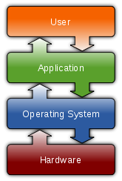](http://en.wikipedia.org/wiki/File:Operating_system_placement.svg)

**Fig 1.1 Common features**

An **operating system** (**OS**) is [software](http://en.wikipedia.org/wiki/Software), consisting of [programs](http://en.wikipedia.org/wiki/Computer_program) and [data](http://en.wikipedia.org/wiki/Data), that runs on [computers](http://en.wikipedia.org/wiki/Computer), manages [computer hardware](http://en.wikipedia.org/wiki/Computer_hardware) resources, and provides common services for execution of various [application software](http://en.wikipedia.org/wiki/Application_software). The operating system is the most important type of [system software](http://en.wikipedia.org/wiki/System_software) in a computer system. Without an operating system, a user cannot run an application program on their computer, unless the application program is selebooting.

Examples of popular modern operating systems include [Linux](http://en.wikipedia.org/wiki/Linux), [Android](http://en.wikipedia.org/wiki/Android_%28operating_system%29), [iOS](http://en.wikipedia.org/wiki/IOS_%28Apple%29), [Mac OS X](http://en.wikipedia.org/wiki/Mac_OS_X), and [Microsoft Windows](http://en.wikipedia.org/wiki/Microsoft_Windows).

## System configuration mainly refers to the specification of a given computer system, from its hardware components to the software and various processes that are run within that system. ... These settings dictate the normal function and features that make the system run in a stable manner.

|  |  |
| --- | --- |
| **Self Check 1** | **Written Test** |

Name:\_\_\_\_\_\_\_\_\_\_\_\_\_\_\_\_\_\_\_\_ Date:\_\_\_\_\_\_\_\_\_\_\_\_\_\_\_\_\_

*Direction:*  Choose the best answer for the following question, if you have some clarifications – feel free to ask your teacher.

# Operating system in computer is \_\_\_\_\_\_\_\_\_?

# A collection of system programs that control computer.

# And any other peripherals connected to it.

# Control the overall activity of a computer.

# All

# Which of the following is the function of operating system?

# Sharing hardware among number of users

# Allow user to share data

# Control the execution of programs

# All

# Without \_\_\_\_\_\_\_\_\_\_\_\_\_\_\_\_ the computer does not work perfectly

# Allow user to share data C. Hardware

# Operating system D. software

***Note:* Satisfactory rating - 3 points Unsatisfactory - below 3 points**

|  |  |
| --- | --- |
| **Information Sheet – 2** | **Installing, upgrading and uninstalling application software** |

* 1. **Installing, upgrading and uninstalling Application software**

When referring to computer software, install, installation, or install.exe is the process or creating, extracting, and moving all of the necessary files to run a program on a computer. An install is started by running the install or setup file on a disc or downloading a program and running the install file.

**You can follow the steps below to install an application from an .exe file.**

1. Locate and download an .exe file.
2. Locate and double-click the .exe file. (It will usually be in your Downloads folder.)
3. A dialog box will appear. Follow the instructions to install the software.
4. The software will be installed.

An update is new, improved, or fixed software, which replaces older versions of the same software. For example, updating your operating system brings it up-to-date with the latest drivers, system utilities, and security software. Updates are often provided by the software publisher free of additional charge.

# In computing uninstall means to remove an application from a computer frequently, however, uninstalling is not 100% effective, and a few orphan files remain. In Windows, you can uninstall an application by selecting Add/Remove Programs from the Control Panel and then selecting the application you want to remove.

**To remove programs and software components in Windows 7 from your computer hard disk drive, follow these steps:**

1. Click Start , and then click Control Panel.
2. Under **Programs**, click **Uninstall** a **program**. ...
3. Select the **program** you want to **remove**.
4. Click **Uninstall** or **Uninstall**/Change at the top of the **program** list.

**How to Update Applications Software**

1. Check the File and Help menus for **update instructions**. ...
2. Choose Start→**Programs**→All **Programs**.
3. Look for the install directory of an application you want to **update**. ...
4. Point your Internet browser to the **software** manufacturer's Web site and look for **update instructions**.
5. Download a newer version than the version you're running.

|  |  |
| --- | --- |
| **Self Check 2** | **Written Test** |

Name:\_\_\_\_\_\_\_\_\_\_\_\_\_\_\_\_\_\_\_\_ Date:\_\_\_\_\_\_\_\_\_\_\_\_\_\_\_\_\_

# *Direction:* filling the appropriate answer for the following question in the specie provided, if you have some clarifications- feel free to ask your teacher.

# \_\_\_\_\_\_\_\_\_\_\_\_\_\_\_\_\_ is the process or creating, extracting, and moving all of the necessary files to run a program on a computer.

# \_\_\_\_\_\_\_\_\_\_\_\_\_\_\_\_\_ is removing application software form the operating system?

# \_\_\_\_\_\_\_\_\_\_\_\_\_\_\_\_\_ is a process of gaining new future for the existing application software

***Note:* Satisfactory rating - 3 points Unsatisfactory - below 3 points.**

|  |  |
| --- | --- |
| **Information sheet – 3** | **Using graphical user interface and the command line interface** |

* 1. **Using graphical user interface and the command line interface**

A **GUI** (Graphic User Interface) is a graphical representation in which the **users** can interact **with** software or devices through graphical icons. A **CLI** (**Command Line Interface**) is a console or text based representation in which the user types the **commands** to operate the software or devices

* 1. **Using Operating system and third-party utilities**

What is a third party utility?

A **third**-**party** energy supplier is a sort of Go-between Company. They buy energy from large **utility** companies and then sell that energy again to consumers at different rates.

What is the difference between operating system and utility program?

**System Software** – The operating system and utility programs that control a computer system and allow you to use your computer. Enables the boot process, launches applications, transfers files, controls hardware configuration, manages files on the hard drive, and protects from unauthorized use.

* 1. **Customizing Graphical user interface**

The graphical user interface is a form of user interface that allows users to interact with electronic devices through graphical icons and visual indicators such as secondary notation, instead of text-based user interfaces, typed command labels or text navigation.

What are some examples of graphical user interface?

The main pieces of a **GUI** are a pointer, icons, windows, menus, scroll bars, and an intuitive input device. **Some** common GUIs are the ones associated with Microsoft Windows, Mac OSX, Chrome OS, GNOME, KDE, and Android.

What is a GUI used for?

**GUI** definition. A **graphical user interface** (**GUI**) is a human-computer interface (i.e., a way for humans to interact with computers) that uses windows, icons and menus and which can be manipulated by a mouse (and often to a limited extent by a keyboard as well).

**Customizable graphical user interface**

A program which aids the process of adding an extra layer to an existing program or system in order to make it look different to the user: for example adding a new interface to an existing operating system so that it looks like another operating system. Sometimes referred to as a skin and often abbreviated to CGUI.

**Graphical User Interfaces**

A **graphical user interface** (GUI) allows a user to interact with a computer program using a pointing device that manipulates small pictures on a computer screen. The small pictures are called icons or widgets. Various types of pointing devices can be used, such as a mouse, a stylus pen, or a human finger on a touch screen.

We refer to programs that use a **graphical user interface** as “GUI programs.” A GUI program is very different from a program that uses a **command line interface** which receives user input from typed characters on a keyboard. Typically programs that use a **command line interface** perform a series of tasks in a predetermined order and then terminate. However, a GUI program creates the icons and widgets that are displayed to a user and then it simply waits for the user to interact with them. The order that tasks are performed by the program is under the user’s control – not the program’s control! This means a GUI program must keep track of the “state” of its processing and respond correctly to user commands that are given in any order the user chooses. This style of programming is called “event driven programming.” In fact, by definition, all *GUI programs* are *event-driven programs*.

|  |  |
| --- | --- |
| **Self Check 3** | **Written Test** |

Name:\_\_\_\_\_\_\_\_\_\_\_\_\_\_\_\_\_\_\_\_ Date:\_\_\_\_\_\_\_\_\_\_\_\_\_\_\_\_\_

# *Instruction:* Choose the best answer for the following question, if you have some clarifications – feel free to ask your teacher.

# \_\_\_\_\_\_\_\_ is a graphical representation in which the users can interact with software or devices through graphical icons.

# Software C. Software configuration

# Graphical user interface D. Network administration

# CLI stand for

# Command Line Interface C. Central processing

# Command Line director D. All

1. A third party utility is
2. Software configuration **C.** A sort of Go-between Company
3. Graphical user interface **D.** All
4. A system software is
5. Allows a user to interact with a computer program using a pointing device
6. Operating system and utility programs that control a computer system and allow you to use your computer.
7. **Central processing**
8. **All**
9. \_\_\_\_\_\_\_ A program which aids the process of adding an extra layer to an existing program or system in order to make it look different to the user
10. Hardware of a computer
11. Software of a computer
12. Customizable graphical user interface
13. All

***Note:* Satisfactory rating - 3 points Unsatisfactory - below 3 points.**

|  |  |
| --- | --- |
| **Instruction sheet** | **LG26. Support input and output devices** |

This learning guide is developed to provide you the necessary information regarding the following content coverage and topics –

* Setting up and checking functionality of Input and output devices
* Installing drivers and checking functionality
* Ensuring Drivers are working properly

This guide will also assist you to attain the learning outcome stated in the cover page.

Specifically, upon completion of this Learning Guide, you will be able to –

* Input and output devices are set up and checked functionality based on requirement.
* Drivers are installed as appropriate and checked functionality based vendor manuals.
* Drivers are ensured to be properly working

**Learning instruction:**

1. Read the specific objectives of this Learning Guide.
2. Follow the instruction describe below 1
3. Read the information written in the information “sheet 1 ” , “in page 3.4.5 and 6 ” respectively
4. Accomplish the “self-check 1” “in page 7”

Respectively

1. If you earned a satisfactory evaluation from the “self-check” proceed to “operation sheet 1, sheet 2 . Sheet 3” “in page 9.10.11.12.and 13”
2. Do the” LAB “Test in page “16”

\*Your teacher will evaluate your output either satisfactory or unsatisfactory. If unsatisfactory, your teacher shall advice you on additional work. But if satisfactory you can proceed to the next topic.

|  |  |
| --- | --- |
| **Information Sheet – 1** | Setting up and checking functionality of Input and output devices |

9.1 **Setting up and checking functionality of Input and output devices**

Input devices only allow for input of data to a computer and output devices only receive the output of data from another device. Most devices are only input devices or output devices, as they can only accept data input from a user or output data generated by a compute

Input and output devices that provide computers with additional functionality are also called peripheral or auxiliary devices. 10 **Examples** of **Output** **Devices**. Monitor. ...

* Monitor
* Printer
* Computer Speakers
* Headphones
* Projector
* GPS
* Sound Card

**What is the difference between an input and output device**

An [input device](https://www.computerhope.com/jargon/i/inputdev.htm) sends information to a computer system for [processing](https://www.computerhope.com/jargon/p/processi.htm), and an [output device](https://www.computerhope.com/jargon/o/outputde.htm) reproduces or displays the results of that processing. Input devices *only* allow for input of data to a computer and output devices *only* receive the output of data from another device.

Most devices are only input devices or output devices, as they can only accept data input from a user or output data generated by a computer. However, some devices can accept input and display output, and they are referred to as [I/O devices](https://www.computerhope.com/jargon/i/io.htm) (input/output devices).

For example, as you can see in the top half of the image to the right, a keyboard sends electrical signals, which are received by the computer as **input**. Those signals are then interpreted by the computer and displayed, or **output**, on the monitor as text or images. In the lower half of the image, the computer sends, or **outputs**, data to a printer, which will print the data onto a piece of paper, also considered **output**?

## Input devices

An [**input**](https://www.computerhope.com/jargon/i/input.htm) device can send data to another device, but it cannot receive data from another device. Examples of input devices include the following.

* [**Keyboard**](https://www.computerhope.com/jargon/k/keyboard.htm) and [**Mouse**](https://www.computerhope.com/jargon/m/mouse.htm) - Accepts input from a user and sends that data (input) to the computer. They cannot accept or reproduce information (output) from the computer.
* [**Microphone**](https://www.computerhope.com/jargon/m/microphone.htm) - Receives sound generated by an input source, and sends that sound to a computer.
* [**Webcam**](https://www.computerhope.com/jargon/w/webcam.htm) - Receives images generated by whatever it is pointed at (input) and sends those images to a computer.

**How to check an installed driver version**

1. Click Start, then right-click My Computer (or Computer) and click Manage.
2. In the Computer Management window, on the left, click Device Manager.
3. Click the + sign in front of the device category you want to check.
4. Double-click the device for which you need to know the driver version.
5. Select the Driver tab.

A **driver**, or device **driver**, **is** a software program that enables a specific hardware device to work with a computer's operating system. For some devices, such as printers, the operating system may automatically find and **install** the correct **drivers** when the device **is** connected.

How a driver is saved and packaged determines how it is installed. Below is information about each of the methods developers use to distribute their drivers, as well as how to install them in Microsoft Windows. Additionally, there are some general insights to help prevent frustrations during the process.

**How to check an installed driver version**

1. Click Start, then right-click My Computer (or Computer) and click Manage.
2. In the Computer Management window, on the left, click Device Manager.
3. Click the + sign in front of the device category you want to check.
4. Double-click the device for which you need to know the driver version.
5. Select the Driver tab.

9.3 **Ensuring Drivers are working properly**

How do I check if my driver is working properly?

Left-click the device to select it. Right-click the device then select Properties. Take a look at the Device status windows. **If** the message is "This device is **working properly**", the **driver** is installed **correctly** as far as Windows is concerned.

Drivers are supporting instructional software that helps computer hardware components work properly. When you install operating system updates, you may assume that all device drivers are updated as well. But driver updates are only installed when they are necessary for the OS to function properly. If your existing drivers are compatible with the newest system update, no changes are made. You can manually install updates if the current drivers are incompatible with newer technology, like a new media player or video game.

**Perform a Windows Update**

Before updating individual device drivers, do a system update. This ensures that your devices will still work right after patches and service packs are applied. Make sure that you are not trying to run an old service pack with a new device driver. If you don't have system updates set to install automatically, open the Windows menu and select "Windows Update." You can also perform an update from the Control Panel, System and Maintenance menu.

**Determine if a Driver Update is Necessary**

Just because a newer version of a driver exists, that does not mean that you have to update it. Your computer's performance will determine the need for an update. For example, if you can't install a new application, or if a graphics tool does not work properly, it could be an indication that a device driver needs updating.

**Check for Updates at the Manufacturer's Website**

If you think that your graphics card or media or audio player needs an updated driver, visit the website of the manufacturer and go to their support page. NVidia, for example, has a "Download Drivers" page that gives you the option to either select your exact device or allow them to detect the device for you, before providing update options.

|  |  |
| --- | --- |
| **Self Check 1** | **Written Test** |

Name: \_\_\_\_\_\_\_\_\_\_\_\_\_\_\_\_\_\_\_\_ Date: \_\_\_\_\_\_\_\_\_\_\_\_\_\_\_\_\_

# *Direction:* filling the appropriate answer for the following question in the specie provided, if you have some clarifications- feel free to ask your teacher.

# \_\_\_\_\_\_\_\_\_\_\_\_\_\_\_ is only allowing for input of data to a computer.

# \_\_\_\_\_\_\_\_\_\_\_\_\_\_\_ only receive the output of data from another device.

# \_\_\_\_\_\_\_\_\_\_\_\_\_\_\_ is a software program that enables a specific hardware device to work with a computer's operating system.

# Operating systems may \_\_\_\_\_\_\_\_\_\_\_\_\_\_\_ and install the correct drivers when the

# device is connected.

# \_\_\_\_\_\_\_\_\_\_ are supporting instructional software that helps computer hardware components work properly.

***Note:* Satisfactory rating - 3 points Unsatisfactory - below 3 points.**

|  |  |
| --- | --- |
| **Operation Sheet – 1** | Setting up and checking functionality of Input and output devices |

Steps of how to checking input and output device are properly connected in computer

Most of the tools used to locally manage a Microsoft Windows XP Professional or a peer-to-peer network are listed in the Administrative Tools window. To open it, you can open Control Panel and double-click Administrative Tools:

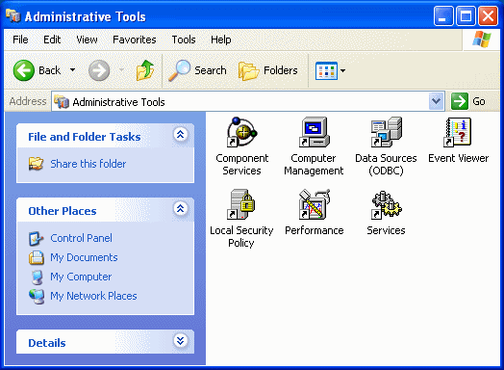

As you install more software or libraries to your computer, the tools may increase in sophistication and number. Here is an example:

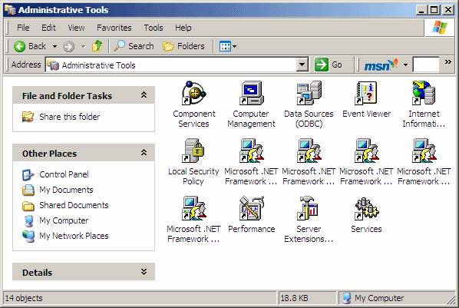

To use a tool, you can double-click it.

|  |  |
| --- | --- |
| **Operation Sheet – 2** | **Network Management with Windows Server 2003** |

Like Microsoft Windows XP Professional, Windows Server 2003 groups its administration routines under an ensemble referred to as Administrative Tools. Unlike the former, the later provides various ways of accessing the tools.

After you have just setup Microsoft Windows Server 2003 and installed Active Directory, the first window that comes up provides some of the most regular tools you will need to administer the network:

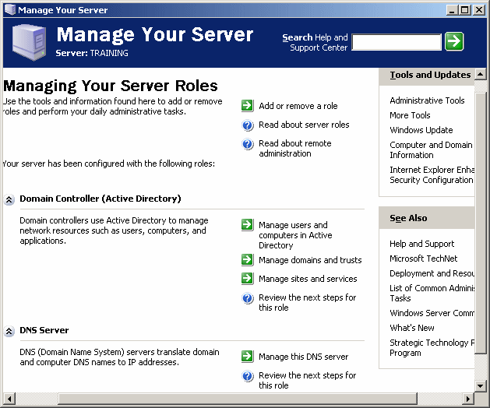

The middle section of this window provides only a limited list of tools, considered to be the most regularly used. Alternatively, you can display the whole list of tools in a window. To do this, under the Tools and Updates Section, you can click Administrative Tools:

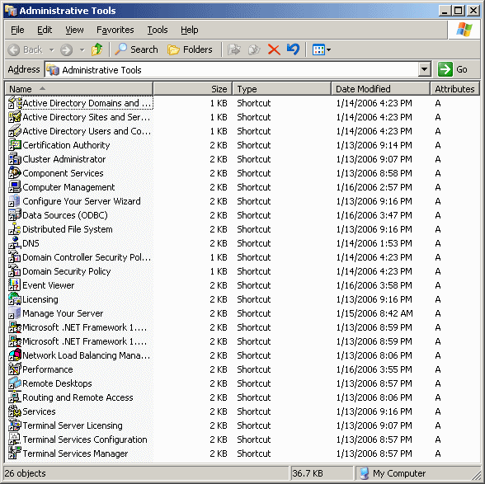

To use a tool, you can double-click it.

Another technique you can access the tools consists of clicking Start -> Administrative Tools:

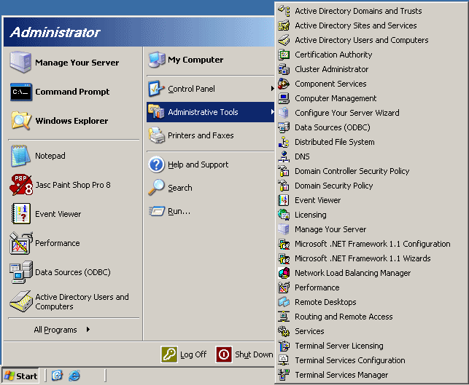

Another technique consists of click Start -> All Programs -> Administrative Tools

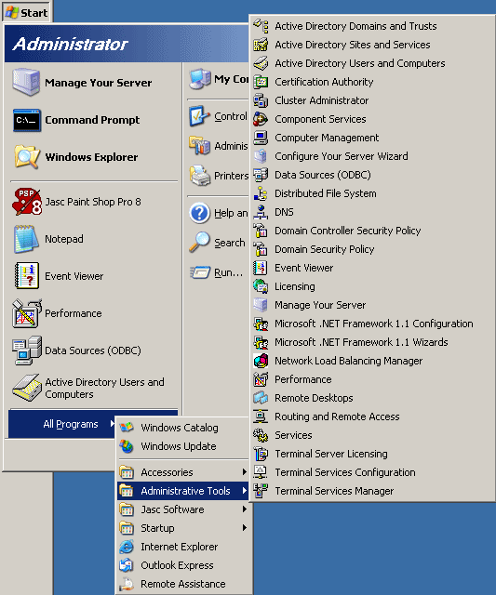

You can also click Start -> Control Panel -> [**Administrative Tools**](http://www.functionx.com/networking/windows/admintools4.gif).

With any of these previous techniques, to use a tool, simply click it from the menu.

|  |  |
| --- | --- |
| **Operation Sheet – 3** | **The Microsoft Management Console** |

|  |
| --- |
| **Introduction** If you have some experience with Windows Explorer of Microsoft Windows 9X and later, you may be aware that, in that same window, you can open your folders, view your files, open Control Panel, or even view a web page. In the same way, to make computer and network management easy, Microsoft Windows XP and Windows Server 2003 provide a common window named Microsoft Management Console or MMC. This makes it possible for all routine operations to be performed in a window that primary looks the same regardless of the task being performed. You can perform all routines operations without formally being aware that you are using the MMC. |

|  |  |  |
| --- | --- | --- |
| **Practical Learning: Introducing the MMC**   1. To view examples of administrative applications that share an interface:  |  | | --- | | * + If you are using Microsoft Windows XP Professional, click open Control Panel, double-click Administrative Tools, and double-click Computer Management   compman1   + If you are using Microsoft Windows Server 2003, click Start -> Administrative tools -> Active Directory Users and Computers   aduc1 |  1. To one more administrative window:  |  | | --- | | * + If you are using Microsoft Windows XP Professional, in the Administrative Tools window, double-click Services   services1   + If you are using Microsoft Windows Server 2003, click Start -> All Programs -> Administrative tools -> Event Viewer   event1 |  1. Close the windows |

|  |  |
| --- | --- |
| **Lap Test** | **Practical Demonstration** |

Name: \_\_\_\_\_\_\_\_\_\_\_\_\_\_\_\_\_\_\_\_\_\_\_\_\_\_\_\_\_ Date: \_\_\_\_\_\_\_\_\_\_\_\_\_\_\_\_\_\_\_\_\_\_\_

Time started: \_\_\_\_\_\_\_\_\_\_\_\_\_\_\_\_\_\_\_\_\_\_\_\_ Time finished: \_\_\_\_\_\_\_\_\_\_\_\_\_\_\_\_

**Instructions:** You are required to perform the following individually with the presence of your teacher.

* *Your teacher will evaluate your output either satisfactory or unsatisfactory. If*

*unsatisfactory, your teacher shall advice you on additional work. But if satisfactory, you can proceed to the next topic.*

1. How to determine the functionality of input and output device?
2. How to configured network management in window 2003 server?
3. How to work the management console in window 2003 server?

**Reference**

* beginners-intro-email-part1
* Computer Hardware\_ Hardware Components and Internal PC Connection
* Computer Networking & Hardware Concepts
* [www.wikipidia.com](http://www.wikipidia.com)
* [www.google.com](http://www.google.com)
* web1.keira-h.school.nsw.edu.au/faculties/IT/
* Beginners-intro-email-part1.
* Computer Hardware\_ Hardware Components and Internal PC Connection.
* Computer Networking & Hardware Concepts.
* Computer-Networks--Introduction\_Computer\_Networking(1)
* Internet-Access-Education\_2017120
* Principles\_of\_Network\_and\_System\_Administration\_(2ed)
* [www.wikipidia.com](http://www.wikipidia.com)
* [www.google.com](http://www.google.com)
* web1.keira-h.school.nsw.edu.au/faculties/IT/