- For the planar frame shown in Figure 1. Design Column AB. For material property, dimension and load type please refer the tables below.

NB:
- Use pattern loading for the design of Column AB.
- All dimensions are in mm unless specified

- Use C30/37 Concrete | - Beam Dimension (Depth X Width) for:
- Use S400 Rebar | - Ground Floor 350x250mm
 | - First Floor 500x400mm
 | - Roof 500x350mm
 | - Column Dimension for all:
 | - Depth = 600mm
 | - Width = 350mm

Floor type | Dead Load (G_{k})- KN/m | Live Load (Q_{k})- KN/m
Ground Floor | 16 | 0
First Floor | 80 | 32
Roof | 60 | 0

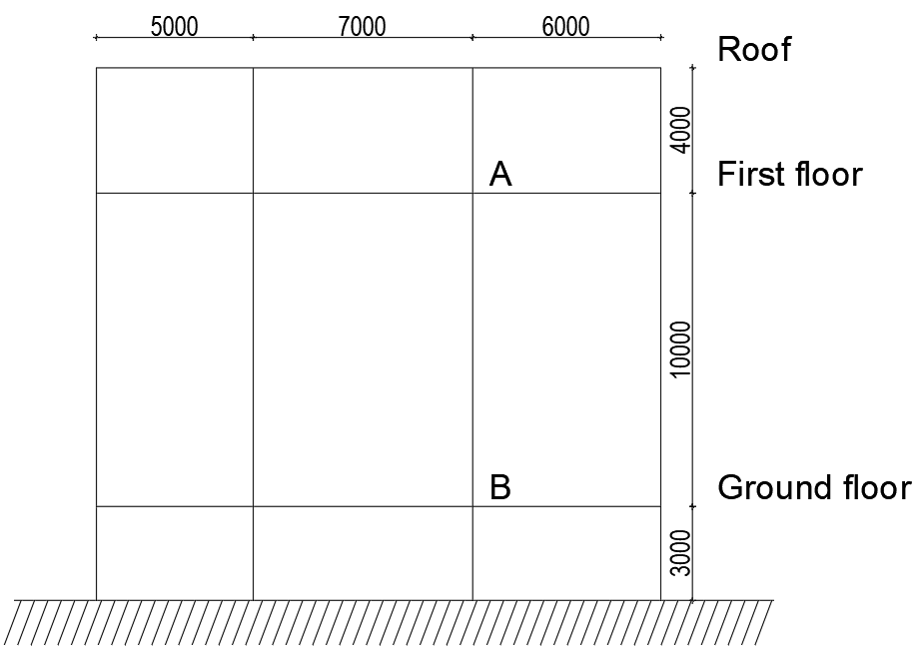

Figure 1: Planar Column

