Problem 3 – Map Projection
- Find the X, Y and k on the sphere for a point with ϕ = 9° N and λ = 40° E in Mercator projection. The central meridian λ_{o} = 39° E and the Radius of the sphere, R = 6371 km.
- Find ϕ, λ on the sphere for the point with Mercator projection coordinates X = 4268.600 km and Y = 12600.600 km. The central meridian λ_{o} = 39° E and the radius of the sphere, R = 6371 km.
- Find the X, Y and k on the Clarke 1880 ellipsoid for a point with ϕ = 9° N and λ = 40° E. The central meridian λ_{o} = 39° E W. Use Mercator projection.
- Find the X, Y and k on the GRS 80 ellipsoid for a point with ϕ = 9° N and λ = 40° E. The central meridian λ_{o} = 39° E. Use Mercator projection.
- Find ϕ, λ on Clarke 1880 ellipsoid for the point with Mercator projection coordinates X = 4140150 m and Y = 11700000. The central meridian λ_{o} = 39° E.
- Find the X, Y and k on the Clarke 1880 ellipsoid for a point with ϕ = 9° N and λ = 40° E in Transverse Mercator projection. The central meridian λ_{o} = 39° E.
- Find ϕ, λ on GRS 80 ellipsoid for the point with Transverse Mercator projection coordinates X = 6110700.158 m and Y = 98762.683 m. The central meridian λ_{o} = 39° E.
- Solve Question No 6 for UTM projection.

Exercises
- For the following data
Day: March 1, 1981 Mid night (UT1 = 0)
Equation of the Equinox = -0.8 sec
A point P has coordinates: Height angle (h) = 80°25’34’’, Declination (δ) = 51°1’14’’, Azimuth (A) = 9°38’11’’
- Compute Julian Date and Modified Julian Date.
- GAST for Time = 22 hr 50 min 42 sec
- Astronomical longitude and latitude for point P

- A point P in Addis has geodetic coordinates of φ = 9°, λ = 40°, h = 2150 m in Clarke 1880 ellipsoid. If the geodetic parameter of Clarke 1880 ellipsoid changed by δxo = 1m, δyo = 1m, δzo = 1m, δa= 1m, δf= 0.006m, calculate the change in geodetic coordinates φ , λ, h.

- The following data is collected for precise leveling

Station | BS | FS | Gravity | Remark
1 | 0.928 | 1.080 | 9.80132316 | Height = 2100 m
2 | 1.212 | 0.765 | 9.8013227
3 | 1.668 | 0.775 | 9.8013216
4 | 2.969 | 0.311 | 9.80132019
5 | 2.938 | 0.367 | 9.80131975
6 | 3.437 | 2.658 | 9.80131931
7 | 2.658 | 0.208 | 9.80131861
8 | 2.500 | 0.728 | 9.80131800
9 | 2.729 | 0.339 | 9.80131714
10 | 2.075 | 0.349 | 9.80131628
11 | 3.825 | 0.375 | 9.80131579
12 | 1.760 | 0.645 | 9.80131539
13 | 3.165 | 0.490 | 9.80131487
14 | 2.055 | 0.950 | 9.80131434
15 | 3.330 | 0.455 | 9.80131291
16 | 1.830 | 1.418 | 9.80131116

Calculate the elevation of Station 16 using geopotential number and check the height with conventional method.

- Let the X, Y, and Z coordinates of point P with respect to the instantaneous pole are:
X | 4827804
Y | 4051009
Z | 991498.6

If the pole has rotation angle of 5’’ and 8’’ with respect to CIO,

- Calculate the X, Y and Z coordinates with respect to CIO
- Calculate the change in geodetic coordinates if the point has geodetic latitude and longitude of 9° and 40° respectively.

Project
- Determine the appropriate two-dimensional coordinate transformation for the following data at a 0.01 level of significance when transforming the XY coordinates into the EN coordinate system.
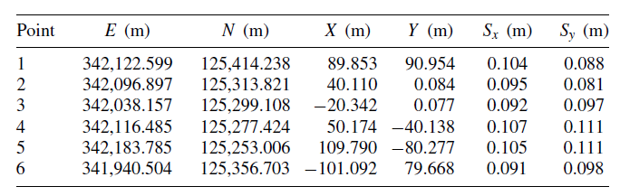

- Using a weighted three-dimensional coordinate transformation and the follow set of data:
(a) Determine the transformation parameters and their standard deviations.
(b) Compute the XYZ coordinates and their standard deviations for points 7 to 10.
