Traversing

A traverse – a sequence of angle and distance measurements which can be used to calculate the coordinates of points.

Different kinds of traverses are known depending on their shape and connection to known coordinates.

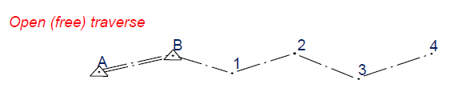
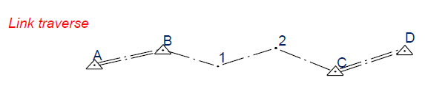
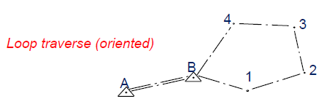

Traversing Field Measurement Procedure – Loop Traverse
B

C

A

D

E

- Set the instrument at A
- Target the instrument to B and measure horizontal angle (face left) and measure distance AB.
- Target the instrument to E and measure horizontal angle (face left) and measure distance AB.
- Turn the instrument at E to face right and measure horizontal angle (face right)
- Target the instrument at B and measure horizontal angle (face right)
- Repeat 1-5 for station B, C, D, E

Traversing Computation – Least square adjustment
Plan networks are solved by variation of coordinates because the observation equations are not linear in the unknowns. In the following pages, the observation equation for each type of observation is developed, linearized, and presented in a standard format. Finally, all the elements that may be in the design matrix are summarized.
The way to set up the linearized equation is as follows.
(1) Form an equation relating the true values of the observations to the true values of the parameters, preferably, but not essentially, in the form

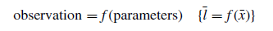
(2) Make the equation equate to zero by subtracting one side from the other. The equation becomes:
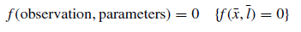
(3) Linearize as the first part of a Taylor series. The equations, expressed in the section on linearization above, may be rewritten as:
Where is the true value of the function with the true values of the parameters and the true values of the observations. From step 2 above, it must, by definition be zero. f (x_{p}, l_{o}) is the same function but the parameters take their provisional values and the observations their observed values.
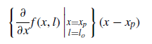
is the function differentiated with respect to a parameter and evaluated using provisional values of the parameters and observed values of the observations. It is then multiplied by the difference between the true value of that parameter and its provisional value. In observation equations, if f (x, l) has been set up in the form described in step 1, then the differentiated function does not contain any observation terms. The term (x − xp) is what is solved for.
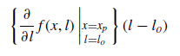
is a similar function to the one above, except the differentiation is with respect to the observations and (l − lo) is the residual. These terms appear in observation equations as 1 if the function is formed as in steps 1 and 2 above.
From the above the linearized equation becomes:
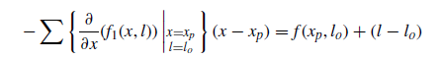
which in matrix terms is one row of the A matrix times the x vector equals an element of the b vector plus the residual. The above will now be applied to the usual survey observation types for a plan, or two-dimensional estimation

Distance equation
Following the three steps above the distance between two points i and j can be related to their eastings and northings by the equation:
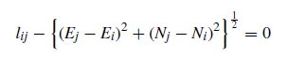
Differentiating with respect to the parameters gives:
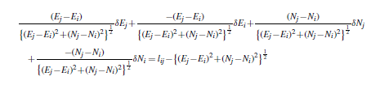
In the four terms on the left-hand side of the equation, the coefficient may be re-expressed as a trigonometrical function of the direction of point j from point i. δEj is the correction to the provisional value of E_{j} , etc. On the right-hand side of the equation is the distance l_{ij} derived from provisional values of the parameters. The right-hand side could now be written as l_{ij}(o−c) where the notation indicates that it is the observed value of the observation minus the computed value of the observation. With a change of sign and re-ordering the terms, the equation may now be more simply expressed in matrix notation as:

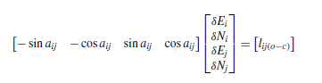
where a_{ij} is the bearing of j from i and is found from provisional values of coordinates of i and j:
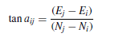
If the units of distance are out of sympathy with the units of the coordinates, and the difference in scale is not known, it can be added to and solved for in the observation equation. This situation might occur when computing on the projection, or when observations have been made with an EDM instrument with a scale error, or even with a stretched tape.

Direction equation
If a round of angles has been observed at a point and it is desired to use the observations in an uncorrelated form to maintain a strictly diagonal weight matrix, then each of the pointings may be used in a separate observation equation. An extra term will be required for each theodolite set up, to account for the unknown amount, z, that the horizontal circle zero direction differs from north. The direction equation is
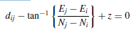

This expression is very similar to the bearing equation above, and the derivation of coefficients of the parameters is exactly the same, but with the addition of one extra term. Upon differentiating and rearranging the final equation in matrix form is

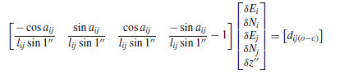
Angle equation
An angle is merely the difference of two bearings. In the current notation it is the bearing of point k from point i minus the bearing of point j from point i

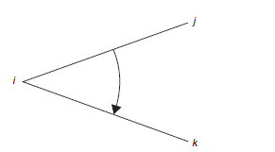
The angle equation is:
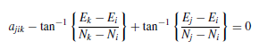
Again, the terms in this are very similar to those in the bearing equation. Now there are six parameters, i.e. the corrections to the provisional coordinates of points i, j and k. Point i is associated with the directions to point j and k so the coefficients of the corrections to the provisional coordinates of point i are a little more complicated.

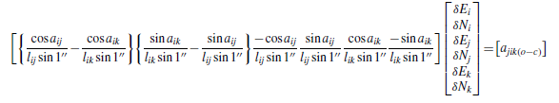
If observations are made to or from points which are to be held fixed, then the corrections to the provisional values of the coordinates of those points, by definition, must be zero. Fixed points therefore do not appear in the x vector and therefore there are no coefficients in the A matrix.

WEIGHT MATRIX
Different surveyors may make different observations with different types of instruments. Therefore the quality of the observations will vary and for a least squares solution to be rigorous the solution must take account of this variation of quality. Consider a grossly overdetermined network where an observation has an assumed value for its own standard error, and thus an expected value for the magnitude of its residual. If all the terms in the observation equation are divided by the assumed, or a priori, standard error of the observation, then the statistically expected value of the square of the residual will be 1. If all the observation equations are likewise scaled by the assumed standard error of the observation, then the expected values
of all the residuals squared will also be 1. In this case the expected value of the mean of the squares of the residuals must also be 1. The square root of this last statistic is commonly known as the ‘standard error of an observation of unit weight’, although the statistic might be better described as the square root of the ‘variance factor’ or the square root of the ‘reference variance’.

If all the terms in each observation equation are scaled by the inverse of the standard error of the observation then this leads to the solution:

where W is a diagonal matrix and the terms on the leading diagonal, wii, are the inverse of the respective standard errors of the observations squared and all observations are uncorrelated. More strictly, the weight matrix is the inverse of the variance-covariance matrix of the ‘estimated observations’, that is the observed values of the observations.

