EDM Calibration
Unknown baseline check
This is a method of checking the total station prism combination. It is a simple procedure that requires 3 tripods and tribrachs and one prism. Set the three tripods up in a line, lined up by eye is good, at a spacing of 30 to 50 metres, they do not need to be setup over anything. The tripods or tribrachs are NOT TO BE MOVED during the procedure

Tripod A _____________________Tripod B___________________ Tripod C
30-40m 30-40m
1: Place the instrument in the tribrach at B. Measure B to A and B to C (horizontal distance.)
2: Place instrument in the tribrach at A. Measure horizontal distance A to C
Any error is contained in each measurement. B to A, B to C and A to C, therefore the sum of (B to A) + (B to C) contains the error twice, while (A to C) contains the error only once.

USE ONLY ONE PRISM PER CHECK. DO NOT MOVE TRIPODS or TRIBRACHS.
SET UP 1: Instrument at ‘B’. Move the prism from ‘A’ to ‘C’.
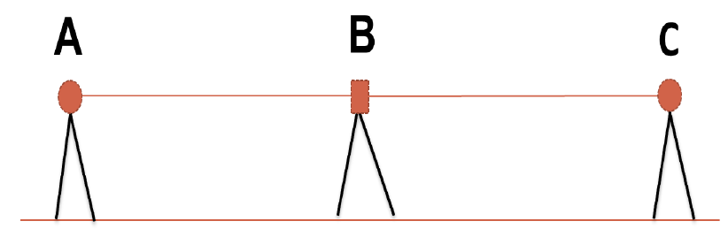
SET UP 1: Instrument at ‘A’
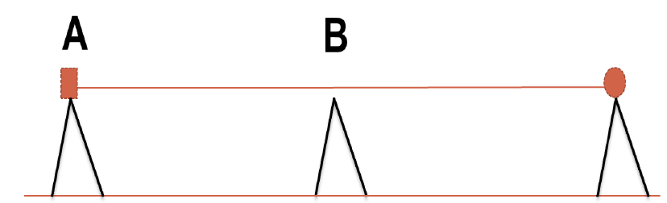
Instrument at ‘B’:
Measure ‘B’ to ‘A’
Move the prism to ‘C’
measure ‘B’ to ‘C’.

Instrument at ‘A”:
measure ‘A’ to ‘C’

The table should look like this.
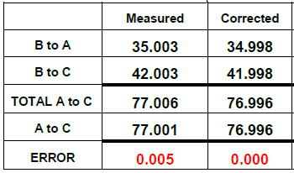
THEREFORE: the error equals (B to A) + (B to C) – (A to C)
The most important thing to remember is that we are testing the EDM / PRISM combination. We are not testing the ability to setup, tribrachs or anything other than the above.

