THE CALIBRATION OF SURVEY EQUIPMENT

SURVEY EQUIPMENT CALIBRATION

Introduction
The terms calibration and validation require some explanation.
First we need to define calibration in the context of survey equipment.
Calibration is a comparison between measurements – one of known magnitude or
correctness made or set with one device and another measurement made in as
similar a way as possible with a second device.
The device with the known or assigned correctness is called the standard. The
second device is the unit under test, test instrument, or any of several other names
for the device being calibrated.
Further to the process of simply testing against a known value it is often possible and therefore
necessary to make adjustments to the equipment to bring it back into calibration. For the
purposes of this discussion the terms calibration and adjustment may both be used to describe
the process of bringing a piece of equipment into specifications.
The validation process differs significantly from calibration. Validation goes beyond
simple calibration. The validation process includes the following:
The equipment;
- Is it capable of achieving the required accuracy under project conditions;
- Are the resulting measurements within specifications, that is, is it properly calibrated?
The procedures used in the field as well as in the office;
In some cases even the personnel become part of the process.

When to calibrate:
There are many reasons why a piece of equipment should be calibrated. Some of those reasons are;
- Surveys legislation;
- Event driven, such as:
- Damaged equipment;
- New equipment
- Rental equipment;

- Time driven such as:

- Heavily used;
- Un used for an extensive period of time;
- Prescribed calibration schedules;

METHODS of CALIBRATION
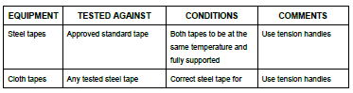
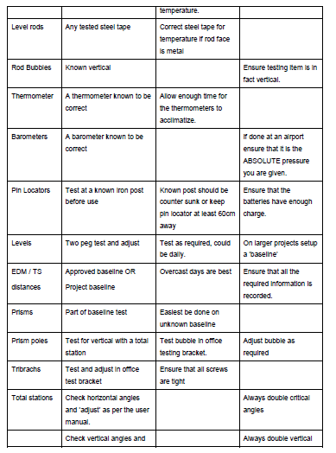
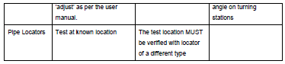

APPENDIX
CALIBRATION EXAMPLE

LEVEL
EDM – Unknown baseline

