General Instruction and Assignment Questions
Dear Students,
It is my hope that you all are in good health condition, despite the epidemic CORONA diseases upsetting the whole world. It is also my believe that you are seriously doing on your courses based on the direction given from the MoE. I have already sent you materials on the first two chapters during the second/third week of the semester. Currently, I’m sending you the materials that can lead you to work on the course, including the two chapters I already sent you and some of the reference materials that I have at moment. I hope I will also add some materials to some of the chapters when I get to full internet access.
The following questions are also useful to guide your readings. After reading and working on all the chapters, please make sure that you are capable to answer these questions. In fact, some of the items in the questions are not included in the power point. In that case, you are required to accomplish further readings from the given or accessible materials. Furthermore, kindly submit the answers of all of the questions as the fulfillment of your assignment (25% weightage).
Please also select and review RELEVANT ARTICLE from internet. The relevance of the article is based on its content’s relevance to particular portion of the course. In your review, you have to emphasize the strengths and weaknesses of the article in all of its sections. The following figure can be used as a guideline to shape the items or contents of your review. For instance, in the Introduction part of the selected article, you have to state how well the “concept”, “research gap” and “aim of the study” were explained. Please put you critiques in clear terms. This is individual assignment and will be evaluated out of 25%.
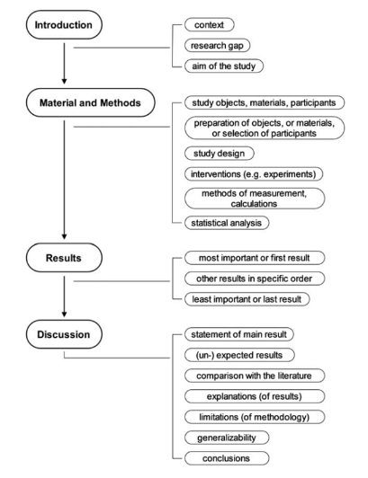
Chapter Two
- State the differences between:
  - Availability, Maintainability, Reliability
  - PDF and CDF
  - Unreliability and reliability functions
- Derive unreliability and reliability functions for:
  - Exponential Distribution
  - Weibull Distribution
  - Normal Distributions
Chapter Three
- Assume that a system has 20 components arranged in series. Also let that each component has a reliability of 0.95.
- Determine the reliability of the system
- From the above calculation, show that:
    - Building a serially reliable system is extraordinarily difficult and expensive
    - The combined availability of the components in series is always lower than the availability of its individual components.
    - A serial system is weaker than the weakest link.
- Consider the system in which Part A, B and C are connected in series. The table below shows the availability for individual components in the series combination.
Components | Availability | Downtime
A | 90.00% | ____________ (days per year)
B | 99.99% | ____________ (hrs per year)
C | 98.98% | ____________ (minutes per year)

Calculate:
- Availability of the system
- Downtime per year of individual components (use the units as shown in the above table)
- Downtime per year of the system (in days per year)
- Consider a system configured by X components in parallel. Assume the availability of individual part is 0.90. Determine the availability and downtime of the system when:
- Two instances of Part X are connected.
- Three instances of Part X are connected.
- Four instances of Part X are connected.
- Show that:
- the overall availability of the system is much higher than the availability of its parts
- Parallel operation provides a highly reliable system from low reliability.
- Find the system reliability of the following combinational system with both serial and parallel arrangements. Assume all sub-systems have a reliability of 0.95.
1
2
3
4
5
6

- Consider a 6 module system requiring 4 correct modules, each with a reliability of 0.94. Determine availability of the system.
Chapter Four
- Calculate the failure rate (number of failures per year) for ten electric motors operated for a collective total time of 50 years with twenty functional failures during the period. Also calculate the MTBF for electric motor.
- 300 cars have accumulated 45000 hours, 10 failures are observed. What is the MTBF? What is the failure rate? Consider car as repairable system
- State the difference between MTBF and MTTF.
- 10 components were tested. The components (not reparable) failed as follows:
Component 1,2,3,4,5,6,7,8,9,10 failed after 75,82,94,100,102,152,180,200,220,250 hours. Find the failure arte and mean time till failure.
Chapter Five
- The followings are some of the types of reliability testing. Discuss all of them in detail using practical examples.
- facility testing
- endurance testing
- serviceability testing
- regression testing
- Discuss the following phases of SDLC and also discuss the purpose, entry criteria, task and exit criteria
- Determine System Needs Phase and its Activities
- Define System Requirements Phase and its Activities
- Design System Components Phase and its Activities
- Build System Components Phase and its Activities
- Evaluate System Readiness Phase and its Activities
- Deploy The System Phase and its Activities
- Decommission the System Phase and its Activities
- Discuss and strengths and weaknesses of the following SDLC models/methodologies
- Waterfall
- Incremental
- Agile
- Discuss the various quality control tools that can be applied for reliability testing. Use numerical data of your own wherever necessary.
- Apply a Fault Tree Analysis (FTA) to assess the reliability of a particular problem of your own.

