University of Gondar
College of Social Science and Humanities
Film and Television Production Department

Course Name: Editing Theory & Technique(FiTv 4221)

prepared by
Melaku Alemnew
(BA in Theatre Arts, MFA in Film Production)

The History & Development of Video Editing
Editing may be thought of as the coordination of one shot with the next. The film editore liminates unwanted footage, usually by discarding all hut the best terke. The editor also cuts super fluolts trames, such as those showing the clapboard.
Like almost every basic idea about movies, the idea of editing has its precursors. Flashbacks had existed in novels; scene changes were already part of live theater; even narrated sequences had been a part of visual culture from medieval altar triptychs to late nineteenth-century comic strips.
But the very earliest filmmakers were afraid to edit film shots together because they assumed that splicing together different shots of different things from different positions would simply confuse audiences.
Shot: The basic temporal unit of film photography and editing. A shot consists of the celluloid used from the moment a camera begins rolling on a scene to the moment it stops.
Sequence: A number of shots edited together and unified, either through the plot, the character(s), the time and/or space, or the theme.
However, filmmakers quickly discovered that editing shots into a sequence not only contributed to the audience's sense of tale, but also enabled them to tell more complex stories as a result.
The lumiere Brothers
Auguste and Louis are the Lumière Brothers and they are often regarded to be the first filmmakers in history, they were the creators of a device called the Cinèmatographe in the 1890s which is essentially a film camera with printer and a projector combined together.
.The lumiere Brothers were the first to create moving pictures. The silent film was called Arrival of a Train at La Ciotat (1895). Its only a train coming into the station and leaving again but it was revolutionary for its time.
. When The Lumiere Brothers filmed the 50 second clip, they purposely placed the camera on the platform and had the camera at a low angle so it made the train look even bigger then it really was to create a sense of scale. They have also made the film Arroseur Arrosé in the same year. The Lumiere Brothers were also the first people to invent the first photography process in 1907.

Georges Melies

Georges Melies was a pioneer in the film industry an was most famous for making the short film "A trip to the Moon" in 1902.
. It was longest film at the time running for 18 minutes.
. It was Melies most complex film he has created and took 3 months to make.
. It was also the first movie to include special effects. even though the film was silent he had a live orchestra play as the film rolled on and often had a narrator talking wile the film was being displayed.
Georges Melies one day accidentally came up with the iconic editing technique Jump Cut. He was filming a bus go by in the streets of Paris when his camera got jammed and when he started to film again but the bus has already gone by and a buggy was now in it's place, this to Melies was extraordinary when he looked though the footage as it looked like the bus has transformed into the buggy. He later used this editing technique in his film The Haunted Castle (1896) He's directed over 500 films. His other famous work was The Voyage Across the Impossible (1904), The 400 Tricks of the Devil (1906) and the Conquest of the Pole (1912).

Edwin S Porter
He was the first person to realise you can cross cut to show simultaneous action scenes in different places to create a narrative technique. Edwin Porter was a film pioneer, director and producer who has directed over 250 films.
. He is most famous for inventing Parallel editing or also known as cross cutting. The short film The Train Robbery (1903) was the first movie to have simultaneous action in more then one place.
It was the first of its kind and is an essential part of modern day films today. His most famous films are Jack and the Beanstalk (1902), Dream of a rarebit Fiend. (1906) and Uncle Josh and the Moving Picture Show (1902).

D W Griffith

He was the first great filmmaker to understand the importance of editing and the psychological effect it can have on audiences, he is even sometimes referred to as ‘The Father of Film’. He was responsible for many techniques still used today in editing including crosscutting, close-ups and fade outs.

D W Griffith was a film director and producer who was best known for his revolutionary film techniques such as the excessive use of close ups which has never been portrayed in films the same way Griffith used them.
He was so many films directed , one of the best film is The Birth of a Nation (1915).
He also used Edwin S Porter's famous film technique of cross cutting but advanced it in a way in which it enhanced the story and emotions portrayed in his films. In some films he had over 28 shots, He was also one of the first directors to use title cards to introduce a scene.

Kuleshov
Lev Kuleshov was a Russian film director who came up with a more redefined version of crosscutting. He was demonstrated the power of Juxtaposition where two images contrast or connect each other.
He used the phycology behind the shots to show that one shot after another can show a certain emotion or feeling. This was calledthe Kuleshov effect.
His most famous work is Po Zakonu (1926) and "The Extraordinary Adventures of Mr. West in the Land of the Bolsheviks". (1924) His techniques are still valued today and was especially evident in Alfred Hitchcock’s work.

Eisenstein
Eisenstein was a Russian film director and film theorist who was most famous for his editing technique of a montage. Eisenstein used montages to create powerful meaning and symbols in films which was very effective in the war.
Eisenstein argued with Kuleshov that the montage was the essence of cinema. Eisenstein argued that editing could be used to create more then just to create a scene and could be used to create an effective moment. He also did a lot of quick cutting in his films.

French New Wave:

The French New Wave was an era in cinema after ww 2 around 1958 to 1964. The French New Wave was a movement that gave the voiceless people a voice by expressing their political or social disconnect in films. Some of the key people involved in this movement were Claude Chabrol, Films were more abstract and controversial to the many because this level of freedom had never been done before in cinema.
The French New Wave was heavily influenced by ww2 due to the economic draught and a rebel against the political elite. The French New ave also helped to make progress in film techniques such as having more natural lighting in shots in contrast with the more traditional artificial lighting used.
Another big innovation in editing techniques were the use of jump cuts to tell a story in a more frantic and abstract way which was different from the traditional long duration shots used.
The handheld camera shot was also used in the French New Wave as a way to tell a more personal story and create more tension. it also meant that smaller studios can now make films and are able to create something new.

One of the biggest contributors to The French New Wave was Francois Truffaunt with the film "The 400 Blows" which was an essential part of French New cinema and is known as one of the most touching and influential films of all time. The story was a reflect of Truffaunt's life as a young boy.
The French New Wave was also the time when the 180 degree rule was invented which gave filmmakers the basic foundations on how to film an effective scene especially when there is a confrontation.
French New Wave also made a path for American New Wave or New Hollywood. which is similar to the French New Wave but for Hollywood. Key people who were part of New Hollywood were Woody Allen, Robert De Niro, Clint Eastwood, Meryl Streep, Martin Scorsese and man more.

THE EDIT: FORMS; ELEMENT & TYPES
I) What is the “EDIT”?

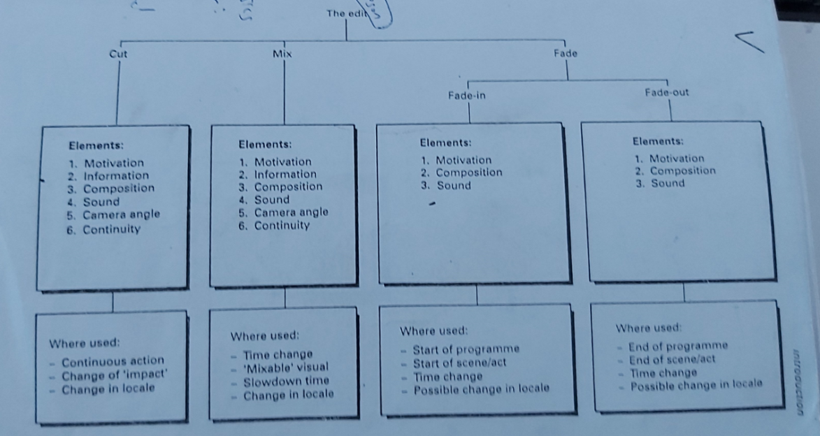

Fig 1 . The Edit chart

The edit is a transition between two shots.
Edit is characterized by its “FORM”; “ELEMENT” and “TYPE”;
There are 3 FORMS of “EDIT”: The CUT; the MIX & the FADE

The 6 ELEMENTS of “EDIT”:
Motivation; Information; Composition; Sound; camera angle,continuity

There are 5 TYPES of “EDIT”:
- The Action Edit;
- The Screen Position Edit;
- The Form Edit;
- The Concept Edit;
- The Combined Edit

II) THE 3 FORMS OF EDIT
The CUT: In the CUT, the transition between shot to shot is not perceived
by the viewer
The MIX: The MIX is a gradual transition from shot to shot by overlapping the
image, and it is perceived by the viewer.
The FADE: The FADE is a transition, by gradual change of the image, to
complete black image. FADE is perceived by the viewer.

Each of these transitions has a completely different meaning and different characteristics, and should be used accordingly.

III) THE 6 ELEMENTS of EDIT

The EDIT is built up of a number of elements. How the edit will be depends on upon the number of elements used and how they are used, how good or bad, and how obtrusive or unobtrusive.

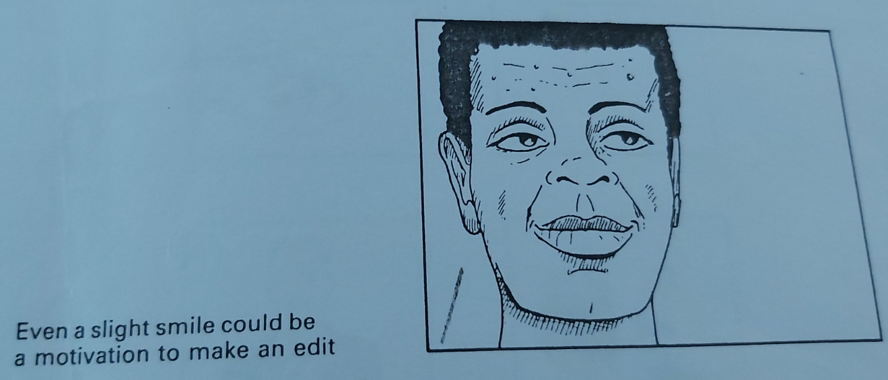
Fig 2. This character looks off-screen, and that very fact motivates for a cut , to a next shot, and show the audience what he is looking at
3.1) Motivation:- There should always be a good reason or motivation to CUT,MIX or FADE
- This motivation can be either visual or aural
- In visual terms it could be an action, even of the smallest kind, made by an actor, for example, a body or facial movement
- In aural terms, it could be a sound, like a knock on the door, or a telephone ring or a voice off-screen
- The motivation could also be a combination of both vision and sound

3.2.) Information:

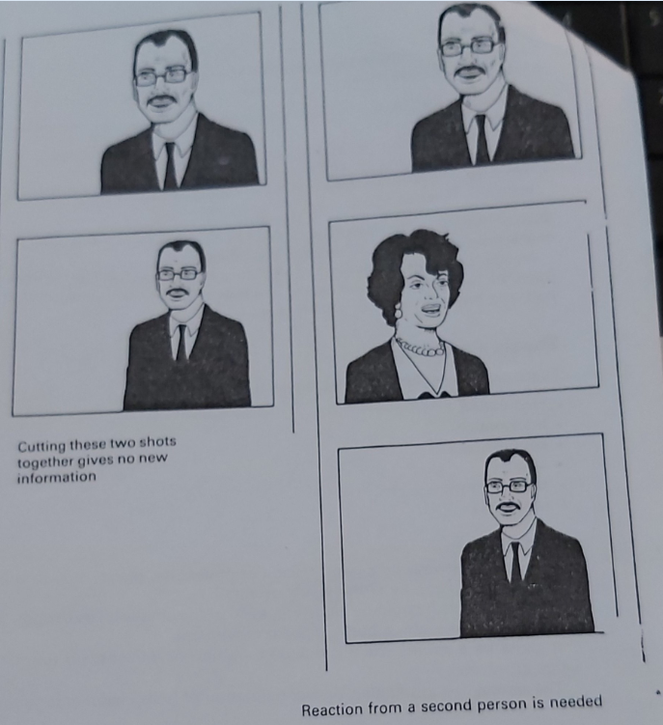
Fig. 3 In the first row, the consecutive shots have no new information, but the in the second row, the man is looking off screen, and the incoming shot of the woman serves as a new information. And in the last row, the shot is a reaction shot
- Information’ is generally recognized to mean ‘visual information’ for the editor, this element is basic to all edits.
- This is simply because if there is no new information in the next shot, then there is little point in cutting to it
- Each shot should, ideally, be a “treat”
- In the selection process, it must be recognized that however beautiful the shot is, it is still should convey visual information different from the last shot
- The more visual information the viewer has and understands, the more informed and involved the viewer becomes
- It is the editor’s job to get as much visual information into the programme as he or she can, without patronizing the audience
- This is another reason why the edits must be so smooth that they are unobtrusive

3.3.) Shot Composition:

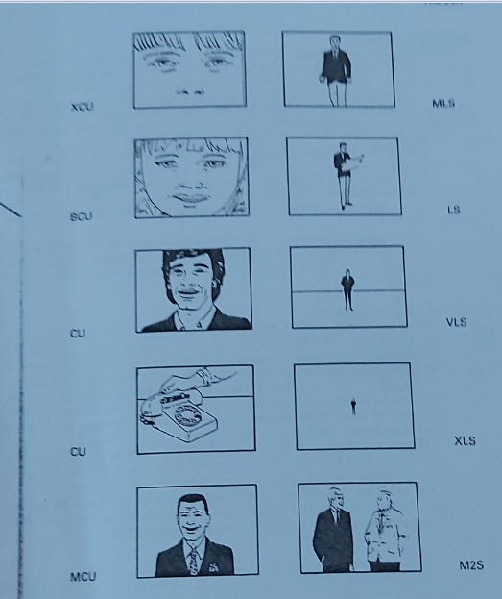

Fig 4. Different shot sizes

- Although the editor cannot create shot composition, it is part of the editor’s job to ensure that a reasonable shot composition exists

- Bad shot composition is a result of bad shooting. It doesn’t stop the editing process, but makes it more difficult

- During pre-production and production, it is a must to adhere to standard shot descriptions with their respective compositions

- It is the editor’s job to select the shots with an acceptable composition

3.4.) Sound:

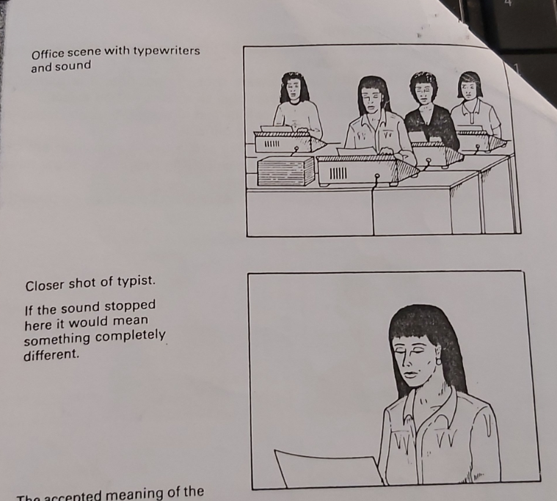

Fig. 5. the elements of sound (effect, atmosphere) must cross over into the next shot,
if the editing is showing the same action taking place in the same place and
same time , by cutting together various shot sizes

- Sound is an important element of the edit
- Sound is not only more immediate than visuals but also more abstract
- The very experienced editors have a saying “you don’t have to see what you hear”
- Sound can be advanced or delayed to create atmosphere, a heightened sense of tension and many other emotions
- Sound also can prepare the audience for a change in scene, in location, or even in history
- Lack of the appropriate sound can devalue an edit.

(for example, consider an office scene where, in the LS, sounds of office machines, typewriters, etc., can be heard. Imagine a cut to a closer shot of a typist without the same sound being heard in the background. That would mean that every single machine had stopped at the instant of the cut to closer shot)
- The audience’s attention can also be generated by advanced sound, which is called lapping.
(for example, it is common to edit the sound four frames in advance of the vision
when cutting from an indoor to an outdoor scene)

3.5.) Camera angle:

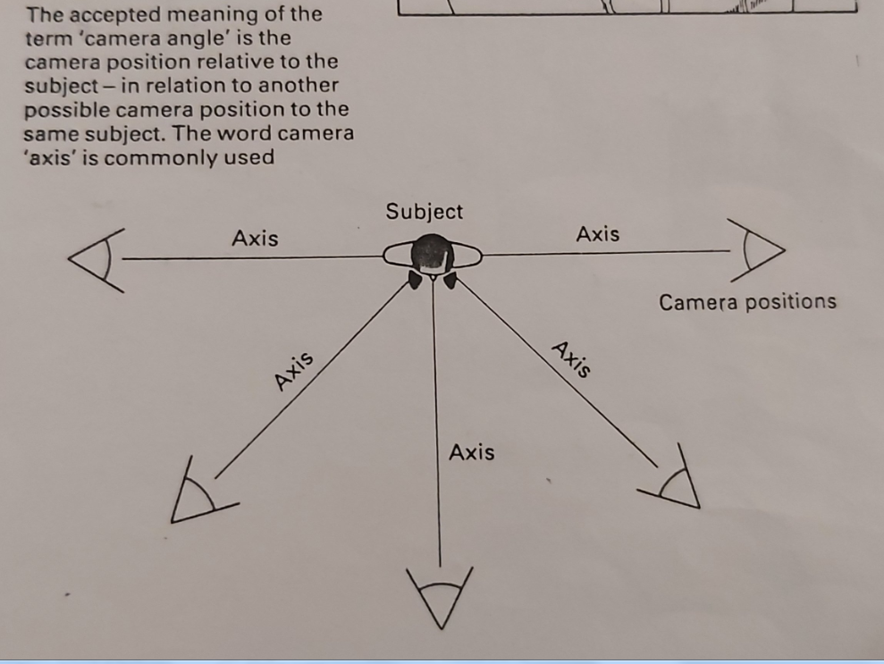

Fig 6. The Camera Axis

- when the director shoots the scene, he or she will have so from a number of positions (camera angles) from each of these positions, the director will have taken a number of shots.

- The word ‘angle’ is used to describe these positions of the camera relative to the object or subject.
- The camera angle is one of the most important elements of an edit.
- The principle is, that each time you cut or mix from one shot to another, the camera should be on a different angle from the previous shot

- For an editor, the difference between axis should never be greater than 180⁰ and
usually less than 45⁰ when shooting the same subject.

- With experience these figures might be altered considerably

3.6.) Continuity:

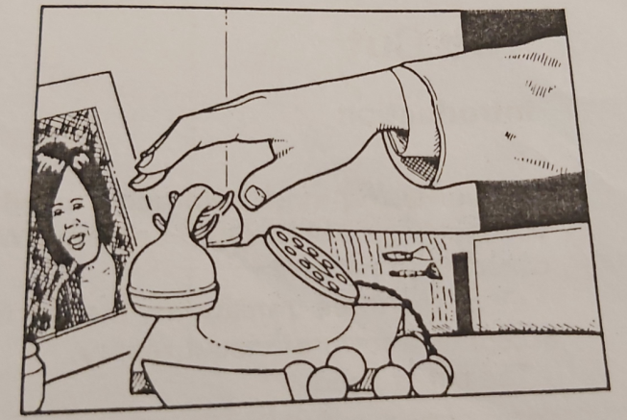 | 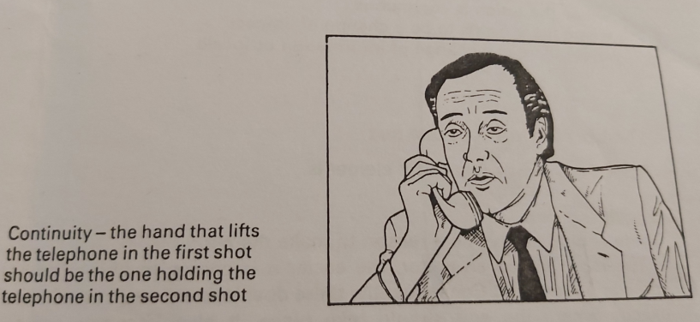

Fig 7 Each time a new camera angle is being shot (in the same sequence) the actor or presenter will have to perform any movement or action in exactly the same way as he or she did in the previous shot.

This, of course, also applies to different ‘takes’

A ) Continuity of content: - there should be continuity of content

(for example, if the actor has picked up a Telephone, in his right hand in the first Shot, then it is expected that the telephone is still in his right hand in any Following shot)

part of the editor’s job is to make sure that the continuity is maintained each time an edit is made in a sequence of shots

b) Continuity of movement: - continuity also involves direction of movement
if the actor or object is moving right to left on the first shot, then it is to be expected that the actor or subject will move in the same direction in the next shot, unless of course you see a change in direction actually taking place in the shot

C) Continuity of position: - continuity is also important in the position of the actor
or subject on the screen.

(for example, if the actor is on the right-hand side of the screen in the first shot, then he must be on the right-hand side in the next shot also. Unless of course, there has been a stage movement seen on screen to change this)

d)Continuity of sound: - the continuity of sound and its perspective is of critical importance.

- If the action is happening in the same place in the same ‘time’, then the sound will continue from one shot to the next one.

- If there is an airplane in the sky in one shot and it is heard, then it needs to be heard in the following shot until the aeroplane is out of distance, Even if the aeroplane is perhaps not seen in the second shot , it does not mean that it should not be heard.
- in addition, with shots in the same scene and at the same ‘time’, there will be a general similarity in background sound. This is known as background ambience, atmosphere, or simply ‘atmos’.
- Atmos must have continuity.

IV) EDIT FORM and its constituent ELEMENTS
We discuss THE CUT and its elements; THE MIX and its elements; and THE FADE and its elements

4.1.) the CUT:

- the cut is the most widely used transitions

- it is an instantaneous change from one shot to another.

- when it is made correctly it is not consciously noticed of all the 3 transitions, the cut is what the audience has learned to accept as a form of visual reality

- the cut is used: --where the action is continuous

-where there is needs to be a change of ‘impact’

-where there is a change of information or locale

The 6 elements of the CUT

A good cut is made of 6 elements፡-
a) motivation: -there should always be a reason to make the cut
- the more skilled an editor, the easier it becomes to find or create a motivation
for a cut.
- Consequently, there develops a greater awareness of exactly where the edit should take place. It also becomes easier to understand how a cut before motivation – an early cut – works.
- A cut after motivation is called a late cut.
- The audiences’ expectations can be delayed or advanced according to how editor uses early or late cuts

b) information: a new shot should always contain new information

c) composition: each shot should have a reasonable shot composition or framing

d) sound: there should ideally be some form of sound continuity or sound development

e) camera angle: each new shot should be on a different camera angle to the last one

f) continuity: the movement or action should be both evident and similar in the two shots to be cut together
-------------------------------------------------------------------------------------------------------------------
GENERAL CONSIDERATIONS

-When the cut becomes visible or noticeable it is called ‘JUMP CUT’.

-A ‘JUMP CUT’ acts as a break to the transition from one shot to the next.

-As a beginner you should always try to obtain a ‘clean cut’ and regard the JUMP CUT as an unsatisfactory edit until you know how to use it.

-Ideally each cut should contain all 6 elements, but not every cut will.

-A general guide is to include as many elements as possible, depending upon the type of edit.

-The editor should know the elements by heart, so that when looking through footage it becomes second routine to check each shot for as many of the 6 elements as possible.
-------------------------------------------------------------------------------------------------------------------

4.2.) the MIX:

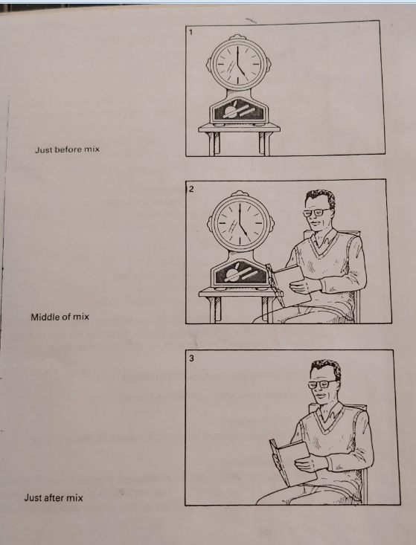

Fig 8
- the MIX is also known as the ‘DISSOLVE’, the ‘LAP DISSOLVE’ or the ‘LAP’
- this is the second most commonly used transition from one shot to another.
- it is made by overlapping the shots, so that near the end of one shot, the beginning of the next shot becomes gradually more visible
- as the old shot becomes more faint, the new shot becomes more stronger
- this transition is clearly visible
- the center point of the mix is when each image is equally strong, creating a new image
- a MIX must be used with extreme care,
- the MIX is correctly used: -- when there is a change in time
--Where the time needs to be slowed down
--Where there is a change in locale
--Where there is a strong visual relationship between the outgoing
and incoming images

The 6 elements of the MIX

A good MIX is made of 6 elements

a) motivation: -there should always be a reason to make the MIX

b) information: the new shot should always contain new visual information

c) composition: the two shots to be mixed should have a composition which overlaps easily and avoids visual contradiction

d) sound: the sound on both shots must also mix together

e) camera angle: the mixed shots should have different camera angles

f) time: a mix lasts a minimum of one second and a maximum of three seconds.

-----------------------------------------------------------------------------------------------------------------
GENERAL CONSIDERATIONS

- With modern machinery there are the possibilities of achieving very fast mix and extremely slow ones.

-With certain equipment a MIX of four frames can be produced easily, or the mix can be as long as the shot itself.

-But, if in the center point of the mix, the images are so pronounced for a long period, then the image appear no longer to be mixed but ‘superimposed’.

-If the mix is short (20 frames or less), it will resemble a visible and badly timed cut.

-For the MIX to be effective, a one-second maximum mix should be used.

-If a MIX is to be longer, the composition of the pictures must be even more carefully observed.

-Images confusing for the editor will be more confusing for the audience.
-----------------------------------------------------------------------------------------------------

4.3.) the FADE:

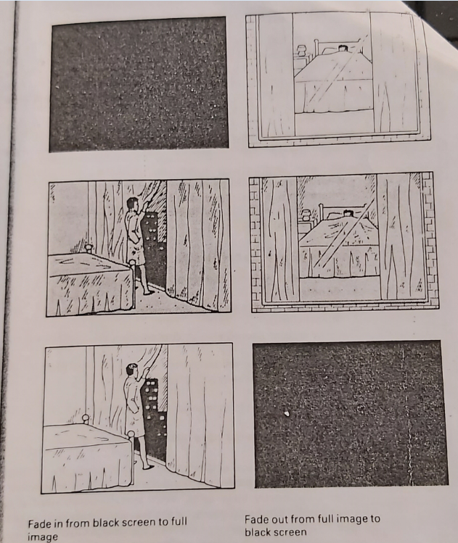

Fig 9) the FADE is a gradual transition from any image to either completely black
or white screen, or from a black or white screen to any image

The FADE is in two forms:
1) The FADE IN (FADE UP) is the transition from black screen to the image

2) The FADE OUT is the transition of the image to black screen
-the FADE IN is used: -- at the beginning of a programme
-- at the beginning of a chapter or scene
-- where there is a change in time
-- where there is a change in locale

-the FADE OUT is used: -- at the end of a programme
-- at the end of a chapter or scene
-- where there is a change in time
-- where there is a change in locale

The fade out and the fade in are often cut together at the point of 100% black, or rarely. 100% white thus suggesting the end of one scene and the start of the next. This is also used to separate ‘time’ and ‘space’

The 3 elements of the FADE

A good FADE is made of 3 elements፡-
A ) motivation: -there should always be a good reason to make a FADE
b) composition: the shot ideally should be composed in such a way that the transition to black is gradual overall. That means that there is no great difference between the very lightest part of the picture and the very darkest
c) sound: the sound element of the picture should approach some form of climax or ending for the fade out, and the opposite for a fade in

V) THE 5 TYPES OF EDIT

There are 5 types of edit:
- Action edit
- Screen position edit
- Form edit
- Concept edit
- Combined edit

It is important for the editor to be able recognizes all the types of edit and how they are made. The editor must also be able to identify each of that individual “elements” that are required in an edit.

5.1.) The Action Edit
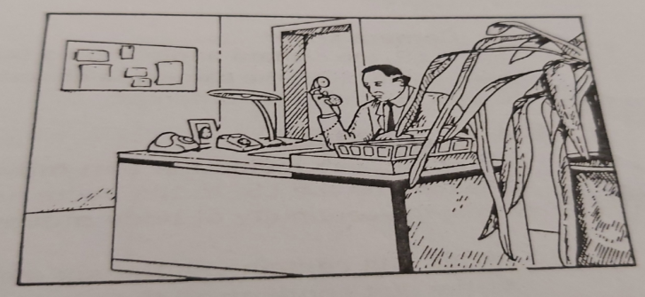 | 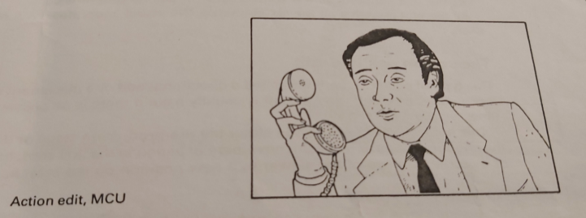
Fig 10

- The action edit, sometimes called a movement edit or a continuity edit, is nearly always a cut. It can be made on the simplest gesture or movement; for example, picking up a telephone.
- The action edit requires all, or nearly all, of the six elements: motivation, information, shot composition, sound, new camera angle and continuity.
- A man is sitting at a desk, the telephone rings; he picks up the phone and answers.

Examine the two shots and identify the six elements.

1.Motivaion

When the telephone rings, we know that the man will pick it up and answer it. This would be a good motivation to make the edit.

2.Information
In the Long shot (LS) we are able to see the office, how the man is sitting and what he is doing; The medium close-up (MCU) tells us even more about the man. We are now able to see, in greater detail, what he looks and, more importantly, his reaction to the telephone call. On the MCU we can see some “body language”. The medium close-up (MCU) therefore gives us new information.

3. Shot composition
The shot composition in the Long shot (LS) is reasonably well constructed, even allowing for a plant in the foreground. It gives a general idea of the office and the man is clearly shown to be working at his desk. The medium close-up (MCU) is well balanced with correct headroom, although experienced editors may argue that he should have been more screen right, to allow for telephone movement. But the shot composition is acceptable.

4. Sound
There will be the same background sound or atmos in both shots. This atmos might be faint traffic noise outside, or office sounds from an inside source. They will give a sound continuity in both shots.

5. Camera angle

In the LS, the camera angle is on a three-quarter profile, almost from the side. In the MCU, the camera is directly in front of the subject. The camera angles are therefore different.

6. Continuity
- It is possible to match the arm movement of the subject picking up the telephone on the LS, to the same arm movement on the MCU. In other words, the continuity of body movement exists.

- As the edit contains all the six elements, it will be smooth.
- As the edit contains all the six elements, it will be unobtrusive
- As the edit contains all the six elements, the visual “story flow” will not stop

5.2.) The Screen position Edit
This type of edit is sometimes called a directional edit or a placement edit. It can either be a cut or a mix, but is usually a cut if there is no passage of time.

This edit is usually planned in either the pre-production stage or during the shooting stage. It relies on the movement or action in the first shot, forcing or directing the eye of the viewer to a new position on the screen.

Example 01

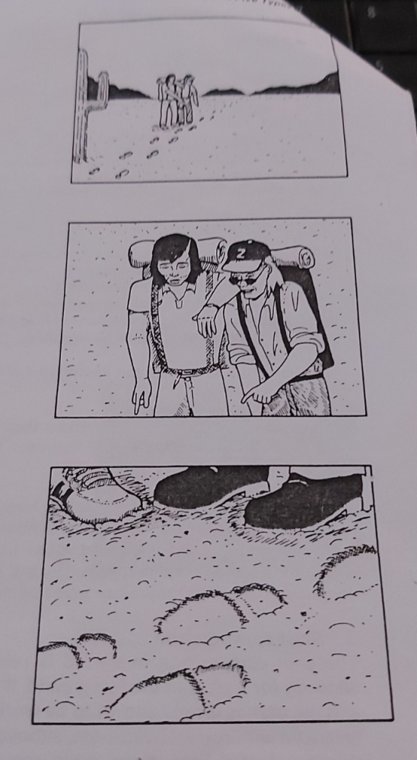

Fig 11) Two walkers stop when they see and point to footsteps of the people they are following. These two shots will cut together. The camera angle is different and there will be continuity in foot and leg movement. There is now new information and there is sound continuity. The motivation is there – they are actually pointing to it, and the shot composition would work.

The edit contains all six elements. The edit would work and the visual story would not be interrupted.

Example 02
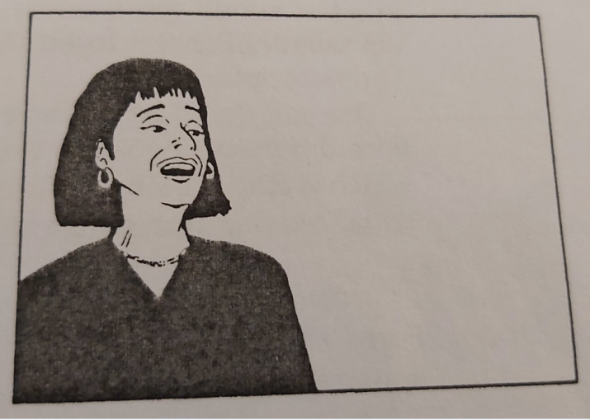 | 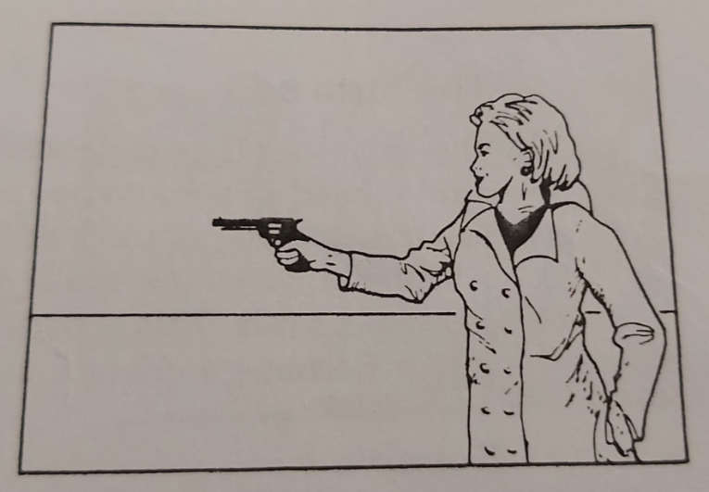

Fig 12. One woman with a gun is threatening another

Example 03

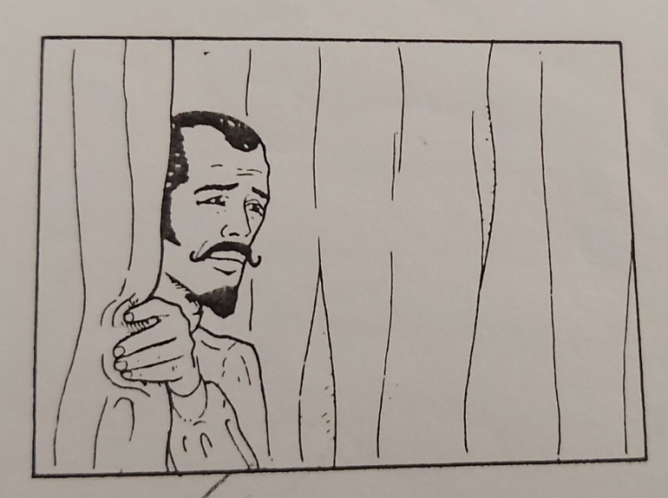 | 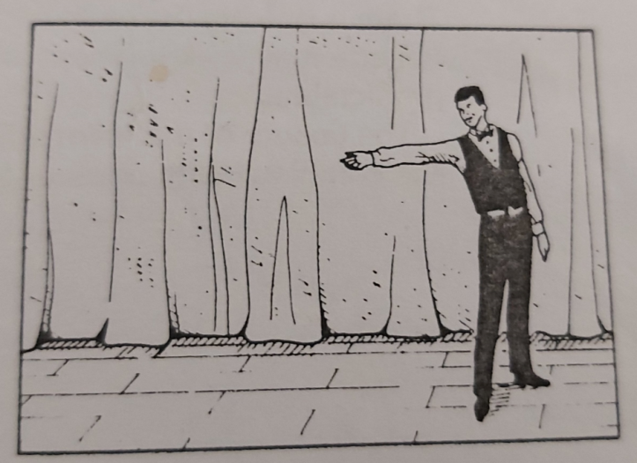

Fig 13 “please welcome … the Great Pompisto!!” A stage. The host of the show is announcing the next act. “So, Ladies and Gentlemen”, he shouts, pointing to the side of the stage. “please welcome … the Great Pompisto!!”

- Again the two shots will edit together.
- The camera angles are different.
- There is new information. We have not seen the Great Pompisto before, and we need to know what he looks like. The sound would offer great possibilities, cutting either on the applause, or on the words “please welcome”, or after the words if you were to delay the entrance of the Great Pompisto.

- There is a motivation to make the cut. Obviously so, the audiences have been told they are going to meet him. So, let’s meet him!

- A screen position edit does not always include all six edit elements; however, the greater the number of elements included, the better the screen position edit will be.

5.3.) The Form Edit
The form edit is best described as a transition from a shot which has a pronounced shape, color, dimension or sound, to another shot which has a matching shape, color, dimension or sound

With sound as the motivation, the form edit can be a cut, but in most cases it is a mix. This is particularly true when there is a change of location and/or perhaps a change in ti
Example 1

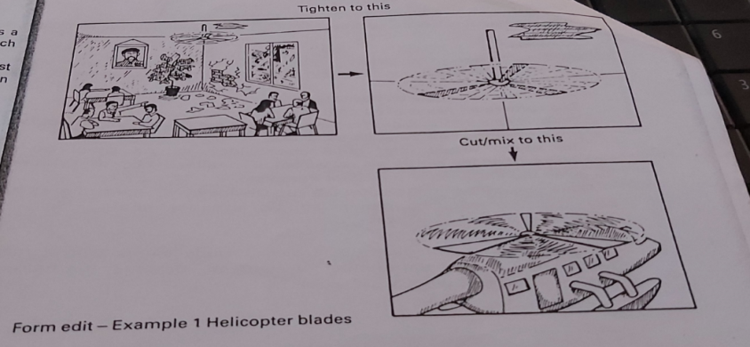
Fig 14

In a hot humid room of the embassy compound, the journalists wait for the relief helicopter to lift them to freedom. On the ceiling a fan rotates. The helicopter arrives.
The edit could be either a cut or a mix. A mix would indicate a greater time difference between the events. The form would be the rotating fan which would match form the form of the rotating helicopter blades. The sound could overlap to create either advanced or delayed apprehension.

Example 2

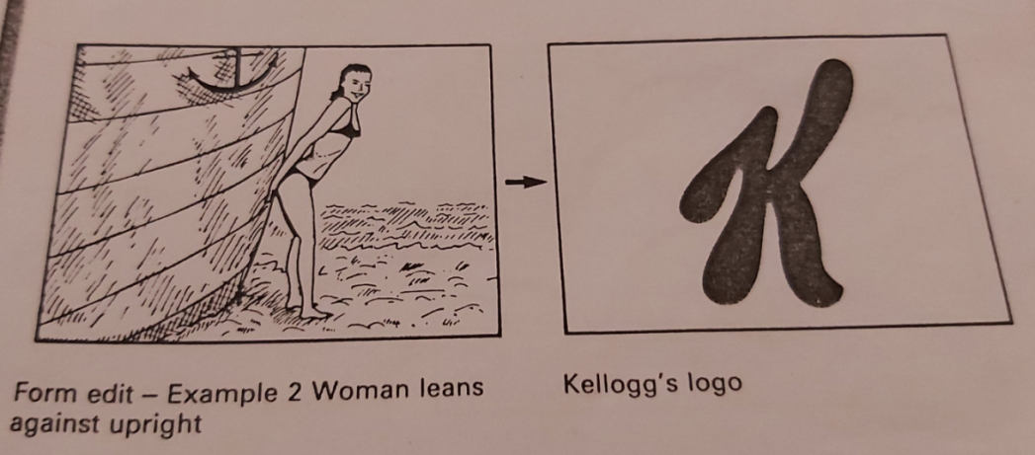

Fig 15 Form edit – in the first shot, a woman leans against upright; and on the
second shot Kellogg’s logo is seen
Form edits are often used in advertisements. Here the subject leaning against an upright simulates a company’s logo.There is one big problem which may be encountered with a form edit: that the edit
may look too contrived. If used frequently, the form edit becomes predictable.

The beauty of the form edit can be seen when it is done well. And, when it is combined with another type of edit, it can become almost unobtrusive.

5.4.) The Concept Edit
The concept edit sometimes called dynamic edit or ideas edit, is a purely mental suggestion. Because of the two shots chosen and the point and the point at which the edit is made, the concept edit plants a story in your mind.

The concept edit can cover changes in place, time, people and even in the story itself. It can do so without any visual break.
If the concept edit is well conceived, it can convey moods, make dramatic emphasis and even create abstract ideas. But to do the concept edit well is very difficult. If it is not well planned, the flow of visual information may stop completely.
It is not the elements in the shot that make a concept edit. The effect of what happens when joining the two shots together produces the concept in the viewer’s mind.Here are three examples of some concept edits that have been copied many times over:

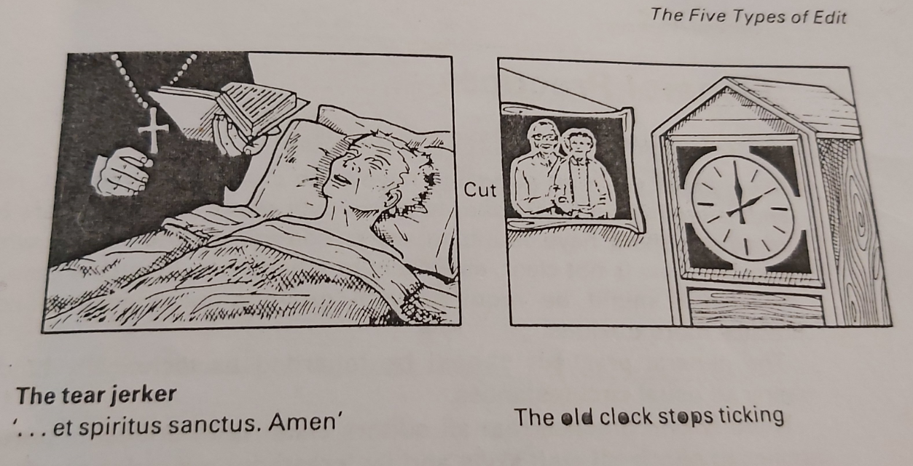

Fig 16 -The tear jerker – the shot of an old man on his dying bed is following by an
old clock stopping to tick

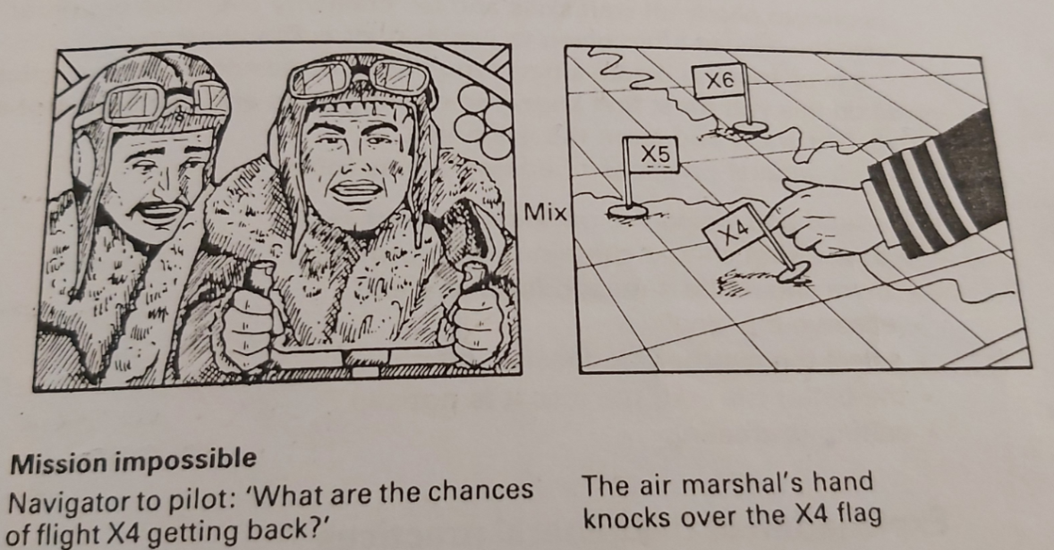

Fig 17 -The mission impossible -“Is there really no hope?” wonder the crew of
Flight X4; and this shot is followed by The Commanding Officer, at the Air
Force commanding base, knocking down the X4 flag down

- At its best the concept edit is an original idea, but at worst it becomes a cliché.

- If you can’t think of a good and original concept edit form the shots available, then it is better to use another type of edit.

5.5.) The Combined Edit

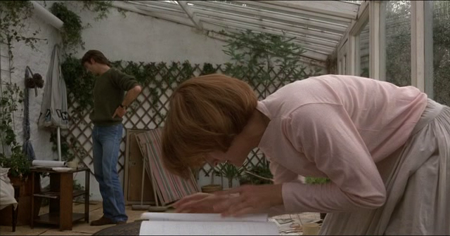 | 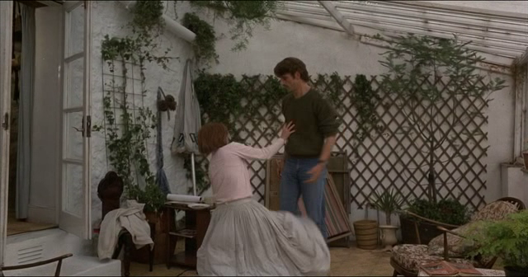

Fig18 In the motion picture The French Lieutenant’s Woman(1981), two actors
rehearse in a conservatory; they rehearse a fall

The combined edit, without doubt the most difficult of all edit types, is also the most powerful. It is also the most powerful. It is the highest achievement of the editor.The combined edit combines two or more of the four other edits types: it combines an action (continuity) edit with a screen position edit, and it includes a form edit and even a concept.

Fig 19 In the motion picture The French Lieutenant’s Woman(1981), two actors
next film the fall they have rehearsed ; the cut makes the transition work

Probably one of the best recent examples can be found in the feature film The French Lieutenant’s Woman. The Director and Editor, Karel Reisz and John Bloom, chose two unusual, but well planned shots, to move the story from an interior modern hote conservatory setting (in which the actors the actors are rehearsing a film scene) to an exterior woodland setting where the actors are wearing their historical costumes. The cut is made as the actress is rehearing a “fall” to the ground and fulfills perfectly all of the six elements of the edit. The continuity requirements of the of the actresses’ fall had to match both shots, making it an action edit. It has requirements of a directional edit, the form was the same in both shots, and finally, the edit creates the idea that takes the viewer from one era to another, a concept edit. Added together, the results is

a combined edit To achieve a combined edit the editor must be able to recognize the aural and visual
potential of each shot as a contribution to the combined edit. Combined edits are carefully planned in both the pre-production and production stages.

Video editing Softwares

Video editing is the process of manipulating video images. Video editing is used to structure and present all video information, including films and television shows, video advertisements and video essays.
Video editing has been dramatically democratized in recent years by editing software available for personal computers. Editing video can be difficult and tedious, so several technologies have been produced to aid people in this task. .
Video editing software can be used to record video, but is used more often in post-production design and editing raw footage in digital file formats.

The video file can be viewed on a computer or device with appropriate viewing software, uploaded to video sharing websites or exported to external media, such as a DVD.

Video Editing Software Features
Video editing used to require expensive machines called video editors, however, today video editing software is now available for personal computers and workstations.
Typical video editing software includes tools to convert file formats, cut segments (trimming), join clips, re-sequence clips, adjust brightness/contrast, rotate or crop footage, add sound or add transitions and other special effects.

Cloud-Based Video Editing
Video editing applications are typically desktop programs, however there are several cloud-based options that allow you to upload a video and edit the file online. Cloud video editing applications typically allow you to connect to various social and online accounts to share your movie.
Free (and nearly free) video editing software and apps
If you've never edited a video before, don't panic. There are plenty of free and paid video editing options on the market that are easy to use.
1. VSDC Video Editor
VSDC Video Editor supports almost all popular codes and video formats. Among video formats are AVI, MP4, MKV, MPG, WMV, 3GP, FLV, and many.
Among the audio formats supported, there are Mp3, Wav, WMA and other and the image support of the formats like BMP, JPG and PNG are offered. It comes with and supports a large number of video effects and transitions. This free program provides a lot of bang for no buck. So, if you’re a beginner, it’s a pretty good place to start.Included in the program are somewhat advanced options like blend overlays, and the options to mask and key. You can also control the speed of the clips as well as add filters transitions.
If your brand is looking to get cinematic and try out some green screen footage, this might be a good program to start with and with its free filters, it would also be a good option for social media videos.

2. Apple iMovie
Apple iMovie is both an app as well as software for iOS and macOS devices. Since 2013, this app either comes bundled with other built-in software or is made freely available to download.
iMovie is a quick and easy way to edit videos for beginners. There are a ton of templates which makes this the ideal software for quick turn around projects and the transitions and animated titles give your production a little extra flare with almost no effort. It’s also good for just quick clip cutting and cobbling together something simple.
Marketers would find this useful for quick culture videos on social media or those that only need basic cuts and fades. If you’re new to video editing and intrigued by the idea of templates. As iMovie is a popular tool among general consumers, using them could be seen as unprofessional or low-budget.
3. Shotcut
Now, this free program is easy to use once you get a hang of the UI. It has good video and audio filters, making it a good choice for posting to social, but it has a limited amount of preset export formats.
Knowing the destination of your final export is important for quality. If you’re focusing heavily on YouTube or Facebook Marketing, you may not want to use this tool until you’re more familiar with the settings best used for each platform. There also doesn’t seem to be a huge support community for questions, which can be tough for newcomers.
4. Magisto
Magisto is basically automatic editing.You can select your own music or use one of their suggested tracks, and it’ll put something together for you assuming you don’t need to trim anything out in the app. This automation is cool and efficient if you need a video quickly, but it does limit creativity as there’s not way to control the order of the images you put in there.
There’s also a time limit for the length of your video with each budget. Still, it’s a fun way to put something quick together if you’re looking to post mostly to social. It’s especially great to use on mobile.

5. Adobe Premiere Pro
Adobe Premiere Pro is a top-notch video editing software in the industry. Developed and released by one of the giants, Adobe Systems, you will be excited to know that it was the editing backbone for Hollywood blockbuster movies such as Terminator-Dark Fate. Since its first release in 2003, it has covered a long from initially able to provide only basic effects to currently extending the capability to motion graphics and intelligent audio editing.
This is an advanced editing software, and while it is possible to learn, if you’re looking for a quick turnaround, you might want to start somewhere else. That being said, if your team needs to edit an interview for a customer testimonial or has the need for a lot of graphics, it’s very easy for this to be your only software and be more than enough.
The essential graphics panel gives you presets that you can fit to your needs, whether it be names and titles for your lower thirds, or an opening graphic for your video. These features do a lot of the work for you and make you look professional and polished. If you create your videos with it, you can publish confidently on any platform, whether it be social, web, film, or even TV. This software is amazing, but is not really geared towards those starting out, especially with it’s monthly subscription pricing model.
6. Final Cut Pro
Final Cut Pro is a professional video editing software that can perform non-linear video editing. It is developed by Apple Inc. and was included as a part of their pro apps family of software programs. The release of its first version in 2011, was not as successful as expected by the developers. However, extensive use of this software in editing and production of Will Smith starred movie “Focus” evidently proved its worth with a great example in the market.
It’s also good for color correction, but bear in mind, this all comes with a bit of learning curve. There are a limited amount of codecs and file types included which will limit what kinds of footage you can work with.
This is a program that can give you a more cinematic look and feel to your projects. If you want your brand to look professional and artistic, but don’t have a huge budget, this tool will definitely help.

7. Sony Vegas Pro
Sony Vegas Pro is on the pricier side for sure, but you get the pro-editor features like motion tracking, HDR support, 360 footage support, video stabilization, speed control, masking, and good presets for color correction.
This is for a marketer who knows what they’re doing and wants a professional finished product, but also has the budget. If you’re looking for a flat rate program that nearly stands up toAdobe Premiere.

8.Lightworks
Lightworks is another professional, non-linear video editing system developed and released by editshare LLC. It has a glorious contribution to history in the video editing industry. Lightworks’ role is associated with blockbuster movie projects like The Wolf of Wall Street, Pulp Fiction, Bruce Almighty, and many more. It offers you a great degree of control.
It supports a wide range of video formats, allows you to make proxies, which let you edit huge video files at a lower resolution and replace before exporting, and has easy timeline editing.
This Video Editing Software can export in various resolutions such as 2K, 4K as well as in different formats also. It works on all three leading operating systems namely Linux, macOS, and Windows.

Essential Cuts Every Editor Should Know
These essential cuts will help any editor transform their footage into a gripping, solid narrative.
If your goal is to master the art of editing, you’re going to need to know the essential cuts to use when editing a film or video. For said examples, we’ll be using excerpts from various films — but keep in mind that you can use these same cuts in any editing session, be it narrative, documentary, commercial, industrial, or even animation.

- Hard cut
The hard cut is the basic type of cut in editing. This type of cut is utilized when you want to cut from clip to clip without any type of transition, or where you cut from the end of one clip to the beginning of another. The only down side of the hard cut is that (out of all the cuts we’ll talk about) this one gives the least amount of visual meaning. To give you a quick overview of the history of cutting, here is a great video from Filmmaker IQ.
- Jump Cut
The jump cut is a technique which allows the editor to jump forward in time. We see an early version of this technique in Eisenstein‘s Battleship Potemkin, where the battleship fires a mortar round and we watch the destruction as various angles jump cut from one to another.
In this very early version of the jump cut, contemporary audiences were introduced to a new way of time passage in film. It obviously gained traction and is one of the most used types of cuts today next to the hard cut.

Another great place to use jump cuts is during an interview, especially if you film the interview with multiple cameras. This allows you to jump from one angle to the other without it being jarring for the audience. In order to really grasp this type of editing technique, here is a fantastic resource from Vimeo Video School on the Understanding of Jump Cuts.

- L Cut & J Cut
First, let’s talk about the L Cut. This editing technique is used not only by narrative filmmakers, but is also a favorite of documentary filmmakers and commercial videographers. What L Cut means is that you are hearing the audio from the previous shot, even though we’ve moved on to another shot. So, the audience is is looking at clip B but still hearing audio from clip A.

A great example of an L Cut from David Fincher’s Fight Club where Tyler recites the rules as various characters ready themselves to fight. What is happening here is that the audience is introduced to the voice, and then we are given visual information on the environment where the voice is located. This technique will keep your film or video flowing naturally, while also giving your audience much needed spacial information.
A J Cut is essentially the opposite of the L Cut. Here we hear the audio before we see the video. So, the audience is is looking at clip A but still hearing audio from clip B. This type of cut is used quite often in all forms of filmmaking and videography, but you can see it quite often in content featuring an interview.
- Cutting on Action
The technique of cutting on action is a huge component of, well, action films. Of course, this type of cut can be used on less-explosive action as well. The basic idea of cutting for action is that the editor cuts from one shot to another and matches the action of the shots. Editing is all about motivation. Your film will develop a better ‘flow’ if you cut on action instead of waiting for pauses. One of the best examples of motivated cutting is The Matrix.
- Cutaways
Cutaways take the audience away from the main action or subject. These are used primarily as transition pieces to give the audience a view of what is happening outside of the main character’s environment. This also goes a long way in helping you emphasize specific details of the mise-en-scène and allowing you to add meaning to them. You can see this clearly in this scene from the The Quick and the Dead where Sam Raimi cuts away from the gunfighters to the clock on the tower, which aids the dramatic tension. Another way to use cutaways is during dialogue sequences. A great example of this is during a scene from Ferris Bueller’s Day Off, where Rooney believes he is talking to Ferris, only to be met with the realization that he is on another line.

- Cross-Cut
The technique of the cross-cut, also known as parallel editing, is where you cut between two different scenes that are happening at the same time in different spaces. When done effectively you can tell two simultaneous stories at once and the information being given to the audience will make complete sense.
Christopher Nolan has used this technique on several films and always uses it effectively to connect the various stories lines in each film. In his 2010 film Inception, Nolan utilizes the cross-cut technique to aid the audience in keeping up with the various levels of the dream state. In fact, it often feels like the entire film is just one long series of cross-cuts. For an example of this cut, let’s watch the now famous zero gravity fight scene and watch how it connects to the crew in the van in a previous dream level.
Utilizing this type of cut, you’ll need to be careful in how you structure your multiple story lines. If not done correctly, you’ll just confuse the audience more.
For other examples of this type of cut, all you need to do is look to other work by Nolan. He successfully uses this technique in Memento, The Dark Knight, and Interstellar.
- Montage
Montage is another technique that has been around for a long time, but isn’t used as much as the previous cuts. The idea behind the montage is to use rapid cuts of imagery to help convey the passing of time or to help aid the context of the narrative.
director Sergio Leone uses quick montage cuts to give the audience the facial reactions of all three characters. This works perfectly to heighten the tension of the moment.montage is also used quite often to help get the audience through a passage of time. There are great examples of this throughout film history, but one of our favorites is its usage during the original Karate Kid. Editor John G. Avildsen uses the montage to quickly get us through the karate tournament showing the main characters progress, as well as the progress of those he will eventually face.

- Match Cuts
The match cut is the technique of matching the movement or space of two opposite environments together.
This technique has been used for many years. It’s most effective when you need to move the narrative along, but you need to find a way to connect them together seamlessly.
There are two particular films that do this extremely well, and they are two of the most lauded films in history. The first film that we’ll look at is 2001: A Space Odyssey, and how Stanley Kubrick found a way to move from the ‘Dawn of Man sequence’ to the ‘Space Station sequence’ in the span of a second without continuity issues. He did this by showing the primitive man throwing the bone up into the air and then replacing it with a spaceship floating through space. This was extremely effective and allowed the audience to move from one scene to another easily.
continuity editing and editing techniques
Continuity editing is the predominant style of film editing and video editing in the post-production process of filmmaking of narrative films and television programs. The purpose of continuity editing is to smooth over the inherent discontinuity of the editing process and to establish a logical coherence between shots.In most films, logical coherence is achieved by cutting to continuity, which emphasises smooth transition of time and space. However, some films incorporate cutting to continuity into a more complex classical cutting technique, one which also tries to show psychological continuity of shots.
The montage technique relies on symbolic association of ideas between shots rather than association of simple physical action for its continuity.
The 180-degree rule is a basic guideline regarding the on-screen spatial relationship between a character and another character or object within a scene. An imaginary line called the axis connects the characters, and by keeping the camera on one side of this axis for every shot in the scene, the first character is always frame right of the second character, who is then always frame left of the first. The camera passing over the axis is called jumping the line or crossing the line; breaking the 180-degree rule by shooting on all sides is known as shooting in the round.

The object that is being filmed must always remain in the center, while the camera must always face towards the object.
The 30 degree rule is rule used in filmmaking with the purpose of creating continuity between different shots within a larger sequence of shots. It should also be noted that the 30 degree rule isn’t a scientific standard.
A flashback is an interjected scene that takes the narrative back in time from the current point in the story.
Flashbacks are often used to recount events that happened before the story’s primary sequence of events to fill in crucial backstory. Flashbacks are shown,for example, through the edges of the picture may be deliberately blurred, photography may be jarring or choppy, or unusual coloration or sepia tone, or monochrome when most of the story is in full colour, may be used.
Slow motion (commonly abbreviated as ‘slowmo’) is an effect in film-making whereby time appears to be slowed down. Slow motion is ubiquitous in modern filmmaking. It is used by a diverse range of directors to achieve diverse effects.
Some classic subjects of slow motion include: Athletic activities of all kinds, to demonstrate skill and style. To recapture a key moment in an athletic game, typically shown as a replay. Natural phenomena, such as a drop of water hitting a glass. Slow motion can also be used for artistic effect, to create a romantic or suspenseful aura or to stress a moment in time.
Slow cutting is a film editing technique which uses shots of long duration.
Fast cutting is a film editing technique which refers to several consecutive shots of a brief duration (e.g. 3 seconds or less). It can be used to convey a lot of information very quickly, or to imply either energy or chaos.
Wipe:- A wipe is a transition that uses an animation (mostly digital these days) that “wipes” the first scene away into the next scene.
There are basic wipes (Star Wars), and there are more complex ones (The 90s TV show Home Improvement is coming to mind), but they can be seen as corny or cheesy, depending on whether you’re a snob or not. I’ve used star wipes, but only as a joke. Take these ridiculous wipes from Tim and Eric Awesome Show, Great Job. They work as a funny transition:

