Course Name: Industrial and Organizational Psychology
Course Code: Psyc2072

COLLEGE: CSS
COURSE: INDUSTRIAL ORGANIZATION
DEPARTMENT: PSYCHOLOGY
AUTHOR: MUSTOFA M.
STUDENTS: 2ND YEAR, 2ND SEM

Part one

Essence, scope, goals of Industrial or organizational psychology
Industrial /organizational psychology: - is the branch of psychology that applies psychological theories and principles to organizations. Frequently it referred to as I-O psychology, this field focuses on increasing workplace productivity and related issues such as the physical and mental wellbeing of employees. The overall goal of this field is to study and understand human behavior in the workplace. In fact Industrial organizational psychologists perform a wide variety of tasks, including studying worker attitudes and behavior, evaluating companies, and conducting leadership training. Despite the fact that industrial organizational psychology is an applied field, basic theoretical researches and deep roots experimental studies are also essential.
As Industrial/ organizational psychology is the study of human behavior in work settings it is a large undertaking. Most jobs are quite complicated, requiring the use of a wide range of mental and motor skills. Work organizations are often large and complex entities made up of hundreds or even thousands of workers who must interact and coordinate activities to produce some product, service, or information. More and more often, workers are physically distant from one another, working in different parts of the country or the world.
Though, it is the study of human and group behavior within organizational settings. The study of organization behavior involves looking at the attitudes, interpersonal relationships, performance, productivity, job satisfaction, and commitment of employees, as well as levels of organizational commitment and industrial relations. Organization behavior can be affected by corporate culture, leadership, and management style.
Organization behavior emerged as a distinct specialty from organization theory in the late 1950s and early 1960s through attempts to integrate different perspectives on human and management problems and develop an understanding of behavioral dynamics within organizations. Organizational Behavior (OB) is the study and application of knowledge about how people, individuals, and groups act in organizations. It does this by taking a system approach. That is, it interprets people-organization relationships in terms of the whole person, whole group, whole organization, and whole social system. Its purpose is to build better relationships by achieving human objectives, organizational objectives, and social objectives.
Organizations are social inventions for accomplishing common goals through group effort. Organizational behavior is concerned with the attitudes and behaviors of individuals and groups in organizations and can be understood in terms of three levels of analysis: the individual, the group, and the organization.
Organizational psychology is having two major sides first; there is the industrial side, which involves looking at how to best match individuals to specific job roles. This segment of I -O psychology is also sometimes referred to as personnel psychology. People who work in this area might assess employee characteristics and then match these individuals to jobs in which they are likely to perform well. Other functions that fall on the industrial side of I-O psychology include training employees, developing job performance standards, and measuring job performance.
The organizational side of psychology is more focused on understanding how organizations affect individual behavior. Organizational structures, social norms, management styles, and role expectations are all factors that can influence how people behavior within an organization. By understanding such factors, I-O psychologists hope to improve individual performance and health while at the same time benefiting the organization as a whole.

Organizational behavior
Organizational behavior is the study of human behavior in the workplace, the interaction between people and the organization with the intent to understand and predict human behavior. It is a field of study that investigates the impact that individuals, groups and structure have on behavior within organizations, for the purpose of applying such knowledge toward improving an organization’s effectiveness. It is the study of human behavior, attitudes and performance within an organizational setting. Management and organization behavior draws on theory, methods and principles from various disciplines to learn about individual perception, values, learning capacities, action of people in an organization.
Management and organization behavior analyzes the external environment’s effect on the organization and its human resources, missions, objectives and strategies. A consciously coordinated social unit composed of a group of people, which functions on a relatively continuous basis to achieve a common goal or set of goals. OBM is the use of behavior analysis principles to help an organization and its members better achieve its goals and mission. Behavior analysis principles are techniques derived from the science of human behavior, as it first defined by Skinner in 1953.
OB is:
It is the study of human behavior in the workplace,
It is the interaction between people and the organization,
And the organization itself.
Organizational Behavior (OB) is the study and application of knowledge about how people, individuals, and groups act in organizations. It does this by taking a System approach. That is, it interprets people-organization Relationships in terms of the whole person, whole group, whole organization, and whole social system. Its purpose is to build better relationships by achieving human objectives, organizational objectives, and social objectives. Generally Organization Behavior is concerned with the study of what people do in an organization and how that behavior affects the performance of the organization.
Goals of organizational/industrial psychology
- Explaining,
- Understanding,
- Predicting, maintaining, and
- Changing employee behavior in an organizational setting.
Major goals
- Explain, predict, and control behavior of worker in an organization.
- It is the study of human behavior in the workplace, interaction between people and the organization, and the organization itself.
- It is the study of how employees work to become assets of organization and how leadership works to assist them in doing so in organization.
- It is study of the interaction between individuals and groups (may include reactions).
- It is the study of people’s work habits, ethics, and how people conduct their day-today tasks how leaders can oversee work in an organization.
- It is the study of interactions between various employees within the organization with encompasses various levels of management, chain of command within organization and interactions between employees and their superiors.
- It involves action taken by a group of people in an organized way…pre-thought in order to have actions done at peak performance of group.
- It is based on relationships and interactions between different people with similar or different roles, inside the organization, and their relationships with outside stakeholders.
- It includes the way an enterprise condones doing business. Ethics are the guide to achieve goals in organization.
- It primarily focuses on attitudes, customs and beliefs that a company/organization holds.
- It is expected for certain ways of business. The way people think and act in an organized manner. The way corporations will gear its thinking or actions toward other companies or people.
- It is the way in which you function and interact with fellow employees in a business setting.
- It is an attitude and judgment of those within an organization.
Scope of organizational psychology
According to Muchinsky (2000), most industrial organizational psychologists work in one of six major subject areas:
- Training and development: Professional in this area often find out what type of skills are necessaryto perform specific jobs as well as develop and evaluate employee training programs.
- Employee Selection: This area involves developing employee selection assessments, such as screening tests to determine if job applicants are qualified for a particular position.
- Ergonomics: The field of ergonomics involves designing procedures andequipment designed to maximize performance and minimize injury.
- Performance Management: I -O psychologists who work in this area develop assessments and techniques to determine if employees are doing their jobs well.
- Work Life: This area focuses on improving employee satisfaction and maximizing the productivity of the workforce. I-O psychologists in this area might work to find ways to make jobs more rewarding or design programs that improve the quality of life in the workplace.
- Organizational Development: I -O psychologists who work in this area help improve organizations, often through increasing profits, redesigning products, and improving the organizational structure.

Part two

Work attitude
Success of a company’s large or small over all the world lies in the attitudes and behaviors of the men and women that work forthem. As Golden Alport said “It’s all about attitude”People often try to influence and influenced by others based on their attitude towards something. In a company Salespeople urge customers to buy goods or services, in politics politicians exhort people to vote for them, in relationship dating partners try to make a good impression on each other, in leadership managers attempt to maintain employee’s dedication to work, and in advertising advertisers try to raise interest in consumer products. In all of these examples, people try to make others like or dislike particular objects,ideas, individuals, groups or tasks.
According to D. Mayer attitude is a favorable or unfavorable reaction towards something or someone exhibited in ones belief, feeling or intended behavior. Attitudes indirectly or directly affect behavior in almost every social interaction.
Peoples reflect how we feel about something. When someone says “I like my job,” he/she is expressing their attitude about work. Attitudes are complex. If you ask people about their attitude toward religion, DR. Abiy Ahmed, or the organization they work for, you may get a simple response, but the reasons underlying or certain reason is it my probably complicated.

“The greatest discovery of my generation is that human beings can alter their lives by altering their attitude of mind”William James of Harvard.

Attitude is the most important thing for an organization as well as for personal and professional life. Can one organization leader be a good leader without a good attitude? Can a worker of one industry can be good employee without having a good attitude? Can the owner of an organization, at the same time can parents, sales persons, teachers etc be good at their roles without a good attitude? In an organizational setting attitude is very vital factor.
Attitude is what is inside us what makes us go up or goes down. Once there was a man who made his living selling balloons at a fair. He had balloons of many different colors including red, yellow, blue and green. Whenever business was slow he would release a helium filled balloon into the air. When the children saw the balloons go up, they all wanted one. They would come up to him, buy a balloon and his sell go up. All day, he continued to release a balloon whenever his sales slowed dawn. One day a balloon man felt some one tugging at his jacket. He turned around and the little boy asked “if you release a black balloon, would that also fly?”moved by the boy concern, the man gently answered “Son, it is not the color of the balloon; it is what’s inside that makes it goes up.” We cannot see what drives our attitude is not about the colorbut it is what’s inside of us that make it to go up. It’s also the same in our life.
Attitudes are tendencies to like or dislike something such as an idea, person or behavior and the object of these tendencies (the thing being liked or disliked) is often called the attitude object.
THE THREE COMPONENTS OF ATTITUDE
Cognitive, affective and behavior are the three components of attitude and they are closely related to one another.
The statement “My pay is low” is the cognitive Component of an attitude a explanation of or belief in the way things are.
It sets the stage for the more critical part of an attitudeitsaffective component. Affect is the emotional or feeling segment of an attitude. “I am angry over how little I’m paid’at last, affect can lead to behavioral outcomes. The behavioral component of an attitude describes an intention to behave in a certainway toward someone or something to carry on.
An American who favors US membership in a global pact to reduce air pollution. Her positive attitude: cognitions, emotions and behaviors. She may:
believe that the pact will be good for the environment
(Cognition)
feel excited when she hears plans for the pact (emotion); and
sign a petition supporting the pact (behavior)
“I’m going to look for another job that pays better.”
Three-component model states that beliefs, feelings and behavior towards an object can influence attitudestowards it, and that these attitudes can reciprocallyinfluence the beliefs, feelings and behavior.
Example, an employee didn’t get a promotion he thought he deserved; a co-worker got it instead. The employee’s attitude toward his supervisor is illustrated; the employee thought he deserved the promotion (cognition), he strongly dislikes his supervisor (affect), and he is looking for another job (behavior).Eminent, that we often think cognition causes affect, which then causes behavior, in reality these components are often difficult to separate. an organizations, attitudes are important for their behavioral component. If workers believe, for example, that supervisors, auditors, bosses, and time and motion engineers are all in conspiracy to make employees work harder for the same or less money, it makes sense to try to understand how these attitudes formed, how they relate to actual job behavior, and how they might be changed.

Attitude
Feeling

Belief

Behavior

Belief
Behavior
Feeling

I

Factors determine attitude
Are we born with attitude or we developed them as we mature?
What are the factors that form our attitude?
Most of our attitudes were shaped during our formative years. While we are born with tendencies toward temperaments, they ware three factors that largely determine our attitude formation.
- Environment
- Experience
- Education
Environment
- It consists of ; Home positive or negative influences
    - School: peer pressure
    - Work supportive or over critical super vision
    - Media, television, news papers, magazines, radio, & movies
    - Cultural background
    - Religious back ground
    - Traditions and beliefs
    - Social environment
All these environments create a culture. Every place be it a home, or a country has a culture. For example you have probably been to a market where you found merchants to sales clerks a like to be polite, helpful, friendly and cheerful. Yet in the other shop you find the staff rude and discourteous. Although you go to home and find the parents and children well behaved, courteous and considerate. You go to another home where everyone is fighting like cats and dogs.
In countries were the government and political environment is honest generally you will find that the people are honest law abiding and helpful. And the reverse is true too. In a corrupt environment the honest individual has a hard time. In a positive environment a marginal performers output goes up in negative environment a good performer output goes down.
While we step back and see what is our environment looks like or what kind of environment we have created for our self and those around us. It thought to expect positive behavior in a negative environment.
Experiences
It’s the other way we form or develop attitude towards something, the more someone experience certain situation the more he is exposed to an attitude. It can make people feel positively or negatively about the objects they are frequently in. Our behavior is changed according to our experiences with various people. If we have a positive experience with person or attitude towards him or her is likely to be positive and conversely negative experiences tend to make us cautious. Experience and events become reference points un our lives, we draw conclusions which serve as guidelines for the future.
Education
Education refers to both formal and informal education. We are drawing information but starving for knowledge and wisdom. Strategically applied, knowledge translates into wisdom which in turn translates into accomplishment.
The role of education is vital in determining our attitude towards something. In fact that a teacher affects a students or education helps to make a behavioral change. There for education teach us not only how to make a living but also how to live.
Benefits of positive attitude in organization
- Helps individuals to have a pleasing personality
- It is energizing for work
- It helps to inspire people aroud you
- It maximizes the level of enjoyment of life
This leads to;
- Increase productivity
- Foster team work
- Solves problem
- Improves quality
- Makes for a congenial atmosphere
- Breeds loyalty
- Increases profit
- Foster better relationship with employers, employees, and customers
- Reduce stress
Consequence of negative attitude in organization
Negative attitude lead to;
- Bitterness
- Resentment
- A purposeless life
- Ill health
- High stress levels for themselves and others
- Unpleasant environment with coworkers
Major Job attitudes
JOB SATISFACTION
People identify themselves by their profession, such as a sales person, doctor, business administrator, lawyer, or teacher. Hence, an individual's personal well-being at work is a significant aspect for job satisfaction. Job satisfaction is the most broadly researched job attitude and among the most extensively researched subjects in Industrial/Organizational Psychology.It is a positive feeling about one’s job resulting from an evaluation of its characteristics.When people speak of employee attitudes, they usually mean job satisfaction, which describes a positive feeling about a job, resulting from an evaluation of its characteristics. A person with a high level of job satisfaction holds positive feelings about his or her job, while a person with a low level holds negative feelings.
Job satisfaction resulted in being linked to productivity, motivation, absenteeism/tardiness, accidents, mental/physical health, and general life satisfaction (Landy, 1978).
The emotional component; refers to job-related feelings such as boredom, anxiety, acknowledgement and excitement.
The cognitive component of job satisfaction pertains to beliefs regarding one's job whether it is respectable, mentally demanding / challenging and rewarding.
The behavioral component includes people's actions in relation to their work such as tardiness, working late, faking illness in order to avoid work
The most widely accepted theory of job satisfaction was anticipated by Locke (1976);he defined job satisfaction as “a pleasurable or positive emotional state resulting from the appraisal of one’s job or job experiences”. Job satisfaction has emotional, cognitive, and behavioral components (Bernstein & Nash, 2008). Job satisfaction refers to the positiveattitudes or emotional dispositions people may gain from work orthrough aspects of work.Employees’ job satisfaction becomes a central attention in the in work and organizationalpsychology because it is assumed to have strong relationshipwith the job performance.

There are basically two types of job satisfaction based on the level of employees' feelings regarding their jobs.
- The first one is the most analyzed, it is global job satisfaction, which refers to employees' overall feelings about their jobs (e.g., "Overall, I love my job").
- The second is job facet satisfaction, which refers to feelings regarding specific job aspects, such as salary, benefits, work hierarchy (reporting structure), growth opportunities, work environment and the quality of relationships with one's co-workers (e.g., "Overall, I love my job, but my schedule is difficult to manage").
According to Kerber and Campbell (1987), measurements of job facet satisfaction helps identify specific aspects of a job that require improvement. The findings may aid organizations in improving overall job satisfaction or in understanding organizational issues such as high turnover.
In fact there are several myths regarding job satisfaction. One such myth is that a happy employee is a productive employee. They believe that happy employees do not negatively affect productivity and can have a positive effect at workplace and on society at large. It also positively impacts the organization's brand image. For that reason, it still benefits all parties to have happy and satisfied employees. On the contrary, some research has suggested that casualness may creep in, shifting from productivity to satisfaction (Bassett, 1994). Hence, if there is a correlation, it is a weak one. Knowing that research does not support the idea that happiness and employee satisfaction creates higher production.
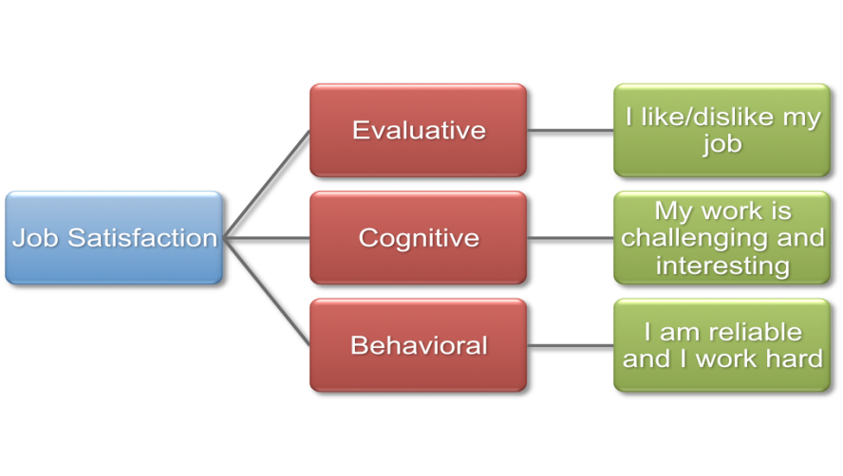
Another fallacy is that the pay is the most important factor in job satisfaction. In reality, employees are more satisfied when they enjoy the environment in which they work. An individual can have a high paying job and not be satisfied because it is boring and lacks sufficient stimulation. In fact, a low-paying job can be seen as satisfying if it is adequately challenging or stimulating. There are numerous factors that must be taken into consideration when determining how satisfied an employee is with his or her job, and it is not always easy to determine which factors are most important to each employee. Job satisfaction is very subjective for each employee and each situation being assesseddirectly by asking the employee about the level of satisfaction via survey, interview, observation and focused group discussions andindirectly by watching the trend of employee turnover.
People tend to evaluate their work experiences based on feelings of satisfaction or dissatisfaction regarding their job, as well as the organization in which they work. Thereare many plausible influences that affect how favorably an individual appraises his or her.
All the way through years of extensive research, I/O psychologists have identified numerous variables that seem to contribute to either job satisfaction or organizational commitment .To explain the development of job satisfaction, researchers have taken three common approaches:
- Job characteristics
- organizational characteristics (social information processing)
- worker characteristics (dispositional)
Job Characteristics
Job characteristics approach research has revealed that the nature of an individual’s job or the characteristics of the organization predominantly determines job satisfaction. job characteristic is an aspect of a job that generates ideal conditions for high levels of motivation, satisfaction, and performance. in addition, Hackman & Oldham (1980) proposed five core job characteristics that all jobs should hold: skill variety, task identity, task significance, autonomy, and feedback. They also defined four personal and work outcomes: internal work motivation, growth satisfaction, general satisfaction, and work effectiveness which have been added to the dimensions of job satisfaction assessment: the work itself, pay, promotional opportunities, supervision, and co-worker relations.
A common premise in making inquiries of the effects of job circumstances on job satisfaction is that individuals assess job satisfaction by comparing the current receivables from the job with what they believe they should receive. For example, if an employee receiving an annual salary of $50,000 believes that he or she should be receiving a salary of $47,000, then he or she will experience satisfaction; however, if the employee believes that he or she should be receiving $60,000, then he or she will feel dissatisfied. This comparison would apply to each job facet including: skill level, seniority, promotional opportunities, supervision, etc.
According to Locke (1976), this process becomes even more complex since the importance of work facets differs as per individual perception. For example, one employee may feel that pay rate is extremely important while another may feel that social relationships are more important. To explain the effects of these differences, Locke (1976) put forth the ideas of the range of affect theory. The hypothesis of this theory is that employees weigh facets differently while assessing job satisfaction (Locke, 1976). Consequently, this leads to an individual measure of satisfaction or dissatisfaction when expectations are met or not. For example, the job satisfaction of an employee who places extreme importance on pay would be positively impacted if he or she receives a salary within expectation. Conversely, his or her level of pay would minimally impact the job satisfaction of an employee who places little importance on pay.
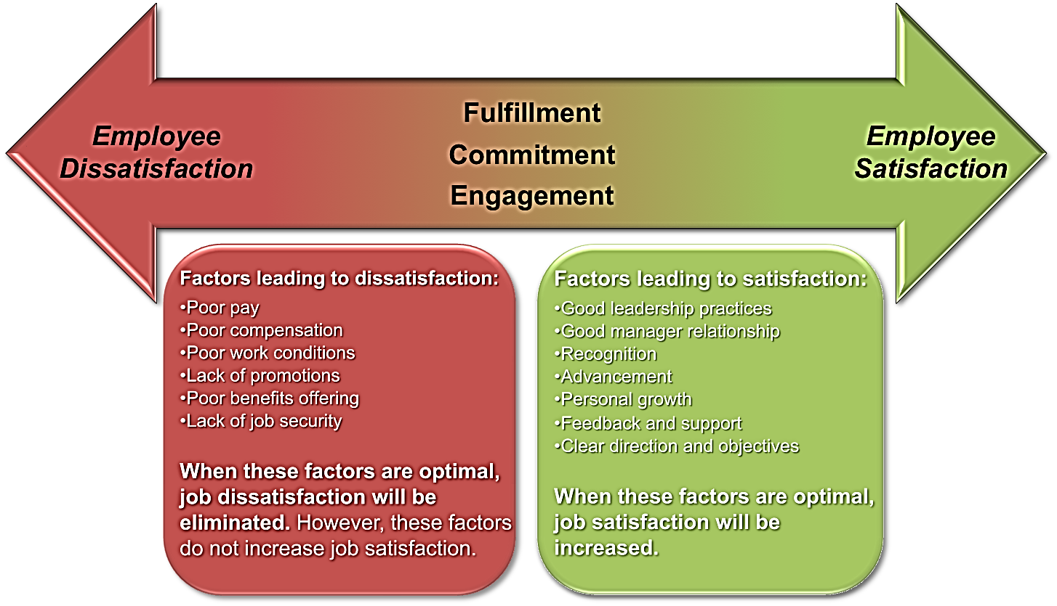
Social information processing (organizational characteristics)
Based on Social Comparison Theory, explains that during social information processing, employees look to co-workers to make sense of and develop attitudes about their work environment. In other words, if employees find their co-workers positive and satisfied then they will most likely be satisfied; however, if their co-workers are negative and dissatisfied then the employee will most likely become dissatisfied. New hires may become “tainted” during the socialization process if placed around employees who are dissatisfied.
Weiss and Shaw conducted a study that required subjects to view a training video where assembly-line workers either made positive or negative comments regarding their jobs. The subjects who viewed the video were then given the opportunity to perform the job. The study found that the subjects who were shown the positive video enjoyed performing the job tasks more than the subjects who viewed the negative tape (Aamondt, 2009).
Mirolli et al., (1998) also conducted a similar study. In this study, the subjects performed a task with two experimenters pretending to be other subjects (referred to as confederates). In one condition, positive comments were made by the confederates about the job and how much they enjoyed it. In the second condition, the confederates made negative comments about the job and how much they disliked it. In the control condition, no positive or negative comments were made regarding the job. The actual subjects exposed to the confederates who made positive comments rated the job tasks as more enjoyable than the subjects exposed to the negative comments by the confederates. This further supports social information processing theory (Aamondt, 2009).
Generally, “the research on social information processing theory supports the idea that social environment does have an effect on employees’ attitudes and behaviors”.As an application of social information processing theory, Netzwerk, an IT company in Germany, implemented rules in their contracts. Employees who work at this company must sign a contract agreeing not to whine or complain and have even fired employees for excessive whining (Aamondt, 2009).
Dispositional (worker characteristics)
Internal disposition is the crux of the latest method of explaining job satisfaction which hints some people being inclined to be satisfied or dissatisfied with their work irrespective of the nature of the job or the organizational environment. More simply put, some people are genetically positive in disposition (the glass half full), whereas others are innately negative in disposition (the glass half empty). For instance, a study of twins who were reared apart (same genetic characteristics but different experiences) found that 30 percent of inconsistency in satisfaction was accredited to genetic factors (Arvey et al., 1989). Although individuals change jobs and employers, individual disposition has been shown to be consistent by the use of survey results on job satisfaction (Staw & Ross, 1985). Additionally, Staw et al. (1986) found that adolescent evaluations of affective disposition were correlated with adult job satisfaction as many as forty years later.
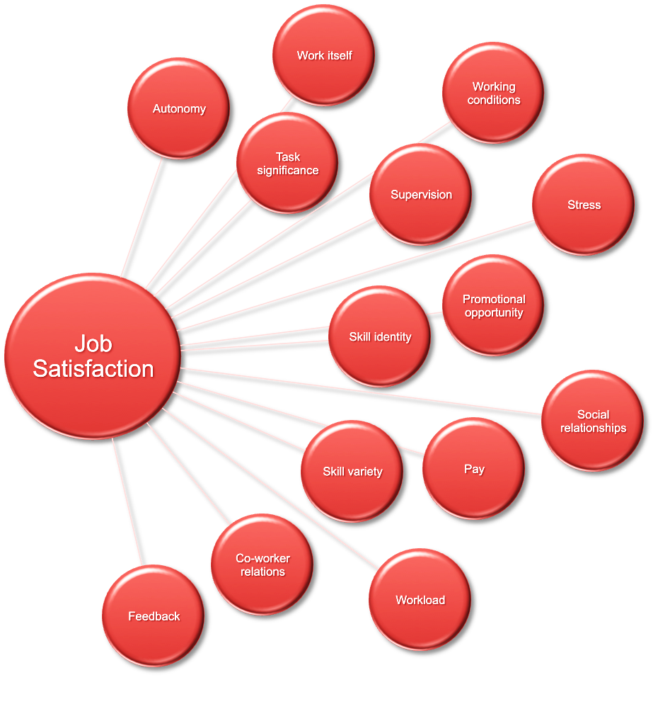
Several years of research have been conducted on the dispositional source of job satisfaction, and have presented strong evidence that job satisfaction, to some extent, is based on disposition (Judge & Larsen, 2001). Dispositional affect is the predisposition to experience related emotional moods over time (Judge & Kammeyer-Mueller, 2008). Accordingly, this approach assumes that an employee’s attitude about his or her job originates from an internal (mental) state. Positive affect is a predisposition favorable to positive emotional experience, whereas negative affect is a predisposition to experience a wide array of negative emotions (Watson, Clark, & Carey, 1988). Positive affective people feel enthusiastic, active, alert and optimistic while negative affective people feel anger, contempt, disgust, guilt, fear and nervousness (Watson, Clark, & Tellegen, 1988).

Job satisfaction and dissatisfaction
Life Satisfaction
Life satisfaction is often considered separately from job satisfaction with regard to productivity in the workplace, but since the majority of this research is correlational, it is crucial to explore potential relationships between these two factors themselves rather than strictly with regard to performance. Research suggests there is in fact a significant relationship between job satisfaction and life satisfaction, with a correlation of 0.44 (based on a meta-analysis of 34 studies with a combined sample size of 19,811) (Tait et al., 1989). With this relationship being correlational, causation cannot be determined, though it is suggested that the nature of the relationship is reciprocal or bi-directional. (Judge et al., 1993) In other words, life satisfaction may positively influence job satisfaction and job satisfaction will also positively influence life satisfaction. Conversely, some research suggests that life satisfaction often precedes and is a good predictor of job satisfaction (Judge et al., 1993). Nevertheless, one cannot deny there is a significant relationship between job satisfaction and life satisfaction based on correlational research (Jones, 2006).
Engagement
It is difficult to establish all the antecedents that lead to job satisfaction. However, an additional construct that has a positive correlation to job satisfaction is engagement. In a meta-analysis, the correlation between job satisfaction and engagement is 0.22 (Harter et al., 2002). Stirling (2008) notes that 20 percent of engaged individuals do 80 percent of the work. An engaged team member is one who is enthusiastic about the organization and the work they do. Examples of employee engagement include a team member helping another struggling to complete a task, or an associate who take over and completes a pending task in the absence of the responsible party. Therefore, it is crucial to continue to cultivate job satisfaction among such highly productive individuals.
A study completed examined three possible factors which play a part in employee engagement. The three factors are vigor, dedication, and absorption (Alarcon & Lyons, 2010). Vigor is directly related to the amount of energy and effort an individual will put forth to complete a task, regardless of difficulties (Alarcon & Lyons, 2010). Dedication relates to the amount of overall significance a task carries and absorption is the depth of work immersion the individual experiences (Alarcon & Lyons, 2010). The study found that the three factors all had an impact on engagement, however they also noted that a positive disposition toward one’s job also correlated with positive engagement (Alarcon & Lyons, 2010).
Job Involvement
The degree, to which a person identifies with a job, actively participates in it, and considers performance important to self-worth. Related to job satisfaction is job involvement, which measures the degree to which people identify psychologically with their job and consider their perceived performance level important to self-worth. Employees with a high level of job involvement strongly identify with and really care about the kind of work they do. in addition closely related concept is psychological empowerment , employees’ beliefs in the degree to which they influence their work environment, their competence, the meaningfulness of their job, and their perceived autonomy.
a study of nursing managers in Singapore found that good leaders empower their employees by involving them in decisions, making them feel their work is important, and giving them discretion to “do their own thing.” High levels of both job involvement and psychological empowerment are positively related to organizational citizenship and job performance. High job involvement is also related to reduced absences and lower resignation rates.
Organizational Commitment
In organizational commitment, an employee identifies with a particular organization and its goals and wishes to remain amember. Most research has focused on emotional attachment to an organization and belief in its values as the “gold standard” for employee commitment. A positive relationship appears to exist between organizational commitment and job productivity, but it is a modest one. A review of 27 studies suggested the relationship between commitment and performance is strongest for new employees and considerably weaker for more experienced employees. Interestingly, research indicates that employees who feel their employers fail to keep promises to them feel less committed, and these reductions in commitment, in turn, lead to lower levels of creative performance.
Although particularly the same as with job involvement, the research evidence demonstrates negative relationships between organizational commitment and both absenteeism and turnover. Theoretical models propose that employees who are committed will be less likely to engage in work withdrawal even if they are dissatisfied, because they have a sense of organizational loyalty. On the other hand, employees who are not committed, who feel less loyal to the organization, will tend to show lower levels of attendance at work across the board. Research confirms this theoretical proposition. It does appear that even if employees are not currently happy with their work, they are willing to make sacrifices for the organization if they are committed enough.
Employee Engagement
A new concept is employee engagement, an individual’s involvement with, satisfaction with, and enthusiasm for, the work she does. We might ask employees whether they have access to resources and the opportunities to learn new skills, whether they feel their work is important and meaningful, and whether their interactions with co-workers and supervisors are rewarding. Highly engaged employees have a passion for their work and feel a deep connection to their company; disengaged employees have essentially checked out—putting time but not energy or attention into their work. A study of nearly 8,000 business units in 36 companies found that those whose employees had high-average levels of engagement had higher levels of customer satisfaction, were more productive, brought in higher profits, and had lower levels of turnover and accidents than at other companies.Molson Coors found engaged employees were five times less likely to have safety incidents, and when one did occur it was much less serious and less costly for the engaged employee than for a disengaged one ($63 per incident versus $392). Engagement becomes a real concern for most organizations because surveys indicate that few employees— between 17 percent and 29 percent—are highly engaged by their work. Caterpillar set out to increase employee engagement and recorded a resulting 80 percent drop in grievances and a 34 percent increase in highly satisfied customers.

The Importance of Job Satisfaction
As mentioned in the overview, job satisfaction has been linked to many variables including performance, absenteeism and turnover, which will be discussed further in this section.
Job satisfaction is significant because a person's attitude and beliefs may affect his or her behavior. Attitudes and beliefs may cause a person to work harder or work less. Job satisfaction also impacts a person's general wellbeing for the simple reason that people spend a good part of the day at work. Consequently, a person's dissatisfaction with work could lead to dissatisfaction in other areas of life.
Employee performance
The relationship between job satisfaction and job performance has a long and controversial history. Researchers were first made aware of the link between satisfaction and performance through the 1924-1933 Hawthorne studies (Naidu, 1996). Since the Hawthorne studies, numerous researchers have critically examined the idea that "a happy worker is a productive worker". Research results of Iaffaldano and Muchinsky (1985) have found a weak connection, approximately 0.17, between job satisfaction and job performance. However, research conducted by Organ (1988) discovered that a stronger connection between performance and satisfaction could not be established because of the narrow definition of job performance. Organ (1988) believes that when the definition of job performance includes behaviors such as organizational citizenship (the extent to which one's voluntary support contributes to the success of an organization) the relationship between satisfaction and performance will improve. Judge, Thoreson, Bono, and Patton (2001) discovered that after correcting the sampling and measurement errors of 301 studies, the correlation between job satisfaction and job performance increased to 0.30. It is important to note that the connection between job satisfaction and job performance is higher for difficult jobs than for less difficult jobs (Saari & Judge, 2004).
A link does exist between job satisfaction and job performance; however, it is not as strong as one would like to believe. The weak link may be attributed to factors such as job structure or economic conditions. For example, some jobs are designed so that a minimum level of performance is required providing no scope for greater satisfaction. Moreover, in times of high unemployment, dissatisfied employees will perform well, choosing unsatisfying work over unemployment.
In 2006, researcher Michelle Jones analyzed three studies combining 74 separate investigations of job satisfaction and job performance in 12,000 workers. She wrote: "The conclusions drawn by these researchers, and many others, indicate the presence of a positive, but very weak, relationship between job satisfaction and job performance" (Jones, 2006). Jones argues that we have been measuring the wrong kind of satisfaction. Instead of job satisfaction, we should be looking at the link between overall satisfaction with life and output at work (Bright, 2008). In this study, Jones implies that the more satisfied we are with our life in general, the more productive we will be in our jobs.
Employee absenteeism
One of the more widely researched topics in Industrial Psychology is the relationship between job satisfaction and employee absenteeism (Cheloha, & Farr, 1980). It is only natural to assume that if individuals dislike their jobs then they will often call in sick, or simply look for a new opportunity. Yet again, the link between these factors and job satisfaction is weak. The correlation between job satisfaction and absenteeism is 0.25 (Johns, 1997). It is likely that a satisfied worker may miss work due to illness or personal matters, while an unsatisfied worker may not miss work because he or she does not have any sick time and cannot afford the loss of income. When people are satisfied with their job they are more likely to attend work even if they have a cold; however, if they are not satisfied with their job, they would be more likely to call in sick even when they are well enough to work.
Employee turnover
According to a meta-analysis of 42 studies, the correlation between job satisfaction and turnover is 0.24 (Carsten, & Spector, 1987). One obvious factor affecting turnover would be an economic downturn, during which unsatisfied workers may not have other employment opportunities. On the other hand, a satisfied worker may be forced to resign his or her position for personal reasons such as illness or relocation. This holds true for the men and women of the US Armed Forces, who might fit well in a job but are often made to relocate regardless. In such case, it would be next to impossible to measure any correlation of job satisfaction. Furthermore, a person is more likely to be actively searching for another job if they have low satisfaction; whereas, a person who is satisfied with his or her job is less likely to be job hunting.
Another researcher viewed the relationship between job satisfaction and an employee's intent to leave the organization, turnover intention, as mediated by workplace culture. Medina (2012) found that job satisfaction was strongly inversely correlated with turnover intention and this relationship was mediated by satisfaction in workplace culture. The study provides evidence that should be further explored to aid in the understanding of employee turnover and job satisfaction; particularly in how job satisfaction and employee turnover relate to workplace culture (Medina, 2012).
Job Satisfaction and Retirement
In a 2013 study from Lehigh University, individuals begin to think about retirement in their early years and develop a plan of action over the years. While individuals who begin working a career earlier on in their life plan to retire earlier, individuals who begin a career later in life, plan to retire later in life as well. The research shows that job satisfaction has very little to do with how we plan for our retirement. While the survey shows that many individuals do consider income, location and attitude when discussing retirement options, they do not solely decide if and when retirement is an option for them nor do the factors (poor work environment, long hours, unhappy with position, etc) (Lehigh University, 2013) There are many studies that have questioned if job satisfaction is something that you experience more in your younger years or older. Studies have returned with both sets of results. Some individuals have more job satisfaction in their earlier years while others experience it more when they are older. So, it is undetermined if you will retire from a job that you have been satisfied at or unsatisfied at.
The application of job satisfaction in the workplace is a difficult concept to grasp due to its individualistic and situational nature. What one employee desires from work, another may not. For instance, one employee may put salary in high regard, while another may find autonomy the most important. Unfortunately, one aspect alone will most likely not effect an employee's job satisfaction. According to Syptak, Marsland, and Ulmer (1999), there are numerous aspects of a job through which an organization can manage increase satisfaction in the workplace, such as:
- Company Policies- Policies that are transparent, fair and applied equally to all employees will decrease dissatisfaction. Therefore, fairness and clarity are crucial in improving employee attitude. For example, if a company has a policy for lunch breaks having the same length and time for all, it will be seen as a norm and will help cut down on wasted time and low productivity.
- Salary/Benefits - Making sure employee salaries and benefits are comparable to other organization salaries and benefits will help raise satisfaction. If a company wishes to produce a competitive product they must also offer competitive wages. Furthermore, this can help reduce turnover, as employees will invariably be more satisfied when paid competitive wages as opposed to being underpaid.
- Interpersonal/Social Relations - Encouraging employees to develop a social aspect to their job may increase satisfaction as well as develop a sense of teamwork. Co-worker relationships will benefit the organization as a whole since teamwork is a very important aspect of organization productivity and success. Moreover, when people are allowed to develop work relationships they care more about pulling their own weight and not letting co-workers down. Employee involvement groups are a great way to help employees interact with individuals outside their department or organization.
- Working Conditions - upgrading facilities and equipment and ensuring employees have adequate personal workspace can decrease dissatisfaction. A cramped employee is a frustrated employee plus faulty equipment leads to frustration in trying to get work done.
- Achievement - Ensuring employees are appropriately placed to utilize their talents may enhance satisfaction. When employees are given proper role and feel a sense of achievement and challenge, their talents will be in line with the goals best suited for them.
- Recognition - Ensuring a job well done is duly acknowledged increases the likelihood of employee satisfaction. Positive and constructive feedback boosts an employee's morale and helps them work at the desired level and towards the desired direction.
- Autonomy - Giving employees the freedom and sense of ownership of their work may help raise job satisfaction as the individuals realise they are responsible for the outcome of their work.
- Advancement - Allowing employees showing high performance and loyalty, the room to advance will help ensure satisfaction. A new / higher position and sense of responsibility can often increase job satisfaction in an employee.
- Job Security - Especially in times of economic uncertainty, job security is a very crucial factor in determining an employee's job satisfaction. Giving an employee the assurance that their job is secure will most likely increase job satisfaction.
- Work-life Balance Practices- In times where the average household is changing, it is becoming increasingly important for an employer to recognize the delicate balancing act that its employees perform between their personal life and work life. Policies that cater to common personal and family needs can be essential to maintaining job satisfaction.
Job Satisfaction and Job Performance
As several studies have concluded, happy workers are more likely to be productive workers. Some researchers used to believe the relationship between job satisfaction and job performance was a myth. But a review of 300 studies suggested the correlation is pretty strong.
As we move from the individual to the organizational level, we also find support for the satisfaction–performance relationship. When we gather satisfaction and productivity data for the organization as a whole, we find organizations with more satisfied employees tend to be more effective than organizations with fewer.
Job Satisfaction and OCB
It seems logical to assume job satisfaction should be a major determinant of an employee’s organizational citizenship behavior (OCB). Satisfied employees would seem more likely to talk positively about the organization, help others, and go beyond the normal expectations in their job, perhaps because they want to reciprocate their positive experiences. Consistent with this thinking, evidence suggests job satisfaction is moderately correlated with OCBs; people who are more satisfied with their jobs are more likely to engage in OCBs.Why? Fairness perceptions help explain the relationship. Those who feel their co-workers support them are more likely to engage in helpful behaviors, whereas those who have antagonistic relationships with coworkers are less likely to do so. Individuals with certain personality traits areJob Satisfaction also more satisfied with their work, which in turn leads them to engage in more OCBs. Finally, research shows that when people are in a good mood, they are more likely to engage in OCBs.
Job Satisfaction and Customer Satisfaction
Employees in service jobs often interact with customers. Because service organization managers should be concerned with pleasing those customers, it is reasonable to ask, Is employee satisfaction related to positive customer outcomes? For frontline employees who have regular customer contact, the answer is “yes.” Satisfied employees increase customer satisfaction and loyalty.
A number of companies are acting on this evidence. The first core value of online retailer Zappos, “Deliver WOW through service,” seems fairly obvious, but the way in which Zappos does it is not. Employees are encouraged to “create fun and a little weirdness” and are given unusual discretion in making customers satisfied; they are encouraged to use their imaginations, including sending flowers to disgruntled customers, and Zappos even offers a $2,000 bribe to quit the company after training (to weed out the half-hearted).
Other organizations seem to work the other end of the spectrum. Two independent reports—one on the Transportation Security Administration (TSA) and the other on airline passengercomplaints—argue that low employee morale was a major factor undermining passenger satisfaction. At US Airways, employees have posted comments on blogs such as “Our planes (sic) smell filthy” and, from another, “How can I take pride in this product?”
Job Satisfaction and Absenteeism
We find a consistent negative relationship between satisfaction and absenteeism, but it is moderate to weak. While it certainly makes sense that dissatisfied employees are more likely to miss work, other factors affect the relationship. Organizations that provide liberal sick leave benefits are encouraging all their employees—including those who are highly satisfied—to take days off. You can find work satisfying yet still want to enjoy a 3-day weekend if those days come free with no penalties. When numerous alternative jobs are available, dissatisfied employees have high absence rates, but when there are few they have the same (low) rate of absence as satisfied employees.
Job Satisfaction and Turnover
The relationship between job satisfaction and turnover is stronger than between satisfaction and absenteeism. The satisfaction–turnover relationship also is affected by alternative job prospects. If an employee is presented with an unsolicited job offer, job dissatisfaction is less predictive of turnover because the employee is more likely leaving in response to “pull” (the lure of the other job) than “push” (the unattractiveness of the current job). Similarly, job dissatisfaction is more likely to translate into turnover when employment opportunities are plentiful because employees perceive it is easy to move. Finally, when employees have high “human capital” (high education, high ability), job dissatisfaction is more likely to translate into turnover because they have, or perceive, many available alternatives.
Job Satisfaction and WorkplaceDeviance
Job dissatisfaction and antagonistic relationships with co-workers predict a variety of behaviors organizations find undesirable, including unionization attempts, substance abuse, stealing at work, undue socializing, and tardiness. Researchers argue these behaviors are indicators of a broader syndrome called deviant behavior in the workplace (or counterproductive behavior or employee withdrawal).
If employees don’t like their work environment, they’ll respond somehow, though it is not always easy to forecast exactly how. One worker might quit. Another might use work time to
Attitudes and Job Satisfaction surf the Internet or take work supplies home for personal use. In short, workers who don’t like their jobs “get even” in various ways—and because those ways can be quite creative, controllingonly one behavior, such as with an absence control policy, leaves the root cause untouched. To effectively control the undesirable consequences of job dissatisfaction, employers should attack the source of the problem—the dissatisfaction—rather than try to control the different responses

Job alternatives
Action Alternatives
- Performance - It’s almost intuitive to conclude that people who are dissatisfied don’t perform as well as people who are satisfied with their job. However this isn’t always the case; discontentment can trigger a change in people to come up with creative solutions to problems (Zhou & George, 2001). If a person is dissatisfied they may perform better to rectify the situation, so performance level may be high or low depending on the individual.
- Protest - Another form of action an unhappy worker may resort to, is the protest. One form of protest is unionization. People tend to join unions for a number of reasons, including support if there is a problem at work or to improve pay and work conditions (Wadditigton & Whitston, 1997). Protests are usually an attempt to change the cause of the unhappiness (Henne & Locke, 1985).
- Withdrawal - Absenteeism and/or leaving the job is another recourse a worker may take when they become dissatisfied in their workplace.
Psychological Alternatives
- Change perception – People can choose to change their outlook and views on life. They can decide that instead of focusing on things at the job that are dissatisfying, they would focus on things about the job they enjoy.
- Change values – Most companies have a mission statement or a group of core values. If there is a conflict between personal values and company values, a person can change their values to align with the company’s values in order to alleviate dissatisfaction.
- Change reaction – Another alternative an individual might have, while experiencing dissatisfaction, would be to avoid it using psychological defense mechanisms such as repression and evasion (Henne & Locke, 1985). He or she may choose to avoid aspects of the job they are unhappy with, or he or she may suppress their unhappiness.
- Toleration – Others may simply tolerate their displeasure. They may reason out that they derive happiness from other sources in their life so they can put up with the displeasure at work (Henne & Locke, 1985).
Consequences of Choices
- Life Satisfaction – Henne & Locke (1985) believed that work is a component of a person’s life and will affect one’s attitude towards life as a whole. "Since work is a component of one's life, it will affect one's attitude toward life as a whole." This is not exclusive, though. The effect on life satisfaction will depend on the importance of the job to the individual.
- Mental Health – Locke (1976) suggests that the existence of dissatisfaction implies conflict in the employee's mind and the conflict may lead to issues. Whether or not dissatisfaction will lead to mental illness depends on the causes. Mental illness is more likely when an individual's values and actions are part of the problem.
- Physical Health - If the dissatisfaction event increases stress levels in an individual, it may have health implications. Many studies have proven the physical effects stress can have on the body including ulcers, headaches, high blood pressure, hyperacidity, and heart disease. (Henne & Locke, 1985)

Part three

Work motivation
- What is motivation?
- Why do we need to get motivated in organization?
Key elementsintensity, direction, and persistence.
Intensity; - describes how hard a person tries. This is the aspect most of us focus on when we talk about motivation. However, high intensity is unlikely to lead to favorable job-performance outcomes unless the effort is channeled in a direction that benefits the organization. Hence, we consider the quality of effort as well as its intensity.
Direction; -Effort directed toward, and consistent with, the organization’s goals is the kind of effort we should be seeking.
Persistence; - motivation has a persistence dimension. This measures how long a person can maintain effort. Motivated individuals stay with a task long enough to achieve their goal.

Motivation is an internal drive that encourages action or feelings. It also means igniting the spark for action. It can persuade and propel you into action in other word motivation can be defined as a motive for action, it’s a force literally changes a life. Although motivate means to encourage and inspire.
Motivation is an important factor in job performance and human productivity. Motivation is not simply about working hard it also reflects your view of your own abilities. Try a self-assessment of your confidence in your ability to succeed.
Motivation is powerful it is like a driving force in our life. It comes from desireto something or certain sort of success.
Motivation helps as to achieve some goalsin life.Motivation as the processesthataccount for an individual’s intensity, direction,and persistence of effort toward attaining a goal.
Whereas motivation is concernedwith efforttoward any goal, we’ll narrow the focus toorganizational goals in order to reflect oursingular interest in work-relatedbehavior.

What is the greatest motivator in work? Is it the money paid? Recognition? Acceptance in work environment? Or loved by the coworkers? All of these can be motivating forces. People do a lot for money, and those for their belief, this happens every day all over the world.
Motivation is like a fire unless you keep adding a fuel to it, it dies. The fuel is the belief in your inner values.
Internal and external motivation
Motivation can be classified into two type’s internal and externalmotivation
External motivation
External motivation comes from outside. For example money, societal approval, fame or fear (fear of getting spanked by parents or fear of getting fired at work). E.g. A company wants to set up a pension plan to be implemented, it needed 100% participation. Every one signed upexceptDereje. The plan sense and was sense and in the best interest of every one. Dereje wants to sign was the only obstacle. Dereje supervisor and others coworkers had tried, withoutsuccess, to persuade him to sign.
The owner of the company called Dereje to his office and said, “Dereje, here is a pen and those are the papers for you to sign to enroll into the pension plan. If you don’t enroll, you are fired this minute.” Dereje signed. The owner asked why he hadn’t signed earlier. Dereje replied “no one explain the plan clearly as you did.”
Advantage of fear motivation
- It gets the job done quickly
- It prevent losses by meeting deadlines
- In the short run the person performance may improve
Disadvantages of fear of motivation
- In the long run the performance goes down
- It destroys creativity
- It causes stress
- Performance is limited to compliance
Incentive motivation
External motivation also seen as the form of incentives, bonuses, commissions, recognition and so forth. The major advantage of incentive motivation is that it works very well as long as the incentive is strong enough. Think of a donkey with a carrot dangling in front and pulling a cart behind. Incentive motivation will work if the donkey is hungry enough, the carrot is sweet enough, and the load light enough. From time to time you have to let the donkey take a bite of a carrot;otherwise it is going to be discouraged. After a donkey takes a bite its stomach is full and you need to weight to the donkey to get hungerky again before it will pull the cart. This is because their motivation is limited to meeting their quotas.
Internal motivation
There was a young boy who come regularly to soccer practice but never made it to the starting team. While he was practicing his father would sit at the far end of the field, waiting for him. The matches began and for four days, the boy didn’tshow up for practice of the quarter of semifinals. He appeared for the final game, went to the coach and said, “coach, you have always kept me in the reserves and never let me play.” the coach said “son am sorry, I can’t let you play; There are better players than you and besides it’s a finals; the reputation of the school is a stake and I cannot take a chance on you,” the boy pleaded, “coach, I promise I will not let you dawn. I beg of you, please let me play.” The coach never saw the boy plead like this before. He said, okay son, go play. But remember, I am not going against my better judgment and the reputation of the school is at stake. Don’t let me dawn.
The game started and the boy played like a hose on fire. Every time he got the ball, he shouts a goal. Needless to say, he was the star of the game. His team had spectacular win. When the game finished, the coach went up to him and said “son, how could I have been so wrong? I have never seen you played like this before. What happened? How did you play so well? The boy replied, “Coach, my father is watching me today.” The coach turned around and looked at the place where the boy‘s father used to sit. There was no one there. He said, “Son you father is used to sit there when you come for practice, but I don’t see any one there today.” The boy replied coach there is something I never told you. “My father was blind. Just four days ago, he died. Today is the first day he is watching me from above.”
Internal motivation comes from within such as pride, a sense of achievement, responsibility and belief. Internal motivation is a sense of gratification, for the fulfillment that comes from having it done it. It’s a feeling of accomplishment rather than just achieving a goal. Two the most important internal motivators are recognition and responsibilities.
Recognition means being accepted; being treated with respect and dignity; and felling a sense of belonging. Recognitions are external but it originate from outside, through its manifestations (feelings) are internal. Responsibilities gives a person a feeling of belong and ownership. He then becomes part of bigger picture.
We all are motivated either positively or negatively
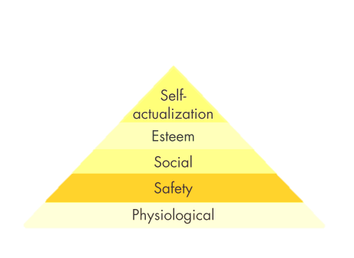
Motivation Theory
Hierarchy of Needs Theory
The best-known theory of motivation is Abraham Maslow’s hierarchy of needs.Maslow hypothesized that within every human being, there exists a hierarchy of five needs:
1. Physiological; -Includes hunger, thirst, shelter, sex, and other bodily needs.
2. Safety; - Security and protection from physical and emotional harm.
3. Social; - Affection, belongingness, acceptance, and friendship.
4. Esteem; -Internal factors such as self-respect, autonomy, and achievement, and external factors such as status, recognition, and attention.
5. Self-actualization; -Drive to become what we are capable of becoming; includes growth, achieving our potential, and self-fulfillment.
Although no need is ever fully gratified, a substantially satisfied need no longer motivates. Thus as each becomes substantially satisfied, the next one becomes dominant. So if you want to motivate someone, according to Maslow, you need to understand what level of the hierarchy that person is currently on and focus on satisfying needs at orabove that level, moving up the steps in. Maslow separated the five needs into higher and lower orders. Physiological and safety needs, where the theory says people start, were lower-order needsand social, esteem, and self-actualization were higher-order needs. Higher-order needs are satisfied internally (within the person),whilelower-order needs are predominantly satisfied externally (by things such as pay, union contracts, and tenure).
Two-Factor Theory
Believing an individual’s relationship to work is basic, and that attitude toward work can determine success or failure, psychologist Frederick Herzberg wondered, “What do people want from their jobs?” He asked people to describe, in detail, situations in which they felt exceptionally good or bad about their jobs. The responses differed significantly and led Hertzberg to his two-factor theory —also called motivation-hygiene theory. Intrinsic factors such as advancement, recognition, responsibility, and achievement seem related to job satisfaction. Respondents who felt good about their work tended to attribute these factors to themselves, while dissatisfied respondents tended to cite extrinsic factors, such as supervision, pay, company policies, and working conditions.
To Hertzberg, the data suggest that the opposite of satisfaction is not dissatisfaction, as was traditionally believed. Removing dissatisfying characteristics from a job does not necessarily make the job satisfying. Herzberg proposed a dual continuum: The opposite of “satisfaction” is “no satisfaction,” and the opposite of “dissatisfaction” is “no dissatisfaction.”
According to Herzberg, the factors that lead to job satisfaction are separate and distinct from those that lead to job dissatisfaction. Therefore, managers who seek to eliminate factors that can createjob dissatisfaction may bring about peace, but not necessarily motivation. They will be placating rather than motivating their workers. As a result, Herzberg characterized conditions such as quality of supervision, pay, company policies, physical working conditions, relationships with others, and job security as hygiene factors. When they’re adequate, people will not be dissatisfied; neither will they be satisfied. If we want to motivate people on their jobs, Herzberg suggested emphasizing factors associated with the work itself or with outcomes directly derived from it, such as promotional opportunities, personal growth opportunities, recognition, responsibility, and achievement. These are the characteristics people find intrinsically rewarding.
Policy and administration SupervisionRelationship with supervisor Work conditions SalaryRelationship with peers Factors characterizing 1,844 events on the job that lead toextreme dissatisfaction
Criticisms include the following:
  - Herzberg’s methodology is limited because it relies on self-reports. When things are going well, people tend to take credit. Contrarily, they blame failure on the extrinsic environment.
  - The reliability of Herzberg’s methodology is questionable. Raters have to make interpretations, so they may contaminate the findings by interpreting one response in one manner while treating a similar response differently.
  - No overall measure of satisfaction was utilized. A person may dislike part of a job yet still think the job is acceptable overall.
  - Herzberg assumed a relationship between satisfaction and productivity, but he looked only at satisfaction. To make his research relevant, we must assume a strong relationship between satisfaction and productivity.
McClelland’s Theory of Needs
You have one beanbag and five targets set up in front of you, each farther away than the last. Target A sits almost within arm’s reach. If you hit it, you get $2. Target B is a bit farther out, but about 80 percent of the people who try can hit it. It pays $4. Target C pays $8, and about half the people who try can hit it. Very few people can hit Target D, but the payoff is $16 for those who do. Finally, Target E pays $32, but it’s almost impossible to achieve. Which would you try for? If you selected C, you’re likely to be a high achiever. Why? Read on. McClelland’s theory of needs was developed by David McClelland and his associates.
It looks at three needs:
Need for achievement (nAch) is the drive to excel, to achieve in relationship to a set of standards.
Need for power (nPow) is the need to make others behave in a way they would not have otherwise.
Need for affiliation (nAff) is the desire for friendly and close interpersonal relationships.
McClelland and subsequent researchers focused most of their attention on nAch. High achievers perform best when they perceive their probability of success as 0.5—that is, a 50–50 chance. They dislike gambling with high odds because they get no achievement satisfaction from success that comes by pure chance. Similarly, they dislike low odds (high probability of success) because then there is no challenge to their skills. They like to set goals that require stretching themselves a little. Relying on an extensive amount of research, we can predict some relationships between achievements need and job performance. First, when jobs have a high degree of personal responsibility and feedback and an intermediate degree of risk, high achievers are strongly motivated.
They are successful in McClelland’s theory of needs a theory that states achievement, power, and affiliation are three important needs that help explain motivation. need for achievement (nAch) The drive to excel, to achieve in relationship to a set of standards, and to strive to succeed. need for power (nPow) The need to make others behave in a way in which they would not have behaved otherwise. need for affiliation (nAff) The desire for friendly and close interpersonal relationships. As a high achiever, Patricia Woertz is motivated by work that demands a high degree of personal responsibility. Today, she is the CEO, president, and chair of Archer Daniels Midland, an agricultural food processing business. She started her career as a certified public accountant but was attracted to the complexity and opportunity of global energy. For the next 30 years she worked for Gulf Oil and Chevron in refining, marketing, strategic planning, and finance positions. Since joining ADM, Woertz continues to shift company resources toward fuel production in a drive to accelerate ADM’s global leadership in bioenergy and has led the company to record financial results.
Theory X and Theory Y
Douglas McGregor proposed two distinct views of human beings: one basically negative, labeled Theory X, and the other basically positive, labeled Theory Y.
After studying managers’ dealings with employees, McGregor concluded that their views of the nature of human beings are based on certain assumptions that mold their behavior.
Under Theory X, managers believe employees inherently dislike work and must therefore be directed or even coerced into performing it. Under Theory Y, in contrast, managers assume employees can view work as being as natural as rest or play, and therefore the average person can learn to accept, and even seek, responsibility.
To understand more fully, think in terms of Maslow’s hierarchy. Theory Y assumes higher-order needs dominate individuals. McGregor himself believed Theory Y assumptions were more valid than Theory X. Therefore, he proposed such ideas as participative decision making, responsible and challenging jobs, and good group relations to maximize an employee’s job motivation.
Unfortunately, no evidence confirms that either set of assumptions is valid or that acting on Theory Y assumptions will lead to more motivated workers.
OB theories need empirical support before we can accept them. Theory X and Theory Y lack such support as much as the hierarchy of needs.
Self-Determination Theory
“It’s strange,” said Marcia. “I started work at the Humane Society as a volunteer. I put in 15 hours a week helping people adopt pets. And I loved coming to work. Then, 3 months ago, they hired me full-time at $11 an hour. I’m doing the same work I did before. But I’m not finding it nearly as much fun.”
Does Marcia’s reaction seem counterintuitive? There’s an explanation for it. It’s called self-determination theory, which proposes that people prefer to feel they have control over their actions, so anything that makes a previously enjoyed task feel more like an obligation than a freely chosen activity will undermine motivation.
Much research on self-determination theory in OB has focused on cognitive evaluation theory, which hypothesizes that extrinsic rewards will reduce intrinsic interest in a task. When people are paid for work, it feels less like something they want to do and more like something they have to do. Self-determination theory also proposes that in addition to being drivenby a need for autonomy, people seek ways to achieve competence and positive connections to others. A large number of studies support self-determination theory.
As we’ll show, its major implications relate to work rewards. When organizations use extrinsic rewards as payoffs for superior performance, employees feel they are doing a good job less because of their own intrinsic desire to excel than because that’s what the organization wants.
Eliminating extrinsic rewards can also shift an individual’s perception of why she works on a task from an external to an internal explanation. If you’re reading a novel a week because your English literature instructor requires you to, you can attribute your reading behavior to an external source. However, if you find yourself continuing to read a novel a week after the course is over, your natural inclination is to say, “I must enjoy reading novels because I’m still reading one a week.”
Studies examining how extrinsic rewards increased motivation for some creative tasks suggest we might need to place cognitive evaluation theory’s predictions in a broader context.
Goal-setting is more effective in improvingmotivation, for instance, when we provide rewards for achieving the goals.
The original authors of self-determination theory acknowledge that extrinsic rewards such as verbal praise and feedback about competence can improve even intrinsic motivation under specific circumstances. Deadlines and specific work standards do, too, if people believe they are in control of their behavior.
This is consistent with the central theme of self-determination theory: rewards and deadlines diminish motivation if people see them as coercive.
What does self-determination theory suggest for providing rewards? If a senior sales representative really enjoys selling and making the deal, a commission indicates she’s been doing a good job and increases her sense of competence by providing feedback that could improve intrinsic motivation. On the other hand, if a computer programmer values writing code because she likes to solve problems, a reward for working to an externally imposed standard she does not accept, such as writing a certain number of lines of code every day, could feel coercive, and her intrinsic motivation would suffer. She would be less interested in the task and might reduce her effort.
Goal-Setting Theory
In the late 1960s, Edwin Locke proposed that intentions to work toward a goal are a major source of work motivation. That is, goals tell an employee what needs to be done and how much effort is needed. Evidence strongly suggests that specific goals increase performance; that difficult goals, when accepted, result in higher performance than do easy goals; and that feedback leads to higher performance than doe’s nonfeedback.
Specific goals produce a higher level of output than the generalized goal “do your best.” Why? Specificity itself seems to act as an internal stimulus. When a trucker commits to making 12 round-trip hauls between Toronto and Buffalo, New York, each week, this intention gives him a specific objective to attain.
All things being equal, he will outperform a counterpart with no goals or the generalized goal “do your best.”
If factors such as acceptance of the goals are held constant, the more difficult the goal, the higher the level of performance. Of course, it’s logical to assume easier goals are more likely to be accepted. But once a hard task is accepted, we can expect the employee to exert a high level of effort to try to achieve it.
But why are people motivated by difficult goals?
First, challenging goals get our attention and thus tend to help us focus. Second, difficult goals energize us because we have to work harder to attain them. Do you study as hard for an easy exam as you do for a difficult one? Probably not. Third, when goals are difficult, people persist in trying to attain them. Finally, difficult goals lead us to discover strategies that help us perform the job or task more effectively.

Self-Efficacy Theory
Self-efficacy (also known as social cognitive theory or social learning theory) refers to an individual’s belief that he or she is capable of performing a task.
The higher your self-efficacy, the more confidence you have in your ability to succeed. So, in difficult situations, people with low self-efficacy are more likely to lessen their effort or give up altogether, while those with high self-efficacy willtry harder to master the challenge.
Self-efficacy can create a positive spiral in which those with high efficacy become more engaged in their tasks and then, in turn, increase performance, which increases efficacy further.
Changes in self-efficacy over time are related to changes in creative performance as well. Individuals high in self-efficacy also seem to respond to negative feedback with increased effort and motivation, while those low in self-efficacy are likely to lessen their effort after negative feedback.
The researcher who developed self-efficacy theory, Albert Bandura, proposes four ways self-efficacy can be increased:
1. Enactive mastery.
2. Vicarious modeling.
3. Verbal persuasion.
4. Arousal.
According to Bandura, the most important source of increasing self-efficacy is enactive mastery that is, gaining relevant experience with the task or job. If you’ve been able to do the job successfully in the past, you’re more confident you’ll be able to do it in the future.
The second source is vicarious modeling becoming more confident because you see someone else doing the task. If your friend slims down, it increases your confidence that you can lose weight, too. Vicarious modeling is most effective when you see yourself as similar to the person you are observing. Watching Tiger Woods play a difficult golf shot might not increase your confidence in being able to play the shot yourself, but if you watch a golfer with a handicap similar to yours, it’s persuasive.
The third source is verbal persuasion: becoming more confident because someone convinces you that you have the skills necessary to be successful. Motivational speakers use this tactic.
Finally, Bandura argues that arousal increases self-efficacy. Arousal leads to an energized state, so the person gets “psyched up” and performs better. But if the task requires a steady, lower-key perspective (say, carefully editing a manuscript), arousal may in fact hurt performance.
Reinforcement Theory
Goal-setting is a cognitive approach, proposing that an individual’s purposes direct his action. Reinforcement theory, in contrast, takes a behavioristic view, arguing that reinforcement conditions behavior. The two theories are clearly at odds philosophically. Reinforcement theorists see behavior as environmentally caused. You need not be concerned, they would argue, with internal cognitive events; what controls behavior is reinforces any consequences that, when immediately following responses, increase the probability that the behavior will be repeated.
Reinforcement theory ignores the inner state of the individual and concentrates solely on what happens when he or she takes some action. Because it does not concern itself with what initiates behavior, it is not, strictly speaking, a theory of motivation. But it does provide a powerful means of analyzing what controls behavior, and this is why we typically consider it in discussions of motivation.
Equity Theory/Organizational Justice
Jane’s situation illustrates the role that equity plays in motivation. Employees perceive what they get from a job situation (salary levels, raises, recognition) in relationship to what they put into it (effort, experience, education, competence), and then they compare their outcome–input ratio with that of relevant others. This is shown in Exhibit 7-6. If we perceive our ratio to be equal to that of the relevant others with whom we compare ourselves, a state of equity exists; we perceive that our situation is fair and justice prevails. When we see the ratio as unequal and we feel underrewarded, we experience equity tension that creates anger. When we see ourselves as over rewarded, tension creates guilt. J. Stacy Adams proposed that this negative state of tension provides the motivation to do something to correct it.
Employees might compare themselves to friends, neighbors, co-workers, or colleagues in other organizations or compare their present job with past jobs.
Which referent an employee chooses will be influenced by the information the employee holds about referents as well as by the attractiveness of the referent.
Four moderating variables are gender, length of tenure, level in the organization, and amount of education or professionalism. Ds to the complexity of equity theory .There are four referent comparisons:
- Self–inside. An employee’s experiences in a different position inside the employee’s current organization.
- Self–outside. An employee’s experiences in a situation or position outside the employee’s current organization.
- Other–inside. Another individual or group of individuals inside the employee’s organization.
- Other–outside. Another individual or group of individuals outside the employee’s organization. Employees might compare themselves to friends, neighbors, co-workers, or colleagues in other organizations or compare their present job with past jobs.
Which referent an employee chooses will be influenced by the information the employee holds about referents as well as by the attractiveness of the referent.
Four moderating variables are gender, length of tenure, level in the organization, and amount of education or professionalism.
Expectancy Theory
Expectancy theory is a theory that says that the strength of a tendency to act in a certain way depends on the strength of an expectation that the act will be followed by a given outcome and on the attractiveness of that outcome to the individual.
One of the most widely accepted explanations of motivation is Victor Vroom’s expectancy theory. Although it has its critics, most of the evidence supports it. Expectancy theory argues that the strength of our tendency to act a certain way depends on the strength of our expectation of a given outcome and its attractiveness. In more practical terms, employees will be motivated to exert a high level of effort when they believe it will lead to a good performance appraisal; that a good appraisal will lead to organizational rewards such as bonuses, salary increases, or promotions; and that the rewards will satisfy the employees’ personal goals. The theory, therefore, focuses on three relationships.
1. Effort–performance relationship. The probability perceived by the individual that exerting a given amount of effort will lead to performance.
2. Performance–reward relationship. The degree to which the individual believes performing at a particular level will lead to the attainment of a desired outcome.
3. Rewards–personal goals relationship. The degree to which organizational rewards satisfy an individual’s personal goals or needs and the attractiveness of those potential rewards for the individual.

Part 4
Organizational structure and culture

Organizational structure
The formal system of work roles and authority relationships that govern how associates and managers interact with one another.
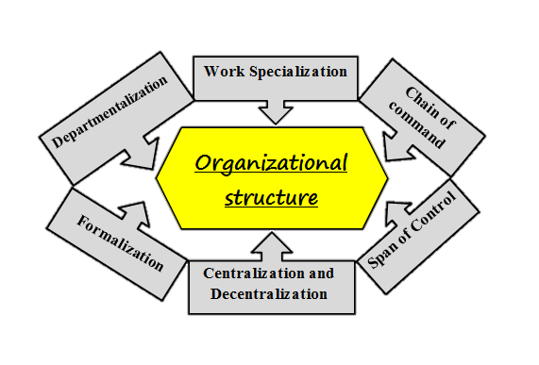
An organization’s structure consists in its rules and regulations (degree of formalization) and the organizational elements that determine procedures for making decisions (degree of centralization). The military and government departments are examples of highly centralized organizations, whereas decentralized organizations include voluntary organizations and partnerships. The trend today is to decentralize decisions as much as possible (though in practice this turns out to be very difficult to achieve), in order to ‘empower’ employees and derive maximum benefit from their knowledge, skills and abilities.
Structure also includes the degree of specialization – that is, how particular and unique each person’s job is. In some organizations, there is a low degree of specialization and one person maybe expected to fill many roles. An organizational structure defines how job tasks are formally divided, grouped, and coordinated. Managers need to address six key elements when they design their organization’s structure: work specialization, departmentalization, chain of command, span of control, centralization and decentralization, and formalization.Generally Organizational structure is the way in which job tasks are formally divided, grouped, and coordinated.
1. Work Specialization: - is the degree to which tasks in an organization is subdivided into separate jobs. Today, we use the term work specialization, or divisions of labor, to describe the degree to which activities in the organization are subdivided into separate jobs. The essence of work specialization is to divide a job into a number of steps, each completed by a separate individual. In essence, individuals specialize in doing part of an activity rather than the entirety.
By the late 1940s, most manufacturing jobs in industrialized countries featured high work specialization. Because not all employees in an organization have the same skills, management saw specialization as a means of making the most efficient use of its employees’ skills and even successfully improving them through repetition. Less time is spent in changing tasks, putting away tools and equipment from a prior step, and getting ready for another. Equally important, it’s easier and less costly to find and train workers to do specific and repetitive tasks, especially in highly sophisticated and complex operations. Could Cessna produce one Citation jet a year if one person had to build the entire plane alone? Not likely! Finally, work specialization increases efficiency and productivity by encouraging the creation of special inventions and machinery.
Example
Early in the twentieth century, Henry Ford became rich by building automobiles on an assembly line. Every Ford worker was assigned a specific, repetitive task such as putting on the right-front wheel or installing the right-front door. By dividing jobs into small standardized tasks that could be performed over and over, Ford was able to produce a car every 10 seconds, using employees who had relatively limited skills.

2. Departmentalization:- Once jobs have been divided through work specialization, they must be grouped so common tasks can be coordinated. The basis by which jobs are grouped is called departmentalization. One of the most popular ways to group activities is by functions performed.
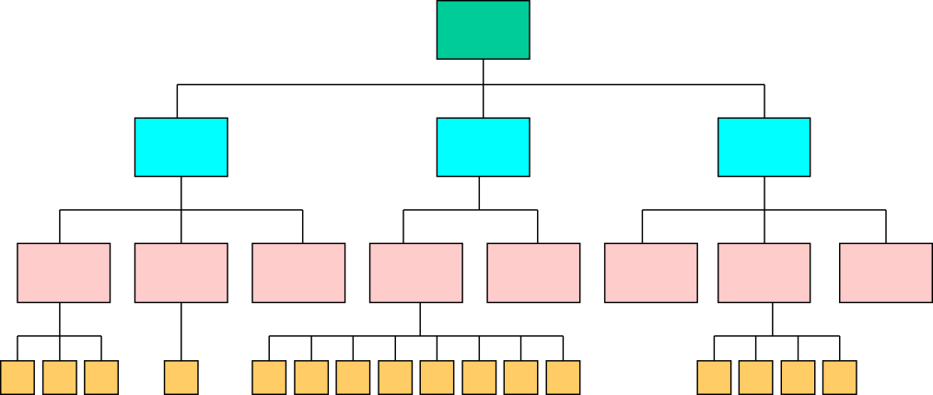
A manufacturing manager might organize a plant into engineering, accounting, manufacturing, personnel, and supply specialists departments. A hospital might have departments devoted to research, surgery, intensive care, accounting, and so forth. A professional football franchise might have departments entitled player personnel, ticket sales, and travel and accommodations. The major advantage of this type of functional departmentalization is efficiencies gained from putting like specialists together.Fig. 4.2 Departmentalization
3. Chain of command:- the unbroken line of authority that extends from the top of the organization to the lowest echelon and clarifies who reports to whom. While the chain of command was once a basic cornerstone in the design of organizations, it has far less importance today.

But contemporary managers should still consider its implications. The chain of command is an unbroken line of authority that extends from the top of the organization to the lowest echelon and clarifies who reports to whom.
We can’t discuss the chain of command without also discussing authority and unity of command. Authority refers to the rights inherent in a managerial position to give orders and expect them to be obeyed.
To facilitate coordination, each managerial position is given a place in the chain of command, and each manager is given a degree of authority in order to meet his or her responsibilities. The principle of unity of command helps preserve the concept of an unbroken line of authority. It says a person should have one and only one superior to whom he or she is directly responsible. If the unity of command is broken, an employee might have to cope with conflicting demands or priorities from several superiors.
4. Span of Control: -How many employees can a manager efficiently and effectively direct? This question of span of control is important because it largely determines the number of levels and managers an organization has.
5. Centralization and Decentralization:- Centralization refers to the degree to which decision making is concentrated at a single point in the organization.
In centralized organizations, top managers make all the decisions, and lower-level managers merely carry out their directives. In organizations at the other extreme, decentralized decision making is pushed down to the managers closest to the action.

The concept of centralization includes only formal authority—that is, the rights inherent in a position. An organization characterized by centralization is inherently different structurally from one that’s decentralized. A decentralized organization can act more quickly to solve problems, more people provide input into decisions, and employees are less likely to feel alienated from those who make decisions that affect their work lives.

6.Formalization:- High formalization creates predictability, orderliness, and consistency. A strong culture achieves the same end without the need for written documentation. Therefore, we should view formalization and culture as twodifferent roads to a common destination. The stronger an organization’s culture, the less management need be concerned with developing formal rules and regulations to guide employee behavior. Those guides will be internalized in employees when they accept the organization’s culture.

Organizational culture
Organizational culture tends to be shared by all or most members of some social group; is something that older members usually try to pass on to younger members; shapes behavior and structures perceptions of the world.
Cultures are often studied and understood at a national level, such as the American or French culture. Culture includes deeply held values, beliefs and assumptions, symbols, heroes, and rituals. Culture can be examined at an organizational level as well. The main distinction between organizational and national culture is that people can choose to join a place of work, but are usually born into a national culture.
Culture includes the organization’s vision, values, norms, systems, symbols, language, assumptions, beliefs, and habits. It is also the pattern of such collective behaviors and assumptions that are taught to new organizational members as a way of perceiving, and even thinking and feeling. Organizational culture affects the way people and groups interact with each other, with clients, and with stakeholders.
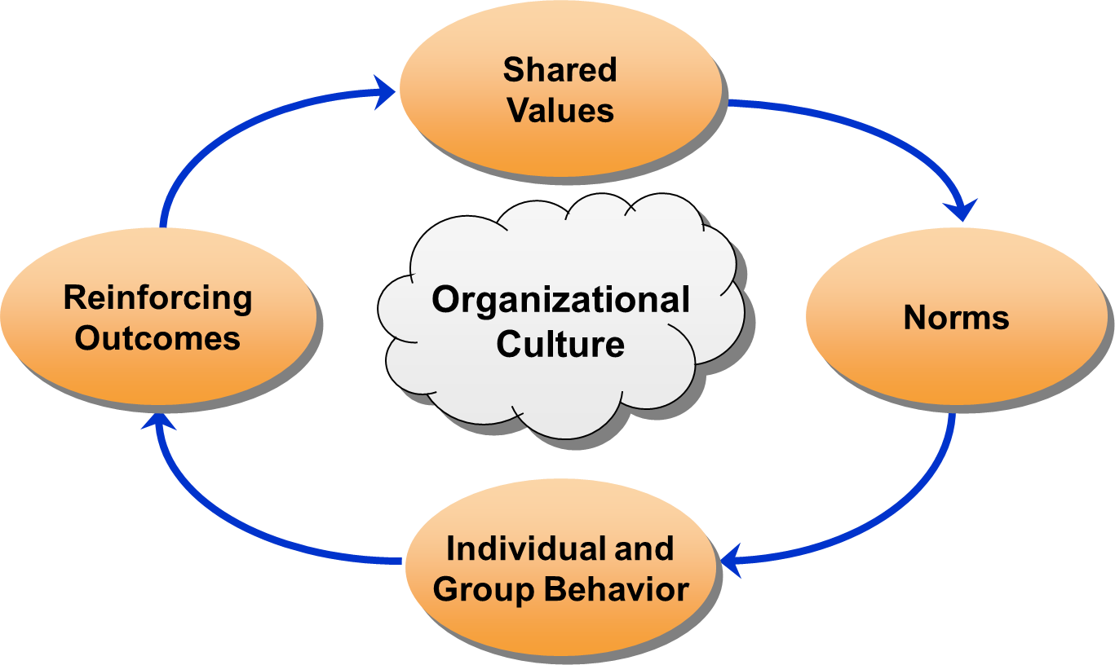
Organizational culture is a set of symbols, ceremonies and myths that enable participants to understand their underlying organizational assumptions and values. Organizational culture can effectively promote or inhibit cooperation, exchange of knowledge, experience and ideas. Open culture, promoting the participation of all team members in the creative process, is favorable to the activity and initiative of employees, while culture based on strong control is definitely not conducive to creativity and innovation. Cultures aimed at developing innovation and creating suitable conditions for doing so are characterized by dynamism, flexibility, fast adaptation to changing conditions, and non-stereotypical solutions. A key to the development of innovation in an organization is support, and encouragement for every employee to seek and discover unconventional, non-standard ways of achieving objectives and performing tasks.
Organization culture thus starts up with a common life style adopted by its members in form of shared learning, behaviors, values & interests & provides the employees with a clear understanding of the way things are done around them in their organization thus guides their further actions. It is considered to be a common perception held by the employees regarding their organization.
There's been a great deal of literature generated over the past decade about the concept of organizational culture -- particularly in regard to learning how to change organizational culture. Organizational change efforts are rumored to fail the vast majority of the time. Usually, this failure is credited to lack of understanding about the strong role of culture and the role it plays in organizations. That's one of the reasons that many strategic planners now place as much emphasis on identifying strategic values as they do mission and vision.
Organizational culture refers to a system of shared meaning held by members that distinguishes the organization from other organizations.
Seven primary characteristics seem to capture the essence of an organization’s culture:
- Innovation and risk taking: - The degree to which employees is encouraged to be innovative and take risks.
- Attention to detail: - The degrees to which employees are expected to exhibit precision, analysis, and attention to detail.
- Outcome orientation: - The degree to which management focuses on results or outcomes rather than on the techniques and processes used to achieve them.
- People orientation: - The degree to which management decisions take into consideration the effect of outcomes on people within the organization.
- Team orientation: - The degree to which work activities are organized around teams rather than individuals.
- Aggressiveness: - The degree to which people is aggressive and competitive rather than easygoing.
- Stability: - The degree to which organizational activities emphasize maintaining the status quo in contrast to growth.
Each of these characteristics exists on a continuum from low to high. Appraising the organization on them, then, gives a composite picture of its culture and a basis for the shared understanding members have about the organization, how things are done in it, and the way they are supposed to behave.

Types of Culture
Power Culture
Within a power culture, control is the key element. Power cultures are usually found within a small or medium size organization. Decisions in an organization that display a power culture are centralized around one key individual. That person likes control and the power behind it. As group work is not evident in a power culture, the organization can react quickly to dangers around it as no consultation is involved. However this culture has its problems, lack of consultation can lead to staff feeling undervalued and de-motivated, which can also lead to high staff turnover.
Role Culture
Common in most organizations today is a role culture. In a role culture, organizations are split into various functions and each individual within the function is assigned a particular role. The role culture has the benefit of specialization. Employees focus on their particular role as assigned to them by their job description and this should increase productivity for the company. This culture is quite logical to organize in a large organization.
Task Culture
A task culture refers to a team based approach to complete a particular task. They are popular in today's modern business society where the organization will establish particular 'project teams' to complete a task to date. A task culture clearly offers some benefits. Staff feels motivated because they are empowered to make decisions within their team, they will also feel valued because they may have been selected within that team and given the responsibility to bring the task to a successful end. NASA organizes part of their culture around this concept ie putting together teams to oversee a mission.
Person culture
Person cultures are commonly found in charities or nonprofit organizations. The focus of the organization is the individual or a particular aim
Forward and backward looking cultures
Organizations that have an entrepreneurial spirit always embrace change and listen to staff and customers are said to be forward looking. Forward looking organizations are risk takers and do well because of it. We can argue that Dyson the vacuum cleaner manufacturer embraces this culture. A backward looking culture does not embrace change and is led by systems and procedures. They do not take risk and because of it are usually left with a business not doing so well UK store Marks and Spencer is said to be 'backward looking' ie slow to change.

Some others classifications

Jeffrey Sonnenfeld

Academy Culture-
Employees are highly skilled and tend to stay in the organization, while working their way up the ranks. The organization provides a stable environment in which employees can development and exercises their skills. Examples are universities, hospitals, large corporations, etc.

Baseball Team Culture
Employees are "free agents" who have highly prized skills. They are in high demand and can rather easily get jobs elsewhere. This type of culture exists in fast-paced, high-risk organizations, such as investment banking, advertising, etc.

Club Culture
The most important requirement for employees in this culture is to fit into the group. Usually employees start at the bottom and stay with the organization. The organization promotes from within and highly values seniority. Examples are the military, some law firms, etc.

Fortress Culture
Employees don't know if they'll be laid off or not. These organizations often undergo massive reorganization. There are many opportunities for those with timely, specialized skills. Examples are savings and loans, large car companies, etc.

Theories on Organizational culture
Several methods have been used to classify organizational culture. While there is no single “type” of organizational culture and organizational cultures vary widely from one organization to the next, commonalities do exist and some researchers have developed models to describe different indicators of organizational cultures. Some are described below:

Deal and Kennedy
Deal and Kennedy created a model of culture that is based on 4 different types of organizations. They each focus on how quickly the organization receives feedback, the way members are rewarded, and the level of risks taken:
- Work-hard, play-hard culture: This has rapid feedback/reward and low risk resulting in: Stress coming from quantity of work rather than uncertainty. High-speed action leading to high speed recreation. Examples: Restaurants, software companies.
- Tough-guy macho culture: This has rapid feedback/reward and high risk, resulting in the following: Stress coming from high risk and potential loss/gain of reward. Focus on the present rather than the longer-term future. Examples: police, surgeons, sports.
- Process culture: This has slow feedback/reward and low risk, resulting in the following: Low stress, plodding work, comfort and security. Stress that comes from internal politics and stupidity of the system. Development of bureaucracies and other ways of maintaining the status quo. Focus on security of the past and of the future. Examples: banks, insurance companies.
- Bet-the-company culture: This has slow feedback/reward and high risk, resulting in the following: Stress coming from high risk and delay before knowing if actions have paid off. The long view is taken, but then much work is put into making sure things happen as planned. Examples: aircraft manufacturers, oil companies.

Factors and elements
Gerry Johnson (1988) described a cultural web, identifying a number of elements that can be used to describe or influence organizational culture:
- The paradigm: What the organization is about, what it does, its mission, its values.
- Control systems: The processes in place to monitor what is going on. Role cultures would have vast rulebooks. There would be more reliance on individualism in a power culture.
- Organizational structures: Reporting lines, hierarchies, and the way that work flows through the business.
- Power structures: Who makes the decisions, how widely spread is power, and on what is power based?
- Symbols: These include organizational logos and designs, but also extend to symbols of power such as parking spaces and executive washrooms.
- Rituals and routines: Management meetings, board reports and so on may become more habitual than necessary.
- Stories and myths: build up about people and events, and convey a message about what is valued within the organization.
These elements may overlap. Power structures may depend on control systems, which may exploit the very rituals that generate stories which may not be true.
According to Schein (1992), the two main reasons why cultures develop in organizations is due to external adaptation and internal integration.
External adaptation reflects an evolutionary approach to organizational culture and suggests that cultures develop and persist because they help an organization to survive and flourish. If the culture is valuable, then it holds the potential for generating sustained competitive advantages. Internal integration is an important function since social structures are required for organizations to exist. Organizational practices are learned through socialization at the workplace. Work environments reinforce culture ona daily basis by encouraging employees to exercise cultural values. Organizational culture is shaped by multiple factors, including the following:
- External environment
- Industry
- Size and nature of the organization’s workforce
- Technologies the organization uses
- The organization’s history and ownership

Schemata
Schemata (plural of schema) are knowledge structures a person forms from past experiences, allowing the person to respond to similar events more efficiently in the future by guiding the processing of information. A person’s schemata are created through interaction with others, and thus inherently involve communication.
Stanley G. Harris (1994) argues that five categories of in-organization schemata are necessary for organizational culture:
- Self-in-organization schemata: a person’s concept of oneself within the context of the organization, including her/his personality, roles, and behavior.
- Person-in-organization schemata: a person’s memories, impressions, and expectations of other individuals within the organization.
- Organization schemata: a subset of person schemata, a person’s generalized perspective on others as a whole in the organization.
- Object/concept-in-organization schemata: knowledge an individual has of organization aspects other than of other persons.
- Event-in-organization schemata: a person’s knowledge of social events within an organization.
All of these categories together represent a person’s knowledge of an organization. Organizational culture is created when the schematas (schematic structures) of differing individuals across and within an organization come to resemble each other (when any one person’s schemata come to resemble another person’s schemata because of mutual organizational involvement), primarily done through organizational communication, as individuals directly or indirectly share knowledge and meanings.
Charles Handy(1976), popularized Roger Harrison (1972) with linking organizational structure to organizational culture. The described four types of culture are:
1. Power culture: concentrates power among a small group or a central figure and its control is radiating from its center like a web. Power cultures need only a few rules and little bureaucracy but swift in decisions can ensue.
2. Role culture: authorities are delegated as such within a highly defined structure. These organizations form hierarchical bureaucracies, where power derives from the personal position and rarely from an expert power. Control is made by procedures (which are highly valued), strict roles descriptions and authority definitions. These organizations have consistent systems and are very predictable. This culture is often represented by a “Roman Building” having pillars. These pillars represent the functional departments.
3. Task culture: teams are formed to solve particular problems. Power is derived from the team with the expertise to execute against a task. This culture uses a small team approach, where people are highly skilled and specialized in their own area of expertise. Additionally, these cultures often feature the multiple reporting lines seen in a matrix structure.
4. Person culture: formed where all individuals believe themselves superior to the organization. It can become difficult for such organizations to continue to operate, since the concept of an organization suggests that a group of like-minded individuals pursue organizational goals. However some professional partnerships operate well as person cultures,because each partner brings a particular expertise and clientele to the firm.

Part five
Work stress and work life balance
What Is Stress?
Stress is unpleasant psychological process that occurs in response to environmental pressures.Stress is a dynamic condition in which an individual is confronted with an opportunity, demand, or resource related to what the individual desires and for which the outcome is perceived to be both uncertain and important.
Although stress is usually seen in a negative context, it is not necessarily bad in and of itself; it also has a positive value. It’s an opportunity when it offers potential gain. Consider, for example, the superior performance an athlete or stage performer gives in a “clutch” situation. Such individuals often use stress positively to rise to the occasion and perform at their maximum. Similarly, many professionals see the pressures of heavy workloads and deadlines as positive challenges that enhance the quality of their work and the satisfaction they get from their job.
Challenge stressors or stressors associated with workload, pressure to complete tasks, and time urgency operate quite differently from hindrance stressors or stressors that keep you from reaching your goals (for example, red tape, office politics, confusion over job responsibilities). Stress exists. It appears that employees who have a stronger affective commitment to their organization can transfer psychological stress into greater focus and higher sales performance, whereas employees with low levels of commitment perform worse under stress.
And when challenge stress increases, those with high levels of organizational support have higher role-based performance, but those with low levels of organizational support do not. More typically, stress is associated with demands and resources.
Demands are responsibilities, pressures, obligations, and uncertainties individuals face in the workplace. Resources are things within an individual’s control that he or she can use to resolve the demands. When test is taken at school or undergo your annual performance review at work, you feel stress because you confront opportunities and performance pressures. A good performance review may lead to a promotion, greater responsibilities, and a higher salary. A poor review may prevent you from getting a promotion. An extremely poor review might even result in being fired.
Potential Sources of Stress
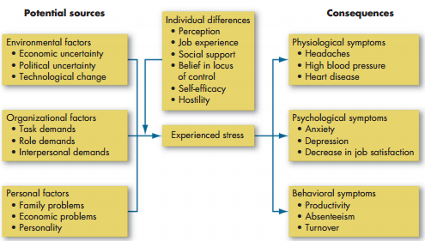

What causes stress?
As the model in shows, there are three categories of potential stressors: environmental, organizational, and personal.
Environmental FactorsJust as environmental uncertainty influences the design of an organization’s structure, it also influences stress levels among employees in that organization. Indeed, uncertainty is the biggest reason people have trouble coping with organizational changes. There are three main types of environmental uncertainty: economic, political, and technological. Changes in the business cycle create economic uncertainties. When the economy is contracting, for example, people become increasingly anxious abouttheir job security.
Know a day’s innovations can make an employee’s skills and experience obsolete in a very short time, computers, robotics, automation, and similar forms of technological change are also a threat to many people and cause them stress.
Pressures to avoid errors or complete tasks in a limited time, work overload, a demanding and insensitive boss, and unpleasant co-workers are a few examples. This is categorized these factors around task, role, and interpersonal demands.
Task demands relate to a person’s job. They include the design of the job (its degrees of autonomy, task variety, degree of automation), working conditions, and the physical work layout. Assembly lines can put pressure on people when they perceive the line’s speed to be excessive. Working in an overcrowded room or a visible location where noise and interruptions are constant can increase anxiety and stress.
As customer service grows ever more important, emotional labor becomes a source of stress. Imagine being a flight attendant for Ethiopian Airlines or a cashier at Hilton. Do you think you could put on a happy face when you’re having a bad day? Role demands relate to pressures placed on a person as a function of the particular role he or she plays in the organization. Role conflicts create expectations that may be hard to reconcile or satisfy. Role overload occurs when the employee is expected to do more than time permits. Role ambiguity means role expectations are not clearly understood and the employee is not sure what to do. Individuals who face high situational constraints (such as fixed work hours or demanding job responsibilities) are also less able to engage in the proactive coping behaviors that reduce stress levels. When faced with hassles at work, Task demands are organizational factors that can cause stress.
The nature of job can also cause stress, as the people they call may be abusive, emotional, frustrated, sad, or angry. Encore strives to reduce the on-the-job stress of its call center workers by teaching them how to empathize with the delinquent borrowers and how to handle verbal abuse. Collectors learn that the debtors respond to them when they are very polite and respectful and never raise their voice.

Work Stress and Its Management
They will not only have higher levels of distress at the time, but they’ll also be less likely to take steps to eliminate stressors in the future. Interpersonal demands are pressures created by other employees. Lack of social support from colleagues and poor interpersonal relationships can cause stress, especially among employees with a high social need. A rapidly growing body of research has also shown that negative co-worker and supervisor behaviors, including fights, bullying, incivility, racial harassment, and sexual harassment, are especially strongly related to stress at work.
Personal Factors The typical individual works about 40 to 50 hours a week. But the experiences and problems people encounter in the other 120-plus can spill over to the job. Our final category, then, is factors in the employee’s personal life: family issues, personal economic problems, and inherent personality characteristics.
National surveys consistently show people hold family and personal relationships dear. Marital difficulties, the breaking of a close relationship, and discipline troubles with children create stresses employees often can’t leave at the front door when they arrive at work.
Some people may have an inherent tendency to accentuate negative aspects of the world. If this is true, then a significant individual factor that influences stress is a person’s basic disposition. That is, stress symptoms expressed on the job may actually originate in the person’s personality.Stressors Are Additive When we review stressors individually, it’s easy to overlook that stress is an additive phenomenon it builds up.
Each new and persistent stressor adds to an individual’s stress level. So a single stressor may be relatively unimportant in and of itself, but if added to an already high level of stress, it can be the straw that breaks the camel’s back. To appraise the total amount of stress an individual is under, we have to sum up his or her opportunity stresses, constraint stresses, and demand stresses.
Individual Differences
Some people thrive on stressful situations, while others are overwhelmed by them. What differentiates people in terms of their ability to handle stress? What individual variables moderate the relationship between potential stressors and experienced stress? Perception, job experience, social support, and personality are relevant.
Employees react in response to their perception of reality, rather than to reality itself. Perception, therefore, will moderate the relationship between a potential stress condition and an employee’s reaction to it. Layoffs may cause one person to fear losing his job, while another sees an opportunity to get a large severance allowance and start her own business. So stress potential doesn’t lie in objective conditions; rather, it lies in an employee’s interpretation of those conditions.
Experience on the job tends to be negatively related to work stress. Why? Two explanations have been offered. First is selective withdrawal. Voluntary

Part six
Group and teams
Why Do People Form Groups?
Why do they feel so strongly about them?
Group is two or more individuals, interacting and interdependent, who have come together to achieve particular objectives. Groups can be either formal or informal. By a formal group, we mean one defined by the organization’s structure, with designated work assignments establishing tasks. In formal group A group that is neither formally structured nor organizationally determined; such a group appears in response to the need for social contact. In formal groups, the behaviors team members should engage in are stipulated by and directed toward organizational goals. For example; the six members of an airline flight crew are a formal group. In contrast, an informal group is neither formally structured nor organizationally determined. Informal groups are natural formations in the work environment that appear in response to the need for social contact.
Three employees from different departments who regularly have lunch or coffee together are an informal group. These types of interactions among individuals, though informal, deeply affect their behavior and performance.
Think the celebrations that follow a sports team’s winning a national championship. Fans have staked their own self-image on the performance of someone else. The winner’s supporters are elated, and sales of team-related shirts, jackets, and hats declaring support for the team skyrocket. Fans of the losing team feel dejected, even embarrassed.
Groups have their place and their pitfalls. group concepts, provide you with a foundation for understanding how groups work, and show you how to create effective teams. In group favoritism Perspective in which we see members of our in group as better than other people, and people not in our group as all the same.
The employees of the Swedish transportation company Scania shown here exercising at a sports complex comprise an informal group. At different company locations, Scania offers employees free access to sports facilities during working hours. The company puts a high priority on employee health and offers employees many opportunities to reinforce an active lifestyle. The informal groups that participate in sports and exercise activities are neither formally structured nor organizationally determined. However, informal groups like these can fulfill employee desires for social interaction at work. Social identity theory proposes that people have emotional reactions to the failure or success of their group because their self-esteem gets tied into the group’s performance.
People develop a lot of identities through the course of their lives.When your group does well, you bask in reflected glory, and your own self-esteem rises. When your group does poorly, you might feel bad about yourself, or you might even reject that part of your identity, like “fair weather fans.” You might define yourself in terms of the organization you work for, the city you live in, your profession, your religious background, your ethnicity, or your gender.
In group favoritism means we see members of our in group as better than other people, and people not in our group as all the same. This obviously paves the way for stereotyping.
When do people develop a social identity?
- Similarity;- Not surprisingly, people who have the same values or characteristics as other members of their organization have higher levels of group identification. Demographic similarity can also lead to stronger identification for new hires, while those who are demographically different may have a hard time identifying with the group as a whole.
- Distinctiveness;- People are more likely to notice identities that show how they are different from other groups. Respondents in one study identified more strongly with those in their work group with whom they shared uncommon or rare demographic characteristics. For example, veterinarians who work in veterinary medicine (where everyone is a veterinarian) identify with their organization, and veterinarians in no veterinary medicine fields such as animal research or food inspection (where being a veterinarian is a more distinctive characteristic) identify with their profession.
- Status;- Because people use identities to define themselves and increase self-esteem, it makes sense that they are most interested in linking themselves to high-status groups. Graduates of prestigious universities will go out of their way to emphasize their links to their alma maters and are also more likely to make donations. People are likely to not identify with a low-status organization and will be more likely to quit in order to leave that identity behind.
- Uncertainty reduction;- Membership in a group also helps some people understand who they are and how they fit into the world.
One study showed how the creation of a spin-off company created questions about how employees should develop a unique identity that corresponded more closely to what the division was becoming. Managers worked to define and communicate an idealized identity for the new organization when it became clear employees were confused.Groups generally pass through a predictable sequence in their evolution.
Although not all groups follow this five-stage model, it is a useful framework for understanding group development.
- The Five-Stage, group-development model characterizes groups as proceeding through the distinct stages of;
- forming
- storming
- norming
- performing,
- And adjourning.
The forming stage is the first stage; it is characterized by a great deal of uncertainty about the group’s purpose, structure, and leadership. Members “test the waters” to determine what types of behaviors are acceptable. This stage is complete when members have begun to think of themselves as part of a group.
The storming stage is one of intragroup conflict. Members accept the existence of the group but resist the constraints it imposes on individuality. There is conflict over who will control the group. When this stage is complete, there will be a relatively clear hierarchy of leadership within the group in the second stage. In the third stage, close relationships develop and the group demonstrates cohesiveness. There is now a strong sense of group identity and camaraderie.
This norming stage is complete when the group structure solidifies and the group has assimilated a common set of expectations of what defines correct member behavior.
The performing stage is the fourth one; the structure at this point is fully functional and accepted. Group energy has moved from getting to know and understand each other to performing the task at hand. For permanent work groups, performing is the last stage in development.
The adjourning stage is for wrapping up activities and preparing to disband on the other hand, for temporary committees, teams, task forces, and similar groups that have a limited task to perform,. Some group members are upbeat, basking in the group’s accomplishments. Others may be depressed over the loss of camaraderie and friendships gained during the work group’s life.
Therefore groups proceed through the stages of group development at different rates. Those with a strong sense of purpose and strategy rapidly achieve high performance and improve over time, whereas those with less sense of purpose actually see their performance worsen over time. Similarly, groups that begin with a positive social focus appear to achieve the “performing” stage more forming stage the first stage in group development, characterized by much uncertainty. Norming stage The third stage in group development, characterized by close relationships and cohesiveness. Adjourning stage the final stage in group development for temporary groups, characterized by concern with wrapping up activities rather than task performance.
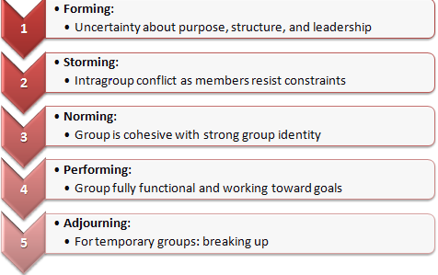
Why Do People Join Groups?
- Need for Security
- Status
- Self-esteem
- Affiliation
- Power
- Goal achievement
- ROLES
Within work groups (and teams), members can play various roles, or patterns of behavior, that are adopted on the basis of expectations about the functions of a particular position. Group roles are important because they help provide some specific plan for behavior. When a worker is playing a particular role within a group, that person usually knows something about the responsibilities and requirements of the role, or the role expectations. In most work groups, members are quite aware of the various expectations associated with each of the different positions within the group.As a work group develops, the various members learn to become responsible for different aspects of its functioning. In other words, members begin to play different roles within the work group. This process whereby group members learn about and take on various defined roles is called role differentiation. For example, a new worker who enters a work group may immediately fall into the role of novice worker. However, that person may later develop a reputation for having a good sense of humor and thus begin to play the role of jokester, providing levity when situations get too tense or when boredom sets in.One important role that is clearly differentiated in most work groups is that of leader. The leader in a formal work group or department plays an important part in directing group activities, being spokesperson for the group, and deciding which courses of action the group will follow.
Group Task Roles
Initiator–contributor: Recommends new ideas about, or novel solutions to, a problem. Information seeker:Emphasizes getting facts and other information from others. Opinion seeker:Solicits inputs concerning the attitudes or feelings about ideas underConsideration. Information giver:Contributes relevant information to help in decision making. Opinion giver:Provides own opinions and feelings. Elaborator:Clarifies and expands on the points made by others. Coordinator:Integrates information from the group. Orientor:Guides the discussion and keeps it on the topic when the group digresses.Evaluator–critic:Uses some set of standards to evaluate the group’s accomplishments. Energizer:Stimulates the group to take action. Procedural technician:Handles routine tasks such as providing materials or supplies. Recorder:Keeps track of the group’s activities and takes minutes.
Group Task Roles
Initiator–contributor: Recommends new ideas about, or novel solutions to, a problem. Information seeker:Emphasizes getting facts and other information from others. Opinion seeker:Solicits inputs concerning the attitudes or feelings about ideas underConsideration. Information giver:Contributes relevant information to help in decision making. Opinion giver:Provides own opinions and feelings. Elaborator:Clarifies and expands on the points made by others. Coordinator:Integrates information from the group. Orientor:Guides the discussion and keeps it on the topic when the group digresses. Evaluator–critic:Uses some set of standards to evaluate the group’s accomplishments. Energizer:Stimulates the group to take action. Procedural technician:Handles routine tasks such as providing materials or supplies. Recorder:Keeps track of the group’s activities and takes minutes.
The various roles in work groups are often created based on factors such as position or formal job title, status within the group, the tasks to which a member is assigned, or the possession of some particular work skill or ability. For example, employees who are designated as assistant supervisor, senior mechanic, or communications specialist perform specific roles and engage in certain behaviors consistent with these job titles.
- NORMS
Work groups contain various members, each playing different roles, but all members, regardless of their role, must adhere to certain group rules. Normsare the rules that groups adopt to indicate appropriate and inappropriate behavior for members. Group norms can be formalized as written work rules, but are most commonly informal and unrecorded. Norms can govern any work activity, including the speed with which a person should perform a job, proper modes of dress, acceptable topics for group conversation, and even who sits where in the employee lunchroom.
According to Feldman (1984), norms develop in a number of ways. They can come from explicit statements made by supervisors or coworkers. For example, a supervisor might tell group members, “No one goes home until the work area is spotlessly clean.” This leads to a norm that all workers stop working 15 minutes before quitting time to clean up the work area. Group leaders or powerful group members often play an important role in such norm formation. Norms can also evolve from the group’s history. For example, if a certain work procedure leads to a disastrous outcome, the group may place a ban on its use. In other instances, norms may be carried over from past situations. When a member changes groups, norms from the old group may be imported to the new one. For example, a sales supervisor was transferred from the corporate office to a regional sales office. On her first day in the new office, she commented on the casual dress of employees by saying, “At the corporate office, men always wear suits and ties and women always wear skirts or dresses.” From the next day on, a new dress code of more formal attire developed.
Norms serve many important purposes for groups. First and foremost, they are established to help the group survive. A group must be able to produce enough to ensure the economic successof the group and the organization. Therefore, some norms will develop to facilitate group production. On the other hand, if members feel that production rates are too high and will possibly lead to layoffs, norms to restrict group output (called “rate setting”) may arise. Norms can also develop that help commit work group members to producing role conflictconflict that results when the expectations associated with one role interfere with the expectations concerning another role normsrules that groups adopt governing appropriate and inappropriate behavior for members.
- GROUP COHESIVENESS
is like the social “glue” that holds people together in groups. Cohesivenessrefers simply to the amount or degree of attraction among group members. It is cohesiveness that explains the team spirit that many work groups possess. It is generally assumed that cohesive groups are more satisfied and more productive than non cohesive groups because their members tend to interact more, participate more fully in group activities, and accept and work toward the groups’ goals .
In fact, however, although cohesive groups are usually more satisfied than no cohesive groups, the relationship between cohesiveness and productivity is rather weak; That is because typically, for a cohesive group to be productive, the reason for the cohesiveness must be work related For example, groups with strong, work-related norms, such as the willingness to work overtime and a norm of workers taking personal responsibility for doing a good job, had higher group performance than work teams without such strong work-related norms
However, a group may be cohesive yet have as a goal to do as little work as possible. In this case, cohesiveness is high and group satisfaction may be high, but productivity is likely to be very low. One way to regain some of the cohesiveness would be to break the large group into smaller work teams.

Part seven

Leadership
I am more afraid of an army of 100 sheep led by a lion than an army of 100 lions led by a sheep.
—Talleyrand

Leadership has been described as “a process of social influence in which one person can enlist the aid and support of others in the accomplishment of a common task".
For example, some understand a leader simply as somebody whom people follow, or as somebody who guides or directs others, while others define leadership as “organizing a group of people to achieve a common goal". Studies of leadership have produced theories involving traits, situational interaction, function, behavior, power, vision and values, charisma, and intelligence, among others.
Yukl (1998) broadly defines leadership as influence processes affecting the interpretation of events for followers, the choice of objectives for the group or organization, the organization of work activities to accomplish the objectives, the motivation of followers to achieve the objectives, the maintenance of cooperative relationships and teamwork, and the enlistment of support and cooperation from people outside the group or organization.
Leadership: - The ability to influence a group toward the achievement of a vision or set of goals.
Leadership theory
Leadership has been an important topic of investigation, especially in North America, for many decades. Several main trends can be distinguished in the development of the study of (business) leadership. Prior to the 1980s the main approaches to leadership were the trait, style, and contingency approach. The table below presents a historical overview of the main trends in the leadership field. The dates in this table represent rough indications of the periods in which the emphasis was on that approach. A new stage did not necessarily mean the previous stage was completely abandoned; rather, a shift in emphasis occurred (Bass, 1990a; Bryman, 1992).
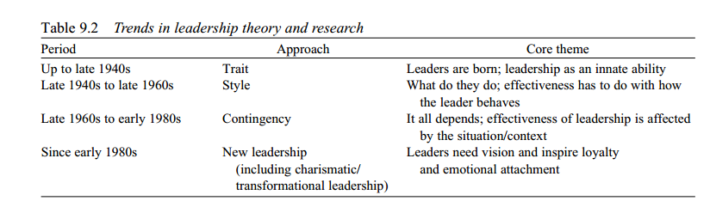

Several alternative ways to conceptualize and study leadership have had a profound influence on the development of ideas about and research into leadership from the early 1980s onward. Below, the three aforementioned main trends and several of these alternative approaches to leadership will be described.
- The Trait Approach
Early research into leadership can be characterized as a search for ‘the great man.’ Personal characteristics of leaders were emphasized and the implicit idea was that leaders are born rather than made.
All leaders were supposed to have certain stable characteristics that made them into leaders.
Trait theories of leadership Theories:-that consider personal qualities and characteristics that differentiate leaders from non -leaders.
The focus was on identifying and measuring traits that distinguished leaders from non-leaders or effective from ineffective leaders (Hollander & Offermann, 1990). From these distinctions between leaders and non-leaders, a profile of an ‘ideal’ leader could be derived, which could serve as the basis for selection of future leaders.
Three main categories of personal characteristics were included in the search for the ‘great man.’
- First, physical features, such as height, physique, appearance, and age.
- Second, ability characteristics such as intelligence, knowledge, and fluency of speech.
- Third, personality traits such as dominance, emotional control and expressiveness, and introversion–extraversion (Bryman, 1992).
- Leadership Style
The second major trend in researching leadership emphasized leader behavior. The focus shifted from who leaders are (traits) to what leaders do (behavioral style). In this approach, effectiveness of leaders is dependent on the exerted leadership style.
Whereas the trait approach focused on stable personal characteristics which were usually thought to be largely innate (implying selection of effective leaders rather than training), the style approach implied that leadership is a behavioral pattern, which can be learned. Thus, according to this approach, once one was able to discover the ‘right’ style, people could be trained to exhibit that behavior and become better leaders (Bass, 1990a; Bryman, 1992).
Most influential in this period was probably the series of questionnaire-based Ohio State studies.
The Ohio State researchers concluded that leadership style could best be described as varying along two dimensions, i.e., ‘consideration’ and ‘initiating structure’ (e.g., Fleishman & Harris, 1962). A second major research program concerning leader behavior in this period was carried out at the University of Michigan. The results of these studies (summarized by Likert, 1961, 1967) show that they found three types of leader behavior differentiating between effective and ineffective managers: task-oriented behavior, relationship-oriented behavior, and participative leadership.
- Contingency Approaches
The main proposition in contingency approaches is that the effectiveness of a given leadership style is contingent on the situation, implying that certain leader behaviors will be effective in some situations but not in others.
Fiedler’s Model
The earliest contingency theory of leader effectiveness was the theory by Fiedler (1967). Fiedler is well-known and heavily criticized for his ‘least-preferred-coworker’ (LPC) measure. Thebasic assumption is that a leader’s description of the person with whom he has the greatest difficulty working reflects a basic leadership style. A second assumption is that which of the basic leadership styles contributes most to group performance varies with the ‘situation favorability.’ This favorability is determined by weighting and combining three aspects of the situation, namely leader–member relations, position -power and task- structure. For instance, a situation is least favorable for a leader when leader–member relations are poor, position power is low and the task is unstructured.
More recently, Fiedler and Garcia (1987) developed a model that deals with the cognitive abilities of leaders (cognitive resources theory). According to this model, group performance depends on an interaction between two ‘traits’ (leader intelligence and experience), one type of leadership behavior(directive), and two aspects of the situation (interpersonal stress and the nature of the group task). Sofar, there is little empirical support for this model.
Situational leadership theory (SLT) A contingency theory that focuses on followers’ readiness.
Situational Leadership Theory
Hersey and Blanchard’s (1969, 1977) situational leadership theory (SLT) has been a popular basis for leadership training for many years. Originally SLT proposes that leaders should attune their behavior to fit with the ‘maturity’ or in later writings the ‘development level’ of the team as a whole as well as its individual members. Combining high or low task and relationship behavior creates four different leadership styles: telling (high task, low relations); selling (high, high); participating (low task, high relations); and delegating (low, low).
These styles are more or less appropriate for different types of team members. For team members who are, for instance, low on willingness and ability a ‘telling’ style is appropriate. The empirical evidence for the theory is scant.
The Normative Decision-Making Model
Another widely known contingency theory focuses on criteria to determine whether or not a leader should involve subordinates in different kinds of decision making (Vroom & Yetton, 1973).
The importance of using decision procedures that are appropriate for the situation has been recognized for some time.
Vroom and Yetton (1973) go beyond these approaches. In their model they try to indicate which decision procedure will be most effective in a specific situation. They distinguish five decision procedures, namely two types of autocratic decision (AI and AII), two types of consultative decision (CI andCII), and one joint decision by leader and group (GII).
AI entails that a manager decides without asking others for input such as opinions or suggestions.
In AII, a manager gathers the necessary information from subordinates (with or without explaining the problem at hand), then makes the decision.
CI means sharing the problem with individual subordinates and considering their ideas and suggestions and
CII involves getting them together as a group and sharing the problem. In both C cases, the manager still decides, and the decision may or may not reflect subordinates’ opinions.
Finally, GII implies sharing the problem with subordinates and that the solution should reflect agreement (consensus) of the group. The manager accepts and implements any decision the group reaches and does not have more influence over the final decision than others.
The Vroom and Yetton model predicts that the effectiveness of these decision procedures depends on several aspects of the situation, including the amount of relevant information held by leader and subordinates, the likelihood subordinates will accept an autocratic decision, and the extent to which the decision problem is unstructured.
Path–Goal Theory
The most influential and complete contingency theory to date is probably House’s path–goal theoryof leadership (House, 1971; House & Mitchell, 1974). This dyadic theory of supervision describes how formally appointed superiors affect the motivation and satisfaction of subordinates (House, 1996). House and Mitchell advanced two general propositions:
(1) Leader behavior is acceptable and satisfying to subordinates to the extent that subordinates see such behavior as either an immediate source of or instrumental to future satisfaction;
(2) leader behavior is motivational (i.e., increases follower effort) to the extent that such behavior makes follower need satisfaction contingent on effective performance and to the extent that such behavior complements the environment of subordinates by providing guidance, support, and rewards necessary for effective performance.
Leaders will be effective to the extent that they complement the environment in which their subordinates work by providing the necessary cognitive clarifications to ensure that subordinates expect they can attain work goals, and to the extent that subordinates experience intrinsic satisfaction and receive valent rewards as a direct result of attaining those work goals (i.e., behavior directed toward satisfying subordinate needs.
House and Mitchell (1974) specify four types of leader behavior: directive path–goal clarifying behavior, supportive leader behavior, participative leader behavior, and achievement-oriented behavior.
Proposed effects of leader behavior include subordinate motivation, satisfaction, and performance. Task and subordinate characteristics are treated as moderator variables.
Bryman (1992) describes several general problems with path–goal theory. Many of these problems are shared with the aforementioned Ohio tradition of investigating leadership style (e.g., inconsistent findings, problems associated with using group average methods of describing leaders, no attentionfor informal leadership, problems with causality and potential measurement problems). However, according to Evans (1996) the theory has not adequately been tested.

ALTERNATIVE APPROACHES TO STUDYING LEADERSHIP (New approaches)
Functional theory
Functional leadership theory is a particularly useful theory for addressing specific leader behaviors expected to contribute to organizational or unit effectiveness. This theory argues that the leader’s main job is to see that whatever is necessary to group needs is taken care of; thus, a leader can be said to have done their job well when they have contributed to group effectiveness and cohesion. While functional leadership theory has most often been applied to team leadership, it has also been effectively applied to broader organizational leadership as well. Hackman and Walton (1986), observed five broad functions a leader performs when promoting organization’s effectiveness. These functions include environmental monitoring, organizing subordinateactivities, teaching and coaching subordinates, motivating others, and intervening actively in the group’s work.
Integrated psychological theory
The Integrated Psychological theory of leadership is an attempt to integrate the strengths of the older theories while addressing their limitations, largely by introducing a new element – the need for leaders to develop their leadership presence, attitude toward others and behavioral flexibility by practicing psychological mastery.
Integrated Psychological theory began to attract attention after the publication of James Scouller’s Three Levels of Leadership model (2011). Scouller argued that the older theories offer only limited assistance in developing a person’s ability to lead effectively.
He pointed out, for example, that
Traits theories, which tend to reinforce the idea that leaders are born not made, might help us select leaders, but they are less useful for developing leaders.
Most of the situational/contingency and functional theories assume that leaders can change their behavior to meet differing circumstances or widen their behavioral range at will, when in practice many find it hard to do so because of unconscious beliefs, fears or ingrained habits. Thus, he argued, leaders need to work on their inner psychology.
None of the old theories successfully address the challenge of developing "leadership presence"; that certain “something” in leaders that commands attention, inspires people, wins their trust and makes followers want to work with them.
Scouller therefore proposed the Three Levels of Leadership model, which was later categorized as an “Integrated Psychological” theory.
The three levels in his model are Public, Private and Personal leadership:
- The first two – public and private leadership – are “outer” or behavioral levels. These are the behaviors that address what Scouller called “the four dimensions of leadership”. These dimensions are:
- A shared, motivating group purpose;
- action, progress and results;
- collective unity or team spirit;
- Individual selection and motivation.
Public leadership focuses on the 34 behaviors involved in influencing two or more people simultaneously. Private leadership covers the 14 behaviors needed to influence individuals one to one.
- The third – personal leadership – is an “inner” level and concerns a person’s growth toward greater leadership presence, knowhow and skill. Working on one’s personal leadership has three aspects:
- Technical knowhow and skill
- Developing the right attitude toward other people – which is the basis of servant leadership
- Psychological self-mastery – the foundation for authentic leadership.
Scouller argued that self-mastery is the key to growing one’s leadership presence, building trusting relationships with followers and dissolving one’s limiting beliefs and habits, thereby enabling behavioral flexibility as circumstances change, while staying connected to one’s core values. To support leaders’ development, he introduced a new model of the human psyche and outlined the principles and techniques of self-mastery, which include the practice of mindfulness meditation.
Transactional and transformational theories
Bernard Bass and colleagues developed the idea of two different types of leadership, transactional that involves exchange of labor for rewards and transformational which is based on concern for employees, intellectual stimulation, and providing a group vision.
The transactional leader is given power to perform certain tasks and reward or punish for the team’s performance. It gives the opportunity to the manager to lead the group and the group agrees to follow hislead to accomplish a predetermined goal in exchange for something else. Power is given to the leader to evaluate, correct, and train subordinates when productivity is not up to the desired level, and reward effectiveness when expected outcome is reached.
Leader–member exchange theory
LMX theory
A theory that supports leaders’ creation of in-groups and out-groups; subordinates with in-group status will have higher performance ratings, less turnover, and greater job satisfaction.
Another theory that addresses a specific aspect of the leadership process is the leader–member exchange (LMX) theory, Similar to the transactional approach, this interaction is viewed as a fair exchange whereby the leader provides certain benefits such as task guidance, advice, support, and/or significant rewards and the followers reciprocate by giving the leader respect, cooperation, commitment to the task and good performance. However, LMX recognizes that leaders and individual followers will vary in the type of exchange that develops between them.
LMX theorizes that the type of exchanges between the leader and specific followers can lead to the creation of in-groups and out-groups. In-groupmembers are said to have high-quality exchanges with the leader, while out-group members have low-quality exchanges with the leader.
Neo-emergent theory
The neo-emergent leadership theory (from the Oxford school of leadership) sees leadership as created through the emergence of information by the leader or other stakeholders, not through the true actions of the leader himself.
In other words, the reproduction of information or stories form the basis of the perception of leadership by the majority. It is well known that the naval hero Lord Nelson often wrote his own versions of battles he was involved in, so that when he arrived home in England he would receive a true hero’s welcome. In modern society, the press, blogs and other sources report their own views of leaders, which may be based on reality, but may also be based on a political command, a payment, or an inherent interest of the author, media, or leader. Therefore, one can argue that the perception of all leaders is created and in fact does not reflect their true leadership qualities at all.
Leadership styles
A leadership style is a leader’s style of providing direction, implementing plans, and motivating people. It is the result of the philosophy, personality, and experience of the leader.
Different situations call for different leadership styles. In an emergency when there is little time to converge on an agreement and where a designated authority has significantly more experience or expertise than the rest of the team, an autocratic leadership style may be most effective; however, in a highly motivated and aligned team with a homogeneous level of expertise, a more democratic or laissez-faire style may be more effective. The style adopted should be the one that most effectively achieves the objectives of the group while balancing the interests of its individual members.
Autocratic or authoritarian
Under the autocratic leadership style, all decision-making powers are centralized in the leader, as with dictators. Leaders do not entertain any suggestions or initiatives from subordinates. The autocratic management has been successful as it provides strong motivation to the manager. It permits quick decision-making, as only one person decides for the whole group and keeps each decision to him/herself until he/she feels it needs to be shared with the rest of the group.
Participative or democratic
The democratic leadership style consists of the leader sharing the decision-making abilities with group members by promoting the interests of the group members and by practicing social equality. This has also been called shared leadership.
Laissez-faire or free-rein
A person may be in a leadership position without providing leadership, leaving the group to fend for itself. Subordinates are given a free hand in deciding their own policies and methods. The subordinates are motivated to be creative and innovative.
Narcissistic
Narcissistic leadership is a leadership style in which the leader is only interested in him/herself. Their priority is themselves - at the expense of their people/group members. This leader exhibits the characteristics of a narcissist: arrogance, dominance and hostility. It is a common leadership style. The narcissism may range from anywhere between healthy and destructive. To critics, narcissistic leadership (preferably destructive) is driven by unyielding arrogance, self-absorption, and a personal egotistic need for power and admiration.
Toxic
A toxic leader is someone who has responsibility over a group of people or an organization, and who abuses the leader–follower relationship by leaving the group or organization in a worse-off condition than when he/she joined it.
Task-oriented and relationship oriented
Task-oriented leadership is a style in which the leader is focused on the tasks that need to be performed in order to meet a certain production goal. Task-oriented leaders are generally more concerned with producing a step-by step solution for given problem or goal, strictly making sure these deadlines are met, results and reaching target outcomes.
Relationship-oriented leadership is a contrasting stylein which the leader is more focused on the relationships amongst the group and is generally more concerned with the overall well-being and satisfaction of group members.
Relationship-oriented leaders emphasize communication within the group, shows trust and confidence in group members, and shows appreciation for work done.
Task-oriented leaders are typically less concerned with the idea of catering to group members, and more concerned with acquiring a certain solution to meet a production goal. For this reason, they typically are able to make sure that deadlines are met, yet their group members’ well-being may suffer.
Relationship-oriented leaders are focused on developing the team and the relationships in it. The positives to having this kind of environment are that team members are more motivated and have support, however, the emphasis on relations as opposed to getting a job done might make productivity suffer.

