Bonga University
College of Natural and Computational Sciences
Department of Physics
Lecture 5 and 6 For Solid state physics I phy(2061)
Lecture objectives
- Identify the three Bravais lattice from the cubic crystal system.
- Calculate the number of atoms in each cubic lattice
- Calculate volume of cubic lattice using primitive vectors
- Calculate coordination number
- Calculate packing fraction
- Study Bragg’s condition and reciprocal lattice
- Define positions, directions and planes in crystals (Miller indices)

The three-common cubic Bravais lattices:

- Simple cubic (sc),
- body-centered cubic (bcc), and
- face-centered cubic (fcc).
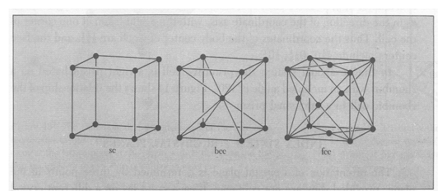
Figure 1 The cubic space lattices. The cells shown are the conventional cells

The commonly adopted primitive vectors of these cubic lattices are:
- Simple Cubic $a_{1}=a\hat{x} { a}_{2}=a\hat{x} { and a}_{3}=a\hat{x}$
- Body centered cubic (bcc)
$$a_{1}=\frac{a}{2}(-\hat{x}+\hat{y}+\hat{z})$$
$a_{2}=\frac{a}{2}(\hat{x}-\hat{y}+\hat{z})$
$a_{3}=\frac{a}{2}(\hat{x}+\hat{y}-\hat{z})$

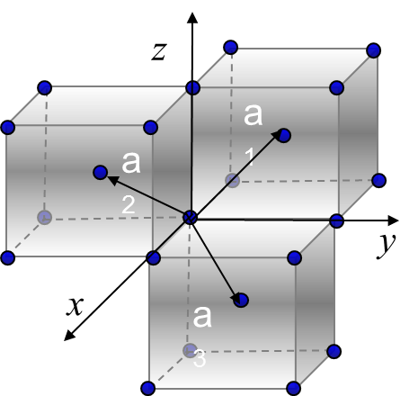

- Face centered cubic(fcc)
$$a_{1}=a(\hat{x}+\hat{y})$$
$$a_{2}=a(\hat{y}+\hat{z})$$
$$a_{1}=a(\hat{x}+\hat{z})$$

c
a₁
a₂
a₃
y
x
a

Coordination number:
The points in a Bravais lattice that are closest to a given point are called its nearest neighbors. Because of the periodic nature of a Bravais lattice, each point has the same number of nearest neighbors. This number is called the coordination number. For example, a sc lattice has coordination number 6; a bcc lattice, 8; a fcc lattice 12.
Bragg Diffraction and Reciprocal Lattice Vectors
Bragg Diffraction (Simple Picture)
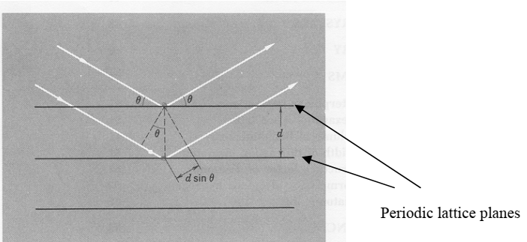
Figure 2. Schematic diagram illustrating the condition for Bragg diffraction.
Bragg diffraction condition: $2d\sin{θ=nλ}$ where n=1,2,3….. (1)
An incident beam of radiation or particles is diffracted from a crystal only if the Bragg
diffraction condition (1) is satisfied. We can view it as the condition where constructive interference takes place between the diffracted radiation or particles from the
adjacent planes. Since the lattice constant of crystals is of the order of 2 to 3 Å, for easily
measurable θ (such as ~1 to 10⁰) at the first order Bragg diffraction, it is desirable for the
wavelength of the beam, λ ~ 0.1 to 1Å. These values correspond to the wavelength of x-rays and 10 - 100 keV electrons. The latter constitutes the basics of transmission electron microscopes.
Index system for crystal planes (Miller indices)
In this section you will learn how to define positions, directions and planes in crystals;
how closed pack structures are formed and the two distinct types.
(a) Positions and directions
(i). The position of any lattice is given by r = ua + vb + wc, where u, v, and w
are integers.
(ii) The position of any general point is r = ua + vb + wc, but in this case u, v, and
w need not be integers.
(iii) Directions are also defined in terms of r, from the origin. Direction is denoted
as [uvw].
(b) To illustrate the two concepts: the position at the center of a bcc has fractional coordinates (½,½,½) while the direction of this point from the origin is [½½½].
(c) Miller Indices
Miller indices are useful for defining sets of planes in crystals. It is useful to specify the orientation of a plane by indices determined by the following rules.
(i) Find the intercepts on the axes in terms of the lattice parameters, a, b, and c.
In the case of a cubic lattice, a = b =c . Let these intercepts be 3a, 2b, 3c ,as figure 3
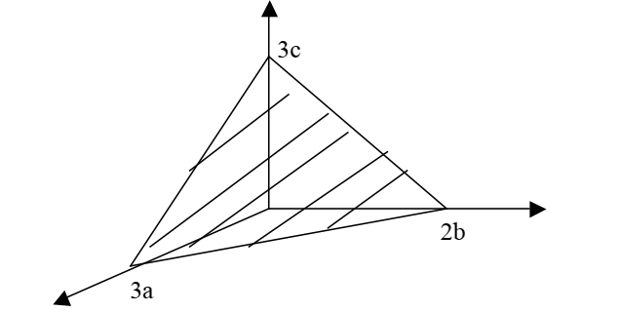
Figure 3: Plane used to derive miller indices
(ii) Take the reciprocals of these numbers.
(iii) Reduce the reciprocals to three integers having the same ratios, usually the
smallest three integers h, k, l. This is done by multiplying the reciprocals with
their LCM.
(iv) Enclose the three integers in a parenthesis as (hkl). There should be no
commas between the indices. (hkl) is called the index of the plane or Miller
indices for the plane.
Illustration of the above procedures:
1. Intercept values on the x-, y-, and z-axis are 3a, 2b and 3c respectively.
2. The reciprocals of the intercepts are $\frac{1}{3a},\frac{1}{2b},\frac{1}{3c}=\frac{1}{3},\frac{1}{2},\frac{1}{3}$ since a, b, and c are unit vectors along the respective axis.
3. Reducing the reciprocals i.e. multiplying throughout by LCM. In this case the
LCM is 6. The reciprocals reduce to 2,3,2 respectively.
4.The miller indices for the plane is thus (232).
If a plane cuts an axis on the negative side of the origin, the corresponding index is
negative and is indicated by a minus sign written as a bar e.g. (h$\overline{k}$l ) . The index k
is read as bar k.
Note that in the case of a cubic lattice all the faces look identical. For this
matter these planes are equivalent by symmetry. Planes equivalent by symmetry are denoted by curly brackets around the indices.
Examples

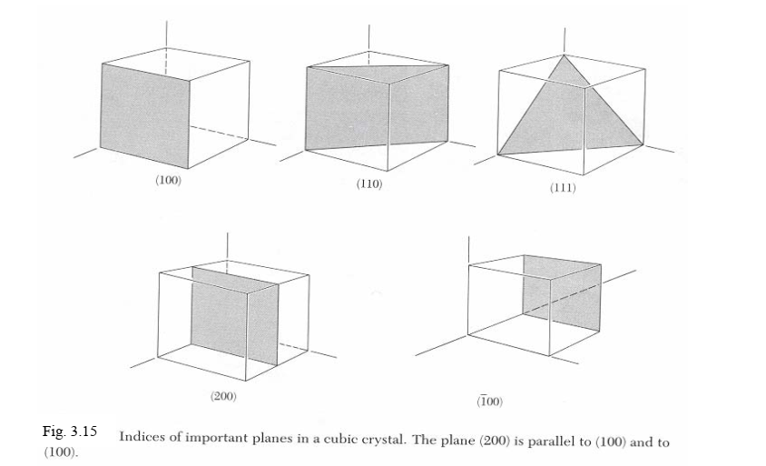
Reciprocal Vectors
The reciprocal lattice of a Bravais lattice constructed by the set of primitive vectors, a, b
and c is one that has primitive vectors given by:
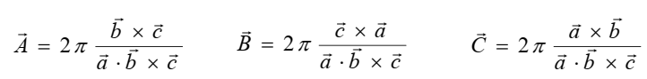 (2)
1) Reciprocal lattice to simple cubic lattice for sc lattice, we may choose the following set of primitive vectors:
$a_{1}=a\hat{x}$ , $a_{2}=a\hat{y}$ $a_{3}=a\hat{z}$ (3)
We may then determine the reciprocal lattice vectors b1, b2 and b3 using eqn (2)
$b_{1}=2π\frac{a_{2}×a_{3}}{a^{3}}=\frac{2π}{a}\hat{x}$ ,
Similarly
$b_{2}=\frac{2π}{a}\hat{y}$ and $b_{3}=\frac{2π}{a}\hat{z}$ (4)

2) Reciprocal lattice for bcc lattice
for bcc lattice, we may choose the following set of primitive vectors:
$a_{1}=\frac{a}{2}(-\hat{x}+\hat{y}+\hat{z}),$ $a_{2}=\frac{a}{2}(\hat{x}-\hat{y}+\hat{z} and a_{3}=\frac{a}{2}(\hat{x}+\hat{y}-\hat{z})$ (5)
We may then determine the reciprocal lattice vectors b1, b2 and b3 using eqn (5)

Implies $b_{1}=\frac{a^{2}/4}{a^{3}/2}=\frac{2π}{a}(\hat{y}+\hat{z})$
Similarly $b_{2}=\frac{a^{2}/4}{a^{3}/2}=\frac{2π}{a}(\hat{x}+\hat{z})$ and $b_{3}=\frac{a^{2}/4}{a^{3}/2}=\frac{2π}{a}(\hat{x}+\hat{y})$
NB. Clearly $b_{1},b_{2} and b_{3}$ generates the fcc Bravais lattice. Therefore the reciprocal lattice to bcc is the fcc lattice.
It is straight forward to show that the reciprocal lattice to fcc lattice is the bcc lattice.
Packing fraction (density)
In this activity you will be able to calculate the packing fraction (density) of different crystals.
(a) Read the theory and example provided about packing fraction (packing density). Use other references to supplement what is provided below.
(b) The packing fraction is defined as the maximum proportion of the available volume that can be filled with hard spheres.
(c) Write down a mathematical expression for the statement in (b).
(d) An example in how to calculate packing fraction. Consider a simple cubic lattice (sc) shown in Fig. 4.
To determine the packing fraction, one has to find first the number of lattice points
in a given cell.
(i) The lattice point in this case refers to a complete number of atoms that a unit
cell contains.
(ii) In a sc, the atoms are in contact with one another only along the edges of the
cell as shown in Fig.4
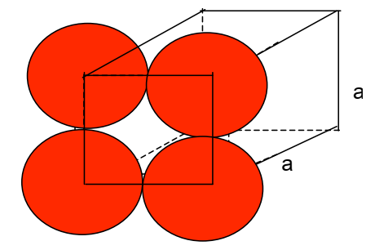

Figure 4. A simple cubic lattice showing relative positions of atoms on one face.
(iii) All the atoms are at the corners of the cubic lattice.
(iv) Each atom at the corner is shared by 8 cells. Thus, each atom contributes $\frac{1}{8}$^{th}
of it to a unit cell. Since there are 8 atoms at the corners;
The lattice point in Sc =1/8(8) =1.This means that a unit cell in sc system has one atom to itself. Thus, volume, V, occupied by this atom is
$$Packing fraction=\frac{volume occupied by lattice points }{Volume occupied by unit cell}$$

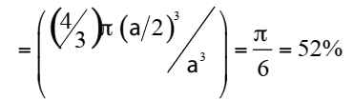
This means that 48% of the volume of a sc is empty, while 52% is flled with
atoms
Summary
Table 1. Important parameters in cubic crystal systems
