CHAPTER TWO
MAJOR FRESHWATER BODIES AND WETLANDS OF ETHIOPIA
2.1. Drainage Basins of Ethiopia
Drainage basin is any area of land where precipitation collects and drains off into a common outlet, such as into a river, bay, or other body of water. The drainage basin includes all the surface water from rain runoff, snowmelt, and nearby streams that run downslope towards the shared outlet, as well as the groundwater underneath the earth's surface.
Ethiopia, often called the water tower of northeast Africa, is endowed with some 7000 km length of flowing water and some 7000 km² of standing water. The drainage patterns are the result of the topographic features formed by the recent geologic activity of the Cenozoic Era during the Tertiary Period. Ethiopia, with its various geologic formations and climatic conditions, is endowed with considerable freshwater resources and wetlands.
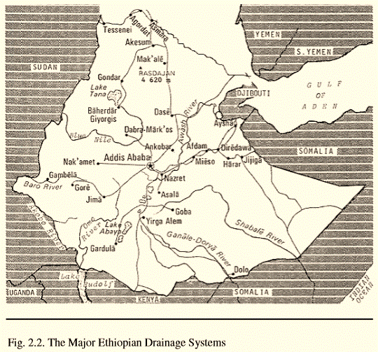
The drainage systems of Ethiopia can be broadly divided into three topographic regions which in turn are further subdivided in to drainage basins. These are: the western drainage system, the south eastern drainage system and the Rift Valley drainage system.
- WESTERN DRAINAGE SYSTEM: includes the Tekeze drainage basin, Abay (Blue Nile) drainage basin, Baro-Akobo drainage basin and Gibe-Omo drainage basin. The major lakes, such as Tana Lake, are located within this drainage system. This is the largest drainage system that drains nearly 40 % of the total area and 60 % of the annual water flow. This is an exorheic system in which the rivers in the system ultimately drain into the Mediterranean Ocean.
- SOUTH-EASTERN DRAINAGE SYSTEM: includes Wabishebele and Ghenale drainage basins. This is also an exorheic system in which the rivers in this system ultimately drain into the Indian Ocean.
- RIFT VALLEY DRAINAGE SYSTEM: includes Awash drainage basin and major lakes such as Ziway, Shala, Abijata, Awassa, Abaya and Chamo are located in the Rift Valley. This is generally an endorheic or closed system with no external flow.
2.2. LAKES
The Ethiopian lakes roughly occupy some 7000 km² area. The formation of most of the natural lakes is associated with tectonic and volcanic activities and thus most are crater lakes.
- HIGH LAND LAKES include Lake Tana, Lake Hayq (near Dessie), Ashengie, Lake Wonchi (near Ambo), and Bishoftu (Debrezeit) Lake groups (such as Lake Hora, Lake Bishoftu, Lake Kuriftu and Lake Arenguade, etc).
- RIFT VALLEY LAKES include lakes in:
- Northern rift valley lakes: Awassa, Langano, Abijata, Shalla and Ziway
- Southern rift valley lakes: Abaya, and Chamo and Chew Bahir
The man-made lakes known as reservoirs include Koka Reservoir, Fincha Reservoir, MelkaWakena Reservoir, Gilgel Gibe Reservoir, Tekeze Reservoir, etc.
Table 2.1. Some of the Major Ethiopian Lakes
Lake | Area (Km2) | Max. Depth (m)
Tana | 3600 | 9
Abaya | 1150 | 13
Chamo | 551 | 10
Ziway | 434 | 4 (shallowest)
Shala | 409 | 266 (deepest)
Abijata | 205 | 14
Koka | 205 | 9
Awassa | 129 | 46

Though fishery activities are not well developed in Ethiopia, some practices are seen in most of the lakes mentioned above. However, most of the fishery activities are common in Rift valley lakes and Lake Tana.
2.3. RIVERS
The Ethiopian rivers are more than 7000 km long. The major rivers located among the various drainage basins are summarized in Table 2.2. Ethiopian rivers are characterized by:
- Extreme seasonal fluctuation due to the marked seasonality of the rainfall:
- They carry only small amount of water and some even dry up along part of their courses during dry season.
- High volume and run off during wet seasons
- Steep flow and profiles:
- Flowing from highlands of over 2,000-3,000 meters to a low land of an elevation less than 500 meters.
- The rivers have high erosive power due to their steep flow
Table 2.2. The Major Rivers of Ethiopia
River | Length (km) |  |  |  | Major tributaries
 | Total | inside |  | outside
Abay (Blue Nile) | 1360 | 800 | 560 |  | Dabus, Didesa, Fincha, Guder, Muger
Wabishebele | 2000 | 1340 | 660 |  | Ramis, Erer, Daketa, Fafen
Ghenale | 1050 | 480 | 570 |  | Dawa, Weyb, Welmel, Mena
Awash | 1200 | 1200 | - |  | Akaki, Kesem, Borena, Mile
Tekeze | 1168 | 608 | 560 |  | Atbara, Angreb
Omo/Ghibe | 760 | 760 | - |  | Gojeb
Baro | 507 | 227 | 280 |  | Akobo

Many Ethiopian rivers including Abay are difficult for fisher activities primarily due to:
- The steep gorge of the rivers that extends for a large portion of the basin. The presence of crocodiles in many segments of the rivers.
- Moreover, many of the tributaries dry or their volumes are highly reduced during the dry seasons
The Ethiopian rivers generally flow into:
- Mediterranean Ocean: Wester drainage system,
- Indian Ocean: South-Eastern drainage system
- Close (inland) flow i.e. with no external flow: Rift valley drainage system
The general flow pattern of Ethiopian rivers is determined by the topography of the country:
- Western and South eastern highlands have an outward slopping topography resulting in the out-ward flow of the rivers. Consequently, most major rivers of Ethiopian high lands cross the border and become internationally significant.
- Baro-Akobo, Abay (Blue Nile) and Tekeze rivers drain west ward into the Mediterranean Ocean.
- Ghenale and WabiShebele Rivers drain east ward into the Indian Ocean.
- Rift Valley has an inward slopping resulting mainly in an inland drainage System
2.4. WETLANDS
Wetlands are dynamic; they change seasonally with changes in annual precipitation. Wetlands with static water levels tend to become more pond like and lose some of their Wetlands with static water levels tend to become more pond-like and lose some of their ecological value. Many wetland plants and animals are adapted to the periodic saturation and drying that occurs and small changes in flood/dry patterns can drastically change plant and animal species composition.
In Ethiopia wetlands are distributed all across the topographic unit of the country ranging from the lowlands of salt lakes in the Afar depression to the freshwater shallow lakes at Bale and Semen Mountains. They are estimated to constitute 2% of the total area of the country.
Swamps and marshes are the predominant forms often identified by reference to a vegetation locally known as “cheffe”, which is the typical vegetation in most wetlands. Marshes are periodically saturated, flooded, or opened with water and characterized by herbaceous vegetation adapted to wet soil conditions. Swamps are, however, fed primarily by surface water inputs and are dominated by trees and shrubs. They are characterized by very wet soils during the growing season and standing water during certain times of the year.
Wetlands are most productive environments important in:
- Maintaining key ecological processes (reduce siltation, purifies water,
ground water recharge and discharge, etc.)
- Supporting high biodiversity (such as waterfowl, mammals, reptiles,
amphibians, fish and invertebrate species, medicinal plan species)
- Providing socio-economic benefits to local communities
In Ethiopia, the socio-economic benefits of wetlands include:
- Provision of clean water supplies throughout the year
- The wetland vegetation, such as “cheffe”, reeds, palms, bamboos and papyrus, etc. are harvested by the local people for roofing and making of various crafts including boats.
- The other wetland plants, such as Hygrophila auriculata (locally known as balanworanti) are used for medicinal purpose
- Most wetlands are used for cattle grazing and watering
- Wetlands are also used to cultivate maize and other edible plants during dry season.

