UNIT THREE

THREATS TO BIODIVERSITY
- Biodiversity is diminished or destroyed in a number of ways either by natural changes or by human disruption. Modern human actions threaten biological diversity on a worldwide scale, over an extremely short geological time period.
- The sources of danger to biodiversity include taxonomically specific threats such as exploitation, introduced species and genetic or behavioral degradation, all of which can interact and ultimately result in extinction.
- These threats combine with the community and ecosystem level threats habitat degradation, habitat fragmentation and destruction, pollution and global climate change causing disruption and ecosystem structure and function.
- The greatest threat to biodiversity is loss of habitat as humans clear woody vegetation for agriculture, grazing livestock, unsustainable use of such as draining wetlands and deforestation for agricultural land, polluting the air, soil water through chemical compounds such as herbicides, insecticides, etc. also contributes a lot for biodiversity loss.
- In general, the trend in the loss of biodiversity has two main components:
  - Loss of habitats, or ‘ecosystem quantity’ resulting from the conversion of natural areas to agricultural or urban use and
  - Loss of ecosystem quality due to factors such as climate change, pollution, habitat fragmentation and over-exploitation.

- The major threats to biodiversity
    - Habitat degradation and loss
    - Habitat fragmentation
    - Overexploitation
    - Species extinction
    - Invasive species
    - Pollution
    - Climate Change

Habitat Degradation and Loss
- Each organism in an ecosystem needs a place to live. The
place in which an organism lives is called its habitat.
- The focus of conservation action has recently shifted from protecting individual species to conserving habitats and ecosystems.
- The majority of the earth’s land surface (83%) has been transformed by humans to some degree.
- Degradation generally refers to impacts that affect many, but not all, species and that may be temporary.
- Habitat degradation or destruction is the most devastating threats to biodiversity are the outright loss of habitat due to human activity.
- Habitat loss typically involves conversion of land for other uses,
- Humans supplant natural ecosystems to grow food, harvest materials, and build our settlements. These actions alter or eliminate the conditions needed for plants and animals to survive.
- Deforestation is of particular concern because so much biological diversity occurs in the complex environments created by forests. Timber harvest and conversion of forests to agriculture are major components of habitat loss.
- But so are coastal development, wetland loss, and conversion to human uses of many other types of natural ecosystems and the species and populations that inhabit them.
- Habitat loss usually refers to impacts so severe that all, or nearly all, species are adversely affected and will take a relatively long time to recover.
- Agricultural activities, extraction and development are the three big drivers in habitat degradation. Other impacts of industrial farming include high irrigation, heavy pesticides, herbicides, and pesticides; all of which negatively impact biodiversity.
- Once removed, a natural habitat is often permanently lost, although natural or artificial restoration of some habitats is possible over time.
- Terrestrial ecosystems suffer habitat destruction in a variety of ways, such as deforestation, desertification, urbanization and artificial burning. Many terrestrial ecosystems have been converted to urban and agricultural areas.
- Habitat degradation or destruction is also a major threat to biodiversity in aquatic regions.
- This type of habitat loss occurs from dam construction, wetland filling, water flow diversion, oil-drilling, pollution and bottom trawling in addition to other human activities.
- The majority of freshwater ecosystems have been altered, and many vital wetland and aquatic habitats have been destroyed.
- Wetland loss particularly affects diversity, as wetlands are often important centers of regional and local diversity.
- In coastal environments, habitat has been destroyed in many river deltas, where large quantities of fertilizers, pesticides, and industrial pollutants empty into gulfs and bays, creating zones without viable habitats.
- Loss and degradation of habitat is the most important factor causing loss of species.
- For example, conversion of forests or grasslands into croplands results in the local extinction of plant and animal species worldwide about 1.2 million km2 of land have been converted to cropland in the past 30 years.
- In a recent global survey, habitat loss was found to be the principal factor affecting 83 % of threatened mammals and 85 % of threatened birds.
- Habitat loss and destruction, usually as a direct result of human activity and population growth, is a major force in the loss of species, populations, and ecosystems.
Habitat Fragmentation
- Fragmentation means the “breaking up” of large patches of native vegetation into smaller and increasingly isolated patches, is a process as old as civilization.
- Habitat fragmentation, by definition, is the “breaking apart” of continuous habitat, such as tropical forest or semi-arid shrub land, into distinct pieces.
- When this occurs, three interrelated processes take place a reduction in the total amount of the original vegetation (i.e. habitat loss); subdivision of the remaining vegetation into fragments, remnants or patches (i.e. habitat fragmentation); and introduction of new forms of land-use to replace vegetation that is lost.
- These three processes are closely intertwined such that it is often difficult to separate the relative effect of each on the species or community of concern.
- Habitat fragmentation is reduced size and increased isolation of habitat; remaining habitat apportioned into smaller and more isolated patches.
- In reality, very rarely is the landscape ‘reconfigured’ with the same amount of habitat as previously. However, there can be varying degrees to how many ‘fragments’ are generated in the process.
- Furthermore, there is a great deal of variation in the pattern of those fragments.
- Over the past several decades scientists have sought to better understand the processes associated with fragmentation, predict which kinds of species are sensitive to fragmentation and suggest measures to reduce or mitigate the effects of fragmentation.
- However, with a phenomenon as complex as fragmentation, empirical generalizations that apply to all systems in all areas are hard (impossible?) to come by.
- A simplistic view of fragmentation is larger patches being broken into smaller ones.
- The definition of habitat fragmentation above implies four effects of the process of fragmentation on habitat pattern:
(a) Reduction in habitat amount,
(b) Increase in number of habitat patches,
(c) Decrease in sizes of habitat patches, and
(d) Increase in isolation of patches.
- These four effects form the basis of most quantitative measures of habitat fragmentation. However, fragmentation measures vary widely; some include only one effect (e.g., reduced habitat amount or reduced patch sizes), whereas others include two or three effects but not all four.
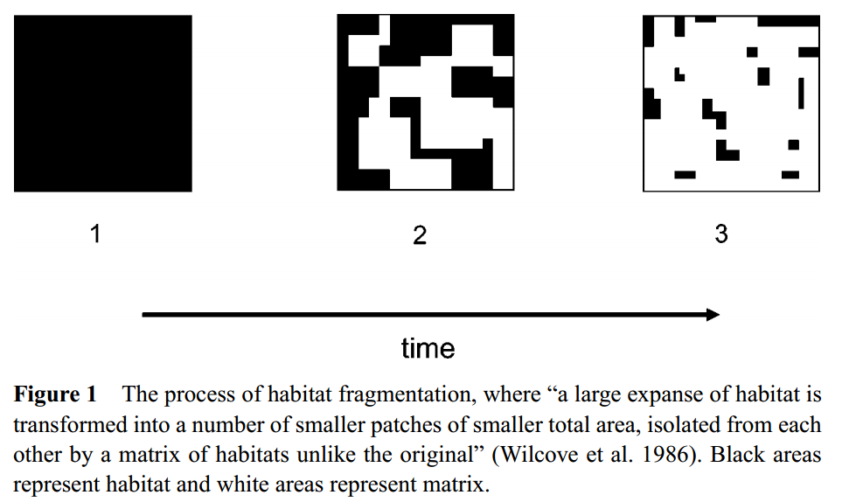
Biological Consequences of Fragmentation
- The effects of fragmentation range from the obvious losses to the more subtle and indirect. Some effects can be ‘repaired. However, most are not being restored or regenerated.
- Initial Exclusion: An obvious effect of fragmentation is the loss of species in the portion of the matrix that was destroyed. Many species have relatively narrow distributions and can easily be excluded.
- Crowding Effect: When the habitat in the matrix is destroyed, those individuals in the destroyed portion seek refuge in the remaining fragments. Frequently see a spike in abundance, but inevitably falls. Where is persists, can have negative impacts (i.e. density-dependent effects.
- Insularization and Area Effects: Small reserves are unlikely to harbor a number of species with large area requirements. Other species avoid tracts of suitable habitat and more than enough room for a territory.
- There are three main reasons why large fragments have more species than small fragments.
  - A large fragment will almost always have a greater variety of environments than a small fragment (e.g. different types of soil, a stream, a rock outcrop, an area recently disturbed by fire), and each of these will provide niches for some additional species.
  - A large fragment is likely to have both common species and uncommon species (i.e. species that occur at low densities), but a small fragment is likely to have only common species.
  - Species that do not occur in small patches of habitat are called area-sensitive species and are often of concern to conservationists.
- Isolation: Isolation of habitats and population is an effect of fragmentation as consequential as reduction in habitat and population size. If no single patch is large enough, perhaps a cluster of suitable habitat can suffice.
- Protect and expand the amount of habitat
Protect and expand the amount of habitat many indicators of conservation status, such as population sizes, species richness, and the occurrence of rare species, are positively correlated with the size of individual fragments or the total amount of habitat in the landscape. Consequently, activities that protect and expand natural and semi-natural habitats are critical priorities in maintaining plant and animal assemblages. These include measures that:
- Prevent further destruction and fragmentation of habitats. ·
- Increase the size of existing fragments and the total amount of habitat in the landscape.
- Increase the area specifically managed for conservation.
- Give priority to protecting large fragments
Overexploitation
- Overexploitation means over use or over harvesting of plants, animals and natural resource.
- It is the major threats of biodiversity (Biodiversity is threatened when overexploitation occurs).
- Overexploitation can lead to dangerously low population numbers, if not the complete disappearance of a species.
- Overexploitation has two meaning
- Overharvesting of species from the wild (too much hunting, fishing…)
- Overconsumption of resources (too much timber cutting, fossil fuel use…)
- Humans have always depended on nature for food and shelter, but when ‘need’ turns to ‘greed’, it leads to over-exploitation of natural resources.
- Many species extinctions in the last 500 years (Steller’s sea cow, passenger pigeon) were due to overexploitation by humans.
- Presently many marine fish populations around the world are over harvested, endangering the continued existence of some commercially important species.
- Over-harvest of both woody and non woody products is occurring on a widespread basis leading to deforestation, ecosystem degradation and biodiversity loss.
- Root causes include demographic pressures and growing demand, especially urban demand, for firewood, charcoal and other products, land tenure and resource access rights resulting in the open access to forest/wild lands, lack of political will to enforce forestry legislation, lack of sustainable management models for most ecosystems and lack of incentives for local communities to conserve.

Over-grazing
- Overgrazing results in decreased soil cover, increased erosion, decreased quality and productivity of range resources, reduction or elimination of the natural regeneration of woody species and preferred forage species, bush encroachment in some areas and loss of biodiversity.
- Root causes include demographic growth, the breakdown in traditional pastoral/range management systems, land tenure and open access to rangelands in some parts of the country, lack of incentives for sustainable use and lack of range management models in some areas.
Over-hunting:
- Wildlife populations have been severely depleted by over-hunting.
- Root causes include the lack of incentives for local people to conserve wildlife, the low risk of being caught and prosecuted for poaching, availability of firearms, growing demographic pressures, and conflicts between wildlife and farmers.
- Usually overexploitation is not the sole cause of extinction, but it often contributes in tandem with other causes.
- Some studies reported that 30 % of species threatened by overexploitation
E.g. collapse of fish stocks

Invasive Alien Species (IAS)
- Invasive alien species (IAS) are plants, animals, fungi and microorganisms whose introduction and/or spread outside their natural past or present ranges pose a risk to biodiversity or have other unforeseen negative consequences.
- IAS is also commonly referred to as invasive, aliens, exotics or non-indigenous species.
- Invasive alien species (IAS) – an alien species that has established and spread, and which causes, or has the potential to cause, harm to the environment, economies, or human health.
- There are various versions of the IAS definition. For example, the Convention on Biological Diversity (CBD) defines an IAS as an alien species whose establishment and spread threatens ecosystems, habitats or species with economic or environmental harm. According to the IUCN an IAS is an alien species which becomes established in natural or semi-natural ecosystems or habitats, is an agent of change, and threatens native biological diversity.
- IAS are species, native to one area or region, that have been introduced into an area outside their normal distribution, either by accident or on purpose, and which have colonized or invaded their new home, threatening biological diversity, ecosystems and habitats, and human well-being.
- According to the most recent global analysis of the International Union for Conservation of Nature (IUCN) Red List of Threatened Species, IAS constitute the fifth most severe threat to amphibians, the fourth to reptiles, the third to birds and mammals, and the second to freshwater fish species (Vié et al., 2009).
- Previously, IAS have also been recognized the second most important threat to biodiversity at the global level (after direct habitat loss or destruction) (CBD, 2001; MA, 2005).
- Species are introduced into new habitat by people for three general reasons
i). Accidental introductions (often invertebrates and pathogens)
ii). Species imported for a limited purpose which then escape; and
iii). Deliberate introductions (usually plants and vertebrates).
- The extent to which introduced species may proliferate and spread is affected by the state of the receiving ecosystem.
- An alien species may find a vacant niche and spread, or it may compete for one already occupied by a native species.
- Some IAS proliferates because they find no natural enemies in their new habitat.
- Although some species have invaded habitats on their own, human activity such as exploration, colonization, trade and tourism has dramatically increased the diversity and scale of invasions by alien species.
- IAS can have spread outside of their natural habitat and threaten biodiversity in their new area, are a major cause of biodiversity loss. These species are harmful to native biodiversity in a number of ways, for example as predators, parasites, vectors (or carriers) of disease or direct competitors for habitat and food.
- Africa is home to hundreds of IAS – both plant and animal but the magnitude of the problem varies from country to country, and from ecosystem to ecosystem.
- In many parts, freshwater ecosystems are particularly at risk with IAS surpassing habitat loss as the number one cause of biodiversity loss.
- Invasive alien species are a problem in diverse ecosystems in Northern, Western, Central, Eastern and Southern Africa and in the Western Indian Ocean (WIO) islands: they affect both savannahs and tropical forests and they are found on land (agricultural and forest), in freshwater systems, along the coast, and in the ocean. (UNEP 2004).
- Virtually all countries in the region are affected by IAS. In 2004, IUCN – the World Conservation Union (IUCN) identified 81 IAS in South Africa, 49 in Mauritius, 44 in Swaziland, 37 in Algeria and Madagascar, 35 in Kenya, 28 in Egypt, 26 in Ghana and Zimbabwe, and 22 in Ethiopia (IUCN, 2004).
- Many IAS found in Africa are included on a global list of the 100 worst IAS (IUCN, 2004).
- These include the infamous, Eichhornia crassipes (water hyacinth); economically important species including the Nile perch, Oreochromis mossambicus (Mozambique tilapia) and Acacia mearnsi (black wattle).
- With increasing globalization, the threat posed by IAS is likely to increase through both intentional and accidental introductions.
- Human movement and the movement of goods are key drivers in the spread of IAS.
- With improvements in communications and infrastructure, this is likely to increase.
- Historically, IAS has been spread through colonization and exploration.
- Today, mobility through tourism, business travel and migration continues to be an important factor.
- Many IAS have been introduced to Africa in, for example, soil, plants, luggage, vehicles and aero planes (Kirby 2003).
- Trade – both legal and illegal – particularly in, but not limited to, plants and animals, is particularly important.
- Many species have been introduced through trade in manufactured goods contaminated with seeds or insects.
- Trade has contributed not only to the introduction of species that colonize and fundamentally alter receiving ecosystems but that are also a factor in the growing incidence of disease.
- Aedes albopictus (Asian tiger mosquito), for example, is associated with the transmission of dengue fever and is believed to have been first introduced through a shipment of tyres from Japan to South Africa in 1989.
Impacts of Invasive Species on Biodiversity and Ecosystems
- Although IAS comes from diverse taxonomic groups they share some similar impacts.
- Tree species such as the black wattle from Australia, Prosopis spp. (mesquite tree) from Mexico, and Leucaena leucocephala (the conflict tree) behave in a similar way to invasive alien fish species, such as Cyprinus carpio (the common carp).
- Invasive alien species may threaten native species as direct predators or competitors, as vectors of disease, or by modifying the habitat or altering native species dynamics (MA 2006).
- The threat posed to biodiversity by IAS is considered second only to that of habitat loss (CBD 2005).
- On small islands, it is now comparable with habitat loss as the lead cause of biodiversity loss (Baillie and others 2004).
- Invasive species may out-compete native species, repressing or excluding them and, therefore, fundamentally change the ecosystem.
- They may indirectly transform the structure and species composition of the ecosystem by changing the way in which nutrients are cycled through the ecosystem (McNeely and others 2001).
- Entire ecosystems may be placed at risk through knock-on effects.
- Given the critical role biodiversity places in the maintenance of essential ecosystem functions, IAS may cause changes in environmental services, such as flood control and water supply, water assimilation, nutrient recycling, conservation and regeneration of soils (GISP 2004, Levine and others 2003).
- Invasive may also affect native species by introducing pathogens or parasites that cause disease or kill native species.
- Among other things, both old and newly established IAS contribute to land degradation through soil erosion and the drawing down of water resources, reducing resources available to people and indigenous plants.
- Others produce leaf litter which poisons the soil, suppressing the growth of other plants, and in particular that of the under story (UNEP 2004).
- They may alter the environment in directions that are more favorable for them but less favorable to native species.
- This could include altering geomorphic processes (soil erosion rates, for instance, or sediment accretion), biogeochemical cycling, hydrological cycles, or fire or light regimes (MA 2006; Levine and others 2003).
- For example, invading trees in the fynbos of the Cape Floral Kingdom reduce stream-flow from mountain catchment areas and change the overall hydrological regime of the entire area, which in turn prevents the germination and growth of native species (MA 2006).
- Wattle trees and mesquite can sink their roots deeper into the soil than indigenous trees, sucking out massive volumes of water and out-competing indigenous plants.
Common Invasive Species in Ethiopia
- Invasive Alien Species (IAS) are of a great concern in Ethiopia, posing particular problems on biodiversity of the country, agricultural lands, range lands, national parks, water ways, lakes, rivers, power dams, roadsides and urban green spaces with great economic and ecological consequences.
- Four key features are associated with invasive plants
- Show prolific seedling and early age of the first reproduction.
- Have unpalatable ( unpleasant test) foliage
- Can easily established in degraded environment
- Have an ability to regenerate profusely from direct seeds, stems or roots
- Foremost among these are parthenium weed (Parthenium hysterophorus), prosopis (Prosopis juliflora), water hyacinth (Eichhornia crassipes), cactus (Euphorbia stricta) and lantana weed (Lantana camara).
- They have been identified by the Environmental Policy and the National Biodiversity Strategy and Action Plan as a major threat to biodiversity of the country and economic well-being of its people.
- Parthenium hysterophorus is a species of flowering plant in the aster family, Asteraceae that is native to the American tropics. It is a common invasive species in India, Australia, and parts of Africa. P. hysterophorus invades all disturbed land, including farms, pastures, and roadsides. In some areas, outbreaks have been of almost epidemic proportions, affecting crop production, livestock and human health and it was introduced accidentally during Ethio-somalia war in 1976/77 through military vehicles.
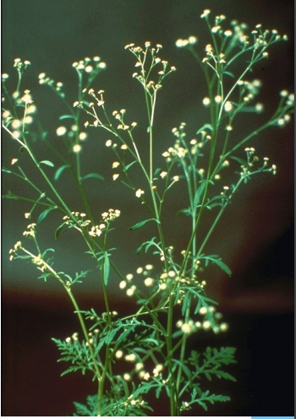
- Prosopis juliflora is a shrub or small tree in the Fabaceae family, a kind of mesquite. It is native to Mexico, South America and the Caribbean. It has become established as an invasive weed in Africa, Asia, Australia and elsewhere.It was intentionally introduced as an agroforestry species in the Awash basin, But now threatens agricultural land and protected areas in the Awash National Park.It is aggressively invading pastoral areas in the Middle and Upper Awash Valley, and Eastern Harerge, It destroying natural pasture, displacing native trees, forming impenetrable thickets, and reducing grazing potential.
- 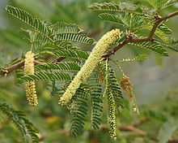
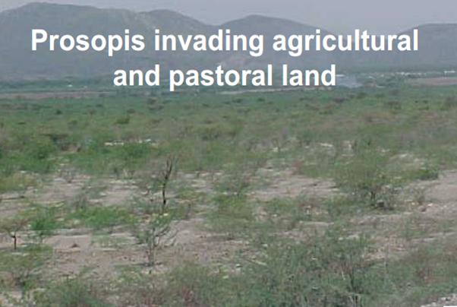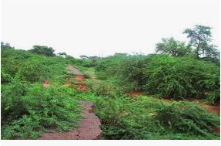

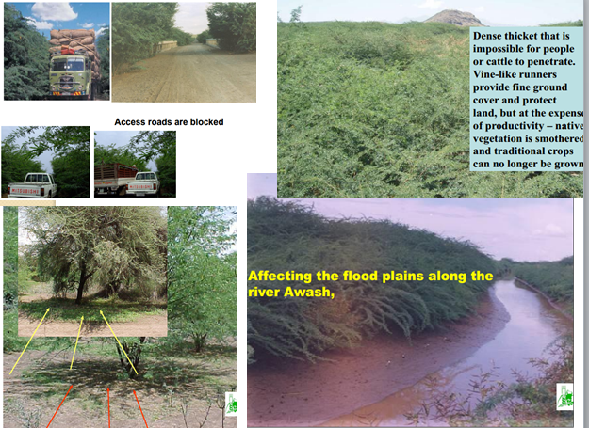
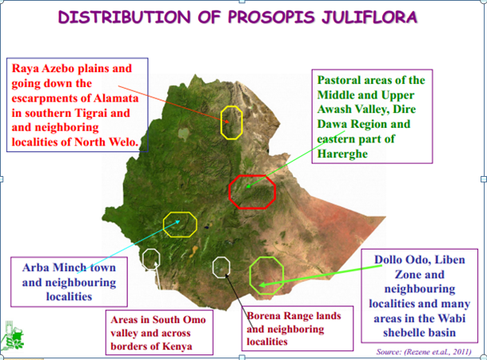
- Eichhornia crassipes, commonly known as (common) water hyacinth, is an aquatic plant native to the Amazon basin, and is often considered a highly problematic invasive species outside its native range.
- It is recently emerge in the lake tana and grow rapidly. 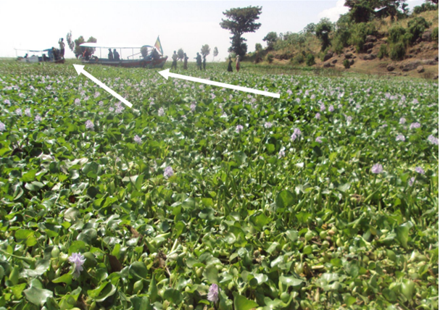
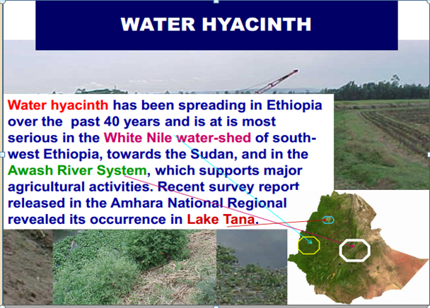

Lantana camara
- A shrub IAPS introduced to Ethiopia from native Tropical America and the West Indies.
- But, no clear year of introduction from native range has been indicated in literatures regarding this species in Ethiopia
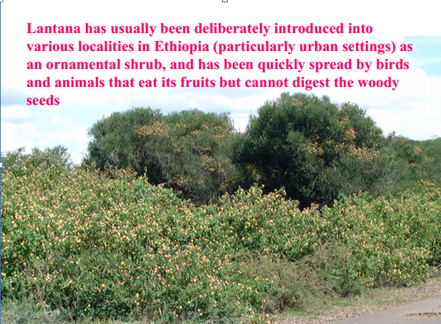
Species Extinction
- The most obvious loss of biodiversity is the extinction of unique taxa.
- Extinction occurs when no more individuals of a taxonomic group survive, either within a specified part of their range or forever lost across their entire range.
- The taxonomic unit of extinction is usually measured as a species, though extinction can be assessed at sub specific or population levels.
- A species, by definition, is evolutionarily unique; each species has distinct genetic, evolutionary, behavioral and ecological attributes that once lost cannot be replaced.
- The process of extinction and speciation has been continual; as new species have arisen others have dwindled and become extinct.
- The one constant of evolutionary change has provided varying amounts of diversity over geological time. Throughout the history of the Earth, species have emerged, while others have disappeared. In other words, a species is born, lives and dies. In the history of life on this planet, losses of biodiversity have been common. There is palaeontological evidence for five mass extinctions, during which many taxonomic groups lost a majority of species. Extinction is a normal process of evolution.
- The current extinction crisis has seen species lost at a rate perhaps 1000 to 10 000 times the average background rate identified by the fossil record.
- Current taxonomic extinction risk has been systematically assessed by several organizations, most notably the International Union for the Conservation of Nature and Natural Resources (IUCN).
- Detailed information is available for well-known groups of organisms, including most vertebrates and flowering plants and to a much lesser extent for invertebrates, other plants and fungi. Since 1600, at least 1.84% of mammals and 1.20% of bird species have become extinct.
- Present calculations estimate 25% of mammals and 12% of birds at risk of extinction with a probability of at least 10% over the next 100 years. Species at risk are mainly those that have small range or population sizes, especially species that have become rare due to human activity.
- The history of life over almost 4 billion years has been studded with periods of crisis, when large numbers of species disappeared.
- Many lines of animals and plants have become extinct, and the entire biological diversity of the present time amounts to a mere 1% of all the species that have lived in the past.
- Extinction occurs when all the individuals of a species have died. Long before humans existed, many species on Earth existed and became extinct in both terrestrial and aquatic ecosystems.
- Extinction occurs when the death rate of a species remains higher than the birth rate for a long period of time. The birth rate is the speed at which new individuals are added to a population, and the death rate is the speed at which individuals are removed from the population by death.
- Over long periods of time, these two rates have to be equal for a species’ population to remain stable.
- Even in ecosystems that are unaffected by human activities, things never remain the same forever. Sometimes a significant biotic or a biotic feature of a species’ ecosystem changes.
- For example, a biotic factor for a plant species could be a decline in rainfall that makes soils drier. A biotic factor for a plant species could be the arrival of a new insect species whose leaf-feeding habit weakens the plants.
- Such factors may not cause the extinction of the species directly, but if the change results in the death rate being greater than the birth rate over an extended period of time, extinction eventually occurs.
Patterns of Natural Extinction: By examining fossil evidence, scientists have described two patterns of extinction in the history of Earth. The difference between these patterns is the speed with which they occur. One pattern, called background extinction, is apparent over long periods of time. As ecosystems gradually change over long periods of time, some existing species become extinct while new species appear through evolution.

The second pattern is mass extinction. Mass extinction is thought to happen when there is a relatively sudden change to Earth’s ecosystems, making them both unsustainable and unsustaining. Earth has experienced five previous mass extinction episodes. The best-known example of mass extinction is the death of the dinosaurs. Many scientists hypothesize that an asteroid hit Earth 65 million years ago, causing huge changes to Earth’s climate and thus eliminating the dinosaurs.

Pollution
- Pollution is defined as contamination of the natural environment. Pollution can be in the form of liquids, solids, gases, or even forms of electromagnetic radiation input into air, water, or land.
- Since the industrial revolution, the input of organic and inorganic substances into the environment by humans has become a growing threat to biodiversity.
- Pollution can be acute, with a single incident, or chronic, with the addition of substances to the environment over a continuous time period.
- Examples of acute environmental disasters include oil spills, refinery and shipping accidents, and nuclear accidents. Although the initial effects of these disasters can result in massive biodiversity loss, there are often longer lasting repercussions as well.
- Sources of chronic pollution from human activity include industrial emissions, aerosol release from biomass burning, agricultural runoff, pesticides, erosion, and automobile emissions. Although the immediate effects of chronic pollution may be small, sustained rates and accumulation of chronic pollution can be more devastating than acute environmental disasters.
- Pollution continues to be an increasing problem for the conservation of biological diversity. River systems and near-shore environments are at particular risk. Localized impacts have occurred and their frequency is increasing.
- A number of river systems suffer from increasing salinity, silt loads, nutrient levels and heavy metal and chemical pollution.
- Pollution of groundwater has adverse effects on ecosystems in both urban and rural environments. Air pollution, acid rain destroys forests. Water pollution kills fishes and other aquatic plants and animals.
- The Environment Protection Agency is developing a National Pollutant Inventory and recommendations for standards and, once reflected in State and Territory control measures, this should help to minimize the impacts of pollution.
- The use of some agricultural, industrial and urban chemicals continues to cause problems for wildlife, including cumulative effects. Sewage discharge into the sea has a localized impact on biological diversity.

Climate Change
- The term Climate Change is used to refer to changes in the Earth's climate. Climate change is the variation in the Earth's global climate or in regional climates over time.
- Biological organisms interact with their environment and vice versa, so environmental change is a key determinant of which organism’s speciate, which thrive and which become extinct.
- Perhaps the most crucial mechanism of environmental change is the global climate. Climate change is reflected in alterations in atmospheric, hydrological and biogeochemical cycles.
- These changes are associated with volcanic activity, changes in atmospheric chemistry, tidal changes, glaciation and melting of ice caps.
- Fluctuations such as slight changes in average daily temperatures, the duration of rainy seasons, night-time temperature, the carbon cycle, and solar radiation, among others, can affect biological organisms.
- Plants respond to critical climatic variables such as daily high temperatures, extended droughts, and other changes. Invertebrates have physiologically established tolerance levels, and cannot survive outside of certain ranges. Vertebrates, such as mammals, are associated with certain habitat types that are dependent on climate. Species that migrate, such as caribou (Rangifer tarandus), are susceptible to local changes in climate, and as such could be the first to be affected.
- The average temperatures in the twentieth century were approximately 0.6 degrees Celsius higher than over recent centuries.
- The worldwide international authority on climate change, the Intergovernmental Panel on Climate Change (IPCC), has conclusively acknowledged that human activity has played a role in the current climatic warming.
- Human activities that affect global climate change include the production of air pollution from sources such as fossil fuel combustion and burning of forests. Agriculture also plays a large role by reducing available forests that serve as carbon sinks releasing carbon dioxide from slash and burn agriculture and by the release of methane, a potent greenhouse gas from livestock.
- Recent events have emphatically demonstrated our growing vulnerability to climate change. Climate change impacts range from affecting agriculture to further endangering food security, sea-level rise and the accelerated erosion of coastal zones, increasing intensity of natural and biological resources.

