TEETH
All of the teeth in the mouth together are referred to as the dentition. The teeth or dentes are accessory digestive organs located in sockets of the alveolar processes of the mandible and maxillae. The alveolar processes are covered by the gingivae, or gums, which extend slightly into each socket. The sockets are lined by the periodontal ligament or membrane (odont-tooth), which consists of dense fibrous connective tissue that anchors the teeth to the socket walls.
The teeth in the upper jawbones are called the maxillae collectively form an arch shape known as the maxillary arch, and those teeth in the lower jawbone (called the mandible) collectively form the mandibular arch. Each arch can further be divided into the left and right halves (also known as left and right quadrants since each quadrant contains one fourth of all teeth in that dentition).
FUNCTIONS OF TEETH
KINDS OF TEETH
There are four different shapes of teeth. First, in front, are the incisors with chisel-like edges for biting and cutting. These are followed by the canines, which correspond with the pointed teeth in this position in the dog (hence their name) and related animals, used for tearing flesh.
In man the pointed shape of the crown has been lost and these teeth are popularly known as "eyeteeth". Next come the premolars, also called bicuspids because they have two somewhat pointed ridges on the crown, and these are followed by the molars which have large grinding surface. The roots of the incisors and canines consist of one fang but the pre-molars and the lower molars have two and the upper molars three. The first molar is the largest and the last one the smallest. The latter are this is called "wisdom teeth" since they don’t appear until sometime between the seventeenth and twenty-fifth years.
STRUCTURE OF TEETH
A typical tooth has three major external regions: the crown, root, and neck. The crown is the visible portion above the level of the gums. Embedded in the socket are one to three roots. The neck is the constricted junction of the crown and root near the gum line. Internally, dentin forms the majority of the tooth. Dentin consists of a calcified connective tissue that gives the tooth its basic shape and rigidity. It is harder than bone because of its higher content of calcium salts (70% of dry weight).
The dentin of the crown is covered by enamel, which consists primarily of calcium phosphate and calcium carbonate. Enamel is also harder than bone because of its even higher content of calcium salts (about 95% of dry weight). In fact, enamel is the hardest substance in the body. It serves to protect the tooth from the wear and tear of chewing. It also protects against acids that can easily dissolve dentin. The dentin of the root is covered by cementum, another bonelike substance, which attaches the root to the periodontal ligament.
The dentin of a tooth encloses a space. The enlarged part of the space, the pulp cavity, lies within the crown and is filled with pulp, a connective tissue containing blood vessels, nerves, and lymphatic vessels. Narrow extensions of the pulp cavity, called root canals, run through the root of the tooth. Each root canal has an opening at its base, the apical foramen, through which blood vessels, lymphatic vessels, and nerves extend. The blood vessels bring nourishment, the lymphatic vessels offer protection, and the nerves provide sensation.
The branch of dentistry that is concerned with the prevention, diagnosis, and treatment of diseases that affect the pulp, root, periodontal ligament, and alveolar bone is known as endodontics (endo-within). Orthodontics (ortho-straight) is a branch of dentistry that is concerned with the prevention and correction of abnormally aligned teeth; periodontics is a branch of dentistry concerned with the treatment of abnormal conditions of the tissues immediately surrounding the teeth, such as gingivitis (gum disease).
DENTITION
Humans have two dentitions throughout life: one during childhood, called the primary dentition, and one that will hopefully last throughout adulthood, called the permanent (also known as secondary) dentition.
Humans have two dentitions, or sets of teeth: deciduous and permanent. The first of these—the deciduous teeth (decidu-falling out), also called primary teeth, milk teeth, or baby teeth—begin to erupt at about 6 months of age, and approximately two teeth appear each month thereafter, until all 20 are present.
All the deciduous teeth are lost—generally between ages6 and 12 years—and are replaced by the permanent (secondary) teeth. The permanent dentition contains 32 teeth that erupt between age 6 and adulthood. The pattern resembles the deciduous dentition, with the following exceptions. The deciduous molars are replaced by the first and second premolars (bicuspids), which have two cusps and one root (upper first premolars have two roots) and are used for crushing and grinding. The permanent molars, which erupt into the mouth posterior to the premolars, do not replace any deciduous teeth and erupt as the jaw grows to accommodate them—the first molars at age 6 (six-year molars), the second molars at age 12 (twelve-year molars), and the third molars (wisdom teeth) after age 17 or not at all.
A. COMPLETE PRIMARY DENTITION
The complete primary dentition is normally present in a child from the ages of about two to six years. There are 20 teeth in the entire primary dentition: ten in the upper maxillary arch and ten in the lower mandibular arch. This dentition is also called the deciduous dentition, referring to the fact that all of these teeth are eventually shed by age 12 or 13, being replaced sequentially by teeth of the permanent dentition. The complete primary dentition has five teeth in each quadrant. The primary teeth in each quadrant are further divided into three classes: incisors, canines, and molars.
Based on location, starting on either side of the midline between the right and left quadrants, the two front teeth in each quadrant of the primary dentition are incisors(I), followed by one canine(C), then two molars(M). Using these abbreviations for the classes of teeth, followed by a ratio composed of a top number representing the number of teeth in each upper quadrant and the bottom number representing the number of teeth in each lower quadrant, a formula can be used to represent the teeth in the human primary dentition as follows:
= 21 2 21 2 C M 5 upper and 5 lower teeth in each quadrant; 20 teeth in all
The classes of primary teeth containing more than one tooth per quadrant (incisors and molars) are subdivided into types within each class. Each type can also be identified by its location within the complete quadrant. The primary incisor closest to the midline separating the right and left quadrants is called a central incisor. The incisor next to, or lateral to, the central incisor is called a lateral incisor. Next in each quadrant is a canine, followed by two types of molars: a first molar behind the canine and then a second molar.
B. COMPLETE PERMANENT DENTITION
The complete permanent (or secondary) dentition is present in the adult. It is composed of 32 teeth: 16 in the upper maxillary arch and 16 in the lower mandibular arch. The permanent dentition has eight teeth in each quadrant, which are divided into four classes: incisors, canines, premolars (PM; a new class for permanent teeth), and molars. Based on location, the two permanent front teeth in each quadrant are incisors (I), followed by one canine (C), then two premolars (PM), and finally three molars (M). The dental formula for the human permanent dentition is as follows:
=3 21 2 21 2 3 C PM M 8 upper and 8 lower teeth on either side, 32 teeth in all I
The classes of permanent teeth containing more than one tooth per quadrant (namely, incisors, premolars, and molars) are subdivided into types within each class. Each type can be identified by location within the quadrant. As in the primary dentition, the permanent incisor closest to the midline between the right and the left quadrants is called a central incisor; the incisor next to, or lateral to, the central incisor is called a lateral incisor. Next in the arch is a canine, followed by a first premolar, then a second premolar. Continuing around toward the back in each quadrant are three molars: a first molar, a second molar, and finally a third molar (sometimes referred to as a wisdom tooth).
As noted by comparing the formulas for primary and permanent teeth, differences exist. Although central and lateral incisors and canines are similarly positioned in both dentitions, permanent dentitions have a new category of teeth called premolars, which are located between canines and molars. Premolars are positioned in the spaces left where the primary molars were located earlier in life. Behind the premolars, there are three instead of two molars.
Two other terms are used to categorize or distinguish groups of teeth by their location: anterior and posterior teeth. Anterior teeth are those teeth in the front of the mouth, specifically, the incisors and the canines. Posterior teeth are those in the back of the mouth, specifically, the premolars and the molars.
NUMBERING OF TEETH
The Palmer Notation System is used by many orthodontists and oral surgeons. It utilizes four different bracket shapes to denote each of the four quadrants. The specific bracket surrounds a number (or letter), which denotes the specific tooth within that quadrant. The specific brackets are designed to represent each of the four quadrants of the dentition, as if you were facing the patient.
is upper right quadrant
is upper left quadrant
is lower right quadrant
is lower left quadrant
The permanent teeth in each quadrant are numbered from 1 (nearest to the arch midline) to 8 (farthest from the midline) as in the International System. For example, 1 is a central incisor, 2 is a lateral incisor, 3 is a canine, and so forth. The bracket shapes used to identify each quadrant as you are facing a patient, and the tooth numbers (1–8) within each quadrant.
To identify a specific tooth, you place the number of the correct tooth within the bracket that indicates the correct –quadrant. For example, the lower left central incisor would be 1, the lower left second premolar would be 5, and the upper right canine would be 3. For primary teeth, the same four brackets are used to denote the quadrants, but five letters of the alphabet A through E represent the primary teeth in each quadrant (with A being a central incisor, B a lateral incisor, C a canine, etc.).
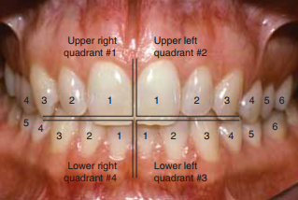
The incisors, which are closest to the midline, are chisel-shaped and adapted for cutting into food. They are referred to as either central or lateral incisors based on their position. Next to the incisors, moving posteriorly, are the cuspids (canines), which have a pointed surface called a cusp. Cuspids are used to tear and shred food. Incisors and cuspids have only one root apiece. Posterior to the cuspids lie the first and second molars, which have four cusps. Maxillary (upper) molars have three roots; mandibular (lower) molars have two roots. The molars crush and grind food to prepare it for swallowing.
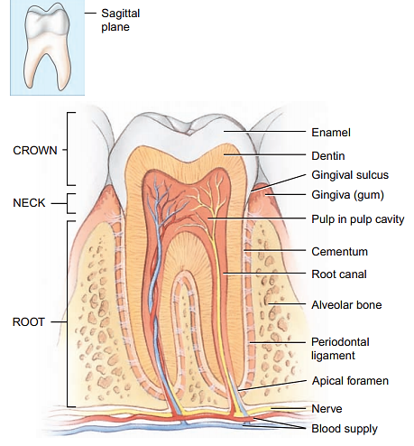
CLASSIFICATION OF DENTITIONS:
A. The human dentition is termed heterodont, which means it is comprised of different types, or classes, of teeth to perform different functions in the mastication process. In comparison, a homodont dentition is one in which all of the teeth are the same in form and type. This sort of dentition is found in some of the lower vertebrates.
B. Furthermore, man has two separate sets of teeth, or dentitions. This is termed diphodont, as opposed to monophodont. When there is only one set of teeth, and polyphyodont, when more than two or continuous, sets of teeth are developed throughout life.
C. In man, the two dentitions are termed deciduous and permanent, while the transitional phase when both deciduous and permanent teeth are present is called the mixed dentition period.
1. Deciduous dentition - The teeth of the first or primary dentition. They are so named because they are shed like the leaves of deciduous trees in autumn. They erupt into the mouth from about six months to two years of age. Normally there are 20 total deciduous teeth. Other non-scientific names for the deciduous teeth include "milk" teeth. ‘baby" teeth, and "temporary" teeth.
2. Permanent dentition -The teeth of the second or adult dentition. Normally, there are 32 permanent teeth and they erupt from 6-21 years of age.
GENERAL ORAL AND DENTAL ANATOMY:
&brief definition and description of the various anatomical features of a normal tooth, and its supporting structures, include the following:
A. Dental Structures:
1. Anatomical crown - That portion of the tooth which is covered by enamel.
3. Anatomical root - That portion of the tooth which is covered with cementum.
4. Enamel - The hard, mineralized tissue which covers the dentin of the crown of a tooth. It is the hardest living body tissue, but is brittle, especially when not supported by sound underlying dentin.
5. Dentin - The hard tissue which forms the main body of the tooth. It surrounds the pulp cavity, and is covered by the enamel in the anatomical crown, and by the cementum in the anatomical root. The dentin constitutes the bulk, or majority, of the total tooth tissues, but because of its internal location, is not directly visible in a normal tooth.
6. Cementum - The layer of hard, bonelike tissue which covers the dentin of the anatomical root of a tooth.
7. Cervical line - The identifiable line around the external surface of a tooth where the enamel and cementum meet. It is also called the cemento-enamel junction or CEJ. The cervical line separates the crown and the root, and is a constant entity. Its location is in the general area of the tooth spoken of as the neck or cervix.
8. Dentino-enamel iunction or DEJ - The internal line of meeting of the dentin and enamel in the anatomical crown of a tooth.
10. Pulp -The living soft tissue which occupies the pulp cavity of a vital tooth. It contains the tooth's nutrient supply in the form of blood vessels, as well as the nerve supply.
11. Pulp Cavity - The entire internal cavity of a tooth which contains the pulp. It consists of the following entities:
a. Pulp canal(s) - That portion of the pulp cavity which is located in the root(s) of the tooth.
and may also be called the root canal(s).
Supporting Structures:
1. Alveolar process - The entire bony entity which surrounds and supports all the teeth in each jaw member.
2. Alveolus (Plural - alveoli) - The bony socket, or portion of the alveolar process, into which an individual tooth is set.
3. Periodontal ligament - (membrane) - The fibrous attachment of the tooth cementum to the alveolar bone.
4. Gingiva (Plural - gingivae) - The "gum" or "gums", or the fibrous tissue enclosed by mucous membrane that covers the alveolar processes and surrounds the necks of the teeth.
PERIODENTIUM
The periodontium is defined as the supporting tissues of the teeth in the mouth, including surrounding alveolar bone, the gingiva, the periodontal ligament, and the outer, cementum layer of the tooth roots. Alveolar bone is the portion of the upper (maxillary) or lower (mandibular) bones that surrounds the roots of the teeth. The gingiva is the part of the soft tissue in the mouth that covers the alveolar bone of the jaws, and is the only part of the periodontium that is visible in a healthy mouth. Part of it is firmly bound to the underlying alveolar bone and is called attached gingiva. The other part is free gingiva (or marginal gingiva) which is a collar of thin gingiva that surrounds each tooth and, in health, adapts to the tooth but provides access into the potential space between the free gingiva and the tooth which is called a gingival sulcus (crevice). The gingival margin (or free gingival margin) is the edge of the gingiva closest to the biting or chewing surfaces of the teeth.
The gingival sulcus is not seen visually but can be evaluated with a periodontal probe, since it is actually a space (or potential space) between the tooth surface and the narrow unattached cervical collar of free gingiva. If you insert a thin probe into this sulcus, it should extend only 1 to 3 mm deep in a healthy person. The interdental (interproximal) papilla (plural is papillae) is that part of the collar of free gingiva that extends between the teeth.
A healthy papilla conforms to the space between two teeth (interproximal space), so it comes to a point near where the adjacent teeth contact. The papilla also has a hidden sulcus where dental floss can fit once it passes between the teeth. The periodontal ligament is a very thin ligament composed of many tissue fibers that attach the outer layer of the tooth root (covered with cementum) to the thin layer of dense alveolar bone surrounding each tooth.

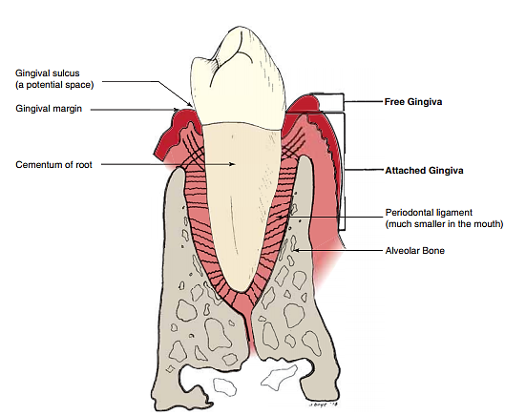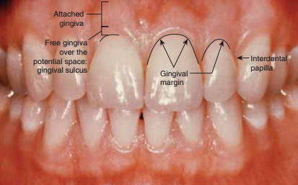
Chewing is important for digestion of all foods, but especially important for most fruits and raw vegetables because these have indigestible cellulose membranes around their nutrient portions that must be broken before the food can be digested. Also, chewing aids the digestion of food for still another simple reason: Digestive enzymes act only on the surfaces of food particles; therefore, the rate of digestion is absolutely dependent on the total surface area exposed to the digestive secretions.
In addition, grinding the food to a very fine particulate consistency prevents excoriation of the gastrointestinal tract and increases the ease with which food is emptied from the stomach into the small intestine, then into all succeeding segments of the gut.
TOOTH AND GUM DISEASE
Food leaves a sticky residue on the teeth called plaque, composed mainly of bacteria and sugars. If plaque is not thoroughly removed by brushing and flossing, bacteria accumulate, metabolize the sugars, and release lactic acid and other acids. These acids dissolve the minerals of enamel and dentin, and the bacteria enzymatically digest the collagen and other organic components. The eroded “cavities” of the tooth are known as dental caries. If not repaired, caries may fully penetrate the dentin and spread to the pulp cavity. This requires either extraction of the tooth or root canal therapy, in which the pulp is removed and replaced with inert material.
When plaque calcifies on the tooth surface, it is called calculus (tartar). Calculus in the gingival sulcus wedges the tooth and gum apart and allows bacterial invasion of the sulcus. This leads to gingivitis, or gum inflammation. Nearly everyone has gingivitis at some time. In some cases, bacteria spread from the sulcus into the alveolar bone and begin to dissolve it, producing periodontal disease. About 86% of people over age 70 have periodontal disease and many suffer tooth loss as a result. This accounts for 80% to 90% of adult tooth loss.
Dental
Functions of the dental pulp are as follows:
Formative •: Dentin-producing cells (odontoblasts) produce dentin throughout the life of a tooth. This is called secondary dentin.
Sensory •: Nerve endings relay the sense of pain caused from heat, cold, drilling, sweet foods, decay, trauma, or infection to the brain, so we feel it. However, the nerve fibers in a dental pulp are unable to distinguish the cause of the pain.
Nutritive •: Blood vessels transport nutrients from the bloodstream to cells of the pulp and the odontoblasts that produce dentin. (Surprisingly, blood in the tooth pulp had passed through the heart only 6 seconds previously.)
TERMS THAT DIFFERENTIATE APPROXIMATING SURFACES OF TEETH
The proximal surfaces are the sides of a tooth generally next to an adjacent tooth. Depending on whether the tooth surface faces toward the arch midline between the central incisors or away from the midline, it is either a mesial surface (closer to the midline) or a distal surface (farther from the midline). Note that the mesial surface of a tooth touches, or is closest to, the distal surface of an adjacent tooth EXCEPT between the central incisors where the mesial surface of one central incisor faces another mesial surface. Also, the distal surface of the last molar in each arch does not approximate another tooth. Proximal surfaces are not naturally cleaned by the action of the cheeks, lips and tongue when compared to most of the facial or lingual surfaces which are more self-cleansing.
The junction line where two tooth surfaces meet is called an external line angle. To name a line angle, combine the names of the two surfaces, but change the “al” ending of the first surface to an “o.” (A guideline has been suggested for the order used when combining terms. Use the following order: mesial is used first, then distal, buccal, lingual (toward the tongue) and labial (toward the lip).
