SENSORY RECEPTORS
The nervous system, one of the two major regulatory systems of the body, consists;
- CENTRAL NERVOUS SYSTEM (CNS); composed of the brain and spinal cord, and
- PERIPHERAL NERVOUS SYSTEM (PNS); composed of the afferent and efferent fibers that relay signals between the CNS and periphery (other parts of the body).
- The afferent division of the PNS:
  - Detects, encodes, and transmits peripheral signals to the CNS
  - Informing the CNS about the internal and external environment.
  - Their input to CNS is essential in maintaining homeostasis and to make appropriate adjustments in effector organs via efferent output, the CNS has to “know” what is going on.
    - It also used to plan for voluntary actions unrelated to homeostasis.
- A stimulus is a change detectable by the body. Stimuli exist in a variety of energy forms, or modalities, such as heat, light, sound, pressure, and chemical changes.
- Afferent neurons have sensory receptors (receptors for short) at their peripheral endings that respond to stimuli in both the external world and internal environment.
- The only way afferent neurons can transmit information to the CNS about stimuli is via action potential propagation, receptors must convert these other forms of energy into electrical signals.
- Stimuli bring about graded potentials known as receptor potentials in the receptor. The conversion of stimulus energy into a receptor potential is known as sensory transduction. Receptor potentials in turn trigger action potentials in the afferent fiber.
Receptors have differential sensitivities to various stimuli. Each type of receptor is specialized to respond to one type of stimulus, its adequate stimulus.
- For example, receptors in the eye are sensitive to light, receptors in the ear to sound waves, and warmth receptors in the skin to heat energy.
Because of this differential sensitivity of receptors, we cannot “see” with our ears or “hear” with our eyes. Some receptors can respond weakly to stimuli other than their adequate stimulus, but even when activated by a different stimulus, a receptor still gives rise to the sensation usually detected by that receptor type.
TYPES OF RECEPTORS ACCORDING TO THEIR ADEQUATE STIMULUS
Depending on the type of energy to which they ordinarily respond, receptors are categorized as follows:
■ Photoreceptors are responsive to visible wavelengths of light.
■ Mechanoreceptors are sensitive to mechanical energy.
- Examples include skeletal muscle receptors sensitive to stretch, the receptors in the ear containing fine hairs that are bent as a result of sound waves, and blood pressure–monitoring baroreceptors.
■ Thermoreceptors are sensitive to heat and cold.
■ Osmoreceptors detect changes in the concentration of solutes in the extracellular fluid and the resultant changes in osmotic activity.
■ Chemoreceptors are sensitive to specific chemicals.
- Chemoreceptors include the receptors for taste and smell, as well as those located deeper within the body that detects O₂ and CO₂ concentrations in the blood or the chemical content of the digestive tract.
■ Nociceptors, or pain receptors, are sensitive to tissue damage such as pinching or burning or to distortion of tissue. Intense stimulation of any receptor is also perceived as painful.
- Some sensations are compound sensations in that their perception arises from central integration of several simultaneously activated primary sensory inputs.
  - For example, the perception of wetness comes from touch, pressure, and thermal receptor input; there is no such thing as a “wetness receptor.”
ANATOMY OF EYE
Several mechanisms help protect the eyes from injury. Except for its anterior (front) portion, the eyeball is sheltered by the bony socket in which it is positioned. The eyelids act like shutters to protect the anterior portion of the eye from environmental insults. They close reflexly to cover the eye under threatening circumstances, such as rapidly approaching objects, dazzling light, and instances when the exposed surface of the eye or eyelashes are touched. Frequent spontaneous blinking of the eyelids helps disperse the lubricating, cleansing, bactericidal (“germ-killing”) tears.
Tears are produced continuously by the lacrimal gland in the upper lateral corner under the eyelid. This eye-washing fluid flows across the anterior surface of the eye and drains into tiny canals in the corner of each eye, eventually emptying into the back of the nasal passageway. This drainage system cannot handle the profuse tear production during crying, so the tears over flow from the eyes.
The eyes are also equipped with protective eyelashes, which trap fine, airborne debris such as dust before it can fall into the eye.
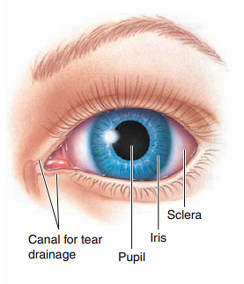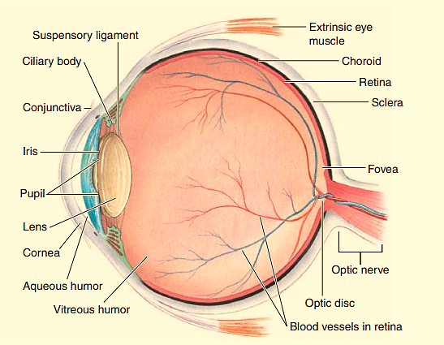
THE EYE IS A FLUID-FILLED SPHERE ENCLOSED BY THREE SPECIALIZED TISSUE LAYERS
- Each eye is a spherical, fluid-filled structure enclosed by three layers. From outermost to innermost, these are:
(1) sclera/cornea;
(2) choroid/ciliary body/iris; and
(3) Retina
SCRELA/CORNEA
- Most of the eyeball is covered by a tough outer layer of connective tissue, the sclera, which forms the visible white part of the eye.
- Anteriorly, the outer layer consists of the transparent cornea, through which light rays pass into the interior of the eye.
- The middle layer underneath the sclera is the highly pigmented choroid, which contains many blood vessels that nourish the retina. The choroid layer becomes specialized anteriorly to form the ciliary body and iris.
- The innermost coat under the choroid is the retina, which consists of an outer pigmented layer and an inner nervous-tissue layer.
- The latter contains the rods and cones, the photoreceptors that convert light energy into nerve impulses. Like the black walls of a photographic studio, the pigment in the choroid and retina absorbs light after it strikes the retina to prevent reflection or scattering of light within the eye.
- The interior of the eye consists of two fluid-filled cavities, separated by an elliptical lens, all of which are transparent to permit light to pass through the eye from the cornea to the retina.
VITEROUS HUMOR: the larger posterior (rear) cavity between the lens and retina contains a semifluid, jellylike substance. It helps to maintain the spherical shape of the eyeball.
AQUEOUS HUMOR: the anterior cavity between the cornea and lens contains a clear, watery fluid, the aqueous humor. It carries nutrients for the cornea and lens, both of which lack a blood supply. Blood vessels in these structures would impede the passage of light to the photoreceptors.
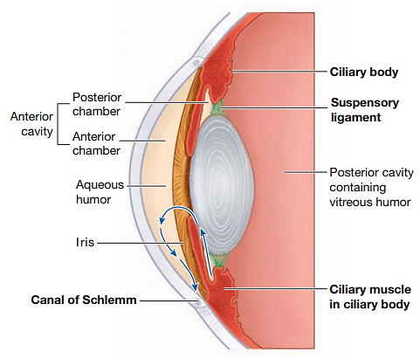
THE AMOUNT OF LIGHT ENTERING THE EYE IS CONTROLLED BY THE IRIS
Not all the light passing through the cornea reaches the light sensitive photoreceptors, because of the presence of the iris, a thin, pigmented smooth muscle that forms a visible ring like structure within the aqueous humor. The pigment in the iris is responsible for eye color. The varied flecks, lines, and other nuances of the iris are unique for each individual, making the iris the basis of the latest identification technology. Recognition of iris patterns by a video camera that captures iris images and translates the landmarks into a computerized code is more foolproof than fingerprinting or even DNA testing.
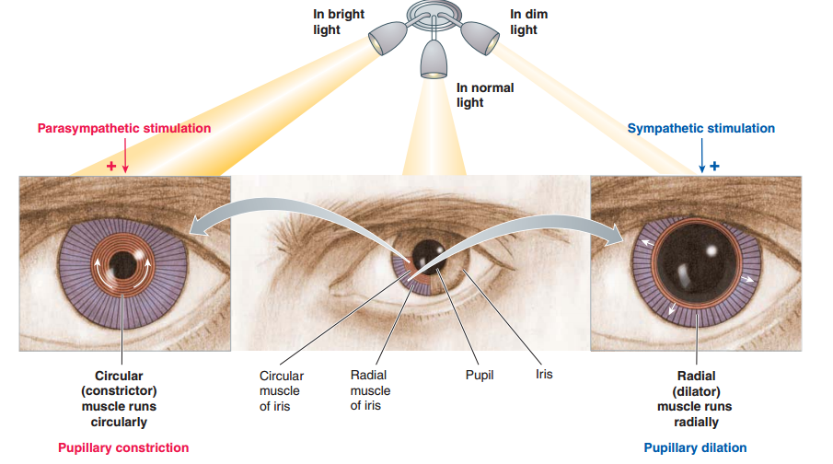
The round opening in the center of the iris through which light enters the interior portions of the eye is the pupil. The size of this opening can be adjusted by variable contraction of the iris muscles to admit more or less light as needed, much as the diaphragm controls the amount of light entering a camera. The iris contains two sets of smooth muscle networks, one circular (the muscle fibers run in a ring like fashion within the iris) and the other radial (the fibers project outward from the pupillary margin like bicycle spokes). Because muscle fibers shorten when they contract, the pupil gets smaller when the circular (or constrictor) muscle contracts and forms a smaller ring. This reflex pupillary constriction occurs in bright light to decrease the amount of light entering the eye.
When the radial (or dilator) muscle shortens, the size of the pupil increases. Such pupillary dilation occurs in dim light to allow the entrance of more light. Iris muscles are controlled by the autonomic nervous system. Parasympathetic nerve fibers innervate the circular muscle (causing pupillary constriction), and sympathetic fibers supply the radial muscle (causing pupillary dilation).
