## UNIT 8. THE RESPIRATORY SYSTEM

**8.1. Introduction**

## The respiratory system is the path of air from the nose to the lungs. The system includes the Nostrils, Nasal Cavities, Pharynx, Epiglottis, Larynx, Trachea, Bronchi, Bronchioles, and the Lungs (Fig8.1). The major function of respiratory system is to supply body with oxygen and remove carbon dioxide. To accomplish this function, the following four processes, collectively called respiration, must happen:

1. ***Pulmonary ventilation(breathing):*** movement of air (O2) into and CO2 out of the lungs,
2. ***External respiration***: exchange of gases between the lungs and the blood.
3. ***Transport of respiratory gases***: transport of O2 from the lungs to the tissue cells of the body, and CO2 from the tissue cells to the lungs. This is accomplished by the cardiovascular system.
4. ***Internal respiration***: exchange of gases between the blood and the tissue cells.

The first two processes are responsibly to be performed by the respiratory system, but to accomplish its primary goal the third and fourth processes also occur. Thus, the respiratory and circulatory systems are closely coupled.

## 8.2. Anatomy of the respiratory system and their function

## 8.2.1. Nose and Nasal Cavities

The nose is the uppermost portion of the human respiratory system. The nose is a hollow air passage that functions in breathing (transporting air to the pharynx). Usually air will enter the respiratory system through the nostrils.  The nostrils then lead to open in the nose called the nasal cavities.  While transporting air into the nasal cavities: they filter the air to remove potentially harmful particles and microorganisms; and they moisten and warm the air to protect the structures in the respiratory system.

## 8.2.2. Pharynx

Pharynx is a short, funnel-shaped tube about 13 cm (5 in) long that transports air to the larynx. Air leaves the nasal passages and flows to the pharynx. Like the nasal passages, the pharynx is lined with a protective mucous membrane and ciliated cells that remove impurities from the air. In addition to serving as an air passage, the pharynx houses the [**tonsils**](http://www.auuuu.org/tonsils/)**,** lymphatic tissues that contain white blood cells.

## 8.2.3. Larynx

Larynx is a structure about 5 cm (2 in) long located approximately in the middle of the neck. Air moves from the pharynx to the larynx.

The primary function of the larynx is to transport air to the trachea, but it also serves other functions. It plays a primary role in producing sound; it prevents food and fluid from entering the air passage; and its mucous membranes and cilia-bearing cells help filter air. two structures associated with larynx:

**i) Glottis:** is a slit-like opening to larynx where air passes into trachea through larynx.

**ii) Epiglottis:** is a thin, leaf-like and triangular flap of cartilaginous tissue present at the glottis. It prevents the food and fluids from the pharynx from entering the larynx.

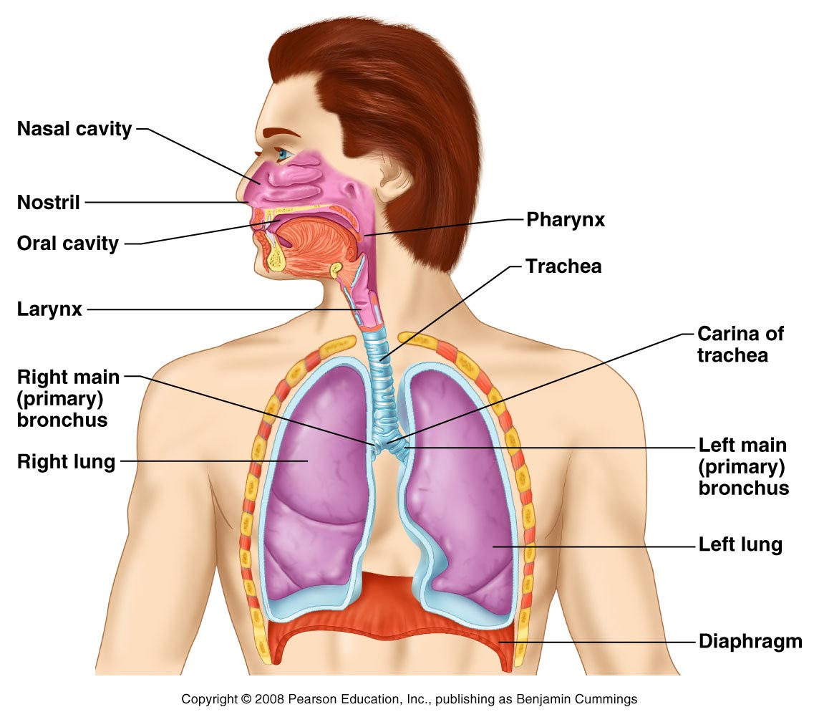

**Fig.8.1.** Structures of the respiratory tract

## 9.2.4. Trachea (windpipe)

Air passes from the larynx into the trachea, a tube about 12 to 15 cm (about 5 to 6 in) long located just below the larynx. The trachea is formed of 15 to 20 C-shaped rings of cartilage that hold the trachea open, enabling air to pass freely at all times.

**8.2.5. Bronchi (**primary bronchus)

The trachea branches into two tubes, the left and right **bronchi (**primary bronchus), which deliver air to the left and right lungs, respectively. Within the lungs, each primary bronchus divides into **secondary bronchi**. Secondary bronchi divide to yield **tertiary bronchi** that then divide to yield **quaternary bronchi** and so forth until about 23 branching have occurred.

**8.2.6. Bronchioles**

Within the lungs, the bronchi branch into smaller tubes and once the bronchi have a diameter less than 1mm they are known as **bronchioles**. The **terminal bronchioles** are the last bronchioles without **alveoli**. Bronchioles with alveoli are known as **respiratory bronchioles** and lead into **alveolar ducts/tubes (Fig. 8.2. b)**. The trachea, bronchi, and the first few bronchioles contribute to the cleansing function of the respiratory system as they produce mucus and possess ciliated cells.

**8.2.7. Alveolar tube and alveoli**

The bronchioles divide many more times into even narrower tubes called **alveolar ducts/tube**. Each alveolar duct ends in a grapelike cluster of thin-walled sacs(0.5 mm in diameter), called **alveoli** (a single sac is called an alveolus). Human beings have 300 to 400 million alveoli per lung and comprise most of the lung tissue.

The walls of the alveoli, which are only about one cell thick, are the respiratory surface.  They are thin, moist, and are surrounded by several numbers of capillaries. The exchange of oxygen and carbon dioxide between blood and air occurs through these walls.

**8.2.8. Lungs**

Lung is a pair of elastic, spongy and roughly triangular organs used in breathing and respiration. In the adult human, each lung is 25 to 30 cm (10 to 12 in) long. Human lungs occupy the thoracic region except at the mediastinum (**Fig. 8.1**).

There are morphological differences between the right and left lungs. The right lung is somewhat larger than the left lung and is divided into three lobes (the superior, middle, and inferior). The left lung has only two lobes (the superior and the inferior), with a cleft to accommodate the heart. The two lungs are separated by a structure called the **mediastinum**. Both right and left lungs are covered by a double sac membrane called the **pleurae**.

**8.2.9. Diaphragm (is not actually part of the respiratory system but aids respiration)**

Diaphragm is a wide muscular partition separating the thoracic, or chest cavity, from the abdominal cavity. In humans the diaphragm is attached to the lumbar vertebrae, the lower ribs, and the sternum or breastbone. It slants upward, higher in front than in the rear, and is **dome-shaped** when relaxed. Contraction and expansion of the diaphragm are significant in breathing.

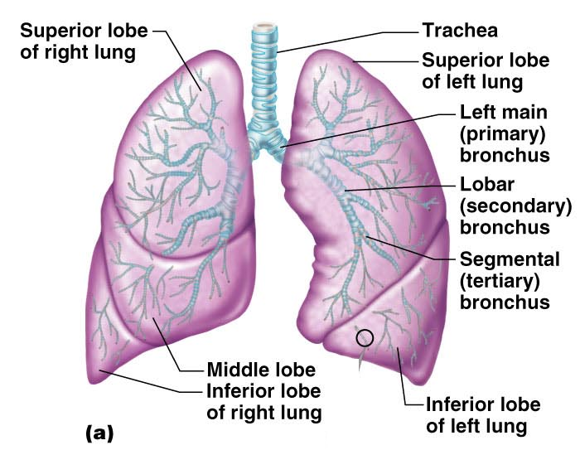 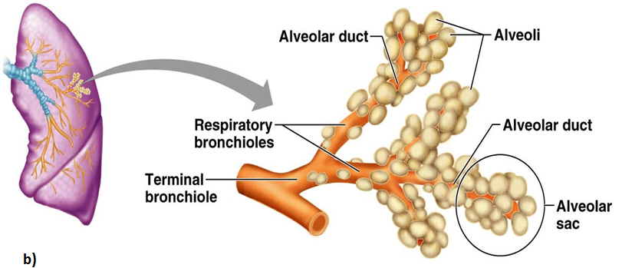

**Fig. 8.2. (a) Gross Anatomy of the lungs; (b) Bronchioles and alveiolar structures**

**8.2 Mechanism (mechanics) of Breathing**

About 30 billion capillaries can be found in each lung, roughly 100 capillaries per alveolus. Thus, an alveolus can be visualized as a microscopic air bubble whose entire surface is bathed by blood. Gas exchange occurs very rapidly at this interface.

Blood returning from the systemic circulation, depleted in oxygen, has a partial oxygen pressure (PO2) of about 40 mm Hg. By contrast, the PO2 in the alveoli is about 105 mm Hg. The difference in pressures, namely the Δ*p* of Fick’s Law, is 65 mm Hg, leading to oxygen moving into the blood. The blood leaving the lungs, as a result of this gas exchange, normally contains a PO2 of about 100 mm Hg. As you can see, the lungs do a very effective, but not perfect, job of oxygenating the blood. These changes in the PO2 of the blood, as well as the changes in plasma carbon dioxide (indicated as the PCO2)

**Lung structure and function**

In humans and other mammals, the outside of each lung is covered by a thin membrane called the **visceral pleural** **membrane.** A second membrane, the **parietal pleural** **membrane,** lines the inner wall of the thoracic cavity. The space between these two membrane sheets, the **pleural cavity,** is normally very small and filled with fluid. This fluid causes the two membranes to adhere, effectively coupling the lungs to the thoracic cavity. The pleural membranes package each lung separately—if one lung collapses due to a perforation of the membranes, the other lung can still function.

During inhalation, the thoracic volume is increased through contraction of two sets of muscles: the *external intercostal* *muscles* and the *diaphragm.* Contraction of the external intercostal muscles between the ribs raises the ribs and expands the rib cage. Contraction of the **diaphragm,** a convex sheet of striated muscle separating the thoracic cavity from the abdominal cavity, causes the diaphragm to lower and assume a more flattened shape. This expands the volume of the thorax and lungs, bringing about negative pressure ventilation, while it increases the pressure on the abdominal organs.

The thorax and lungs have a degree of elasticity; expansion during inhalation places these structures under elastic tension. The relaxation of the external intercostal muscles and diaphragm produces unforced exhalation because the elastic tension is released, allowing the thorax and lungs to recoil. You can produce a greater exhalation force by actively contracting your abdominal muscles—such as when blowing up a balloon.



**Figure 8.3. How a human breathes. *a.*** Inhalation. The diaphragm contracts and the walls of the chest cavity expand, increasing the volume of the chest cavity and lungs. As a result of the larger volume, air is drawn into the lungs. ***b.*** Exhalation. The diaphragm and chest walls return to their normal positions as a result of elastic recoil, reducing the volume of the chest cavity and forcing air out of the lungs through the trachea. Note that inhalation can be forced by contracting accessory respiratory muscles (such as the sternocleidomastoid), and exhalation can be forced by contracting abdominal muscles.

**8.2.1 Inspiration (inhalation)**

Inspiration occurs when the inspiratory muscles—(the diaphragm and the external intercostals muscles)—contract.

The following events occur during:

a) **Respiratory centers** in the **ventral medulla oblongata** become active stimulating **external intercostal muscles**..

b) Diaphragm and external intercostals contract.

c) Contraction of the external intercostals lifts the ribs and sternum

d) Volume of the thoracic cavity increases.

e) Lung volume increases.

f) Alveolar pressure decreases. Alveolar pressure is now less than atmospheric pressure.

g) Air flows from the atmosphere into the alveoli until alveolar partial pressure equal to atmospheric partial pressure.

**8.2.2 Exhalation (Expiration)**

**Expiration** is a passive process, that involves the removal of gas (CO2) out of the lung. It is not powered by skeletal muscle contraction. Exhalation occurs in the following sequence.

a) Diaphragm and external intercostals relax.

b) The thoracic volume decreases.

c) Lung volume decreases.

d) Alveolar pressure increases. Alveolar pressure is now greater than atmospheric pressure.

e) Air flows from the alveoli into the atmosphere

.

**Table 8.1** summary on comparison of inspiration and expiration

|  |  |
| --- | --- |
| **Inspiration** | **Expiration** |
| * External intercostals muscle contracts * Internal intercostals muscle relax * Ribs raised up & outward * Diaphragm contracts & flattened * Volume of thoracic cavity increases * Lung volume increases * Air pressure in the lungs decreases * Air moves into the lungs | * External intercostals muscle relax * Internal intercostals muscle contracts * Ribs raised down and inward * Diaphragm relaxes and assumes its dome-shape * Volume of thoracic cavity decreases * Lung volume decreases * Air pressure in the lungs increases * Air moves leaves the lungs |