The **reproductive system** or **genital system** is a system of [organs](http://en.wikipedia.org/wiki/Organ_(anatomy)) within an [organism](http://en.wikipedia.org/wiki/Organism) which work together for the purpose of [**reproduction**](http://en.wikipedia.org/wiki/Reproduction). The ability to reproduce is one of the [**unifying characteristics**](http://www.emc.maricopa.edu/faculty/farabee/BIOBK/BioBookintro.html#Characteristics of living thing)of all living things. [Sexual reproduction](http://www.emc.maricopa.edu/faculty/farabee/BIOBK/BioBookglossS.html#sexual reproduction) produces offspring that are **genetically** different from their parents. [Asexual reproduction](http://www.emc.maricopa.edu/faculty/farabee/BIOBK/BioBookglossA.html#asexual reproduction) produces offspring **genetically identical** to their parent. Sexual reproduction is the process of producing offspring for the survival of the species, and passing on hereditary traits from one generation to the next. The male and female reproductive systems contribute to the events leading to fertilization. Then, the female organs assume responsibility for the developing human, birth, and nursing. The male and female gonads (testes and ovaries) produce sex cells (ova and sperm) and the hormones necessary for the proper development, maintenance, and functioning of the organs of reproduction and other organs and tissues.

In sexual reproduction new individuals are produced by the fusion of **haploid** [**gametes**](http://www.emc.maricopa.edu/faculty/farabee/BIOBK/BioBookglossG.html#gametes) to form a **diploid** [**zygote**](http://www.emc.maricopa.edu/faculty/farabee/BIOBK/BioBookglossWXYZ.html#zygote). [Sperm](http://www.emc.maricopa.edu/faculty/farabee/BIOBK/BioBookglossS.html#sperm)s are male gametes, [ova](http://www.emc.maricopa.edu/faculty/farabee/BIOBK/BioBookglossO.html#ovum) (ovum singular) are female gametes. [**Meiosis**](http://www.emc.maricopa.edu/faculty/farabee/BIOBK/BioBookglossM.html#meiosis)produces cells that are genetically distinct from each other; [**fertilization**](http://www.emc.maricopa.edu/faculty/farabee/BIOBK/BioBookglossF.html#fertilization) is the fusion of two such distinctive cells that produces a unique new combination of [alleles](http://www.emc.maricopa.edu/faculty/farabee/BIOBK/BioBookglossA.html#alleles), thus increasing variation on which natural selection can operate.

Human reproduction employs internal fertilization, and depends on the integrated action of [hormones](http://www.emc.maricopa.edu/faculty/farabee/BIOBK/BioBookglossH.html#hormones), the [nervous system](http://www.emc.maricopa.edu/faculty/farabee/BIOBK/BioBookglossN.html#nervous system), and the reproductive system. [**Gonads**](http://www.emc.maricopa.edu/faculty/farabee/BIOBK/BioBookglossG.html#gonads) are sex organs that produce gametes. Male gonads are the [testes](http://www.emc.maricopa.edu/faculty/farabee/BIOBK/BioBookglossT.html#testes), which produce sperm and male sex hormones. Female gonads are the [ovaries](http://www.emc.maricopa.edu/faculty/farabee/BIOBK/BioBookglossO.html#ovaries), which produce eggs (ova) and female sex hormones. Humans have a high level of [sexual differentiation](http://en.wikipedia.org/wiki/Sexual_differentiation). In addition to differences in nearly every reproductive organ, numerous differences typically occur in [secondary sexual characteristics](http://en.wikipedia.org/wiki/Secondary_sexual_characteristic).

**The Male Reproductive System**

***The primary reproductive organs (****gonads****) of the male are called testes (testis, singular) or testicles, which produce sperm and male sex hormones (****androgens****). All other male reproductive organs (scrotum, ducts, glands, and penis) are*** *accessory reproductive structures* ***that protect the sperm and aid in their delivery to the female reproductive tract. The paired, oval testes (testicles) are suspended outside the abdominal cavity by the*** [*scrotum*](http://www.emc.maricopa.edu/faculty/farabee/BIOBK/BioBookglossS.html#scrotum)***, a pouch of skin that keeps the testes close or far from the body at an optimal temperature for sperm development. This is important because viable sperm cannot be produced at body temperature in humans. Each testis contains coiled seminiferous tubules where sperm production occurs. Between the seminiferous tubules are Leydig cells, clusters of endocrine (secretory) cells which produce androgens (sex hormones), mostly testosterone.*** [*Seminiferous tubules*](http://www.emc.maricopa.edu/faculty/farabee/BIOBK/BioBookglossS.html#seminiferous tubules) ***are inside each testis, and are where sperm are produced by meiosis. Spermatocytes inside the tubules divide by meiosis to produce spermatids that in turn develop into mature sperm.***

**The scrotum** (figure below) is a pouch of skin and superficial fascia (the subcutaneous layer consisting of fibrous connective tissue) that hangs at the base of the penis, anterior to the anal opening. Internally, a septum divides the scrotum into two sacs, each containing one testis.

When temperatures are cold, the scrotum becomes shorter and heavily wrinkled as it is pulled up closer to the warmth of the body. When the external temperature is warm, the scrotal skin is flaccid and loose, and the testes hang lower from the body.

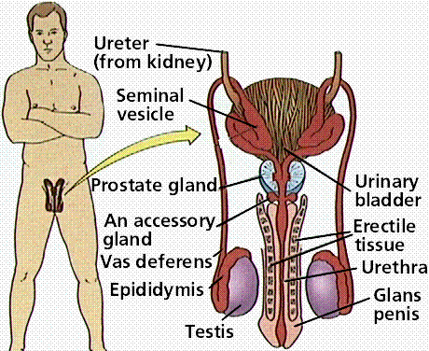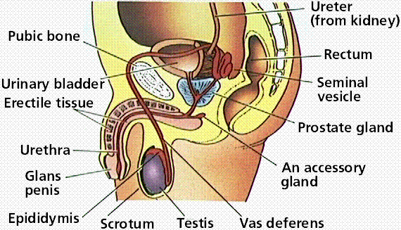

**Fig.**The male reproductive system.

**Spermatogenesis- s**perm production begins at puberty and continues throughout life, with several hundred million sperm being produced each day. After the sperms are formed in the seminiferous tubules, they leave the testis and enter the **ductus epididymis** (see the diagram) which is very tightly coiled. The ductus epididymis lies within the organ called the **epididymis**. The **comma-shapedepididymis** (coiled tubules) is on the posterior side of each testis.  The immature, nearly non-motile sperm that leave the testis are stored temporarily in the epididymis. During their transport within the epididymis (a trip that takes about 10 to 14 days), the sperm become both motile and fertile (capable of fertilizing an ovum). Spermatozoa can be stored in the epididymis for at least a month. If they are not ejaculated, the sperm degenerate and are reabsorbed. When a male is sexually stimulated and ejaculates, the smooth muscle in the walls of the epididymis contracts rhythmically, expelling sperm from the epididymis into the next segment of the duct system, the ductus (vas) deferens which is the dilated continuation of the epididymis. Functionally, the **ductus deferens** stores sperm and conveys sperm from the epididymis toward the urethra. At the moment of ejaculation, the smooth muscle in the walls of the ductus deferens creates peristaltic waves that rapidly squeeze the sperm forward.

**The ductus deferens** joins with the duct of the seminal vesicle (a gland) to form the **ejaculatory duct**. The ejaculatory duct passes through the **prostate gland** and merges with the urethra. **The urethra** passes from the **internal urethral orifice** of the urinary bladder down through the prostate gland and then through the penis to the external urethral orifice. The urethra conveys both urine and semen (at different times) outside of the body. During ejaculation, the internal **urethral spincter** (a smooth muscle sphincter) at the base of the urinary bladder is closed, so that urine is not expelled during ejaculation.

In humans, spermatogenesis takes about 74 days. **Spermatozoa** are produced at the rate of about 300 million per day. Once ejaculated, they have a life expectancy of about 48 hours within the female reproductive tract. Each spermatozoon consists of a **head, midpiece (middle piece),** and **tail**.  See Figure below. The head contains the nucleus with its genetic material and an **acrosome**. The acrosome contains digestive enzymes that allow the sperm to penetrate the ovum (egg). **The midpiece** contains numerous **mitochondria**.  The mitochondria provide abundant ATP energy for sperm locomotion. The tail is a **flagellum** that propels the sperm toward the ovum

. 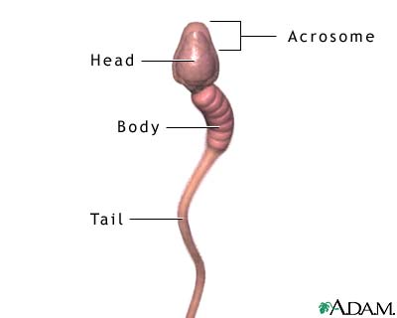

Between the seminiferous tubules are the interstitial endocrinocytes (**cells of leydig**), which are endocrine cells that produce male sex hormones called **androgens** (primarily **testosterone**). Notice that each testis is both an **exocrine gland** (producing sperm, which are released into ducts) and an **endocrine gland** (producing androgen hormones, which are released into the bloodstream). Also note that the sperm and hormones are produced in the testes by completely different cells.

**The accessory glands-** include the **seminal vesicles**, **prostate gland** and the **bulbourethral glands**. The accessory glands produce fluids that nourish and energize the sperm for the journey to the ovum. For example, during sexual excitement the seminal vesicles add secretions to the sperm in the ejaculatory duct. These secretions provide energy for the sperm and a neutralizing chemical that reduces vaginal acidity. These glands produce the seminal fluid, the liquid portion of semen. Semen consists of both seminal fluid and sperm.

* **The paired seminal vesicles** are located posterior to and at the base of the urinary bladder. They are convoluted pouch-like structures and produce about 60% of the fluid volume of semen. The duct of each seminal vesicle joins the **ductus deferens** to form the **ejaculatory duct**. Sperm and seminal fluid mix in the ejaculatory duct and enter the urethra together during ejaculation.
* **The prostate gland** is a single gland about the size of a walnut. It encircles the upper part of the urethra just inferior to the bladder. During ejaculation, the smooth muscle in the wall of the prostate contracts, propelling seminal fluid into the urethra through several prostatic ducts. Since the prostate is located immediately anterior to the rectum, its size and texture can be palpated (felt) through the anterior wall of the rectum. Its secretions also help neutralize vaginal acidity and make sperm motile (able to move).
* **The pairedbulbo-urethral** glands (**cowper's glands)** are tiny **pea-sized** glands located inferior to the prostate gland, on each side of the urethra. They produce thick, **clear mucus** which is released prior to ejaculation when a male first becomes **sexually aroused.** The secretion is alkaline, so it neutralizes traces of acidic urine in the urethra. It also serves as a lubricant during sexual intercourse.

Semen is seminal fluid and sperm. Seminal fluid provides a transportation medium to the sperm. It contains **fructose sugar** for the sperm's ATP energy production. Sperm cannot survive at acidic pH levels, so semen has a slightly alkaline pH (7.2-7.7), which neutralizes the acidic pH of the male's urethra & female's vagina. Seminal fluid contains enzymes that activate sperm (making them more motile & fertile).

**The penis** is a **copulatory organ**, used to deliver sperm into the female reproductive tract. The penis and scrotum make up the external reproductive structures, or **external genitalia**, of the male.

**Male Sex Hormones**-the [**anterior pituitary**](http://www.emc.maricopa.edu/faculty/farabee/BIOBK/BioBookglossPQ.html#pituitary gland) produces [follicle-stimulating hormone (FSH)](http://www.emc.maricopa.edu/faculty/farabee/BIOBK/BioBookglossF.html#follicle-stimulating hormone (F) and [luteinizing hormone (LH)](http://www.emc.maricopa.edu/faculty/farabee/BIOBK/BioBookglossL.html#luteinizing hormone (LH)). Action of LH is controlled by the [gonadotropin-releasing hormone (GnRH)](http://www.emc.maricopa.edu/faculty/farabee/BIOBK/BioBookglossG.html#gonadotropin-releasing hormone). LH stimulates cells in the **seminiferous tubules** to secrete [testosterone](http://www.emc.maricopa.edu/faculty/farabee/BIOBK/BioBookglossT.html#testosterone), which has a role in **sperm production** and developing male secondary sex characteristics. FSH acts on cells to help in **sperm maturation**. Negative feedback by testosterone controls the actions of GnRH.

**The Female Reproductive System**

The reproductive role of the female is far more complex than that of the male and designed to carry out several functions. The female must produce **ova** (egg cells), carries, and protects the developing embryo, and her body must prepare to nurture a developing **embryo**&**fetus** for a period of about nine months. The female also provides the infant with nourishment after the baby is born. Therefore, the mammary glands are considered to be part of the female reproductive system. The system structures are the ovary, uterine tubes, uterus, vagina, vulva, and mammary glands.

**The Ovaries-** are small, **oval-shaped glands** that are located on either side of the uterus and are the **primary reproductive organs (gonads)** of a female, and serve a dual purpose: they produce the **ova** (eggs) and female sex hormones (**progesterone** and **estrogen**). The **accessory ducts** are the uterine tubes, uterus and vagina. The ovaries and duct systems of the female are located within the pelvic cavity/ lower abdominal cavityand are called the **internal genitalia**. External organs of the female form the **external genitalia** or **vulva**. (See fig. below).

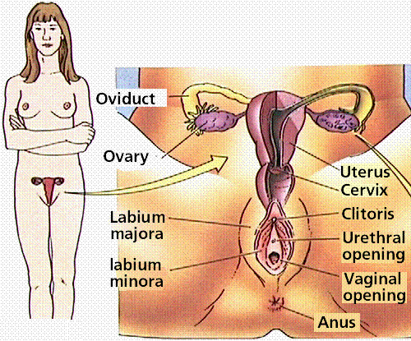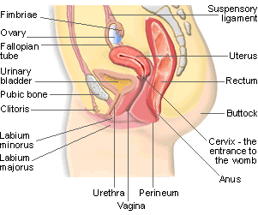

**Figure.** The female reproductive system

**The uterine tubes**-the female possesses two uterine (**fallopian**) tubes, also called **oviducts** (fig. above), which are held in position by the **suspensory ligaments**. These are narrow **funnel-shaped tubes** that are attached to the upper part of the uterus and serve as **tunnels** for the ovulated ova (egg cells) to travel from the ovaries to the uterus. They have a number of **finger-like projections** known as **fimbriae** on the end near the ovary. When an egg is released by the ovary it is ‘**caught**’ by one of the fimbriae and transported along the fallopian tube to the uterus. The egg is moved along the fallopian tube by the wafting action of cilia--**hairy projections** on the surfaces of cells at the entrance of the fallopian tube and the contractions made by the tube. It takes the egg about 5 days to reach the uterus and it is on this journey down the fallopian tube that fertilization may occur if a sperm penetrates and fuses with the egg. The egg, however, is only usually viable for **24 hours** after ovulation, so fertilisation usually occurs in the top one-third of the fallopian tube. The fertilized egg then moves to the uterus, where it implants into the lining of the uterine wall.

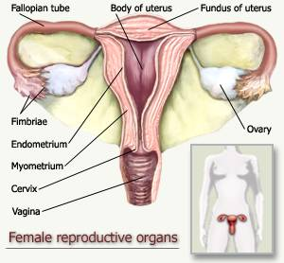**The Uterus (womb):** The uterus is a hollow, thick-walled organ shaped like an upside-down pear that is the home to a developing fetus. It is located in the pelvis anterior to the rectum and superior to the urinary bladder. The uterus is divided into two parts: the **cervix,** which is the lower part that opens into the vagina, and the main body of the uterus, called the **corpus**. The corpus can easily expand to hold a developing baby. A channel through the cervix allows sperm to enter and menstrual blood to exit. Its functions are to receive, retain and nourish an embryo. It is the site of menstruation, implantation of the embryo, development of the embryo & fetus during pregnancy, as well as labor contractions. In a woman who has never been pregnant, the uterus is about the 7.5 cm long, 5 cm wide, and 2.5 cm thick, but it is usually larger after childbirth.

The wall of the uterus is composed of three layers. The outermost layer, the **perimetrium**, is visceral peritoneum (serosa). The middle layer is the **myometrium**, the thick **smooth muscle** layer of the uterus. The smooth muscle stretches as the developing fetus grows in the womb. The myometrium plays a role during childbirth by contracting rhythmically to force the baby out of the uterus. The mucosal lining of the uterine cavity is the **endometrium**. If fertilization occurs, the embryo implants into the **endometrium** and forms the **placenta**. The placenta begins to produce the hormone **human chorionic gonadotropin (HCG)**, which is what is tested for in pregnancy tests. Human chorionic gonadotropin maintains the corpus luteum, which produces estrogen and progesterone that maintain the endometrium (and, therefore, maintain the pregnancy). If fertilization does not occur, the outer layer of the endometrium is sloughed off during the monthly menstruation. The **fundus** of the uterus is the rounded top of the uterus.  **The cervix** is the narrow outlet of the uterus. Most of the lubrication during sexual intercourse comes from secretions of glands of the cervix. The **vagina** is inferior to the cervix.

**The vagina** is a thin-walled, muscular, tubular organ and is posterior to the urinary bladder and urethra and anterior to the rectum. It extends from the cervix to the external vaginal opening, the vaginal orifice.

**The external genitalia-**the female reproductive structures located external to the vagina are called the **external genitalia**. See fig. below. The vulva or pudendum is the collective designation for the external genitalia of the female. The following structures are part of the vulva.

**The clitoris**-is a small, protruding structure, composed mostly of erectile tissue. It is located at the anterior junction of the labia minora. The clitoris is richly innervated with sensory nerve endings sensitive to touch, and it becomes swollen with blood during tactile stimulation, contributing to the female's sexual arousal.

**Ovarian Cycles (Hormones and Female Cycles)**

The ovarian cycle is hormonally regulated in two phases. The follicle secretes [estrogen](http://www.emc.maricopa.edu/faculty/farabee/BIOBK/BioBookglossE.html#estrogen)**before ovulation;** the **corpus luteum** secretes both estrogen and [progesterone](http://www.emc.maricopa.edu/faculty/farabee/BIOBK/BioBookglossPQ.html#progesterone)**after ovulation**. The ovarian cycle covers events in the ovary; the menstrual cycle occurs in the uterus. The ovarian cycle, fluctuating levels of ovarian hormones in the blood, causes the menstrual cycle. The **ovarian and menstrual** cycles begin each month when a follicle (developing ovum surrounded by a cluster of cells) develops in the ovary. The **hypothalamus** in the brain produces hormones that cause these cycles. The hypothalamus releases **gonadotropin-releasing hormone (GnRH),** which acts on the **anterior pituitary** gland. GnRH causes the pituitary to release two more hormones: follicle-stimulating hormone **(FSH)** and luteinizing hormone **(LH).FSH** causes the **primary oocyte** within the follicle to develop into a **secondary oocyte**. Each secondary oocyte completes meiosis division only when sperm fertilizes it. The developing follicle produces estrogen, which causes the endometrium to prepare to nourish a fertilized egg. Estrogen also inhibits pituitary gland production of FSH.

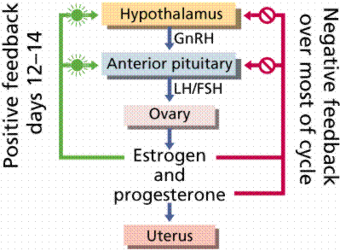 **Figure.** Hormonal controls and the functioning of the female reproductive system

The elevated estrogen level causes the anterior pituitary to release LH. This action causes ovulation, a process in which the follicle rapidly enlarges and releases the secondary oocyte. **LH** also causes the collapsed follicle to become the **corpus luteum**, an endocrine (secretory) body, which secretes estrogen and progesterone (hormone that stimulates endometrium thickening). These cyclic phases are interrupted only by pregnancy and continue until menopause, when reproductive capability ends. Menstrual cycles vary from between 15 and 31 days but lasts usually 28 days. The first day of the cycle is the first day of blood flow (day 0) known as **menstruation**. At midpoint of the cycle, the **oocyte** is released from the ovary in a process known as [**ovulation**](http://www.emc.maricopa.edu/faculty/farabee/BIOBK/BioBookglossO.html#ovulation). Following ovulation the follicle forms a corpus luteum which synthesizes and prepares hormones to prepare the [**uterus**](http://www.emc.maricopa.edu/faculty/farabee/BIOBK/BioBookglossU.html#uterus) for pregnancy. During menstruation the uterine lining is broken down and shed as menstrual flow. FSH and LH are secreted on day 0, beginning both the menstrual cycle and the ovarian cycle. Both FSH and LH stimulate the

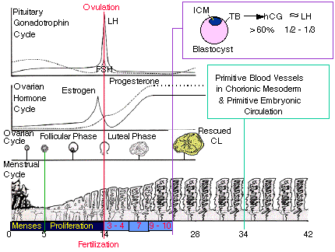

**Figure.**Hormonal changes and the female reproductive cycles

maturation of a single follicle in one of the ovaries and the secretion of estrogen. Rising levels of estrogen in the blood trigger secretion of LH, which stimulates follicle maturation and ovulation (**day 14, or midcycle).** Estrogen and progesterone stimulate the development of the endometrium and preparation of the uterine inner lining for implantation of a zygote. If pregnancy does not occur (if an egg is not fertilized and does not implant), the drop in FSH and LH cause the **corpus luteum** to disintegrate, which in turn stops producing progesterone: hence the lining of the uterus breaks down and is shed.

**Production of Gametes (**[**Spermatogenesis**](http://en.wikipedia.org/wiki/Spermatogenesis) **and** [**Oogenesis**](http://en.wikipedia.org/wiki/Oogenesis)**)**

The formation of sex cells begins before birth; spermatozoa form in males and oocytes in females. The production of gametes takes place within **the gonads** through a process known as [**gametogenesis**](http://en.wikipedia.org/wiki/Gametogenesis). Gametogenesis occurs when certain types of [**germ cells**](http://en.wikipedia.org/wiki/Germ_cell)undergo [**meiosis**](http://en.wikipedia.org/wiki/Meiosis) to split the normal **diploid number** of [chromosomes](http://en.wikipedia.org/wiki/Chromosome) in humans (n=46) into **haploids cells** containing only 23 chromosomes.

* **In males** this process is known as [**spermatogenesis**](http://en.wikipedia.org/wiki/Spermatogenesis) (sperm cell production) and takes place only after [puberty](http://en.wikipedia.org/wiki/Puberty) in the [seminiferous tubules](http://en.wikipedia.org/wiki/Seminiferous_tubules) of the testes. Spermatogonia (stem cells) line these tubules at birth, after birth, spermatogonia continue to divide during mitosis. This cell division process produces two daughter cells with the same chromosome number (46) as the parent. At puberty onset, some spermatozoa grow to become primary spermatocytes. These cells undergo meiosis, the cell division process that cuts back the number of chromosomes from 46 to 23. Each primary spermatocyte undergoes the first meiotic division to produce two secondary spermatocytes. Each secondary spermatocyte undergoes the second meiotic division to produce two spermatids. Each spermatid develops into a mature spermatozoon (sperm cell). The immature [spermatozoon](http://en.wikipedia.org/wiki/Spermatozoon) or sperm are then sent to the [epididymis](http://en.wikipedia.org/wiki/Epididymis) where they gain a tail and [motility](http://en.wikipedia.org/wiki/Motility).
* **In females** gametogenesis is known as [**oogenesis**](http://en.wikipedia.org/wiki/Oogenesis)( the formation of the ovum /female sex cells), which occurs in the [ovarian follicles](http://en.wikipedia.org/wiki/Ovarian_follicle) of the ovaries and begins as hundreds of thousands of **oogonia (stem cells)** in the fetal ovaries. During prenatal development, the oogonia grow to become **primary oocytes** that contain 46 chromosomes. Each oocyte undergoes **meiosis**; at birth, **oocytes are in prophase**. During this first meiotic division, oocytes enter a resting phase that lasts until the oocyte resumes development during the ovarian cycle (puberty). At birth each female carries a lifetime supply of developing oocytes, each of which is in Prophase I. Oogenesis does not produce mature ovum until puberty. In contrast with males, each of the original diploid germ cells or primary [oocytes](http://en.wikipedia.org/wiki/Oocyte) will form only one mature ovum, and three [polar bodies](http://en.wikipedia.org/wiki/Polar_body) which are not capable of fertilization.

The ovary contains many [follicles](http://www.emc.maricopa.edu/faculty/farabee/BIOBK/BioBookglossF.html#follicles (ovary)) composed of a developing egg surrounded by an outer layer of **follicle cells.** Each egg begins [oogenesis](http://www.emc.maricopa.edu/faculty/farabee/BIOBK/BioBookglossO.html#oogenesis) as a primary [oocyte](http://www.emc.maricopa.edu/faculty/farabee/BIOBK/BioBookglossO.html#oocyte). A developing egg (secondary oocyte) is released each month from puberty until menopause, a total of 400-500 eggs.

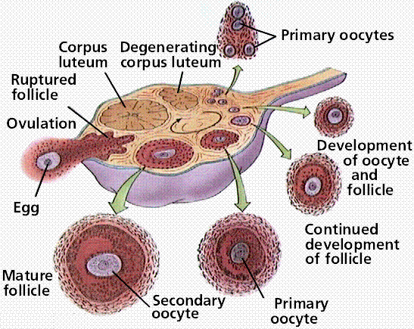

**Figure**. Oogenesis

**Sexual Responses**- humans do not have a mating season, females are sexually receptive to the male at all times of the year. There are four stages in mating: arousal, plateau, orgasm, and resolution. During male **arousal,** blood flows into the three shafts of spongy erectile tissue inside the penis, causing it to become elongated and erect. The female arousal has the swelling of the areas around the vagina, erection of the clitoris and nipples, and secretion of lubricating fluids in the vagina.

After insertion of the penis into the vagina, pelvic thrusts by both partners stimulate sensory receptors in the penis, vaginal walls, and clitoris. The sperm leave the epididymis and secretions of glands form the semen. **Orgasm** involves contractions of muscles of the penis (male) or vagina (female) and waves of pleasurable sensations. **Resolution** reverses the previous phases: muscles relax, breathing slows, the penis returns to its normal size.

**Fertilization and Cleavage**

**Fertilization has three functions**:

1. transmission of genes from both parents to offspring
2. restoration of the diploid number of chromosomes reduced during meiosis
3. initiation of development in offspring

**Steps in Fertilization**

* Contact between sperm and egg
* Entry of sperm into the egg
* Fusion of egg and sperm nuclei
* Activation of development

**Cleavage-**is the first step in development of **ALL multicelled** organisms. Cleavage converts a **single-celled zygote** into a **multicelled embryo** by **mitosis**. Usually, the zygotic cytoplasm is divided among the newly formed cells.

* The[**blastula**](http://www.emc.maricopa.edu/faculty/farabee/BIOBK/BioBookglossB.html#blastula) is produced by mitosis of the zygote, and is a **ball of cells** surrounding a fluid-filled cavity (**the** [**blastocoel**](http://www.emc.maricopa.edu/faculty/farabee/BIOBK/BioBookglossB.html#blastocoel)). The decreasing size of cells increases their surface to volume ratio, allowing for more efficient oxygen exchange between cells and their environment. RNA and information carrying molecules are distributed to various parts of the blastula, and this molecular differentiation sets the stage for the layering of the body in the next phases of development.
* **Gastrulation**- involves a series of cell migrations to positions where they will form the three primary cell layers.
* [**Ectoderm**](http://www.emc.maricopa.edu/faculty/farabee/BIOBK/BioBookglossE.html#ectoderm) forms tissues associated with outer layers: skin, hair, sweat glands, and epithelium. The brain and nervous system also develop from the ectoderm.
* [**Mesoderm**](http://www.emc.maricopa.edu/faculty/farabee/BIOBK/BioBookglossE.html#endoderm)forms structures associated with movement and support: body muscles, cartilage, bone, blood, and all other connective tissues. Reproductive system organs and kidneys form from mesoderm.
* **Endoderm forms** tissues and organs associated with the digestive and respiratory systems. Many endocrine structures, such as the thyroid and parathyroid glands, are formed by the endoderm. The liver, pancreas, and gall bladder arise from endoderm.