CHAPTER 11

RENAL SYSTEM
The urinary system consists of the kidneys, ureters, urinary bladder, and urethra. The kidneys filter the blood to remove wastes and produce urine. The ureters, urinary bladder, and urethra together form the urinary tract, which acts as a plumbing system to drain urine from the kidneys, store it, and then release it during urination. Besides filtering and eliminating wastes from the body, the urinary system also maintains the homeostasis of water, ions, pH, blood pressure, calcium...
- Urinary System Anatomy
  - Kidneys
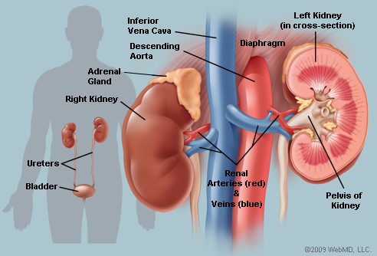

Fig.11.1. structure of kidneys
The kidneys are a pair of bean-shaped organs found along the posterior wall of the abdominal cavity. The left kidney is located slightly higher than the right kidney because the right side of the liver is much larger than the left side. The kidneys, unlike the other organs of the abdominal cavity, are located posterior to the peritoneum and touch the muscles of the back. The kidneys are surrounded by a layer of adipose that holds them in place and protects them from physical damage. The kidneys filter metabolic wastes, excess ions, and chemicals from the blood to form urine.
  - Ureters
The ureters are a pair of tubes that carry urine from the kidneys to the urinary bladder. The ureters are about 10 to 12 inches long and run on the left and right sides of the body parallel to the vertebral column. Gravity and peristalsis of smooth muscle tissue in the walls of the ureters move urine toward the urinary bladder. The ends of the ureters extend slightly into the urinary bladder and are sealed at the point of entry to the bladder by the ureterovesical valves. These valves prevent urine from flowing back towards the kidneys.
  - Urinary Bladder
The urinary bladder is a sac-like hollow organ used for the storage of urine. The urinary bladder is located along the body’s midline at the inferior end of the pelvis. Urine entering the urinary bladder from the ureters slowly fills the hollow space of the bladder and stretches its elastic walls. The walls of the bladder allow it to stretch to hold anywhere from 600 to 800 milliliters of urine.
  - Urethra
The urethra is the tube through which urine passes from the bladder to the exterior of the body. The female urethra is around 2 inches long and ends inferior to the clitorisand superior to the vaginal opening. In males, the urethra is around 8 to 10 inches long and ends at the tip of the penis. The urethra is also an organ of the male reproductive system as it carries sperm out of the body through the penis.
The flow of urine through the urethra is controlled by the internal and external urethral sphincter muscles. The internal urethral sphincter is made of smooth muscle and opens involuntarily when the bladder reaches a certain set level of distention. The opening of the internal sphincter results in the sensation of needing to urinate. The external urethral sphincter is made of skeletal muscle and may be opened to allow urine to pass through the urethra or may be held closed to delay urination.
- Urinary System Physiology
  - Maintenance of Homeostasis
The kidneys maintain the homeostasis of several important internal conditions by controlling the excretion of substances out of the body.
- Ions. The kidney can control the excretion of potassium, sodium, calcium, magnesium, phosphate, and chloride ions into urine. In cases where these ions reach a higher than normal concentration, the kidneys can increase their excretion out of the body to return them to a normal level. Conversely, the kidneys can conserve these ions when they are present in lower than normal levels by allowing the ions to be reabsorbed into the blood during filtration.
- pH. The kidneys monitor and regulate the levels of hydrogen ions (H+) and bicarbonate ions in the blood to control blood pH. H+ ions are produced as a natural byproduct of the metabolism of dietary proteins and accumulate in the blood over time. The kidneys excrete excess H+ ions into urine for elimination from the body. The kidneys also conserve bicarbonate ions, which act as important pH buffers in the blood.
- Osmolarity. The cells of the body need to grow in an isotonic environment in order to maintain their fluid and electrolyte balance. The kidneys maintain the body’s osmotic balance by controlling the amount of water that is filtered out of the blood and excreted into urine. When a person consumes a large amount of water, the kidneys reduce their reabsorption of water to allow the excess water to be excreted in urine. This results in the production of dilute, watery urine. In the case of the body being dehydrated, the kidneys reabsorb as much water as possible back into the blood to produce highly concentrated urine full of excreted ions and wastes. The changes in excretion of water are controlled by antidiuretic hormone (ADH). ADH is produced in the hypothalamus and released by the posterior pituitary gland to help the body retain water.
- Blood Pressure. The kidneys monitor the body’s blood pressure to help maintain homeostasis. When blood pressure is elevated, the kidneys can help to reduce blood pressure by reducing the volume of blood in the body. The kidneys are able to reduce blood volume by reducing the reabsorption of water into the blood and producing watery, dilute urine. When blood pressure becomes too low, the kidneys can produce the enzyme renin to constrict blood vessels and produce concentrated urine, which allows more water to remain in the blood.
  - Filtration
Inside each kidney are around a million tiny structures called nephrons. The nephron is the functional unit of the kidney that filters blood to produce urine. Arterioles in the kidneys deliver blood to a bundle of capillaries surrounded by a capsule called aglomerulus. As blood flows through the glomerulus, much of the blood’s plasma is pushed out of the capillaries and into the capsule, leaving the blood cells and a small amount of plasma to continue flowing through the capillaries. The liquid filtrate in the capsule flows through a series of tubules lined with filtering cells and surrounded by capillaries. The cells surrounding the tubules selectively absorb water and substances from the filtrate in the tubule and return it to the blood in the capillaries. At the same time, waste products present in the blood are secreted into the filtrate. By the end of this process, the filtrate in the tubule has become urine containing only water, waste products, and excess ions. The blood exiting the capillaries has reabsorbed all of the nutrients along with most of the water and ions that the body needs to function.
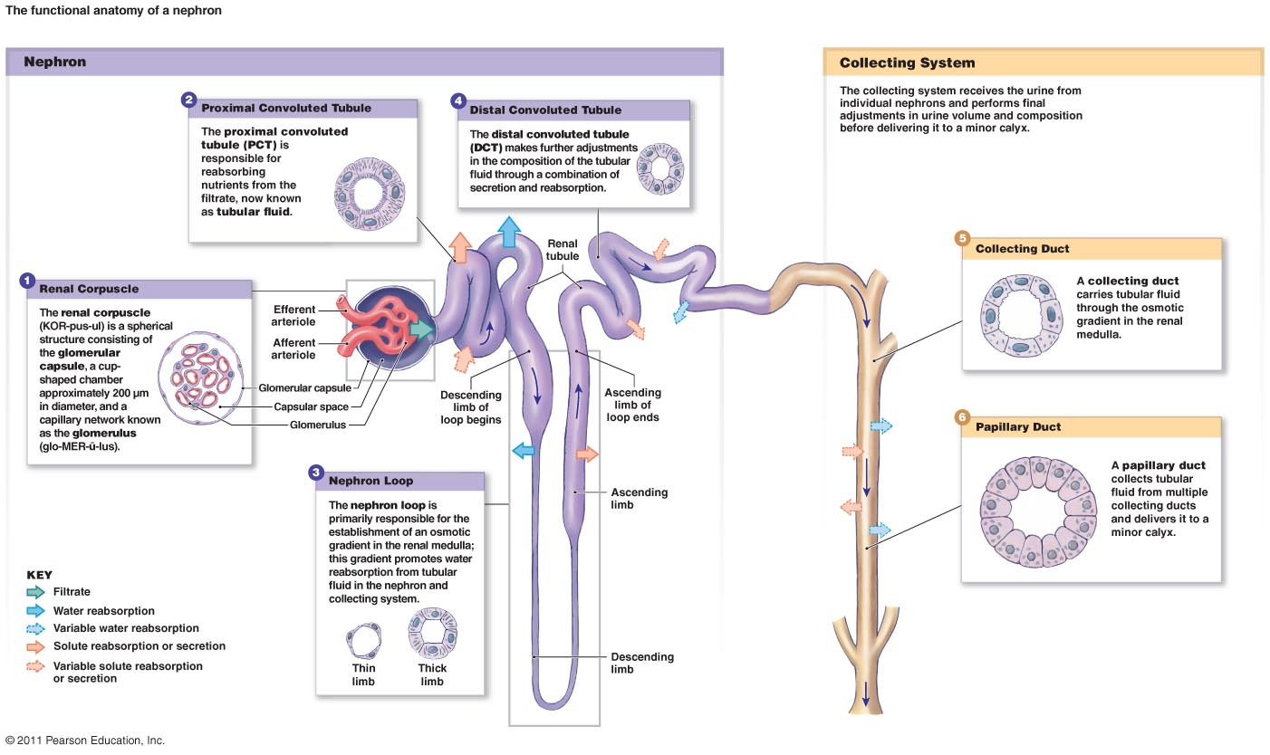

Fig.11.2. structure of nephron

  - Storage and Excretion of Wastes
After urine has been produced by the kidneys, it is transported through the ureters to the urinary bladder. The urinary bladder fills with urine and stores it until the body is ready for its excretion. When the volume of the urinary bladder reaches anywhere from 150 to 400 milliliters, its walls begin to stretch and stretch receptors in its walls send signals to the brain and spinal cord. These signals result in the relaxation of the involuntary internal urethral sphincter and the sensation of needing to urinate. Urination may be delayed as long as the bladder does not exceed its maximum volume, but increasing nerve signals lead to greater discomfort and desire to urinate.
Urination is the process of releasing urine from the urinary bladder through the urethra and out of the body. The process of urination begins when the muscles of the urethral sphincters relax, allowing urine to pass through the urethra. At the same time that the sphincters relax, the smooth muscle in the walls of the urinary bladder contract to expel urine from the bladder.

