**NERVOUS SYSTEM**

None of the body system is capable of functioning alone. All are interdependent and work together as one unit so that normal conditions within the body may succeed. Control of the body’s billions of cells is accomplished mainly by two communication systems: the **nervous system** and the **endocrine system**. Both systems transmit information from one part of the body to another, but they do it in different ways. The nervous system transmits information very rapidly by nerve impulses conducted from one body area to another. The endocrine system transmits information more slowly by chemicals secreted by ductless glands into blood steam and circulated from glands to other parts of the body.

**The nervous system has three overlapping functions:**

* Sensory functions
* Integration or association function
* Motor functions.

For example, when you are driving and see a red light ahead (**sensory input**), your nervous system **integrates** this information (red light means “stop”), and your foot goes for the brake (**motor output**).

**HISTOLOGY OF NERVOUS TISSUE**

The nervous tissue consists of two kinds of nerve cells—**neurons** and **neuroglia** (simply 'glial cells').

(1) **Neurons** - the excitable nerve cells that transmit electrical signals.

(2) **Neuroglia (Supporting cells)** - smaller cells that surround and wrap neurons.

**Neuroglia**: There are six types of neuroglia—four in the CNS and two in the PNS.

* Neuroglia in the CNS include:
  + **Astrocytes**: highly branched, support and anchor neurons to nutrient supplies, control chemical environment
  + **Microglia**: fixed macrophage, protect the CNS by engulfing and destroying pathogens and dead nerve tissue
  + **Ependymal cells**: secrete cerebrospinal fluid (CSF) in the brain. CSF cushion and protects the brain and spinal cord.
  + **Oligodendrocytes:** produce insulated coverings called myelin sheaths around the nerve fibers in the CNS.
* **Neuroglias in the PNS are**
  + *Satellite cells and*
  + *Schwann cells* they surround and form myelin sheaths around the larger nerve fibers in the peripheral nervous system.

**NEURONS AND CLASSIFICATION OF NEURONS**

Neurons are the structural units of the nervous system. They are specialized to conduct messages in the form of nerve impulses. Neurons are typically large and complex cells.

**STRUCTURE OF THE NEURON**

Basically, neuron has **three** major parts; the cell body, dendrites and axon. The processes that extend from the cell bodies are axons and dendrites. The central nervous system (CNS) contains both neuron cell bodies and their processes. The peripheral nervous system (PNS) consists chiefly of neuron processes.

**1. Cell Body:**(soma or perikaryon) contains the nucleus and other cell organelles. It is the major biosynthetic center of a neuron. It receives information from other neurons. Clusters of cell bodies in the CNS are called ***nuclei***, whereas those that lie along the nerves in the PNS are called ***ganglia***.

**2. Dendrites**: it is typically a short, abundantly branched, slender process (extension) of the cell body that receives stimuli. Dendrites convey incoming messages toward the cell body.

**3. Axon**: It is typically a long, slender process of the cell body that sends nerve impulses. It emerges from the axon hillock. Any long axon is called ***a nerve fiber***. The axon generates nerve impulses and it is the conducting region of the neuron, typically away from the cell body.

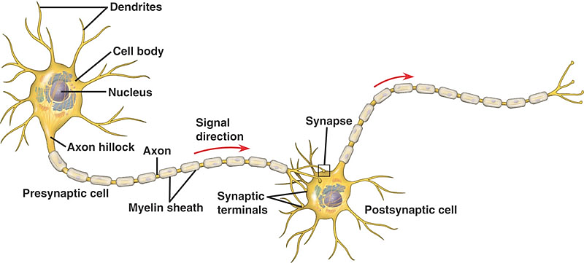

**Figure**: The structure of typical neurons

* Bundles of nerve fibers (neuron processes) in the CNS are called **tracts**, whereas in the PNS they are called **nerves**.
* **Myelin Sheath:** Myelin sheath is a whitish, fatty, substance covering long axons. It is interrupted at the nodes of ranvier. The functions of myelin sheath are:
* To protect and electrically insulates fibers, and
* To increase the speed of transmission of nerve impulses.

**CLASSIFICATION OF NEURONS**

Two ways of classifying neurons, i.e., structural and functional classification

1. ***Structural Classification***

Neurons are grouped structurally according to the number of processes extending from their cell body. The three major neurons are: *multipolar, bipolar,* and *unipolar* neurons.

***i) Multipolar neurons*** have three or more processes arising from the cell body. They are the most common neuron type in humans and the major neuron type in the CNS.

***ii) Bipolar neurons***: have two processes—an axon and a dendrite—that extend from opposite sides of the cell body. These are rare neurons and are found in some special sense organs: in the retina of the eye and in the olfactory mucosa.

***iii) Unipolarneurons*** have a single short process emerging from the cell body. Unipolar neurons are found chiefly in ganglia in the PNS, where they function as sensory neurons.

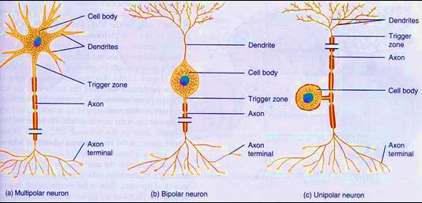

**Figure**: The Structural Classification on neuron

1. ***Functional Classification***

Neurons are classified according to the direction in which the nerve impulse travels relative to the CNS. Based on this criterion, there are ***sensory neurons****,* ***motor neurons****, and* ***interneurons****.*

1. ***Sensory or afferent neurons*** transmit impulses from sensory receptors in the skin or internal organs towards the central nervous system.
   * virtually all sensory neurons are unipolar,
   * cell bodies are located in sensory ganglia outside the CNS
2. ***Motor or efferent neurons*** carry impulses away from the CNS to the effector organs (muscles and glands) of the body periphery.
   * Motor neurons are multipolar,
   * Except for some neurons of the autonomic nervous system, their cell bodies are located in the CNS
3. ***Interneurons or association neurons*** lie between motor and sensory neurons in the CNS. Most interneurons are confined within the CNS. They make up over 99% of the neurons of the body, including most of those in the CNS. Almost all interneurons are multipolar.

**IMPULSE GENERATION AND CONDUCTION**

**THE NERVE IMPULSE**

* The cell membrane of an unstimulated (resting) neuron carries an electric charge. Because of positive and negative ions concentrated on either side of the membrane, the inside of the membrane at rest is negative as compared with the outside.
* A nerve impulse is a local reversal in the charge on the nerve cell membrane that then spreads along the membrane like an electric current. This sudden electrical change in the membrane is called an **action potential**. A **stimulus**, then, is any force that can start an action potential.
* This electric change results from rapid shifts in sodium and potassium ions across the cell membrane. The reversal occurs very rapidly (in less than one thousandth of a second) and is followed by a rapid return of the membrane to its original state so that it can be stimulated again.
* A myelinated nerve fiber conducts impulses more rapidly than an unmyelinated fiber of the same size because the electrical impulse "jumps" from node (space) to node in the myelin sheath instead of traveling continuously along the fiber.

**THE SYNAPSE**

Each neuron is a separate unit, and there is no anatomic connection between neurons. How then is it possible for neurons to communicate? In other words, how does the axon of one neuron make functional contact with the membrane of another neuron? This is accomplished by the synapse, from a Greek word meaning "**to clasp**." Synapses are points of junction for the transmission of nerve impulses.

* Within the branching endings of the axon are small bubbles (vesicles) containing a type of chemical known as neurotransmitter.
* When stimulated, the axon releases its neurotransmitter in to the narrow gap, the synaptic cleft, between the cells. The neurotransmitter then acts as a chemical signal to stimulate the next cell, described as the postsynaptic cell.
* On the receiving membrane, usually that of a dendrite, sometimes another part of the cell, there are special sites, or receptors, ready to pick up and respond to specific neurotransmitters.
* Receptors in the cell membrane influence how or if that cell will respond to a given neurotransmitter.

Although there are many known neurotransmitters, the main ones are **epinephrine**, also called **adrenaline**; a related compound, norepinephrine, or noradrenaline; and acetylcholine.

* Acetylcholine (Ach) is the neurotransmitter released at the neuromuscular junction, the synapse between a neuron and a muscle cell.
* All three of the above neurotransmitters function in the autonomic nervous system. It is common to think of neurotransmitters as stimulating the cells they reach. Note, however, that some of these chemicals act to inhibit the postsynaptic cell and keep it from reacting.



**ORGANIZATION OF THE NERVOUS SYSTEM**

The nervous system has **two main divisions**: the central nervous system (CNS) and peripheral nervous system (PNS).

1. **CENTRAL NERVOUS SYSTEM (CNS**): consists of the brain and spinal cord. CNS occupies the dorsal body cavity. It is the integrating and command center of the nervous system.

* It interprets sensory input and dictates motor responses. That is, it regulates organ function, higher thought, and movement of the body.

**2. PERIPHERAL NERVOUS SYSTEM (PNS):** is part of the nervous system outside the CNS:

* Consists mainly **two types** of peripheral nerves that extend from the brain or spinal cord
* Spinal nerves: carry impulses to and from the spinal cord;
* Cranial nerves: carry impulses to and from the brain.

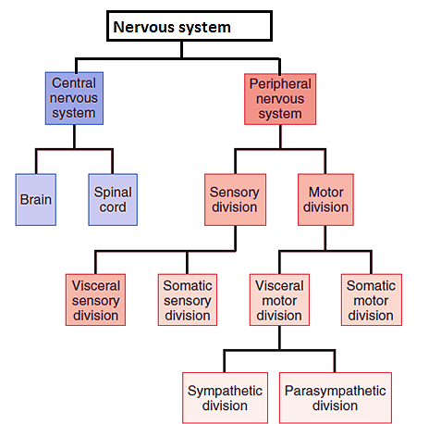

**Figure:** Sub-divisions (based on functional organization) of the nervous system

These peripheral nerves serve as the communication link between all parts of the body to the CNS. They are divided in to **two divisions**: the sensory and motor divisions.

1. ***The sensory, or afferent, division*** (“carrying toward”) is divided as:

* ***Somatic sensory fibers****:* carry impulses from the skin, skeletal muscles, and joints.
* ***Visceral sensory fibers****:* are those transmitting impulses from the visceral organs (organs within the ventral body cavity).

1. ***The motor, or efferent, division*** (“carrying away”): It has **two main parts**:
2. ***Somatic nervous system*** –it consists of the somatic nerve fibers that conduct impulses from the CNS to skeletal muscles. It is often referred to as the **voluntary nervous system** because it allows us to consciously control our skeletal muscles.
3. ***Visceral motor division*** *(the autonomic nervous system,* ANS) – it consists of the somatic nerve fiber that regulate the activity of smooth muscles, cardiac muscles, and glands. ANS is also referred to as the **involuntary nervous system**. The ANS has two functional subdivisions, the ***sympathetic*** and the ***parasympathetic.***

**PROTECTION OF THE CNS**

The very soft and delicate tissues of the CNS (brain and spinal cord) are protected by three structures:

1. ***Bone***: the skull and vertebral canal (vertebrae) protects brain, and spinal cord resp.
2. ***Membrane***: Meninges, which consist of **dura mater**, **pia mater**, and **arachnoid**.
3. ***Watery cushion***: Cerebrospinal fluid (CSF) also helps to protect the delicate CNS.

**BRAIN**

* The average adult brain weighs about **1,600** g in men and **1,450** g in women. Its size is proportional to body size, not intelligence. Within the brain there are **four irregular-shaped cavities**, or **ventricles**, containing CSF.
* The brain is the largest and most complex mass of nervous tissue in the body. Thus, brain has four major regions, i.e.,
  + Cerebrum
  + Diencephalon,
  + Brain Stem, and
  + Cerebellum.
* Cerebral hemispheres envelop the diencephalon and midbrain.
* **Brain cross section shows *two kinds*** of nervous tissue called **gray** and **white matter**

1. **Gray matter**— forms the outer layer, surrounded by white matter.
2. **White matter** thus lies deep to the cortical gray matter of the brain. This is opposite from the relationship of gray and white matter in the spinal cord.

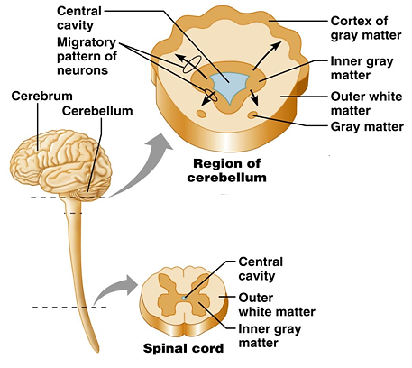

**Figure:** Cross-section of brain and spinal cord showing basic parts

**A) CEREBRUM**

The **cerebrum** consists of two (right and left) cerebral hemispheres. It is the largest part of the brain, which accounts for about 83% of total brain mass. In fact, the cerebral hemispheres enclose and obscure most of the brain stem.

The cerebrum appears as folded ridges and grooves, called ***convolutions***. The following terms are used to describe the convolutions:

1. A *gyrus* (plural, *gyri*) is an elevated ridges of tissues among the convolutions.
2. A sulcus (plural, sulci) is a shallow groove, which divide cerebral hemispheres into five separated lobes—frontal, parietal, temporal, occipital, and insula**.**
   1. The ***central sulcus***, separates the frontal lobe from the parietal lobe.
   2. The ***parieto-occipital sulcus*,** separates the occipital lobe from the parietal lobe.
   3. The deep ***lateral sulcus*** and separates temporal lobe from the parietal and frontal lobes.
3. A fissure is a deep groove that separate large regions of the brain (e.g. longitudinal fissure separates cerebrum into left and right cerebral hemispheres).

Each cerebral hemisphere acts contra-laterally (controls the opposite side of the body). Hemispheres are not equal in function and no functional area acts alone.

* Each cerebral hemisphere has **three basic regions**:
* a superficial cortex of gray matter;
* an internal white matter; and
* the basal nuclei, islands of gray matter situated deep within the white matter

**I) Cerebral cortex**

The cerebral cortex is the “executive suite” of the nervous system, where our **conscious mind is found**. The cortex – superficial gray matter; accounts for roughly **40%** of the mass of the brain. Its many convolutions effectively triple its surface area.

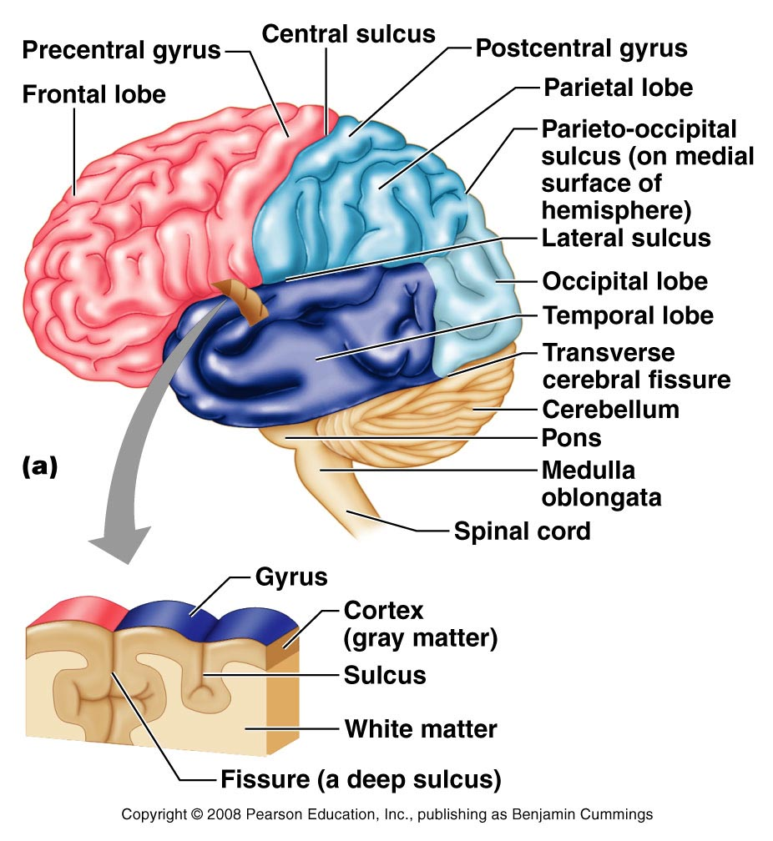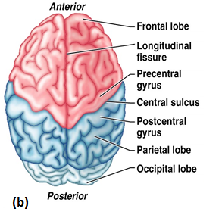

**Figure:** *Lobes and fissures of the cerebral hemispheres: (a) Diagram of the lobes and major sulci and fissures of the brain. (b) The posterior surface of the cerebral hemispheres showing the cortices of the frontal, temporal, and occipital lobes*

**GENERALIZATIONS OF THE CEREBRAL CORTEX**

1. Each hemisphere is chiefly concerned with the sensory and motor functions of the opposite (contralateral) side of the body.
2. The two hemispheres are not entirely equal in function. Instead, there is a lateralization (specialization) of cortical functions. In most people:
   1. the left hemisphere is dominant (i.e., specialized for language and mathematical skills and logic);
   2. the right hemisphere is more concerned with visual-spatial skills, intuition, emotion, artistic and musical skills.
3. No functional area of the cortex acts alone, and conscious behavior involves the entire cortex.

**B) DIENCEPHALON**

Diencephalon forms the central core of the forebrain. It connects the cerebrum to the brain stem. Diencephalon consists largely of **three paired structures**—the thalamus, hypothalamus, and epithalamus.

1. ***Thalamus***: is a relay station for sensory nerve impulses traveling from the spinal cord to the cerebrum.
   * Thalamus makes up 80% of the diencephalon. Thus, thalamus serves as the “*gateway*” to the cerebral cortex
2. ***Epithalamus*:** it is the most dorsal portion of the diencephalon and forms the roof of the third ventricle.
   * It contains the pineal gland -secretes **melatonin**, helps regulate the sleep-wake cycle.
3. ***Hypothalamus:*** It is located below the thalamus, it caps the brainstem. The pituitary gland projects inferiorly.

* Despite its small size, the hypothalamus is an important visceral control center to overall body homeostasis. Thus, the functions of hypothalamus include:
* Regulates cardiac and smooth muscle and secretion by the glands.
* Control of *emotional responses (*pleasure, fear, and rage, sex, etc.)
* Regulation of *body temperature*
* Regulation of *hunger and thirst sensations*
* Regulation of *sleep-wake cycles*
* Control of the **endocrine system (**It is also called t***he master gland’s master!!)***

**C) BRAIN STEM**:

The brain stem connects the diencephalon to the spinal cord. The brainstem is a pathway from superior to inferior, the brain stem regions are midbrain, pons, and medulla oblongata. Collectively they account for only 2.5% of total brain mass.

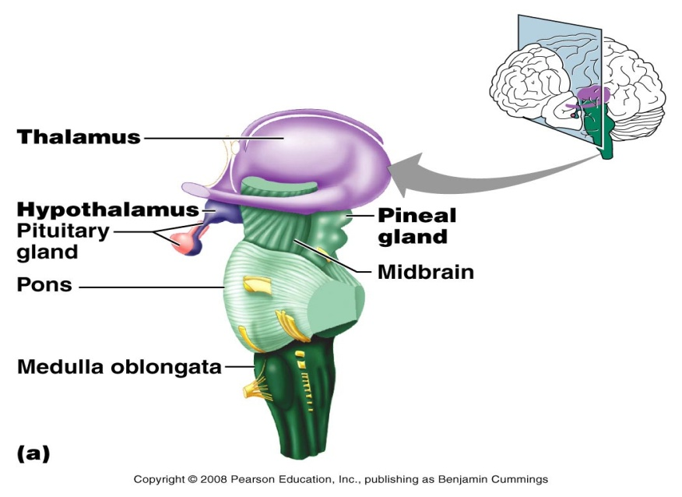

**Figure:** *Brain structure showing the dinencephalon region*

The brain stem provides connections between various parts of the brain and between the brain and the spinal cord. Additionally, brain stem nuclei are associated with **10** of the **12 pairs** of cranial nerves, so it is involved with innervations of the head.

**i) *Midbrain***: is the uppermost part of the brain stem that connects the hindbrain and fore-head. It is located between the diencephalon and the Pons.

**ii) *Pons (Pons = bridge)*:** It is an anterior bulge between the midbrain and the medulla oblongata.

**iii) *Medulla oblongata (medulla*):** is the most inferior part of the brainstem that merges with the spinal cord at the foramen magnum. Cranial nerves VIII–XII attach to the medulla.

***FUNCTIONS***: the medulla plays crucial role as an autonomic reflex center in maintaining body homeostasis.

Important visceral motor nuclei found in the medulla include the following:

**1.  Cardiovascular center:** the cardiac center controls heart contraction; and the vasomotor center regulates blood vessel diameter to regulate blood pressure.

**2. Respiratory centers:** control the rate and depth of breathing and maintain respiratory rhythm.

3. Other additional centers: regulate vomiting, hiccuping, swallowing, coughing, and sneezing.

**D) CEREBELLUM:**

Cerebellum is the second-largest region of the brain that accounts for about 11% of total brain mass. The cerebellum is located dorsal to the pons and medulla.

Like the cerebrum, the cerebellum has a thin outer cortex of gray matter and internal white matter (called the arbor vitae).

The cerebellum provides the precise timing for skeletal muscle activity and controls our balance and equilibrium. Because of its activity, body movements are smooth and coordinated.

**THE SPINAL CORD**

The *spinal cord* is an “information highway” between your brain and your trunk and limbs. Begins at the foramen magnum and extends through the vertebral canal to the first lumbar vertebra (L1).

The spinal cord serves three principal functions: conduction of nerve impulses, locomotion and center of reflexes. It connects different body parts with each other and with the brain. Sensory information reach to the brain, motor commands to reach the effectors.

**ANATOMY OF THE SPINAL CORD**

The spinal cord is divided into **cervical, thoracic, lumbar,** and **sacral regions** from superior to inferior. Spinal nerves originate from the spinal cord. There are31 pairs of spinal nerves– each attached to the cord by paired roots. ***Anatomical cross section***: The spinal cord has a central core of **gray matter** that looks somewhat butterfly-or H-shaped and **an outer layer of** white matter.

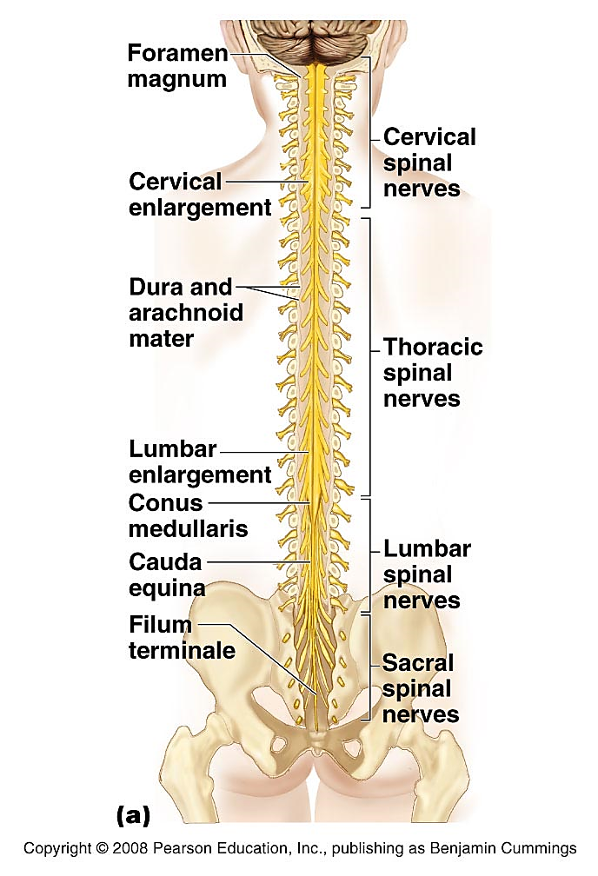

**PERIPHERAL NERVOUS SYSTEM (PNS)**

The PNS includes the nervous structures outside the brain and spinal cord. The peripheral nervous system consists of sensory receptors, nerves conducting impulses to and from the CNS, their associated ganglia, and motor endings.

**NERVES**

The **peripheral nervous system** includes 12 cranial nerves (I to XII) and 31 pairs of spinal nerves. It is a way of communication between the CNS to the rest of the body by nerve impulses.

* 1. **CRANIAL NERVES**

**Cranial nerves** are nerves of the PNS that originate and attach to the brain. Cranial nerves are 12 pairs numbered in roman numerals from I-XII (anterior to posterior) summarized in the table below. They serve mainly the head and neck region. The vagus nerve (X) extends into the abdomen. Cranial nerves I and II attach to the forebrain. All others attach to the brain stem.

**Table 1: The 12 pairs of cranial nerves and their functions**

|  |  |
| --- | --- |
| **CRANIAL NERVES** | **FUNCTIONS** |
| **I. Olfactory:** | Sensory nerves of smell |
| **II. Optic:** | Sensory nerve of vision, Sight |
| **III. Oculomotor:** | Innervates four of the extrinsic eye muscles; Movement of the eyeball, lens, and pupillary sphincter |
| **IV. Trochlear:** | Innervates the **superior oblique muscle** (an extrinsic eye muscle) |
| **V. Trigeminal:** | Provides *sensory innervation* to the face,  Motor innervation to *chewing muscles* |
| **VI. Abducens:** | innervates the lateral rectus muscle, moves the eye outward |
| **VII. Facial:** | Innervates muscles of facial expression |
| **VIII. Vestibulocochlear:** | Sensory nerve of hearing and balance |
| **IX. Glossopharyngeal:** | Innervates structures of the tongue and pharynx |
| **X. Vagus:** | Sensory and motor to thoracic and abdominal viscera |
| **XI. Accessory:** | An accessory part of the vagus nerve, Innervates trapezius muscle, Permits movement of head and shoulders |
| **XII. Hypoglossal:** | Innervates the tongue muscles, controls muscles of tongue |

**NOTE:** Neither the olfactory nor the optic nerves are really cranial nerves since these nerves are composed of fibers belonging to the central nervous system.

**2. SPINAL NERVES**

Thirty-one pairs of **spinal nerves** arise from the spinal cord and supply all parts of the body except the head and some areas of the neck. All These nerves are named according to the spinal cord segment from which they originate. There are 8 pairs of cervical spinal nerves (C1–C8), 12 pairs of thoracic nerves (T1–T12), 5 pairs of lumbar nerves (L1–L5), 5 pairs of sacral nerves (S1–S5), and 1 pair of tiny coccygeal nerves.

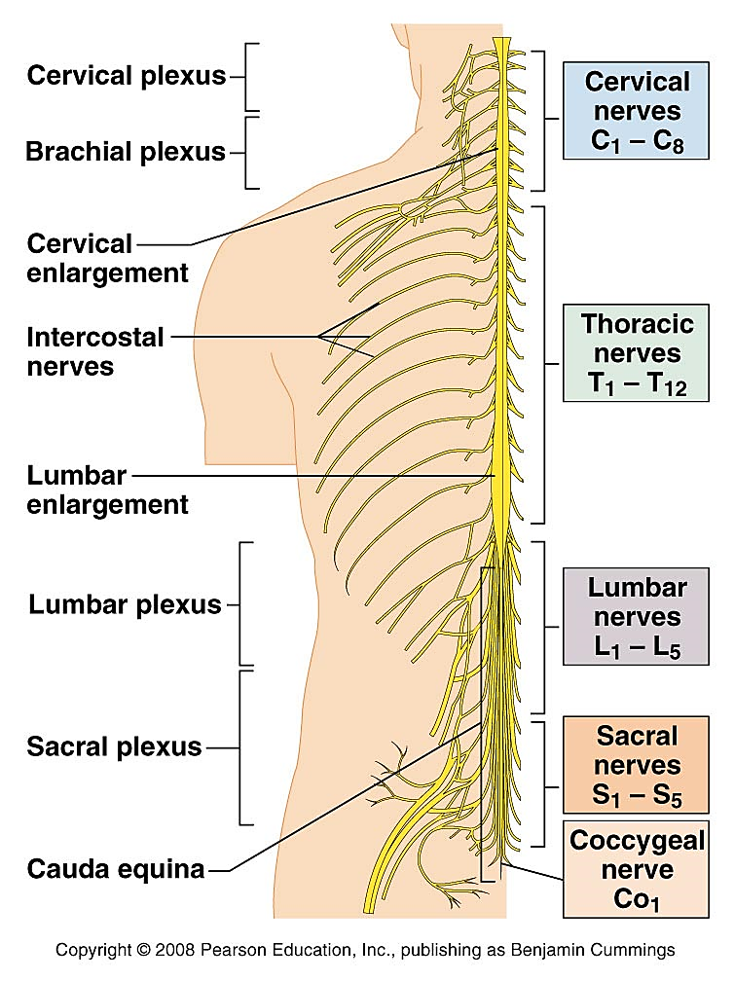

**Figure:** *Structure of the spinal cord and the spinal nerves from the spinal cord*

**AUTONOMIC NERVOUS SYSTEM (ANS)**

The two arms of the ANS, the parasympathetic and sympathetic divisions, generally serve the same visceral but cause essentially opposite effects. If one division stimulates certain smooth muscles to contract or a gland to secrete, the other division inhibits that action.

1. The **sympathetic** nervous system prepares the body for situations requiring alertness or strength or situations that arouse fear, anger, excitement, or embarrassment (“fight-or-flight” situations).
2. The **parasympathetic** nervous system is active during periods of digestion and rest. It stimulates the production of digestive enzymes and stimulates the processes of digestion, urination, and defecation.

**Role of the Parasympathetic Division**

This division, sometimes called the “*resting and digesting*” system

* keeps body energy use as low as possible,
* Performs the D-activities: digestion, defecation (elimination of feces) &diuresis (elimination of urine) (This explains why it is a good idea to relax after a heavy meal: so that digestion is not interfered with by sympathetic activity.)
* Blood pressure, heart rate and respiratory rates are low
* Gastrointestinal tract is actively digesting food
* The skin is warm, the pupils are constricted the eyes

**Role of the Sympathetic Division**

* This division is often referred to as the “*fight-or-flight*” system
* Its activity is evident when we are excited or find ourselves in emergency
* Heart rate increases
* rapid and deep breathing; dry mouth
* The skin is cold and sweaty, and the pupils dilate
* visceral (and sometimes cutaneous) blood vessels are constricted, and blood is shunted to active skeletal muscles and the vigorously working heart
* The bronchioles in the lungs dilate, increasing ventilation
* Liver releases more glucose into the blood to accommodate the increased energy needs of cells.
* Increase in: mental activity, blood flow to muscles, cellular metabolism
* temporarily non-essential activities, such as gastrointestinal tract motility, are damped

**REFLEXES**

A reflex is a rapid, involuntary response to a stimulus. A reflex arc is the pathway traveled by the nerve impulses during a reflex.

Most reflexes are spinal reflexes with pathways that traverse only the spinal cord. Some reflexes are cranial reflexes with pathways through cranial nerves and the brain stem.

A reflex arc involves the following five components

**1. Receptor** – site where stimulus acts

**2. Sensory neuron** – transmits afferent impulses to the CNS

**3. Integration center** – consists of one or more synapses in the CNS

**4. Motor neuron** – conducts efferent impulses from integration center to an effector

**5. Effector** – muscle and gland cells that respond to efferent impulses by contracting and secreting, respectively.

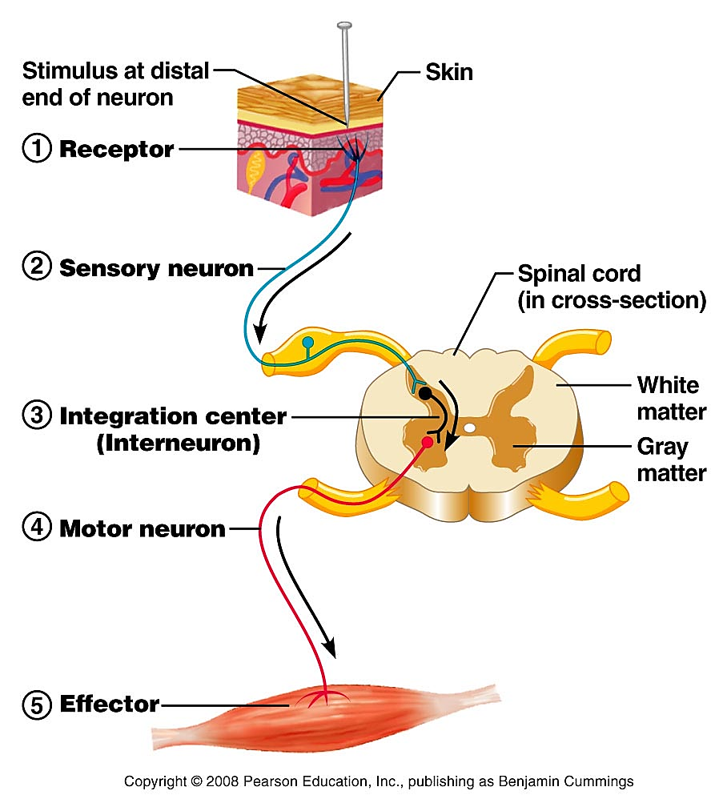

**Figure**: The five components in the reflex arc path ways

***Some examples of reflexes:***

1. ***A stretch reflex*** is a monosynaptic reflex that is a response to a muscle that has been stretched (the knee jerk reflex is an example). When receptors in muscles, called muscle spindles, detect changes in muscle length, they stimulate, through a reflex arc, the contraction of muscles to regain normal body position.

2. ***A flexor (withdrawal) reflex*** is a polysynaptic reflex that causes a limb to be withdrawn when it encounters pain.

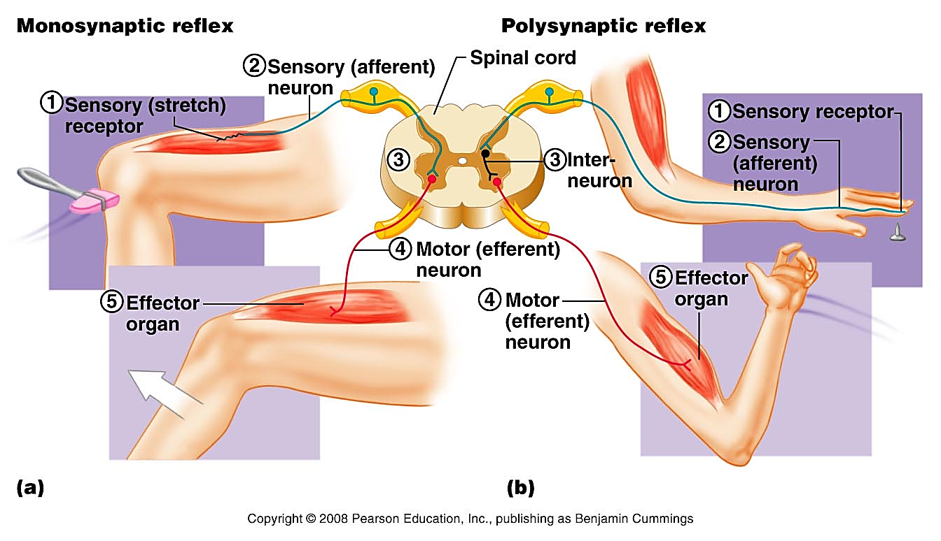

**Figure:** Examples of reflexes (a) monosynaptic reflex (only one synapse, the fastest of the reflexes, e.g. knee jerk); (b) polysynaptic reflex (more synapses, the most common type)