CHAPTER FOUR: MUSCULAR SYSTEM
Myology: is the study of muscles
- More than 600 skeletal muscles make up the muscular system
- Collectively, the skeletal muscles accounts for 40% of the body weight
Each skeletal muscle is an organ consists:
- Skeletal Muscle tissue
- Connective tissue
- Nerve tissue
PROPERTIES OF MUSCLE
Muscle has four major functional properties: contractility, excitability, extensibility, and elasticity.
- Contractility is the ability of muscle to shorten with a force. When muscle contracts, it causes movement of the structures to which it is attached, or it may increase pressure inside hollow organs or vessels. Although muscle shortens forcefully during contraction, it lengthens passively; that is, gravity, contraction of an opposing muscle, or the pressure of fluid in a hollow organ or vessel produces a force that acts on the shortened muscle, causing it to lengthen.
- Excitability is the capacity of muscle to respond to a stimulus. Normally skeletal muscle contracts as a result of stimulation by nerves. Smooth muscle and cardiac muscle can contract without outside stimuli, but they also respond to stimulation by nerves and hormones.
- Extensibility means that muscle can be stretched to its normal resting length and beyond to a limited degree.
- Elasticity is the ability of muscle to recoil to its original resting length after it has been stretched.
FUNCTION OF MUSCULAR SYSTEM
There are three types of muscle tissue: skeletal, smooth, and cardiac. The major functions of muscles are:
- Body movement: Most skeletal muscles are attached to bones, are typically under conscious control, and are responsible for most body movements including walking, running, or manipulating objects with the hands.
- Maintenance of posture: Skeletal muscles constantly maintain tone, which keeps us sitting or standing erect.
- Respiration: Muscles of the thorax are responsible for the movements necessary for respiration.
- Production of body heat: When skeletal muscles contract, heat is given off as a by-product. This released heat is critical to the maintenance of body temperature.
- Communication: Skeletal muscles are involved in all aspects of communication, such as speaking, writing, typing, gesturing, and facial expression.
- Constriction of organs and vessels: The contraction of smooth muscle within the walls of internal organs and vessels causes constriction of those structures. This constriction can help propel and mix food and water in the digestive tract, propel secretions from organs, and regulate blood flow through vessels.
- Heart beat: The contraction of cardiac muscle causes the heart to beat, propelling blood to all parts of the body

TYPES OF MUSCLE TISSUE
There are three types of muscles; skeletal, smooth, and cardiac muscle.
- Skeletal muscle with its associated connective tissue constitutes about 40% of the body’s weight and is responsible for locomotion, facial expressions, posture, respiratory movements, and many other body movements. The nervous system voluntarily, or consciously, controls the functions of the skeletal muscles.
- Smooth muscle is the most widely distributed type of muscle in the body, and it has the greatest variety of functions.
  - It’s in the walls of hollow organs and tubes, the interior of the eye, the walls of blood vessels, and other areas.
  - Smooth muscle performs a variety of functions, including propelling urine through the urinary tract, mixing food in the stomach and intestine, dilating and constricting the pupils, and regulating the flow of blood through blood vessels.
- Cardiac muscle is found only in the heart, and its contractions provide the major force for moving blood through the circulatory system.
  - Unlike skeletal muscle, cardiac muscle and many smooth muscles are autorhythmic, that is, they contract spontaneously at somewhat regular intervals, and nervous or hormonal stimulation is not always required for them to contract.
  - Furthermore, unlike skeletal muscle, smooth muscle and cardiac muscle are not consciously controlled by the nervous system. Rather, they are controlled involuntarily or unconsciously by the autonomic nervous system and the endocrine system.
NOMENCLATURE OF MUSCLE
Muscles are named according to their location, size, shape, orientation of fasciculi, origin and insertion, number of heads, or function. Recognizing the descriptive nature of muscle names makes learning those names much easier.
- Location. Some muscles are named according to their location. For example, a pectoralis (chest) muscle is located in the chest, a gluteus (buttock) muscle is located in the buttock, and a brachial (arm) muscle is located in the arm.
- Size. Muscle names may also refer to the relative size of the muscle. For example, the gluteus maximus (large) is the largest muscle of the buttock, and the gluteus minimus (small) is the smallest. A longus (long) muscle is longer than a brevis (short) muscle.
- Shape. Some muscles are named according to their shape. The deltoid (triangular) muscle is triangular, a quadratus (quadrangular) muscle is rectangular, and a teres (round) muscle is round.
- Orientation. Muscles are also named according to their fascicular orientation. A rectus (straight) muscle has muscle fasciculi running straight with the axis of the structure to which the muscle is associated, whereas the fasciculi of an oblique muscle lie oblique to the longitudinal axis of the structure.
- Origin and insertion. Muscles may be named according to their origin and insertion. The sternocleidomastoid originates on the sternum and clavicle and inserts onto the mastoid process of the temporal bone. The brachioradialis originates in the arm (brachium) and inserts onto the radius.
- Number of heads. The number of heads (origins) a muscle has may also be used in naming it. A biceps muscle has two heads, and a triceps muscle has three heads.
- Function. Muscles are also named according to their function. An abductor moves a structure away from the midline, and an adductor moves a structure toward the midline. The masseter (a chewer) is a chewing muscle.
MUSCLE ARCHITECTURE is the physical arrangement of muscle fibers with in a muscle relative to the axis of force generation.
- Skeletal muscles may be classified on the basis of fiber arrangement as fusiform, parallel, convergent, sphincteral(circular), or pennate.
- Each type of fiber arrangement provides the muscle with distinct capabilities.
- Fusiform muscles are thick in the middle and tapered at each end. Their contractions are moderately strong.
Examples: The biceps brachii of the arm and gastrocnemius of the calf
- Parallel muscles are long, strap like muscles of uniform width and parallel fascicles. They can span a great distance and shorten more than other muscle types, but they are weaker than fusiform muscles.
Examples: the rectus abdominis of the abdomen, Sartorius of the thigh, and zygomaticus major of the face
- Convergent muscles are fan-shaped—broad at the origin and converging toward a narrower insertion.These muscles are relatively strong because all of their fascicles exert their tension on a relatively small insertion.
Examples: The pectoralis major in the chest is a muscle of this type
- Pennate muscles are feather-shaped. Their fascicles insert obliquely on a tendon that runs the length of the muscle, like the shaft of a feather.
There are three types of pennate muscles:
- Unipennate, in which all fascicles approach the tendon from one side (for example, the palmar interosseous muscles of the hand and semimembranosus of the thigh);
- Bipennate, in which fascicles approach the tendon from both sides (for example, the rectus femoris of the thigh); and
- Multipennate, shaped like a bunch of feathers with their quills converging on a single point (for example, the deltoid of the shoulder).
- Circular muscles (sphincters): form rings around body openings.
Examples: The orbicularis oris of the lips and orbicularis oculi of the eyelids
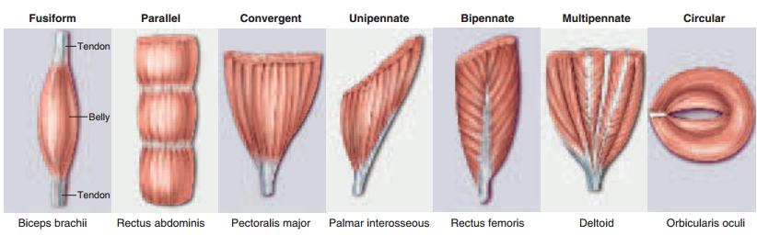
STRUCTURE OF SKELETAL MUSCLE
CONNECTIVE TISSUE OF MUSCLE
Connective tissue is structurally arranged within muscle to protect, strengthen, and bind muscle fibers into bundles and bind the bundles together.
- The individual fibers of skeletal muscles are surrounded by a fine sheath of connective tissue called endomysium.
- The endomysium binds adjacent fibers together and supports capillaries and nerve endings serving the muscle.
- Another connective tissue, the perimysium, binds groups of muscle fibers together into bundles called fasciculi.
- The perimysium supports blood vessels and nerve fibers serving the various fasciculi.
- The entire muscle is covered by the epimysium, which in turn is continuous with a tendon.

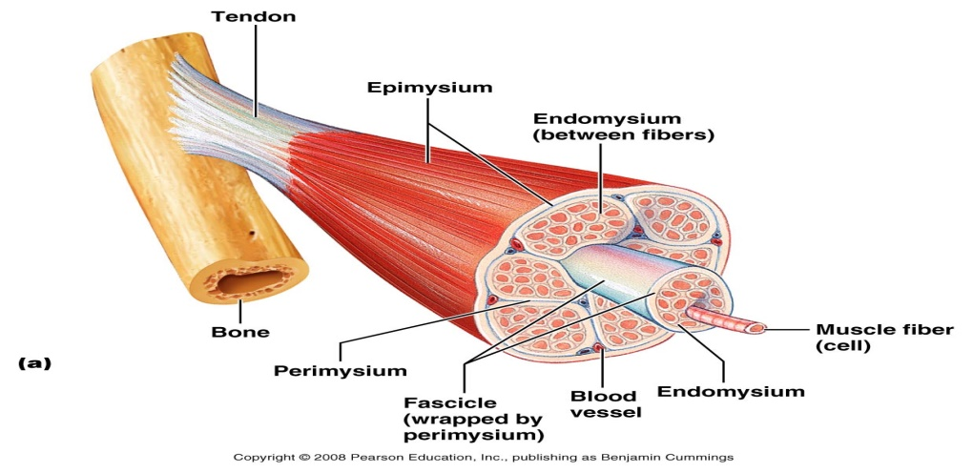
MUSCLE ATTACHMENTS
- Most skeletal muscles are attached to a different bone at each end, so either the muscle or its tendon spans at least one joint.
- Tendon is composed of dense connective tissue and binds a muscle to the periosteum of a bone. When the muscle contracts, it shortens and moves one bone relative to the other.
Most skeletal muscles span joints and attached to bones at least in two places.
- The muscle attachment at the relatively stationary end is called its origin, or head.
- Its attachment at the more mobile end is called its insertion.
- Many muscles are narrow at the origin and insertion and have a thicker middle region called the belly
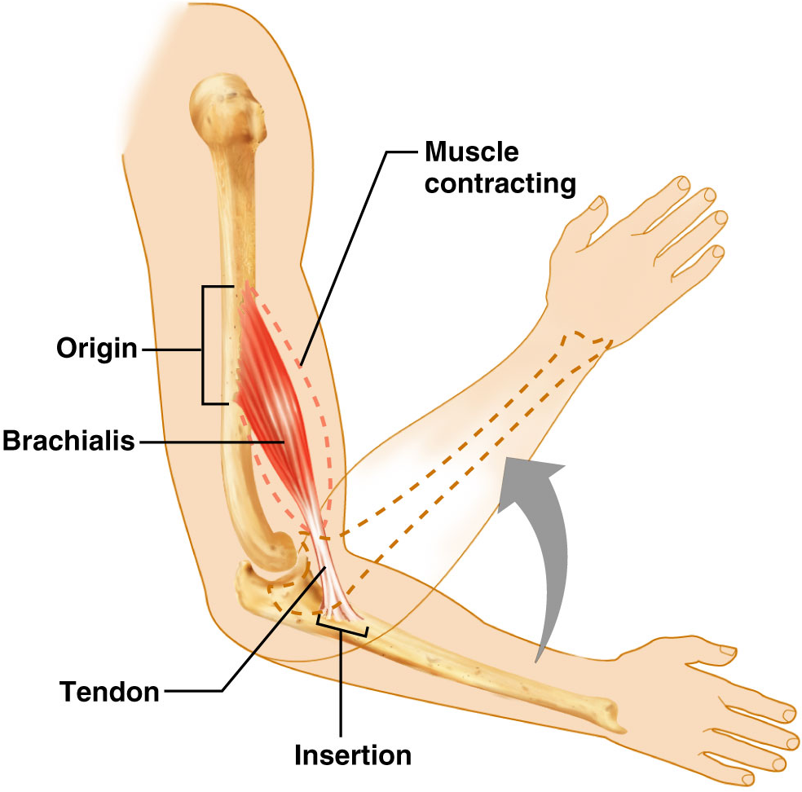
There are two ways of muscle attachment; Direct and Indirect
Direct or Fleshy Attachment: Collagen fibers of the epidermis are continuous with the periosteum.
- The epimysium of the muscle is fused to periosteum of bone/cartilage
- The red muscle tissue appears to emerge directly from bone
Example: the intercostal muscles between ribs
Indirect Attachment: collagen fibers of the epimysium continue as a strong fibrous tendon that merges into the periosteum of a nearby bone.
- Some collagen fibers of periosteum continue into bone matrix, so there is a strong structural continuity from
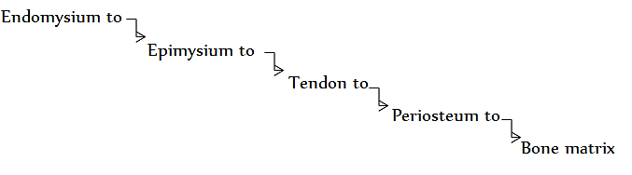
Example: biceps brachii muscle to the scapula
MICROSCOPIC ANATOMY OF SKELETAL MUSCLE
MUSCLE FIBER
- Structural unit- muscle cell or fiber (10-100µm thick, 1-30cm long)
- Each muscle fiber consists of a number of myofibrils-threadlike strands within muscle fibers
- Muscle fibers have multiple flattened or sausage shaped nuclei pressed against the inside of the plasma membrane.
- This unusual condition results from their embryonic development—several stem cells called myoblasts fuse to produce each muscle fiber, with each myoblast contributing a nucleus to the mature fiber.
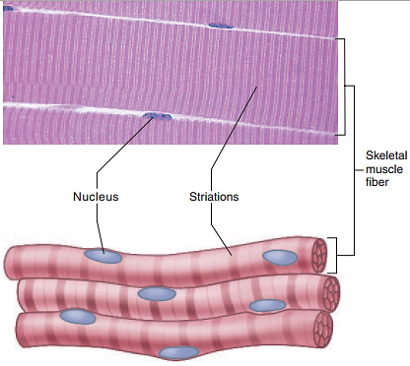
- The plasma membrane, called the sarcolemma, has tunnel-like infoldings called transverse (T) tubules that penetrate through the fiber and emerge on the other side.
- Function of a T tubule is carrying an electrical current from the surface of the cell to the interior when the cell is stimulated.
- The cytoplasm, called sarcoplasm, is occupied mainly by long protein bundles called myofibrils about 1 µm in diameter.
- Most other organelles of the cell, such as mitochondria and smooth endoplasmic reticulum (ER), are located between adjacent myofibrils.
- The sarcoplasm also contains:
- an abundance of glycogen, which provides stored energy for the muscle to use during exercise, and
- a red pigment called myoglobin, which binds oxygen until it is needed for muscular activity
- The smooth ER of a muscle fiber is called sarcoplasmic reticulum (SR).It forms a network around each myofibril, and alongside the T tubules it exhibits dilated sacs called terminal cisternae. T tubule and terminal cisternae together form Triad.
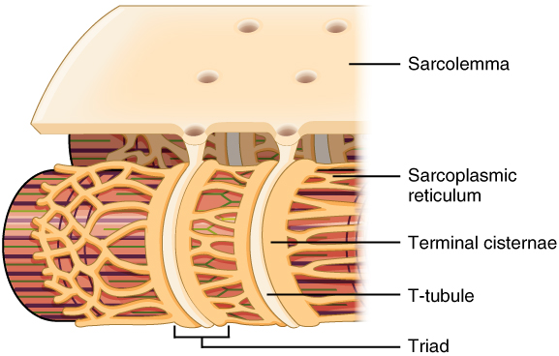
- The SR is a reservoir for calcium ions; it has gated channels in its membrane that can release a flood of calcium into the cytosol, where the calcium activates the muscle contraction process.
MYOFILAMENTS
Each myofibril is a bundle of parallel protein microfilaments called myofilaments
There are three kinds of myofilaments:
- Thick filaments
- About 15 nm in diameter and Made of several hundred molecules of a protein called myosin
- A myosin molecule is shaped like a golf club, with:
  - two polypeptides intertwined to form a shaft-like (rod) tail and
  - A double globular head, or cross-bridge, projecting from it at an angle
The myosin heads have three important properties:
- It can bind to active sites on the actin molecules to form cross-bridges.
- They are attached to the rod portion by a hinge region that can bend and straighten during contraction.
- It have ATPase activity, the enzymatic activity that breaks down adenosine triphosphate (ATP), releasing energy. Part of the energy is used to bend the hinge region of the myosin molecule during contraction.
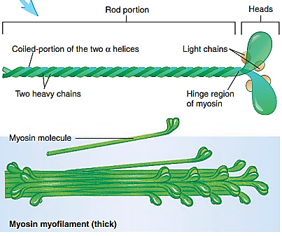

- Thin filaments
- About 7 nm in diameter,
- Composed primarily of two intertwined strands of a protein called fibrous (F) actin.
  - Each F actin is like a bead necklace—a string of subunits called globular (G) actin.
    - Each G actin has an active site that can bind to the head of a myosin molecule
- A thin filament also has 40 to 60 molecules of yet another protein called tropomyosin. When a muscle fiber is relaxed, tropomyosin blocks the active sites of six or seven G-actins, and prevents myosin cross-bridges from binding to them.
- Each tropomyosin molecule, in turn, has a smaller calcium-binding protein called troponin bound to it.
  - The complex of tropomyosin and troponin regulates the interaction between active sites on G-actin and Myosin.
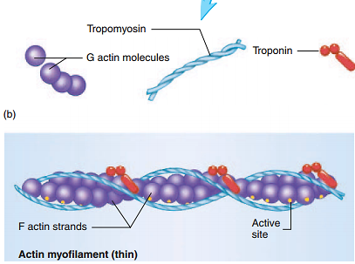
- Elastic filaments
1 nm in diameter, are made of a huge springy protein called titin (connectin).They run through the core of a thick filament, emerge from the end of it, and connect it to a structure called the Z disc. They help to
  - Keep thick and thin filaments aligned with each other,
  - Resist overstretching of a muscle, and
  - Help the cell recoil to resting length after it is stretched
- Myosin and actin are called the contractile proteins of muscle because they do the work of shortening the muscle fiber.
- Tropomyosin and troponin are called the regulatory proteins because they act like a switch to determine when it can contract and when it cannot.
STRIATION AND SACROMER
The characteristic dark and light striations of skeletal or cardiac muscle are due to the arrangement of these myofilaments.
- Dark bands are called A bands (A- stands for anisotropic)
- Light bands are called I bands (I- stands for isotropic)
- Each A-band consists of thick filament; each thick filament is surrounded by thin filaments
- In the middle of A-band, there is a lighter region called H-band, which thin filaments don’t reach
A dark band which found in the middle of H-zone called M-line, which helps to hold myosin filaments in place similar to Z-disk holds actin filaments in place.
- Each I-band is bisected by a dark narrow Z-disc (Z-line) composed of protein connectin

- Z-disc
  - provides anchorage for the thin filament and elastic filaments
  - form boundaries between two adjacent sarcomere
  - provides a filamentous network of protein forming a disk-like structure for the attachment of actin myofilaments
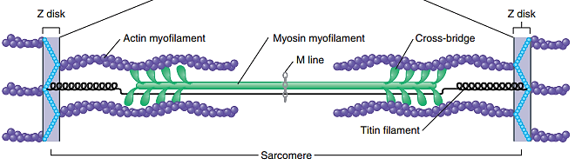
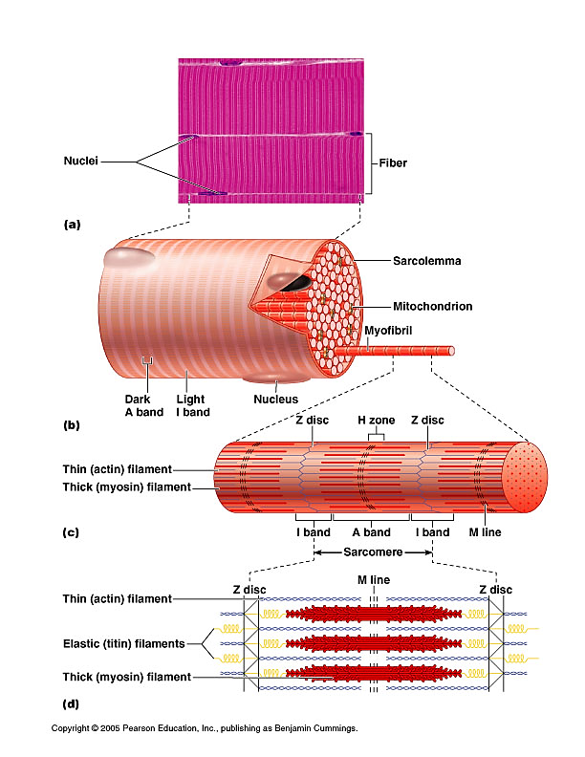
NERVE-MUSCLE RELATIONSHIP
Skeletal muscle never contracts unless it is stimulated by a nerve (or artificially with electrodes). If its nerve connections are severed or poisoned, a muscle is paralyzed. Muscle contraction cannot be understood without first understanding the relationship between nerve and muscle cells.
MOTOR NEURONS
Skeletal muscles are innervated by somatic motor neurons. The cell bodies of these neurons are in the brainstem and spinal cord. Their axons, called somatic motor fibers, lead to the skeletal muscles.
- At its distal end, each somatic motor fiber branches about 200 times, with each branch leading to a different muscle fiber. Each muscle fiber is innervated by only one motor neuron.
THE MOTOR UNIT
It consists of a single motor neuron and the aggregation of muscle fibers innervated by the motor neuron. When a nerve signal approaches the end of an axon, it spreads out over all of its terminal branches and stimulates all the muscle fibers supplied by them. Thus, these muscle fibers contract in unison. Since they behave as a single functional unit, one nerve fiber and all the muscle fibers innervated by it are called a motor unit.
- The muscle fibers of a single motor unit are not all clustered together but are dispersed throughout a muscle. Thus, when they are stimulated, they cause a weak contraction over a wide area—not just a localized twitches in one small region.
- Large motor units are much stronger, but have larger neurons over a wide area.
- Muscle fibers fatigue when subjected to continual stimulation, so the advantage of having multiple motor units in a muscle is that they are able to work in shifts and muscle as a whole can sustain long term contraction.
PHYSIOLOGY OF SKELETAL MUSCLE FIBERS
MEMBRANE POTENTIALS
- Plasma membranes are polarized, which means there is a voltage difference, or electrical charge difference, across the membrane before action potentials can be generated. This charge difference is called the resting membrane potential.
- The negative charge at the internal surface of the plasma membrane compared to its outer surface results mainly from the concentration differences of ions and charged molecules across the plasma membrane and to its permeability characteristics.
- The concentration of K⁺ inside the cell is much higher than its concentration outside the cell.
- The plasma membrane is relatively permeable to K⁺ and much less permeable to negatively charged molecules found inside the cell.
- Consequently, positively charged K⁺ tends to diffuse out of the cell leaving the negatively charged molecules behind.
ION CHANNELS
The diffusion of ions through these channels changes the charge across the plasma membrane and produces an action potential. Two types of gated ion channels are responsible for producing action potentials:
- Ligand-gated ion channels: A ligand is a molecule that binds to a receptor. A receptor is a protein or glycoprotein that has a receptor site to which a ligand can bind.
- Ligand-gated ion channels are channels which open in response to a ligand binding to a receptor that is part of the ion channel.
- For example, the axons of nerve cells supplying skeletal muscle fibers release ligands, called neurotransmitters, which bind to ligand-gated Na⁺ channels in the membrane of the muscle fibers. As a result, the Na⁺ channels open, allowing Na⁺ to enter the cell.
- Voltage-gated ion channels: These channels open and close in response to small voltage (charge) changes across the plasma membrane.
- When a nerve or muscle cell is stimulated, the charge difference changes and that cause voltage-gated ion channels to open or close.
- Ligand-gated and voltage-gated ion channels are specific for the type of ion that passes through them. The specific type of ion channels that opens determine what ions move across the plasma membrane.
  - For example, opening ligand-gated Na⁺ channels allows Na⁺ to cross the plasma membrane, whereas the opening of voltage-gated K⁺ channels allows K⁺ to cross.
- The concentration gradient for an ion determines whether that ion enters or leaves the cell after the ion channel, specific for that ion, opens.
- For example, there is a higher concentration of Na⁺ and Ca²⁺ outside the cell than inside it. Consequently, when gated Na⁺ channels open, Na⁺ moves through them into the cell. In a similar fashion, when gated Ca²⁺ channels open, Ca²⁺ moves into the cell.
ACTION POTENTIAL
- Action potential is a rapid rise and subsequent fall in voltage or membrane potential across a cellular membrane with a characteristic pattern.
- An action potential takes approximately 1 to a few milliseconds to occur, and it has two phases called depolarization and repolarization. Stimulation of a cell can cause depolarization of its plasma membrane.
  - Depolarization occurs when the inside of the plasma membrane becomes less negative, which is indicated by movement of the curve upward toward zero.
- The depolarization phase of an action potential is triggered if the depolarization changes the membrane potential to a value called threshold. The charge difference across the plasma membrane reverses when the membrane potential becomes a positive value.
  - Repolarization is the return of the membrane potential to its resting value.
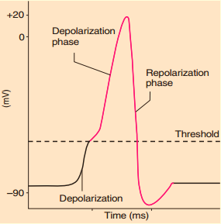
- Depolarization and repolarization result from the opening and closing of gated ion channels. Before a nerve or muscle cell is stimulated, these gated ion channels are closed. When the cell is stimulated, gated Na⁺ channels open, and Na⁺ diffuses into the cell.
- The positively charged Na⁺ makes the inside of the cell membrane less negative. If the depolarization reaches threshold, many voltage-gated Na⁺ channels open rapidly and Na⁺ diffuse into the cell until the inside of the membrane becomes positive for a brief time.
- Additional permeability changes in the plasma membrane stop depolarization and start repolarization shortly after the inside of the plasma membrane becomes positive.
- The repolarization phase results from the closing of gated Na⁺ channels and the opening of gated K⁺ channels. Thus, the movement of Na⁺ into the cell stops and the movement of K⁺ out of the cell increases.
- This change causes the inside of the plasma membrane to become more negative and the outside to become more positive. The action potential ends and the resting membrane potential is re-established when the gated K⁺ channels close.
1. Resting membrane potential
Gated Na⁺ channels (pink) and gated K⁺ channels (purple) are closed. The outside of the plasma membrane is positively charged compared to the inside.
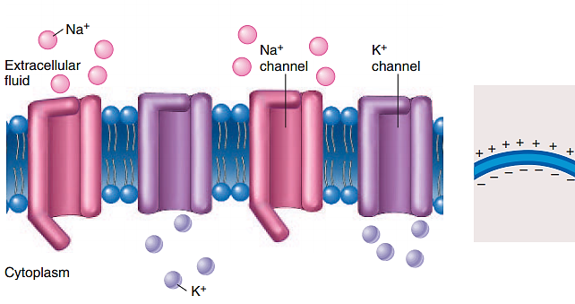
2. Depolarization.
Gated Na⁺ channels are open. Depolarization results because the inward movement of Na⁺ makes the inside of the membrane more positive.
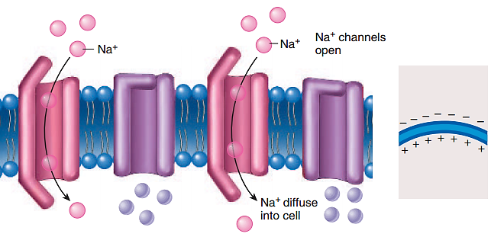
- Repolarization.
Gated Na+ channels are closed and gated K+ channels are open. Na+ movement into the cell stops and K+ move out of the cell, causing repolarization.
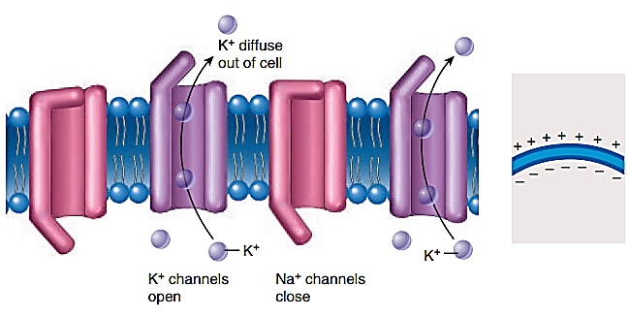

NEUROMUSCULAR JUNCTION
- The functional connection between a nerve fiber and its target cell is called a synapse. When the second cell is a muscle fiber, the synapse is called a neuromuscular junction.
- Each branch of a motor nerve fiber ends in a spherical swelling called a synaptic knob, which is nestled in a depression on the sarcolemma called the motor end plate.
- The two cells do not actually touch each other but are separated by a tiny gap, the synaptic cleft, about 60 to 100 nm wide.
- Each axon terminal is the presynaptic terminal. The space between the axon terminal and the muscle fiber is the synaptic cleft, and the muscle plasma membrane in the area of the junction is the postsynaptic membrane, or motor end-plate.
- Each presynaptic terminal contains numerous mitochondria and many small, spherical sacs approximately 45 µm in diameter, called synaptic vesicles. The vesicles contain acetylcholine
- A third cell, called a Schwann cell, envelops the entire neuromuscular junction and isolates it from the surrounding tissue fluid.
- The electrical signal (nerve impulse) traveling down a nerve fiber cannot cross the synaptic cleft like a spark jumping between two electrodes—rather; it causes the nerve fiber to release a neurotransmitter that stimulates the next cell.
  - Although many chemicals function as neurotransmitters, the one released at the neuromuscular junction is acetylcholine (ACh) an organic molecule composed of acetic acid and choline.
- Directly across from the synaptic vesicles, the sarcolemma of the muscle cell exhibits infoldings called junctional folds, about 1 µm deep.
- The muscle fiber has about 50 million membrane proteins called ACh receptors, which bind the acetylcholine release by the nerve fiber.
  - Most ACh receptors are concentrated in and near these junctional folds
  - Very few ACh receptors are found anywhere else on a muscle fiber
- Junctional folds increase the surface area for receptor sites and ensure a more effective response to ACh.
- The muscle nuclei beneath the junctional folds are specifically dedicated to the synthesis of ACh receptors and other proteins of the motor end plate.
- A deficiency of ACh receptors leads to muscle paralysis. The entire muscle fiber is surrounded by a basal lamina that passes through the synaptic cleft and virtually fills it.
- Both the sarcolemma and that part of the basal lamina in the cleft contain an enzyme called acetylcholinesterase (AChE), which breaks down ACh, shuts down the stimulation of muscle fibers, and allows a muscle to relax.
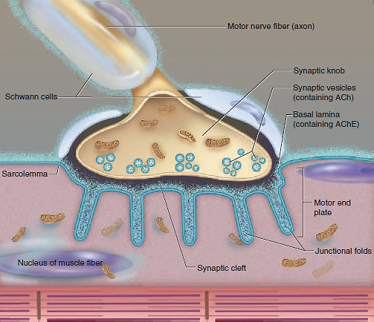
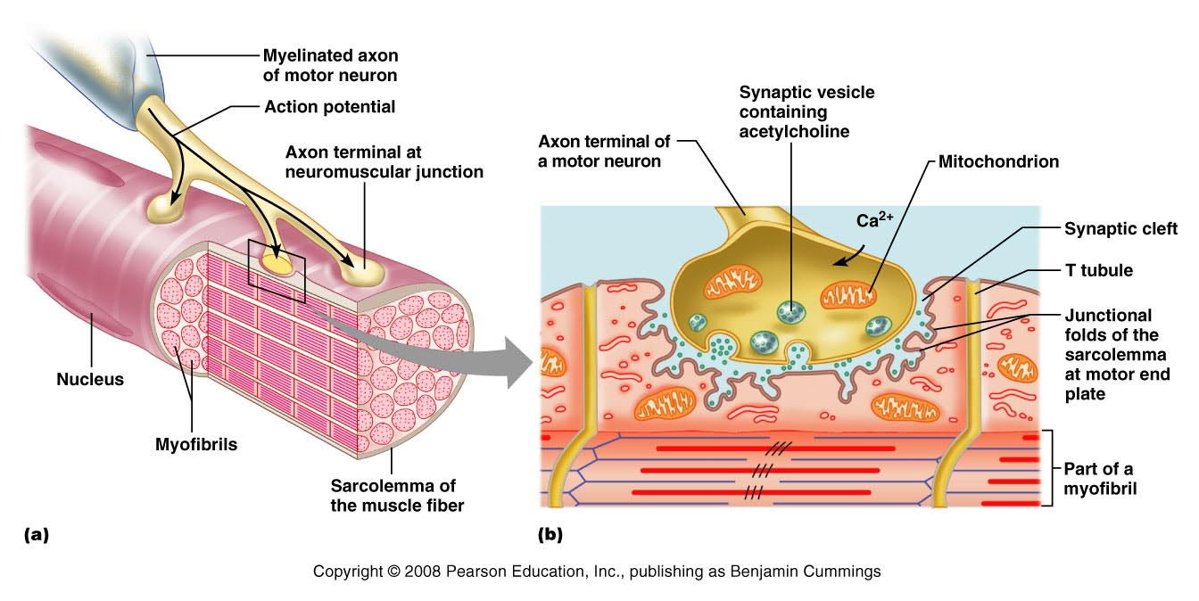
NEUROTRANSMITTER
- A neurotransmitter is a substance released from a presynaptic membrane that diffuses across the synaptic cleft and stimulates (or inhibits) the production of an action potential in the postsynaptic membrane.
- When an action potential reaches the presynaptic terminal, it causes voltage-gated calcium ion (Ca²⁺) channels in the plasma membrane of the axon to open, and as a result, Ca²⁺ diffuses into the cell.
- Once inside the cell, the ions cause the contents of a few synaptic vesicles to be secreted by exocytosis from the presynaptic terminal into the synaptic cleft. The acetylcholine molecules released from the synaptic vesicles then diffuse across the cleft and bind to receptor molecules located within the postsynaptic membrane. This causes ligand-gated Na⁺ channels to open, increasing the permeability of the membrane to Na⁺. Na⁺ then diffuses into the cell causing depolarization. In skeletal muscle, each action potential in the motor neuron causes a depolarization that exceeds threshold, resulting in the production of an action potential in the muscle fiber.
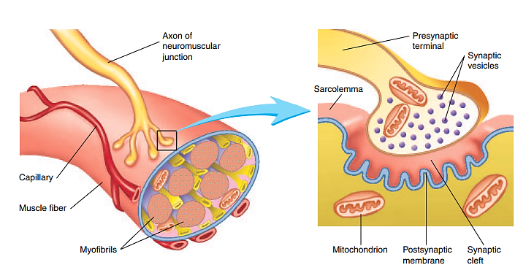
Figure: Neuromuscular Junction
- An action potential arrives at the presynaptic terminal causing voltage gated Ca²⁺ channels to open, increasing the Ca²⁺ permeability of the presynaptic terminal.
- Ca²⁺ enters the presynaptic terminal and initiates the release of a neurotransmitter, acetylcholine (ACh), from synaptic vesicles into the presynaptic cleft.
- Diffusion of ACh across the synaptic cleft and binding of ACh to ACh receptors on the postsynaptic muscle fiber membrane causes an increase in the permeability of ligand-gated Na⁺ channels.
- The increase in Na⁺ permeability results in depolarization of the postsynaptic membrane; once threshold has been reached a postsynaptic action potential results.
- Once ACh is released into the synaptic cleft it binds to the receptors for ACh on the postsynaptic membrane and causes Na⁺ channels to open.
- ACh is rapidly broken down in the synaptic cleft by acetylcholinesterase to acetic acid and choline.
- The choline is reabsorbed by the presynaptic terminal and combined with acetic acid to form more ACh, which enters synaptic vesicles. Acetic acid is taken up by many cell types
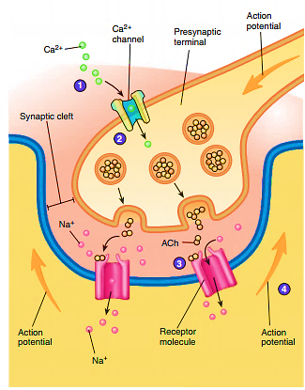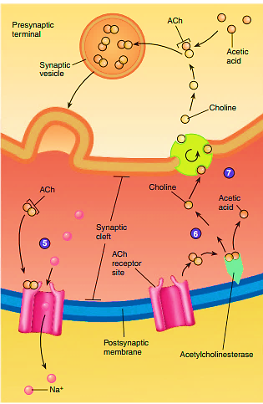
Figure: Process of Neuromuscular Junction
The process of muscle contraction and relaxation can be viewed as occurring in four major phases:
(1) Excitation,
(2) Excitation-contraction coupling,
(3) Contraction, and
(4) Relaxation
- EXCITATION: is the process in which action potentials in the nerve fiber lead to action potentials in the muscle fiber. The steps in excitation are;
1. A nerve signal arrives at the synaptic knob and stimulates voltage-gated calcium channels to open. Calcium ions enter the synaptic knob.
2. Calcium ions stimulate exocytosis of the synaptic vesicles, which release acetylcholine (ACh) into the synaptic cleft. One action potential causes exocytosis of about 60 synaptic vesicles, and each vesicle releases about 10,000 molecules of ACh.
3. ACh diffuses across the synaptic cleft and binds to receptor proteins on the sarcolemma.
4. These receptors are ligand-gated ion channels. When ACh (the ligand) binds to them, they change shape and open an ion channel through the middle of the receptor protein. Each channel allows Na⁺ to diffuse quickly into the cell and K⁺ to diffuse outward.
- As a result of these ion movements, the sarcolemma reverses polarity—its voltage quickly jumps from the RMP of +90 mV to a peak of -75 mV as Na⁺ enters, and then falls back to a level close to the RMP as K⁺ diffuses out. This rapid fluctuation in membrane voltage at the motor end plate is called the end-plate potential (EPP).
5. Areas of sarcolemma next to the end plate have voltage-gated ion channels that open in response to the EPP. Some of the voltage-gated channels are specific for Na⁺ and admit it to the cell, while others are specific for K⁺ and allow it to leave. These ion movements create an action potential. The muscle fiber is now excited.
- EXCITATION–CONTRACTION COUPLING
Action potentials produced in the sarcolemma of a skeletal muscle fiber can lead to contraction of the fiber. The mechanism by which an action potential causes contraction of a muscle fiber is called excitation-contraction coupling and it involves the sarcolemma, T tubules, sarcoplasmic reticulum, Ca²⁺, and troponin.
Excitation-contraction coupling refers to the events that link the action potentials on the sarcolemma to activation of the myofilaments, thereby preparing them to contract. The action potential is propagated along the entire sarcolemma of the muscle fiber.
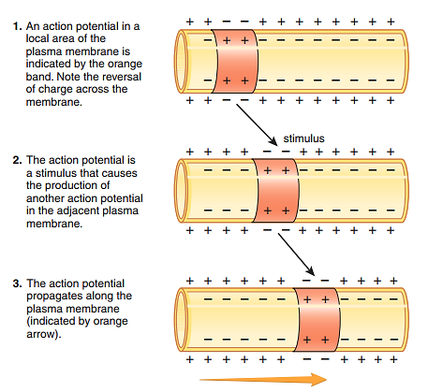
Figure: Action Potential Propagation
6. A wave of action potentials spreads from the end plate in all directions, like ripples on a pond. When this wave of excitation reaches the T tubules, it continues down them into the sarcoplasm.
7. Action potentials open voltage-regulated ion gates in the T tubules. These are physically linked to calcium channels in the terminal cisternae of the sarcoplasmic reticulum (SR), so gates in the SR open as well and calcium ions diffuse out of the SR, down their concentration gradient and into the cytosol.
8. The calcium ions bind to the troponin of the thin filaments.
9. The troponin-tropomyosin complex changes shape and shifts to a new position. This exposes the active sites on the actin filaments and makes them available for binding to myosin heads.
- CONTRACTION
Contraction is the step in which the muscle fiber develops tension and may shorten. (Muscles often “contract,” or develop tension, without shortening).
SLIDING FILAMENT THEORY
This theory holds that the thin filaments slide over the thick ones and pull the Z discs behind them, causing the cell as a whole to shorten.
10. During contraction of a muscle, Ca²⁺ binds to troponin, causing exposure of active sites on actin myofilaments.
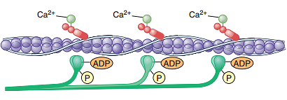
11. The myosin molecules attach to the exposed active sites on the actin myofilaments to form cross-bridges, and phosphate (P) is released from the myosin head.
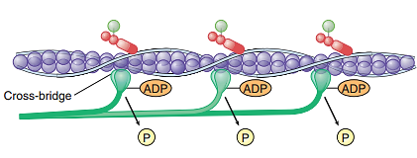
12. Myosin ATPase, an enzyme in the head, hydrolyzes this ATP. The energy released by this process activates the head, which “cocks” into an extended, high-energy position and to move the head of the myosin. Movement of the head causes the actin myofilament to slide past the myosin myofilament. The head temporarily keeps the ADP and phosphate group bound to it. ADP is released from the myosin head.
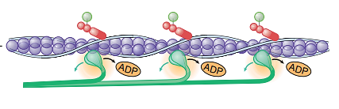
13. An ATP molecule binds to the myosin head resulting in the release of actin from myosin.
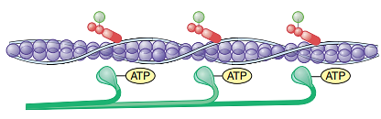
14. The ATP is broken down to ADP and phosphate, which remain bound to the myosin head, the head of the myosin molecule returns to its resting position, and energy is stored in the head of the myosin molecule. If Ca²⁺ is still attached to troponin, cross-bridge formation and movement are repeated (return to step 1). This cycle occurs many times during a muscle contraction.
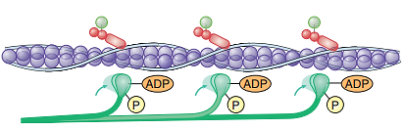

11. The cocked myosin binds to an active site on the thin filament.
12. Myosin releases the ADP and phosphate and flexes into a bent, low-energy position, tugging the thin filament along with it. This is called the power stroke. The head remains bound to actin until it binds a new ATP.
13. Upon binding more ATP, myosin releases the actin. It is now prepared to repeat the whole process—it will hydrolyze the ATP, recock (the recovery stroke), attach to a new active site farther down the thin filament, and produce another power stroke.
- RELAXATION
When its work is done, a muscle fiber relaxes and returns to its resting length.
15. Nerve signals stop arriving at the neuromuscular junction, so the synaptic knob stops releasing ACh.
16. As ACh dissociates (separates) from its receptor, acetylcholinesterase breaks it down into fragments that cannot stimulate the muscle. The synaptic knob reabsorbs these fragments for recycling. All of this happens continually while the muscle is being stimulated, too; but when nerve signals stop, no new ACh is released to replace that which is broken down. Therefore, stimulation of the muscle fiber by ACh ceases.
17. Active transport pumps in the sarcoplasmic reticulum (SR) begin to pump Ca²⁺ from the cytosol back into the cisternae. Here, the calcium binds to a protein called calsequestrin and is stored until the fiber is stimulated again. Since active transport requires ATP, you can see that ATP is needed for muscle relaxation as well as for muscle contraction
18. As calcium ions dissociate from troponin, they are pumped into the SR and are not replaced.
19. Tropomyosin moves back into the position where it blocks the active sites of the actin filament. Myosin can no longer bind to actin, and the muscle fiber ceases to produce or maintain tension.
FATIGUE
- Fatigue is the decreased capacity to do work and the reduced efficiency of performance that normally follows a period of activity. The rate at which individuals develop fatigue is highly variable, but it’s a phenomenon that everyone has experienced.
- Fatigue can develop at three possible sites: the nervous system, the muscles, and the neuromuscular junction.
  - Psychologic fatigue, the most common type of fatigue, involves the central nervous system. The muscles are capable of functioning, but the individual “perceives” that additional muscular work is not possible.
    - A burst of activity in a tired athlete in response to encouragement from spectators is an illustration of how psychologic fatigue can be overcome. The onset and duration of psychologic fatigue vary greatly and depend on the emotional state of the individual.
  - Muscular fatigue is the second most common type of fatigue occurs in the muscle fiber results from ATP depletion.
    - Without adequate ATP levels in muscle fibers, cross-bridges cannot function normally. As a consequence, the tension that a muscle is capable of producing declines.
    - Example: Fatigue in the lower limbs of marathon runners or in the upper and lower limbs of swimmers.
- Synaptic fatigue is the least common type of fatigue occurs in the neuromuscular junction.
  - If the action potential frequency in motor neurons is great enough, the release of acetylcholine from the presynaptic terminals is greater than the rate of acetylcholine synthesis.
  - As a result, the synaptic vesicles become depleted, and insufficient acetylcholine is released to stimulate the muscle fibers.
  - Under normal physiologic conditions, fatigue of neuromuscular junctions is rare; however, it may occur under conditions of extreme exertion.

