HOMEOSTASIS
INTRODUCTION
- The term homeostasis comes from two Greek words, homeo, which means “the same,” and stasis, which means “standing” Literally translated, homeostasis means “staying the same.”
  - Thus, many people refer to homeostasis as a state of internal constancy. In reality, homeostasis is not a static state; rather, it is a dynamic (ever-changing) state.
- Homeostasis also defined as a physiological process by which the internal systems of the body are maintained at equilibrium despite variations in the external conditions.
WHY HOMEOSTASIS?
- The organ systems help control the body’s internal environment so that it remains relatively constant. For example, the digestive, respiratory, circulatory, and urinary systems function together so that each cell in the body receives adequate oxygen and nutrients and so that waste products do not accumulate to a toxic level.
- If the fluid surrounding cell deviates from homeostasis, the cells do not function normally and can even die. Disruption of homeostasis results in disease and sometimes death. So, it is essential for survival and function of all cells.
- For instance, the lungs provide oxygen to the extracellular fluid to replenish the oxygen used by the cells, the kidneys maintain constant ion concentrations, and the gastrointestinal system provides nutrients.
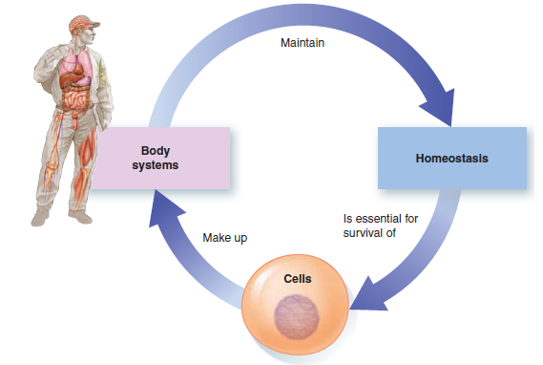
CONTRIBUTIONS OF THE BODY SYSTEMS TO HOMEOSTASIS
The 11 body systems contribute to homeostasis in the following important ways
- The Circulatory System: (heart, blood vessels, and blood) transports materials such as nutrients, O₂, CO₂, wastes, electrolytes, and hormones from one part of the body to another.
- The Digestive System: (mouth, esophagus, stomach, intestines, and related organs) breaks down dietary food into small nutrient molecules that can be absorbed into the plasma for distribution to the body cells. It also transfers water and electrolytes from the external environment into the internal environment. It eliminates undigested food residues to the external environment in the feces.
- The Respiratory System: (lungs and major airways) gets O₂ from and eliminates CO₂ to the external environment. By adjusting the rate of removal of acid-forming CO₂, the respiratory system is also important in maintaining the proper pH of the internal environment.
- The Urinary System: (kidneys and associated “plumbing”) removes excess water, salt, acid, and other electrolytes from the plasma and eliminates them in the urine, along with waste products other than CO₂.
- The Skeletal System: (bones and joints) provides support and protection for the soft tissues and organs. It also serves as a storage reservoir for calcium (Ca²⁺), an electrolyte whose plasma concentration must be maintained within very narrow limits. Together with the muscular system, the skeletal system also enables movement of the body and its parts. Furthermore, the bone marrow the soft interior portion of some types of bone is the ultimate source of all blood cells.
- The Muscular System: (skeletal muscles) moves the bones to which the skeletal muscles are attached. From a purely homeostatic view, this system enables an individual to move toward food or away from harm.
- Furthermore, the heat generated by muscle contraction is important in temperature regulation. In addition, because skeletal muscles are under voluntary control, a person can use them to accomplish myriad other movements of his or her own choice. These movements, which range from the fine motor skills required for delicate needlework to the powerful movements involved in weight lifting, are not necessarily directed toward maintaining homeostasis.
- The Integumentary System; (skin and related structures) serves as an outer protective barrier that prevents internal fluid from being lost from the body and foreign microorganisms from entering. This system is also important in regulating body temperature.
- The amount of heat lost from the body surface to the external environment can be adjusted by controlling sweat production and by regulating the flow of warm blood through the skin.
- The Immune System (white blood cells, lymphoid organs) defends against foreign invaders such as bacteria and viruses and against body cells that have become cancerous.
- It also paves the way for repairing or replacing injured or worn-out cells.
- The Nervous System: (brain, spinal cord, nerves, and sense organs) is one of the body’s two major regulatory systems. In general, it controls and coordinates bodily activities that require swift responses.
- It is especially important in detecting changes in the external environment and initiating reactions to them.
- Furthermore, it is responsible for higher functions that are not entirely directed toward maintaining homeostasis, such as consciousness, memory, and creativity.
- The Endocrine System (all hormone-secreting glands) is the other major regulatory system.
- In contrast to the nervous system, the endocrine system in general regulates activities that require duration rather than speed, such as growth.
- It is especially important in controlling the concentration of nutrients and, by adjusting kidney function, controlling the volume and electrolyte composition of the ECF.
- The reproductive system: (male and female gonads and related organs) is not essential for homeostasis and therefore is not essential for survival of the individual. It is essential, however for perpetuating the species.
- As we examine each of these systems in greater detail, always keep in mind that the body is a coordinated whole even though each system provides its own special contributions.
It is easy to forget that all the body parts actually fit together into a functioning, interdependent whole body.
FACTORS HOMEOSTATICALLY REGULATED
Many factors of the internal environment must be homeostatically maintained. They include the following:
- CONCENTRATION OF NUTRIENTS: Cells need a constant supply of nutrient molecules for energy production. Energy, in turn, is needed to support life-sustaining and specialized cell activities.
- CONCENTRATION OF O₂ AND CO₂: Cells need O₂ to carry out energy-yielding chemical reactions. The CO₂ produced during these reactions must be removed so that acid-forming CO₂ does not increase the acidity of the internal environment.
- CONCENTRATION OF WASTE PRODUCTS: Some chemical reactions produce end products that have a toxic effect on the body’s cells if these wastes are allowed to accumulate.
- pH: Changes in the pH (relative amount of acid) of the extra cellular fluids (ECF) adversely affect nerve cell function and wreak havoc with the enzyme activity of all cells.
- CONCENTRATION OF WATER, SALT AND OTHER ELECTROLYTES: Because the relative concentrations of salt (NaCl) and water in the ECF influence how much water enters or leaves the cells, these concentrations are carefully regulated to maintain the proper volume of the cells.
- Cells do not function normally when they are swollen or shrunken. Other electrolytes (chemicals that form ions in solution and conduct electricity) perform a variety of vital functions. For example, the rhythmic beating of the heart depends on a relatively constant concentration of potassium (K) in the ECF.
- VOLUME AND PRESSURE: The circulating component of the internal environment, the plasma, must be maintained at adequate volume and blood pressure to ensure body wide distribution of this important link between the external environment and the cells.
- TEMPERATURE: Body cells function best within a narrow temperature range. If cells are too cold, their functions slow down too much; if they get too hot, their structural and enzymatic proteins are impaired or destroyed.
HOMEOSTATIC CONTROL SYSTEM
A homeostatic control system is a functionally interconnected network of body components that operate to maintain a given factor in the internal environment relatively constant around an optimal level. To maintain homeostasis, the control system must be able to
- Detect deviations from normal in the internal environmental factor that needs to be held within narrow limits;
- Integrate this information with any other relevant information; and
- Make Appropriate Adjustments in the activity of the body parts responsible for restoring this factor to its desired value.
- All Homeostatic Feedback Mechanisms Contain a Sensor (or Receptor), Control center and an Effector; they are the Three interdependent components of control mechanisms.
- RECEPTOR – monitors the environments and responds to changes (stimuli)
- CONTROL CENTER – receives information from receptors and send signals to the set point at which the variable is maintained
- EFFECTOR – cells or organs that respond to the control center to respond to stimuli
- In your body, for instance, specially modified nerve cell endings in the skin detect temperature changes in the environment. These sensors not only detect changes in the ambient (outside) temperature, but also send signals to the brain, alerting it to such changes.
- The brain then sends signals to the body to rectify matters-usually to reduce heat loss and increase heat output. The options for generating more heat are many. In other words, the body contains several different types of effectors.
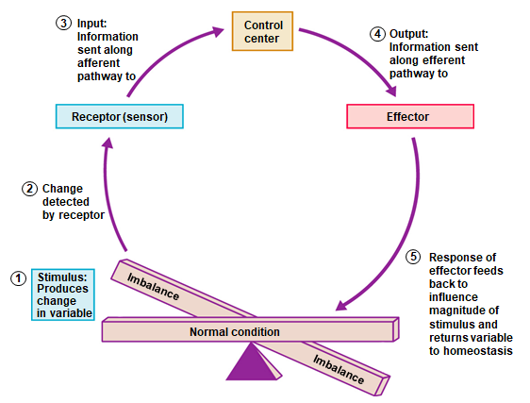

FEED BACK MECHANISM
- The term feedback refers to responses made after a change has been detected; the term feedforward is used for responses made in anticipation of a change. Effectors either enhance or oppose the original stimulus: two types of feedback mechanisms;
- Negative Feedback
- Positive Feedback
NEGATIVE FEEDBACK
- Negative feedback opposes an initial change and is widely used to maintain homeostasis. Homeostatic control mechanisms operate primarily on the principle of negative feedback.
- In negative feedback, a change in a homeostatically controlled factor triggers a response that seeks to restore the factor to normal by moving the factor in the opposite direction of its initial change.
- The most common examples are:
- Regulation of room temperature
- Osmoregulation
- Acid–base regulation
- regulation of blood glucose level
- Regulation of hormone synthesis
- Most systems of the body are regulated by negative-feedback mechanisms that maintain homeostasis
POSITIVE FEEDBACK
- Positive-feedback responses are not homeostatic and are rare in healthy individuals. Positive implies that, when a deviation from a normal value occurs, the response of the system is to make the deviation even greater. Positive feedback therefore usually creates a cycle that leads away from homeostasis
Examples:
When a woman is giving birth, the head of the baby pushes against her cervix (the neck of the uterus) and stimulates its nerve endings.
- Nerve signals travel to the brain, which, in turn, stimulates the pituitary gland to secrete the hormone oxytocin.
- Oxytocin travels in the blood and stimulates the uterus to contract. This pushes the baby downward, stimulating the cervix still more and causing the positive feedback loop to be repeated.
- Labor contractions therefore become more and more intense until the baby is expelled.
- Other cases of beneficial positive feedback in blood clotting, protein digestion, and the generation of nerve signals.

- 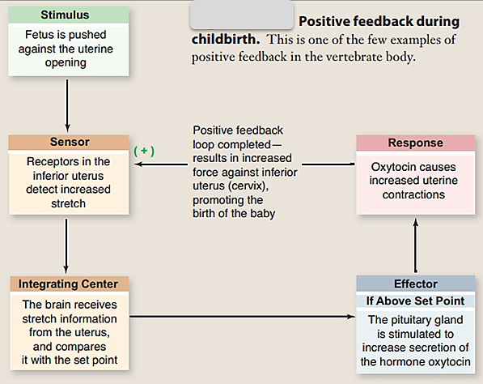

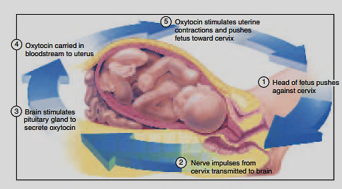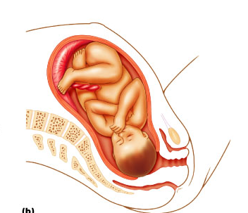
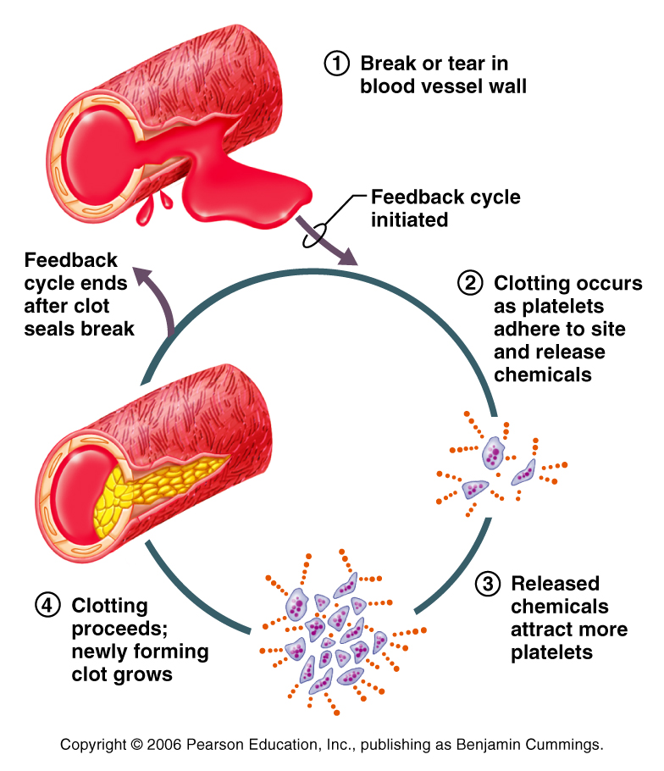

'HARMFUL POSITIVE FEEDBACK'
Although Positive Feedback is needed within Homeostasis it also can be harmful at times. When you have a high fever it causes a metabolic change that can push the fever higher and higher. In rare occurrences the body temperature reaches 113 degrees and the cellular proteins stop working and the metabolism stops, resulting in death.
DISRUPTIONS IN HOMEOSTASIS CAN LEAD TO ILLNESS AND DEATH
- Despite control mechanisms, when one or more of the body’s systems malfunction, homeostasis is disrupted, and all the cells suffer because they no longer have an optimal environment in which to live and function.
- Various pathophysiological states develop, depending on the type and extent of the disruption.
- The term pathophysiology refers to the abnormal functioning of the body (altered physiology) associated with disease. When a homeostatic disruption becomes so severe that it is no longer compatible with survival, death results.
THERMOREGULATION
The survival of living beings greatly depends on their capability to maintain a stable body temperature irrespective of temperature of surrounding environment. This capability of maintaining body temperature is called thermoregulation.
Body temperature depends on the heat produced minus the heat lost.
Heat is lost by
- Radiation,
- Convection and
- Conduction
However, the net loss by all three processes depends on a gradient between the body and the outside.
- Thus, when the external temperature is low, radiation is the most important form of heat loss.
- When there is a high external temperature, evaporation is the most important form of heat loss.
The balance of heat produced and heat lost maintains a constant body temperature. However, temperature does vary during the day, and this set point is controlled by the hypothalamus.
- Body temperature is usually about 37.4°C, but does vary during the day by about 0.8°C. The lowest daily temperature is when the person is asleep.
- Temperature receptors are found in the skin, the great veins, and the abdominal organs and the hypothalamus. While the ones in the skin provide the sensation of coldness, the hypothalamic (central core) temperature receptors are the most important.
- The hypothalamus responds by promoting the dissipation of heat through sweating, dilation and constriction of blood vessels in the skin, and other mechanisms. These responses tend to counteract the rise in body temperature.

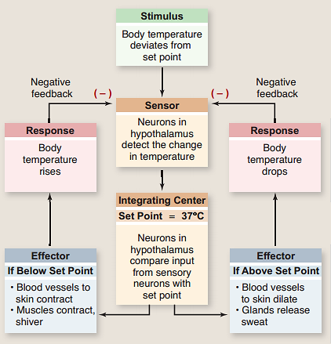
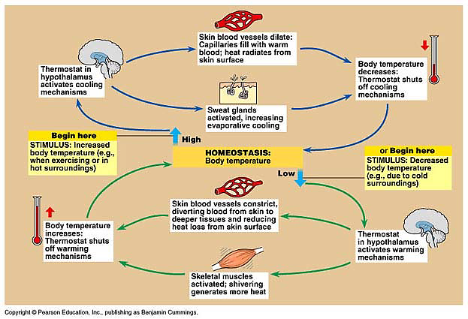
One of the most important examples of homeostasis is the regulation of body temperature. Not all animals can do this physiologically. Animals that maintain a fairly constant body temperature (birds and mammals) are called endotherms, while those that have a variable body temperature (all others) are called ectotherms. Endotherms normally maintain their body temperatures at around 35 - 40°C, so are sometimes called warm-blooded animals, but in fact ectothermic animals can also have very warm blood during the day by basking in the sun, or by extended muscle activity 9e.g. bumble bees, tuna). The difference between the two groups is thus that endothermic animals use internal corrective mechanisms, whilst ectotherms use behavioral mechanisms (e.g. lying in the sun when cold, moving into shade when hot). Such mechanisms can be very effective, particularly when coupled with internal mechanisms to ensure that the temperature of the blood going to vital organs (brain, heart) is kept constant. We use both!
In humans, body temperature is controlled by the thermoregulatory centre in the hypothalamus. It receives input from two sets of thermoreceptors: receptors in the hypothalamus itself monitor the temperature of the blood as it passes through the brain (the core temperature), and receptors in the skin (especially on the trunk) monitor the external temperature. Both sets of information are needed so that the body can make appropriate adjustments. The thermoregulatory centre sends impulses to several different effectors to adjust body temperature:
