UNIT SEVEN: THE ENDOCRINE SYSTEM

Endocrine system consists of specialized glands located in different parts of the body. Endocrine glands are glands have no ducts, so they are called ductless glands. These gland secrete chemicals substances called hormones.
Endocrinology is the study of hormones and the endocrine endocrine glands. The endocrine system interacts with the nervous system to coordinate and integrate the activity of body cells.
7.1. Endocrine glands/organs and their functions
The organs of endocrine system are not structurally connected but distributed in different body regions (Fig. 7.1). The pituitary gland, the hypothalamus, and the pineal gland are associated with the brain. The thyroid gland and parathyroid glands are located in the neck. The adrenal glands and pancreas are located within the abdominal region. The gonads (ovaries) of the female are located within the pelvic cavity, whereas the gonads (testes) of the male are located in the scrotum. The pancreas and gonads are frequently classified as mixed glands because they have exocrine as well as endocrine functions.
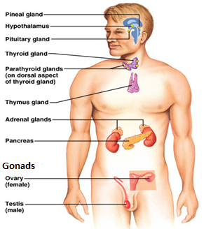
Fig 7.1. Major organs of the endocrine system

7.1.1 Pituitary glands
It is very small, pea sized gland present just below the hypothalamus in the brain and produces several hormones. It is referred as to the ' master gland'. It consists of two lobes. These are anterior and posterior lobes.
I. Anterior pituitary lobe: is connected to hypothalamus by portal blood vessels It produces seven hormones, each with specific action.
- Adrenocorticotropic hormone ( ACTH): stimulates the cortex of adrenal gland and influence metabolism.
- Thyroid stimulating hormone (TSH): stimulates secretion of thyroid hormone, which has widespread effects on the body’s metabolism.
- Follicle stimulating hormone (FSH): stimulate (initiate) the development of ovarian follicle and spermatogenesis.
- Lutenizing hormone (LH): stimulate ovulation and production of progesterone and testosterone.
- Growth hormone (GH): Promote protein synthesis and fatty acid break down to stimulate growth.
- Prolactin (PRL): stimulates mammary glands to synthesize milk.
- Melanocyte stimulating hormone (MSH): stimulates melanocytes to synthesize melanin

II. Posterior pituitary Lobe: It is connected to hypothalamus by nerve fiber. It stores two hormones by hypothalamus.
- Vasopressin (Antidiuretic Hormone or ADH): promotes water conservation. ADH acts on the kidneys to increase water retention, reduce urine volume, and help prevent dehydration.
- Oxytocin: stimulate the contraction of the uterus at the time of childbirth or delivery.

7.1.2. Thyroid gland
It is a bow -tie shaped gland present just below the larynx (in front of the neck). The thyroid gland consists of 2 lobes, connected to each other. It produces three hormones.
A. Thyroxine: controls metabolic rate, and growth. It also promotes alertness & bone growth
B. Triiodothyronine: same function as thyroxine
C. Calcitionin: decreases blood calcium level and increases excretion of calcium by kidney.
- The thyroid gland produces hormones when it is activated by thyroid stimulating hormone (TSH) from anterior pituitary.
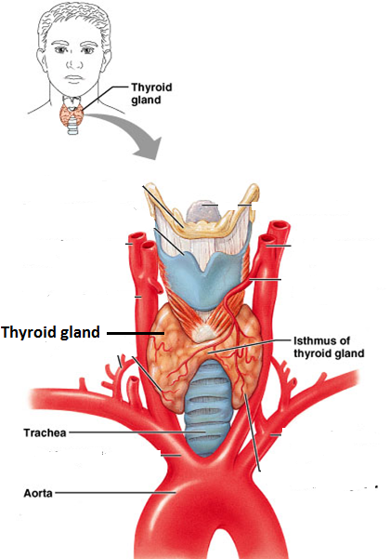
Fig. 7.1.2. Thyroid gland

7.1.3. Parathyroid gland
It is found embedded on the dorsal surface of the thyroid gland. It produces parathyroid hormone (PTH). It increases the calcium level and decreases the phosphate level in the blood plasma. It increases the uptake of calcium ions by the gut and their re-absorption in the kidney.

7.1.4. Pineal gland
It is a small cane-shaped gland located in the mid brain area and produces two hormones. melatonin and serotonin. In animals with seasonal breeding, it regulates the gonads and the annual breeding cycle. Melatonin may suppress gonadotropin secretion; removal of the pineal from animals causes premature sexual maturation.
7.2.5. Thymus gland
The thymus is located in the mediastinum superior to the heart. Like the pineal, it is large in infants and children but involutes after puberty.
The thymus secretes thymopoietin and thymosins, hormones that regulate the development and later activation of disease-fighting blood cells called T lymphocytes (T for thymus) and helps in immune response.
7.1.6. Adrenal gland
These are 2 small yellowish conical glands, each present just above the kidney. Each adrenal gland is of 2 distinct regions, the outer, cortex and the inner, medulla.
a) Adrenal Medulla (a knot of nervous tissue)
About three-quarters of the output is epinephrine. These hormones supplement the effects of the sympathetic nervous system, but their effects last much longer (about 30 min.)

I. Adrenal cortex: produces steroid hormones e.g. of two general types are:
A. Gluco-corticoids: are principally metabolism hormones and are secreted in response to

ACTH. They stimulate fat and protein catabolism, gluconeogenesis, and release of acids and glucose into the blood.
secretion, play a role in adjustment to stress and raise blood sugar levels.
B. Mineralocorticoids: act on the kidneys to control electrolyte balance. E.g. aldosterone, promotes Na⁺ retention and K⁺ excretion by the kidneys.
II. Adrenal medulla: it forms the central core of adrenal gland. It produces two structurally similar hormones.
A . Adrenaline - also called as epinephrine
B . Noraderaline - are called as norepinhrine
Adrenal medulla is actually modified postganglionic sympathetic neurons. It is active during emergencies for “fight, flight and fright” response. Effects of the hormones includes increase in blood pressure & blood sugar level, dilation of eye pupils, decrease gastro-intestinal activity, etc.
7.1.7. The Pancreas
Pancreas is located retroperitoneally, inferior and dorsal to the stomach (fig. 7.1). It is approximately 15 cm long and 2.5 cm thick. It contains both an exocrine digestive gland, endocrine cell clusters called pancreatic islets (islets of Langerhans).
There are two main endocrine cell types:
  - Alpha cells (α cells) – secrete glucagon
    - Signals liver to release glucose from glycogen
    - Raises blood sugar
  - Beta cells (β cells) – secrete insulin
    - Signals most body cells to take up glucose from the blood
    - Promotes storage of glucose as glycogen in liver
    - Lowers blood sugar
7.1.8. Sex hormones ( Gonads)
Male gonads are called testis and female gonads are ovaries. Although gonads are reproductive organs that produce gametes, they are also the endocrine glands that produce the sex hormones. Sex hormones are responsible for secondary sexual characteristics and secreted at on set of puberty. These hormones are under the control of pituitary gland. It contains two hormones, i.e., male sex hormone and female sex hormone

I. Male Sex hormone: the male sex hormone called testosterone. Role of testosterone includes:-
- Stimulating the growth and development of male sex organs
- stimulate development of male secondary sexual characters like development of beard, deepening of voice, broadening of shoulders etc.
- Stimulating the formation of sperm in testes.
- Stimulating the lengthening of long bones and causes a marked support of growth during
puberty.
- It is also associated with a simultaneous support in mental growth.

II. Female Sex hormone
Pair of ovaries produce egg cells (ova) as well as the female sex hormones. These hormones are estrogen and progesterone.

Role of estrogen are:
- It stimulates the growth and development of female secondary sex organs like uterus,
fallopian tubes and duct system of mammary glands.
- It is responsible for the development and maintenance of female sex characters
like female voice and the pattern of hair distribution.
- It controls menstrual cycle.

Role of progesterone are:
- It stimulates the secretion of mucus and further thickening of the uterus lining during the
Ovarian cycle.
- It is basically associated with the changes necessary for implantation of embryo,
pregnancy and changes thereafter in the body.
- It brings about the formation of placenta that attaches the fetus to the mother.
- It also stimulates the growth of secretary alveolar cells in mammary glands.

7.1.9. Other endocrine cell containing organs
Endocrine cells occur within the following organs:
a) The heart: produces atrial natriuretic peptide (ANP). ANP increases sodium excretion and urine, lower the blood pressure
b) The GI tract: contains enteroendocrine cells that secrete at least 10 enteric hormones. These hormones coordinate the different regions and glands of the digestive system
c) The placenta: secretes estrogen, progesterone, and other hormones. These help regulate pregnancy and stimulate development of the fetus and the mother’s mammary glands
d) The skin: Keratinocytes produce vitamin D3, the first step in the synthesis of calcitriol.
e) The liver: secretes erythropoietin (EPO). EPO is important in red blood cell formation.
f) The kidneys: the kidneys also produce about 85% of our EPO.

7.2. Mechanism of Hormone actions
Hormones are secreted in one part of the body, transported through the blood stream and acting on cells in different parts of the body carrying information from one set of cells to another. This information enables the organism to adjust various activities of the body to the changing demands of external and internal environment. In general, the function of endocrine system is to control, coordinate and integrate various physiological processes and activates of the body.
Basic hormone action
  - Secreted into the blood
  - They circulate throughout the body in blood vessels
  - Influences only specific tissues – target cells
    - Only those organs having the specific receptors respond to the hormone
  - A hormone can have different effects on different target cells
  - Rapidly destroyed so that new messages can be sent
  - Involved in homeostasis and adaptation
7.3. Some example of endocrine system disorders
Diseases could be caused due to insufficient hormone production or due to excess hormone productions by endocrine glands.

Pituitary gland
- Low hormone secretion causes dwarfism and is due to disorders in anterior lobe. Dwarfism is when the body doesn't grow to normal.
- Over secretion of the hormone can cause gigantism. Gigantism is when the whole body grows more than normal.
  - Acromegly- is when increased, non-proportional growth is caused on different body parts, such as hands, feet etc.
- Diabetes insipidus: disorders of posterior lobe of Pituitary gland, a disease, characterized by excretion of abnormally large quantities of urine and dehydration.
Thyroid gland
- Cretinism, a disease resulting in dwarfism and mental retardation, due to reduced level hormones
- Goiter on the neck region: an enlargement of the thyroid. Deficiency of iodine is the source of this disorder.
Pancreas of Islets of Lagerhan's
- Diabetes mellitus: due to less amount of insulin, which is characterized by increase urine and loss of much sugar in urine
Gonads- disorders related to sex hormones may lead to sterility in males and females.

