CHAPTER TEN

DIGESTIVE SYSTEM

10.1 Introduction

The human digestive system is made up of a group of organs working together. The digestive tract is made up of the mouth, esophagus, stomach, small intestine, and the large intestine. There are also associated organs that support the digestive tract, such as; the liver, gall bladder, and the pancreas.

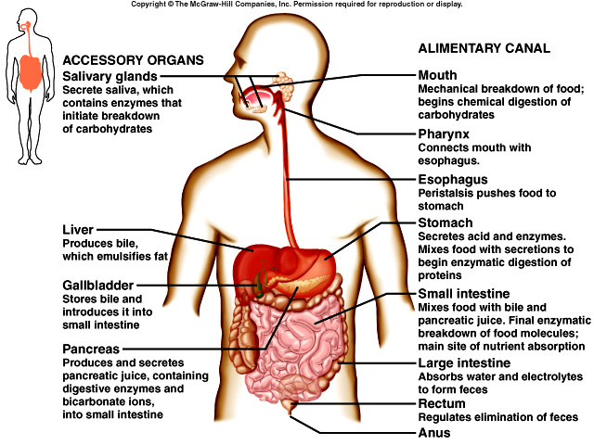

Figure 10.1 the digestive tract and associated organs take up a significant portion of the space in a human body. The small intestine is over 6 m long and 2.5 cm in diameter. The Large intestine is about 1.5 m long and 5 cm in diameter.

10.2 Parts of the Human Digestive System

The Mouth

The first part of the digestive system is the mouth, the entry point of food. The smell and sight of food, stimulates your salivary glands to secrete fluid called saliva, consisting of water and enzymes.

The purpose of the saliva is to lubricate the food for swallowing, dissolve water soluble food particles, and start chemical digestion of carbohydrates (starch) into smaller molecules. Amylase is the enzyme secreted. The pH of the mouth is 7.

Salivary glands – are glands in the mouth that produces saliva to begin the chemical digestion of food.

Saliva – is a watery secretion in the mouth that begins the digestive process.

Mechanical digestion also begins here. The teeth and tongue are responsible for the breaking of large food particles into smaller food particles, while increasing surface area for faster chemical digestion.

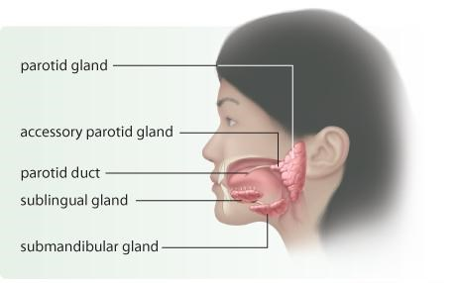
Figure 10.2 each parotid gland and sub-mandibular gland release saliva into the mouth through the parotid duct and the sub-mandibular duct. The sublingual glands release saliva into the mouth through many smaller ducts.

The Esophagus

The esophagus is a tube connecting the mouth to the stomach running through the Thoracic cavity. Your teeth and tongue move food around in the mouth turning the food into a mushy bolus. The tongue moves the bolus to the back of the throat for swallowing. The bolus enters the esophagus.

The esophagus lies behind your windpipe (Trachea). The trachea has as an epiglottis which prevents food from entering the windpipe, moving the food to the esophagus while swallowing. This prevents food from entering the windpipe and choking. Food travels down the esophagus, through a series of rhythmic contractions (wave-like) called peristalsis. The lining of the esophagus secretes mucus, lubricating to support the movement of food.

When the bolus reaches the stomach, it must pass through a muscular ringed valve called the esophageal sphincter (Cardiac Sphincter). The role of the sphincter is to prevent stomach acids from back flowing into the esophagus creating a burning feeling known as heart burn.

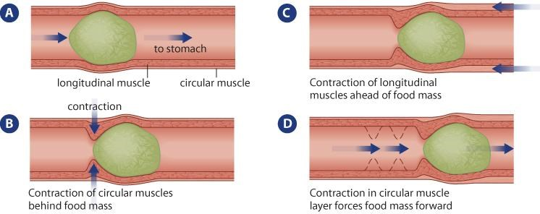

Figure 10.3 Peristalsis moves food through the esophagus by means of muscular contractions. When you vomit, or ‘throw up’ your stomach contents, the contractions of the esophagus are reversed. Similarly, small amounts of acidic liquid can escape from the stomach and move up the esophagus into your throat. This id experienced as a burning sensation in the throat or chest, commonly called heartburn or acid reflux.

The Stomach

The stomach is a muscular J-shaped organ found in the abdominal cavity. Food is temporarily stored in the stomach. The stomach is a muscular organ (three layers of muscle fibres) which performs mechanical digestion by churning the bolus and mixing it with the gastric juices (HCl, salts, enzymes, water and mucus) secreted by the lining of the stomach. The bolus is now called Chyme.

Gastric Juices – are a mixture of hydrochloric acid, salts, enzymes, water and mucus that is produced by glands in the stomach to help digest food.

The environment of the stomach is very acidic. HCl is secreted to kill any microbes that are found in the bolus, creating a pH of 2. Mucus prevents the stomach from digesting itself.

Pepsin is also secreted. This enzyme is responsible for initiating the breakdown of proteins found in the food. Pepsin hydrolyzes proteins to yield polypeptides. Since the pH is 2, the enzyme from the salivary glands stops breaking down carbohydrates.

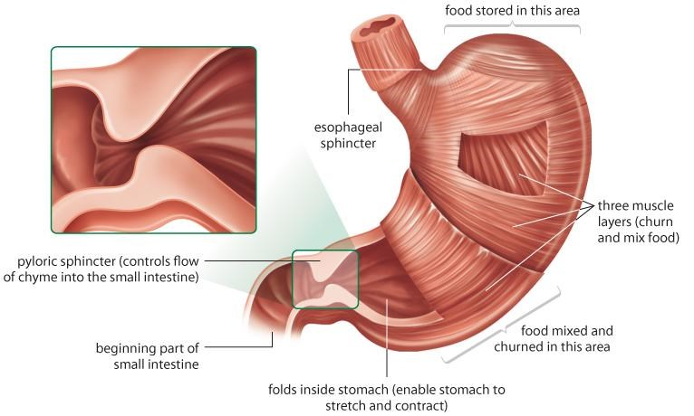
Figure 10.4 folds in the stomach wall allow it to expand and contract as it fills with food and then empties its contents into the small intestine.

The stomach does not digest itself because of three protective mechanisms. First the stomach only secretes small amounts of gastric juices until food is present. Second the secretion of mucus coats the lining of the stomach protecting it from the gastric juices. The third mechanism is the digestive enzyme pepsin is secreted in an inactive protein called pepsinogen. Pepsinogen is converted to pepsin in the increased presence of hydrochloric acid (pH 1).

The chyme moves from the stomach to the small intestine. It passes through a muscular ringed sphincter called the pyloric sphincter.

Chyme – is a thick liquid produced in the stomach and made of digested food combined with gastric juice.

Pepsin – is an enzyme in gastric juice that helps break down proteins into polypeptides.

The Small Intestine

The small intestine is responsible for the complete digestion of all macromolecules and the absorption of their component molecules (glucose, glycerol, fatty acids, amino acids and nucleotides). The process of absorption allows the component molecules to be diffused into the surrounding intestinal cells and then into the circulatory system for transport to all the cells in the body.

The small intestine is made up of three parts, duodenum, jejunum, and the ileum.
The first part is the duodenum, u-shaped organ, approximately 30 cm in length. This area completes most of the digestion processes. Enzymes are secreted into the duodenum form the pancreas and the gall bladder.

The duodenum is lined by folds of tissue called villi. The villi are covered by fine brush-like microvilli. These folds increase the surface area of the small intestine increase the rate of absorption.

The jejunum is approximately 2.5 m. long. Although some digestion is completed here, it has more villi and microvilli; its role is absorption o nutrients.

The ileum, is approximately 3 m. long, and has fewer villi and microvilli than the other two parts. Although absorption also occurs here, it is responsible for pushing the waste materials into the large intestine.

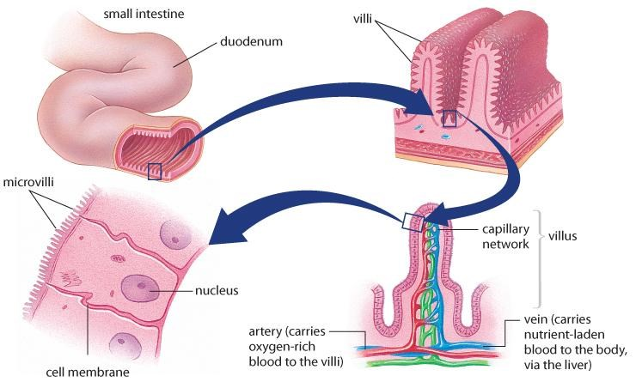

Figure 10.5 the lining of the duodenum is arranged in circular folds. Each fold is covered in tiny villi and microvilli, through which the absorption of nutrients into the bloodstream takes places.

10.3 The Accessory Organs

The accessory organs that support the digestive system but are not part of the digestive tract are; the liver, gall bladder and the pancreas. These organs secrete fluids into the digestive tract, and are connect by ducts.

The liver is the largest of these organs, about the size of a football and a mass of about 1.5 kg. The liver produces bile, a greenishyellow pigment made up bile pigments and bile salts, as it breaks down old red blood cells.

The bile is secreted into a storage sac called the gall bladder. The bile salts are stored here between meals. The bile salts are secreted into the small intestine to digest fats. The bile causes the emulsification (increases surface area) of fat blobs found in the chyme from the stomach.

The pancreas secretes a number of different enzymes into the small intestine to digest carbohydrates, lipids and proteins completely. The pancreas also secretes bicarbonate ions which neutralize the HCl from the stomach and change the pH of the small intestine to a pH of 8. The pancreas will secrete about 1.0 L. of pancreatic fluids per day.

10.4 Chemical Digestion and Absorption

Enzymatic digestion (chemical digestion) of macromolecules are performed by carbohydrases (carbohydrates digestion), lipases (lipid digestion), proteases (protein digestion), and nucleases (nucleic acid digestion).

.

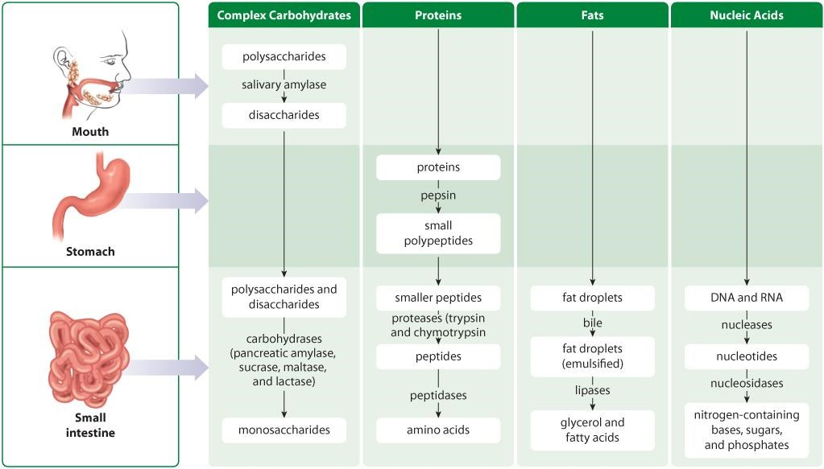

Figure 10.6 an overview of chemical digestion and absorption in the small intestine

Table 10.1 Selected Enzymes of the Digestive System

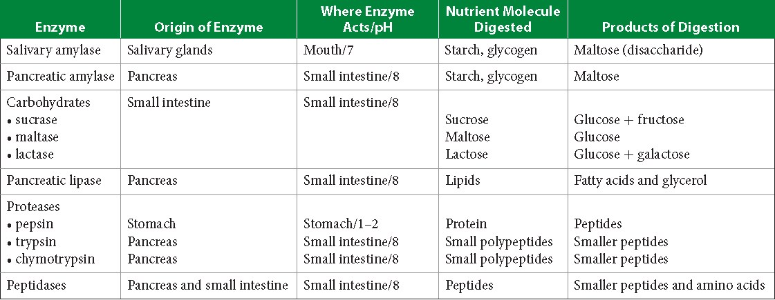

10.5 Factors That Affect Enzyme Actions

There are two factors that affect enzyme function; temperature and pH. As the temperature increases beyond optimal levels (37⁰C), the enzyme becomes denatured and no longer functions. As temperature decreases all chemical reactions slow down.

Enzymes also function at optimal pH levels. The pH levels vary depending on which organ of the digestive tract is involved. The mouth has a pH of 7, therefore only enzymes suitable work, salivary amylase.
The stomach has a pH of 1. The enzyme pepsin is best suited here to digest proteins.
The small intestine has a pH of 6 -8, lipase, trypsin, chymotrypsin, peptidase, pancreatic amylase, sucrase, maltase and lactase work.

10.6 Absorption in the Small Intestine

Carbohydrates in the simplest form are monosaccharides. Monosaccharides are absorbed from the small intestine into the circulatory system. Monosaccharides are transported to the liver. Any monosaccharides other than glucose are converted into glucose. The excess glucose is converted to glycogen, which can be stored in the liver and in smaller amounts in the muscles. When the body requires energy the glycogen is converted by into glucose and is used by the cells in cellular respiration.

Amino acids, the building blocks of proteins, are also absorbed into the circulatory system and transported to the liver. Some amino acids are converted into sugar and used as an energy source.
Other amino acids are converted to a waste product called urea.
Urea is removed from the body through the excretory system.

Lipids are broken down into glycerol groups and fatty acid chains. The sub units enter the cells of the small intestine and converted to triglyceridesand coated with protein to make it water soluble. The triglyceride enters the lymphatic system and eventually to the circulatory system. The triglycerides are then broken down again and used as an energy source by the body.

The Large Intestine

The waste materials move from the small intestine and moves into the large intestine (colon – ascending, transverse and descending). The large intestine is approximately 1.5 m. in length. Here the 90% of water is reabsorbed back into the blood stream. Anaerobic bacteria in the colon breaks down the waste material producing vitamins, folic acid, B vitamins, and vitamin K, which is transported to the blood stream. The rectum stores the fecal matter until eliminated by the anus.

Table 10.2 Times Required for Human Digestion
