THE SKELETAL SYSTEM
The study of this system, which provides support for the body, attachment for muscles and protection for some of the organs, is called osteology. The histological structure of the bone has already been examined but there are two forms of bone—compact bone on the outside of bones and spongy or cancellous bone inside. The latter, which predominates in the ends of the long bones has, as the term suggests, spaces amongst the bone material. A substance called marrow is found in these spaces.
The supporting structure of the body is the framework of joined bones that we refer to as the skeleton. It enables us to stand erect, to move in our environment, to accomplish extraordinary feats of artistic grace like ballet moves and athletic endeavors like the high jump, as well as normal physical endurance. The skeletal system allows us to move a pen and write and aids us in breathing. It is closely associated with the muscular system. The skeletal system includes all the bones of the body and their associated cartilage, tendons, and ligaments. Despite the appearance of the bones, they are indeed composed of living tissue. The hard, “dead” stone like appearance of bones is due to mineral salts like calcium phosphate embedded in the inorganic matrix of the bone tissue. Leonardo da Vinci (1452–1519), the famous Italian Renaissance artist and scientist, is credited as the first anatomist to correctly illustrate the skeleton with its 206 bones.

THE FUNCTIONS OF THE SKELETAL SYSTEM

The skeleton has five general functions:
1. It supports and stabilizes surrounding tissues such as muscles, blood vessels, nerves, fat, and skin.
2. It protects vital organs of the body such as the brain, spinal cord, the heart, and lungs and it protects other soft tissues of the body.
3. It assists in body movement by providing attachments for muscles that pull on the bones that act as levers.
4. It manufactures blood cells. This process is Called hematopoiesis and occurs chiefly in red bone marrow.
5. It is a storage area for mineral salts, especially phosphorous and calcium, and fats.

Associated with the bones are cartilage, tendons, and ligaments. Cartilage, a connective tissue, is the environment in which bone develops in a fetus. It is also found at the ends of certain bones and in joints in adults, providing a smooth surface for adjacent bones to move against each other. Ligaments are tough connective tissue structures that attach bones to bones like the ligament that attaches the head of the femur to the acetabulum of the pelvic bone in the hip joint. Tendons are similar structures that attach muscle to bone.

THE GROWTH AND FORMATION OF BONE
The skeleton of a developing fetus is completely formed by the end of the third month of pregnancy. However, at this time, the skeleton is predominantly cartilage. During the subsequent months of pregnancy, ossification, the formation of bone and growth occur. The osteoblasts invade the cartilage and convert it to bone. Longitudinal growth of bones continues until approximately 15 years of age in girls and 16 years of age in boys. This takes place at the epiphyseal line or plate. Bone maturation and remodeling continue until the age of 21 in both sexes. It would be incorrect to state that cartilage actually turns into bone. Rather cartilage is the environment in which the bone develops. The strong protein matrix is responsible for a bone’s resilience or “elasticity” when tension is applied to the bone so that it gives a little under pressure. The mineral salts deposited into this protein matrix are responsible for the strength of the bone so that it does not get crushed when pressure is applied to the bone.

Deposition of Bone
Bone develops from spindle-shaped cells called osteoblasts that develop from undifferentiated bone cells called osteoprogenitor (oss-tee-oh-pro-JENih- tohr) cells (Figure 7-1). These osteoblasts are formed beneath the fibrovascular membrane that covers a bone called the periosteum (pair-ee-AHstee- um) (Figure 7-2). These osteoblasts are also found in the endosteum (en-DOS-tee-um), which lines the bone marrow or medullary cavity. Deposition of bone is controlled by the amount of strain or pressure on the bone. The more strain the greater the deposition of bone. The heel bone or calcaneum is a large strong bone because it receives the weight of the body when walking. Bones (and muscles) in casts will waste away or atrophy, whereas continued and excessive strain via exercise will cause the bone and muscles to grow thick and strong. This is the reason children are told to run and play to develop strong bones during their formative years. When a cast is removed, the patient participates in physical therapy to build up the bone (and muscles) that became weak while in the cast. A break in a bone will stimulate injured osteocytes to proliferate. They then secrete large quantities of matrix to form new bone. In addition, other types of bone cells called osteoclasts are present in almost all cavities of bone (see Figure 7-1). They are responsible for the reabsorption of bone. These are large cells that remove bone from the inner side during remodeling, such as when a bone is broken. These cells are also responsible for the ability of a crooked bone to become straight. If a young child is detected to be bow-legged, the physician will apply braces to the legs. Periodic tightening of the braces puts pressure on the bone so that new bone is deposited by osteocytes (mature osteoblasts), or mature bone cells, while the osteoclasts remove the old bone during this remodeling process. This process can cause a broken bone that was set improperly to heal incorrectly. To correct this, the bone must be broken again and correctly reset to straighten properly.
Types of Ossification
There are two types of ossification (the formation of bone by osteoblasts). The first type is intramembranous ossification, in which dense connective tissue membranes are replaced by deposits of inorganic calcium salts thus forming bone. The membrane itself will eventually become the periosteum of the mature bone. Underneath the periosteum will be compact bone with an inner core of spongy or cancellous bone. Only the bones of the cranium or skull form by this process. Because complete ossification in this way does not occur until a few months after birth, one can feel these membranes on the top of a baby’s skull as the soft spot or fontanelle (fon-tah-NELL). This allows the baby’s skull to give slightly as it moves through the birth canal. The other bones of the body are formed by the second process called endochondral (en-doh- KON-dral) ossification (Figure 7-3). This is the process in which cartilage is the environment in which the bone cells develop (endo = inside, chondro = cartilage). As the organic matrix becomes synthesized, the osteoblast becomes completely surrounded by the bone matrix and the osteoblasts become a mature bone cell or osteocyte. Both types of ossification result in compact and cancellous bone.

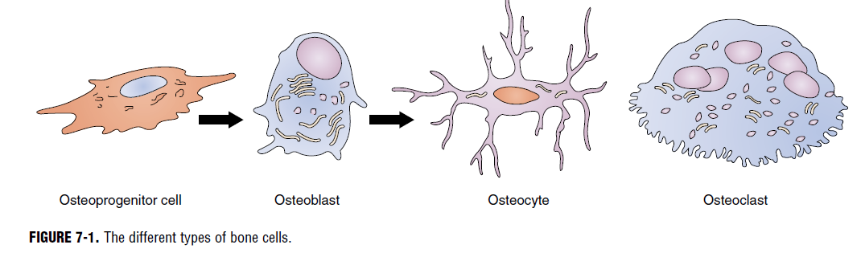

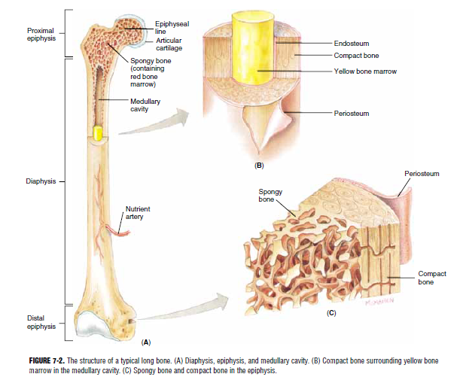

Maintaining Bone
In a healthy body, a balance must exist between the amount of calcium stored in the bones, the calcium in the blood, and the excess calcium excreted by the kidneys and via the digestive system. The proper calcium ion concentration in the blood and bones is controlled by the endocrine system. Two hormones, calcitonin and parathormone, control the calcium concentration in our bodies. Calcitonin causes calcium to be stored in the bones; parathormone causes it to be released into the bloodstream.

THE HISTOLOGY OF BONE
There are two types of bone tissue: compact or dense bone; and cancellous or spongy bone (see Figure 7-2C). In both types of tissue, the osteocytes are the same but the arrangement of how the blood supply reaches the bone cells is different. The two types of tissue have different functions. Compact bone is dense and strong, whereas cancellous bone has many open spaces giving it a spongy appearance. It is in these spaces that bone marrow can be found.
The Haversian system of Compact Bone
The haversian canal, also called an osteon, was named for an English physician, Clopton Havers (1650–1702), who first described it as a prominent feature of compact bone (Figure 7-4). This system allows for the effective metabolism of bone cells surrounded by rings of mineral salts. It has several components. Running parallel to the surface of the bone are many small canals containing blood vessels (capillaries, arterioles, venules) that bring in oxygen and nutrients and remove waste products and carbon dioxide. These canals are called haversian or central canals and are surrounded by concentric rings of bone, each layer of which is called a lamella . Between two lamella or rings of bone are several tiny cavities called lacunae.

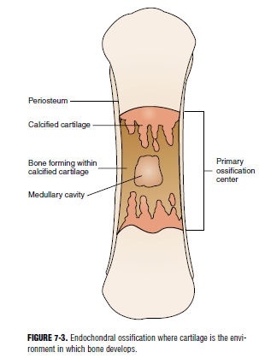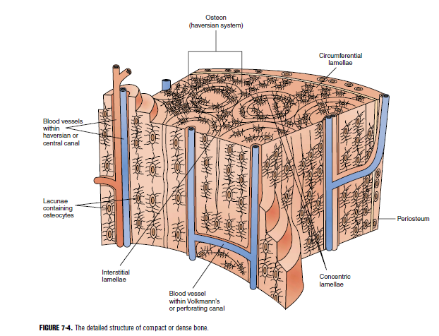

Each lacuna contains an osteocyte or bone cell suspended in tissue fluid. The lacunae are all connected to each other and ultimately to the larger haversian canals by much smaller canals called canaliculi (kan-ah- LIK-you-lye). Canals running horizontally to the haversian (central) canals, also containing blood vessels, are called Volkmann or perforating canals. It is tissue fluid that circulates through all these canals and bathes the osteocyte bringing in oxygen and food and carrying away waste products and carbon dioxide keeping the osteocytes alive and healthy.
Cancellous Bone
Cancellous or spongy bone is located at the ends of long bones and forms the center of all other bones. It consists of a meshwork of interconnecting sections of bone called trabeculae (trah-BEK-you-lay) creating the spongelike appearance of cancellous bone. The trabeculae give strength to the bone without the added weight of being solid. Each trabecula consists of several lamellae with osteocytes between the lamellae just as in compact bone. The spaces between the trabeculae are filled with bone marrow. Nutrients exit blood vessels in the marrow and pass by diffusion through the canaliculi of the lamellae to the osteocytes in the lacunae.

Bone Marrow

The many spaces within cancellous bone are filled with red bone marrow. This marrow is richly supplied with blood and consists of blood cells and their precursors. The function of red bone marrow is hematopoiesis or the formation of red and white blood cells and blood platelets. Therefore, blood cells in all stages of development will be found in red bone marrow. We shall discuss in more detail the different stages of blood cell development in Chapter 13. In an adult, the ribs, vertebrae, sternum, and bones of the pelvis all contain red bone marrow in their cancellous tissue. These bones produce blood cells in adults. Red bone marrow within the ends of the humerus or upper arm and the femur or thigh is plentiful at birth but gradually decreases in amount as we age. Yellow bone marrow is connective tissue consisting chiefly of fat cells. It is found primarily in the shafts of long bones within the medullary cavity, the central area of the bone shaft (see Figure 7-2B). Yellow bone marrow extends into the osteons or haversian systems, replacing red bone marrow when it becomes depleted.

THE CLASSIFICATION OF BONES BASED ON SHAPE
The individual bones of the body can be divided by shape into five categories: long, short, flat, irregular, and sesamoid.

Long Bones

Long bones (see Figure 7-2) are bones whose length exceeds their width and consist of a diaphysis (dye-AFF-ih-sis) or shaft composed mainly of compact bone, a metaphysis (meh-TAFF-ih-sis) or flared portion at each end of the diaphysis consisting mainly of cancellous or spongy bone, and two extremities, each called an epiphysis (eh-PIFF-ihsis), separated from the metaphysis by the epiphyseal line where longitudinal growth of the bone occurs. The shaft consists mainly of compact bone. It is thickest toward the middle of the bone because strain on the bone is greatest at that point. The strength of a long bone is also ensured by the slight curvature of the shaft, a good engineering design to distribute weight. The interior of the shaft is the medullary cavity filled with yellow bone marrow. The extremities or the epiphyses of the long bone have a thin covering of compact tissue overlying a majority of cancellous tissue, which usually contains red marrow. The epiphyses are usually broad and expanded for articulation with other bones and to provide a large surface for muscle attachment. Examples of obvious long bones would be the clavicle, humerus, radius, ulna, femur, tibia, and fibula. Not so obvious would be those short versions of a long bone, the metacarpals of the hand, the metatarsals of the foot, and the phalanges of the fingers and toes.

Short Bones
Short bones are not merely shorter versions of long bones. They lack a long axis. They have a somewhat irregular shape. They consist of a thin layer of compact tissue over a majority of spongy or cancellous bone.
Examples of short bones of the body are the carpal bones of the wrist and the tarsal bones of the foot.
Flat Bones
Flat bones are thin bones found whenever there is a need for extensive muscle attachment or protection for soft or vital parts of the body. These bones, usually curved, consist of two flat plates of compact bone tissue enclosing a layer of cancellous bones. Examples of flat bones are the sternum, ribs, scapula, parts of the pelvic bones, and some of the bones of the skull.

Irregular Bones
Irregular bones are bones of a very peculiar and different or irregular shape. They consist of spongy bone enclosed by thin layers of compact bone. Examples of irregular bones are the vertebrae and the ossicles of the ears.
Sesamoid Bones
Sesamoid (SESS-ah-moyd) bones are small rounded bones. These bones are enclosed in a tendon and fascial tissue and are located adjacent to joints. They assist in the functioning of muscles. The kneecap or patella is the largest of the sesamoid bones. Some of the bones of the wrist and ankle could also be classified as sesamoid bones as well as short bones.

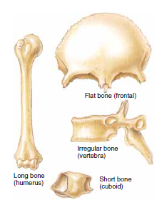
Classifications of bone based on the shape

BONE MARKINGS
The surface of any typical bone will exhibit certain projections called processes or certain depressions called fossae or both. These markings are functional in that they can help join one bone to another, provide a surface for the attachments of muscles, or serve as a passageway into the bone for blood vessels and nerves. The following is a list of terms and definitions regarding bone markings.
Processes
Processes are a general term referring to any obvious bony prominence. The following is a list of specific examples of processes.
1. Spine: any sharp, slender projection such as the spinous process of a vertebra
2. Condyle: a rounded or knucklelike prominence usually found at the point of articulation with another bone such as the lateral and medial condyle of the femur
3. Tubercle : a small round process like the lesser tubercle of the humerus
4. Trochlea : a process shaped like a pulley as in the trochlea of the humerus
5. Trochanter ; a very large projection like the greater and lesser trochanter of the femur
6. Crest: a narrow ridge of bone like the iliac crest of the hip bone
7. Line: a less prominent ridge of bone than a crest.
8. Head: a terminal enlargement like the head of the humerus and the head of the femur
9. Neck: that part of a bone that connects the head or terminal enlargement to the rest of the bone, like the neck of the femur.
Fossae
Fossae is a general term for any depression or cavity in or on a bone. The following is a list of specific examples of fossae.
1. Suture: a narrow junction often found between two bones like the sutures of the skull bones
2. Foramen: an opening through which blood vessels, nerves, and ligaments pass like the foramen magnum of the occipital bone of the skull or the obturator foramen of the pelvic
bone .
3. Meatus or canal: a long tube-like passage, like the auditory meatus or canal
4. Sinus or antrum: a cavity within a bone like the nasal sinuses or frontal sinus.
5. Sulcus: a furrow or groove like the intertubercular sulcus or groove of the humerus.

DIVISIONS OF THE SKELETON

The skeleton has 206 bones. The axial part consists of the skull (28 bones including the cranial and facial bones), the hyoid bone, the vertebrae (26 bones), the ribs (24 bones), and the sternum. The appendicular part of the skeleton consists of the bones of the upper extremities or arms (64 bones including the shoulder girdle bones) and the bones of the lower extremities or legs (62 bones including the bones of the pelvic girdle) (Figure 7-6).
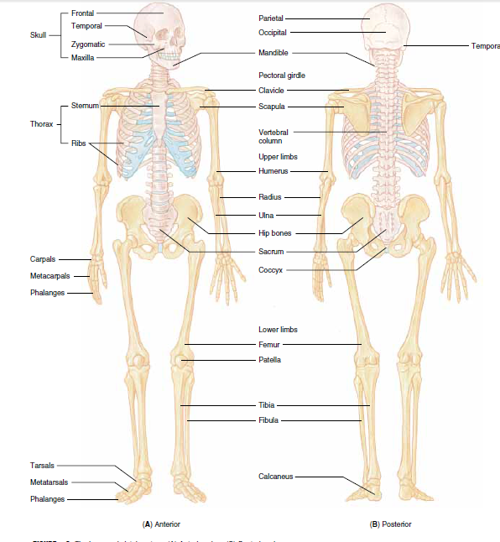
Figures. The human skeletal system. (A) Anterior view. (B) Posterior view.

THE AXIAL SKELETON
The skull, in the correct use of the term, includes the cranial and the facial bones. We will discuss the cranial bones first.
The Cranial Bones
The bones of the cranium have a number of important functions. They protect and enclose the brain and special sense organs like the eyes and ears. Muscles for mastication or chewing and muscles for head movement attach to certain cranial bones.
At certain locations air sinuses or cavities are present that connect with the nasal cavities (Figure 7-7). All of the individual bones of the cranium are united by immovable junction lines called sutures. The frontal bone is a single bone that forms the forehead, the roof of the nasal cavity, and the orbits, which are the bony sockets that contain the eyes (Figure 7-8). Important bone markings are the orbital margin, a definite ridge above each orbit located where eyebrows are found, and the supraorbital ridge, which overlies the frontal sinus and can be felt in the middle of your forehead. The coronal suture is found where the frontal bone joins the two parietal bones. The two parietal (pah-RYE-eh-tal) bones form the upper sides and roof of the cranium. They are joined at the sagittal suture in the midline. The occipital bone is a single bone that forms the back and base of the cranium (see Figure 7-8) and joins the parietal bones superiorly at the lambdoid suture. The inferior portion of this bone has a large opening called the foramen magnum through which the spinal cord connects with the brain. On each lower side of the occipital bone is a process called the occipital condyle. These processes are significant because they articulate with depressions in the first cervical vertebra (atlas), thus allowing the head to connect with and rest on the vertebrae. Other notable markings are the external occipital crest and the external occipital
protuberance, which can be felt through the scalp at the base of the neck. Several ligaments and
muscles attach to these regions. The two temporal bones help form the lower sides and base of the cranium (see Figure 7-8). Each temporal bone encloses an ear and bears a fossa for articulation with the lower jaw or mandible. The temporal bones are irregular in shape and each consists of four parts: the squamous, petrous, mastoid, and tympanic parts. The squamous portion is the largest and most superior of the four parts. It is a thin flat plate of bone that forms the temple. Projecting from its lower part is the zygomatic process that forms the lateral part of the zygomatic arch or cheek bone. The petrous part is found deep within the base of the skull where it protects and surrounds the inner ear. The mastoid portion is located behind and below the auditory meatus or opening of the ear. The mastoid process is a rounded projection of the mastoid portion of the temporal bone easily felt behind the ear. Several muscles of the neck attach to this mastoid process and assist in moving your head. Finally the tympanic plate forms the floor and anterior wall of the external auditory meatus. A long and slender styloid process can be seen extending from the under surface of this plate. Ligaments that hold the hyoid bone in place (which supports the tongue) attach to this styloid process of the tympanic plate of the temporal bone. The single sphenoid bone forms the anterior portion of the base of the cranium (Figure 7-9). When viewed from below it looks like a butterfly. It acts as an anchor binding all of the cranial bones together. The single ethmoid bone is the principle supporting structure of the nasal cavities and helps form part of the orbits. It is the lightest of the cranial bones (see Figure 7-9). The six auditory ossicles are the three bones found in each ear (Figure 7-7B, page 144): the malleus or hammer, the stapes (STAY-peez) or stirrup, and the incus or anvil. These tiny bones are highly specialized in both structure and function and are involved in exciting the hearing receptors. The wormian bones or sutural bones are located within the sutures of the cranial bones. They vary in number, are small and irregular in shape, and are never included in the total number of bones in the body. They form as a result of intramembranous ossification of the cranial bones.

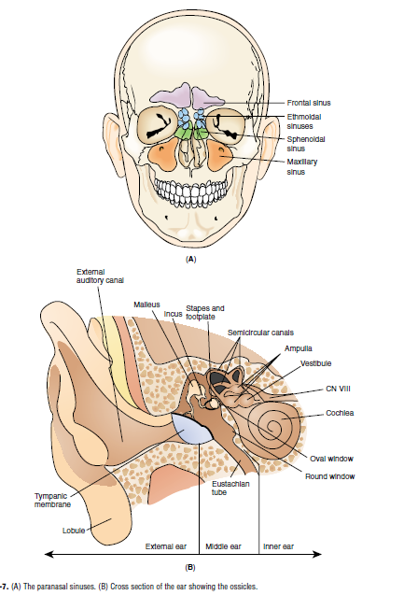

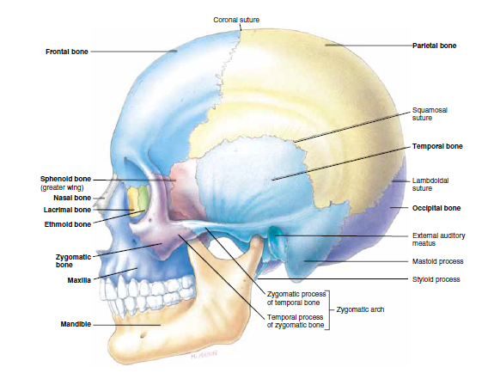

The Facial Bones
Like the bones of the cranium, the facial bones are also united by immovable sutures, with one exception: the lower jawbone or mandible. This bone is capable of movement in a number of directions. It can be elevated and depressed as in talking and it can protract and retract and move from side to side as in chewing. The two nasal bones are thin and delicate bones that join in a suture to form the bridge of the nose (see Figure 7-9). The two palatine bones form the posterior part of the roof of your mouth or part of the hard palate. This region is the same as the floor of the nasal cavity. Upward extensions of the palatine bones help form the outer walls of the nasal cavity. The two maxillary bones make up the upper jaw (see Figure 7-9). Each maxillary bone consists of five parts: a body, a zygomatic process, a frontal process, a palatine process, and an alveolar process. The large body of the maxilla forms part of the floor and outer wall of the nasal cavity, the greater part of the floor of the orbit, and much of the anterior face below the temple. The body is covered by a number of facial muscles and contains a large maxillary sinus located lateral to the nose. The zygomatic process extends laterally to participate in the formation of the cheek. (Processes are named according to the bone they go to, thus the zygomatic process of the maxillary bone goes toward and joins the zygomatic or cheek bone). The frontal process extends upward to the frontal bone or forehead. The palatine process extends posteriorly in a horizontal plane to join or articulate with the palatine bone and actually forms the greater anterior portion of the hard palate or roof of the mouth. The alveolar processes bear the teeth of the upper jaw, and each tooth is embedded in an alveolus (al-VEE-oh-lus) or socket. The two maxillary bones join at the intermaxillary suture. This fusion is usually completed just before birth. If the two bones do not unite to form a continuous structure, the resulting defect is called a cleft palate and is usually associated with a cleft lip. With today’ surgical techniques, the defect can be repaired early in the development of the child. The two zygomatic bones, also known as the malar bones, form the prominence of the cheek
