**CHAPTER ONE**

**THE SCOPE OF ANATOMY AND PHYSIOLOGY**

**Anatomy** is the study of structure, and **physiology** is the study of processes or functions of living things. These approaches are complementary and never entirely separable. Physiology lends meaning to anatomy and, conversely, anatomy is what makes physiology possible.

**SUB-DISCIPLINES OF ANATOMY**

Anatomy can be considered at many different levels.

* **Developmental anatomy**

It is the study of the structural changes that occur between conception and adulthood.

* **Embryology**

It is a sub-specialty of developmental anatomy, considers changes from conception to the end of the eighth week of development. Most birth defects occur during embryologic development.

* **Microscopic Anatomy**

It is the study of the structure and function of the body result from its individual cells. Some structures, such as cells, are so small that they are best studied using a microscope.

* **Cytology** examines the structural features of cells, and **histology** examines tissues, which are cells and the materials surrounding them.
* **Gross anatomy**,

It is the study of structures that can be examined without the aid of a microscope, can be approached from either a **systemic** or **regional** perspective.

* **In systemic anatomy** the body is studied system by system. A system is a group of structures that have one or more common functions. Examples are the circulatory, nervous, respiratory, skeletal, and muscular systems.
* **In regional anatomy** the body is studied area by area. Within each region, such as the head, abdomen, or arm, all systems are studied simultaneously.
* **Surface anatomy**

It is the study of the external form of the body and its relation to deeper structures. For example, the sternum (breastbone) and parts of the ribs can be seen and palpated (Felt) on the front of the chest. These structures can be used as landmarks to identify regions of the heart and points on the chest where certain heart sounds can best be heard.

**SUB-DISCIPLINES OF PHYSIOLOGY**

Like anatomy, physiology can be considered at many different levels. Physiology often examines systems rather than regions because portions of a system in more than one region can be involved in a given function.

* **Cell physiology** examines the processes occurring in cells and systemic physiology considers the functions of organ systems.
* **Neurophysiology** focuses on the nervous system and cardiovascular physiology deals with the heart and blood vessels.
* **Pathology** is the medical science dealing with all aspects of disease, with an emphasis on the cause and development of abnormal conditions as well as the structural and functional changes resulting from disease.
* **Endocrinology** that discusses the physiology of hormones.
* **Comparative physiology** is the study of how different species have solved problems of life such as water balance, respiration, and reproduction.

**STRUCTURAL AND FUNCTIONAL ORGANIZATION**

Humans have an analogous hierarchy of complexity as follows: The **organism** is composed of **organ systems**, **organ systems** are composed of organs, **organs** are composed of tissues, **tissues** are composed of cells, **cells** are composed (in part) of organelles, **organelles** are composed of molecules, **molecules** are composed of atoms, and **atoms** are composed of subatomic particles.

An **atom** is a tiny building block of matter composed of subatomic particles—protons, neutrons, and electrons. A **molecule** is a particle composed of at least two atoms, and the largest molecules, such as proteins, fats, and DNA, are called **macromolecules**. Organelles and other cellular components are composed of molecules. **Organelles** are microscopic structures in a cell that carry out its individual functions. Examples include mitochondria, centrioles, and lysosomes. **Cells** are the smallest units of an organism that carry out all the basic functions of life; nothing simpler than a cell is considered alive. A cell is enclosed in a plasma membrane composed of lipids and protein.Most cells have one nucleus, an organelle that contains most of its DNA. **Cytology**, the study of cells and organelles.

A **tissue** is a mass of similar cells and cell products that forms a discrete region of an organ and performs a specific function. The body is composed of only four primary classes of tissue-epithelial, connective, nervous, and muscular tissues. **Histology**, the study of tissues.

An **organ** is a structure composed of two or more tissue types that work together to carry out a particular function. Organs have definite anatomical boundaries and are visibly distinguishable

from adjacent structures. Most organs and higher levels of structure are within the domain of gross anatomy.However, there are organs within organs—the large organs visible to the naked eye often contain smaller organs visible only with the microscope. The skin, for example, is the body’s largest organ. Included within it are thousands of smaller organs: each hair follicle, nail, sweat gland, nerve, and blood vessel of the skin is an organ in itself.

An **organ system** is a group of organs that carry out a basic function of the organism such as circulation, respiration, or digestion. The human body has **11 organ systems**: the integumentary, skeletal, muscular, nervous, endocrine, circulatory, lymphatic, respiratory, urinary, digestive, and reproductive systems. Usually, the organs of a system are physically interconnected, such as the kidneys, ureters, urinary bladder, and urethra that compose the urinary system. The endocrine system, however, is a group of hormone-secreting glands and tissues that, for the most part, have no physical connection to each other. The **organism** is a single, complete individual.

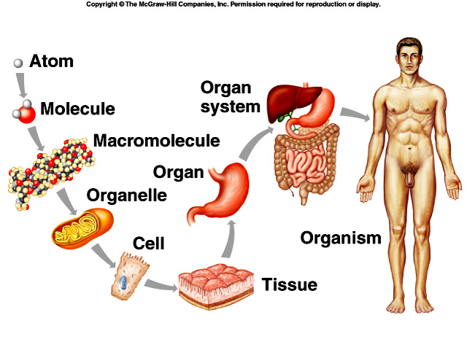

**Figure 1. Level of human body organization**

* **Types of Tissue**

The tissues of the human body can be categorized into four major types: **Connective tissue** binds and supports body parts. **Muscular tissue** moves the body and its parts. **Nervous tissue** receives stimuli and conducts nerve impulses. **Epithelial tissue** covers body surfaces and lines body cavities.

1. **Connective tissue**

It is diverse in structure and function. Even so, all types have **three** components: **specialized cells**, **ground substance**, and **protein fibers**. The ground substance is a non cellular material that separates the cells. It varies in consistency from solid (bone) to semifluid (cartilage) to fluid (blood). The fibers are of three possible types. **White collagen fibers** contain collagen, a protein that gives them flexibility and strength. **Reticular fibers** are very thin collagen fibers, highly branched proteins that form delicate supporting networks. **Yellow elastic fibers** contain elastin, a protein that is not as strong as collagen but is more elastic (meaning that it can return to its original shape; elastic fibers may stretch over 100 times their relaxed size without damaging the proteins).

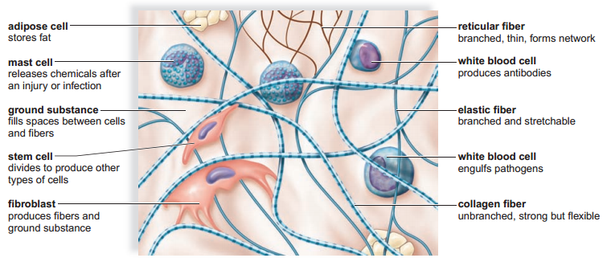**Figure 2. Figure 2: Components of connective tissue**

* **Fibrous Connective Tissue**

Fibrous tissue exists in two forms: **loose fibrous** **tissue** and **dense f brous tissue**. Both loose fibrous and dense fibrous connective tissues have cells called fibroblasts located some distance from one another and separated by a jellylike ground substance containing white collagen fibers and yellow elastic fibers. Matrix is a term that includes ground substance and fibers.

1. **Loose fibrous**

connective tissue,also called areolar tissue, supports epithelium and many internal organs. Its presence in lungs, arteries, and the urinary bladder allows these organs to expand. It forms a protective covering enclosing many internal organs, such as muscles, blood vessels, and nerves.

* **Adipose tissue**

Is a special type of loose connective tissue in which the cells enlarge and store fat. Adipose tissue has little extracellular matrix. Its cells are crowded, and each is filled with liquid. The body uses this stored fat for energy, insulation, and organ protection. Adipose tissue also releases a hormone called leptin,which regulates appetite-control centers in the brain. Adipose tissue is primarily found beneath the skin, around the kidneys, and on the surface of the heart.

1. **Dense fibrous**

Is a connective tissue contains many collagen fibers packed together. This type of tissue has more specific functions than does loose connective tissue. For example, dense fibrous connective tissue is found in tendons,which connect muscles to bones, and in ligaments,which connect bones to other bones at joints.

* **Specialized Connective Tissue**

There are two types of specialized connective tissue, which are **supportive** and **fluid** connective tissue. **Cartilage** and **bone** are supportive connective tissues. In both tissues, the extracellular matrix is solid. In fluid connective tissues, such as **blood** and **lymph**, the matrix surrounding the cells is a liquid.

* **Cartilage**

In cartilage, the cells lie in small chambers called lacunae (sing, lacuna), separated by a solid flexible, matrix. This matrix is formed by cells called chondroblasts and chondrocytes. Unfortunately, because this tissue lacks a direct blood supply, it heals slowly. The **three** types of cartilage are distunguished by the type of fiber found in the matrix.

* **Hyaline cartilage**, the most common type of cartilage, contains only fine collagen fi bers. The matrix has a glassy, translucent appearance. Hyaline cartilage is found in the nose and at the ends of the long bones and the ribs, and it forms rings in the walls of respiratory passages. The fetal skeleton also is made of this type of cartilage. Later, the cartilaginous fetal skeleton is replaced by bone.
* **Elastic cartilage** has more elastic fibers than hyaline cartilage. For this reason, it is more flexible and is found, for example, in the framework of the outer ear.
* **Fibrocartilage** has a matrix containing strong collagen fibers. It is found in structures that withst and tension and pressure, such as the disks between the vertebrae in the backbone and the cushions in the knee joint.

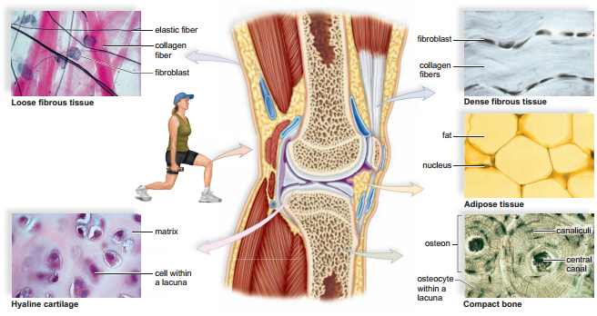

**Figure 3: Connective tissue in knee**

* **Bone**

Bone is the most rigid connective tissue. It consists of an extremely hard matrix of inorganic salts, notably calcium salts. These salts are deposited around protein fibers, especially collagen fibers. The inorganic salts give bone rigidity. The protein fibers provide elasticity and strength, much as steel rods do in reinforced concrete. Cells called **osteoblasts** and **osteoclasts** are responsible for forming the matrix in bone tissue.

* **Compact bone** makes up the shaft of a long bone. It consists of cylindrical structural units called **osteons**. The central canal of each osteon is surrounded by rings of hard matrix. Bone cells are located in lacunae between the rings of matrix. In the central canal, nerve fibers carry nerve impulses, and blood vessels carry nutrients that allow bone to renew itself. Thin extensions of bone cells within canaliculi (minute canals) connect the cells to each other and to the central canal. The ends of the long bones are composed of spongy bone covered by compact bone.
* **Spongy bone** also surrounds the bone marrow cavity. This, in turn, is covered by compact bone forming a “sandwich“ structure. Spongy bone appears as an open, bony latticework with numerous bony bars and plates. These are separated by irregular spaces. Although lighter than compact bone, spongy bone is still designed for strength. Just as braces are used for support in buildings, the solid portions of spongy bone follow lines of stress.
* **Blood**

Blood represents a fluid connective tissue. Blood, which consists of formed elements and plasma, is located in blood vessels. Blood transports nutrients and oxygen to tissue fluid. Tissue fluid bathes the body’s cells and removes carbon dioxide and other wastes. Blood helps distribute heat and also plays a role in fluid, ion, and pH balance. The systems of the body help keep blood composition and chemistry within normal limits. The formed elements of blood each have specifi c functions.

The **red blood cells** (erythrocytes) are small, biconcave, diskshaped cells without nuclei. The presence of the red pigment hemoglobin makes the cells red, which, in turn, makes the blood red. **White blood cells** (leukocytes) may be distinguished from red blood cells because they have a nucleus.There are many different types of white blood cells, but all are involved in protecting the body from infection. **Platelets** (thrombocytes) are not complete cells. Rather, they are fragments of giant cells present only in bone marrow. When a blood vessel is damaged, platelets form a plug that seals the vessel, and injured tissues release molecules that help the clotting process.

* **Lymph**

Lymph is also a fl uid connective tissue. Lymph is a clear (sometimes faintly yellow) fl uid derived from the fl uids surrounding the tissues. It contains white blood cells.

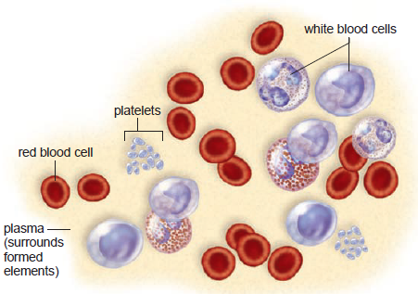

**Figure 4:** The formed elements of blood

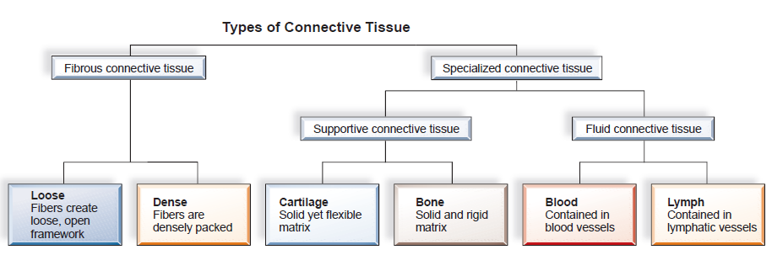**Figure 5: Types of Connective Tissue**

1. **Muscular (contractile) tissue**

Muscular tissue is a type of tissue that composed of muscle fiber cells. Muscle fibers contain filaments made of proteins called actin and myosin. The three types of vertebrate muscular tissue are skeletal, smooth, and cardiac.

1. **Nervous Tissue**

Nervous tissue is a type of tissue thatconsists of nerve cells called **neurons**, and **neuroglia** which are the cells that support and nourish the neurons.

1. **Epithelial Tissue**

It consist tightly packed cells that form a continuous layer. Epithelial tissue covers surfaces and lines body cavities. Usually, it has a protective function. It can also be modified to carry out secretion, absorption, excretion, and filtration. Epithelial cells are exposed to the environment on one side. On the other side, they are bounded by a basement membrane. The basement membrane should not be confused with the plasma membrane (in the cell) or the body membranes that line the cavities of the body. Instead, the basement membrane is a thin layer of various types of carbohydrates and proteins that anchors the epithelium to underlying connective tissue.

Epithelial tissue is either **simple** or **stratified**. **Simple epithelia** have only a single layer of cells and are classified according to cell type.

* **Squamous epithelium**, composed of flattened cells, is found lining the air sacs of lungs and walls of blood vessels. Its shape and arrangement permit exchanges of substances in these locations. Oxygen–carbon- dioxide exchange occurs in the lungs, and nutrient–waste exchange occurs across blood vessels in the tissues.
* **Cuboidal epithelium** consists of a single layer of cube shaped cells. This type of epithelium is frequently found in glands, such as the salivary glands, the thyroid gland, and the pancreas. **Simple cuboidal epithelium** also covers the ovaries and lines kidney tubules, the portions of the kidney in which urine is formed.
* **Columnar epithelium** has cells resembling rectangular pillars or columns, with nuclei usually located near the bottom of each cell. This epithelium is found lining the digestive tract, where microvilli expand the surface area and aid in absorbing the products of digestion.
* **Pseudo stratified** columnar epithelium is so named because it appears to be layered (pseudo, “false”; stratified, “layers”). The lining of the windpipe, or trachea, is pseudo stratified ciliated columnar epithelium.
* **Transitional Epithelium** the term transitional epithelium implies changeability, and this tissue changes in response to tension. It forms the lining of the urinary bladder, the ureters (tubes that carry urine from the kidneys to the bladder), and part of the urethra (the single tube that carries urine to the outside). All are organs that may need to stretch. When the bladder is distended, this epithelium stretches, and the outer cells take on a squamous appearance.
* **Stratified Epithelia** have layers of cells piled one on top of the other. Only the bottom layer touches the basement membrane. The nose, mouth, esophagus, anal canal, the outer portion of the cervix (adjacent to the vagina), and vagina are lined with stratified squamous epithelium.
* **Glandular Epithelium:** When an epithelium secretes a product, it is said to be glandular. A gland can be a single epithelial cell, as in the case of mucus-secreting goblet cells, or a gland can contain many cells. Glands with ducts that secrete their product onto the outer surface (e.g., sweat glands and mammary glands) or into a cavity (e.g., salivary glands) are called exocrine glands.

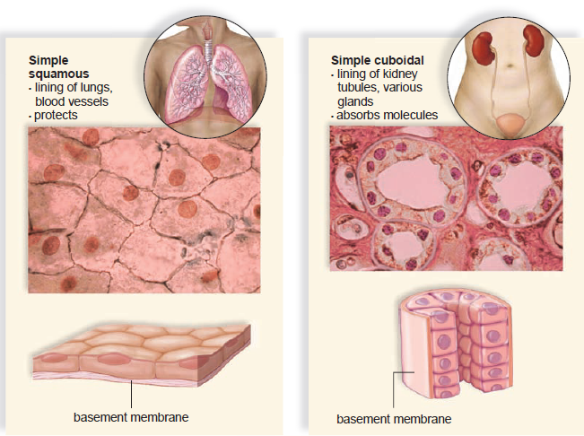

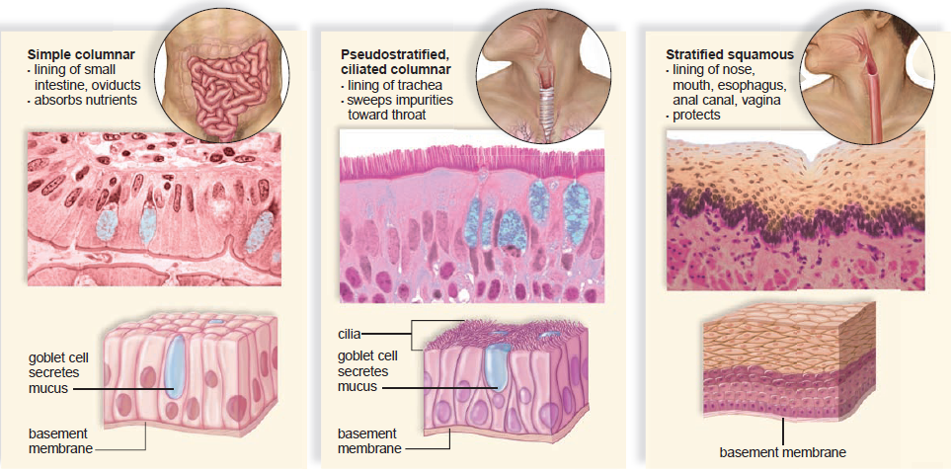

**Figure 6: Types of Epithelium tissue**

**GENERAL TERMINOLOGY OF ANATOMY**

* **ANATOMICAL POSITION**

Anatomical position is a posture in which a person stands erect with the feet flat on the floor, arms at the sides, and the palms, face, and eyes facing forward. This position provides a precise and standard frame of reference for anatomical description and dissection. Without such a frame of reference, to say that a structure such as the sternum, thymus, or aorta is “above the heart” would be vague. From the perspective of anatomical position, however,we can describe the thymus as superior to the heart, the sternum as anterior or ventral to it, and the aorta as posterior or dorsal to it. These descriptions remain valid regardless of the subject’s position.

The forearm is said to be **supine** when the palms face up or forward and **prone** when they face down or rearward. The difference is particularly important to descriptions of anatomy of this region.

* In the **supine position**, the two forearm bones (radius and ulna) are parallel and the radius is lateral to the ulna.
* In the **prone position**, the radius and ulna cross; the radius is lateral to the ulna at the elbow but medial to it at the wrist.

 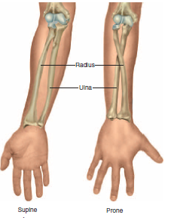

**Figure 7: Anatomical positions**

* **ANATOMICAL PLANES**

Many views of the body are based on real or imaginary “slices” called **sections** or **planes**. Section implies an actual cut or slice to reveal internal anatomy, whereas plane implies an imaginary flat surface passing through the body. The **three** major anatomical planes are **sagittal**, **frontal**, and **transverse**.

1. **Sagittal plane** extends vertically and divides the body or an organ into **right** and **left** portions. The **median** (midsagittal) plane passes through the midline of the body and divides it into **equal** right and left halves. Parasagittal is other type of sagittal planes which is parallel to the median plane divides the body into **unequal** right and left portions. The head and pelvic organs are commonly demonstrated in midsagittal views.
2. **Frontal** (coronal) plane also extends vertically, but it is perpendicular to the sagittal plane and divides the body into **anterior (front)** and **posterior (back)** portions. A frontal section of the head, for example, would divide it into one portion bearing the face and another bearing the back of the head. Contents of the thoracic and abdominal cavities are most commonly shown in frontal section.
3. **Transverse or horizontal**: it is a plane that runs parallel to the ground and divides the body into superior and inferior portions.

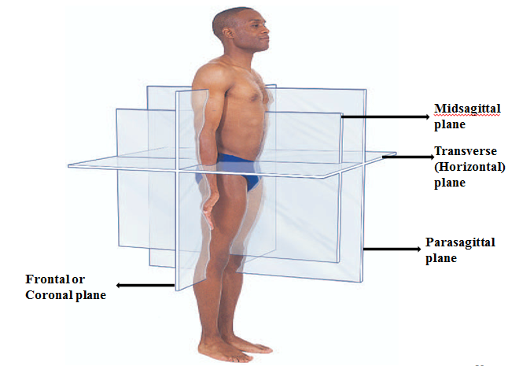**Figure 5**: Anatomical Planes of Reference.

* **Directional Terms**

It describe parts of the body relative to each other. **Right** and **left** retained as directional terms in anatomic terminology. **Up** is replaced by **superior**, **down** by **inferior**, **front** by **anterior**, and **back** by **posterior**. In humans, **superior** is synonymous with **cephalic**, which means toward the head. The term **inferior** is synonymous with **caudal**, which means toward the tail, which would be located at the end of the vertebral column if humans had tails.

* The word **anterior** means that which “**goes before”**, and **ventral** means belly because the belly “**goes first**” when we are walking.
* The word **posterior** means that which **follows**, and **dorsal** means **back**. The posterior surface of the body is the dorsal surface, or back, which follows as we are walking.
* **Proximal** means **nearest**, whereas **distal** means **distant**. These terms are used to refer to linear structures, such as the limbs, in which one end is near some other structure and the other end is farther away.
* **Medial** means **toward the midline**, and **lateral** means **away from the midline**.
* The term **superficial** refers to a structure close to the surface of the body, and **deep** is toward the interior of the body. The skin is superficial to muscle and bone.

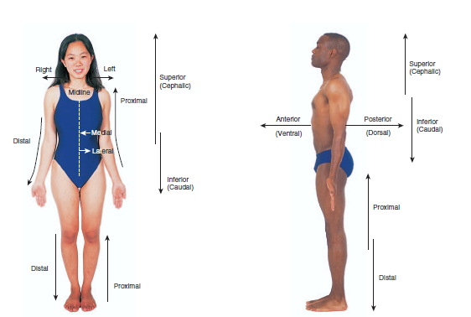

**Figure 8: Directional Terms**

**BODY PARTS AND REGIONS**

The human body consists two body regions in general appendage or limbs and central region:

* The **central region** of the body consists of the **head**, **neck**, and trunk. The **trunk** can be divided into **thorax (chest)**, **abdomen** (region between the thorax and pelvis), and **pelvis** (the inferior end of the trunk associated with the hips).
* Limb can be classified into upper and lower limb;
* The **upper limb** is divided into the **arm**, **forearm**, **wrist**, and **hand**. The **arm** extends from the **shoulder to the elbow**, and the **fore arm** extends from the **elbow to the wrist**.
* The **lower limb** is divided into the **thigh**, **leg**, **ankle**, and **foot**. The **thigh** extends from **hip to the knee**, and **leg** extends from **knee to the ankle**.

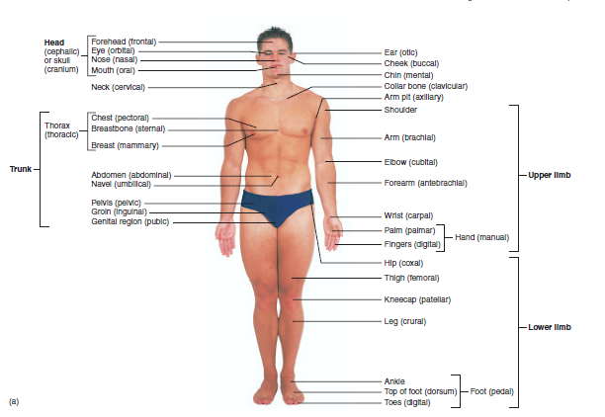

**CHAPTER TWO**

**THE INTEGUMENTARY SYSTEM**

The **skin,** or **integument,** is the body’s largest organ (fig. 6.1). In adults, it covers an area of 1.5 to 2.0 m2 and accounts for about 15% of the body weight. It consists of two layers:

(1) A stratified squamous epithelium called the *epidermis* and

(2) A deeper connective tissue layer called the *dermis.* Below the skin is another connective tissue layer, the *hypodermis*

Most of the skin is 1 to 2 mm thick—about half as thick as the cover of this book. It ranges, however, from less than 0.5 mm on the eyelids to 6 mm between the shoulder blades. This difference is due mainly to variation in the thickness of the dermis. However, skin is classified as *thick* or *thin skin* based on the relative thickness of the epidermis alone, especially the surface layer of dead cells called the *stratum corneum.* **Thick** **skin** covers the palms, soles, and corresponding surfaces of the fingers and toes. It has an epidermis that is 400 to 600_m thick, due to a very thick, tough stratum corneum. Thick skin has sweat glands but no hair follicles or sebaceous (oil) glands. The rest of the body is covered with **thin skin,** which has an epidermis 75 to 150 _m thick, with a thin stratum corneum. It possesses hair follicles, sebaceous glands, and sweat glands.

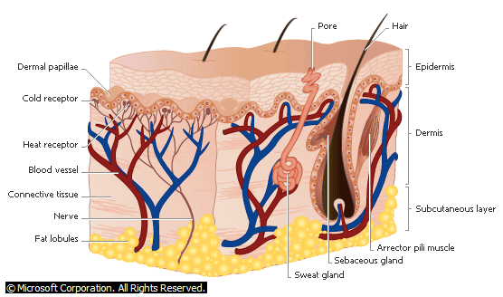

**Structure of the Skin**

The skin consists of an outer, protective layer (epidermis) and an inner, living layer (dermis). The top layer of the epidermis is composed of dead cells containing keratin, the horny protein that also makes up hair and nails

The **skin** is the body’s largest organ. In adults, it covers an area of 1.5 to 2.0 m and accounts for about 15% of the body weight. The skin consists of two layers: a stratified squamous epithelium called the *epidermis* and a deeper connective tissue layer called the *dermis*. Below the dermis is another connective tissue layer, the *hypodermis,* which is not part of the skin but is customarily studied in conjunction with it. Most of the skin is 1 to 2 mm thick, but it ranges from less than 0.5 mm on the eyelids to 6 mm between the shoulder blades.

The difference is due mainly to variation in the thickness of the dermis, although skin is classified as thick or thin based on the relative thickness of the epidermis alone. **Thick skin** covers the palms, soles, and corresponding surfaces of the fingers and toes. It has an epidermis that is 400 to 600 μm thick, due to a very thick surface layer of dead cells called the *stratum corneum*. Thick skin has sweat glands but no hair follicles or sebaceous (oil) glands. The rest of the body is covered with **thin skin,** which has an epidermis 75 to 150 μm thick with a thin stratum corneum. It possesses hair follicles, sebaceous glands, and sweat glands.

**Functions of the Skin**

The skin is much more than a container for the body. It has a variety of important functions that go well beyond appearance, as we shall see here.

1. **Resistance to trauma and infection.** The skin bears the brunt of most physical injuries to the body, but it resists and recovers from trauma better than other organs do. The epidermal cells are packed with the tough protein **keratin** and linked by strong desmosomes that give this epithelium its durability. Few infectious organisms can penetrate the intact skin. Bacteria and fungi colonize the skin surface, but their numbers are kept in check by the relative dryness and slight acidity (pH 4–6) of the surface. This protective acidic film is called the *acid mantle.*

2. **Water retention.** The skin is important as a barrier to water. It prevents the body from absorbing excess water when you are swimming or bathing, but even more importantly, it prevents the body from losing excess water.

3. **Vitamin D synthesis.** The skin carries out the first step in the synthesis of vitamin D, which is needed for bone development and maintenance. The liver and kidneys complete the process.

4. **Sensation.** The skin is our most extensive sense organ. It is equipped with a variety of nerve endings that react to heat, cold, touch, texture, pressure, vibration, and tissue injury. These sensory receptors are especially abundant on the face, palms, fingers, soles, nipples, and genitals. There are relatively few on the back and in skin overlying joints such as the knees and elbows.

5. **Thermoregulation.** In response to chilling, the skin helps to retain heat. The dermis has nerve endings called **thermoreceptors** that transmit signals to the brain, and the brain sends signals back to the dermal blood vessels. **Vasoconstriction,** or narrowing of these blood vessels, reduces the flow of blood close to the skin surface and thus reduces heat loss. When one is overheated, **vasodilation** or widening of the dermal blood vessels increases cutaneous blood flow and increases heat loss. If this is not enough to restore normal temperature, the brain also triggers sweating.

6. **Nonverbal communication.** The skin is an important means of communication. Humans, like other primates, have much more expressive faces than most mammals.

Complex skeletal muscles insert on dermal collagen fibers and pull on the skin to create subtle and varied facial expressions.

**The Epidermis**

The **epidermis** is a keratinized stratified squamous epithelium. That is, its surface consists of dead cells packed with keratin. Like other epithelia, the epidermis lacks blood vessels and depends on the diffusion of nutrients from the underlying connective tissue. It has sparse nerve endings for touch and pain, but most sensations of the skin are due to nerve endings in the dermis.

**CELLS OF THE EPIDERMIS**

The epidermis is composed of five types of cells:

1. **Stem cells** are undifferentiated cells that undergo mitosis and give rise to the keratinocytes described next. They are found only in the deepest layer of the epidermis, called the *stratum basale*.

2. **Keratinocytes** (keh-RAT-ih-no-sites) are the great majority of epidermal cells. They are named for their role insynthesizing keratin. In ordinary histological specimens, nearly all of the epidermal cells you can see are keratinocytes.

3. **Melanocytes** also occur only in the stratum basale, amid the stem cells and deepest keratinocytes. They synthesize the brown to black pigment *melanin.* They have long branching processes that spread among the keratinocytes and continually shed melanin-containing fragments from their tips. The keratinocytes phagocytize these fragments and accumulate melanin granules on the “sunny side” of the nucleus. Like a parasol, the pigment shields the DNA from ultraviolet radiation. People of all races have about equal numbers of melanocytes. Differences in skin color result from differences in the rate of melanin synthesis and how clumped or spread-out the melanin is. In light skin, the melanin is less abundant and is relatively clumped near the keratinocyte nucleus, imparting less color to the cells.

4. **Tactile (Merkel**) **cells,** relatively few in number, are receptors for the sense of touch. They, too, are found in the basal layer of the epidermis and are associated with an underlying dermal nerve fiber. The tactile cell and its nerve fiber are collectively called a *tactile (Merkel) disc.*

5. **Dendritic (Langerhans) cells** are found in two layers of the epidermis called the *stratum spinosum* and *stratum* *granulosum* (described in the next section). They are macrophages that originate in the bone marrow but migrate to the epidermis and epithelia of the oral cavity, esophagus, and vagina. The epidermis has as many as 800 dendritic cells per square millimeter. They “stand guard” against toxins, microbes, and other pathogens that penetrate into the skin. When they detect such invaders, they alert the immune system so the body can defend itself.

**LAYERS OF THE EPIDERMIS**

The epidermis consists of four to five layers of cells (five in thick skin). This description progresses from deep to superficial and from the youngest to the oldest keratinocytes.

1. The **stratum basale** (bah-SAY-lee) consists mainly of a single layer of cuboidal to low columnar stem cells and keratinocytes resting on the basement membrane. Scattered among these are also found melanocytes and tactile cells. As stem cells of the stratum basale undergo mitosis, they give rise to keratinocytes that migrate toward the skin surface and replace lost epidermal cells. The life history of these cells is described in the next section.

2. The **stratum spinosum** (spy-NO-sum) consists of several layers of keratinocytes; in most skin, this is the thickest stratum, but in thick skin it is usually exceeded by the stratum corneum. The deepest cells of the stratum spinosum retain the capability of mitosis, but as they arepushed farther upward, they cease dividing. Instead, they produce more and more keratin filaments, which cause the cells to flatten. Therefore, the higher up you look in the stratum spinosum, the flatter the cells appear. Dendritic cells are also found throughout the stratum spinosum, but are not usually visible in tissue sections.

The stratum spinosum is named for an artificial appearance *(artifact)* created by the histological fixation of tissue specimens. Keratinocytes are firmly attached to each other by numerous desmosomes, which partly account for the toughness of the epidermis. Histological fixatives shrink the keratinocytes and cause them to pull away from each other, but they remain attached to each other by the desmosomes—like two people holding hands while they step farther away from each other. The desmosomes thus create bridges from cell to cell, giving each cell a spiny appearance from which we derive the word *spinosum.*

3. The **stratum granulosum** consists of three to five layers of flat keratinocytes—more in thick skin than in thin skin— and some dendritic cells. The keratinocytes of this layer contain coarse, dark-staining *keratohyalin granules* that give the layer its name. The functional significance of these granules will be explained shortly.

4. The **stratum lucidum**7 (LOO-sih-dum) is a thin translucent zone superficial to the stratum granulosum, seen only in thick skin. Here, the keratinocytes are densely packed with

*eleidin* (ee-LEE-ih-din), an intermediate product in the production of keratin. The cells have no nuclei or other organelles. Because organelles are absent and eleidin does not stain well, this zone has a pale, featureless appearance with indistinct cell boundaries.

5. The **stratum corneum** consists of up to 30 layers of dead, scaly, keratinized cells that form a durable water-resistant surface layer.

**THE LIFE HISTORY OF A KERATINOCYTE**

Dead cells constantly flake off the skin surface. They float around as tiny white specks in the air, settling on household surfaces and forming much of the house dust that accumulates there. Because we constantly lose these epidermal cells, they must be continually replaced. Keratinocytes are produced deep in the epidermis by the mitosis of stem cells in the stratum basale. Some of the deepest keratinocytes in the stratum spinosum also remain mitotic and thus increase their number.Mitosis requires an abundant supply of oxygen and nutrients, which these deep epidermal cells can acquire from the blood vessels in the nearby dermis. Once the epidermal cells migrate more than two or three cell layers away from the dermis, their mitosis ceases. Mitosis is seldom seen in prepared slides of the skin, because it occurs mainly at night and most histological specimens are taken during the day.

As new keratinocytes are formed, they push the older ones toward the surface. Over the course of 30 to 40 days, a keratinocyte makes its way to the skin surface and then flakes off. This migration is slower in old age, and faster in skin that has been injured or stressed. Injured epidermis regenerates more rapidly than any other tissue in the body. Mechanical stress from manual labor or tight shoes accelerates keratinocyte multiplication and results in *calluses* or *corns,* thick accumulations of dead keratinocytes on the hands or feet.

As keratinocytes are shoved upward by the dividing cells below, their cytoskeleton proliferates, the cells grow flatter, and they produce lipid-filled **membrane-coating vesicles.** In the stratum granulosum, three important developments occur.

(1) The keratinocytes undergo apoptosis (programmed cell death).

(2) The keratohyalin granules release a substance that binds to the intermediate filaments of the cytoskeleton and converts them to keratin.

(3) The membrane-coating vesicles release a lipid mixture that spreads out over the cell surface and waterproofs it.

An *epidermal water barrier* forms between the stratum granulosum and the stratum spinosum. It consists of the lipids secreted by the keratinocytes, tight junctions between the keratinocytes, and a thick layer of insoluble protein on the inner surfaces of the keratinocyte plasma membranes. The epidermal water barrier is crucial to retaining water in the body and preventing dehydration.

Cells above the barrier quickly die because the barrier cuts them off from the supply of nutrients below. Thus, the stratum corneum consists of compact layers of dead keratinocytes and keratinocyte fragments. Dead keratinocytes soon *exfoliate* (fall away) from the epidermal surface as tiny specks called **dander.** *Dandruff* is composed of clumps of dander stuck together by sebum (oil).

**The Dermis**

Beneath the epidermis is a connective tissue layer, the **dermis.** It ranges from 0.2 mm thick in the eyelids to about 4 mm thick in the palms and soles. It is composed mainly of collagen but also contains elastic and reticular fibers, fibroblasts, and the other cells typical of fibrous connective tissue. It is well supplied with blood vessels, sweat glands, sebaceous glands, and nerve endings.

The hair follicles and nail roots are embedded in the dermis. Smooth muscles (piloerector muscles) associated with hair follicles contract in response to such stimuli as cold, fear, and touch. This makes the hairs stand on end, causes “goose bumps,”and wrinkles the skin in areas such as the scrotum and areola. In the face, skeletal muscles attach to dermal collagen fibers and produce such expressions as a smile, a wrinkle of the forehead, and the lifting of an eyebrow.

The boundary between the epidermis and dermis is histologically conspicuous and usually wavy. The upward waves are fingerlike extensions of the dermis called **dermal papillae,**8 and the downward waves are extensions of the epidermis called **epidermal** **ridges.** The dermal and epidermal boundaries thus interlock like corrugated cardboard, an arrangement that resists slippage of the epidermis across the dermis. If you look closely at your hand and wrist, you will see delicate furrows that divide the skin into tiny rectangular to rhomboidal areas. The dermal papillae produce the raised areas between the furrows (see fig. 5.2*b*). On the fingertips, this wavy boundary forms the *friction ridges* that leave fingerprints on the things we touch. In highly sensitive areas such as the lips and genitals, tall dermal papillae allow nerve fibers and blood capillaries to reach close to the skin surface.

**The Hypodermis**

Beneath the skin is a layer called the **hypodermis,** **subcutaneous tissue,** or **superficial fascia**11 (FASH-ee-uh). The boundary betweenthe dermis and hypodermis is indistinct, but the hypodermisgenerally has more areolar and adipose tissue. The hypodermisbinds the skin to the underlying tissues and pads the body. Drugsare introduced here by hypodermic injection because the subcutaneoustissue is highly vascular and absorbs them quickly. **Subcutaneous fat** is hypodermis composed predominantly ofadipose tissue. This fat serves as an energy reservoir and thermal insulation.

It is not uniformly distributed; for example, it is virtually absent from the scalp but relatively abundant in the breasts, abdomen, hips, and thighs. The subcutaneous fat averages about 8% thicker in women than in men, and is different in distribution. It also varies with age. Infants and elderly people have less subcutaneous fat than other people and are therefore more sensitive to cold.

**Skin Color**

The most significant factor in skin color is **melanin,** which is produced by the melanocytes but which accumulates in the keratinocytes of the stratum basale and stratum spinosum. There are two forms of melanin—a brownish black **eumelanin** and a reddish yellow sulfur-containing pigment, **pheomelanin.**13 People of different races have essentially the same number of melanocytes, but in dark-skinned people, the melanocytes produce greater quantities of melanin, and the melanin in the keratinocytes breaks down more slowly. Thus, melanized cells may be seen throughout the epidermis, from stratum basale to stratum corneum. In light-skinned people, the melanin breaks down more rapidly and little of it is seen beyond the stratum basale, if even there.

The amount of melanin in the skin also varies with exposure to the ultraviolet (UV) rays of sunlight, which stimulate melanin synthesis and darken the skin. Suntans fades as melanin is degraded in older keratinocytes and as the keratinocytes migrate to the surface and exfoliate. The amount of melanin also varies substantially from place to place on the body. It is relatively concentrated in freckles and moles, on the dorsal surfaces of the hands and feet as compared to the palms and soles, in the nipple and surrounding area (areola) of the breast, around the anus, in the scrotum and penis, and on the lateral surface of the female genital folds *(labia majora).* The contrast between heavily melanized and lightly melanized regions of the skin is more pronounced in some races than in others, but it exists to some extent in nearly everyone.

Other factors in skin color are hemoglobin and carotene.

**Hemoglobin,** the red pigment of blood, imparts reddish to pinkish hues to the skin. Its color is lightened by the white of the dermal collagen. The skin is redder in places such as the lips, where blood capillaries come closer to the surface and the hemoglobin shows through more vividly. **Carotene** is a yellow pigment acquired from egg yolks and yellow and orange vegetables. Depending on the diet, it can become concentrated to various degrees in the stratum corneum and subcutaneous fat. It is often most conspicuous in skin of the heel and in “corns” or calluses of the feet because this is where the stratum corneum is thickest.

The skin may also exhibit abnormal colors of diagnostic value:

• **Cyanosis**1 is blueness of the skin resulting from a deficiency of oxygen in the circulating blood. Oxygen deficiency turns the hemoglobin a reddish violet color. It can result from conditions that prevent the blood from picking up a normal load of oxygen in the lungs, such as airway obstructions in drowning and choking, lung diseases such as emphysema, or respiratory arrest. Cyanosis also occurs in situations such as cold weather and cardiac arrest, when blood flows so slowly through the skin that most of its oxygen is extracted faster than freshly oxygenated blood arrives.

• **Erythema** (ERR-ih-THEE-muh) is abnormal redness of the skin. It occurs in such situations as exercise, hot weather, sunburns, anger, and embarrassment. Erythema is caused by increased blood flow in dilated cutaneous blood vessels or by dermal pooling of red blood cells that have escaped from abnormally permeable capillaries.

• **Pallor** is a pale or ashen color that occurs when there is so little blood flow through the skin that the white color of the dermal collagen shows through. It can result from emotional stress, low blood pressure, circulatory shock, cold temperatures, or severe anemia.

• **Albinism** is a genetic lack of melanin that results in white hair, pale skin, and pink eyes. Melanin is synthesized from the amino acid tyrosine by the enzyme tyrosinase. People with albinism have inherited a recessive, nonfunctional tyrosinase gene from both parents.

• **Jaundice** is a yellowing of the skin and whites of the eyes resulting from high levels of bilirubin in the blood. Bilirubin is a hemoglobin breakdown product.When erythrocytes get old, they disintegrate and release their hemoglobin. The liverconverts hemoglobin to bilirubin andother pigments, which are excreted in the bile. Bilirubin can accumulate enough to discolor the skin, however, in such situations as a rapid rate of erythrocyte destruction; when diseases such as cancer, hepatitis, and cirrhosis interfere with liver function; and in premature infants, where the liver is not well enough developed to dispose of bilirubin efficiently.

• **Bronzing** is a golden-brown skin color that results from Addison disease, a deficiency of glucocorticoid hormones from the adrenal cortex. John F. Kennedy had Addison disease and bronzing of the skin, which many people mistook for a suntan.

**HAIR AND NAILS**

The hair nails, and cutaneous glands are the **accessory organs (appendages)** of the skin. Hair and nails are composed mostly ofdead, keratinized cells.While the stratum corneum of the skin is madeof pliable **soft keratin,** the hair and nails are composed mostly of **hard keratin.**Hard keratin is more compact than soft keratin and is toughenedby numerous cross-linkages between the keratin molecules.

**Hair**

A hair is also known as a **pilus** (PY-lus); in the plural, *pili* (PY-lye). It is a slender filament of keratinized cells that grows from an oblique tube in the skin called a **hair follicle**.

**DISTRIBUTION AND TYPES**

Hair is found almost everywhere on the body except the lips, nipples, parts of the genitals, palms and soles, ventral and lateral surfaces of the fingers and toes, and distal segment of the fingers. Hairless skin is sometimes called *glabrous* *skin.* The extremities and trunk have about 55 to 70 hairs per square centimeter, and the face has about 10 times as many. There are about 30,000 hairs in a man’s beard and about 100,000 hairs on the average person’s scalp. The number of hairs in a given area does not differ much from one person to another or even between the sexes. Differences in apparent hairiness are due mainly to differences in the texture and pigmentation of the hair. Not all hair is alike, even on one person. Over the course of our lives, we grow three kinds of hair: lanugo, vellus, and terminal hair. **Lanugo** is fine, downy, unpigmented hair of the fetus. By the time of birth, it is replaced by **vellus,** a similarly fine, unpigmented hair. Vellus constitutes about two-thirds of the hair of women, one-tenth of the hair of men, and all of the hair of children except for the eyebrows, eyelashes, and hair of the scalp. **Terminal** **hair** is longer, coarser, and pigmented. It forms the eyebrows andeyelashes, covers the scalp, and after puberty, it forms the axillary and pubic hair, the male facial hair, and some of the hair on the trunk and limbs.

**STRUCTURE OF THE HAIR AND FOLLICLE**

A hair is divisible into three zones along its length:

(1) The **bulb,** a swelling at the base where the hair originates in the dermis;

(2) The **root,** which is the remainder of the hair within the follicle; and

(3) The **shaft,** which is the portion above the skin surface. Except near the bulb, all the tissue is dead. The hair bulb grows around a bud of vascular connective tissue called the **dermalpapilla,** which provides the hair with its sole source of nutrition.

Immediately above the papilla is a region of mitotically active cells, the **hair matrix,** which is the hair’s growth center. All cells higher up are dead.

In cross section, a hair reveals three layers:

(1) the **medulla,** a core of loosely arranged cells and air spaces found in thick hairs, but absent from thin ones;

(2) the **cortex,** a layer of keratinized cuboidal cells; and (3) the **cuticle,** a surface layer of scaly cells that overlap each other like roof shingles, with their free edges directed upward. Cells lining the follicle are like shingles facing in the opposite direction. They interlock with the scales of the hair cuticle and resist pulling on the hair. When a hair is pulled out, this layer of follicle cells comes with it.

The follicle is a diagonal tube that dips deeply into the dermis and sometimes extends as far as the hypodermis. It has two principal layers: an **epithelial root sheath** and a **connective tissue root** **sheath.** The epithelial root sheath, which is an extension of the epidermis, lies immediately adjacent to the hair root. The connective tissue root sheath, derived from the dermis, surrounds the epithelial sheath and is somewhat denser than the adjacent dermal connective tissue.

Associated with the follicle are nerve and muscle fibers.

Nerve fibers called **hair receptors** entwine each follicle and respond to hair movements. You can feel their effect by carefully moving a single hair with a pin or by lightly running your fingerover the hairs of your arm without touching the skin. Also associated with each hair is a **piloerector muscle (arrector pili**), a bundle of smooth muscle cells extending from dermal collagen fibers to the connective tissue root sheath of the follicle. In response to cold, fear, or other stimuli, the sympathetic nervous system stimulates these muscles to contract and Thereby makes the hair stand on end. In other mammals, this traps an insulating layer of warm air next to the skin or makes the animal appear larger and less vulnerable to a potential enemy. In humans, it pulls the follicles into a vertical position and causes “goose bumps” but serves no useful purpose.

**HAIR TEXTURE AND COLOR**

The texture of hair is related to differences in cross-sectional shape straight hair is round, wavy hair is oval, and tightly curly hair is relatively flat. Hair color is due to pigment granules in the cells of the cortex. Brown and black hair are rich in eumelanin. Red hair has less eumelanin but a high concentration of pheomelanin. Blond hair has an intermediate amount of pheomelanin but very little eumelanin. Gray and white hair results from a scarcity or absence of melanins in the cortex and the presence of air in the medulla.

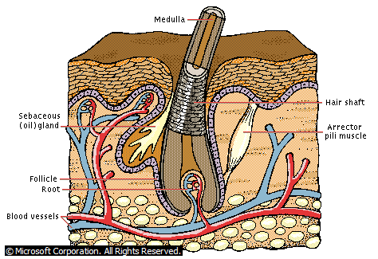

**Hair Growth**

A hair grows upward from the root. Lengthening fibers of keratin-filled dead cells, grouped around the semihollow medulla, make up the cortex. A living structure called the bulb (visible as a white lump at the end of a plucked hair) surrounds and feeds the root, which lies in a pocket of the epidermis called the follicle. Hair grows fastest when it is short.

**FUNCTIONS OF HAIR**

In most mammals, hair serves to retain body heat. Humans have too little hair to serve this purpose except on the scalp, where there is no insulating fat. Hair elsewhere on the body serves a variety of functions that are somewhat speculative, but probably best inferred by comparison to the specialized types and patches of hair in other mammals.

**Nails**

Fingernails and toenails are clear, hard derivatives of the stratum corneum. They are composed of very thin, dead, scaly cells, densely packed together and filled with parallel fibers of hard keratin. Most mammals have claws, whereas flat nails are one of the distinguishing characteristics of primates. Flat nails allow for more fleshy and sensitive fingertips, while they also serve as strong keratinized “tools” that can be used for digging, grooming, picking apart food, and other manipulations.

The anatomical features of a nail are shown in figure 5.9. The most important features are the **nail matrix,** a growth zone concealed beneath the skin at the proximal edge of the nail, and the **nail** **plate,** which is the visible portion covering the tip of the finger or toe. The nail groove and space under the free edge accumulate dirt and bacteria and require special attention when scrubbing for duty in an operating room or nursery.

Fingernails grow about 1 mm per week and toenails somewhat more slowly. New cells are added to the nail plate by mitosis in the nail matrix. Contrary to some advertising claims, adding gelatin to the diet has no effect on the growth or hardness of the nails. The appearance of the nails can be valuable to medical diagnosis. An iron deficiency, for example, may cause the nails to become flat or concave (spoonlike) rather than convex. The fingertips become swollen or *clubbed* in response to long-term hypoxemia stemming from conditions such as congenital heart defects and emphysema.

**CUTANEOUS GLANDS**

**Sweat Glands**

Sweat glands, or **sudoriferous** (soo-dor-IF-er-us) **glands,** are of two kinds, merocrine and apocrine. **Merocrine (eccrine)** **sweat glands,** the most numerous type, produce watery perspiration that serves primarily to cool the body. There are 3 to 4 million merocrine sweat glands in the adult skin, with a total weight about equal to that of a kidney. They are especially abundant on the palms, soles, and forehead, but they are widely distributed over the rest of the body as well. Each is a simple tubular gland with a twisted coil in the dermis or hypodermis and an undulating or coiled duct leading to a sweat pore on the skin surface. This duct is lined by a stratified cuboidal epithelium in the dermis and by keratinocytes in the epidermis. Amid the secretory cells at the deep end of the gland, there are specialized **myoepithelial**26 **cells** with properties similar to smooth muscle. They contract in response to stimuli from the sympathetic nervous system and squeeze perspiration up the duct.

**Apocrine sweat glands** occur in the groin, anal region, axilla, and areola, and in mature males, they also occur in the beard area. They are absent from the axillary region of Koreans and are very sparse in the Japanese. Their ducts lead into nearby hair follicles rather than opening directly onto the skin surface. They produce their secretion in the same way that merocrine glands do—that is, by exocytosis. The secretory part of an apocrine gland, however, has a much larger lumen than that of a merocrine gland, so these glands have continued to be referred to as apocrine glands to distinguish them functionally and histologically from the merocrine type.

Apocrine sweat is thicker and more milky than merocrine sweat because it has more fatty acids in it.

Apocrine sweat glands are scent glands that respond especially to stress and sexual stimulation. They do not develop until puberty, and in women, they enlarge and shrink in phase with the menstrual cycle. These facts, as well as experimental evidence, suggest that their function is to secrete chemicals called *sex* *pheromones,* which exert subtle effects on the sexual behavior and physiology of other people. They apparently correspond to the scent glands that develop in other mammals on attainment of sexual maturity. Fresh apocrine sweat does not have a disagreeable odor, and indeed it is considered attractive or arousing in some cultures.

Stale apocrine sweat acquires a rancid odor from the action of bacteria on the lipids in the perspiration. Disagreeable body odor is called *bromhidrosis.* It occasionally indicates a metabolic disorder, but more often it reflects poor hygiene. Many mammals have apocrine scent glands associated with specialized tufts of hair. In humans, apocrine glands are found almost exclusively in regions covered by the pubic hair, axillary hair, and beard, suggesting that they are similar to other mammalian scent glands in function. The hair serves to retain the aromatic secretion and regulate its rate of evaporation from the skin. Thus, it seems no mere coincidence that women’s faces lack both apocrine scent glands and a beard.

**Sebaceous Glands**

**Sebaceous** (seh-BAY-shus) **glands** produce an oily secretion called **sebum** (SEE-bum). They are flask-shaped,with short ducts that usually open into a hair follicle, although some of them open directly onto the skin surface. These are holocrine glands with little visible lumen. Their secretion consists of broken-down cells that are replaced by mitosis at the base of the gland. Sebum keeps the skin and hair from becoming dry, brittle, and cracked. The sheen of well-brushed hair is due to sebum distributed by the hairbrush.

**Ceruminous Glands**

**Ceruminous** (seh-ROO-mih-nus) **glands** are found only in the auditory (external ear) canal, where their secretion combines with sebum and dead epidermal cells to form earwax, or **cerumen.** They are simple, coiled, tubular glands with ducts leading to the skin surface.

Cerumen keeps the eardrum pliable, waterproofs the canal, and kills bacteria.

**Mammary Glands**

**Mammary glands** are milk-producing glands that develop within the breasts *(mammae)* under conditions of pregnancy and lactation.

**The Aging Integumentary System**

Senescence (age-related degeneration) of the integumentary system often becomes noticeable by the late 40s. The hair turns grayer and thinner as melanocytes die out, mitosis slows down, and dead hairs are not replaced. Atrophy of the sebaceous glands leaves the skin and hair drier. As epidermal mitosis declines and collagen is lost from the dermis, the skin becomes almost paperthin and translucent. It becomes looser because of a loss of elastic fibers and flattening of the dermal papillae. If you pinch a fold of skin on the back of a child’s hand, it quickly springs back when you let go; do the same on an older person, and the skin fold remains longer. Because of its loss of elasticity, aged skin sags to various degrees and may hang loosely from the arm and other places.

Aged skin has fewer blood vessels than younger skin, and those that remain are more fragile. The skin can become reddened as broken vessels leak into the connective tissue. Many older people exhibit *rosacea*—patchy networks of tiny, dilated blood vessels visible especially on the nose and cheeks. Because of the fragility of the dermal blood vessels, aged skin bruises more easily. Injured skin heals slowly in old age because of poorer circulation and a relrelative scarcity of immune cells and fibroblasts. Antigen-presenting dendritic cells decline by as much as 40% in the aged epidermis, leaving the skin more susceptible to recurring infections.

Thermoregulation can be a serious problem in old age because of the atrophy of cutaneous blood vessels, sweat glands, and subcutaneous fat. Older people are more vulnerable to hypothermia in cold weather and heatstroke in hot weather. Heat waves and cold spells take an especially heavy toll among the elderly poor, who suffer from a combination of reduced homeostasis and inadequate housing. Degeneration of the skin is accelerated by excessive exposure to the ultraviolet radiation of sunlight. This *photo aging* accounts for more than 90% of the changes that people find medically troubling or cosmetically disagreeable: skin cancer; yellowing and mottling of the skin; age spots, which resemble enlarged freckles on the back of the hand and other sun-exposed areas; and wrinkling, which especially affects the most exposed areas of skin (face, hands, and arms). Sundamaged skin shows many malignant and premalignant cells, extensive damage to the dermal blood vessels, and dense masses of coarse, frayed elastic fibers underlying the surface wrinkles and creases.

**SKELETAL SYSTEM**

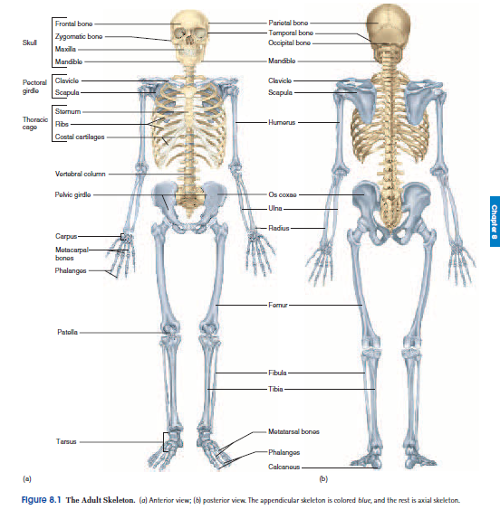

The **skeletal system** is composed of bones, cartilages, and ligaments tightly joined to form a strong, flexible framework for the body. Cartilage, the embryonic forerunner of most bones, covers many joint surfaces in the mature skeleton. Tendons are structurally similar to ligaments but attach muscles to bones.

**Functions of the Skeleton**

The skeleton obviously provides the body with physical support, but it plays many other roles that go unnoticed by most people. Its functions include:

• **Support.** Bones of the legs, pelvis, and vertebral column hold up the body; the jaw bones support the teeth; and nearly all bones provide support for muscles.

• **Movement.** Skeletal muscles would serve little purpose if not for their attachment to the bones and ability to move them.

• **Protection.** Bones enclose and protect such delicate organs and tissues as the brain, spinal cord, lungs, heart, pelvic viscera, and bone marrow.

• **Blood formation.** Red bone marrow is the major producer of blood cells, including most cells of the immune system.

• **Electrolyte balance.** The skeleton is the body’s main mineral reservoir. It stores calcium and phosphate and releases them when needed for other purposes.

• **Acid-base balance.** Bone buffers the blood against excessive pH changes by absorbing or releasing alkaline salts such as calcium phosphate.

• **Detoxification.** Bone tissue removes heavy metals and other foreign elements from the blood and thus reduces their toxic effects on other tissues. It can later release these contaminants more slowly for excretion. The tendency of bone to absorb foreign elements can, however, have terrible consequences.

**Bones and Osseous Tissue**

Bone, or **osseous** **tissue,** is a connective tissue in which the matrix is hardened by the deposition of calcium phosphate and other minerals. The hardening process is called **mineralization** or **calcification.** Osseous tissue, however, is only one of the tissues that make up a bone. Also present are blood, bone marrow, cartilage, adipose tissue, nervous tissue, and fibrous connective tissue. The word *bone* can denote an organ composed of all these tissues, or it can denote just the osseous tissue.

**The Shapes of Bones**

Bones are classified into four groups according to their shapes and corresponding functions:

1. **Long bones** are roughly cylindrical in shape and significantly longer than wide. Like crowbars, they serve as rigid levers that are acted upon by the skeletal muscles to produce body movements. Long bones include the humerus of the arm, the radius and ulna of the forearm, the metacarpals and phalanges of the hand, the femur of the thigh, the tibia and fibula of the leg, and the metatarsals and phalanges of the feet.

2. **Short bones** are more nearly equal in length and width. They include the carpal (wrist) and tarsal (ankle) bones. They have limited motion and merely glide across one another, enabling the ankles and wrists to bend in multiple directions.

3. **Flat bones** enclose and protect soft organs and provide broad surfaces for muscle attachment. They include most cranial bones, the ribs, the sternum (breastbone), the scapula (shoulder blade), and the ossa coxae (hipbones).

4. **Irregular bones** have elaborate shapes that do not fit into any of the preceding categories. They include the vertebrae and some skull bones, such as the sphenoid and ethmoid bones.

**General Features of Bones**

Bones have an outer shell of dense white osseous tissue called **compact (dense) bone,** usually enclosing a more loosely organized form of osseous tissue called **spongy (cancellous) bone.** The skeleton is about three-quarters compact bone and one-quarter spongy bone by weight. The principal features of a long bone are its shaft, called the **diaphysis** (dy-AF-ih-sis), and an expanded head at each end, called the **epiphysis** (eh-PIF-ih-sis). The diaphysis consists largely of a cylinder of compact bone enclosing a space called the **medullary** (MED-you-lerr-ee) **cavity.** The epiphysis is filled with spongy bone. Bone marrow occupies the medullary cavity and the spaces amid the spongy bone of the epiphysis. The diaphysis of along bone provides leverage, while the epiphysis is enlarged to strengthen the joint and provide added surface area for the attachment of tendons and ligaments.

In children and adolescents, an **epiphyseal** (EP-ih-FIZZ-ee-ul) **plate** of hyaline cartilage separates the marrow spaces of the epiphysis and diaphysis. On X rays, it appears as a transparent line at the end of a long bone. The epiphyseal plate is a zone where the bones grow in length. In adults, the epiphyseal plate is depleted and the bones can grow no longer, but an *epiphyseal line* on the bone surface marks the former location of the plate.

Externally, most of the bone is covered with a sheath called the **periosteum.** This has a tough, outer *fibrous layer* of collagen and an inner *osteogenic layer* of bone-forming cells. Some collagen fibers of the outer layer are continuous with the tendons that bind muscle to bone, and some penetrate into the bone matrix as **perforating** **(Sharpey) fibers.** The periosteum thus provides strong attachment and continuity from muscle to tendon to bone. The osteogenic layer is important to the growth of bone and healing of fractures. Blood vessels of the periosteum penetrate into the bone through minute holes called **nutrient foramina** (for-AM-ih-nuh); we will trace where they go when we consider bone histology. The internal surface of a bone is lined with **endosteum,** a thin layer of reticular connective tissue and cells that deposit and dissolve osseous tissue. At most joints, the ends of the adjoining bones have no periosteum but rather a thin layer of hyaline cartilage, the **articular** **cartilage.** Together with a lubricating fluid secreted between the bones, this cartilage enables a joint to move far more easily than it would if one bone rubbed directly against the other.

Flat bones have a sandwichlike construction, with two layers of compact bone enclosing a middle layer of spongy bone. In the skull, the spongy layer is called the **diploe**11 (DIP-loee).

A moderate blow to the skull can fracture the outer layer of compact bone, but the diploe can sometimes absorb the impact and leave the inner layer of compact bone unharmed.

**HISTOLOGY OF OSSEOUS TISSUE**

**Cells**

Like any other connective tissue, bone consists of cells, fibers, and ground substance. There are four types of bone cells:

1. **Osteogenic**12 **(osteoprogenitor) cells** are stem cells found in the endosteum, the inner layer of the periosteum, and within the central canals of the osteons. They arise from embryonic fibroblasts. Osteogenic cells multiply continually, and some of them differentiate into the *osteoblasts* described next.

2. **Osteoblasts** are bone-forming cells that synthesize the organic matter of the matrix and help to mineralize the bone. They line up in rows in the endosteum and inner layer of periosteum, and resemble a cuboidal epithelium on the bone surface. Osteoblasts are nonmitotic, so the only source of new osteoblasts is mitosis and differentiation of the osteogenic cells. Stress and fractures stimulate accelerated mitosis of osteogenic cells, and therefore a rapid rise in the number of osteoblasts.

3. **Osteocytes** are former osteoblasts that have become trapped in the matrix they deposited. They live in tiny cavities called **lacunae,** which are connected to each other by slender channels called **canaliculi** (CAN-uh-LIC-you-lye). Each osteocyte has delicate cytoplasmic processes that reach into the canaliculi to meet the processes of neighboring osteocytes. The processes of neighboring osteocytes are joined by gap junctions, which allow osteocytes to pass nutrients and chemical signals to each other and to transferwastes to the nearest blood vessels for disposal. Osteocytes also communicate by gap junctions with the osteoblasts on the bone surface. Osteocytes play no major role in depositing or resorbing bone. Rather, they are strain detectors.When they detect strain in a bone, they communicate with osteoblasts at the surface. The osteoblasts then deposit bone where needed—for example, building up bone in response to weight-bearing exercise. Osteoblasts also chemically signal *osteoclasts* to remove bone elsewhere.

4. **Osteoclasts** are bone-dissolving macrophages found on bone surfaces. They develop from the same marrow cells that produce monocytes of the blood. Several of these marrow cells fuse with each other to form an osteoclast; thus, osteoclasts are unusually large (up to 150 _m in diameter) and typically have 3 or 4 nuclei, but sometimes up to 50. The side of the osteoclast facing the bone has a *ruffled border* with many deep infoldings of the plasma membrane, increasing its surface area. Hydrogen pumps in the ruffled border secrete hydrogen ions (H_) into the extracellular fluid, and chloride ions (Cl_) follow by electrical attraction; thus, the space between the osteoclast and the bone becomes filled with hydrochloric acid (HCl) with a pH of about 4. HCl dissolves the minerals of the adjacent bone, then lysosomes of the osteoclast release enzymes that digest the organic component. Osteoclasts often reside in little pits called *resorption bays (Howship* *lacunae)* that they have etched into the bone surface.

**Compact Bone**

The histological study of compact bone usually uses slices that have been dried, cut with a saw and ground to translucent thinness. This procedure destroys the cells and much of the other organic content but reveals fine details of the inorganic matrix. Such sections show onion like **concentric lamellae**—layers of matrix concentrically arranged around a **central (haversian**18 or **osteonic)** **canal.** A central canal and its lamellae constitute an **osteon (haversian** **system)**—the basic structural unit of compact bone. Along their length, central canals are joined by transverse or diagonal passages.

The central canals contain blood vessels and nerves. Lacunae lie between adjacent layers of matrix and are connected with each other by canaliculi. Canaliculi of the innermost lacunae open into the central canal. In longitudinal views and three-dimensional reconstructions, we find that an osteon is a cylinder of tissue surrounding a central canal. In each lamella, the collagen fibers are laid down in a helical pattern like the threads of a screw. In areas where the bone must resist tension (bending), the helix is loosely coiled like the threads on a wood screw and the fibers are more nearly longitudinal. In weight-bearing areas, where the bone must resist compression, the helix is more tightly coiled like the closely spaced threads on a bolt and the fibers are more nearly transverse. Often, the helices coil in one direction in one lamella and in the opposite direction in the next lamella. Like alternating layers of a sheet of plywood, this makes the bone stronger and enables it to resist tension in multiple directions.

The skeleton receives about half a liter of blood per minute. Blood vessels, along with nerves, enter the bone tissue through nutrient foramina on the surface. These open into narrow **perforating (Volkmann) canals** that cross the matrix and lead to the central canals. The innermost osteocytes around each central canal receive nutrients from these blood vessels and pass them along through their gap junctions to neighboring osteocytes.

They also receive wastes from their neighbors and convey them to the central canal for removal by the bloodstream. Thus, the cytoplasmic processes of the osteocytes maintain a two-way flow of nutrients and wastes between the central canal and the outermost cells of the osteon. Not the entire matrix is organized into osteons. The inner and outer boundaries of dense bone are arranged in *circumferential* *lamellae* that run parallel to the bone surface. Between osteons, we can find irregular patches of *interstitial lamellae,* the remains of old osteons that broke down as the bone grew and remodeled itself.

**Spongy Bone**

Spongy bone consists of a lattice of thin plates called **trabeculae** and rods and spines called **spicules**. Although calcified and hard, spongy bone is named for its sponge like appearance; it is permeated by spaces filled with bone marrow. The matrix is arranged in lamellae like those of compact bone, but there are few osteons. Central canals are not needed here because no osteocyte is very far from the blood supply in the marrow. Spongy bone is well designed to impart strength to a bone with a minimum of weight. Its trabeculae are not randomly arranged as they might seem at a glance, but develop along the bone’s lines of stress.

**Bone Marrow**

**Bone marrow** is a general term for soft tissue that occupies the medullary cavity of a long bone, the spaces amid the trabeculae of spongy bone, and the larger central canals. In a child, the medullary cavity of nearly every bone is filled with **red bone marrow** **(myeloid tissue).** This is a *hemopoietic* (HE-mo-poy-ET-ic) tissue— that is, it produces blood cells. Red bone marrow looks like blood but with a thicker consistency. It consists of a delicate mesh of reticular tissue saturated with immature blood cells and scattered adipocytes.

With age, the red bone marrow is gradually replaced by fatty **yellow bone marrow,** like the fat at the center of a ham bone. By early adulthood, red bone marrow is limited to the vertebrae, sternum, ribs, pectoral (shoulder) and pelvic (hip) girdles, and the proximalheads of the humerus and femur, while the rest of the skeleton contains yellow marrow. Yellow bone marrow no longer produces blood, although in the event of severe or chronic anemia, it can transform back into red marrow and resume that role.

**BONE DEVELOPMENT**

The formation of bone is called **ossification** (OSS-ih-fih-CAYshun), or **osteogenesis.** There are two methods of ossification—*endochondral* and *intramembranous.* **Endochondral Ossification**

**Endochondral**23 (EN-doe-CON-drul) **ossification** is a process in which a bone develops from hyaline cartilage.Most bones form by this method, including the vertebrae, pelvic bones, and limb bones.

In endochondral ossification, embryonic mesenchyme condenses into a hyaline cartilage *model* that resembles the shape of the bone to come. The cartilage is then broken down, reorganized, and calcified to form a bone.

**THE PRIMARY OSSIFICATION CENTER**

In the cartilage model, the first sign of endochondral ossification is the multiplication and swelling of chondrocytes near the center, forming a **primary ossification center.** As the lacunae enlarge, the matrix between them is reduced to thin walls and the model becomes weak at this point. It soon gets reinforcement, however.

Some cells of the perichondrium become osteoblasts, which produce a bony collar around the model. This collar acts like a splint to provide temporary support for the model, and it cuts off the diffusion of nutrients to the chondrocytes, hastening their death. Once the collar has formed, the fibrous sheath around it is considered periosteum rather than perichondrium. Buds of connective tissue grow from this periosteum into the cartilage and penetrate the thin walls between the enlarged lacunae.

They break down the lacunae and transform the primary ossification center into a cavity called the **primary marrow space.** Osteogenic cells invade the cartilage model by way of the connective tissue buds, transform into osteoblasts, and line the marrow space. The osteoblasts deposit an organic matrix called **osteoid**24 **tissue**—soft collagenous tissue similar to bone except for a lack of minerals—and then calcify it to form a temporary framework of bony trabeculae.As ossification progresses, osteoclasts break down these trabeculae and enlarge the primary marrow space. The ends of the bone are still composed of hyaline cartilage at this stage.

**THE METAPHYSIS**

At the boundary between the marrow space and each cartilaginous head of a developing long bone, there is a transitional zone called the **metaphysis** (meh-TAF-ih-sis). It exhibits five histological zones of transformation from cartilage to bone:

1. **Zone of reserve cartilage.** In this zone, farthest from the marrow space, the resting cartilage as yet shows no sign of transforming into bone.

2. **Zone of cell proliferation.** A little closer to the marrow space, chondrocytes multiply and become arranged into longitudinal columns of flattened lacunae.

3. **Zone of cell hypertrophy.** Next, the chondrocytes cease to divide and begin to hypertrophy, just as they did in the primary ossification center. The cartilage walls between lacunae become very thin. Cell multiplication in zone andhypertrophy in zone continually push the zone of reserve cartilage toward the ends of the bone and make the bone grow longer.

4. **Zone of calcification.** Minerals are deposited in the matrix between columns of lacunae and calcify the cartilage for temporary support.

5. **Zone of bone deposition.** Within each column, the walls between lacunae break down and the chondrocytes die. This converts each column into a longitudinal channel, which is quickly invaded by marrow and blood vessels from the primary marrow space. Osteoclasts dissolve the calcified cartilage while osteoblasts line up along the walls of these channels and begin depositing concentric layers of bone matrix. The channel therefore grows smaller and smaller as one layer after another is laid down, until only a narrow channel remains in the middle—now a central canal.

Osteoblasts trapped in their own matrix become osteocytes and stop producing matrix. The primary ossification centers of a 12-week-old fetus are shown in figure 7.30. The joints are translucent because they have not yet ossified. They are still cartilaginous even at the time of birth, which is one reason human newborns cannot walk.

**THE SECONDARY OSSIFICATION CENTER**

Around the time of birth, **secondary ossification centers** begin to form in the epiphyses. Here, too, chondrocytes enlarge, the walls of matrix between them dissolve, and the chondrocytes die.

Vascular buds arise from the perichondrium and grow into the cartilage, bringing osteogenic cells and osteoclasts with them. The cartilage is eroded from the center of the epiphysis outward in all directions. Thin trabeculae of cartilage matrix calcify to form spongy bone. Hyaline cartilage persists in two places—on the epiphyseal surfaces as the articular cartilages and at the junction of the diaphysis and epiphysis, where it forms the epiphyseal plate (fig. 6.9). Each side of the epiphyseal plate has a metaphysis, where the transformation of cartilage to bone occurs.

**Intramembranous Ossification**

**Intramembranous**25 (IN-tra-MEM-bruh-nus) **ossification** produces the flat bones of the skull and most of the clavicle (collarbone).

It begins when some of the embryonic connective tissue (mesenchyme) condenses into a sheet of soft tissue with a dense supply of blood capillaries. The cells of this sheet enlarge and differentiate into osteogenic cells, and some of the mesenchyme transforms into a network of soft trabeculae. Osteogenic cells gather on the trabeculae, become osteoblasts, and deposit osteoid tissue. As the trabeculae grow thicker, calcium phosphate is deposited in the matrix and some osteoblasts become trapped in lacunae. Once trapped, they differentiate into osteocytes.

Some of the now-calcified trabeculae form permanent spongy bone. Osteoclasts soon appear on these trabeculae, resorbing and remodeling bone and creating a marrow space. Trabeculae at the surface continue to calcify until the spaces between them are filled in, thereby converting the spongy bone to compact bone. This process gives rise to the typical structure of a flat cranial bone—a sandwichlike arrangement of spongy bone between two surface layers of compact bone. Mesenchyme at the surface of the developing bone remains uncalcified, but becomes increasingly fibrous and eventually gives rise to the periosteum.

**The Aging Skeletal System**

The predominant effect of aging on the skeleton is a loss of bone mass and strength. After age 30, osteoblasts become less active than osteoclasts. The imbalance between deposition and resorption leads to **osteopenia,** the loss of bone; when the loss is severe enough to compromise physical activity and health; it is called *osteoporosis*. After age 40, women lose about 8% of their bone mass per decade and men lose about 3%. Bone loss from the jaws is a contributing factor in tooth loss. Not only does bone density decline with age, but the bones become more brittle as the osteoblasts synthesize less protein. Fractures occur more easily and heal more slowly.

**STRUCTURAL DISORDERS OF BONE**

**Fractures**

There are multiple ways of classifying bone fractures.A **stress fracture** is a break caused by abnormal trauma to a bone, such as fracturesincurred in falls, athletics, and military combat. A **pathologic fracture** is a break in a bone weakened by some other disease, suchas bone cancer or osteoporosis, usually caused by a stress thatwould not normally fracture a bone. Fractures are also classified accordingto the direction of the fracture line, whether or not the skinis broken, and whether a bone is merely cracked or is broken intoseparate pieces. Most fractures are set by *closed reduction,* a procedure inwhich the bone fragments are manipulated into their normal positionswithout surgery. *Open reduction* involves the surgical exposureof the bone and the use of plates, screws, or pins to realignthe fragments. To stabilize the bone during healing,fractures are often set in fiberglass casts. *Traction* is used to treatfractures of the femur in children. It aids in the alignment of thebone fragments by overriding the force of the strong thigh muscles.

Traction is rarely used for elderly patients, however, because the risks from long-term confinement to bed outweigh the benefits. Hip fractures are usually pinned, and early ambulation (walking) is encouraged because it promotes blood circulation and healing.

An uncomplicated fracture heals in 8 to 12 weeks, but complex fractures take longer and all fractures heal more slowly in older people. Usually, a healed fracture leaves a slight thickening of the bone visible by X ray, but in some cases healing is so complete that no trace of the fracture can be found.

**Osteoporosis**

**Osteoporosis**—literally, “porous bones”—is a disease in which the bones lose mass and become increasingly brittle and subject to fractures. It involves loss of proportionate amounts of organic matrix and minerals, and it affects spongy bone in particular, since this is the most metabolically active type. The bone that remains is histologically normal but insufficient in quantity to support the body’s weight. The most serious consequence of osteoporosis is pathologic fractures, which occur especially in the hip, wrist, and vertebral column and under stresses as slight as sitting down too quickly. Among the elderly, hip fractures often lead to fatal complications such as pneumonia. For half of those who survive, a hip fracture involves a long, costly recovery. As the weight-bearing bodies of the vertebrae lose spongy bone, they become compressed like marshmallows.

Consequently, many people lose height after middle age, and some develop a spinal deformity called **kyphosis,** an exaggerated thoracic curvature (“widow’s hump” or “dowager’s hump”).

Postmenopausal white women are at greatest risk for osteoporosis for multiple reasons: (1) women have less bone mass than men to begin with, (2) they begin losing it earlier (starting around age 35), (3) they lose it faster than men do, and (4) after menopause, the ovaries no longer produce estrogen, an important stimulus to bone deposition. By age 70, the average white woman has lost 30% of her bone mass, and some have lost as much as 50%. Young black women develop more bone mass than whites. Although they, too, lose bone after menopause, the loss usually does not reach the threshold for osteoporosis and pathologic fractures.

Men of both races suffer osteoporosis less than white women but more than black women. In men, bone loss begins around age 60 and seldom exceeds 25%. Osteoporosis also occurs among young female runners and dancers in spite of their vigorous exercise. Their percentage of body fat is so low that their ovaries secrete unusually low levels of estrogen and the women may stop ovulating. Estrogen replacement therapy cannot reverse osteoporosis, but it can slow its progress. Furthermore, in some women, estrogen therapy increases the risk of breast cancer. Alternatives to estrogen therapy are becoming available, but each has its own undesirable side effects. Some patients are now treated with a calcitonin nasal spray. Milk and other calcium sources and moderate exercise can also slow the progress of osteoporosis, but only slightly.