CHAPTER TWO
OPERATIONS STRATEGY & COMPETITIVENESS
2.1 Introduction to operations strategy
2.2 Operations strategy in Manufacturing
2.3 Operations strategy in Services

2.1.Introduction to operations strategy
Each of a firm’s strategies should be established in light of (1) the threats and opportunities in the environment and (2) the strengths and weaknesses of the organization. Ultimately, every strategy is an attempt to answer the question, “How do we satisfy a customer?” within these constraints.

Identifying Missions and Strategies: An effective operations management effort must have a mission so it knows where it is going and a strategy so it knows how to get there.

Mission: Economic success, indeed survival, is the result of identifying missions to satisfy a customer’s needs and wants.
Definition: We define the organization’s mission as its purpose―what it will contribute to society. Mission statements provide boundaries and focus for organizations and the concept around which the firm can rally. The mission states the rationale for the organization’s existence. Developing a good strategy is difficult, but it is much easier if the mission has been well defined. The mission can also be thought of as the intent of the strategy―what the strategy is designed to achieve.
Once an organization’s mission has been decided, each functional area within the firm determines its supporting mission. By “functional area” we mean the major disciplines required by the firm, such as marketing, finance /accounting, and production/operations. Missions for each functional area are developed to support the firm’s overall mission. Then within that function lower-level supporting missions are established for the operation management functions.

Strategy: With the mission established, strategy and its implementation can begin. Strategy is an organization’s action plan to achieve the mission. Each functional area has a strategy for achieving its mission and for helping the organization reach the overall mission.
These strategies exploit opportunities and strengths, neutralize threats, and avoid weaknesses.
Firms achieve missions in three conceptual ways: (1) differentiation, (2) cost leadership, and (3) quick response. This means operations managers are called on to deliver goods and services that are (1) better, or at least different, (2) cheaper, and (3) more responsive. Operations managers translate these strategic concepts into tangible tasks to be accomplished. Any one or combination of these three strategic concepts can generate a system that has a unique advantage over competitors.

Strategies and Tactics: A mission statement provides a general direction for an organization and gives rise to organizational goals, which provide substance to the overall mission. For example, one goal of an organization may be to capture a certain percent of market share for a product; another goal may be to achieve a certain level of profitability. Taken together, the goals and the mission establish a destination for the organization.
Strategies: are plans for achieving goals. If you think of goals as destinations, then strategies are the road maps for reaching the destinations. Strategies provide focus for decision-making. Generally speaking, organizations have overall strategies called organization strategies, which relate to the entire organization, and they also have functional strategies, which relate to each of the functional areas of the organization. The functional strategies should support the overall strategies of the organization, just as the organizational strategies should support the goals and mission of the organization.
Tactics: are the methods and actions used to accomplish strategies. They are more specific in nature than strategies, and they provide guidance and direction for carrying out actual operations, which need the most specific and detailed plans and decision-making in an organization. You might think of tactics as the “how to” part of the process (e.g., how to reach the destination, following the strategy road map) and operations as the actual “doing” part of the process. It should be apparent that the overall relationship that exists from the mission down the actual operations is hierarchical in nature.
Example- Nina is a high school student in Bahirdar. She would like to have a career in business, have a good job, and earn enough income to live comfortably.
A possible scenario for achieving her goals might look something like this:
Mission: Live a good life.
Goal: Successful career, good income.
Strategy: Obtain a university education.
Tactics: Select a university and a major; decide how to finance university.
Operations: Register, buy books, takes courses, study.

Operations Strategy: The organization strategy provides the overall direction for the organization. It is broad in scope, covering the entire organization. Operation strategy is narrower in scope, deals primarily with the operations aspect of the organization. Operations strategy relates to products, processes, methods, operating resources, quality, cost, lead times, and scheduling. In order for operations strategy to be truly effective, it is important to link it to organization strategy; that is, the two should not be formulated independently. Rather, formulation of organization strategy should take into account the realities of operations’ strengths and weaknesses, capitalizing on strengths and dealing with weaknesses. Similarly, operations strategy must be consistent with the overall strategy of the organization, and formulated to support the goals of the organization

WHAT IS STRATEGY?
- A Strategy is an integrated and coordinated set of commitments and actions designed to gain a competitive advantage.
- Strategic decisions can be classified as those decisions which make major long term changes to the resource base of the organization in response to external factors such as markets, customers and competitors.
- Operations strategy is concerned with both what the operation has to do in order to meet current and future challenges and also is concerned with the long-term development of its operations resources and processes so that they can provide the basis for a sustainable advantage

LEVELS OF STRATEGY:

Strategy can be considered to exist at three levels in an organization:
- Corporate level strategy: Corporate level strategy is the highest level of strategy. It sets the long-term direction and scope for the whole organization. If the organization comprises more than one business unit, corporate level strategy will be concerned with what those businesses should be, how resources (e.g. cash) will be allocated between them, and how relationships between the various business units and between the corporate centre and the business units should be managed. Organizations often express their strategy in the form of a corporate mission or vision statement.
- Business level strategy: Business level strategy is primarily concerned with how a particular business unit should compete within its industry, and what its strategic aims and objectives should be. Depending upon the organization’s corporate strategy and the relationship between the corporate centre and its business units, a business unit’s strategy may be constrained by a lack of resources or strategic limitations placed upon it by the centre. In single business organizations, business level strategy is synonymous with corporate level strategy.

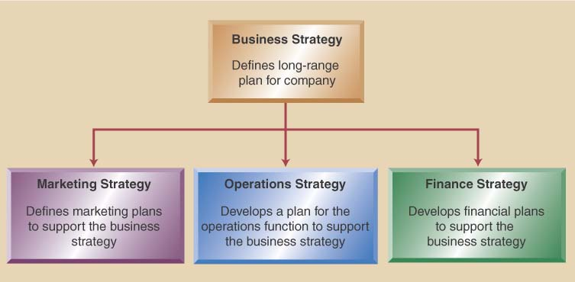

To Develop a Business Strategy:
- Consider these factors in strategic decisions:
  - What business is the company in (mission)
  - Analyze and understand the market (environmental scanning)
  - Identify the company strengths (core competencies)

Three Inputs to a Business Strategy
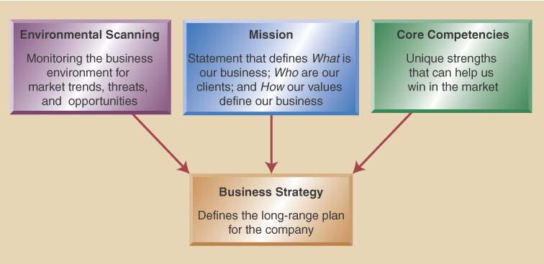

Example:
- Mission: Dell Computer- “to be the most successful computer company in the world”
- Environmental Scanning: political trends, social trends, economic trends, market place trends, global trends
- Core Competencies: strength of workers, modern facilities, market understanding, best technologies, financial know-how, logistics

- Functional level strategy: The bottom level of strategy is that of the individual function (operations, marketing, finance, etc.) These strategies are concerned with how each function contributes to the business strategy, what their strategic objectives should be and how they should manage their resources in pursuit of those objectives.

OPERATIONS STRATEGY OF MANUFACTURING/SERVICES
OPERATIONS STRATEGY OF MANUFACTURINGF/SERVICES
Companies must be competitive to sell their goods and services in the market place. Competitiveness is an important factor in determining whether a company prospers or fails. Business organizations compete with one another in variety of ways there are three strategies (differentiation, cost leadership, and quick response) that provides an opportunity for operations managers to obtain competitive advantage. Competitive advantage implies the creation of a system that has a unique advantage over competitors. The idea is to create customer value in an efficient and sustainable way. Let us briefly look at how managers achieve competitive advantage via differentiation, low cost, and response.

Competing on Differentiation: Differentiation is concerned with providing uniqueness. A firm’s opportunities for creating uniqueness are not located within a particular function or activity, but can arise in virtually everything that the firm does. Moreover, because most products include some service and most services include some product, the opportunities for creating this uniqueness are limited only by imagination.
Competing on Cost: One driver of a low-cost strategy is an optimal facility that is effectively utilized. Low-Cost Leadership: entails achieving maximum value as defined by your customer. It requires examining each of the different operation management decisions in a relentless effort to drive down costs while meeting customer expectations of value. A low-cost strategy does not imply low value or low quality.

Competing on Response: Response is often thought of as flexible response, but it also refers to reliable and quick response. Indeed, we define response as including the entire range of values related to timely product development and delivery, as well as reliable scheduling and flexible performance.

An operations strategy is concerned with Coordination of operational goals. ‘Operations strategy concerns the pattern of strategic decisions and actions which set the role, objectives and activities of operations’. Their use of the term ‘pattern’ implies a consistency in strategic decisions and actions over time. Strategy in a business organization is essentially about how the organization seeks to survive and prosper within its environment over the long-term. The decisions and actions taken within its operations have a direct impact on the basis on which an organization is able to do this. The way in which an organization secures, deploys and utilizes its resources will determine the extent to which it can successfully pursue specific performance objectives.

There are five operations strategy:
- Cost: The ability to produce at low cost.
  - Offering product at a low price relative to competition
  - Typically high volume products
  - Often limit product range & offer little customization
  - May invest in automation to reduce unit costs
  - Can use lower skill labor
  - Probably uses product focused layouts
  - Low cost does not mean always low quality

- Quality: The ability to produce in accordance with specification and without error.
  - Two major quality dimensions include
    - High performance design:
      - Superior features, high durability, & excellent customer service
    - Product & service consistency:
      - Meets design specifications
      - Close tolerances
      - Error free delivery
- Speed: The ability to do things quickly in response to customer demands and thereby offer short lead times between when a customer orders a product or service and when they receive it.
  - Time/speed one of most important competition priorities
  - First that can deliver often wins the race
  - Time related issues involve
    - Rapid delivery:
      - Focused on shorter time between order placement and delivery
    - On-time delivery:
      - Deliver product exactly when needed every time

- Dependability: The ability to deliver products and services in accordance with promises made to customers (e.g. in a quotation or other published information).
- Flexibility: The ability to change operations. Flexibility can comprise up to four aspects:
i. The ability to change the volume of production.
ii. The ability to change the time taken to produce.
iii. The ability to change the mix of different products or services produced.
iv. The ability to innovate and introduce new products and services.
- Company environment changes rapidly
- Company must accommodate change by being flexible
  - Product flexibility:
    - Easily switch production from one item to another
    - Easily customize product/service to meet specific requirements of a customer
  - Volume flexibility:
    - Ability to ramp production up and down to match market demands
Excelling at one or more of these operations performance objectives can enable an organization to pursue a business strategy based on a corresponding competitive factor. However, it is important to note that the success of any particular business strategy depends not only on the ability of operations to achieve excellence in the appropriate performance objectives, but crucially on customers valuing the chosen competitive factors on which the business strategy is based. Matching operations excellence to customer requirements lies at the heart of any operations based strategy.
Operations excellence and competitive factors:
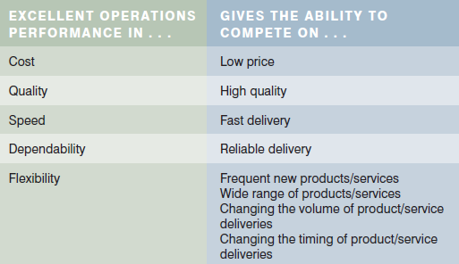

Operations Strategy Process

CORE COMPETENCE:
Core competency is what a firm does better than anyone else, its distinctive competence. A firm’s core competence can be exceptional service, higher quality, faster delivery, or lower cost. One company may strive to be first to the market with innovative designs, whereas another may look for success arriving later but with better quality.
Based on experience, knowledge, and know-how, core competencies represent sustainable competitive advantages. For this reason, products and technologies are seldom core competencies. The advantage they provide is short-lived, and other companies can readily purchase, emulate, or improve on them. Core competencies are more likely to be processes, a company’s ability to do certain things better than a competitor.
Core competencies are not static. They should be nurtured, enhanced, and developed over time. Close contact with the customer is essential to ensuring that a competence does not become obsolete. Core competencies that do not evolve and are not aligned with customer needs can become core rigidities for a firm. To avoid these problems, companies need to continually evaluate the characteristics of their products or services that prompt customer purchase; that is, the order qualifiers and order winners.
A firm is in trouble if the things it does best are not important to the customer. That’s why it’s essential to look toward customers to determine what influences their purchase decision.
- Order qualifiers are the characteristics of a product or service that qualify it to be considered for purchase by a customer.
- An order winner is the characteristic of a product or service that wins orders in the marketplace—the final factor in the purchasing decision. Order winner is a criterion that differentiates the products and services of one firm from another.
For example, when purchasing a DVD or Blu-ray player, customers may determine a price range (order qualifier) and then choose the product with the most features (order winner) within that price range. Or they may have a set of features in mind (order qualifiers) and then select the least expensive player (order winner) that has all the required features.
Which priorities are “Order Winners”?
- Dell competes on all four priorities
- Southwest Airlines competes on cost
- McDonald’s competes on consistency
- FedEx competes on speed

STEPS IN DEVELOPING A MANUFACTURING STRATEGY
- Segment the market according to the product group
- Identify product requirements, demand patterns, and profit margins of each group
- Determine order qualifiers and winners for each group
- Convert order winners into specific performance requirements

SERVICE STRATEGY CAPACITY CAPABILITIES
- Process-based
Capacities that transforms material or information and provide advantages on dimensions of cost and quality
- Systems-based
Capacities that are broad-based involving the entire operating system and provide advantages of short lead times and customize on demand
- Organization-based
Capacities those are difficult to replicate and provide abilities to master new technologies

