UNIT FOUR
AGRICULTURE AND ECONOMIC DEVELOPMENT
Pretest
Dear learners, do you think that strategy of agricultural development can be taken as a basis for overall development in the context of the contemporary developing countries? Outline your reason.

4.1 The Structure of Agrarian Systems in the Developing World
World agriculture comprises two distinct types of farming: (1) the highly efficient agriculture of the developed countries, and (2) the inefficient and low-productivity agriculture of developing countries,
In 1960, agricultural labor productivity in developed countries was more than 13 times that in the less developed countries. By 2000, this productivity gap had widened to more than 50 to 1. Another manifestation of the productivity gap relates to land productivity. In 2000, variations in land productivity between developed countries and developing countries are also immense. For example, despite the far smaller number of farm workers per hectare in the United Kingdom, its grain yield per hectare was 3 times that of India, 6 times that of Nigeria, and almost 12 times that of Sudan.
The steady growth has been spurred by technological and biological improvements, which have resulted in ever-higher levels of labor and land productivity. For example, in 1820 an American farmer could produce only four times his own consumption. By 2000, a single American farmer could provide enough food to feed nearly 100 people. Moreover, during the entire period, average farm incomes in North America rose steadily.

The picture is different when we turn to the agricultural production experience of low- income nations. In many poor countries, agricultural production methods have changed relatively slowly over time. Where fertile land is scarce, rapid population growth has led to an increase in the number of people living on each unit of land. Given the same farming technology and the use of traditional non-labor inputs, we know from the principle of diminishing returns that as more and more people are forced to work on a given piece of land, their marginal productivity will decline.
A common characteristic of agriculture in all developing regions is the position of the family farm as the basic unit of production. Agrarian systems in many parts of Asia and Latin America show more structural and institutional similarities than differences, and subsistence farmers in all three regions exhibit many of the same economic behavior patterns.
4.1.1 The Structure of Agrarian Systems in Latin America and Asia: Similarities and differences:
Both the Latin American and Asian peasant is
- a rural cultivator whose prime concern is survival.
- Earns subsistence income by tilling inadequate piece of land rented from or pawned to a landlord or moneylender,
- employs techniques rationally scaled to his level of disposable capital:
- human and animal power rather than mechanized equipment;
- excrement rather than chemical fertilizers;
- traditional crops and seeds rather than experimental cultivation
- Has no effective social security, unemployment insurance.
4.1.1.2 The Structure of Agrarian Systems in Asia
As opposed to the major agrarian problem of Latin America as too much land under the control of too few people, the basic problem in Asia is one of too many people crowded onto too little land. For example, the per capita availability of arable land in 1994 in In- dia, China, and Bangladesh was 0.19, 0.08, and 0.07 hectares, respectively.
Gunnar Myrdal identified three major interrelated forces: (1) the intervention of European rule, (2) the progressive introduction of monetized transactions and the rise in power of the moneylender, and (3) the rapid growth of Asian populations.
The arrival of the Europeans (mainly the British, French, and Dutch) led to major changes in the traditional agrarian structure, some of which had already begun. As Myrdal points out, "Colonial rule acted as an important catalyst to change, both directly through its effects on property rights and indirectly through its effects on the pace of monetization of the indigenous economy and on the growth of population." In the area of property rights, European land tenure systems of private property ownership were both encouraged and reinforced by law.
The ultimate impoverishment of the peasantry was the inevitable consequence of this process of fragmentation, economic vulnerability, and loss of land to rich and powerful landlords.

4.1.1.3 The Structure of Agrarian Systems in Africa
However, the organization and structure of African agricultural systems differ markedly from those found in contemporary Asia or Latin America. African agriculture systems are dominated by three major characteristics: (1) the importance of subsistence farming in the village community; (2) the existence of some land in excess of immediate requirements; and (3) the rights of each family in a village to have access to land and water in the immediate territorial vicinity, excluding from such access use by families that do not belong to the community even though they may be of the same tribe.
The low-productivity subsistence farming characteristic of most traditional African agriculture results from a combination of three historical forces restricting the growth of output:
- In spite of the existence of some unused and potentially cultivable land, only small areas can be planted and weeded by the farm family at a time when it uses only traditional tools. In some countries, use of animals is impossible because of the notorious tsetse fly or a lack of fodder in the long dry seasons, and traditional farming practices must rely primarily on the application of human labor to small parcels of land.
- Given the limited amount of land that a farm family can cultivate in the context of a traditional technology and the use of primitive tools, these small areas tend to be intensively cultivated. Under shifting cultivation, once the minerals are drawn out of the soil as a result of numerous cropping, new land is cleared, and the process of planting and weeding is repeated. In the meantime, formerly cropped land is allowed to recover fertility until it can be used again.
- Labor is scarce during the busiest part of the growing season, planting and weeding times. Because the time of planting is determined by the onset of the rains and because much of Africa experiences only one extended rainy season, the demand for workers during the early weeks of this rainy season usually exceeds all available rural labor supplies.

Of all the major regions of the world, Africa has suffered the most from its inability to expand food production at a sufficient pace to keep up with its rapid population growth.
As a result of declining production, African per capita food consumption fell dramatically during the 1980s and I990s while dependence on imports-particularly wheat and rice-increased.

4.2 The Important Role of Women in Agricultural Production
In Africa, where subsistence farming is predominant and shifting cultivation remains important. Although men who remain home generally perform the initial task of cutting trees and bushes on a potentially cultivable plot of land, women are responsible for all subsequent operations, including removing and burning felled trees, sowing or planting the plot, weeding, harvesting, and preparing the crop for storage or immediate consumption. In her pioneering work on women and development, Ester Boserup found, in some cases, women do around 70% and in one case nearly 80% of the total agricultural work.

Women provide an important source of labor for cash crop production, raise and market livestock, generate additional income through cottage industries, collect firewood and water, and perform household chores, including the processing and cooking of foods. Studies concerning the allocation of women's time among different activities have greatly increased recognition of the importance of rural women's economic contribution. Current estimates show that in addition to work within the household, women provide 60% to 80 % of agricultural labor in Africa and Asia and about 40% in Latin America. Much of this work, however, is statistically "invisible" in that women often receive no payment for the work they perform. These facts imply that successful agricultural reform will require raising women's productivity.

Women’s investments in revenue-generating projects and livestock are crucial to stabilizing household income, especially in female-headed households, where resource constraints are the most severe.
When credit and resources are unavailable, reducing the variability of household earnings generally entails choosing less efficient methods of production and thus lower income. This trade-off occurs most frequently in female-headed households, where resource constraints are greatest. Thus, as a consequence of their restricted range of choices, women tend to retain traditional modes of economic activity. The upshot is that their productivity has stagnated while that of men has continued to improve.

In many developing regions, women are still unremunerated for the long hours they contribute to the tending of commercial crops. As revenue-generating cash cropping rises in importance, the proportion of resources controlled by women tends to diminish. This is largely due to the fact that household resources, such as land and inputs, are transferred away from women's crops in order to promote the production of cash crops.
Government extension programs that provide resources exclusively to men tend to exacerbate existing disparities between men's and women's access to resources. If credit is provided solely or preferentially to men for the purpose of cash cropping, commercial production will increase at the expense of women's vegetable gardens. Since homegrown vegetables must be replaced by purchased substitutes, significant increases in a male spouse's cash contribution are necessary to offset a woman's losses. If the market price of vegetables increases markedly (there are now fewer producers) and the increase in the husband's contribution is not sufficient to compensate for the increased need for cash, the welfare of the woman and her children will decline.

This fall in the well- being of household members is due to the fact that a considerably higher proportion of women's income than men's is used for nutrition and basic necessities. Thus, if men's incomes rise at the expense of women's resources, as many studies have indicated, an increase in household income will not necessarily lead to improvements in health and nutrition. Changes in land use that increase household income but reduce women's economic status can be detrimental to the welfare of both women and children. Consequently, it is important that the design of government extension programs reflect the interests of all household members.

Yet government-sponsored programs continue to exclude women, often because women lack collateral for loans or are barred by law from owning proper’ or conducting financial transactions without their husband's permission. Agricultural inputs and training are rarely provided to female applicants. Even efforts to reduce poverty through land reforms have been found to reduce female income and economic status because they distribute land titles only to male heads of household. Cultural and social barriers to women's integration into agricultural programs remain strong because in many countries, women's income is perceived as a threat to men's authority. While men are taught new agricultural techniques to increase their productivity, women, if involved at all, are trained to perform low productivity tasks that are considered compatible with their traditional roles, such as sewing, cooking, or basic hygiene. Women's components of development projects are frequently little more than welfare programs that fail to improve economic well-being. Furthermore, these projects tend to depend on the unpaid work of women, while men are remunerated for their efforts.

Though efforts to increase the income of women by providing direct access to credit and inputs have experienced considerable success, programs that work indirectly with women have frequently fallen short of their stated goals. Studies have found that projects are most likely to elicit the cooperation of women when resources are placed directly under their control. Clearly, projects that depend on the unremunerated labor of women are likely to obtain only minimal support. Adoption of new crops and technologies will be more effective where patterns of production are consistent with the interests of female household members. Because the active participation of women is critical to agricultural prosperity, policy design should ensure that women benefit equally from development efforts.
4.3 The Economics of Agricultural Development
The most primitive is the pure, low-productivity, mostly subsistence-level peasant farm.
The second stage is what might be called diversified or mixed family agriculture,
The third stage represents the modern farm, exclusively engaged in high-productivity specialized agriculture geared to the commercial market.

4.3.1 Subsistence Farming: Risk Aversion, Uncertainty, and Survival
On the classic peasant subsistence farm, most output is produced for family consumption, and a few staple foods (usually including wheat, barley, sorghum, rice, or corn) are the chief sources of nutrition. The law of diminishing returns is in operation as more labor is applied to shrinking (or shifting) parcels of land.
The failure of the rains, the appropriation of his land, and the appearance of the moneylender to collect outstanding debts are the banes of the peasant's existence and cause him to fear for his survival.
Labor is underemployed for most of the year, although workers may be fully occupied at seasonal peak periods such as planting and harvest. The peasant usually cultivates only as much land as his family can manage without the need for hired labor, although many peasant farmers intermittently employ one or two landless laborers. Any cash income that is generated comes mostly from non-farm wage labor.

Throughout much of the developing world, agriculture is still in this subsistence stage. But in spite of the relative backwardness of production technologies and the misguided convictions of some foreigners who attribute the peasants' resistance to change as a sign of incompetence or irrationality, the fact remains that given the static nature of the peasants' environment, the uncertainties that surround them, the need to meet minimum survival levels of output, and the rigid social institutions into which they are locked, most peasants behave in an economically rational manner when confronted with alternative opportunities.
The standard two-factor neoclassical theory of production in which land is fixed, labor is the only variable input, and profit is maximized does not satisfactorily explain why small-scale farmers are often resistant to technological innovation in farming techniques or to the introduction of new seeds or different cash crops. According to the standard theory, a rational income or profit-maximizing farm or firm will always choose a method of production that will increase output for a given cost or lower costs for a given output level. But the theory is based on the crucial assumption that farmers possess "perfect knowledge" of all technological input-output relationships as well as about prevailing factor and product prices. When access to information is highly imperfect, the transaction costs of obtaining this information are usually high. Given price uncertainty, peasant farmers often face price bands rather than a single input price. Along with limited access to credit and insurance, such an environment is not conducive to the type of behavior posited by neoclassical theory and goes a long way toward explaining the actual risk aversion behavior of peasant farmers, including their caution in the use of purchased in· puts such as fertilizer.

In regions where farms are extremely small and cultivation is dependent on the uncertainties of variable rainfall, the peasant and his family will be exposed to the very real danger of starvation in years with inadequate rainfall. In such circumstances, the main motivating force in the peasant's life may be the maximization of his family's chances of survival. Accordingly, when risk and uncertainty are high, a small farmer may be very reluctant to shift from a traditional technology and crop pattern that over the years he has come to know and understand to a new one that promises higher yields but may entail greater risks of crop failure.
When sheer survival is at stake, it is more important to avoid a bad year than to maximize the output in better years. Risk-avoiding peasant farmers are likely to prefer a technology of food production that combines a low mean per-hectare yield with low variance to alternative technologies and crops that may promise a higher mean yield but also present the risk of a greater variance.
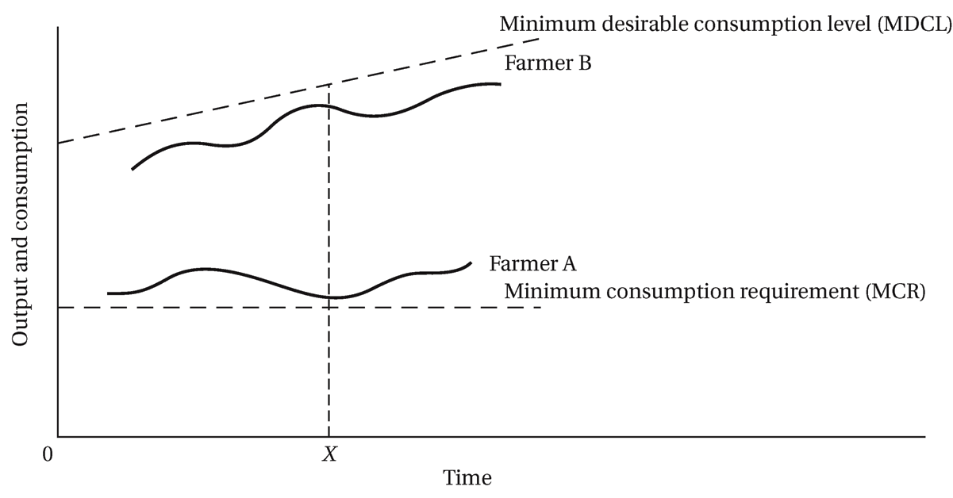
Figure 4.1: Small-Farmer Attitudes toward risk: Why it is sometimes Rational to Resist Innovation and Change

Figure 4.1 provides a simple illustration of how attitudes toward risk among small farmers may militate against apparently economically justified innovations. In the figure, levels of output and consumption are measured on the vertical axis and different points in time on the horizontal axis, and two straight lines are drawn. The lower horizontal line measures the minimum consumption requirements (MCR) necessary for the farm family's physical survival. This may be taken as the starvation minimum fixed by nature. Any output below this level would be catastrophic for the peasant and his family. The upper, positively sloped straight line represents the minimum level of food consumption that would be desirable given the prevailing cultural factors affecting village consumption standards. It is assumed that the minimum desirable consumption level (MDCL) rises over time to reflect rising expectations as traditional societies are opened up to external influences. The producer's attitude toward risk will be largely conditioned by his historical output performance relative to these two standards of reference.

Figure 4.1 we see that at time X, farmer A’s output levels have been very close to the MCR. He is barely getting by and cannot take a chance of any crop failure. He will have a greater incentive to minimize risk than farmer B, whose output performance has been well above the minimum subsistence level and is close to the culturally determined MDCL. Farmer B will therefore be more likely to innovate and change than farmer A. The result may be that farmer A remains in self-perpetuating poverty trap.

There is an alternative way to look at risk-aversion decisions of peasant farmers. In 4.2, two graphs portraying hypothetical probabilities for crop yield are depicted. The higher graph (technique A) shows a production technology with a lower mean crop yield (10) than that of technique B (12), shown by the lower graph. But it also has a lower variance around that mean yield than technique Clearly, the chances of starving are much greater with technique B, so risk-averse peasant farmers would naturally choose technique A, the one with the lower me yield.

Figure 4:2 Crop Yield Probability Densities of Two Different Farming Techniques

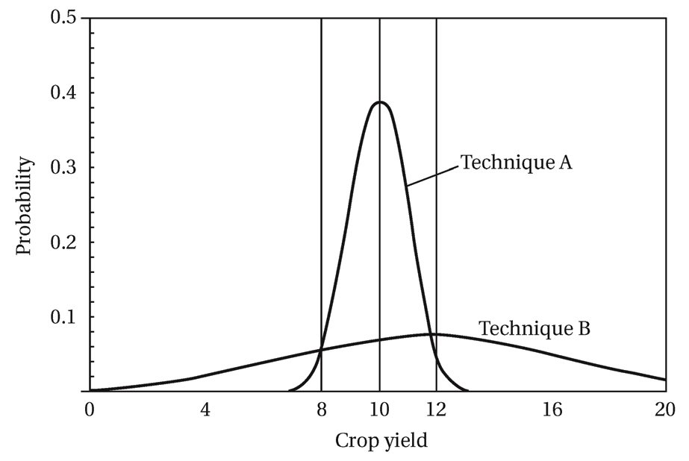

Many programs to raise agricultural productivity among small farmers have suffered because of failure to provide adequate insurance (both financial credit and physical "buffer" stocks) against the risks of crop shortfalls, whether these risks are real or imagined.

We may conclude that peasant farmers do act rationally and are responsive economic incentives and opportunities. Efforts to minimize risk and remove commercial and institutional obstacles to small-farmer innovation therefore essential requirements of agricultural and rural development.

4.4 The Transition to Mixed and Diversified Farming
It is neither realistic nor desirable to think of instantly transforming a traditional agrarian system that has prevailed for many generations into a highly specialized commercial farming system.

Diversified or mixed farming stage, the staple crop no longer dominates farm output, and new cash crops such as fruits, vegetables, coffee, tea, and pyrethrum are established, together with simple animal husbandry. These new activities can take up the normal slack in farm workloads, during times of the year when disguised unemployment is prevalent. This is especially desirable in many developing nations where rural labor is abundantly available for better and more efficient use.

The success or failure of efforts to transform traditional agriculture will depend not only on the farmer's ability and skill in raising his productivity but, even more important, on the social, commercial, and institutional conditions under which he must function. If he can have reasonable and reliable access to credit, fertilizer, water, crop information, and marketing facilities; if he receives a fair market price for his output; and if he can feel secure that he and his family will be the primary beneficiaries of any improvements, there is no reason to assume that the traditional farmer will not respond to new opportunities to improve his standard of living. Evidence from such diverse countries as Colombia, Mexico, Nigeria, Ghana, Kenya, India, Pakistan, Thailand, and the Philippines shows that under proper conditions, small farmers are responsive to price incentives and economic opportunities and will make radical changes in what they produce and how they produce it. Lack of innovation in agriculture, as we have seen, is usually due not to poor motivation or fear of change but to inadequate or unprofitable opportunities.

From Divergence to Specialization: Modern Commercial Farming
The specialized farm represents the final and most advanced stage of individual holding in a mixed market economy. General rises in living standards, biological and technical progress, and the expansion of national and international markets have provided the main impetus for its emergence and growth.

In specialized farming, pure commercial profit becomes the criterion of success, and maximum per-hectare yields derived from synthetic and natural resources become the object of farm activity. Production, in short, is entirely for the market.

They range from intensively cultivated fruit and vegetable farms to the vast wheat and corn fields of North America. In most cases, sophisticated laborsaving mechanical equipment, ranging from huge tractors and combine harvesters to airborne spraying techniques, permits a single family to cultivate many thousands of hectares of land.

The common features of all specialized farms, therefore, are their emphasis on the cultivation of one particular crop, their use of capital-intensive and in many cases laborsaving techniques of production, and their reliance on economies of scale to reduce unit costs and maximize profits.

4.5 Toward a Strategy of Agricultural and Rural Development: Some Main Requirements
If the major objective of agricultural and rural development in developing nations is the progressive improvement in rural levels of living achieved primarily through increases in small-farm incomes, output, and productivity.
These are necessarily interrelated, but for purposes of description we may separate them and further divide each into three components:
- Sources of small-scale agricultural progress include:
- Technological change and innovation
- Appropriate government economic policies
- Supportive social institutions
- Conditions for General Rural Advancement
- Modernizing farm structures to meet rising food demands
- Creating an effective supporting system
- Changing the rural environment to improve levels of living

Technology and Innovation
Unfortunately, both have somewhat problematic implications for LDC agricultural development. The first is the introduction of mechanized agriculture to replace labor. The introduction of labor-saving machinery can have a dramatic effect on the volume of output per worker; especially where land is extensively cultivated and labor is scarce. For example, one man operating a huge combine harvester can accomplish in a single hour what would require hundreds of workers using traditional methods.

But in the rural areas of most developing nations, where land parcels are small, capital is scarce, and labor is abundant, the introduction of heavily mechanized techniques is not only often ill-suited to the physical environment but, more important, often also has the effect of creating more rural unemployment without necessarily lowering per-unit costs of food production.

The second major sources are biological water control, and chemical innovations, that is, they improve the quality of existing land by raising yields per hectare. Only indirectly do they increase output per worker.

Although they are scale-neutral and thus offer the potential for small-farm progress, the social institutions and government economic policies that accompany their introduction into the rural economy are often not scaleneutra1. On the contrary, they often merely serve the needs and vested interests of the wealthy landowners. Large landowners, with their disproportionate access to these complementary inputs and support services, are able to gain a competitive advantage over smallholders and eventually drive them out of the market. Large-scale farmers obtain access to low-interest government credit, while smallholders are forced to turn to moneylenders. The inevitable result is the further widening of the gap between rich and poor and the increased consolidation of agricultural land in the hands of a very few so-called progressive farmers.

Institutional and Pricing Policies: Providing the Necessary Economic Incentives
Many LDC governments, in their headlong pursuit of rapid industrial and urban development, maintained low agricultural prices in an attempt to provide cheap food for the urban modern sector. Farmers were paid prices below either world competitive or free-market internal price. The relative internal price ratio between food and manufactured goods thus turned against farmers and in favor of urban manufacturers. With farm prices so low-in some cases below the costs of production there was no incentive for farmers to expand output or invest in new productivity-raising technology. As a result, local food supplies continually fell short of demand, and many developing nations, especially in sub-Saharan Africa, that were once self-sufficient in food production had to import food.
Economists therefore argue that if LDC governments are to promote increase in agricultural production through new green revolution technologies, they must not only make the appropriate institutional and credit market adjustments but also provide incentives for small- and medium-size farmers by implementing pricing policies that truly reflect internal market conditions.
4.5.1 Land Reform
A first step in any such effort, especially in Latin America and Asia, is the provision of secured tenure rights to the individual farmer. A small farmer's attachment to his land is profound. It is closely bound up with his innermost sense of self-esteem and freedom from coercion.

It is for these reasons as well as for reasons of higher agricultural output and the simultaneous achievement of both greater efficiency and more equity that land reform is often proposed as a necessary first condition for agricultural development in many LDCs. In most countries, the highly unequal structure of land ownership is probably the single most important determinant of the existing highly inequitable distribution of rural income and wealth.

Land reform usually entails a redistribution of the rights of ownership or use of land away from large landowners in favor of cultivators with very limited or no landholdings. It can take many forms:
- the transfer of ownership to tenants who already work the land to create family farms,
- transfer of land from large estates to small farms to rural cooperatives, or to state farms; or
- the appropriation of large estates for new settlement

All go under the heading of land reform and are designed to fulfill one central function.
4.5.2 Supportive Policies
Though land reform is essential in many parts of Asia and Latin America, it is likely to be ineffective and perhaps even counterproductive unless there are corresponding changes in rural institutions that control production, in supporting government aid , and in government pricing policies with regard to both and outputs. Even where land reform is not necessary but where productivity and incomes are low ,this broad network of external support services, also with appropriate governmental pricing policies related to both farm inputs and outputs, is an essential condition for sustained agricultural progress.
The conclusion is that the full benefits of small-scale agricultural development cannot be realized unless government support systems are created that provide the necessary incentives, economic opportunities, and access to needed credit and inputs to enable small cultivators to expand their output and raise their productivity

4.5.3 Integrated Development Objectives
It encompasses
(a) efforts to raise both, farm and non-farm rural real incomes through job creation, rural industrialization, and the increased provision of education, health and nutrition,
(b) a decreasing inequality in the distribution of rural incomes and; and
(c) the capacity of the rural sector to sustain and accelerate the pace of these improvements.
This is not only because the majority of populations in the developing world are located in rural areas but also because the burgeoning problems of urban unemployment and population congestion must find their ultimate solution in the improvement of the rural environment. By restoring a proper balance between urban and rural economic opportunities and by creating the conditions for broad popular participation in national development efforts and rewards, developing nations will have taken a giant step toward the realization of the true meaning of development.
Questions for Review and Discussion
- Why should any analysis of development problems place heavy emphasis on the study of agricultural systems, especially peasant agricultural, and the rural sector?
- It is sometimes said the world consists of two kinds of agriculture. Explain what is meant by this statement, and indicate how it might be illustrated. Be specific.
- Compare and contrast the nature of peasant or small-scale agriculture in Asia, Africa, and Latin America. How do overall agricultural systems differ among these regions? What are their common characteristics?
- It is sometimes asserted that small peasant farmers are backward and ignorant because they seem to resist agricultural innovations that could raise farm yields substantially. Does this resistance stem from an inherent irrationality on their part, or might it be attributable to some other factors often overlooked by Western economists? Explain your answer.
- What are the principal characteristics of the three stages in the transition from subsistence to specialized agriculture?
- There appears to be widespread agreement that in regions where the distribution of land ownership is highly unequal, land reform is a necessary but not sufficient condition for promoting and improving small-scale agriculture. What is meant by this statement and by the concept of land reform? Give some examples of supportive policy measure that might accompany land reform?
7. What is meant by comprehensive or integrated rural development? What criteria would you use to decide whether or not such integrated rural development was or was not taking place?
- What explains sharecropping? To what extent do you think your explanation?
Justifies the practice?
- If land reform is efficient, why do you think it is so rare?

