UNIT ONE
- Population Growth and Economic Development: Causes, Consequences, and Controversies

Pretest

Dear distance learners, using your general knowledge and intuitive understanding, could you explain the interdependence between human capital and economic development? What controversies are there surrounding this relationship? Could you outline?

1.1 The Basic Issue: Population Growth and the Quality of Life
Almost all net population increase (97%) is in developing countries. Increases of such magnitude are unprecedented. But the problem of population growth is not simply a problem of numbers. It is a problem of human welfare and of development. Rapid population growth can have serious consequences for the well-being of all of humanity.

1.2 Population Growth – Past, Present, and Future: A Review
1.2.1 World Population Growth through History

Throughout most of the more than 2 million years of human existence on earth, humanity’s numbers have been few. When people first started to cultivate food through agriculture some 12,000 years ago, the estimated world population was no more than 5 million. At the beginning of the Common Era 2,000 years ago, world population had grown to nearly 250 million, less than a fifth of the population of China today. From A.D. to the beginning of the industrial revolution around 1750, it tripled to 728 million people, well under the total number living in India today. During the next 200 years (1750-1950), an additional 1.7 billion people were added to the earth’s numbers. But in just four decades thereafter (1950-1990), world population more than doubled again, bringing the total figure to around 5.3 billion. The world entered the twenty-first century with almost 6.1 billion people.

Turning from absolute numbers to percentage growth rates for almost the whole of human existence on earth until approximately 300 years ago, population grew at an annual rate not much greater than zero (0.002%). Naturally, this overall rate was not steady; there were many ups and downs as a result of natural catastrophes and variations in growth rates among regions. By 1750, the population growth rate had accelerated by 150 times, from 0.002% to 0.3% per year. By the 1950s, the rate had again accelerated, tripling to about 1.0% per year. It continued to accelerate until around 1970, when it peaked at 2.35%. Today the world’s population growth rate remains at a historically high rate of 1.3% per year, but the rate of increase is slowing. However, the population growth rate in Africa is still extremely high 2.4% per year.

The reason for the sudden change in overall population trends is that for almost all of recorded history, the rate of population changes, whether up or down, had been strongly influenced by the combined effects of famine, disease, malnutrition, plague, and war-conditions that resulted in high and fluctuating death rates.In the twentieth century, such conditions came increasingly under technological and economic control. As a result, human mortality is now lower than at any other point in human existence. It is this decline in mortality resulting from rapid technological advances in modern medicine and the spread of modern sanitation measures throughout the world, particularly within the past half century that has resulted in the unprecedented increases in world population growth, especially in developing countries.
In short, population growth today is primarily the result of a rapid transition from a long historical era characterized by high birth and death rates to one in which death rates have fallen sharply but birthrates, especially in developing countries, are only just beginning to fall from their historically high levels.
1.2.2 Structure of the World’s Population
Geographic Region More than three-quarters of the world’s people live in developing countries; fewer than one person in four lives in an economically developed nation.
Given current population growth rates in different parts of the world, the regional distribution of the world’s population will inevitably change by 2050. By that time, it is likely that there will be 6.6 billion more people on the earth than in 1950 and 3.1 billion more than in 2000. Africa will experience the largest percentage increase (184%), and its projected population of 2.1 billion will be almost three times its 1998 population and almost 10 times its 1950 population.
Fertility and Mortality Trends: the rate of population increase is quantitatively measured as the percentage yearly net relative increase in population size due to natural increase and net international migration. Natural increase simply measures the excess of births over deaths. The difference between developing and developed nations in terms of rates of population growth can be explained simply by the fact the birthrates in developing countries are generally much higher than in the rich nations. In Developing countries, death rates are also higher. However, these death rate differences are substantially smaller than the differences in birthrates.
- Modern vaccination campaigns against diseases as well as the proliferation of public health facilities, clean water supplies, improved nutrition, and public education have all worked together over the past three decades to lower death rates by as much as 50% in parts of Asia and Latin America and by over 30 % in much of Africa and the Middle East. Nevertheless, the average life span remains almost 13 years greater in the developed countries. But even this gap has been sharply reduced in recent decades.
Age Structure and dependency Burdens: World population today is very youthful, particularly in the developing world. Children under the age of 15 constitute more than 30 % of the total population of developing countries but just 18% of developed nations.
For example, 46% of Ethiopia’s population is young(less than 15 years old). In countries with such age structure, the youth dependency ratio – the proportion of youths (under age 15) to economically active adults (ages 15 to 64) – is very high. Thus, the workforce in developing countries must support almost twice as many children as it does in the wealthier countries. For example, in Sweden and the United Kingdom, the workforce age group (15 to 64) amounts to about 65% of the total population. This workforce has to support only about 18% of the population as youthful dependents. Their main problems relate more to their low population growth and old-age dependents (over age 65), who represent 18% to 16% of their populations.

By contrast, in countries like Ethiopia, the economically active workforces and the child dependents each make up about 46% of the total population. In general, the more rapid the population growth rate, the greater the proportion of dependent children in the total population and the more difficult it is for people who are working to support those who are not. This phenomenon of youth dependency also leads to an important concept, the hidden momentum of population growth.

1.3 The Hidden Momentum of Population Growth
There are two basic reasons for this. First, high birthrates cannot be altered substantially overnight. The social, economic, and institutional forces that have influenced fertility rates over the course of centuries do not simply evaporate at the urging of national leaders. Consequently, even if developing countries assign top priority to the limitation of population growth, it will still take many years to lower national fertility to desired levels.
The second and less obvious reason for the hidden momentum of population growth rate is related to the age structure of LDC populations.
Figure 1.1 illustrates the great difference between age structures in less developed and more developed countries by means of two population pyramids for 1998. Each pyramid rises by five-year age intervals from 0 to 80 + years for both males and females, with the total number in each age cohort measured on the horizontal axis. We see from the LDC pyramid that in 1998 there were over 2 billion young people below the age of 20 and over 400 million youths aged 15 to 19. By contrast, in more developed countries there were fewer than 75 million youths aged 15 to 19. In terms of future population growth, this enormous numerical difference is compounded by the fact that the number of teens giving birth can run as high as 18% to 24% of all teenagers in many Developing countries, while in some the ratio is less than 1%.

Figure 1:1 Population by age and sex:

We saw earlier that nations with high birthrates have large proportions of children and adolescents in their population, sometimes as high as 50%. In such a high-fertility population, young people greatly outnumber their parents, and when their generation reaches adulthood, the number of potential parents will inevitably be much larger than at present. It follows that even if these new parents have only enough children to replace themselves (two per couple, as compared with their parents, who may have had four children), the fact that the total number of couples having two children is much greater than the number of couples who previously had four children means that the total population will still increase substantially before leveling off.
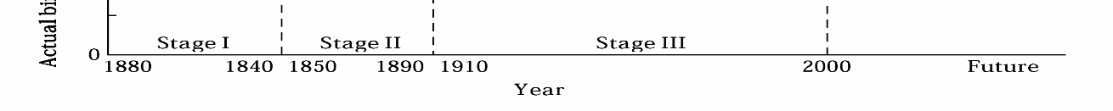
As a result, developing countries should set goals for desirable future population sizes, they must accept the fact that increases on the order to 60% to 125% are coming regardless of the policy strategies they adopt. But this should not be a cause for despair or a diminished commitment on the part of countries that believe that slowing population growth is in their best national interest. The important message of population momentum is that every year that passes without a reduction in fertility means a larger multiple of the present total population size before it can eventually level off.
1.4 The Demographic Transition
The process by which fertility rates eventually decline to replacement levels has been portrayed by a famous concept in economic demography called the demographic transition.

Figure: 1. 2: Demographic Transition in Western Europe

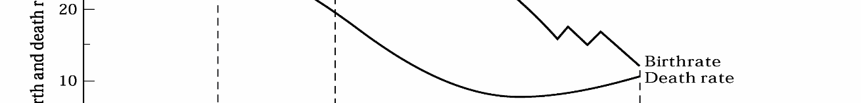

Before their economic modernization, these countries for centuries had stable or very slow growing populations as a result of a combination of high birthrates and almost equally high death rates. This was stage 1. Stage 2 began when modernization, associated with better public-health methods, healthier diets, higher incomes, and other improvements, led to a marked reduction in mortality that gradually raised life expectancy from under 40 years to over 60 years.
However, the decline in death rates was not immediately accompanied by a decline in fertility. As a result, the growing divergence between high birthrates and falling death rates led to sharp increases in population growth compared to past centuries. Stage 2 thus marks the beginning of the demographic transition (the transition from stable or slow-growing population first to rapidly increasing numbers and then to declining rates). Finally, stage 3 was entered when the forces and influences of modernization and development caused the beginning of a decline in fertility; eventually, falling birthrates converged with lower death rates, leaving little or no population growth.

Figure 1:3: Beginning of Demographic Transition in Developing countries
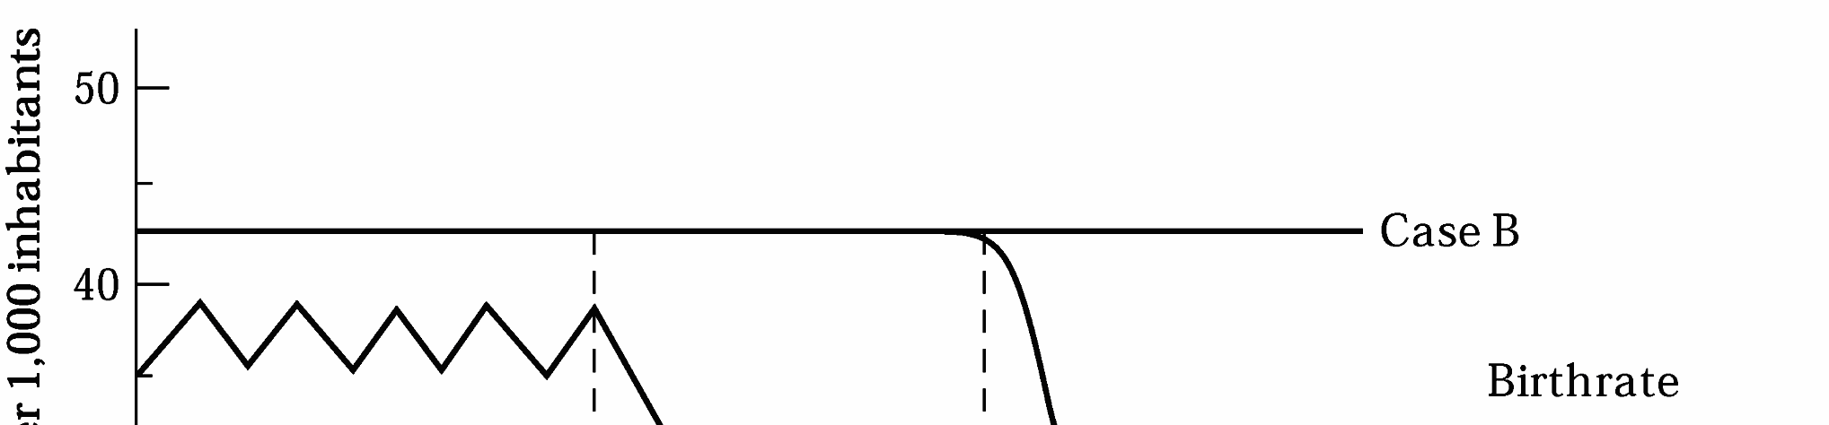

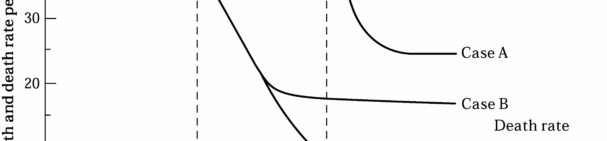

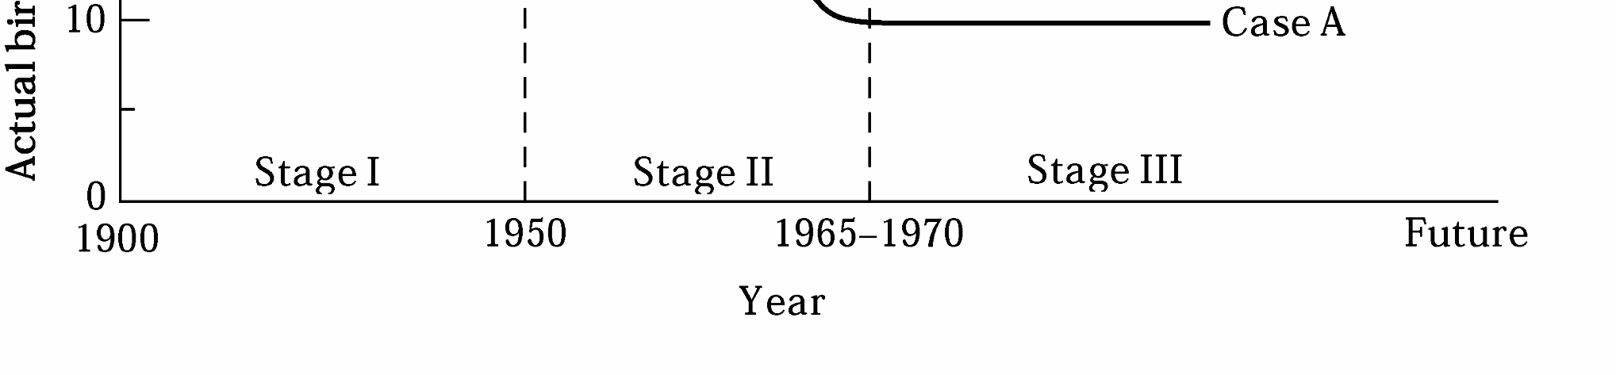

Figure 1.3 shows the population histories of contemporary developing countries, which contrast with those of Western Europe and fall into two patterns. Birthrates in many underdeveloped countries today are considerably higher than they were in pre-industrial Western Europe. This is because women tend to marry at an earlier age. As a result, there are both more families for a given population size and more years in which to have children. Beginning in the 1940s and especially in the 1950s and 1960s, stage 2 of the demographic transition occurred throughout most of the developing world. The application of highly effective imported modern medical and public-health technologies caused developing countries’ death rates to fall much more rapidly than in nineteenth-century European countries. Given their historically high birthrates (over 40 per 1,000 in many countries), his has meant that stage 2 of the developing countries demographictransition has been characterized by population growth rates well in excess of 2.0% per annum.
With regard to stage 3, we can distinguish between two broad classes of developing countries. In case A in figure 1.3, modern methods of death control combined with rapid and widely distributed rises in levels of living have resulted in death rates falling as low as 10 per 1,000 and birthrates also falling rapidly, to levels between 20 and 30 per 1,000. In the 1980s and 1990s, countries such as: Colombia, Indonesia, the Dominican Republic, Thailand, Malaysia, Mexico, Kenya, South Africa, and Brazil, appeared to be entering a period of sustained fertility decline consistent with case A.
But some developing countries fall into case B of figure 1.3. After an initial period of rapid decline, death rates have failed to drop further, largely because of the persistence of widespread poverty, and low levels of living more recently because of the AIDS epidemic. Moreover, the continuance of high birthrates as a result of these low levels of living causes overall population growth rates to remain relatively high. These countries, including many of those in sub Saharan Africa and the Middle East, are still in stage 2 of their demographic transition. Though fertility is declining, it remains very high in these parts of the world.

The important question, therefore, is this: When and under what conditions are developing nations likely to experience falling birthrates and a slower expansion of population? To answer this question, we need to ask a prior one.
What are the principal causes of high fertility rates in developing countries, and can these determinants of the “demand” for children be influenced by government policy?

1.5 The Causes of High Fertility in Developing Countries: The Malthusian and Household Models
1.5.1 The Malthusian Population Trap
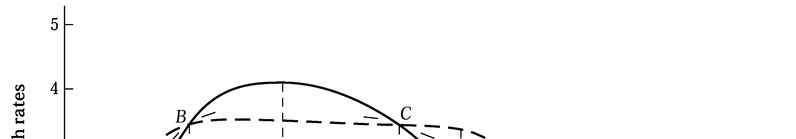
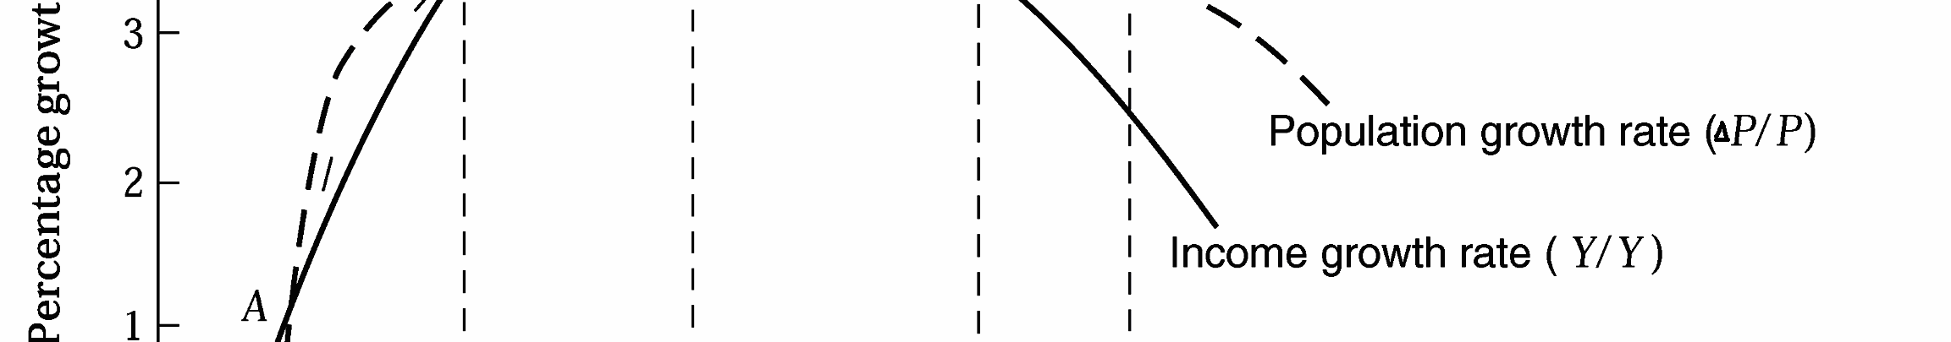
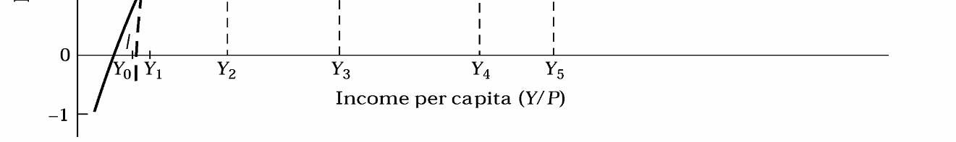
Writing in 1798 in his Essay on the principle of population and drawing on the concept of diminishing return, Malthus postulated a universal tendency for the population of a country, unless checked by dwindling food supplies, to grow at a geometric rate, doubling every 30 to 40 years. At the same time, because of diminishing returns to the fixed factor, land, food supplies could expand only at a roughly arithmetic rate. In fact, as each member of the population would have less land to work, his or her marginal contribution to food production would actually start to decline. Because the growth in food supplies could not keep pace with the burgeoning population, per capita incomes would tend to fall so low as to lead to a stable population existing barely at or slightly above the subsistence level. Malthus therefore contended that the only way to avoid this condition of chronic low levels of living or absolute poverty was for people to engage in “moral restraint” and limit the number of their children. Hence, we might regard Malthus, indirectly and inadvertently, as the father of the modern birth control movement.
Figure 1:4: The Malthusian population Trap

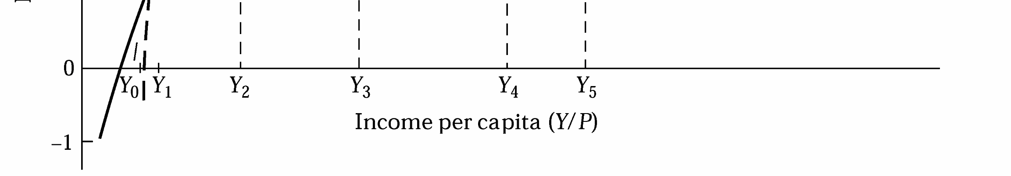

Diagrammatically, the basic Malthusian model can be illustrated by comparing the shape and position of curves representing population growth rates and aggregate income growth rates when these two curves are each plotted against level of per capita income. This is done in figure 1.4.
On the vertical axis, we plot numerical percentage changes, both positive and negative, in the two principal variables under consideration (total population and aggregate income). On the horizontal axis are levels of per capita income. Look first at the dashed curve portraying the assumed relationship between rates of population growth  P/P (measured vertically) and levels of per capita income, Y/P (measured horizontally). At a very low level of per capita income, Y0, the rate of population change will be nil, and a stable population will exist. Thus, Y₀ might represent our concept of absolute poverty. Birth and death rates are equal, and the population is barely holding its own absolute level. The situation is analogous to stage 1 of the demographic transition theory. At per capita income levels beyond (to the right of) Y0, it is assumed that population size will begin to increase under the pressure of falling death rates. Higher incomes mean less starvation and disease. And with birthrates always assumed to be at the biological maximum, falling death rates provide the impetus for an expanding population (i.e., stage 2).
In figure 1.4 population growth achieves its maximum rate, roughly 3.3%, at a per capita income level of Y₂ It is assumed to remain at that level until much higher per capita income levels are realized. Thereafter (beyond Y5), in accordance with stage 3 of the demographic transition, birthrates will begin to decline, and the population growth rate curve becomes negatively sloped and once again approaches the horizontal axis.
The other part of the Malthusian theory requires us to plot a relationship between the growth rate of aggregate income (in the absence of population growth) and levels of per capita income. We can then compare the two rates (aggregate income and total population). If aggregate income (total product) is rising faster, per capita income by definition must be increasing; if total population is growing faster than total income, per capita income must be falling. In figure 1.4, the rate of aggregate income growth (also measured vertically) is assumed at first to be positively related to levels of per capita income; that is, the higher the level of per capita income, the higher rate of increase in aggregate income will be. The economic reason for this positive relationship is the assumption that savings vary positively with income per capita. Countries with higher percapita incomes are assumed to be capable of generating higher savings rates and thus more investment. Beyond a certain per capita income point (Y 3), however, the incomegrowth rate curve is assumed to level off and then begin to decline as new investments and more people are required to work with fixed quantities of land and natural resources. This is the point of diminishing returns in the Malthusian model (note that the possibility of technological progress is not considered). The aggregate income growth curve is therefore conceptually analogous to the total product curve in the basic theory of production.
Observe that in Figure 1.4, the curves are drawn so that they intersect at three points, A, B and C. Point A represents the point at which the Malthusian population trap level of per capita income (Y 1) is attained. It is a stable equilibrium point-any small movement to the left or right of point A will cause the per capita income equilibrium point to return to Y₁. For example, as per capita income rises from Y 1 toward Y 2, the rate of population increase will exceed the rate of aggregate income growth (the P/P curve is vertically higher than the Y/Y curve). We know that whenever population is growing faster than income, per capita income must fall. The arrow pointing in the direction of A from the right therefore shows that per capita income must fall back to its very low level at Y₁ for all points between Y₁ and Y2. Similarly, to the left of point A, incomes grow faster than population, causing the equilibrium per capita income level to rise to Y1.
According to the neo-Malthusians, poor nations will never be able to rise much above their subsistence levels of per capita income unless they initiate preventive checks birth control) on their population growth. In the absence of such preventive checks, Malthusian positive checks starvation, disease, wars) on population growth will inevitably provide the restraining force.
Completing our description of the population trap portrayed in Figure 1.4, we see that point B is an “unstable” equilibrium point. If per capita income can somehow jump rapidly from Y₁ to Y₂ (e.g., as a result of “big push” investment and industrialization programs) before Malthusian positive checks take their toll, it will continue to grow until the other stable equilibrium point Cat capita income level Y₄ is reached. Point B is an unstable equilibrium point in the sense that any movement to the left or right will continue until either A or C is reached.
1.5.1.1 Criticisms of the Malthusian Model
- They do not take adequate account of the role and impact of technological progress.
- They are based on a hypothesis about a macro relationship between population growth and levels of per capita income that does not stand up to empirical testing.
- They focus on the wrong variable, per capita income, as the principal determinant of population growth rates.
A much better and more valid approach to the question of population and development centers on the microeconomics of family size decision making in which individual, and not aggregate, levels of living become the principal determinant of a family’s decision to have more or fewer children.
1.5.2 The Microeconomic Household Theory of Fertility
The conventional theory of consumer behavior assumes that an individual with a given set of tastes or preferences for a range of goods (a “utility function”) tries to maximize
the satisfaction derived from consuming these goods subject to his or her own income constraint and the relative prices of all goods. In the application of this theory to fertility analysis, children are considered as a special kind of consumption (and in Developing countries, investment) good so that fertility becomes a rational economic response to the consumer’s (family’s) demand for children relative to other goods. The usual income and substitution effects are assumed to apply. That is, if other factors are held constant, the desired number of children can be expected to vary directly with household income (this direct relationship may not hold for poor societies; it depends on the strength of demand for children relative to other consumer goods and to the sources of increased income, such as female employment), inversely with the price (cost) of children, and inversely with the strength of tastes for other goods relative to children.
Mathematically, these relationships can be expressed as follows:
Cd = f(Y, Pc,Px ,Tx ---------------------------------------------------------------------------------1

Where:
Cd = demand for surviving children
Y = level of household income (+)
Pc = ‘’net’’ price of children (-)
PX = Price of all other goods (+)
TX = tastes for goods relative to children (-)
It is also possible to express the expected signs of each of the independent variables in the following forms.
dCd/dY>0dCd/dpx>0
dCd/dTx<0dCd/dPc<0
Where dis the partial derivative of demand for children function with respect to the explanatory variables
Figure 1.5 provides a simplified diagrammatic presentation of the microeconomic theory of fertility. The number of desired (surviving) children, Cd, is measured along the horizontal axis, and the total quantity of goods consumed by the parents, G_{p}is measured on the vertical axis.
Household desires for children are expressed in terms of an indifference map representing the subjective degree of satisfaction derived by the parents for all possible combinations of commodities and children. Each individual indifference curve portrays a locus of commodity-child combinations that yield the same amount of satisfaction. Any point (or combination of goods and children) on a “higher” indifference curve that is, on a curve farther out from the origin-represents a higher level of satisfaction than any point on a lower indifference curve. But each indifference curve is a “constant satisfaction” locus.
Figure 1:5: Microeconomic Theory of Fertility: An Illustration

In figure 1.5, only four indifference curves, I₁ to I₄, are shown; in theory, there is an infinite set of such curves, filling the whole quadrant and covering all possible commodity-child combinations. The household’s ability to “purchase” alternative combinations of goods and children is shown on line ab (within the triangular area 0ab) are financially attainable by the household on the basis of its perceived income prospectsand the relative prices of children and goods, as represented by the slope of the ab budget constraint. The steeper the slope of the budget line, the higher the price of children relative to goods.
According to the demand-based theory of fertility, the household chooses from among all attainable combinations the one combination of goods and children that maximizes family satisfaction on the basis of its subjectively determined preferences. Diagrammatically, this optimal combination is represented by point f, the tangency points between the budget constraint, ab, and indifference curve, I₂ Therefore, C3 children and G₂ good will be demanded.

A rise in family income, represented in Figure 1.5 by the parallel outward shift of the budget line from ab to a ‘b’, enables the household to attain a higher level of satisfaction (point h on curve I₄ by consuming more of both commodities and children- that is, if children, like most commodities, are assumed to be normal goods (demand for them rises with income), an important if in low-income countries where children are often in demand primarily as a source of future financial security. Note that as income rises, parents may spend more on each child, preferring a smaller number of children each of higher “quality,” for example, healthier and better-educated.
Similarly, an increase in the price (opportunity cost) of children relative to other goods will cause households to substitute commodities for children. Other factors (namely, income and tastes)being constant, a rise in the relative price of children causes the household utility-maximizing consumption combination to occur on a lower indifference curve, as shown by the movement of the equilibrium point from f to e when the budget line rotates around point a to ab”
Note, finally, that if there is a simultaneous increase in household income and net child price as a result of, say, expanding female employment opportunities and a rise in wages coupled with a tax on children beyond a certain number per family, there will be both an outward shift and downward rotation of the budget constraint line of Figure 1.5 to, say, dashed line cd. The result is a new utility-maximizing combination that includes fewer children per family) point g compared with point f). In other words, higher levels of living for low-income families in combination with a relative increase in the price of children (whether brought about directly by fiscal measures or indirectly by expanded female employment opportunities) will motivate households to have fewer children while still improving their welfare. This is just one example of how the economic theory of fertility can shed light on the relationship between economic development and population growth as well as suggest possible lines of policy.
1.5.2.1 The Demand for Children in Developing Countries
The choice mechanism in the economic theory of fertility as applied to Developing countries is assumed, therefore, to exist primarily with regard to the additional or marginal children who are considered as investment. In deciding whether or not to have additional children, parents are assumed to weigh private economic benefits against private costs, where the principal benefits are, as we have seen, the expected income from child labor, usually on the farm, and eventual financial support for elderly parents. Balanced against these benefits are the two principal elements of cost: the opportunity cost of the mother’s time (the income she could earn if she were not at home caring for her children) and the opportunity and actual cost of educating children the financial trade- off between having fewer “high-quality,” high-cost, educated children with high-income- earning potentials versus more “low-quality,” low-cost, uneducated children with much lower earning prospects.
Using the same thought processes as in the traditional theory of consumer behavior, the theory of family fertility as applied to Developing countries concludes that when the price or cost of children rises as a result of, say, increased educational and employment opportunities for women or a rise in school fees or the establishment of minimum-age child labor laws or the provision of publicly financed old-age social security schemes, parents will demand fewer additional children, substituting, perhaps, quality for quantity or a mother’s employment income for her child-rearing activities. It follows that one way to induce families to desire fewer children is to raise the price of child rearing by, say, providing greater educational opportunities and a wider range of higher-paying jobs for young women.

1.5.2.2 Implications of Women’s Education for Development and Fertility
Specifically, birthrates among the very poor are likely to fall where there is
- An increase in the education of women.
- An increase in female nonagricultural wage employment opportunities,
- A rise in family income levels through the increased direct employment and earnings,
- A reduction in infant mortality through expanded public-health programs
- The development of old-age and other social security systems.
- Expanded schooling opportunities.

1.6 The Consequences of High fertility: Some Conflicting Opinions
1.6.1 Population Growth is Not a Real Program
- The problem is not population growth but other issues.
- Population growth is a false issue deliberately created by dominant rich-country agencies and institutions to keep developing countries in their underdeveloped, dependent condition.
- For many developing countries and regions, population growth is in fact desirable.
The Problem is population growth but others Issues:
(i) Underdevelopment: According to this argument, underdevelopment is the real problem, and development should be the only goal. With it will become economic progress and social mechanisms that will more or less automatically regulate population growth and distribution. As long as the vast majority of people in developing countries remain impoverished, uneducated, and physically and psychologically weak, the large family will constitute the only real source of social security. Proponents of the underdevelopment argument then conclude that birth control programs will surely fail, as they have in the past, when there is no motivation on the part of poor families to limit their size.
(ii) World Resource Depletion and Environmental Destruction: The fact is that developed countries, with less than one-quarter of the world's population, consume almost 80% of the world's resources. In terms of the depletion of the world’s limited resources, therefore, the addition of another. This combination of rising affluence and extravagant consumption habits in rich countries and among rich people in poor countries, and not population growth, should be the major world concern.
(iii) Population Distribution: According to this argument, it is not the number of people per se that is causing population problems but their distribution in space. Many regions of the world (e.g.parts of sub-Saharan Africa) and many regions within countries (e.g., the northeastern and Amazon regions of Brazil) are in fact under populated in terms of available or potential resources. Others simply have too many people concentrated in too small an area e.g., most urban concentrations in Developing countries.
(iv). Subordination of Women: According to this argument, population growth is a natural outcome of women's lack of economic opportunity. If women's health, education, and economic well-being are improved along with their role and status in both the family and the community, this empowerment of women will inevitably lead to smaller families and lower population growth.

1.6.2 Population Growth is a Real Problem
(i) The Extremist Argument: The extreme version of the population-as-problem position attempts to attribute almost all of the world's economic and social evils to excessive population growth. Indeed, direct predictions of world food catastrophes and ecological disaster are attributed almost entirely to the growth in world numbers. Such an extreme position leads some of its advocates to assert that developing countries population stabilization or even decline is the most urgent contemporary task even if it requires severe and coercive measures such as compulsory sterilization to control family size in some of the most populated developing countries.
(ii) The Theoretical Argument:
Advocates start from the basic proposition that population growth intensifies and exacerbates the economic, social, and psychological problems associated with the condition of underdevelopment. It also severely draws down limited government revenues simply to provide the most rudimentary economic, health, and social services to the additional people. This in turn further reduces the prospects for any improvement in the levels of living of the existing generation and helps transmit poverty to future generations of low-income families.

(iii) The Empirical Argument: Seven Negative Consequences of Population Growth
According to the latest empirical research, the potential negative consequences of population growth for economic development can be divided into seven categories:
Economic Growth: Evidence shows that rapid population growth lowers per capita income growth in most Developing countries.
Poverty and Inequality Even though aggregate statistical correlations between measures of poverty and population growth at the national level are often inconclusive, at the household level the evidence is strong and compelling. Poor women once again bear the greatest burden of government austerity programs, and an- other vicious cycle is set in motion. To the extent that large families perpetuate poverty, they also worsen inequality.
Education: Although the data are sometimes ambiguous on this point, it is generally agreed that large family size and low incomes restrict the opportunities of parents to educate all their children.
Health: It increases the health risks of pregnancy, and closely spaced births have been shown to reduce birth weight and increase child mortality rates.
Food: Feeding the world's population is made more difficult by rapid population growth-over 90% of additional Developing countries food requirements are caused by population increases.
Environment: Rapid population growth contributes to environmental degradation in the form of forest encroachment, deforestation, fuel-wood depletion, soil erosion, declining fish and animal stocks, inadequate and unsafe water, air pollution, and urban congestion.
International Migration: Many observers consider that rapid increase in international migration, both legal and illegal.
1.7 Goals and Objectives: Toward a Consensus
- Population growth is not the primary cause of low levels of living, gross inequalities, and etc that characterize much of the developing world.
- The problem of population is not simply one of numbers but involves the quality of life and material well-being.
- Rapid population growth does serve to intensify problems of underdevelopment and
make prospects for development that much more remote. It follows that high population growth rates, though not the principal cause of underdevelopment, are nevertheless important contributing factors in specific countries and regions of the world.

1.8 Some Policy Approaches
Three areas of policy can have important direct and indirect influences on the well-being of present and future world populations:
- General and specific policies that LDC governments can initiate to influence and perhaps even control their population ,
- General and specific policies that developed-country governments can initiate in their own countries to lessen their disproportionate consumption of limited world resources and promote a more equitable distribution of the benefits of global economic progress .
- General and specific policies that developed-country governments and International assistance agencies can initiate to help developing countries achieve their population objectives. Let us deal with each of these areas in turn.

1.8.1 What Developing Countries Can Do?
It is not numbers by itself or parental irrationality that is at the root of the LDC "population problem." Rather, it is the pervasiveness of absolute poverty and low levels of living that provides the economic rationale for large families and burgeoning population. And it is the spillover effects or negative social externality private parental decisions that provide economic justification for government intervention in population matters. Clearly, there are non-economic as well. Although long-run development policies of the kind just outlined to ultimate population stabilization, there are some more specific to Developing countries governments might try to adapt to lower birthrates in the short run. Governments can attempt to control fertility in five ways.
First, they can try to persuade people to have smaller families through the media and the educational process.
Second, they can establish family-planning programs to provide health and contraceptive services to encourage the desired behavior. Such publicly sponsored or officially supported programs now exist in most developing countries.
Third, they can deliberately manipulate economic incentives and disincentives for having children-for example, through the elimination or reduction of maternityleaves and benefits, the reduction or elimination of financial incentives, or the imposition of financial penalties for having children beyond a certain number; the establishment of old-age social security provisions and minimum-age child labor laws; the raising of school fees and the elimination of heavy public subsidies for secondary and higher education; and the subsidization of smaller families through direct money payments.
Fourth, governments can attempt to coerce people into having smaller families through the power of state legislation and penalties. For obvious reasons, few governments would attempt to engage in such coercion; not only is it often morally repugnant and politically unacceptable, but it is also almost always extremely difficult to administer.
Finally, no policy measures will be successful in controlling fertility unless efforts are made to raise the social and economic status of women and hence create conditions favorable to delayed marriage and lower marital fertility. A crucial ingredient in any program designed to lower fertility rates is the increased education of women, followed by the creation of jobs for them outside the home. The availability of income-earning opportunities can lead young women to delay marriage by enabling them to become economically self-sufficient and therefore in a better position to exercise control over the choice of partner and the timing of marriage.

1.8.2 What the Developed Countries Can Do?
When we view the problems of population from the perspective of global resources and the environment, the question of the relationship between population size and distribution and the depletion of many nonrenewable resources in developed and underdeveloped countries assumes major importance.
In a world where 4.6% of the population, located inone country, the United States, accounts for 40% of annual world resource use. We must also be concerned with the impact of rising affluence and the very unequal worldwide distribution of incomes on the depletion of many nonrenewable resources such as petroleum, certain basic metals, and other raw materials essential for economic growth. In terms of food consumption, basic grains like wheat, corn, and rice are by far the most important source of humanity's direct food energy supply. Consumed indirectly, they make up a significant share of the remainder. In resource terms, more than 70% of the world's cropland goes into grain production. Yet the average North American directly and indirectly consumes five timesas much grain and the corresponding agricultural resources-land, fertilizer, water-as his or her counterpart in India or Nigeria for example.
The point, therefore, is that any worldwide program designed to engender a better balance between resources and people by limiting LDC population growth through social intervention and family planning must also include the responsibility of rich nations systematically to simplify their own consumption demands and lifestyles. Such changes would free resources that could then be used by poor nations to generate the social and economic development essential to slow population growth.
1.8.3 How Developed Countries Can Assist Developing Countries with Their Population Programs
There are also a number of ways in which the governments of rich countries and multilateral donor agencies can help the governments of developing countries achieve their population policy objectives in shorter periods of time. The most important of these concerns the willingness of rich countries to be of genuine assistance to poor countries in their development efforts. Such genuine support would consist not only of expanded public and private financial assistance but also of improved trade relations, such as tariff- and quota-free access to developed-country markets, more appropriate technology transfers, and assistance in developing indigenous scientific research capacities, better international commodity-pricing policies, and a more equitable sharing of theworld’s scarce natural resources.

There are two other activities more directly related to fertility moderation in which rich- country governments, international donor agencies, and private non-governmental organizations (NGOs) can play an important assisting role.
The first is the whole area of research into the technology of fertility control, the contraceptive pill, modern intrauterine devices (IUDs), voluntary sterilization procedures, and, particularly for Africa in the age of AIDs, effective barrier contraception.
The second area includes financial assistance from developed countries for family- planning programs, public education, and national population policy research activities in the developing countries. This has traditionally been the primary area of developed-country assistance in the field of population.

