**CHAPTER TWO**

**MONEY, INTEREST RATE AND THE EXCHANGE RATE**

**Introduction**

The first step in building the model is to explain the effects of a country’s money supply and the demand for its money on its interest rate and exchange rate. Because exchange rates are the relative prices of national monies, factors that affect a country’s money supply or demand are among the most powerful determinants of its currency’s exchange rate against foreign currencies. It is therefore natural to begin a deeper study of exchange rate determination with a discussion of money supply and money demand.

**What is Money?**

Money is an asset that is widely used as a means of payment. *Money have functions such as: medium of exchange, unit of account, store of value and defer of payment.* Different groups of assets may be classified as money. Money can be defined narrowly or broadly. That means, there are several ways to define "money," but standard measures usually include currency in circulation and demand deposits (travelers checks (TC)) (depositors' easily-accessed assets on the books of financial institutions). This definition of money supply is called M1 but this is the narrowest of the money supply definitions. M1 is the ***potential base for deposit expansion and money supply creation.***

M2 is the broadest measure of money supply and is larger than M1. It includes M1, plus other quasi money or deposit (D2) such as time deposits (TD), saving deposits (SD), and money market mutual funds (MMMFs) of individuals and firms. ***M2 is the most widely accepted measure of money supply.***

M3 includes M2 plus large denomination time deposits and saving deposits and long term money market mutual funds. But, M3 is not usually in use in money countries as a measure of money supply.

* The **money supply** or **money stock** is the total amount of money available in an economy at a particular point in time.
* Money is a *liquid* asset: it can be easily used to pay for goods and services or to repay debt without substantial transaction costs.
  + But monetary or liquid assets earn *little or no interest*.
* Illiquid assets require substantial transaction costs in terms of time, effort or fees to convert them to funds for payment.
  + But they generally earn a higher interest rate or rate of return than monetary assets.
* The central bank substantially controls the quantity of money that circulates in an economy, the **money supply**.
  + In Ethiopia, the central banking system is the national bank of Ethiopia.
    - The national bank of Ethiopia directly regulates the amount of currency in circulation.
    - It indirectly influences the amount of checking deposits, debit card accounts, and other monetary assets using monetary policy instruments such as **open market operation, discount rate and required reserve ratio.**

**Money Demand**

Money demand is the proportion of their total assets that people are willing to hold in the  
form of money (instead of illiquid assets).

♦ We will consider individual money demand and aggregate money demand.

♦ What influences willingness to hold money?

**What Influences Individual Demand for Money?**

🖳 **Expected returns/interest rate** on money relative to the expected returns on other assets.  
🖳 **Risk**: the risk of holding money derives principally from unexpected inflation, which might unexpectedly reduce the purchasing power of money.

🖳 But domestic-currency bonds have precisely this risk too, so this risk is not very important in money demand

🖳 **Liquidity**: A need for greater liquidity occurs when either the price of transactions increases or the quantity of goods normally bought in transactions increases.

**What Influences Aggregate Demand for Money?**

🌢 **Interest rates**: money pays little or no interest, so the interest rate is the opportunity cost of holding money instead of other assets, like bonds, which have a higher expected return/interest rate.  
🌢 A higher interest rate means a higher opportunity cost of holding money → lower money demand.  
🌢 **Prices**: the prices of goods and services bought in transactions will influence the willingness to hold money to conduct those transactions.

🌢 A higher price level means a greater need for liquidity to buy the same amount of goods and services → higher money demand.

🌢 Income: greater income implies more goods and services can be bought, so that more  
money is needed to conduct transactions.

♦ A higher real national income (GNP) means more goods and services are being produced  
and bought in transactions, increasing the need for liquidity → higher money demand.

**The aggregate demand of money can be expressed as:**

*Md = P x L*(*R, Y*),

where: *P* is the price level, *Y* is real national income, *R* is a measure of interest rates on non-monetary assets and ***L(R,Y) is the aggregate demand of real monetary assets***

Alternatively: Demand for real money balances can be stated as: *Md/P = L*(*R, Y*)

That is, aggregate demand of real monetary assets is a function of national income and interest rates.

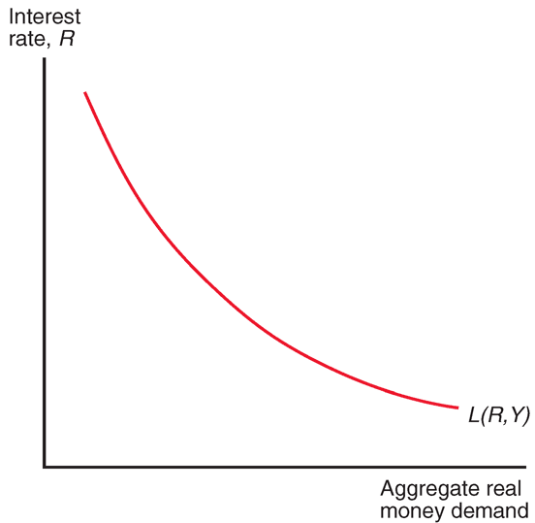

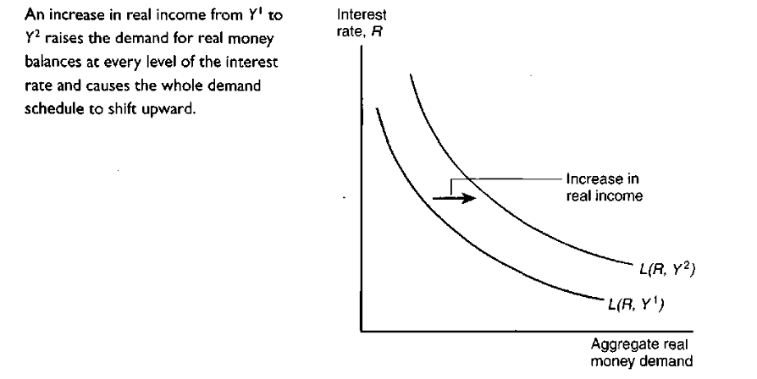

The Money Market

☞ The money market uses the (aggregate) money demand and (aggregate) money supply.  
☞ The condition for equilibrium in the money market is:

***Ms = Md***

☞ Alternatively, we can define equilibrium using the supply of real money and the demand for real money (by dividing both sides by the price level):

***Ms/P = L*(*R,Y*)**

☞ This equilibrium condition will yield an equilibrium nominal interest rate *R*.

☞ When there is an excess supply of money, there is, correspondingly, an excess demand for alternative, interest-bearing assets.

☞ People holding excessive money balances are willing to acquire interest bearing assets (by buying them with money) at a lower interest rate.

♦ Potential money holders are more willing to hold additional quantities of money as the interest rate (the opportunity cost of holding money) falls.

⮳When there is an excess demand for money, there, correspondingly, is an excess  
supply of interest-bearing assets.

♦ People who desire money but do not have access to it are willing to sell off assets that offer higher nominal interest rates in return for the money balances that they desire.

♦ Those with money balances are more willing to give them up in return for interest bearing assets as the interest rate on these assets rises and as the opportunity cost of holding money (the nominal interest rate) rises.

***Determination of Money Market Equilibrium (see the graph below)***

***Explanation: follow class lecture***

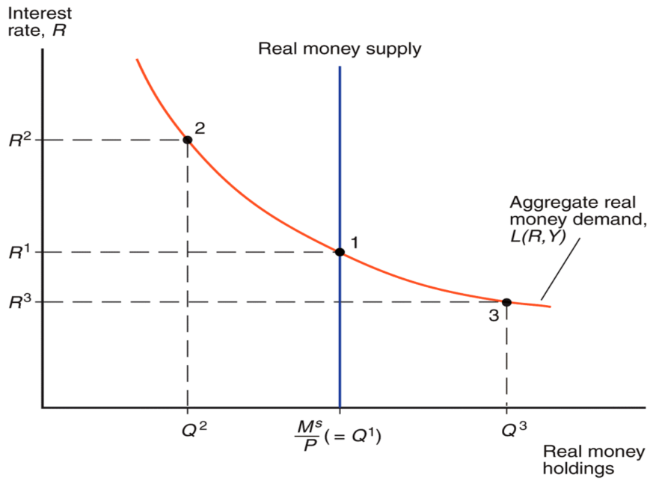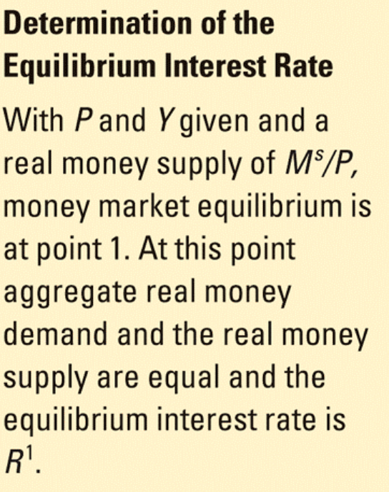

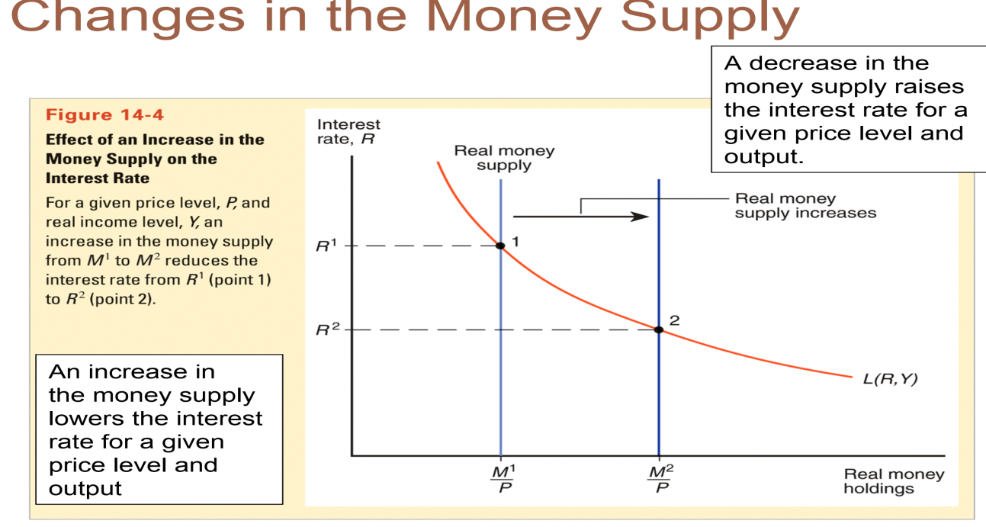

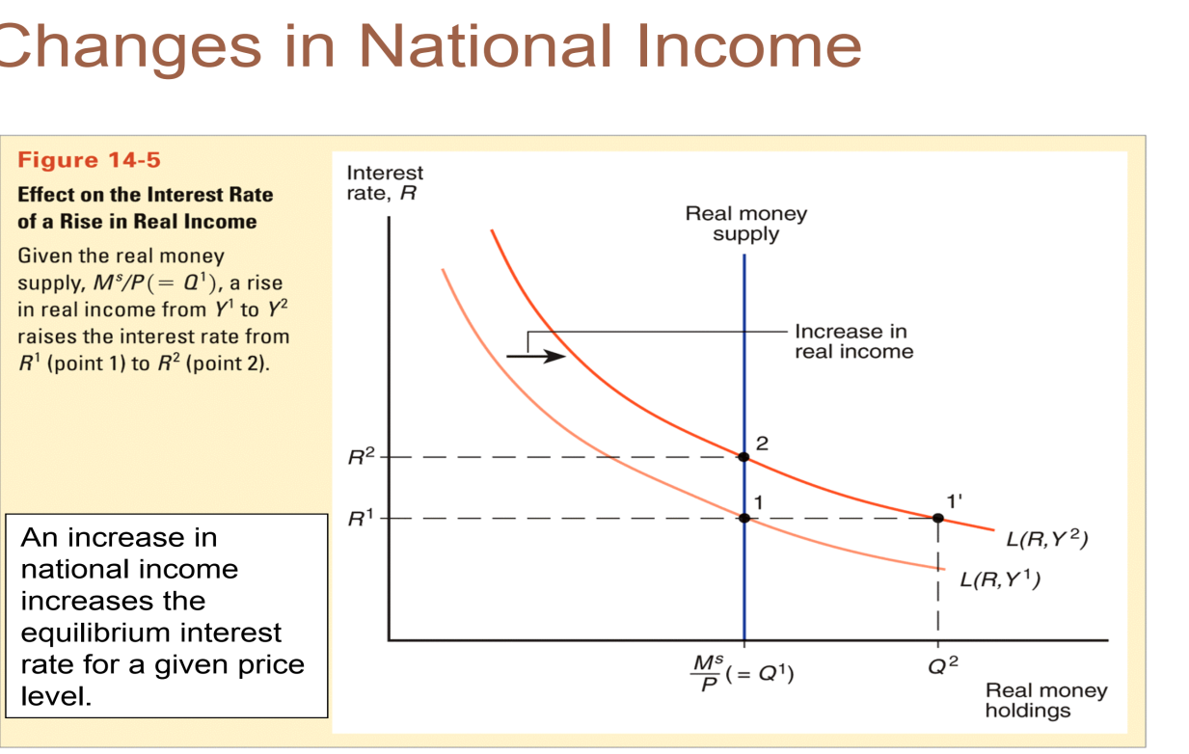

**1.2 The Money Supply and the Exchange Rate in the Short Run**

Now we know how shifts in a country’s money supply affect the interest rate on non-money assets denominated in its currency, we can see how monetary changes affect the exchange rate. We know that *an increase in a country’s money supply* *causes its currency to depreciate in the foreign exchange market, while a reduction in the* *money supply causes its currency to appreciate.*

Expected future level makes euro deposits more attractive by leading people to anticipate a  
sharper dollar depreciation in the future. At the intersection of the two schedules (point 1'), the expected rates of return on dollar and euro deposits are equal, and therefore interest parity holds. £j/ € is the equilibrium exchange rate.

The second diagram we need to examine the relation between money and the exchange  
rate was introduced in the figure below. This figure shows how a country's equilibrium interest  
is determined in its money market and it appears as the bottom part of the following figure. For  
convenience, however, the figure has been rotated clockwise by 90 degrees so that dollar  
interest rates are measured from 0 on the horizontal axis and the U.S. real money supply is  
measured from 0 on the descending vertical axis. Money market equilibrium is shown at  
point 1, where the dollar interest rate **R$**1 induces people to demand real balances equal to  
the U.S. real money supply, *MsPUS.*The following figure emphasizes the link between the U.S. money market (bottom) and the foreign exchange market (top)—the U.S. money market determines the dollar interest rate,  
which in turn affects the exchange rate that maintains interest parity. (Of course, there is a  
similar link between the European money market and the foreign exchange market that  
operates through changes in the euro interest rate.)



The conclusions we have reached also apply when the ESCB changes Europe's money  
supply. An increase in ***MSE*** causes a depreciation of the euro (that is, an appreciation of the  
dollar, or a fall in **E$/€),** while a reduction in **MS**causes an appreciation of the euro (that is,  
a depreciation of the dollar, or a rise in **E$/e).**

The mechanism at work, which runs from the European interest rate to the exchange rate, is the same as the one we just analyzed. It is good exercise to verify these assertions by  
drawing figures similar to the above figures that illustrate the linkage between the European money market and the foreign exchange market.

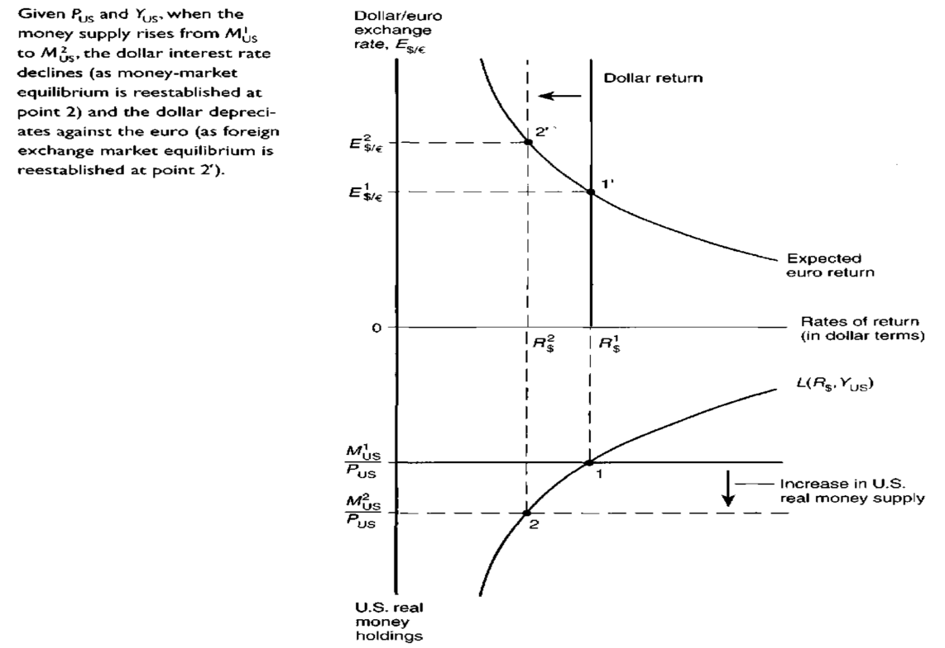

**Money Price and exchange rate in the Long run (Long run Exchange Rate Determination)**

In the *long run*, money prices of factors of production and of goods and services are allowed to adjust to demand and supply in their respective markets.

♦ Nominal wages adjust to the demand and supply of labor.

♦ Real output and income are determined by the supply of labor and other factors of production—by the economy’s productive capacity—not by the supply of money.

♦ the interest rate depends on the supply of saving and the demand for saving in the economy and the expected inflation rate—and thus is also independent of the money supply’s *level*.

**☞** In the long run, the *level* of the money supply does not influence the amount of real output *Y* or the nominal interest rate *R*. But the money prices of output and factors of production *adjust proportionally* to changes in the money supply:

♦ Long run equilibrium: *Ms/P = L*(*R,Y*)

♦ *Ms = P x L*(*R,Y*)

♦ Increases in the money supply are matched by proportional increases in the price level.  
♦ Analogous to effects of *currency reform.*

*In the long run, there is direct relationship between the inflation rates (rate of increase in P) and ongoing growth in the money supply.*

*MS = P* L(R, Y) where L(R, Y) means money demand in the function of interest rate and level of income.*

*P = MS/L(R, Y)*

*ΔP/P = ΔMS/MS – ΔL/L*

***N.B*** *The inflation rate equals growth rate in money supply minus growth rate for money demand.*

* + Long run means a sufficient amount of time for prices of all goods and services to adjust to market conditions so that their markets and the money market are in equilibrium.

*What economic forces lay behind dramatic long-term movements in exchange rates?*

* In the short run we have seen that exchange rates are determined by interest rates and expectations about the future, which are, in turn, influenced by conditions in national money markets.
* In the long run, national price levels play a key role in determining both interest rates and the relative prices at which countries’ products are traded. A theory of how national price levels interact with exchange rates is thus central to understanding why exchange rates can change dramatically over periods of several years.
* The long-run models are not intended to be completely realistic descriptions about how exchange rates behave, but ways of representing how market participants may form expectations about future exchange rates and how exchange rates tend to move over long periods.

**2.3.1 Law of One Price**

The law of one price states that in competitive markets free of transportation costs and official barriers to trade (such as tariffs), identical goods sold in ***different countries must sell for the same*** price when their prices are expressed in terms of the same currency. For example, if the dollar/pound exchange rate is per pound, a sweater that sells for in New York must sell for £30 in London. The dollar price of the sweater when sold in London is then ($1.50 per pound) × (£30 per sweater) = $45 per sweater, the same as its price in New York.

Let’s continue with this example to see why the law of one price must hold when trade is free and there are no transport costs or other trade barriers. If the dollar/pound exchange rate were per pound, you could buy a sweater in London by converting $43.50 (= $1.45 per pound × £30) into £30 in the foreign exchange market. If the same sweater were selling for in New York, U.S. importers and British exporters would have an incentive to buy sweaters in London and ship them to New York, pushing the London price up and the New York price down until prices were equal in the two locations. Similarly, at an exchange rate of per pound, the dollar price of sweaters in London would be $46.50 (= $1.55 per pound × £30), $1.50 more than in New York. Sweaters would be shipped from west to east until a single price prevailed in the two markets.

* Thus, the law of one price implies that when trade is open and costless, identical goods must trade at the same relative prices regardless of where they are sold.
* That means, it provides one link between the domestic prices of goods and exchange rates. We can state the law of one price formally as follows:
* Let be the dollar price of good when sold in the United States, the corresponding euro price in Europe. Then the law of one price implies that the dollar price of good is the same wherever it is sold.

**2.3.2 The Purchasing – Power Parity (PPP) Approach**

Determining the *long – run equilibrium* value of an exchange rate (the value toward which the actual rate tends to move, given current economic conditions and policies) is important for successful exchange rate management. For example, if a nation’s exchange rate rises above the level warranted by economic conditions, so that its currency becomes *overvalued*, the nation’s costs will no longer be competitive and a trade deficit will likely occur. An *undervalued* currency tends to lead to a trade surplus. National authorities try to forecast the long–run equilibrium exchange rate and initiate exchange rate adjustments to keep the actual rate in line with the forecast rate. The PPP, therefore, can be used to make predictions about exchange rates.

* There is two important concepts of the PPP approach:

**2.3.1 Law of One Price**

This is the simplest concept of the model of PPP. For analysis, it assumes:

* It is costless to transport commodities between nations; and
* There are no barriers to trade (such as tariffs).

**Absolute PPP** is the application of the law of one price across countries for *all* goods and services, or for representative groups (“baskets”) of goods and services.

The theory of absolute purchasing power parity states that the exchange rate between two countries’ currencies equals the ratio of the countries’ price levels. The domestic purchasing power of a country’s currency is reflected in the country’s price level, the money price of a reference basket of goods and services.

* The absolute PPP theory therefore predicts that a fall in a currency’s domestic purchasing power (as indicated by an increase in the domestic price level) will be associated with proportional currency depreciation in the foreign exchange market. Symmetrically, PPP predicts that an increase in the currency’s domestic purchasing power will be associated with a proportional currency appreciation.

However, before the costs of goods in different countries can be compared, prices must first be converted in to a common currency. Once converted at the current market exchange rate, the prices of identical goods from any two countries should be identical. After converting birr’s in to dollars, for example, machine tools purchased in Ethiopia should cost the equal dollars as identical machine tools bought in the United States.

For instance, if the price of a kilo of sugar is $1 in the United States and Br. 9 in Ethiopia, then the exchange rate between the birr and the dollar should be R = Br.9/$ 1= 9 (according to the law of one price).

In practice, however, the law of one price (absolute PP) does not always prevail. There is little empirical support for absolute purchasing power parity. International trade is more complicated than suggested by this theory (laws). For example, tariffs and other trade obstructions tend to drive a wedge between prices of identical goods in different nations. Moreover, the costs of transporting goods from one nation to another restrict the potential profit from buying and selling identical products with different prices.

**3.3.2 Relative PPP**

* The *relative purchasing power–parity theory* states that changes in relative national (general) price levels determine changes in exchange rates over the long-run.

The theory predicts that the foreign exchange value of a currency tends to appreciate or depreciate at a rate equal to the difference between foreign and domestic inflation. A currency would be expected to depreciate by an amount equal to the excess of domestic inflation over foreign inflation. It would appreciate by an amount equal to the excess of foreign inflation over domestic inflation.

In general, the PPP theory can be used to predict long–run exchange rates. We will consider an example using the price indexes (P) of Ethiopia and Germany. Let **0** be the base period and **1** be period 1.

The purchasing –power –parity theory can thus be given in symbols as:

R1  = Ro  PE1/PEo = Ro. PGo . PE1

PG1/PGO PEo PG1

Where Ro is the equilibrium exchange rate existing in the base period and R1 equals the estimated target at which the actual rate should be in the future.

**Example:** The general price level in Ethiopia and in Germany in 1995 was 100 and the birr price of the mark was birr 3 during this period. Forecast the exchange rate that will prevail in 2010 if the Ethiopian inflation rate rises by 100 percent and Germany’s rate remains unchanged by taking year 1995 as the base year.

**Solution:** If 1995 is the base year, PEo = PGo = 100. And if 2010 is the first period, PG1 = 100 but PE1 = 200 since 100% rise means doubling of the original. Ro = Br. 3. Therefore, the exchange rate between the birr and the German mark in 2010 will be:

R1 = Br.3. 100 . 200 = 6 = 6 Br/mark

100 100

**Relation between Relative PPP and Absolute PPP**

* If the absolute PPP held, the relative PPP would also hold, but when the relative PPP holds, the absolute PPP need not hold. e.g. while the very existence of capital flows, transportation costs, other obstructions to the free flow of international trade, and government intervention policies leads to the refection of the absolute PPP, only a change in these would lead the relative PPP theory astray.
* As compared to absolute PPP, Relative PPP is more consistent with data, but it also performs poorly to predict exchange rates.

In general, the reasons why absolute PPP may not be accurate: the law of one price may not hold because of:

* Trade barriers and non-tradable products: Transport costs and governmental trade restrictions make trade expensive and in some cases create non-tradable goods or services. Services are often not tradable: services are generally offered within a limited geographic region (for example, haircuts).
* Imperfect competition: A firm sells the same product for different prices in different markets to maximize profits, based on expectations about what consumers are willing to pay.
* Differences in measures of average prices for baskets of goods and services: levels of average prices differ across countries because of differences in how representative groups (“baskets”) of goods and services are measured. Because measures of groups of goods and services are different, the measure of their average prices need not be the same.

**2.3.4 Flexible-price monetary model of exchange rate**

Unlike the balance of payments approach, which discusses exchange rate determination in terms of the flow of funds in the foreign exchange market over a period of time, the monetary approach views exchange rates as determined by the responses to changes in the stock (or total) demands and supplies of national currencies.

* ***The* *monetary approach*** emphasizes the fact that the foreign exchange market is a monetary phenomenon, where monies are traded for monies. The money supply and money demand at home and abroad are thus used to explain a nation’s exchange rate trend. Because money supplies can be controlled by central banks the monetary approach emphases on a nation’s demand for money and its determinants.

The aggregate demand for money in a nation depends on the level of real income, prices and interest rates.

* As the economy grows and *real income* (the purchasing power of money) rises, the public’s demand for money increases in order to finance rising transactions.
* That is, if *prices* rise, the public will demand more money to cover their economic transactions.
* Lower *interest rates* induce the public to hold more money because the opportunity cost of holding cash balances is decreased. Note that interest rate represents the opportunity cost of holding money. Conversely, as these determinants of money demand change in the opposite direction, the demand for money decreases.

The following table summarizes the impact of changes in money demand and money supply on the equilibrium foreign exchange rate. Note that a change in money supply implies an increase or decrease of money by the central bank of a country, say by the National Bank of Ethiopia.

**Table 2.2*: Impact of Changes in Money Supply and Demand on Market Determined***

***Exchange Rate (R)***

|  |  |
| --- | --- |
| **Change** | **Impact on R** |
| Increase in money supply | Depreciate |
| Decrease in money supply | Appreciate |
| Increase in money demand | Appreciate |
| Decrease in money demand | Depreciate |