CHAPTER ONE
COST-VOLUME-PROFIT (CVP) ANALYSIS
Learning objectives;
After completing this unit, you are expected to:
- Define cost volume profit analysis (CVP Analysis)?
- Understand the assumptions underlying cost-volume-profit (CVP) analysis.
- Determine the breakeven point and output level needed to achieve a target operating income
- Understand how income taxes affect CVP analysis
- Explain CVP analysis in decision making and how sensitivity analysis helps managers cope with uncertainty
- Apply CVP analysis to a company producing Multiple products
  - Introduction
In this unit you will be introduced with one of the most powerful management accounting tools that helps managers in quick decision about the income generated at different activity level. The tool is termed as Cost-Volume-Profit (CVP) Analysis, as the relationship among cost, profit and the volume of output or the level of activity is considered in the model.
Understanding the relationship between a firm’s costs, profits and its volume levels is very important for strategic planning. When you are undertaking a new project, you will probably ask yourself, “How many units do I have to produce and sell in order to breakeven?” The feasibility of obtaining the level of production and sales indicated by that answer is very important in deciding whether or not to move forward on the project in question. Similarly, before undertaking a new project, you have to assure yourself that, you can generate sufficient profits in order to meet the profit targets set by your firm. Thus, you might ask yourself, “How many units do I have to sell in order to produce a target income?” Breaking Even? You could also ask, “If I increase my sales volume by certain percent, what will be the impact on my profits?” The topics in this unit are, therefore designed to familiarize you with the ability of applying Cost-Volume-Profit (CVP) Analysis in answering different questions while you are taking part in planning decision in different types of organizations.
Although the term “profit” is attached in the CVP model; it does not mean that, the application of CVP analysis is limited to business organizations only. It can be used by government and nongovernmental organizations (NGOs) as well in planning their activity levels in light of the recourse availability and constraints.
  - Meaning, and underlying Assumptions of CVP analysis
Examining shifts in costs and volume and their resulting effects on profit is called cost-volume-profit (CVP) analysis. This analysis is applicable in all economic sectors, including manufacturing, wholesaling, retailing, and service industries and not-for- profit (NFP) organizations. CVP can be used by managers to plan and control more effectively because it allows them to concentrate on the relationships among revenues, costs, volume changes, taxes, and profits. CVP analysis can be used to determine a company’s break-even point (BEP), which is that level of activity, in units or Birr value, at which total revenues equal total costs. At breakeven, the company’s revenues simply cover its costs; thus, the company incurs neither a profit nor a loss on operating activities. Companies, however, do not wish merely to “break even” on operations.

The break-even point is calculated to establish a point of reference. Knowing BEP, managers are better able to set sales goals that should generate income from operations rather than produce losses. CVP analysis can also be used to calculate the sales volume necessary to achieve a desired target profit. Target profit objectives can be stated as either a fixed or variable amount on a before- or after-tax basis. Because profit cannot be achieved until the break-even point is reached, the starting point of CVP analysis is BEP. It also helps in conducting a sensitivity analysis to understand how the change in variables in the CVP model affects the profitability.
After going through the major assumptions upon which the CVP model is developed, you will be exposed through the application of CVP in determining the BEP, target profit; in a single and multiple product companies. You will also come across on how CVP is used to conduct a sensitivity analysis as well as its application in business enterprises. Notice that on advanced managerial accounting courses you will come across with diverse and advanced applications of CVP analysis in various financial and strategic decisions.
- Cost-volume-profit analysis determines how costs and profit react to a change in the volume or level of activity, so that management can decide the 'best' activity level.

    - UNDERLYING ASSUMPTIONS OF CVP ANALYSIS
CVP analysis is a short-run model that focuses on relationships among several items: selling price, variable costs, fixed costs, volume, and profits. This model is a useful planning tool that can provide information on the impact on profits when changes are made in the cost structure or in sales levels. However, the CVP model, like other human-made models, is an abstraction of reality and, as such, does not reveal all the forces at work. It reflects reality but does not duplicate it. Although limiting the accuracy of the results, several important but necessary assumptions are made in the CVP model. These assumptions are as follow.
1. All revenue and variable cost behavior patterns are constant per unit and linear within the relevant range.
2. Total contribution margin (total revenue - total variable costs) is linear within the relevant range and increases proportionally with output. This assumption follows directly from assumption 1.
3. Total fixed cost is a constant amount within the relevant range.
4. Mixed costs can be accurately separated into their fixed and variable elements. Although accuracy of separation may be questioned, reliable estimates can be developed from the use of regression analysis or the high-low method.
5. Sales and production are equal; thus, there is no material fluctuation in inventory levels. This assumption is necessary because of the allocation of fixed costs to inventory at potentially different rates each year. This assumption requires that variable costing information be available. Because both CVP and variable costing focus on cost behavior, they are distinctly compatible with one another.
6. There will be no capacity additions during the period under consideration. If such additions were made, fixed (and, possibly, variable) costs would change. Any changes in fixed or variable costs would violate assumptions 1 through 3.
7. In a multiproduct firm, the sales mix will remain constant. If this assumption were not made, no weighted average contribution margin could be computed for the company.
8. There is either no inflation or, if it can be forecasted, it is incorporated into the CVP model. This eliminates the possibility of cost changes.
9. Labor productivity, production technology, and market conditions will not change. If any of these changes occur, costs would change correspondingly and selling prices might change. Such changes would invalidate assumptions 1 through 3.
These assumptions limit not only the volume of activity for which the calculations can be made, but also the time frame for the usefulness of the calculations to that period for which the specified revenue and cost amounts remain constant. Changes in either selling prices or costs will require that new computations be made for break-even and product opportunity analyses.
The nine assumptions listed above are the traditional ones associated with CVP analysis. An additional assumption must be noted with regard to the distinction of variable and fixed costs. Accountants have generally assumed that cost behavior, once classified, remained constant over periods of time as long as operations remained within the relevant range. Thus, for example, once a cost was determined to be “fixed,” it would be fixed next year, the year after, and 10 years from now.
The above assumptions thus, imply that cost-volume-profit analysis is always based on contribution per unit (assumed to be constant unless a question clearly says otherwise) and never on profit per unit because profit per unit changes every time a few more or less units are made.
  - Applications of CVP Analysis
Dear learners in the previous parts of this unit you have gone through the meaning and underlying assumptions of CVP. As you have learnt CVP can be used by managers in a variety of sectors as management decision tool.
On the subsequent part of the module you will find an explanation and illustrations on the applications of CVP in different scenarios.
    - Break Even Analysis
CVP analysis has wide-range applicability. It can be used to determine a company’s break-even point (BEP), which is that level of activity, in units or dollars/Birr, at which total revenues equal total costs. At breakeven, the company’s revenues simply cover its costs; thus, the company incurs neither a profit nor a loss on operating activities.
- At the breakeven point total revenue is equal to total cost (both variable and fixed)
For instance, Dolollo Cinema sold 4,800 tickets during a show one month run. The following contribution margined approach income statement show that the operating income for the month will be zero:
Sales Revenue (4800 X Br25) --------------------------- Br 120, 000
Less Variable Cost (4800 X Br 15) -------------------------- 72,000
Total Contribution Margin----------------------------------Br 48,000
Less Fixed Costs-------------------------------------------------- 48,000
Operating Income---------------------------------------------------Br 0
The income statement above highlights (1) the distinction between variable and fixed cost and (2) the total contribution margin, which is the amount that contributes towards covering Dolollo Cinema’s fixed cost and income generation. To state it differently, each ticket sold add Birr 10 to the firm’s bottom line profit. The Birr 10 -unit contribution margin is derived by deducting the unit variable cost Birr 15 from Birr 25 the unit selling price of a ticket.
How could you compute Dolollo Cinema’s breakeven point if you didn’t already know it is Birr 4,800 tickets per month? Well on the following discussion you will get the basics of CVP analysis to determine BEP and other application. CVP analysis can be done using three alternative approaches, namely: contribution margin approach, equation approach and graphical approach.
In discussing CVP application we will assume that the following variables have the meanings given below:
- SP = Selling Price Per Unit, Q = Units Produced and Sold, VCU = Variable Cost Per Unit, CMU=contribution margin per Unit, CM%= contribution margin percentage (CMU÷SP), FC = Total Fixed Costs, TOI =Target operating Income, TNI=Target Net Income, t = Tax rate

      - Equation Method
In using equation approach to CVP analysis, you need to convert your income statement in the following equation form.

Revenue - Variable Costs - Fixed Costs = Operating Income

Sales Revenue is equal to the number of units sold times the price you get for each unit sold:
Sales Revenue = SPQ
Assume that you have a linear cost function, and your total costs equal the sum of your Variable Costs and Fixed Costs:
Total Costs = Variable costs + Fixed costs
The profit equation can, therefore rewritten as: (SPXQ) - (VCUXQ) + FC= OI
This equation provides the most general and easiest approach to remember approach to any CVP situation. The determination of breakeven level using this method can easily performed by making the operating income on the righthand side of the equation zero. Here the basic assumption is that, when you are at breakeven, your Sales Revenue minus your Total Costs is zero.
- At breakeven point,
(SPXQ) - (VCUXQ) + FC = 0

From the information given above for the Dolollo Cinema, you can determine the breakeven point (BEP) using the equation approach as follows,
(Br25 X Q) – (Br15 X Q) – Br 48, 000 = 0 Br10Q = Br 48,000 Q= 4,800

If Dolollo sells fewer than 4800 tickets, it will have a loss, if it sells 4800 tickets, it will breakeven; and if the sales are more than 4800 units, it will make a profit.
The breakeven point stated in units can be stated in terms of Birr by multiplying the breakeven quantity and unit selling price. The breakeven point in Birr= BEQ x SP
= 4,800 x Br25 = Br120, 000

      - Contribution Margin Approach

The contribution margin technique is merely a short version of the equation technique. The formulas used in the determination of the breakeven point in unit as well as in value are derived by the rearrangement of the terms in the equation method above, which is
(SP x Q) – (VCU x Q) – FC= OI
Re-written equation takes the following format:
(SP-VCU) x Q = FC + OI That is, Q= FC + OI/ (SP-VCU)
The difference between unit selling price and unit variable cost is termed as unit contribution margin. You can replace the (P-V) by the term "Contribution Margin per Unit (CMU),
Q= FC + OI/CMU
As you know from the discussion above at breakeven point the target operating income is Birr 0, so replacing OI by 0, you will get,
Q= FC/ (SP-VCU)

    - Breakeven point in units using contribution Margin Approach
Breakeven point in units using this formula is determined by dividing the total fixed cost by the contribution margin per unit due to the fact that this approach centers on the idea that each unit sold provides a certain amount of fixed costs. When enough units have been sold to generate a total contribution margin equals to the total expense and only after that point the units sold contributes for profit of the organization.
The breakeven number of tickets that Dolollo Cinema must sold to reach at breakeven using this method can be determined as,
Q = FC/CMU Q = Br48, 000/Br10 Q = 4,800 units
    - Determining breakeven point in terms of sales value (Dollar/Birr)
To find the breakeven sales value, you can use contribution margin percentage in place of contribution margin per unit in the formula you used in the determination of breakeven units. Contribution margin percentage is simply the ratio of contribution margin per unit to selling price.
CM% = CMU/USP
It can also be determined by dividing the total contribution margin to total sales when the unit selling price and variable cost is not known. We will see how this formula is used in such a situation later. Before that let see how the formula works using the above example.
CM % on our example of Dolollo Cinema = UCM/USP = Br 10/ Br 25 = 0.4
This can be interpreted as, units sold cover variables costs and contribute 40 percent to cover fixed cost and increase in profit.
The break-even sales amount (Birr) for Dolollo Cinema = FC/CM = 48,000/0.40 = Br 120,000

The breakeven sales determined using equation method was a mere multiplication of the breakeven point in unit and the unit selling price (4800 units x Br 25) which is exactly the same with what you determined using a more complicated contribution margin approach.
- Why do you think using the contribution margin approach is essential?
Well, sometimes you will be given only the income statement and asked to determine the breakeven sales without sufficient information about units selling price and unit variable cost. In this case, by only using the contribution margin ratio you can determine the breakeven point in sales by dividing total fixed cost by CM ratio gives the break-even point in sales dollars.

For example, Jimma Electronics Co. produces portable radios. It has released the following Variable Costing Income Statement. This is the only financial information that we have regarding the company’s operations:

Sales Revenue--------- 100,000
Less Variable Costs------30,000
Contribution Margin----- 70,000
Less Fixed Costs--------- 50,000
Operating Income ------- Br 20,000

What is the Break-Even point for Jimma Electronics Co? You do not know the number of units that Jimma Electronics sold in a year. You do not also know the Price or the Variable Cost per unit. Although you do not know the price or the Variable Cost per unit, you are still able to calculate the Contribution Margin Ratio.
Contribution ratio can be determined by dividing total contribution margin to total sales.
CM% in this case is, therefore, determined as follows:
= Br 70,000 ÷ Br 100,000 or 1- variable cost ratio
= 0.7 0r 70% 1- (variable cost ÷ sales)
1-(30,000 ÷ 100,000)
0.7 Or 70%

The breakeven point in sales is also determined by dividing the total fixed cost by the contribution margin ratio determined above as follows:
= FC/CM% = 50,000/0.7 =Br 71,428.57
Keep in mind the reason that Jimma Electronics’ Sales Revenue is lower than it was before is because the company sold fewer units. Keeping the price and Variable Cost per unit remained unchanged. Let's check if Breaks Even at this Sales Revenue figure:

Sales Revenue: -------------------------------------- Br 71,428.57
Less Variable Costs (30% of 71,428.57) -------------- 21,428.57
Contribution Margin------------------------------------Br 50,000
Less Fixed Costs--------------------------------------------- 50,000
Operating Income -------------------------------------------- Br0__

      - Graphical Approach
You have seen how solutions to break-even problems are determined using an algebraic formula. However, sometimes managers need information in more visual format, such as graphs. In this approach you can construct a CVP graph by plotting total cost and total revenue graph at different activity level. The breakeven point is found at the intersection point of total revenue and total cost lines.
The chart or graph is constructed as follows:
  - Plot fixed costs, as a straight line parallel to the horizontal axis
  - Plot sales revenue and variable costs from the origin
  - Total costs represent fixed plus variable costs.
  - The breakeven point represents the intersection point of total revenue and total cost lines
Now you can draw a CVP graph to Dolollo Cinema following the steps given above and locate the breakeven point.
Birr Total Revenue Line
^{Operating Profit} Total Cost Line

^{Operating Loss}
^{120,000} _{Total Variable Cost}

^{48,000} _{Breakeven Point}
Fixed Cost Line
_{Fixed Cost}

4,800 Units

The breakeven points for Dolollo cinema can determined from the graph by identifying the level of output and sales value where the total revenue and total cost line cross to each other. In the case of Dolollo cinema this happened when 4800 tickets are sold for birr 120,000 in which both the unit and the Birr value are similar with what have been determined in the equation and contribution margin approaches. The graphical approach is usually preferred by managers as it can provide a detail insight of the cost volume and profit relationship pictorially.
    - Target operating Income Analysis
Using CVP analysis managers can determine the total sales in unit and Birr/Dollar needed to reach the target profit level. The computation of sales volume in unit and/ or in amount to attain the targeted profit is similar with that of the breakeven analysis, except that the targeted profit is more than offsetting the cost. For instance, the management of Dolollo Cinema desires to get Br 9000 profit for the coming month, instead of operating at breakeven point, how many tickets must be sold? Managers want to answer this question to provide the necessary resource support to attain the desired profit at already determined volume of activity. The analysis can be performed using equation method or contribution margin approach on the basis of personal preference.
See both the methods using the information given for Dolollo Cinema to determine the target sales in unit and Birr so, that enable the firm to earn the targeted profit of birr 9,000 as follows;

Equation Method to Determine  (Target sales unit) | Contribution Margin Approach  (Target sales unit)
(SP x Q) - (VCU x Q) -FC= TOI  (25 x Q) – (15 x Q) - 48,000= 9000  10Q= 57,000 Q= 5,700 | Q = FC +TOI/ CMU  Q = (48,000 + 9,000)/10 Q= 5,700
Equation Method to Determine  (Target sales in birr) | Contribution Margin Approach  (Target sales in birr)
TR= SP x Q =25 x 5700 = Br 142,500 | Target Sales in Birr = (FC + TOI)/CM%  = (48,000 + 9000)/ 40% = Birr 142, 500

Both the methods provided similar result that the cinema must sell 5,700 tickets at a total of Birr 142, 500 to meet its target profit goal of birr 9000.
- Here you can recognize that each ticket sales beyond the breakeven point contributes to the firms operating income.
      - The impact of Income Tax on CVP Analysis
Profit seeking enterprises must pay tax on their profit, meaning that target income figures are set at high enough to cover the firm’s tax obligation to the government. The relationship between an organization’s before tax income and after-tax income is expressed in the following formula:
After Tax income = Before Tax Income – Income Taxes
NIAT = NIBT- (NIBT x t) = NIBT x (1-t)
Dividing both sides by (1-t) you can get: NIAT/ (1-t) = NIBT
Which gives you the desired before tax income that will generate the desired after-tax income, given the company’s tax rate.
For instance, if the target profit given for Dolollo Cinema above is expressed on after tax basis and the firm is subject to a 40 percent income tax rate, what will be the required sales of ticket in units and Birr? If you want to know how many units that you need to produce and sell in order to generate a target Net Income (or after-tax profit), just convert the after-tax number into a before-tax number.
NIBT = NIAT/ (1-t) =Br 9000/ (1-0.4) = Br 15,000
You can then substitute the before-tax profit figure in the formulas used in target operating income analysis. The analysis of sales of tickets and amount of Dolollo cinema to earn the desired profit after tax can be determined using the equation and contribution margin approach as shown on the following table:

Equation Method to Determine  (Target sales unit) | Contribution Margin Approach  (Target sales unit)
(SP x Q) - (VCU x Q) -FC= TOIBT  (25 x Q) – (15 x Q) - 48,000= 15,000  10Q= 63,000  Q= 6,300 | Q = FC +TOIBT/ CMU  Q = (48,000 + 15,000)/10  Q= 6,300
Equation Method to Determine  (Target sales in birr) | Contribution Margin Approach  (Target sales in birr)
TR= SP x Q  =25 x 6300  = Br 157,500 | Target Sales in Birr = (FC + TOIBT)/CM%  = (48,000 + 15,000)/ 40%  = Birr 157, 500

    - USING CVP ANALYSIS FOR DECISION MAKING
We have seen how CVP analysis is useful for calculating the units that need to be sold to break even, or to achieve a target operating income or target net income. Managers also use CVP analysis to guide other decisions, many of them strategic decisions. Consider a decision about choosing additional features for an existing product. Different choices can affect selling prices, variable cost per unit, fixed costs, units sold, and operating income. CVP analysis helps managers make product decisions by estimating the expected profitability of these choices.
Strategic decisions always entail risk. CVP analysis can be used to evaluate how operating income will be affected if the original predicted data are not achieved—say, if sales are 10% lower than estimated. Evaluating this risk affects other strategic decisions a company might make. For example, if the probability of a decline in sales seems high, a manager may take actions to change the cost structure to have more variable costs and fewer fixed costs. We return to our GMAT Success example to illustrate how CVP analysis can be used for strategic decisions concerning advertising and selling price.
Example 1: Decision to Advertise
Example: Emma Frost is considering selling GMAT Success, a test prep book and software package for the business school admission test, at a college fair in Chicago. Emma knows she can purchase this package from a wholesaler at $120 per package, with the privilege of returning all unsold packages and receiving a full $120 refund per package the selling price per package is $200. She also knows that she must pay$2,000 to the organizers for the booth rental at the fair. She will incur no other costs. She must decide whether she should rent a booth.
Suppose Emma anticipates selling 40 units at the fair. Emma’s operating income will be $1,200. Emma is considering placing an advertisement describing the product and its features in the fair brochure. The advertisement will be a fixed cost of $500. Emma thinks that advertising will increase sales by 10% to 44 packages. Should Emma advertise? The following table presents the CVP analysis.
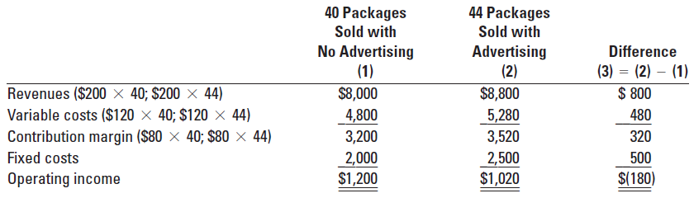
Operating income will decrease from $1,200 to $1,020, so Emma should not advertise.
Example 2: Consider the following data for Mr. SABIR Manufacturing & Distribution PLC for the month of January. Sales volume (Q) = 400 units, SP= 250 birr per unit, VC = 150 birr per unit and FC = 35,000 birr per unit. The marketing manager forecasted that, for the next month, if advertisement cost is incurred for 10,000 birr the sales volume will increase by 120 units. Should the company advertise?
The following table shows the financial impact of the proposed change in the monthly advertising budget:
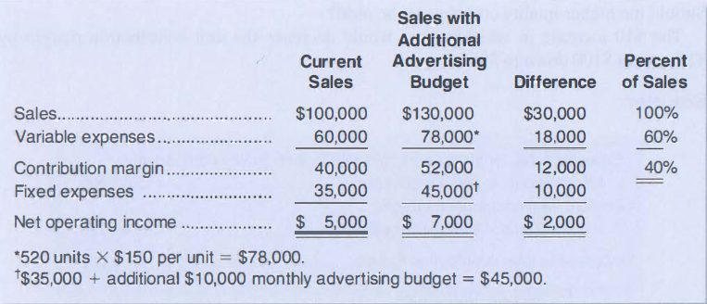
Assuming no other factors need to be considered, the increase in the advertising budget should be approved because it would increase net operating income by $2,000. There are two shorter ways to arrive at this solution. The first alternative solution follows:
Alternative solution 1:
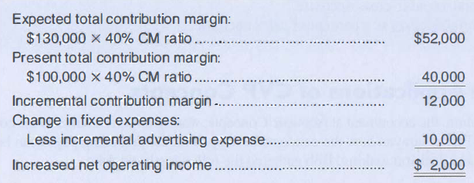

Alternative solution 2:
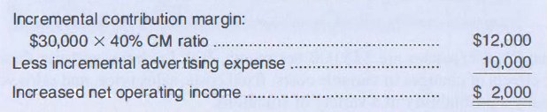
Notice that this approach does not depend on knowledge of previous sales. Also, note that it is unnecessary under either shorter approach to prepare an income statement. Both of the alternative solutions involve an incremental analysis--they consider only those items of revenue, cost, and volume that will change if the new program is implemented. Although in each case a new income statement could have been prepared, the incremental approach is simpler and more direct and focuses attention on the specific changes that would occur as a result of the decision.
Example 3: Change in Fixed Cost, Sales Price, and Sales Volume. Refer to the original
Data for the case of Mr. SABIR Manufacturing & Distribution PLC and recall again that the company is currently selling 400 units per month. To increase sales, the sales manager would like to cut the selling price by $20 per unit and incurs the advertising budget by $ 1 5,000 per month. The sales manager believes that if these two steps are taken, unit sales will increase by 50% to 600 units per month. Should the changes be made? A decrease in the selling price of $20 per unit would decrease the unit contribution margin by $20 down to $80.
Solution
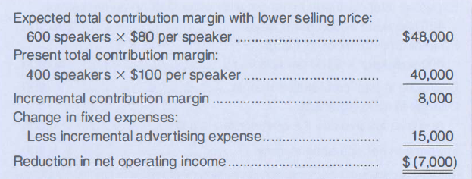
According to this analysis, the changes should not be made. The $7,000 reduction in net operating income that is shown above can be verified by preparing comparative income statements as follows:
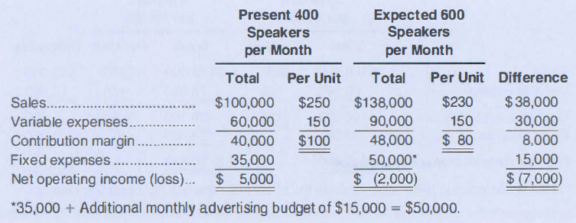

Exercise 4: Change in Selling Price. Refer to the original data where Mr. SABIR Manufacturing & Distribution PLC is currently selling 400 speakers per month. The company has an opportunity to make a bulk sale of 1 50 speakers to a wholesaler if an acceptable price can be negotiated. This sale would not disturb the company's regular sales and would not affect the company's total fixed expenses. What price per speaker should be quoted to the wholesaler if the company wants to increase its total monthly profits by $3, 000?
Solution
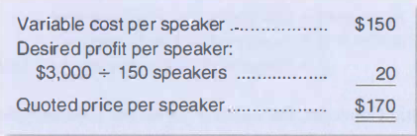
Notice that fixed expenses are not included in the computation. This is because fixed expenses are not affected by the bulk sale, so the entire additional contribution margin increases the company's profits.
    - Margin of Safety
The margin of safety is the excess of the budgeted or actual sales over the breakeven sales level. This tells managers the margin between current sales and the breakeven point. In a sense margin of safety indicates the risk of losing money that a company faces; that is the amount by which sales can fall before the company is in the loss area. The margin of safety is determined using the following formula:

Margin of Safety = Sales Volume - Breakeven Sales volume
(Actual or Budgeted)

As an example, consider the case of Dolollo Cinema, that planned to attain a Birr 9000 before tax profit at a sales volume of 5700 units or Birr 142, 500. The breakeven point for this company as determined on section 3 above is attained at the sales volume of 4,800 units or Birr 120,000. The margin of safety for this company is the difference between the budgeted sales and the breakeven sales, which is 900 units (5,700unit -4,800). The margin of safety in terms of sales value is also determined as Birr 22, 500(Birr 142,500-Birr120, 000). The interpretation is that, sales volume of Dolollo can drop by 900 tickets or Birr 22,500 before the firm incurs a loss, if all other things remain constant.
In practice the margin of safety is determined in sales amount (Birr) and as a percentage of current sales. To determine the margin of safety in percentage the following formula can be used:
Margin of Safety (%) = Margin of safety in Birr
Sales
For Dolollo Cinema the margin of safety percentage is,
22,500/142,500 = 15.8%
    - Multiple Product Company and Cost-Profit-Volume Analysis

Our illustration of CVP Analysis on the previous part of this unit assumes that the company has only one product; however, in real life, companies produce a range of products, not just one kind as was assumed in the example above. In case when a company offers more than one product, obviously different products will have different selling prices, variable costs per unit and, as a result, different contribution margins and contribution margin ratios.
- Dear learners, Can CVP analysis help managers in a multi-product companies with complication of some CVP assumptions?

The answer is 'Yes’, you can perform the same similar analysis if you just obtain some data about the product mix and the constant sales mix assumption discussed above holds true. The term sales/revenue mix, which is essential in such a situation, is defined as the relative proportions or combinations of quantities of products that comprise total sales.

In performing the analysis, first, you need to know proportion in which each of the products is sold. Then you can calculate contribution margin for each product. After that you define weighted average contribution margin, which is used in the determination of break-even point or the amount of sales required to gain desired income (profit).
Let's illustrate it on Ethio. Tire Corporation an example. Assume, the company produces 3 types of tire: for trucks, cars and motor-bikes. The following data is available:

 | Truck Tire | Car Tire | Motor-bike Tire
(A) Share in physical volume sold, % | 30% | 45% | 25%
(B) Selling price per unit, Birr | Birr10 | Birr8 | Birr7
(C) Variable cost per unit, Birr | Birr7 | Birr6 | Birr5
(D) Contribution per unit, Birr (B - C) | Birr3 | Birr2 | Birr2
(E) Contribution margin ratio (D ÷ B) | 0.30 | 0.25 | 0.29
(F) Fixed costs total, Birr | Birr10,000

From the given above you can calculate weighted average contribution margin. To calculate weighted average contribution margin, you need to "weight" the contribution margin per unit of these three products and present it as "three-in-one". To state it in the form of formula,

Weighted Average Contribution Margin per Unit = CMU x Percentage of sales Mix
Using information given above you can calculate Weighted Average contribution margin as follows: Weighted Average Contribution Margin per Unit = (30% x Birr3) + (45% x Birr2) + (25% x Br2 ) = Birr2.3
Now break-even point may be calculated using the weighted average contribution margin as far as the given sales mixes remain as it is.
    - Contribution Margin Technique and Break-even point for a Multiple Product Company

The calculation of breakeven point in a multi-product company follows the same logic as in a single product company. While the numerator will be the same fixed costs, the denominator now will be weighted average contribution margin. The modified formula is as follows:
Break-even Point (in units) = | Fixed Costs
 | Weighted Average Contribution Margin per Unit
For our example break-even point (in units) for Ethio.Tire Corporation, can be determined using the formula as,
BEP (in units) = FC/ WA.CM =Br 10,000/2.3 = Br 4347.86

The company will be at breakeven if it approximately produces 4,348 units. The total numbers of outputs required to breakeven are then split in accordance with the proportion defined in row 1 in the above table:

Truck tires: | 4,348 units x 30% = 1,304 units
Car tires: | 4,348 units x 45% = 1,957 units
Motor-bike tires: | 4,348 units x 25% = 1,087 units

Ethio.Tire Corporation will be at break-even (i.e., will get neither profit nor loss) if it sells the above volumes of Tires at the given proportion 30%:45%:25%.
However, it is important to remember that each proportion of product mix will have different break-even points. For example, if market situation changes and Ethio.Tire Corporation switches to larger production of more expensive truck tires with proportion 45%:30%:25%, break-even point will change. In this case, the weighted average contribution margin per unit will be Birr2.45 and zero profit will be earned at total level of sales of around 4,082 units (compared to 4,348 units).
The change occurred due to the fact that contribution ratio per unit of truck tires is the highest (Birr3 for truck tires versus Birr2 per car or motor-bike tires). Thus, more income can be generated by producing and selling truck tires and break-even point is reached faster (with less total items produced and sold).

- A shift in sales-mix from high-margin items to low-margin items can cause total profit to decrease even though total sales may increase. Conversely, a shift in the sales mix from low margin items to high margin items can cause the reverse effect-total profit may increase even though total sales decrease.

Break-even point for multiple product production can be calculated in Birr value as well. Here also, the numerator is the same fixed costs. The denominator now will be weighted average contribution margin ratio. The modified formula is as follows:

Break-even Point (in Birr) = | Fixed Costs
 | Weighted Average Contribution Margin Ratio
Based on figures from the earlier table with information about three Tire types, the break-even point will be reached at:

Break-even Point (in dollars) = | Birr10,000 | = Birr36,364
 | 30% x 0.3 + 45% x 0.25 + 25% x 0.29
Therefore, to achieve the break-even point, Ethio.Tire Corporation has to sell tires for a total of Birr36, 364 (valid only when proportion of sales is 30%:45%:25%).
Let's check the results: ( Sales Units x Contribution - Fixed Costs, should approximately equal zero (rounding difference may arise): Br3 x 1,304 + Br2 x 1,957 + Br2 x 1,087 - Br10, 000 = 0
    - Contribution margin technique and sales required for desired income for a multi-product company
The logic to calculate sales required for designed income (profit) for a multi-product company is the same as for a single product company. In the formula for determining the sales required for desired profit, we just substitute contribution margin per unit for one product with weighted average contribution margin for multiple products.
The formula to calculate the required unit sale for a given desired income is shown below:
Unit Sales = | Fixed Costs + Profit
 | Weighted Average Contribution Margin per Unit
And the amount of sales in dollars can be determined using the following formula:
Sales (Birr) = | Fixed Costs + Profit
 | Contribution Margin Ratio

