Watershed Management (SRWM2091)

Introduction
Degradation of watersheds in recent decades has brought the long-term reduction of the quantity and quality of land and water resources. Some of the causes of degradation include natural and anthropogenic factors like pollution, deforestation, change in farming systems, soil erosion and overgrazing. This degradation resulted in negative impacts such as flash flood, runoff, water pollution and soil depletion. The combination of environmental costs and socioeconomic impacts has led to the development of watershed management approaches.
The origins of modern watershed management can be traced to several parallel and independent movements:
- The restoration of the Alps (the last quarter of the 19th century)
- The conservation movement in the United States in the 1930s
- Watershed rehabilitation activities of colonial governments in Africa.
The watershed management approach became prominent in developing countries in the 1970s and 1980s when the problems of watershed degradation first became apparent.
A particular concern was the damage to downstream infrastructure caused by degradation in the uplands. National and regional programs were set up to address the problems.
For example; National Watershed Development Program (Regreening and Reforestation, 1976) in Indonesia, soil conservation programs launch in Brazil in 1970s that evolved by the mid-1980s into the Integrated Soil and Water Management Program in Micro-catchments and in 1990 India created the National Watershed Development Program for Rainfed Areas.
Planning the development of watersheds for Ethiopia started in the 1980’s. A planning unit for developing large watersheds comprised 30-40 thousand hectares. The purpose was mostly for implementing natural resource conservation and development programs. Large-scale efforts remained mostly unsatisfactory due to lack of effective community participation, limited sense of responsibility over assets created, and unmanageable planning units.

  - Definition of watershed and other basic concepts
What is watershed?
There are various definition for watershed as presented below:
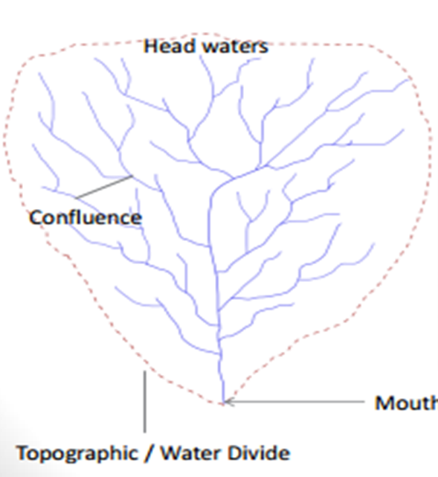
- It is an area that supplies water by surface or subsurface flow to a given drainage system or body of water, be it a stream, river, wetland, lake, or ocean (World Bank 2001).
- It is area drained by rivers/ steams system in such a way that all flow produced in that area is discharged through a single outlet.
- a watershed is the divide separating one drainage area from another (Chow, 1964).
- It is commonly used to refer to an area, specifically, the area in which all surface waters flow to a common point.
- It refers to any topographically delineated area that can collect water and is drained by river system with an outlet
- It can be defined as a unit of area covers all the land which contributes runoff to a common point or outlet and surrounded by a ridge line.
- It is the drainage area on the earth's surface from which runoff resulting from precipitation flows past a single point into a larger stream, a river or ocean
- It is the total land and water surface, which is bounded by a topographic water-divide and which in one way, or the other contributes to the discharge of one stream through movement of water to a common confluence point. etc.
The common point towards which all the water tends to converge flowing in the drainage network is the outlet of the watershed. A drainage divide is the boundary that physically separates two drainage basins from each other. Precipitation on one side of a divide will drain into one basin, whereas, precipitation on the other side will drain into another basin.

What is watershed management?
Watershed management is the process of formulating and carrying out a course of action involving the manipulation of resources in a watershed to provide goods and services without adversely affecting the soil and water base.
Watershed management includes the treatment of land by using appropriate biological and
physical measures in such a manner that the results are economically, environmentally and
socially acceptable.
Participatory watershed management is defined as a process “which aims to create a self-supporting system, which is essential for sustainability” (Wani et al, 2005). Participatory watershed management provides opportunities to the stakeholders to jointly negotiate their interests, set priorities, evaluate opportunities, implement and monitor the outcomes.
Participatory means involving method where the community is motivated to function and contributes as a group to perform various tasks. The management must involve local farmers and other land users and wide community who depend on the land.
Participatory watershed development can be defined as the rational and socially acceptable utilization of all the natural resources for optimum production to fulfil the present need with minimal degradation of natural resources such as land, water, and environment.
What is integrated watershed management (IWSM)?
IWSM is defined as the protection, improvement and rational use of water, land and other renewable natural resources in a watershed, in order to reach the optimal goals of ecological, economic and social benefits (Newason 2000;Lixian 2002).
  - Important of IWSM
Effective Integrated Watershed Management is important for sustaining and development of watersheds. Farmers, local community and larger society can benefit of a sound watershed management. What kind of improvements can be achieved?
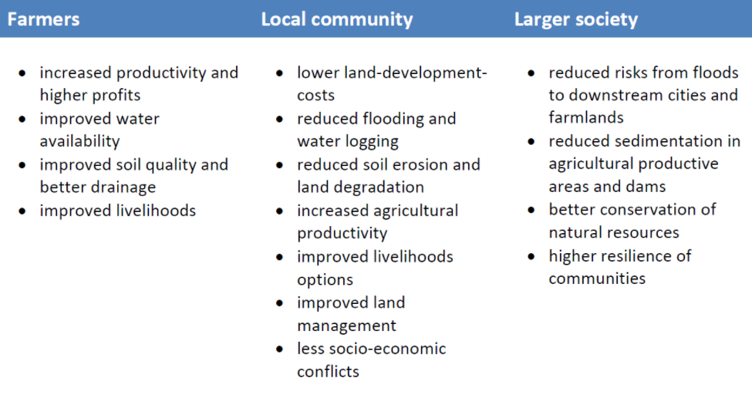
  - Aims and principles of WSM
What are the aims of WSM?
A typical watershed management program is thus likely to aim at the following:
- Improving the management of land and water, and their interactions and externalities.
- Increasing the intensity and productivity of resource use in the upland area with the objective of reducing poverty and improving livelihoods.
- Improving environmental services and reducing negative externalities for downstream areas.
- Addressing technical, institutional, and policy issues needed to ensure equitable sharing of benefits among stakeholders and sustainable watershed management.
What are the principles of watershed management?
The following principles are crucial for any watershed management planning.
- Watershed as natural system that we can work with.
A system can be defined as complex whole formed from related parts or a combination of related parts organized into a complex whole. Similarly, watershed can be regarded as a complete system and it entails several components. Entities that define the system may include products or outputs leaving the system, inputs coming to the system and interaction (+, -) between its components. Land, water and vegetation resources are interactive parts of natural ecosystem and should be managed on watershed basis.
- Watershed management must be participatory
Participatory means involving method where the community is motivated to function and contributes as a group to perform various tasks. The management must involve local farmers and other land users and wide community who depend on the land. The adequacy of planning depends on the human element and not only on physical or technical aspects. Therefore, planning must start from people living on the land. The watersheds communities must involve in all stages of implementation of watershed development activities.
- Should follow multi-disciplinary approach and it is a continuous process
Watershed management is inter-disciplinary approach. Watershed planning is a coordinated analysis by a team of technicians representing various disciplines like hydrology, geology, engineering, soil science, forestry, agronomy, and economists. Each disciple is inter-related with each other.
Many management agencies and organizations realized that effective resource management is never ending and it involves those affected by decisions. Therefore watersheds are practical for integrating these efforts.
- Watershed management must be gender sensitive
Women's are the most affected by environmental hardship; for example, they need to walk long hours to fetch increasingly scarce water, firewood and animal dung in addition to attending livestock, to name a few. Their involvement in watershed development planning, implementation and management is the key to ensure that they equally benefit from the various measures
- Watershed management must be build up on local experience, strength.
Local knowledge is essential to improve the existing technologies, to adopt new ones and to manage natural measures once they are introduced and established
- Watershed management must be realistic, integrated, productive and manageable.
It must be realistic based up on local capacity, available resources and of government and partner support. Integrated conservation and development base is the guiding principles of watershed management.
The watershed activities must be tangible and quick benefits the households. The measures must accommodate both production and conservation. Management is not only for the sake of conservation it must include both conservation and production.
- Watershed management must be flexible at different level
Flexibility is needed during the selection of community based, their size (slightly smaller or flexibility or higher than the ranges indicated), and clustering and during the steps of the producer. Flexibility is also essential when considering the choice and design of measures within agreed criteria of quality and integration
- Watershed management must be cost-sharing and empowerment/ownership building
Cost-sharing by stakeholders contributes to the sustainability of the projects for establishing the responsibility of various stakeholders in the management of the resource. Various forms of local contributes are possible upon social networks and groups formation mechanisms.
- Watershed management must be complementary to food security and rural development mainstream (like HIV, health, education and others)
Watershed deployment planning should incorporate additional elements related to basic services and social infrastructure.
- Watershed management framework support partnering, using sound science, taking well-planned action, and achieving results
When you are designing a house, you first think about all the functions you want it to serve. The same is true for designing a watershed management framework. A strong watershed framework uses sound science, facilitates communications and partnership, fosters actions that are well planned and cost effective. Among the three common elements of successful watershed management framework, Geographic management units (the watershed itself) is the first one, which agreed up on by partners to provide a functional, practical basis for integrating efforts. Secondly, stakeholders (anyone who can impact or is impacted by decisions in the watershed are involved through the processes, with clearly defined roles and responsibilities. Thirdly, partners agree on a management cycle, including activities they will work on together and a fixed time schedule for sequencing these activities. Importantly, the cycle signals that watershed management is a never ending job. Remember, these steps can be initiated by a local watershed associations, basin group, or regional or federal agency.
- Flexible approach is always need
One should never look for a rigid, step-by-step ‘’cookbook recipe’’ for watershed management. Different regions have watershed that function in very different way, and even neighboring watersheds can have major differences in geology, land use, or vegetation that imply the need for different management strategies.
Different communities vary in benefits they want from their watersheds. Therefore, watershed management is a dynamic and continually readjusting process that is built to accommodate these kinds of changes.

INTRODUCTION TO THE GEOMORPHOLOGY OF WATERSHEDS
Watershed geomorphology:
- Refers to the study of the characteristics, configuration and evolution of land forms and properties; developing physical characteristics of the watershed. It comprises of the characteristics of land surface as well as the characteristics of the channels within the watershed/basin boundary.
- It refers also to the physical characteristics of the watershed such as Basin area, basin length, basin slope, and basin shape that significantly affect the characteristics of runoff and other hydrologic processes.
  - Watershed delineation, mapping and area measurement
Table 1. The basic characteristics of watershed & their importance for watershed management
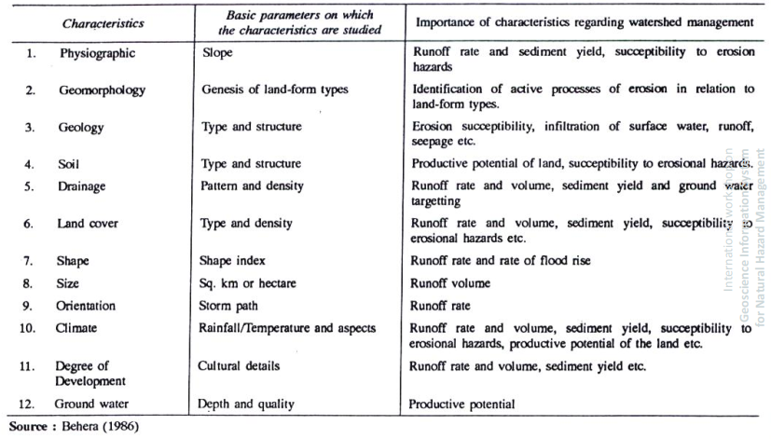
Watershed delineation and mapping
Watershed Delineation Methods
Different methods have been devised and are used to delineate watersheds. The following are some of the common watershed delineation methods
1.Watershed delineation using Topographic map (contour, Drainage Patterns),
2.Watershed delineation using hand held GPS (Tracks, points),
3.Automatic delineation from DEM using ArcGIS software, ILWIS and ArcHydro (..\NRM\IWSM_Lab_Exercise\WatershedDelineation_10_2.pdf)
A digital elevation model (DEM) is a regularly spaced grid of numbers representing elevation – it is the digital equivalent of a topographic map. Typical DEM data has a resolution of 1 arc sec (approx 30 m) or 1/3 arc sec (~10 m). 1/9 arc sec data is also available for some. Keep in mind that the higher the resolution, the more accurate the elevations, but the larger the files you’ll be working with (3X better resolution = 9X larger files). The resolution to use depends on the scale of the problem you are working on – for example, for large watersheds using 10 m vs. 30 m resolution has very little effect on the results.
Watershed area measurement
The area (size) of watershed:
- It is also known as the drainage area and it is the most important watershed characteristic for hydrologic analysis.
- It reflects the volume of water that can be generated from a rainfall.
- It is defined as the area contained within the vertical projection of the drainage divide on a horizontal plane.
Watershed area is comprised of two sub-components; Stream areas and Inter-basin areas.
- The inter-basin areas are the surface elements contributing flow directly to streams of order higher than 1.
- Stream areas are areas that would constitute the area draining to a predetermined point in the stream or outlet.
Once the watershed has been delineated, its area can be determined by:
- Approximate map methods
- Planimeter
- ArcGIS

Based on size (catchment area), a watershed can classified as:
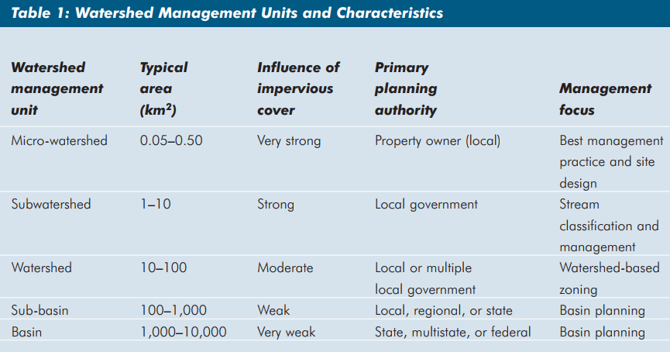
  - Watershed shapes and shape attributes
The basin shape is determined as the shape of the projected surface on the horizontal plane of the basin map. The evaluation of the basin shape has significant importance to predict its effect on stream discharge characteristics. For example, the shape of a watershed influences the shape of its characteristic hydrograph. For example,
- elongated shape watershed generates, for the same rainfall, a lower outlet flow, as the concentration time is higher.
- a fan-shape presents a lower concentration time, and it generates higher flow than an elongated shape.
Watersheds have an infinite variety of shapes, and the shape supposedly reflects the way that runoff will “bunch up” at the outlet.
- A circular watershed
- An elliptical watershed
A number of watershed parameters have been developed to reflect basin shape such as:
- Form Factor
- Circularity Ratio
- Elongation Ratio
- Compactness Coefficient
- 1. Form Factor: The area of the basin divided by the square of axial length of the basin; where value < 1
Ff=A/L²
- 2. Circularity Ratio: The ratio of basin area to the area of a circle having the same perimeter as the basin; where value £ 1
4∏A/P_{r}²
- 3. Elongation Ratio: The ratio of the diameter of a circle of the same area as the basin to maximum basin length; where value £ 1
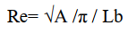
- 4. Compactness Coefficient: The perimeter of the basin divided by circumference of equivalent circular area; where value 1
0.2821P_{r}/A^{0.5}
  - Stream/channel orders and other watershed characteristics
    - Stream/Channel Order
Stream Ordering: is a method of classifying, or ordering, the hierarchy of natural channels within a watershed. It was developed by Horton (1945). Several modifications of the original stream ordering scheme have been proposed, but the modified system of Strahler (1957) is probably the most popular today. Strahler's stream ordering system is a well-known classification based on stream/tributary relationships.
The first-order streams (1st ) are defined as channels that have no tributaries.
The second order stream (2nd ) is formed by the junction of two first-order channels.
A third-order channel (3rd ) is formed by the junction of two second-order channels. Thus, a stream of any order has two or more tributaries of the previous lower order.
Note: the intersection of a channel with another channel of lower order does not raise the order of the stream below the intersection (e.g., a fourth-order stream intersecting with a second-order stream is still a fourth- order stream below the intersection).
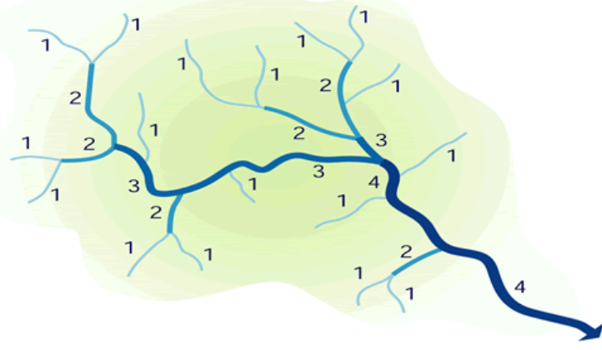
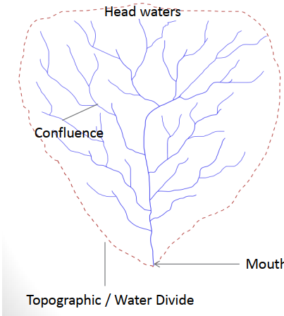
The Horton-Strahler ordering scheme.
Other channel characteristics
Bifurcation ratio is defined as the ratio between the number of streams of a particular order to the number of streams of the next higher order.
R_{b} = N_{w}/N_{w+1}
Where
R_{b}-bifurcation ratio
N_{w}-number of stream of a particular order
Example: Determine the bifurcation ratio of the stream with 17 first order stream and 6 second order stream.
Solution

N_{w}=17
N_{w}+1=6
Thus, R_{b}=17/6=2.83

Channel Length
- Refers to the length of channels of each order. The average length of channels of each higher order increases as a geometric sequence. Thus, the first-order channels are the shortest of all the channels and the length increases geometrically as the order increases. This relation is called Horton's law of channel lengths and can be formulated as:
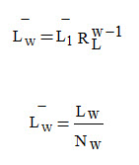
where
L_{w} = total length of all channels of order w
N_{w} = number of channels of order w
L_{w} = mean channel length of order w
L₁ = mean length of the first-order streams
R_{L} = Stream-Length Ratio generally varies between 1.5 and 3.5
R_{L} = L_{w}/L_{w-1}
Channel Slope
- It is determined as the elevation difference between the endpoints of the main channel divided by the channel length.
Channel Profile
- It includes the point of origin of the stream called the head, the point of termination called the mouth, and a decreasing gradient of the stream channel towards the mouth.
Drainage Density
- Drainage density (D_{d}) is the measure of closeness of drainage spacing.
- It is the indication of drainage efficiency of overland flow and the length of overland flow as well as the index of relative proportions.
- It is defined as the length of drainage per unit area.
D_{d} = L/A
where
L = Total length of all channels of all orders,
A = Area
Horton (1945) recommended using 1/2 the reciprocal of the drainage density to determine the average length of overland flow (L₀) for the entire drainage basin
L₀ = 1/(2 D_{d})
Where
D_{d} basically describes the average distance between streams and L₀ approximates the average length of overland flow from the divides of the stream channels.
  - Watershed hydrology

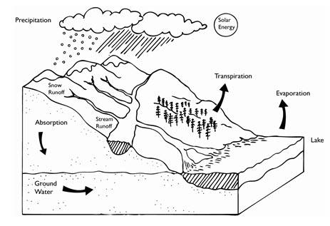

SOCIO-ECONOMIC ISSUES IN WATERSHED MANAGEMENT
  - Impact of population and local economic activities on watersheds
More people means more infrastructure needs such as domestic water, housing and schools, etc., and also means more land, more food, and more jobs.
Rural poverty in the uplands, causing migration to crowded urban centres and/or destroying watershed resources.
Improper land use (slopeland farming, shifting cultivation without proper fallow, overgrazing, etc.) resulting in degradation of land and other watershed resources.
Deforestation, thereby increasing hazards of seasonal flooding and/or drought downstream.
  - Institutions and watershed management
Institutions are norms, rules and regulations that mediate socio-economic interactions between agents and facilitate exchanges, enforcement of contracts, decision making, coordination, and conflict resolution. Institutions define property rights to productive resources access and control over resources.
1. Government – state and federal
2. District/Woreda/ Rural Development Agency
3. Project Implementing Agency (PIA)
4. Watershed Development Team
5. Village admin council /Kebele administration
6. Watershed association/committee
7. Local user groups (for land owners)
8. Local self-help groups (land-less)
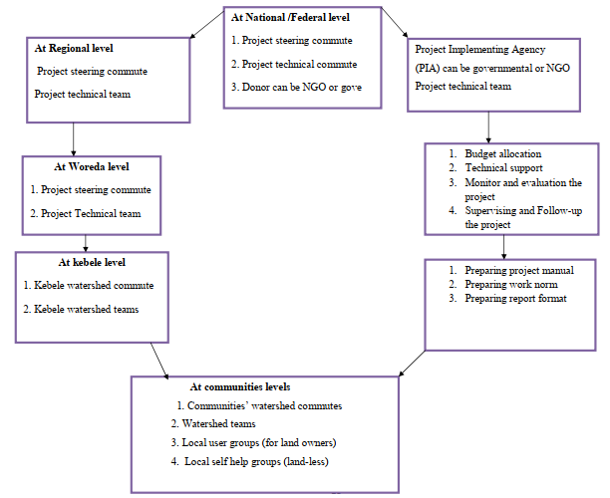
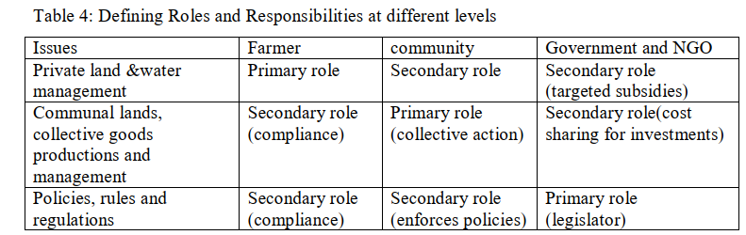
  - Infrastructure
Generally, the infrastructure development in watershed include:
- Transportation
Existing road networks including
- Highways
- Secondary roads
- Feeder roads
- Forest roads, etc.
- Housing
Types of structure; construction material (for frame, wall, floor, etc ); age of the house; rooms per household; total area (sq. m); number of persons per household; ownership; utility; kitchen and kind of stoves; type of toilet; present status; maintenance
- Domestic Water Supply, Irrigation and Energy
- Present water supply system
- Capacity
- Delivery
- Distribution (in yards, into dwellings or at roadsides), and
- Potential for development, etc.
- Minor irrigation and
- Water harvesting
- Public Services
- Marketing
- Extension services
- Credit or loan facilities, etc.
- Schools
- Health clinics
- Post offices
- Community centers, etc.
- Agro-Industry
- cottage industry
- existing small shops
  - Participatory approaches in surveying and planning watershed management
Planning is to "devise detailed methods for doing, arranging and making something".
Various participatory techniques are used to promote local participation. They originate
from different methodologies widely applied throughout the world.
Major participatory watershed management approaches adopted in many parts of the world include:
- Bottom-up approach
- Iterative approach
- Flexible approach
Participatory watershed planning approaches in Ethiopia originated from:
- Local level Participatory Planning Approach (LLPPA)
- Participatory Rural Appraisal (PRA)
- Farming System Development (FSD)
- Participatory Land Use-Planning and the like.
These techniques are designed to ensure involvement of the whole community in watershed management survey and planning. A participatory watershed planning is designed to be as simple and practical as possible, so that one or more Development Agent (s) and the community can prepare a plan together.
Participatory planning methods and techniques
- Working in an interdisciplinary team
- Participatory targeting
- Gender sensitization
- Group meetings and brainstorming
- Vulnerability/wealth ranking
- Problem identification and ranking
- Semi-structured interviews
- Transect walks
- Village and households mapping
- Soil, vegetation and topographic surveys
- Watershed and community area delineation
- Action planning
- Participatory and result-based monitoring.
  - Stakeholder analysis and involvement in watershed management planning
Who are stakeholders?
- A stakeholder is a person (or group) who is responsible for making or implementing a management action, who will be significantly affected by the action, or who can aid or prevent its implementation
- Stakeholder groups are formal or informal assemblies that represent a variety of interests and points of view within a watershed.
- Stakeholders are those who will make decisions, those who will be affected by them, and those who can stop the process if they disagree.
- Stakeholders can be individuals, organizations or groups.
- Stakeholders include public-sector agencies involved in water resources (for example, departments of agriculture, industry, transportation, recreation), various levels of public-sector agencies in the water sector (state, regional or local), private-sector organizations and companies with water interests, environmental and professional NGOs, and representatives of those people likely to be affected, specifically including people who may have little knowledge of the effects of strategy and who may lack the means to participate.
- Any group or individual who can affect or is affected by the achievement of the organization's objectives (Freeman, 1984)
- A stakeholder is any individual, community, group or organisation with an interest in the outcome of a programme, either as a result of being affected by it positively or negatively, or by being able to influence the activity in a positive or negative way.
Why involve stakeholders?
Involving stakeholders
- Builds trust and support for the process and outcome
- Shares the responsibility for decisions or actions
- Creates solutions more likely to be adopted
- Leads to better, more cost-effective solutions
- Forges stronger working relationships
- Enhances communication and coordination of resources
- Helps to ensure that any environmental justice concerns are identified at an early stage
It’s important to note that public involvement processes can greatly enhance watershed management efforts, but they can’t override laws and regulations enacted by elected officials and public agencies. In fact, stakeholder group processes are used most often to support and complement legally required actions such as achieving water quality standards, protecting drinking water supplies, restoring habitat, and generally making the nation’s waters fishable and swimmable. Another important aspect of stakeholder involvement is utility. If you convene a group and don’t somehow include their input in the process or product, they’ll likely wonder why they wasted their time. Make sure that stakeholders’ contributions are recognized and are used in some manner to achieve the goals of the watershed program, and that stakeholders are informed about how their participation has affected the outcomes. In addition, a robust stakeholder involvement program can help to identify any potential environmental justice concerns that might be present in the watershed. Including representatives from minority or low-income communities in the stakeholder group can help you to identify any such concerns early in the planning process. Then the watershed plan can include addressing situations in which certain groups are disproportionately affected by water quality problems.
What is stakeholder analysis?
Stakeholder Analysis is the process of identifying the interests of different groups and find ways of harnessing the support of those in favor or the activity, while managing the risks posed by stakeholders who are against it.
Methods of stakeholder involvement
Stakeholder participation (involvement): is the process of involving those who are affected by and thus have an interest in water resources, and hence in the formulation of water strategy. It is a two-way communication process that explicitly seeks to identify and to clarify the interests at stake, with the ultimate aim of producing a well-informed water management strategy that has a good chance of being implemented.
Stakeholder involvement should be an integral part of the process of developing a strategy, mainly because it can:
- ensure that alternatives serving a broad range of interests are considered;
- help to gather data or information, identify gaps in data or information, and identify those who might provide data or information in the future;
- provide transparency and accountability regarding both decisions taken and the process by which those decisions were arrived at;
- accustom stakeholders to the fact that some difficult choices may have to be made in order to manage water resources effectively; and
- build a broad base of commitment to options by creating an environment that rewards the realistic discussion of benefits, risks and costs of options and that provides a meaningful basis for informed consent to recommendations.
In certain situations there may be barriers to effective stakeholder participation in the form of cost, access and prevailing cultural norms.
Stakeholder involvement is more than just holding a public hearing or seeking public comment on a new regulation. Effective stakeholder involvement provides a method for identifying public concerns and values, developing consensus among affected parties, and producing efficient and effective solutions through an open, inclusive process. Although not every single interested party needs to be a member of the board (it’s important to keep the size of the group manageable and efficient), you should make sure all the key groups in the watershed are represented. For example, there might be three farmer organizations in a watershed, but it might not be necessary to include representatives from all three in the stakeholder group. Instead, the participation of one, well respected farmer from the community might be adequate.
What are the methods of identifying stakeholders?
A variety of methods can be used to identify stakeholders.
- Self-identification,
- Simply means that individuals or groups step forward and indicate an interest in participating.
- Third-party identification
- Uses knowledgeable parties, such as existing advisory committees, informal or formal community leaders, and representatives of known interests, to suggest people or organizations that should be included.
- Identification by the strategy team.
- Relies on the team systematically identifying and approaching stakeholders.
Criteria for stakeholders classification
- The stakeholder's power to influence life on the watershed
- The legitimacy of the stakeholder's relationship with the watershed region
- The urgency of the stakeholder's claim on the watershed area
Type of stakeholders | Characteristics
Key stakeholders. | significantly influence or are important to the success of an activity.
Primary stakeholders | ultimately affected by an activity, either as beneficiaries (positively impacted) or disbeneficiaries (adversely impacted).
Secondary stakeholders | with a stake, interest or intermediary role  in the activity.

Stakeholder Analysis: Importance/Influence Matrix
Importance: The priority given to satisfying the needs and interests of each stakeholder.
Influence: The power a stakeholder has to facilitate or impede the achievement of an activity’s objective. The extent to which the stakeholder is able to persuade or coerce others into making decisions, and following a certain course on action.
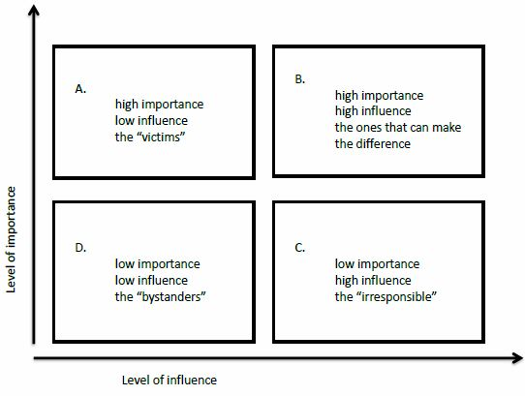
Source: APMAS Knowledge Network
Tools for development_A handbook for engaged in development.pdf

PLANNING WATERSHED MANAGEMENT
What is watershed management planning?
Proper planning depends on the human element and not only on physical or technical aspects. Therefore, planning must start from the bottom. Local farmers, other land users and the wider community who depend on the land must be involved from the very beginning of the planning process since they are the ones that will live with its results. Natural resources development, conservation and management constitute the foundation of watershed planning.
The basic elements included in the planning process are
- Soil conservation and water harvesting
- Forestry and agroforestry
- Crop and livestock production and
- Small-scale rural infrastructure (including water, feeder roads, small-scale irrigation).
Therefore, agronomists, livestock’s specialists, foresters and conservationists should interact together, combining skills and experience and their respective strengths.
  - Getting started at community level
- Organization and formation of community watershed team (CWT)
- Call general assembly Meeting with community
- Elect a representative community watershed team (CWT)
In order to elect CWT representative, two options are considered based upon local conditions:
- One team
- Two teams (by gender)
Composition of community watershed planning team involves:
The creation of one gender balanced CWT is the most challenging and therefore the recommended option. After wealth ranking exercise, community should elect 10 people's representatives with equal gender proportion and active members of each of the main social groups to form the “Community Watershed Team”.
In general, the community should elect a CWT that includes:
- The Community leader (also representing the community at kebele level)
- Four male-headed households representing different social groups (including vulnerable) and living in different parts of the community
- Four female-headed households representing different social groups (including vulnerable) and living in different strata of the community (down to top)
- One youth representative
- One religious representative
- Others as required by the community (innovative farmers, respected people, women's group, and others).
Functions of the CWT:
- Serve as a permanent contact with the DA, the rest of the community/target group and local leaders during planning, implementation and monitoring and evaluation
- Responsible to ensure the watershed liaison with other communities located within the broader watershed unit
- Agree on timing for planning work and main tasks
  - Biophysical and socio-economic survey
    - Get to know the watershed, people’s interactions, opportunities and limitations
The CWT and the DAs will proceed with a community and sub-watershed familiarization exercise.
The main survey techniques include:
- Participatory mapping
- Transects
    - Get to know people’s needs, strengths and aspirations
- Problem identification (PI) and ranking in order to:
- To identify the most important problems of the community and target group(s)
- To accomplish preliminary assessment of possible solutions.
In defining problems, it is important to pay attention to the following 3 issues:
- Distinguishing problems from causes and effects
- Distinguishing between symptoms and problems
- Interactions between problems.
4 types of problem ranking commonly used in participatory planning
- Preference ranking (ranking by voting)
- Direct matrix ranking
- Pair-wise ranking
- Wealth ranking
- Community level socio-economic survey
the sources of information and methods to undertake this survey.
- Review of existing reports
- Socio economic survey acts also as a baseline for Monitoring and Evaluation
    - Detailed biophysical survey and mapping
Mapping is undertaken using 1:50,000 topomaps or sketch maps for this purpose.
Mapping work include:
- Demarcate community boundaries and sub-watersheds
- Identify land use, topography, soils and past erosion
    - Relationship between biophysical and socio-economic survey results: Analysis of focus areas and priorities
The DA and the CWT should then analyze the relationship between the identified problem and socio-economic survey results, as well as the biophysical resources assessed.
Important of analysis of the relationship between biophysical and socio-economic surveys:
- help to identify existing opportunities
- show which areas should be focused as a key and priority needs.
- it would be possible to fulfill short, medium, and long-term objectives.
- BASE MAP is produced with suitable scale (1:2000 to 1: 5000) scale for community maps.
- Farmers’ maps and transects should be also reported on paper for reference and for comparing these maps with base maps.
At the end of this stage, the general assembly meeting will be conducted.
  - Identification and prioritization of major biophysical problems and management options (Erosion, flood, sedimentation, deforestation etc.)
Now relate the various socio-economic issues with bio-physical elements within and outside the community watershed to select the different interventions that bring change. Interventions should be technically correct and implemented following quality criteria and in the correct sequence.
    - Identification of interventions and prioritization elements
- Pool of experience and options: To properly select from the different measures, particularly those related to natural resource development and productivity enhancement, the DA and the CWT should
- Carefully look at land use, soil, slope and vegetation features.
- identify the most suitable measures under different agro-ecological conditions based on the problems and demands or priorities expressed by the community.
- Role of traditional knowledge:
- Regardless of their performance, traditional experience and knowledge in SWC and farming should be capitalized by field technicians and used effectively to identify, select, design and implement improved natural resources development and productivity intensification measures.
- Measures and target groups: There are measures that are implemented at individual, group, community, and inter-community levels. They are often all connected and need a common understanding on which activity to start first or simultaneously that will be most logical and advantageous.
- The Role of the Development Agent:
- The DA plays a facilitating and technical role, leaving the CWT to own the planning process.
- Addressing women’s needs:
- It means the promotion of activities that benefit women. For example, women would be very much interested in treatment of upper watersheds mostly because of their effect on water-tables, thus on springs, wells or filling of ponds.
- Promote participatory technology development for new and untested measures.
- It is always advisable to initiate small-scale trials where the farmers (and yourself) can assess the performance of the measures.
    - General technical and social aspects related to watershed planning
In planning development activities, the DA will notice that for problems of common interest to households, it is easy to reach agreement on what measures should be implemented.
    - Key integration requirements and sequencing of activities
Integration has different aspects:
- Measures (Technologies)
- Each technology in a watershed and land-use system is not applied in isolation and needs to be integrated with other measures to:
Important of technologies integration
- Further strengthen the measure and improve its efficiency,
- Improve its productivity
- Reduce maintenance costs
- Generate multiple benefits
- Micro-watershed
The next level of interactions includes mutually reinforcing activities and basic linkages between activities within a micro-watershed unit (few hectares).
- Community watershed and the overall critical watershed
- The interactions and integration requirements at this level are essential to guide the sequence of activities and increase the range and quality of conservation and development opportunities that can be generated from systematic treatment within and between sub-watershed and broader units.
- Integration, interactions and sequencing interventions following watershed logic
The type of treatments to consider in community-based watershed planning can be divided into:
1. Treatment of overall community and/or inter-community-based watershed
2. Treatment of small sub-watersheds
3. Treatment of small micro-watersheds
    - Intervention areas
Different intervention are applied in different agro-ecology and several measures have multiple functions (for instance both for forestry and fodder, for water harvesting and conservation, for soil fertility improvement and moisture conservation, etc).
  - Development map, inputs and action plan preparation
- Development map
The development map is an essential instrument that shows the actual placement of sites of development interventions in type with respect to land use types.
Points to be considered when preparing a development map:
- The scale should be the same as that of the base map.
- It should show compartments of the development blocks in accordance with phasing.
- Any major community asset and development works that have been previously implemented should be transferred to the development map.
- Proposed development works, including maintenance or rehabilitation of existing
measures should be shown.
- Symbols should be used to show the development interventions and other necessary
information.
- The map should be provided with standard legend so that the user can easily read and use
the map.
- Inputs
The inputs include the labor and planting/ working/construction materials.
Factors that influence the volume of an input are:
- The extent of the work (area)
- Specification
- Degree of slope
- Soil texture and condition (wet or dry)
- The working pattern
- Tools of the workers
- Planting materials
- Action plan
- It should be carefully and accurately developed on the basis of what has been agreed upon with the community for the implementation of the proposed measures.
- It should show a multi-year plan (1st year plan prepared in detail quarterly and monthly and other years are strategic projections ) to be adjusted and/ or modified after the first year implementation and results.
  - Implementation strategies, Monitoring and evaluation
    - Implementation strategy
Once the preparation for implementation completed,
- The DAs should send the plans to the wereda for final consolidation and approval.
- Then the WWT should forward a summary of the plans (maps and main input requirements) to the zone and/or to the region, where necessary.
- Institutional organization and terms of reference
General roles and responsibilities for Participatory watershed development planning (PWDP)
1. Regional, zonal (if applicable), wereda experts and DAs are responsible to propose
and arrange training for land users before and during implementation based on local
conditions and specific needs.
2. DAs and wereda experts are responsible to follow-up trials and development of on-farm participatory technology for innovative measures to be tested in specific areas.
3. DAs and wereda experts will play a major role in strengthening the communication between the various sector agencies operating in the area by involving their experts and using their resources whenever required; for instance, education and health experts, resources, NGOs and others.
4. DAs and land users will also discuss the possible modifications that may occur to the plan during implementation
- Resource identification and mobilization
- Self-help contributions and empowerment
- Linkage with existing forms of support (safety nets, food security, other projects)
Participatory monitoring and evaluation
The planned list of activities, targets, technical designs, reasons for selection, maps, and others, should be considered as benchmarks, which allow field staff to compare achievements and their impact against original purposes. Participatory monitoring and evaluation (PM&E) is different from conventional monitoring and evaluation in its focus on participation.
Benefits of PM&E:
- Increases consensus on project goals, objectives and activities
- Creates ownership over evaluation results
- Increases cost-effectiveness of ME information
- Provides timely and reliable information for decision making
- Enhances learning by local stakeholders
- Enhances skills and confidence of local people on management of development projects
- Utilizes local knowledge.
A participatory monitoring and evaluation system with the following characteristics should be developed for effective implementation of watershed development:
- Simple to apply
- Fully involves communities
- Should be consistent with already existing government system
- It should be universally applicable in all weredas
- Promotes accountability
- Should use existing data to the extent possible
- Should assist in replanning and correction of failed interventions
- should also assist in introducing new innovative activities.
Participatory monitoring
Monitoring: is the collection of raw data or information for evaluation purposes. It is a management tool which facilitates continuous learning and provides quality information on which to base evaluation.
Participatory monitoring:
- is the systematic recording and periodic analysis of information that has been chosen and recorded by insiders with the help of outsiders.
- It means that each stakeholder is involved in identifying the indicators and in measuring them.
Examples of data to be monitored regularly:
- Quantity of SWC measures (physical and biological) constructed/established
- Quality of the SWC measures (physical and biological) constructed/established
- Area of land treated with different measures
- Improved seeds supplied
- Participation in planning and selection of beneficiaries
- Number of planting material produced by type
- Number of trees planted
- Area under irrigation
- Participants by activity and gender segregated
- Others of relevance.
Participatory evaluation
Evaluation: is a process in which judgments on success and failures are made.
Three types of evaluations:
- Process evaluation
- Measures the implementation of activities and how effectively this is done.
- Enables the stakeholders to develop a better understanding of the functioning of the program.
- It allows the stakeholders to understand the links between resource use, program activities, the intended and unintended immediate effects of those activities, the predetermined objectives, which are pursued, and the contribution of the program to some long-term vision.
- Outcome evaluation
- Measures the effect of the activities that have been undertaken, mainly the more immediate, tangible or observable changes.
- It enables the participants to apply the understanding, which they developed in the process evaluation to assess which of their goals are achieved, and how well it is done.
- Impact assessment
- Measures the long-term widespread consequences of the interventions.
- Comparison is made between the situation at the beginning of interventions and the situation after few years of interventions.
- It is also made by comparing the intervention area with an area, which did not receive any intervention during the period under observation.

