WATER HARVESTING SYSTEM (SRWM2094)

Introduction
As land pressure rises, more and more marginal areas in the world are being used for agriculture. Much of this land is located in the arid or semi­arid belts where rain falls irregularly and much of the precious water is soon lost as surface runoff. Recent droughts have highlighted the risks to human beings and livestock, which occur when rains falter or fail. While irrigation may be the most obvious response to drought, it has proved costly and can only benefit a fortunate few. There is now increasing interest in a low cost alternative­generally referred to as "water harvesting".
In its historical perspective, various forms of water harvesting (WH) have been used traditionally throughout the centuries. Example of traditional forms of water harvesting across the world
- Diversion of "wadi" flow (spate flow from normally dry watercourses) onto agricultural fields in the Middle East
- The clearing of hillsides from vegetation to increase runoff, which was then directed to fields on the plains in the Negev Desert of Israel in the last 4,000 years
- Floodwater farming in the desert areas of Arizona and northwest New Mexico in the last 1000 years (Zaunderer and Hutchinson 1988).
- Cultivation of the fields (Akchin) situated at the mouth of ephemeral streams by the Hopi Indians on the Colorado Plateau.
- Microcatchment techniques for tree growing, used in southern Tunisia, which were discovered in the nineteenth century by travelers.
- In the "Khadin" system of India, floodwater is impounded behind earth bunds, and crops then planted into the residual moisture when the water infiltrates.
The importance of traditional, small scale systems of WH in Sub­Saharan Africa is just beginning to be recognized. For example
- Stone line practices in Burkina Faso
- Earth bunding systems in Eastern Sudan and the Central Rangelands of Somalia.

So, what is water harvesting and water harvesting system?
Water harvesting has been defined as:
- Its broadly defined as the collection of runoff for its productive use.
- It is a collection and concentration of direct rainfall or runoff water from treated or untreated ground / rooftop catchments or ephemeral streams or adjacent roads (foot path) to store in ponds, tanks, reservoirs, dams, water pans or in soil profile for irrigation, domestic consumption and livestock consumption
- It is a technique of developing surface water resources that can be used in dry regions to provide water for livestock, for domestic use, and for agroforestry and small scale subsistence farming.
- It is the process of harnessing water for beneficial use with any kind of device or technique that collects, stores, and/or increases the availability of intermittent surface runoff and groundwater in drylands.
- It is the collection, conveyance, and storage of rainwater for future use (domestic, agricultural, livestock, environmental management).
Water harvesting system
- It is defined as a system of catching and storing rainfall until it can be beneficially used.
- It is also defined as an artificial methods whereby precipitation can be collected and stored until it is beneficially used.
The water harvesting system includes:
- A catchment area,
- A storage facility for the harvested water
- A water distribution

Global Water Potential
Water use has been increasing worldwide by about 1% per year since the 1980s, driven by a combination of population growth, socio-economic development and changing consumption patterns. Global water demand is expected to continue increasing at a similar rate until 2050, accounting for an increase of 20-30% above the current level of water use, mainly due to rising demand in the industrial and domestic sectors. Over 2 billion people live in countries experiencing high water stress, and about 4 billion people experience severe water scarcity during at least one month of the year. Stress levels will continue to increase as demand for water grows and the effects of climate change intensify. About 71 % of the Earth's surface is covered by water.
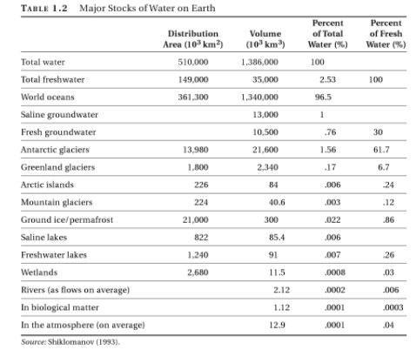
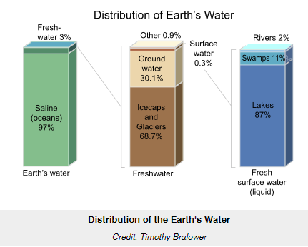
Most of this fresh water (69%) is used for agriculture, 23% for industrial purposes and 8% for domestic purposes.

Water Resource Potential of Ethiopia and Related Constraints
Water Resource Potential of Ethiopia
About 0.7% of Ethiopia is covered with water bodies (MOWE 2013). Although Ethiopia has abundant rainfall and water resources, its agricultural system does not yet fully benefit from the technologies of water management and irrigation. Rainfall is the ultimate source of water in the country which is available in multiple forms that can be used for agriculture and irrigation. Ethiopia has 12 river basins, 11 fresh and 9 saline lakes, 4 crater lakes and over 12 major swamps or wetlands. These river basins generate an estimated annual runoff around 122 billion m³ of which 45% of this potential is contributed by Abbay basins. Ethiopia’s surface water potential as identified and estimated in different integrated river basin master plans is 124.4 billion cubic meter (MOWE 2013). Majority of the lakes are found in the Rift Valley Basin. The total surface area of these natural and artificial lakes in Ethiopia is about 7,500 km². Most of the lakes except Ziway, Tana, Langano, Abbaya and Chamo have no surface water outlets, i.e., they are endhoric. Lakes Shala and Abiyata have high concentrations of chemicals and Abiyata is currently exploited for production of soda ash.
No. | River Basin | Area (km²) | Run-off (Bm³) | Potential Irrigable Land (ha) | Estimated Ground Water Potential (Bm³)
1 | Abbay | 199,812 | 54.8 | 815,581 | 1.80
2 | Awash | 112,696 | 4.9 | 134,121 | 0.14
3 | Baro-Akobo | 75,912 | 23.6 | 1,019,523 | 0.28
4 | Genale-Dawa ** | 171,042 | 5.88 | 1,074,720 | 0.14
5 | Mereb *** | 5,900 | 0.65 | 67,560 | 0.05
6 | Omo-Ghibe | 79,000 | 16.6 | 67,928 | 0.42
7 | Rift Valley | 52,739 | 5.6 | 139,300 | 0.10
8 | Tekeze *** | 82,350 | 8.2 | 83,368 | 0.20
9 | Wabi-Shebelle ** | 2002,692 | 3.16 | 237,905 | 0.07
10 | Afar/Denakil **** | 74,002 | 0.86 | 158,776 | -
11 | Ogaden **** | 77,121 | - | - | -
12 | Aysha **** | 2,223 | - | - | -
Total |  | 1,135,494 | 124.25 | 3,798,782 | 2.86

As compared to surface water resources, Ethiopia has lower ground water potential. However, by many countries’ standard the total exploitable groundwater potential is high. With the understanding of the nature of the distribution of rocks and the recharge classification of the country, the total groundwater reserve of the country was estimated as 185 BCM, which is distributed in an area of 924,140 km² made of Sedimentary, Volcanic, and Quaternary rocks and sediments, including the highlands and the Rift Valley. But this estimate is expected to be exaggerated and require thorough investigation. Due to the hydro-geological complexity and costs, Ethiopia has barely exploited its groundwater resources, especially for agriculture. The initial estimates of groundwater potential of Ethiopia vary from 2.6 to 13.5 billion m³ per year.

Constraints for Water Resource Development in Ethiopia
Despite the potential, the availability of resources and demand of the water resources and its products in Ethiopia, the water sector development is still at infancy. A number of factors that can be group into four main streams as natural, technical, economical, and institutional factors hinder the water sector development. These include:
- Natural
- Climate
- Topography
- Geology
- Technical
- little or no organized knowledge and information about the water resources of the country
- there are no reliable rainfall–runoff methods that address the climatic and topographic variability of the country
- no dedicated national research, academic and development institute on water
- The existing system also suffers from high staff turnover
- Economic
- Construction of hydraulic structure is expensive and need much investment
- Insufficient budget allocation
- Hydro-politics
- Lack of formal transboundary water use and management agreements exist between riparian countries.
- lack of discouragement for the financing institution to lend.

Major Limitation of Dryland Environment, approaches of classifying dryland environments.
Definition of drylands
There is no single widely accepted definition of drylands, however; the definition given by FAO and the United Nations Convention to Combat Desertification (UNCCD, 2000) are widely used. FAO defined drylands: areas with a length of growing period (LGP) of 1–179 days (FAO, 2000a); this includes regions classified climatically as arid, semi-arid and dry sub-humid.
The UNCCD classification employs a ratio of annual precipitation to potential evapotranspiration (P/PET). Under the UNCCD classification, drylands are characterized by a P/PET of between 0.05 and 0.65.
According to both classifications, the hyper-arid zones (LGP = 0 and P/PET < 0.05), or true deserts, are not included in the drylands and do not have potential for agricultural production, except where irrigation water is available.
Drylands cover approximately 40% of the world’s land area, and support 2 billion people, 90% of whom live in developing countries. Approximately 10% of drylands bear a legacy of land degradation. Drylands have three primary economic functions: as rangelands (65% of the global drylands including deserts); as rain-fed farmland and irrigated farmland (25%); and as forest or sites for towns and cities (10%), which are growing rapidly. They include the world’s driest places (hyperarid deserts such as the Atacama in Chile and the Namib in southwest Africa) as well as the Polar Regions. The deserts and drylands cover major parts of most continents, particularly Asia, Africa, North America and Australia. In Ethiopia, most of the drylands are situated in the regions of Somali, Afar, Southern Nations, Nationalities and Peoples Regional State, Benishangul-Gumuz and Gambella. This accounts for nearly 70% of Ethiopia’s total land mass. The climate in the Ethiopian drylands is characterized by low and erratic rainfall and very high temperatures, along with sparse and barren vegetation in some places. These areas are extremely vulnerable to land degradation and cyclic droughts, which are likely to increase in frequency given the likelihood of continued climatic change.
Global Aridity Index (Global -Aridity)
Aridity is defined as:
- The average conditions of limited rainfall and water supplies, not to the departures from the norm, which define a drought.
- A generalized function of precipitation, temperature, and/or potential evapo-transpiration (PET).
Global mapping of mean Aridity Index from the 1950-2000 period at 30 arc second spatial resolution is calculated as:
$$Aridity index (AI)=\frac{MAP}{MAET}$$
Where:
MAP = Mean Annual Precipitation
MAET = Mean Annual Evapo-transpiration
In the Global-Aridity dataset, following this formulation, Aridity Index values increase for more humid conditions, and decrease with more arid conditions.
Classification of dryland environments
Based on aridity index, drylands environment can be classified into the following:
Table 1. Classes of drylands environment
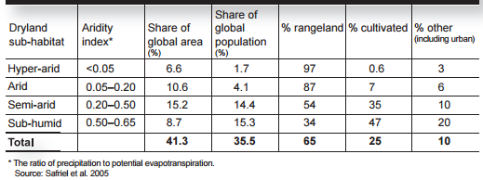
Table 2. Regional extent of drylands
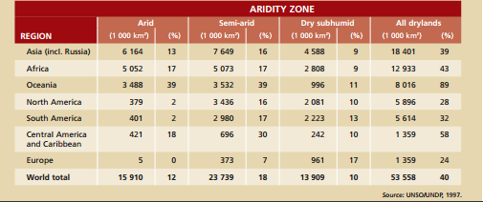
Table 3. Human population of the world's dryland areas
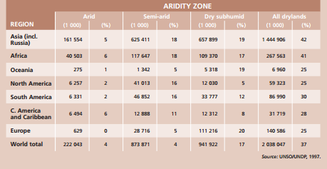
Drylands limitations
There are countless limitations in the drylands area. Some of the limitations are listed below
- High variability in both rainfall amounts and intensities
- occurrence of prolonged periods of drought.
- Low soil organic content
- Low natural soil fertility
- High ET
- High temperature
- Serious water scarcity
In addition to the limitation above, the following are qualitative descriptions of the most pressing environmental concerns facing most dryland countries.
Water Shortage
- spatiotemporal variability of water
- Most of the time water is scarce
- Saline soil because of high irrigation practice
- many irrigated drylands depend on "fossil" groundwater left from earlier climate periods, or extract water from wells faster than it is recharged by rainfall.
Soil Loss
- vulnerable soil because f poor vegetation cover and recurrent drought
- overgrazing or land clearing for agriculture
- High winds and dust storms
Endangered Species
- Overexploitation of limited animal and plant populations
- Habitats are fragile and easily damaged.
- competition with humans for water resources, and with domesticated animals for food supplies.
- Provision of little cover for animals to hide from hunters.
- Desert species can easily become rare, or even be lost all together.
Plant and tree cover
- the steady reduction in trees, grass and other vegetation.
Land Use and Land Tenure
- limited natural resources
- growing populations, encroachment of more sedentary communities, and new technologies are modifying and limiting nomadic land uses and migrations.
- High intensity of conflicts over land
- Conflict between farmers and herders is frequent.
Mining
- the disposal of mine wastes, tailings and processing wastes, erosion problems and the pollution of rivers in mined areas, loss of natural habitat or of land with agricultural potential, and the abandonment of unusable wastelands once the mining has ended.
Human Habitat
- Problem of housing and sanitation.
- High degree of pollution by animals and human wastes.
- High migration
- overcrowding and makeshift construction with consequent health problems.
- partial sewage treatment
Domestic Waste
- lack of safe disposal of domestic wastes, particularly human wastes and urban sewage.
- Poor sanitation and sanitation facilities
Radioactivity
- deserts areas are uses for testing nuclear weapons.
- Uranium mines also occur in some dryland areas, and can contaminate land and water courses.

Water harvesting in Ethiopia
The following water harvesting techniques are practiced in Ethiopia
- Rainwater harvesting
- Flood water harvesting
- Dry weather flow river diversion
- Groundwater harvesting
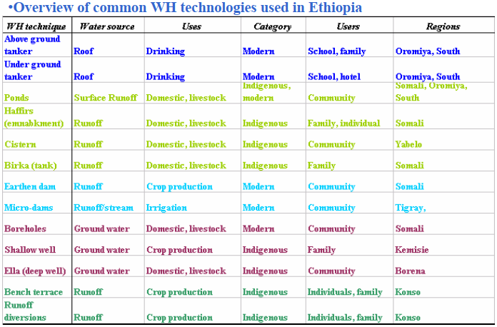

CONCEPTS AND SCOPE OF WATER HARVESTING

Principles and concepts of water harvesting
Principles of water harvesting
The principles presented below are important in water harvesting planning
A water harvesting should:
- Begin with long and thoughtful observation
- Start at the top (highpoint) of your watershed and work your way down.
- Start small and simple.
- Slow, spread, and infiltrate the flow of water.
- Always plan an overflow route, and manage that overflow as a resource.
- Maximize living and organic groundcover.
- Maximize beneficial relationships and efficiency by “stacking functions.”
- Continually reassess your system: the “feedback loop.”
Concepts of water harvesting
The term “water harvesting” was comprehensively defined as all the different techniques to collect runoff or flood water for storage in the soil profile or in tanks so that it can be used for the production of crops, trees or fodder and domestic consumption.
Water harvesting techniques in general are aimed at increasing agricultural production and improving agricultural productivity. Therefore, it provides an opportunity to stabilize agricultural production particularly in arid, semi-arid and semi-humid areas where water is a limiting factor. Silt, manure, and other organic matters can be “harvested” or kept in place together with the water. If the soil profile stays moist for longer time, microorganisms in the soil can be stimulated so that the formation of stable humus, the nutrient availability, and the water holding capacity of the soil can be improved.
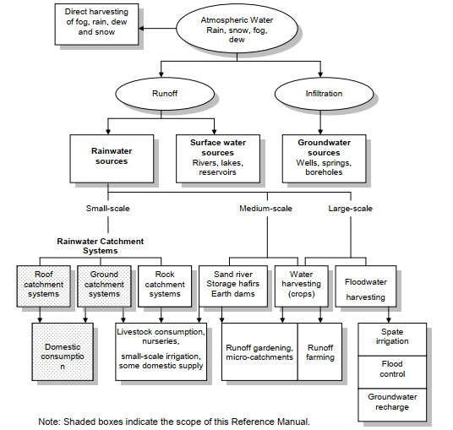
Water harvesting techniques are broadly classified as:
- Rain water harvesting
- Flood water harvesting
- Dry weather flow river diversion and
- Groundwater harvesting.
- Rainwater harvesting: It is a method of inducing, collecting, storing and conserving local surface runoff for agriculture in arid and semi-arid regions. Water can be collected from rooftops, courtyards and similar compacted or treated surfaces.
- Floodwater harvesting (Spate irrigation or large catchment water harvesting): the collection and storage of creek flow for irrigation use. This technique is subdivided in to (Floodwater harvesting within - the stream & Floodwater diversion)
- Dry weather flow river diversion: is commonly used where sustained base-flow is available in a river.
- Ground water harvesting: Some consists of a horizontal tunnel that taps underground water in an alluvial fan, brings it to the surface due to gravitational effect. A tunnel may have an inclination of 1-2% and a length of up to 30km. Some obstruct the flow of ephemeral streams in a river bed; the water is stored in the sediment below ground surface and can be used for aquifer recharge.

Benefits and Limitations of water harvesting
Benefits of water harvesting
  - Provide water at or near the point where water is needed or used, resulting in time savings for women who need to fetch water from other distant sources and eliminating the need for complex and costly distribution systems.
  - Complement other water sources and utility systems, thus relieving pressure on limited water supplies.
  - Provides a buffer for use in times of emergency or breakdown of the public water supply systems, particularly during natural disasters.
  - People have full control of their own catchment systems, which greatly improves household water security and water conservation, while at the same time reducing operation and maintenance problems.
  - Technology is based on traditional methods and relatively simple to construct, install and operate.
  - Flexible and can be built to meet almost any requirements. It is relatively easy to reconfigure, expand, or in some cases, relocate systems.
  - Local people can be trained to construct and install rainwater harvesting technologies, and construction materials are also readily available.
  - Rainwater is a free resource. While there are capital costs to construct and install a catchment system, households can save money over the long run since they don’t have to purchase water from private vendors or pay public utilities.
  - Operation and maintenance costs are also almost negligible.
  - The physical and chemical properties of rainwater are usually superior to sources of surface and groundwater that may have been subjected to contamination.
  - Water collected from roof catchments is generally of acceptable quality for domestic use and consumption.
  - Constructing a rainwater harvesting system in conjunction with household water treatment allows people to enjoy improved water supply and quality which are linked to better health.
  - Few negative environmental impacts compared to other water supply developments, such as dams and piped systems.
  - Rainwater harvesting for domestic use emphasizes small-scale, community-based, self-help development.
Limitations of water harvesting
- Aesthetically intrusive - you have to do something with big tanks
- May not meet local building code requirements for primary water source for new construction
- Requires more ground space than a well for the storage tanks and pumping system
- Requires a good sized roof
- Roof materials and airborne pollutants can pollute the rainwater
- Gutters require constant maintenance and cleaning
- Seasonal nature and uncertainty of rainwater supply depending on the region in the world.
- Capital costs required to construct and install a rainwater harvesting system may still be high for the end users.
- Potential breeding grounds for mosquitoes if storage tanks are not properly covered and maintained.
- Requires a "bottom up" rather than the traditional "top down" approach often used by government and international organizations in other water resource development projects.

Potentials of water harvesting for improved agricultural production
Do you think water harvesting improve agricultural production?
In arid and semi-arid regions of the world plant production is critically limited by:
- Low soil moisture availability
- Low nutrient availability
- Low infiltration rate
- High soil surface losses
- Overgrazing
- Deforestation
- High surface runoff cause by short period rainfall
Consequently,
- The soil loses its natural protection against rain drop impact and erosion
- Cause soil degradation
- Dwindling plant production to extend to larger areas.
- Threaten food production.
To avert this vicious circle rain water harvesting techniques have been proposed to increase water supply for crop production through runoff farming.
Concentration of rainfall as surface runoff from a large watershed or catchment (runoff area), into a smaller lower-lying runoff receiving (runon area), also referred to as cultivated area.
Water harvesting techniques for agricultural production
- Zai planting pit
- Terrace
- Dam
- Micro-basin
- Tied ridge
As a result of water harvesting system in agricultural areas,
- Plan available moisture increase
- Production of adequate and renewable supplies of food, fodder and firewood
- Reduce the claim on natural vegetation
- Mitigate soil degradation
- Contribute to more resilient plant production

Water harvesting in Ethiopia: Historical Perspective and Recent Development
What is historical & current development in water harvesting in Ethiopia?
Rainwater harvesting in Ethiopia has a long history that date back to pre-Axumit period (560 BC). During this period rainwater was harvested and stored in ponds and tanks for agriculture and water supply purposes. The remains of an ancient roof- water harvesting system is still visible in the oldest palaces in Axum. Other evidences include the remains of one of the old castles in Gondar, constructed in the 15 and16th century and Lalibela Rock hewn churches (over 800 years ago), including a pool that was used to store water used for religious rituals. Rainwater harvesting systems in monasteries like Mahbre Selassie in Gondar and Debrekerbe in Shoa can be mentioned as examples. In south of the country, the Konso people have had a long and well established tradition of building level terraces to harvest rainwater that is used to produce sorghum successfully under extremely harsh environment characterized by low, erratic and unreliable rainfall. In the Ogaden (Eastern Ethiopia), Brikas are used to store rainwater. People in North Omo (Gatto Valley), Eastern Hararghe, and other parts of the country have been practicing the art of conserving soil and water. The promotion and application of rainwater harvesting systems as an alternative to address water scarcity were started in Ethiopia through government initiatives of soil and water conservation programs in response to the 1971-74 droughts with the introduction of the Food-for–Work (FFW) program. The initial rainwater harvesting activities included construction of ponds, micro dams, bunds, and terraces in most parts of the drought affected areas. Recently a number of initiatives have been undertaken to investigate its potential in the drier areas at national level in all regions of the country.

COMPONENTS OF WATER HARVESTING TECHNIQUES
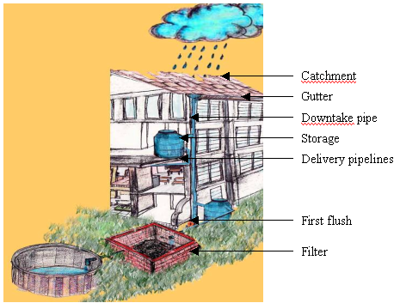
Water harvesting systems consist of four components:

Collection catchment
The catchment can be defined as:
- the area from which the water is collected.
- a natural or man-made unit draining runoff water to a common point.
- an area used to provide additional soil moisture in the form of runoff.
- Any area that is reasonably impermeable to water infiltration can be utilized as a catchment.
Catchment system can be categorized based on:
- Materials used for tank construction (e.g. Ferrocement, concrete, plastic)
- The purpose for which water is being collected (e.g. Domestic use, livestock, flood control).
- The type of surface used (e.g. Rooftop, ground surface, rock) surface.

Catchment characterization and rainfall-runoff analysis
Catchment characterization
The total amount of water that is received in the form of rainfall over an area is called the rainwater endowment of that area. Out of this, the amount that can be effectively harvested is called the water harvesting potential. the rainwater harvesting potential of a site can be influenced by:
- Climatic conditions
- The catchment characteristics
Rainfall-Runoff Analysis of water harvesting system
The surface runoff process
When rain falls, the first drops of water are intercepted by the leaves and stems of the vegetation usually referred to as interception storage. As the rain continues, water reaching the ground surface infiltrates into the soil until it reaches a stage where the rate of rainfall (intensity) exceeds the infiltration capacity of the soil. Thereafter, surface puddles, ditches, and other depressions are filled (depression storage), after which runoff is generated. The infiltration capacity of the soil depends on its texture and structure, as well as on the antecedent soil moisture content (previous rainfall or dry season). The initial capacity (of a dry soil) is high but, as the storm continues, it decreases until it reaches a steady value termed as final infiltration rate. The process of runoff generation continues as long as the rainfall intensity exceeds the actual infiltration capacity of the soil but it stops as soon as the rate of rainfall drops below the actual rate of infiltration.
The major factors which influence the rainfall­runoff process are described below.
- Rainfall characteristics (such as intensity, duration and distribution)
- site (or catchment) specific factors which have a direct bearing on the occurrence and volume of runoff (soil type,vegetation, slope, catchment size)
Runoff coefficients
The physical conditions of a catchment area are not homogenous. Even at the micro level there are a variety of different slopes, soil types, vegetation covers etc. Each catchment has therefore its own runoff response and will respond differently to different rainstorm events. The design of water harvesting schemes requires the knowledge of the quantity of runoff to be produced by rainstorms in a given catchment area. It is commonly assumed that the quantity (volume) of runoff is a proportion (percentage) of the rainfall depth.
Runoff [mm] = K x Rainfall depth [mm]
An analysis of the rainfall­runoff relationship and subsequently an assessment of relevant runoff coefficients should best be based on actual, simultaneous measurements of both rainfall and runoff in the project area.
The runoff coefficient from an individual rainstorm is defined as runoff divided by the corresponding rainfall both expressed as depth over catchment area (mm):
$$K=\frac{Runoff(mm)}{Rainfall(mm)}$$
When analysing the measured data it will be noted that a certain amount of rainfall is always required before any runoff occurs (threshold rainfall). This represents the initial losses due to interception and depression storage as well as to meet the initially high infiltration losses. The threshold rainfall depends on the physical characteristics of the area and varies from catchment to catchment. The fact that the threshold rainfall has first to be surpassed explains why not every rainstorm produces runoff. This is important to know when assessing the annual runoff­coefficient of a catchment area.

Mechanisms of Estimating surface runoff
Rational Method
The rational method is generally considered to be an approximate model for computing the flood peak resulting from a given rainfall, with the runoff coefficient accounting for all differences between the rainfall intensity and the flood peak. Such differences result from infiltration, temporary storage, and other losses.
The rational method equation is given below:
Q_{p} = 0.00278CIA; for T ≥T_{c}
Where:

Q_{p} - Peak flow (m³/s).
C - Dimensionless runoff coefficient
i - Rainfall intensity (mm/hr).
A - Catchment area (ha).
T – Rainfall duration (hr)
Tc- Time of concentration (hr)

The use of this method to compute Q_{p} requires three parameters: T_{c}, I and C
Time of Concentration (Tc): the time required for water to flow from the hydraulically most remote point of the drainage area to the outlet. The duration of rainfall is then set equal to the time of concentration and is used to estimate the design average rainfall intensity (I).
Time of concentration value needs to be entered in order to determine the intensity value to be used in the Rational Method equation. Kirpich (1940) developed an equation for computing Tc.
Tc = 0.000323L^{0.77} S^{-0.385}
Where:
Tc: time of concentration (hr)
L: Length of channel reach (m)
S: average slope of the channel reach
Runoff Coefficient
The runoff coefficient (C) is defined as the ratio of the runoff and rainfall. It is a dimensionless factor whose values are assigned on the basis of land use, topography and soil type.
Table2.1a: Values of C for use in rational formula (rural area)
S.N | Land use | Soil type
 |  | Sandy loam | Clay and silt loam | Tight clay
1 | Cultivated land
 | a) flat | 0.40 | 0.50 | 0.60
 | b) rolling | 0.40 | 0.60 | 0.70
 | c) hilly | 0.52 | 0.72 | 0.82
2 | Pasture range
 | a) flat | 0.10 | 0.30 | 0.40
 | b) rolling | 0.16 | 0.36 | 0.55
 | c) hilly | 0.22 | 0.42 | 0.60
3 | Forest land
 | a) flat | 0.10 | 0.30 | 0.40
 | b) rolling | 0.25 | 0.35 | 0.60
 | c) hilly | 0.30 | 0.50 | 0.60
4 | Populated area
 | a) flat | 0.40 | 0.55 | 0.65
 | b) rolling | 0.50 | 0.65 | 0.80
Another table for values of C recommended by the American Society of Civil Engineers (ASCE) and Water Pollution Control Federation is shown below.
Table2.1b: Values of C for use in rational formula (urban area)
Area Description | Runoff Coefficient C | Character of surface | Runoff Coefficient C
Business |  | Pavement
Downtown | 0.70-0.95 | Asphaltic and concrete | 0.70-0.95
Neighborhood | 0.50-0.70 | Brick | 0.70-0.85
Residential |  | Roofs | 0.75-0.95
Single-Family | 0.30-0.50 | Lawns, sandy soil
Multiunits, detached | 0.40-0.60 | Flat, 2 percent | 0.05-0.10
Multiunits, attached | 0.60-0.75 | Average, 2-7 percent | 0.10-0.15
Residential (suburban) | 0.25-0.40 | Steep, 7 percent | 0.15-0.20
Apartment | 0.50-0.70 | Lawns, heavy soil
Industrial |  | Flat, 2 percent | 0.13-0.17
Light | 0.50-0.80 | Average, 2-7 percent | 0.18-0.22
Heavy | 0.60-0.90 | Steep, 7 percent | 0.25-0.35
Parks, cemeteries | 0.10-0.25
Playgrounds | 0.20-0.35
Railroad yard | 0.20-0.35
Unimproved | 0.10-0.30
When a watershed has different features regarding its land use and soil types, the weighted value of runoff coefficient is calculated.

Example1:
The land use of the area and the corresponding runoff coefficients are as given below. Calculate the equivalent runoff coefficient?
Land use | Area (ha) | Runoff coefficient(C)
Roads | 8 | 0.7
Lawn | 17 | 0.10
Residential area | 50 | 0.30
Industrial area | 10 | 0.80
Solution:

Factors affecting the total volume and distribution in time of runoff
The runoff rate and its volume from an area, mainly influenced by following factors
- Rainfall characteristics
Type of precipitation: a precipitation which occurs in the form of rainfall, starts immediadly in form of surface flow over the land surface, while a precipitation which take place in form of snow or hails, the flow of water on ground surface will not take place immediately, but after melting of the same.
Rainfall intensity: if rainfall intensity greater than infiltration rate of the soil, the surface runoff takes place very shortly, while in case of low intensity rainfall, there is fund a reverse trend to the same. Thus, high intensities rainfall yield higher runoff. form of precipitation
Duration of rainfall: rainfall duration is directly related to the volume of runoff, due to the fact, that infiltration rate of the soil goes on decreasing with the duration of rainfall, till it attains a constant rate.
Rainfall distribution: Runoff from a watershed depends very much on the distribution of rainfall, the rainfall distribution for this propose can be expressed by the term of distribution coefficient, which my be defined as the ratio of max. rainfall at appoint to the mean rainfall of the watershed. The greater value of the distribution coeff., grater the peak runoff.
- Watershed characteristics
The different characteristics of watershed and channel, which affect the runoff, are listed below:
- Size of watershed
- Shape of watershed
- Slope of watershed
- Orientation of watershed
- Land use
- Soil moisture
- Soil type
- Topographic characteristic
- Drainage density

Diversion Channel
- concentrate and channel collected runoff from catchments to the storage facilities.
- transfer rainwater runoff from the rooftop or ground surface to the storage reservoir.
Diversion channel for Roof Catchments:
- Gutters
- Roof glides
- Surface drains or channels
Diversion channel for a surface catchment
- channel
- trench
- trap or filtering devise can be used to reduce the amount of silt or dirt that enters the tank.

Sediment Pond/ Site trap
The collected water is ultimately stored in some sort of reservoir, usually a tank. The storage tank usually represents the largest capital cost of a domestic rainwater harvesting system. Careful design and construction are essential to provide optimal storage capacity while keeping the cost as low as possible.
Key features of any storage tank are that it should be:
- Watertight
- Durable
- Affordable
- Designed to not contaminate the water in any way
Types of storage facilities includes:
- Natural sediment bodies
- Cisterns (surface & sub-surface)
- Open reservoirs (dam or retaining wall).
Storage facilities function as a buffer between the short rainfall and runoff events when natural water is provided and the long dry periods when water is required. Hence, their storage capacity has to meet the water demands during dry periods. When water harvesting is accompanied by farming, the storage devices often also act as the cropping area and the water is stored in the sediment column respectively, in the root zone of the crops. In areas where a sufficient sediment layer is lacking or prone to erosion, storage devices might be built to collect and conserve sediments. In those instances, the storage facilities are used to conserve both water and soil.

Storage Design and implementation of water harvesting systems; operation and maintenance of water harvesting and irrigation
For a rainwater system to provide a year-round supply of water, the following two conditions must be met:
1. Total water supply must be greater than the total demand.
2. There must be sufficient storage capacity to allow enough water collected in the wetter seasons to be carried over to meet the demand in the drier seasons. Usually, the main calculation when designing a rainwater catchment system will be to size the water tank correctly to give adequate storage capacity. Often the only variable that a designer can influence is the tank size since existing roofs are used as catchments and the amount of rainfall cannot be changed. When sizing the system, it is important to consider whether it is going to be used in conjunction with other water sources as a supplementary, partial or backup supply. For example, rainwater may only provide drinking water while other sources are used for cleaning, toilet flushing and washing. The water demand in these situations will be very different than if it is the primary source of water supply. If rainwater is intended to be the main or only source of water supply, then the reliability of the system becomes critically important.
As a general rule of thumb,
- It is appropriate to over design a rainwater catchment system to provide at least 20% more than the estimated demand.
- This safety margin is especially important if the rainwater system is the main or only source of water supply.
There are a number of different sizing methods which vary in complexity and sophistication. Some are readily carried out by relatively inexperienced first-time practitioners, while others require computer software and trained users who understand how to use the models.
Criteria for the selection of tank size estimation method
- Size and complexity of the rainwater catchment system.
- Availability of tools and data required for using a particular method (e.g. computers, historical rainfall data)
- Skill level required for using a particular method (e.g. computer training)
Several techniques are used to estimate water demand from storage tanks, including:
- Demand Side Approach (DSA)
- Supply Side Approach (SSA) (Computational Method & Graphical method)
- Computer Method (CM)
- Demand Side Approach (DSA)
The DSA is a very simple method used to calculate storage requirements based on consumption rates and building occupancy. It is applicable in high rainfall area It is a method for acquiring rough estimates of tank size.
SC=C*N*DP
Where,
SC=Storage capacity (m³)
C=Consumption per capita per day for drinking & cooking (m³/person/day)
N=Number of people per household
D=Dry period (day)
Example: Estimate the storage capacity of the household (X) with 6 persons when each household member require 30m³ of water per day for 5months dry period.
Solution
C=30m³
N=6 persons
DP=5months=150days
SC=?
Thus, SC=30*6*150=27,000m³
- Supply Side Approach (SSA)
In low rainfall areas or areas where the rainfall is of uneven distribution, more care has to be taken to properly estimate the size the storage tank required. There may be an excess of water at some times of year, while at other times there will be a deficit. So, if there is sufficient water throughout the year to meet demand, then sufficient storage will be required to bridge periods of scarcity.
- Graphical Method
Calculate the storage capacity from the rainfall data graphically as follows by comparing water harvested and the amount of harvested water that can be supplied.
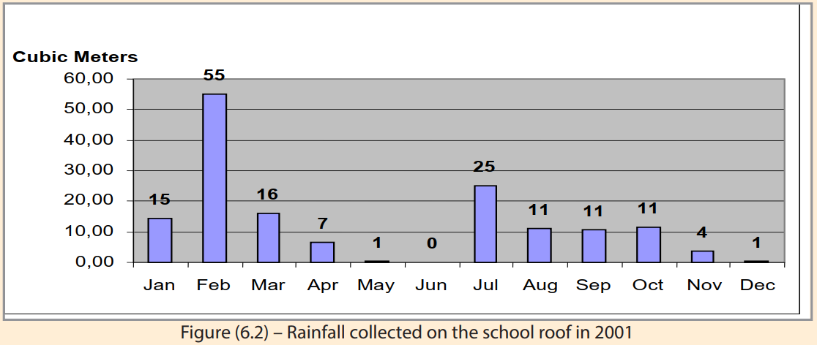
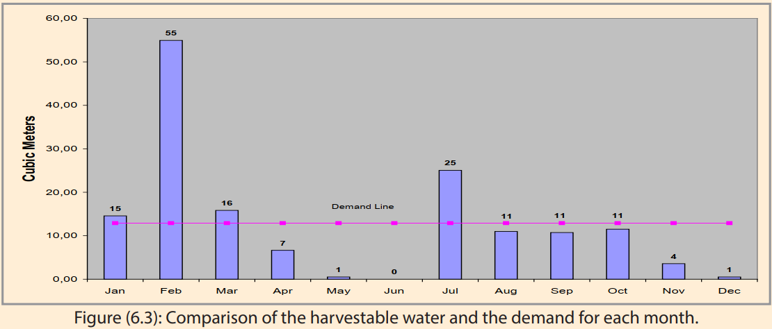
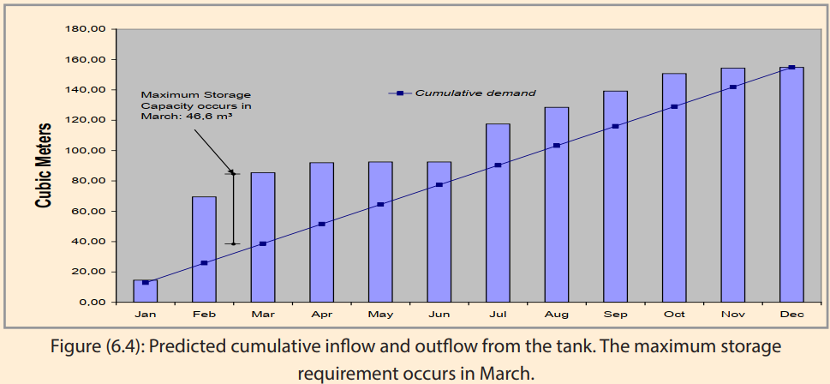
- Computer models (CM)
There are several computer-based programs that calculate tank size quite accurately.
- e.g. The Rainwater Tank Performance Calculator
- SimTanka
Implementation, operation and maintenance of water harvesting
Proper operation and maintenance of water harvesting infrastructure is an important part for the success of the system. It affects the efficiency, effectiveness and durability of the structures and ensures water is available and utilized as planned. Proper maintenance is an important aspect in the management of RWH systems and needs to include, among others, the following activities.
- Inspection, regular cleaning and minor repair of the whole RWH system: the catchment, the conveyance, the tank and the various tank components such as tap.
- Removal of branches of trees over hanging on roofs. Not only leaves and debris, but also the droppings of birds and small animals contaminate rainwater. Dust and other such dirt also need to be cleaned regularly from the catchment/roof.
- Cleaning and minor repair of the conveyance system (gutters and downpipes/gutters) at least once a year;
- Inspection of water quality in the tank, testing from time to time and treating/disinfecting regularly
- There should be no opening that allows small animals to enter into the storage structure; it is therefore necessary to inspect, clean and repair/replace screens and filters. Screens and filters unless cleaned regularly can themselves be a source of water contamination.
- Clean/wash-out accumulated sediment and sludge when necessary; take the opportunity to clean the tank when it is empty.
- There should be no tree growing within 10 m from the tank to protect the foundation from damage/crack by roots searching for moisture underneath.
- Dispose of safely runoff and/or ponding water around the tank as this may damage the tank or bring health risks.
- Inspect regularly the amount of water in the tank, and compare with demand and abstraction rates.
- Inspect and maintain/repair/replace water taps.

WATER HARVESTING TECHNIQUES
Commonly, water harvesting techniques are distinguished by the source of water they harvest and are classified as groundwater harvesting, runoff harvesting and floodwater harvesting.

Groundwater harvesting
These are some example of groundwater harvesting
- Water wells (artificial holes that reach the groundwater table)
- Hand dug shallow wells dug in beds of ephemeral streams (wadis)
- Channeling water from mountain streams to shallow aquifers in the lowlands
- Groundwater dams.
- Qanat (subsurface conduits or tunnels tapping an upslope aquifer whose gathering ground is naturally different from that of the area of usage).
- Khettara
- Galleria
- Felaj.

Runoff (rainwater) water harvesting
Rooftop (courtyard) harvesting
Roofs, plastered courtyards and squares (sometimes roads) are especially suitable for the collection of runoff as their surfaces are often almost impermeable and relatively clean or easily cleaned of sediments and litter. The collected runoff is usually conveyed by a gutter system to cisterns or reservoirs and used for animal and domestic consumption and the small-scale irrigation of gardens. As the catchment area of roofs and courtyards are rather limited these systems usually provided water of high purity suitable for individual households or administrative and religious buildings.
There are many examples of the application of rooftop harvesting in ancient times.
- The Minoan settlements in Crete
- Resafa, Syria (bottle-shaped cisterns).
The term runoff (rainwater) harvesting comprises the collection and storage of largely unconfined locally generated runoff from modified catchments. Runoff flowing in rills and minor channels is included in this definition. The collected runoff may be used for irrigation or domestic and animal consumption. Commonly two types of runoff harvesting are distinguished by the size of the harvested catchment:
- Micro-catchment
- Macro-catchment runoff harvesting.
- Micro-catchment runoff harvesting (insitu)
Main characteristics:
- Overland flow harvested from short catchment length
- Catchment length usually between 1 and 30 metres
- Runoff stored in soil profile
- Ratio catchment: cultivated area usually 1:1 to 3:1
- Normally no provision for overflow
- Plant growth is even
Typical Examples:
- Negarim Microcatchments (for trees)
- Contour Bunds (for trees)
- Contour Ridges (for crops)
- Semi­Circular Bunds (for range and fodder)
- Macro-catchment runoff harvesting (external or exsitu)
Main Characteristics:
- Overland flow or rill flow harvested
- Runoff stored in soil profile
- Catchment usually 30 ­ 200 metres in length
- Ratio catchment: cultivated area usually 2:1 to 10:1
- Provision for overflow of excess water
- Uneven plant growth unless land levelled
Typical Examples:
- Trapezoidal Bunds (for crops)
- Contour Stone Bunds (for crops)
- Hillside conduit systems
- Hafirs and Tabias (also called Limans)
- Aljibe systems channeled runoff from hillslope to fill cisterns.
- Multitude of rock carved conduit systems collected the runoff and channeled it to cisterns.

Flood water harvesting (Water Spreading/Spate Irrigation)
Floodwater harvesting (or spate irrigation) is a technique that collects and stores water from ephemeral streams during flood events.
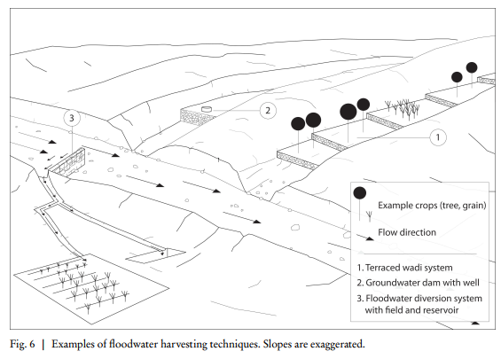
Main Characteristics:
- Turbulent channel flow harvested either (a) by diversion or (b) by spreading within channel bed/valley floor
- Runoff stored in soil profile
- Catchment long (may be several kilometres)
- Ratio catchment: cultivated area above 10:1
- Provision for overflow of excess water
Typical Examples:
- Permeable Rock Dams (for crops)
- Water Spreading Bunds (for crops)
Two techniques of flood water harvesting are usually distinguished:
- Floodwater harvesting within stream (wadi) beds
- Floodwater diversion (off wadi harvesting).
    - Stream (Wadi) bed floodwater harvesting
Structures are built across wadi beds to partially or completely dam flood water and to store it either in surface reservoirs or in channel sediments. These structures might be walls built of masonry or earthen embankments. A widespread type of this technique is called terraced wadi system. These systems are commonly built for agricultural purposes. Terraced wadi systems consist of a series of small dams (check dams) that intersect parts of a wadi course. The check dams lower the runoff velocity of the floods and thereby their transport capacity. In consequence the transported sediments accumulate behind the dams and gradually build a terrace or sediment reservoir upstream. Excess water flows into the subsequent component of the system where the same process proceeds. After a few years (depending on the frequency and character of the flood events) when the volume of the accumulated sediment body is sufficient, the terraces might be cultivated. The subsequently occurring floods now percolate into the terrace bodies where the water is stored and provide crops with water. On occasion the check dams may be raised, thus enlarging the cropping area and the water storage capacity of the terraces. These systems are sometimes supplemented with hillside conduit systems.
Basically two types are distinguished:
- Sand storage dams and
- Subsurface dams.
    - Floodwater diversion systems
Floodwater diversion systems are built to deflect floods from a wadi channel to convey the water to adjacent storage devices or fields. This is either accomplished by damming parts of the wadi or blocking the entire channel. The retaining structures are called diversion dams.
Uses
- Irrigate fields
- Animal consumption
- Human water consumption.
Blocking the channel along its entire width might be necessary if the fields or storage devices are located considerably higher than the adjacent wadi channel floor. Thereby the water level of a flood can be raised to the appropriate height.
Examples
- The Great Dam in Ma’rib, Yemen.
- Resafa & the Harbaqa dam in Syria
- The dam and pond system in Jawa, Jordan
- Diversion systems in the runoff farms of the Negev, in Oman
- The Boqueras and Acequiade cañon systems in southeast Spain.

WATER BALANCE AND DEMAND ANALYSIS

5.1. The Concept of Water Balance
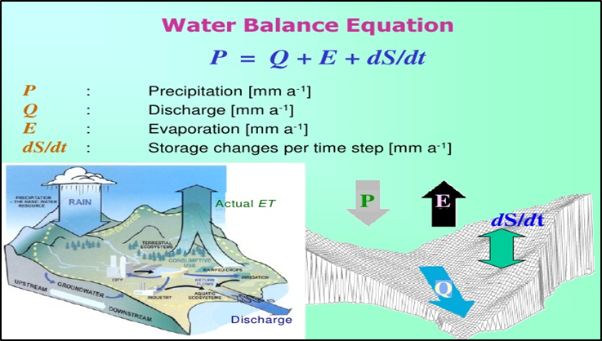

5.2. Water demand estimation for Livestock production and Domestic use
Water demand estimation for domestic uses
Residents in developed countries use significantly more water on a daily basis than those living in developing countries. Per capita domestic water consumption in North America (about 350 litres per day) and Europe (about 200 litres per day) are high compared to 50-150 litres per day in developing countries in Asia, Africa and Latin America. In regions with insufficient water resources, this figure may be as low as 20-60 litres per day (Environment Canada, n.d.; UNESCO, 2000).
Domestic water demand includes all water used by the household for the following
Essential purposes:
- Drinking
- Food preparation and cooking
- Washing dishes
- Personal hygiene (e.g. hand washing, bathing, brushing teeth)
- Toilet flushing
- Washing clothes
- Cleaning (e.g. floors, bathroom)
Other non-essential domestic uses for water include:
- Watering gardens (e.g. trees, flowers, vegetables)
- Water for animals (e.g. pets, chickens, small livestock)
- Washing vehicles
- Water for construction (e.g. repairing mud walls)
- Recreational uses
- Income generating activities (e.g. food sales, beer making)
A survey should be the starting point to estimate the household water demand.
Factors that affect domestic water consumption include:
- Number of adults and children (i.e. adults use more water than children)
- Family members staying at home (i.e. absentee members working or studying away from home for part of the year)
- Time of year (i.e. more water is used during the hottest and driest seasons)
Households located in regions with low and very seasonal precipitation may require large storage tanks which can be expensive to build. In these situations, it is worth investigating ways to reduce the storage capacity by modifying the household water demand according to the time of year.

5.3. Water demand estimation for irrigation

Irrigation Water Requirements of Crop
Irrigation requirement (IR) of a crop refers to the amount of water needed to apply as irrigation to supplement the water received through rainfall, stored soil moisture and from ground water in meeting the water needs of the crop for optimum growth and yield. Irrigation water requirement may be classified in to gross and net irrigation requirements.
Gross Irrigation Requirement
Gross irrigation requirement (GIR) of a crop denotes the amount of water applied to the crop from the beginning of land preparation to the harvest of the crop for its optimum growth and yield. It includes the losses that may occur in conveyance of water through distributaries and field channels and during application of water to the crop.
Where:
Gross irrigation Requirement (mm)
Water requirement of crops (mm)
Effective Rainfall (mm)
Soil water contribution for crop use (mm) (SW at sowing – SW at harvesting)
Ground water contribution (mm) (shallow soils)
Effective rainfall can be defined as the rainfall that is stored in the root zone and can be utilized by crops. All the rainfall that falls is not useful or effective. As the total amount of rainfall varies, so does the amount of useful or effective rainfall. Some of the seasonal rainfall that falls will be lost as unnecessary deep percolation; surface runoff and some water may remain in the soil after the crop is harvested. From the water requirement of crops point of view, this water, which is lost, is ineffective.

5.3.1. Factors influencing crop water requirements
The term crop water requirement is defined as the "amount of water required to compensate the Evapo-transpiration loss from the cropped field"
Evaporation: is the process whereby liquid water is converted to water vapour (vaporization) and removed from the evaporating surface (vapour removal).
Energy: is required to change the state of the molecules of water from liquid to vapour.
Transpiration: consists of the vaporization of liquid water contained in plant tissues and the vapour removal to the atmosphere.
The main factors affecting evapotranspiration (ET) are climatic parameters, crop characteristics, management practices and environmental aspects. Factors such as soil salinity, poor land fertility, limited use of fertilizers and chemicals, lack of pest and disease control, poor soil management and limited water availability at the root zone may limit the crop development and reduce evapotranspiration. Other factors that affect evapotranspiration are groundcover and plant density. Cultivation practices and the type of irrigation system used can alter the microclimate, affect the crop characteristics or affect the wetting of the soil and crop surface. All these affect evapotranspiration.
Climatic Factors
The principal weather parameters affecting evapotranspiration are radiation, air temperature, humidity and wind speed. Several procedures have been developed to assess the evaporation rate from these parameters. The evaporation power of the atmosphere is expressed by the reference crop evapotranspiration (ET_{o}). The reference crop evapotranspiration represents the evapotranspiration from a standardized vegetated surface.
Crop Type
The crop type, variety and development stage should be considered when assessing the evapotranspiration from crops grown in large, well-managed fields. Differences in resistance to transpiration, crop height, crop roughness, reflection, ground cover and crop rooting characteristics result in different ET levels in different types of crops under identical environmental conditions. Crop evapotranspiration under standard conditions (ET_{c}) refers to the evaporating demand from crops that are grown in large fields under optimum soil water, excellent management and environmental conditions, and achieve full production under the given climatic conditions.

5.3.2. Calculation of crop water requirements (Indicative Values of ETo, Pan Evaporation Method, Blaney Criddle Method, FAO Penman-Monteith Equation)
Crop water requirements (CWR) encompass the total amount of water used in evapotranspiration. FAO (1984) defined crop water requirements as ‘the depth of water needed to meet the water loss through evapotranspiration of a crop, being disease-free, growing in large fields under non restricting soil conditions, including soil water and fertility, and achieving full production potential under the given growing environment’. A crop water requirement (CWR) is equal to crop evapotranspiration ET_{c}. Different approaches are used for determining ET_{crop}. These are Direct and indirect measurement techniques. Direct measurement techniques include field water balance method, depth interval method, lysimeter etc. Indirect measurement techniques include empirical formulae using climatologically data.
Reference crop evapotranspiration (ETo) or potential evapotranspiration (PET) is the rate of evapotranspiraion from a large area covered by green grass which grows actively, completely shading the ground and which is not short of water. The reference surface is a hypothetical grass reference crop with specific characteristics.The rate of water which evapotranspirates depends on the climate. The highest value of ETo is found in areas which are hot, dry, windy and sunny whereas the lowest values are observed in areas where it is cool, humid and cloudy with little or no wind. It is expressed as a mean value in mm per day over a period of 10-30 days.
The only factors affecting ETo are climatic parameters. As a result, ETo is a climatic parameter and can be computed from weather data. ETo expresses the evaporative demand of the atmosphere at a specific location and time of the year and does not consider crop and soil factors.
- Direct methods
Pan Evaporimeter
Pan Evaporation method is still widely used in some parts of East and Southern Africa. This is mainly because the method is very practical and simple, which appeals to many farmers and practitioners. For this, a description of the method is given below.
The evaporation rate from pans filled with water can be easily determined. In the absence of rainfall, the amount of water evaporated during a given period corresponds to the decrease in water depth in the pan during the given period. Pans provide a measurement of the combined effect of radiation, wind, temperature and humidity on an open water surface. The pan responds in a similar manner to the same climatic factors affecting crop transpiration. However, several factors produce differences in the loss of water from a water surface and from a cropped surface.
Despite the difference between pan evaporation and reference crop Evapo-transpiration, the use of pans to predict ETo for periods of 10 days or longer is still practiced. The measured evaporation from a pan (Epan) is related to the reference Evapo-transpiration (ETo) through an empirically derived pan coefficient (Kp) as given in the following equation
ET_{o} = K_{p} x E_{pan}

Where:
ET_{o} = Reference crop evapotranspiration (mm/day)
K_{p} = Pan coefficient
E_{pan} = Pan evaporation (mm/day)
- Indirect methods
Empirical Formulae
The reference Evapo-transpiration, ET_{o}, is a climatic parameter expressing the evaporating power of the atmosphere when water is abundantly available. This concept was introduced to know the evaporative demand of the atmosphere independent of crop type, crop development and management practices. Therefore, the only factors affecting ET_{o} are climatic parameters and can be computed from weather data.
The FAO Penman-Monteith method is recommended as the sole model for determining ETo. Now a day ETo could be easily obtained from windows based computer using CropWat. The FAO Penman-Montieth equation requires air temperature, relative humidity, wind speed and sunshine hours.
Crop coefficient (K_{c}) reflects the effect of crop on crop water requirement (CWR). The changing characteristics of the crop over the growing season affect the Kc-values. The quantity of water used at different growth stages of a growing crop is related to some standard (reference) ET. The ratio of actual crop ET at specified time to the reference crop ET at the same time is known as crop coefficient, Kc. The values vary with the crop, stage of growth, and growing season and the prevailing weather conditions. If ET_{crop} is known, Kc could be computed from the following relationship:
Where,
K_{c}-crop coefficient
ET_{c}-crop evapotranspiration
ET_{o}-Reference crop evapotranspiration
FAO Penman-Monteith method
The FAO Penman-Monteith method is now the sole recommended method for determining reference crop Evapo-transpiration (ETo). This method overcomes the shortcomings of all other previous empirical and semi-empirical methods and provides ETo values that are more consistent with actual crop water use data in all regions and climates. The method has been developed by unambiguously defining the reference surface as ‘a hypothetical reference crop with an assumed crop height of 0.12 m, a fixed surface resistance of 70 sec/m and an albedo of 0.23’ The surface resistance describes the resistance of vapour flow through the transpiring crop and evaporating soil surface. The reference surface closely resembles an extensive surface of green grass that is of uniform height, actively growing, completely shading the ground and adequately watered. The requirement that the grass surface should be both extensive and uniform results from the assumption that all fluxes are one-dimensional upwards. The reference crop Evapo-transpiration (ET_{o}) provides a standard to which:
- Evapotranspiration at different periods of the year or in other regions can be compared
- Evapotranspiration of other crops can be related through the use of crop coefficients
Penman-Monteith Equation
The Penman-Monteith Equation is given by the following equation

Where:

ETo = Reference evapotranspiration (mm/day)
Rn = Net radiation at the crop surface (MJ/m² per day)
G = Soil heat flux density (MJ/m² per day)
T = Mean daily air temperature at 2m height (°C)
U₂ = Wind speed at 2m height (m/sec)
e_{s} = Saturation vapour pressure (kPa)
e_{a} = Actual vapour pressure (kPa)
e_{s} - e_{a} = Saturation vapour pressure deficit KPa.

Table 1. Saturation vapor pressure of water
Temperature  (ºC) | Saturation vapor pressure e_{s} |  | Δ Slope of plot between  (1) and (2)
 | mmHg) | mbar
(1) | (2) | (3) | (4)
0.0 | 4.58 | 6.11 | 0.30
5.0 | 6.54 | 8.72 | 0.45
7.5 | 7.78 | 10.37 | 0.54
10.0 | 9.21 | 12.28 | 0.60
12.5 | 10.87 | 14.49 | 0.71
15.0 | 12.79 | 17.05 | 0.80
17.5 | 15.00 | 20.00 | 0.95
20.0 | 17.54 | 23.38 | 1.05
22.5 | 20.44 | 27.95 | 1.24
25.0 | 23.76 | 31.67 | 1.40
27.5 | 27.54 | 36.71 | 1.61
30.0 | 31.81 | 42.42 | 1.85
32.5 | 36.68 | 48.89 | 2.07
35.0 | 42.81 | 57.07 | 2.35
37.5 | 48.36 | 64.46 | 2.62
40.0 | 55.32 | 73.14 | 2.95
42.5 | 62.18 | 84.23 | 3.25
45.0 | 71.20 | 94.91 | 3.66
Table 2. Mean daily maximum duration of bright sunshine hour N for different month and latitudes
N Lat  S Lat | Jan  July | Feb  Aug | March  Sept | April  Oct | May  Nov | June  Dec | July  Jan | Aug  Feb | Sept  March | Oct  April | Nov  May | Dec  June
50 | 8.5 | 10.1 | 11.8 | 13.6 | 15.4 | 16.3 | 15.9 | 14.5 | 12.7 | 10.8 | 9.1 | 8.1
48 | 8.8 | 10.2 | 11.8 | 13.8 | 15.2 | 16.0 | 15.6 | 14.3 | 12.6 | 10.9 | 9.3 | 8.3
46 | 9.1 | 10.4 | 11.9 | 13.5 | 14.9 | 15.7 | 15.4 | 14.2 | 12.6 | 10.9 | 9.5 | 8.7
44 | 9.3 | 10.5 | 11.9 | 13.4 | 14.7 | 15.4 | 15.2 | 14.0 | 12.6 | 11.0 | 9.7 | 8.9
42 | 9.4 | 10.6 | 11.9 | 13.4 | 14.6 | 15.2 | 14.9 | 13.9 | 12.9 | 11.1 | 9.8 | 9.1
40 | 9.6 | 10.7 | 11.9 | 13.3 | 14.4 | 15.0 | 14.7 | 13.7 | 12.5 | 11.2 | 10.0 | 9.3
35 | 10.1 | 11.0 | 11.9 | 13.1 | 14.0 | 14.5 | 14.3 | 13.5 | 12.4 | 11.3 | 10.3 | 9.8
30 | 10.4 | 11.1 | 12.0 | 12.9 | 13.6 | 14.0 | 13.9 | 13.2 | 12.4 | 11.5 | 10.6 | 10.2
25 | 10.7 | 11.3 | 12.0 | 12.7 | 13.3 | 13.7 | 13.5 | 13.0 | 12.3 | 11.6 | 10.9 | 10.6
20 | 10.0 | 11.5 | 12.0 | 12.6 | 13.1 | 13.3 | 13.2 | 12.8 | 12.3 | 11.7 | 11.2 | 10.9
15 | 11.3 | 11.6 | 12.0 | 12.5 | 12.8 | 13.0 | 12.9 | 12.6 | 12.2 | 11.8 | 11.4 | 11.2
10 | 11.6 | 11.8 | 12.0 | 12.3 | 12.6 | 12.7 | 12.6 | 12.4 | 12.1 | 11.8 | 11.6 | 11.5
5 | 11.8 | 11.9 | 12.0 | 12.2 | 12.3 | 12.4 | 12.3 | 12.3 | 12.1 | 12.0 | 11.9 | 11.8
0 | 12.1 | 12.1 | 12.1 | 12.1 | 12.1 | 12.1 | 12.1 | 12.1 | 12.1 | 12.1 | 12.1 | 12.1

Table 3. Psychrometric constant (γ) for different altitudes (z) (Source: FAO, 1998a)
Z(m) | Γ | Z(m) | Γ | Z(m) | γ | Z(m) | γ
0 | 0.067 | 1000 | 0.060 | 2000 | 0.053 | 3000 | 0.047
100 | 0.067 | 1100 | 0.059 | 2100 | 0.052 | 3100 | 0.046
200 | 0.066 | 1200 | 0.058 | 2200 | 0.052 | 3200 | 0.046
300 | 0.065 | 1300 | 0.058 | 2300 | 0.051 | 3300 | 0.045
400 | 0.064 | 1400 | 0.057 | 2400 | 0.051 | 3400 | 0.045
500 | 0.064 | 1500 | 0.056 | 2500 | 0.050 | 3500 | 0.044
600 | 0.063 | 1600 | 0.056 | 2600 | 0.049 | 3600 | 0.043
700 | 0.062 | 1700 | 0.055 | 2700 | 0.049 | 3700 | 0.043
800 | 0.061 | 1800 | 0.054 | 2800 | 0.048 | 3800 | 0.042
900 | 0.061 | 1900 | 0.054 | 2900 | 0.047 | 3900 | 0.042
1000 | 0.060 | 2000 | 0.053 | 3000 | 0.047 | 4000 | 0.041
z (m) γ (kPa/°C)
Table 4. Mean Monthly Solar Radiation Incident on Earth's Outer Space (Extra Terrestrial Radiation) Ra in mm of Evaporable Water per day.
North Latitude in Degrees
Month | 0º | 10⁰ | 20⁰ | 30⁰ | 40⁰ | 50⁰ | 60º | 70º | 80⁰ | 90º
Jan. | 14.5 | 12.8 | 10.8 | 8.5 | 6.0 | 3.6 | 1.3 | - | - | -
Feb. | 15.0 | 13.9 | 12.3 | 10.5 | 8.3 | 5.9 | 3.5 | 1.1 | - | -
Mar. | 15.2 | 14.8 | 13.9 | 12.7 | 11.0 | 9.1 | 6.8 | 4.3 | 1.8 | -
Apr. | 14.7 | 15.2 | 15.2 | 14.8 | 13.9 | 12.7 | 11.1 | 9.1 | 7.8 | 7.9
May | 13.9 | 15.0 | 15.7 | 16.0 | 15.9 | 15.4 | 14.6 | 13.6 | 14.6 | 14.9
Jun. | 13.4 | 14.8 | 15.8 | 16.5 | 16.7 | 16.7 | 16.5 | 17.0 | 17.8 | 18.1
Jul. | 13.5 | 14.8 | 15.7 | 16.2 | 16.3 | 16.1 | 15.7 | 15.8 | 16.5 | 16.8
Aug. | 14.2 | 15.0 | 15.3 | 15.3 | 14.8 | 13.9 | 12.7 | 11.4 | 10.6 | 11.2
Sep. | 14.9 | 14.9 | 14.4 | 13.5 | 12.2 | 10.5 | 8.5 | 6.8 | 4.0 | 2.6
Oct. | 15.0 | 14.1 | 12.9 | 11.3 | 9.3 | 7.1 | 4.7 | 2.4 | 0.2 | -
Nov. | 14.6 | 13.1 | 11.2 | 9.1 | 6.7 | 4.3 | 1.9 | 0.1 | - | -
Dec. | 14.3 | 12.4 | 10.3 | 7.9 | 5.5 | 3.0 | 0.9 | - | - | -
Where Ha is the extraterrestrial solar radiation received on a horizontal surface in mm of evaporable water per day (whose value for different latitudes are given in Table 3), φ the latitude of the place where ETo is to be computed, n is the actual duration of bright sunshine which is a function of latitude and is an observed data at a place, N is the maximum possible hours of bright sunshine available at different location, σ is the Stefan-Boltzman constant = 2.01 x 10⁻⁹ mm/day, T_{a} is the mean air temperature in ºK = (273 + ⁰C) and e_{a} is the actual vapor pressure in mm of Hg.

5.4. Inflow and outflow analysis and Dimensioning Water Harvesting Techniques
Inflow and outflow analysis of water harvesting techniques
Inflow into the water harvesting catchment
Outflow from the water harvesting catchment
Dimensioning water harvesting techniques (design of water harvesting techniques)

SOCIO-ECONOMIC FACTORS AFFECTING WATER HARVESTING

6.1. People’s experience and priorities with water harvesting techniques
If the objective of rainwater harvesting projects is to assist resource-poor farmers to improve their production systems, it is important that the farmer's or agro-pastoralist’s priorities are being fulfilled, at least in part. Otherwise success is unlikely. If the local priority is drinking water supply, for example, the response to water harvesting systems for crop production will be poor.

6.2. Equality and gender issues
If water harvesting is intended to improve the lot of farmers in the poorer, drier areas, it is important to consider the possible effects on gender and equity. In other words, will the introduction of water harvesting be particularly advantageous to one group of people, and exclude others? Perhaps water harvesting will give undue help to one sex, or to the relatively richer landowners in some situations. These are points a projects should bear in mind during the design stage. There is little point in providing assistance which only benefits the relatively wealthier groups.

6.3. People’s participation
It is becoming more widely accepted that unless people are actively involved in the development projects which are aimed to help them, the projects are doomed to failure. It is important that the beneficiaries participate in every stage of the project. When the project is being planned, the people should be consulted, and their priorities and needs assessed. During the construction phase the people again should be involved -supplying labour but also helping with field layouts after being trained with simple surveying instruments. Throughout the course of the season it is helpful to involve people in monitoring, such as rainfall and runoff and recording tree mortality. A further participatory role is in maintenance, which should not be supported by incentives. After the first season it is the farmers themselves who will often have the best ideas of modifications that could be made to the systems. In this way they are involved in evaluation, and in the evolution of the water harvesting systems.
- Structure of Participation
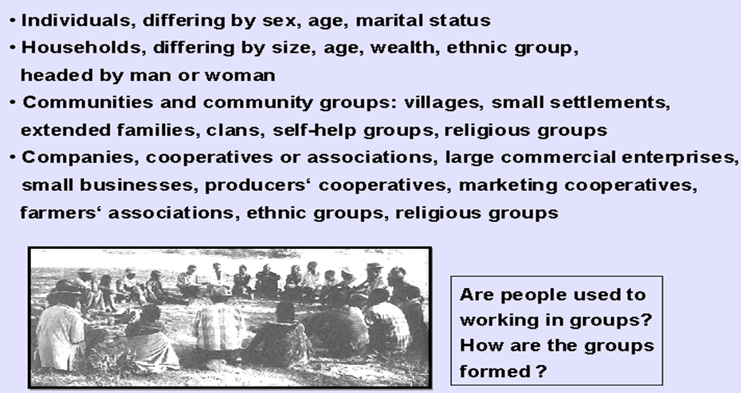

6.4. Adoption and Adaptation
Widespread adoption of water harvesting techniques by the local population is the only way that significant areas of land can be treated at a reasonable cost on a sustainable basis. It is therefore important that the systems proposed are simple enough for the people to implement and to maintain. To encourage adoption, apart from incentives in the form of tools for example, there is a need for motivational campaigns, demonstrations, training and extension work.

PLANNING WATER HARVESTING SCHEMES

7.1. Factors involved in planning schemes
Project planning must take into account the following factors:
- People-centred approach
- Socio-economic
- Cultural
- Institutional
- Gender issues
- People’s perceptions
- Preferences & abilities

7.2. System selection in water harvesting
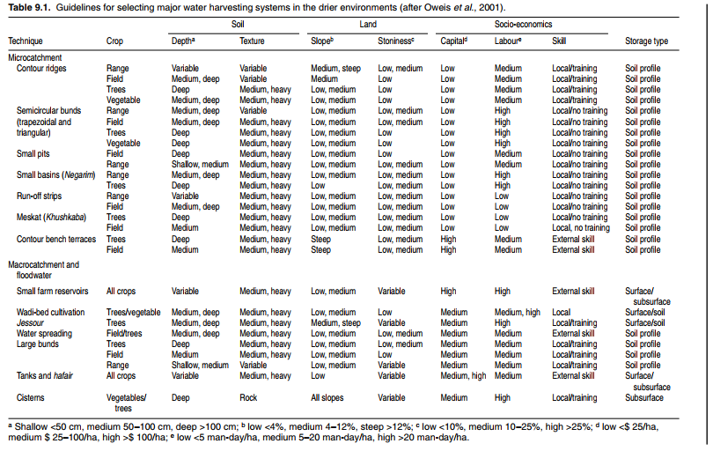
How to select water harvesting system?

MANAGING WATER HARVESTING PROJECTS

Suitable Management approaches
What are management approaches for water harvesting projects?
What are the suitable management approaches for water harvesting projects?
Once a rainwater harvesting system is planned and designed properly, and built with good
construction material and workmanship, it is ready to provide the services expected and aimed at
meeting the objectives set for it in a sustainable manner. This however requires certain arrangement in terms of putting in place a management system/mechanism that is capable of ensuring the proper operation, maintenance and repair of the RWH system. This is necessary not only for RWH systems, but for any development work and infrastructure. Whenever possible, the management of RWH systems is done by the users themselves, unlike design and construction which in many cases are initiated and implemented by qualified professionals. The users of RWH systems could be individual households, institutions such as schools, or communities for whom the RWH systems are built for communal use. In case where a household individually owns and uses a RWH system, the management is straight forward; the household itself assumes the direct individual responsibility. In cases where a system is owned by an institution, usually a work unit that provides general services or a person/committee is entrusted with the task. In RWH systems that are built for communal use by a community, a water users committee is elected for the management with a trained technician/tap attendant assigned for the day to day work. The communal management of RWH systems is generally more difficult and complicated owing to the communal nature of ownership. It is therefore important that bylaws are developed for such systems with clear guidelines for their management. It would also be useful if the management have links with organizations that are capable and willing to extend support in situations where external assistance needed. The guidelines/bylaws to be prepared for the management of RWH systems need to lay out clear duties and responsibilities in respect of the following items.
- The management arrangement/system and responsibilities
- Physical safety and protection of the RWH system
- Maintenance and control of water quality
- Regulation of water abstraction rates, time and appropriate use
- Operation, maintenance and repair of the system; and
- Allocation/collection of water fees/budget for operation maintenance and repair; and the management of finance and other properties.
Water storage systems operate at a larger scale than runoff farming systems, often on a watershed scale, and thereby necessitate addressing issues like ownership, local institutions and land tenure. They require relatively high capital and labor investments (often too high for individual households) and are relatively complicated systems to design. Service-giving institutions, generally, have very little capacity to disseminate and assist in design of storage water harvesting systems. As with any other technology, it is vital when planning and implementation of rainwater harvesting systems is viewed holistically beyond the technical issues. It is necessary to consider the broader aspects in terms of economic environmental, health and social factors. A key factor in project success is community involvement at every stage from inception to long-term maintenance and operation. Involvement in planning and construction phases will not only help to build skills and a sense of self reliance within communities but also prepare the community better for any future maintenance or repair work.

Management tools
What are the tools for managing water harvesting projects?

Monitoring water harvesting projects
What are monitoring mechanisms for water harvesting projects?

Monitoring, evaluation and reporting
Monitoring, evaluation and reporting are often weak spots in water harvesting projects. Too many projects fail to collect data at even the most basic level. For example crop yields and tree heights are often just estimated. It is also very rare to find any information on the frequency or depth of water harvested. Without a basic monitoring system, projects are starving themselves of data for evaluation. Without clearly written reports, widely circulated, projects are denying to provide others with important information.
Table. Suggested Monitoring Format for Water Harvesting Projects
1. HYDROLOGICAL DATA
 | - rainfall (standard gauges at important sites)
 | - runoff (at least visual recordings of occurrence)
2. INPUTS
 | - labour/machinery hours for | (a) construction
 |  | (b) maintenance
 |  | (c) standard agricultural operations
3. COSTS
 | - labour/machinery use in | (a) construction
 |  | (b) maintenance
 |  | (c) standard agricultural operations
4. OUTPUTS
 | - crops: yields of treated plots compared with controls
 | - trees: survival and growth rates
 | - grass/fodder: dry matter of treated plots compared with controls
5. ACHIEVEMENTS
 | - area (hectares) covered each season
 | - number farmers/villagers involved/benefitting
6. INCENTIVES/SUPPORT
 | - quantity and costs
7. TRAINING
 | - number of training sessions
 | - attendance/number of trained personnel
8. EXTENSION
 | - number of farmers visited
 | - number of field days and attendance
Note: SUMMARY SHEETS of data are very useful. These could include:
- labour/ha
- cost/ha
- average yield increases over controls
- total land treated and people benefitting

SMALL EARTH DAMS AND FARM PONDS

Small earth dam
There are nearly 50,000 dams in the world with heights above 15 m – defined as large dams – and more than 16 million small dams built for farm ponds and other tiny impoundments. These dams can retain about 8,000km3 of water, which represents >18% of the annual global runoff (C. Nilsson, 2013). A dam is a structure or barrier constructed across a valley, river or stream to conserve, store or to control the flow of water. The water may be used for drinking water supplies, hydroelectric power generation, irrigation, or environmental conservation. Small earth dam is one whose embankment is basically constructed using compacted earth. A small earth dam has a crest height ranging 2 to 5 m from high, while the reservoir capacity is at least 5,000 m3 but less than 1 million m3 storage volume. They can be designed by local technicians, built and managed/maintained by user communities. The dams can be of uniform material, or have clay core for better seepage control. They also have spillways to protect them from overtopping excess runoff flows. Small earth dams are usually constructed for rainwater harvesting or on small rivers to retain flood runoff during the rainy season, on a watercourse which may be a perennial river or a dry riverbed. The dam wall has a clay core, while the outlet has a stone apron and spillway to discharge excess runoff. Sediment traps and delivery wells may help to improve water quality but, as with water from earthen dams, it is usually not suitable for drinking without being subject to treatment. Small earth dams can provide adequate water for irrigation projects as well as for livestock watering.
Uses of small earth dam
- Irrigation
- Water supply
- Water diversion
- Stabilize water flow
- Hydropower generation
- Land reclamation
- Flood prevention
- Recreation & aesthetic
Types of earth dam
- Earth fill dam
- Rock fill dam
- Regulation dam
- Dry dam
- Silt trap dam
- Valley dam
- Hillside dam
- Hafir dam
- Gully dam
Water-harvesting-and-storage-in-Valleys-using-Earth-Dams.pdf

Farm ponds
What is farm pond?
The construction of dugout pond consists of digging of a truncated reverse-pyramid shaped pit with 1:1 side slopes. The depth has to be restricted to 1-1.5m to avoid upward movement of bottom soil due to buoyant force of water. At the locations where stones are available near the site, the depth of pond may be increased to 2 m by doing the stone pitching all around the surface of the pond. A single piece LDPE sheet (0.25 mm thick) of required size is placed with properly folded corners and buried ends on all sides. Before placing the sheet, the inner surfaces of the pond were plastered with 5cm thick mud plaster so that the sheet is properly stuck to the surfaces. Another 10 cm layer of mud mixture of soil and wheat straw or chopped dry pine needles (4:1) is placed on the sides, and a 15cm thick layer is placed at the bottom. In case of harvesting the surface runoff, a small silt retention trench of 1x 0.5 x 0.5 m size is dug at the entry point to the main pond so that debris and suspended particles along with overland runoff could settle down and relatively clean runoff water may enter the main pond. The silt retention trench is not required while harvesting the runoff through rooftops or water-springs. Evaporation losses from the pond can be minimized by spreading a small quantity of burnt engine oil or by broadcasting polyethylene granules of about 3 mm size on water surface. Being relatively free from dust or foreign materials, the runoff from roof-tops and the flows from water-springs can be stored in closed brick-cemented tanks for drinking, domestic uses and cattle feeding after proper treatment or filtration.
Farm ponds can meet the objectives such as:
- harvest rainwater,
- recharging of wells,
- increase moisture content in the field and
- ensuring the availability of drinking water for Livestock.
- ensure life-saving irrigation, In the absence of monsoon rain, water from the farm pond could be used to save the crop.
- maintain micro humid conditions during the dry spells,
- replenishes groundwater
- make water available for human consumption as well as for livestock.
- provide opportunity for undertaking orchards & agro –forestry and the sprinkler system can be easily run with farm pond water.
- provide critical irrigation facility to the crops during the terminal drought phase.
- checks soil erosion and retains silt
- prevents excess runoff

