Bonga University
College of Agriculture and natural Resources
Department of Animal Science
Vet. Parasitology
1. Introduction
1.1. Definition:
Parasitology – study of parasites & parasitism or it is the study of parasites, their hosts, and the relationship between them. Parasite is an organism that lives in or on another and takes its nourishment from that other organisms or host. It is moved into phytoparasitology and zooparasitology.
Zooparasitology is the subject of our study which can be divided in to veterinary, medical and agronomical Parasitology. The veterinary Parasitology deals with the helminthes, arthropods and protozoa that are parasites of animals.
Veterinary Parasitology focuses on
  - The diagnosis, treatment and control those parasites that inflict disease and economic loss on food producing animals, companion animals, laboratory animals, zoo animals and indigenous free – ranging wildlife species.
1.2. Relationship of organisms
Symbiosis It describes any association (either temporary or permanent) between at least two living organisms of different species. There are different relationships
Predator-prey: - short term relationship in which one symbiont benefits at the expense of the other.
Mutualism :- is an association in which both organisms in the symbiotic relationship benefit
Commensalism: is an association in which one symbiont benefits and the other neither benefits nor is harmed.
Parasitism: is an association (the parasite) lives on or within the other member (the host), and may cause host.
Relationship Host Symbiont
Mutualism + +
Parasitism - +
Commensalism 0 +
Predation -(Death) +
1.3. Parasitism and hosts
Degrees of parasitism:
Parasitiasis: - the parasite is present on or within the host and is potentially pathogenic (harmful); however the animal does not exhibit outward clinical signs of disease.
Parasitosis :-the parasite is present on or within the host and does produce obvious injury or harm to the host animal
Location on the Host
Depending on the location of parasite on the host, parasite classified in to two
Ectoparasite : parasite lives On outside surface of body of host. Examples – fleas, mosquitoes, horse flies
Endoparasite : parasite Lives in body of host. Examples – roundworms, whipworms, heartworms
There are different Types of Parasites
Incidental (Accidental) Parasite: Appears in unusual hosts. Examples – Heartworms in man
Erratic (Aberrant) Parasite: parasite Seen in unusual locations in hosts. Examples –Heartworm in eye
Obligate Parasite: parasite must lead parasitic existence. No free-living stages. Examples Lice, Ear mites
Facultative Parasite: Free-living organism that can become parasitic in certain hosts. Examples: Ringworm in cats, calves
1.4. Pathogenic effect of parasites
Direct effects:
  - Mechanical obstruction of tubular organs ( ascarids, lungworms, heartworms)
  - Extraction of host body fluids (hookworms, Haemonchus, ticks, fleas, etc.)
  - Actual mechanical destruction of body tissues (larvae)
  - Feeding on tissue of host (hookworms)
      - Causing irritation to host (mite, lice)
      - Causing allergic reactions (flea)
      - Secreting toxic or otherwise harmful substances
      - Hemolytic substances (Babesia)
      - Anticoagulants (hookworms)
      - Neurotoxic substances (Ticks )
    - Interfere with skin function (mange mites)
    - Absorbing food intended for host (tapeworm)

Indirect effects:
    - Create avenues of entrance for secondary invading organisms, because of their traumatic effects on natural barriers of infection like skin and mucosa
    - Act as vectors or transport hosts for various infectious agents such as bacteria and viruses
    - Impair natural host resistance to other forms of opportunistic infectious agents and disease.
Economical effects
    - sub- acute/ subclinical infestation, lowering the quantity and quality of products, condemnations of organs, etc ( loss of milk, meat, egg, wool, therapy, etc)
1.5. Nomenclature and Principles of classification
Every organism can be classified using the following classification scheme: kingdom, phylum, Class, order, family, genus, and species which are termed as linnean classification scheme. A group of organisms with common morphological features are called a taxon and the study of this aspect of biology is taxonomy.All formally recognized and described organisms, including parasites, have a scientific name, composed of the Genus and Species names
Classification scheme contains five kingdoms: Planta ( plants), Animalia ( Animals ), Protista (unicellular organism), Monera (Algae) and Fungi
Protista – Single-celled organisms example: Amoeba, Coccidia , Giardia , Toxoplasma
Animalia – Multi-cellular animals. Most parasites we will cover Phylum (from Animalia) Platyhelminthes – flatworms Nemathelminthes – nematodes Arthropoda – animals with exoskeleton this arthropods contains Class Crustacea – no parasites here! Class Insecta – fleas, flies, lice and Class Arachnida – ticks, mites
The scientific name is assigned and enveloped along strict international rules of zoological nomenclature. There are also strict to be followed whenever the name is written either by hand or in formal print:
- Always written in Latin
- Generic name begins with a capital letter
- Species ( specific) name begins with letters of the lower case
- When asked for the scientific name or specific name – always provide both the Genus and species
Terminologies/useful definitions
Larva:- is the immature form of the helminthes. L_{1,} L₂, and L₃
Oviparous: - undeveloped eggs are passing from the host. These worms lay eggs which pass from the body of the host enclosed in their egg shells.
Ovo-viviparous: - worms which pass eggs containing larvae.
Viviparous: - active larvae produced by the female worm.
Host:- is the animal which is parasitized.
Final or definitive host:-is the animal in which the adult, reproducing stage of the parasite occurs.
Intermediate host:- is the one in which part of the immature phase of the life cycle is spent.
Transport host:- an animal in which part of the immature phase is spent, but no development occurs; the larva, in a passive state, may be shed at any time. E.g. earthworm. .
Prepatent period: - is the time which elapses between the entry of the infective stage into the final host and the demonstration of the presence of the adult parasite within the host.
Life cycle:-is the development of a parasite through its various life stages. Every parasite has at least one definitive host and may have one or more intermediate hosts.

Chapter 2.
Phylum Nemathelminthes
Though the phylum Nemathelminthes has six classes only one of these, the nematoda, contains worms of parasitic significance. The nematodes are commonly called roundworms, from their appearance in cross-section. Separate male & female worms .The head is small and possesses only small sense organs. Most nematodes have a cylindrical form, tapering at either end, and the body is covered by a colourless, somewhat translucent, layer, the cuticle. Locomotion is effected by undulating waves of muscle contraction and relaxation. Most of the internal organs are filamentous and suspended in the fluid-filled body cavity. The digestive system is tubular. The mouth of many nematodes is a simple opening which may be surrounded by two or three lips, and leads directly into the esophagus. In others, such as the strongyloids, it is large, and opens into a buccal capsule, which may contain teeth; such parasites, when feeding, draw a plug of mucosa into the buccal capsule. The oesophagus is usually muscular and pumps food into the intestine. The intestine is a tube whose lumen is enclosed by a single layer of cells or by a syncytium. In female worms the intestine terminates in an anus. In males there is a cloaca which functions as an anus, and into which opens the vas deferens and through which the copulatory spicules may be extruded. The reproductive systems consist of filamentous tubes, the female organs comprise ovary, oviduct and uterus, which may be paired, ending in a common short vagina which opens at the vulva. The male organs consist of a single continuous testis and a vas deferens terminating in an ejaculatory duct into the cloaca
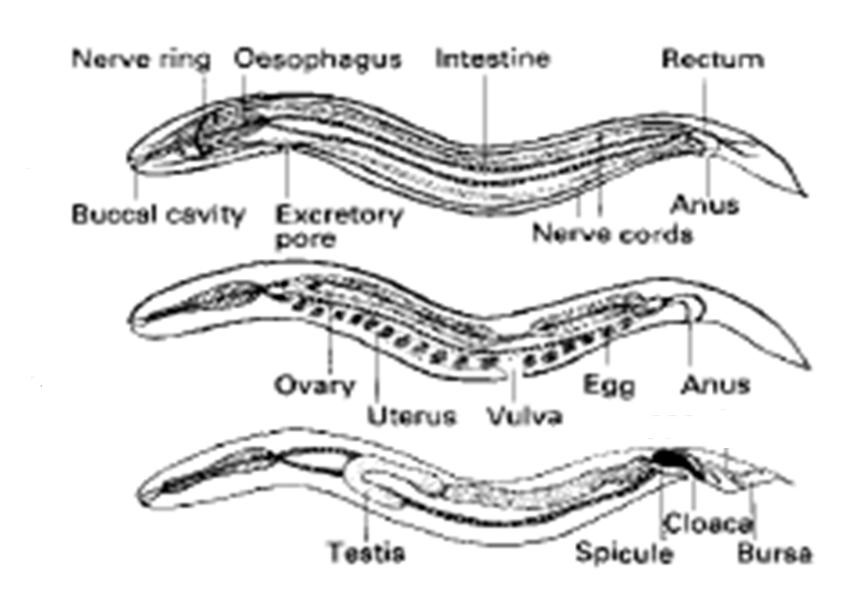

Basic Life Cycle
Males are generally smaller than the females which lay eggs or larvae. During development, a nematode moults at intervals shedding its cuticle. In the complete life cycle there are four moults. The successive 4 larval (=juvenile) stages being designated L₁, L₂, L₃, L₄ and finally L₅, which is the immature adult.Some development usually takes place either in the faecal pat or in a different species of animal, the intermediate host, before infection can take place. In the common form of direct life cycle, the free-living larvae undergo two moults after hatching and infection is by ingestion of the free L₃. In indirect life cycles, the first two moults usually take place in an intermediate host and infection of the final host is either by ingestion of the intermediate host or by inoculation of the L₃ when the intermediate host, such as a blood sucking insect, feeds. After infection, two further moults take place to produce the L₅ or immature adult parasite. Following copulation a further life cycle is initiated. In the case of gastrointestinal parasites, development may take place entirely in the gut lumen or with only limited movement into the mucosa. However, in many species, the larvae travel considerable distances through the body before settling in their final (predilection) site and this is the migratory form of life cycle.
One of the most common routes is the hepatic-tracheal.
  - This takes developing stages from the gut via the portal system to the liver.
  - Then via the hepatic vein and posterior vena cava to the heart and from there via the pulmonary artery to the lungs.
  - Larvae then travel via the bronchi, trachea and oesophagus to the gut.
2.1. Super family Trichostrongylidea
The trichostrongyloids are small, often hair-like, worms in which, with the exception of the lungworm Dictyocaulus, parasitize the alimentary tract of animals and birds. The life cycle is direct and usually non-migratory and the ensheathed L3 is the infective stage.
Haemonchus(The Barber Pole Worm)
Description: This blood-sucking abomasal nematode may be responsible for extensive losses in sheep and cattle, especially in tropical areas. A blood-sucking parasite that pierces the mucosa of the abomasum , causing blood plasma and protein loss to the sheep or goat. Adults are 10 – 30 mm long. Hosts: where this parasite parasitizes Cattle, sheep and goats. The predilection site is Abomasum. There are different species of Haemonchus such as Haemonchus contortus, H.placei, H. similis. Distribution of this parasite is Worldwide. Most important in tropical and subtropical areas.
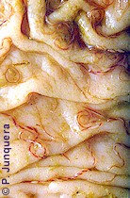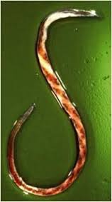
Life cycle
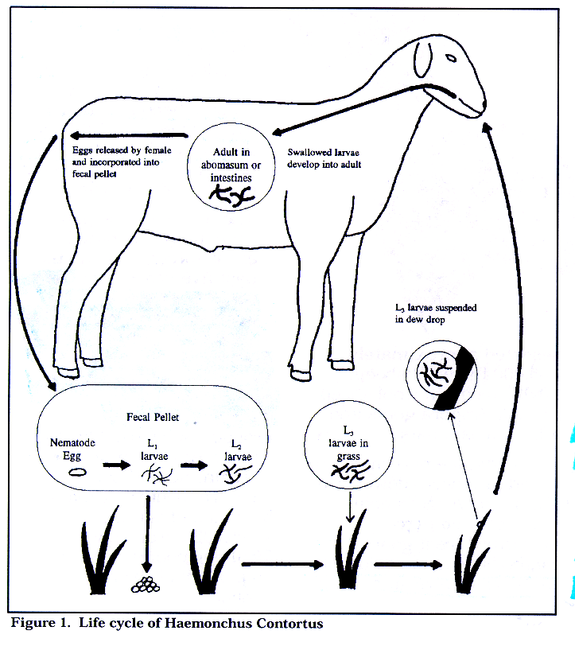
Pathogenesis:
Essentially the pathogenesis of haemonchosis is that of an acute heamorrhagic anaemia due to the blood sucking habits of the worms. Each worm removes about 0.05 ml of blood per day by ingestion and seepage from the lesions so that a sheep with 5000 haemonchus may lose about 250ml daily.
Clinical sign
Sheep die suddenly from haemorrhagic gastritis, Blood containing feces, Dehydration, Rough hair coat and depressed, Significantly reduced growth and reproductive performance, Fluid accumulation in sub-mandibular tissues (bottle jaw), abdomen, thoracic cavity, and gut wall(ascites), Blood loss, white mucous membranes, anemia and weight loss and weakness
Diagnosis
  - The history and clinical signs, faecal worm egg counts.
Treatment
When an outbreak has occurred the sheep should be treated with one of the : benzimidazoles, levamisole, Morantel tartrate and Fenbendazole.
2.2. Dictyocaulus
Description: This genus live in the respiratory system. adults are slender thread-like worms up to 8.0cm in length. Their location in the trachea and bronchi and their size are diagnostic. Hosts which parasitizes such as Ruminants, horses and donkeys. Predilection site for this parasite are Trachea and bronchi. There are different species : Dictyocaulus viviparous for cattle , D. filaria for sheep and goats and D.arnfieldi for donkeys and horses. The Distribution is Worldwide.
Life cycle
The female worms are ovo-viviparous. The L1, migrate up the trachea, are swallowed and pass out in the faeces. Under optimal conditions the L3, stage is reached within five days, but usually takes longer in the field. The L3,leave the faecal pat to reach the herbage either by their own motility or through the agency of the fungus Pilobolus. After ingestion, the L3, penetrate the intestinal mucosa and pass to the mesenteric lymph nodes where they molt. Then the L4, travel via the lymph and blood to the lungs and break out of the capillaries into the alveoli about one week after infection. The final molt occurs in the bronchioles a few days later and the young adults then move up the bronchi and mature. The prepatent period is around 3-4 weeks.
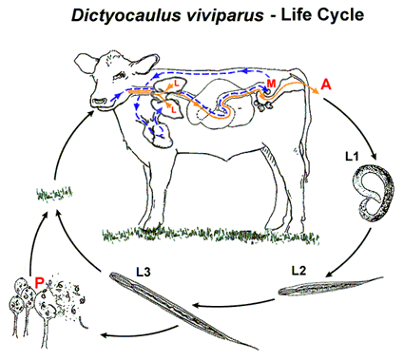

Pathogenesis
This may be divided into four phases:
- Penetration phase (days 1-7): During this period the larvae are making their way to the lungs and pulmonary lesions are not yet apparent.
- Prepatent phase(days 8-25): this phase starts with the appearance of larvae within the alveoli where they cause alveolitis. This is followed by bronchiolitis and finally bronchitis as the larvae become immature adults and move up the bronchi.
- Patent phase(days 26-60): parasitic bronchitis occur due the presence of adult worms in the lumen of the bronchi. The presence of dark red collapsed areas around infected bronchi.
- Post patent phase(days 61-90): Worms ‘self-cure’ due to immune response and clinical signs decrease.

Clinical sign
Mildly affected animals cough intermittently, particularly when exercised. Moderately affected animals have frequent coughing at rest, tachypnoea (>60 respirations per minute). Severely affected animals show severe tachypnoea and dyspnoea and frequently adopt the classic 'air-hunger' position of mouth breathing with the head and neck outstretched.

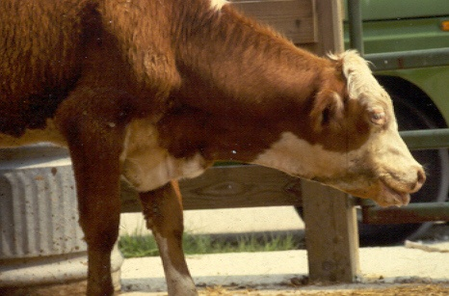
Diagnosis
- Usually the clinical signs
- Faecal examinations by using of Baermann Technique
Treatment
- The anthelmintics available for the treatment of bovine parasitic bronchitis are the modern benzimidazoles, levamisole or the milbemycins.
- These drugs have been shown to be effective against all stages of lungworms with.

2.3. Super family Spiruroidea
2.3.1. Thelazia
Description: Members of this genus are principally found in or around the eyes of animals. Adult Thelazia worms are up to 20 mm long, have a whitish color. Hosts: Cattle, other domestic animals and occasionally man. Intermediate hosts: Muscid flies; particularly Musca, andFannia. Species: T. rhodesi, T. gulosa and T. skrjabini
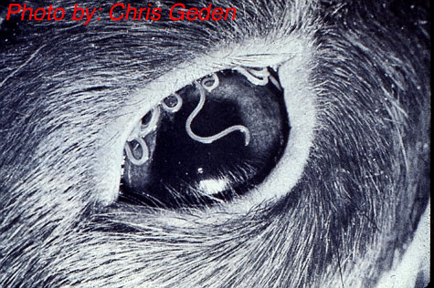
Life cycle:
The worms are viviparous.The L1 passed by the female worm into lachrymal secretion is injected by the fly intermediate host as its feed. Development from L1 to L3 occurs in the ovarian follicles of fly in 15-30days during the summer months. L3 migrate to the mouth parts of the fly and are transferred to the final host when the fly feeds on lachrymal secretion. Development in the eye takes place without further migration and the prepatent period is between 3 and 11 weeks.
Pathogenesis
Lesions are caused by the worm and most damage results from movement by the active young adults causing lachrymation, followed by conjunctivitis. In heavy infections the cornea may become cloudy and ulcerated.
Clinical signs
- Lachrymation, conjunctivitis and photophobia.
- Flies are usually clustered around the eye because of the excessive secretion.
- In severe cases, the whole cornea can be opaque.
Diagnosis:
This is based on observation of the parasites in the conjunctival sac and Clinical sign.
Treatment and control:
Treatment was at one time based on manual removal of the worms under a local anaesthetic, but this is now replaced by administering an effective anthelmintic such as levamisole. Prevention is difficult because of the ubiquitous nature of the fly vectors.
General control methods for helminthes
- Use “clean or safe” pastures
Safe pasture is New pasture, A pasture that has not been grazed with the same species for the past 6 to 12 months. Pasture in which a hay or silage crop has been removed and Pasture that has been rotated with row crops.
- Graze multiple species
Sheep and goats share the same internal parasites, but they are different from the parasites that generally affect cattle and horses. Producers who graze multiple species of livestock report fewer parasite problems.

- Alternative Grazing of different species of animal
Grazing one species in one area for one season. In the next season grazing that area by another species
- Using of broads spectrum anthehelminthics :At every three month

Unit. 3
Unit 3.
PHYLUM PLATYHELMINTHES
This phylum contain the two classes of parasitic flatworms the Trematoda and the Cestoda.
3.1.Class Trematoda
The class Trematoda falls into two main subclasses,
  - Monogenea (direct life cycle)
  - Digenea (indirect life cycle)
Digenea are of considerable veterinary importance. The adult digenetic trematodes, commonly called 'flukes', occur primarily in the bile ducts, alimentary tract and vascular system. Most flukes are flattened dorsoventrallv. have a blind alimentarv tract. suckers for attachment and they are hermaphrodite. Depending on the predilection site. the eggs pass out of the final host, usually in faeces or urine, and the larval stages develop in a molluscan intermediate host. For a few species, a second intermediate host is involved, but the'mollusc is essential for all members of the group.
There are many families in the class Trematoda, and those which include parasites of major veterinary importance are the Fasciolidae, Dicrncneliidae, Paramphistomatidae and Schistosomatidae. The most important group by far are the Fasciolidae and the discussion below.
DIGENETIC TREMATODES
Structure and function of digenetic trematodes
The adult possesses two suckers for attachment. The oral sucker at the anterior end surrounds the mouth. The digestive system is simple, the oral opening leading into a pharynx, oesophagus and a pair of branched intestinal caeca which end blindly. The trematodes are usually hermaphrodite and both cross- and self-fertilization may occur. Food, generally blood or tissue debris is ingested and passed into the caeca where it is digested and absorbed. Metabolism appears to be primarily anaerobic.

Life Cycle of digenetic trematodes
One Trematodes egg may develop in to hundreds of adults. This is due to the phenomena of paedogenesis in the Mulluscan intermediate host. The adult are always oviparous and lay eggs with an operculum or lid at one pole. Once the egg has left the body of the final host a succession of larval stages must occur before infection of another final host can take place. The stages are: Miracidium Sporocyst Rediae Cercariae Metacercaria .
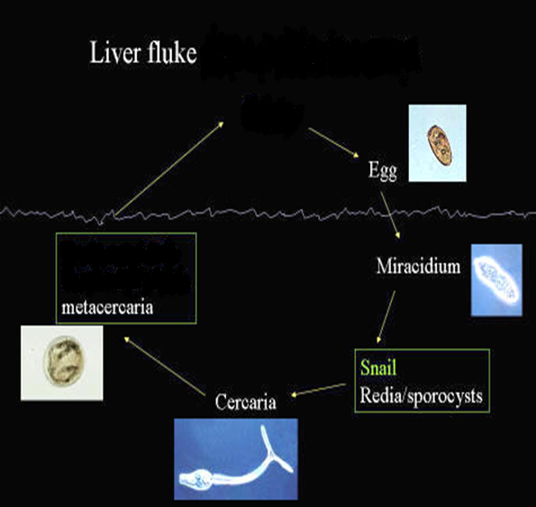

Familly Fasciolidae
These are large leaf-shaped flukes. The anterior end is usually prolonged into the shape or a cone and the anterior sucker is located at the end of the cone. The ventral sucker is placed at the level of the 'shoulders' of the fluke. There are three important genera: Fasciola, Fascioloides and Fasciolopsis.
Fasciola
The members of this genus are commonly known as liver flukes. They are responsible for widespread morbidity and mortality in sheep and cattle characterized by weight loss, anaemia and hypoprotcinaemia. The two most important species are F.hepatica and F. gigantica.
F. Hepatica
Hosts: Most mammals; sheep and cattle are the most important. Intermediate hosts: Snails of the genus Lymnaea. 'The most common, L.truncatula . Site: The adults are found in the bile ducts and the immature flukes in the liver parenchyma. Occasionally aberrant flukes become encapsulated in other organs, such as the lungs. Distribution: Worldwide.
Identification: The young fluke at the time of entry into the liver is 1.0-2.0 mm in length and lancet-like. When it has become fully mature in the bile ducts it is leaf-shaped, grey-brown in color and is around 3.5 cm in length and l.5cm in width. The egg is oval, operculate, yellow and large.
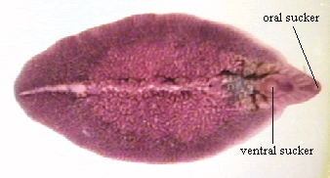
Life cycle
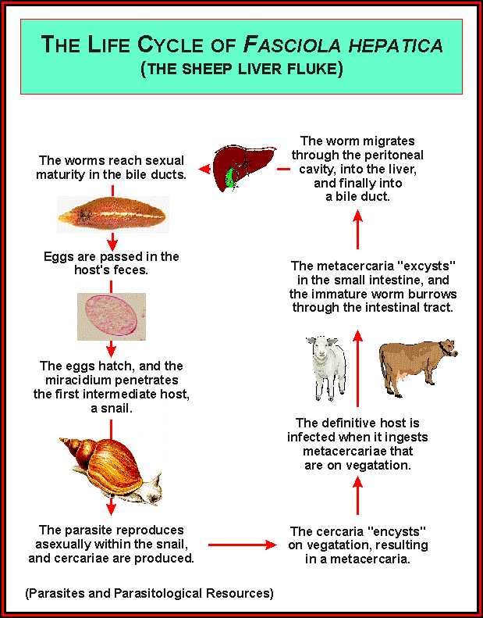
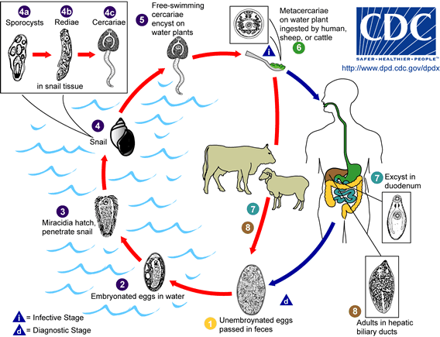

Pathogenesis and clinical signs
These vary according to the phase of parasitic development in the liver and the species of host involved. Essentially the pathogenesis is two-fold; the first phase occurs during migration in the liver parenchyma and is associated with liver damage and haemorrhage. The second occurs when the parasite is in the bile ducts, and results from the haematophagic activity of the adult flukes and from damage to the biliary mucosa by their cuticular spines.
Fasciolosis may be acute, sub-acute or chronic
Acute fasciolosis
The acute disease occurs 2-6 weeks after the ingestion of large numhers of metacercariae, usually over 2000. due to the severe haemorrhage which results when the young flukes migrating in the liver parenchyma, rupture blood vessels. Damage to the liver parenchyma is also severe.
Subacute fasciolosis
This form of the disease occurring 6-10 weeks after ingestion of approximately 500-1500 metacercariae, Howcvcr it is not so rapidly fatal as the acute condition and affected sheep may show clinical signs for 1-2 weeks prior to death; these include :a rapid loss of condition, a marked pallor of the mucous membranes, an enlarged and palpable liver and Submandibular or facial oedema and ascites may be present.
Chronic fasciolosis
It occurs 4-5 months after the ingestion of moderate numbers, 200-500, of metacercariae. Clinicallv, chronic fasciolosis is characterired bv . a Progressive loss of condition, development of anemia and hypo albumineamia which can result an emaciation, pallor of the mucous mcmbranes and submandibular oedema and ascites
Diagnosis
This is based primarily on clinical signs, seasonal occurrence, prevailing weather patterns, and the identification of snail habitats. In live animals, chronic fasciolosis is indicated by fluke eggs in faecal samples. Flukes do not begin to produce eggs until about 4 months after infection, so you cannot test the feces. Prior to 4 months: serological tests can be used Diagnosis in dead animals relies on seeing mature or immature fluke in the liver/bile duct
Treatment
The treatment recommended will depend on the nature of the disease. Some of the available anthelmintics are not effective against immature fluke and so are not recommended in acute fluke outbreaks. The best prevention and control can be achieved with drugs such as triclabendazole, which are effective against early immature and adult fluke.
Strategic control
- Due to the great biotic potential of Fasciola hepatica and their intermediate host snails, only a continuous and coordinated strategic application of all available measures can provide economic control of the disease.
- Use strategic anthelmintic treatment, to reduce the number of fluke in the host and the number of fluke eggs in pasture
- Application of molluscicides to decrease the population of Lymnaea snails
- Regular clearing of vegetation from drainage channels may reduce silting and blockages that normally support snail contaminated herbage.
- Draining marshy pastures and building dams may reduce snail habitats and increase grazing areas.
3.2. Class Cestoda (Tapeworms)
Structure and function
This class differs from the Trematoda in having a tape-like body. There is no mouth or digestive system; food is absorbed through the cuticle. The body is segmented. Each segment containing one and sometimes two sets of male and female reproductive organs. All adult tapeworms are found within the digestive system of a vertebrate host. The body of the Adult tapeworm is usually divided into 3 regions
- The scolex is the holdfast or anchoring organ; have suckers, rostellum, and hooks.
- The neck is the area of cell division which gives rise to proglottids or segments
- The strobila is the rest of the body which is composed of individual and progressively mature proglottids.
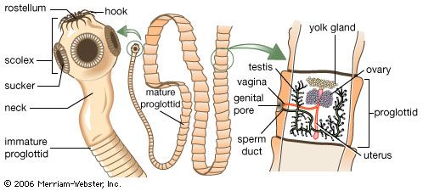
Life-Cycle
The egg contains an embryo (oncosphere or hexacanth) with 6 hooks and embryophore Gravid segments (containing eggs) are detached from the adult worm and are released into the environment. When the egg is ingested by the intermediate host, the gastric and intestinal secretions digest the embryophore and activate the onchosphere. Using its hooks, it tears through the mucosa to reach the blood or lymph stream. Once in its predilection site the onchosphere loses its hooks and develops, depending on the species, into one of the following larvae stages, often known as metacestode:
  - Cysticercus –fluid filled cyst containing a single invaginated scolex
  - Strobilocercus – The scolex is evaginated and is connected to the cyst by a chain of asexual proglottid
  - Coenurus – fluid filled cyst containing many invaginated scolices, each of which can become an adult.
  - Hydatid cyst – large fluid filled cyst lined with germinal epithelium from which are produced invaginated scolices,
  - Tetrathyridium –worm like larvae with an invaginated scolex
  - Cysticercoid: Single evaginated scolex is depressed within a small solid cyst.
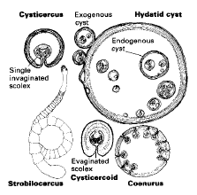
Family Taenidae
The shape of the segments changes as they mature. Immature ones being broader than they are long. Those with fully developed genital apparatus has square shaped proglotid and the gravid ones being longer than they are broad. The Two important genera are Taenia and Echinococcus.
Taenia saginata (Cysticercus bovis)
The intermediate stages of this tapeworm found in the muscles of cattle, frequently present economic problems to the beef industry and are a public health hazard. Disease: Bovine cysticercosis, beef measles (taeniasis in man)
Site: IH: cattle; Intermuscular connective tissue, particularly of the masseter, heart, diaphragm, and tongue. In severe infections it may be found in other organs and tissues such as the liver, lungs, kidney, and abdominal fat.
FH: Human; it is found in intestine
Identification:The adult tapeworm, found only in man, ranges from 5.0-15.0m in length.
  - The scolex. exceptional among the species of Taenia, has neither rostellum nor hooks.
  - In the bovine animal the mature cysticercus, C. bovis greyish white, about 1.0cm in diameter and filled with fluid in which the scolex is usually clearly visible.
Life cycle
An infected human may pass millions of eggs daily.
    - Most onchospheres can survive about 5 months on grass exposed to air.
    - They will live 33 days in water
    - 71 days in liquid manure.
Cattle acquire the infection by ingesting grass, forage crops, or silage contaminated with tapeworm eggs released from gravid segments passed in the feces of man. After ingestion by a susceptible bovine the onchosphere travels via the blood to striated muscle. It is first grossly visible about 2 weeks later as a pale, semi-transparent spot about l0mm in diameter, but is not infective to man until about 12 weeks. By then it is enclosed by the host in a thin fibrous capsule. Man becomes infected by ingesting raw or inadequately cooked meat (muscle containing a viable cysticercus). Once in the human gut, the cysts release the young tapeworm, which attach to the gut's wall and start producing segments. Within 5 to 12 weeks the tapeworms mature and start shedding eggs (prep tent period).
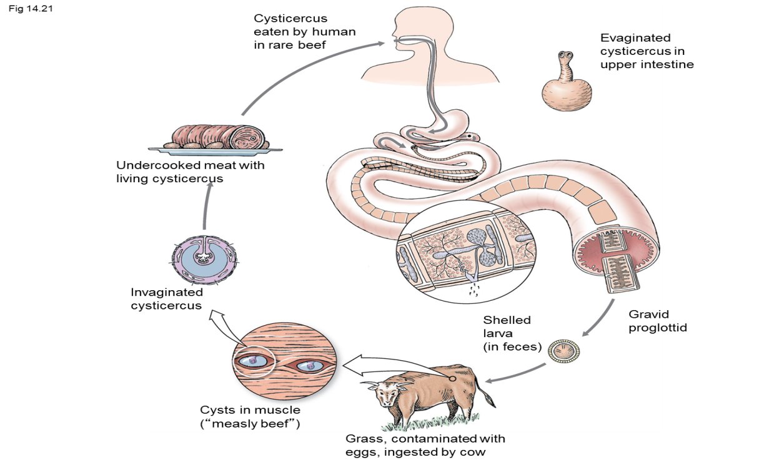
Pathogenesis and clinical sign
Under natural conditions the presence of cysticerci in the muscles of cattle is not associated with clinical signs. Although, experimentally, calves given massive infections of T. saginata eggs have developed severe myocarditis and heart failure associated with developing cyst cerci in the heart

Diagnosis
Individual countries have different regulations regarding the inspection of carcasses, but invariably the masseter muscle, tongue and heart are incised and examined and the intercostal muscles and diaphragm inspected.The triceps muscle is also incised.
Treatment
As yet there is no licensed drug available which will effectively destroy all of the cysticerci in the muscle. Praziquantel has shown efficacy in experimental situations. Control of bovine cysticercosis depends on a high standard of human sanitation / personal hygiene, on the general practice of cooking meat thoroughly. Avoiding backyard slaughtering .
Taenia multiceps (Coenurus cerebralis)
Disease: Coenurosis cerebralis, gid, sturdy.
Host: Intermediate hosts are sheep, goats, cattle, and horses;
Definitive hosts are dogs, coyotes, and foxes.
Site: Small intestine for the adult. Brain and spinal cord for larvae/ cyst intermediate host.
Identification: Adult is 100 cm. long; small scolex with 22-32 hooks. The full-grown coenurus is about 5 cm in diameter.
Life cycle:
Tapeworm segments are passed in the dog's feces, and eggs are ingested by sheep on pasture or in pens and yards. Eggs hatch in the sheep's intestine. The onchosphere passes through the intestinal wall to the blood-stream and then is carried throughout the body. If it reaches the C.N.S. it develops, otherwise it dies. When, mature, this is readily recognized as a large fluid-filled cyst up to 5.0cm or more in diameter. The coenurus takes about eight months to mature in the central nervous system and, as it develops, clinical signs commonly occur. A carnivore then ingests the coenurus, and the adult develops in 3-4 weeks. The coenurus has a delicate translucent wall, and several hundred scolex may be seen on the inner side of the cyst.
Signs and pathogenicity:
The signs seen in the sheep depend upon the site of the coenurus in the central nervous system. Locomotors disturbance is common, and the disease is known as "sturdy" or "gid".
  - The animal may hold its head to one side, circle, or lose its balance.
  - Blindness and convulsions may be seen.
  - Signs usually appear 7 months after initial infection.
Diagnosis:
By identification of the adult from a carnivore by facal examination. By identification of the coenurus from the intermediate host. This may be detected by local softening of the skull, or by detailed neurological examination.
Control/treatment:
  - Destroy bladder worms in carcasses and prevent their ingestion by the definitive host.
  - Treat dogs regularly for tapeworms
  - Surgical removal is possible if the cyst is situated on the brain surface.
  - However, for many cases there is no treatment
Echinococcus granulosus (hydatid cyst)
Is found worldwide, but the prevalence varies a lot. It is generally more abundant in rural regions with abundant livestock and wildlife together with poor sanitary conditions.
Host: Final host: dogs and other canids (e.g. foxes, wolves, coyotes, etc.)
Intermediate hosts: domestic and wild mammals, including cattle, sheep, goats, pigs, horses, dromedaries, deer, kangaroos, Human etc.

Identification:
Adult Echinococcus granulosus worms are rather small, not longer than 7 mm. They have only 4 segments, the last one being the largest and gravid, i.e. filled with eggs. The head (scolex) has 4 suckers, long rostillum and numerous hooks for attaching to the gut's wall
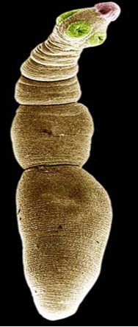
Life cycle
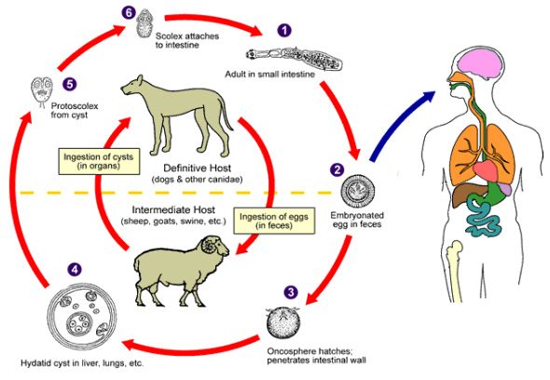
Clinical sign:
Final hosts: mostly without clinical signs, unless in case of very heavy infections, which are unusual. Intermediate hosts: is usually due to the growing cysts pressuring the organ tissues. Parts of the tissue die, which impairs the functioning of the affected organ. The clinical signs depend on the affected organs. Digestive disturbances, cough and difficult breathing have been described. The major damage for livestock is organ condemnation at slaughter.
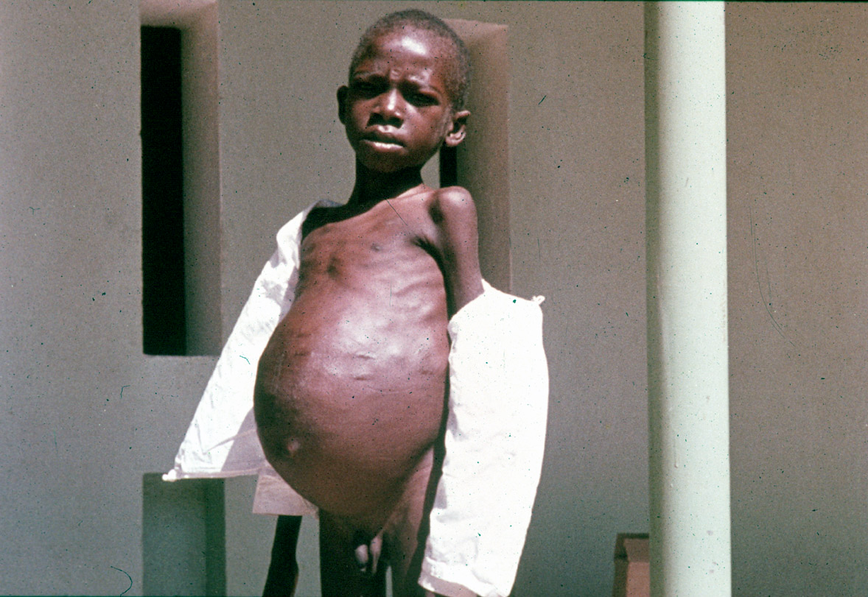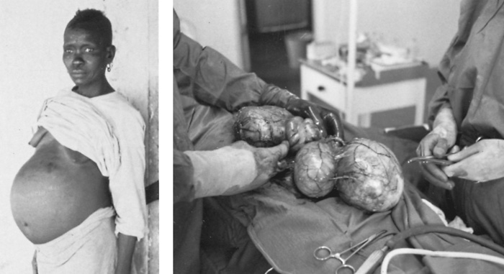
Prevention and control
- In endemic regions it is advisable to reduce the number of stray dogs.
- Abattoir control and avoiding home slaughtering practices
- Awareness about transmission factors
- Dogs must be kept away from contaminated offal.
- It is essential to thoroughly cook whatever offal they get, or to feed them on commercial dog food.
- vaccine against livestock echinococcosis caused by Echinococcus granulosus is now available in several countries. The commercial brand is called PROVIDEAN HIDATIL EG 95
- They can be preventatively treated with broad-spectrum like praziquantel, mebendazolThe major damage for livestock is organ condemnation at slaughter
Unit 4.
Phylum Arthropoda
The phylum Arthropoda contains over 80% of all known animal species. It consists of invertebrates whose major characteristics are a hard chitinous exoskeleton, a segmented body and jointed limbs. There are two major classes of arthropods of veterinary importance, namely the Insecta and Arachnida.
- Insecta: These have three pairs of legs, the head, thorax and abdomen are distinct, and they have a single pair of antennae.
- Arachnida: The adults have four pairs of legs, the body is divided into a cephalo-thorax and abdomen, and there are no antennae
Class Insecta - Insects
External Form and Function
Head
Usually equipped with pair of large compound eyes. One pair of antennae varies greatly in Function in touch, taste, hearing. Mouth parts consist Pair of mandibles and maxillae .The paired mandibles and maxillae or jaws have areas of their surfaces adapted for cutting, slashing or grinding. The maxillae may also carry maxillary palps which are sensory in function and used in the monitoring of food. Tongue like Hypopharynx (determines how it feeds.) – Proboscis The labrum or upper lip is a hinged plate attached to the face. A labium or lower lip, which may be extensively modified, especially in the flies, and sometimes bears two sensory labial palps.
Thorax
Consists of 3 parts (pro-, meso- and meta-thorax). Each section has a pair of legs. The thorax of many insects also bears two pairs of wings, but in the winged insects of veterinary significant, only one pair is functional, the second being reduced to small knob-like sensory structures called halteres, which are apparently have a balancing function. Veins on the Wings serve to strengthen the wing. Vein pattern used to identify insect taxa. In insects the sexes are separate and after fertilization either eggs or larvae are produced. Development often involves three or more larval stages followed by the formation of a pupa and a marked transformation or metamorphosis to the adult stage( egg-larvae-pupa-adult) as in all the flies and fleas, i.e. a holometabolous life cycle. In other insects development occurs from the egg through several nymphal stages(egg- nymph-adult) which resemble the adult, as in lice, i.e, a hemimetabolous life cycle
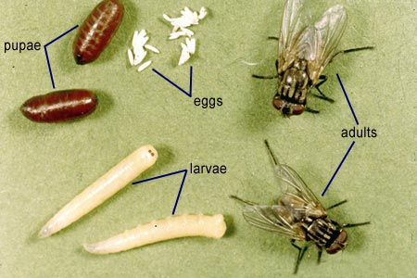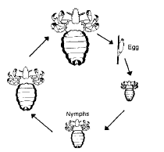

Order Diptera
This order of insects contains all of the flies of veterinary importance. These are generally characterized by having a single pair of membranous wings and a pair of halteres. Some are important as external parasites, while in others the larvae parasitize the tissues of the host. Many members of this group are also important as vectors of disease. The Diptera can be conveniently divided into three suborders, namely, the Nematocera, Brachycera and Cyclorrhapha

Suborder: Nematocera
These are small flies and the adults are characterized by having a pair of long, jointed antennae and segmented maxillary palps. The wings generally have few cross-veins.
Suborder: Brachycera
These are large flies with stout antennae often consisting of only three segments, the last segment frequently bearing annulations. Cross-veins are present on the wings .
Suborder: Cyclorrhapha
These are small to medium sized flies with short, three-segmented antennae, the last of which often bears a feather-like attachment, the arista . The maxillary palps are small and the wings show cross-venation.
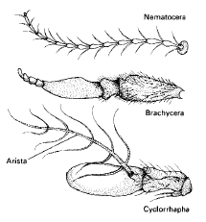

Suborder: Nematocera
Genus Simulium
Hosts: All domestic animal and human
Species: Numerous and often divided into sub-species.
Morphology:
These flies are usually black with a humped thorax. The adults are 1.5-1.55mm long, relatively stout bodies, with colorless wings which show indistinct venation. Morphologically, adult male and female flies are similar, but can be differentiated by the fact that in the female the eyes are distinctly separated (dichoptic) whereas in males the eyes are very close together (holoptic).
Pathogenesis
Only the adult females suck blood and different species have different preferred feeding sites and times. Generally they feed on the legs, abdomen, head and ears, and most species are particularly active during the morning and evening in cloudy warm weather. Although flies may be active throughout the year there may be a large increase in their numbers in the tropics during the rainy season. In domestic animals, especially cattle, mass attack by these flies may be associated with an acute syndrome characterized by generalized petechial haemorrhages, particularly in areas of --fine skin, Lesion with edema of the larynx and abdominal wall. Some spp transmit the viruses causing Eastern equine encephalitis and vesicular stomatitis. the avian protozoan Leucocytozoon and filarioid helminths such as Onchocerca in cattle.
Control: The most practical control method is the application of insecticides to breeding sites to kill larvae.

Suborder Brachycera
Family Tabanidae
These large robust flies are commonly known throughout the world as horseflies. They attack and feed on a wide variety of large animals and man. The pain caused by their bites leads to interrupted feeding, and as a consequence, flies may feed on a succession of hosts and are therefore important in the mechanical transmission of pathogens such as trypanosomes. There are many genera of tabanids, but only three are of veterinary significance, namely Tabanus, Haematopota and Chrysops.
Tabanus
Hosts
Generally large domestic or wild animals and man, but small mammals and birds may also be attacked.
Species: There are over 3000 species of tabanids.
Morphology
These are medium to large biting flies, up to 2.5cm in length, with wing spans of up to 6.5cm. They are generally dark colored, but may have various stripes or patches of color on the abdomen or thorax and even the large eyes, which are dichoptic in the female and holoptic in the male, may be coloured. The coloration of the wings is useful in differentiating the three major genera.
Life cycle
The mouthparts, which are adapted for slashing/ sponging, are short and strong and always point downwards. After a blood meal the female lays batches of several hundred creamy-white or greyish cigar-shaped eggs, on the underside of vegetation or on stones, generally in muddy or marshy areas. The eggs hatch in 1-2 weeks and the cylindrical, poorly differentiated larvae drop into the mud or water. They are sluggish and feed either by scavenging on decaying organic matter or by predation on small arthropods including other tabanid larvae. Optimally, larval development takes three months. Mature larvae pupate partially buried in mud or soil and the adult fly emerges after 1-3 weeks. The whole life cycle takes a minimum of 4-5 months or longer if larval development is prolonged.

Pathogenic significance
These powerful flies may disperse many kilometres from their breeding areas and are most active during hot, sunny days. The adult females locate their prey mainly by sight and their bites are deep and painful. They feed every 3-4 days causing a great deal of annoyance, and because their feeding is often disturbed, They are efficient mechanical vectors of the organisms responsible for diseases such as anthrax, pasteurellosis, trypanosomosis, anaplasmosis and the human filarial disease.
Control:
- This poses a special problem since breeding places are both diffuse and difficult to detect.
- For general fly control insecticidal sprays with a residual effect are used in animal houses and on the animals themselves.
- There is also the possibility of using dark panels with sticky adhesive as traps

Suborder: Cyclorrhapha
Family: Calliphoridae
This family together with the Oestridae contain the species responsible for the most important myiasis of domestic animals and man. myiasis is defined as the infestation of living animals with the larvae of dipteran flies. It may be facultative (optional), as in the calliphorids, or obligatory, as in the oestrids. It also may be cutaneous (e.g. Lucilia), nasal (e.g. Oestrus) or somatic (e.g. Hypoderma). A common term for myiasis caused by members of the Calliphoridae is `blowfly strike', the laying of eggs by the fly being termed the `blow' and the development of the larvae (maggots) and the damage they cause the `strike'. '

Blowfly myiasis
Mainly sheep, but any other animal may be affected. It is important to note that only the larvae are responsible for myiasis
Major spp
  - I.ucilia cuprina
  - Lucilia sericuta
Life cycle
The gravid female blowfly lays clusters of yellowish cream eggs on wounds, soiled fleece or dead animals, being attracted by the odour of the decomposing matter. under summer conditions, the eggs hatch into larvae in about 12 hours. The larvae then feed, grow rapidly and moult twice to become fully mature maggots in 3-10 days. These then drop to the ground and pupate. The pupal stage is completed in 3-7 days in summer and the emergent female fly, after a protein meal, reaches sexual maturity. The fertilized female can lay up to 3000 eggs, usually in batches of 100-200. Adult flies can live for about 30 days.
Pathogenesis
After the eggs are deposited on the wool by the primary adult fly, the larvae emerge and crawl down the wool on to the skin, which they lacerate with their oral hooks, and secrete proteolytic enzymes which digest and liquefy the tissues. Secondary blowflies are then attracted by the odour of the decomposing tissues and their larvae extend and deepen the lesion. The situation is often complicated by secondary bacterial infection. The irritation and distress caused by the lesion is extremely debilitating and sheep can rapidly lose condition. The latter is often the first obvious sign of strike as the lesion occurs at the skin surface and is sometimes observed only on close examination. Where death occurs, it is often due to septicaemia.
Control
- This has been based largely on the prophylactic treatment of sheep with insecticides.
- Any insecticide used must not only kill the larvae, but persist in the fleece.
- In this respect the chlorinated hydrocarbon, dieldrin, proved particularly effective and gave protection for at least 20 weeks.
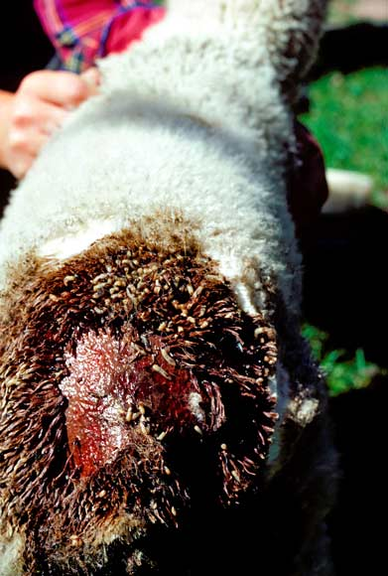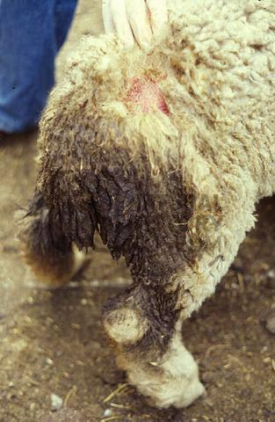
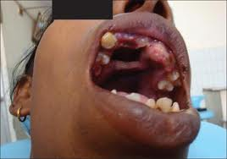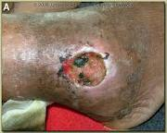
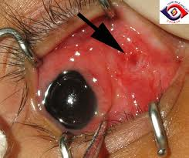

Stomoxys
The commonest species in this genus is Stomoxy calcitrans, commonly known as the stable fly or biting housefly. The bites of this fly are painfull and it is a vector of several protozoal and helminth deseases of animals.
Host: Most animals and man.
Species: Stomoxy calcitrans
Morphology
Superficially, Stomoxy calcitrans resembles the housefly M. domestica, being similar in size and grey with four longitudinal dark stripes on the thorax. Its abdomen, however, is short and boarder than Musca with three dark spots on the second and third segment.
Lifecycle
Both male and female flies feed on blood. the female lays batches of 20-50 eggs, in moist, decaying vegetable matter such as hay and straw contaminated with urine. Eggs hatch in 1-4 days, or longer in cold weather, and the larvae are mature in 6-30 days. After emergence the adult females require several blood meals before the ovaries mature and egg laying can start.
Pathogenic significance
When feeding, the proboscis swings downwards and skin penetration is achieved by the rasping action of fine teeth on the end of the labium. This is painful and stable flies may be a serious pest of animals and man.
Glossina
This genus is considered here as a member of the family Muscidae. Members of this group of biting flies are commonly termed tsetse flies. They are distributed over 10 million square kilometres of Africa. They are extremely important as vectors of African trypanosomosis which is a serious disease of domestic animals and man.
Hosts: Various mammals, reptiles and birds
Species: There are around 30 species and sub-species of the genus Glossina
Morphlogy:
In general the adults are narrow, yellow to dark brown flies. 6-15mm in length, and have a long, rigid and forward projecting proboscis. They are easily distinguished from all other flies by the characteristic cleaver (hatchet) cell in the wings. There are no maxillae or mandibles in the mouthparts although the proboscis is adapted for piercing and sucking, an upper narrower sharp labrum and slender hypopharynx which carries saliva and anticoagulant into the wound formed during feeding. Tsetse flies become infected with trypanosomes during feeding and then undergo multiplication within the fly before they are infective for other hosts during subsequent feeding.
Life cycle
Both male and female flies suck blood and although they may have some host preferences, they will feed on a wide variety of animals. The females, in contrast to other muscids, are viviparous and produce only one larva at a time, up to a total of 8-12 larvae. Third stage larva deposited by the adult takes approximately 10 days. After deposition the larva wriggles into loose soil to a depth of a few centimeters and forms a rigid dark brown, barrel-shaped puparium. The pupal period is relatively long, taking 4-5 weeks, or more. On emergence the female fly requires several blood meals over a period of 16-20 days before producing her first larva
Pathogenic significance
Although the bites of tsetse flies are very painful and cause marked irritation, their main significance is in the transmission of animal and human trypanosomosis.
Control
- Currently, most anti-tsetse measures rely on the use of insecticides applied from the ground or by aircraft.

4. Protozoology
Phylum protozoa
They are unicellular organisms. Contain one nucleus enveloped in a nuclear membrane. They Don’t process cell wall, unlike bacteria. Are motile organisms. They reproduce both sexually and asexually. The asexual type of reproduction includes binary fission and multiple fission shizogony and budding where as the sexual consists of conjugation and syngamy.
Subphylum Sarcomastigophora
Locomotion is by pseudopodia and/or flagella.
Class Mastigophora
Members of the class contain one or more flagella
Genus Trypanosoma
Are found in the blood stream and tissue of vertebrates and transmitted by arthropod vectors. They are serious causes of morbidity and mortality in man and animals in tropics.Based on their development in the vector and mode of transmission, they are divided into three groups
- The Salivaria Trypanosomes
- The Stercoraria Trypanosomes
- Mechanically transmitted Trypanosome
The Salivaria
Cause a disease in cattle known as ‘nagana’.
Hosts: all domestic livestock, most important in cattle
Intermediate Host: Glossina spp. (tsetse flies)
Site: In blood stream, Trypanosoma brucei is also found in tissues (heart, CNS, reproductive tract)
Species: Trypanosoma brucei, T. congolense, T. vivax.
Life Cycle:
Tsetse flies ingest trypanosomes in the blood or lymph while feeding on an infected host. They multiply in the digestive tract of the fly and undergo structural changes and finally they migrate to the salivary glands and the proboscis and there they transform and continue to multiply. Finally they convert to an infective stage called metacyclic trypanosomes (the entire process takes 2 –3 weeks). The metacyclic trypanosomes are inoculated into the new host, when the tsetse fly feed. At the site of inoculation the metacyclic forms multiply locally producing inflammatory skin swelling called a chancre. There after they enter blood stream and multiply. Detectable parasitemia is appears within 1-3 weeks.
Pathogenesis:
Lymphoid enlargement and spleenomegaly . Anaemia (haemolytic) is the main feature of the disease.
Clinical Signs
Acute form:
Occasionally caused by some strains of T. vivax. The clinical signs include fever, severe anaemia, and widespread haemorrhages on the mucosa and serosal surfaces. Death occurs within 2-3 weeks of infection in ruminants.
Chronic form:
In ruminants signs include anaemia, enlargement of superficial lymph glands, lethargy, and progressive loss of body condition (emaciation). Fever and loss of appetite intermittently corresponding to the level of parasitaemia. This form is common, and leads to death if untreated In a herd the growth of young animals is stunted, decreased fertility, abortion and the birth of weak offspring. In horses, T. brucei (acute or chronic) often accompanied by oedema of the limbs and genitalia. In dogs and cats T. brucei and T. congolense (acute sign), fever, anaemia, myocarditis, corneal opacity and neurological signs.

Diagnosis:
based on clinical signs and history . confirmation depends on the demonstration of trypanosomes in the blood. Techniques of blood examination includes
a) Wet film b) thin and thick film c) buffy coat technique
Treatment:
- In cattle, sheep and goats – Diminazene aceturate (berenil) – toxic to camel.
- Homidium salts (ethidium, novidium)
- In camel and horse -- Quinapyramine sulphate
Control
  - Chemoprophylaxis: using trypanocidal drugs that remain in tissues e.g. isomethamedium (samorin, trypamidium) and Quinapyramin salt.
  - Vector control (tsetse fly control)
  - Selective breeding of trypanotolerant breed such as N’Dama breed of West Africa
The Stercoraria
Often called the non pathogenic trypanosomes. It includes T. theileria and T. melophagia . In man T. cruzi cause chagas disease in central and South America.
Mechanically transmitted trypanosomosis
T. evansi is transmitted mechanically by biting insects and causes a disease commonly called surra. It primarily affects horses and camels. Biting flies such as tabanids and Stomoxys spp. serve as mechanical vectors.
Clinical signs:
produce similar syndromes like that produced by the tsetse transmitted trypanosomes
Treatment: --Suramin (quinapyramin)
--Quinapyramin pro salt
Venerally transmitted trypanosomes
T. equiperdum causes a venereal disease of horses and donkeys called dourine. The clinical sign include genital and ventral abdominal oedema and progressive emaciation. Central nervous system disturbance which is fatal
Subphylum Sporozoa
They occur intracellularly. Reproduction involves both asexual (schizogony) and sexual (gametogony) phase.
Class Coccidia (Family Emeriidae)
Genus Emeria
Hosts: poultry, cattle, sheep, goats, pigs and horses
Site: epithelial cells of the intestine
Important species and their hosts
Chicken: caecum - E. tenelle, E. necatrix.
Small intestine – E. necatrix, E. brrunetti, E. acervulina, E. mitis
Cattle(E. zuernii and E. bovis ),Sheep( E. crandallis, E. ovinoidalis, E. Ovina),Goat(E. Artoingi), Horses(E. Leulcarti)
Distribution: worldwide.
Life cycle:
Oocysts are passed in the faeces, under optimal condition undergo sporulation consists of the formation of sporoblast, sporocyst and sporozoites. Sporulation occur in 2-4 days. Sporulated oocyst is the infective stage. Following igestion of the sporulated oocyst sporozoites are released in the small intestine and penetrate its epithelial cells changing to trophozoites and divide by multiple fission to form schizont containing nucleated organisms called merozoites that are released through rupture of the mature schizont and epithelial cells. Schizogony may be repeated. Finally merozoites give rise to male and female gametocytes. The macrogametocyte are female and microgametocytes are males and are flagellated. Fusion of the two gametocytes results in zygote formation known as oocyst. The oocysts are passed in the faeces unsporulated. The prepatent period is 5 days in chicken and 3-4 weeks in ruminants.
Pathogenesis: rupture of intestinal epithelial cells to release merozoites and gametes in heavy infections cause severe haemorrhage. Light infection result in impairment of local absorption.
Chicken Coccidiosis
Caecal coccidiosis. Primarily caused by Eimeria tenella.
Clinical signs include:
Soft faeces often containing blood . The chicks are dull and listless with drooping feathers, Sub clinical infections result poor weight gains food conversation rates. At necropsy, blood in the faeces, caeca dilated and contain blood and caecal plugs detached and caesous material is shed in the faeces.
Intestinal coccidiosis.
Caused by intestinal species including Eimeria tenella. Eimeria brunetti is highly pathogenic and Eimeria acerviluna and Eimeria maxima are moderately pathogenic.
Clinical signs: are similar with caecal cocidlosis.
Diagnosis : Based on post –mortem examination of a few affected birds and detection of oocyts on faecal examination.
Treatment:- sulphonamides gives for two period of 3 days in drinking water with on interval of 2 days between treatments.

Control:-
- Good management- Avoid over crowding
- Feeding and watering utensils should be kept high enough, not to be contaminated by droppings.
- Good ventilation to decrease humidity and keep litter dry.
- use of anticocidial compouns in the feed and water most frequently used drugs include - monensin , dinitolnide Salinomyin and halofuginene
Coccidiosis of cattle
It affects cattle under one year old but rarely seen in older ones E- werni is pathogenic . attacking the caecum and colon. In heavy infections produces a severe blood stained dysentery accompanid by tenesmus. E. bovis also affects colon and caecum producing enteritis and diarrphea.
Diognosis ;- based on history , clinical signs , and in patent infections , on the presence of oocysts in the faeces
Treatment :- sulphamzaine for 3 days
Control :-
- Good Mangement - Aviod over crowding and improve hygienic in animal yards or at pasture
- Keep bedding dry
- Avoid contamination of feeding troughs And water containers with animals faeces

