CHAPTER TWO: THE CONCEPT OF FARMING SYSTEM
Introduction
Farm: Farm is an area of land and its buildings, which is used for growing crops and rearing animals. It is devoted primarily to agricultural processes with the primary objective of producing food and other crops. It is the basic facility in food production.
System: A system is a set of inter-related, interacting and interdependent elements acting together for a common purpose and capable of reacting as a whole to external stimuli.
It is unaffected by its own output and it has external boundaries based on all significant feedbacks
Farming System: Farming system is an approach for developing farm- household systems, built on the principles of productivity, profitability, stability and sustainability.
The farming system approach emphasizes understanding of farm household, community inter linkages, reviews constraints and assesses potentials. Moreover, it combines improvements desired from better technology.
2.1 Basic Concepts of farming Systems
Farmers typically view their farms, whether small subsistence units or large corporations, as systems in their own right. A typical farming system may include a type of land, various water sources and access to common property resources - including ponds, grazing areas and forest.
Each individual farm in a specific farming system has its own unique characteristics arising from variations in resource endowments and family circumstances. The household, its resources, and the resource flows and interactions at an individual farm level are together referred to as a farm system. The biophysical, socio-economic and human elements of a farm are interdependent, and thus farms can be analyzed as systems from various points of view.
Regardless of their size, individual farm systems are organized to produce food and to meet other household goals through the management of available resources - whether owned, rented or jointly managed - within the existing social, economic and institutional environment. They often consist of a range of interdependent gathering, production and post-harvest processes, so that besides cropping and livestock keeping, household livelihoods can encompass fishing, agro-forestry, as well as hunting and gathering activities.
Off-farm incomes, which make a significant contribution to the livelihoods of many poor rural households, are also included. Farm systems are not found only in rural areas; significant levels of urban agriculture exist in many cities and towns in a wide range of developing countries.
The functioning of any individual farm system is strongly influenced by the external rural environment, including policies and institutions, markets and information linkages. Not only are farms closely linked to the off-farm economy through commodity and labour markets, but also the rural and urban economies are also interdependent. Farm women and men are also linked to rural communities and social networks, and this social capital influences the management of farms.
Farming system is an integrated set of activities that farmers perform in their farms under their resources and circumstances to maximize the productivity and net farm income on a sustainable basis. The farming system takes into account the components of soil, water, crops, livestock, labour, capital, energy and other resources, with the farm family at the centre managing agriculture and related activities
A farming system, by contrast, is defined as a population of individual farm systems that have broadly similar resource bases, enterprise patterns, household livelihoods and constraints, and for which similar development strategies and interventions would be appropriate
The farming system approach emphasizes understanding of farm household, community inter linkages, reviews constraints and assesses potentials. Moreover, it combines improvements desired from better technology.
Any farm can be viewed as a system, with Inputs, Processes, Outputs and Feedback.
Inputs: are the factors that a farm needs to work.
Inputs can be divided into two groups.
Physical inputs are naturally occurring things such as water, raw materials and the land.
Human or Cultural inputs are things like money, labour, and skills.
Processes are the actions within the farm that allow the inputs to turn into outputs. Processes could include things such as milking, harvesting and spraying.
Outputs: can be negative or positive.
Negative outputs include waste products and soil erosion.
The positive outputs are the finished products, such as wheat, seeds, meat, milk, and eggs, and the money gained from the sale of those products.
Feedback is what is put back into the system. The main two examples of this are money, from the sale of the outputs, and knowledge, gained from the whole manufacturing process. This knowledge could then be used to make the production better or improve the efficiency of the processes.
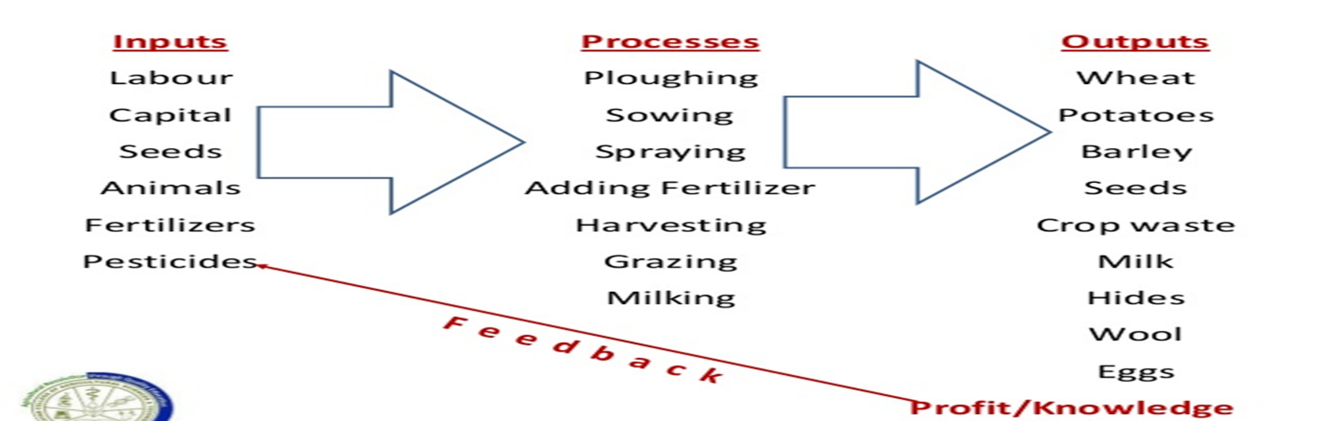
2.1.1 Definition Farming systems
Farming system represents an appropriate combination of farm enterprises (cropping systems horticulture, livestock, fishery, forestry, and poultry) and the means available to the farmer to raise them for profitability.
Farming system is a unique and reasonably stable arrangement of farming enterprises that a household manages according to well-defined practices in response to the physical, biological and socio-economic environment and in accordance with the household goals preferences and resources
Farming system consist of several enterprises like cropping system, dairying, piggery, poultry, fishery, bee, keeping etc. these enterprises are interrelated. The product and wastes of one enterprise are used as inputs in others. The waste of dairying like dung, urine, refuse etc. is used for preparation of FYM, which is an input in cropping systems. The straw obtained from the crops is used as fodder for cattle’s are used for different field operations for growing crops. Thus, different enterprises of farming systems are highly interrelated.
Farming system is a complex inter related matrix of soil plants, animals, implements, power labour, capital and other inputs controlled in parts by farming families and influenced to varying degree by political, economic, institutional and socials forces that operate at many levels. Thus farming system is the result of a complex interaction among a number of interdependent components. To achieve it, the individual farmer allocates and qualities of four factors of production; Land, labour, capital and management, which has access to processes like management which has crop, livestock and off farm enterprises in a manner, which within the knowledge he possess will maximize the attainment of goal he is striving for.
Income through arable farming alone is insufficient for bulk of the marginal farmers. The other activities such as dairying, poultry, sericulture, apiculture, fisheries etc. assume critical importance in supplementing their farm income.
“ Farming System is defined as a complex inter related matrix of soil, plants, animals, implements, power, labour capital and other inputs controlled in part by farming families and influenced to varying degrees by political, economic, institutional and social forces that operate at many levels. The farming system therefore, refers to the farm as an entity of inter dependent farming enterprises carried out on the farm”.

2.1.2. Farming system components
The farming system conceptually is a set of elements or components that are interrelated which interact among themselves. At the center of the interaction is the farmer exercising control and choice regarding the types of results of interaction.
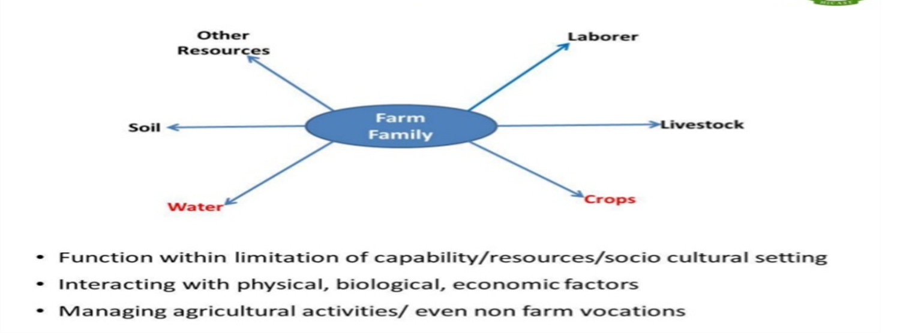

2.2. Types of farming systems
There are different basis for classifying farming systems. The selection of the basis for classification is dependent on the purpose to which the classification some of the commonly used basis for classification are:
- Available water, land, grazing areas, arable lands, forest; climate, landscape
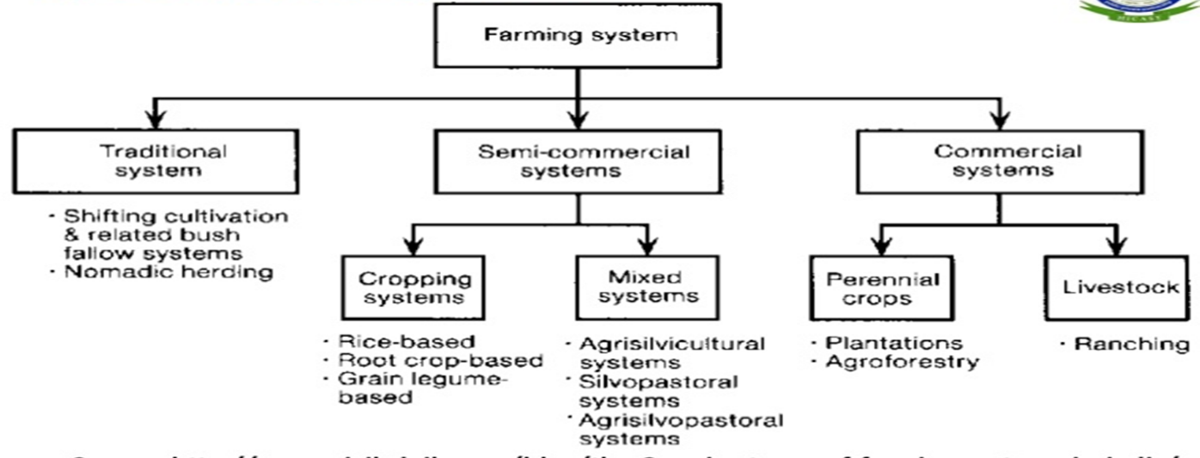
- The dominant pattern of farm activities and household livelihoods.
Commercial farming
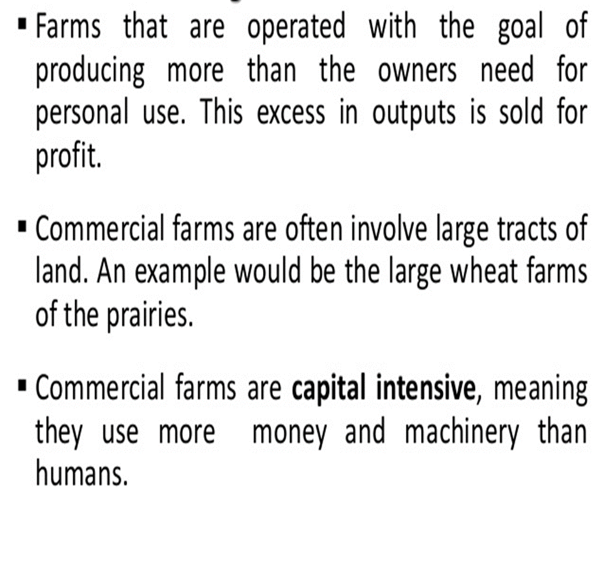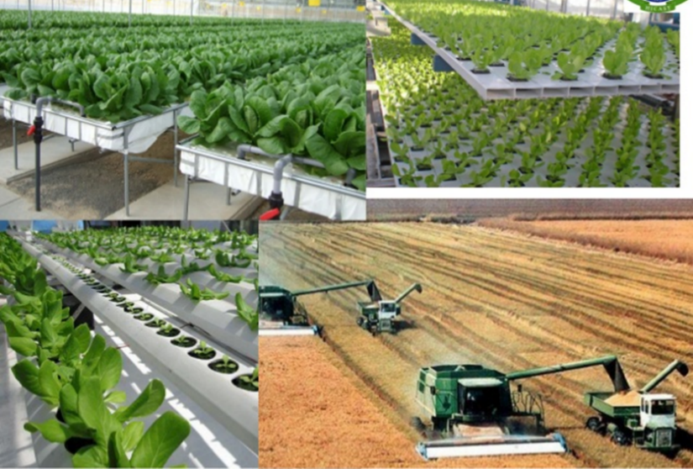

Subsistence Farming

- Subsistence farming is where the farmer produces food for himself and his family.
- Farming is usually done on relatively small land holding with simple farm tools.
- It is perceived; the farmers in this system are poor and do not use fertilizers and improved seeds as much as they should.
- Moreover, facilities like electricity and irrigation are mostly not available to them.
- The whole family works on the farm.
- Most of the work is done manually.
- The farms are small.
- Farmers follow traditional methods of farming.
- Yield is not very high.
- The family consume the yield
- The farmers and their household consume most of the yield produce.
- Productivity is usually low.
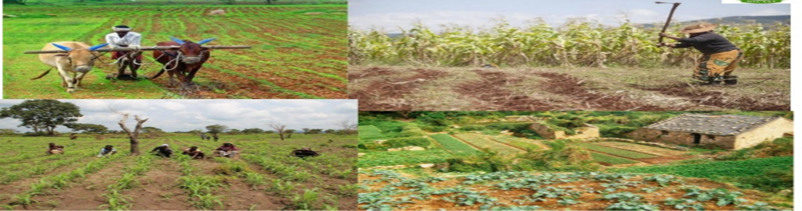

Types of farming practices

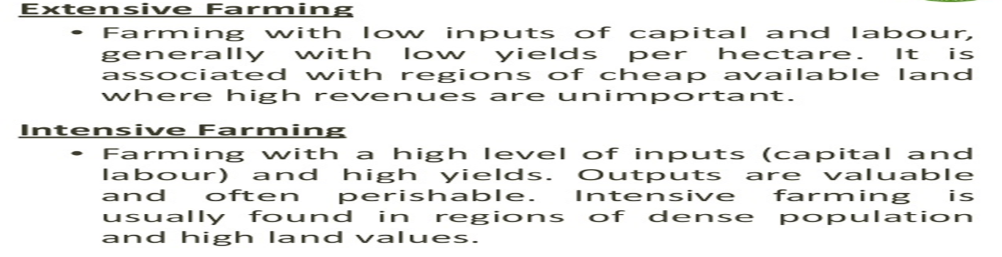
Crop rotation
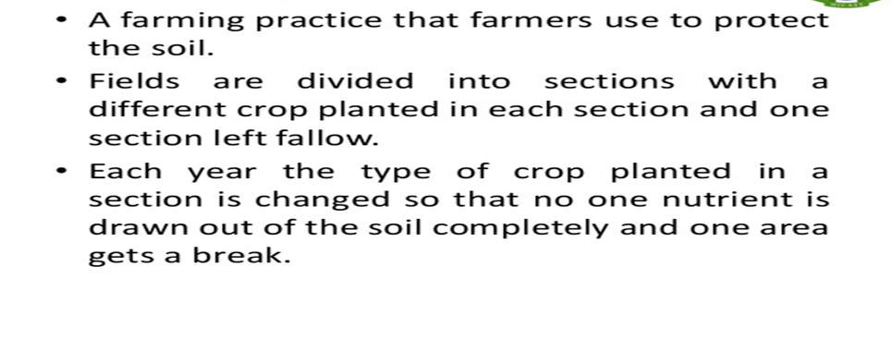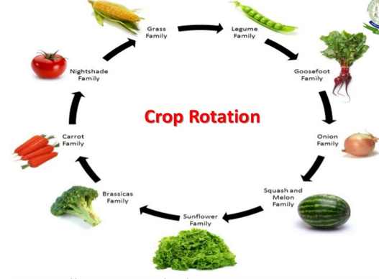
Shifting cultivation
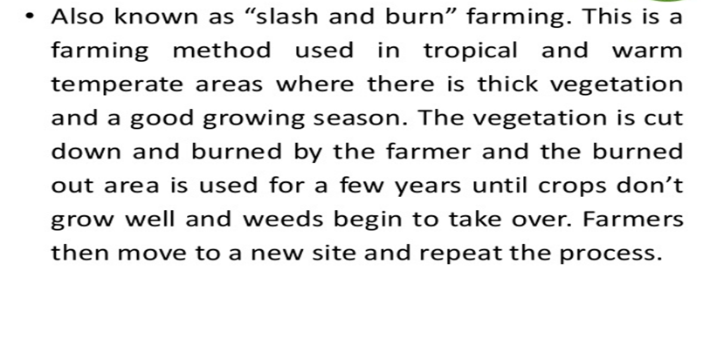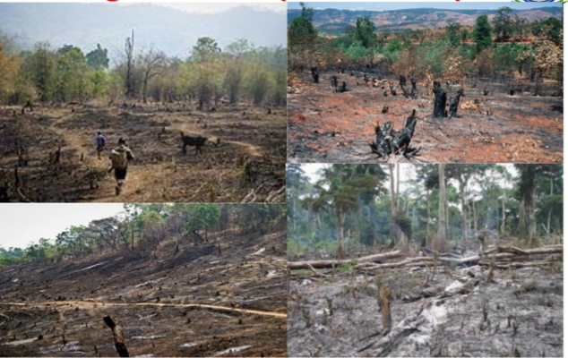
Terrace cultivation
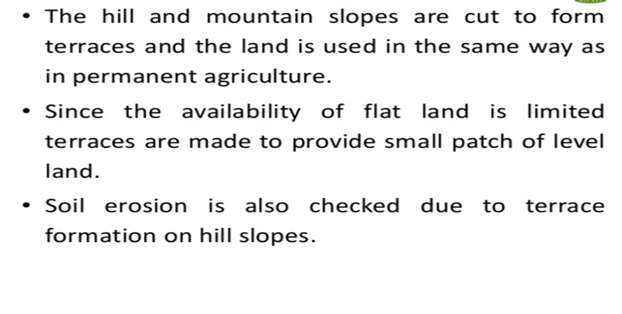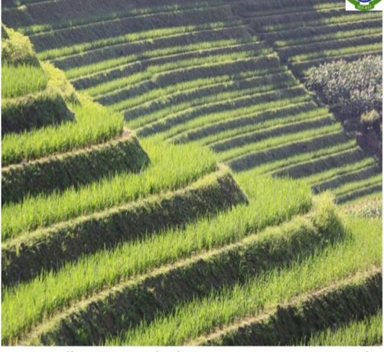
Agribusiness Farming
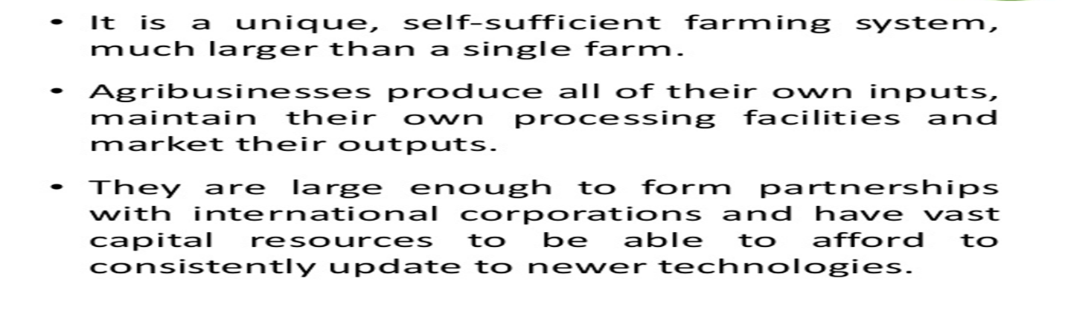
Sedentary & Nomadic Farming
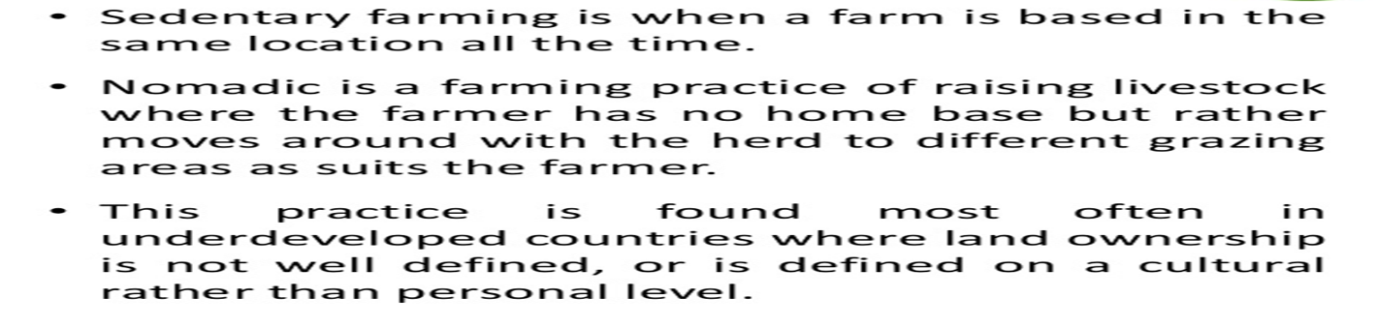

Inter cropping and Mixed cropping
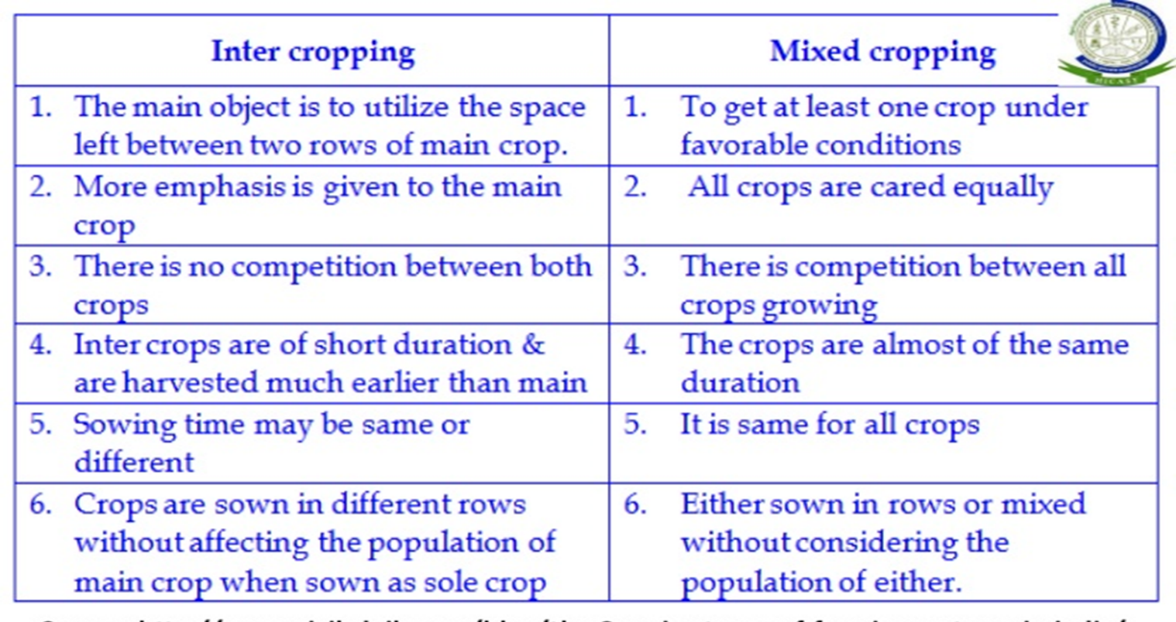
Factors Determining Farming Systems

- Natural Resources and Climate
- Science and Technology
- Trade Liberalization and Market Development
- Policies, Institutions and Public goods
- Information and Human Capital
- Indigenous Technological Knowledge
- Soil and climatic features of the selected area
- Availability of the resources, land, labor &Capital
- Present level of utilization of resources
- Economics of proposed integrated farming system
- Managerial skill of farmer

Challenges & Prospects of Farming System

- Food insecurity is increases with increasing population & decreasing arable land
- Small and marginalized farmers with fragmented land holding
- Increasing use of hybrid varieties
- Institutional and policy constraints
- Demand & Supply
- Market facilities
2.3 Rationale and philosophy of Farming systems
Using crop residues more rationally is an important route out of poverty. For resource-poor farmers, the correct management of crop residues, together with an optimal allocation of scarce resources, leads to sustainable production.
The development of a region is heavily determined by decisions at the micro (family), village (or similar sub-regions) and regional levels. Decisions are made in light of the needs and objectives of the decision-makers and the availability of resources and constraints. Differences between the three levels in these issues can lead to conflicts, which are often related to objectives and resource use. To understand and model the decisions and linkages at and between all levels, an integration of the micro, village and regional level in a systems concept is suggested.
Since human beings with their objectives and decision-making are central to this philosophy it can be defined as a decision-oriented farming systems view.
The approach can be described as follows:
a) It is a holistic approach that applies and uses knowledge and experience in systems theory and existing practical knowledge and the experience of the local people concerned (e.g. target groups). It includes:
- Horizontal relations: farm, household and off-farm/off-household activities are tools of the families, which make decisions according to their needs
- Vertical relations: decisions are made at family, village, regional and national levels and are related to each other especially with respect to resources, administrative regulations and social norms.
- The relation to time (dynamics) of the systems relate to sustainability and improvement of the living standard,
b) It is a behavioral approach, which takes into, account the objectives and values of the farm families and their decision-making process.
It includes:
- Structure and responsibility of decision-making within a family and its relation to village (or clan, tribal) and regional level decisions.
- Objectives and decisions: families make decisions according to their objectives, which result from their view of their problems under the physical, economic, social and cultural conditions given. Gender issues play specific roles.
- A participatory element: this ensures that the needs and objectives of the target group will be considered when problems are defined and solutions are developed, tested and evaluated for their impact on rural development. Such a view surpasses the top-down concept and gives room for a bottom-up strategy or elements of it.
The farming and rural systems consist of three sub-systems: the farm family system, the village livelihood system and the regional system.
Cyclic
The farming system is essentially cyclic (organic resources–livestock– land–crops).Therefore, management decisions management decisions related to one component may affect the others.
Ecological sustainable
Combining ecological sustainability and economic viability, the integrated livestock farming system maintains and improves agricultural productivity while also reducing negative environmental impacts.
2.4. Gender and HIV/AIDS in farming systems
It is estimated that 42 million people in the world are infected with the HIV virus and 95 percent live in developing countries (UNAIDS 2002). Assuming that each HIV/AIDS case directly influences the lives of four other individuals, at least 160 million people are likely to be affected by the epidemic (Barnett, Whiteside 2002). With more than two-thirds of the population of the 25 most affected African countries living in rural areas and largely dependent upon agriculture as a means of subsistence, any HIV/AIDS mitigation strategy has to encompass the livelihoods of rural agricultural populations (FAO 2002a).
The major impacts of HIV/AIDS on food security and rural livelihoods
Loss of productive generations
In many countries, AIDS is erasing decades of progress made in improving mortality conditions and extending life expectancies. The average life expectancy in sub-Saharan Africa is now 47 years, when it would have been 62 years without AIDS.
Shortage of labour
AIDS is characterized by recurrent periods of sickness, and so recurrent loss of labour, which eventually erodes agricultural production and food security. Much of rural agricultural production is highly labour-dependent and often labour demands are concentrated in specific periods of the year
Gross agricultural production is also affected by labour shortages. The FAO has estimated that in the 25 hardest hit countries in Africa, AIDS has killed around 7 million agricultural workers since 1985 and it could kill 16 million more before 2020.
Loss of agricultural skills and knowledge
Rural farming systems depend upon a wealth of local agricultural and biodiversity knowledge that is essential for maintaining production. The loss of a productive generation means that livelihood skills including agricultural knowledge are not passed from generation to generation, leaving a young population ill equipped to manage the impacts of the epidemic. Moreover, agricultural skills are often gender-specific and the sickness or death of a male or female household member can result in a weakening of the farming system.
Decreasing nutritional status
HIV/AIDS has direct impacts on nutrition for the individual, the household and the community. For the individual, HIV infection, compounded by inadequate dietary intake, rapidly leads to malnutrition. Persons living with HIV have higher than normal nutritional requirements; approximately 50 percent more protein and 10-15 percent more energy per day is needed (Academy for Educational Development 2001, Woods 1999, James, Schofield 1990). Malnutrition may hasten the onset of AIDS and ultimately death, and may increase the risk of vertical HIV transmission from mother to child.
Weakening institutional capacity
The rural and agricultural dimensions of the HIV/AIDS epidemic not only present devastating impacts on agricultural production, but also reduce the capacity of rural institutions to provide adequate services. The first impact experienced by formal organizations is a decline in human resources, as more staff are absent due to repeated periods of AIDS-related sickness. The quality of the service is affected, as other staff members have to cover for their colleagues’ absence, thus increasing their own workload and decreasing the geographical area which mobile staff, such as extension workers, are able to cover. Organizations also suffer from less tangible results of increasing staff attrition. Certain technical skills can be/ replaced, but institutional knowledge and experience cannot be easily substituted with new staff. In addition, there are direct budgetary costs associated with continual attrition that can divert organizations’ funds away from operational activities. Informal institutions are also affected by a dwindling contribution from AIDS afflicted households. Constraints on these households’ time and resources reduce their ability to participate in these community networks, in turn, reduce their access to these vital social safety nets, and so increase their vulnerability.
Exacerbation of gender inequalities
Gender inequality is one of the driving forces behind the spread of HIV. In many places, HIV infection rates are three to five times higher among young women than young men. These differentials in HIV infection are partly explainable by biological factors, which make women more vulnerable to HIV, especially in youth and adolescence.
Gender inequalities render women more vulnerable to the effects of the HIV/AIDS epidemic. Rural women’s domestic workloads tend to increase, as they are often the care providers when household members are sick. Access to productive resources, including land, credit, training and technology are strongly determined by gender and frequently favor men in the allocation of resources. As the household asset base dwindles and more members become sick, women’s access to scarce resources is further diminished. Moreover, following the death of a spouse, a widow may not be granted access to household resources resulting in further impoverishment.

Self-check
- Define farming system and farm system separately
- Discuss factors that determine farming system by giving example
- Any farm can be viewed as a system, with inputs, process, output and feedback. Justify it.
- Elaborate and explain basic concepts of farming system
- Discuss elements of farming system
- Briefly explain types of farming system and their features
- Discuss types of farming practices
- What are factors that determine farming system?
- What are Challenges & Prospects of Farming System?
- Discuss and describe the rationale and philosophies farming system by giving examples.
- Briefly describe Gender and HIV/AIDS in farming system

CHAPTER 3. FARMING SYSTEMS RESEARCH AND DEVELOPMENT (FSR/D)
3.1. Concepts of FSR/D
The FSR was developed in 1970s and 80s in response to the failure of ToT model in developing nations especially in Africa. It was developed by collective efforts of scholars from different disciplines (natural and social sciences), who were working in developing nations. It was developed as alternative research method or form of inquiry, which use systemic thinking to challenge the reductionist scientists to consider local context and farmers’ realities. Because; during that time farmers, who failed to adopt technologies, were seen as backward and traditional.
However, FSR scholars have empirically shown that ToT model is irrelevant for small farmers’ contexts. They claimed most agricultural researches are conducted on research stations mostly by plant and moderately by animal scientists. These scientists use biological principles to study physical productivity of crops and/or animals. These type of researches benefitted farmers, who cultivate single crop (mono cropping) on suitable farmland (fertile soil, enough rainfall or irrigation, large size farm etc.), and who have access to inputs (cheap fertilizer, credit, extension advices etc.) and who have output markets.
However, small farmers make their living in very diverse and risk prone biophysical and socio-economic contexts in which different family farms encounter context specific constraints and opportunities over time.
Reasons for initiation of FSR in Developing World
•It was realized that models of discipline-oriented research (i.e. Where department conducts research separately) from the industrialized countries were inappropriate as the basis for agricultural improvement in most developing worlds. Because, developing world’s agriculture is complex farming systems were little understood by researchers
•Few agricultural technologies proposed by reductionist researchers were being adopted by small farmers
•In developing world, unlike developed world, the vast majority of farmers lack influences in shaping research and development strategies. E.g. no subsidies, strong farmer organization etc. in developing nations
•Many agricultural programs have led to benefits for larger farmers at the expense of poorer families; like extension bias toward model farmers
•Most experimentation has been conducted on research stations, which are largely unrepresentative of conditions on the majority of small farms;
•The FSR approach is consistent with current political notions of equity and sustainable production
•Research focused on components or commodities and/or productivity alone has sometimes led to land degradation.
The FSRA entails a broad view that concentrates on interactions among components and on emergent properties of farming system that are relevant to problematic situations we intended to study or solve. What you should know is that the boundary is negotiable here, not like living organisms or computer modeling. We can exclude the elements from the system based on objective of the system or based on problem to be solved. For example, if you (as a team of researchers) want to study or understand farming system of Eastern Ethiopia, it is up to the team to discuss where and what to be focused or included and why.
3.2 Characteristics of FSR/D
While the overall goal of FSA is to match technology with farmer circumstance to ensure adoption and increase productivity, the conceptual aspects of the farming systems approach are still evolving. The following list provides the basic characteristics of FSA.
A.FSA is farmer oriented
Research and extension starts with the understanding of farmer and the farm family his or her needs and priorities his or her resource base, the environment with in the which he/she operates, and how she/he manipulates his or her resource to fulfill his or her housed hold needs . In the process or problems / constraints of fulfilling the farming, household’s objectives are identified. This involves focusing on groups of farmers whose problems are to be solved.
B.FSA is system oriented
The component of farming, i.e. cropping livestock, etc are to be seen as a part of a bigger farming system. Resource flows among the components or sub – system make them interdependent .Therefore changes in one affect the other positively or negatively. On the other hand, the farming system is a part of a bigger regional system and therefore is influenced by factors outside the farming system. It is important therefore understand such inter-dependencies and their inter-relationships even when working on single component.
C.FSA is problem solving
In order to improve the efficiency of the system, it is important to understand the problems preventing farming households from fulfilling their objectives, exploiting the biological potential of the various enterprises as well as the underlying cause of such problems. Only such an understanding of the problems and their courses and priorities can help scientists and extension staff to generate appropriate technologies that are relevant to farmers.
D.FSA is participatory
Partnership with farmers whose problems are to be solved need to be established through the process: from diagnosis of problems to evaluating technologies and making recommendations. Such partnership allows scientists and extension staff to gather insight into the farming system to obtain first- hand information from farmers on the performance of technology and farmers attitudes towards such technologies. Broader stakeholder participation in entire process of FSA_TDT is emphasized.
E.FSA is inter-disciplinary
Because of every farmer is in fact an “inter –disciplinary’’ person and farming requires combining the knowledge of various disciplines team of scientists from various related and relevant disciplines to need to work together during the various stage of the research process. It is also important to recognize the full participation of the extension staff in the process. The FSA_TDT process is multi-disciplinary in nature.
F.FSA complements and guides on station basic and applied research.
FSA does not seek to replace basic and applied research, rather needs the support from basic and applied research. It packages the knowledge generated by the basic and applied research to deal coherently with issues related to priority problems of the farming community. FSA provides feedback to experimental station and enables the research staff to develop suitable technology to address the farmers’ problems. It is practical way of testing, adapting and evaluating technologies with the farmer in the farmer’s environment (Norman et al., 1986).
G.FSA attempts to bring incremental changes
FSA aims at small incremental changes in the existing farming systems as most farmers like to avoid risk and most small farmers may not have a financial and managerial capability in dealing with big change.
H.FSA closely links research with extension and other development agents
Such linkages are absolutely necessary at the various stages of the research and extension process. This helps in better focusing of research, in getting assistance in implementation and evaluation, in receiving feedback, and in identifying input needs during the dissemination, and adoption. For effective design, implementation, and dissemination, it is vital to establish the necessary forward and backward linkages with private sectors as well as with policy makers.
I.FSA enables better management of risk
Small farmers have effective strategies to manage risk. Because the research process starts from understanding of the farmers and t5hier circumstances, scientists also gain a better understanding of their risk associated with farming and any potential technology solution. This helps in designing technologies that fit within the farmers’ risk management capability.
J.FSA deals with sustainability of resources and household economy.
FSA recognizes the need to preserve/ improve the productivity of the natural resource –base for the future generation, and the farm itself is seen as a sustainable entity. Sustainability perspective could be easily integrated into the design as well as evaluation of technologies.
K.FSA emphasizes building upon indigenous technical knowledge (ITK)
It is recognized that the “down of agriculture” was the result of research done by farmers and over time, farmers have perfected this without the help of science. FSA provides opportunities to researchers to better understand and appreciate the technical knowledge available to the farmers and build upon that knowledge base. For technology transfer to be efficient, farmers’ knowledge must be respected.
L.FSA is dynamic and iterative approach
As agriculture is dynamic in nature due to continuously changing and asses the implications for extension must remain continuously tuned to such change and asses the implications for technological need.
M. FSA attempts to reconcile national and farmer priorities
An effective research and extension program should seek to match government’s development objectives with farmer’s objectives. There is need to reconcile national priorities with that of the farmer in order to achieve the national development goal. The bottom –line is that FSA brings opportunities for research. FSA provides a systematic way of understanding the technical and socio-economic environment of farmers; it helps to identify constraints and to develop solutions to the problems farmers face. Then each ‘target group’ of farmers could be assessed against the stated developmental objectives for commonality in objectives and priorities.
3.3 Steps involved in FSR/D
1. Selection of target areas
The purpose of the FSR initiation is the base for area selection. The selection of a target area for FSR programme:
- Is made by national decision maker, usually ministry of Agriculture or their equivalent.
- It should be in line with the long-term development framework of the nation
- Is usually done before formation of the FSR team
Reason for selection could be to:
- Improve the living standard of people living in the target area and/or develop the agricultural potential of the area
If the conditions within the target are very substantially, it can be sub-divided on the basis of similar physical, biological, socio-economic and farming characteristics.
2. Selection of research area
Done after the selection of target areas. The selection is usually made by members of FSR team, as one of their activities in the field. However, close consultation with government and none-government agents involved in agricultural development in the research area is necessary important points to consider in defining a research area(s):
- Representativeness :it must be representative of the target areas or sub-areas with respect to environmental condition s;
- Accessibility: the ability to travel to all parts of the research area.

This is important to:
- Enhance co-operation between the research team and farmers
- To allow for easy distribution of inputs and access market
- Reduce the teams operation costs
Important points …
- Existence of nearby agricultural research station (s):
Encourage more co-operation between on-station and off-station researcher and
Provide a more integrated approach to the overall research programme.
Cooperation of farmer contact agencies and leader support good working relations with agencies operating directly with farmers e.g. extension development agencies.
In order to make an informed selection of a research area within in a target area, a good deal of information must be available to the decision makers. Different data are required for selection of research area.
Data sources
- Secondary source such as reports aerial photograph, etc
- Spot visit in the proposed research area often and reconnaissance type survey
The final decision about the research area, often involves input, from national, regional, district and local level government officials as well as the FSR team. Research area selection, may take a few to many weeks based on the number of area selected, data source availability and/or other problems.
3. Selection of village
This done by FSR team as part of beginning FSR work. An important point to consider in selecting villages within the research area may include factors such as:
- Representativeness: - the selected villages should be representative of the target and research areas. This is important to assure transferability of the technologies to the larger research and target areas.
- Logistical considerations:- number of field staff and other resource constraints, the ease of access of the chosen village, the proximity to one another etc.
Characteristics of the village
Representativeness (physical, biological and socioeconomic sense); availability of the markets, the presence of an extension agent, etc.
Other factors: teams’ assessment of local support, both by local officials and by farmers.
Reason for changing village
- New evidence on non- representativeness
- The environment is not typical but created by past research activities
- A change in mandate of the FSR team.
4. Selection of cooperators
Identifying individuals to be interviewed or individual’s field for experimental purpose.
Selection is at the beginning of every season or ta the start of any new research initiative. It is made by the FSR team but may be often be improved by consulting with the local authorities agents, etc.
Criteria to select farmers
- Representativeness
- Interest, willingness and ability to cooperate
- Logistical consideration
5. Descriptive/Diagnostic stage
Objectives:
- To develop a basic understanding of how the farming system is operating within the research area (to understand the present situation i.e. the form of the farming system).
- To identify problem areas or areas of under-utilized potential that could benefit from change. These may differ for different farmers; therefore, requiring preliminary identification of recommendation domains is vital.
Formal descriptive and diagnostic studies begin after research sites have been identified fully.
Procedures for the Design Stage
Analysis of the research area and farming system: analysis of historic, events, migration flows, customs of ethnic groups, population growth rate, and development trends, which are necessary to arrive at understanding of the factors, that might stimulated or impede activities for implementation of the production systems.
Definition development objectives in the research areas: the basic consideration is to determine importance of the production system under study within the study area and the reasons behind the particular form of the existing production system.
Analysis of the production system or sub-system to be analysis
In this step, there are three levels of analysis:
- To consider outside or exogenous factors that have impact on the system. Disease occurrence, genetic potential of livestock etc.
- Inventory of land use structures and equipment
- The way system functions, thus address the management of the production system and interaction of the production system under consideration with other systems on-and-off farm. It is at this point that constraints to production and flexibility in the farming system are determined. The opinion of farmers themselves as to their problems.

Preliminary definition of recommendation domains
Identifying a maximum percentage of the potential target population in minimum number of stratifications.
6. Design stage
The design stage involves proposing new technologies to address constraints or opportunities identified in the description and diagnostic work.
Steps in this stage:
Identification of Technical Interventions (on field research). Trials-RMRI; surveys to quantify farmers attributes or preferences to help in prioritizing what should be tested.
Ex- ante (i.e., before the event) analysis of the potential alternatives. Seeks to evaluate the expected biological, economic, and social impacts of making these changes.
Design
Listing of assumptions and requirements for the potential alternatives: once an alternative has been provisionally selected for field evaluation, it must be describe in detail, specifying inputs required and assumptions concerning levels of management, institutional support etc.
Identification of applied research need: on station trails and on-farm.
7. Testing
Once the best ideas have been selected, they will need to be tested. The ultimate objective of FSD is to produce new technology options that will be used by farmers to increase their productivity and incomes. It is very important that researchers keep this objective in mind during the testing activities, because it determines the type of testing that is carried out.
Issue worth considering
- Size of the testing programme:
- To proceed to farm testing should be an interdisciplinary team decision
- Evaluation of test results by the FSR interdisciplinary team and the collaborating farmers.
- Integrated analysis: assessment should include technical, feasibility, economic viability, social acceptability and above all a farmer viewpoints and role of experts outside the FSR team on evaluation.
Evaluation of the test results is followed by the decision on further on-farm research or complementary station research or eventually on the release and dissemination of new technology recommendations.

Steps involved at this stage
Testing the selected technologies: Do they increase farm production, make farm production in terms of quality, reliability or improve efficiency of the most critical inputs?
Measuring the effectiveness under actual farmers’ condition involves:
- On-farm testing: different types of involving different levels of farmer management.
- Prove practically of the new option (feasible, profitable, and socially acceptable) and must fit within the resources that farmers have available.
- ensure acceptability, representative farmers must be included in the testing activities
Improving the Applicability and Acceptability of the Technology:
- Paying more attention to farmer assessment.
- Decision on the way of extending the technology – extension service
- Incorporating conditional clauses, which state what to do under circumstances different from those originally envisioned in the recommendation
- Including targeting information showing under what technical and socioeconomic conditions the technology being recommended would be most applicable.
- Try to Ensure the Appropriate Policy/Support System is in Place.
8. Dissemination stage
This is the stage at which technology identified and screened during the design and testing stages are extended to farmers (the end users).
- Extension/development agency staff obviously play the major role in such activities,
- The FSD team should play certain specialized roles to improve both the efficiency of the research process and the rate of return from the limited research resources.
To move past the research area into the larger target area, usually the following two decisions are required:
- The FSD team must have determined that using the technology provides a significant benefit in the recommendation domain indicated.
- A national or regional ministerial or equivalent level body usually would review test data and officially release the recommendation
Steps involved at this stage include:
- Supporting the Dissemination Process – high role by extension
- Impact and Adoption Study:
- Adoption rate: these potentially can very useful, not only in giving some ideas of the impact of general technology but also in giving some ideas of future priorities for development projects and indicating what adjustment are required in the policy/support systems of ensure better rates of adoption.
- Impact assessment
- Cost –benefit studies
Issues in implementing FSR
Some of the general issues are
- Interdisciplinary cooperation
- Establishing FSR linkages with other actors in the agricultural development process
- Issues relating to leverage and handling constraints
- Issues relating to limited research process including assessing the level of understanding required and setting priorities.
Interdisciplinary team Vs Multidisciplinary team
Multidisciplinary team: individuals of different disciples working independently on the same or different research topics.
Interdisciplinary team: individuals of different discipline working together on the same research topic.
Keys to operate effectively in an interdisciplinary team mode
- Ensuring good communication between the team members
- Assuming joint responsibility in planning, implementation, analysis, writing –up and disseminating the result of the research programme
- Making sure that recognizing for work done is equitably distributed
Linkage
FSD works very much dependent upon contributions by people outside the FSR team. Therefore, strong linkage with farmers, experiment station –based researchers, extension/ development staff and planners is crucial
A key principle behind any linkage activity is to be sure at the outset that all parties:
- See the benefits of specific activities
- Benefits from and receive credit from, such activities
- Make sure some commitment in terms of approval, effort and or resources to ensure that the key place.
Level of commitment or cooperation
Commitment or cooperation can be thought at three levels:
- The minimal degree of cooperation required would be consultation and approval of activities that may be of interest to or have an impact on other actors before the implementation
- The next level would be to get other interested pairs to provide resources to help defray expenses of activities that have linkage contribution.
- The most desirable commitment would be far for direct collaboration for staff on both sides of linkage each to devote staff time to common activities.
The most promising strategies are chosen by discussing with the farming families and then tested under conditions comparable to those existing on the local farms. On farm, research in its different forms may also be part of this stage:
1. The research worker carries out trials on the farmer’s land.
2. The research worker supervises trials on the farmer’s land.
3. The farmer independently tests a proposed innovation.
3.4 Challenges of FSR/D
Natural Resources and Climate
Issues and expected changes related to the availability, quality, utilization and management of natural resources, as well as possible changes in climatic parameters, such as rainfall, temperature and the frequency of severe weather events.
Science and Technology
Current levels and distribution of technologies, as well as changes and advances in their utilization and scientific developments in areas such as analytical tools, biotechnology and post-harvest treatments.
Globalization and Market Development
The impact and changes related to expanding market infrastructure and activity in rural areas, as well as the broader implications of reductions in barriers to trade between countries and future patterns of demand for agricultural outputs.
Policies, Institutions and Public Goods
The role and impact of the state and related institutions on the functioning of farming systems, expressed principally through policies, programmes, institutions, services and public investment in the rural space.
Information and Human Resources
The relevance of non-material capital to farming systems, in terms of knowledge, information and ability to access and utilize such knowledge.
3.5 Comparing station based research and FSR/D
Use of comparison
- Develop understanding of their major differences
However, this comparison is not on the assumption of sustainability for each other. Both experimental station research and FSR are needed .this is because they focus on different things that are complimentary to each other.
- To know when and where to apply the right kind of research type
This comes to be known as Farming System Research (FSR) Anglophone world. In the Francophone world the terms Recherché Systems Agraires (RSA) and Recherché -Development (R-D) were coined.
Farming Systems Research, as is originally formulated had two basic believes:
1. The farming system with emphasis on interactions between components is the appropriate unity of analysis for agricultural research on small –farmers. A holistic view of the farming system should reserve as the framework for designing, developing, and testing technologies. The goal should be to improve the productivity of the farming system, not specific components.
2. Technology cannot be developed in vacuum. To be relevant and adopted, it must take into account small- farmers (the clients,) socio- economic circumstance, their goal for production, and the constraints operative with in the farming system. The most effective means to do this is to bring small farmers into the research processes.
The FSA is evolved because of an increased awareness on the part of researchers that the resource poor farmers.
A.) Had a right to be involved in the technology development process because they soon to gain or to loss most from adoption of the technology.
B) Could productively contribute to the development of appropriate improved technologies
Major difference
1. On the experiment station, applied research is usually undertaken, in which new technologies created
2. FSR, on the other hand concentrates mainly on adaptive research, which involves helping to adjust technologies to specific environmental conditions. FSR also helps feedback information about future priorities for applied research to experiment stations. The following shows some of the major differences between experiment station-based research and FSR and in doing so helps indicate why both are necessary, particularly in areas where the green revolution has not occurred. In such areas, greater attention will need to be, paid to adaptive research if relevant improved technologies are too developed and adopted by farmers.
Table1. Some differences between station-based research and FSR
Characteristics | station-based research | FSR
Location of final | Usually experimental station | Usually on farm
Disciplines involved | Often single, Mostly technical | Usually several, Technical & social
Priority setting for Trial  - Researcher  - Farmer | More involved  Less involved | Less involved  More involved
Implementation | Researcher | Researcher &farmer
Degree of experimental error | More | Usually less
Evaluation of trial results : factors taken in to account ;  - System perspective  - Technical feasibility  - Economic viability/reliability  - Social acceptability  - Farmer operation | Less likely  Yes  Less likely  Less likely  More likely | More likely  Yes  More likely  More likely  More likely
Expense of experimental programme  ∑ fixed (overhead) cost  ∑ variable (recurrent) cost | Likely to be higher  Likely to be higher | Likely to be lower  Likely to be higher

Self-check
- FSR scholars revealed that ToT model is irrelevant for small farmers’ contexts. Justify the reasons.
- Briefly elaborate reasons for initiation of FSR in Developing World
- List and discuss the basic characteristics of FSR/D
- List and briefly describe the issues, objectives, characteristics and procedures of each Steps involved in FSR/D.
- Discuss issues in implementing FSR
- What are Keys to operate effectively in an interdisciplinary team mode?
- What are a key principle behind any linkage activity?
- List levels of commitment or cooperation
- Briefly discuss Challenges of FSR/D
- Compare and contrast station based research with FSR/D
- What is advantages of comparing station based research and FSR/D?

CHAPTER FOUR. FARMING SYSTEMS IN SUB SAHARAN AFRICA/ ETHIOPIA
Introduction
The Sub-Saharan African region is defined by the United Nations Statistical Division and is used to indicate all of Africa, except Northern Africa, with Sudan included in Sub-Saharan Africa.
Sub-Saharan Africa contains a total population of 626 million people of whom 384 million (i.e. 61 percent) are classified as agricultural. The region is relatively well endowed with natural resources. Total land area is 2455 million ha, of which 173 million ha are under annual cultivation or permanent crops, about one quarter of the potentially arable area. In the region as a whole, the arid and semiarid agro-ecological zones encompass 43 percent of the land area; the dry sub humid zone is equivalent to 13 percent and the moist sub humid and humid zones jointly account for 38 percent. In West Africa, 70 percent of the total population live in the moist sub humid and humid zones, whereas in East and Southern Africa only about half the population lives in these areas.
Despite the abundance of natural resources, the average Gross Domestic Product (GDP) per capita in constant prices was lower at the end of the 1990s than in 19704. Nineteen of the 25 poorest countries in the world are found in Sub-Saharan Africa and income inequality is high. Approximately 16 percent of the region's population lives in countries that have an average GDP per capita of less than US$200; 36 percent live in countries with an average GDP per capita of less than US$300 and as many as 75 percent live in countries with an average GDP per capita below US$400. In the region as a whole, an estimated 43 percent of the total population fall either below the international dollar poverty line or below nationally defined poverty lines. In East and Southern Africa, it is estimated that rural poverty accounts for as much as 90 percent of total poverty. Although remote areas with marginal agricultural resources are poorer than other places, they have a low population density and hence account for a relatively low proportion of total poor people.
Agriculture accounts for 20 percent of the region's GDP, employs 67 percent of the total labour force and is the main source of livelihood for poor people. Although the share of agricultural GDP is declining in more than one third of regional countries, in a further one quarter it is actually increasing. In most cases, a declining share of GDP is the result of rapid growth in non-agricultural sectors, whereas increases in the contribution of agriculture to national GDP stem from either growth of agricultural value added or, more commonly, from declines in non-agricultural sector output.
Although Sub-Saharan Africa accounts for hardly one percent of global GDP and only two percent of world trade (down from nearly four percent in 1970), international trade contributes a relatively large share of regional GDP. Agriculture is the dominant export sector for East Africa (47 percent of total exports), and a significant source of exports in other areas of the region (14 percent of exports in Southern Africa and 10 percent in West Africa). The region's main agricultural export commodities are cocoa, coffee and cotton. In the region as a whole agricultural exports make up 16 percent of total exports, while agricultural imports - mainly cereals - account for around 11 to 15 percent of total imports. During the past three decades, the region has suffered massive losses from the erosion of its share of world trade, aggravated by substantially worsening terms of trade.
4.1 Characteristics the Region:
- Traditional, subsistence oriented – agriculture as a way of life not for market.
- Largely rain fed, low soil fertility, low input use, little mechanization,
- Complex farming systems – mixed crops, livestock
- In remote villages, far away from research and extension, based on farmer knowledge.
- Women perform the majority of agricultural tasks, with limited access to extension, credit value addition, market)
- Out-migration of men and youth from to urban areas
- Population growth - pressure on land & natural resource base
- HIV/AIDS, malaria & other pandemic diseases impacts labor productivity
- Low input, low output.4.2. Major farming systems in Sub-Saharan Africa
4.2 Classification of farming systems in the region
The classification of the farming systems, as specified herein, has been based on a number of key factors, including: (i) the available natural resource base; (ii) the dominant pattern of farm activities and household livelihoods, including relationship to markets; and (iii) the intensity of production activities. Based on these criteria, fifteen broad categories of farming system have been distinguished
1. Irrigated Farming System
This farming system comprises large-scale irrigation schemes such as the Gezira Scheme in Sudan, extensive riverine and flood recession-based irrigation, West African Fadama areas and the Wabi Shebelle in Somalia. It covers only 35 million ha (1.4 percent) of the land area in the region, but accounts for nearly 2 million ha (29 percent) of the irrigated surface and supports an agricultural population of 7 million (nearly 2 percent of the regional total). The remainder of the irrigated area in the region occurs within other farming systems - notably the Large Commercial and Smallholder System in South Africa and Namibia, and the Rice-Tree Crop System in Madagascar.
The Irrigated Farming System is quite complex, especially in respect of institutional aspects. In many cases, irrigated cropping is supplemented by rain fed cropping or animal husbandry (the Gezira is one notable exception). Water control may be full or partial. Irrigated holdings vary in size from 22 ha per household in the Gezira scheme to less than 1 ha. Crop failure is generally not a problem, but livelihoods are vulnerable to water shortages, scheme breakdowns and deteriorating input/output price ratios. Many state-run schemes are currently in crisis, but if institutional problems can be solved, future agricultural growth potential is good. The incidence of poverty is lower than in other farming systems and absolute numbers of poor are small.
2. Tree Crop Farming System
This farming system runs from Côte d'Ivoire to Ghana and from Nigeria and Cameroon to Gabon, with smaller pockets in Congo and Angola, largely in the humid zone. The system occupies 73 million ha (three percent) of the region's land area, but accounts for 10 million ha (6 percent) of total cultivated area and supports an agricultural population of nearly 25 million (7 percent of the regional total).
The backbone of the system is the production of industrial tree crops; notably cocoa, coffee, oil palm and rubber. Food crops are inter-planted between tree crops and are grown mainly for subsistence; few cattle are raised. There are also commercial tree crop estates (particularly for oil palm and rubber) in these areas, providing services to smallholder tree crop farmers through nucleus estate and out grower schemes. Since neither tree crop nor food crop failure is common, price fluctuations for industrial crops constitute the main source of vulnerability. Socio-economic differentiation is considerable. The incidence of poverty is limited to moderate, and tends to be concentrated among very small farmers and agricultural workers, but growth potential is moderately high.
3. Forest Based Farming System
This farming system occupies 263 million ha (11 percent) of the total land in the region, accounts for 6 million ha (4 percent) of cultivation and supports an agricultural population of 28 million (7 percent of the region). It is found in the humid forest zone of the Congo Democratic Republic, the Congo Republic, Southeast Cameroon, Equatorial Guinea, Gabon, Southern Tanzania and the northern tips of Zambia, Mozambique and Angola.
Farmers’ practice shifting cultivation; clearing a new field from the forest every year, cropping it for 2 to 5 years (first cereals or groundnuts, then cassava) and then abandoning it to bush fallow for 7 to 20 years. With increasing population density, however, the fallow periods are progressively being reduced. Cassava is the main staple, complemented by maize, sorghum, beans and cocoyams. Cattle and small ruminant populations are low, as is human population density. Physical isolation plus lack of roads and markets pose serious problems. Forest products and wild game are the main source of cash, which is in very short supply because few households have cash crops and market outlets are distant. Poverty is extensive, and in places very severe. Agricultural growth potential is moderate, thanks to the existence of large uncultivated areas and high rainfall, but yield increases in the near future are expected to be modest. Development requires careful management of environmental risks, including soil fragility and loss of wildlife habitats.
4. Rice-Tree Crop Farming System
This farming system is located in Madagascar - mostly in the moist sub humid and humid agro-ecological zones. It accounts for only 31 million ha of land area and 2.2 million ha of cropland (both one percent of the total in the region), yet it supports an agricultural population of seven million (two percent of the regional total). Though farm size is small, there is a significant amount of irrigation - equivalent to 10 percent of the region's total irrigated area. Rice, maize, cassava and legumes complement banana and coffee cultivation. Cattle numbers are relatively low.
Poverty is of moderate prevalence. From a resource and climatic perspective, the agricultural growth potential is high. However, actual agricultural growth and the poverty reduction potential are both considered fairly low in the short term, due to small farm size, shortage of appropriate technologies, and poor development of markets and off-farm activities.
5. Highland Perennial Farming System
This farming system, found in Ethiopia, Uganda, Rwanda and Burundi, covers 32 million ha (only 1 percent) of the land area of the region, mostly in the sub humid and humid agro-ecological zones, but accounts for 6 million ha (4 percent) of the cultivated area and has an agricultural population of 30 million (8 percent of the regional total). This system supports the highest rural population density (more than one person per ha of land) in the region. Land use is intense and holdings are very small (average cultivated area per household is just under one ha, but more than 50 percent of holdings are smaller than 0.5 ha). The farming system is based on perennial crops such as banana, plantain, enset and coffee, complemented by cassava, sweet potato, beans and cereals. Eleven million cattle are kept, for milk, manure, bride-wealth, savings and social security. The main trends are diminishing farm size, declining soil fertility, and increasing poverty and hunger. People cope by working the land more intensively, but returns to labour are low.
Poverty is high, in terms of both severity and absolute numbers. Despite favorable natural resources and climate, both the overall agricultural growth potential and the poverty reduction potential are considered fairly low, due to very small farm size, absence of under-utilized resources, shortage of appropriate technologies, poor infrastructure, and markets and few opportunities for off-farm activities.
6. Highland Temperate Mixed Farming System
This farming system occupies 44 million ha (only two percent) of the land area of the region and accounts for six million ha (4 percent) of cultivated area, but supports an agricultural population of 28 million (7 percent of the total in the region). Most of the system is located at altitudes between 1800 and 3000 meters in the highlands and mountains of Ethiopia. Smaller areas are found in Eritrea, Lesotho, Angola, Cameroon and Nigeria, generally in sub-humid or humid agro-ecological zones. Average population density is high and average farm size is small (1 to 2 ha). Cattle are numerous (estimated population of 17 million) and are kept for ploughing, milk, manure, bride-wealth, savings and emergency sale. Small grains such as wheat and barley are the main staples, complemented by peas, lentils, broad beans, rape, tef (in Ethiopia) and Irish potatoes. The main sources of cash are from the sale of sheep and goats, wool, local barley beer, Irish potatoes, pulses and oilseeds. Some households have access to soldiers' salaries (Ethiopia and Eritrea) or remittances (Lesotho), but these mountain areas offer few local opportunities for off-farm employment. Typically, there is a single cropping season, although some parts of Ethiopia have a second, shorter season. There are major problems in the farming system: for instance, soil fertility is declining because of erosion and a shortage of biomass; and cereal production is suffering from a lack of inputs. There is, however, considerable potential for diversification into higher-value temperate crops.
Household vulnerability stems mainly from the risky climate: early and late frosts at high altitudes can severely reduce yields, and crop failures are not uncommon in cold and wet years. As with other food-crop based farming systems, a hungry season occurs from planting time until the main grain harvest. Poverty incidence is moderate to extensive - in comparison with other systems in Africa - except for the periodic droughts, which afflict the Horn of Africa. The potential for poverty reduction and for agricultural growth potential is only moderate.
7. Root Crop Farming System
This farming system is situated in, and extends from, Sierra Leone to Côte d'Ivoire, Ghana, Togo, Benin, Nigeria and Cameroon, typically in the moist sub-humid and humid agro-ecological zones. The area is bounded by the Tree Crop and Forest Based Farming Systems on the southern, wetter side and by the Cereal-Root Crop Mixed Farming System on the northern, drier side. There is a similar strip in Central and Southern Africa, on the south side of the forest zone - in Angola, Zambia, Southern Tanzania and Northern Mozambique - and a small area in Southern Madagascar. The system accounts for 282 million ha (around 11 percent) of the land area of the region, 28 million ha (16 percent) of the cultivated area and 44 million (11 percent) of the agricultural population of the region. Rainfall is either bimodal or nearly continuous and risk of crop failure is low. The prevalence of poverty is limited to moderate. Agricultural growth potential and poverty reduction potential are moderate; technologies for this system are not yet fully developed. Nonetheless, market prospects for export of oil palm products are attractive, urban demand for root crops is growing, and linkages between agriculture and off-farm activities are relatively better than elsewhere.
8. Cereal-Root Crop Mixed Farming System
This farming system extends from Guinea through Northern Côte d'Ivoire to Ghana, Togo, Benin and the mid-belt states of Nigeria to Northern Cameroon; and there is a similar zone in Central and Southern Africa. It accounts for 312 million ha (13 percent) of the land area of the region - predominantly in the dry sub-humid zone - 31 million ha (18 percent) of the cultivated area and supports an agricultural population of 59 million (15 percent of the region). Cattle are numerous - some 42 million head. Although the system shares a number of climatic characteristics with the Maize Mixed System, other characteristics set it apart, namely; lower altitude, higher temperatures, lower population density, abundant cultivated land, higher livestock numbers per household, and poorer transport and communications infrastructure. Although cereals such as maize, sorghum and millet are widespread, wherever animal traction is absent, root crops such as yams and cassava are more important than cereals. Intercropping is common, and a wide range of crops is grown and marketed.
The main source of vulnerability is drought. Poverty incidence is limited, numbers of poor people are modest and the potential for poverty reduction is moderate. Agricultural growth prospects are excellent and, as described in the relevant section below, this system could become the breadbasket of Africa and an important source of export earnings.
9. Maize Mixed Farming System
This farming system is the most important food production system in East and Southern Africa, extending across plateau and highland areas at altitudes of 800 to 1500 meters, from Kenya and Tanzania to Zambia, Malawi, Zimbabwe, South Africa, Swaziland and Lesotho. It accounts for 246 million ha (10 percent) of the land area, 32 million ha (19 percent) of the cultivated area and an agricultural population of 60 million (15 percent of the regional total). Climate varies from dry sub-humid to moist sub-humid. The most typical areas have monomodal rainfall, but some areas experience bimodal rainfall.
Population density is moderately high and average farm sizes are rather modest - often less than two ha. The farming system also contains scattered irrigation schemes, but these are mostly small-scale and amount to only six percent of the irrigated area in the region. Where a bimodal rainfall pattern occurs farmers have two cropping seasons, but in drier areas they usually harvest only once a year from a given field. The main staple is maize and the main cash sources are migrant remittances, cattle, small ruminants, tobacco, coffee and cotton, plus the sale of food crops such as maize and pulses. About 36 million cattle are kept for ploughing, breeding, milk, farm manure, bride-wealth, savings and emergency sale. In spite of scattered settlement patterns, community institutions and market linkages in the maize belt are relatively better developed than in other farming systems.
Socio-economic differentiation is considerable, due mainly to migration, and the whole system is currently in crisis as input use has fallen sharply due to the shortage of seed, fertilizer and agro-chemicals, plus the high price of fertilizer relative to the maize price. As a result, yields have fallen and soil fertility is declining, while smallholders are reverting to extensive production practices. The main sources of vulnerability are drought and market volatility. There is a moderate incidence of chronic poverty, linked to small farm size and absence of draught oxen and migrant remittances. Recently transitory poverty has sharply increased because of retrenchment of off-farm workers coupled with policy reforms affecting maize. In spite of the current crisis, long-term agricultural growth prospects are relatively good and the potential for reduction of poverty is high.
10. Large Commercial and Smallholder Farming System
This farming system extends across the northern part of the Republic of South Africa and the southern part of Namibia, mostly in semiarid and dry sub-humid zones, and accounts for 123 million ha (5 percent) of the land in the region, 12 million ha (7 percent) of the cultivated land and 17 million (4 percent) of the agricultural population. It comprises two distinct types of farms: scattered smallholder farming in the homelands and large-scale commercialized farming. Both types are largely mixed cereal-livestock systems, with maize dominating in the north and east, and sorghum and millet in the west. Both cattle (an estimated 11 million head) and small ruminants are raised in this system, but the level of crop-livestock integration is only modest.
Although the overall prevalence of poverty is moderate, it is often severe among smallholder families who often survive by means of off-farm income from employment, principally in other sectors outside the area. Vulnerability is high, since a considerable part of the farming; system has poor soils and is drought-prone. Chronic and extensive poverty exists among smallholder families. Agricultural growth prospects are moderate, and there is a low-medium potential for poverty reduction.

11. Agro-Pastoral Millet/Sorghum Farming System
This farming system occupies 198 million ha (8 percent) of the land of the region, generally in the semiarid zone of West Africa from Senegal to Niger, and in substantial areas of East and Southern Africa from Somalia and Ethiopia to South Africa. It has an agricultural population of 33 million (8 percent) and their density is modest, but pressure on the limited amount of cultivated land is very high. Crops and livestock are of similar importance. Nearly 22 million ha are used for crops - 12 percent of the cultivated land in the region. Rain fed sorghum and pearl millet are the main sources of food and are rarely marketed, whereas sesame and pulses are sometimes sold. Land preparation is by oxen or camel, while hoe cultivation is common along riverbanks. The system contains nearly 25 million head of cattle as well as sheep and goats. Livestock are kept for subsistence (milk and milk products), offspring, transportation (camels, donkeys), land preparation (oxen, camels), sale or exchange, savings, bride-wealth and insurance against crop failure. The population generally lives permanently in villages, although part of their herds may continue to migrate seasonally in the care of herd-boys.
The main source of vulnerability is drought, leading to crop failure, weak animals and the distress sale of assets. Poverty is extensive, and often severe. The potential for poverty reduction is only moderate. Agricultural growth potential is also modest and presents important challenges.
12. Pastoral Farming System
This system is located in the arid and semiarid zones extending from Mauritania to the northern parts of Mali, Niger, Chad, Sudan, Ethiopia, Eritrea, Kenya and Uganda. There are also pastoral areas in the arid zones of Namibia and in parts of Botswana and Southern Angola. The system occupies 346 million ha (14 percent) of the regional land area, but accounts for only 27 million (7 percent) of the agricultural population and 21 million cattle, as well as sheep, goats and camels. During the driest period of the year, Sahelian pastoralists move south to the Cereal-Root Crop Mixed System areas and they return north during the rainy season.
The main source of vulnerability is the great climatic variability and consequently high incidence of drought. Socio-economic differentiation is considerable - many herders have lost most of their animals due to droughts or stock theft. Poverty incidence is extensive, but the potential for poverty reduction is low. Agricultural growth potential is also modest.
13. Sparse (Arid) Farming System
Despite covering some 429 million ha (17 percent) of the land area of the region, this system is found mainly in six countries: Sudan, Niger, Chad, Mauritania, Botswana and Namibia. It is of limited significance from the point of view of agriculture, and has a human population of around six million - 1.5 percent of the regional agricultural population - and a cattle population of eight million. Because the wad is and their surrounding areas are considered part of the Pastoral System, grazing within the actual Sparse (Arid) System is limited. There are some scattered irrigation settlements in these arid areas (and thus about 0.7 million ha of cultivation), in most cases used by pastoralists to supplement their livelihoods.
Poverty is extensive and often severe, especially after droughts. The potential for both agricultural growth and poverty reduction is low.
14. Coastal Artisanal Fishing Farming System
In East Africa, the system stretches southward from Kenya to Mozambique and includes coastal areas of Zanzibar, Comoros and Madagascar. In West Africa, it stretches southward from the Gambia and the Casamance region of Senegal, along the coast of Guinea Bissau, Sierra Leone, Liberia, Côte d'Ivoire and Ghana, to Nigeria, Cameroon and Gabon. The system occupies almost 38 million (two percent) of the land and accounts for 13 million (three percent) of the agricultural population in the region; with a high average population density. Households that depend on lake and river fishing are not included in this system.
The livelihood system is based on artisanal fishing supplemented by crop production, sometimes in multi-storied tree crop gardens with root crops under coconuts, fruit trees and cashews, plus some animal production. Cultivated area amounts to five million ha (three percent of the regional total). Some four percent of cultivated land is irrigated. Artisanal fishing includes sea fishing from boats, seine net fishing from beaches, and setting of nets and traps along estuaries and in shallow lagoons, and catching of crustaceans in mangrove swamps. Poultry and goats are the main domestic animals. Cattle keeping is rare, due to, inter alia, tsetse infestation, and land preparation is by hand. Off-farm opportunities are connected with tourist resorts along the beaches and with large tree crop estates. In West Africa, because of the humid climate, there is more swamp rice and little or no cashewnut.
Although socio-economic differentiation is considerable, the current prevalence of poverty is only moderate. The potential for poverty reduction is considered low, and agricultural growth potential is only modest.
15. Urban Based Farming System
Within the estimated total urban population of over 200 million in the region, there is a significant number of farmers in cities and large towns. In some cities, it is estimated that 10 percent or more of the population are engaged in urban agriculture15. Overall, it is estimated that there are around 11 million agricultural producers in urban areas. This farming system is very heterogeneous; ranging from small-scale but capital-intensive market-oriented commercial vegetable growing, dairy farming and livestock fattening, and part-time farming by the urban poor to cover part of their subsistence requirements. The level of crop-livestock integration is often low, and there are some environmental and food quality concerns associated with urban farming.
The potential for poverty reduction is low, mainly because the absolute number of poor is low. Agricultural growth is likely to take place spontaneously, in response to urban market demand for fresh produce, even in the absence of public sector support. Unless curbed by concerns over negative environmental effects, rapid adoption of improved technologies can be expected. Overall, this very dynamic farming system has considerable growth potential.

Self-check
- Define The Sub-Saharan African region
- Describe Characteristics the SSA region.
- What is the base for classification of farming system in SSA region?
- Briefly describe the Classification of farming systems in SSA region by giving example

CHAPTER 5. SUSTAINABLE LIVELIHOODS
Definition of livelihood
Livelihoods are ‘means of making a living; the various activates and resources that allow people to live.
- Livelihood is defined as adequate stocks and flows of food and cash to meet basic needs.
Livelihoods comprises the capabilities, assets (including both materials and social) and activates required for a means of living. (Chambers and Conway, 1992.)
Livelihoods are similar for groups of people doing similar things.
A “livelihood group” is a group of people who:
- access similar resources,
- share similar social and cultural values, and
- Have a comparable economic status.
A livelihood is sustainable when it can:
- Cop with , and recover from stress and shock (drought, flood, war etc)
- Maintain or enhance its capabilities and asset, while no undermining the natural resource base”.
5.1 Concepts of sustainable livelihoods
Sustainable livelihoods is a systemic and adaptive approach that links issues of poverty reduction, sustainability and empowerment processes (e.g., participation, gender empowerment, and good governance). The attractiveness of SL lies in its applicability to different contexts, situations of uncertainty and in its capacity as a consultative and participatory process for the cross-fertilization of ideas and strategies between various stakeholders. Those living in extreme poverty and outside the formal labor market, for example, constantly improvise their livelihood strategies due to high uncertainty and limited options. A subsistence farmer in the off-season or during drought becomes a wage laborer and could later revert to farming when it is time to plough the field. The SL approach has the flexibility to tap into such kinds of adaptive responses and utilize them as entry points for policymaking.
Sustainable livelihoods are derived from people's capacity to make a living by surviving shocks, stress, and improve their material condition without jeopardizing the livelihood options of other people's, either now or in the future. This requires reliance on both capabilities and assets (i.e., stores, resources, claims and accesses) for a means of living. A livelihood is sustainable if it can cope with, recover from and adapt to stresses and shocks, maintain and enhance its capabilities and assets, and enhance opportunities for the next generation.
One of the ways to understand SL systems is to analyze the coping and adaptive strategies pursued by individuals and communities as a response to external shocks and stresses such as drought, civil strife and policy failures. There is, however, an important distinction between coping and adaptive strategies. Coping strategies are often a short-term response to a specific shock such as drought.

5.2 Principles of sustainable livelihoods
People centered beginning by understanding people’s priorities and livelihood strategies
Responsive and participatory: responding to the expressed priorities of poor people
Multi-level: ensuring micro-level realities inform macro-level institutions and processes
Conduct in partnership: working with public private and civil society actors.
Sustainable: environmentally economically, institutionally, and civil society actors.
Dynamic: ensuring support is flexible and process –oriented, responding to changing livelihoods.
Holistic: reflecting the integrated natures of people’s lives and diverse strategies.
Building on strength: while addressing vulnerabilities.
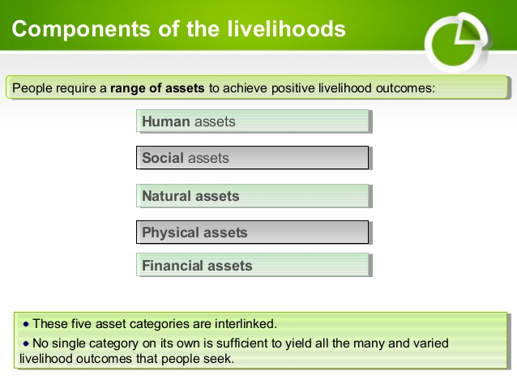

Livelihood Assets/ Endowments
Human capital: - represents the skills, education, knowledge, ability to labour (both quantity and quality), and good health that together enable people to pursue different livelihood strategies and achieve their livelihood objectives.
To build human capital for the poor
- Provide health/education/training, infrastructure
- Changes in local institutions -culture, norms that limit access to health/education/training (e.g. for women),
- Reform of health/education/training policies and
- Reform of health/education/training organization –etc.
Financial capitals
Financial capital denotes the financial resources that people use to achieve their livelihood objectives, it includes flows as well as stocks, and it can contribute to consumption, production, etc.
Sources of financial capital.
Available stocks: Savings (can be held in cash, bank deposits or liquid assets such as livestock and jewelry) and obtained through credit-providing institutions.
Regular inflows of money: Excluding earned income, inflows are pensions, or other transfers from the state, and remittances.
Importance of financial capital
- It can be converted with varying degrees of ease, depending upon Transforming Structures and Processes into other types of capital.
- It can be used for direct achievement of livelihood outcomes (for example when food is purchased to reduce food insecurity)
- It can also be transformed into political influence and can free people up for more active participation in organizations that formulate policy and legislation and govern access to resources-etc
To build financial capital for poor
Organizational - increasing the productivity of existing savings and financial flows develop effective financial services for the poor, encouraging people to save, developing organizations that transit remittance income more efficiently to final recipients-etc.
Institutional - increasing access to financial services, including overcoming barriers associated with poor people’s lack of collateral
Legislative/regulatory - reform the environment in which financial services operate, provide better safety nets for the poor (including pensions) and reform of financial sector legislation/regulation.

Natural capital;-comprises land, water, forests, marine/wild resources ,water, air quality, erosion protection, waste assimilation, storm protection, biodiversity degree and rate of change, etc. that are utilized by people to generate a means of survival. It has
Direct use value (e.g. land used for agricultural production or of recreational areas, etc);
Indirect use value (e.g. biodiversity, erosion protection and other ecological services); and
Non-use value (often calculated based on the amount people would be willing to pay to see the continued existence of a given resource, regardless of whether they use it).
To build natural capital for poor
- Conserve resources and biodiversity (through technology and direct action),
- Provision of services/inputs (e.g. for forestry, agriculture. etc),
- Reform of organizations that supply services (e.g. involved in forests/agriculture/fisheries--etc),
- Changes in institutions that manage, and govern access to natural resources,
- Environmental legislation and enforcement mechanisms and
- Support to market development to increase the value of forest-etc
Social capital – refers to community and wider social claims on which individuals and households can draw by virtue of belonging to social groups.
It is developed through:
- Networks and connectedness (increase people’s trust and ability to work together and expand their access to wider institutions, such as political or civic bodies, etc).
- Membership of more formalized groups which often entails adherence to mutually-agreed or commonly accepted rules, norms and sanctions; and
- Relationships of trust, and exchanges that facilitate co-operation, reduce transaction costs and may provide the basis for informal safety nets amongst the poor.
To build natural capital for poor
- Improve the internal functioning of groups, leadership and management extending external links of local group) ,
- Develop group/network formation and structure,
- Develop of more open and reliable policy environment (good governance) and
- Organizations develop systems for external consultation with civil society.

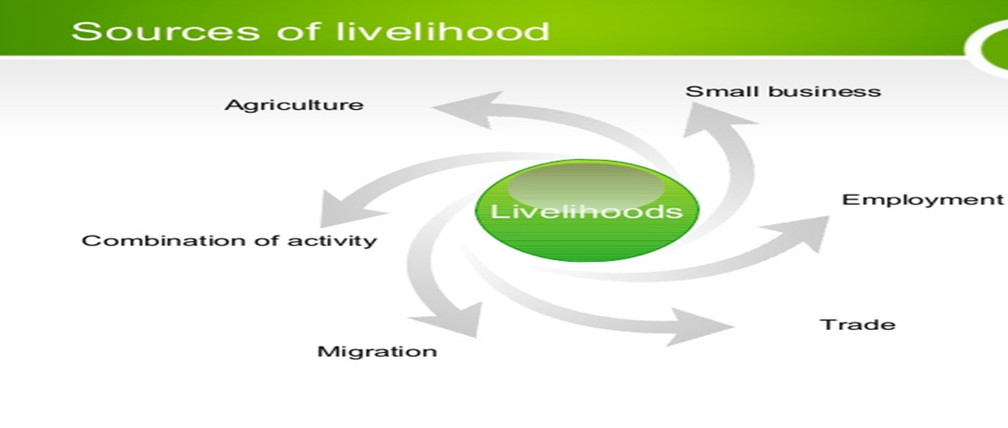
5.3 Determinants of sustainable livelihoods
The initial determinants of livelihood strategies are:
Birth: many livelihoods are largely predetermined by accident of birth. Eg children may be born into a caste with an assigned roles as potters, shepherds etc
Gender: as socially defined, it is also a pervasive ascriptive determined of livelihood activities
Inherited livelihood: a person may be born socialized & apprenticed into an inherited livelihood as cultivar with land and tools, a pastoralist with animals, a forest dweller with trees, a fisher person with bot and shopkeeper with shop & stick. Each of these may create a new household via the same occupation.
Livelihoods are determined by multiple factors
Livelihoods are determined by multiple factors

A combination of different types of information is needed to understand them, including:

Vulnerability context
Livelihood resources or assets

Policies, institutions and processes

Livelihood strategies
Livelihood outcomes or goals
Vulnerability context፡ the vulnerability context frames the external environment in which people live.
It includes factors over which people have limited or no control such as Long-term trend factors, risk of shocks and seasonal elements.
It is important to understand the political context in order to understand the vulnerability context.
In situations of political instability and war, it is ethnic or political affiliation that determines risk and vulnerability, irrespective of wealth.
Livelihood resources or assets: People require a range of assets to achieve positive livelihood outcomes like human, social, natural and physical, financial assets.
- These five asset categories are interlinked.
- No single category on its own is sufficient to yield all the many and
Varied livelihood outcomes that people seek.
Policies, institutions and processes: are man-made external factors that shape the options that people have in achieving their livelihood goals. They:
- Influence access to assets and vulnerability to shocks,
- Operate at all levels, from the local to the international level,
- Operate in all spheres, from the most private to the most public
- Can be instrumental in increasing or reducing vulnerability to disasters (especially Agricultural, land tenure or land use policies).
Policies (agricultural, land tenure or land use) can be instrumental in increasing or reducing vulnerability to disasters.
Institutions include civic, political and economic agencies. People’s protection and welfare depend on:
- Accountable political systems,
- Rule of law,
- Functioning judicial systems, and
- The provision of public services.
Processes determine the way institutions and people operate and interact. They can include:
- changes in the economy,
- employment patterns,
- markets,
- culture, and
- Long-term processes of social, economic and political marginalization.
Livelihood strategies: are the range and combination of activities and choices that people make or undertake in stable times to achieve their livelihood goals (e.g. productive activities, investment strategies, reproductive choices).
Livelihood strategies are the methods and processes used to transform livelihood assets into livelihood outcomes.
Livelihood strategies divided in to:
- Natural resource-based activities (e.g. cultivation, livestock-keeping, weaving, collection and gathering)
- Non-natural resource-based activities (e.g. trade, services, remittances).
Coping strategies, in contrast, are temporary responses to food insecurity (although in many protracted emergencies they become livelihood strategies).
Livelihood outcomes or goals: Livelihood outcomes can be categorized under three headings:
Economic: Food and income security, i.e. the ability to acquire sufficient food and income to meet basic needs.
Biological: Mortality and malnutrition rates or levels are biological measures of livelihood outcome.
Social: Dignity is clearly a social measure the right to; life with dignity is one of the fundamental principles in the Humanitarian Charter.
Self-check
- Define livelihoods
- Elaborate “livelihood group” and “sustainable livelihood” briefly.
- Describe the Principles of sustainable livelihoods
- Give brief explanation for components livelihood assets
- Discuss sources of livelihood
- Explain determinants of sustainable livelihood
- What do you mean by livelihoods strategies? Justify your answer with explanation
- Describe livelihoods outcomes.

CHAPTER SIX: LIVELIHOOD ZONING
6.1 Meaning of Livelihood Zoning
A livelihood zone is a geographical area within which people share the same patterns of access to food and income (that is, they grow the same crops, or keep the same types of livestock), and have the same access to markets.
Therefore, livelihood zones are areas within which people share broadly the same pattern of livelihood, including options for obtaining food and income and market opportunities.
Objectives of livelihood zoning
To delineate coherent areas where people share broadly similar livelihood patterns methods of food and other agricultural production methods of securing other incomes, market systems, food consumption, or preference habits poverty levels.
The delineated areas typically fall into biophysical (agro-climatic) and socioeconomic poverty/wealth zones.
Livelihood zoning thus creates an economic geographical map that shows the varied contexts in which livelihoods are followed.
Usually livelihood zones do not exactly aligned with administrative or political boundaries.
However, livelihood zone maps are super imposed upon administrative maps so that the populations within the zones can be easily identified.
6.2 Purpose of livelihood zoning
A livelihood zoning is essential for the following reasons:
It provides geographic orientation of livelihood systems to inform food security analysis and assistance targeting
It provides the basis for identifying geographically relevant food security monitoring indicators
It provides a sampling frame for future on-the-ground assessments
Livelihood patterns clearly vary from one geographic area to another, which is why the preparation of a livelihood zone map is a logical first step for livelihoods-based analysis.
Livelihood zones help identify relevant indicators for monitoring household food security
They provide a sampling frame for field surveys and assessments
Provide a logical starting point for emergency assessments, market assessments, nutrition surveys and other food security or livelihood-related investigations. Using homogenous zones as the foundation for fieldwork helps reduce the risk of inconsistencies and unexplained anomalies in field data.
Livelihood zones, when combined with full household economy baselines, can also provide the basis for targeting emergency relief or development assistance.
Provide the geographical boundaries for household economy baseline data, which consists of quantified data on sources of food and cash income and patterns of expenditure for different wealth groups. This data can be used to determine how much assistance is needed and where if a hazard (such as drought or market failure) occurs.
It provides geographic orientation of livelihood systems to inform food security analysis and assistance targeting
It provides the basis for identifying geographically relevant food security monitoring indicators
It provides a sampling frame for on the‐ground assessments and assistance targeting
6.3 Determinants of livelihood zoning
Local factors such as climate, soil, access to markets, etc. all influence livelihood patterns. For example, people living in a fertile highland area generally have very different options from those living in a semi-arid lowland area. In highland areas, people can generally pursue an agricultural pattern of livelihood, while in the lowlands; they can grow few crops and will be either pastoralists or agro-pastoralists. Those living in a coastal or lakeside zone will follow a livelihood based upon fishing or combining fishing with other activities, and so on.
The livelihood zones are composites of various combinations of the following factors:
Source of water for agriculture- (rain fed or irrigated)
- Irrigated zones rely on water from snowmelt and/or rivers.
- Rain fed zones depend almost entirely on seasonal precipitation.
Number of months covered by own crop production
Households in all but one zone rely on crop production to meet at least some of their annual food needs.
Importance of livestock (pastoral, agro-pastoral, mixed)
Prevalence of cross-border trade-
Agro-ecology is only one aspect of geography, which determines patterns of livelihood.
Market access: this affects the ability of people to sell their production (crops, livestock, or other items) and the price obtained for it. Since patterns of livelihood depend so much upon geography, it makes sense to divide a country or a region into a number of livelihood zones.
Livelihood zone boundaries do not always follow administrative boundaries. It is quite common to find different patterns of livelihood within a single administrative unit (e.g. pastoralists living alongside agriculturalists, or agro-pastoralists alongside fishing communities). However, resource allocation and service provision decisions are made based on administrative areas, it is important that livelihood zone boundaries should wherever possible follow lower level administrative boundaries.
The Wealth Breakdown: Geography is clearly not the only thing that determines the pattern of livelihood. Geography tends to define the different livelihood options, but the extent to which people exploit these options depends upon a number of factors, of which wealth is generally the most important. It is obvious, for example, that better-off households owning larger farms will in general produce more crops and be more food secure than their poorer neighbors. Land is just one aspect of wealth, however.
Wealth groups are defined in terms of their land holdings, livestock holdings, capital, education, skill, labor availability and/or social capital.
Defining the different wealth groups in each zone is the second step in a food economy analysis, the output from which is a wealth breakdown.
The Food Economy Baseline: Having grouped households according to where they live and their wealth, the next step is to generate food economy baseline information for typical households in each group for a baseline year. This involves investigating the different sources of food and cash income and their relative contribution to the household budget over the year as a whole.
It also involves developing a seasonal calendar of activities to see how access to food and cash income varies throughout the year. These types of information are critical in terms of understanding how households living at different levels of wealth and in different zones will be affected by a particular hazard.
It follows, for example, households that depend heavily upon local livestock production will be affected quite differently by drought compared to those that have relatives living and working in the capital city from whom they receive regularly assistance or remittances.
Hazard: Food economy baseline data provide a starting point for investigating the effect that a hazard will have on livelihoods and household food security.
Hazards may either be natural (e.g. drought or flood) or man-made (e.g. conflict or market dislocation).
The consequences of a hazard will vary according to the hazard itself and according to the local pattern of livelihood.
A drought may result in a loss of crop and livestock production, loss of crop and livestock sales income, loss of farm-based employment, etc., posing a threat to households that are heavily dependent upon crop or livestock production or upon local agricultural labor.
On the other hand, may be associated with the theft of crops or livestock, reduced access to certain areas (markets, wells, grazing areas or fields) and disruptions to trade and transportation, all of which will pose a threat to groups living in, moving through or trading with the insecure area.
Response: When exposed to a hazard, most households will do their utmost to try to deal with its effects.
If the hazard tends to reduce their access to certain sources of food and/or cash income, they may try to expand other sources, or they may turn to new or little-used sources.
Common response strategies include an increase in the collection of wild foods, increase in the sale of livestock, or temporary out-migrating in search of employment. These strategies significantly reduce vulnerability to a range of hazards. However, response strategies may have long-term as well as short-term effects, some of which may ultimately undermine local livelihoods, e.g. the sale of productive assets, the unsustainable sale of livestock, in increase in the sale of firewood where this has negative environmental effects, and so on
6.4 Procedures of livelihood zoning
The livelihood zone map that provides a starting point for any subsequent baseline assessment, and can be used on its own to provide an overview of different livelihood patterns across a large area.
Steps in a national or regional livelihood zoning
1. A review of available rainfall, agro-ecological, soil, vegetation and agro- economic maps;
2. An initial workshop at either national or regional level to obtain a preliminary map and zone descriptions. Participants usually include technical staff from relevant line ministries (e.g., agriculture, livestock, meteorology, natural resources, fishing), NGOs and international organizations.
3. Consultations with key informants at a lower level (either regional or district), and possibly some village visits, to confirm the map and clarify any outstanding issues. (It is generally not possible to delineate livelihood zones on the basis of secondary data alone, because livelihood zones are not based on what the land is used for (as shown on a land use map) or on what people grow (as shown on an agro-ecological map), but on what people do).
4. A return to the first level to agree any changes with partners and to get a consensus on the ‘final’ map – although a livelihood zone map is always open to change because of fieldwork that is more detailed.

Self –check
- Define livelihood zoning
- Explain the objectives of livelihood zoning
- What is the difference between livelihood zone and administrative boundaries?
- Discus the purpose of livelihood zoning
- Briefly explain factors determine livelihood zoning
- Describe procedures of livelihood zoning
CHAPTER 7. SUSTAINABLE LIVELIHOOD ANALYSIS
Livelihoods analysis is an approach that determine how people live or make a living. It incorporates an understanding of how household capabilities, assets and activities combine with in specified environment to achieve household wellbeing in the short and long term. Livelihoods analysis is assesses the resilience of household strategies in the face of shocks and stresses and assists in identifying vulnerable areas or groups. Equally, livelihoods analysis assesses the household strategies in the face of assets or endowments and capabilities and assists in identifying high potential areas or groups.
A livelihoods analysis aims to increase understanding of about:
- The nature of livelihoods for different categories of people
- The main issues concerning livelihoods such as
  - Major trends, problems and constraints
  - Shocks and stress
  - Coping and adaptive strategies
  - Overall and absolute levels of livelihood insecurity and vulnerability
- The opportunities and potentials for addressing these issues
- Potential strategies and priorities as well as actions to be taken.
7.1 Analytical framework of sustainable livelihoods
Sustainable livelihood framework will improve our understanding of the diverse nature and the complexity of social change in rural as well as in urban areas where there is a wide range of processes and factors that affect livelihoods. Sustainable livelihood framework accommodate process of social change and how they affect the configuration of available key resources and what individuals and households can do with such resources. Sustainable livelihood framework intends to deepen our understanding of social differentiation and vulnerability.
The livelihoods framework centered around three analytical principals:
1. The analysis is ‘holistic’, involving three levels of analysis:
• Contextual: the analysis explores the major economic, political, social, resource-based and cultural trends and issues facing households in a particular context.
• Differentiated: the analysis highlights social and economic differentiation between households;
• Disaggregated: the analysis draws out the different experiences of diverse individuals with regard to gender, and generational differences within households.
2. Livelihoods analysis delineates the ‘vulnerability context.’ Identifying the wider shocks and stresses that influence livelihoods and present challenges to the maintenance of household assets, or to their accumulation and depletion, then by understanding how and why households are responding to such trends, it gives key insight into livelihood strategies.
3. Finally, livelihoods framework distinguishes between the vulnerability context, the livelihood strategies of households, and livelihood outcomes. Livelihood outcomes are the results of household livelihood strategies within a particular context. In that context, factors such as markets, governance, policies, and civil society are analyzed, showing both the major trends and the prevailing shocks and stresses. At the level of livelihood strategies, the analysis captures the levels of human, social, economic and natural capital of different households, and the nature of the household production, income and exchange activities based on these assets. Consumption activities of household members relate to livelihood outcomes for households with different levels of livelihood security.
Sustainable livelihoods are those that are:
- Able to cope with and recover from shocks and stresses (such as drought, civil war, policy failure) through adaptive and coping strategies;
- Economically effective;
- Ecologically sound, ensuring that livelihood activities do not irreversibly degrade natural resources within a given ecosystem; and
- Socially equitable, which suggests that promotion of livelihood opportunities for one group should not foreclose options for other groups, either now or in the future.
It adopts a five-stage approach when applying the SL approach:
- Participatory assessment of risks, assets, indigenous knowledge base, coping and adaptive strategies of communities and individuals.
- Analysis of micro, macro and sectoral policies that influence people’s livelihood strategies.
- Assessment of how modern science and technology can help people improve their livelihoods (complementing indigenous technologies).
- Assessment of social and economic investment mechanisms that help or hinder people’s livelihoods.
- Making sure, the first four stages are integrated in real time, so that this process is part of overall programme development, rather than isolated events in time.
Core Features of the Sustainable Livelihoods Framework
The application of the SLF involves the requires the consideration of the following aspects:
- An understanding of vulnerability in a given context.
- A strategy to protect livelihoods.
- An analysis of different types of capital:
Human Capital: It represents the abilities, experience, work skills and the physical state of good health which, when combined, allow populations to engage with different strategies and fulfil their own objectives for their livelihoods.
Social Capital: It refers to the social resources, which populations will rely on when seeking their objectives relating to livelihoods (in the present study this refers specifically to local social capital, this being networks, associations, local authorities, local officials and broader population receiving program assistance).
Natural Capital: It is the term used to refer to the stocks of naturally occurring resources (soil, water, air, genetic resources, etc.) which can be used as inputs to create additional benefits, such as food chains, protection against soil or coastal erosion, and other natural resources, which can support livelihoods.
Physical Capital: This refers to the basic infrastructure and production inputs needed to support livelihoods.
Financial Capital: This refers to the financial resources, which populations employ to achieve their objectives regarding livelihoods
7.2 Components of livelihood analytical framework
The framework consists of a number of key elements as follows:
• Livelihood assets and activities
• Vulnerability and coping strategies
• Policies, institutions and processes
• Livelihood outcomes
- The framework presents the main factors that affect people’s livelihoods and typical relationships
The framework used in both:
- Planning new development activities and
- Assessing the contribution to livelihood sustainability made by existing activities
- It consists of five major components that are related through sequential relationships and feedback.
These include:
1. Vulnerability context
The vulnerability context describes the external uncontrollable factors that influence people’s assets and livelihood opportunities. Broadly, these factors are classified as:
- Shocks (e.g. environmental, conflict-related);
- Trends (e.g. resources, technology);
- Seasonality (e.g. price fluctuations, employment opportunities)
How to influence: In the short- to medium-term, there is little that people can do to affect the vulnerability context itself. However, humanitarian and development agencies can play a critical role in promoting resilience to these factors by increasing access to insurance, improving institutional response capacity, and implementing other resiliency-promotion programs.
2. Livelihood assets
Overview: the framework outlines assets in terms of five categories necessary for the pursuit of positive livelihood outcomes:
- Human capital (i.e. the amount and quality of knowledge and labor available in a household)
- Natural capital (i.e. the quality and quantity of natural resources, ranging from fisheries to air quality)
- Financial capital (i.e. savings and regular inflows of money)
- Physical capital (i.e. the infrastructure, tools, and equipment used for increasing productivity)
- Social capital (i.e. social resources, including networks for cooperation, mutual trust, and support)
How to influence: This element of the framework utilizes a pentagon to describe livelihood assets, with each point assigned to a particular type of asset so that the shape of the pentagon changes as stores of certain types increase. When addressing this component of the framework, humanitarian and development agencies should pay attention to two considerations in particular: the sequence in which certain assets contribute most effectively to the attainment of others, and instances when certain types of assets can be substituted for other types (e.g. human capital for financial). As people acquire more assets, they will become more empowered to influence the next component of the framework, the structures and processes that affect them.
3. Transforming structures and processes
Overview: Here, “structures” refer to the organizations that create and enforce legislation, provide the necessary requirements for acquiring and capitalizing upon assets (e.g. private suppliers of materials for building shelters), manage natural resources, and provide other services crucial for gaining access to assets, exchanging them, and benefiting from their use. Meanwhile, “processes” determine the interactions between the structures and individuals. Examples of processes include policies, legislation, power relations, norms, market stability, and general rule of law.
How to influence: Structures must be accompanied by appropriate policies if they are to have any impact on the poor, while policies must be implemented by competent structures if they are to be carried out in the intended manner. Still, humanitarian and development organizations can take steps to improve structures and processes individually. Organizations should focus on building institutions’ capacity to represent interests of the poor, provide training to reduce the market gap in goods and services, and bring together different organizations and interests through joint forums. Likewise, they should support participatory models of policy formulation, increase the accountability and transparency of institutions, support the expansion of social safety net policies, and direct other efforts toward elevating the voice of the poor in policies, legislation, and institutions.
4. Livelihood strategies
Overview: Livelihood strategies concern the individual’s available and implemented options for pursuing livelihood goals. The greater the diversity of livelihood strategies, the higher the household’s resilience to the shocks, trends, and seasonality conditions within the vulnerability context.
How to influence: In accordance with a sustainable livelihoods approach, humanitarian and development agencies should look to promote those underlying conditions that provide the greatest diversity of choice and flexibility in the pursuit of maintaining a livelihood. In doing so, agencies should focus on expanding access to a variety of capital assets and supporting the improvement of the structures and processes that shape livelihoods. These efforts should be complemented by attention to the social safety nets provided to those who are unable to achieve livelihood objectives through the market system.
5. Livelihood outcomes
Livelihood outcomes refer to the outputs of livelihood strategies. Achievements may include higher income, greater well-being (e.g. self-esteem, physical security, political empowerment), reduced vulnerability, greater food security, and/or improved environmental sustainability.
How to influence: The balance of livelihood goals indicates motivations for behavior, livelihood priorities, and, in turn, the types of activities that humanitarian and development agencies should implement. Of course, livelihood outcomes are not always coherent; they oftentimes conflict, as when the pursuit for income comes at the expense of environmental sustainability. Thus, while the primary goal of agencies is to support the achievement of positive livelihood outputs, conflicting outcomes, the difficulty of translating outputs into indicators of success, and lack of objectivity in the monitoring process make an output-based set of indicators complicated.
Figure 1.sustainable live hood framework
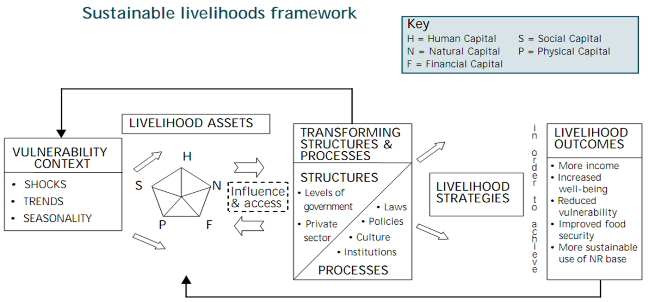

7.3 Comparison of Livelihood frameworks
In contrast, the Sustainable Livelihoods Approach starts by looking at the day-to-day experiences of people’s lives. Its starting point is the assumption that in order to make ends meet people draw upon a combination of different assets that are available to them.
How does sustainable livelihood differ from community based development programmes?
- Sustainable livelihoods builds on many of the strength of community based development programs.
- It is participatory and works with local people to understand their strengths and determine their priorities (therefore enables people to take action).
- It tries to avoid sectional preconceptions. However, a core difference is that it looks beyond the local environment.
- It is neither bottom-up nor top-down, but stress that all levels work together.
- A primary objects of sustainable livelihood analysis is to understand how wider policies, institutions and process affect local livelihoods.
- Sustainable livelihood informed programmes then main to engage at various levels and to help change this wider environment so that it facilitates sustainable livelihoods.
How does sustainable livelihood approach related to sector programmes?
- Sector wide approaches and sustainable livelihood approaches need not conflict.
- Sustainable livelihood approaches can be effective at both gross roots and policy levels.
- Sustainable livelihood should encourage sector programs to broaden stakeholder participation, to consider local outcomes when thinking about policy and to establish cross-sectional links.
- Sustainable livelihood guided sector programs might be the most appropriate form of development activity.
- Sustainable livelihood approaches also aims to be built on ‘best practices’ in public expenditure and management issues.
How doe sustainable livelihood approach related to rights?
- Sustainable livelihood approaches encourages users to adopt a rights perspective. This encourage them to put people:
  - Their access to resources
  - Their degree of voice and power in the wider political and social context at center of development.
Conversely, rights practitioners can use sustainable livelihood approaches to promote rights based projects in cases where calling then rights based project is not feasible.
The ways in which people combine their assets to support themselves and their families, and the decisions and choices that they make within the context in which they live, is what makes up their livelihood strategy. The approach sets out to understand these strategies and the impact of both internal and external factors upon them.
The final stage of the approach is to identify the constructive steps that could be taken to improve an individual or family situation further up the livelihood ladder, starting from their own experiences and building upon their existing strategies, to enable them to make their livelihoods more secure and sustainable.

Figure 2.livelihood framework
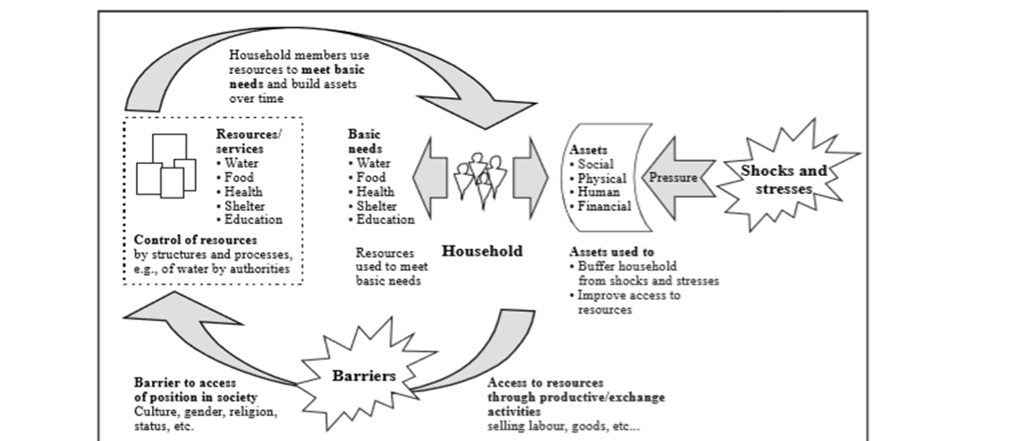
7.4 Methods of livelihood analysis
The Livelihood analysis is process consists of three interrelated elements: a Livelihood Baseline (LB); an initial Livelihood influence Appraisal (ILIA); and a detailed Livelihood Assessment (DLA).
Each of the three parts of the livelihood analysis serves different but related functions in the assessment process. Each part may also have different targets in terms of funding mechanisms and may be executed by different people, as indicated as follows.
-Livelihood Baseline LB:
To provide a good picture of ‘normal’ livelihood patterns in areas at risk from natural hazards together with an indication of likely impact of hazards, key response priorities and institutions likely to be involved in recovery. Gives a ‘head start’ for post-disaster assessments.
Provides the pre-disaster context for the ILIA and DLA, so enhancing the power of these tools to make informed generalizations on the livelihood impact and opportunities presented by the disaster.
Initial Livelihood Impact Appraisal: ILIA
Initial assessment of impact of disaster on livelihoods at ‘local level’ – to be integrated into multi-sectoral quick impact assessments and feeding into Flash Appeal proposals.
Detailed Livelihood Assessment: DLA
Assessment of impact of disaster on livelihoods and opportunities, capacities and needs for recovery at household, community, and local economy levels. Includes conversion of the results of assessments into response options containing strategy outlines programme profiles and concrete projects

Self-check
- Define livelihood analysis
- Describe aims of livelihood analysis
- Describe analytical framework of sustainable livelihoods
- Elaborate analytical principals of livelihood framework
- Describe approaches of analytical framework of sustainable livelihood.
- What are core features of sustainable livelihood frameworks?
- Briefly explain components of livelihood analytical framework
- Elaborate comparison of livelihood framework
- Briefly explain livelihood analysis methods
- Elaborate the difference between sustainable livelihood framework and livelihood framework.

