**Polymerase Chain Reaction**

Polymerase Chain Reaction (PCR) is a revolutionary method developed by Kary Mullis and Michael Smith. Both shared Nobel Prize in Chemistry for the work in 1993. PCR is based on ability of DNA polymerase to synthesize complementary strand to the template strand. As DNA polymerase can add a nucleotide only onto a 3'-OH group, it needs an artificial DNA strand (called DNA primer) of about 18 to 25 nucleotides complementary to 3’ end of the DNA template. As shown below, each polynucleotide has a free 3’ –OH group and 5’ phosphate group. Moreover, a DNA strand has complimentary sequence, already paired by hydrogen bonding. Thus, primer can bind only when DNA strands are separated. This is generally done by heating. The primers anneal to the single-stranded DNA template at specific temperature (depends on primer sequence) and then DNA-Polymerase binds to this double stranded DNA produced. The again reaction mixture is heated to 72°C (extension); a temperature optimum for DNA- polymerase functions. This starts synthesis of the new DNA strand. Than reaction mixture is cooled to lower temperature for short term storage, if required. This completes one cycle. After first cycle, one DNA molecule has become two. After multiple cycle of the PCR reaction, the specific sequence will be accumulated in billions of copies.

**The PCR reaction requires the following components:**

***DNA template:*** DNA template is DNA target sequence. As explained earlier, at the beginning of the reaction, high temperature is applied to separate both the DNA strands from each other so that primers can bind during annealing.

***DNA polymerase:*** DNA polymerase sequentially adds nucleotides complimentary to template strand at 3’-OH of the bound primers and synthesizes new strands of DNA complementary to the target sequence. The most commonly used DNA polymerase is *Taq* DNA polymerase (from *Thermus aquaticus,* a thermophillic bacterium) because of high temperature stability. *Pfu* DNA polymerase (from *Pyrococcus furiosus*) is also used widely because of its higher fidelity (accuracy of adding complimentary nucleotide). Mg2+ ions in the buffer act as co-factor for DNA polymerase enzyme and hence are required for the reaction.

***Primers:*** Primers are synthetic DNA strands of about 18 to 25 nucleotides complementary to 3’ end of the template strand. DNA polymerase starts synthesizing new DNA from the 3’ end of the primer. Two primers must be designed for PCR; the forward primer and the reverse primer. The forward primer is complimentary to the 3’ end of antisense strand (3’-5’) and the reverse primer is complimentary to the 3’ end of sense strand (5’-3’). If we consider the sense strand (5’-3’) of a gene, for designing primers, then forward primer is the beginning of the gene and the reverse primer is the reverse-compliment of the 3’ end of the gene.

***Nucleotides (dNTPs or deoxynucleotide triphosphates):*** All types of nucleotides are "building blocks" for new DNA strands and essential for reaction. It includes Adenine(A), Guanine(G), Cytosine(C), Thymine(T) or Uracil(U).

**In some cases, the following compounds are added to enhance the specificity and or efficiency of a PCR:**

* Betadine; Bovine serum albumin; Dimethylysulfoxide; Glycerol; Pyrophosphatase; Spermidine, Detergent, Gelatin,…….

**PCR Reaction Setup:**

|  |  |  |  |
| --- | --- | --- | --- |
| **Stock Concentration** | **Reaction**  **Components** | **Volume**  **/reaction** | **Final Concentration** |
| 10X | PCR Buffer | 5 µl | 1X |
| 25mM | MgCl2 | 4 µl | 2mM |
| 10mM | dATP | 1 µl | 0.2mM |
| 10mM | dCTP | 1 µl | 0.2mM |
| 10mM | dTTP | 1 µl | 0.2mM |
| 10mM | dGTP | 1 µl | 0.2mM |
| 5Unit/µl | Taq DNA Polymerase enzyme | 0.3 µl | 1.5 Unit |
| 10ng/µl | Forward Primer | 1 µl | 10ng |
| 10ng/µl | Reverse Primer | 1 µl | 10ng |
| 100ng/µl | Template DNA | 1 µl | 100ng |
|  | Molecular grade H2O | 33.7 µl |  |
|  | **Total Volume =** | **50 µl** |  |

**Procedure:**

There are three major steps in a PCR, which are repeated for 30 or 40 cycles. This is done on an automated cycler, which can heat and cool the tubes with the reaction mixture in a very short time.

1. **Denaturation** at 94°C :

During the heating step (denaturation), the reaction mixture is heated to 94°C for 1 min, which causes separation of DNA double stranded. Now, each strand acts as template for synthesis of complimentary strand.

2. **Annealing** at 54°C :

This step consist of cooling of reaction mixture after denaturation step to 54°C, which causes hybridization (annealing) of primers to separated strand of DNA (template). The length and GC-content (guanine-cytosine content) of the primer should be sufficient for stable binding with template. Please recall our discussion about DNA structure during earlier lectures. Guanine pairs with cytosine with three hydrogen bonding adenine binds with thymine with two hydrogen bonds. Thus, higher GC content results in stronger binding. In case GC content is less, length may be increased to have stronger binding (more number of H bonding between primer and template).

3. **Extension** at 72°C :

The reaction mixture is heated to 72°C which is the ideal working temperature for the Taq polymerase. The polymerase adds nucleotide (dNTP's) complimentary to template on 3’ –OH of primers thereby extending the new strand.

4. **Final hold**:

First three steps are repeated 35-40 times to produce millions of exact copies of the target DNA. Once several cycles are completed, during the hold step, 4–15 °C temperature is maintained for short-term storage of the amplified DNA sample.

**PCR-an exponential cycle:**

|  |  |  |  |
| --- | --- | --- | --- |
| **Step** | **Action** | **Temperature**  **(°C)** | **Duration** |
| 1 | Initial denaturation | 94 | 3 min |
| 2 | Denturation | 94 | 1 min |
| 3 | Annealing | 55 | 1 min |
| 4 | Extension | 72 | 2 min |
| 5 | Go to Step 2 |  | Repeat for 30 times |
| 6 | Final extension | 72 | 7 min |
| 7 | Hold | 10 | **∞** (infinity) |

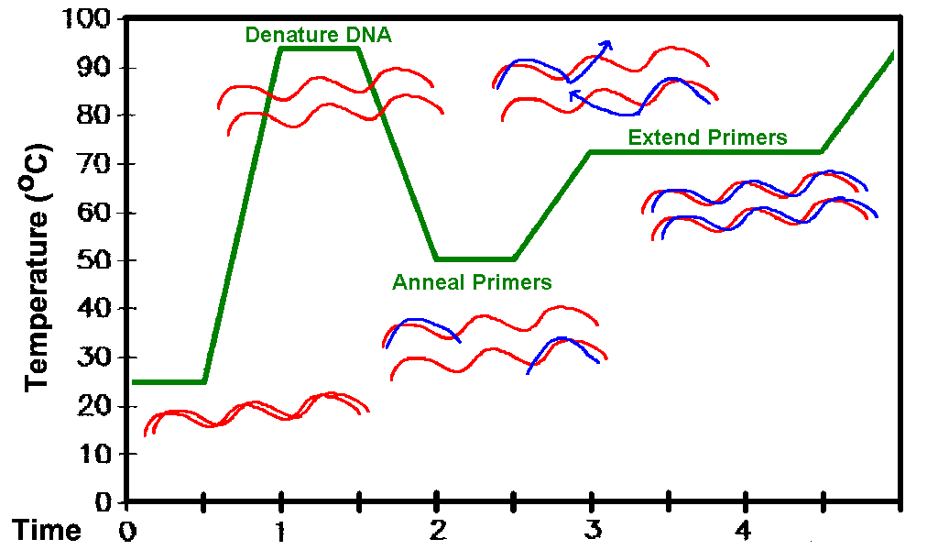As both strands are copied during PCR, there is an exponential increase of the number of copies of the gene as shown in the figure. Suppose there is only one copy of the desired gene before the PCR starts, after one cycle of PCR, there will be 2 copies, after two cycles of PCR, there will be 4 copies. After three cycles there will be 8 copies and so on.

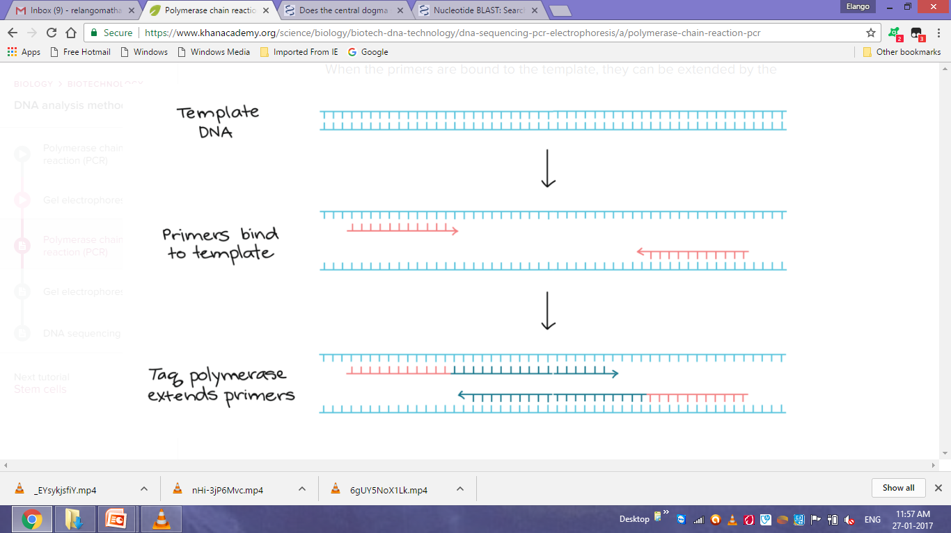

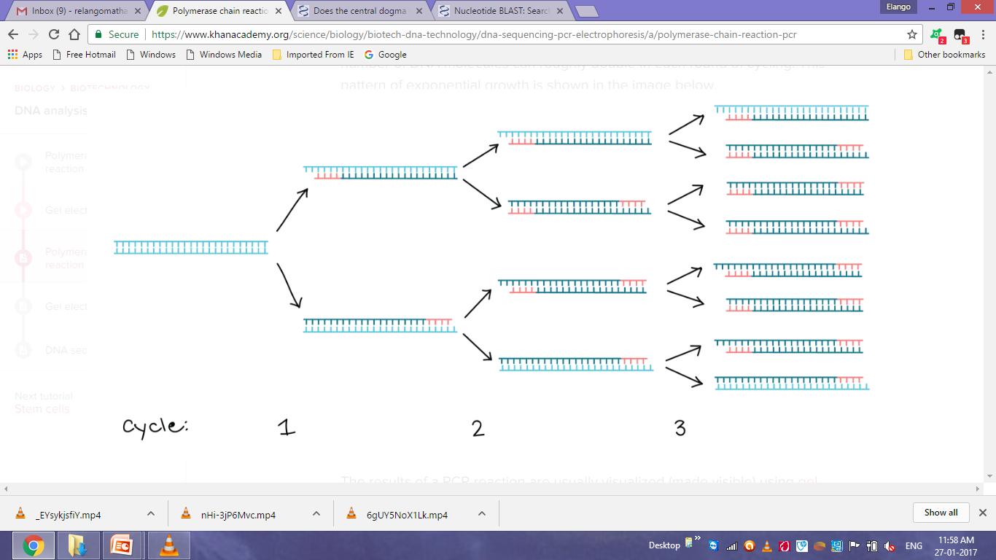



**Agarose gel electrophoresis of PCR product compared with DNA ladder at both end lanes.**

**Primers design:**

Primers should bind to template with good specificity and strength. If primers do not bind to correct template, wrong sequence will get amplified. Optimal primer sequences and appropriate primer concentrations are essential for maximal specificity and efficiency in PCR. PCR specificity and efficiency can be greatly affected by the way primers are designed and used. Even when primers are designed to have similar annealing properties, the PCR may yield nonspecific PCR products (undesired DNA segment amplified), low amounts of specific product, or fail completely.

* Complementary nucleotide sequences within a primer and between primers should be avoided. If there are complimentary sequences in two primers used (one primer for each DNA strand), the primers will hybridize with each other thus forming primer-dimmers and will not be available for binding with template. If there are complementary sequences within a primer, it will make hairpin loop structures as shown below.
* The primers should preferably end on a Guanine and Cytosine (GC) sequence so that it can attach with sufficient strength with template. This increases efficiency of priming due to stronger bonding of G and C bases.
* Runs of three or more Cytosine (C) or Guanine (G) at the 3'-ends of primers should be avoided. This may promote mispriming i.e non-specific binding to G or C rich sequences in the genome other than the target sequence.
* As Adenine and Thymine base pairs with a single H-bond so Thymine (T) or Adenine (A) residues should be avoided at the 3’ end of primers as this weaken the primer’s hold on the template DNA
* **Calculation of melting (Tm) and annealing (Ta) temperature for the primers.**

**Tm= 2 X [number of A + T] + 4 X [number of G + C]**

**Optimal annealing temperature (Ta) is 5-10**°**C lower than Tm values of the primers.**

**[Ta = Tm – (5 to 10) ]**

**PCR Advantages:**

* Specific
* Simple, rapid, relatively inexpensive
* Amplifies from low quantities
* Works on damaged DNA
* Sensitive
* Flexible

**PCR Limitation:**

* Contamination risk
* Primer complexities
* Primer-binding site complexities
* Amplifies rare species
* Detection methods

**Variants of PCR** (Types of PCR):

* Reverse transcriptase-PCR.
* Nested-PCR.
* Hot-start PCR.
* Quantitative PCR.
* [Multiplex-PCR.](http://info.med.yale.edu/genetics/ward/tavi/p04.html)
* [Mutagenesis by PCR](http://www.nwfsc.noaa.gov/protocols/pcr-mut.html).
* Allele specific PCR.
* [Inverse PCR.](http://www.invitrogen.com/expressions/696-8.html)
* [Asymmetric PCR](http://www.uct.ac.za/microbiology/pcrcond.htm).
* [*In situ* PCR](http://www.cbc.med.umn.edu/VirtLibrary/Retzel/chapter3.7.fm.html).

**Applications of PCR:**

* Used in molecular biology and genetic disease research to identify new genes; for example, the sample containing pathogenic DNA can be PCR amplified using different known specific primers. The amplification indicates presence of pathogenic DNA.
* Viral targets, such as HIV-1 (Human Immunodeficiency Virus causing AIDS) and HCV (Hepatitis C virus) can also be identified and quantified by PCR. The severity of a viral infection can be measured and calculated by estimating the amount of virus in body fluid called as viral load using real time PCR. Thus it can be calculated as RNA copies per milliliter of blood plasma.
* In fields such as anthropology and evolution, sequences of degraded ancient DNAs can be tracked after PCR amplification. The source DNA from blood, chorionic villus, amniotic fluid, semen, hair root, saliva can be PCR amplified to produce in huge amounts, which can further be studied through Gel analysis, Restriction digestion, Sequencing etc.
* With its exquisite sensitivity and high selectivity, PCR has been used for wartime human identification and validated in crime labs for mixed-sample forensic casework. DNA is unique for each single type of organism, which can be exploited to identify an organism.
* PCR permits early diagnosis of malignant diseases such as leukemia and lymphomas. PCR assays can be performed directly on genomic DNA samples to detect translocation-specific malignant cells, infectious agents, like mycobacterium, anaerobic bacteria, or viruses.
* PCR - Polymerase Chain Reaction for Site Directed Mutagenesis -This technique is used for introduction of mutations at the desired place in a DNA sequence by altering the sequences of primers.

----------------------------------------------------------------------------------------------------------------------------------------------------