Basics of DNA Cloning
Cloning is making of identical copies. DNA cloning is process of making several identical copy of a gene or gene fragment. DNA fragment from an organism is cleaved or amplified and inserted in a DNA carrier called vector. Vectors are generally double stranded closed circular DNA which has origin of replication through which they can replicate in the host system. Vectors also have a selectable marker (generally antibiotics resistance gene) for screening of recombinant colonies. Vector with desired DNA insert is called recombinant DNA. This can be transferred to suitable host system (generally E.Coli) where it finds machinery for replication and makes several copies of it (may also express protein). The process is also called recombinant DNA technology or genetics engineering. Recombinant DNA technology is largely based on the work of Paul Berg, Herbert W. Boyer and Stanley N. Cohen although many other scientists have also made important contributions. Paul Berg in 1972, isolated a gene from a human cancer-causing monkey virus (SV40) using a restriction enzyme and joined this virus DNA with a molecule of DNA from the bacterial virus lambda using an enzyme called DNA ligase. This way the first recombinant DNA molecule was created. Later on, in 1980, Paul Berg shared Nobel Prize in Chemistry for the work.
Cloning is a natural process in biology where genetically identical individuals are produced by asexually reproducing organisms such as bacteria, insects or plants. In biotechnology, the process of producing multiple identical copies of DNA fragments (molecular cloning), cells (cell cloning), or organisms is referred to as cloning. A clone has an exact genetic imprint as that of the original cell, tissue or organism. There are different types of cloning technologies used for various purposes besides producing the genetic copy of an organism. Basically the cloning technology can be divided into three types as reproductive cloning, therapeutic cloning and recombinant DNA technology or DNA cloning. Reproductive cloning is a technology used to generate a twin of an animal that is genetically same as another currently or previously existing animal. The best example for reproductive cloning is Dolly, the first cloned sheep. Therapeutic cloning which is also known as “embryo cloning,” is production of human embryos for use in research and treatment of diseases. The aim of this technique is not human cloning, but rather to harvest stem cells that are used for research studies and to treat diseases. The last and most widely used cloning technique in biotechnology is recombinant DNA technology.
In Biotechnology the gene is the cornerstone of most molecular biology studies. The study of genes can be facilitated by isolation and amplification of gene of interest. Cloning is one method used for isolation and amplification of gene of interest. The gene is cloned by inserting it into another DNA molecule which acts as vehicle or vector that will replicate in living cells. As the two DNA molecules of different origin are combined, the resulting DNA is known as recombinant DNA molecule. The term “gene cloning,” “DNA cloning,” “molecular cloning,” and “recombinant DNA technology” all refer to same technique: Insertion of DNA fragment of interest from one organism into a vector which is a self- replicating genetic element inside a living cell. Gene cloning processes include removal of DNA from the cell, carrying out the DNA manipulations in test vial and, transformation of constructed DNA molecule back into the cells.
The first step in cloning is to prepare large amount of the vector and chromosomal DNAs. To carry the gene or the desired DNA fragment to the cell there is a need of a vector molecule. All cloning vectors are carrier DNA molecules. These carrier molecules host few common features in general such as; all vectors are self replicating in the cell, they contain a number of unique restriction enzyme cleaving sites that are present only once in the vector, they carry the selectable marker gene which is useful in selection of clone (usually an antibiotic resistance gene that is absent in the host cell) and, they can be very easily isolated from host cell. Depending on the purpose of cloning there are many vectors available. For use in the bacterial host E. coli system a greatest variety of cloning vectors have been developed. Thus, the first thing in cloning that a molecular biologist requires is to grow pure culture and isolate the cloning vector from the cells.
Choice of vector is dependent on insert size and application The most commonly used cloning vectors include plasmids and bacteriophages (phage λ) beside all the other available vectors (Table 1). The cloning vectors are limited to the size of insert that they can carry. Depending on the size and the application of the insert the suitable vector is selected. The different types of vectors available for cloning are plasmids, bacteriophages, bacterial artificial chromosomes (BACs), yeast artificial chromosomes (YACs) and mammalian artificial chromosomes (MACs).
Plasmids: Plasmids are extra chromosomal circular double stranded DNA replicating elements present in bacterial cells. Plasmids show the size ranging from 5.0 kb to 400 kb. Plasmids are inserted into bacterial cells by a process called transformation. Plasmids can accommodate an insert size of upto 10 kb DNA fragment. Generally plasmid vectors carry a marker gene which is mostly a gene for antibiotic resistance; thereby making any cell that contains the plasmid will grow in presence of the selectable corresponding antibiotic supplied in the media.
Bacteriophage: The viruses that infect bacteria are called bacteriophage. These are intracellular obligate parasites that multiply inside bacterial cell by making use of some or all of the host enzymes. Bacteriophages have a very high significant mechanism for delivering its genome into bacterial cell. Hence it can be used as a cloning vector to deliver larger DNA segments. Most of the bacteriophage genome is non-essential and can be replaced with foreign DNA. Using bacteriophage as a vector, a DNA fragment of size up to 20 kb can be transformed.
Bacterial artificial chromosomes (BACs): Bacterial artificial chromosomes (BACs) are simple plasmid which is designed to clone very large DNA fragments ranging in size from 75 to 300 kb. BACs basically have marker like sights such as antibiotic resistance genes and a very stable origin of replication (ori) that promotes the distribution of plasmid after bacterial cell division and maintaining the plasmid copy number to one or two per cell. BACs are basically used in sequencing the genome of organisms in genome projects (example: BACs were used in human genome project). Several hundred thousand base pair DNA fragments can be cloned using BACs.
Yeast artificial chromosomes (YACs): YACs are yeast expression vectors. A very large DNA fragments whose sizes ranging from 100 kb to 3000 kb can be cloned using YACs. Mostly YACs are used for cloning very large DNA fragments and for the physical mapping of complex genomes. YACs have an advantage over BACs in expressing eukaryotic proteins that require post translational modifications. But, YACs are known to produce chimeric effects which make them less stable compared to BACs.
Human artificial chromosomes (HACs): Human artificial chromosomes (HACs) or mammalian artificial chromosomes (MACs) are still under development. HACs are microchromosomes that can act as a new chromosome in a population of human cells. HACs range in size from 6 to 10 Mb that carry new genes introduced by human researchers. HACs can be used as vectors in transfer of new genes, studying their expression and mammalian chromosomal function can also be elucidated using these microchrosomes in mammalian system. Different types of vectors are summarized in Table 1.

Table 1: Different types of vector with their properties.
Vector | Basis | Size limit of insert | Major application
Plasmid | Naturally occurring multi copy plasmids | ≤ 10 kb | Subcloning and gene manipulation, cDNA cloning and expression studies.
Phage | Bacteriophage λ | 10- 20 kb | Genomic DNA cloning, cDNA and expression libraries.
Cosmid | Plasmid containing a bacteriophage λ cos site | 35- 45 kb | Genomic library construction.
BACs | Escherichia coli F factor plasmid | 75- 300 kb | Analysis of large genomes.
YACs | Saccharomyces cervisiae centromere, telomere, and autonomously replicating sequence | 100- 3000 kb | Analysis of large genomes, YAC transgenic mice.
MACs | Mammalian centromere, telomere, and origin of replication | 4> 10 mb | Still in budding stage for use in animal biotechnology and human gene therapy.

Cutting and joining DNA molecules: To construct the plasmid with desire DNA fragment, both the plasmid and the desired DNA fragment has to be digested with the same restriction enzyme. Restriction enzymes are nucleases that cut double stranded DNA at specific nucleotide sequence known as restriction site. Theses enzymes were discovered in early 1960s by Werner Arber as DNA cutting enzymes. These enzymes are isolated by several types of bacterial species. It is interesting to note that a restriction enzyme found in a bacterial species does not cleave its own DNA, as recognition sites of the restriction enzymes are modified in the species by an enzyme called methylases. These restriction endonucleases in bacterial system are thought to have evolved as defense system to fight against foreign DNA that invading the bacterial cell such as viruses. To join the digested plasmid and insert, another enzyme called DNA ligase is required. Hence to generate recombinant DNA molecule two major categories of enzymes are required: restriction endonuclease and DNA ligase. Restriction enzyme cleaves phosphodiester bonds at the specific restriction sites and DNA ligases ligate double stranded DNA molecule by formation of phosphodiester bond between the two distinctly originated DNA molecules, thereby forming the recombinant DNA molecule which is transformed to bacterial cells. Different types of restriction endonucleases with their properties are summarized in Table 2.
Table 2: Classification of restriction endonucleases
Class | Abundance | Recognition site | Composition | Use in recombinant DNA technology
Type I | Less common | Cut both strands at a nonspecific location > 1000 bp away from recognition site | Individual recognition, endonuclease, and methylase activity. | Not useful
Type II | More common | Cuts double strand at a specific, usually palindromic, recognition site 4-8 bp | Endonuclease and methylase are separate, single- subunit enzymes. | Very useful
Type III | Rare | Cleaves single strand, 24- 26 bp downstream of the 3’ recognition site. | Endonuclease and methylase are separate. | Not useful

Recognition sequences for type II restriction endonucleases:
Type II restriction endonucleases are homodimeric polypeptide. These homodimer enzymes recognize short nucleotide sequences of about 4-8 bp known as restriction site and are usually palindromic in nature (Fig. a). Most of the restriction enzymes used in molecular biology research are six base cutters. Restriction enzymes such as EcoR1, cuts the double stranded DNA at its recognition site in which the single stranded complementary tails called “sticky” or cohesive ends are generated. These single stranded sticky ends can form hydrogen bond with the complementary DNA sequence from different source. For example, two DNA sequences of different origin both containing EcoR1 restriction site can be ligated if they are digested with the EcoR1 restriction enzyme, as both produce sticky ends that are complementary to each other (Fig. b). Some of the type II restriction endonucleases, such as smaI, cuts double strand DNA at the same position and generate blunt ends when they cleave the DNA. Restriction endonucleases show high degree of specificity in recognizing specific restriction site which is specific for that particular restriction enzyme. Any change in recognition site of the restriction endonuclease essentially eliminates total enzymatic activity.

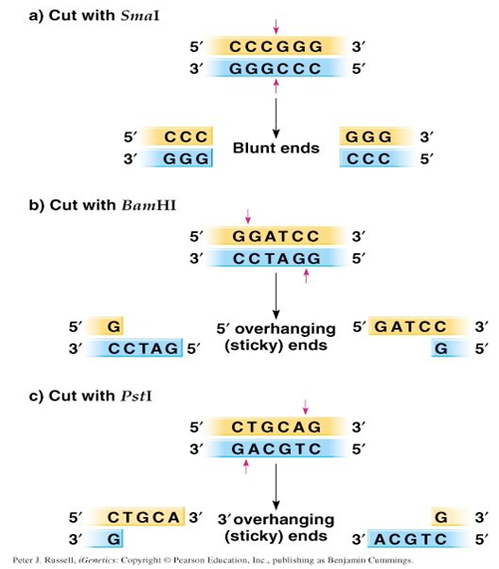
Fig. 1a. Restriction digestion and production of sticky and blunt ends

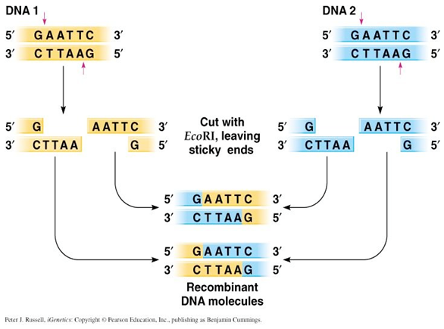
Fig.1b. Possible recombination of DNA molecule after restriction digestion.
Sequential steps involved in DNA cloning using plasmid DNA as vector:
Molecular cloning using a plasmid vector involves five major steps as shown in Fig. 1-6.
Step 1: Isolation of DNA (gene of interest and vector): The first initial step in cloning a DNA fragment is to isolate foreign DNA containing gene of interest and bacterial plasmid. If the sequence of the gene of interest is known it is isolated by PCR amplification using gene specific primers which include restriction sites selected from the multiple cloning site of the plasmid selected for cloning. When the sequence of the gene is not known degenerate primers are used for PCR amplification. Most of the time people generate genomic DNA library and screen for the gene using southern hybridization technique. According to the result of southern hybridization, the DNA is sequenced and the gene was confirmed by BLAST analysis. Now the gene is amplified by PCR and cloned. There are many plasmids available commercially for cloning.
Step 2: Treatment of plasmid and foreign DNA with the same restriction enzyme and ligation:
The gene of interest and the plasmid are modified using same restriction enzymes. Plasmid vectors are engineered to contain a specific antibiotic resistance gene and a multiple cloning site (also called the polylinker region) which contain many unique target sites for restriction endonucleases. When the circular plasmid is cut with one of the restriction enzyme whose restriction site is present in the plasmid, it results the linearization of plasmid. A fragment of DNA molecule, referred to as the “insert,” is treated with the same restriction enzyme, and then can be joined to the plasmid DNA in a ligation reaction. The chance for recombinant clones in ligations of the insert to vector will not be 100% as there is more possibility of self-ligation of two ends of the plasmid. To decrease the degree of self-ligation, enzyme phosphatase is used which removes the terminal 5′-phosphate and prevents self-ligation. Another strategy to overcome self-ligation is by using two different restriction enzymes cutting sites with non- complementary sticky ends. In this way self-ligation is inhibited and also promotes correct orientation of the insert DNA within the plasmid. The ligation of the digested insert and the plasmid is performed by pooling both in a single reaction tube and adding DNA ligase enzyme which catalyses the formation of phosphodiester bond between insert and plasmid DNAs, there by forming the recombinant DNA molecule.
Step 3: Transformation: transfer of recombinant plasmid DNA to a suitable host: The ligation reaction mixture of recombinant DNA described in the step 2 is introduced into bacterial cells in a process called transformation. The traditional method to prepare cells for transformation process is to incubate the cells in a concentrated calcium salt solution to neutralize the negative charge of membrane (due to salicylic acid), so that the negatively charged DNA molecules can come close to bacterial membrane and during heat shock (method of transformation) can easily enter in the cells. These “competent” cells are then mixed with ligation product to allow entry of the DNA into the bacterial cell. An alternative mode of transformation is electroporation method which is used to drive DNA (comparatively larger size) into cells by a strong electric current. This method is not very common due to less percentage of survival of transformed cells. As mentioned earlier bacterial species use restriction enzymes to degrade foreign DNA lacking the methylation pattern, including the plasmids, then why don’t they degrade the transformed recombinant DNA. The answer is that molecular biologist have cleverly engineered and developed the bacterial strains that lake restriction-modification system. The best example is common lab strain E.coli DH5α. A transformed bacterial cell may carry either recombinant or non- recombinant plasmid DNA. The plasmid DNA multiplies within each transformed bacterial cell. Each transformed bacterial cell when plated to the solid agar media (nutrient media) can multiply to form a visible colony made of millions of identical cells. As the transformed cell divides, the plasmids are passed on to progeny, where they continue to replicate. Single transformed bacteria undergo numerous cell divisions results in clones of a cell (single bacterial colony) from a single parental cell. From this step the name “cloning” is given. From the colony of bacterial cells the cloned DNA can now be isolated.
Step 4: Screening for transformed cells: To avoid the growth of the untransformed bacterial cells, plasmid vectors are engineered with selectable marker gene for resistance to the antibiotics (Table 3). The media in which the transformed bacterial cells are grown is supplied with that antibiotic whose resistance gene is present in the plasmid. Due to this only transformed cells show antibiotic resistance will grow in the media supplied with antibiotic and untransformed cells cannot grow as they do not carry antibiotic resistance gene. Transformed bacterial cells may contain either recombinant plasmid DNA (vector containing foreign DNA insert) or non-recombinant plasmid DNA (self ligated vector only). Both type of transformed bacterial cells will show antibiotic resistance and grow on the agar media plate.

Table 3: Some commonly used antibiotics and antibiotic resistance genes.
Antibiotic | Mode of action | Resistance gene
Kanamycin | Inactivates translation by interfering with ribosome function | Neomycin or aminoglycoside phosphotransferase (neor) gene product inactivates kanamycin by phosphorylation
Ampicillin | Inhibits bacterial cell wall synthesis by disrupting peptidoglycan cross-linking | β-Lactamase (ampr) gene product is secreted and hydrolyzes ampicillin
Tetracycline | Inhibits binding of aminoacyl tRNA to the 30S ribosomal subunit | tetr gene product is membrane bound and prevents tetracycline accumulation by an efflux mechanism

Blue-white screening or “lac selection” (also called α-complementation) can be used to distinguish between recombinant transformants and non- recombinant transformants. Bacterial colonies are allowed to grow on selective media containing antibiotic and X-gal (5-bromo-4-chloro-indolyl-β-D-galactopyranoside), a colorless chromogenic compound. Not all plasmid vectors are engineered for “lac selection”; the plasmid that are engineered for blue-white screening carry a MCS site in between gene that encodes for amino acids for enzyme β-galactosidase which cleaves β-glycosidic bond in D- lactose. X-gal mimic D-lactose and β-galactosidase enzyme acts on X- gal and produces a blue color complex.

A successful ligation of the desired gene disrupts the lac Z gene, hence no functional β-galactosidase is produced resulting in white colonies. Hence successful recombinant transformed colonies can be easily identified by its white coloration from unsuccessful blue ones. pUC19, pBluescript, pGem-T are few example of cloning vectors used for this test and it also requires the use of specific E. coli host strains such as DH5α which carries the mutant lacZΔM15 genes.
Step 5: Amplification and purification of recombinant plasmid DNA The final step in DNA cloning is the isolation of the cloned recombinant DNA. A positive colony containing recombinant plasmid is identified and it is aseptically transferred to liquid medium and cell are allowed to grow exponentially overnight. A fully grown culture contains trillions of identical cells, which is harvested for the isolation of the plasmid DNA. The plasmid DNA is purified from harvested bacterial cell lysates. The purified plasmid DNA is dissolved in an appropriate buffer solution and can be used for further confirmation of the clone by restriction digestion and sequencing the plasmid DNA.

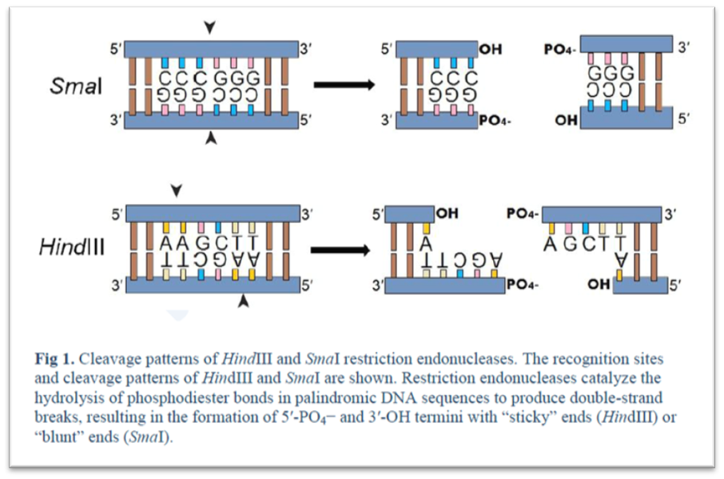
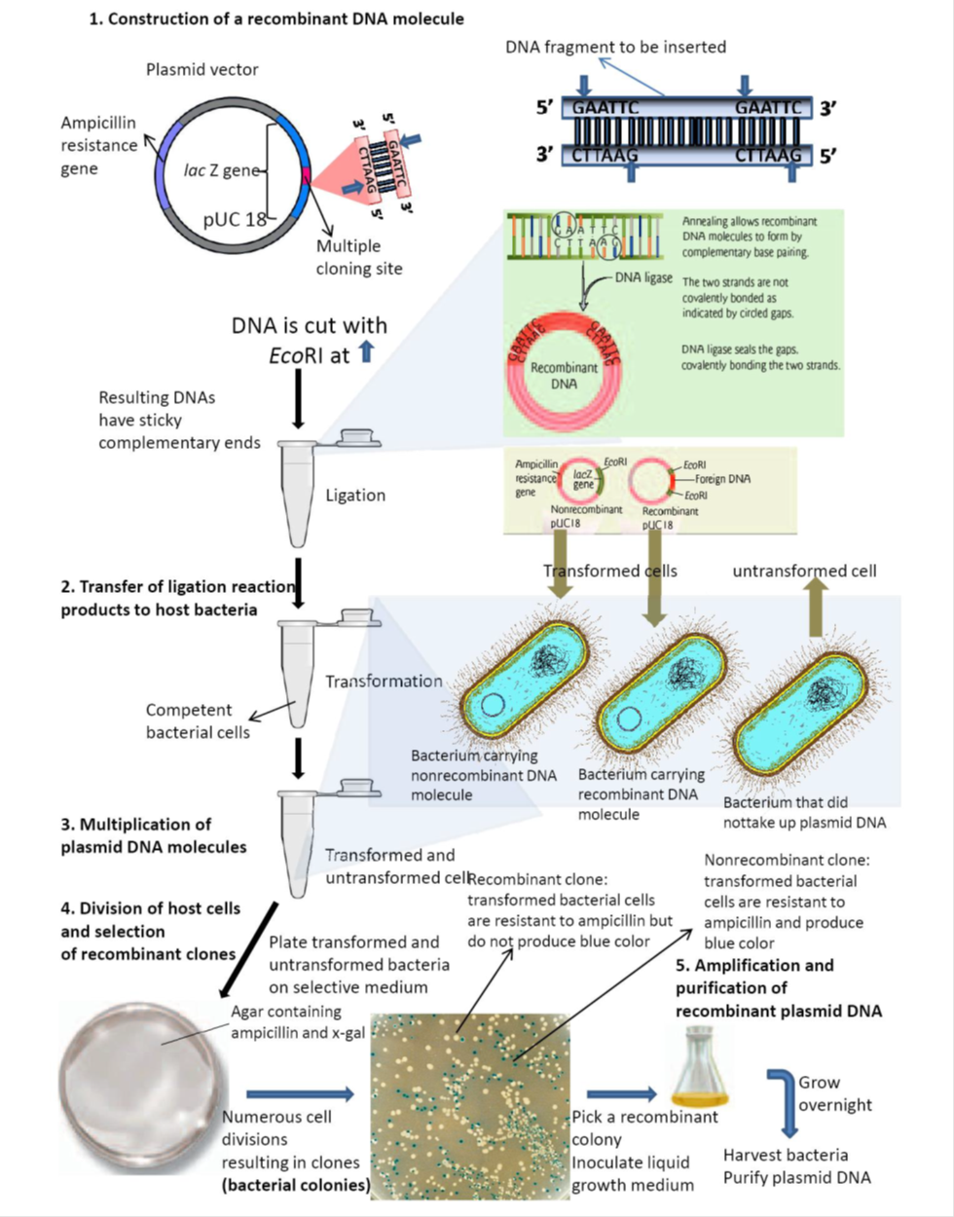
Figure 2: DNA cloning using a plasmid vector. Molecular cloning using a plasmid vector involves five major steps.

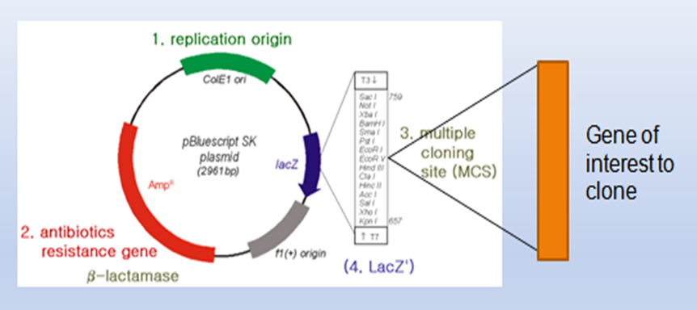

Fig.3. Plasmid Bluescript (pBSK2961) genetic Map
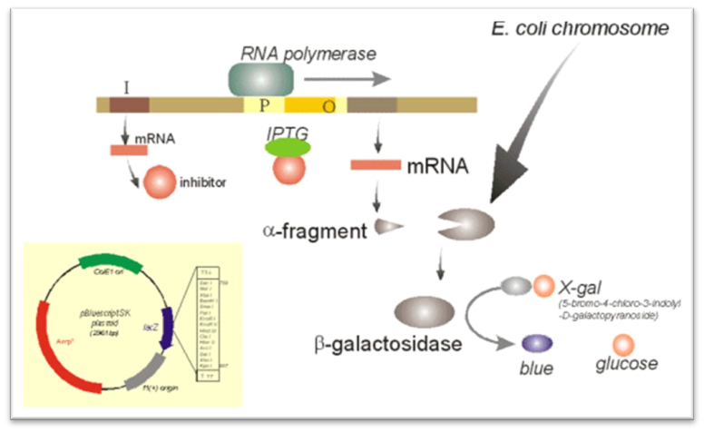
Fig 4: Transformants with vector only (Blue colour colony)

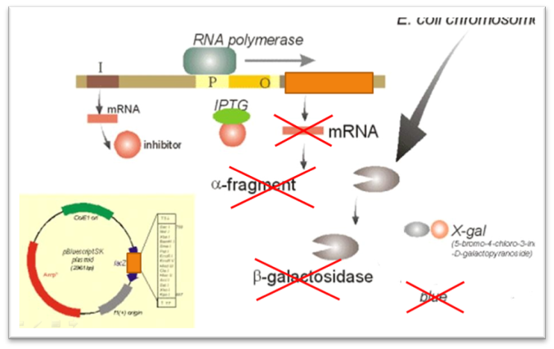
Fig 5: Transformants with recombinant DNA only (White colony)
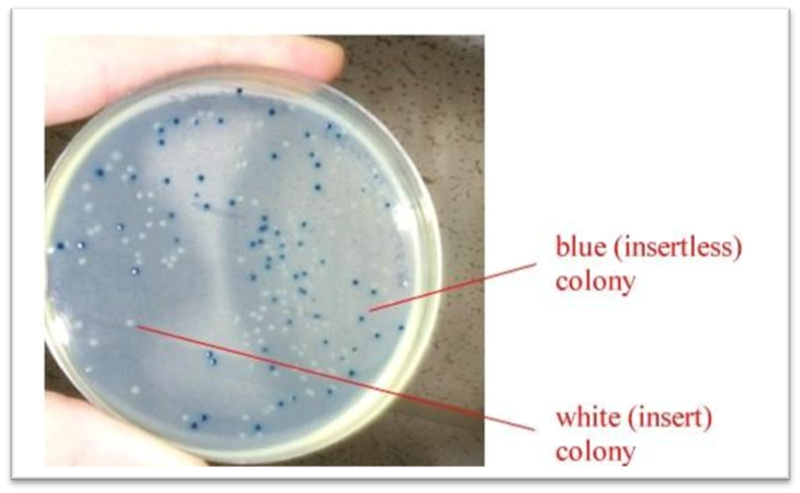
Fig 6: Selection of transformed E.coli on antibiotic fortified culture medium
Applications of gene cloning:
- Production of recombinant proteins: Gene of a given sequence may be expressed in bacteria. Desired affinity tag may be added with protein for simpler purification (please recall our discussion during affinity chromatography).
- Agricultural utility: Making transgenic crop (expression foreign gene) to boost food production.
- Transgenic organisms: Cloned genes may be inserted into organisms, generating transgenic species, producing pharmaceuticals and other commercially useful compounds.
- Gene Therapy: Gene therapy involves supplying a functional gene to cells lacking that function for correcting a genetic disorder or acquired disease.
-----------------------------------------------------------------------------------------------------------------------------

