Random Amplified Polymorphic DNA (RAPD)

The advent of Randomly Amplified Polymorphic DNA (RAPD) by Williams et al. (1990) provided new tool for the molecular geneticist. Estimation of genetic variations are increasingly being based upon information at the DNA level by various molecular techniques such as Randomly Amplified Polymorphic DNA (RAPD), Amplified Fragment Length Polymorphism (AFLP), Restriction Fragment Length Polymorphism (RFLP), and Simple Sequence Repeats (SSR). Among them, RAPD, markers generated by Polymerase Chain Reaction (PCR) is widely used since 1990’s to assess intra specific genetic variation at nuclear level. RAPD is a PCR based technique for identifying genetic variation. It involves use of single arbitrary primer in a PCR reaction, resulting in amplification of many discrete DNA. RAPD technology provides a quick and efficient screen for DNA sequence based polymorphism at a very large number of loci. The major advantage of RAPD includes that, it does not require pre-sequencing of DNA. The vast range of potential primers that can be used, give the technique great diagnostic power. Reproducible RAPD bands can be found by careful selection of primers, optimization of PCR condition for target species and replication to ensure that only reproducible bands are scored. RAPD analysis has been extensively used for various purposes which include identification and classification of accessions, identification of breeds and genetic diversity analysis.
Principal of RAPD
The standard RAPD technology (Williams et al., 1990) utilises short synthetic oligonucleotides (10 bases long) of random sequences as primers to amplify nanogram amounts of total genomic DNA under low annealing temperatures by PCR. Amplification products are generally separated on agarose gels and stained with ethidium bromide. Decamer primers are commercially available from various sources (e.g., Operon Technologies Inc., Alameda, California, USA).
DNA Amplification Fingerprinting (DAF) has also been used producing more complex DNA fingerprinting profiles. Although these approaches are different with respect to the length of the random primers, amplification conditions and visualisation methods, they all differ from the standard PCR condition in that only a single oligonucleotide of random sequence is employed and no prior knowledge of the genome subjected to analysis is required. At an appropriate annealing temperature during the thermal cycle, oligonucleotide primers of random sequence bind several priming sites on the complementary sequences in the template genomic DNA and produce discrete DNA products if these priming sites are within an amplifiable distance of each other. The profile of amplified DNA primarily depends on nucleotide sequence homology between the template DNA and oligonucleotide primer at the end of each amplified product.
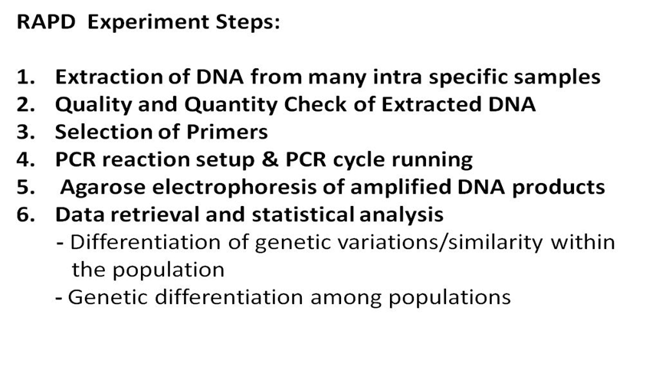
Extraction of DNA:
DNA is extracted by various methods. It also depends upon the species of plants under study but the basic procedure remains the same. Genomic DNA is basically extracted and purified from leaf using standard phenol or Chloroform extraction as per the standard protocols.
Quality and Quantity Check of Extracted DNA:
Quantity and quality of DNA is determined by U.V. Spectrophotometric method. Quality of the DNA can be checked by the ratio between OD₂₆₀ and OD₂₈₀ and also by 0.8% agarose gel electrophoresis.
Selection of Primers:
Random Amplified Polymorphic DNA (RAPD) is a multiplex marker system that conventionally uses single primer PCR to amplify random DNA fragments. The standard RAPD technology utilises short synthetic oligonucleotides (10 bases long) of random sequences as primers to amplify nanogram amounts of total genomic DNA under low annealing temperatures by PCR. A total of 40 random oligonucleotide primers were used for amplification. All the random primers were 10 bp long and with high GC content.
PCR Amplification
The polymerase Chain Reaction (PCR) is a relatively simple but powerful technique that amplifies a DNA template to produce multiple copies of specific DNA fragment in vitro. PCR amplification consists of following 3 steps:
DENATURATION-In PCRs catalyzed by Taq DNA polymerase, denaturation was carried out at 94°C. During the denaturation, the first part of process, the double strand melted and opened to a single stranded DNA.
ANNEALING-Annealing is carried out at 38- 35°C in touch down fashion for 30 min (3-5°C lower than the calculated melting temp at which the oligonucleotide primers dissociate from their templates). In the PCR reaction carried out, the primers binded or “annealed” to the ends of the DNA strands at the temp up to 34-42°C.
EXTENSION-Extension of oligonucleotide primer is carried out at 72°C (near the optimal temp for DNA synthesis catalyzed by the thermo stable polymerase). In case of Taq polymerase, the optimal temperature is 72°C. The polymerization rate of Taq polymerase is ~2000 nucleotide/minute and at the optimal temperature (72°C), extension is carried out for every 1000 bp of the product.
The bases (complementary to the template) are coupled to the primer on the 3’ end (the polymerase adds dNTP’s from 5’to 3’, reading the template from 3’to 5’ side; bases are added complementary to the template). Using fresh clean tips, all the reagents are added to an autoclaved microfuge tube placed on ice. A typical cocktail for PCR (1 reaction) consists of,
- 10X Reaction Buffer -1.5 μL
- DNTPs (250 μM) -1 μL
- Primer (10 μm) -2 μL
- Taq polymerase -0.2 μL (1 unit)
- MgCl₂ -1.5 μL
- Genomic DNA -2 μL
All the reagents are mixed, the appropriate cocktails for the desired number of samples are made and complete mixing is ensured by tapping the tube and quick spinning. About 2.0 μL of the template DNA are added directly into the PCR tube for each reaction. The appropriate quantity of cocktail are pipetted directly into the bottom of the PCR tube (0.2 mL) containing the genomic DNA for each reaction. Adequate mixing of the cocktail in the tube is ensured. Tightly capped tubes are placed in the temperature block and it is made sure that each firmly seated by pressing on the tube individually. The PCR machine is programmed for the specific reaction conditions desired. After completion of the PCR reaction, the tubes are removed from the temperature block. The reaction products are separated according to size by agarose gel electrophoresis and visualized after staining the gel with ethidium bromide.
Agarose Gel Electrophoresis of RAPD products: After completion of the PCR programme, the products are checked in 2% agarose for the amplification. Before loading into the wells, gel loading dye (bromophenol blue in glycerol) is added to the sample and the samples are run under constant voltage condition (80 V) till the two dyes get separated. Amplified products appear as sharp orange color bands under UV Transilluminator due to the intercalation of ethidium bromide. To ensure that the amplified DNA bands originated from genomic DNA and not primer artifacts, negative control are carried out for each primer combination. No amplification is detected in control reactions. All amplification products are found to be reproducible when reactions are repeated using the same reaction conditions.
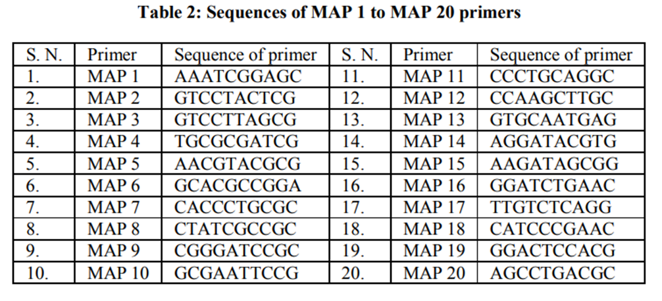

MAP 10 Primer (GCGAATTCCG) based annealing with template DNA
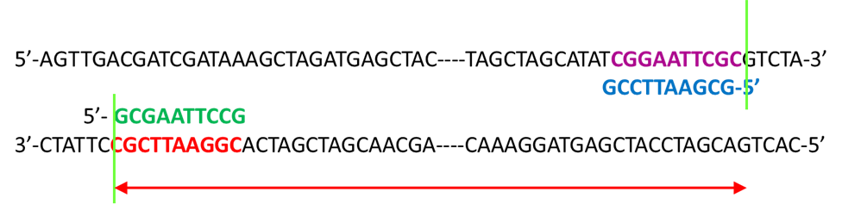

Certain primers will produce unrelated patterns between unrelated organisms and identical ones for very closely related organisms. Presumably, primer sites are randomly distributed along the target genome and flank both conserved and highly variable regions. Wide variation in band intensity can be shown to be reproducible between experiments, which could be the result of multiple copies of the amplified regions in the template or the efficiency with which particular regions are amplified.
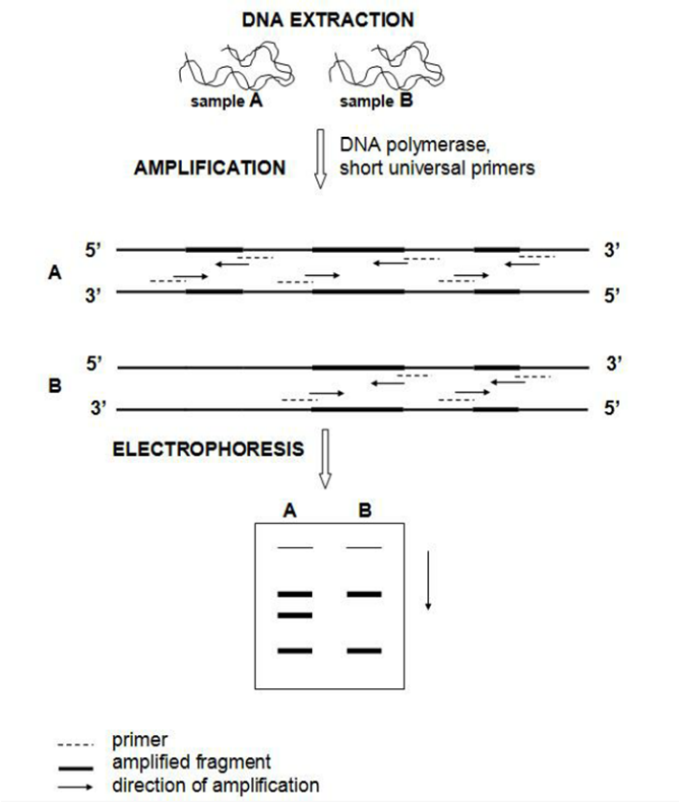
ADVANTAGES OF RAPD:
- Suitability for work on anonymous genomes,
- Applicability to problems where only limited quantities of DNA are available,
- It is a simple technique, efficiency and low expense.
- High numbers of fragments are formed.
- Arbitrary primers used for this technique can be easily purchased.
- Generally amplify a range of fragments of most DNA and show polymorphisms.
- The polymorphic bands obtained from RAPDs can also be cloned for further analysis.
Disadvantages of RAPD:
- RAPD markers are dominant.
- Amplification either occurs at a locus or it does not, leading to scores based on band presence or absence. This means that homozygotes and heterozygotes cannot be distinguished.
- The absence of a band through lack of a target sequence cannot be distinguished from that occurring through the lack of amplification for other reasons (e.g., poor quality DNA), contributing to ambiguity in the interpretation of results.
- Nothing is known about the identity of the amplification products.
- Problems with reproducibility result as RAPD
- Problems of co-migration raise questions like ‘Do equal-sized bands correspond to DNA fragment’?
- The presence of a band of identical molecular weight in different individuals is not evidence per se that the individuals share the same (homologous) DNA fragment.
- A band detected on a gel as being single can comprise different amplification products. This is because the type of gel electrophoresis used, while able to separate DNA quantitatively (i.e., according to size), cannot separate equal-sized fragments qualitatively (i.e., according to base sequence).
Field of application of RAPD:
- Genetic Mapping
- Developing Genetic Markers Linked to a Trait in Question
- Population and Evolutionary Genetics
- Plant and Animal Breeding
Restriction Fragment Length Polymorphism

Restriction Fragment Length Polymorphism (RFLP) is a technique in which organisms may be differentiated by analysis of patterns derived from cleavage of their DNA. If two organisms differ in the distance between sites of cleavage of a particular Restriction Endonuclease, (RE) the length of the fragments produced will differ when the DNA is digested with a restriction enzyme. The similarity of the patterns generated can be used to differentiate species (and even strains) from one another. This technique is mainly based on the special class of enzyme i.e. Restriction Endonucleases (RE).

Restriction endonucleases
Restriction endonucleases are enzymes that cleave DNA molecules at specific nucleotide sequences depending on the particular enzyme used. Restriction enzymes are isolated from a wide variety of bacterial genera and are thought to be the part of the cell's defense against invading bacterial viruses. These enzymes are named by using the first letter of the genus, the first two letters of the species, and the order of discovery.
1. More than 500 restriction endonucleases are known.
2. Hundreds of these are commercially available.
3. Sites range from 4 to 8 or more bp.
4. Cut frequently or very rarely (-250 bp to - 66 kb).
5. Supplied with buffer and instructions are provided by the manufacturing companies.

Generally, shorter the recognition sequence, greater the number of fragments generated. If molecules differ in nucleotide sequence, fragments of different sizes may be generated. The fragments can be separated by gel electrophoresis. RFLP analysis takes advantage of the cutting enzymes. In southern blotting, the genomic DNA is digested with different enzymes. The pathogenic and non-pathogenic conditions are examined by analyzing the fragment of the DNA. Some of the important restriction endonucleases and the organism from which these are isolated and restriction recognizing sequence are shown.
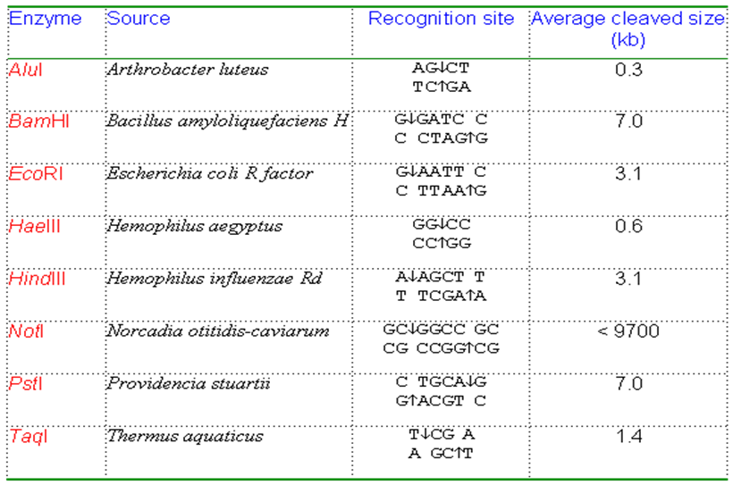

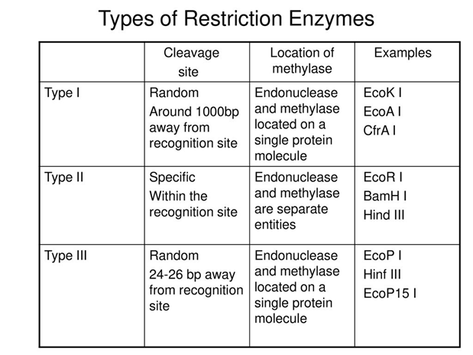
How Restriction Endonucleases works
RE hydrolyse both strands of a double stranded DNA within a (normally symmetrical) recognition sequence to give a 5'-phosphate and a 3'-hydroxyl at each break point. When RE cuts the two strands of DNA at nucleotide on the same position, then it results into two fragments with BLUNT ends, but if RE cut the two strands at nucleotide not on the same position then it results into two fragments with STICKY ends. The later one is highly useful in DNA recombinant technology and is used to insert the DNA of interest into the vector.
Formation of “Blunt ends” and “Sticky ends” during the restriction of DNA
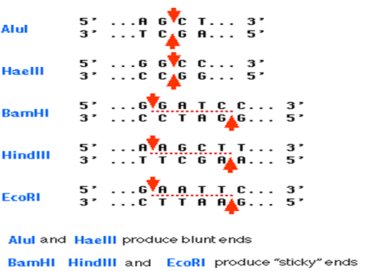

RFLP Mechanism:
An RFLP is a sequence of DNA that has a restriction site on each end with a "target" sequence in between. A target sequence is any segment of DNA that binds to a probe by forming complementary base pairs. A probe is a sequence of single-stranded DNA that has been tagged with radioactivity or an enzyme so that the probe can be detected. When a probe base pairs to its target, the investigator can detect this binding and know where the target sequence is since the probe is detectable. RFLP produces a series of bands when a Southern blot is performed with a particular combination of restriction enzyme and probe sequence.
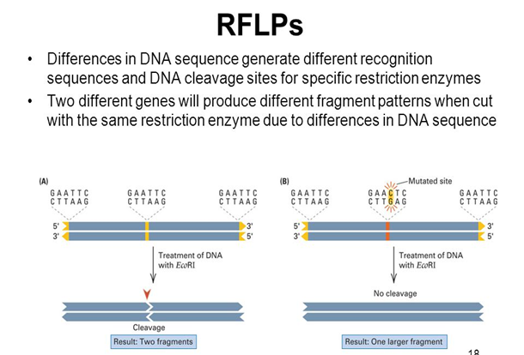
RFLP – Experimental Steps:
- The first step in this process is to isolate the DNA from the sample material to be tested.
- DNA is subjected to restriction digestion using restriction enzymes.
- The digested DNA sample is then separated by agarose gel electrophoresis, in which the DNA is separated based on the size.
- Transfer of separated DNA from gel slab onto the nitrocellulose membrane to hybridize with a labeled probe that is specific for one candidate region (Southern Blotting).
- After the hybridization with the radioactive probes, the X- ray film is developed from the southern blotting.
- DNA bands are compared with the other known samples, will give the final result of the DNA fingerprinting.

DNA Fingerprinting
The DNA of every human being on the planet is 99.9% same. However, 0.1% of DNA is unique to the individual that makes all the difference. These differences are a consequence of mutations during evolution. As single change in nucleotide may make a few more cleavage site of a given nucleotide or might abolish some existing cleavage site of restriction enzymes. Thus if, DNA of any individual is digested with a restriction enzyme, fragments pattern (sizes) will be produced and will be difference in cleavage site position. This is the basics of DNA fingerprinting. DNA Fingerprinting is used by scientists to distinguish between individuals of the same species using only samples of their DNA. The process of DNA fingerprinting was invented by Sir Alec Jeffrey at the University of Leicester in 1985.
The DNA profiling of each individual is unique because of the diverse in polymorphic regions present in genome of every individual. These polymorphic regions used for identification are the non-coding regions of the genome. The polymorphic regions of the DNA do not code for proteins and which make-up 95% of our genetic DNA. Hence these regions are therefore called the junk DNA Although these junk DNA‖ regions do not code for proteins, they are involved in regulating gene expression, they help in reading of other genes that code for protein and are a large portion of the chromosome structure. The junk DNA regions are made-up of length polymorphisms, which show variations in the physical length of the DNA molecule. In DNA profile the length of the polymorphisms in the non-coding areas is measured as it varies with each individual. These polymorphisms are identical repeat sequences that are present in non- coding DNA region. At specific loci on the chromosome the number of tandem repeats varies between individuals. There will be a certain number of repeats for any specific loci on the chromosome. Depending on the size of the repeat, the repeat regions are classified into two groups. Short tandem repeats (STRs) contain 2-5 base pair repeats and Variable number of tandem repeats (VNTRs) have repeats of 9-80 base pairs.
We inherit a copy of chromosome, one from father and one from mother for each of the 23 pairs of chromosomes, which indicate that we carry two copies of each STR/VNTR locus, just like we have two copies of genes donated by our parents. At a particular STR/VNTR site if you have the same number of sequence repeats, you are called homozygous at that site; if you have a different number of repeats, you are said to be heterozygous‖. STR/VNTR sequences from different loci can be combined to create DNA fingerprint. Resulting patter of each individual is theoretically unique.
The two types of DNA fingerprinting tests: (i) PCR/STR polymerase chain reaction (PCR) amplification of short tandem repeats (STRs) and (ii) RFLP/VNTR Restriction fragment length polymorphism (RFLP) analysis of VNTR regions are two main DNA tests widely used for DNA fingerprinting.
Polymerase chain reaction (PCR) amplification of short tandem repeats (STRs)
Kary mullis in the year 1991 developed a technique to amplify a DNA. PCR generates the repeated copies of a specific area of the DNA fragment. These areas are the alleles and are specific sequences of base pairs. They are the target regions with variable length. On either side of the target regions there are ―flanker‖ sequences which are non-variable regions. On chromosomes ―flanker‖ occurs at same location for all individuals. Thousands of copies of a particular variable region are amplified by PCR which forms the basis of this detection. STR with a known repeat sequence is amplified and separated using gel-electrophoresis. The distance migrated by the STR is examined. For the amplification of STRs using PCR, a short synthetic DNA, called primers are specially designed to attach to a highly conserved common non- variable region of DNA that flanks the variable region of the DNA. By comparing the STR sequence size amplified by PCR with the other known samples, will give the final result of the DNA fingerprinting.
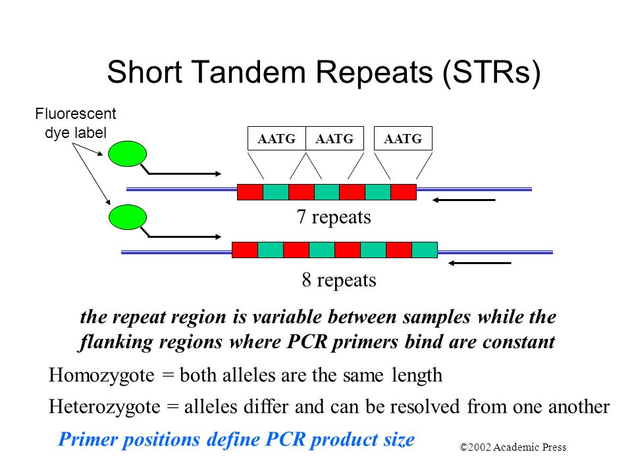
In this case study the gel image reveals the lane 2 is the DNA from crime scene is amplified and that produce 200bp size amplicon/PCR product. Among the three suspects people’s DNA analysis, it is obvious that the suspect #3 must be the culprit since he has the similar DNA profile (STR profile of crime scene is matching with suspect #3). In case of #1 the allelic nature of the target DNA region is large in size. But in the case of #2 both allele forms the region are available.

Restriction fragment length polymorphism (RFLP) based analysis of VNTR:
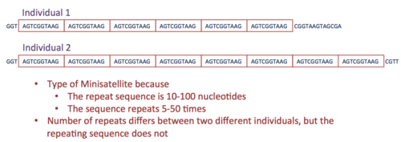
The first step in this process is to isolate the DNA from the sample material to be tested. As mentioned, the sample size for RFLP test must be large enough to get the proper result. Once the required size of the sample is available, the DNA is isolated from the sample and is subjected to restriction digestion using restriction enzymes. The digested DNA sample is then separated by agarose gel electrophoresis, in which the DNA is separated based on the size. The next step is transfer of separated DNA from gel slab onto the nitrocellulose membrane to hybridize with a labeled probe that is specific for one VNTR region (radio activity labeled complimentary sequence for VNTR region nucleotide sequence). This technique of transferring and hybridizing DNA onto nitrocellulose membrane is known as southern blotting, a most widely used DNA detection technique by molecular biologists. After the hybridization with the radioactive probes, the X- ray film is developed form the southern blotting and only the areas where the radioactive probe binds will show up on the film. Now these bands when compared with the other known samples, will give the final result of the DNA fingerprinting.
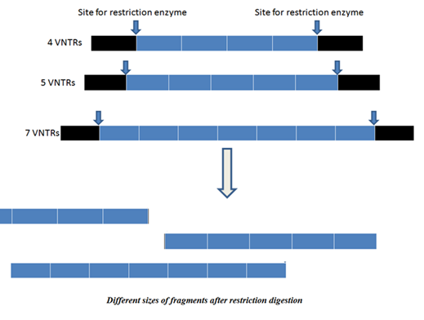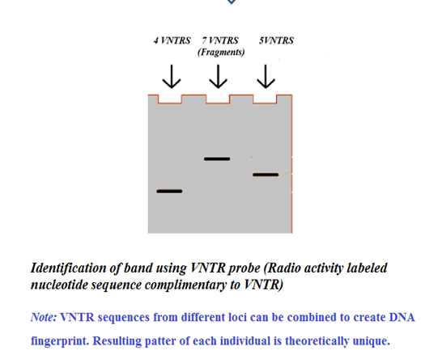
STR Vs VNTR
STR is a type of tandem repeat in which a short sequence of nucleotides (2 - 6 base pairs) are repeated as variable number of time in a particular locus | VNTR is a type of tandem repeat in which a short sequence of nucleotides (10 - 60 base pairs) are repeated as variable number of time in a particular locus
Consists of 2 – 6 base pairs | Consists of 10 – 60 base pairs
A type of microsatellite DNA | A type of minisatellite DNA
Consists of 5 – 200 repeats in the array | Consists of 10 – 1500 repeats in the array
Forms an array of 10 – 1000 bp | Forms an array of 0.5 – 15 kb
Produces homogenous array | Produces heterogeneous arrays

Applications of DNA Fingerprinting:
1. In Forensics Science:
DNA Fingerprinting and Forensics Forensic science can be defined as the intersection of law and science. The DNA profile of each individual is highly specific. The chances of two people having the exact DNA profile are 30,000 million to 1 (except for identical twins). Biological materials used for DNA profiling are: Blood, Hair, Saliva, Semen, Body tissue cells etc. DNA isolated from the evidence sample can be compared through VNTR (Variable number of tandem repeats) prototype. It is useful in solving crimes like murder and rape. For example; the sex scandal of President Clinton with Monica Lewinsky, Double murders of O.J. Simpson in 1995. Colin Pitchfork was the first criminal caught based on DNA fingerprinting evidence. He was arrested in 1986 for the rape and murder of two girls and was sentenced in 1988. O.J. Simpson was cleared of a double murder charge in 1994, which relied heavily on DNA evidence.
2. Paternity and Maternity Determination: A Person accedes to his or her VNTRs from his or her parents. Parent-child VNTR prototype analysis has been used to solve disputed cases. This information can also be used in inheritance cases, immigration cases. For Example: In 2002 Elizabeth Hurley used DNA profiling to prove that Steve Bing was the father of her child Damien.
3. Personal Identification: The concept of using DNA fingerprints as a sort of genetic bar code to pinpoint individuals has already been discussed above.
4. Diagnosis of Inherited Disorders: It is also useful in diagnosing inherited disorders in both prenatal and newborn babies. These disorders may include cystic fibrosis, hemophilia, Huntington's disease, familial Alzheimer's, sickle cell anemia, thalassemia, and many others.
5. Development of Cures for Inherited Disorders: By studying the DNA fingerprints of relatives who have a history of some particular disorder, DNA prototypes associated with the disease can be ascertained. The Hong Kong Baptist University was able to use DNA fingerprinting to identify the Chinese medicine—Lingzhi in 2000.
6. Detection of AIDS: By comparing the band of HIV "RNA" (converted to DNA using RT-PCR) with the bands form by the man’s blood, person suffering with AIDS can be identified.
7. Breeding Program: Breeders conventionally use the phenotype to evaluate the genotype of a plant or an animal. For example, homozygous dominant genotype AABB is always desirable. As it is difficult to make out homozygous or heterozygous dominance from appearance, the DNA fingerprinting allows a fastidious and precise determination of genotype. Offspring from the discerning mating of superior animals are expected to inherit desirable characters like strong cardiopulmonary capacity and speed. It is basically useful in breeding race horses and hunting dogs.

---------------------------------------------------------------------------------------------------------------------------------------

